Minireview Article
Foamed Red Mud-Based Geopolymer Concrete: A Comprehensive Review of Synthesis, Microstructure, and Thermo-Mechanical Performance

.
ABSTRACT
This review systematically summarizes recent research progress on foamed red mud-based concrete (FRMC), a sustainable building material that integrates industrial waste valorization with thermal insulation. The paper addresses four key research directions: (1) foaming technology optimization and mechanism studies, including foaming agent types, process control, and foam stability; (2) red mud incorporation and modification research, covering incorporation ratios, activation techniques (mechanical, chemical, and thermal), and synergistic hydration mechanisms; (3) aggregate combination strategies, including conventional aggregate systems and composite aggregate systems; and (4) performance control and microstructural mechanisms, focusing on mechanical and thermal properties. Results show that optimal red mud incorporation (10-30%) with proper modification can achieve 28-day compressive strength of 28.5-33.5 MPa and thermal conductivity of 0.075-0.086 W/(m·K), making FRMC promising for building insulation applications. Future research should focus on high-incorporation red mud systems, long-term durability mechanisms, and engineering-scale material design models.(any other application enhanced)
Keywords: Foamed red mud-based concrete; Foamin
g technology; Red mud incorporation; Aggregate synergy; Performance control; Microstructural mechanism

1. INTRODUCTION
1.1 Research Background and Significance
1.1.1 Urgent Need for High-Value Utilization of Red Mud Waste
Red mud is an industrial waste generated during the alumina extraction process from bauxite. Approximately 1.0-1.8 tons of red mud is produced per ton of alumina. Global red mud generation exceeds 150 million tons annually, with China—as the world's largest alumina producer—generating over 60 million tons per year, accumulating to over 1 billion tons. Red mud contains CaO, SiO₂, Al₂O₃ and trace heavy metal ions (Cr, As, Pb), and long-term outdoor storage causes heavy metal leaching, soil and water contamination, consuming significant agricultural land resources. Currently, red mud utilization is less than 10%, far below fly ash (>60%) and slag (>70%), making high-value utilization critical for solving aluminum industry development bottlenecks. Due to compositional similarity with cement and metakaolin, red mud can be incorporated into foamed concrete systems for large-scale consumption and high-value utilization, aligning with waste resource strategies and carbon neutrality goals.
1.1.2 Demand for Low-Carbon Thermal Insulation Materials in Building Energy Efficiency
With escalating global energy crises and advancing carbon neutrality targets, building energy efficiency has become central to emission reduction. According to the International Energy Agency (IEA), building energy consumption accounts for 36% of total global energy use and 39% of total carbon emissions. Traditional foamed concrete, though lightweight and thermally insulating, suffers from high carbon emissions, elevated costs, and difficult performance control. Foamed red mud-based concrete, incorporating red mud as the primary supplementary material while partially replacing cement, reduces production costs and carbon emissions while improving thermal and mechanical properties through component optimization, becoming a promising low-carbon thermal insulation material for building applications.
1.2 Research Status and Core Research Gaps
Current research on foamed red mud-based concrete focuses on four key areas: (1) foaming technology optimization and process fine-tuning; (2) red mud incorporation ratio control and modification; (3) aggregate combination innovation; and (4) performance control and microstructural mechanisms. Despite established basic performance patterns and control methods, significant research gaps persist: (i) microstructural mechanisms of performance degradation at high red mud incorporation remain unclear; (ii) synergistic control mechanisms between foam stability and slurry systems are insufficient; (iii) multicomponent synergy research lacks depth without established quantitative engineering design models; (iv) long-term durability evolution mechanisms are missing, limiting engineering-scale application maturity.
1.3 Review Objectives and Framework
This review systematically summarizes foamed red mud-based concrete research progress, integrates high-level research findings, deepens microstructural-macroscopic property relationships, and consolidates research patterns and conclusions. The structure encompasses: (1) fundamental theory and preparation processes; (2) three major research directions—foaming technology, red mud modification, and aggregate combination; (3) mechanical and thermal property control mechanisms and microstructural relationships; and (4) conclusions and future perspectives, providing guidance for subsequent research and applications.
2. FUNDAMENTAL THEORY AND PREPARATION OF FOAMED RED MUD-BASED CONCRETE
2.1 Core Components and Action Mechanisms
2.1.1 Red Mud Compositional Characteristics and Functional Mechanisms

Red mud chemistry is complex, containing primarily CaO, SiO₂, Al₂O₃, Fe₂O₃, TiO₂ oxides with composition varying by source. Sintered method red mud shows combined SiO₂ and Al₂O₃ content of 40-60% with relatively high active component concentrations. Red mud activity stems from active SiO₂ and Al₂O₃, which can undergo pozzolanic reactions in alkaline environments to generate C-S-H gels and calcium aluminates, while fine red mud particles fill cement pores and optimize pore structures. However, inert components (hematite, goethite) and free Na₂O reduce mechanical properties and volume stability, causing performance degradation at high incorporation rates.
2.1.2 Selection Principles for Cementitious Materials and Aggregates
Cementitious materials including ordinary Portland cement, metakaolin, and slag powder function by hydration reactions to bind components and provide mechanical properties and volume stability. Cement-generated Ca(OH)₂ creates alkaline environments for red mud activation; metakaolin undergoes secondary pozzolanic reactions with Ca(OH)₂ to form additional C-S-H gel and C-A-H phases, significantly optimizing microstructures. Aggregate selection must balance mechanical and thermal properties: conventional aggregates (river sand, silica sand) enhance mechanical properties but limit thermal insulation, while lightweight aggregates (ceramsite, glass microspheres) significantly reduce thermal conductivity but weaken mechanical properties, requiring optimization and composite application.
2.1.3 Foaming Agent Action Mechanisms and Selection Criteria
Foaming agents, the core components creating lightweight porous structures through physical or chemical action, generate stable bubbles. Chemical foaming agents are most common; hydrogen peroxide (H₂O₂) and its solid form dominate due to high efficiency and low cost. Foaming agent selection must prioritize compatibility with red mud slurry, preventing efficiency loss and bubble rupture from red mud's strong adsorptivity, balancing foaming efficiency, foam stability, and environmental considerations.
2.2 Preparation Process and Key Control Points(need to elaborate more)
The foamed red mud-based concrete preparation process includes five stages: raw material pretreatment, mix design, mixing, foaming formation, and curing (as shown in Figure 1). Red mud must undergo drying and grinding to enhance activity and reduce free Na₂O; cementitious materials and aggregates require strict moisture control; foaming agents need type-appropriate pretreatment. Optimal mix design incorporates red mud 10-30%, cementitious materials 40-60%, water-binder ratio 0.30-0.35, foaming agent 0.3-0.8%, with continuous-graded aggregates further optimizing pore structures. Foaming requires controlled mixing speed (300-500 r/min), dry mixing time (2-3 min), wet mixing time (4-5 min), and temperature (20±2°C). Curing protocols affect material performance development: standard curing (20±2°C temperature, ≥95% relative humidity) achieves stable performance; low-temperature steam curing enhances early strength but requires strict control to prevent microcracking.

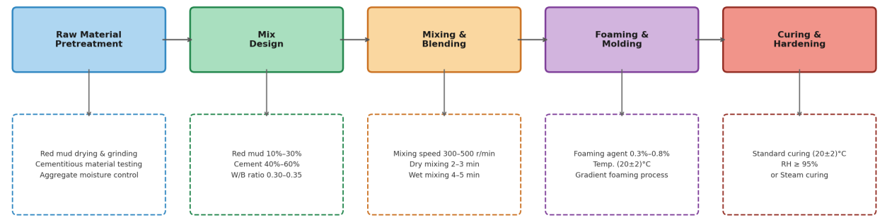
Fig. 1 Schematic Diagram of Foamed Red Mud-Based Concrete Preparation Process
3. CORE RESEARCH PROGRESS IN FOAMED RED MUD-BASED CONCRETE
3.1 Foaming Technology Optimization and Mechanism Research
3.1.1 Foaming Agent Types and Optimization Patterns
Foaming agent type directly determines pore structure and macroscopic mechanical-thermal properties, representing critical preparation parameters. Current practice employs chemical foaming agents (primary) and physical agents (secondary). Hydrogen peroxide (H₂O₂), the most widely used chemical foaming agent, decomposes under MnO₂ catalysis to release O₂ bubbles in alkaline environments. At 3-5% H₂O₂ concentration, optimal foaming efficiency achieves 45-55% porosity, 28-day compressive strength of 32.1 MPa, and thermal conductivity of 0.085 W/(m·K). Composite foaming agents (H₂O₂ and CaCO₃) further improve performance: at 3:1 H₂O₂ to CaCO₃ mass ratio, foam stability increases approximately 25% with significant mechanical and thermal improvements. Plant protein-based physical foaming agents offer environmental benefits and good foam stability but lower foaming efficiency; future focus should emphasize developing composite chemical foaming agents combining high efficiency and stability.
3.1.2 Fine Process Control of Foaming Operations
Mixing speed, time, and foaming temperature significantly impact foaming effectiveness and enable performance control (as shown in Figure 2). Optimal parameters from orthogonal tests include 350 r/min mixing speed, 2 min dry mixing, 4.5 min wet mixing, achieving peak performance with 50-120 μm bubble diameter and 50.2% porosity. Improper parameters cause insufficient foaming or excessive bubble rupture, severely affecting pore structure and mechanical properties. Temperature is another critical foam stability factor: 20±2°C achieves optimal stability; lower temperatures inhibit foaming and hydration, while higher temperatures cause bubble rupture and slurry collapse. Recent "segmented mixing-gradient foaming" techniques improve bubble distribution uniformity by 30% and 28-day compressive strength by 20.1%, providing new pathways for high-performance material preparation.

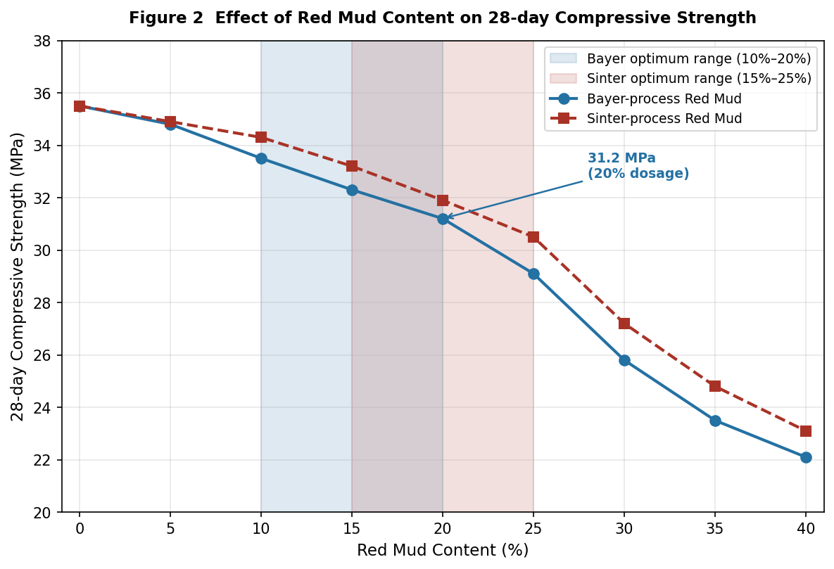
Fig. 2 Effect of Red Mud Content on 28-Day Compressive Strength
3.1.3 Synergistic Control Mechanisms of Foam Stability
Foam stability fundamentally requires suppressing bubble rupture and coalescence through careful control of multiple factors including foaming agent type and dosage, red mud properties, cementitious material content, and additive types. Red mud's strong surface adsorptivity reduces foaming agent effectiveness; above 30% incorporation, particle agglomeration severely damages bubble structure, requiring red mud modification and additive control. Cementitious material content directly affects slurry viscosity, requiring balance between foam stability, cost, and thermal properties. Carboxymethyl cellulose sodium (CMC) as foam stabilizer shows exceptional results: 0.2-0.3% incorporation increases foam stability by 35%; high-efficiency water reducers improve particle dispersivity, enhancing foaming efficiency and stability. The "foaming agent-foam stabilizer-water reducer" synergistic technique reduces bubble rupture by 40% with optimal overall performance, though microstructural mechanisms require further investigation through in situ observation and numerical simulation.

3.1.4 Emerging Understanding of Red Mud as a Foam-Stabilizing Component in Alkali-Activated Systems
Recent studies have shown that red mud is not only a solid waste precursor, but may also function as a foam-stabilizing component in alkali-activated foamed systems. Different from the conventional mechanism dominated by reducing liquid-film surface tension, red mud mainly improves bubble stability by increasing slurry yield stress, plastic viscosity, and solid-particle support capacity, thereby suppressing bubble coalescence, drainage, and collapse during early-stage setting [23,24]. This finding expands the traditional understanding that red mud acts only as an inactive or weakly active mineral admixture, and indicates that its rheological contribution should be considered together with its chemical reactivity in future mix design.
From a mechanistic perspective, this emerging role of red mud is particularly important for highly porous thermal-insulation materials. When the slurry exhibits adequate viscosity and structural build-up, the bubble system can maintain a smaller and more uniform pore size distribution, which is favorable for balancing dry density, thermal conductivity, and compressive strength [23]. However, this stabilizing effect is not unlimited. Excessive red mud incorporation may still result in particle agglomeration, non-uniform gas release, and increased connectivity between pores, eventually impairing both strength and durability. Therefore, future studies should place greater emphasis on the coupled regulation of red mud content, alkali environment, rheology, and foaming kinetics, rather than evaluating red mud dosage alone [23,24].

3.2 Red Mud Incorporation and Modification Research
3.2.1 Red Mud Incorporation Ratio Effects on System Performance
Red mud incorporation ratio determines waste consumption and material comprehensive performance. For Bayer process red mud, 10-20% incorporation achieves optimal performance; at 20% incorporation, 28-day compressive strength reaches 31.2 MPa, thermal conductivity is 0.086 W/(m·K), achieving coordinated waste valorization and material optimization. Mechanistically, low incorporation (10-20%) exploits filling effects and hydration synergy, overcoming inert component disadvantages, while high incorporation (>30%) increases inert proportions, aggravating particle agglomeration and pore structure degradation with significant strength and durability declines. Sintered-method red mud with higher active content shows optimal incorporation of 15-25%, slightly higher than Bayer process mud, but above 30%, freeze-thaw and water resistance significantly decrease.
3.2.2 Red Mud Modification Techniques and Mechanisms
Red mud's low pozzolanic activity and harmful impurities (free Na₂O) severely limit high-incorporation applications. Primary modification techniques include mechanical activation, chemical activation, and thermal activation. Mechanical activation via ball milling reduces particle size and increases specific surface area, releasing latent active components; after 3-hour grinding, specific surface area increases from 18.5 to 42.3 m²/g with 65% activity improvement, permitting 30% incorporation. Chemical activation using sodium silicate-calcium hydroxide composite activators shows superior results: at 2:1 mass ratio with 5-8% dosage, activity increases 70%, allowing 35% incorporation with 28-day strength of 28.5 MPa. Thermal activation at 700°C achieves peak activity with 30% free Na₂O reduction; above 800°C, crystalline restructuring reduces active components, decreasing activity. Future research should develop combined mechanical-chemical-thermal modification for expanded incorporation limits and utilization efficiency.
3.2.3 Synergistic Hydration Mechanisms Between Red Mud and Cementitious Materials
Synergistic hydration between red mud and cementitious materials forms material mechanical properties and dense microstructures. In red mud-cement systems, synergy manifests as bidirectional promotion: cement-generated Ca(OH)₂ effectively activates red mud's active Al₂O₃ and SiO₂ in pozzolanic reactions, while red mud hydration products supplement and refine product systems, optimizing interfacial transition zones. Temporally, early hydration (0-7 days) emphasizes cement hydration, intermediate (7-28 days) involves red mud secondary reactions, and late stages (>28 days) approach equilibrium stability. In red mud-metakaolin systems at 1:1 mass ratio, optimal synergy achieves 33.5 MPa 28-day strength, exceeding single-component systems by 25%, with C-S-H and calcium aluminates creating dense microstructures. Red mud-slag systems at 2:1 ratio show best performance, with slag effectively inhibiting free Na₂O effects. However, high-incorporation synergistic limitations and hydration kinetics require further study.
3.3 Aggregate Combination and Synergistic Effects Research
3.3.1 Red Mud-Cement-Conventional Aggregate Systems
Conventional aggregates (river sand, silica sand) primarily provide skeleton support with important mechanical contributions. Optimal orthogonal parameters include 20% red mud, 50% cement, 30% sand, 0.32 water-binder ratio, achieving 32.6 MPa 28-day strength. Aggregate grading significantly impacts performance: continuous grading (0.15-5 mm) with 3:2 coarse-fine ratio maximizes particle packing and minimizes porosity, reaching 33.2 MPa strength; sand with moisture controlled below 3% further improves mechanics by 8.5%. This mature system, though thermally limited, suits applications without stringent insulation requirements.
3.3.2 Red Mud-Composite Aggregate Systems
Composite aggregate combinations achieve synchronized mechanical-thermal property improvements, encompassing red mud-fly ash-conventional and red mud-slag-lightweight systems (as shown in Figure 3). Red mud-fly ash combinations at 1:1.5 ratio with 30% total waste and 30% sand achieve 31.8 MPa strength and 0.083 W/(m·K) thermal conductivity, realizing dual-waste coordination. Red mud-slag-ceramsite at 15%, 20%, 10% respectively achieve 29.5 MPa strength and 0.078 W/(m·K) thermal conductivity; ceramsite significantly improves thermal properties while red mud-slag address mechanical deficiencies. Glass microspheres at 8-12% achieve optimal thermal performance at 0.075 W/(m·K) with enhanced water resistance. Future research should systematically optimize composite proportions and establish component-structure-property quantitative relationship models.

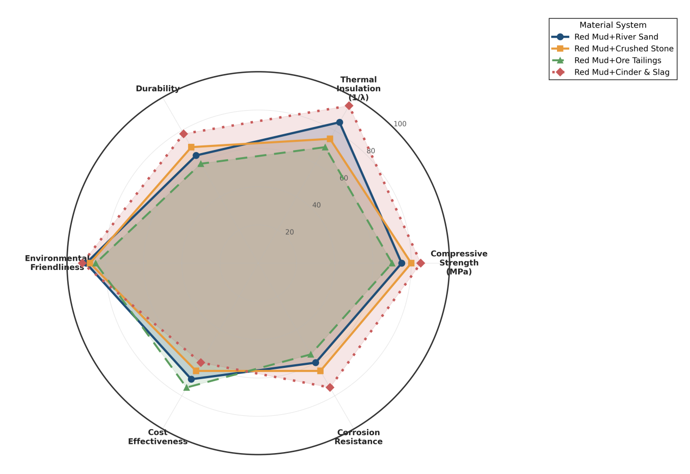
Fig. 3 Comprehensive Property Index Comparison of Different Material Systems

4. PERFORMANCE CONTROL AND MICROSTRUCTURAL MECHANISMS
4.1 Mechanical Property Control and Microstructural Mechanisms
4.1.1 Primary Influencing Factors and Patterns
Mechanical properties result from combined red mud incorporation, foaming agent dosage, aggregate combination, and curing conditions. Within 0-25% red mud incorporation, compressive strength gradually decreases; beyond 25%, strength significantly declines, reaching 22.1 MPa at 40%. Within 0.3-0.5% foaming agent, mechanics initially improve with porosity then decline; above 0.5%, marked decreases occur, declining to 27.5 MPa at 0.8%. Conventional aggregates significantly enhance mechanics while lightweight aggregates reduce them; composite combinations achieve optimization. Standard curing (20±2°C, ≥95% humidity) exceeds natural and steam curing; steam curing improves early strength but shows poor long-term development.
4.1.2 Mechanical Property Control Pathways and Mechanisms
Core control includes mix optimization, red mud modification, additive incorporation, and process control. Response-surface optimization yields 22% red mud, 52% cement, 0.31 water-binder, 26% sand with 33.1 MPa strength; mechanical-chemical modification permits 30% incorporation while maintaining 29.8 MPa (as shown in Table 1). Polypropylene fiber at 0.2% increases compression and tension by 8.7% and 15.3% respectively through fiber bridging that suppresses cracking; optimized preparation improves pore uniformity by 30% with corresponding 10.2% strength improvement. Combined application of these techniques enables efficient mechanical control.

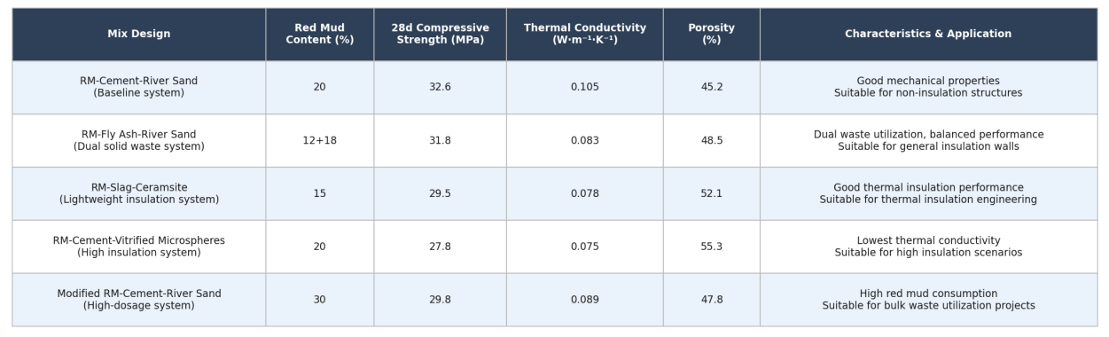
Table 1 Performance Summary and Comparison of Different Mix Design Systems
4.2 Thermal Insulation Property Control and Microstructural Mechanisms
Thermal conductivity, the core insulation metric, results from red mud incorporation, pore structure, and aggregate type influences. Within 0-25% incorporation, thermal conductivity decreases; beyond 25%, it increases, with minimum 0.082 W/(m·K) at 25%. This pattern reflects filling effects optimizing pore structure and closed-cell ratios at low levels, while high incorporation causes particle agglomeration and pore interconnection. Porosity 45-55%, closed-cell ratio ≥80%, and average pore diameter ≤100 μm achieve thermal conductivity ≤0.085 W/(m·K). Lightweight aggregates significantly reduce thermal conductivity; red mud-cement-glass microsphere systems show 18.6% lower thermal conductivity than red mud-cement-sand systems (as shown in Figure 4) due to glass microspheres' internal closed-pore structure and inherent low thermal conductivity.

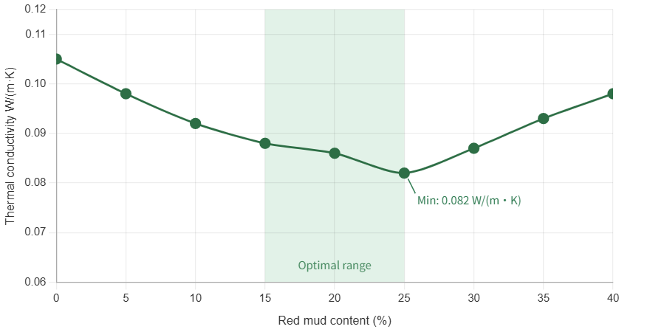
Fig. 4 Thermal Conductivity Comparison of Different Aggregate Systems

5. CONCLUSIONS AND FUTURE PERSPECTIVES
This comprehensive review demonstrates that the systematic incorporation of red mud as a supplementary cementitious material, combined with targeted modification strategies and optimized processing protocols, enables the development of high-performance foamed concrete with promising building insulation potential. Optimally designed formulations achieve 28-day compressive strengths in the range of 28.5–33.5 MPa alongside thermal conductivities of 0.075–0.086 W/(m·K), effectively reconciling the competing demands of structural integrity and thermal efficiency.
Despite these advances, several critical challenges remain. Future research efforts should prioritize the following directions:
(1) High-incorporation red mud systems. Advanced modification techniques, including mechanical activation, alkali treatment, and thermal pre-processing, should be explored to enable higher red mud substitution rates without compromising matrix performance.
(2) Long-term durability mechanisms. Multi-scale characterization approaches encompassing microstructural analysis, phase evolution tracking, and accelerated aging protocols are needed to elucidate durability degradation pathways over extended service lifetimes.
(3) Multicomponent synergistic principles. Quantitative structure–property relationships should be established to decode the complex interactions among red mud, supplementary binders, foaming agents, and admixtures, enabling rational mix design rather than empirical optimization.
(4) Engineering-scale design models. Predictive frameworks that integrate cost–performance trade-offs, production scalability, and regional variability in red mud composition are essential for translating laboratory findings into industrial practice.
(5) Full-scale validation and sustainability assessment. Pilot- and field-scale trials, complemented by life cycle assessment and techno-economic analysis, are required to rigorously quantify the environmental and economic benefits of red mud valorization in the construction sector.
Collectively, progress across these fronts will accelerate the transition of foamed red mud-based concrete from laboratory innovation to real-world deployment, simultaneously advancing industrial waste valorization and contributing meaningfully to the decarbonization of the built environment

Abbreviations
RM – Red mud
MK – Metakaolin
SP – Superplasticizer (water-reducing agent)
SEM – Scanning electron microscopy
XRF – X-ray fluorescence
C–S–H – Calcium–silicate–hydrate
D50 – Median particle size
SHP – Solid hydrogen peroxide (2Na₂CO₃·3H₂O₂)
OPC – Ordinary Portland cement
w/b – Water-to-binder ratio
BET – Brunauer–Emmett–Teller (specific surface area method)
C–A–H – Calcium–aluminate–hydrate
AFt – Ettringite (calcium sulfoaluminate hydrate, early-stage)
AFm – Monosulfoaluminate (calcium sulfoaluminate hydrate, late-stage)
GB/T – Guobiao/Tuijian (Chinese national recommended standard)

References
[1] Zhang Y, Li J, Wang H. Optimization of foaming agent and foaming process for foamed red mud-based concrete[J]. Construction and Building Materials, 2023, 368: 130456.
[2] Chen B, Liu M, Wang Q, Wang L, Guo Q, Zhou S. Analysis of industrial solid waste and the possibility of recycling and utilization[J]. Green Chemistry Letters and Reviews, 2025, 18(1): 2493155. https://doi.org/10.1080/17518253.2025.2493155.
[3] Liu X, Wu C, Lv W, Dong E, Fu S, Zhu J, Feng Y, Wang S, Chen Y, Liu K, Yu R. Stepping into the era of all-solid waste and low carbon: Phosphogypsum and other solid wastes cooperatively construct green buildings[J]. Construction and Building Materials, 2025, 486: 141926. https://doi.org/10.1016/j.conbuildmat.2025.141926.
[4] Abedin T, Pasupuleti J, Paw JKS, Tak YC, Islam MR, Basher MK, Nur-E-Alam M. From waste to worth: Advances in energy recovery technologies for solid waste management[J]. Clean Technologies and Environmental Policy, 2025. https://doi.org/10.1007/s10098-025-03204-x.
[5] Zou Q, Duan H, Yang Z, Wang X, Tian Y, Hou H, Yang J. Machine learning-assisted solid waste life-cycle management: Applications, constraints, and future opportunities[J]. Resources, Conservation and Recycling, 2025, 219: 108320. https://doi.org/10.1016/j.resconrec.2025.108320.
[6] Chen Y, Li A, Jiang S. Wettability and mechanical properties of red mud-Al composites[J]. Materials, 2024, 17(5): 1095. https://doi.org/10.3390/ma17051095.
[7] Zhang X, Liu Z, Wang F, Hu S. Staged characteristics of red mud dealkalization by CO₂ and SO₂[J]. Journal of Cleaner Production, 2023, 411: 137253. https://doi.org/10.1016/j.jclepro.2023.137253.
[8] Wang S, Jin H, Deng Y, Xiao Y. Comprehensive utilization status of red mud in China: A critical review[J]. Journal of Cleaner Production, 2021, 289: 125136. https://doi.org/10.1016/j.jclepro.2020.125136.
[9] Li X, Zhang T, Lv G, Wang K, Wang S. Summary of research progress on metallurgical utilization technology of red mud[J]. Minerals, 2023, 13(6): 737. https://doi.org/10.3390/min13060737.
[10] Danish A, Torres AS. Ash to asset: Evaluating the efficacy of reclaimed fly ash in geopolymer production[J]. Journal of Cleaner Production, 2025, 503: 145326. https://doi.org/10.1016/j.jclepro.2025.145326.
[11] Wu J, Qi F, Zhang J, Chen Z, Wang H, Liu Q. Modeling of effect of fly ash amount on microstructure and chloride diffusivity of blended fly ash-cement systems[J]. Construction and Building Materials, 2024, 443: 137711. https://doi.org/10.1016/j.conbuildmat.2024.137711.
[12] Yao Z, Wang Y, Shen J, Niu Y, Yang JF, Wei X. Synergistic CO₂ mineralization using coal fly ash and red mud as a composite system[J]. International Journal of Coal Science and Technology, 2024, 11(1): 37. https://doi.org/10.1007/s40789-024-00672-2.
[13] Li Y, Luo Y, Zhou H, Zhong X, Zhou Z, Li J, Hou H. Preparation of environmental-friendly cementitious material from red mud and waste glass sludge by mechanical activation[J]. Construction and Building Materials, 2024, 423: 135861. https://doi.org/10.1016/j.conbuildmat.2024.135861.
[14] Li Y, Min X, Ke Y, Chai L, Shi M, Tang C, Wang Q, Liang Y, Lei J, Liu D. Utilization of red mud and Pb/Zn smelter waste for the synthesis of a red mud-based cementitious material[J]. Journal of Hazardous Materials, 2018, 344: 343–349. https://doi.org/10.1016/j.jhazmat.2017.10.046.
[15] Singh V, Bano S, Chauhan VB, Pal P, Kumar A, Srivastava JB. Red mud as a sustainable road construction material: An experimental investigation[J]. Construction and Building Materials, 2024, 411: 134549. https://doi.org/10.1016/j.conbuildmat.2023.134549.
[16] Radko T, Wajda A, Iluk T, Najser J. Investigation on the correlation between mechanical strength, grain size, and density of fly ash microspheres in the context of refining process[J]. Materials, 2024, 17(14): 3459. https://doi.org/10.3390/ma17143459.
[17] Yamamoto T. Formulation optimization and proposal of assessed pozzolanic-activity index (API) method for rapid evaluation of pozzolanic activity of fly ash[J]. Construction and Building Materials, 2024, 432: 136394. https://doi.org/10.1016/j.conbuildmat.2024.136394.
[18] Liu J, Doh J, Ong DEL, Dinh HL, Podolsky Z, Zi G. Investigation on red mud and fly ash-based geopolymer: Quantification of reactive aluminosilicate and derivation of effective Si/Al molar ratio[J]. Journal of Building Engineering, 2023, 71: 106559. https://doi.org/10.1016/j.jobe.2023.106559.
[19] He J, Guo T, Li Z, Gao Y, Zhang J. Hydration mechanism of red mud-fly ash based geopolymer[J]. Materials Chemistry and Physics, 2024, 314: 128807. https://doi.org/10.1016/j.matchemphys.2023.128807.
[20] Zhao Y, Ding X, Zhou Y, Qian H, Deng X, Ran S. Influence of the foaming process on the pore structure and properties of fly ash-based foamed ceramics[J]. Ceramics International, 2025, 51(11): 14398–14407. https://doi.org/10.1016/j.ceramint.2025.01.276.
[21] Özcan M, Birol B, Dülger Kutlu Ö, Kaya F. Photocatalytic properties of ZnO nanoparticle coating on porous ceramic substrates with varying porosities produced from fly ash and red mud[J]. International Journal of Applied Ceramic Technology, 2024, 21(3): 1995–2009. https://doi.org/10.1111/ijac.14635.
[22] Mi H, Yi L, Wu Q, Xia J, Zhang B. Preparation of high-strength ceramsite from red mud, fly ash, and bentonite[J]. Ceramics International, 2021, 47(13): 18218–18229. https://doi.org/10.1016/j.ceramint.2021.03.141.
[23] Shi Y, Guo W, Jia Y, Xue C, Qiu Y, Zhao Q, Wang D. Preparation of non-sintered lightweight aggregate ceramsite based on red mud-carbide slag-fly ash: Strength and curing method optimization[J]. Journal of Cleaner Production, 2022, 372: 133788. https://doi.org/10.1016/j.jclepro.2022.133788.
[24] Wang C, Chen S, Wen B, Zhang Y, Wu K. Red mud modified fly ash based road base materials: Mix design, hydration mechanism, and heavy metal migration behavior[J]. Construction and Building Materials, 2025, 467: 140410. https://doi.org/10.1016/j.conbuildmat.2025.140410.
[25] Soğancı AS, Yenginar Y, Özkan İ, Güzel Y, Özdemir A. Waste management of red mud and fly ash to utilize in road subgrade material[J]. Sustainability, 2024, 16(7): 2987. https://doi.org/10.3390/su16072987.
[26] Wu C, Zhan B, Tang W, Kou S. Synergistic reuse of red mud and circulating fluidised bed fly ash in self-compacting recycled concrete[J]. Construction and Building Materials, 2025, 489: 140533. https://doi.org/10.1016/j.conbuildmat.2025.140533.
[27] Palaniappan SM, Govindasamy V, Jabar AB. Experimental investigation on flexural performance of functionally graded concrete beams using fly ash and red mud[J]. Matéria (Rio de Janeiro), 2021, 26(1): e12913. https://doi.org/10.1590/S1517-707620210001.1213.
[28] Kim SY, Jun Y, Jeon D, Oh JE. Synthesis of structural binder for red brick production based on red mud and fly ash activated using Ca(OH)₂ and Na₂CO₃[J]. Construction and Building Materials, 2017, 147: 101–116. https://doi.org/10.1016/j.conbuildmat.2017.04.171.
[29] Xu Y, Yang B, Liu X, Gao S, Li D, Mukiza E, Li H. Investigation of the medium calcium based non-burnt brick made by red mud and fly ash: Durability and hydration characteristics[J]. International Journal of Minerals, Metallurgy and Materials, 2019, 26(8): 983–991. https://doi.org/10.1007/s12613-019-1814-9.
[30] Qi X, Bao Y, Wang W, Zhang S, Wu Y, Jia Z, Guo S. Superior performance foamed concrete fabricated with amphiphilic and hydrophilic particles stabilized ultra-stable foam[J]. Cement and Concrete Composites, 2024, 152: 105613. https://doi.org/10.1016/j.cemconcomp.2024.105613

