Multifaceted Influences of Osmolytes on Heat Stress Tolerance Mechanism of Plants Under Changing Climate

Abstract
The climate is becoming more stressful and is causing extreme heat stress events which are challenging to the productivity of agricultural activities and survival of plants across the world. Osmolytes which are organic and inorganic compatible solutes are the important biochemical adaptations by which plants can endure high temperatures. The mechanism of action of these molecules is a combination of inter-linked processes such as osmotic adjustment, protein stabilization, membrane protection, and reactive oxygen species scavenging. Large volume osmolytes (proline, glycine betaine, trehalose, mannitol and polyamines) are concentrated significantly during heat stress, ensuring cellular homeostasis and metabolic life support. There is highly developed research on the topic that has shown that osmolyte biosynthesis is controlled by multifaceted signaling pathways that comprise transcriptional factors, kinases, and epigenetic alterations. Osmolytes when exogenously applied have proven to have impressive potential in improving thermotolerance in various crop species. This is a full-scale review of the current knowledge regarding osmolyte-mediated heating stress alleviation, considering the molecular pathways, metabolism, genetic control as well as biotechnological use. We, moreover, examine the new developments in osmolyte deposition engineering by use of transgenic methods and molecular breeding. Knowledge of such complex protective functions helps in generating climate resistant cultivars that can be sustained to produce under rising temperatures of thermal stress.
Keywords: Heat Stress; Osmolytes; Proline; Climate Adaptation; Thermotolerance; Reactive Oxygen Species; Genetic Engineering

Introduction
Global climate change represents one of the most pressing challenges confronting agricultural sustainability and 21st century food security. The Intergovernmental panel on climate change estimates a rise in temperatures of 1.5-4.5 o C by 2100 and that the frequency and intensity of heat waves is becoming more common in the agricultural lowlands. Heat stress, which is the temperatures that are higher than the optimal temperatures regarding the growth of plants, has dire effects on physiological processes as well as the crop yields and poses a threat to biodiversity. In India, agriculture supports more than 60% of the population and the escalating temperatures have already led to a decline of 10-40% in the yield of the main crops, such as wheat, rice, and pulses, and the development of climate-tolerant varieties is a burning need. Among the most important adaptive strategies that plants use to resist the adverse impact of elevated temperatures, there is the formation and storage of a range of compatible organic solutes, also referred to as osmolytes (Jayara et al., 2023; “Plant Stress Physiology,” 2020). Such molecules as proline, glycine betaine, and trehalose play major roles in protecting the cell integrity and metabolic processes in thermal stress via osmoregulation, antioxidant defense, and macromolecular stabilization (Bhardwaj et al., 2023; Saeed et al., 2023; Tiwari, 2024). In this review, the complex roles of these osmolytes are discussed, their biosynthesis, regulation, and action mechanisms of thermotolerance are studied (Ayan et al., 2023; Chaudhary et al., 2022). They reduce the effects of stress because of their low molecular weight, great solubility, and non-toxicity at high concentrations, allowing them to maintain osmotic balance, detoxify reactive oxygen species, and preserve the integrity of the membranes and proteins (Ahmed et al., 2017; “Plant Signaling Molecules,” 2019).
Sessile organisms, Plants, have developed complex biochemical and molecular adaptation strategies to sense, respond and adapt to thermal stress. The osmolytes accumulation is one of such adaptive mechanisms that proves to be a fundamental and evolutionarily conserved response. Osmolytes are organic molecules of low molecular weight and are high solubility compounds that do not disrupt the normal metabolic processes in the cells. These compatible solutes comprise a variety of chemical groups such as; amino acids (proline, glycine betaine), sugars (trehalose, sucrose), polyols (mannitol, sorbitol), and polyamines (putrescine, spermidine, spermine). They are multifunctional protective factors that have not only osmotic regulation functions, but also macromolecular stabilization, antioxidant activity, and signaling functions. In particular, these thermoprotective metabolites, i.e., some amino acids, e.g., tyrosine, valine, tryptophan, and glutamine, and quaternary ammonium compounds, sugars, and polyols are essential in osmotic adjustment to preserve turgor pressure in the course of heat-accelerated evaporation and stabilize macromolecules (Dutta et al., 2019; Guihur et al., 2022). The most important osmolytes, including proline, glycine betaine, and soluble carbohydrates, play a significant role in balancing the water in cells, stabilizing the cell membranes, and pH buffering cellular redox problems in extreme temperatures (Awasthi et al., 2015; Chavez-Arias et al., 2021). Moreover, these compounds are chemical chaperones, which inhibit the denaturation of proteins and aid in the correct protein folding in the heat-stressed conditions at room temperature, which is essential to preserve the enzymatic activity and the work of cells (Singh et al., 2017).
Recently, molecular studies have transformed the field of osmolyte biosynthesis since there are complex regulatory pathways that coordinate the synthesis of osmolytes during stresses. DREB2A, HSFs, and the ABF family transcription factors coordinate the expression of the biosynthetic genes whereas a fine-tuning of the enzymatic activity of the gene occurs through post-translational changes. The discovery of quantitative trait loci, which are related to osmolyte build-up, has made it possible to use marker-assisted selection to achieve improved thermotolerance. More so, biotechnological solutions such as transgenic expression of biosynthetic genes and CRISPR-based genome editing have some potential to increase osmolyte levels in crops of economic value. This has been a critical review of osmolyte-mediated heat stress tolerance and it is a compilation of physiological, biochemical, molecular and biotechnological interpretations of the phenomenon with an aim of furthering the understanding of climate-resistant agricultural systems. Due to their essential functionality in reducing abiotic stress, it is the key that the exact mechanisms of osmoprotectant action of proline, glycine betaine, and other sugars and sugar alcohols be understood in terms of their contribution to cell stability and osmoprotection (Ben-Laouane et al., 2026; Lamaoui et al., 2018; Zulfiqar et al., 2019). An example is proline that is an osmoprotectant and antioxidant that stabilize cell integrity in the face of heat stress (Shrestha, 2025). Proline, glycine betaine accumulation, and soluble sugars are needed in particular amounts to balance osmotic activities, cell water balance, membrane stability, and redox potential buffer of the cellular activities under extreme temperatures (Bita & Gerats, 2013). In addition to their osmotic functions, the compounds are associated with reactive oxygen species scavenging, and thus they mitigate oxidative damage that occurs during thermal stress (Kishor et al., 2022). As an example, proline accumulation is able to counteract cellular redox modifications and stabilize subcellular structures during heat stress, whilst glycine betaine can enhance the capacity to endure drought and salt stress as it accumulates (Muhammad et al., 2025; Zhao et al., 2018).
Biochemical Nature And Classification Of Osmolytes

Amino Acid-Derived Osmolytes
Proline is the best studied amino acid osmolyte that rises to more than 80 percent of total free amino acid pool during extreme heat stress (Ref??). The properties of this imino acid are unusual as the pyrrolidine ring of the molecule gives it exceptional hydration effects and protein stabilizing properties. There is biosynthesis by the glutamate pathway to 5-carboxylate of 1,5-pyrroline which is reduced by Δ¹-pyrroline-5-carboxylate synthetase (P5CS), then reduced by P5C reductase (P5CR), and is degraded by proline dehydrogenase (ProDH). Glycine betaine is a quaternary ammonium compound, which is a strong osmoprotectant in thermotolerant plants such as Spinacia oleracea and Beta vulgaris. It was synthesized in response to choline by oxidation by choline monooxygenase and betaine aldehyde dehydrogenase encoded by the CMO and BADH gene respectively. The two osmolytes are helpful in reducing cell damage by neutralizing hydroxyl radicals, osmotic balance, and protein and membrane stability (Hussain et al., 2021; Kalisz et al., 2024).
Sugar-Based Osmolytes and Polyols
Trehalose is a non-reducing disaccharide composed of 2 glucose molecules and connected 1,1-glycosidically, and 1,1,1-glycosidically, and angle of resistance at high temperatures is remarkable. This sugar is synthesized through trehalose-6-phosphate synthase (TPS) and trehalose-6-phosphate phosphatase (TPP), and is used both in the storage of carbon and the protection of stress. Sugar alcohols such as mannitol, sorbitol, and myo-inositol are useful compatible solutes especially in plant families that have a high ability to endure stress. Mannitol build up which is catalyzed by mannitol-1-phosphate dehydrogenase is up to 20-30 percentage dry weight in species such as Apium graveolens. The transport sugar sucrose concentrates in thermotolerant genotypes in large amounts stabilizing membranes by direct interplay with phospholipid headgroups. These sugars and polyols shield the enzymes and the cellular structures against denaturation and aggregation, which essentially preserve the functioning of cells in the presence of thermal stress (Massange-Sanchez et al., 2021; Salgado-Aguilar et al., 2020). In addition to these well-characterized osmolytes, there are other compatible solutes like 2-alanine betaine and pipecolate betaine, which also promote osmotic adjustment and cell protection to different forms of abiotic stresses in a variety of plant species (Gandra et al., 2019).
Polyamines and Polyamines Conjugates
Polyamines are polycationic aliphatic amines in which the most common forms of polyamines found in higher plants are putrescine (diamine), spermidine (triamine) and spermine (tetraamine). The start of biosynthesis is arginine or ornithine with the help of the arginine decarboxylase (ADC), ornithine decarboxylase (ODC), S-adenosylmethionine decarboxylase (SAMDC), and aminopropyltransferases. These anionic charges attach to negatively charged cellular components such as nucleic acids, proteins, and phospholipids in an electrostatic manner and in doing so stabilize macromolecular structures in the presence of thermal stress. In Oryza sativa, the heat-stressed plant shows the effects of 3-5 fold rise in spermidine and spermine, which is associated with improvement of membrane integrity and decreased electrolyte leakage. Moreover, these polyamines control various physiological functions, such as cell division, differentiation and senescence, which lead to the overall plant resilience to thermal stressors (Marothia et al., 2020). The identification of the multi-interaction of these polyamines with other stress-responsive pathways including pathways of trehalose and its corresponding trehalose-6-phosphate demonstrates a complex regulatory network in terms of enhancing thermotolerance (Liu et al., 2013).
Table 1: Major Osmolyte Classes and Their Chemical Characteristics
Osmolyte Class | Representative Compounds | Molecular Weight (Da) | Solubility | Primary Function | Key Biosynthetic Enzyme
Amino Acids | Proline, Glycine Betaine | 115-117 | Highly Soluble | Protein Stabilization | P5CS, CMO
Disaccharides | Trehalose, Sucrose | 342 | Highly Soluble | Membrane Protection | TPS, SPS
Sugar Alcohols | Mannitol, Sorbitol | 182 | Moderately Soluble | Osmotic Adjustment | M1PDH, SDH
Polyamines | Putrescine, Spermidine | 88-145 | Soluble | Nucleic Acid Protection | ADC, SAMDC
Tertiary Sulfonium | Dimethylsulfoniopropionate | 134 | Highly Soluble | ROS Scavenging | DMSP Synthase
Quaternary Ammonium | β-alanine Betaine | 131 | Highly Soluble | Ionic Balance | BADH

Physiological Mechanisms Of Osmolyte-Mediated Thermotolerance

Osmotic Adjustment And Water Relations
The heat stress causes water deficit by increasing transpiration and decreasing water uptake and this demands osmotic adjustment to maintain cell hydration. Osmolytes bring cytoplasmic osmotic potential to 0.2-0.8 MPa, which helps preserve water and avoids the metabolism of dehydration and its consequences. Such osmotic adjustment mechanism is especially important to turgor pressure which is critical in cell expansion, stomatal regulation and photosynthetic efficiency. Experiments on heat stressed Triticum aestivum have shown that proline build up is associated with the maintenance of relative water content higher than 75 percent, which is higher than the 55 percent relative water content of sensitive genotypes. Osmolytes also aid in loading xylem and efficiency in phloem transport which ensures sustained long range distribution of water and nutrients in the face of thermal stresses. The high concentration of polyamines, including putrescine, spermidine, and spermine, are especially important to the active growth and cellular processes in thermopriming and recovery processes, and the practical importance of their depletion in non-primed plants is significant to their protective activity of heat shock-induced damage (Serrano et al., 2019). Moreover, polyamines are used as direct protective factors and signaling molecules, which launch adaptive responses that scavenge reactive oxygen species and stabilize biological membranes (Jing et al., 2020; Pinto et al., 2015).
Stabilization and Chaperone activity of protein
High temperatures destabilize protein tertiary and quaternary structures causing aggregation and loss of enzymatic activity. This denaturation is counteracted by osmolytes which preferentially excluded the protein surfaces thereby thermodynamically favouring the native folded form. Proline shows remarkable protein-stabilizing ability and elevates midpoint denaturation temperature (Tm) of lactate dehydrogenase by 8-12o C during physiological concentration. Glycine betaine also shields Rubisco against heat damage to maintain photosynthetic carbon fixation during a heat stress. Spectroscopic analysis has shown that osmolytes preserve α-helical structure and do not allow the aggregation of β-sheets in heat sensitive proteins. In addition, the molecules combine synergistically with heat shock proteins (HSPs), increasing the chaperone-mediated refolding and decreasing protein carbonylation marks. In addition to direct chaperoning effects, some osmolytes such as proline also demonstrate free-radical scavenging properties and alleviate the oxidative damages caused by heat stress (Bokszczanin and Fragkostefanakis, 2013). This shielding effect is also multi-faceted, as osmolytes add stability to lipid bi-layers against the thermally-induced phase transitions and are more thermostable (Bhantana, 2021).
Membrane Integrity and Lipid Protection
At high temperatures, plasma and organellar membranes change their liquid-crystalline and gel phases, which diminishes the selective permeability and leads to ion leakage. Trehalose and glycine betaine in between headgroups of phospholipids, keeping the membranes fluidic and avoiding fusion. Lipidomic studies indicate that plants subjected to osmolytic conditions have less malondialdehyde, which indicates that osmolytic plants have reduced lipid peroxidation. Thylakoid membranes have been shown to be stabilized in chloroplasts by osmolytes, which maintain the photosystem II efficiency and electron transport chain activity. The protection allows the preservation of optimal membrane lipid composition, especially unsaturation indices essential when it comes to temperature adaptation. This is important stabilization since the osmolytes can stabilize the plant enzymes against stress-induced denaturation and can also serve as hydrotropes, binding with the proteins associated with the plasma membrane to preserve their structural and biochemical functionality (Jahed et al., 2023; Rajasheker et al., 2019). This essential part in maintaining membrane architecture is exchanged into enhanced cellular compartmentalization and controlled transmembrane transport during conditions of thermic stress. The importance of osmolytes in mitigating the damage caused by heat by maintaining cellular infrastructure is emphasized by such mechanisms (Jabeen and Jabeen, 2022).
Reactive Oxygen Species Scavenging
Heat stress increases the excessive production of reactive oxygen species (ROS) by impaired electron transport in chloroplasts and mitochondria leading to oxidative stress of lipids, proteins and nucleic acids. Osmolytes have both a direct and indirect antioxidant effect, singlet oxygen (¹O2) hydroxyl radicals (•OH), and superoxide anions (O2 -). Proline is redox cycled between reduced and oxidized forms to produce NADP+ to antioxidant enzyme systems. Polyamines occupy transition metal ions inhibiting Fenton reaction and formation of hydroxyl radical. Transcriptomic analysis demonstrates that osmolyte build-up activates antioxidant genes such as SOD, CAT, APX, and GR creating all-inclusive oxidative stress protection. Such teamwork highlights the importance of their action in alleviating any form of cellular damage through the detoxification of noxious reactive oxygen species (Sharma et al., 2019; Singh et al., 2015). In addition to enzymatic upregulation, osmolyte, such as proline, glycine betaine, and trehalose, has a direct effect as a scavenging agent of reactive oxygen species and osmotic homeostasis in promoting heat tolerance (Onaga and Wydra, 2016; Zhang et al., 2023).
Table 2: Protective Mechanisms of Osmolytes Under Heat Stress
Protective Mechanism | Osmolyte Involved | Molecular Target | Concentration Range | Protective Efficacy | Reference Plant
Osmotic Adjustment | Proline, Glycine Betaine | Cytoplasm | 20-100 mM | High (ΔΨ = -0.5 MPa) | Triticum aestivum
Protein Stabilization | Trehalose, Proline | Enzymes, Structural Proteins | 50-200 mM | Very High (ΔTm = 10°C) | Arabidopsis thaliana
Membrane Protection | Glycine Betaine, Sugars | Phospholipid Bilayers | 10-80 mM | High (50% MDA Reduction) | Oryza sativa
ROS Scavenging | Proline, Polyamines | Chloroplasts, Mitochondria | 15-60 mM | Moderate to High | Lycopersicon esculentum
DNA/RNA Stabilization | Polyamines | Nuclear and Plastid Genomes | 5-30 mM | Moderate | Zea mays
Photosystem Protection | Trehalose, Mannitol | PSII Complex | 30-100 mM | High (Fv/Fm > 0.75) | Glycine max
Signal Transduction | Trehalose-6-P | SnRK1 Pathway | 0.1-1 mM | Regulatory Function | Nicotiana tabacum

Molecular Regulation Of Osmolyte Biosynthesis

Transcriptional Regulation Networks
The genes of osmolyte biosynthesis are regulated with the help of multifamily transcriptional networks related to multiple families of transcription factors. Heat shock factors (HSFs) especially HsfA2 and HsfA7, interact with heat shock elements (HSEs) in promoter sequences of P5CS and BADH genes, which stimulates transcriptional response to heat shock. DREB proteins, which are dehydration-responsive proteins and most significantly DREB2A, bind to the DRE/CRT cis-elements, which triggers various osmolyte biosynthetic cascades in a co-ordinated manner. The hormone signaling is connected to osmolyte accumulation through the mediation of abscisic acid-regulated regulation by ABFs. High-resolution ChIP-seq studies have revealed more than 200 direct target genes of HsfA1 in Arabidopsis including important trehalose and polyamine enzymes (Ref??). The complex regulatory systems provide a synchronized and healthy response to osmolytes and maximize plant tolerance to various thermal stresses. In addition to the transcription factors, microRNAs (miRNAs) are important post-transcriptional regulators by binding mRNAs that encode important enzymes and regulatory proteins in the production of the osmolytes and fine tuning their expression during heat stress (Samat et al., 2025). Moreover, these transcriptional and post-transcriptional mechanisms work together and allow plants to dynamically regulate the level of osmolytes to provide an effective stress response in the stress of high temperature (Pei et al., 2021; Saeed et al., 2023).

Post-Transcriptional and Post-Translational Modifications
The stability of RNA and efficiency of translation play a crucial role in the level of enzyme as a biosynthetic osmolyte. The heat-responsive miRNAs such as miR398 and miR156 regulate degradation of stress-related transcripts of mRNAs. Different isoforms of P5CS in terms of catalytic properties and subcellular localization are produced through alternative splicing. Enzyme activity and stability is regulated by post-translational modifications such as phosphorylation, ubiquitination and SUMOylation. P5CS is phosphorylated at serine residues by calcium-dependent protein kinases (CDPKs) and its catalytic efficiency is increased 3-4 fold. ProDH is ubiquitinated and degraded by Ubiquitin ligases into 26S proteasomes in response to heat stress to inhibit proline metabolism and preserve high cytoplasmic levels. On the other hand, the SUMOylation of DREB2A and HSFA1 that are essential in heat shock response regulates their transcriptional activity, enhancing the osmolyte biosynthesis machinery further (Wang et al., 2024). Along with these complex regulatory responses, the DREB2C transcription factor was also discovered as one of the key activators of HsfA3, which implies a greater level of interconnectedness of the heat regulation pathways (Sajid et al., 2018).
Epigenetic Control and Intergenerational Memory
The available emerging evidence reveals the epigenetic process in heat stress memory and priming responses. The DNA methylation level of P5CS promoters reduces after exposure to heat, which supports a higher transcriptional responsiveness in further stress attacks. Deposits of histone modifications such as H3K4me3 and H3K9ac at osmolyte biosynthetic loci help to keep the chromatin accessible. Transgenerational inheritance of heat-primed Arabidopsis plants with increased thermotolerance is associated with stable epigenetic modification of TPS and SAMDC genes. Long non-coding RNAs mediate chromatin remodelling complexes that refine temporal dynamics of expression of osmolyte genes in the course of acclimation. It is an epigenetic plasticity, which entails alteration, including the retrotransposon activation that enables an advanced, heritable memory of the past heat stresses and streamlines plant acclimatization to thermal conditions in the future (Zuo et al., 2021). As an example, long-term stress resistance may be acquired because of changes in DNA methylation at particular loci, which results in chronic changes in gene expression (Luqman et al., 2025; Staacke et al., 2025).
Table 3: Key Regulatory Genes in Osmolyte Biosynthesis
Gene | Encoded Protein | Osmolyte Pathway | Regulation Type | Key Transcription Factor | Plant Model
P5CS1/P5CS2 | Pyrroline-5-Carboxylate Synthetase | Proline | Transcriptional | DREB2A, ABF3 | Arabidopsis thaliana
ProDH | Proline Dehydrogenase | Proline Degradation | Post-translational | HsfA1, E3 Ligase | Oryza sativa
BADH | Betaine Aldehyde Dehydrogenase | Glycine Betaine | Transcriptional | HsfA2, AREB1 | Beta vulgaris
TPS1 | Trehalose-6-P Synthase | Trehalose | Both | HsfA7, SnRK1 | Zea mays
TPP | Trehalose-6-P Phosphatase | Trehalose | Transcriptional | DREB1A | Solanum lycopersicum
ADC1/ADC2 | Arginine Decarboxylase | Polyamines | Transcriptional/Feedback | MYC2, WRKY40 | Nicotiana tabacum
SAMDC | S-Adenosylmethionine Decarboxylase | Polyamines | Post-transcriptional | miR156, NF-YA | Glycine max
M1PDH | Mannitol-1-P Dehydrogenase | Mannitol | Transcriptional | CBF3, ZAT12 | Apium graveolens

Crop-Specific Osmolyte Responses And Thermotolerance

Cereals: Wheat, Rice, And Maize
Heat stress at anthesis in the Triticum aestivum breed results in disastrous losses in yield because of sterile pollen and faster grain filling. The thermotolerant lines are able to produce higher levels of proline in the anthers, 4-8 times greater, and pollen lasts longer than pollen in sensitive lines (40 C surpassing 60 C). Indian wheat lines such as HD 2967, PBW 343 are constitutively higher in P5CS expression and have high biosynthetic capacity of proline. Osmolytes in rice (Oryza sativa) appears to have genotypic variation with indica types accumulating more proline and japonica exhibiting more trehalose. high temperature treatment at booting stage causes 12-fold increment in spikelet trehalose, which is corresponding with 25% yield maintenance (Ref??). Heat stress of maize (Zea mays) during grain filling demonstrates a significant increase in polyamine levels in endosperm, maintains the starch biosynthetic enzyme activity, and grain weight. As an example, exogenous spermidine treatment of rice at the grain filling phases has been discovered to increase the percentage of germination and gain quality after heat stress (Khan et al., 2022). Along with these direct effects, the synthesis of polyamines is controlled by numerous genes, such as ADC1/ADC2 and SAMDC, which is also under the control of different transcription factors and miRNAs (Singh et al., 2022).
Legumes and Pulses
Chickpea (Cicer arietinum), which is one of the important pulse crops in India, is affected by harsh heat stress when it is exposed to terminal drought-heat interaction. Coordinated accumulation of proline and trehalose in heat-tolerant lines allows them to retain pod set at temperatures above 35 o C (Ref??). Nodule-specific osmolytes have been shown in soybean (Glycine max),when glycine betaine can prevent thermal deactivation of nitrogenase and save symbiotic fixation of nitrogen. Cowpea (Vigna unguiculata) is a heat-tolerant species, which constitutively retains high baseline osmolyte levels, thereby allowing it to warmly adapt to temperature changes typical of tropical agriculture. On the contrary, cool-season legumes, including lentils and peas, are extremely sensitive to heat stress at the reproductive phase, which causes them to lose their yields significantly because of flower abortion and low pollen viability (Advances in Plant Defense Mechanisms, 2022). This weakness of the cool-season legumes highlights the need to develop heat-tolerant varieties of legumes using genetic introgression of thermotolerance characteristics, as is the case with warm-season pulses (Basu et al., 2022; Chaudhary et al., 2020).
Crops, Horticultural and Vegetable
Heat stress has been shown to decrease the quality of tomato (Solanum lycopersicum) fruits by inhibiting the biosynthesis of lycopene and stepping up softening. The exogenous application of proline at the concentration of 10 mM increases the firmness of fruits and shelf life by 40 percent as stored at high temperature. Tuberization of potato (Solanum tuberosum) is highly temperature sensitive and heat stress over 29 C inhibits the stolon swelling. Mannitol is built up in stolons of the heat-adapted cultivars to retain cell division and tuber initiation in marginal conditions. Leafy vegetables such as Spinacia oleracea naturally produce glycine betaine giving them natural thermotolerance and maintenance of nutritional value under heat pressure. The exogenous application of polyamines, namely the use of spermidine, has been demonstrated to enhance heat resistance in tomatoes by raising the chlorophyll fluorescence properties and Ca2+ levels and alleviating the negative impact of stress (HanumanthaRao et al., 2016; Najafi et al., 2025). This observation is consistent with the results in the case of chickpea and mungbean where exogenous application of proline and ascorbic acid has been found to provide protection against oxidative damage and activate antioxidant-defensive mechanisms, thus enhancing growth under heat stress conditions (Lamotte & Jeandroz, 2017). The exact actions of these exogenous applications in alleviating stress frequently entail some complicated signaling pathway regulating the generation of endogenous osmoprotectants and antioxidant enzymes (Pandey and Singh, 2024). This complex interaction underscores how exogenous interventions might be applied to enhance resistance of plants to thermal stress, especially of crops that are highly sensitive to supraoptimal temperatures (Angon et al., 2024; Carmody et al., 2020). Both high and low temperatures have considerable negative effects on plant development at any of the growth stages, causing a significant decline in productivity (Bhandari et al., 2017).
Table 4: Osmolyte Accumulation Patterns in Major Crops
Crop Species | Primary Osmolyte | Concentration (μmol/g FW) | Critical Growth Stage | Yield Impact | Tolerance Threshold
Triticum aestivum | Proline | 45-180 | Anthesis | 25-40% Protection | 38-40°C
Oryza sativa | Trehalose, Proline | 30-120 | Booting-Flowering | 15-30% Protection | 35-38°C
Zea mays | Polyamines | 25-95 | Grain Filling | 20-35% Protection | 38-42°C
Cicer arietinum | Proline, Trehalose | 60-200 | Pod Development | 30-45% Protection | 35-37°C
Glycine max | Glycine Betaine | 15-70 | Flowering-Pod Fill | 18-28% Protection | 36-39°C
Solanum lycopersicum | Proline, Mannitol | 40-160 | Fruit Set | 25-40% Protection | 32-35°C
Gossypium hirsutum | Glycine Betaine | 35-140 | Boll Development | 20-35% Protection | 38-42°C

Biotechnological Interventions For Enhanced Osmolyte Accumulation

Transgenic Approaches And Gene Pyramiding
Genetic engineering strategies have successfully enhanced osmolyte biosynthetic capacity across diverse crop species. Vigna aconitifolia P5CS overexpression in tobacco results in 10-15 fold P5CS increase, making tobacco survive 6 hours at 48 o C. The transfer of BADH genes of glycine betaine-accumulating species to non-accumulators such as rice and tomato promotes the level of thermotolerance. Combining several biosynthetic genes is synergistic; when Arabidopsis is co-expressing P5CS, TPS1, and SAMDC, the thermotolerance is better than in single-gene expressors (Ref?). The organellar protection is assured through chloroplast-targeted expression, which is important in retaining photosynthetic ability. Moreover, new biotechnological methods include CRISPR-Cas9-mediated gene editing, which provides accurate control of endogenous osmolyte pathways, which allows them to be finely-tuned to accumulation without insertion of foreign DNA sequences.
CRISPR-Cas9 mediated Genome Editing
Refined methods of osmolyte pathways control with no foreign DNA loading are provided by precision genome editing. ProDH knockout in rice using CRISPR removes proline catabolism, which keeps the levels of proline constitutively high and enhances heat tolerance. Base editing technology has allowed point mutation of promoter regions, which enrich the sensitivity of transcription factors and can strengthen the expression of biosynthetic genes. CRISPRa systems have dCas9-VP64 fusions which enhance endogenous TPS expression 5-8 fold without affecting coding sequences (Ref?). Multiplexed editing concurrently activates many pathway genes; inactivation of negative regulators in triple increments the accumulation of osmolytes in the absence of the pleiotropic growth penalties of constitutive overexpression. The high-tech genomic methods enable the development of osmoprotectant production to be modulated, and this approach provides a developed way that can increase the stress resistance of plants to abiotic environments, such as drought and salinity (Rontein et al., 2002; Wani et al., 2013).
Marker-Assisted selection and Genomic Selection
The association between the accumulation of osmolytes and quantitative trait loci (QTLs) can be used to breed thermotolerant animals by using markers. The proline accumulation major QTLs have been mapped on the wheat chromosomes 2B, 5A, and 7A which have explained 35-60 percent phenotypic difference. P5CS promoter single nucleotide polymorphisms are associated with the level of expression that is induced by stress, which is used as a functional marker of selection. Thermotolerance prediction by genomic selection models that use genome-wide markers has a prediction accuracy of 70-85 and breeding times are reduced. Screening of large groups of individuals can be done quickly by integrating high-throughput phenotyping platforms that can measure the leaf osmolyte content through the use of a near-infrared spectroscopy. However, the methods of breeding these molecules are usually associated with the problems of high costs, technicalities, and ethical issues that restrict their widespread use by farmers (Khan and Zulfiqar, 2023).

Exogenous Application and Priming Strategy
One practice of agronomic intervention against heat stress as a practical intervention is the application of osmolytes to the foliars or roots. Application of proline at the critical growth stage of 10-50 mM can improve the yield by 15-35% in the presence of heat stress in various crops. Glycine betaine sprays enhance stability of the membrane and photosynthetic activity with the optimum concentration of 25-100 mM depending on the species (Ref?). Nano-encapsulation of cellular uptake and the release of osmolytes in liposomal formulations or chitosan enhances prolonged release and cellular uptake. Polyamine seed priming causes a memory form of stress that leads to the development of elevated thermotolerance during later vegetative and reproductive phases. Enhanced efficacy with combination treatments Synergistic effects demonstrated by combination of proline plus trehalose mixtures which are better in protecting against single compounds. Moreover, indirectly, exogenous treatment with signaling molecules like salicylic acid, abscisic acid, and nitric oxide may induce stress-responsive gene expression and improve antioxidant functions, which, in turn, will increase osmoprotection and general thermotolerance (Alotaibi, 2023; Hemantaranjan, 2014).
Table 5: Transgenic Strategies for Osmolyte Enhancement
Strategy | Target Gene | Host Plant | Osmolyte Increase | Thermotolerance Gain | Commercial Status
Overexpression | P5CS (Vigna) | Oryza sativa | 12-18 Fold | High (42°C Tolerance) | Field Trials
Overexpression | BADH (Spinach) | Solanum lycopersicum | 8-15 Fold | Moderate to High | Greenhouse Tests
Gene Stacking | P5CS + TPS1 | Arabidopsis thaliana | 15-25 Fold | Very High (45°C) | Research Stage
CRISPR Knockout | ProDH | Oryza sativa | Constitutive 6-Fold | High | Regulatory Review
CRISPRa Activation | TPS Endogenous | Zea mays | 5-8 Fold | Moderate | Research Stage
Base Editing | P5CS Promoter | Triticum aestivum | 3-5 Fold | Moderate | Development
RNAi Suppression | ProDH + P5CDH | Nicotiana tabacum | 10-14 Fold | High | Proof of Concept

Osmolytes In The Context Of Climate Change Adaptation

Projected Climate Scenarios And Agricultural Impacts
The climate models indicate that mean temperatures in South Asia would rise by 2-4.5 o C in 2070-2100, doubling the frequency and raising the intensity of heat waves by 3-5 C. Kharif and rabi crops will be highly affected as Indian agricultural areas will record 15-25 days more a year of 40 o C temperatures. Stress situations that are compound and entail drought and heat will increase in frequency and require the crops that possess inherent stress resistance mechanisms. In the Indo-Gangetic plains, the yield of wheat is at risk of 20-50% decline unless measures are implemented to adapt to it. There will be an increase in susceptibility to rice production in the eastern and coastal areas during flowering stages. Variability in yield as a result of climate change poses a threat to food security of more than 600 million individuals who rely on Indian agriculture.
Climate Resilience Strategies based on Osmolytes
Osmolyte enhancement has provided a feasible climate adaptive route through integration in crop improvement programs. Indian agricultural research institutes are using osmolyte QTLs to introduce into elite germplasm using the marker-assisted backcrossing technique in breeding programs. The creation of climatic-ready types with the combination of high osmolyte concentration with other thermotolerance characteristics (membrane thermostability, efficient antioxidant systems) is the ultimate protection. Participatory varietal selection where farmers in heat prone areas are involved makes sure that adapted cultivars are adopted. The methods of precision farming based on the remote sensing to predict the situations of heat stresses will allow the application of exogenous osmolytes in a timely manner, which maximizes the efficiency of resource utilization. Moreover, editing technologies, such as CRISPR-Cas9, can selectively regulate genes that are a part of osmolyte biosynthesis and regulation, which will help to create crops specifically with improved intrinsic osmoprotection (KhokharVoytas et al., 2023; Pagnotta, 2025).
Interaction with the Other Adaptation Strategies
The increase in osmolysis is synergetic with agronomic practices of climate adaptations. The methods of conservation agriculture such as soil residue retention, lower the surface temperature of soils by 4-6 o C, and lowers the severity of heat stress and cushions cellular processes with osmolytes. Peak heat periods combined with thermotolerant varieties and altered sowing to avoid the heat are maximized. The intercropping systems generate microclimate amelioration and production risk diversity. The timing of deficit irrigation is synchronized with the important periods of accumulation of osmolytes that optimise the use of water and increase the tolerance to stress. Combination of indigenous knowledge and modern biotechnology can be used to identify locally adapted landraces that have better osmolyte profiles to be incorporated in breeding. These combined approaches are essential to the establishment of resilient agricultural systems that are able to endure the intricate and compounding abiotic stresses that could be experienced in future climatic conditions (Andjelković, 2018; Mthiyane et al., 2024).
Table 6: Climate Change Projections and Osmolyte Requirements
Region (India) | Temperature Increase (2050) | Heat Wave Days | Vulnerable Crops | Required Osmolyte Enhancement | Priority Strategy
Indo-Gangetic Plains | +2.5-3.5°C | 20-30 Days | Wheat, Rice | 3-5 Fold Proline | MAS Breeding
Deccan Plateau | +3.0-4.0°C | 25-35 Days | Sorghum, Pulses | 4-6 Fold Multiple | Transgenic + Agronomy
Coastal Regions | +2.0-3.0°C | 15-25 Days | Rice, Vegetables | 2-4 Fold Betaine | Exogenous Application
Northwestern Arid | +3.5-4.5°C | 30-40 Days | Pearl Millet, Pulses | 5-8 Fold Trehalose | Landraces + CRISPR
Eastern India | +2.5-3.0°C | 18-28 Days | Rice, Jute | 3-5 Fold Proline | Conventional Breeding
Southern States | +2.8-3.8°C | 22-32 Days | Rice, Millets | 4-6 Fold Combined | Integrated Approach
Central Highlands | +3.2-4.2°C | 24-34 Days | Soybean, Wheat | 4-7 Fold Polyamines | Gene Pyramiding

Future Perspectives And Research Priorities

Systems Biology And Multi-Omics Integration
Comprehensive understanding of osmolyte function requires integration of transcriptomics, proteomics, data in phenomics, metabolomics, and phenomics. Network analysis shows that osmolyte metabolism has been linked to more than 300 metabolic reactions indicating more extended regulatory functions. The cell-type-specific osmolyte accumulation can be explained by single-cell transcriptomics, and this information can be used to develop specific engineering solutions. Quantification of metabolic flux Fluxomics methods based on stable isotope labeling can be used to measure biosynthetic pathway metabolic flux under stress to optimize rate-limiting steps. Multi-omics trained machine learning algorithms can be used to predict the best combination of genes to get the highest level of thermotolerance. Additionally, metabolomics can be additionally combined with transcriptomic and proteomic strategies to determine the presence of other osmoprotectants like betaine or trehalose that can alleviate the damages caused by heat stress to protein and membrane integrity (Guihur et al., 2020; Liu et al., 2023).
Pathway Engineering and Synthetic Biology
Synthetic biology methods can be used to build new osmolyte biosynthetic networks that can be highly effective and controlled. Minimal synthetic promoters can be designed to respond to heat stress signals, and can be used to induce accurate spatiotemporal expression patterns. Pathway flux is engineered by biosynthetic reactions Bifunctional or trifunctional fusion enzymes catalyzing sequential reactions in single polypeptides have been engineered to enhance flux. Protective capacity is extended by the introduction of bacterial or fungal biosynthetic pathways of osmolytes that are not synthesized by plants (e.g. ectoine biosynthesis). Non-plant transcription factor-mediated orthogonal regulation systems allow the control of endogenous networks to be independent and to avoid interference with them. More sophisticated genetic circuits would also be programmed to regulate the amount as well as the intracellular localization of osmolytes in order to maximize their protective capabilities in selected cellular compartments (Gupta & Shrestha, 2023).
Field Implementation and Socioeconomic Issues
There are challenges in translation of laboratory results to the field such as genotype-environment interactions, yield trade-offs and regulatory hurdles. Field trials in multi-locations and under various agroclimatic conditions are imperative in authenticating thermotolerance in the real life scenario. The economic analysis should take into account the costs of inputs, benefits of yield and acceptance at the market. Gene-edited crops that have improved osmolyte profiles require regulatory frameworks that are developed. Farmer education on exogenous osmolyte use and climate-sensitive agriculture can guarantee successful use of technology. On the side of private partners, there are ways in which it can be used to speed up the production and distribution of climate-resistant varieties to smallholder farmers who face the greatest threats of climate change. In order to achieve fair and sustainable agricultural development, it is also important to undertake further studies on the socio-economic effects of such biotechnological interventions and ethical concerns. Moreover, the optimization of the delivery systems of exogenous osmoprotectants, like seed priming, direct application to the plant, and soil modification will be essential to make them the most effective and precise in terms of delivery to the plant system (Goszcz et al., 2025). Overcoming nonbiological limitations, especially those pertaining to commercialization of transgenic crops is still a major obstacle to the realization of the full benefits of these biotechnological developments in the agricultural sector (Govindaraj et al., 2018; Pehlivan et al., 2025).
Table 7: Emerging Technologies for Osmolyte Research
Technology | Application | Current Status | Expected Impact | Timeline | Implementation Barrier
Single-Cell RNA-seq | Cell-Type Profiling | Research Phase | High Precision | 3-5 Years | Technical Complexity
CRISPR Base Editing | Promoter Optimization | Proof of Concept | Targeted Enhancement | 2-4 Years | Regulatory Approval
Metabolic Flux Analysis | Pathway Optimization | Active Development | Biosynthesis Efficiency | 3-6 Years | Analytical Infrastructure
Synthetic Promoters | Precise Regulation | Early Research | Controlled Expression | 5-8 Years | Design Complexity
Nanobiotechnology | Delivery Systems | Field Testing | Enhanced Uptake | 2-3 Years | Cost Economics
Phenomics Platforms | High-Throughput Screening | Operational | Accelerated Breeding | 1-2 Years | Capital Investment
AI-Driven Prediction | Multi-Trait Selection | Development | Breeding Precision | 3-5 Years | Data Availability

Conclusion
Osmolytes represent evolutionarily conserved and multifunctional molecular adaptations central to plant heat stress tolerance. They have a set of protective mechanisms including osmotic adjustment, macromolecular stabilization, membrane protection, ROS scavenging, and signaling which all work together to achieve cellular homeostasis during heat stress. Time has seen the development of molecular biology explaining osmolyte regulatory networks which entail transcriptional, post-transcriptional, and epigenetic regulation. Transgenic solutions, CRISPR-based genome editing, marker-assisted breeding and exogenous applications represent the most viable alternatives to improve thermotolerance traits in crop plants by use of biotechnological interventions. Under the large-scale approach of changing climate, adaptation measures which are osmolyte based in combination with agronomic practices can be considered as the key to a sustainable agro-ecosystem in the future. Future research needs are systems-level knowledge by integrating multi-omics, synthetic biology methods of pathway engineering, and overall field validation across a variety of environments. Implementation must aim at regulation systems, economic viability and adoption systems by farmers, especially to the vulnerable smallholder groups in climatic-stressed areas.

References
Advances in Plant Defense Mechanisms. (2022). In IntechOpen eBooks. IntechOpen. https://doi.org/10.5772/intechopen.98128
Aslam, M., Ahmed, M, Fayyaz-ul-Hassan, Qadair, G., Shaheen, F. A., and Aslam, M. (2017). Proline accumulation response in bread wheat ( Triticum aeritum L.) during rainfed condition. Journal of Agricultural Meteorology, 73: 4, 147. doi.org/10.2480/agrmet.d-14-00047.
Alotaibi, M. A. (2023). Climate change, the effect on crop production, the problems, and the solutions. In: Notulae Botanicae Horti Agrobotanicae Cluj-Napoca, 51(1), 13020. https://doi.org/10.15835/nbha5113020.
Andjelković, V. (2018). Climate Change and its Responses by Plants, Abiotic Stress. InTech eBooks.https://doi.org/10.5772/intechopen.69916.
Angon, P. B., Das, A., Roy, A., Khan, J. J., Ahmad, I., Biswas, A. K., Pallob, A. T., Mondol, M., and Yeasmin, S. T. (2024). Development of plants under heat stress: exogenous nutrients and phytohormones in thermotolerance. Discover Plants., 1(1). https/doi/10.1007/s44372-024-00020-3.
Awasthi, R., Bhandari, K., & Nayyar, H. (2015). Redox homeostasis and temperature stress of agricultural crops. Frontiers in Environmental Science, 3. doi: 10.3389/fenvs.2015.00011.
Ayan, A., Meriç, S., Gümüş, T., & Atak, Ç. (2023). Transgenic Plants in Adaptation of Heat Stress: Current Programmes and Future Perspectives. In IntechOpen eBooks. IntechOpen. https://doi.org/10.5772/intechopen.111791
Basu, P., Chaturvedi, S. K., Gaur, P. M., Mondal, B., Meena, S. K., Das, K., Kumar, V., Tewari, K., and Sharma, K (2022). Getting Physiological Understanding of Tolerance to Drought, Heat in Major Pulses to Enhance Yield under Stress Conditions. In IntechOpen eBooks. IntechOpen. https://doi.org/10.5772/intechopen.106054
Ben-Laouane, R., Boutasknit, A., and Ait-El-Mokhtar, M., and Baslam, M. (2026). Multi-omics, genome editing, and microbiome-based approaches to enhance abiotic stress tolerance: engineering resilience in woody plants. Frontiers in Sustainable Food Systems, 9. https.
Bhandari, K., Sharma, K. D., Rao, B. H., Siddique, K. H. M., Gaur, P. M., Kumar, S., Nair, R. M., and Nayyar, H. (2017). Food legumes temperature sensitivity: a physiological phenomenon. Acta Physiologiae Plantarum, vol. 39, no. 3. doi:10.1007/s11738-017-2361-5.
Bhantana, P. (2021). Application of Arbuscular Mycorrhizal Fungi (AMF) and Zinc Fertilizers in An Adaptation of Plant to Drought and Heat Stress. Biomedical Journal of Scientific and Technical Research, 38(3). doi.org/10.26717/bjstr.2021.38.006152.
Bhardwaj, R., Lone, J. K., Pandey, R., Mondal, N., Dhandapani, R., Meena, S. K., Khan, S., and Gayacharan, C. (2023). The perspectives of morphological and physio-biochemical adaptive responses of the mungbean (Vigna radiata L.) to heat stress [Review of Insights into morphological and physio-biochemical adaptive responses in mungbean (Vigna radiata L.) under heat stress). Frontiers in Genetics, 14. Frontiers Media. doi.org/10.3389/fgene.2023.1206451.
Bita, C. E., & Gerats, T. (2013). Plant stressfulness to high temperature in a shifting environment: scientific principles and generation of heat stress-tolerant crops. The article by Frontiers in Plant Science, 4. https: doi.org/10.3389/fpls.2013.00273.
Bokszczanin, Katharyna, and Fragkostefanakis, Sophia. (2013). Views on mechanisms of deciphering plant heat stress response and thermotolerance. Frondiers in Plant science, 4. https: doi.org/10.3389/fpls.2013.00315.
Carmody, N., Goñi, O., Łangowski, Ł., and O’Connell, S. (2020). Ascophyllum nodosum Extract Biostimulant Processing and its effects on improving the tolerance to heat stress at a tomato fruit set. Frontiers in Plant Science, 11. https://doi.org/10.3389/fpls.2020.00807.
Chaudhary, S., Devi, P., Bhardwaj, A., Jha, U. C., Sharma, K. D., Prasad, P. V. V., Siddique, K. H. M., HanumanthaRao, B., Kumar, S., and Nayyar, H. (2020). Identification and Characterization of Contrasting Genotypes/Cultivars to Develop Heat Tolerance in Agricultural crops: Current status and Prospects [Review of Identification and Characterization of Contrasting Genotypes/Cultivars to Develop Heat Tolerance in Agricultural crops: Current status and Prospects]. Frontiers in Plant Science, 11. Frontiers Media. doi.org/10.3389/fpls.2020.587264.
Chaudhary, S., Devi, P., HanumanthaRao, B., Jha, U. C., Sharma, K. D., Prasad, P. V. V., Kumar, S., Siddique, K. H. M., and Nayyar, H. (2022). Physiological and Molecular Approaches to develop Thermotolerance in Vegetable Crops: A Growth, Yield and Sustenance Perspective [Review of Physiological and Molecular Approaches to Develop Thermotolerance in Vegetable Crops: A Growth, Yield and Sustenance Perspective]. Frontiers in Plant Science, 13. Frontiers Media. https:doi.org/10.3389/fpls.2022.878498.
Chavez-Arias, C. C., Moreno, G. A. L., Ramirez-Godoy, A., and Restrepo-Diaz, H., (2021). Maize Responses Challenged by Drought, Elevated Daytime Temperature and Arthropod Herbivory Stresses: A Physiological, Biochemical and Molecular View [Review of Maize Responses Challenged by Drought, Elevated Daytime Temperature and Arthropod Herbivory Stresses: A Physiological, Biochemical and Molecular View]. Frontiers in Plant Science, 12. Frontiers media. https: doi.org/10.3389/fpls.2021.702841.
Dutta, T., Neelapu, N. R. R., Wani, S. H., and Challa, S. (2019). Role and Regulation of Osmolytes as Signaling Molecule to Abiotic Stress Tolerance. In Elsevier eBooks (p. 459). Elsevier BV. https://doi.org/10.1016/b978-0-12-816451-8.00029-0
Gandra, J., Rajasheker, G., Parveda, M., Punita, D. L., Naravula, J., Kumari, P. H., Kumar, S. A., Afreen, R., Karumanchi, A. R., Rathnagiri, P., Sreenivasulu, N., and Kishor, P. B. K. (2019). Osmolyte Diversity, Distribution and their Biosynthetic Pathways. In Elsevier eBooks (p. 449). Elsevier BV. https://doi.org/10.1016/b978-0-12-816451-8.00028-9
Goszcz, A, Furtak, K, Stasiuk, R, Wojtowicz, J, Musialowski, M, Schiavon, M and Domebiec-Andrzejewska, K (2025). Bacterial osmoprotectants- one mode of surviving in saline environment and possible crop allies. FEMS Microbiology Reviews, 49. [accessed through] doi.org/10.1093/femsre/fuaf020.
Govindaraj, M., Pattanashetti, S. K., Patne, N., and Kanatti, A. (2018). The Breeding of Staple Food Crops to Stress HeatDone. Within: InTech eBooks. https://doi.org/10.5772/intechopen.76480.
Guihur, A., Fauvet, B., Finka, A., Quadroni, M., and Goloubinoff, P. (2020). To determine the role of the proteins accumulated with heat in moss plant developed thermotolerance, quantitative proteomic analysis was used to realize the role of the proteins. Plant Cell and Environment, 44,7 2117. doi.org/10.1111/pce.13975.
Guihur, A., Rebeaud, M. E., and Goloubinoff, P. (2022). What is the reaction of plants to the heat? How do plants feel the heat and survive? [Review of How do plants feel the heat and survive?]. The Journal of Biochemical Sciences, 47(10), 824. Elsevier BV. https:doi.org/ 10.1016/j.tibs. 2022.05.004.
Gupta, B., & Shrestha, J. (2023). Editorial: Editorial: Adaptation and tolerance of crop plants to abiotic stress. Frontiers in Plant Science, 14. doi.org/10.3389/fpls.2023.1278895.
HanumanthaRao, B., Nair, R. M., and Nayyar, H. (2016). Salinity and High Temperature Tolerance in Mungbean [Vigna radiata (L.) Wilczek] through a Physiological Prism [Review of Salinity and High Temperature Tolerance in Mungbean [Vigna radiata (L.) Wilczek] through a Physiological Prism]. Frontiers in Plant Science, 7. Frontiers Media. https://doi.org/10.3389/fpls.2016.00957.
Hemantaranjan, A. (2014). Heat Stress Response and Thermotolerance. Plants and Agriculture Research, 1(3).https://doi.org/10.15406/apar.2014.01.00012.
Hussain, R., Ayyub, C. M., Shaheen, M. R., Rashid, S., Nafees, M., Ali, S., Butt, M., Ali, M., Maqsood, A., Fiaz, S., Ahmar, S., Mahmood, T., and Mora, F. (2021). Osmotic Homeostasis and Enhanced Antioxidant Antimalarial Activities during Heat Stress in Abelmoschus esculentus L. induced by Exogenous Proline. Agronomy, 11 (4), 685.https://doi.org/10.3390/agronomy11040685.
Jabeen, M., & Jabeen, A. (2022). Effects of Compatible Solutes in Reducing Effect of Abiotic Stress to Plants. 3(1), 141. International Research Journal of Education and Innovation. https://doi.org/10.53575/irjei.v3.01.14(22)141-153.
Jahed, K. R., Saini, A. K., & Sherif, S. M. (2023). Coping with the cold: unveiling cryoprotectants, molecular signalling pathways, and strategies to stay stress resistant to cold [Review of Coping with the cold: unveiling cryoprotectants, molecular signalling pathways, and strategies to stay stress resistant to cold]. Frontiers in Plant Science, 14. Frontiers Media. doi.org/1246093.
Jayara, A. S., Pant, C., Singh, S. N., Shukla, P. K., Singh, S. and Pandey, S. (2023). Physiological effect of heat stress and its mitigation in agriculture: A review [Review of Physiological impact of heat stress and their alleviation measures in agriculture: A review]. Journal of Applied and Natural Science, 15(4) 1741. Applied and Natural Science Foundation. doi.org/10.31018/jans.v15i4.4532.
Jing, J., Guo, S., Li, Y., & Li, W. (2020). The mitigating influence of exogenous polyamines on heat stress-vulnerability of varied heat resistant wheat ( Triticum aestivum L. ) varieties. Scientific Reports, 10(1). https: doi.org/ 10.1038/ s41598- 20-64468-5.
Kalisz, A., Kornaś, A., Gil, J., Rudolphi-Skora, E., Gawrońska, K., Sieprawska, A., Jafari, H., Mahdavinia, G. R., Kulak, M., Gohari, G., and Fotopoulos V. (2024). Amino acids and their chitosan nanocomposites as effective means of foliar spray to reduce abiotic stress in iceberg lettuce cultivated under various temperatures with the aim of reducing abiotic stress. Scientific Reports, 14 (1). https://doi.org/10.10 38/s41598-024-68005-6.
Khan, A., Khan, V., Pandey, K., Sopory, S. K., and Sanan-Mishra, N. (2022). Thermo-Priming Mediated Cellular Networks to manage Abiotic Stress in Plants [Review of Thermo-Priming Mediated Cellular Networks to manage Abiotic Stress in Plants]. Frontiers in Plant Science, 13. Frontiers Media. https://doi.org/10.3389 / fpls.2022.866409.
Khan, M. S., & Zulfiqar, I. (2023). Plant Drought Stress Microbial Mitigation: Climate Change Adaptations. In IntechOpen eBooks. IntechOpen. https://doi.org/10.5772/intechopen.109669
KhokharVoytas, A., Shahbaz, M., Maqsood, M. F., Zulfiqar, U., Naz, N., Iqbal, U. Z., Sara, M., Aqeel, M., Khalid, N., Noman, A., Zulfiqar, F., Syaad, K. M. A., and AlShaqhaa, M. A. Genetic modification strategies of improving plant resilience to abiotic stresses in a changing climate [Review of Genetic modification strategies for enhancing plant resilience to abiotic stresses in the context of climate change]. Functional and Integrative Genomics, vol. 23, issue 3, p. 283. Springer Science+Business Media. https: / doi.org/10.1007/s10142-23-01202-0.
Kishor, P. B. K., Suravajhala, P., Rathnagiri, P. and Sreenivasulu, N. (2022). Interesting Role of Proline in Redox Potential Conferring High Temperature Stress Tolerance [Review of Intriguing Role of Proline in Redox Potential Conferring High Temperature Stress Tolerance]. Frontiers in Plant Science, 13. Frontiers Media. https://doi.org/10.3389/fpls.2022.867531.
Lamaoui, M., Jemo, M., Datla, R., and Bekkaoui, F. (2018). Heat and Drought Stresses in Crops and Approaches to Mitigating them [Review of Heat and Drought Stresses in Crops and Approaches to Mitigating them]. Frontiers in Chemistry, 6, 26. Frontiers Media. https://doi.org/10.3389/fchem.2018.00026.
Lamotte, O., & Jeandroz, S. (2017). Cell Signaling lessons on Plants Responding to Biotic and Abiotic Stresses. The Frontiers research subjects. Frontiers Media. https:doi.org/10.3389/978-2-88945-356-6.
Liu, S., Zenda, T., Tian, Z., & Huang, Z. (2023). Drought or/and heat tolerance Metabolic pathways engineering of drought or/and heat tolerance in cereals [ Review of Metabolic pathways engineering for drought or/and heat tolerance in cereals]. Frontiers in Plant Science, 14. Frontiers Media. doi.org/10.3389/fpls.2023.1111875.
Liu, Y., Offler, C. E., & Ruan, Y. (2013). Nutrient and signal regulation of fruit and seed response to heat and drought by sugars. Frontiers in Plant Science, 4. https: doi.org/ 10.3389/fpls.2013.00282.
Hussain, M., Ahmed, S. R., Ijaz, I., Maryum, Z., Nadeem, S., Khan, Z., Khan, S. M. U. D., Aslam, M., Liu, Y., and Khan, M. K. R. (2025). Cotton under heat stress: a comprehensive review of molecular breeding, genomics, and multi-omics strategies [ Review of Cotton under heat stress: a comprehensive review of molecular breeding, genomics, and multi-omics strategies]. Frontiers in Genetics, 16. Frontiers Media. https://doi.org/10.3389/fgene.2025.1553406.
Marothia, D., Kaur, N., & Pati, P. K. (2020). Current knowledge and future expectations of abiotic Stress Responses in Plants. In IntechOpen eBooks. IntechOpen. https://doi.org/10.5772/intechopen.93824
Massange-Sanchez, J. A., Sanchez-Hernandez, C, Hernandez-Herrera, R. M., and Palmeros-Suarez, P. A. (2021). Biological processes of salt tolerance in plants. In Physiology. IntechOpen. https://doi.org/10.5772/intechopen.101048
Mthiyane, P., Aycan, M., & Mitsui, T. (2024). The Strategic Innovation on Rice Cultivation: Fighting Heat Stress by Genetic Innovation and Green Practices. Stresses, 4(3), 452. doi.org/10.3390/stresses4030030.
Muhammad, M., Basityt, A., Ameen, N., Khan, A., Wahab, A., Nazim, M., Waheed, A., Rajput, V. D., and Li, L. (2025). Clues on molecular and biochemical methods of multi-stress responses to horticultural crops. Plant Growth Regulation. doi.org/10.1007/s10725-025-01374-8.
Najafi, R., Kappel, N. and Mozafarian, M. (2025). Role of exogenously applied polyamines to improve heat tolerance in tomatoes: a review [Review of The Role of exogenously applied polyamines to improve heat tolerance in tomatoes: a review]. Agriculture, 15(9), 988. Multidisciplinary Digital Publishing Institute. https:/ doi.org/ 10.3390/ agriculture15090988.
Onaga, G., & Wydra, K. (2016). Progress of Plant Resistance to Abiotic Stresses. In InTech eBooks. https://doi.org/10.5772/64350.
Pagnotta, M. A. (2025). Recent advances and future perspectives of molecular Breeding to Abiotic Stress Tolerance in Crops. Publix: 26(18), 9164. International Journal of Molecular Sciences. https: doi.org/10.3390/ijms26189164.
Pandey, V., & Singh, S. (2024). Plant adaptation and tolerance to heat stress: current methods and a look into the future [Review of plant adaptation and tolerance to heat stress: Advance Approaches andFuture Aspects]. Combinatorial Chemistry and High throughput Screening, 27(12), 1701. Bentham science publishers. https://doi.org/ 10. 2174/ 0113862073300371240229100613.
Pehlivan, N., Altaf, M. T., Emamverdian, A., and Ghorbani, A. (2025). Beyond the lab: future-proofing agriculture to be climate resilient and stress-managing [Review of Beyond the lab: future-proofing agriculture to be climate resilient and stress-managing]. Frontiers in Plant Science, 16, 1565850. Frontiers Media. doi.org/10.3389/fpls.2025.1565850.
Pei, X., Zhang, Y., Zhu, L., Zhao, D., Lu, Y., and Zheng, J. (2021). High temperature stress response mechanisms in Sorbus pohuashanensis were physiological and transcriptomic in nature. Scientific Reports, 11 (1). http:doi.org/10.1038s41598-021-89418-7.
Pinto, M. C. de, Locato, V., Paradiso, A., and Gara, L. D., (2015). The importance of redox homeostasis in thermo-tolerance in a climate change scenario: Fig. 1. [Overview Role of redox homeostasis in thermo-tolerance in a climate change scenario: Fig. 1.]. Annals of Botany, 116(4), 487. Oxford University Press. doi.org/10.1093/aob/mcv071.
Plant Signaling Molecules. (2019). In Elsevier eBooks. Elsevier BV. https://doi.org/10.1016/c2017-0-03384-0
Plant Stress Physiology. (2020). In IntechOpen eBooks. IntechOpen. https://doi.org/10.5772/intechopen.88761
Rajasheker, G., Gandra, J., Naravula, J., Kumar, S. A., Kumari, P. H., Punita, D. L., Karumanchi, A. R., Reddy, P. S., Rathnagiri, P., Sreenivasulu, N. and Kishor, P. B. K. (2019). Role and Regulation of Interaction between Osmolytes and ABA in Salt and Drought Stress Tolerance. In Elsevier eBooks (p. 417). Elsevier BV. https://doi.org/10.1016/b978-0-12-816451-8.00026-5
Rontein, D., Basset, G. J., & Hanson, A. D. (2002). Osmoprotectant Engineering Metabolic Engineering of Osmoprotectant Accumulation in Plants. Metabolic Engineering, 4(1), 49. doi: 10.1006/mben.2001.0208.
Saeed, F., Chaudhry, U. K., Raza, A., Charagh, S., Bakhsh, A., Bohra, A., Ali, S., Chitikineni, A., Saeed, Y. J., Visser, R. G. F., Siddique, K. H. M., and Varshney, R. K. (2023). Designing future-resistant vegetable crops to heat [ Review of Developing future heat-resilient vegetable crops]. 23(1). Functional & Integrative Genomics. Springer Science+Business Media. doi.org/10.1007/s10142-023-00967-8.
Sajid, M., Rashid, B., Ali, Q., and Husnain, T. (2018). Plant heat sensory and heat response mechanisms. It is not all about Ca2+ ions. The 62(3), 409, Biologia Plantarum. https:id. cada.10535-018-0795-2.
Salgado-Aguilar, M., Molnar, T., Pons-Hernandez, J. L., Covarrubias-Prieto, J., Ramiz-Pimentel, J. G., Raya-Perez, J. C., Hearne, S., and Iturriaga, G. (2020). Physiological and biochemical standards of novel drought-tolerant maize lines indicate the accretion of osmoprotectants at silking phase. The article is published in the Chilean Journal of Agricultural Research, 80(2), 241, with the doi: 10.4067/s0718-58392020000200241.
Semat, A. A. A., Soltabayeva, A., Bekturova, A., Zhanassova, K., Auganova, D., Masalimov, Z., Srivastava, S., Satkanov, M., & Kurmanbayeva, A. (2025). Plant responses to heat stress and developments in mitigation strategies [ Review of Plant responses to heat stress and advances in mitigation strategies]. Frontiers in Plant Science, 16, 1638213. Frontiers Media. 10.3389/fpls.2025.1638213.
Serrano, N., Ling, Y., Bahieldin, A. and Mahfouz, M. M. (2019). Thermopriming re-programs the metabolic homeostasis to induce heat tolerance. Scientific Reports, 9 (1). doi.org/10.1038/s41598-018-36484-z.
Sharma, A., Shahzad, B., Kumar, V., Kohli, S. K., Sidhu, G. P. S., Bali, A. S., Handa, N., Kapoor, D., Bhardwaj, R., and Zheng, B. (2019). Phytohormones Control Osmolyte Accumulation in Abiotic Stress. Biomolecules, vol. 9(7), p. 285. doi.org/10.3390/biom9070285.
Shrestha, J. (2025). Interactions between plants and abiotic environment. Discover Agriculture, 3(1). https:/ doi.org/10.1007/ s44279-025-00366-6.
Singh, A. K., Mishra, P., Kashyap, S. P., Karkute, S. G., Singh, P., Rai, N., Bahadur, A. and Behera, T. K. (2022). Mechanisms of thermo-tolerance in tomato Molecular insights [ Review of Molecular insights into mechanisms underlying thermo-tolerance in tomato]. Frontiers in Plant Science, 13, 1040532. Frontiers Media. doi.org/10.3389/fpls.2022.1040532.
Singh, A., Sharma, M. K., & Sengar, R. S. (2017). Osmolytes: Proline metabolic as RNA sensors of abiotic stress in plants. Journal of Applied and Natural Science, 9(4), 2079. doi.org/10.31018/jans.v9i4.1492.
Singh, V. P., Kumar, J., Singh, S., Singh, V. P., and Prasad, S. M. (2015). Salinity and drought tolerance in plants: Osmoprotectants roles in enhancing plant salinity. Environmental Science and Bio/Technology, 14(3), 407. doi.org/10.1007/s11157-2015-9372-8.
Mueller-Roeber, B. Staacke, T. and Balazadeh, S. (2025). Stress resilience in plants: complex interplay between heat stress memory and resetting [Review of Stress resilience in plants: the complex interplay between heat stress memory and resetting]. New Phytologist, 245(6), 2402. Wiley. https://doi.org/10.1111/nph.20377
Tiwari, Y. K. (2024). Proline as an important player in heat stress tolerance: maize input. Discover Agriculture, 2(1). doi.org/10.1007/s44279-024-00084-5.
Wang, G., Wang, X., Li, D., Yang, X., Hu, T., & Fu, J. (2024). Comparative proteomics of tall fescue to unravel concealed themes of enhancing Photosystem II thermotolerance during heat stress memory. BMC Genomics, 25(1). https://doi.org/10.1186/s12864-024-10580-z
Wani, S. H., Singh, N. B., Haribhushan, A. and Mir, J. I. (2013). Plant Compatible Suture Engineering in Stress tolerant Abiotic Stress - Glycine Betaine. Current Genomics, 14(3) 157. doi:10.2174/1389202911314030001.
Zhang, X. et al., Ma, M., Wu, C., Huang, S. and Danish, S. (2023). Reduction of heat stress on wheat ( Triticum aestivum L.) by manipulation of physiological parameters with sodium nitroprusside and gibberellic acid. The article is published in BMC Plant Biology, 23(1). The article has a doi of 10.1186/s12870-023-04321-9.
Zhao, Q., Chen, W., Bian, J., Xie, H., Li, Y., Xu, C., Ma, J., Guo, S., Chen, J., Cai, X., Wang, X., Wang, Q., She, Y., Chen, S., Zhou, Z., & Dai, S. (2018). Proteomics and Phosphoproteomics of Heat Stress-Responsive Signaling in Spinach. Frontiers in Plant Science, 9. https: doi.org/10. 3389/ f pl s. 2018. 00800.
Zulfiqar, F., Akram, N. A., & Ashraf, M. (2019). Osmoprotection during abiotic stresses in plants: new insights into an old phenomenon [ Review of Osmoprotection in plants under abiotic stresses: new insights into an old phenomenon]. Planta, 251(1), 3. Springer Science + Business Media. https: / doi.org/ 10.1007/ s00425-019-03293-1.
Zuo, Z.-F., He, W., Li, J., Mo, B., & Liu, L. (2021). The Essential Regulators of plant thermotolerance: Small RNAs [Review of Small RNAs: The Essential Regulators in Plant Thermotolerance]. Frontiers in Plant Science, 12. Frontiers Media. doi: 10.3389/fpls.2021.726762.

Figure 1: Global Impact of Heat Stress and the Protective Role of Osmolytes
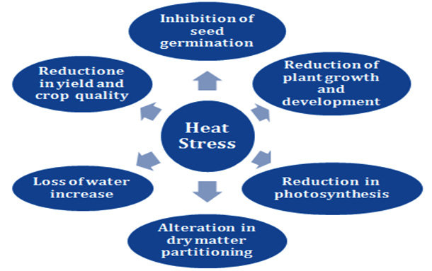

Figure 2: Major Biochemical Pathways of Osmolyte Biosynthesis
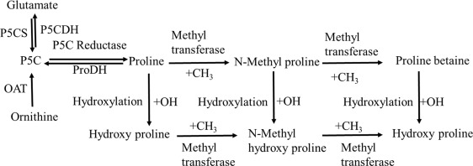
Figure 3: Physiological Mechanisms of Osmolyte-Mediated Thermotolerance
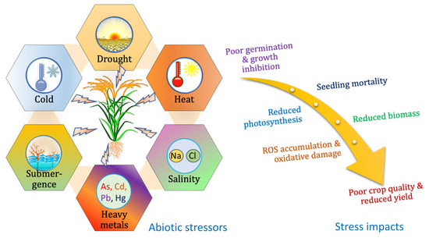
Figure 4: Stabilization of Cellular Membranes and Macromolecules
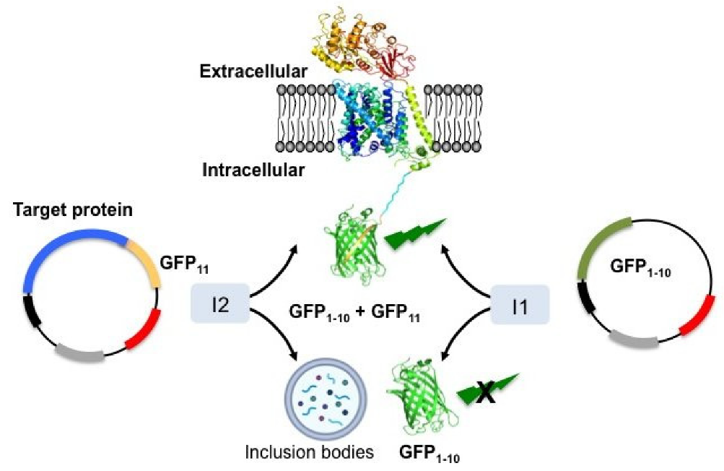
Figure 5: Transcriptional and Epigenetic Regulation of Osmolyte Networks
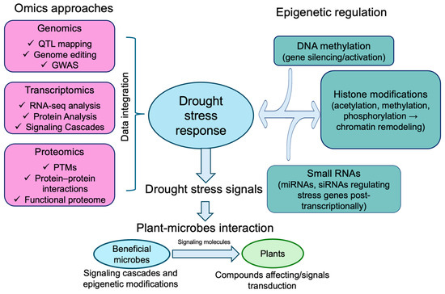
Figure 6: Crop-Specific Osmolyte Dynamics in Major Cereals and Legumes
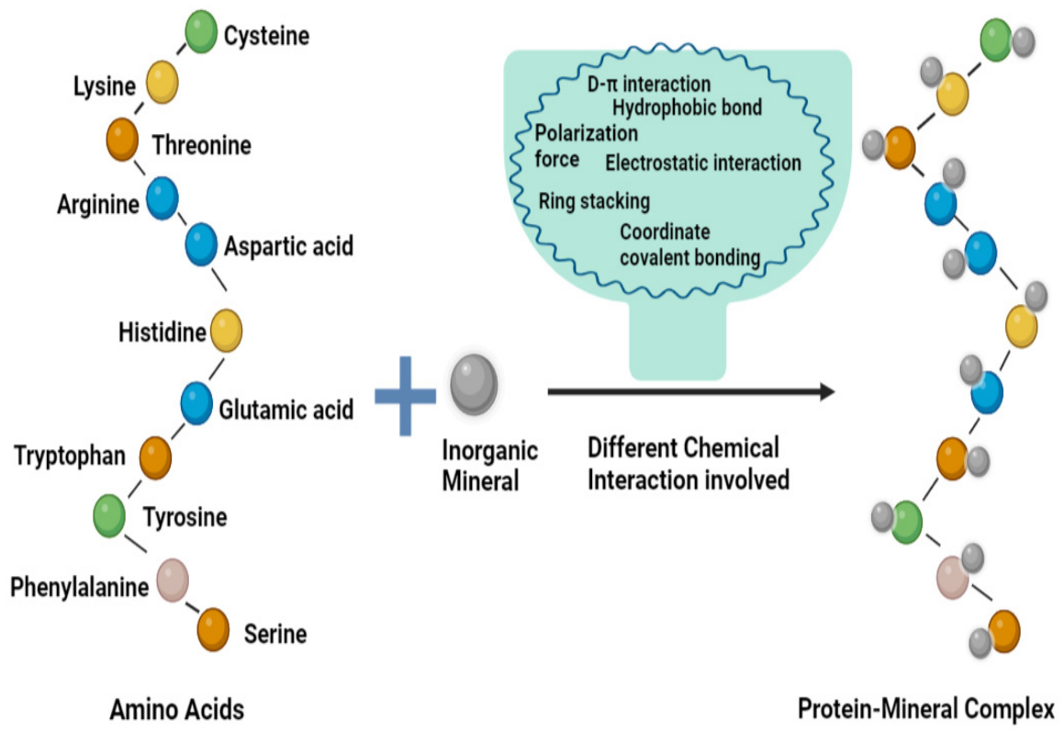
Figure 7: Precision Genome Editing and Transgenic Strategies
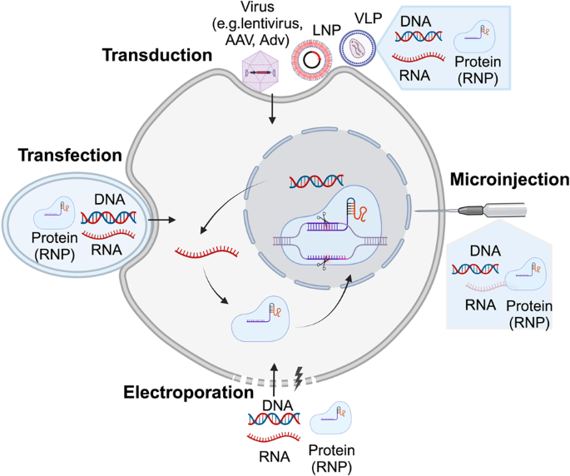
Figure 8: Agronomic Interventions: Exogenous Application and Seed Priming
