Genetic Divergence in Green Gram Genotypes Evaluated under Coastal Climate based on Quantitative Traits and Multivariate Analysis Approach

Abstract
In the present paper, assessment of genetic divergence in a set of 41 accessions of green gram was used following standard statistical procedure and multivariate analysis approach. The field experiments were carried out in a randomized block design with three replications during rabi season of 2016-2018. The study revealed significant differences among the genotypes for all the traits. Seed yield had a maximum phenotypic and genotypic coefficient of variation and were grouped into thirteen clusters with the highest number of 18 genotypes in cluster-I, seven in cluster-III, five in cluster-V, two in cluster-X and one genotype each in rest nine clusters. Yield ha⁻¹ contributed maximum (21.4 per cent) towards divergence followed by plant height (15.2%) and pods/plant (14.7%). Average intra- and inter-cluster D² values revealed no intra-cluster distance between clusters II, IV, VI to IX and XI to XIII being monogenic in nature. The present investigation revealed that the genotypes studied are very diverse and can be useful for selective breeding of specific traits and in enhancing the genetic base of breeding programs in future.

Key words: Genetic divergence, green gram, heritability, quantitative traits.

- Introduction
Green gram [Vignaradiata(L.)Wilczek], popularly known as mung bean or golden gram, is an important pulse crop in south Asian countries. It belongs to the family Fabaceae with chromosome number 2n=2x=22, and widely cultivated and consumed throughout India. The seeds are a rich source of high-quality protein (240g kg⁻¹), digestible carbohydrates (630g kg⁻¹), iron (0.03-0.06 mg g⁻¹) and zinc (0.02-0.04 mg g⁻¹) (Keatinge et al., 2011; Nair et al., 2013). Mung bean is consumed as whole grains, sprouted form as well as dal in a variety of ways in every household. The dried leaves, stems and pods after harvesting the crop and the husk of the seed is also used as cattle feed. It is the third most important pulse crop in India, occupying nearly 3.72 million ha area with 1.56 million tons of production (Ali and Gupta, 2012). India is the largest producer and consumer of pulses, contributing 26.0% to the global pulse production and 30.0 % of total pulse consumption of the world (MAFW, 2017) and in case of green gram, India alone accounts for 65.0 % of world acreage and 54.0 % of the global production. Despite several good qualities of mungbean, the global average productivity is staggeringly low at 0.5 t ha⁻¹ which is much below than the estimated yield potential, i.e. 2.5–3.0 t ha⁻¹ of the crop (Nair et al., 2019). Though India is the largest producer of green gram, but about 2–3 million tons of pulses are imported annually to meet the domestic consumption requirement. Thus, there is need of more intensive interventions to increase the production and productivity of pulses in general and green gram in particular.
The development of new varieties depends largely on the availability of genetic variability in the base material and the magnitude of variability for the desired character. The development of cultivated species and breeding of new varieties typically relies on the available biological diversity in existing genotypes (Mahesha et al. 2017). Knowledge on extent of genetic variation, association of yield with component traits, their heritability and genetic advance are pre-requisites for its use in breeding and improvement. Thus, the utility of techniques like Mahalanobis D² analysis to detect genetic divergence in a group of genotypes and to have an effective strategy of inter- and intra-specific hybridization programme has often been emphasized. Potential sources of genes for different characters can be identified by taking into consideration the clusters of genotypes which excel in each trait and heterogeneity among the genotypes. Several workers studied the genetic diversity, clustering pattern, relative contribution of different characters towards divergence and effectiveness of selection criteria (Abbas et al., 2010; Kingsly et al., 2015). Therefore, the objectives of the present study were set to estimate the heritability and genetic advance, to classify the germplasm into distinct groups based on their genetic variability, to determine the association between grain yield and its component traits and to identify diverse genotypes with suitable traits useful in hybridization programme for the development of better recombinants.

- Materials and methods
2.1 Experimental site and design
The investigation was undertaken in a randomized block design (RBD) with three replications during rabi season of 2016–2018 at the experimental field of ICAR-NBPGR Base Centre, CRRI Campus, Cuttack located at 20º.5’ N, 86º.0’ E and 23.5 m altitude above mean sea level. The major climatic condition was characterized as tropical, hot and sub-humid environment with average rainfall of 1400–1600 mm. Plants were grown in plot size of 3.6 m² (3.0 m × 1.2m) crop geometry with a spacing of 40 cm between rows and 10 cm between plants.
2.2 Plant material
Forty-one green gram genotypes including three check varieties were selected from a group of germplasm collections made from different agro-climatic zones of Odisha under national germplasm exploration programme of ICAR-National Bureau of Plant Genetic Resources, New Delhi.
2.3 Data collection
Observations were recorded on five randomly selected plants from each replication on ten quantitative traits viz., plant height (cm), days to 50% flowering, number of branches, number of clusters, number of pods, pod length (cm), number of seeds per pod, seed yield (kg ha⁻¹), yield per plant (g) and 100 seed weight (g). The mean values were used for statistical analyses.
2.4 Statistical methods
The data were subjected to analysis of variance for each character by using the Statistical Analysis System (SAS) version 9.3 for windows. Multivariate analysis of D² statistics was done according to Mahalanobis (1936). The genotypes were grouped into different clusters following Tocher's method and a dendrogram is derived to show the morphological relatedness of the genotypes under study. The relative contributions of various characters towards genetic divergence were also worked out. Yield and its related traits were used to estimate the phenotypic, genotypic and environmental variances using the method of Burton & Devane (1953). The variance components were used to compute the genotypic coefficient of variation (GCV), phenotypic coefficient of variation (PCV), error coefficient of variation (ECV) (Falconer, 1981), broad sense heritability (h²) (Allard1960) and expected genetic advance (GA) (Burton 1952).

- Results and discussion
Statistical parameters like ANOVA, GCV, PCV, heritability and genetic advance help in a better understanding of the genetic diversity that exists within the genotypes. In the present study, analysis of variance revealed highly significant differences among 41 green gram accessions for all the ten quantitative traits under study at 1% and 5% level of significance, indicating the presence of sufficient variability among the different genotypes (Table 1). In general, estimates of PCV were higher than the GCV. Maximum seed yield per plant was recorded for the genotype IC-565287 (6.1g), followed by IC- 565226 (4.9 g). A higher magnitude of GCV was recorded for seed yield per plant (34.28) followed by number of clusters per plant (23.76), number of branches per plant (16.11), 100 seed weight (15.87) and plant height (15.75) suggesting sufficient variability and thus scope for genetic improvement through selection for these traits. In the other hand, number of pods per cluster (12.89), number of seeds per pod (10.16) and pod length (5.88) depicted moderate to low genotypic coefficient of variation (Table 2). The moderate magnitude of PCV was recorded for number of clusters per plant (31.79), seed yield (28.42), 100 seed weight (22.92), plant height (22.91), number of branches per plant (21.74) and the trait days to 50% flowering (3.93) exhibited lowest value of phenotypic coefficient of variation. The minimum difference between PCV and GCV (0.94) in days to flowering reflects the least effect of environment on this trait and in the contrary, high differences in yield/plant (13.83) indicate the higher influence of environment (Table 2).

Table 1. Analysis of variance for 10 different quantitative characters in 41 green gram germplasm
S. N. | Traits | Mean sum of squares
S. N. | Traits | Replications  (df=2) | Treatments  (df= 40) | Error  (df= 80)
1 | Days to 50% flowering | 0.51 | 4.54** | 2.21
2 | Plant height (cm) | 49.65 | 116.09*** | 31.46
3 | No. of branches/ plant | 1.30 | 2.48*** | 0.53
4 | No. of clusters/ plant | 5.92 | 4.36*** | 0.91
5 | No. of pods/ cluster | 3.28 | 0.66*** | 0.13
6 | No. of seeds/pod | 41.71 | 3.67*** | 1.16
7 | Pod length (cm) | 7.95 | 0.90*** | 0.47
8 | Seed yield (kg/ha) | 11.46 | 78.38*** | 4.97
9 | Yield/ plant(g.) | 6.80 | 32.44*** | 0.79
10 | 100 seed wt. (g) | 0.86 | 0.69*** | 0.17

Table 2.Genetic parameters for 10 quantitative traits of 41 green gram germplasm
SN | Traits | Range | Mean + SE | Genotypic Coefficient of variation (GCV) | Phenotypic Coefficient of variation (PCV) | Heritability (%) broadsense (h²) | Genetic advance (GA) | Genetic advance as % of mean
1 | Days to 50% flowering | 42.0-45.6 | 44.0 + 0.9 | 2.00 | 3.93 | 25.90 | 0.92 | 2.10
2 | Plant height (cm.) | 20.4-52.6 | 33.7 + 3.2 | 15.75 | 22.91 | 47.30 | 7.52 | 22.31
3 | No. of branches/ plant | 2.9-6.7 | 5.0 + 0.4 | 16.11 | 21.74 | 54.90 | 1.23 | 24.60
4 | No. of clusters/ plant | 2.2-4.4 | 4.5 + 0.6 | 23.76 | 31.79 | 55.80 | 1.65 | 36.57
5 | No. of pods/ cluster | 6.6-10.7 | 3.3 +0.2 | 12.89 | 17.02 | 57.40 | 0.65 | 20.11
6 | No. of seeds/pod | 5.0-7.7 | 9.0 + 0.6 | 10.16 | 15.73 | 41.80 | 1.22 | 13.53
7 | Pod length (cm) | 5.1-7.7 | 6.4 + 0.4 | 5.88 | 12.20 | 23.30 | 0.38 | 5.84
8 | Seed yield (Q/ha) | 4.2-17.5 | 7.27 +4.07 | 26.72 | 28.42 | 88.40 | 7.54 | 51.74
9 | Yield/ plant (g) | 1.1-6.1 | 2.6 + 0.5 | 34.28 | 48.11 | 50.80 | 1.33 | 50.32
10 | 100 seed wt. (g) | 1.4-3.7 | 2.5 + 0.2 | 15.87 | 22.92 | 47.90 | 0.57 | 22.63

In the present analysis of genetic diversity, forty-one genotypes were grouped into thirteen clusters with the highest no. of 18 genotypes in cluster-I followed by seven genotypes in cluster -III , five genotypes in cluster -V and two genotypes (check varieties) in cluster -X, leaving one genotype each in rest of the nine clusters (Table 3; Fig. 1). All the clusters are separated from each other but the geographical distribution of the genotypes has not shown a considerable impact on classification pattern. The results are corroborated with the findings of the study made by Basnet et al. (2014) and Waniale et al. (2014) on a diverse set of green gram genotypes. The cluster mean values among the green gram germplasm accessions for different quantitative traits are given in Table 4. The traits with cluster mean values for days to 50 % flowering varies from 40.33 in cluster XII with IC-565264 to 45.67 in cluster XIII with IC-569021. The results revealed that cluster XII (IC-565268) has the lowest value for plant height and cluster II with IC-565270 has the highest value. For the trait, number of branches per plant, cluster XI (IC-568946) has the lowest estimate as compared with highest value for cluster VIII (IC-565209. The number of clusters per plant varies between 3.40 (cluster VI & XIII) and 7.0 (cluster VIII). For the trait viz. number of pods per cluster, cluster V with five genotypes possess the lowest value (2.64) as compared with the highest value (4.10) for cluster IV bearing IC-565248. The number of seeds per pod is minimum (8.10) in case of cluster XII (IC-565264) and maximum in case of clusters IV with IC-565248. Pod length showed the lowest range in cluster XI (IC-568946) and the highest range in cluster VI (IC-565282). Seed yield in cluster XIII (IC-569021) showed the lowest (1.71) and cluster VII (IC-565287) exhibited the highest value (5.91). But the national check varieties viz. PDM-54 & Pusa Vishal in cluster X resulted highest values for 100 seed weight (3.70) against cluster XII comprising IC-565264 (Table 4).

Table 3.Composition of clusters based on D² -statistics among 41 green gram germplasm
Cluster No | No. of genotypes | Name of genotypes
I | 18 | ICs-565212, 565223,565226,565233, 565242, 565246, 565249,565251, 565255, 565257, 565261, 565268, 565278, 565285, 565290, 565293, 565295, 569082
II | 1 | IC 565270
III | 7 | ICs-565203, 565207, 565258, 565271, 565292, 568981& LGG-460
IV | 1 | IC-565248
V | 5 | ICs 565241, 565252, 568945, 569034, 569058
VI | 1 | IC-565282
VII | 1 | IC-565287
VIII | 1 | IC-565209
IX | 1 | IC-565245
X | 2 | PDM-54, Pusa Vishal
XI | 1 | IC-568946
XII | 1 | IC-565264
XIII | 1 | IC-569021

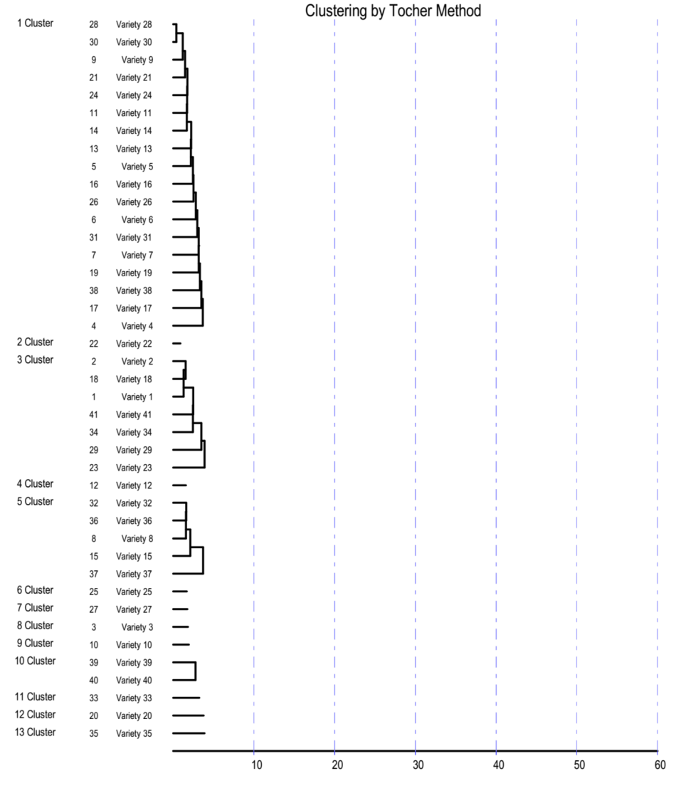
Figure 1. Dendrogram based on 10 quantitative traits depicting genetic divergence in 41 green gramgermplasm

In the clustering pattern shown in non-hierarchical Euclidean cluster analysis (Fig. 2), the group constellation proved the existence of a significant amount of variability. While analysing the percentage contribution of various traits towards genetic diversity, it is revealed that seed yield (kg ha⁻¹) contributed maximum towards divergence (21.4%), followed by plant height (15.2%) and pods/plant (14.7%). Average intra- and inter- cluster D² values revealed that cluster II, IV, VI to IX and XI to XIII showed no intra-cluster D² values. Highest inter cluster distance is observed between cluster IX and XI (56.19) followed by inter cluster III and XIII (54.73) and inter cluster IX and XIII (50.01) indicating wide divergence among the clusters. Cluster-II showed maximum intra-cluster D² value (9.58), followed by cluster-V (8.88) and cluster-I (8.23) revealing diverse nature of genotypes within the cluster (Table 5).

Table 5. Intra-(diagonal) and inter-cluster average distances (D²) for 10 quantitative traits in green gram
Cluster | Traits
Cluster | Days to 50% flowering | Plant height (cm) | No. of branches/ plant | No. of clusters/ plant | No. of pods/ cluster | No. of seeds/pod | Pod length  (cm) | Seed yield (kg/ha) | Yield/ plant(g) | 100seed wt. (g)
I | 44.07 | 31.84 | 5.07 | 4.42 | 3.36 | 8.88 | 6.32 | 655.65 | 2.56 | 2.38
II | 45.33 | 41.45 | 5.20 | 3.90 | 3.00 | 8.40 | 6.67 | 958.85 | 2.39 | 2.78
III | 43.76 | 37.69 | 4.91 | 4.82 | 3.29 | 9.10 | 6.40 | 1004.12 | 2.76 | 2.70
IV | 43.00 | 32.10 | 4.50 | 4.50 | 4.10 | 10.30 | 6.73 | 776.13 | 3.24 | 2.67
V | 44.07 | 30.31 | 4.68 | 4.06 | 2.64 | 8.91 | 6.34 | 601.32 | 2.51 | 2.32
VI | 44.67 | 38.80 | 5.10 | 3.40 | 3.60 | 9.10 | 7.74 | 942.39 | 2.22 | 2.49
VII | 43.00 | 29.24 | 6.30 | 7.30 | 4.00 | 8.80 | 6.57 | 455.14 | 5.91 | 2.67
VIII | 43.33 | 34.02 | 6.60 | 7.00 | 3.40 | 8.90 | 6.28 | 872.43 | 2.52 | 2.92
IX | 43.00 | 34.78 | 5.50 | 4.20 | 3.70 | 8.80 | 6.52 | 959.67 | 1.73 | 2.43
X | 43.50 | 40.84 | 4.48 | 3.80 | 3.13 | 9.33 | 6.81 | 692.80 | 3.50 | 3.70
XI | 45.00 | 36.13 | 2.90 | 4.30 | 3.10 | 10.13 | 6.08 | 480.66 | 2.46 | 2.24
XII | 40.33 | 29.05 | 4.30 | 5.80 | 2.80 | 8.10 | 6.31 | 744.86 | 1.08 | 1.51
XIII | 45.67 | 36.97 | 6.40 | 3.40 | 2.70 | 9.30 | 6.28 | 423.87 | 1.71 | 2.79

Figure 2. Cluster diagram depicting Euclidean intra and inter cluster distances among 41 green gramgermplasm

Significant differences among the genotypes for all the traits indicated high scope of these genotypes in greengram breeding and improvement programmes. High genetic advance coupled with high heritability was found in seed yield (kg ha⁻¹), number of clusters/plant, number of branches/plant, suggesting the predominance of supplemental gene effect and the possibility of high genetic gain through phenotypic selection. Characterization of mungbean germplasm have been reported by various workers like Yimram et al. (2009) evaluated 340 accessions for 9 qualitative and 21 quantitative traits; Rahim et al. (2010) evaluated 26 genotypes; Pandiyan et al. (2012) subjected 646 greengram accessions into hierarchical cluster analysis and Abna et al. (2012) evaluated 20 genotypes for 8 morphological traits and Waniale et al. (2014). Their studies also revealed a good range of diversity in mungbean germplasm. Zhou et al. (2020) reported grain yield in mungbean (Vignaradiata) is associated with spatial distribution of root dry weight and volume.

- Conclusions
Development of mung bean varieties with the higher number of branches, pods per plant, seeds per pod¸ yield per plant, and seed yield can help increase the production and productivity of the crop. An increase in higher production of mungbean will mitigate malnutrition and hidden hunger in the south Asia, Africa and Pacific countries. To enhance global pulse production and create awareness about the nutritional quality of pulses, 68th UN General Assembly declared 2016 as the International Year of Pulses (IYP). Hence, there is an urgent need for the collection, characterisation and identification of suitable donor for mungbean germplasm improvement. Based on genetic divergence studies, the genotypes viz. IC-565245 (Cluster-IX) and IC-568946 (Cluster-XII) having the highest inter-cluster distance is recommended to be used as parents for green gram hybridization programme to obtain better transgressive segregants. Further, the traits like seed yield, number of branches/plant and number of clusters/plants with high heritability estimates (in broad sense) along with high genetic advance as a percentage of mean would be more effective for further improvement of yield and yield components.

REFERENCES
Abbas, G., Asghar, M.J. & Shah, T. M. (2010). Genetic diversity in mungbean (Vigna radiata L. Wilczek) germplasm. Pakistan Journal of Botany, 42, 3485-3495.
Abna, F., Faruq, G., & Bhassu, S. (2012). Estimation of genetic diversity of mungbean (Vigna radiata L. Wilczek) in Malaysian tropical environment. Afican Journal of Microbiology Research, 6, 1770-1775.
Ali, M., & Gupta, S. (2012). Carrying capacity of Indian agriculture: Pulse crops. Current Science, 102(6), 874-881.
Allard, R.W. (1960). Principles of Plant Breeding. John Wiley and Sons Inc., New York, USA.
Basnet, K. M., Adhikari, N. R., & Pandey, M. P. (2014). Multivariate analysis among the Nepalese and exotic mungbean (Vigna radiate L. Wilczek) genotypes based on the qualitative parameters. Universal Journal of Agricultural Research, 2(5), 147-155.
Burton, G. W., & Devane, E. M. (1953). Estimating heritability in tall fescue (Festuca arundinacea) from replicated clonal material. Agronomy Journal, 45(3), 478-481.
Burton, G. W. (1952). Quantitative inheritance in grasses. Proc. 6th International Grassland Congress 1: 277-283.
Falconer, D. S. (1981). Introduction to Quantitative Genetics. Oliver and Boyd, London.
Keatinge, J. D. H., Easdown, W. J., Yang, R. Y., Chadha, M. L., & Shanmugasundaram, S. (2011). Overcoming chronic malnutrition in a future warming world: The key importance of mungbean and vegetable soybean. Euphytica, 180(1), 129–141.
MAFW (2017). Pulses in India: Retrospect & Prospects -2017. In A. K. Tiwari & A. K. Shivhare (Eds.), Directorate of Pulses Development, Ministry of Agriculture & Farmers Welfare, Government of India.
Mahalanobis, P. C. (1936). On the generalized distance in statistics. Proc. National Institute of Science 2, 49-55.
Mahesha, H. S., & Gabriel, M. L. (2017). Studies on genetic diversity in blackgram (Vigna mungo L. Hepper) germplasm. International Journal of Advanced Biological Research, 7 (3), 426-434.
Nair, R. M., Pandey, A. K., War, A. R., Hanumantharao, B., & Shwe, T. et al. (2019). Biotic and Abiotic Constraints in Mungbean Production – Progress in Genetic Improvement. Frontiers in Plant Science, 10:1340. https://doi.org/10.3389/fpls.2019.01340 .
Nair, R. M., Yang, R. Y., Easdown, W. J., Thavarajah, D., Thavarajah, P., Hughes, J. D. A., & Keatinge, J. D. H. (2013). Biofortification of mungbean (Vigna radiata) as a whole food to enhance human health. Journal of the Science of Food and Agriculture, 93(8), 1805–1813.
Kingsly, N. B., Packiaraj, D., Pandiyan M., & Senthil, N. (2015). Tailoring genetic diversity of mungbean (Vigna radiata L. Wilczek) germplasm through cluster analysis for yield and yield related traits. Trends in Biosciences, 8(12), 3239-3244.
Pandiyan, M., Natesan, S., Packiaraj, D., & Sundaramoorthy, J. (2012). Greengram germplasm for constituting of core collection. Wudpecker Journal of Agricultural Research, 1, 223 - 232.
Rahim, M. A., Mia, A. A., Mahmud, F., Zeba, N., & Khandker, A. (2010). Genetic variability, character association and genetic divergence in mungbean (Vigna radiata L. Wilczek). Plant Omics, 3, 1-6.
SAS Institute, (2012). SAS/STAT Version 9.3. SAS Institute, Cary, North Carolina, USA.
Waniale, A., Wanyera, N., & Talwana, H. (2014). Morphological and agronomic traits variations for mung bean variety selection and improvement in Uganda. African Crop Science Journal, 22(2), 123 – 136.
Yimram, T., Somta, P., & Srinives, P. (2009). Genetic variation in cultivated mung bean germplasm and its implication in breeding for high yield. Field Crops Research, 112(2–3), 260–266.
Zhou, H., Zheng, D., Feng, N., Xiang, H., Liu, Y., & Liang, X. (2020). Grain yield in mung bean (Vigna radiata) is associated with spatial distribution of root dry weight and volume. Legume Research, 43(3), 408-414.

