Phytochemical, Antioxidant, and Antimicrobial Evaluation of Terminalia arjuna Bark Extracts

Abstract
The current study was determined to determine the phytochemical composition, antioxidant activity, antimicrobial activity, and GC-MS profile of the extracts made using the solvents of varying polarity, of the Terminalia arjuna tree, using the bark. The sampled of barks were extracted using methanol, ethanol, hexane, and dichloromethane (DCM) and the percentage yield was then calculated. Initial phytochemical screening had shown the occurrence of phenols, flavonoid, alkaloid, terpenoid, and glycoside with polar solvents showing a wider range of secondary metabolites. The quantitative analysis revealed that the ethanolic extract possessed the greatest amount of total phenolic (329 mg GAE -1) and total flavonoid (129 mg QE -1) content, and the statistical significance between solvent extracts (p -1). The DPPH assay has revealed that antioxidant activity was pronounced in the ethanol (IC 5 -1 = 7.76 -1 ) and the methanol extract (IC 5 -1 = 6.34 -1 ) which were significantly high compared to the non-polar extracts (p -1). Antimicrobial testing on the agar-well diffusion technique showed that the ethanolic extract had a much higher level of inhibition (p < 0.05) with respect to the following bacteria like taphylococcus aureus, Shigella sonnei, Klebsiella pneumoniae and Escherichia coli. The ethanolic extract was analyzed by GC -MS, which identified ethanolic extract as containing bioactive constituents, such as monoterpenes (add-pinene, limonene, 1,8-cineole), sesquiterpenes (caryophyllene), fatty acids (hexadecanoic acid, linoleic acid, oleic acid), and phytol. Taken together, these results confirm that the bark of the Terminalia arjuna plant is a valuable source of bioactive phytoconstituents with statistically significant antioxidant and antimicrobial effects, especially when it is extracted using ethanol.
Keywords: Terminalia arjuna, phytochemicals, antioxidant activity, antimicrobial activity, GC–MS, phenolic content, flavonoids.
- Introduction
The medicinal plants have carried a revolutionary purpose in drug discovery, which provides structurally varied bioactive compounds (e.g., alkaloids, flavonoids, and terpenoids) with therapeutic action (e.g., cancer, inflammation, infections). These compounds have a wide range of secondary metabolites, which are produced through well-established biosynthetic pathways and give them pharmacological properties, such as antioxidant, antimicrobial, anti-inflammatory, and cytotoxic actions (Roy et al., 2022). These phytochemicals also play protective and adaptive roles in the plant systems and they also have therapeutic effects when used as medicinal preparations. The structure and the concentration of the secondary metabolites depend on the plant species, part of the organ, the environmental factors, and the methodologies used to extract the metabolites. Bioactive metabolites are identified by using systematic phytochemical screening with specialized analytical methods, thus clarifying the pharmaceutical and biomedical roles of the bioactive metabolites (Shu et al., 2025; Wawrosch and Zotchev, 2021).

Through an enormous amount of research on medicinal plants, it has been found that various organs of plants have a variety of different classes of compounds, including phenolics, flavonoids, tannins, glycosides, and terpenoids, which all play a role in therapeutic activity (Nayab et al., 2023). The genus, therefore, Terminalia, has been widely studied in the academic setting of traditional and modern medicinal systems, especially in the ethnomedicine of South Asia. One of its species, Terminalia arjuna, is one of the most historically grown plants with mostly cardiovascular and overall vitality health outcomes in herbal formulations (Rajaram et al., 2024). The pharmacologically active component of the bark is considered to be the most active, where it contains various phytoconstituents, including polyphenols, flavonoids, which are correlated to a variety of biological processes, including free-radical scavenging, antimicrobial protection, and cellular protection. Although it has been recognized medicinally, there is a need to do a thorough chemical profiling of its bioactive constituents with modern analytical methods to explain its pharmacological potential (Tahir et al., 2025).

All the past phytochemical studies have conclusively indicated that plant extracts that are rife in phenolic and flavonoid compounds have a strong antioxidant activity, thus implying that they may be useful in the treatment and alleviation of oxidative-stress-induced conditions and microbial infections (Larit et al., 2016). The quantitative measurements of the parameters, including total phenolic content (TPC) and total flavonoid content (TFC), demonstrate that high concentrations of these compounds are often linked with the increased biological activity (Erizal et al., 2024). However, differences in extraction, polarity of solvent, and the method of analysis may have a major impact in the yield and composition of phytochemicals, and in turn, on the efficiency of antioxidant and antimicrobial activities. Advanced instrumentation, such as Gas Chromatography–Mass Spectrometry (GC 25), can be used as a potent instrument in the identification and characterization of volatile and semi-volatile phytochemicals, and they provide a complete chemical profile, which is better than traditional phytochemical assay methods (Mzali et al., 2025). The combination of these sophisticated techniques in phytochemical work improves the reliability, simplifies the work with the identification of compounds and allows making more specific interpretations of the biological activity.

This study was conducted in order to evaluate the phytochemical profile of solvent based extract of the bark of the plant, Terminalia arjuna systematically. The study measures the total phenolic and flavonoid contents as the measure of antioxidant potential and antimicrobial activity. Characterization of chemical constituents was done through GC -MS (Dikamu et al., 2025). Through standard experimental procedures and comparative solvent studies, supplemented with high-resolution instrument procedures, including GC-MS, the paper determines the most effective solvent to use in extracting bioactive constituents, thus yielding strong quantitative and qualitative data on bioactive constituents and scientifically substantiating the medicinal importance of this plant.

The experiment will be conducted on standardized experimental procedures, comparative solvent analyses, and high-quality instrumental characterization, especially GC-MS. It will therefore establish the best extraction medium, which will provide credible quantitative and qualitative data of bioactive compounds and provide empirical support to the medicinal importance of the plant. It is presumed that the expected conclusions will support the traditional applications, develop the knowledge of phytochemical complexity, and provide the basis of the future research aimed at the isolation of active compounds, structural clarification, and pharmacological evaluation. compounds.

Materials and Methodology
  - Experimental Workflow
The experimental protocol was systematic and sequential and it began with the procurement of the plant material, and was followed by thorough cleaning, shade-drying, pounding and finally attracting solvent extraction, filtration and further analysis.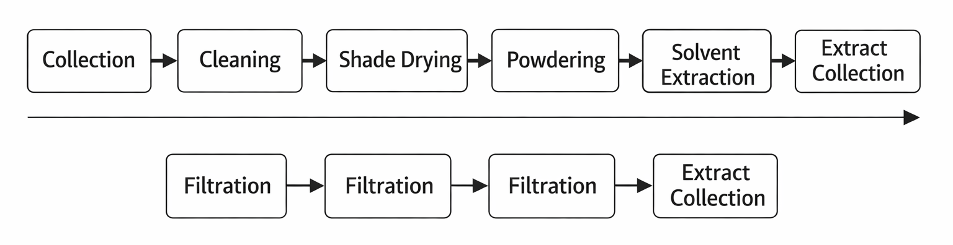

Figure 1: Schematic figure of the process of work to prepare and analytically evaluate plant extracts, which include collection, cleaning, drying, pulverization, extraction, filtration, and final analytical evaluation.

2.1 Sample Collection and Preparation
The samples of fresh Terminalia arjuna bark were taken off the premises of J.S.Murarka Multiple Campus and carefully washed off, to clear off any debris that was on them. The vegetation was washed, cut into small chips, and dried in the shade over a few days until totally dry. The samples that were dried were also comminuted into a fine powder and kept in airtight containers to undergo further analyses.

2.2 Extraction Procedure
About 80g of finely powdered Terminalia arjuna bark was respectively impregnated in methanol, ethanol, hexane and dichloromethane (DCM) to produce extracts of different polarities. All sample-solvent mixtures were left to stand in 72 hours with occasional stirring to ensure that the phytoconstituents were extracted effectively; the mixtures were then filtered in order to obtain the liquid extract and leave the plant residue behind. A water bath was used in order to concentrate the filtrate to give crude extracts. The remaining vegetal matter was then left under repeated re-extractions using the same solvents over the next 48 hours and then 24 hours in as much as the residual vegetal material allowed maximum soluble compounds to be extracted. The entire filtrates of these serial extractions were pooled together, dried by evaporation and stored in clean airtight flasks in refrigerated conditions awaiting further analysis(Bouzidi et al., 2023). To determine the efficiency of extraction, the percentage yield of every extract was determined.
Extract yield %= (W₁/W₂) ×100

2.3 Phytochemical Screening
Phytochemical analysis was done using standard method to identify major bioactive compounds by means of colour change or giving precipitate when suitable chemical is utilized. The text is summarized in table:
Table 1: Showing phytochemical analysis(Mandal et al., 2013)
S.N. | Test Name | Phytochemical Detected | Procedure | Positive Indication
1 | Salkowski reaction | Phytosterols | Chloroform extract + conc. H₂SO₄ | Reddish-brown color in chloroform layer
2 | Liebermann–Burchard test | Triterpenoids | Extract + acetic anhydride, boil, cool, add conc. H₂SO₄ | Brown ring + deep red color
3 | Foam test | Saponins | Extract + water, shaken vigorously | Persistent foam (10 min)
4 | Dragendorff’s test | Alkaloids | Extract residue + Dragendorff’s reagent | Orange-red precipitate
5 | Molisch’s test | Carbohydrates | Extract + Molisch reagent + conc. H₂SO₄ | Reddish-violet ring
6 | Lead acetate test | Flavonoids | Alcoholic extract + 10% lead acetate | Yellow precipitate
7 | Legal’s test | Lactones | Extract + sodium nitroprusside + pyridine + NaOH | Deep red color
8 | Ferric chloride test | Phenols & Tannins | Extract + FeCl₃ solution | Bluish-black precipitate
9 | Ninhydrin test | Amino acids/Proteins | Extract + ninhydrin | Blue color
10 | Keller–Killiani test | Glycosides | Extract + glacial acetic acid + FeCl₃ + conc. H₂SO₄ | Reddish-brown ring

2.3 Determination of Total Phenolic Content (TPC)
An aliquot of 100 µL of the prepared sample extract was transferred into a suitable reaction vessel or 96 well microplate, after which 200 µL of 10% freshly prepared Folin–Ciocalteu (FC) reagent was added to initiate the reaction. The mixture was gently mixed to ensure uniform interaction between the reagent and the phenolic compounds present in the sample, and an initial absorbance reading was recorded to establish baseline values. Following this, 800 µL of 700 Mm sodium carbonate solution was added to the reaction mixture to neutralize the medium to promote the formation of a blue-colored chromophore complex resulting from the reduction of the FC reagent by phenolic constituents. The total volume of the reaction mixture was then adjusted to 200 µL using distilled water to maintain consistent assay conditions. The prepared mixture was incubated in the dark at room temperature for 2 hours to allow complete colour development while preventing light-induced degradation or interference. After incubation, the absorbance of the resulting solution was measured spectrophotometrically at a wavelength of 765 nm against an appropriate blank solution. All experimental determinations were performed in triplicate under identical conditions to ensure precision, reproducibility, and statistical reliability of the results (Sabaragamuwa & Perera, 2023).

2.4 Determination of Total Flavonoid Content (TFC)
The calculation of the total flavonoid content (TFC) was done through the aluminium chloride colorimetric, and quercetin was used as a reference standard to construct the calibration curve. Quercetin was dissolved in methanol at the concentration of 1 mg/mL, and standard solutions were then obtained by a series of dilution using methanol at the different concentration ranges. In each assay, 20µL of the diluted standard solution or plant extract was combined with 100µL of distilled water and 60µL of ethanol in a 96 ul plate and an initial absorbance value was taken. Then 10µLL of 10per cent. aluminium chloride solution containing potassium acetate was put into every well to facilitate the formation of complex between the ions of aluminium and the flavonoid constituents. The reaction mixture was stirred markedly and allowed to incubate at room temperature within 30 minutes so that the colour can be fully developed. A spectrophotometer was then used to measure absorbance against a blank at 415nm. Calculation of total flavonoid content of each sample based on the calibration curve was in terms of milligrams of quercetin equivalent (QE) per gram of dried plant material. All decisions were made thrice to guarantee accuracy, precision and reproducibility(Chandra et al., 2014).
2.4 Antioxidant activity
The antioxidant activity of Terminalia arjuna bark extracts was determined using DPPH free radical scavenging method. For the analysis, ascorbic acid was used as the standard and dissolved in methanol, while methanolic fractions of bark served as the test samples. Approximately 1 ml of each fraction was transferred into separate test tubes, followed by the addition of 0.5 ml of 1 mmol/L DPPH solution prepared in methanol. The mixtures were incubated for 15 minutes, after which the absorbance was measured at 517 nm. A blank solution consisted of DPPH dissolved in the same volume of methanol. The percentage of DPPH radical scavenging activity was calculated using the following formula:
DPPH Scavenging Activity (%) =​ $\frac{Acontrol​-Asample}{Acontrol}$×100
2.5. Antimicrobial Assay
Agar well diffusion test was used to assess the antimicrobial activity of the prepared extracts of Terminalia arjuna bark against several pathogenic microorganisms including; Staphylococcus aureus (SA), Shigella sonai (SS), Klebsiella pneumoniae (KP) and Escherichia coli (E. coli) pathogens. New cultures of bacteria were grown and standardized to a certain level of turbidity that is comparable to the 0.5 McFarland standard. A homogenous population of bacterial suspension on the plate of sterile nutrient agar was achieved by spreading the bacterial suspension uniformly across the plate using a sterile cotton swab to obtain a confluent growth on the plate. The well of the same diameter (6mm) was prepared in the agar plate, and the respective volumes of the plant extract solutions added into the wells. The negative control was a 50% DMSO blank and the positive control was a (1 mg/mL) neomycin solution that was used to compare them. Plates were left to stand a short time to allow diffusion of the extracts into the agar and placed at 37 o C after which they were incubated in 24 hours. Antimicrobial activity was determined by determining the size of the zones of inhibition around the individual well in millimetres after incubation. Each experiment was done thrice to guarantee the reliability and reproducibility of the results(Aneja et al., 2012; Vijayalakshmi et al., 2023).
2.6. Gas Chromatograph and Mass Spectrometry analysis
Chemical characterization of the extracts was done through the use of a Agilent 8890 GC system coupled with a Single Quadrupole Mass Spectrometer 5977B MSD (Agilent Technologies, Santa Clara, CA, USA) at the SAIF, Indian Institute of Technology Madras (IITM) to determine the presence of volatile and semi-volatile bioactive constituents in the samples. Before the analysis, concentrated extracts were filtered using a membrane filter to remove any form of particulate matter as well as to make them compatible with the instrumentation. The GC-MS platform that included Agilent HP-5 MS UI column (30 m × 250 µm × 0.25 µm) and were run for a total duration of 53.5 min. The capillary column was loaded with an aliquot of the filtered extract and the system operated under GC oven started at 75 °C and increased to 350 °C at a rate of 5 °C per minute, H₂ carrier-gas with 18 mL/min flow rate. The samples were injected using a 10 µL syringe with a 1 µL injection volume(Yadav et al., 2024).
2.7. Statistical Analysis
There was the use of statistical analysis to ensure accuracy, reproducibility and validity. Each experiment was repeated three times under equivalent conditions and the results were given in form of means plus standard deviation. The differences between solvent extracts were represented graphically and the group comparison was analysed by ANOVA and post-hoc tests, and p < .05 was taken as statistically significant. This research methodology ensured the validity and the interpretation of the results.

3. Results

3.1 Percentage yield
The percentage yield of Terminalia arjuna bark extracts obtained using different solvents is presented in Table 2. The extraction yield varied depending on solvent polarity. Among the solvents tested, methanol extract showed the highest yield, while hexane extract showed the lowest yield. This variation indicates that solvent polarity plays a significant role in determining extraction efficiency of phytoconstituents.

Table 2. Percentage yield of different solvent extracts
Solvent | Extract weight (g) | Yield (%)
Methanol | 5 | 32.34
Ethanol | 5 | 28.23
Hexane | 5 | 5.35
DCM | 5 | 7.89

3.2 Phytochemical screening
Preliminary phytochemical screening of Terminalia arjuna bark extracts prepared using different solvents revealed the presence of several bioactive secondary metabolites. The qualitative tests indicated variations in phytochemical composition depending on solvent polarity. Polar solvents such as methanol and ethanol showed a wider range of phytoconstituents compared to non-polar solvents like hexane. The detailed results of phytochemical analysis are summarized in Table 3.
Table 3. Qualitative phytochemical screening of bark extracts
Phytochemical | Methanol | Ethanol | Hexane | DCM
Alkaloids | + | + | – | +
Flavonoids | +++ | +++ | – | +
Phenols & Tannins | +++ | +++ | – | +
Saponins | + | + | – | –
Terpenoids | + | + | + | +
Glycosides | + | + | – | +
Proteins | + | + | – | –
Carbohydrates | + | + | – | –
Lactones | + | + | – | +
Phytosterols | + | + | + | +

+++ = strongly present
+ = present
– = absent

3.3. Total Phenolic Content (TPC)
The total phenolic contents were determined using gallic acid as the standard through the Folin–Ciocalteu reagent assay for each extract. Upon treatment with the Folin–Ciocalteu reagent, the plant extracts produced a blue-colored complex, which was measured spectrophotometrically at 765 nm. Different concentrations of gallic acid (125, 250, 500, and 1000 µg/mL) were used to construct the calibration curve. The phenolic contents of the extracts were found to range between 231 and 329 mg GAE/g. Among the tested solvents, the ethanolic extract showed the highest phenolic content (329 mg GAE/g), whereas the hexane extract exhibited the lowest value (231 mg GAE/g).
3.4. Total Flavonoid Content
For the determination of total flavonoid contents, quercetin was used to prepare the standard calibration curve. The absorbance was recorded at 415 nm using quercetin concentrations of 125, 250, 500, and 1000 µg/mL. The flavonoid contents of the extracts ranged between 37 and 129 mg QE/g. The ethanolic extract was found to possess the maximum flavonoid content (129 mg QE/g), followed by methanol and dichloromethane extracts, while the hexane extract showed comparatively lower flavonoid concentration.
Table 4: Phytochemical Content and Antioxidant Activity of Extracts
Solvent Used | Total Phenolic Content (mg GAE/g) | Total Flavonoid Content (mg QE/g) | IC₅₀ (µg/mL) | Activity Strength
Methanol | 307 | 45 | 6.34 | Very strong
Ethanol | 329 | 129 | 7.76 | Very strong
Hexane | 231 | 37 | 25.63 | Moderate
DCM | 258 | 42 | 15 | Strong
3.5 Antioxidant Activity
The antioxidant activity of Terminalia arjuna bark extracts was evaluated using the DPPH radical scavenging assay, and the activity was expressed in terms of IC₅₀ values. Lower IC₅₀ values indicate stronger antioxidant potential. The results demonstrated that all solvent extracts possessed noticeable antioxidant activity, although their effectiveness varied depending on solvent polarity and phytochemical composition.
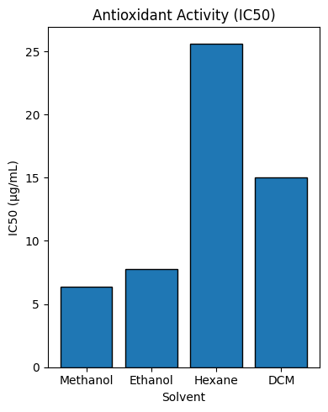
Among the tested extracts as shown in Table 4, the methanolic extract exhibited the strongest antioxidant activity with the lowest IC₅₀ value (6.34 µg/mL), followed closely by the ethanolic extract (7.76 µg/mL). The dichloromethane extract showed moderate activity (15 µg/mL), whereas the hexane extract displayed comparatively weaker antioxidant potential (25.63 µg/mL). The higher activity observed in methanol and ethanol extracts may be attributed to their higher total phenolic and flavonoid contents, which are known to contribute significantly to free radical scavenging ability.

Figure 2. Antioxidant activity (IC₅₀)

3.6. Antimicrobial Test
The antimicrobial activity of different solvent extracts was evaluated against Staphylococcus aureus, Shigella sonnei, Klebsiella pneumoniae, and Escherichia coli using zone of inhibition measurements. Among the tested extracts, ethanol showed the strongest and most consistent antibacterial activity, producing inhibition zones of 12 mm, 11 mm, 10 mm, and 10 mm respectively against the four bacteria. Methanol extracts demonstrated moderate activity (10–9 mm range), while hexane extracts exhibited comparatively weak effects, particularly against Shigella sonnei (5 mm). Dichloromethane (DCM) extracts displayed selective activity, with notable inhibition against Staphylococcus aureus (12 mm) but lower effects on the remaining organisms (7–8 mm). The positive control, neomycin, produced substantially larger inhibition zones (19–21 mm), confirming assay validity, whereas the negative control (DMSO) showed no inhibition, indicating that antimicrobial effects were due to the extracts rather than the solvent. Overall, ethanol proved to be the most effective extraction solvent for isolating antibacterial compounds from the tested material.

Table 5. Antimicrobial activity of Terminalia arjuna bark extracts (Zone of inhibition in mm)
Solvent Extract | Staphylococcus aureus | Shigella sonnei | Klebsiella pneumoniae | Escherichia coli
Methanol | 10mm | 07 mm | 09 mm | 09mm
Ethanol | 12mm | 11mm | 10 mm | 10mm
Hexane | 8 mm | 5 mm | 10 mm | 08mm
DCM | 12mm | 07mm | 08 | 08mm
Positive Control (Neomycin) | 19 mm | 21mm | 19 mm | 19mm
Negative Control (DMSO) | 0 | 0 | 0 | 0
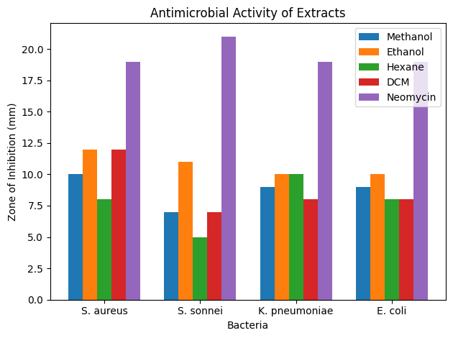

Figure 3: Antimicrobial test

3.7 Gas Chromatography -Mass Spectrometry Analysis (GC-MS) Analysis
The GC–MS chromatogram of the ethanol extract (Figure 4) demonstrated a diverse profile of phytochemical constituents, as presented in Table 6. The early retention time region (RT 7.933–13.148 min) was dominated by monoterpene hydrocarbons and oxygenated monoterpenes, including α-pinene, limonene, 1,8-cineole (eucalyptol), linalool, terpinen-4-ol, and α-terpineol. These compounds are commonly associated with essential oils and contribute to the characteristic aroma and biological activities of aromatic and medicinal plants. Minor peaks observed in the mid-retention region (approximately 18–20 min) were attributed to sesquiterpenes such as caryophyllene, which are known for their anti-inflammatory and antioxidant properties.

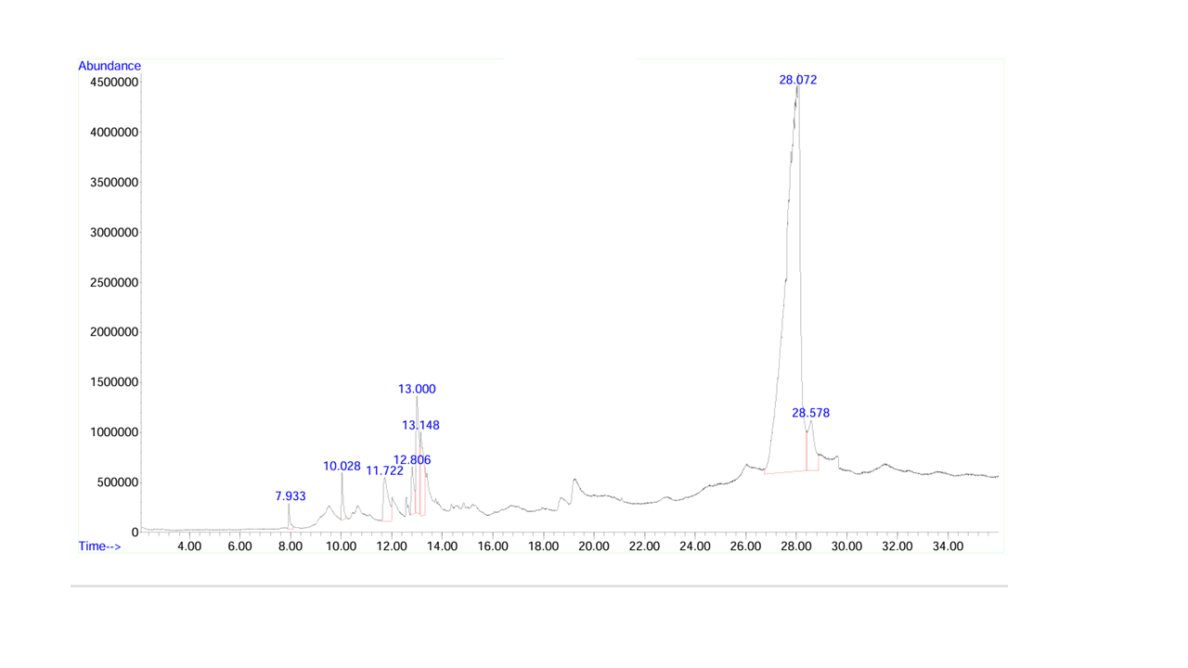
Figure 4. GC/MS Chromatogram of Ethanol Extract
A major peak was recorded at RT 28.072 min, corresponding to hexadecanoic acid (palmitic acid), indicating it as one of the predominant constituents of the extract. Another significant compound identified at RT 28.578 min was phytol, a diterpene alcohol derived from chlorophyll degradation. In the late retention time region (30–32 min), unsaturated fatty acids such as linoleic acid and oleic acid were detected. Overall, the GC–MS analysis revealed that the extract is rich in terpenoids and fatty acid derivatives, which may contribute to its potential biological and pharmacological activities.
Table 6: Phytochemical Constituents Identified in the Ethanol Extract by GC–MS Analysis
Peak RT (min) | Peak Intensity (Relative) | Compounds | Chemical Class | Common Occurrence in Plants
7.933 | Small | α-Pinene | Monoterpene hydrocarbon | Essential oils (pine, herbs)
10.028 | Medium | Limonene | Monoterpene hydrocarbon | Citrus, aromatic plants
11.722 | Medium | 1,8-Cineole (Eucalyptol) | Oxygenated monoterpene | Eucalyptus, herbs
12.806 | Medium | Linalool | Monoterpene alcohol | Floral plants
13.000 | Strong | Terpinen-4-ol | Monoterpene alcohol | Tea tree, herbs
13.148 | Medium | α-Terpineol | Monoterpene alcohol | Many essential oils
~18–20 (small humps visible) | Low | Caryophyllene | Sesquiterpene | Spices, clove, leaves
28.072 (Major peak) | Very High | Hexadecanoic acid (Palmitic acid) | Fatty acid | Almost all plants
28.578 | High | Phytol | Diterpene alcohol | Chlorophyll breakdown product
30–32 (broad region) | Medium | Linoleic acid / Oleic acid | Unsaturated fatty acids | Seed oils

  - Statistical Analysis
All experimental data were expressed as mean ± standard deviation (SD) of three independent replicates. Statistical evaluation using one-way ANOVA followed by appropriate post-hoc tests revealed significant differences among the solvent extracts (p < 0.05). The analysis confirmed that variations in phytochemical content, antioxidant activity, and antimicrobial effects between extracts were statistically significant and not due to random variation.

4. Discussion
The phytochemical composition, antioxidant activity, antimicrobial activity, and GC-MS profiling of the extracts of the bark of the plant Terminalia arjuna using solvents with varying polarities were systematically evaluated in the current investigation. The overall findings suggest that extraction solvent type has a significant implication on the phytochemical yield, compositional profile, and subsequent bioactivities. Extraction efficiencies and the ability to extract a broader range of bioactive constituents was found with polar solvents like methanol and ethanol as compared to non-polar solvents such as hexane and dichloromethane, which supports the evidence in the previous literature that solvent polarity plays a central role in phytochemical recovery (Larit et al., 2016).
Preliminary phytochemical reconnaissance surveys indicated that in the ethanol and methanol extracts the most common were phenolic, flavonoid glycoside terpenoid and alkaloid compounds. These qualitative results were supported with quantitative measurements of total phenolic content (TPC) and total flavonoid content (TFC); highest concentrations were observed in the ethanolic preparation (329 mg GAE -1 and 129 mg QE -1, respectively). It is already established that a high concentration of phenolics and flavonoids is strictly correlated with the high antioxidant activity due to their ability to give electrons and remove free radicals (Erizal et al., 2024; Sabaragamuwa and Perera, 2023).
In line with these findings, the DPPH radical -scavenging assay showed that the methanol and ethanol extracts had strong antioxidant properties as indicated by their relatively low values of IC 50. The correlation between the phenolic content, on the one hand, and the antioxidant capacity, on the other, is also positive, which is why the earlier findings that polyphenolic compounds are the main participants of oxidative stress alleviation also receive support (Roy et al., 2022). On the other hand, the hexane extract, which had lower phenolic and flavonoid concentration, had a lesser antioxidant potential, which highlights the importance of the polar phytochemicals in free-radical-scavenging activities.
The phytochemical and antioxidant data are further supported by antimicrobial tests. The ethanolic extract always showed strong antibacterial activities against Staphylococcus aureus, Shigella sonnei, Klebsiella pneumoniae, and Escherichia coli but the hexane extract had relatively weak antibacterial activity. The antimicrobial activity of the ethanol extract is highly pronounced, which could be attributed to their repertoire of phenols, flavonoids, and terpenoids, which are reported to damage microbial membranes, interrupt enzyme pathways, and nucleic-acid production (Roy et al., 2022). The absence of the negative control is a reason to believe that the bioactivity is a result of the plant constituents and not the solvent.
The molecular-level verification of the bioactive constituents in the ethanolic extract was conducted by GC 929 -MS analysis. Qualitative phytochemical screening is supported by the identification of monoterpenes (a -pinene), limonene, 1,8 -cineol, linalool, terpinen -4 -ol, a -terpineol), a sesquiterpene (caryophyllene), fatty acids (hexadecanoic, linoleic and oleic acids), and phytol. It has been noted by many researchers that these compounds possess antioxidant, anti-inflammatory, and antimicrobial effects (Mzali et al., 2025; Uthirapathy and Ahamad, 2019). Based on this, GC-MS profiling is used in conjunction with the traditional phytochemical methods to provide a structural identity of the volatile and semi-volatile compounds, thus enhancing the persuasiveness of the results.
Altogether, the summed up analysis of extraction yields, phytochemical screening, quantitative TPC and TFC measurements, antioxidant analyses, antimicrobial analysis, and GC-MS profiles provides a detailed, scientifically supported profile of the bark of the plant Terminalia arjuna. The one-way analysis of variance and post-hoc comparisons showed the statistically significant differences (p < .05) between the solvent extracts in terms of extraction yield, phytochemical content, antioxidant capacity, and antimicrobial activity, which rules out the possibility of random variation as the cause of observed differences. The research supports the traditional medicinal applicability of the herb and validates ethanol as an effective solvent in the purification of biologically active components (Rajaram et al., 2024). Further studies should focus on bioassay-directed fractionation, separation of the active compounds one at a time and mechanistic pharmacological studies to further ratify its medicinal usefulness.
Conclusion
This paper proves the fact that the solvent polarity has a determining impact on the extraction efficiency, phytochemical profile, and bioactivity of the extracts of the bark of the plant Terminalia arjuna. Ethanol was found to be the most effective of the solvents that were tested and it was also associated with high levels of antioxidant and antimicrobial activities. The antioxidant activity of the methanolic extract was also very high with a relatively low bioactivity being exhibited by extracts prepared using hexane and dichloromethane. Qualitative phytochemical studies identified the existence of a variety of bioactive secondary metabolites, GC-MS profiling provided in-depth identification of volatile and semi-volatile products, including terpenoids, fatty acids, and phytol derivatives. The combination of biochemical and instrumental data confirms the traditional medicinal value of the herb and reflects the potential of the herb as a source of therapeutic agents in nature. The results support the use of ethanolic extraction as the best method of extracting bioactive compounds in a manner that will increase the recovery of bioactive compounds and forms a solid scientific basis on future studies that aim at isolating, clarifying, and evaluating the active ingredients of potential drug development.
References
Aneja, K. R., Sharma, C., & Joshi, R. (2012). Antimicrobial activity of Terminalia arjuna Wight & Arn.: An ethnomedicinal plant against pathogens causing ear infection. Brazilian Journal of Otorhinolaryngology, 78(1), 68–74. https://doi.org/10.1590/s1808-86942012000100011
Bouzidi, A., Azizi, A., Messaoudi, O., Abderrezzak, K., Vidari, G., Hellal, A. N., & Patel, C. N. (2023). Phytochemical analysis, biological activities of methanolic extracts and an isolated flavonoid from Tunisian Limoniastrum monopetalum (L.) Boiss: An in vitro and in silico investigations. Scientific Reports, 13(1), 19144. https://doi.org/10.1038/s41598-023-46457-6
Chandra, S., Khan, S., Avula, B., Lata, H., Yang, M. H., ElSohly, M. A., & Khan, I. A. (2014). Assessment of Total Phenolic and Flavonoid Content, Antioxidant Properties, and Yield of Aeroponically and Conventionally Grown Leafy Vegetables and Fruit Crops: A Comparative Study. Evidence-Based Complementary and Alternative Medicine, 2014(1), 253875. https://doi.org/10.1155/2014/253875
Dikamu, M., Ezez, D., Birhanu, H., Mamo, A., & Tefera, M. (2025). Analysis of phytochemical constituents using GC–MS, evaluation of antioxidants and antibacterial activities of Maerua oblongifolia root bark extracts. Discover Applied Sciences, 7(5), 417. https://doi.org/10.1007/s42452-025-06939-w
Erizal, E., Hanafiah, M., Mudatsir, M., Helmi, T., & Yusuf, M. (2024). Determination of Total Phenolic Content and Total Flavonoid Content of Nutmeg Flesh (Myristica Fragrans Houtt) Ethanol Extract from South Aceh Province. IOP Conference Series: Earth and Environmental Science, 1297(1), 012053. https://doi.org/10.1088/1755-1315/1297/1/012053
Larit, F., León, F., Jasika-Misiak, I., Wieczorek, P. P., & Cutler, S. J. (2016). Phenolic Content And Antioxidant Activity Of Cytisus Villosus And Hypericum Afrum Extracts. Planta Medica, 82(05), PB21. https://doi.org/10.1055/s-0036-1578669
Latif, R., & Nawaz, T. (2025). Medicinal plants and human health: A comprehensive review of bioactive compounds, therapeutic effects, and applications. Phytochemistry Reviews. https://doi.org/10.1007/s11101-025-10194-7
Mandal, S., Patra, A., Samanta, A., Roy, S., Mandal, A., Mahapatra, T. D., Pradhan, S., Das, K., & Nandi, D. K. (2013). Analysis of phytochemical profile of Terminalia arjuna bark extract with antioxidative and antimicrobial properties. Asian Pacific Journal of Tropical Biomedicine, 3(12), 960–966. https://doi.org/10.1016/S2221-1691(13)60186-0
Mzali, A., Amalich, S., El-Guourrami, O., Benzeid, H., Mahraz, M. A., Cherkani-Hassani, A., Benkhnigue, O., & Doukkali, A. (2025). Phytochemical Profiling, GC-MS Analysis, Antioxidant, and Antimicrobial Activities of Cannabis sativa L. var. Beldia: A Comparative Study of Four Extraction Methods. Tropical Journal of Natural Product Research, 9, 1402–1422. https://doi.org/10.26538/tjnpr/v9i4.7
Nayab, A., Khan, A., Marrium, F., Waqas, M., Bashir, A., Abbas, A., Yousaf, N., Shaheen, S., & Perveen, F. (2023). Recent Advances, Innovative Aspects, Botanical Description of Therapeutic Medicinal Plants and Different Applications. Haya: The Saudi Journal of Life Sciences, 8(04), 44–50. https://doi.org/10.36348/sjls.2023.v08i04.001
Rajaram, V., Namasivayam, A., Shanmugam, R., Mahendra, J., Sudhakar, U., Munusamy, T., & Subbiah, U. (2024). Terminalia arjuna: An overview of its magical properties. Bioinformation, 20(12), 2080.
Roy, A., Khan, A., Ahmad, I., Alghamdi, S., Rajab, B. S., Babalghith, A. O., Alshahrani, M. Y., Islam, S., & Islam, Md. R. (2022). Flavonoids a Bioactive Compound from Medicinal Plants and Its Therapeutic Applications. BioMed Research International, 2022(1), 5445291. https://doi.org/10.1155/2022/5445291
Sabaragamuwa, R., & Perera, C. O. (2023). Total Triterpenes, Polyphenols, Flavonoids, and Antioxidant Activity of Bioactive Phytochemicals of Centella asiatica by Different Extraction Techniques. Foods, 12(21). https://doi.org/10.3390/foods12213972
Shu, F., Hu, Y., Sarsaiya, S., Jin, L., Yang, X., Liu, F., Zhu, J., Chen, G., & Chen, J. (2025). Plant-derived extracellular vesicles quality control: Key process progress and future research directions​. Discover Nano, 20(1), 233. https://doi.org/10.1186/s11671-025-04399-0
Tahir, H., Akhtar, M. N., Bishoyi, A. K., Sanghvi, G., Rasheed, M., Afzaal, M., Imran, A., Saeed, F., Khare, N., Ahmed, F., Sahni, O., Ateeq, H., Islam, F., & Kinki, A. B. (2025). Nutritional Composition, Phytochemical Profile, Extraction Methods of Bioactive Components, and Health Benefits of Terminalia Arjuna Bark. eFood, 6(2), e70038. https://doi.org/10.1002/efd2.70038
Uthirapathy, S., & Ahamad, J. (2019). PHYTOCHEMICAL ANALYSIS OF DIFFERENT FRACTIONS OF TERMINALIA ARJUNA BARK BY GC-MS. International Research Journal Of Pharmacy, 10, 10. https://doi.org/10.7897/2230-8407.10018
Vijayalakshmi, R., Ambalavanan, N., & Rajeshkumar, S. (2023). Antimicrobial and anti-inflammatory activity of Terminalia arjuna. Bioinformation, 19(2), 184.
Wawrosch, C., & Zotchev, S. B. (2021). Production of bioactive plant secondary metabolites through in vitro technologies—Status and outlook. Applied Microbiology and Biotechnology, 105(18), 6649–6668. https://doi.org/10.1007/s00253-021-11539-w
Yadav, R. P., Huo, C., Budhathoki, R., Budthapa, P., Bhattarai, B. R., Rana, M., Kim, K. H., & Parajuli, N. (2024). Antibacterial, Antifungal, and Cytotoxic Effects of Endophytic Streptomyces Species Isolated from the Himalayan Regions of Nepal and Their Metabolite Study. Biomedicines, 12(10). https://doi.org/10.3390/biomedicines12102192

