Phytocompounds Profiling and Assessment of the Antioxidant and Anti-diabetic Potentials of Methanol Extracts of Garcinia kola (Heckel)

.
ABSTRACT

Aims: The main aim of this study was to described the phytochemical constituents, antioxidant and anti-diabetic activities of methanol extracts of the leaf, stem and root of Garcinia kola (Heckel).
Study design: The study was designed to evaluate the phytochemical constituents, antioxidants and anti-diabetic potentials of methanol extracts of the leaves, stem bark and root bark of Garcina kola (Heckel) grown in Nigeria.
Place and Duration of Study: Fresh leaves, stem barks and root barks of G. kola were collected from a location in Abeokuta, Ogun state Nigeria, in June 2024.
Methodology: Extract were obtained from the air-dried leaves, stem barks and root barks of Garcina kola by maceration in methanol for 48 h. Afterwards the various extracts were concentrated in vacuo. Phytochemical screenings were analysed by conventional methods while the various phytocompounds were determined by suing gas chromatography-mass spectrometry technique. The antioxidant activity of the various extracts was tested by using 2,2-diphenyl-1-picrylhydrazyl (DPPH) assays. The antidiabetic potential was assessed by evaluating the inhibitory effect of the extracts on the activities of α-amylase and α-glucosidase enzymes.

Results: The main compounds identified by GC/MS in the leaf extract were hexadecanoic acid (15.28%), 2-butenedioic acid (14.23%), and 6-hydroxy-4,4,7a-trimethyl-5,6,7,7-tetrahydrobenzofuran-2(4H)-one (12.69%). The stem bark consists mainly of Phenol (20.88%), 1-propanone (18.06%) and 9-octadecenoic acid (11.21%), while ethyl 2-(5-methyl-5-tetrahydrofuran-2-yl) propan-2-yl carbonate (13.77%), phenol (13.34%), decanoic acid (8.79%) and hexadecanoic acid (7.74%) were the main compounds of the root extract. At a concentration of 100 µg/mL, the leaves, stem barks and root barks exhibited 80 ±0.01%, 82 ±0.00% and 79 ±0.01% DPPH radical scavenging activity. All the studied Garcina extracts displayed IC₅₀ value of 3.7 µgmL⁻¹, when compared with Ascorbic acid which exhibited IC₅₀ value of 2.5 µgmL⁻¹ against DPPH. The inhibitory potency of G. kola extracts against α-amylase activity were concentration dependent. All extracts showed higher potency at 100 µg/mL, with inhibitory percentages of 93 ±0.00 (leaves), 91 ±0.01 (stem bark) and 89 ±0.01 (root barks). At a concentration of 100 µg/mL, all the extracts displayed good inhibition of α-glucosidase enzyme activity at percentages of 75 ±0.00, 74 ±0.01 and 72 ±0.01, respectively.
The extracts displayed almost equal and similar activity against the inhibition of α-Amylase enzymatic activity, with IC₅₀ values between 5.50 µgmL⁻¹ - 5.80 µgmL⁻¹. While Acarbose exhibited IC₅₀ value of 1.70 µgmL⁻¹ towards α-Glucosidase enzyme, the extracts showed values ranging from 4.80- 5.00 µgmL⁻¹ α-Glucosidase enzyme.

Conclusion: G. kola can be assumed to contains phytochemicals with promising antidiabetic and antioxidant activities which can serve as a source of future lead drugs for combating oxidative stress related diseases.

Keywords: Garcina kola, Phytochemicals, antioxidant activity, anti-diabetic activity

1. INTRODUCTION

Garcinia kola (Clusiaceae family), or bitter kola, is a tropical flowering plant found in western and central Africa, produces large orange fruits and brown, nut-like seeds. The seed plays a very important role in African ethno-medicine, in the treatment of coughs, colds, hoarseness of voice, liver diseases, and as aphrodisiac. The seeds have been formulated into tablets and are also used in many herbal preparations, either singly or in combination with other plants. Hepa-Vital Tea, a blend of G. kola and Combretum micranttum, and Hangover Tonic, comprising kolaviron and Cola nitida, are manufactured and marketed as phytomedicines (Farombi, 2011).
Garcinia kola oil inhibited the microbial growth of bacterial and fungal strains responsible for spoiling of food products (Doh et al., 2023). The antioxidant and hepatoprotective properties of the seed have been associated with the isolated bioflavonoid complex kolaviron (Farombi, 2011). Extracts and compounds isolated from the plants displayed potent antimicrobials activities (Seanego and Ndip, 2012; Ineta et al., 2018). A methanol extract displayed inhibition of Staphylococcus aureus (MIC 250 µg/mL) and cytotoxicity (MIC 33 µg/mL) in the brine shrimp lethality assay (Nwadike and Oyetunji, 2024). According to a finding, bitter kola has no negative effects on the Wistar rats' testes, especially when taken in low doses (Chukwudi-Emelike et al., 2016). A previous investigation revealed that seeds of G. kola are very efficient as antioxidant, antimicrobial, antidiabetic, antihypertension, anti-analgesic, and anti-inflammatory. The study also found that too much consumption of the seeds caused low fertility and toxicity (Dogara et al., 2022). The in vivo antitrypanosomal activity of a methanolic extract of G. kola nuts on rats can be demonstrated (Rufa’I et al., 2023). The anti-ulcer and antioxidant effects of G. kola was described recently (Fokou et al., 2024). Garcinia kola is used in treatment of numerous diseases, including gastric disorders, bronchial diseases, fever, malaria and is used to induce a stimulating and aphrodisiac effect. The plant is now attracting considerable interest as a possible source of pharmaceutically important drugs (Ogbadoyi et al., 2011; Tauchen, et al., 2023)
The isolation of flavonoid apigenin and biflavone, kolaflavanone has been described from the plant (Iwu and Igboko, 1982). G. kola contains various other chemicals alongside kolaviron, including garcinianin, kolanone, gakolanone, garcinoic acid, garcinal, garcifuran A and B, and garcipyran (Akoro et al., 2020). Saturated fatty acids (myristic, pentadecanoic, palmitic, margaric, stearic, arachdic, behemic); monosaturated fatty acids (myristoleic, palmitoleic (trans), palmitoleic (cis), oleic (cis), vaccenic (cis)]; polysaturated fatty acids (linoleic, eiscosadienoic, polyenes) and essential amino acids (arginine, aspartic acid, glutamic acid, serine, histidine, proline, glycine and alanine were reported to be found in G. kola seed and hulls (Afolabi et al., 2006). The results from the GC-MS analysis of the methanolic extract of G. kola ((Rufa’I et al., 2023) revealed the presence of hexanedioic (adipic) acid (45.3%), tetrasiloxane (15.4%), and pentanone (6.60%). A phytochemical analysis (Penduka et al., 2014) identified (3β)-9,19-cyclolanost-24-en-3-ol (37.707%), (3β)-9,19-cyclolanostan-3-ol,24-methylene (19.464%), and 2-piperidinecarboxylic acid,1-(trimethylsilyl)-,trimethylsilyl ester (9.148%) as major compounds, while another fraction indicated the presence of (3β)-9,19-cyclolanost-24-en-3-ol (14.376%), 9-octadecenoic acid, ethyl ester (13.615%), hexadecanoic acid, ethyl ester (8.403%) and (3β)-9,19-cyclolanostan-3-ol,24-methylene (7.861%). An investigation found that G. kola oil contains 1,2-benzenediol, 3,5-bis (1,1-dimethyl ethyl)- and phytoacetate, which significant anticancer action (Folayan et al., 2023). The constituents isolated from the seed include xanthones, benzophenones, and kolaviron which have shown hepatoprotection activity (Farombi, 2011). Column chromatography separation of extracts from the seeds (Seanego and Ndip, 2012) revealed the isolation of linoleic acid (26.60%), hexadecanoic acid (25.07%) and 9-octadecenoic acid (24.81%) from a fraction. Another fraction of the extract produced an abundant of 1,2-benzenedicarboxylic acid, a carboxylic fatty acid ester (100%), while the third fraction was rich in 2,3-dihydro-3,5-dihydroxy-6-methyl (24.16%), 1- butanol (15.72%) and 9-octadecenamide (13.82%). These chemical compounds which are volatiles were majorly responsible for the observed biological activities of the extract (Seanego and Ndip, 2012).
The composition of G. kola essential oil (Oloruntola, 2024) comprised mainly of hexadecanoic acid (16.24%) and linolenic acid (42.86%). The composition of the volatiles isolated by distillation-extraction from an oleoresin from sample of seeds of G. kola Heckel grown in Nigeria (Onayade et al., 2013) was analysed and found to contained mainly of 6-methylhept-5-en-2-one (16%), (E,E)-farnesol (14%), 5-ethenyldihydro-5-methylfuran-2-one (=lavender lactone, 12%) and linalol (11%). The leaf essential oil obtained by hydrodistillation (Okhale et al., 2016) was shown to dominated by citronellic acid (48.3%), dihydropseudoionone (5.12%), α-ionone (4.38%), and 3- buten-2-one (3.25%). The essential oil also exhibited antimicrobial activities against wide range of microbes. A previous result showed that the essential oil of G. kola exhibited stronger antioxidant activity against DPPH with the scavenging rate of 94.19% at 0.2 mg/mL, as well as potent inhibition against gastric cancer, lung cancer (A549) and Hela cell lines with the inhibitions of 96.397%±0.929, 98.005%±0.513 and 94.77±2.09 respectively at 8.3 mg/mL, while the oil exhibited moderate inhibition against the human breast carcinoma cells (MCF-7) with the inhibition of 59.257%±4.544 at 8.3mg/mL (Olagoke. Et al., 2021). It is well noted that the compositional patterns of the essential oils from different parts of G. kola differes from each other.
In continuation of our extensive research aimed at the characterization of the chemical constituents and biological activities of Nigerian medicinal plants (Avoseh et al., 2024; Ogunwande et al., 2025), we report the results of our investigation on the chemical constituents, antioxidant and anti-diabetic properties of methanol of leaves, stem bark and root bark of G. kola grown in Nigeria. Nigeria is endowed with many medicinal plants which are yet to be exploited for their medicinal values. Such plant has been shown to possess scavenging activity anti-inflammatory potentials (Amos-Tautua et al., 2025).

2. material and methods

All reagents used in this research are of analytical grade.

2.1 Plant sample collection and identification
Fresh leaves, stem barks and root barks of G. kola were collected in Abeokuta, Ogun state Nigeria, in June 2024. The plant sample was identified and authenticated at the Botany Department Herbarium at the University of Lagos, Akoka, Lagos, Nigeria, by Dr. Nodza G.I. A voucher specimen number LUH: 9058 was given and deposited at the herbarium.

2.2 Extraction of plant samples for screening
Fifty grams (50 g) of pulverized and sieved leaves, stem barks and root barks were weighted and macerated separately in adequate amount of 99.9% methanol for 48 h in separating funnel. Then, each funnel was shake for 15 min at intervals, of which methanolic extract was then decanted into a conical flask and covered with a foil. The extract was filtered using Buchner funnel to get pure filtrate and concentrated using rotary evaporator at 64℃ and then dried to get the crude concentrate of each sample. The crude concentrates were stored in separate sampling bottles until further analysis.

2.3. DPPH radical scavenging assays
The antioxidant activity of the different samples was assayed using the 2,2-diphenyl-1-picrylhydrazyl (DPPH) assays (Baliyan et al., 2022). 0.1 mM solution of DPPH in ethanol was prepared as required. Thereafter, 1mL of the solution was added to 1 mL of chosen extract in distilled water at different concentrations (25-100 μgmL⁻¹). The mixture was shaken vigorously and allowed to stand at room temperature for 30 min. Then the absorbance was measured at 517 nm by using a UV-Visible Spectrophotometer. Lower absorbance of the reaction mixture indicated higher free radical scavenging activity. The percent DPPH scavenging effect was calculated using the following equation:
DPPH Scavenging effect (%) = [(A₀ – A₁)/A₀] X 100
where A₀ was the absorbance of the control and A₁ was the absorbance of the sample or extract.

2.4 α-Amylase inhibition assay
α-amylase inhibitory activity of extracts was carried out according to the standard method with minor modification (Oyedemi et al., 2021). In a 96-well plate, reaction mixture containing 50 µL phosphate buffer (100 mM, pH = 6.8), 10 µL α-amylase (2UmL⁻¹), and 25 µL of varying concentrations of extract (25, 50, 75 and 100 μgmL⁻¹) was pre-incubated at 37˚C for 20 min. Then, the 20 µL of 1% soluble starch in 100 mM phosphate (buffer pH 6.8) was added as a substrate and incubated further at 37˚C for 30 min, after which 100 µL of the dinitrisalicyclic acid (DNS) colour reagent was added, incubated in boiling water bath for 10 min and then cooled to room temperature. After cooling, the reaction mixture was diluted with distilled water. The absorbance of the resulting mixture was measured at 540 nm. Acarbose at several concentrations (25 -100 μgmL⁻¹) was used as standard. The standard was set up in parallel as control and each experiment was carried out in triplicates. The results were expressed as percentage inhibition, which was calculated using the formula.
(% inhibition) = [(A₀ – A₁)/A₀] X 100.
where A₀ was the absorbance of the control and A₁ was the absorbance of the sample or extract.
2.5 α-Glucosidase inhibitory assay
α-glucosidase inhibitory activity of the extract was carried out using standard method with slight modification (Telagan and Hullatti, 2015). In a 96-well plate, reaction mixture containing 50 μL phosphate buffer (100 mM, pH = 6. 8), 10 μL α-glucosidase (1 UmL⁻¹), and 25 μL of varying concentrations of the extract (25, 50, 75 and 100 μgmL⁻¹) was pre-incubated at 37°C for 15 min. Then, 20 μL p-nitrophenol (5 mM) solution was added as a substrate and incubated further at 37°C for 20 min. The reaction was halted by adding 50 μL Na₂CO₃ (0.1 M). The absorbance of the released p-nitrophenol was measured at 405nm. Acarbose at various concentrations (25, 50, 75 and 100 μgmL⁻¹) was included as a standard. Buffer solution was used as the blank instead of the substrate. The enzyme solution without plant extracts or acarbose served as the control and each experiment was performed in triplicate. The enzyme inhibition activity results were expressed as percentage inhibition, which was calculated using the formula:
% Inhibition= [(A₀-A₁)/A₀] x 100
where A₀ was the absorbance of the control and A₁ was the absorbance in the presence of the standard (acarbose) sample or extract.

2.6. Calculation of IC₅₀ for antioxidant, α-Amylase inhibition and α-Glucosidase inhibitory assay
The IC₅0 for the biological studies was determined according to an established procedure as reported previously (Giwa-Ajeniya et al., 2026).

2.6 Gas chromatography-mass spectrometry (GC-MS) analysis
GC-MS analysis of the methanolic extracts of G. kola was performed using an Agilent 5977B GC/MSD system coupled with Agilent 8860 auto-sampler, a Gas Chromatograph interfaced to a Mass Spectrometer (GC-MS) equipped with an HP-5MS fused a capillary column (30 × 0.25μm ID × 0.25 μm df). For GC-MS detection, an electron ionization system was operated in electron impact mode with ionization energy of 70 eV. Helium gas (99.999%) was used as a carrier gas at a constant flow rate of 1 mLmin⁻¹, and an injection volume of 1μl was employed (a split ratio of 10:1). The injector temperature was maintained at 250 °C, the ion-source temperature was 200 °C, and the oven temperature was programmed from 110 °C (isothermal for 2 min), with an increase of 10 °C/min to 200°C, then 5 °Cmin⁻¹ to 280°C, ending with a 9 min isothermal at 280 °C. Mass spectra were taken at 70 eV; a scan interval of 0.5 s and fragments from 45 to 450 Da. The solvent delay was 0 to 3 min, and the total GC-MS running time was 36 min.
2.6.1. Identification of phytocomponents
Interpretation of each mass spectrum from GC-MS was conducted using the database of National Institute Standard and Technology (NIST) and National Center for Biotechnology Information. The spectrum of the unknown components was compared with the spectrum of known components stored in the NIST library (NIST, 2018).

2.7 Statistical analysis
All the measurements were carried out in triplicate and the results are expressed in terms of mean ± standard deviation was calculated using Microsoft Excel software respectively.

3. results and discussion

3.1 Quantitative phytochemical analysis
The phytochemical quantifications of alkaloids, flavonoids, cardiac glycosides, saponins, tannins, terpenoids, steroids, reducing sugars and phenols from G. kola are displayed in Table 1. The leaves displayed high total cardiac glycosides (36.19 mg/100g) and phenolic contents (39.81 mg/100g), while the root had the highest amounts of steroids (30.57 mg/100g). The terpenoids were present in higher quantity in the stem barks (28.10 mg/100g). However, saponins and alkaloids were detected in the root and stem barks, while terpenoids was also absent in the root bark.
Table 1. Quantification of phytochemicals of extract from Garcinia kola.
Phytochemicals (mg/100g) | Leaves | Root barks | Stem barks
Tannins | 28.96 ± 0.01 | 23.80 ± 0.01 | 26.13 ± 0.01
Saponins | 30.36 ± 0.00 | - | -
Alkaloids | 31.11 ± 0.01 | - | -
Terpenoids | 26.15 ± 0.02 | - | 28.10 ± 0.00
Cardiac glycosides | 36.19 ± 0.00 | 34.44 ± 0.01 | 37.30 ± 0.01
Flavonoids | 28.66 ± 0.01 | 30.20 ± 0.00 | 31.61 ± 0.00
Reducing sugars | - | 31.60 ± 0.01 | 32.44 ± 0.01
Steroids | 28.91 ± 0.00 | 30.57 ± 0.01 | 29.13 ± 0.01
Phenols | 39.81 ± 0.01 | 32.71 ± 0.01 | 35.91 ± 0.01
- Absent
The present results are in agreement with results of phytochemical analysis obtained from other parts of G. kola (Morabandza et al., 2013; Chukwudi-Emelike et al., 2016).

3.2 Antioxidant assays
Figure 1 displayed the in-vitro antioxidant potentials of methanol extract from G. kola leaves, stem barks and root barks. The percentage inhibition graphs for DPPH radical scavenging activity was concentrations dependent with lowest inhibition at 25 µg/ml and highest inhibition at 100 µg/ml. However, the standard (ascorbic acid) displayed a higher percentage inhibition at all tested concentration. The leaf sample displayed antioxidant activity of 41%, 52%, 63% and 80% at tested concentrations of 25, 50, 75 and 100 µg/mL, respectively. The root showed an increasing antioxidant activity of 38%, 50%,60% and 78% as concentration increases. The same progression was observed for the stem bark where the percentage inhibitions were 42%, 57%, 64% and 81%, respectively. Overall, the stem bark displayed higher antioxidant activity at all tested concentrations than other samples (Fig. 1). In addition, all the tested extracts displayed promising antioxidant activity with the same IC₅₀ of 3.70 µgmL⁻¹, when compared with Ascorbic acid which exhibited IC₅₀ value of 2.50 µgmL⁻¹ towards the tested extracts.

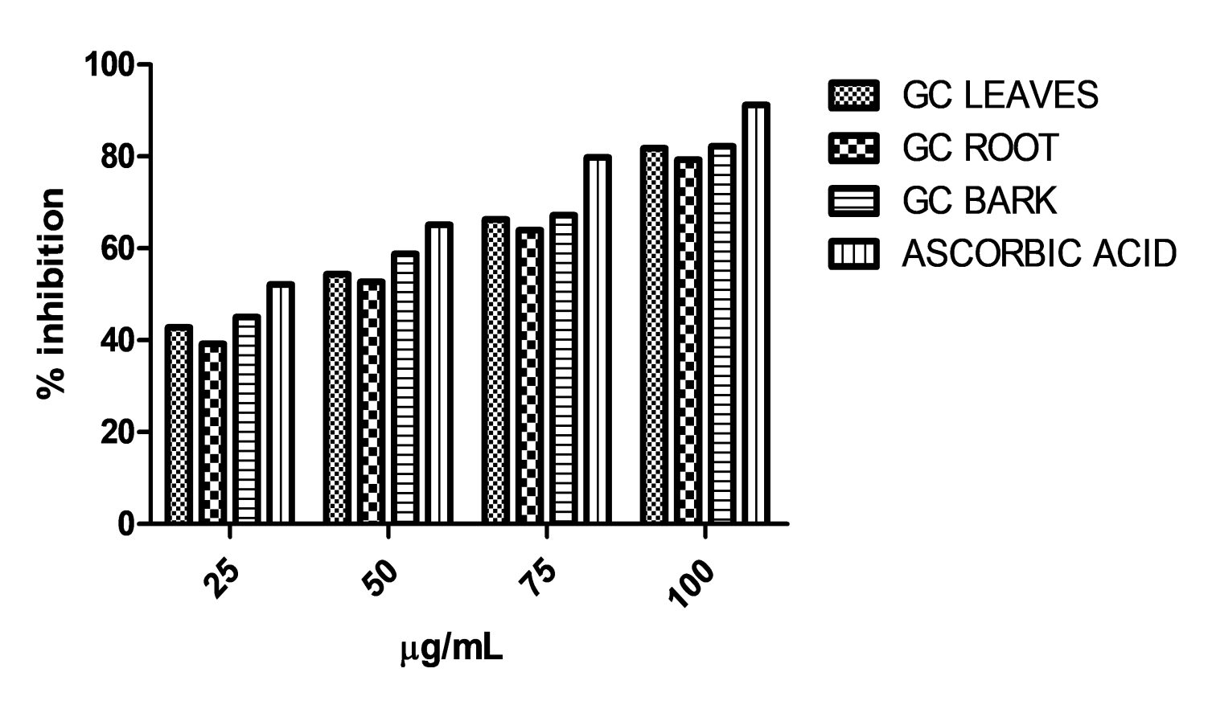
Fig. 1. 1,1-diphenyl-2-picylhydrazyl (DPPH) radicals scavenging activities of G. kola extracts

3.3 α-Amylase inhibition assay
Figure 2 shows the % inhibition of α-amylase by methanol extracts of G. kola. The graph is concentrations dependent with lowest inhibition at 25 µg/mL and highest inhibition at 100 μgmL⁻¹. As the concentration increases from 25-100 μgmL⁻¹, the percentage inhibitory potency of the methanol extract against α-amylase increases whereas the standard (acarbose) displayed higher inhibitory potency at all tested concentrations. At the concentration of 25 μgmL⁻¹ all the extracts showed percentage inhibition of α-amylase of less than 50%. Only the root barks displayed a percentage inhibition of 50% at the concentration of 50 μgmL⁻¹. At 75 µg/mL concentration, there are 62%, 59% and 61% inhibition of α-amylase activities by the leaves, root and stem barks. At 100%, however, the percentage inhibition increases to 83%, 81% and 82%, respectively.
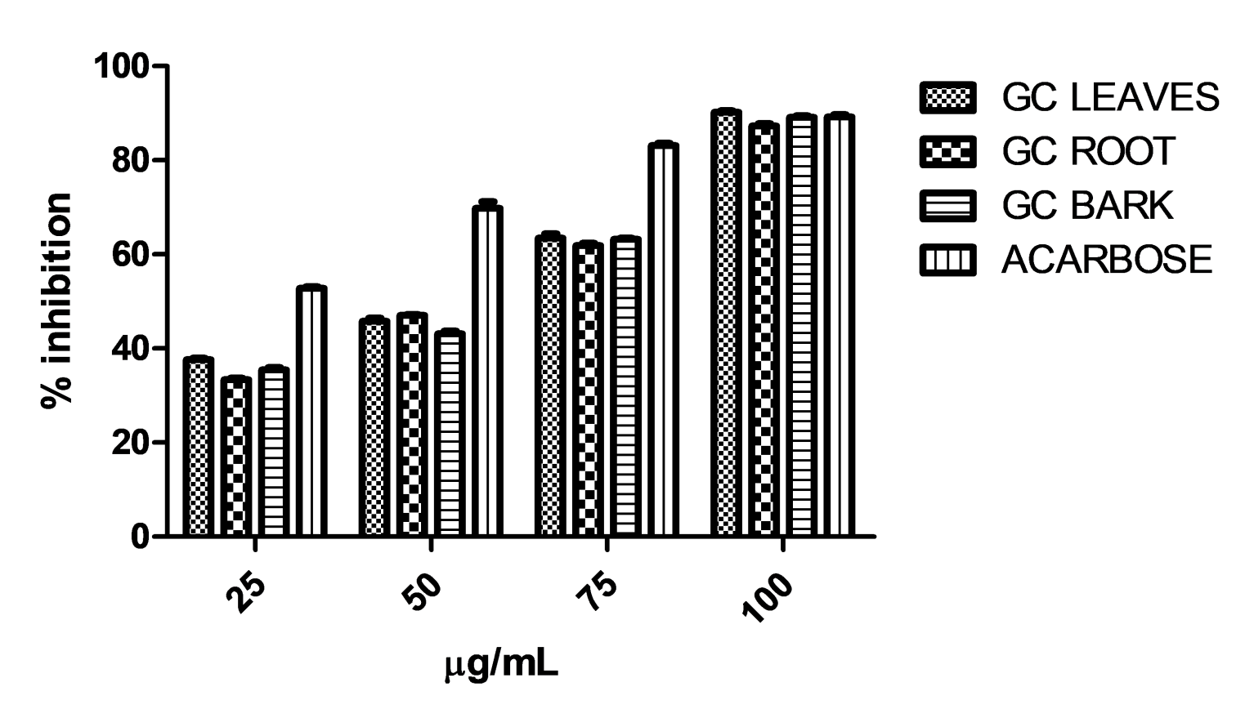
Fig. 2: Inhibitory potency of G. kola extracts against α-amylase activity.
The extracts displayed almost equal and similar activity against the inhibition of α-Amylase enzymatic activity. This was reflected in the observed IC₅₀ values of 5.60 µgmL⁻¹, 5.80 µgmL⁻¹ and 5.50 µgmL⁻¹ for the leaves, root bark and stem bark, respectively. These values are meaningful and are indication of anti-diabetic potential of G. kola methanol extracts when compared with Acarbose, the standard and positive control which displayed an IC₅₀ value of 4.20 µgmL⁻¹.

3.4. α-Glucosidase inhibitory activity
Fig. 3. shows the % inhibition of α-glucosidase by methanol extracts of G. kola. The graph is concentrations dependent with lowest inhibition at 25 μgmL⁻¹ and highest inhibition at 100 μgmL⁻¹. At higher concentrations of 75-100 µg/mL, ethanol extract displayed better inhibitory potency against α-glucosidase than the standard (acarbose) while at lower concentrations of 25-50 μgmL⁻¹, the standard displayed better activity against α-glucosidase than the methanol extracts.

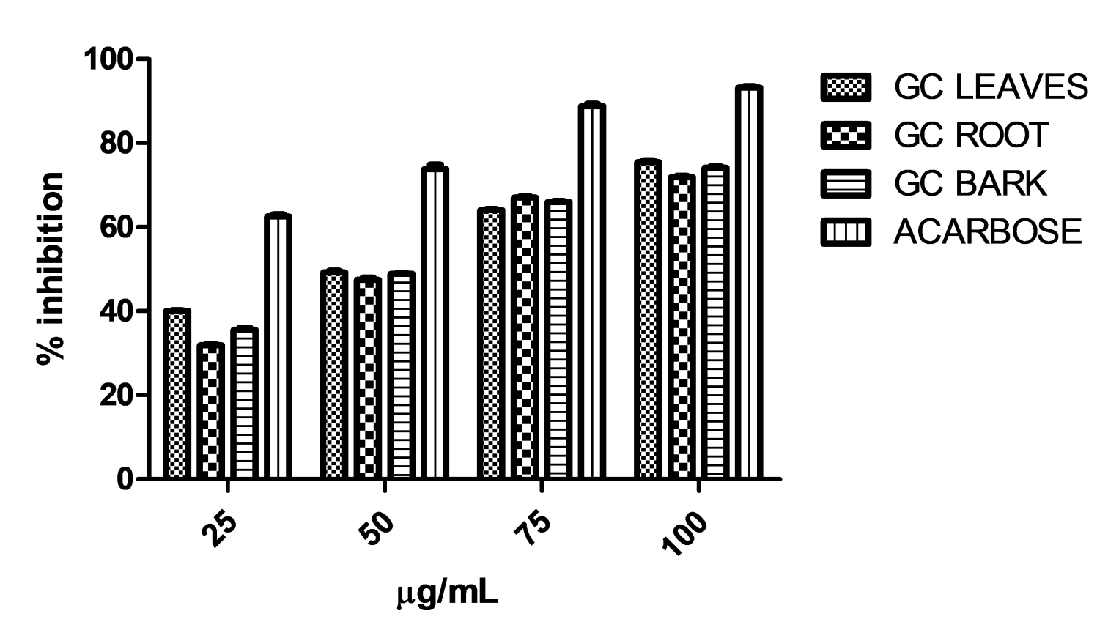
Fig. 3. Inhibitory potency of G. kola against α-glucosidase activity.
From Fig. 3., all the extracts were inactive against the activities of α-glucosidase enzyme at the concentration of 25 and 50 μgmL⁻¹, as the percentage inhibitions were less than 50% when compared with acarbose. At 75 μgmL⁻¹, the percentage inhibitory activities of the leaves, stem barks and root barks were 63%, 66% and 65%, respectively. The percentage inhibition increases to 73%, 72% and 70%, respectively, at 100 μgmL⁻¹. Both the Acarbose and the methanol extracts of G. kola exhibited some relatively higher activities against the action of α-Glucosidase enzyme. These activities are comparable with IC50 values of 4.80 µgmL⁻¹ (leaves), 5.00 µgmL⁻¹ (root bark), 4.90 µgmL⁻¹ (stem bark) and 1.70 µgmL⁻¹ (Acarbose)

3.5. Phytochemical compositions of the extracts

Table 2. Compounds identified from the methanol leaf extracts of G. kola
S/N | Name | RI (Exp.) | RI (Lit) | Percentage (%)
1 | Furan | 492 | 483 | 0.92
2 | (E,E)-2,6-Octadiene | 797 | 793 | 2.89
3 | Butanal | 840 | 832 | 1.60
4 | α-Pinene | 936 | 932 | 3.69
5 | Benzaldehyde | 979 | 976 | 1.27
6 | Hexanoic acid | 981 | 97 | 2.18
7 | (E)-β-Ocimene | 1049 | 1044 | 1.37
8 | p-Guaiacol (p =Hydroxyanisole) | 1080 | 1075 | 4.21
9 | Formic acid phenyl methylester | 1087 | 1081 | 2.48
10 | Terpinen-4-ol | 1180 | 1177 | 2.89
11 | m-Guaiacol (- m-Hydroxyanisole) | 1220 | 1211 | 1.55
12 | Aciphyllene | 1503 | 1499 | 3.77
13 | β-Elemene | 1644 | 1642 | 2.65
14 | 1-Heptadecene | 1681 | 1679 | 0.85
15 | 3-Tetradecanol | 1701 | 1699 | 0.92
16 | 2-Butenedioic acid (= Fumaric acid) | 1788 | 1787 | 14.23
17 | Isololiolide | 1790 | 1784 | 12.69
18 | 3-Pentadecanone | 1957 | 1955 | 2.42
19 | Hexadecanoic acid | 1964 | 1960 | 15.28
20 | 4-methylBenzenemethanol | 1971 | 1977 | 2.04
21 | Methyl stearate | 2101 | 2099 | 4.35
22 | trans-Vaccenic acid methyl ester | 2117 | 2115 | 4.11
23 | 2-methoxy-4-vinylphenol (= Varamol) | 2155 | 2160 | 3.11
24 | Octadecanoic acid | 2180 | 2172 | 0.85
25 | (Z)-9,17-Octadecadienal | 2300 | 2297 | 6.55
26 | Lup-20(29)-en-3-one | 3382 | 3384 | 1.12
Total |  |  |  | 99.9
Monoterpene hydrocarbons (Sr. No.: 4,7,12) |  |  |  | 8.83
Oxygenated monoterpenes (Sr. No.: 10,17) |  |  |  | 15.58
Sesquiterpene hydrocarbons (Sr. No.: 13) |  |  |  | 2.65
Diterpenes (Sr. No.: 26) |  |  |  | 1.12
Alkenes (Sr. No.: 2,14) |  |  |  | 3.74
Aldehydes (Sr. No.: 3,5) |  |  |  | 8.15
Alcohols (Sr. No.: 15) |  |  |  | 0.92
Ketones (Sr. No.: 18) |  |  |  | 2.42
Acids (Sr. No.: 16) |  |  |  | 16.41
Aromatic compounds (Sr. No.: 1,8,11,20,23) |  |  |  | 15.58
Fatty acids (Sr. No.: 19,21,22,24,25) |  |  |  | 24.59
S/N = Elution order on HP-5MS column; RI (Exp.) Experimentally determined Retention indices; RI (Lit.) Literature retention indices

The main classes of compounds found in the methanol extract of G. kola were fatty acids (24.59%), aliphatic acids (16.41%), oxygenated monoterpenes (15.58%), aromatic compounds (15.58%), monoterpene hydrocarbons (8.83%) and aldehydes (8.15%). From Table 2, the major non-terpenoid compounds present in leaf extract of G. kola were identified as hexadecanoic acid (15.28%), fumaric acid (14.23%), and (Z)-9,17-Octadecadienal (6.55%). The terpene constituents include isololiolide (12.69%), aciphyllene (3.77%), α-pinene (3.69%), terpinen-4-ol (2.89%), β-elemene (2.65%) and lup-20(29)-en-3-one (1.12%).

Table 3. GC-MS constituents of bark methanolic extract of G. kola
S/N | Name | RI (Exp.) | RI (Lit) | Percentage (%)
1 | 2-Propanone | 476 | 470 | 18.06
2 | α-Pinene | 890 | 880 | 10.15
3 | 3-Methylcyclopentyl acetate | 910 | 904 | 1.15
4 | β-Pinene | 984 | 978 | 2.39
5 | exo-Norbornyl alcohol | 1082 | 1078 | 0.77
6 | trans-Linalool oxide | 1098 | 1094 | 1.26
7 | trans-Sabinol | 1150 | 1148 | 0.92
8 | Benzoic acid | 1197 | 1193 | 0.93
9 | 1-Hepten-6-one | 1200 | 1190 | 0.92
10 | Bornyl acetate | 1295 | 1294 | 20.88
11 | 2-Cyclopenten-1-one | 1388 | 1385 | 2.03
12 | Dodecanal | 1411 | 1412 | 1.01
13 | Aristolochene | 1500 | 1501 | 1.12
14 | Propanoic acid | 1502 | 1498 | 0.73
15 | Ethanone, 1-(2-methyl-1-cyclopenten-1-yl) | 1508 | 1504 | 1.17
16 | (E,E)-α-Farnesene | 1512 | 1511 | 0.90
17 | Isopentenyl-8-methylnon-6-enoate | 1599 | 1592 | 0.85
18 | Hexadecanoic acid, methyl ester (Palmitic acid) | 1910 | 1906 | 0.65
19 | Hexadecanoic acid | 1964 | 1960 | 7.28
20 | 9,12,15-Octadecatrienoic acid, ethyl ester, (Z,Z,Z) | 2084 | 2078 | 0.82
21 | 7-Octadecenoic acid, methyl ester | 2093 | 2087 | 11.21
22 | Methyl stearate | 2101 | 2099 | 2.41
23 | 3-Cyclopentylpropionic acid ethyl ester | 2174 | 2169 | 6.81
24 | 13-undecyl-Pentacosane | 3530 | 3500 | 4.22
25 | Hexatriacontane | 3600 | 3600 | 0.65
Total |  |  |  | 99.1
Monoterpene hydrocarbons (Sr. No: 2,4 ) |  |  |  | 12.54
Oxygenated monoterpenes (Sr. No: 5-7,10) |  |  |  | 23.83
Sesquiterpene hydrocarbons |  |  |  | 2.02
Aliphatic acids (Sr. No: 14) |  |  |  | 0.73
Aromatic acids (Sr. No: 8) |  |  |  | 0.93
Ketones (Sr. No: 1,9,11,15) |  |  |  | 22.18
Aldehydes (Sr. No: 12) |  |  |  | 1.01
Fatty acids (Sr. No: 18-22) |  |  |  | 22.37
Alkanes (Sr. No: 24,25) |  |  |  | 4.87

S/N = Elution order on HP-5MS column; RI (Exp.) Experimentally determined Retention indices; RI (Lit.) Literature retention indices

Terpenoid compounds were present in large quantities in the stem bark extract of G. kola. These are monoterpene hydrocarbons (12.54%) and oxygenated monoterpenes (28.35%). The non-terpenoid compounds were represented by ketones (22.18%) and fatty acids (22.37%). As seen in Table 3, the prominent compounds of the stem bark extracts were bornyl acetate (20.88), 2-propanone (18.06%), 7-octadecenoic acid, methyl ester (11.21%), α-pinene (10.15%), hexadecanoic acid (7.28%), 3-cyclopentylpropionic acid (6.81%) and 13-undecyl-pentacosane (5.22%).

Table 4. GC-MS constituents of root bark methanolic extract of G. kola.
S/N | Name | RI (Exp) | RI (Lit) | Percentage (%)
1 | 3-Furanmethanol ( = Furfuryl alcohol) | 890 | 880 | 2.28
2 | α-Pinene | 936 | 932 | 0.90
3 | β-Pinene | 984 | 978 | 0.97
4 | Ethyl 2-(5-methyl-5-tetrahydrofuran-2-yl) propan-2-yl carbonate | 1090 | 1092 | 1.44
5 | Terpinolene | 1094 | 1092 | 0.53
6 | trans-Linalool oxide | 1098 | 1094 | 0.88
7 | Bicyclo[6.1.0]non-1-ene | 1130 | 1128 | 0.47
8 | Menthol | 1150 | 1148 | 6.38
9 | 3-Cyclopentylpropionic acid ethyl ester | 1280 | 1282 | 8.79
10 | Geranyl acetate | 1383 | 1383 | 3.26
11 | Neryl acetone | 1436 | 1435 | 5.62
12 | (Z)-β-Farnesene (13.34%) | 1460 | 1460 | 13.34
13 | Caryophyllene oxide | 1605 | 1608 | 1.08
14 | Humulene epoxide II | 1632 | 1632 | 8.89
15 | Caryophyllene oxide | 1632 | 1634 | 1.12
16 | (E,E)-Farnesol | 1718 | 1720 | 7.68
17 | Pentadecanal | 1722 | 1720 | 0.48
18 | trans-Farnesol | 1746 | 1741 | 0.48
19 | Hexadecanoic acid, methyl ester (Palmitic acid) | 1910 | 1906 | 0.64
20 | Hexadecanoic acid | 1964 | 1960 | 7.74
21 | Menthan-3,8-diene | 1995 | 1997 | 3.00
22 | Methyl stearate | 2101 | 2099 | 11.37
23 | Vaccenic acid methyl ester | 2117 | 2115 | 1.10
24 | Phytol | 2120 | 2119 | 13.77
Total |  |  |  | 99.30
Monoterpene hydrocarbons (Sr. No: 2,3,5,21) |  |  |  | 5.4
Oxygenated monoterpenes (Sr. No: 6,8,10,11) |  |  |  | 16.14
Sesquiterpene hydrocarbons (Sr. No: 12) |  |  |  | 13.34
Oxygenated sesquiterpenes (Sr. No: 13-16,18) |  |  |  | 19.25
Diterpenes (Sr. No: 24) |  |  |  | 13.77
Esters (Sr. No: 9) |  |  |  | 8.79
Fatty acids (Sr. No: 19,20,22,23) |  |  |  | 20.85
Aldehydes (Sr. No: 17) |  |  |  | 0.48
Alcohols (Sr. No: 1) |  |  |  | 2.28
Oxide(Sr. No: 4) |  |  |  | 0.44
S/N = Elution order on HP-5MS column; RI (Exp.) Experimentally determined Retention indices; RI (Lit.), Literature retention indices

From Table 4, it could be observed that oxygenated monoterpenes (16.14%), sesquiterpene hydrocarbons (13.34%), oxygenated sesquiterpenes (19.25%), diterpenes (13.77%) and fatty acids (20.88) constitute the main classes of compounds present in the methanolic root extract of G. kola. The compounds occurring in higher amounts were phytol (13.77%), (Z)-β-farnesene (13.34%), methyl stearate (11.37%), humulene epoxide II (8.89%), 3-cyclopentylpropionic acid ethyl ester (8.79%), hexadecanoic acid (7.745), (E, E)-farnesol (7.68%), menthol (6.38%) and neryl acetone (5.62%).

It has been observed that one of the biggest challenges of Africa as a continent is the obvious under exploitation and utilization of our forest resources, including mangrove trees. According to FAO, approximately 4 percent of Nigeria’s rain forest disappear every day, which could have served as reservoirs for pharmaceutical/therapeutic precursors and industrial raw materials (Buba et al., 2016). There is a current global trend in the utilization of natural plant remedies thus creating enormous need for database on the properties and uses of medicinal plants. Our previous efforts in this regard have resulted in a number of published articles (Giwa-Ajeniya et al., 2025; Avoseh et al., 2024). The analysis of the chemical compositions of the different extracts revealed both quantitative and qualitative variations in both the major and minor constituents. For example, although hexadecanoic acid which was identified in the three extracts was not the main compound of the stem and root bark. The compounds phytol, (Z)-β-farnesene, methyl stearate, and humulene epoxide II were present in higher quantity only in the root extract. More so, bornyl acetate, 2-propanone, and 7-octadecenoic acid methyl ester, which constitutes the bulk of the stem extract were conspicuously absent in the leaf and root extract. In addition, fumaric acid and isololiolide are present only in the leaf extract. It has been postulated that different plant parts stored different phytochemicals. These phytochemicals are responsible for the variations in the biological and pharmacological activities of the species (Seanego, & Ndip, 2012; Ogunwande et al., 2025).

4. Conclusion

The methanol extracts of G. kola were found to contain several phytocompounds as they also exhibit noteworthy antioxidant and anti-diabetic properties. Existence of these compounds validates the traditional exploitation of G. kola for the amelioration of several ailments. These findings indicate that different G. kola extracts could be excellent natural sources of antioxidants and anti-inflammatory compounds, with potential applications in treating oxidative stress and inflammatory conditions.

Consent

Not applicable

Ethical approval (where ever applicable)

Not applicable

References

- Afolabi, F. E., Bressler, D.C., Isiaka, A. A., Peter, S., & Aladesanmi, A. O. (2006). Chemical composition of Bitter cola (Garcinia kola) seed and hulls. Polish Journal of Food and Nutrition Sciences, 15(4): 395–40.
- Akoro, S. M., Aiyelaagbe, O. O., Onocha, P. A., Gloer, J. B. (2020). Gakolanone: a new benzophenone derivative from Garcinia kola Heckel stem-bark. Natural Product Research, 34(3):241–250.
- Avoseh, O. N., Giwa-Ajeniya, A. & Ogunwande, I.A. (2024) Toxicity, Anti-nociceptive and Anti-inflammatory Activities of Essential Oils from Medicinal Plants from Nigeria. In V. F., da Veiga Jr. I. A. Ogunwande & J. L. Martinez (Eds.), Essential Oils: Biological and Industrial Applications (Chapter 11, pp. 147-165). Boca Raton, Florida, USA: CRC Press.
- Amos-Tautua, B. M., Imomotimi, T. A., & Christopher, U. Ebong. (2025). Phytocompounds profiling and assessment of the antioxidant and anti-inflammatory efficacies of Spondias mombin (Linn) leaf extracts. South Asian Research Journal of Natural Products, 8(1): 1-20.
- Baliyan, S., Mukherjee, R., Pryadarshini, A., Vibhuti, A., Gupta, A., & Padey PA. Et al (2022). Determination of antioxidant by DPPH radical scavenging activity and quantification of phytochemical analysis of Ficus religiose. Molecules. 27(4): 1-16.
- Buba, C. I., Okhale, S. E. & Muazzam, I. (2016). Garcinia kola: the phytochemistry, pharmacology and therapeutic applications. International Journal of Pharmacognosy, 3(2), 67-81.
- ‎Chukwudi-Emelike, N. N., Ovie, F.O., & Onyewuchi, M. O. (2022). Evaluation of aqueous and ethanolic extracts of Garcinia kola on testicular morphology of adult male Wistar Rats. International Journal of Pharmaceutical and BioMedical Science, 02(06): 160-166.
- Dogara, M. M., Saber, W. H., Harmand, A. H., Sarwan, W. B., Soran, K., & Sawsan, S. A., Et al (2022). Biological evaluation of Garcinia kola Heckel. Advances in Pharmacological and Pharmaceutical Sciences, 2022, 1-15.
- Doh, A. A., Adjouman, Y. D., Nindjin, C., Kouamé, K. A., Solange, G. A., & Ouattara‎, K. B. Et. al. (2003). Antioxidant activity and efficacy of Garcinia kola (bitter kola) oil on pathogenic and alteration microorganisms of attiéké. Heliyon, 9(11): e21152.
- Farombi, E. O. (2011). Bitter Kola (Garcinia kola) seeds and hepatoprotection. In V. R. Preedy, R. R. Ross & V. B. Patel (Eds.), Nuts and Seeds in Health and Disease Prevention (Chapter 26, pp. 221-228). New York: Elsevier Press.
- Fokou, J. B. H., Tenda, M. M., Sone, B., Yinyang, J., Bamal, D. H., & Manaoda, A. V. (2024). Anti-ulcerative effect and antioxidant effects of Garcinia kola Heckel (Clusiaceae) seed infusate. RPS Pharmacy and Pharmacology Reports, 3(2): 1-11.
- Folayan, ‎ A. D., Akintunde, J. K., ‎Akamo‎, A. J., & ‎Oyelakin, A. S. (2023). The Intervention of oil constituents from Garcinia kola against epidermal growth factor receptor in breast cancer using in-silico analysis. Informatics in Medicine Unlocked, 40: 101297.
- Giwa-Ajeniya, A. O., Olatayo, A. O., & Ogunwande, I. A. (2025) Phytochemical compositions, volatile constituents, antioxidants and anti-diabetic activities of Sargassum natans (Linn.) Gaillon from Nigeria. American Journal of Essential Oils and Natural Products. 13(1), 120-126.
- Ineta, B. L., Hany, E. K., & Emeka, P. M. (2018). Evaluation of different fractions of Garcinia kola Extracts against multidrug resistant clinical bacterial and fungal isolates. Pharmacognosy Journal, 10(5), 1055-60.
- Iwu, M., & Igboko, O. (1982). Flavonoids of Garcinia kola seeds. ‎Journal of Natural Products. 45(5): 650–651.
- Morabandza, C. J., Ongoka, R. P., Matini, L., Epa, C., Nkounkou, L. C., & Abena, A. A. (2013). Chemical composition of the mesocarp of Garcinia kola Heckel (Clusiaceae) fruit. Research Journal of Recent Sciences, 2(1), 53-58.
- National Institute of Standards and Technology. (2018). Gaithersburg, Maryland, USA, 2018.
- Nwadike, B. I.& Oyetunji, K. J. (2024). Antibacterial, phytochemical and toxicological activities of Garcinia kola extracts against multidrug resistant clinical bacteria. International Journal of Traditional and Complementary Medicine Research, 5(1): 28-38.
- Ogunwande, I. A., Mbachu, K. A., Anifalaje, E. O., Ogunmoye, A. O., Ismaeel, R. O., & Giwa-Ajeniya, A. O. (2025). Essential oils from the medicinal plants of Africa In: Kuete, V. (Ed), Medicinal Plant Research in Africa, Advances in Pharmacology and Chemistry. (2nd Edition, pp. 149-249.), USA: Elsevier Press Ltd.
- Okhale, S. E., Buba, C. I., Peters, O., Egharevba, H. O., Ugbabe, G., & Ibrahim, J. I. (2016). Chemical constituents and antimicrobial activity of the leaf essential oil of Garcinia kola Heckel (Clusiaceae) from Nigeria. American Chemical Science Journal, 13(4): 1-7.
- ‎Olagoke, Z. Olatunde., Danian, Tian., Jianping, Y., & Canzhong, L. (2021). Chemical compositions of the essential oil extracted from the seeds of Garcina kola, and its biological activities. Biomedical & Pharmacology Journal, 14(2); p. 607-621.
- Oloruntola, O. D., Simeon, O. A., Emmanuel, K. A., Oluwafemi, A. A., Adebimpe, O. A., & Oluwagbemiga, S. F. (2024). Nutraceutical value of walnut Kkrnels and bitter kola seeds essential oils: a comparative study of the phytochemical composition, fatty acid composition, and antioxidant activities. Malaysian Journal of Halal Research Journal, 7(2): 100-104.
- Onayade, O. A., Looman, A. M. G., Scheffer, J. J. C. & Gbile, Z. O. (). Lavender lactone and other volatile constituents of the oleoresin from seeds of Garcinia kola Heckel. Flavour and Fragrance Journal, 13(6), 409-412.
- Oyedemi, S. O., Oyedemi, B. O., Ijeh, I. I., Ohanyeren, P. E., Coopoosamy, R. M., Aiyegoro, O. A. (2021). Alpha-amylase inhibition and antioxidant capacity of some antidiabetic plants used by the traditional healers in Southeastern Nigeria. The World Scientific Journal, 1(1), 1-17.
- Pendukaa, D., Bassonb, K. A., Mayekisoa, B., Buwaa, L. & Okoh, I. A. (2014). Gas chromatography-Mass spectrometry characterisation of the anti-Listeria components of Garcinia kola seeds. Applied Biochemistry and Microbiology, 50(3): 297–305.
- Rufa’I, F. A., Baecker, D., & Mukhtar, M. D. (2023). Phytochemical screening, GC-MS analysis, and evaluating In vivo antitrypanosomal effects of a methanolic extract of Garcinia kola nuts on rats. Antibiotics, 12: 713-724
- ‎‎ Seanego, C. T., & Ndip, R. N. (2012). ‎Identification and antibacterial evaluation of bioactive compounds from Garcinia kola (Heckel) seeds. Molecules, 17(6): 6569–6584.
- Tauchen, J., Adela, F., Anna, M., Irena, V., Bohdan, L., &, Olga, L. (2023). Garcinia kola: a critical review on chemistry and pharmacology of an important West African medicinal plant. Phytochemical Review, 23(1), 1–47.
- Telagan, M., & Hullatti, K. (2015). In vitro α-amylase and α-glucosidase inhibitory activities of Adantum caudatum Linn and Celosia argentea Linn extracts and fractions. Indian Journal of Pharmacology, 47(4), 421-429.

