Impact of AI in Marketing of Organic Food Products

ABSTRACT
Artificial Intelligence (AI) is rapidly transforming the marketing landscape and its application in the organic food sector is increasingly shaping how brands built relationship with consumers. As consumer demand for organic food products continues to rise, the impact of AI in enhancing marketing efforts has become rapidly increasingly. This paper explores the potential applications of AI in the marketing of organic food products and focusing on areas such as building relationship with consumers, attracting consumers with different products, understanding consumers’s preference, identify trends and optimizes pricing and promotions. The study highlights the growing importance of AI in enhancing the optimizing supply chain management, and ensuring sustainability and all critical factors in the marketing of organic food products. As AI technologies continue to evolve, their impact on the organic food sector is expected to deepen, creating opportunities for innovation, efficiency, and better alignment with consumer values.
Key words: marketing landscape, personalized consumer engagement, data-driven decision-making, predictive analytics
INTRODUCTION
In today’s competitive marketplace, the organic food industry faces unique challenges, like creating awareness to the consumers, building trust about the quality of organic food products, and managing fluctuating demand for the organic food products. As the preference of the consumers shifted towards healthier food products, the organic industries must adopt innovative strategies to retain their consumers. Artificial Intelligence (AI) has emerged as a modernized tool, transforming how organic food products are marketed. It enables the organic food industries to understand the consumer’s behaviour, personalize marketing campaigns, optimize supply chains and analyzing consumers preferences and predicting buying patterns. Artificial Intelligence helps organic food producers (Marketers) can connect more effectively with their target audience and drive sustainable growth in an increasingly digital world.

STATEMENT OF THE PROBLEM
The organic food industry faces several marketing challenges like limited consumer awareness, fluctuating demand, intense competition, and the need for trust-building in product authenticity. With the rise of digital technologies, artificial intelligence (AI) offers potential solutions to these challenges. Thus, the study focused on the how AI-driven marketing can enhance the promotion of organic food products. It aims to identify specific AI applications that address consumer targeting, personalized advertising, trend prediction, and consumers engagement.

LITERATURE REVIEW
(Tohidi, 2023) findings showed that the demographic characteristics of consumers, especially education and income, are the dominant variables in the segmentation of the organic food market. Among the 4 A’s marketing mix elements, the results showed that a low level of awareness and accessibility are obstacles to organic saffron market development. Advertising, distribution channel improvement, package downsizing and online business development are suggested strategies for expanding the organic saffron market in Iran.
Arora, S. &. (2024) in the article titled “Using Artificial Intelligence with Big Data Analytics for Targeted Marketing Campaigns” mentioned that when innovation is the dominant force, businesses that put the demands of their customers first will flourish. Artificial intelligence (AI) and machine learning (ML) have played crucial roles in this architecture for big data analytics, with the capacity to anticipate and provide client-specific guided interactions. Artificial intelligence (AI), the most recent technological breakthrough, offers immense promise for the future of industry, healthcare, agriculture, transportation, and online advertising.
Wilson, G. J. (2024) highlights several challenges that must be addressed to fully leverage the benefits of machine learning. Ensuring high-quality data, acquiring specialized skills, integrating new technologies with existing systems, and maintaining ethical standards are critical factors that organizations must navigate. . These technologies promise to further enhance data accuracy, real-time processing capabilities, and overall supply chain efficiency. As organizations continue to adapt and evolve, the strategic application of machine learning, coupled with emerging technological advancements, will be crucial in shaping the future of supply chain management.
(Park, 2022) analyzed the characteristics affecting the consumer’s intention to use the chatbot service and customer satisfaction, which is a representative artificial intelligence (AI) technology in the banking industry. The theoretical model was based on the technology acceptance model (TAM). The anthropomorphism and personalization of chatbots were proposed as important characteristics that lead to the intention to use the chatbot service.
(Devi, 2025) The findings show that AI can help create more personalized marketing, improve product recommendations and give useful insights into what consumers want. As marketers tend to be more customer-focused, they can easily meet the needs of customers within time. Using the technology in this way, AI personalizes the user experience, and users will become comfortable and more likely to buy what is offered.
(Vikram, 2025) concluded that AI is transforming organic product marketing by promoting personalized consumer experiences and allowing brands to engage with eco-conscious buyers more meaningfully. Using predictive analytics and AI recommendation systems, businesses would be able to predict consumer preferences. Their marketing strategies would then be aligned with the sustainability values.
(Yadav, 2025) stated that the Indian rural market has emerged as a focal point for the growth of the Fast-Moving Consumer Goods (FMCG) sector. With increasing digital penetration, evolving consumer behaviour, and infrastructural improvements, companies are exploring innovative strategies to engage rural consumers effectively. It investigates the integration of smart management practices--particularly the application of Artificial Intelligence (AI) and business process innovations--into rural marketing strategies of Indian and foreign FMCG companies operating in Madhya Pradesh.
(Jain, 2025)The research investigated how AI-based sustainable innovation effects Indian digital market customer actions through four essential variables which included Perceived Usefulness of AI for Sustainability, Brand Innovativeness, AI Transparency and Communication, and Customer Eco-Consciousness. The research results demonstrate that Perceived Usefulness leads customers to purchase products while Brand Innovativeness, AI Transparency and Eco-Consciousness follow as secondary factors.
(Bharadwaj, 2025) Show that Indian Supermarket consumers, especially those in urban areas, are increasingly aware of an open to supporting AI-Driven sustainable packaging. A Majority of respondents not only preferred eco-friendly packaging but also expressed a willingness to pay a little extra for it, indicating a positive shift in consumer values toward environmental responsibility. Importantly, factors such as income level, place of residence, and awareness levels were found to significantly influence this willingness, while education level did not have a strong impact– suggesting that sustainability is becoming a shared concern across different segments of society.
(Nie, 2026) The results find that consumers exhibit significantly greater willingness to purchase organic foods when information is provided by AI (vs. Human) in both online and offline scenarios. Also, consistent with previous studies, trust significantly mediates the relationship between received information and organic food purchase intentions. However, the data indicate that trust in integrity rather than in competence or benevolence emerges as the dominant factor in this market. Furthermore, the findings show that highly anthropomorphized AI agents significantly reduce perceived reliability of promotional information, thereby lowering purchase intentions for organic foods.

OBJECTIVES OF THE STUDY
- To analyze the application of AI to marketing the Organic Food Products by the producers
- To evaluate the challenges and opportunities of using AI in marketing organic food products.

METHODOLOGY
The study is based on both primary and secondary data. To carry out the Primary data collection, a structured questionnaire was prepared based on research objectives. Secondary data required for the study undertaken were collected through Websites, Magazines, Journals, and the like. The primary data were collected from 100 respondents for the study.
Collected data were analyzed with the help of the software package Statistical Package for Social Sciences and analysis of moment structure (AMOS 16). Structural equation modeling (SEM) and Friedman rank Test was used for data analysis
DATA ANALYSIS AND INTERPRETATION
FIGURE 1: THE APPLICATION OF AI TO MARKETING THE ORGANIC FOOD PRODUCTS TO UNDERSTAND CONSUMER PREFERENCES
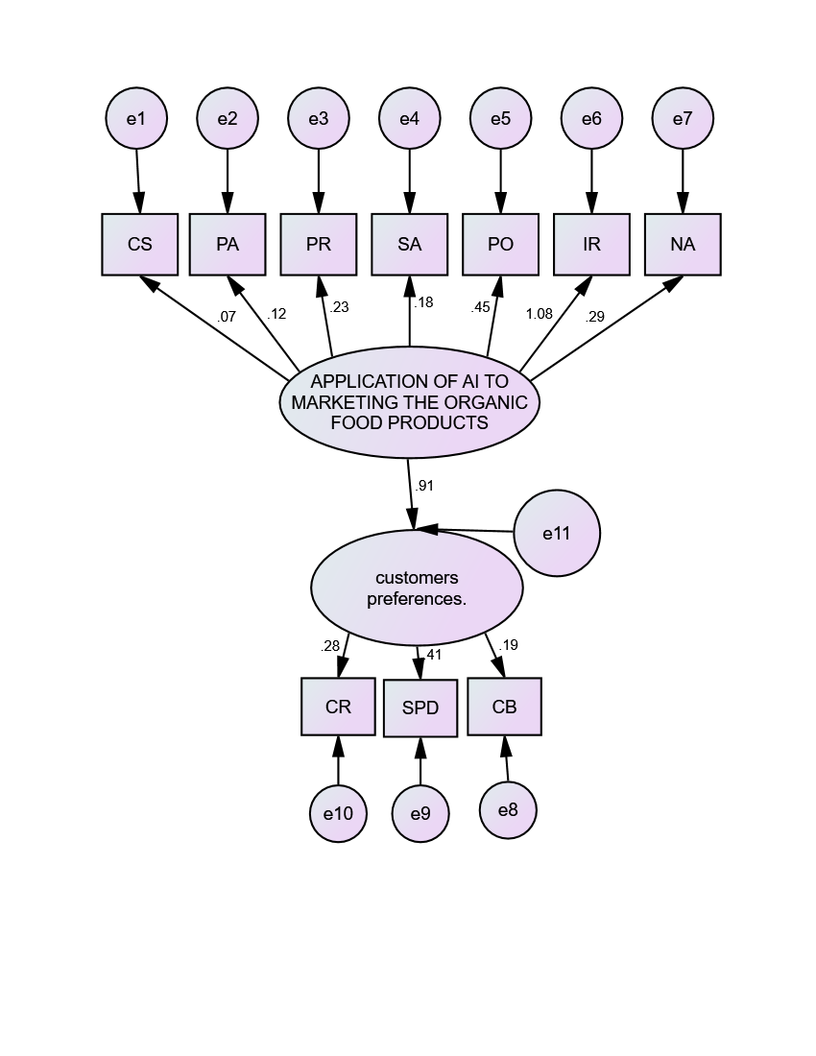
The AI applications significantly impacts to know the consumers preferences with a path coefficient of 0.91 and it illustrates that 91 per cent, AI applications in assisting organic food producers to know about the consumer preferences through Consumer Retention (CR) with a coefficient of 0.28, Sales Performance (SPD) with the highest impact, a coefficient of 0.41 and Consumer Behavior (CB) with a coefficient of 0.19. It demonstrates that an AI application like predictive analytics, sentiment analysis, and process optimization, plays a significant role in aiding producers of organic food products. And the above applications directly impacts consumer preferences, which influence key business outcomes like retention, sales, and behavior. Among AI applications, process optimization (PO) and image recognition (IR) have higher influences compared to others.

MODEL FIT
The degree to which the sample covariance matrix and the model-implied covariance matrix match is determined by the model fit.
Null hypothesis : The hypothesized model has a good fit.
Alternate hypothesis : The hypothesized model does not have a good fit
TABLE 1
Model Fit Summary of Structural Equation Model
Indices | Value
P value | 0.000
Chi-square value/DF | 2.752
GFI | 0.969
AGFI | 0.753
NFI | 0.458
CFI | 0.533
RMR | 0.054
RMSEA | 0.133
From the above Table 1, it is found that the calculated P value is 0.000 which is greater than 0.05 which indicates the model has perfectly fit. Here, the Goodness of Fit Index (GFI) value is (0.969) it is greater than 0.9 which represents it is a good fit. The calculated Normed Fit Index (NFI) value is (0.458) and the Comparative Fit Index (CFI) value is (0.533) which indicates that it is a perfect fit also it is found that Root Mean square Residuals (RMR) and Root Mean Square Error of Approximation (RMSEA) value is 0.054which is less than 0.133 which indicated it is perfectly fit. Hence, the null hypothesis is accepted.

CHALLENGES AND OPPORTUNITIES OF USING AI IN MARKETING ORGANIC FOOD PRODUCTS
Challenges are the problems or obstacles that businesses face when implementing AI in marketing organic food products. These may include issues such as high implementation cost, lack of technical expertise, data privacy concerns, and difficulty in integrating AI with existing marketing systems. Opportunities are the advantages or potential benefits that AI provides in marketing organic food products. AI can help businesses analyze consumer behavior, personalize marketing messages, predict demand, improve customer engagement, and increase sales of organic products.
TABLE 2
CHALLENGES OF USING AI IN MARKETING ORGANIC FOOD PRODUCTS
S.NO | CHALLENGES | MEAN SCORE | RANK
1 | High cost of implementing AI technologies | 7.37 | I
2 | Lack of technical knowledge and AI expertise among marketers | 5.28 | V
3 | Limited availability of quality consumer data | 4.53 | IX
4 | Difficulty in integrating AI with existing marketing systems | 5.11 | VI
5 | Data privacy and security concerns | 4.36 | X
6 | Lack of awareness about AI tools among organic food producers | 6.75 | II
7 | Dependence on technology and risk of system failures | 4.79 | VIII
8 | Resistance to change from traditional marketing practices | 6.01 | III
9 | Difficulty in interpreting AI-generated insights | 4.89 | VII
10 | Limited financial resources for small organic food businesses | 5.91 | IV
From the analysis, high cost of implementing AI technologies obtained the highest mean score of 7.37 and ranked first, indicating that it is the most significant challenge faced by businesses in adopting AI for marketing organic food products. This shows that the financial investment required for AI tools and infrastructure is a major barrier.

The challenge lack of awareness about AI tools among organic food producers secured the second rank with a mean score of 6.75, suggesting that many producers are not fully informed about the available AI technologies and their marketing benefits.
Resistance to change from traditional marketing practices ranked third with a mean score of 6.01, which implies that some marketers and producers prefer conventional marketing methods and hesitate to adopt advanced technologies like AI.
Limited financial resources for small organic food businesses received the fourth rank with a mean score of 5.91, highlighting that smaller businesses may struggle to afford AI-based marketing solutions.
The factor lack of technical knowledge and AI expertise among marketers ranked fifth with a mean score of 5.28, indicating that insufficient skills and technical understanding also hinder AI adoption.
Further, difficulty in integrating AI with existing marketing systems ranked sixth with a mean score of 5.11, while difficulty in interpreting AI-generated insights ranked seventh with a mean score of 4.89, showing that technical and analytical challenges exist in implementing AI tools effectively.
The factor dependence on technology and risk of system failures secured the eighth rank with a mean score of 4.79, indicating moderate concern among respondents.
Limited availability of quality consumer data ranked ninth with a mean score of 4.53, while data privacy and security concerns ranked tenth with a mean score of 4.36, making them the least significant challenges among the factors considered.
TABLE 3
TEST STATISTICS ON CHALLENGES OF USING AI IN MARKETING ORGANIC FOOD PRODUCTS
Test Statisticsª
N | 100
Chi-Square | 96.052
df | 9
Asymp. Sig. | .001
- Friedman Test
The Chi–Square test was applied to examine whether there is a significant difference in the ranking of challenges in using AI in the marketing of organic food products. The test results show that the Chi–Square value is 96.052 with 9 degrees of freedom and the significance value (p-value) is 0.001 for a sample size of 100 respondents. Since the p-value (0.001) is less than the standard significance level of 0.05, the result is statistically significant. Therefore, the null hypothesis is rejected and the alternative hypothesis is accepted. This indicates that there is a significant difference in the ranking of challenges faced in implementing AI in the marketing of organic food products. Hence, the respondents have different levels of perception regarding the various challenges associated with AI adoption in organic food marketing.

OPPORTUNITIES:
The use of Artificial Intelligence (AI) in the marketing of organic food products provides several opportunities for businesses to improve their marketing effectiveness and reach a wider audience. AI helps marketers understand consumer behavior by analyzing large amounts of data and identifying purchasing patterns. It enables personalized marketing and product recommendations based on consumer preferences, which can increase customer satisfaction and loyalty. AI also supports improved demand forecasting, helping businesses plan production and distribution more efficiently. Through AI-driven digital advertising and targeted promotions, marketers can reach the right consumers at the right time. In addition, AI-powered chatbots and virtual assistants enhance customer engagement by providing instant responses and support. Marketing activities can be automated using AI, saving time and reducing operational costs. AI also allows real-time analysis of market trends, enabling businesses to quickly adapt to changing consumer demands for organic products. Furthermore, it improves supply chain coordination and enhances brand awareness through social media marketing

INTERPRETATION
- The AI applications significantly impacts consumer preferences with a path coefficient of 0.91. Among AI application, process optimization (PO) and image recognition (IR) have higher influences compared to others.
- The calculated P value is 0.206 which is greater than 0.05 which indicates the model has perfectly fit.
- Friedman rank test reveal that financial constraints, lack of awareness, and resistance to technological change are the major challenges in implementing AI for marketing organic food products

CONCLUSION
Production of organic food products is a challenging one at the same time the producers face lot of difficulties in marketing of organic food products. The producers made an attempt to apply AI applications to market their organic food products. Artificial Intelligence (AI) has emerged as a powerful tool in transforming the marketing of organic food products. These technological changes help the producers to know about consumer decisions, showcasing their pivotal role in enhancing marketing efficiency, consumer expectations and market trends. Friedman rank test reveal that financial constraints, lack of awareness, and resistance to technological change are the major challenges in implementing AI for marketing organic food products. In future, the marketers can use AI applications to design more targeted segments and efficient marketing strategies to sustain in the market.

References
Amudha, M. K. (2024). Consumer Involvement And Purchase Pattern Of Organic Food Products In Chennai City. Educational Administration: Theory and Practice, 687-694.
Antony, N. &. (2023). Persuasiveness Towards Organic Food Products Among Metropolitans. In AI and Business, and Innovation Research: Understanding the Potential and Risks of AI for Modern Enterprises, 853-862.
Arora, S. &. (2024). Using Artificial Intelligence with Big Data Analytics for Targeted Marketing Campaigns. NO.
Balaji, K. C. (2018). Impact of Sales Promotions and Knowledge of Organic Food Products on Purchase Intention of consumers. IJRAR, 579-584.
Baourakis, G. (2004). Marketing trends for organic food in the 21st century. World Scientific, 3.
Bazaluk, O. Y. (2020). Dynamic development of the global organic food market and opportunities for Ukraine. Sustainability, 12(17), 6963.
Bharadwaj, M. (2025). AI in Sustainable Retail Packaging: Consumer Awareness in Indian Supermarkets.
Canavari, M. C. (2010). Challenges in marketing quality food products. Journal of International Food & Agribusiness Marketing, , 203-209.
Devi, H. &. (2025). Leveraging AI to Drive Consumer's Intention to Purchase Organic Products: A Holistic Marketing Approach. Intersecting Natural Language Processing and FinTech Innovations in Service Marketing.
GRACE, M. A. (2022). BUYER’S PERCEPTION TOWARDS ORGANIC FOOD PRODUCTS DURING POST COVID. Journal of Emerging Technologies and Innovative Researh, 9(12).
GRACE, M. A. (2022). BUYER’S PERCEPTION TOWARDS ORGANIC FOOD PRODUCTS DURING POST COVID.
Gunasekaran, V. &. (2020). Challenges and opportunities of organic products market. Stud Indian Place Names, 40(18), 2626-2640.
Hamzaoui-Essoussi, L. &. (2012). The organic food market: Opportunities and challenges. IntechOpen.
Jain, R. (2025). EXPLORING THE INFLUENCE OF AI-DRIVEN SUSTAINABLE INNOVATION ON CONSUMER BEHAVIOR. (2 ed., Vol. 7). Corporate Governance.
Khadda, B. S. (2021). Prospects of organic farming in India. A Voice for Agriculture, 27-34.
Muthmain, J. (2022). Challenges and possibilities in consumers’ views of organic foods in Rajshahi. Bangladesh Journal of Public Administration, 30(4), 250-270.
Nie, C. Z. (2026). Trust in artificial intelligence: an empirical investigation in the organic food market. British Food Journal,.
Niggli, U. (2015). Sustainability of organic food production: challenges and innovations. Proceedings of the Nutrition Society, 83-88.
Park, Y. K. (2022). Impact of artificial intelligence (AI) chatbot characteristics on customer experience and customer satisfaction. Journal of Global Scholars of Marketing Science, 34(3), 439-457.
Rehber, E. &. (2002). rospects and challenges for developing countries in trade and production of organic food and fibers: The case of Turkey. British food journal, 371-390.
Selvan, S. A. (2021). Organic food-way ahead for healthy life and a smarter choice. ANVESAK.
Selvan, S. S. (2021). MARKETING OF ORGANIC FOOD PRODUCTS IN TAMILNADU. MARKETING, 7(10).
Selvan, S. S. (2022). CONSUMER’S BEHAVIOUR TOWARDS ORGANIC FOOD PRODUCTS DURING POST COVID.
Tohidi, A. M. (2023). Organic food market segmentation based on the neobehavioristic theory of consumer behavior (3 ed., Vol. 125). British Food Journal.
Vikram, D. R. (2025). Leveraging Artificial Intelligence for Sustainable Marketing: A Theoretical Exploration of AI in Organic Products Promotion (Vol. 2). Journal of Marketing & Social Research.
Vittersø, G. &. (2015). The role of consumers in transitions towards sustainable food consumption.he case of organic food in Norway. Journal of Cleaner Production, 91-99.
Wilson, G. J. (2024). The Role of Machine Learning in Predictive Analytics for Supply Chain Management.
Yadav, D. M. (2025). Smart Management In Rural Markets: A Comparative Study Of AI-Driven Fmcg Strategies Of Indian And Foreign Companies And Their Impact On Consumer Purchase Decisions In Madhya Pradesh (3 ed., Vol. 15). European Economics Letters.

