Antagonism of nonpathogenic Fusarium isolates against phytopathogenic soil fungus

Abstract:
Laboratory experiments were conducted to explore antagonistic potential of selected Fusarium spp. against soil borne phytopathogen Rhizoctonia solani. A total of nine Fusarium isolates belonging to four genera viz., F. equiseti, F. solani, F. oxysporum and F. chlamydosporum were tested for their ability to inhibit growth of Rhizoctonia sp. in dual culture. The isolates were recovered from different agricultural fields of Murshidabad district and identified by routine morphological studies and molecular analysis. Non-pathogenic nature of the isolates was also proven by increased germination percentage and vigour index in the inoculated chickpea, black gram mustard, cucumber, chili and paddy seeds. All the isolates were tested positive for siderophore production and ammonia production necessary for antagonism against pathogenic soil fungus. Percentage of inhibition varies from 58 to 85 in dual culture with Rhizoctonia sp. Interestingly, the most potential Fusarium solani SF0204 was found to inhibit growth of the pathogen under different carbohydrate concentrations. Maximum antagonism was observed in the absence of dextrose indicating the Fusarium isolate was more competitive than the fungal pathogen.
Keywords: Fusarium, antagonism, non-pathogenic, germination percentage, vigour index, siderophore, ammonia, dual culture, percentage of inhibition, Rhizoctonia etc.
Introduction:
Plant pathogens are serious threat to the yield of economically important agricultural crops throughout the world. Pathogens causing plant diseases include viruses, bacteria and fungi etc. Environmental pollution caused by rampant use of pesticides raises serious concern among the agricultural biologists. Researchers are now focusing on developing the alternative approach to these chemical pesticides for controlling plant diseases. Among these approaches, biological control is considered as one of the effective strategies.
The genus Fusarium is a soil borne fungus and resides in the soil as saprophyte. Many non-pathogenic strains of Fusarium spp., are well known for their efficacy in controlling plant diseases caused by phytopathogenic soil fungi. Though many antagonists have been reported from time to time but unfortunately, they were not as effective as non-pathogenic Fusarium isolates (Larkin and Fravel, 1998). Non-pathogenic isolates of F. oxysporum and F. solani were reported to be the most consistent antagonists, providing significant disease control in several crop plants (Larkin and Fravel, 1998). There are plenty of evidences on the role of non-pathogenic Fusarium spp. isolated from different agroclimatic zones (Schneider, 1984; Paulitz e t al., 1987; Larkin et al., 1993, 1996).
Use of saprophytic or non-pathogenic isolates of Fusarium for biological control of pathogenic Fusarium spp. in various crops has been extensively studied and applied (Schneider, 1984; Larkin et al., 1996; Mandeel and Baker, 1991; Yamaguchi et al., 1992; Nel, 2006). Protection of host plants from challenge inoculation with pathogenic or virulent strains has been reported by several workers (Nel, 2006; Gessler and Kuc, 1982; Ogawa and Komada, 1986; Thangavelu and Jayanthi, 2009). Though mutants of pathogenic isolates have been attempted for biocontrol purposes, the mutants could not protect the plants while non-pathogenic saprophytic isolates of Fusarium spp, could protect the plants. The active growth of non-pathogenic F. oxysporum was limited to the root epidermis and thus provided the requisite protection against the soil borne phytopathogens. (Paparu et al., 2009; Behamou and Garnard, 2001)
The different mechanisms of antagonism occur across a spectrum of interactions between microbes. Direct antagonism results from physical contact and/or a high-degree of selectivity for the pathogen by the mechanism(s) expressed by the biocontrol agents whereas indirect antagonisms result from activities that do not involve sensing or targeting a pathogen by the biocontrol agents. It is also apparent that antagonism often involves the synergistic action of several mechanisms. Direct microbial antagonism for competition of same nutrients may lead to hyperparasitism, antibiosis and mycolysis (Agrios, 1997).
The present study explores the antagonistic potential of isolated Fusarium spp. against soil born fungus Rhizoctonia solani with a view to recommend these isolates as biocontrol agents in agricultural fields which would eventually lead to better production of agricultural crops.
Materials and Methods
Isolation and identification of fungus: The soil was screened for isolation of the fungi by dilution plate technique on selective peptone PCNB agar medium [composition (g/l): peptone 15, KH₂PO₄ 1.0, MgSO₄, 7H₂O 0.5, PCNB 1.0, agar 20, pH 6] supplemented with streptomycin sulphate 1.0 g/l and neomycin sulphate 0.12 g/l. The plates were incubated at 28°C for 5-7 days until visible sign of colony growth occurred. Fungal isolate was identified by observing the colony morphology, sporulation and pigmentation on Czapek’s Dox agar (CDA) medium. The isolate was further identified based on rDNA analysis. For this, genomic DNA was extracted and used as template for amplification of the rDNA region using primer pair sets (White et. al., 1990). The amplified product was sequenced and the sequence was analysed using Nucleotide BLAST function at NCBI to find similarity of the sequence with nucleotide database.
Pathogenecity test: Effect of culture filtrates on germination of seeds of six plants such as chickpea (Cicer arietinum), black gram (Vigna mungo), cucumber (Cucumis sativus), chilli (Capsicum sp.), mustard (Brassica sp.) and paddy (Oryza sativa) was evaluated to check whether the isolates were pathogenic or not. The isolates were cultivated in CD broth for 14 days and their culture filtrate was used for the study. Ten seeds were taken for each experimental set up. Seeds were surfaced sterilized in 0.1% HgCl₂ solution for 1 min and washed thrice with sterile water. The surface sterilized seeds were then transferred to culture filtrates of the respective Fusarium isolates and kept at 4°C for overnight period. On the subsequent day, the seeds were placed on sterilized pre-soaked blotting paper kept within the petridish. After five days, percentage of seed germination, length of radical and plumule were recorded. Vigour index was also calculated using following formula:
Vigour index (VI) = root length+ shoot length× germination%
Assay of siderophore production: Siderophore production by the isolates was determined using blue indicator dye, chrome azurol sulfone (CAS). Fusarium isolates were inoculated on CAS agar plates and incubated at 28°C for 7 days. An orange halo surrounding their colonies indicated siderophore production.
Isolates were further tested for quantification of siderophore production using CAS reagent. Siderophore, irrespective of its chemical nature, was detected using CAS reagent. Isolates were inoculated in CD broth and incubated at 28°C for 14 days. CAS reagent (0.5 ml) was added to 0.5 ml each of cell-free culture filtrates (with respective dilution) and uninoculated broth (control). The mixtures were incubated for 30 min at room temperature followed by reading the absorbance of the mixture at 630 nm. Deferoxamine mesylate (desferal) was used to draw the standard for quantifying the amount of siderophore produced in the culture filtrate.
Assay of ammonia production: Freshly grown Fusarium cultures were inoculated in 25 ml of peptone water and incubated at 28°C for 7 days. After the incubation period, 10 ml of the culture filtrates of each isolate were taken in separate tubes and Nessler’s reagent (0.5 ml) was added in each tube. Uninoculated peptone water treated with Nessler’s reagent was kept as control. Development of brown to yellow colour was considered as positive result for ammonia production (Cappucino & Sherman, 1992).
Antagonism against pathogenic soil fungus: The Fusarium isolates were tested for their antagonistic property against soil borne phytopathogenic fungus Rhizctonia solani by dual culture technique. Mycelial discs (5 mm) from the pathogen and the Fusarium antagonists were placed 3 cm apart on half diluted PDA medium and the plates were kept at 28°C for 7 days. The antagonism effect was determined by observing inhibition of mycelial growth of the pathogen and percentage of inhibition (I) was measured using the formula:
I = (R – r)/R X 100;
where r = radius of the pathogen colony opposite the antagonist colony and R = maximum radius of the pathogen colony in untreated (control) plate.
Effect of different carbohydrate concentrations on antagonism of Fusarium solani SF0204 against pathogenic soil fungus: Different sets of half diluted PDA medium supplemented with dextrose in increasing concentrations viz., 0.2%, 0.5% and 1% were prepared with respect to a control having without ant dextrose. Antagonism property of the selected Fusarium isolate was studied by dual culture technique against the soil borne phytopathogenic fungus Rhizoctonia solani.
Results:
Identification of Fusarium isolates: BLAST search analysis of the rDNA sequences showed maximum identities (99-100%) with Fusarium spp. and the isolates were identified accordingly (Table 1). Four isolates viz., SF0104, SF0204, SF0301 and SF1303 were identified as F. solani, isolate SF0105 was identified as F. equiseti, five isolates viz., SF0501, SF0801, SF1401, SF1404 and SF1905 were identified as F. oxysporum, isolate SF1807 was identified as F. commune and isolate SF2102 was identified as F. chlamydosporum. The Genebank accession numbers of the rDNA sequences of the Fusarium isolates are also given in table 1.
Table 1. Molecular identification of the Fusarium soil isolates
Sl  No. | Isolates | Primer used for PCR | DNA portions (size) amplified | DNA size sequenced | Maximum identity with  (accession no.) | Genebank accession no.
1. | SF0105 | LROR, LR5 | partial 28S rRNA gene (~1kb) | 544 bp | F. equiseti MP35 (99%)  (KF181212) | MF803160
2. | SF0204 | ITS1, ITS2 | partial 18S rRNA gene + ITS 1 + partial 5.8S rRNA gene (~250 bp) | 229 bp | F. solani CBPPR0024 (99%) (KT211516) | KY593923
3. | SF0301 | ITS1, ITS4 | partial 18S rRNA gene + ITS 1 + 5.8S rRNA gene + ITS2 + partial 28S rRNA gene (~ 550 bp) | 518 bp | F. solani TVD (100%)  (KF494114) | MF136401
4. | SF0501 | ITS5, ITS4 | partial 18S rRNA gene + ITS 1 + 5.8S rRNA gene + ITS2 + partial 28S rRNA gene (~ 550 bp) | 540 bp | F. oxysporum FO-10 (99%)  (AY928417) | MF136402
4. | SF0501 | LROR, LR5 | partial 28S rRNA gene (~1kb) | 860 bp | F. oxysporum H3 (99%)  (HM210091) | MF136403
5. | SF0801 | ITS5, ITS4 | partial 18S rRNA gene + ITS 1 + 5.8S rRNA gene + ITS2 + partial 28S rRNA gene (~ 550 bp) | 514 bp | F. oxysporum ZB072 (99%)  (KJ52888) | MF803161
5. | SF1303 | LROR, LR5 | partial 28S rRNA gene (~1kb) | 867 bp | F. solani ATCC 56480 (99%)  (FJ345352) | MF113250
7. | SF1404 | ITS5, ITS4 | partial 18S rRNA gene + ITS 1 + 5.8S rRNA gene + ITS2 + partial 28S rRNA gene (~ 550 bp) | 543 bp | F. oxysporum FO-10 (100%) (AY928417) | MF136405
7. | SF1404 | LROR, LR5 | partial 28S rRNA gene (~1kb) | 859 bp | F. oxysporum H3 (99%)  (HM210091) | MF136406
8. | SF1905 | LROR, LR5 | partial 28S rRNA gene (~1kb) | 809 bp | F. oxysporum f. sp. lycopersici 4287 (99%) (XR001936475) | MF113249
9. | SF2102 | ITS1, ITS4 | partial 18S rRNA gene + ITS 1 + 5.8S rRNA gene + ITS2 + partial 28S rRNA gene (~ 550 bp) | 505 bp | F. chlamydosporum NBAIM:236 (100%)  (EU214561) | MF136407

Effect of culture filtrate on seed germination and vigour index: Fusarium isolates were tested to study their effect on germination of seeds of six plants such as chickpea (Cicer arietinum), black gram (Vigna mungo), cucumber (Cucumis sativus), chilli (Capsicum sp.), mustard (Brassica sp.) and paddy (Oryza sativa). Surface sterilized seeds were soaked overnight in culture filtrate of the isolates and placed in moistened blotting paper for germination. After five days, most of the seeds showed germination although percentage of germination varied among isolates and plants (Table 2). The culture filtrate of SF1905 showed inhibitory effect on germination of chickpea seeds and radical and plumule growth of chilli and cucumber seeds. Conversely, some isolates showed promoting effect on growth of radical and plumule. Chickpea seeds treated with culture filtrate of SF1404 showed increased vigour index than the control set.
 | Table 2. Pathogenecity Test of Fusarium isolates
Sl. no. | Isolate no. | Chickpea |  | Blackgram |  | Cucumber |  | Chili |  | Mustard |  | Paddy
Sl. no. | Isolate no. | % of germination | Vigour index | % of germination | Vigour index | % of germination | Vigour index | % of germination | Vigour index | % of germination | Vigour index | % of germination | Vigour index
1. | SF0105 | 70 | 15.4 | 100 | 31.9 | 65 | 94.2 | 50 | 32.2 | 70 | 61.5 | 90 | 22.6
2. | SF0204 | 100 | 46.0 | 100 | 29.5 | 80 | 168.8 | 60 | 42.5 | 70 | 64.3 | 100 | 24.0
3. | SF0301 | 90 | 42.3 | 100 | 39.8 | 80 | 150.4 | 60 | 46.6 | 80 | 66.6 | 100 | 64.2
4. | SF0501 | 40 | 6.0 | 100 | 22.1 | 80 | 132.0 | 40 | 32.5 | 60 | 37.7 | 70 | 15.4
5. | SF0801 | 50 | 9.5 | 100 | 23.8 | 60 | 57.6 | 40 | 28.8 | 50 | 31.6 | 70 | 14.2
6. | SF1303 | 50 | 7.5 | 100 | 33.9 | 60 | 31.2 | 30 | 10.2 | 80 | 60.0 | 60 | 11.3
7. | SF1404 | 60 | 132.4 | 100 | 27.6 | 90 | 70.2 | 40 | 3.6 | 70 | 63.0 | 60 | 35.6
8. | SF1905 | 10 | 2.0 | 100 | 22.7 | 100 | 7.9 | 50 | 2.0 | 90 | 45.0 | 60 | 39.6
9. | SF2102 | 60 | 18.2 | 100 | 26.0 | 70 | 53.9 | 60 | 32.4 | 80 | 61.6 | 70 | 44.7

Antagonism against pathogenic soil-borne fungus: Antagonistic effect of different Fusarium isolates against soil borne phytopathogen Rhizoctonia solani was studied by dual culture technique (Fig. 1; Table 3). The isolates could inhibit both mycelia growth and sclerotia formation of the pathogen to a varied extent. Out of the nine tested Fusarium isolates, eight isolates showed more than 70% of inhibition of the pathogen growth with a maximum of inhibition found in case of SF0204 (85%).

Table 3. Siderophore production, ammonia production and antagonism against Rhizoctonia sp. by Fusarium isolates
Sl. no. | Isolate no. | Siderophore production (nmole/ml) | Ammonia production | Percentage of inhibition
1. | SF0105 | 50 | ++ | 77
2. | SF0204 | 500 | + | 85
3. | SF0301 | 70 | +++ | 82
4. | SF0501 | 270 | + | 80
5. | SF0801 | 280 | + | 70
6. | SF1303 | 200 | +++ | 58
7. | SF1404 | 710 | + | 76
8. | SF1905 | 650 | + | 72
9. | SF2102 | 80 | ++ | 70

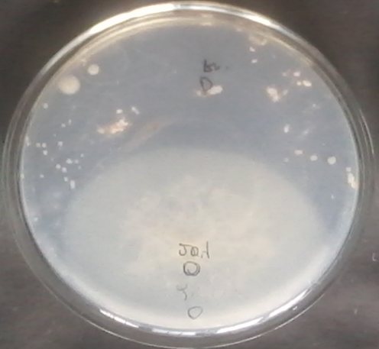 | 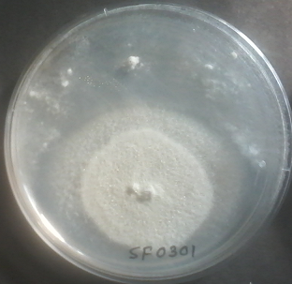 | 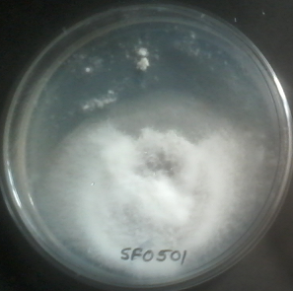
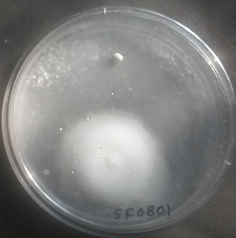 | 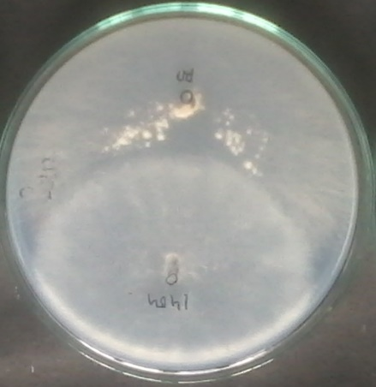 | 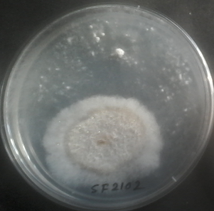
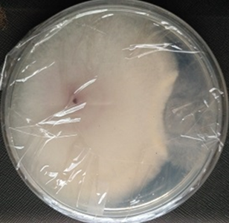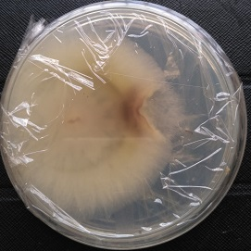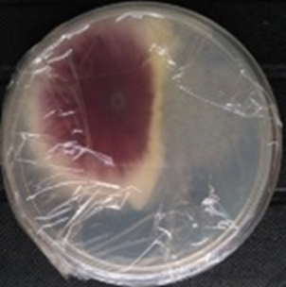
Fig. 1. Antagonism of Fusarium isolates against Rhizoctonia solani
(Upper panel from left to right, SF0204, SF0301 and SF0501
Middle panel from left to right, SF0801, SF1404 and SFF2102
Lower panel from left to right SF0105, SF1303, SF1905)

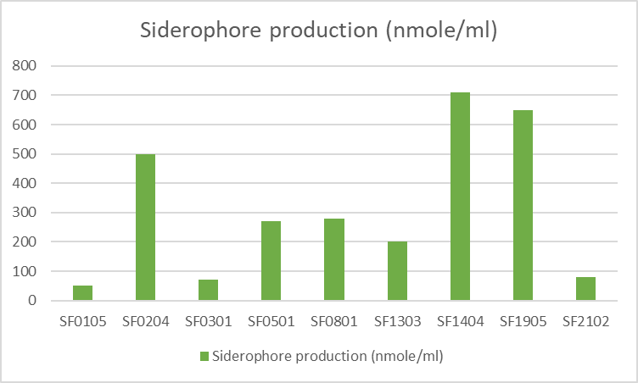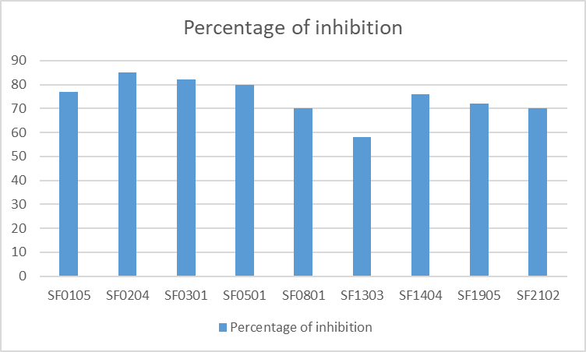
Fig. 2: Siderophore production (left), and antagonism against Rhizoctonia solani (right) by the Fusarium isolates
Study of the effect of different carbohydrate concentrations on antagonism of Fusarium solani (SF0204) against Rhizoctonia solani: To study competitive utilization of dextrose for growth of the antagonist and the pathogen, they were grown on PDA medium with increasing concentrations of dextrose by dual culture technique. Maximum antagonism was observed in the absence of dextrose indicating the Fusarium isolate was more competitive than the fungal pathogen. With further increase in dextrose concentration, the percentage of inhibition remained almost equal (Table 4, Fig. 3).
Table 4. Antagonism of F. solani with increasing dextrose concentrations on PDA medium
Concentrations of dextrose | 0% | 0.2% | 0.5 % | 1 %
Percentage of inhibition | 80 | 71.4 | 75 | 75

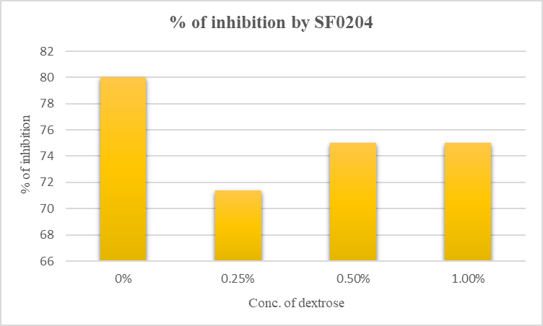
Fig. 3: Antagonism of F. solani at varying dextrose concentrations

Discussion:
Employing biological control against fungal diseases involve utilization of antagonistic fungi (AF). Non-pathogenic Fusarium spp. for suppression of Fusarium wilt was first evidenced by Smith & Snyder (1971) and Toussoun (1975). Later on, several studies have clearly showed that non-pathogenic Fusarium spp., especially F. oxysporum have some protective role for biological control of Fusarium wilt in numerous crops in green house and field trials in different area of the world (Kaur et al., 2010). Moreover, some endophytic strains of nonpathogenic F. oxysporum were reported to reduce damage caused by Meloidogyne incognita in tomato roots. F. oxysporum strain Fo47 recovered from Fusarium wilt suppressive soil in France has been studied extensively for its bioprotective activity.
Fast growth is an important character for a potential antagonist used in biological control of plant pathogens. It suggests strong competition for nutrients and space, which is very useful for the inhibition and possible elimination of pathogens (Mandeel & Baker, 1991). All the tested Fusarium spp. were fast growing in nature. In dual culture assay, all the Fusarium isolates were found to inhibit the growth of the soil borne phytopathogenic fungus Rhizoctonia solani to a reasonable extent with percentage of inhibition (I) varied from 58 to 85 % (Table 3, fig. 2). Maximum antagonism was performed by F. solani isolates SF0204, SF0301 and F. oxysporum SF0501 against Rhizoctonia solani inhibiting both mycelia growth and sclerotia formation. After the additional incubation period, the growth of pathogen’s mycelia was covered by the mycelia of tested soil isolates indicating the antagonism was very strong. It might be suggested that the antagonism mechanisms followed by the Fusarium isolates against Rhizoctonia solani have involved the competition for space, for nutrients via production of siderophore and/or other antifungal metabolites like ammonia.
Production of ammonia is considered as important plant growth promoting trait since it shows inhibitory effect to control soil borne pathogens (Baligh et al., 1996). Moreover, in aqueous medium it forms ammonium salt which at a low concentration (20-200 μM) is absorbed by the plant (Ludewig et al., 2007). Fusarium isolates were found to be potential ammonia producers. Among these F. equiseti isolate SF0105, F. solani isolate SF0301 and SF1303 and F. chlamydosporum isolate SF2102 were found to be the most potent isolates (Table 3).
Siderophores are iron-chelating molecules produced by microorganisms under iron deficient condition (Meyer & Stintzi, 1998). Most of the Fuarium soil isolates were found to be siderophore positive (Table 3, fig. 2) producing orange halo on CAS-agar plate around their colonies. CAS assay is a universally accepted method for estimation of extracellular production of siderophore (Schwyn & Neilands, 1987). F. solani isolates SF0104 and SF0204, F. oxysporum isolates SF0501, SF0801, SF1401, SF1404 and SF1905 and F. commune SF1807 were high producers (>500 nmole siderophore/ml). Such types of siderophore were also reported from other Fusarium species (Lopez-Berges et al., 2012). Pathogenic F. oxysporum isolate of banana in iron-limiting Fries’ basal medium produced a siderophore which was an aromatic amide with the formula C₁₆H₁₂O₇N₂ (Wijesundera et al., 1995). Siderophore production was found maximum in F. oxysporum SF1404 (710 nmole/ml) after 14 days of incubation in CD broth.
The direct microbial antagonism ultimately leads to hyperparasitism causing mycolysis and ultimate death of the pathogenic fungus. Competition for dextrose was identified as a mechanism of antagonism of F. solani SF0204 against R. solani since it showed higher percentage of inhibition (80%) in the absence of dextrose than that in the media containing the nutrient (75%) (Table 4, fig. 3). Fusarium isolate JDF12 produced siderophore and exhibited antifungal activity against a number of phytopathogens (Dalal et al., 2014). In our study, F. solani isolate SF0204 produced a higher amount of siderophore (>500 nmole/ml) and exhibited maximum antagonism (I>80%) against R. solani. The competition for nutrients and infection sites by a nonpathogenic strain of F. oxysporum (C14) with F. oxysporum f. sp. cucumerinum on the rhizoplane of cucumber has been reported (Mandeel, 2007).
Saprophytic competition for the carbon sources in soil and rhizosphere was reported to be one of the mechanisms for biocontrol activity of nonpathogenic F. oxysporum strains such as CS1, CS20, C5, C14 (Larkin & Fravel, 1999; Paul et al., 1999). In vitro growth inhibition of F. oxysporum f. sp. dianthi WCS-816 by the strain Fo47 was due to competition for carbon sources (Lemanceau et al., 1992).
Effective biocontrol strains of non-pathogenic F. oxysporum have been isolated from the stems of healthy plants (Ogawa and Komada, 1984). The modes of action of non-pathogenic Fusarium spp. include competition for food and space and induced systemic resistance. Our investigation successfully reports the isolation of non- pathogenic Fusarium spp., confirmation of their non- pathogenicity by bioassays in dual culture with Rhizoctonia.
With naturally available saprophytic Fusarium spp. that are not pathogenic to crop plants, much success has been obtained in the biological control of Fusarium wilt as indicated in the review by Fravel et al. (2003). Endophytic non-pathogenic F. oxysproum have been demonstrated to control both banana weevils and Radopholus similis (Griesbach, 2000; Niece et al., 2001) by means of induced resistance and antibiosis to eggs and larvae besides acting as plant growth promoters (Tam et al., 2006).
Conclusion:
The findings of the present investigation highlighted that the soil isolates of Fusarium have great potential to retard the growth of Rhizoctonia solani in dual culture. Production of siderophore and ammonia have been found to be central to the process of antagonism. These non-pathogenic Fusarium soil isolates could be exploited in improvement of crop yield in pathogen infested compromised soil. Though the protective Fusarium isolates need further study under field conditions to confirm the present findings and also to recommend the isolates as potential antagonists and biocontrol agents in agricultural fields.
References
Agrios, G. N. (1997). Control of plant diseases. Plant pathology, 5, 295-357.
Alabouvette, C., Lemanceau, P. and Steinberg, C. 1993. Recent advances in the biological control of Fusarium wilts. Pesticide Science, 37: 365-373.
Baligh, M., Conway, K. E., & Delgado, M. A. (1996). Production of ammonia by Pseudomonas cepacia and Pseudomonas aeruginosa: Quantification and effect on host and pathogen. Recent research developments in plant pathology, 1, 19.
Behamoll, N. and Garnard, C. 2001. Cytological analysis of defense-rclatcd mechanisms induced in pea root tissue in response to colonization by non-pathogenic F. oxysporunm Fo47. Phytopathology, 91: 730-740.
Blok, W. J., Zwankhuizen, M. J . and Bollen, G. J. 1997. Biological control of Fusarium moxysporurn f. sp. asparagi by applying non-pathogenic isolates of F. oxysporum. Biocontrol Science and Technology, 7: 527-541.
Booth, C. 1971. The genus Fusarium. The Eastern Press, CMI, London, England. 237 pp.
Cappucino, J. C., & Sherman, N. (1992). Nitrogen cycle. Microbiology: a laboratory manual, 4th edn. Benjamin/Cumming, New York, 311-312.
Dalal, R. C., Strong, W. M., Weston, E. J., Cooper, J. E., Wildermuth, G. B., Lehane, K. J., ... & Holmes, C. J. (1998). Sustaining productivity of a Vertisol at Warra, Queensland, with fertilisers, no-tillage, or legumes. 5. Wheat yields, nitrogen benefits and water-use efficiency of chickpea-wheat rotation. Australian Journal of Experimental Agriculture, 38(5), 489-501.
Duijff, B. J., Recorbet, G., Bakker, P., Loper, J. E. and Lemanceau, P. 1999. Microbial antagonism at the root level is involved in the suppression of Fusarium wilt by the combination of non-pathogenic Fusarium oxysporum Fo47 and Pseudomonas putida WCS358. Phytopathology, 89: 1073-1079.
Fravel, D., Olivain, C. and Alabouvette C. 2003. Fusarium oxysporum and its biocontrol. New Phytologist, 157: 493-502.
Freeman, S. and Rodriguez, R. J. 1993. Genetic conversion of a fungal plant pathogen to a non-pathogenic endophytic mutant. Science, 260: 75-78.
Gessler, C. and Kuc, J. 1982. Induction of resistance to Fusarium wilt in cucumber by root and foliar pathogens. Phyto- pathology, 72: 1439-1441.
Griesbach, M. 2000. Occurrence of mutualistic endophytes in banana (Musa spp.) and their potential as biocontrol agents of the banana weevil (Cosmopolites sordidus (Germar) (Coleoptera: Curculionidae)) in Uganda. Ph.D. Dissertation, University of Bonn, 131 pp.
Haridon, F. L., Aime, S., Alabouvette, C. and Olivain, C. 2007. Lack of biocontrol capacity in a non-pathogenic mutant of Fusarium oxysporum f. sp. melonis. European Journal of Plant Pathology, 118: 239-246.
Hoch, R. C. and Abawi, G. S. 1979. Mycoparasitism of oospores of Pythium ultimum by Fusarium merismoides. Mycologia, 71: 621-625.
Kaur, R., Kaur, J., & Singh R. S. (2010). Nonpathogenic Fusarium as a Biological control agent. Plant pathology 9(3), 79-91.
Larkin, R. P., Hopkins, D. L. and Martien, F. N. 1993. Effect of successive water melon plantings on Fusarium oxysporum and other microorganisms in soils suppressive and conducive to Fusarium wilt of water melon. Phytopathology, 83: 1097-1 105.
Larkin, R. P., Hopkins, D. L. and Martin, F. N. 1996. Suppression of Fusarium wilt of water melon by non-pathogenic Fusarium oxysporum and other microorganisms recovered from disease-suppressive soil. Phytopathology, 86: 812-819.
Larkin, R. P. and Fravel, D. R. 1998. Efficacy of various fungal and bacterial biocontrol organisms for control of Fusariutti wilt of tomato. Plant Disease, 82: 1022-1028.
Lemanceau, P., Baker, P. A. H. M., De Kogel, W. J., Alabouvette, C., & Schippers, B. (1992). Effect of Pseudobactin 358 production by Pseudomonas putida WCS358 on suppression of Fusarium wilt of carnation by nonpathogenic Fusarium oxysporum Fo47. Applied and Environmental Microbiology, 58, 2978-2982.
López-Berges, M. S., Capilla, J., Turrà, D., Schafferer, L., Matthijs, S., Jöchl, C., ... & Di Pietro, A. (2012). HapX-mediated iron homeostasis is essential for rhizosphere competence and virulence of the soilborne pathogen Fusarium oxysporum. The Plant Cell, 24(9), 3805-3822.
Ludewig, U., Neuhäuser, B., & Dynowski, M. (2007). Molecular mechanisms of ammonium transport and accumulation in plants. FEBS letters, 581(12), 2301-2308.
Mandeel, Q. and Baker, R. 1991. Mechanisms involved in biological control of Fusariurit wilt of cucumber with strains of non-pathogenic Fusarium oxysporum Pl~ytopatlzology, 81: 462-469.
Meyer, J. M., & Stintzi, A. (1998). Iron metabolism and siderophores in Pseudomonas and related species. In Pseudomonas (pp. 201-243). Springer, Boston, MA.
Nash, S. M. and Snyder, W. C. 1962. Quantitative estimations by plate counts of propagules of bean root rot Fusarium in field soils. Pltytopathology, 52: 567-572.
Nel, B., Steinberg, C., Labuschagne, C. N. and Viljoen, A. 2006. The potential of non-pathogenic Fusarium oxysporum and other biological control organisms for suppressing fusarium wilt of banana. Plant Pathology, 55: 217-223.
Niere, B, Sikora, R. and Speijer, P. 2001. Mutualistic endophytic fungi - role in biocontrol and safety of application. In: Tri-trophic interactions in the rhizosphere. IOBC/ WPRS Bulletin, 24: 117- 120.
Patil, S., Sriram, S., Savitha, M. J. and Arulmani, N. 201 1. Induced systemic resistance (ISR) in tomato by non-pathogenic Fusarium. Archives of Phytopathology and Plant Protection, 44 (In press).
Paul, J., Singh, R. S., Kaur, J., & Alabouvette, C. (1999). Effect of inoculums density of nonpathopgenic Fusarium in biological control of chickpea wilt caused by Fusarium oxysporum f. sp. ciceri. Proceedings of symposium on Biological control based pest management for quality crop protection in the current Millennium, P.A.U Ludhiana, pp: 97-98.
Ogawa, K. and Komada, H. 1984. Biological control of Fusarium wilt of sweet potato by non-pathogenic Fusarium oxysporum. Annals of Phytopathological Society of Japan, 50: 1-9.
Ogawa, K. and Komada, H. 1986. Induction of systemic resistance against Fusarium wilt of sweet potato by non- pathogenic Fusarium oxysporum. Annals of Phyto- pathological Society of Japan, 52: 15-21.
Paparu, P., Macleod, A., Dubois, T., Coyne, D. and Viljoen, A. 2009. Efficacy of chemical fluorescent protein markers in studying plant colonization by endophytic non-pathogenic Fusarium oxysporum isolates. Biocontrol, 54: 709-722.
Paulitz, T. C., Park, C. S. and Baker, R. 1987. Biological controI of Fusarium wilt of cucumber with non-pathogenic isolates of Fusarium oxysporum. Canadian Journal of Microbiology, 33: 349-353.
Postma, J. and Rattink, H. 1992. Biological control of Fusarium wilt of carnation with a non-pathogenic isolate of Fusarium axysporum. Canadian Journal of Botany, 70: 1199-1 205.
Schneider, R. W. 1984. Effects of non-pathogenic strains of Fusarium oxysporum on celery root infection by l? oxysproum f. sp. apii and a novel use of the lineweaver-burk double reciprocal plot technique. Phytopathology, 74: 646-653.
Schwyn, B., & Neilands, J. B. (1987). Universal chemical assay for the detection and determination of siderophores. Analytical biochemistry, 160(1), 47-56.
Smith, S. N., & Snyder, W. C. (1971). Relationship of inoculum density and soil types to severity of Fusarium wilt of Sweet Potato. Phytopathology, 61(9), 1049-1051.
Subramanyam, C. V. 1970. Hypltomycetes -An account of Indian species except Cercosporae. Indian Council of Agricultural Research, New Delhi.
Tam, V. R., Hauschild, R. A. and Sikora, R. A. 2006. Fusarium oxysporum endophytes induced systemic resistance against Radopholus sirnilis on banana. Nematology, 8: 847-852.
Thangavelu, R. and Jayanthi, A. 2009. R F L P analysis of rDNA- ITS regions of native non-pathogenic Fusarium oxysporum isolates and their field evaluation for the suppression of Fusarium wilt disease of banana. Australasian Plant Patliology, 38: 13-2 1.
Toussoun, T. A. (1975). Fusarium-suppressive soils. In Biology and Control of Soil Borne Plant Pathogens International Symposium.
Yamaguchi, K., Sano, T., Arita, M. and Takashushi, M. 1992. Biocontrol of Fusarium wilt of tomato and Verticillium wilt of eggplant by non-pathogenic Fusarium oxysporum MT0062. Annals of Phytopathological Society of Japarl, 58: 188-194.
White, TJ., Bruns, T., Lee, S., Taylor JW. 1990. Amplification and direct sequencing of fungal ribosomal RNA genes for phylogenetics. In: Innis, MA, Gelfand DH, Sninsky JJ, White TJ, (eds) PCR Protocols: A Guide to Methods and Applications, Academic Press, Inc., New York, pp. 315-322.
Wijesundera, R. L. C., Amarasekera, A. S., & Yapa, D. N. D. (1995). Production of a siderophore by the fungus Fusarium oxysporum. Journal of the National Science Foundation of Sri Lanka, 23(3), 97-100.

