HOUSEFLIES AS RESERVOIRS OF MICROBIAL AND PARASITIC PATHOGENS IN OPEN WASTE DUMP SITES

.
ABSTRACT

Houseflies (musca domestica) are typical synanthropic insects that are frequently found at open waste disposal facilities. They are important in the spread of parasites and harmful microorganisms there. The perfect breeding and feeding conditions found in these settings make it easier for disease-causing organisms to be acquired and spread. The significance of houseflies for public health is highlighted in this abstract, which examines the microbial and parasite dynamics of houseflies linked to open waste dumpsites. Numerous bacterial pathogens, such as Salmonella spp., Shigella spp., Staphylococcus aureus, Vibrio spp., Escherichia coli, Fungus, and antibiotic-resistant strains, are routinely found in houseflies collected from dumpsites, according to studies. Furthermore, parasites of medical significance, including Ascaris lumbricoides, Trichuris trichiura, Giardia lamblia, Entamoeba histolytica, and Taenia spp., have been identified from the gut contents and external body surfaces of flies. Seasonal variations, temperature, humidity, waste composition, and sanitation techniques all have an impact on the dynamics of microbial and parasite carriage. Houseflies serve as mechanical vectors, spreading infections from polluted waste to surfaces that come into touch with people, food, and water. Particularly in low-income areas with inadequate waste treatment, the high microbial and parasite load linked to flies from open dumpsites highlights their importance in the epidemiology of diarrheal illnesses and other enteric infections. Houseflies constitute a threat to public health in these environments, thus effective waste management, environmental sanitation, and fly control techniques are crucial.

Keywords: Dumpsites, Housefly, Synanthropic, Microbial, Waste, Vector, Pathogens

INTRODUCTION
Human activities always generate waste. When there were few people on the planet and people lived in nomadic communities, this was not a major concern. However, as cities grew and metropolitan areas expanded, it became a significant issue. A significant impact on public health resulted from improper waste disposal, which also contaminated the air, water, and soil. Waste material's properties changed in tandem with lifestyle shifts, and the quantity of novel chemicals found in the different waste increased dramatically. It is more challenging to quantify the long-term health impacts of exposure to compounds found in garbage or produced at waste disposal facilities, particularly when such substances are present in very minute concentrations and when there are multiple exposure pathways such as food or soil (Singh et al., 2018).
The common insects known as houseflies (Musca domestica) are closely linked to human homes and landfills, where they contribute significantly to the spread of parasites and microbial infections. Open waste dump sites which are defined by the uncontrolled disposal of both organic and inorganic garbage, are home to houseflies and offer a favorable habitat for the growth of a variety of parasites and microbial communities. Effective waste management methods and the assessment of public health concerns depend on an understanding of the dynamics of the microbial and parasite populations linked to houseflies in these environments. The housefly is a member of the Calliphoridae and Fanniidae families of flies, which are collectively known as "filth flies" (Szalanski et al., 2020). Since the beginning of human history, house flies have existed and have adapted successfully to living in human habitats. M. domestica is an endophilic, eusynanthropic species, meaning it coexists closely with humans and can live its whole life cycle in human and domestic animal homes. House flies are frequently found in large numbers in areas of human activities such as hospitals, food markets, slaughterhouses, food centers, restaurants and farms that raise poultry and livestock. These areas are not only hazardous to people but also serve as potential disease vectors habitat (Awache and Farouk, 2016). Because they serve as carriers of several infections, they are especially important (Nayduch and Burrus, 2017). They are said to have originated in the savannahs of Central Asia and then expanded to other parts of the world, particularly the tropical and subtropical regions, where they are associated with domestic animals and people in both rural and urban locations (Khamesipour et al., 2018). Like other flies, it has four life stages: eggs, larvae/maggots, pupae, and adults (de Jonge et al., 2020). These flies may disseminate whatever bacteria, parasites, or their eggs they carry throughout a career of up to 20 kilometers while living in filthy settings. They are synanthropic and found all throughout the planet. They may access a variety of places, including contaminated sites, because of their own biological eating habits.
In areas where a lot of rubbish and excrement are left out in the open, as well as on decaying animal carcasses, houseflies flourish. The attraction of flies to unclean and unhealthy situations has long been known. There is strong evidence that Nigeria's environment is characterized by filth, which aids in the incredible growth of insects such as houseflies (Adeleke et al., 2017). A common domestic fly that is found all throughout the world and lives close to people is the housefly, Musca domestica. Their anthropogenic activities, which enable them to pick up pathogens on their body parts, and their association with unsanitary environments brought on by human feces, trash, etc., make them a major threat to public health (Oyeyemi et al., 2016). Apart from bacteria and fungi, houseflies are also carriers of helminths, protozoa, and other parasitic organisms. Particularly in areas with inadequate sanitation and hygiene standards, parasitic diseases spread by houseflies can provide serious health concerns to both people and animals (Bennett et al., 2018). In houseflies collected from waste dump sites, helminth parasites such as roundworms (Ascaris lumbricoides) and tapeworms (Taenia spp.) have been found, suggesting the possibility of parasitic infection spread by contaminated food and water sources (Traore et al., 2017). Giardia lamblia and Cryptosporidium spp. are protozoan parasites that have also been linked to houseflies, highlighting the importance of understanding parasite dynamics in waste dump environments (Koohsar et al., 2021).
Pathogens can be spread to humans and animals by houseflies' frequent back-and-forth travel between their nesting grounds and human homes. Shigellosis, Salmonellosis, Cholera, Hepatitis A and E, Polio, Amoebic dysentery, parasitic worms, and eye infections (trachoma and epidemic conjunctivitis) are the main illnesses linked to houseflies as a vector. The majority of these microbes are expelled in human, animal, and avian feces. The microbes that adhere to the fly's exterior may only live for a few hours, while those that are consumed along with the meal may live in the fly's gut for a varied period of time (Pava-Ripoll et al., 2015). The fly transmits when it comes into contact with humans or their meals. The majority of infections can also be acquired by contaminated hands, food, drink, air, and interpersonal contact. E. Coli and other coliforms are surrogate markers that can be used to identify fecal contamination of food and water (Junqueira et al., 2017).
Soil-transmitted helminths (STH), bacteria, viruses, fungi, and even protozoa have all been linked to muscoid flies. Poverty, poor hygiene, undeveloped health facilities, and unsanitary environments are all closely related to the high prevalence of these parasite diseases. These parasite infections are rather common in many countries' rural and slum areas. Defecation, regurgitation, and mechanical transfer from the exoskeleton are the three ways that flies spread infections (Onwugamba et al., 2018).
According to Zhang et al. (2018), houseflies that have been colonized by bacterial species may also be linked to the exposure of virulent bacterial strains in the same environment or the propagation of genes that resist antibiotics. Houseflies' potential to spread resistant bacterial strains from homes and farms to locations like hospices is therefore a serious public health concern. Species-specific oligonucleotide primers and probes have been created to help the polymerase chain reaction (PCR) technology identify antibiotic-resistant infections and their resistance genes (Czekalski et al., 2014). It has recently become commonplace to utilize PCR to find antibiotic resistance genes in bacterial isolates and samples from various environments (Anjum et al., 2017).
Adult house flies' mobility allows them to come into contact with microorganisms from different parts of a facility that they wouldn't otherwise engage with. According to Figure 1C and D, house flies are commonly observed consuming or examining animal feed and feed storage locations, as well as sitting on actual structures such as buildings, equipment, fences, and feed bunkers. With a wide selection of substrates to choose from, including human and animal food as well as their excrement, adult flies exhibit extensive trophic relationships. In addition to consuming microbe-rich substrates like dung, female flies may be motivated by a direct yet unidentified need for microbial nutrition or by opportunities presented during oviposition (Thomson et al., 2017). Adult male flies typically favor food sources high in carbohydrates, while when given the alternative, female flies are drawn to options high in protein (Neupane et al., 2023). Given that their anautogenous reproductive physiology necessitates protein for egg development (vitellogenesis), the preference is most likely the result of this. Female flies are frequently observed consuming animal excretions and proteinaceous secretions in agricultural environments, such as blood, mucus, eye discharge, weeping wounds, and manure (Figure 1D). Unsurprisingly, female flies have more bacteria than male flies, perhaps because they prefer surroundings with a lot of microbes (Neupane et al., 2020). Because they can transfer infections from low-risk environments, like dung, to high-risk environments, including animal and human feed, house flies offer the biggest hazard. House flies, being both zoophilic and synanthropic, serve as a bridge between animals, including humans, and filth, both within and between environmental niches. House flies are essential to microbial ecology at all scales, from small scale settings like farms to larger landscape scales like CAFOs and nearby communities, as well as urban areas with waste disposal facilities like dumpsters. This is because, at the very least, houseflies act as reservoirs and dispersers of microbes in the environment.
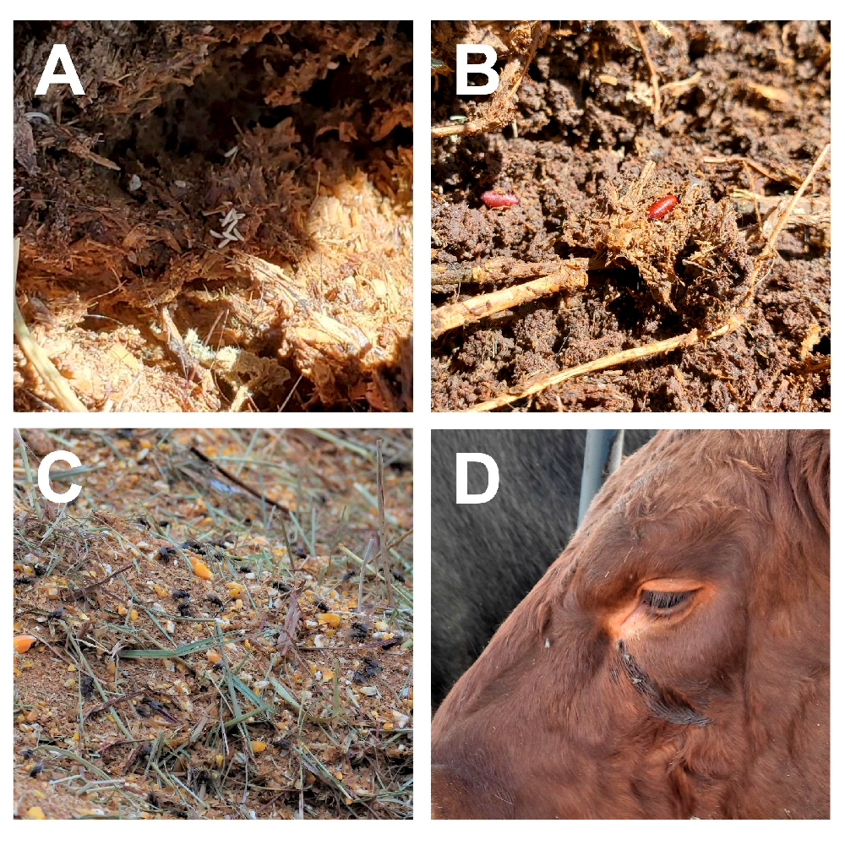
Fig. 1. Houseflies associate with animals, their waste, and feed in livestock operations. Housefly eggs (A) and pupae (B) in cattle manure. Adult houseflies feeding on food in feed bunk (C) and cattle eye secretions (D) (Nayduch et al., 2023).

BIOLOGY OF HOUSEFLIES
Feeding
Adult house flies must either eat liquid food or regurgitate crop contents onto solid foods to soften them before ingesting them since their mouthparts are sponges. Flies frequently exhibit "bubbling," which is the release of a droplet of regurgitation. In order to concentrate the nutrients in the food that is consumed and lessen the weight that flies must carry while in flight, bubbling is believed to remove extra water (Stoffolano, 2019). Additionally, bubbling might contribute to thermoregulation (Gomes et al., 2018). Occasionally, the droplets end up in the surroundings, causing fecal stains and regurgitation to accumulate on surfaces where flies rest. The quality of the meal consumed affects the proportion of regurgitation spots. Regurgitation spots are less common in flies that have consumed nutrient-dense diets like blood, liquid milk, and high-concentration sugar solutions than in flies that have consumed less nutrient-dense foods. Fecal spots and regurgitation deposits contribute to the spread of infections and can be used as a measure of fly abundance in monitoring programs.
The fly can eat enormous amounts of high-quality liquid food when it comes across it because the crop, a ventral diverticulated structure of the foregut, gives it a highly extensible storage organ. The contents of the crop are then either transferred forward for discharge from the proboscis as regurgitation or transmitted to the midgut for digestion. Food can occasionally pass through the crop and enter the midgut straight, particularly if it has little moisture. The peritrophic matrix (PM) surrounds food as it enters the midgut. Midgut cells produce the PM, which is made up of a matrix of chitin, glycoproteins, peritrophins, and other substances that operate as a barrier to keep ingested pathogens from infecting the fly by preventing them from coming into contact with the microvillar membrane of the midgut epithelium. After passing through the PM, nutrients are absorbed in the midgut. Any leftover food then moves into the hindgut, where it absorbs water and eventually becomes excrement. Food can pass through the digestive system in fewer than six hours (Stoffolano, 2019).
Genetics
The house fly possesses an X and Y chromosome in addition to five pairs of autosomes. The Mdmd gene (Sharma et al., 2017) determines sex and can be located on any chromosome, with several copies possible (Hamm et al., 2015, Son et al., 2019). Y is thought to be Mdmd's ancestral chromosome. In line with its strong link to infections, the genome of the house fly was sequenced, revealing an abundance of immune system recognition and effector components. Male house flies were found to exhibit a lack of crossing-over, which is typical of most Diptera. Subsequently studies show that crossover frequencies in males vary, depending on the genes investigated and the populations used. The range of reported values is 0–0.53%, 0.03–0.11%, 9.3–31%, and 7–28%. Males with Mdmd on an autosome typically have higher rates of male recombination (Son et al. 2019).
LIFE CYCLE AND HABITS OF HOUSEFLIES
Life Cycle
During their whole life cycle, houseflies go through four stages: egg, larva or maggot, pupa, and adult. In a single summer, houseflies may produce up to 10 to 12 generations since they can finish their life cycle in as little as 7 to 10 days. The purpose of placing eggs in gaps and crevices is to prevent them from drying out. The primary breeding grounds for house flies are dirt, trash, and contaminated food (Service, 2012). Animal manure, poultry dung, urine-contaminated bedding, corpses, decomposing organic materials from waste dumps, household garbage, and leftover food from kitchens are among the decomposing things on which female Musca domestica lay their eggs. Between 75 and 150 eggs are either deposited in batches or all at once. Over the course of her life, a fly may lay five to ten eggs, occasionally reaching a total of 1000. The eggs have a banana-like appearance, are creamy-white, and measure 1 to 1.2 mm in length. They are also noticeably concave dorsally. They can hatch in 10 to 16 hours; though cool weather lengthens this time. The dorsal concave surface's strip of eggshell between parallel ridges lifts up and partially separates from the rest of the egg to complete hatching. Eggs are not resilient to bad weather and will perish if they dry out. Most of them die after being exposed to temperatures below 15 °C or beyond 40 °C since they are unable to withstand temperature extremes (Service, 2012).
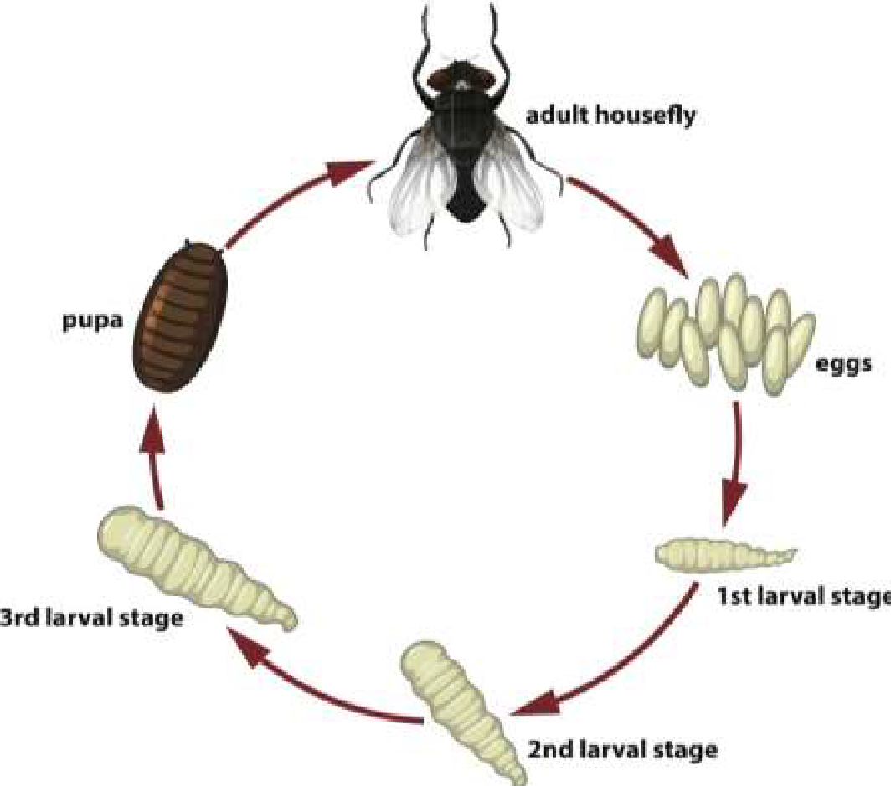
Fig. 2. Life Cycle of Housefly (Ripley, 2019).
Feeding Habitat
Adult house flies must either eat liquid food or regurgitate crop contents onto solid foods to soften them before ingesting them since their mouthparts are sponges. A common phenomenon is "bubbling," where flies release a droplet of regurgitation. In order to concentrate the nutrients in the food that is consumed and lessen the weight that flies must carry while in flight, bubbling is believed to remove extra water (Stoffolano 2019). Additionally, bubbling might be involved in thermoregulation (Gomes et al., 2018). The droplets can occasionally be released into the environment, causing fecal stains and regurgitation to accumulate on surfaces where flies rest. The quality of the meal consumed affects the proportion of regurgitation spots. Regurgitation spots are less common in flies that have consumed nutrient-dense diets like blood, liquid milk, and high-concentration sugar solutions than in flies that have had less nutrient-dense foods. Fecal and regurgitation spot deposition contributes to pathogen transmission and can be utilized as a fly abundance indicator in monitoring operations.
According to Stoffolano (2019), the fly's crop, a ventral diverticulated structure of the foregut, gives it a highly expandable storage organ that enables it to swallow huge amounts of high-quality liquid food when it comes into contact with it. Subsequently, the crop's contents are either transferred to the midgut for digestion or released from the proboscis as regurgitation. Sometimes food skips the crop and enters the midgut straight, particularly when it has little moisture. Food is encased in the peritrophic matrix (PM) as it passes through the midgut. A matrix of chitin, glycoproteins, peritrophins, and other substances make up the PM, which is produced by midgut cells. It acts as a barrier to keep ingested pathogens from infecting the fly by preventing them from coming into touch with the microvillar membrane of the midgut epithelium. After passing through the PM and being absorbed in the midgut, nutrients move on to the hindgut, where they absorb water and eventually deposit as feces. In under six hours, food can pass through the entire digestive system.
INTERACTIONS BETWEEN FLY AND MICROBE
Microbes Acquisition, Retention, and Transmission by Adult Houseflies
Adult houseflies frequently pick up bacteria, viruses, and protists during their persistent interactions with microbe-rich environments. According to Nayduch and Burrus (2017), wild-caught houseflies yielded more than 200 distinct species of bacteria, and a single housefly can harbor up to 100 distinct harmful microorganisms. Flies pick up microorganisms on their surfaces by direct contact with or consumption of garbage, animal feces, wounds, and exudate. When houseflies groom themselves or come into physical contact with a mammal, the pathogens on their surfaces are dislodged (Jacques et al., 2017). Prior to transmission, certain bacteria, such E. coli O157:H7, can live and multiply on housefly mouthparts for several days.
Transmission potential is affected by the location and duration of bacteria in the digestive tract when ingested by houseflies. According to Nayduch and Burrus (2017) and Stoffolano (2019), bacteria that are ingested and stored in the midgut and crop are either broken down and eliminated or they live to be expelled and may spread. Different disease types can have different bacterial persistence, growth, excretion, and transmission patterns. According to Thomson et al. (2017) and Nayduch et al. (2018), even housefly sex can affect the infections' acquisition, persistence, proliferation, and excretion. It's possible that flies will help new harmful and resistant microbial strains evolve and spread (Onwugamba et al., 2018). For instance, the fly gut (midgut + crop) may be the site of lateral gene transfer between bacteria, which includes the horizontal transfer of resistance alleles between pathogens and no pathogens (Poudel et al., 2020). In the house fly gut, it has been shown that a plasmid containing tetracycline and cephalosporin resistances can be horizontally transferred between donor and recipient bacteria (Fukuda et al., 2016). Along with other bacterial taxa that were present as "normal flora," such as Achromobacter spp. and Pseudomonas fluorescens, the plasmid was also transmitted across donor and recipient strains of E. coli. It has also been shown that plasmids containing tetracycline resistance can be horizontally transferred between Enterococci in the gut of houseflies. Furthermore, genes controlling virulence may be introduced and spread more easily by flies. Due to their high degree of mobility, adult flies play a significant role in the spread of these new infections over different biological niches and habitats (Poudel et al., 2019).
Pathogen Transmission by Adult Flies
Adult flies spread pathogens from their source to animal facilities, food, water, and humans in the vicinity by bridging hygienic and unhygienic surroundings (Nayduch and Burrus 2017). Fly populations thrive in livestock facilities, and when inadequate manure management and poor sanitation provide flies unfettered access to pathogen sources such as waste and excrement, the threat to human and cattle health is exacerbated. There is a risk to public health because house fly dispersal between farms and adjacent residential and urban areas makes it easier for germs to spread to people. Flies can spread out several kilometers from their larval habitats (such as farms), as was previously mentioned. This raises the possibility that bacteria acquired from manure, particularly strains that are resistant to antibiotics (AMR), will spread to nearby areas (Baldacchino et al., 2018, Neupane et al., 2020). Antibiotic-resistant bacteria may spread up to 100 kilometers from a livestock feedlot all because of house flies. According to Usui et al. (2015), flies have the potential to transmit AMR E. coli between geographically dispersed animal production locations, which could lead to the occurrence of numerous AMR E. coli strains in a single facility (Sola-Gines et al., 2015). Other specific instances of fly transmission include the spread of methicillin-resistant Staphylococcus aureus to urban areas (Schaumburg et al., 2016), the spread of AMR serotypes of different Salmonella species both within and between swine farms, the spread of Corynebacterium pseudotuberculosis, which causes bovine mastitis, and the potential spread of Salmonella or Campylobacter at poultry facilities.
Transmission of Diseases by Housefly
Pathogens are mechanically transferred from one vertebrate host to another by houseflies without the organism's growth or amplification within the vector. Parasites and viruses were the least common isolated pathogens, while bacteria and fungi were the most common (Deakpe et al., 2018). Diseases like typhoid, cholera, salmonellosis, dysentery, polio, diarrhea, tuberculosis, anthrax, and eye inflammation are caused by the transmission of bacterial pathogens; Rota virus, viral hepatitis, and poliomyelitis are caused by the transmission of viral pathogens, and fungi are caused by the transmission of fungi (Onyenwe et al., 2016). Enteric protozoa cysts, trophozoites, and helminthic eggs (Entamoeba histolytica, Isospora spp, Sacrocystis spp, Entamoeba coli, Toxoplasma gondii, Giardia spp, Cryptosporidium parvum, Trichomonas spp, Dipylidium spp, Hymenolepis spp, and Diphyllobothrium spp.) are examples of parasitological pathogens. Additionally, the diseases are spread by nematodes like helminthic eggs from Toxocara species, Trichiuris trichiura, Strongyloide stercoralis, Taenia species, Ancyclostoma caninum, Enterobius vermicularis, and Harbonema larvae, which are carried by their hairy legs and feet (Motazedian et al., 2014).
IMPACT OF HOUSEFLIES ON HUMAN AND ANIMAL SYSTEMS
Human Health Concerns
When human waste and excrement are available to house flies in environments with inadequate sanitation standards, they become a threat. House flies have been linked to outbreaks of typhoid fever and diarrhea caused by Salmonella typhi. A 15% increase in the risk of human diarrhea was caused by the close proximity of food and water supplies to excrement as well as the presence of higher-than-normal fly densities (Collinet-Adler et al., 2015). According to Doza et al., (2018), houseflies were found to be responsible for the contamination of food with entero pathogenic E. coli that came from human feces in the vicinity. In many underdeveloped nations, the bazaar fly, Musca sorbens Wiedemann, is a significant vector of the trachoma-causing agent, Chlamydia trachomatis. It is closely related to the house fly and has a great liking for human eye secretions. Additionally, M. domestica seems to be a capable vector. Although there is currently no concrete proof that house flies can spread the SARS-CoV-2 or Ebola viruses, it is nonetheless advised to eliminate them as a sanitary measure to prevent mechanical transmission (Haddow et al., 2017, Dehghani and Kassiri 2020).
Animal Health Concerns
Food security (e.g., animal health) and pre- and post-harvest food safety for a range of livestock commodities are significantly impacted by filth flies, especially house flies. The list of harmful microorganisms linked to flies is extensive and still expanding, particularly those linked to livestock (Nayduch and Burrus, 2017; Khamesipour et al., 2018). Many of the microorganisms that cause animal diseases are mechanically spread by house flies. The effects of livestock diseases might vary according to their severity and type. The entire livestock industry can be significantly impacted by diseases that affect the food supply because outbreaks of certain diseases can result in drastic cuts to supply, partial or complete halts of trade with trading partners of varying lengths of time, and a reluctance to eat meat products from areas where livestock disease outbreaks are detected. The spread of disease throughout the herd, which results in decreased productivity or an increase in mortality and morbidity, is a less serious situation.
MICROBIAL TRANSMISSION BY FLIES AS MECHANICAL AND BIOLOGICAL VECTORS.
Because flies are so common, it is very possible that they will swallow pathogenic organisms from their environment or come into contact with them on the outside of their bodies (e.g., legs, wings, mouthparts). According to Khamesipour et al. (2018), flies are known as mechanical vectors since they are able to spread microorganisms to other areas without the need for a necessary life cycle modification. The insect host serves as a biological vector when a pathogen completes a vital stage of its life cycle inside it (replication, growth, or maturation) before spreading to a secondary host (Stoffolano, 2019). In such situations, the pathogen must avoid the insect's immune system as it colonizes and multiplies in order to spread to the secondary host. On the other hand, insects function as mechanical vectors when they retain and passively spread pathogenic microorganisms (bacteria, viruses, and fungi) by regurgitation or contact (Stoffolano, 2019). The main difference between the two is that a mechanical vector does not require the microbe to replicate during insect transmission, in contrast to a biological vector. Houseflies have the potential to act as mechanical vectors that spread pathogens to food animals and/or human food products because foodborne and human enteric pathogens are frequently isolated from the external surfaces of synanthropic flies and migrate from feces (or other animal waste) to food and drinking water (Nayduch et al., 2023).
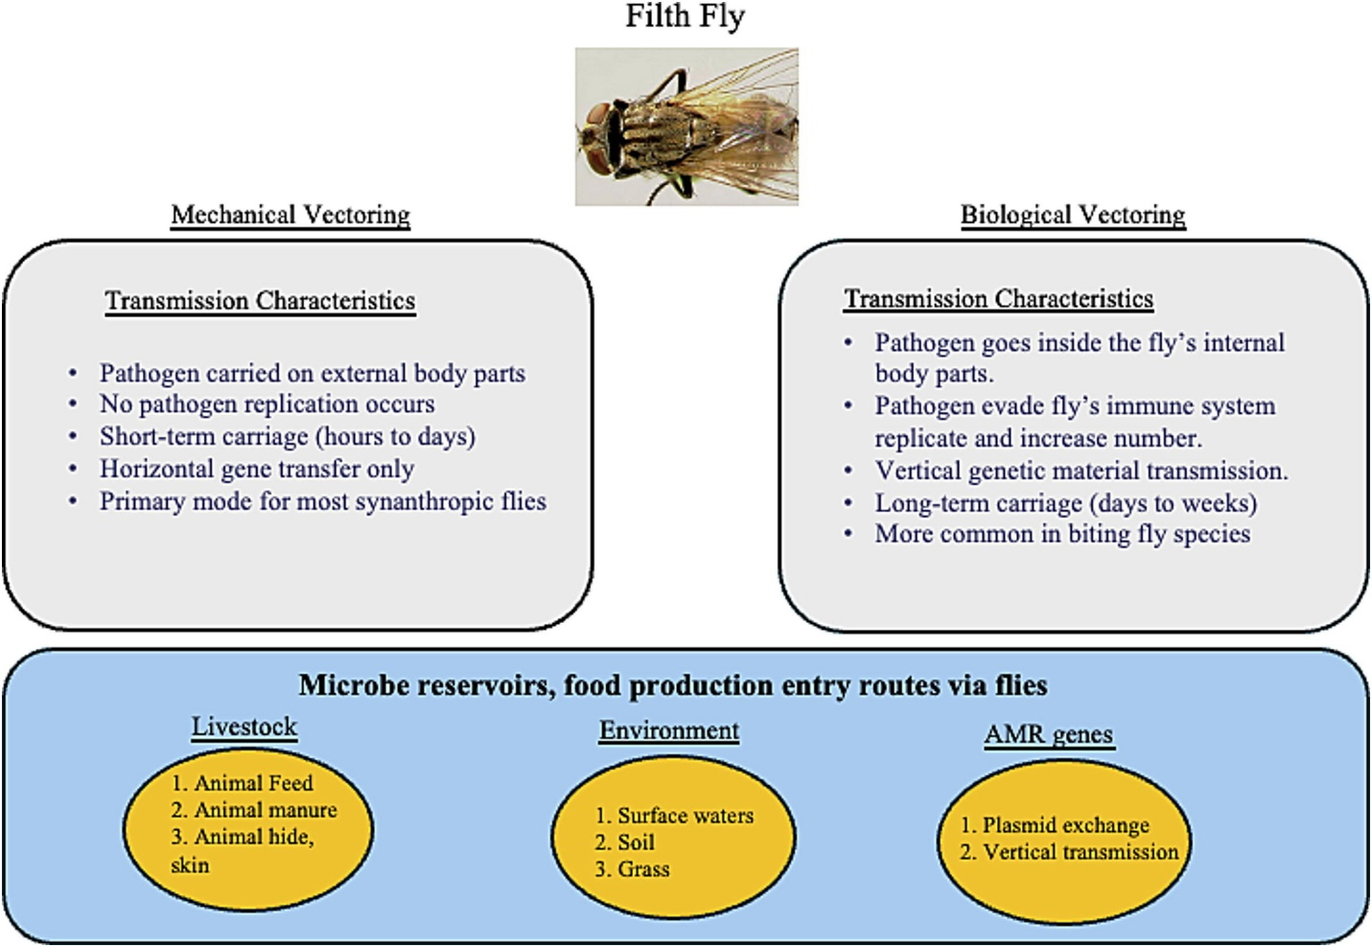
Fig 3- Transmission Characteristics of Filth Fly
Fly as a mechanical and biological vector of pathogenic microbes (Khamesipour et al., 2018; Lin et al., 2024; Stoffolano, 2019, Yin et al., 2022).
Housefly as a Mechanical and Biological Vector of Pathogenic Microbes.

An essential internal component that enhances flies' ability to operate as biological vectors is the fly crop (Stoffolano, 2022). Before food is digested in the midgut, it is stored in the crop, an enlarged section of the foregut in insects (Stoffolano, 2022). In many fly species, regurgitation is a normal physiological function. By using food item ejection from the crop, it can facilitate the spread of pathogens. The majority of pathogen transmission by regurgitation is mechanical (Stoffolano, 2019); biological transmission through defecation and regurgitation is only recognized when pathogens are demonstrated to multiply and grow in number within the insect. The fly is regarded as a biological vector for the transmission of infections through the foregut, gut, and reproductive systems when pathogen genetic material is found in fly offspring and subsequently vertically transported. The fly's mouth may be a recurrent source of pathogens including Salmonella enterica, Campylobacter, and Verotoxin-producing Escherichia coli (VTEC) members since different bacterial germs may persist in fly saliva or on other mouthparts (Onwugamba et al., 2018).
ROLE OF HOUSEFLIES AS MECHANICAL VECTOR OF PATHOGENS
Associations of Adult Houseflies with Bacteria and their Potential as Vectors
Adult houseflies get contaminated with microorganisms on their outside surfaces when they come into contact with substrates that are rich in microorganisms. Direct contact (mechanical transfer), feeding (infected mouthparts), and/or grooming (removal and disposal) are the ways in which bacteria on a housefly's mouthparts, tarsi, wings, and body become dislodged from and transmitted to the places the fly later visits (Jacques et al., 2017). As demonstrated for Escherichia coli O157:H7, which survived on the fly body for up to 13 days after bacterial exposure, flying has been shown to adversely affect the viability of bacteria on flies, presumably by speeding up drying. Instead, bacteria found in the external anatomy of the house fly may have greater protection that increases persistence. For both male and female flies that visit and engage with septic substrates, mechanical transfer from the external surfaces is probably applicable.
Additionally, flies have bacteria in their guts that they either purposefully consume the microbe-rich substrate or acquire indirectly by auto-grooming (Nayduch and Burrus, 2017). Female flies, which visit and examine substrates like manure and dumpster sludge as possible oviposition locations, have been found to consume bacteria more frequently (Thomson et al., 2017). Bacteria can be kept in the midgut, where they encounter hostile digestive and defensive processes, or in the crop, a diverticulated storage area of the insect foregut where ingested items are held prior to digestion in the midgut. Bacteria that make it through these midgut challenges may enter the alimentary canal and exit the body through excrement. According to recent research, individual house flies can have up to 400 different bacterial taxa in their internal bacterial communities (Park et al., 2019; Neupane and Nayduch, 2022). However, other studies that use whole flies for next-generation sequencing (which accounts for both internal and external bacteria) have found that a single fly can carry more than 1600 operational taxonomic units (Bahrndorff et al., 2017; Bahrndorff et al., 2020; Poudel et al., 2020).
Wild Houseflies as Potential Threats to Human and Animal Health
According to international surveys, adult houseflies from urban and agricultural settings carry more than 200 pathogenic bacterial taxa, including important species for human and animal health like Salmonella spp. (Hamilton et al., 2021), pathogenic strains of E. coli (Puri-Giri et al., 2017), Campylobacter spp. (Royden et al., 2016), Aeromonas cavie, and bacterial pathogens that cause bovine respiratory disease. Even more comprehensive lists of pathogens carried by flies have been produced by culture-based and, more recently, molecular-based surveys (Geden et al., 2021; Sudagidan et al., 2022; Gioia et al., 2022). Adult houseflies are unquestionably important for food security, particularly for pre- and post-harvest food safety across a range of food and animal species, because they are carriers of numerous harmful microorganisms.
Houseflies as Antimicrobial Resistance Disseminators and Reservoirs
Animal and human infections frequently develop antimicrobial resistance (AMR) as a result of the widespread and/or excessive use of antibiotics, especially in the production of animals for food (Ferri et al., 2017). Tetracycline, florfenicol, enrofloxacin, and ceftiofur are examples of broad-spectrum antibiotics that are frequently used for metaphylaxis to prevent or lessen suspected infection and disease (O'Connor et al., 2019). The widespread use of antibiotics as growth promoters continues even though they are currently prohibited in several nations (Wallinga et al., 2022). Food animals maintain an abundance of drug-resistant bacterial species as a result of this careless abuse, which they expel in their excreta and which house flies then consume.
The AMR bacteria found in house flies obtained from urban settings (Neupane et al., 2020) and animal production facilities (Wadaskar et al., 2021) are diverse and include both human and animal pathogenic species. These flies have also yielded multidrug-resistant bacteria, such as Staphylococcus species that have been isolated with multiple antibiotic-resistant genes (ARGs; msrA, msrB, tetK, tetM, tetL, ermC, and aad6) and that have a multidrug-resistant phenotype (oxacillin, penicillin, erythromycin, clindamycin, tetracycline, ciprofloxacin, gentamicin, and chloramphenicol) (Sudagidan et al., 2022).According to Zhang et al. (2018), Providencia spp., Enterobacter spp., and E. coli from house flies with colistin resistance genes (mcr-1, mcr-2, and mcr-3) were extremely common in a range of ecological niches, including animal production facilities. According to Fukuda et al. (2018), house flies linked to animal husbandry also have a high prevalence of E. coli that has multiple extended-spectrum beta-lactamase genes (blaCTX-M, blaTEM) and tetracycline resistance genes (tetA, tetB, tetD, tetM). In addition to harboring AMR bacteria, house flies have the concerning ability to help other bacterial species in their guts transfer AMR components to one another (Fukuda et al., 2016). In the environment, house flies visit several sources of microorganisms, which facilitates interactions between bacteria collected from physically disparate environments that would not otherwise interact. Gene transfer events can occur extremely quickly. As such, they play a major role in the spread of AMR bacteria and the genes that confer resistance to them throughout different ecological niches and ecosystems.
CONTROL AND MANAGEMENT OF HOUSEFLIES
Houseflies have long been thought of as both a disease-causing insect and a vector for the spread and transmission of infections, particularly in infectious illnesses of the digestive system (Khamesipour et al., 2018). Furthermore, because female adult houseflies have a high reproductive capability and can lay 150 eggs during each gonotrophic cycle and 500 eggs during each life cycle (about two weeks), flies proliferate quickly, particularly in favorable conditions (Neupane et al., 2020). According to epidemiological research, there was a correlation between the density of houseflies and the number of shigellosis patients, with shigellosis incidents peaking following housefly populations. Few useful field studies have demonstrated an effort to manage houseflies and offer a practical plan to lower illnesses in humans and animals. Using housefly screens decreased the incidence of Campylobacter spp. in agricultural settings by keeping houseflies out of the broiler houses. However, the number of houseflies and shigellosis cases decreased by 64% and 85%, respectively, when a bait and trap method was implemented in human-populated regions. Concurrently, there were 42%, 85%, and 57% fewer clinical visits, diarrheal illness cases, and antibody retention for enterotoxigenic E. coli, respectively.
Housefly fecundity is also significantly influenced by appropriate environmental hygiene and animal waste management. Because raising livestock produces manure, producers must understand how crucial efficient waste management is to preventing the spread and development of antimicrobial resistance. Agricultural development frequently makes use of chemical control techniques, such as commercial insecticides and larvicides. However, there is disagreement over these products' long-term viability. Primary concerns which have led to some countries banning the sale of pesticides include leakage and accumulation into surrounding environments and toxicity damage in humans and animals (Tudi et al., 2021). Depending on their chemical composition, different oils have been shown to be effective insecticides at every stage of the housefly life cycle, making botanical pesticides or oils extracted from specific plants (such as eucalyptol) an increasingly appealing option (Hazarika et al., 2020). These strategies worked well against houseflies, specific pathogen-related illnesses, and other vectors such as insects, mice, cockroaches, and microbes. Additionally, housefly control would require a raise in awareness of hygiene management. Thus, it is necessary to identify the sources of intermediary bacterial contamination caused by houseflies and to provide recommendations for effectively stopping the spread of bacteria.
CONCLUSION
Numerous microbial and parasitic diseases of public health importance are mechanically transmitted by houseflies (Musca domestica), which are frequently found around open garbage dumpsites. Open waste environments are highly contaminated, as evidenced by the great diversity and number of bacteria and parasites isolated from houseflies' exterior surfaces and gut contents. Particularly in areas with poor waste management and sanitary facilities, houseflies contribute to the spread of these infections by routinely migrating between garbage, food, and human habitations, raising the risk of enteric and other infectious diseases. The dynamics of disease persistence and transmission are also influenced by environmental parameters like temperature, humidity, and waste composition. These reviews highlight the urgent need for better fly control methods, better environmental sanitation, and better solid waste management in order to reduce the health hazards that houseflies provide at open disposal sites. Reducing disease transmission and improving community health outcomes require integrated public health initiatives that focus on vector control and waste disposal practices.
ETHICAL APPROVAL
This study did not involve human participant or animal experimentation and therefore did not require formal ethical approval.
REFERENCES
1. Singh, J., Saxena, R., Bharti, V & Singh, A. (2018). The Importance of Waste
Management to Environmental Sanitation: A Review. Advances in Bioresearch Journal Vol 9 (2) 202-207.
2. Szalanski, A. L., Owens, C. B., Mckay T. & Steelman, C. D. (2020). Detection of
Campylobacter and Escherichia coli O157:H7 from filth flies by polymerase chain reaction. Journal of Medical and Veterinary Entomology 18(3), 241–246.
3. Awache, I & Farouk, A. A. (2016). Bacteria and fungi associated with house flies
collected from cafeteria and food Centres in Sokoto. FUW Trends in Science and Technology Journal 1(1):123–125.
4. Nayduch, D & Burrus, R. G (2017). Flourishing in filth: House Fly-Microbe interactions
across life history. Journal of Annals of Entomological Society of America 110: 6- 18.
5. Khamesipour, F., Lankarani, K. B., Honarvar, B & Kwenti, T. E (2018). A systematic
reviewof human pathogens carried by the housefly (Musca domestica L.). BMC Public Health Journal 18, 1049.
6. de Jonge, N., Michaelsen, T. Y., Ejbye-Ernst, R., Jensen, A., Nielsen, M. E., Bahrndorff,
S & Nielsen, J. L. (2020). Housefly (Musca domestica L.) associated microbiota across different life stages. Journal of Scientific Report 10, 7842
7. Adeleke, M.A., Oyewole, V.O., Olabiyi, K.O & Oforka, L.C (2017). Parasites
and pathogenic bacteria associated with houseflies and the public health implications in Osogbo, Southwestern Nigeria. Munis Entomology and Zoology Journal 12, 94-98.
8. Oyeyemi, O. T., Agbaje, M. O. & Okelue, U. B. (2016). Foodborne human parasitic
pathogens associated with household cockroaches and houseflies in Nigeria. Parasite Epidemiology and Control Journal 1: 10-13.
9. Bennett, G. F., Peirce, M. A., & Wall, R. (2018). Houseflies as vectors of parasites of
food animals. International Journal of Parasitology 28(6), 941-949.
10. Traore, A., Carnevale, P., & Duchemin, J. B. (2017). Roundworms and houseflies: a
quantitative study of helminths and dipterans in an urban environment. Journal of Environmental Health Perspectives 125(2), 305-312.
11. Koohsar, F., Parvizi, P & Rashno, Z. (2021). Survey of parasitic contamination of
housefly (Musca domestica L.) (Diptera: Muscidae) in the sanitary landfill of Tabriz, northwest Iran. Journal of Arthropod-Borne Diseases 15(3), 330-336.
12. Pava-Ripoll, M., Pearson, R. E., Miller, A. K., Tall, B. D & Keys, C.E. (2015) Ingested
Salmonella enterica, Cronobacter sakazakii, Escherichia coli O157:H7, and Listeria monocytogenes: transmission dynamics from adult house flies to their eggs and first filial (F1) generation adults. BMC Microbiology Journal 15: 150.
13. Junqueira, A. C. M., Ratan, A., Acerbi, E., Drautz-Moses, D. I., Premkrishnan, B. N. V.,
Costea, P. I., Linz, B., Purbojati, R. W., Paulo, D. F., Gaultier, N. E., Subramanian, P., Hasan, N. A., Colwell, R. R, Bork, P., Azeredo-Espin, A. M. L., Bryant, D. A & Schuster, S. C. (2017). The microbiomes of blowflies and houseflies as bacterial transmission reservoirs. Scientific Reports Journal 7:16324.
14. Onwugamba, F. C., Fitzgerald, J. R., Rochon, K., Guardabassi, L., Alabi, A., Kühne,
S., Grobusch, M. P & Schaumburg, F. (2018). The Role of ‘Filth Flies’ in the Spread of Antimicrobial Resistance. Travel Medicine and Infectious Disease Journal 22, 8–17.
15. Zhang, J., Wang, J., Chen, L., Yassin, A. K., Kelly, P., Butaye, P., Li, J., Gong, J.,
Cattley, R & Qi, K. (2018). Housefly (Musca domestica) and Blow Fly (Protophormia terraenovae) as Vectors of Bacteria Carrying Colistin Resistance Genes. Journal of Applied Environmental Microbiology 84.
16.Czekalski, N., Diez, E. G & Burgmann, H. (2014). Wastewater as a point source of
antibiotic resistance genes in the sediment of a freshwater lake. International Society for Microbial Ecology Journal 8, 1381–1390.
17. Anjum, M. F., Zankari, E & Hasman, H. (2017). Molecular methods for detection of
antimicrobial resistance. Microbiology Spectrum Journal 5.
18. Thomson, J. L., Yeater, K. M., Zurek, L & Nayduch, D. (2017). Abundance and
Accumulation of Escherichia coli and Salmonella typhimurium Procured by Male and Female House Flies (Diptera: Muscidae) Exposed to Cattle Manure. Annals of Entomological Society of America Journal 110, 37–44.
19. Neupane, S., Hall, B., Brooke, G & Nayduch, D. (2023). Sex-Specific Feeding Behavior
of Adult House Flies, Musca domestica L. (Diptera: Muscidae). Journal of Medical Entomology 60, 7–13.
20. Neupane, S., White, K., Thomson, J. L., Zurek, L & Nayduch, D. (2020). Environmental
and Sex Effects on Bacterial Carriage by Adult House Flies (Musca domestica L.). Journal of Insects 11, 401.
21. Nayduch, D., Neupane, S., Pickens, V., Purvis, T & Olds, C. (2023). House Flies Are
Underappreciated Yet Important Reservoirs and Vectors of Microbial Threats to Animal and Human Health. Journal of Microorganisms 11(3), 583.
22. Stoffolano, J. G. (2019). Fly foregut and transmission of microbes. Advances in
Insect Physiology Journal 57: 27–95.
23. Gomes, G., Köberle, R., Von Zuben, C. J & Andrade, D. V. (2018). Droplet bubbling
evaporatively cools a blowfly. Scientific Report Journal 8: 5464.
24. Stoffolano, J. G. (2019). Fly foregut and transmission of microbes. Advances in Insect
Physiology Journal 57: 27–95.
25. Sharma, A., Heinze, S. D., Wu, Y., Kohlbrenner, T., Morilla, I., Brunner, C., Wimmer, E.
A., van de Zande, L., Robinson, M. D & Beukeboom, L. W. (2017). Male sex in houseflies is determined by Mdmd, a paralog of the generic splice factor gene CWC22. Science Journal 356: 642–645.
26.Hamm, R. L., Meisel, R. P & Scott, J. G. (2015). The evolving puzzle of autosomal
versus Y-linked male determination in Musca domestica. Genes Genomes and Genetics Journal 5: 371–384.
27. Son, J. H., Kohlbrenner, T., Heinze, S., Beukeboom, L.W., Bopp, D & Meisel, R. P.
(2019). Minimal effects of proto-Y chromosomes on house fly gene expression in spite of evidence that selection maintains stable polygenic sex determination. Genetics Journal 213: 313–327.
28. Son, J. H., Kohlbrenner, T., Heinze, S., Beukeboom, L.W., Bopp, D & Meisel, R. P.
(2019). Minimal effects of proto-Y chromosomes on house fly gene expression in spite of evidence that selection maintains stable polygenic sex determination. Genetics Journal 213: 313–327.
29. Service, M. (2012) Medical Entomology for Students. United Kingdom: Cambridge
University Press. Pp. 140–141.
30. Service, M. (2012) Medical Entomology for Students. United Kingdom: Cambridge
University Press. Pp. 140–141.
31. Stoffolano, J. G. (2019). Fly foregut and transmission of microbes. Advances in
Insect Physiology Journal 57: 27–95.
32. Gomes, G., Köberle, R., Von Zuben, C. J & Andrade, D. V. (2018). Droplet bubbling
evaporatively cools a blowfly. Scientific Report Journal 8: 5464.
33. Stoffolano, J. G. (2019). Fly foregut and transmission of microbes. Advances in
Insect Physiology Journal 57: 27–95.
34. Nayduch, D & Burrus, R. G (2017). Flourishing in filth: House Fly-Microbe
interactions across life history. Journal of Annals of Entomological Society of America 110: 6-18.
35. Jacques, B. J., Bourret, T. J & Shaffer, J. J. (2017). Role of Fly Cleaning Behavior
on Carriage of Escherichia coli and Pseudomonas aeruginosa. Journal of Medical Entomology 54, 1712–1717.
36. Nayduch, D & Burrus, R. G (2017). Flourishing in filth: House Fly-Microbe
interactions across life history. Journal of Annals of Entomological Society of America 110: 6-18.
37. Stoffolano, J. G. (2019). Fly foregut and transmission of microbes. Advances in
Insect Physiology Journal 57: 27–95.
38. Thomson, J. L., Yeater, K. M., Zurek, L & Nayduch, D. (2017). Abundance and
Accumulation of Escherichia coli and Salmonella typhimurium Procured by Male and Female House Flies (Diptera: Muscidae) Exposed to Cattle Manure. Annals of Entomological Society of America Journal 110, 37–44.
39. Nayduch, D., Zurek, K., Thomson, J. L & Yeater, K. M. (2018). Effects of bacterial
dose and fly sex on persistence and excretion of Salmonella enterica serovar Typhimurium from Adult House Flies (Musca domestica L.; Diptera: Muscidae). Journal of Medical Entomology 55: 1264–1270.
40. Onwugamba, F. C., Fitzgerald, J. R., Rochon, K., Guardabassi, L., Alabi, A.,
Kühne, S., Grobusch, M. P & Schaumburg, F. (2018). The Role of ‘Filth Flies’ in the Spread of Antimicrobial Resistance. Travel Medicine and Infectious Disease Journal 22, 8–17.
41. Poudel, A., Kang, Y., Mandal, R. K., Kalalah, A., Butaye, P., Hathcock, T., Kelly, P.,
Walz, P., Macklin, K & Cattley, R. (2020). Comparison of Microbiota, Antimicrobial Resistance Genes and Mobile Genetic Elements in Flies and the Feces of Sympatric Animals. FEMS Microbiology Ecology Journal 96, fiaa027.
42. Fukuda, A., Usui, M., Okubo, T & Tamura, Y. (2016). Horizontal Transfer of Plasmid-
Mediated Cephalosporin Resistance Genes in the Intestine of Houseflies (Musca domestica). Journal of Microbial Drug Resistance 22, 336–341.
43. Poudel, A., Hathcock, T., Butaye, P., Kang, Y., Price, S., Macklin, K., Walz, P.,
Cattley, R., Kalalah, A & Adekanmbi, F. (2019). Multidrug-Resistant Escherichia coli, Klebsiella pneumoniae and Staphylococcus spp. in Houseflies and Blowflies from Farms and Their Environmental Settings. International Journal of Environmental Research and Public Health 16, 3583.
44. Nayduch, D & Burrus, R. G (2017). Flourishing in filth: House Fly-Microbe interactions
across life history. Journal of Annals of Entomological Society of America 110: 6-18.
45. Baldacchino, F., Desquesnes, M., Duvallet, G., Lysyk, T & Mihok, S. (2018).
Veterinary importance and integrated management of Brachycera flies in dairy farms. In Garros, C., Bouyer, J., Wi. Takken & Smallegange, R. C (eds.), Pests and vector-borne diseases in the livestock industry, ecology and control of vector-borne diseases. Wageningen Academic Publishers, Wageningen, pp. 55–90.
46. Neupane, S., White, K., Thomson, J. L., Zurek, L & Nayduch, D. (2020). Environmental
and Sex Effects on Bacterial Carriage by Adult House Flies (Musca domestica L.). Journal of Insects 11, 401.
47. Usui, M., Shirakawa, T., Fukuda, A & Tamura, Y. (2015). The role of flies in
disseminating plasmids with antimicrobial-resistance genes between farms. Journal of Microbial Drug Resistance 21: 562–569.
48. Solà-Ginés, M., González-López, J. J., Cameron-Veas, K., Piedra-Carrasco, N.,
Cerdà-Cuéllar, M & Migura-Garcia, L. (2015). Houseflies (Musca domestica) as Vectors for Extended-Spectrum β-Lactamase-Producing Escherichia coli on Spanish Broiler Farms. Journal of Applied Environmental Microbiology 81(11):3604–3611.
49. Schaumburg, F., Onwugamba, F. C., Akulenko, R., Peters, G., Mellmann, A., Köck, R
& Becker, K. A. (2016). Geospatial analysis of flies and the spread of antimicrobial resistant bacteria. International Journal of Medical Microbiology 306, 566–571.
50. Deakpe, T. E., Manyi, M. M. & Utume, L. N. (2018). Pathogenic parasites and
bacteria associated with the housefly (Musca domestica) in Makurdi; a fly-infested area in central Nigeria. Nigerian Journal of Parasitology 39(1): 111-115.
51. Onyenwe, E., Okore, O. O., Ubiaru, P. C. & Abel, C. (2016). Housefly-borne
helminth parasites of MOUAU and its public health implication for the university community. Animal Research International Journal 13(1): 2352-2358.
52. Motazedian, M. H., Davood, M & Golnoush, M. (2014) The role of Musca domestica
as a carrier of parasites in Shiraz, Southern Iran. Academic Journal of Entomology 7(3):84–87.
53. Collinet-Adler S., Babji, S., Francis, M., Kattula, D & Premkumar, P. S, (2015).
Environmental factors associated with high fly densities and diarrhea in Vellore. Applied and Environmental Microbiology Journal 81: 6053-6058.
54. Doza, S., Jabeen Rahman, M., Islam, M. A., Kwong, L. H., Unicomb, L., Ercumen,
A., Pickering, A. J., Parvez, S. M., Naser, A. M & Ashraf, S. (2018). Prevalence and association of Escherichia coli and Diarrheagenic Escherichia coli in stored foods for young children and flies caught in the same households in rural Bangladesh. American Journal of Tropical Medicine and Hygiene 98: 1031–1038.
55. Haddow, A. D., Nasar, F., Schellhase, C. W., Moon, R. D., Padilla, S. L., Zeng, X &
Wollen-Roberts, S. E. (2017). Low potential for mechanical transmission of Ebola virus via house flies (Musca domestica). Journal of Parasites and Vectors 10: 218.
56. Dehghani, R & Kassiri, H. (2020). A brief review on the possible role of houseflies
and cockroaches in the mechanical transmission of Coronavirus Disease 2019 (COVID-19). Archives of Clinical Infectious Disease Journal 15: e102863.
57. Nayduch, D & Burrus, R. G (2017). Flourishing in filth: House Fly-Microbe
interactions across life history. Journal of Annals of Entomological Society of America 110: 6-18.
58. Khamesipour, F., Lankarani, K. B., Honarvar, B & Kwenti, T. E (2018). A systematic
review of human pathogens carried by the housefly (Musca domestica L.). BMC Public Health Journal 18, 1049.
59. Khamesipour, F., Lankarani, K. B., Honarvar, B & Kwenti, T. E (2018). A systematic
review of human pathogens carried by the housefly (Musca domestica L.). BMC Public Health Journal 18, 1049.
60. Stoffolano, J. G. (2019). Fly foregut and transmission of microbes. Advances in Insect
Physiology Journal 57: 27–95.
61. Stoffolano, J. G. (2019). Fly foregut and transmission of microbes. Advances in Insect
Physiology Journal 57: 27–95.
62. Nayduch, D., Neupane, S., Pickens, V., Purvis, T & Olds, C. (2023) House Flies Are
Underappreciated Yet Important Reservoirs and Vectors of Microbial Threats to Animal and Human Health. Journal of Microorganisms 11(3), 583.
63.Khamesipour, F., Lankarani, K. B., Honarvar, B & Kwenti, T. E (2018). A systematic
review of human pathogens carried by the housefly (Musca domestica L.). BMC Public Health Journal 18, 1049.
64. Lin, C., Liu, J., Yuan, Y., Yu, S., Feng, L., Gu, Y., ... & Liu, H. (2024). Unveiling the
hidden dangers: enteropathogens carried by flies in Pudong New Area. BMC Infectious
Diseases, 24(1), 569.
65. Stoffolano, J. G. (2019). Fly foregut and transmission of microbes. Advances in Insect
Physiology Journal 57: 27–95.
66. Yin, J. H., Kelly, P. J., & Wang, C. (2022). Flies as vectors and potential sentinels for
bacterial pathogens and antimicrobial resistance: A review. Veterinary Sciences, 9(6), 300.
67. Stoffolano Jr, J. G. (2022). Synanthropic flies—a review including how they obtain
nutrients, along with pathogens, store them in the crop and mechanisms of transmission. Insects, 13(9), 776.
68. Stoffolano Jr, J. G. (2022). Synanthropic flies—a review including how they obtain
nutrients, along with pathogens, store them in the crop and mechanisms of transmission. Insects, 13(9), 776.
69. Stoffolano, J. G. (2019). Fly foregut and transmission of microbes. Advances in Insect
Physiology Journal 57: 27–95.
70. Onwugamba, F. C., Fitzgerald, J. R., Rochon, K., Guardabassi, L., Alabi, A., Kühne, S.,
Grobusch, M. P & Schaumburg, F. (2018). The Role of ‘Filth Flies’ in the Spread of Antimicrobial Resistance. Travel Medicine and Infectious Disease Journal 22, 8–17.
71. Jacques, B. J., Bourret, T. J & Shaffer, J. J. (2017). Role of Fly Cleaning Behavior on
Carriageof Escherichia coli and Pseudomonas aeruginosa. Journal of Medical Entomology 54, 1712–1717.
72. Nayduch, D & Burrus, R. G (2017). Flourishing in filth: House Fly-Microbe interactions
across life history. Journal of Annals of Entomological Society of America 110: 6- 18.
73. Thomson, J. L., Yeater, K. M., Zurek, L & Nayduch, D. (2017). Abundance and
Accumulation of Escherichia coli and Salmonella typhimurium Procured by Male and Female House Flies (Diptera: Muscidae) Exposed to Cattle Manure. Annals of Entomological Society of America Journal 110, 37–44.
74. Park, R., Dzialo, M. C., Spaepen, S., Nsabimana, D., Gielens, K., Devriese, H.,
Crauwels, S., Tito, R. Y., Raes, J & Lievens, B. (2019). Microbial Communities of
the House Fly Musca domestica Vary with Geographical Location and Habitat.
Journal of Microbiome 7, 147.
75. Neupane, S & Nayduch, D. (2022). Effects of Habitat and Sampling Time on Bacterial
Community Composition and Diversity in the Gut of the Female House Fly,
Musca domestica Linnaeus (Diptera: Muscidae). Journal of Medical Veterinary
Entomology 36, 435–443.
76. Bahrndorff, S., de Jonge, N., Skovgård, H. & Nielsen, J. L. (2017). Bacterial
Communities Associated with Houseflies (Musca domestica L.) Sampled within
and between Farms. PLoS ONE Journal 12(1).
77. Bahrndorff, S., Ruiz-González, A., de Jonge, N., Nielsen, J. L., Skovgård, H &
Pertoldi, C. (2020). Integrated Genome-Wide Investigations of the Housefly, a
Global Vector of Diseases Reveal Unique Dispersal Patterns and Bacterial
Communities across Farms. BMC Genomics Journal 21, 66.
78. Poudel, A., Kang, Y., Mandal, R. K., Kalalah, A., Butaye, P., Hathcock, T., Kelly, P.,
Walz, P., Macklin, K & Cattley, R. (2020). Comparison of Microbiota,
Antimicrobial Resistance Genes and Mobile Genetic Elements in Flies and the
Feces of Sympatric Animals. FEMS Microbiology Ecology Journal 96, fiaa027.
79. Hamilton, A. M., Paulsen, D. J., Trout-Fryxell, R. T., Orta, V. E., Gorman, S. J.,
Smith, D. M., Buchanan, J. R., Wszelaki, A. L & Critzer, F. J. (2021). Prevalence
of Salmonella enterica in Flies on a Diversified Cattle and Fresh Produce Farm
across Two Growing Seasons. Journal of Food Protection 84, 1009–1015.
80. Puri-Giri, R., Ghosh, A., Thomson, J. L & Zurek, L. (2017). House Flies in the
Confined Cattle Environment Carry Non-O157 Shiga Toxin-Producing
Escherichia coli. Journal of Medical Entomology 54, 726–732.
81. Royden, A., Wedley, A., Merga, J. Y., Rushton, S., Hald, B., Humphrey, T &
Williams, N. J. A (2016). Role for Flies (Diptera) in the Transmission of
Campylobacter to Broilers? Journal of Epidemiology and Infections 144, 3326–
3334.
82. Geden, C. J., Nayduch, D., Scott, J. G., Burgess, E. R., Gerry, A. C., Kaufman, P. E.,
Thomson, J., Pickens, V & Machtinger, E. T. (2021). House Fly (Diptera:
Muscidae): Biology, Pest Status, Current Management Prospects, and
Research Needs. Journal of Integrated Pest Management 12, 39.
83. Sudagidan, M., Ozalp, V. C., Can, Ö., Eligül, H., Yurt, M. N. Z., Tasbasi, B. B., Acar,
E. E., Kavruk, M & Koçak, O. (2022). Surface Microbiota and Associated
Staphylococci of Houseflies (Musca domestica) Collected from Different
Environmental Sources. Microbial Pathogenesis Journal 164, 105439.
84. Gioia, G., Freeman, J., Sipka, A., Santisteban, C., Wieland, M., Gallardo, V. A.,
Monistero, V., Scott, J. G & Moroni, P. (2022). Pathogens associated with
houseflies from different areas within a New York State dairy. JDS
Communication Journal 3, 285–290.
85. Ferri, M., Ranucci, E., Romagnoli, P & Giaccone, V. (2017). Antimicrobial
Resistance: A Global Emerging Threat to Public Health Systems. Journal of
Critical Reviews in Food Science and Nutrition 57, 2857–2876.
86. O’Connor, A. M., Hu, D., Totton, S. C., Scott, N., Winder, C. B., Wang, B., Wang, C.,
Glanville, J., Wood, H & White, B. (2019). A Systematic Review and Network
Meta-Analysis of Injectable Antibiotic Options for the Control of Bovine
Respiratory Disease in the First 45 Days Post Arrival at the Feedlot. Journal
of Animal Health Research Reviews 20, 163–181.
87. Wallinga, D., Smit, L. A. M., Davis, M. F., Casey, J. A & Nachman, K. E. (2022). A
Review of the Effectiveness of Current US Policies on Antimicrobial Use in
Meat and Poultry Production. Journal of Current Environmental Health
Reports 9, 339–354.
88. Neupane, S., White, K., Thomson, J. L., Zurek, L & Nayduch, D. (2020).
Environmental and Sex Effects on Bacterial Carriage by Adult House Flies
(Musca domestica L.). Journal of Insects 11, 401.
89. Wadaskar, B., Kolhe, R., Waskar, V., Budhe, M., Kundu, K & Chaudhari, S.
(2021). Detection of Antimicrobial Resistance in Escherichia coli and
Salmonella Isolated from Flies Trapped at Animal and Poultry Farm
Premises. Journal of Animal Research 11, 341–350.
90. Sudagidan, M., Ozalp, V. C., Can, Ö., Eligül, H., Yurt, M. N. Z., Tasbasi, B. B.,
Acar, E. E., Kavruk, M & Koçak, O. (2022). Surface Microbiota and
Associated Staphylococci of Houseflies (Musca domestica) Collected from
Different Environmental Sources. Microbial Pathogenesis Journal 164,
105439.
91. Zhang, A., Li, Y., Guan, Z., Tuo, H., Liu, D., Yang, Y., Xu, C., Lei, C & Wang, H.
(2018). Characterization of resistance patterns and detection of apramycin
resistance genes in Escherichia coli Isolated from chicken feces and
houseflies after apramycin administration. Frontier in Microbiology Journal
9, 328.
92. Fukuda, A., Usui, M., Okubo, T., Tagaki, C., Sukpanyatham, N & Tamura, Y.
(2018). Co-Harboring of Cephalosporin (bla)/Colistin (mcr) Resistance
Genes among Enterobacteriaceae from Flies in Thailand. FEMS
Microbiology Letters Journal 365, fny178.
93. Fukuda, A., Usui, M., Okubo, T & Tamura, Y. (2016). Horizontal Transfer of
Plasmid-Mediated Cephalosporin Resistance Genes in the Intestine of
Houseflies (Musca domestica). Journal of Microbial Drug Resistance 22,
336–341.
94. Khamesipour, F., Lankarani, K. B., Honarvar, B & Kwenti, T. E (2018). A
systematic review of human pathogens carried by the housefly (Musca
domestica L.). BMC Public Health Journal 18, 1049.
95. Neupane, S., White, K., Thomson, J. L., Zurek, L & Nayduch, D. (2020).
Environmental and Sex Effects on Bacterial Carriage by Adult House
Flies (Musca domestica L.). Journal of Insects 11, 401.
96. Tudi, M., Daniel Ruan, H., Wang, L., Lyu, J., Sadler, R., Connell, D & Phung,
D. T. (2021). Agriculture development, pesticide application and its
impact on the environment. International journal of environmental
research and public health, 18(3), 1112.

97. Hazarika, H., Tyagi, V., Krishnatreyya, H., Islam, J., Boruah, D., Kishor, S &
Zaman, K. (2020). Essential oil based controlled-release non-toxic
evaporating tablet provides effective repellency against Musca
domestica. Acta Tropica, 210, 105620.

