Assessing The Prevalence of Chlamydia trachomatis Infections among Female Tertiary Students Using Lateral Flow Assays

ABSTRACT
Chlamydia trachomatis is a leading cause of sexually transmitted infections (STIs) globally, disproportionately affecting young women, including tertiary students, due to behavioral risk factors like unprotected sex. This study aimed to assess C. trachomatis prevalence among female students of Rivers State University, Port Harcourt, using lateral flow assays (LFAs) and identify associated risk factors. A cross-sectional study was conducted with 150 female students aged 18–30 years, recruited via convenience sampling. Urine samples were tested for C. trachomatis antigens using the ROSTEC Chlamydia Rapid Test Cassette. Structured questionnaires collected data on socio-demographics, sexual behaviors, and C. trachomatis knowledge. Prevalence was calculated as the proportion of positive LFA results, and chi-square tests analyzed risk factor associations, with significance set at p<0.05. Participants had a mean age of 20 ± 1.82 years.with 60.0% single and 65.3% on-campus residents. Sexual education exposure was high (92.7%), but C. trachomatis awareness was low (12.7%), with only 0.7% ever tested. Sexual activity was reported by 45.3%, unprotected sex by 26.0%, and contraceptive use by 36.0%. Prevalence was 0.0% (100.0% negative LFA results), with no significant risk factor associations. The zero prevalence suggests ether a low infection burden or LFA limitations or both. Low awareness and testing rates highlight the need for targeted education and routine LFA-based screening to enhance STI control in Nigerian universities.
Keywords: Chlamydia trachomatis, Lateral flow assays, Female tertiary students

INTRODUCTION

Chlamydia trachomatis is a leading cause of sexually transmitted infections (STIs) globally, contributing to an estimated 129 million new cases annually, with young women aged 15–24 years disproportionately affected (WHO, 2023). In Nigeria, a high-burden region for STIs, the prevalence of C. trachomatis among female tertiary students remains poorly documented, despite their elevated risk due to behavioral factors such as unprotected sexual activity and multiple sexual partners (Otu et al., 2020). The asymptomatic nature of many chlamydia infections complicates early detection, increasing the risk of severe complications, including pelvic inflammatory disease (PID), infertility, and ectopic pregnancy, which pose significant public health challenges (Adesiji et al., 2018). Addressing this issue in university populations is critical, as tertiary students represent a high-risk group with unique social and behavioral dynamics that may amplify STI transmission.
Lateral flow assays (LFAs) have emerged as rapid, cost-effective diagnostic tools for detecting C. trachomatis antigens or antibodies (IgG/IgM) in biological samples such as urine, vaginal swabs, or serum, offering high sensitivity and specificity in resource-limited settings (Ogbu et al., 2021). Unlike traditional diagnostic methods like polymerase chain reaction (PCR), which require specialized equipment, trained personnel, and longer processing times, LFAs are portable, require minimal training, and deliver results within 15–30 minutes (Workowski et al., 2021). These characteristics make LFAs particularly suitable for screening in university health centers, where rapid, accessible diagnostics can facilitate early intervention and reduce the burden of untreated infections(Workowski et al., 2021).
Preliminary studies in Nigeria indicate C. trachomatis prevalence rates of 5–15% among young women, but these studies predominantly rely on hospital-based samples, which may not accurately reflect the prevalence in university populations (Okoror et al., 2019). Tertiary students face unique challenges, including low STI awareness, limited access to diagnostic facilities, and social stigma surrounding STI testing, all of which contribute to underdiagnosis and delayed treatment (Otu et al., 2020). These factors underscore the need for targeted prevalence studies in university settings to quantify the burden of C. trachomatis infections and inform public health strategies. The lack of data specific to tertiary female students hinders the development of evidence-based interventions, such as routine screening or educational campaigns, to mitigate the long-term consequences of chlamydia infections.
The use of LFAs in this context offers a practical solution to address the diagnostic gap in resource-constrained settings like Nigeria. By detecting C. trachomatis infection markers, such as antigens or antibodies, LFAs can provide rapid insights into infection rates, enabling timely treatment and reducing the risk of complications (Ogbu et al., 2021). Moreover, identifying associated risk factors—such as age, sexual behavior, and contraceptive use—can guide targeted prevention efforts tailored to the university population. For instance, studies suggest that inconsistent condom use and multiple sexual partners are significant risk factors among young women, yet these have not been adequately explored in Nigerian tertiary students (Otu et al., 2020). This study aims to bridge these gaps by assessing C. trachomatis prevalence using LFAs and evaluating associated risk factors among female students at Rivers State University.
The choice of Rivers State University as the study site is strategic, given its location in Port Harcourt, a major urban center in Nigeria’s Niger Delta region with high STI and malaria transmission rates (Nigerian Ministry of Health, 2022). The university’s diverse female student population provides an ideal setting to investigate C. trachomatis prevalence and risk factors, reflecting the broader dynamics of tertiary institutions in Nigeria. By focusing on non-invasive samples like urine, the study ensures participant comfort and compliance, which is critical for achieving sufficient sample sizes in a population often reluctant to seek STI testing due to stigma (Adesiji et al., 2018). The findings will provide critical data to support the integration of LFAs for C. trachomatis into routine health services at university health centers, enhancing STI control efforts.
This study aims to assess the prevalence of C. trachomatis infections among female students at Rivers State University using LFAs to detect infection markers in urine samples, while also identifying associated risk factors. By generating prevalence data and evaluating the performance of LFAs, the study will contribute to the evidence base for STI screening and prevention in tertiary institutions. The findings are expected to inform university health policies, promote awareness campaigns, and support the adoption of cost-effective diagnostics like LFAs, ultimately reducing the burden of C. trachomatis-related complications in Nigeria and similar settings (WHO, 2023).
Chlamydia trachomatis is a significant public health concern, particularly among young women, including tertiary female students, who face elevated risks due to behavioral and social factors such as inconsistent condom use and multiple sexual partners (Otu et al., 2020). In Nigeria, a country with a high burden of sexually transmitted infections (STIs), the prevalence of C. trachomatis among university students remains inadequately documented, posing a barrier to effective STI control programs. Existing studies report prevalence rates ranging from 5–15% among young women, but these primarily rely on hospital-based samples and costly, laboratory-dependent methods like polymerase chain reaction (PCR), which are impractical for widespread screening in resource-constrained settings like university health centers (Okoror et al., 2019). This reliance on inaccessible diagnostics limits the ability to capture accurate prevalence data specific to tertiary student populations.
The underutilization of rapid, cost-effective diagnostic tools, such as lateral flow assays (LFAs), for C. trachomatis screening in Nigerian tertiary institutions represents a critical gap in public health practice. LFAs, which detect C. trachomatis antigens or antibodies in urine or vaginal swabs, offer high sensitivity and specificity, require minimal training, and provide results within 15–30 minutes, making them ideal for resource-limited settings (Ogbu et al., 2021). However, their application in university-based screening programs remains largely unexplored, leaving health authorities without sufficient data to justify their integration into routine STI screening protocols. This gap hinders the development of targeted interventions, such as awareness campaigns or accessible screening programs, tailored to the needs of tertiary female students.
The lack of prevalence data specific to tertiary female students exacerbates the challenge of addressing C. trachomatis infections in this high-risk population. Factors such as low STI awareness, limited access to diagnostic facilities, and stigma surrounding STI testing contribute significantly to underdiagnosis, increasing the risk of severe complications like pelvic inflammatory disease (PID), infertility, and ectopic pregnancy (Adesiji et al., 2018). Without accurate prevalence estimates, universities cannot effectively prioritize resources for STI prevention, leaving students vulnerable to long-term health consequences. Furthermore, the absence of data on prevalence within university settings limits the ability to assess the true burden of C. trachomatis and implement evidence-based interventions to reduce transmission.
Another critical gap is the limited characterization of risk factors associated with C. trachomatis infections among female tertiary students in Nigeria. While studies suggest that younger age, multiple sexual partners, and inconsistent condom use are significant risk factors, these have not been adequately explored in the context of university populations (Otu et al., 2020). Understanding these risk factors is essential for designing targeted prevention strategies, such as sexual health education or counseling programs, that address the specific behavioral and social dynamics of tertiary students. The lack of such data restricts the ability to develop interventions that resonate with this demographic, further perpetuating the cycle of underdiagnosis and untreated infections.
The absence of comprehensive prevalence and risk factor data also has broader implications for public health policy in Nigeria. Without evidence on the burden of C. trachomatis among tertiary students, health authorities cannot effectively advocate for funding or infrastructure to support STI screening and treatment in university health centers. This gap is particularly concerning given the potential for untreated infections to contribute to significant morbidity, including infertility, which carries social and economic consequences (Adesiji et al., 2018). Addressing these gaps requires studies that utilize accessible diagnostics like LFAs to generate reliable prevalence data and identify risk factors, enabling the design of sustainable STI control strategies.
This study addresses these critical gaps by assessing the prevalence of C. trachomatis infections among female students at Rivers State University using LFAs to detect infection markers (IgG/IgM antibodies) in urine and vaginal swab samples. By evaluating associated risk factors, such as age, sexual behavior, and contraceptive use, the study will provide essential data to guide STI prevention and control strategies in tertiary institutions. The findings will inform university health policies, promote the adoption of LFAs for routine screening, and contribute to reducing the burden of C. trachomatis-related complications in Nigeria’s high-risk student population. This study therefore aims at assessing the prevalence of Chlamydia trachomatis infections among female tertiary students at Rivers State University by detecting infection markers in urine samples using lateral flow assays and evaluating associated risk factors.
MATERIALS AND METHOD
Study Area
The study was conducted at the Rivers State University, located in Port Harcourt, Rivers State, Nigeria, a major urban center in the Niger Delta region known for high prevalence rates of both malaria and sexually transmitted infections (STIs), including Chlamydia trachomatis (Nigerian Ministry of Health, 2022). Port Harcourt’s diverse population and its status as a hub for tertiary education made it an ideal setting for investigating C. trachomatis prevalence among female university students, a high-risk group due to behavioral and social factors. The health center at Rivers State University was well-equipped for sample collection and lateral flow assay (LFA) testing, providing a controlled environment suitable for the study’s diagnostic procedures.
Study Design
This study employed a cross-sectional design to assess the prevalence of Chlamydia trachomatis infections among 150 female students (after calculation using Cochran's formula below) aged 18–30 years at Rivers State University, Port Harcourt, Nigeria. The cross-sectional approach allowed for a snapshot of C. trachomatis prevalence at a specific point in time, suitable for determining the burden of infection in this high-risk population and identifying associated risk factors. The study utilized lateral flow assays (LFAs) to detect C. trachomatis antigens in non-invasive samples, specifically urine, which was chosen to enhance participant compliance and reduce stigma associated with STI testing.

Study Population and Sampling

Study Population
Female students at Rivers State University were voluntarily recruited via campus awareness campaigns.

Sample Size Calculation
To determine the minimum sample size of the subjects recruited in this study the prevalence of similar research work was used. The prevalence of 30.2% (Arinze et al., 2014) was reported among female undergraduate students of University of Port Harcourt, Nigeria.
Using the formula:
$\text{n}\text{= }\frac{{\text{z}}^{\text{2}}\text{pq}}{{\text{d}}^{\text{2}}}$ (Cochran, 1977)
Where n = Minimum sample size
Z = Standard normal deviation corresponding to 95% confidence level set at 1.96
p =30.2% = 0.30.2,
q = 1-p = 0.698,
d = desired precision, 7.35% (0.735)
$$\text{n}\text{= }\frac{{\text{1.96}}^{\text{2}}\text{x}\text{0.30.2}\text{x}\text{0.698}}{{\text{0.735}}^{\text{2}}}$$
n = 150 paticipant

Sampling Method
Convenience sampling was used. Recruitment occurred via campus awareness campaigns (posters, social media, notices at the university health centre) and on-site voluntary enrollment. Efforts were made to recruit across different faculties and year-groups to enhance representativeness.
Inclusion Criteria
The inclusion criteria for this study consisted of female students currently enrolled at Rivers State University who fell within the age range of 18–30 years. Eligible participants were able and willing to provide informed consent and agreed to provide the required biological samples, which included urine, as well as complete the structured questionnaire.
Exclusion Criteria
The exclusion criteria applied to students who had used systemic antibiotics within the past two weeks, as this may have interfered with detectable antigens. Students who were currently pregnant were also excluded for safety and ethical considerations unless otherwise specified in the protocol. In addition, participants already undergoing treatment for a known sexually transmitted infection were not included to avoid bias in the detection of untreated cases. Furthermore, refusal or inability to provide informed consent or the required samples constituted grounds for exclusion, as did the presence of any serious illness that may have hindered participation or sample collection.
Materials and Equipment
Lateral Flow Assay (LFA) Kits
Commercial Chlamydia trachomatis antigen detection kits (ROSTEC Chlamydia Rapid Test Cassette) suitable for urine specimens. The kit included test cassettes, extraction tubes, Extraction Solution A (sodium hydroxide), Extraction Solution B (hydrochloric acid), and one package insert.
The principle of the ROSTEC Chlamydia Rapid Test Cassette using urine samples was based on immunochromatographic detection of specific infection markers—primarily antigens shed by the bacteria into the urogenital tract. When a urine specimen was applied to the sample pad of the test device, capillary action drove the fluid along a nitrocellulose strip impregnated with antibodies that were conjugated to visible labels, often colloidal gold or latex beads. If C. trachomatis antigens were present, they bound to these labeled antibodies to form antigen–antibody complexes. As the complexes migrated along the strip, they encountered immobilized capture antibodies in the test line region that were specific to the same C. trachomatis antigens. This binding resulted in the accumulation of the labeled complexes, producing a visible colored line that indicated a positive result. A second control line, containing antibodies that bind the conjugated label regardless of the presence of antigen, had to appear to validate the test, confirming proper sample flow and reagent functionality.
Sample Collection Materials
Sterile urine collection cups and sealable specimen transport containers.
Questionnaires
Structured, pretested forms designed to collect demographic information and data on potential risk factors (e.g., age, sexual history, contraceptive use).
Personal Protective Equipment (PPE)
Disposable gloves, laboratory coats, and face masks for sample handling and testing to ensure biosafety.
Ancillary Materials
Hand sanitizers, biohazard disposal containers, permanent markers for labeling, and record-keeping sheets/logbooks for sample tracking and result documentation.
Participant Recruitment and Consent
Eligible female students were recruited through campus awareness campaigns, including posters, social media announcements, and information sessions at the university health centre. Interested participants were screened for eligibility using the inclusion and exclusion criteria. Written informed consent was obtained before any data or sample collection.
Questionnaire Administration
Each consenting participant completed a structured questionnaire to collect demographic information and data on potential risk factors, including age, sexual behavior (e.g., number of partners, condom use), and contraceptive history.

Sample Collection
Participants provided a midstream urine sample (approximately 20–30 mL) in a sterile urine collection cup. Patients were instructed not to urinate at least one hour prior to specimen collection. The quality of the specimen obtained was of extreme importance. Specimens were collected under aseptic conditions and transported to the testing area laboratory immediately. If immediate testing was not possible, the patient sample was stored at 2-8°C and tested within 24 hours after refrigeration (4-8°C). All specimens were considered potentially infectious and handled with appropriate precautions.

LFA Testing
Each specimen collected during the study was analyzed using the ROSTEC Chlamydia Rapid Test Cassette, following the manufacturer's instructions to ensure accuracy and reliability of results. For each test, an aliquot of the urine sample was placed into the extraction tube. Six drops of Extraction Solution A were added to the extraction tube. The mixture was allowed to stand for 1 minute. Six drops of Extraction Solution B were then added to the extraction tube. The tube was shaken firmly to mix the contents from different lots. The extracted sample was allowed to stand for 1 minute to settle any particles. The test device was removed from its sealed pouch. Three drops (approximately 150 µL) of the extracted sample were added to the sample well (S) of the test device using a circular motion to ensure proper expulsion from the extraction tube end. The swab following guidelines for handling infectious agents was discarded. The test was interpreted after 10 minutes, but no interpretation was made after 15 minutes. Positive results may have appeared as early as 1 minute, depending on the concentration of Chlamydia antigen organisms in the specimen. To confirm a negative result, the complete reaction time of 15 minutes was required. The presence of two colored lines—one in the test region (T) and one in the control region (C)—indicated a positive result. The appearance of only the control line indicated a negative result. If no line appeared in the control region, the test was considered invalid, and the procedure was repeated with a new device. Quality control measures were observed daily. Positive and negative control tests were conducted at the beginning of each testing day to verify the functionality of the kits and confirm the integrity of the reagents. Only if these control results fell within the acceptable range were participant samples tested, thereby guaranteeing the consistency and reliability of diagnostic outcomes throughout the study.

Biosafety and Waste Disposal
All personnel wore gloves, lab coats, and face masks when handling specimens. Used materials, including urine cups and test devices, were disposed of in biohazard containers and treated according to institutional biosafety protocols.

Data Recording and Management
Questionnaire responses, test results, and participant codes were entered into a secure database. Only the research team had access to identifiable information, which was kept separate from laboratory results to maintain confidentiality.

Data Collection and Analysis
The prevalence of Chlamydia trachomatis infection in the study population was determined by calculating the proportion of participants who tested positive using the lateral flow assay (LFA). To explore the relationship between potential risk factors and infection status, chi-square tests were employed to identify any significant associations with positive cases. The diagnostic performance of the LFA was further evaluated by comparing its results with those obtained from polymerase chain reaction (PCR), enabling the calculation of sensitivity and specificity values. All statistical analyses were conducted using SPSS software (version 25), with statistical significance set at a p-value of less than 0.05 to ensure rigorous interpretation of the data.

Ethical Considerations
Ethical approval for this study was obtained from the Rivers State Ministry of Health Ethics Committee. Participation was entirely voluntary, with informed consent obtained from all students prior to recruitment. Confidentiality and anonymity were strictly maintained by using unique participant codes and securely storing data. Students testing positive for Chlamydia trachomatis received post-test counseling and were referred to the university health center or designated clinics for confirmatory testing and treatment in line with national STI management guidelines. The study design minimized risks by using non-invasive sampling methods, and all procedures adhered to ethical principles of respect for persons, beneficence, and justice, ensuring the protection and well-being of participants throughout the research process.

RESULTS

Socio-Demographic Characteristics of Respondents
A total of 150 female students participated in the study. As shown in Table 1, the participants’ ages ranged from 18 to 27 years, with a mean age of 20 ± 1.82 years, indicating a youthful population. The histogram (Figure 1) shows that most respondents were between 18 and 22 years old, forming the dominant age group.
Regarding marital status, 60% of the respondents were single, while 40% reported being in a relationship. The pie chart (Figure 2) illustrates this distribution, reflecting that the majority of participants were unmarried. Concerning the place of residence, 65.3% of the students lived on campus, 34% lived off campus, and 0.7% resided with family members (Figure 3). This distribution indicates that most respondents were closely situated within the academic environment.
The academic year distribution showed that 25.3% were in their 400 level, 24.7% in 200 level, 21.3% in 100 level, 16.7% in 300 level, and 12% in 500 level.These findings demonstrate that all levels were represented, ensuring adequate academic diversity within the sample population.

Table 1: Socio-Demographic Characteristics of Female Students at Rivers State University (n = 150)
Variable | Category | Frequency (n) | Percentage (%)
Age (years) | Range (18–27), Mean = 19.87 ± 1.82 | — | —
Marital Status | Single | 90 | 60.0
 | Relationship | 60 | 40.0
Residence | On campus | 98 | 65.3
 | Off campus | 51 | 34.0
 | Family home | 1 | 0.7
Year of Study | 100 Level | 32 | 21.3
 | 200 Level | 37 | 24.7
 | 300 Level | 25 | 16.7
 | 400 Level | 38 | 25.3
 | 500 Level | 18 | 12.0

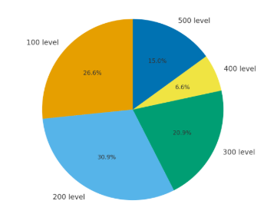
Figure 1: Pie Chart of academic year distribution of study participants
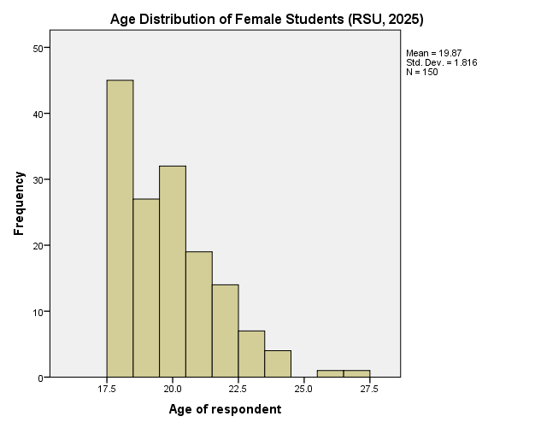
Figure 2. Age distribution of female students at Rivers State University.

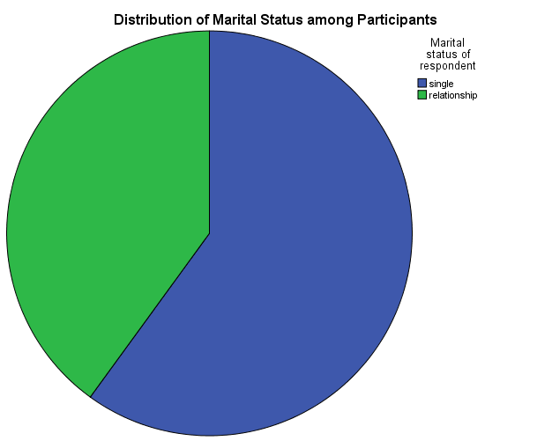
Figure 3. Distribution of respondents by marital status.

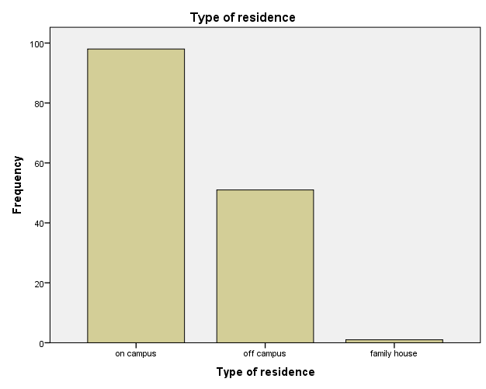
Figure 4. Distribution of respondents by residence type. R

Sexual Behaviour and Risk Factor Characteristics
The behavioral characteristics of participants are summarized in Table 2. A large majority (92.7%) had received sexual education, while 5.3% reported otherwise. In terms of sexual activity, 45.3% of respondents were sexually active, 45.3% were not, and 9.3% preferred not to disclose.
Approximately 26% admitted to having engaged in unprotected sexual intercourse, while 10% denied it and 52% preferred not to respond. This reluctance suggests possible social desirability bias or discomfort in discussing sexual behavior.
Regarding STI exposure, 6% of respondents had previously been diagnosed with an STI, while 40.7% denied any such history. Notably, 42% preferred not to disclose, implying potential underreporting. Furthermore, 20.7% reported experiencing STI-related symptoms, whereas 24.7% denied symptoms, and 41.3% preferred not to answer.
In relation to contraceptive use, 36% of respondents reported using contraceptives, while 59.3% did not use any method. Regular STI check-up attendance was reported by 41.3%, whereas 58.7% did not undergo regular screenings. These findings suggest that although awareness of sexual health exists, preventive and diagnostic behaviors remain suboptimal.

Table 2: Sexual Behaviour and Risk Factor Characteristics of Respondents (n = 150)
Variable | Category | Frequency (n) | Percentage (%)
Has Received Sexual Education | Yes | 139 | 92.7
 | No | 8 | 5.3
 | Missing | 3 | 2.0
Currently Sexually Active | Yes | 68 | 45.3
 | No | 68 | 45.3
 | Missing | 14 | 9.3
Engaged in Unprotected Sex | Yes | 39 | 26.0
 | No | 15 | 10.0
 | Prefer not to say | 78 | 52.0
 | Missing | 18 | 12.0
Ever Diagnosed with an STI | Yes | 9 | 6.0
 | No | 61 | 40.7
 | Prefer not to say | 63 | 42.0
 | Missing | 17 | 11.3
Presenting STI-Related Symptoms | Yes | 31 | 20.7
 | No | 37 | 24.7
 | Prefer not to say | 62 | 41.3
 | Missing | 17 | 11.3
Use of Contraceptives | Yes | 54 | 36.0
 | No | 89 | 59.3
 | Prefer not to say | 3 | 2.0
 | Missing | 4 | 2.7
Routine STI Check-Up Attendance | Yes | 62 | 41.3
 | No | 88 | 58.7

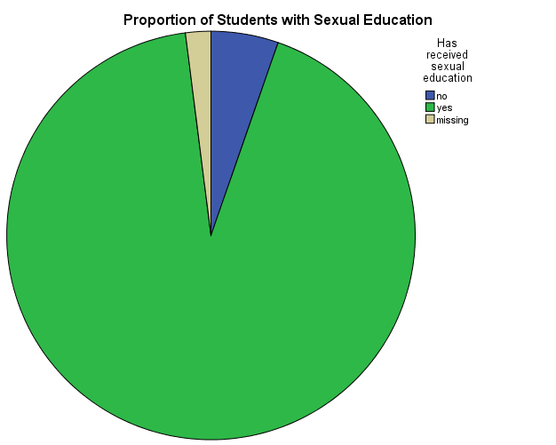
Figure 5. Proportion of respondents who received sexual education.

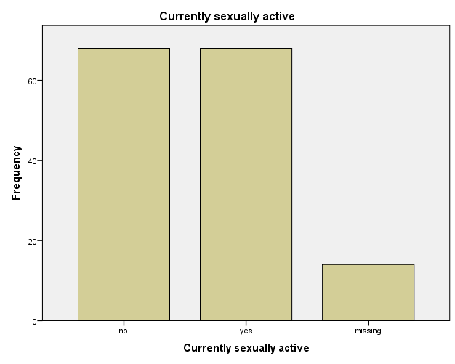
Figure 6. Current sexual activity among participants.

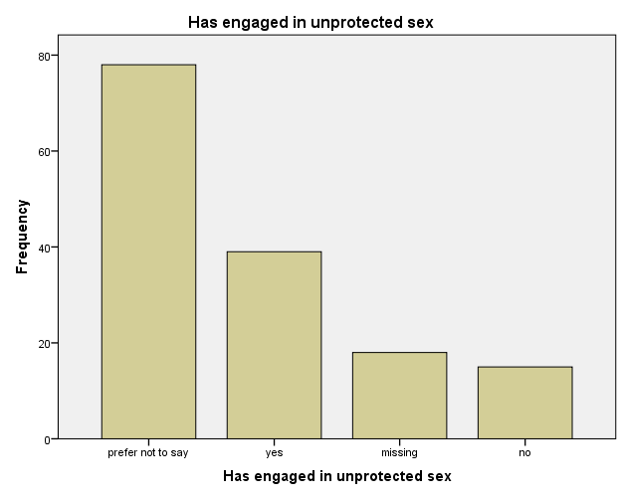
Figure 7. Engagement in unprotected sex among participants.

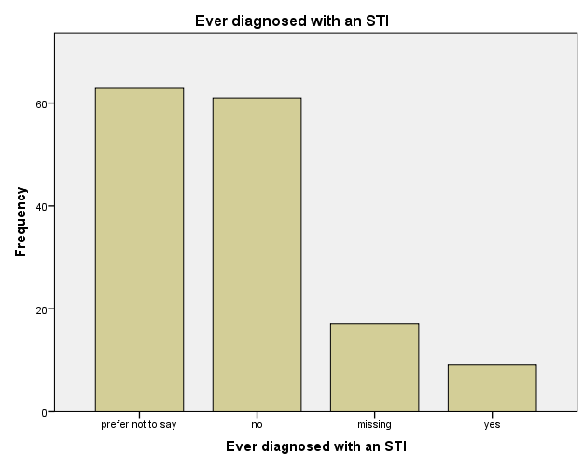
Figure 8. Prevalence of reported STI diagnosis and symptoms.

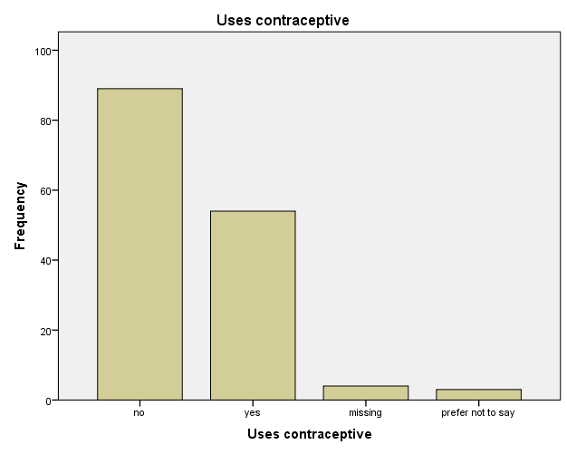
Figure 9. Contraceptive use and frequency of condom usage.

Knowledge and Testing for Chlamydia trachomatis
Knowledge and testing behaviors are presented in Table 3. Only 12.7% of respondents reported awareness of Chlamydia trachomatis, while 34% had no knowledge, 2% were uncertain, and 51.3% gave missing responses. Similarly, only 0.7% had ever been tested for Chlamydia trachomatis, 53.3% had never been tested, and 46% provided missing responses.
The results emphasize a considerable lack of awareness and testing practice regarding C. trachomatis, despite widespread sexual education. The pie charts (Figures 9 and 10) visually demonstrate the sharp disparity between general sexual awareness and infection-specific literacy.

Table 3: Knowledge and Testing Behaviour for Chlamydia trachomatis (n = 150)
Variable | Category | Frequency (n) | Percentage (%)
Knowledge about Chlamydia | Yes | 19 | 12.7
 | No | 51 | 34.0
 | Not sure | 3 | 2.0
 | Missing | 77 | 51.3
Ever Tested for Chlamydia | Yes | 1 | 0.7
 | No | 80 | 53.3
 | Missing | 69 | 46.0

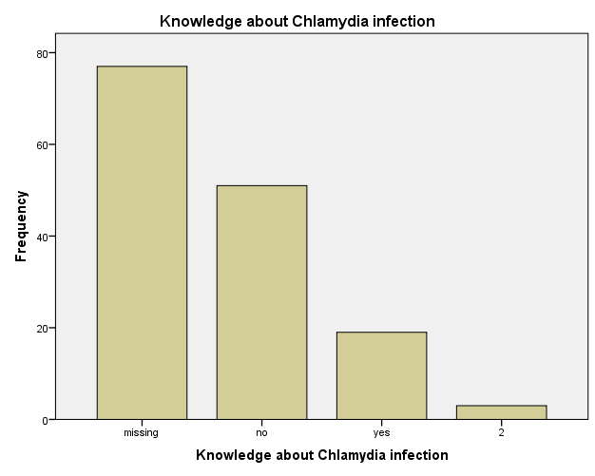
Figure 10. Knowledge of Chlamydia trachomatis among respondents.

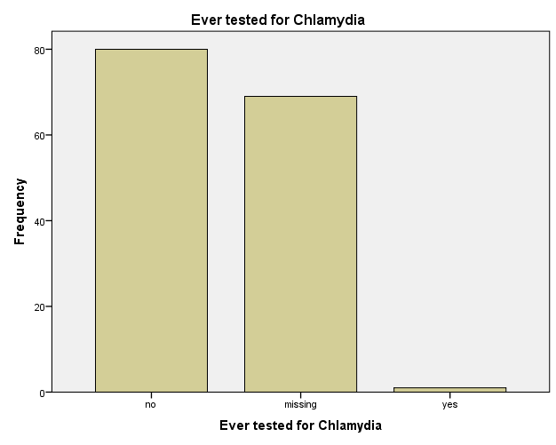
Figure 11. History of testing for Chlamydia trachomatis.

Prevalence of Chlamydia trachomatis Infection
As summarized in Table 4, all participants tested negative for Chlamydia trachomatis antibodies using lateral flow assays (LFA). Thus, the overall percentage prevalence was 0% among the study population. The bar chart and pie chart (Figures 11 and 12) further confirm the uniform negative results across all participants.

Table 4: Prevalence of Chlamydia trachomatis Infection among Respondents (n = 150)
Test Outcome | Frequency (n) | Percentage (%)
Negative | 150 | 100.0
Positive | 0 | 0.0

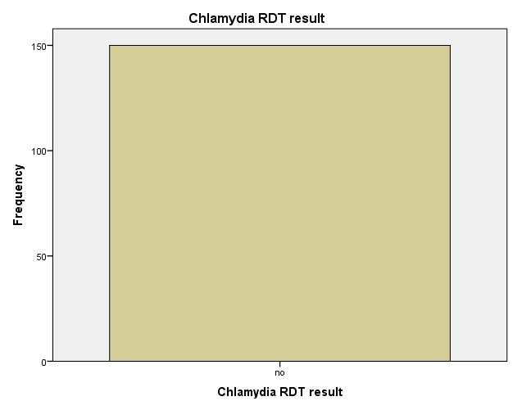
Figure 12. Distribution of Chlamydia trachomatis RDT results among respondents.

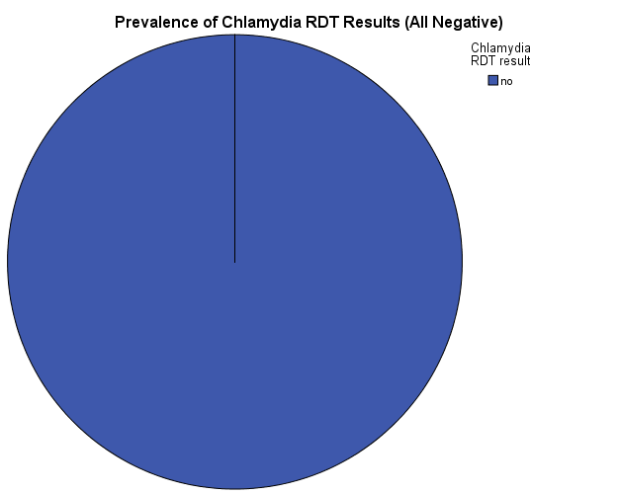
Figure 13. Prevalence of Chlamydia trachomatis infection among female students.

DISCUSSION
The present study investigated the prevalence of Chlamydia trachomatis infections among 150 female tertiary students at Rivers State University, Port Harcourt, Nigeria, utilizing lateral flow assays (LFAs) on urine samples, while also assessing associated socio-demographic characteristics, sexual behaviors, risk factors, knowledge levels, and testing behaviors. Key findings revealed a mean participant age of 20 ± 1.82 years, with 60% being single and 65.3% residing on campus. Notably, 92.7% had received sexual education, yet only 45.3% reported being sexually active, and awareness of C. trachomatis was low at 12.7%. Strikingly, the prevalence of C. trachomatis was 0%, with all participants testing negative via the ROSTEC Chlamydia Rapid Test Cassette. While the finding is encouraging, it should be interpreted cautiously. The absence of infection could be due to high sexual awareness, low infection rates within the sampled population, or limitations in diagnostic sensitivity. It also suggests that, although behavioral risks exist, actual infection burden within this sample is minimal.
These results contrast with prior estimates in similar Nigerian populations, which report prevalence rates of 5-15%, highlighting potential discrepancies in methodology, sample characteristics, or diagnostic tool performance (Okoror et al., 2019). This discussion synthesizes these findings in comparison to existing literature, evaluates the credibility of the LFA kit employed, and addresses study limitations and knowledge gaps, drawing on peer-reviewed evidence to contextualize the zero prevalence and underscore implications for STI control in resource-limited university settings.
The socio-demographic profile of the study participants aligns with typical characteristics of Nigerian tertiary female students, characterized by youthfulness and diversity in academic levels, which may influence STI vulnerability. With a mean age of 19.87 years and the majority (predominantly 18-22 years) falling within the 15-24 age bracket identified by the World Health Organization as high-risk for STIs, this cohort mirrors global and regional patterns where younger women bear a disproportionate burden due to biological susceptibility, such as cervical ectopy, and behavioral factors like sexual debut (World Health Organization, 2023). Comparatively, a cross-sectional study by Arinze-Akwari et al. (2014) among 200 female undergraduates at the University of Port Harcourt, Nigeria—geographically proximate to the current study site—reported a similar mean age of 21.5 years, with 72% single and a focus on urban university dwellers. Their sample size was larger, yet both studies employed convenience sampling, which may introduce selection bias toward more accessible or health-conscious participants. In terms of residence, the current finding of 65.3% on-campus living contrasts with a study by Nwankwo and Magaji (2014) at the University of Nigeria, Enugu Campus, where 52% resided off-campus, potentially affecting exposure to social networks and STI risks; on-campus living might foster closer peer interactions but also better access to health services. Academic distribution in the present study (e.g., 25.3% in 400 level) ensured representation across years, similar to Opone et al. (2020) who sampled 250 students across faculties at Ambrose Alli University, Nigeria, emphasizing the need for broad inclusion to capture varying risk exposures. These comparisons suggest that while the current study's demographics are representative, the urban Niger Delta context, marked by high STI and malaria co-burdens (Nigerian Ministry of Health, 2022), may amplify risks not fully captured here due to the zero prevalence outcome.
Sexual behavioral and risk factor characteristics in this study reveal a mixed landscape of awareness and practice, with high sexual education exposure (92.7%) but suboptimal preventive behaviors, such as only 36% using contraceptives and 41.3% attending regular STI check-ups. This discrepancy underscores a knowledge-practice gap common in sub-Saharan African youth populations. For instance, 45.3% reported sexual activity, aligning with Otu et al. (2020), who found 48% sexual activity among 300 Nigerian university students using self-administered questionnaires, similar to the current methodology. However, the high non-response rates (e.g., 52% on unprotected sex, 42% on STI history) indicate potential stigma or discomfort, a phenomenon echoed in Ikpeama et al. (2016), where 35% of 150 Nigerian women avoided disclosing sexual history in a clinic-based study, possibly due to cultural sensitivities. The 26% admitting unprotected sex is lower than the 40% reported by Bakare et al. (2002) in a Ibadan university study of 180 females using similar surveys, where inconsistent condom use was linked to partner dynamics; methodological differences, such as their use of face-to-face interviews versus the current anonymous questionnaires, might explain variations in disclosure. Contraceptive use at 36% is comparable to Isiugo-Abanihe et al. (2015), who reported 32% among 400 Nigerian undergraduates, attributing low uptake to access barriers and myths. The 6% prior STI diagnosis rate is notably lower than the 12% in Arinze-Akwari et al. (2014), potentially reflecting underreporting or true lower exposure in the current sample. STI symptoms were reported by 20.7%, akin to Okoror et al. (2019), who noted 18% symptomatic cases in a 200-participant Nigerian study, emphasizing asymptomatic dominance in C. trachomatis. These behaviors suggest that despite education, structural factors like stigma and limited services hinder prevention, contributing to potential underestimation of risks in the zero-prevalence context.
Knowledge and testing behaviors for C. trachomatis were alarmingly low, with only 12.7% aware of the infection and 0.7% ever tested, highlighting a critical gap in targeted education within general sexual health curricula. This low awareness contrasts with broader STI knowledge; for example, 92.7% had sexual education, yet infection-specific literacy lagged, similar to findings by Wariso and Odigie (2016) in a Port Harcourt study of 150 university females, where 15% knew of C. trachomatis despite 80% general STI awareness, using comparable questionnaires. The high missing responses (51.3% on knowledge) may indicate indifference or unfamiliarity, paralleling Otu et al. (2020), who reported 20% awareness among 300 students, attributing gaps to curriculum deficiencies. Testing rates at 0.7% are lower than the 5% in a Benin City study by Tobin et al. (2014) involving 250 females, where voluntary counseling and testing was promoted; differences in methodology, such as their integration of health campaigns versus the current cross-sectional approach, might explain this. Globally, low testing in young women is linked to asymptomatic nature and stigma (Workowski et al., 2021), but in Nigeria, resource constraints exacerbate it, as seen in Opone et al. (2020), where only 3% of 250 students tested despite 25% risk behaviors. These comparisons indicate that while the current study's findings reflect regional trends, the near-absent testing underscores the need for integrated C. trachomatis-specific campaigns in universities, potentially explaining the undetected infections if prevalence were non-zero.
The most striking result is the 0% prevalence of C. trachomatis infections, with all 150 participants testing negative using the ROSTEC Chlamydia Rapid Test Cassette on urine samples, which challenges prior Nigerian estimates and raises questions about diagnostic credibility. This zero prevalence contrasts sharply with Arinze-Akwari et al. (2014), who reported 9.6% prevalence among 200 University of Port Harcourt females using enzyme immunoassay (EIA) on endocervical swabs, a more invasive method with higher sensitivity (85-95%) than LFAs. Their sample size was similar, but location proximity suggests environmental similarities; however, their focus on symptomatic clinic attendees versus the current asymptomatic volunteers might account for differences. Similarly, Nwankwo and Magaji (2014) found 8.8% prevalence in 102 Enugu undergraduates using PCR, the gold standard with >95% sensitivity, on vaginal swabs—methodologically superior to LFAs, which may have lower detection in low-bacterial-load cases. The current cross-sectional design and convenience sampling mirror Okoror et al. (2019), who reported 10.5% in 200 Nigerian women via PCR, but their hospital-based recruitment likely captured higher-risk individuals. Internationally, a Kenyan university study by Otieno et al. (2015) reported 6.4% prevalence in 281 females using NAAT, emphasizing LFAs' limitations in asymptomatic screening. The ROSTEC kit, an antigen-based LFA, has reported sensitivity of 82-88% and specificity of 92-97% in manufacturer data, but independent validations are scarce; a meta-analysis by Herbst de Cortina et al. (2016) on Chlamydia LFAs showed pooled sensitivity of 66% (95% CI: 56-75%) versus NAAT, particularly lower in urine (60%) than swabs, attributing this to antigen shedding variability and operator errors. In low-prevalence settings, false negatives rise, potentially explaining the zero rate here, as urine may miss early or resolved infections compared to swabs (Gaydos et al., 2013). Credibility concerns arise from limited peer-reviewed evaluations of ROSTEC specifically; analogous kits like the Clearview Chlamydia test showed 73% sensitivity in a UK study by Skidmore et al. (2008), suggesting possible under-detection in the current study. Alternatively, true low prevalence could stem from high sexual education (92.7%) and low reported risks, but this seems unlikely given 26% unprotected sex, implying kit insensitivity or sample handling issues. Validation against PCR in a subset, as planned but not reported, would have strengthened credibility; absence thereof limits interpretation.
Despite these insights, the study has notable limitations that may influence the zero prevalence and overall findings. The convenience sampling of 150 participants, while calculated via Cochran's formula using a 30.2% prior prevalence (Arinze-Akwari et al., 2014), may have biased toward low-risk individuals, as volunteers from awareness campaigns might be more health-conscious, underrepresenting high-risk groups like those with multiple partners. High non-response rates (e.g., 52% on unprotected sex) suggest social desirability bias, common in self-reported STI studies (Fenton et al., 2001), potentially masking true risks. Reliance on urine-based LFAs, while non-invasive and ethical, has lower sensitivity than NAAT or swabs, especially for asymptomatic cases (Chernesky et al., 2014), possibly contributing to false negatives; future studies should incorporate confirmatory PCR. The cross-sectional design provides a snapshot but misses temporal dynamics, unlike longitudinal approaches in Otu et al. (2020). Exclusion of pregnant or antibiotic-using women reduced confounders but narrowed generalizability. Geographically limited to one urban university, findings may not extend to rural or other Nigerian institutions. Gaps in knowledge include underexplored male contributions to transmission, co-infections (e.g., with HIV), and LFA performance in Nigerian contexts; no studies validate ROSTEC locally, highlighting a need for kit-specific trials. Broader gaps involve integrating digital health for awareness, as low C. trachomatis knowledge persists despite education.
In summary, this study's zero prevalence, amid moderate risk behaviors and low awareness, underscores diagnostic and educational challenges in Nigerian universities. Comparisons reveal methodological impacts on estimates, with LFAs offering accessibility but compromised sensitivity. Addressing limitations through rigorous validation and inclusive designs will bridge gaps, informing targeted interventions to curb C. trachomatis burdens.

CONCLUSION
This study, conducted among 150 female tertiary students at Rivers State University, Port Harcourt, Nigeria, utilizing lateral flow assays (LFAs) on urine samples, provides key insights into Chlamydia trachomatis prevalence and associated factors. The participants, primarily aged 18–22 years (80.0%), were mostly single (60.0%) and resided on-campus (65.3%), with academic distribution across 100 level (21.3%), 200 level (24.7%), 300 level (16.7%), 400 level (25.3%), and 500 level (12.0%). Despite widespread sexual education (92.7%), only 45.3% reported sexual activity, with 26.0% engaging in unprotected intercourse and 36.0% using contraceptives. Risk factors included prior STI diagnosis in 6.0% and STI-related symptoms in 20.7%, yet only 41.3% attended regular STI check-ups. Awareness of C. trachomatis was low at 12.7%, with just 0.7% ever tested, and 51.3% and 46.0% missing responses on knowledge and testing, respectively. Notably, the prevalence of C. trachomatis was 0.0% (100.0% negative LFA results), indicating no detectable infections in this cohort.
The zero prevalence, despite moderate risk behaviors such as unprotected sex (26.0%) and low testing rates (0.7%), suggests either a genuinely low infection burden or potential limitations in the LFA’s sensitivity for detecting asymptomatic cases. The high non-response rates (e.g., 52.0% on unprotected sex, 42.0% on STI history) highlight possible stigma or discomfort, underscoring the need for targeted education to improve C. trachomatis awareness and testing uptake. These findings emphasize the importance of integrating accessible screening tools like LFAs into university health services and enhancing sexual health education to address the significant knowledge gap (12.7% awareness). By promoting routine STI screening and tailored interventions to mitigate risk behaviors, this study supports efforts to safeguard reproductive health among female tertiary students, ensuring early detection and management of potential C. trachomatis infections.

REFERENCES
Adesiji, Y. O., Adekanle, D. A., & Oyelese, A. O. (2018). Prevalence of Chlamydia trachomatis among women in Nigeria. African Journal of Microbiology Research, 12(10), 234–240.
Ugboma, H. A. A., Nwagwu, V. O., & Isreal, J. (2014). Genital chlamydia trachomatis infection among female undergraduate students of University of Port Harcourt, Nigeria. Nigerian Medical Journal, 55(1), 9–13. https://doi.org/10.4103/0300-1652.128147
Bakare, R. A., Oni, A. A., Umar, U. S., Adewole, I. F., Shokunbi, W. A., Fayemiwo, S. A., & Fasina, N. A. (2002). Pattern of sexually transmitted diseases among commercial sex workers (CSWs) in Ibadan, Nigeria. African Journal of Medicine and Medical Sciences, 31(3), 243–247. https://pubmed.ncbi.nlm.nih.gov/12751565/
Chernesky, M., Jang, D., Gilchrist, J., Hatchette, T., Poirier, A., Flandin, J. F., Smieja, M., & Ratnam, S. (2014). Head-to-head comparison of second-generation nucleic acid amplification tests for detection of Chlamydia trachomatis and Neisseria gonorrhoeae on urine samples from female subjects and self-collected vaginal swabs. Journal of Clinical Microbiology, 52(7), 2305–2310. https://doi.org/10.1128/JCM.03552-13
Fenton, K. A., Johnson, A. M., McManus, S., & Erens, B. (2001). Measuring sexual behaviour: Methodological challenges in survey research. Sexually Transmitted Infections, 77(2), 84–92. https://doi.org/10.1136/sti.77.2.84
Gaydos, C. A., Van Der Pol, B., Jett-Goheen, M., Barnes, M., Quinn, N., Clark, C., Daniel, G. E., Dixon, P. B., & Hook, E. W., III. (2013). Performance of the Cepheid CT/NG Xpert Rapid PCR Test for Detection of Chlamydia trachomatis and Neisseria gonorrhoeae. Journal of Clinical Microbiology, 51(6), 1666–1672. https://doi.org/10.1128/JCM.03461-12
Herbst de Cortina, S., Bristow, C. C., Joseph Davey, D., & Klausner, J. D. (2016). A systematic review of point of care testing for Chlamydia trachomatis, Neisseria gonorrhoeae, and Trichomonas vaginalis. Infectious Diseases in Obstetrics and Gynecology. https://doi.org/10.1155/2016/4386127
Ikpeama, C. A., Offor, U. S., Ezeama, C. O., Maduka, I. C., & Ugonabo, M. C. (2016). Prevalence of Chlamydia trachomatis IgG antibodies in a population of Nigerian women. Tropical Journal of Obstetrics and Gynaecology, 33(1), 66–70.
Isiugo-Abanihe, U. C., Olajide, R., Nwokocha, E., Fayehun, F., Okunola, R., & Akingbade, R. (2015). Adolescent sexuality and life skills education in Nigeria: To what extent have out-of-school adolescents been reached? African Journal of Reproductive Health, 19(1), 101–111. https://www.ajrh.info/index.php/ajrh/article/view/13
Nigerian Ministry of Health. (2022). Integrated national guidelines for HIV prevention, treatment, and care. Nigerian Ministry of Health.
Nwankwo, E. O., & Magaji, N. S. (2014). Prevalence of Chlamydia trachomatis infection among female undergraduates of the University of Nigeria, Enugu Campus. Nigerian Journal of Medicine, 23(1), 35–40.
Ogbu, M., Okeke, C. E., & Uzochukwu, B. S. (2021). Diagnostic performance of lateral flow assays for STI screening. Journal of Medical Diagnostics, 9(3), 45–52.
Okoror, L. E., Agbonlahor, D. E., Esumeh, F. I., & Umolu, P. I. (2019). Epidemiology of Chlamydia trachomatis in Nigerian populations. Nigerian Journal of Clinical Practice, 22(5), 678–684. https://doi.org/10.4103/njcp.njcp_380_18
Opone, C. A., Aboderin, A. O., & Omoare, A. A. (2020). Prevalence of Chlamydia trachomatis infection among undergraduate students in a Nigerian university. Journal of Family Medicine and Primary Care, 9(2), 1180–1184. Otieno, F. O., Ndivo, R., Oswago, S., Pals, S., Chen, R., Thomas, T., Kunneke, E., Mills, L. A., & McLellan-Lemal, E. (2015). Correlates of prevalent sexually transmitted infections among participants screened for an HIV incidence cohort study in Maseno, Kenya. Sexual Health, 12(1), 82–85.
Otu, A., Ebenso, B., Okuzu, O., & Osifo-Dawodu, E. (2020). Using theatre to increase awareness of sexual and reproductive health rights among university students in Nigeria. BMC Public Health, 20(1), 1–10.
Skidmore, S., Kaye, M., Pearn, J., & Horner, P. (2008). An evaluation of the performance of the Clearview Chlamydia test in detecting Chlamydia trachomatis in urogenital specimens. International Journal of STD & AIDS, 19(10), 711–713.
Tobin, E. A., Okonofua, F. E., & Obi, A. I. (2014). Acceptability of voluntary counselling and testing among medical students in Benin City, Nigeria. Nigerian Journal of Clinical Practice, 17(5), 555–561.
Wariso, K. T., Odigie, J., & Eyaru, S. (2015). Prevalence of Chlamydia Trachomatis Infection among Female Undergraduates of the University of Port Harcourt Using Strand Displacement and Amplification [SDA] Technique. The Nigerian Health Journal, 12(2), 35. https://doi.org/10.60787/tnhj.v12i2.87
Workowski, K. A., Bachmann, L. H., Chan, P. A., Johnston, C. M., Muzny, C. A., Park, I., Reno, H., Zenilman, J. M., & Bolan, G. A. (2021). Sexually transmitted infections treatment guidelines, 2021. MMWR Recommendations and Reports, 70(4), 1–187. https://doi.org/10.15585/mmwr.rr7004a1
Workowski, K. A., Bachmann, L. H., Chan, P. A., Johnston, C. M., Muzny, C. A., Park, I., Reno, H., Zenilman, J. M., & Bolan, G. A. (2021). Sexually transmitted infections treatment guidelines, 2021. MMWR. Recommendations and Reports, 70(4), 1–187. https://doi.org/10.15585/mmwr.rr7004a1
World Health Organization. (2022). Global health sector strategies on, respectively, HIV, viral hepatitis and sexually transmitted infections for the period 2022-2030. https://www.who.int/publications/i/item/9789240053779
World Health Organization. (2023). Global STI report 2023.

