Original Research Article
ASSESSMENT OF ABUNDANCE AND PARASITIC CONTAMINATION OF SYNANTHROPIC FLIES IN SELECTED REFUSE DUMP SITES IN AWKA METROPOLIS: A PUBLIC HEALTH PERSPECTIVE

Abstract

The study to assess the presence and types of pathogenic organisms carried by Synanthropic flies collected from selected refuse dump sites in Awka metropolis employed a cross-sectional ecological survey in Awka and surrounding areas from May 2024 to March 2025. This study assessed the abundance, species composition, and parasite carriage of synanthropic flies collected from refuse dump sites across Awka metropolis, southeastern Nigeria. A total of 1,449 flies belonging to seven species were collected from 11 locations within the study area. Musca domestica was the most abundant species (52.7%), followed by Chrysomya megacephala (19.6%) and Sarcophagidae spp. (14.0%), while Stomoxys calcitrans was the least abundant (0.8%). Fly abundance and species composition varied significantly among locations (χ² = 114.06, df = 60, p < 0.001), Okpuno recorded the highest mean abundance, whereas Amawbia had the lowest. Parasitological analysis identified 71 parasite stages belonging to eight taxa. Ascaris lumbricoides was the most prevalent parasite (36.62%), followed by Entamoeba histolytica cysts (18.31%) and Cryptosporidium species cysts (15.49%), reflecting considerable environmental faecal contamination. Musca domestica carried the highest number of parasite stages (39.4%), highlighting its dominant role as a mechanical vector. While parasite occurrence differed significantly among parasite species (p = 0.026) and parasite load varied significantly among fly species (p = 0.003), no significant association was observed between specific fly species and parasite types (p = 0.902).The high abundance of synanthropic flies and their carriage of medically important parasites in Awka metropolis pose potential public health risks. These results underscore the need for improved waste management, enhanced environmental sanitation, and effective fly control strategies to reduce fly-mediated transmission of intestinal parasites.
Keywords: Houseflies, Pathogenic organisms, Dumping sites, Disease transmission, Public health.

1. INTRODUCTION
Background of the study
Synanthropic flies are among the most ubiquitous and medically significant synanthropic insects found in human settlements, particularly in tropical and subtropical regions (Akhtar et al., 2019). Due to their indiscriminate feeding habits and their attraction to decaying organic matter, faeces, and garbage, they are widely recognized as mechanical vectors of a variety of pathogenic microorganisms including bacteria, viruses, protozoa, and helminths (Olatunji et al., 2021; Sharma and Dhakal, 2020). They can pick up these pathogens on their body surfaces and in their gut and transmit them to humans through contact with food, water, and kitchen utensils (Fotedar et al., 2022). In Nigeria, the rise in poor waste disposal practices and inadequate sanitation infrastructure particularly in rapidly urbanizing cities like Awka has led to an increase in housefly populations around refuse dumps. These refuse dump sites provide optimal conditions for the breeding and proliferation of flies, thereby increasing the risk of disease transmission (Anyanwu et al., 2020). In Awka Metropolis, open dumping remains common due to ineffective waste collection systems and lack of environmental hygiene enforcement, posing serious threats to public health, especially in areas near markets, abattoirs, and residential quarters. Studies have shown that synanthropic flies collected from refuse dumps and markets often carry a wide range of pathogens such as Escherichia coli, Salmonella species, Shigella species, and parasitic ova and cysts like Entamoeba histolytica and Ascaris lumbricoides (Olawuni et al., 2021; Ismail et al., 2023). These pathogens are associated with gastrointestinal infections, diarrhoeal diseases, and other food borne illnesses, which remain significant public health concerns in Nigeria. Despite growing awareness of the health risks associated with housefly infestations, there is limited localized research in southeastern Nigeria, including Awka, on the pathogenic load of these flies in relation to refuse dumps. Most sanitation and public health policies are not adequately backed by specific entomological and microbiological data necessary for targeted intervention. Synanthropic flies are not merely nuisance insects; they are recognized vectors of numerous disease-causing microorganisms due to their synanthropic nature and feeding habits. By frequenting human waste, decomposing materials, and refuse dumps, they pick up and transmit pathogens to human food and surfaces, playing a substantial role in the spread of enteric infections such as diarrhoea, typhoid fever, cholera, dysentery, and intestinal parasitoses (Fotedar et al., 2022; Olawuni et al., 2021). In Nigeria, diarrhoeal diseases are among the leading causes of morbidity and mortality, particularly in children under five years old, with poor sanitation and unhygienic environments being major contributors (WHO, 2023). Urban centers like Awka, experiencing rapid population growth and strained waste management systems, become hotspots for vector proliferation and disease outbreaks. Thus, understanding the pathogenic load carried by synanthropic flies in such environments is essential for targeted interventions.
2. MATERIALS AND METHODS
2.1 Study Area Description
The study was carried out in Awka Metropolis, the capital of Anambra State, situated in southeastern Nigeria. Awka is a rapidly expanding urban center, comprising two primary Local Government Areas: Awka South and Awka North. The metropolis is geographically positioned between longitudes 7°04′E and 7°10′E and latitudes 6°09′N and 6°14′N. Awka experiences a tropical rainforest climate, characterized by high temperatures ranging from 26°C to 30°C and elevated humidity, particularly during the rainy season (April to October). These warm and moist conditions facilitate the rapid development and reproductive cycles of houseflies. The city is densely populated, with growing commercial activities and expanding residential zones, leading to significant generation of municipal solid waste. Improper waste management has resulted in numerous refuse dump sites, often situated close to markets, residential neighborhoods, abattoirs, and roadside gutters, creating optimal breeding and feeding habitats for synanthropic flies.
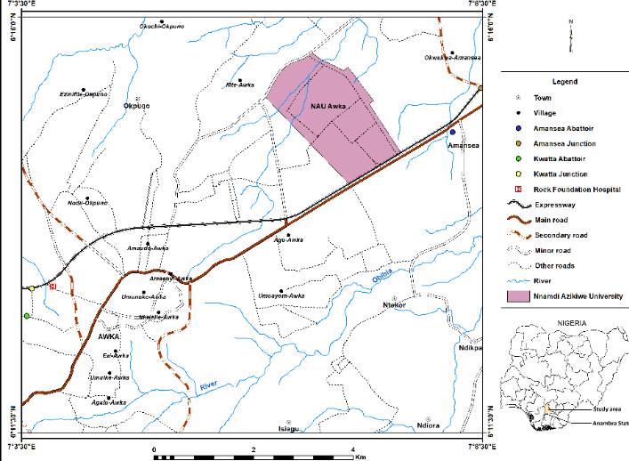
The climate in Awka is marked by two distinct seasons: the rainy season (April to October) and the dry season (November to March). The combination of high temperatures and elevated relative humidity, especially during the rainy months, promotes the rapid growth and survival of houseflies and supports the proliferation of microorganisms associated with them.

Fig 1: Map of the study area. Source: Obiakor et al., 2025
2.2. Sample Collection
The collection of synanthropic flies samples for this study was carried out using standardized entomological techniques to ensure accuracy and minimize contamination. The process involved selecting strategic refuse dumping sites across Awka Metropolis based on their accessibility, size, and frequency of human activity. They include refuse dumps in Ifite, Eke Awka, Amenyi, Aroma, Okpuno, Regina Caeli junction, Unizik temporary Site, Kwatta Abattoir, Amawbia, Unizik Permanent Site, and Amansea abattoir. The samples were collected using sweep nets.

2.3. Selection of Sampling Sites
A total of eleven (11) major refuse dumps sites were selected across various neighborhoods in Awka Metropolis. This includes urban and semi-urban zones. These sites were chosen based on the visible presence of decomposing organic waste, household refuse, and high synanthropic fly activity.

2.4. Fly Trapping Techniques
The synanthropic flies were captured using a combination of sweep nets, baited traps, and sticky traps (Mullens et al., 2016).
2.4.1. Sweep Nets: Hand-held sweep nets were used to collect adult synanthropic flies by sweeping over refuse dump surfaces three consecutive times at each interval during peak fly activity hours (between 8:00 AM and 11:00 AM) (Southwood & Henderson, 2000).
2.4.2. Baited Traps: The commercially procured cone shaped net traps (fig 2) were baited with semi-decomposed fish and meat. These baits traps attracted flies and trapped them. This made it easy for the collection of the flies without causing physical damage (Greenberg, 1971).
Captured flies were carefully transferred into sterile, labeled universal containers using forceps. Each container was sealed and transported in a cool box to maintain sample integrity and prevent biological degredation (Service, 2012), to the laboratory of Parasitology and Entomology Department Nnamdi Azikiwe University for idententification and parasite isolation.

2.5. Sample Identification and Parasite Isolation
The flies were identified morphologically using standard entomological keys. Each sample was processed within 2 hours of collection to ensure accurate representation of parasite load.
2.5.1. Identification of Synanthropic flies
The collected synanthropic flies were preserved in 70% ethanol to maintain their morphological integrity. In the laboratory, collected specimens were placed in labeled Petri dishes, mounted under a stereomicroscope, and carefully examined. Identification was based on diagnostic morphological characteristics, including body size and coloration, bristle arrangement (chaetotaxy), wing venation patterns, antennal structure, arista type, thoracic and abdominal markings, and other distinguishing external features. Specimens were sorted and identified to species level using standard taxonomic keys as described by Service (1980) and Byrd and Castner (2009).
2.5.2. External parasite isolation procedures
Surface wash methods were performed by immersing flies in a phosphate-buffered saline (PBS) to dislodge parasites from body parts such as legs, wings, mouthparts, and abdominal hairs. External parasites were isolated by immersing flies in phosphate-buffered saline (PBS) to dislodge organisms from the legs, wings, mouthparts, and abdominal hairs. Groups of ten flies were placed in 10 mL of PBS in sterile test tubes and gently rocked for 3 minutes. The resulting wash was centrifuged, and the pellet was examined microscopically to recover and identify parasites and their developmental stages.
2.5.3. Gut Content Analysis
Flies are surface-sterilized in 70% ethanol, rinsed with sterile distilled water, and then dissected aseptically. Midguts and hindguts are macerated in saline solution and examined under a compound microscope for parasite eggs, cysts, larvae, or protozoan oocysts (Graczyk et al., 2001).
2.5.4. Microscopic Examination
Direct Wet Mount: Small portions of gut contents or surface wash sediment were placed on slides, stained with lugos iodine, and observed for protozoan cysts, helminth eggs, and larvae (Adenusi et al., 2013) and identified under x10 and x40 objectives, following morphological keys (Bunchu et al., 2012).
2.6. Data analysis techniques
Data from fly sampling and parasitological examinations were analyzed to assess abundance patterns, species composition, and parasite carriage. Descriptive statistics (frequencies, percentages, means ± standard deviations) summarized the distribution of synanthropic flies across the 11 locations and parasite prevalence. Chi-square (χ²) tests evaluated differences in fly species distribution among locations and examined associations between fly species and parasite types. One-way ANOVA compared mean fly abundance across locations, differences in parasite prevalence among parasite species, and variations in parasite loads among fly species. Crosstabulation further described parasite distribution across fly species to interpret mechanical vector potential. Statistical significance was set at p < 0.05, and all analyses were conducted using SPSS, enabling comprehensive evaluation of fly ecology and their role in mechanical transmission of intestinal parasites.

3. RESULTS AND DISCUSSIONS

Table 1: Abundance of Synanthropic flies across refuse dump sites sites in Awka metropolis
Location | Musca domestica | Fannia spp | Stomoxy calcitrans | Chrysomya megacephala | Lucilia spp | Chrysomya bezianna | Sarcophagidae spp | Total (%)
Ifite | 89 | 2 | 0 | 35 | 0 | 7 | 28 | 161
Eke Awka | 36 | 0 | 0 | 11 | 5 | 3 | 13 | 68
Amenyi | 29 | 0 | 0 | 8 | 3 | 1 | 9 | 50
Aroma | 101 | 4 | 0 | 22 | 13 | 4 | 13 | 157
Okpuno  Regina Caeli | 234  21 | 13  0 | 9  0 | 81  7 | 36  3 | 17  0 | 59  6 | 449  37
Unizik Temp Site | 74 | 0 | 0 | 33 | 11 | 0 | 21 | 139
Kwatta Abattoir | 40 | 0 | 0 | 19 | 5 | 9 | 11 | 84
Amawbia | 11 | 0 | 0 | 6 | 2 | 2 | 8 | 29
Unizik Perm Site | 46 | 6 | 0 | 23 | 5 | 9 | 10 | 99
Amansea Abattoir | 82 | 2 | 2 | 39 | 23 | 3 | 25 | 176
Total | 763 | 27 | 11 | 284 | 106 | 55 | 203 | 1449
χ² = 114.06, df = 60, p < 0.001

A total of 1,449 synanthropic flies representing seven species were collected from 11 locations. Musca domestica was the most abundant species (52.7%), followed by Chrysomya megacephala (19.6%) and Sarcophagidae spp. (14.0%), while Stomoxys calcitrans was the least abundant (0.8%).
There was a significant association between location and fly species distribution (χ² = 114.06, df = 60, p < 0.001), indicating that species composition varied across locations. Mean fly abundance differed among locations, with Okpuno recording the highest mean abundance (64.14 ± 79.41) and Amawbia the lowest (4.14 ± 4.26).

Table 2: Parasites associated with synanthropic flies across refuse dump sites in Awka metropolis
Parasite | Number Observed | Percentage (%)
Ascaris lumbricoides | 26 | 36.62
Cochidia oocyst | 09 | 12.67
Balantidium coli  Trichuris trichiura egg | 1  1 | 1.41  1.41
Cryptosporidium species cyst | 11 | 15.49
Entamoeba histolytica cyst | 13 | 18.31
Toxocara species egg | 9 | 12.67
Giardia lamblia cyst | 1 | 1.41
Total | 71 | 100

The table 2 above shows the parasites associated with synanthropic flies in Awka metropolis and their relative prevalence. A total of 71 parasite stages were identified. Ascaris lumbricoides was the most frequently observed parasite, accounting for 36.62%, indicating a high level of environmental fecal contamination. This was followed by Entamoeba histolytica cysts (18.31%) and Cryptosporidium species cysts (15.49%), all of which are of significant public health importance.

Table 3: Distribution of parasites associated with synanthropic flies in Awka metropolis according to fly species
Flies species | A. lumbricoides | Cochidia oocyst | T. trichiura egg | Cryptosporidium sp cyst | E. histolytica sp scyst | Toxocara sp egg | G. lamblia cyst | Total (%)
Musca domestica | 12 | 3 | 1 | 2 | 6 | 3 | 1 | 28
Fannia spp | 2 | 0 | 0 | 1 | 0 | 0 | 0 | 3
Stomoxy calcitrans | 0 | 0 | 0 | 0 | 0 | 2 | 0 | 2
Chrysomya megacephala | 5 | 2 | 0 | 4 | 3 | 2 | 0 | 16
Lucilia spp | 2 | 1 | 0 | 1 | 1 | 0 | 0 | 5
Chrysomya bezianna | 1 | 0 | 0 | 1 | 0 | 1 | 0 | 3
Sarcophagidae sp | 4 | 3 | 0 | 2 | 3 | 2 | 0 | 14
Total | 26 | 9 | 1 | 11 | 13 | 10 | 1 | 71 (100)
df = 2.70, p = 0.026

The table above shows the distribution of parasites carried by different synanthropic fly species in Awka metropolis. Musca domestica harbored the highest number of parasites (28), indicating its major role as a mechanical vector of intestinal parasites. This was followed by Chrysomya megacephala (16) and Sarcophagidae spp (14), which also carried a wide range of parasite stages. Ascaris lumbricoides (26) was the most commonly detected parasite across most fly species, while Entamoeba histolytica (13) and Cryptosporidium species cysts (11) were also widely distributed. Fannia spp, Stomoxys calcitrans, and Chrysomya bezziana carried fewer parasites, suggesting a lower vector potential.
The ANOVA showed a significant difference in observations among parasite species (df = 2.70, p = 0.026). Ascaris lumbricoides had the highest mean and differed significantly from several other parasites, while most remaining species had low and similar mean values. Overall, parasite occurrence varied by species, with A. lumbricoides being the most prevalent.

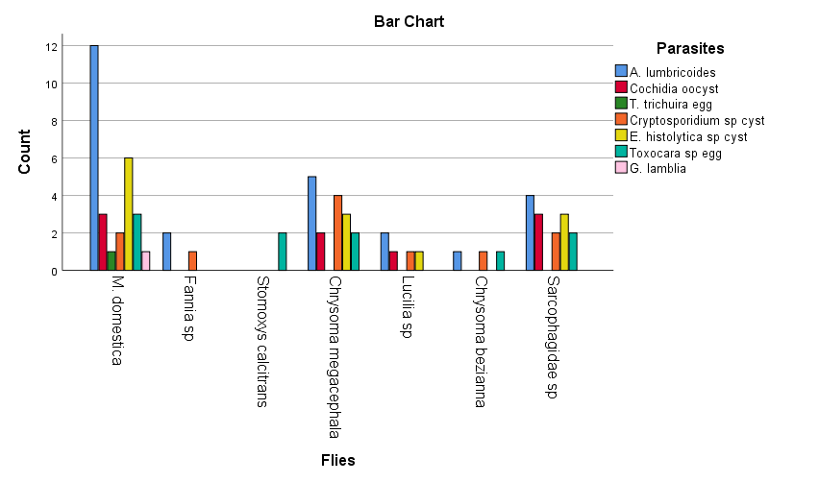Bar Chart 1: Graphical Representation of the Distribution of Parasites Carried by Different Synanthropic Fly Species in Awka Metropolis
The bar chart shows that Musca domestica carries the highest number and variety of parasites, especially Ascaris lumbricoides and Entamoeba histolytica, highlighting its major role as a mechanical vector. Other flies like Chrysomya megacephala and Sarcophagidae spp. carry multiple parasites but in lower numbers, while species such as Fannia spp., Lucilia spp., Chrysomya bezziana, and Stomoxys calcitrans have minimal parasite loads. This indicates significant differences in parasite carriage among fly species, with Musca domestica being the most important in transmitting intestinal parasites.

This study assessed the abundance of synanthropic flies across major refuse dump sites in Awka metropolis and examined the parasites they harbour. The results demonstrate that synanthropic flies are not only abundant in the study area but also serve as important mechanical vectors of medically important parasites.
The high abundance of Musca domestica recorded in this study aligns closely with findings from other regions in Nigeria and beyond. In this study, Musca domestica accounted for more than half of all collected flies, demonstrating its strong ecological adaptability and preference for waste-rich environments. Similar dominance of this species was documented by Adeyemi et al. (2012), who observed that M. domestica was the most prevalent synanthropic fly in their survey of refuse sites in Ogun State. Likewise, a more recent survey in Anambra State reported that M. domestica was the predominant species in both urban and rural communities, with high parasite carriage, further supporting its significance as a global synanthropic vector The variation in fly abundance across sites in the present study, particularly the exceptionally high numbers at Okpuno and Amansea Abattoir, can be attributed to differing sanitation conditions and waste management practices. Abattoir environments are well known for supporting large populations of calliphorid and sarcophagid flies due to the availability of decomposing organic matter. This observation is consistent with reports by Nabie et al. (2023), who noted that species such as Chrysomya megacephala and Sarcophagidae are especially well adapted to protein-rich substrates, making them common in slaughterhouse environments. Comparable findings were also reported by Oda et al. (1991) in Southeast Asia, where C. megacephala was frequently associated with waste dumps and animal processing facilities.
The parasite diversity observed in this study also echoes patterns reported in earlier literature. The dominance of Ascaris lumbricoides and the significant presence of protozoan cysts such as Entamoeba histolytica and Cryptosporidium spp. correlate with the results of Adeyemi et al. (2012), who documented similar parasite assemblages on synanthropic flies in Ogun State. These parasites are commonly linked with poor sanitation, and their recovery from flies in Awka metropolis underscores ongoing environmental contamination. Asuquo et al. (2023) likewise identified A. lumbricoides, Giardia lamblia, and E. histolytica/dispar on houseflies in Cross River State, reinforcing the widespread nature of these pathogens in areas with inadequate waste disposal.
The identification of Toxocara spp. eggs in this study further suggests contamination from domestic animals, a pattern also highlighted in other Nigerian studies. The lower parasite loads recorded in Fannia spp. and Lucilia spp. compared to M. domestica align with their more specialized ecological niches, as described by Nabie et al. (2023). Conversely, the finding that Stomoxys calcitrans carried only Toxocara eggs corresponds well with the typical association of this species with animal husbandry environments rather than household refuse sites (Smith et al., 2025). The high abundance of synanthropic flies and their carriage of parasites at refuse dumps in Awka metropolis indicate significant environmental contamination and a potential pathway for disease transmission. Residents near these sites are at increased risk of helminth and protozoan infections through contaminated food, water, or surfaces. Musca domestica was the most dominant species, consistent with other studies in Nigeria that identify it as a primary mechanical vector of intestinal parasites (Adeyemi et al., 2012). Poor waste management practices including open dumping, irregular waste collection, and proximity of dumps to homes likely exacerbate this risk, creating ideal breeding grounds for flies capable of spreading pathogens (Nabie et al., 2023).
The similarity in species distribution and parasite carriage underscores the influence of environmental sanitation on fly ecology and public health. Collectively, these studies highlight the urgent need for improved waste management and vector control to mitigate the transmission of parasitic diseases.
4. CONCLUSION
This study reveals that synanthropic flies, especially Musca domestica, are abundant at refuse sites in Awka metropolis and serve as key mechanical vectors of intestinal parasites. Medically important parasites like Ascaris lumbricoides and Entamoeba histolytica were commonly found, reflecting poor environmental sanitation and high disease risk. The findings emphasize the need for better waste management, improved sanitation, public health education, and effective fly control to reduce parasite transmission in the area.
5. REFERENCE
Adenusi, A. A., Adewoga, T. O. S., & Human, L. R. D. (2013). Mechanical transmission of human intestinal parasites by synanthropic flies in a tropical urban environment. Journal of Parasitology Research, 2013, 1–7. https://doi.org/10.1155/2013/256214
Adeyemi, R. O., Oke, A. O., & Salu, O. B. (2012). Parasitic organisms on synanthropic flies in Abeokuta, Nigeria. Journal of Vector Borne Diseases, 49(3), 183–188. https://pubmed.ncbi.nlm.nih.gov/23290716/
Akhtar, N., Sulaiman, S. A., and Khan, A. A. (2019). Role of Musca domestica in disease transmission: A systematic review. Journal of Vector Borne Diseases, 56(4), 247–254. https://doi.org/10.4103/0972-9062.263726
Anyanwu, E. C., Okonkwo, J. C., and Ibe, O. (2020). Sanitation challenges and public health risks in urban markets of southeastern Nigeria. African Health Sciences, 20(1), 113–121. https://doi.org/10.4314/ahs.v20i1.15
Asuquo, M. E., Edet, U. A., and Bassey, E. N. (2023). Parasitic load of houseflies in selected urban areas of Cross River State, Nigeria. South Asian Journal of Parasitology, 8(2), 10–19. https://journalsajp.com/index.php/SAJP/article/view/104
Cheesbrough, M. (2009). District laboratory practice in tropical countries (2nd ed.). Cambridge University Press.
Fotedar, R., Banerjee, U., Verma, A. K., and Shriniwas, L. (2022). Housefly (Musca domestica): A vector for pathogenic microorganisms in hospitals and markets. International Journal of Environmental Health Research, 32(2), 211–218.
Graczyk, T. K., Knight, R., Gilman, R. H., & Cranfield, M. R. (2001). The role of non-biting flies in the epidemiology of human infectious diseases. Microbes and Infection, 3(3), 231–235.
Greenberg, B. (1971). Flies and disease: Ecology, classification and biotic associations (Vol. 1). Princeton University Press.
Ismail, M., Ahmed, A., and Musa, B. (2023). Bacteriological and parasitological assessment of houseflies from refuse dumps in Kano, Nigeria. Nigerian Journal of Parasitology, 44(1), 33–41.
Mullens, B. A., Soto, D., & Gerry, A. C (2016). Field evaluation of fly traps for monitoring synanthropic flies. Journal of Medical Entomology, 53(3), 689–695.
Nabie, R., Choi, D. Y., and Lee, H. S. (2023). Non-biting flies as mechanical vectors of human pathogens: A systematic review. Parasites & Vectors, 16(1), 45. https://parasitesandvectors.biomedcentral.com/articles/10.1186/s13071-023-05650-2
Obiakor, U. A., Emmanuel, G.C., Ishar, C. O., Egbuche, C. M., Obiakor, B. T., Okwelogu, I. S., & Igboeli, C. N. (2025). Malaria and Hepatitis B Virus Co-Infection Among Pregnant Women Attending Rock Foundation Hospital and Maternity Awka, Anambra State, Nigeria. International Journal of Pathogen Research, 14(3), 69-80.
Oda, T., Anantaphruti, M., and Sukhavat, K. (1991). Helminth egg contamination on synanthropic flies in urban Manila. Southeast Asian Journal of Tropical Medicine and Public Health, 22(4), 614–619. https://pubmed.ncbi.nlm.nih.gov/1948283/
Olatunji, B. O., Yusuf, R. O., and Okonkwo, O. (2021). Microbiological profile of houseflies collected from waste disposal sites in Lagos. West African Journal of Medical Microbiology, 18(2), 80–87.
Olawuni, T. I., Akinbo, F. O., and Adeyemi, A. M. (2021). The role of houseflies in the mechanical transmission of intestinal parasites in rural communities of southwestern Nigeria. Parasite Epidemiology and Control, 13, e00214.
Onyido, A.E., Azubuike, J., Amadi, E.S., Obiukwu, M.O., Ozumba, N.A and Ikpeze, O.O. (2011). A Survey of Public Health Disease vectors Breeding in Refuse Dumps in Onitsha Metropolis, Anambra State Nigeria. New York Science Journal, 4(9):34-39]. (ISSN: 1554-0200). http://www.sciencepub.net/newyork.
Service, M. W. (2012). Medical entomology for students (5th ed.). Cambridge University Press.
https://doi.org/10.1017/CBO9781139004044
Sharma, P., and Dhakal, S. (2020). Public health significance of houseflies: A review. Journal of Health and Allied Sciences, 10(3), 110–116.
Smith, J. L., Thomsen, B. R., and Carter, D. J. (2025). Ecological behavior and pathogen carriage of Stomoxys calcitrans: Implications for animal health. BMC Veterinary Research, 21(1), 112. https://bmcvetres.biomedcentral.com/articles/10.1186/s12917-025-04627-w
Southwood, T. R. E., & Henderson, P. A. (2000). Ecological methods (3rd ed.). Blackwell Science Ltd.
WHO/UNICEF (2023). Progress on household drinking water, sanitation and hygiene 2000–2022: Special focus on gender. Geneva: World Health Organization (WHO) and the United Nations Children’s Fund (UNICEF). https://washdata.org.

APPENDIX

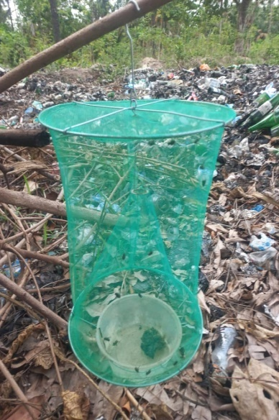

Fig.2. Commercially procured cone-shaped synanthropic fly trap.

