Original Research Article

Thermodynamic Characterization of Wet and Dry Atmospheric States Using a Two-State Hidden Markov Model over the Middle Belt Region of Nigeria

.ABSTRACT

This study investigated the temporal and seasonal evolution of rainfall and temperature variability in the core Middle Belt states (Benue, Plateau, Niger, Kogi, Nasarawa, Kwara, and FCT) of Nigeria using a two-state Hidden Markov Model (HMM). The model identified two hidden thermodynamic regimes representing dry and wet atmospheric states based on 30 years (1991-2020) observed rainfall and temperature data. Transition probabilities showed that dry-state persistence was strongest in Plateau (0.979), Benue (0.956), and Kogi (0.918), while wet-state persistence was particularly high in Kogi (0.961), Benue (0.911), and Plateau (0.955), indicating stable atmospheric conditions once a regime is established. State frequency analysis revealed spatial heterogeneity across the Middle Belt, with dry-state dominance in Kwara (80%), Niger (73%), Plateau (69%), and Benue (68%), while wet-state dominance occurred in Nasarawa (77%), the Federal Capital Territory (74%), and Kogi (69%). Seasonal analysis confirmed strong dry-state dominance during the dry season in Plateau (0.996), Niger (0.994), and Kwara (0.985), whereas Nasarawa (0.993) and FCT (0.991) maintained wet-state characteristics even during nominal dry periods, indicating sustained atmospheric moisture availability. The study concludes that rainfall and temperature variability in the Middle Belt is controlled by alternating thermodynamic equilibrium states associated with moisture convergence and radiative energy balance. The two-state HMM effectively captures these hidden atmospheric regimes and provides a physically meaningful framework for understanding seasonal climate variability and improving climate predictability in central Nigeria.

Keywords: Hidden Markov Model, Temperature, Rainfall, Dry thermodynamic state, Wet thermodynamic state, Middle Belt Nigeria, Transition Probability

1. INTRODUCTION

The intricate relationships between thermal energy, moisture availability, and large-scale atmospheric circulation control the tropical atmosphere. Temperature and rainfall are two basic meteorological variables that illustrate these thermodynamic mechanisms. Rainfall is the result of condensation processes involving latent heat release during phase shifts of water vapor, whereas temperature represents the thermal condition of the atmosphere (Wallace and Hobbs, 2006). In the tropics, convection, atmospheric stability, and large-scale circulation are all significantly influenced by the interchange of sensible and latent heat (Holton, 2004). The West African monsoon system often causes atmospheric conditions in tropical countries like Nigeria to fluctuate between dry and wet regimes (Nicholson, 2013). Wet periods are defined by moist convection, deep cloud formation, and significant latent heat release during rainfall events, whereas dry periods are typically linked to increased solar radiation, decreased cloud cover, and the predominance of sensible heat flux (Rogers and Yau, 1989). One important atmospheric heating mechanism that influences regional temperature variability is latent heat generated during condensation, which intensifies vertical motion and propels convective circulation (Emanuel, 1994). Therefore, it is crucial to comprehend the switching behavior between these thermodynamic states in order to characterize the climate and predict the seasons in tropical environments.

Akinsanola and Ogunjobi, (2014) investigated rainfall and temperature variabilities in Nigeria and discovered that there have been statistically significant increases in precipitation and air temperature in vast majority of the country. Traditional statistical approaches often describe rainfall (Ayoade, 1994: Adejuwon, 2012; Mage, 2015; Ayansina, 2009; Bosch and Davis, 2008; Tyubee 2006; Trenberth and Stepaniak 2003; Olugunorisa and Adejuwon, 2003) and temperature (Ewona and Udo, 2008; Ogolo and Adeyemi, 2009; Odjugo, 2011; Olofintoye and Sule, 2010) variability without explicitly accounting for hidden atmospheric regimes responsible for observed transitions. However, thermodynamic equilibrium and large-scale dynamical restrictions naturally drive the evolution of atmospheric processes between quasi-stable states. A probabilistic framework for detecting such hidden states is offered by the Hidden Markov Model (HMM), which connects observable temperature and rainfall fluctuations to underlying atmospheric regimes (Zucchini and MacDonald, 2009).

Markov chains have been applied to temperature (Agada, et al., 2016) and rainfall (Gabriel and Neumann, 1961; Zucchini and Guttorp, 1991; Agada, et al., 2017; Agada, et al., 2025) occurrence for many years. According to early research, first-order Markov chains can be used to probabilistically simulate the persistence and conditional dependence structures found in precipitation (rainfall) sequences (Katz, 1977). These methods were later expanded to Hidden Markov Models, which made it possible to identify unobserved weather conditions that affect rainfall variability (Zucchini and Guttorp, 1991; Charles et al., 2004). In West Africa, these models have been effectively used to describe seasonal rainfall dynamics, identify changes in the climate regime, and categorize wet and dry spells (Laurence et al., 2009). HMM's efficacy stems from its capacity to link observed meteorological data with underlying atmospheric conditions. Nevertheless, a lot of earlier applications focused on statistical classification rather than providing a clear physical understanding of the states that were found. In order to establish a connection between statistical regime identification and physical atmospheric dynamics, this study makes a contribution by explicitly understanding HMM states as thermodynamic regimes controlled by energy exchange processes within the climate system of the core Middle Belt states of Nigeria.
2. methodology

2.1 Study Area
A transitional region, the Middle Belt of Nigeria is located between latitudes 6°N and 11°30'N and longitudes 2°42'E and 15°E. Its tropical wet (April–October) and dry (November–March) seasons differ from the south to the north, with milder temperatures seen in some locations, such as the Jos Plateau. Nigeria's Middle Belt (Figure 1) is a diverse central region that primarily consists of the North Central geopolitical zone, which includes the Plateau, Nasarawa, Niger, Kogi, Kwara, Benue states, and the Federal Capital Territory (FCT). It is well-known for its numerous ethnic groups and cultural diversity between the largely Hausa-Fulani North and the Yoruba/Igbo South. It also extend to the southern regions of other northern states of Kaduna, Adamawa, Taraba, Bauchi, Kebbi, Gombe, and Yobe.
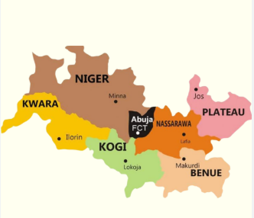
Figure 1: Map of the Middle Belt States in Nigeria

2.2 Data Description

Daily Rainfall and Air temperature data for the Middle Belt States (Abuja, Benue, Kogi, Kwara, Nassarawa, Niger, and Plateau) in Nigeria from January1, 1991 to December 31, 2020 (30 years) was obtained from National Aeronautic and Space Administration (NASA) meteorological center.
2.3 Two-State Hidden Markov Model

The Hidden Markov Model consists of a discrete hidden state process that evolves according to a Markov chain A Markov chain is a stochastic model describing a sequence of possible events in which the probability of each event depends only on the state attained in the previous event (Markovian property). A stochastic process {X_{n}} is said to have the Markovian property if
$$P\left\{X_{n+1}= j | X_{n} = i, X_{n-1} ={ i}_{n-1},. . . , X_{1}={ i}_{1},X_{0} = i_{0}\right\}$$
$= P\left\{X_{n+1}= j | X_{n} = i\right\}= P_{ij}$ (1)
For all states $i_{0}, i_{1}, . . ., i, j$and$n ≥ 0$.
For a first-order Markov chain, the future state $X_{n+1}$is independent of the previous states $X_{0}, X_{1},. . . .., X_{n-1}$and depends only on the present state $X_{n}$ (Agada et al., 2020). A stochastic process {X_{n}} (n = 0, 1 . . .) is a Markov chain if it has the Markovian property.

The conditional probabilities P{X_{n+1} =j/X_{n} = i} for a Markov chain are called (one-step) transition probabilities. A Markov chain transition matrix is a square array describing the probabilities of the chain transiting from one state to another. The transition probability $P_{ij}$ describes the probability of moving from one rainfall regime to another regime and is governed by a 2x2 matrix:
$P_{ij}=\left(\begin{matrix}p_{11} & p_{12} \\ p_{21} & p_{22}\end{matrix}\right)$ (2)
The elements are also called stationary probabilities.
2.4 Data Preparation

The daily Rainfall amount and Air Temperature data were classified without a distribution function. A random variable ${ T}_{k}$ was defined for daily Air Temperature (T) with realization ‘0’ if ‘T’ is below average ($\overline{T}$) and ‘1’ if the daily Air Temperature (T) is above average ($\overline{T}$). This is termed low and high Temperature respectively. Also, a random variable is defined to represent the Rainfall event, with the realization ‘0’ if the daily Rainfall amount is between 0-5mm (Dry) and ‘1’ if the daily Rainfall amount is greater than 5mm (Wet) (Agada, et al., 2017). Mathematically, we have;
${ T}_{k}=\left\{\begin{aligned}0, if T <\overline{T}\left(low Temperature\right). \\ 1, if T≥ \overline{T}\left(high Temperature\right).\end{aligned}\right.$ (3)
${ R}_{nk}=\left\{\begin{aligned}0, if R_{n} 0-5mm \left(Dry \right). \\ 1, if R_{n}>5mm \left(Wet\right).\end{aligned}\right.$ (4)
Therefore, in order to model the relationship between Rainfall amount and Air Temperature across the core Middle Belt States in Nigeria, equation (2) and (3) was combined to:
${ X}_{k}=\left\{\begin{aligned}1, if Temperature is 1 and Rainfall is 0 \\ 2, if Temperature is 0 and Rainfall is 1\end{aligned}\right.$ (5)
where 1 is termed Dry thermodynamic regime and 2 is Wet thermodynamic regime.

The Dry Thermodynamic State is characterizes by high temperature values and Low rainfall occurrence, while the Wet Thermodynamic State is characterizes by increased rainfall occurrence and low temperature. Transition probabilities were estimated to determine persistence and switching behavior between states. Mathematically, the transition probability matrix is expressed as:
$P_{DW}=\left(\begin{matrix}p_{DD} & p_{DW} \\ p_{WD} & p_{WW}\end{matrix}\right)$ (6)
where: $p_{DD}$ = probability of remaining in Dry Thermodynamic state, $p_{DW}$ = probability of transition from Dry to Wet Thermodynamic State, $p_{WD}$= probability of transition from Wet to Dry Thermodynamic State and $p_{WW}$ = probability of remaining in Wet Thermodynamic State
The Viterbi algorithm was used to reconstruct the most probable sequence of atmospheric regimes. The HMM model estimated Transition probability matrices, Frequency of hidden states, Seasonal distribution of states and Monthly distribution of atmospheric regimes. The analysis was performed without imposing probability distribution assumptions, allowing the hidden states to emerge directly from observed rainfall and temperature interactions. The Hidden Markov Model estimation was performed using the depmixS4 R package.

3. results and discussion
The dry thermodynamic state, which is characterized by high temperatures and little rainfall, and the wet thermodynamic state, which is characterized by more rainfall and comparatively lower temperatures, were the two dominant atmospheric regimes found by the two-state Hidden Markov Model in Nigeria's Middle Belt states. Tropical atmospheric dynamics are physically compatible with the thermodynamic difference between these two states. Dry weather increases sensible heat flow and surface heating because less cloud cover allows for more incoming solar radiation (Wallace and Hobbs, 2006). Conversely, wet weather is linked to the production of deep convective clouds, where cloud cover lowers surface temperatures through radiative shading effects and condensation releases latent heat that drives vertical motion (Rogers and Yau, 1989). The tropical climatic system is characterized by these wet and dry thermodynamic oscillations.
The findings show a high degree of persistence throughout Benue, Plateau, and Kogi States in both climatic regimes. The Middle Belt's atmospheric conditions show significant temporal memory, as evidenced by the high odds of staying in the wet state (0.911, 0.955, and 0.961) and dry state (0.956, 0.979, and 0.918). This persistence is in line with the known behavior of rainfall processes in tropical regions, where there is a strong serial correlation and a Markov dependent structure for precipitation occurrence (Katz, 1977). The application of Hidden Markov Models to rainfall has also shown that both dry and wet regimes are often quasi-stable and last for a few days before changing (Charles et al., 2004). The regional climate system is thus thought to be controlled by stable air circulation patterns during both dry and wet phases, based on the substantial persistence probability seen in Benue, Plateau, and Kogi. Thus, the large-scale stability of monsoon-driven circulation throughout the Middle Belt region is reflected in the persistence values given in Table 1. The Middle Belt's rainfall and temperature variability is not random, but rather controlled by physically significant thermodynamic regimes with robust persistence features, as the transition probabilities verify.
Table1: Transition Probability from one state to another across locations
Location | State | Dry | Wet | Location | State | Dry | Wet
Benue | Dry | 0.956 | 0.044 | Kwara | Dry | 0.5 | 0.5
 | Wet | 0.089 | 0.911 |  | Wet | 0.5 | 0.5
Plateau | Dry | 0.979 | 0.021 | Nasarawa | Dry | 0.5 | 0.5
 | Wet | 0.045 | 0.955 |  | Wet | 0.5 | 0.5
Niger | Dry | 0.5 | 0.5 | FCT | Dry | 0.5 | 0.5
 | Wet | 0.5 | 0.5 |  | Wet | 0.5 | 0.5
Kogi | Dry | 0.918 | 0.082
 | Wet | 0.039 | 0.961

The significant persistence of temperature and rainfall regimes in Benue suggests that a seasonal atmospheric regime tends to last for a number of successive periods after it is formed. The predominant seasonal dominance of the West African monsoon system over central Nigeria is shown in this behavior. Through the seasonal migration of the Inter-Tropical Discontinuity (ITD), the monsoon circulation creates distinct wet and dry seasons throughout the Middle Belt, with prolonged wet conditions during peak monsoon months and sustained dry conditions during Harmattan dominance (Sultan and Janicot, 2003). The high persistence probability in both wet and dry states found in Benue can be explained by such extensive atmospheric control. Temperature gradients, convective activity, and patterns of rainfall dispersion are all influenced by orographic elevation (Wallace and Hobbs, 2006). Topography greatly influences rainfall intensity and seasonal persistence in Nigeria, according to studies on the country's rainfall variability, especially over high elevations like the Jos Plateau (Ibebuchi and Abu, 2023). The high dry-state persistence (0.979) and distinct wet seasons are a result of the elevated terrain's ability to sustain colder temperatures and organized convective systems.

Given its location at the meeting point of the Niger and Benue rivers, Kogi condition's predominance of the wet thermodynamic condition makes sense. Being close to large bodies of water increases boundary-layer humidity and local moisture recycling, which can intensify convective rainfall and prolong wet conditions (Emanuel, 1994). According to Nigeria's hydrological climatological interactions, river basins and moisture convergence zones frequently have longer-lasting rainfall than nearby areas (Ajanaku et al., 2021). Therefore, Kogi's extremely high wet-state persistence probability (0.961) is a result of both local moisture feedback mechanisms and monsoon management. Conversely, the Federal Capital Territory (FCT), Kwara, Nasarawa, and Niger show equal transition probabilities (0.5) between rainy and dry states. This implies frequent transitions between thermodynamic states and the lack of dominant regime permanence. This type of behavior is typical of the Middle Belt's transitional climatic zones, where localized convective processes and variations in monsoon penetration lead to varying rainfall and temperature interactions. Intermittent moisture surges and mesoscale convective systems typically cause greater intra-seasonal variability in transitional regions, resulting in a balanced occurrence of wet and dry regimes (Froidurot, 2017).

As seen in Table 2, the frequency analysis supports this conclusion even more. Even though the wet season was persistent, Benue recorded 7,433 dry occurrences (68%) and 3,525 wet occurrences (32%), indicating that the dry state predominated. According to climatological analyses, even in areas with substantial rainfall totals, a large portion of Nigeria's annual cycle is defined by prolonged dry-season months (Nicholson, 2013). Plateau State's comparable preponderance of dry events (69%) is indicative of the organized seasonal pattern impacted by elevation-modified monsoon precipitation. The maximum dry-state dominance (73%), which indicates longer dry seasons and fewer wet periods, was recorded by Niger State. The length and variability of the dry season have been observed to increase in northern and central Nigeria, according to climatological evaluations. This has consequences for water resources and agriculture (Oguntunde et al., 2017). Despite Niger's equal transition probability (0.5), the overwhelming preponderance of dry events suggests that dry circumstances take up more time during the yearly climate cycle. In contrast, Kogi State documented 7,594 wet events (69%) as opposed to 3,364 dry events (31%), indicating persistently moist circumstances. According to studies, rainfall persistence is generally higher in southern Middle Belt regions that are nearer to significant river basins and moisture convergence zones (Ibebuchi and Abu, 2023). Further evidence of steady moist monsoon input and local moisture reinforcement can be found in the high wet-state persistence probability (0.961).
Table 2: Frequency of Hidden states
Location | State Frequency |  | Probability Freq. |  | State Percentage (%)
 | Dry | Wet | Dry | Wet | Dry | Wet
Benue | 7433 | 3525 | 0.678 | 0.322 | 68 | 32
Plateau | 7522 | 3436 | 0.686 | 0.314 | 69 | 31
Niger | 7996 | 2962 | 0.730 | 0.270 | 73 | 27
Kogi | 3364 | 7594 | 0.307 | 0.693 | 31 | 69
Kwara | 8750 | 2208 | 0.799 | 0.201 | 80 | 20
Nasarawa | 2514 | 8444 | 0.229 | 0.771 | 23 | 77
FCT | 2885 | 8073 | 0.263 | 0.737 | 26 | 74

At 8,750 occurrences (80%), Kwara had the most dry-state dominance, followed by 2,208 wet occurrences (20%). This shows that rainfall and temperature fluctuations in the state are largely governed by dry conditions (Table 2). The climatology of the western Middle Belt, where delayed monsoon penetration and protracted subsidence frequently predominate seasonal fluctuation, is compatible with this dry-season persistence (Odekunle, 2004). The equal transition probabilities (0.5) indicate that the climatic system spends much more time in the dry regime even when there is state change. State persistence and emission characteristics, in addition to transition probability, define state dominance in Hidden Markov modeling (Rabiner, 1989; Robertson et al., 2004). Wet-state dominance is substantial in Nasarawa, with 2,514 occurrences (23%) in the dry state and 8,444 occurrences (77%) in the wet state. This points to the influence of prolonged rainfall and extended wet seasons. The southeastern Middle Belt has greater moisture advection from the Atlantic and is situated nearer the core monsoon rain belt (Nicholson, 2013; Sultan and Janicot, 2003). In addition to suggesting ideal moisture conditions, the high wet-state frequency may make central Nigeria more vulnerable to floods during the heaviest rainy months. This effect has been extensively documented during years with intense monsoons (WMO, 2018). In the Federal Capital Territory, there were 8,073 wet events (74%) and 2,885 dry events (26%), suggesting a rainfall regime that was dominated by rain, much like Nasarawa. This illustrates how local convection processes and monsoon circulation have a significant impact on the area. Rainfall persistence in central Nigeria is significantly influenced by the Inter-Tropical Discontinuity's (ITD) northward migration and increased convective activity during the rainy season (Adejuwon, 1998).
The time evolution of the two hidden thermodynamic states found using the two-state Hidden Markov Model (HMM) throughout the Nigerian Middle Belt states is depicted in Figure 2(a–g). Dry Thermodynamic State (State 1) and Wet Thermodynamic State (State 2) are the hidden states. The monsoonal climate dynamics of central Nigeria are shown in the temporal plots, which clearly show an alternating structure between dry and wet regimes (Nicholson, 2013). Long, uninterrupted stretches of the dry state can be seen in Benue, Plateau, Niger, and Kwara. As shown in Table 2, where Kwara is 80% dry, Niger is 73% dry, Plateau is 69% dry, and Benue is 68% dry, this is consistent with their high dry-state frequencies. Transition probabilities (Table 1) provide additional evidence for the dry state's significant persistence, which is in line with regime persistence behavior reported in stochastic climate-state models (Hughes and Guttorp, 1994; Robertson et al., 2004). On the other hand, Nasarawa, FCT, and Kogi demonstrate extended wet-state dominance, supporting the previous finding that these areas have continuous moisture availability. The lengthier continuous wet state segments seen in the temporal plots are consistent with the high wet-state frequencies of 69% in Kogi, 77% in Nasarawa, and 74% in FCT.

Furthermore, the temporal evolution shows that state transitions are gradual rather than abrupt, indicating strong seasonal persistence in the atmospheric system. This gradual regime switching is typical of monsoon-driven climates, where rainfall variability is controlled by large-scale monsoon circulation rather than purely random atmospheric fluctuations (Sultan and Janicot, 2003). As a result, synoptic-scale dynamic processes and large-scale monsoon circulation play a major role in controlling rainfall and temperature variability in the Middle Belt.
Table 3: Seasonal distribution of states
Location | Season | Dry | Wet
Benue | Dry | 0.986 | 0.014
 | Wet | 0.461 | 0.539
Plateau | Dry | 0.996 | 0.004
 | Wet | 0.468 | 0.532
Niger | Dry | 0.994 | 0.006
 | Wet | 0.543 | 0.457
Kogi | Dry | 0.017 | 0.983
 | Wet | 0.512 | 0.488
Kwara | Dry | 0.985 | 0.015
 | Wet | 0.667 | 0.333
Nasarawa | Dry | 0.007 | 0.993
 | Wet | 0.387 | 0.613
FCT | Dry | 0.009 | 0.991
 | Wet | 0.443 | 0.557

The well-known meteorological seasons of Nigeria's Middle Belt closely match the hidden thermodynamic states, according to seasonal study. The extended dry conditions characteristic of the dry season are explained by the high dry-state persistence seen in Plateau (0.979) and Benue (0.956) (Table 3). The dominance of continental northeasterly Harmattan winds throughout the boreal winter, which prevent convective rainfall and reduce moisture influx throughout central Nigeria, is consistent with this behavior (Nicholson, 2013). In contrast, the wet state takes center stage during the rainy season, especially in Kogi and Benue, where wet-state persistence surpasses 0.90, indicating that southwesterly monsoon winds continuously deliver precipitation from the Atlantic Ocean (Sultan and Janicot, 2003).

The hidden states' monthly distribution (Table 4) corresponds to the anticipated yearly rainfall cycle in central Nigeria. Due to Harmattan impact, low air humidity, and decreased rainfall, the dry state predominates from January to March in all areas (Ibebuchi and Abu, 2023). The transitional months of April through June are when the likelihood of rainfall begins to progressively change from dry to rainy conditions. This slow change reflects growing monsoon penetration and moisture availability, supporting previous results that rainfall onset in Nigeria happens gradually rather than suddenly (Ati et al., 2002). Peak wet-state dominance occurs from July to September, especially in Benue and Kogi, and is correlated with tempered surface temperatures and the highest amounts of rainfall. Enhanced convective activity and the height of the West African monsoon occur during this time (Nicholson, 2013). October gradually return to dry conditions, whereas November through December sees a significant return to dry conditions, which is indicative of monsoon withdrawal. Rainfall cessation in the Middle Belt is likewise progressive, in line with regional climatological studies, as evidenced by the transition probability' slow shift between states. There is dual climatic domination in the Middle Belt, with some states (Kwara, Niger, Benue, Plateau) having a dry climate and others (Kogi, Nasarawa, FCT) a wet climate.
Table 4: Monthly Distribution of States
MONTH | Benue |  | FCT |  | kogi |  | kwara |  | Nasarawa |  | Niger |  | Plateau
 | 1 | 2 | 1 | 2 | 1 | 2 | 1 | 2 | 1 | 2 | 1 | 2 | 1 | 2
JAN. | 928 | 2 | 1 | 929 | 2 | 928 | 926 | 4 | 0 | 930 | 929 | 1 | 930 | 0
FEB. | 844 | 4 | 4 | 844 | 12 | 836 | 844 | 4 | 3 | 845 | 844 | 4 | 848 | 0
MAR. | 901 | 29 | 27 | 903 | 48 | 882 | 884 | 46 | 19 | 911 | 914 | 16 | 915 | 15
APR. | 600 | 300 | 182 | 718 | 199 | 701 | 768 | 132 | 202 | 698 | 744 | 156 | 703 | 197
MAY | 501 | 429 | 347 | 583 | 379 | 551 | 694 | 236 | 327 | 603 | 599 | 331 | 447 | 483
JUN. | 365 | 535 | 412 | 488 | 470 | 430 | 588 | 312 | 355 | 545 | 476 | 424 | 378 | 522
JUL. | 413 | 517 | 510 | 420 | 587 | 343 | 569 | 361 | 426 | 504 | 400 | 530 | 263 | 667
AUG. | 323 | 607 | 560 | 370 | 587 | 343 | 553 | 377 | 496 | 434 | 343 | 587 | 168 | 762
SEPT. | 235 | 665 | 541 | 359 | 674 | 226 | 418 | 482 | 443 | 457 | 304 | 596 | 318 | 582
OCT. | 520 | 410 | 291 | 639 | 393 | 537 | 691 | 239 | 233 | 697 | 621 | 309 | 727 | 203
NOV. | 873 | 27 | 10 | 890 | 13 | 887 | 888 | 12 | 10 | 890 | 892 | 8 | 895 | 5
DEC. | 930 | 0 | 0 | 930 | 0 | 930 | 927 | 3 | 0 | 930 | 930 | 0 | 930 | 0
Note: Dry Thermodynamic State (State 1); Wet Thermodynamic State (State 2)
The seasonal distribution of hidden thermodynamic states is shown in Figure 3(a–g). Benue, Plateau, Niger, and Kwara show overwhelming dominance of the dry state throughout the dry season, with probability typically exceeding 0.98. In accordance with the combined impacts of altitude and Harmattan dominance, the plateau exhibits the strongest dry-season stability (0.996), indicating nearly total suppression of rainfall (Wallace and Hobbs, 2006). On the other hand, even in the dry season, Nasarawa, the FCT, and Kogi exhibit significant wet-state dominance. This implies that geographic position, closeness to significant river systems, and deeper monsoon penetration all have an impact on the amount of persistent atmospheric moisture (Ibebuchi and Abu, 2023). While sporadic dry spells are still noticeable, especially in Benue and the Plateau, the wet state predominates in most places during the wet season. Mesoscale convective variability and gaps in monsoon flow are linked to this intra-seasonal variability, which has been extensively shown in rainfall studies conducted in Nigeria (Ajanaku et al., 2021).
Strong dry-state dominance is seen from November to March in the monthly distribution of atmospheric states (Figure 4[a–g]), particularly in Plateau, Niger, Kwara, and Benue, where dry occurrences surpass 90% in January and February. According to Nicholson (2013), this is in line with the peak Harmattan conditions, which are marked by dry northeasterly winds and lower atmospheric humidity. From April forward, wet-state occurrences rise quickly, with June to September seeing the highest levels of wet dominance. The largest wet-state events occur in August, which explains why Plateau and Benue see their highest rainfall during this month (Table 4). Starting in October, the monsoon retreat is reflected in a steady return to dry-state dominance, which validates the rainfall systems' gradual northward shift and subsequent departure over the Middle Belt.
The HMM categorization is further validated by the rainfall patterns linked to each hidden thermodynamic state (Figure 5[a–g]). With cloud shadowing and latent heat release, the wet state shows much larger rainfall accumulation and lower temperature variability, whereas the dry state is linked too little to no rainfall and greater temperature variability. Greater and longer-lasting rainfall events associated with prolonged monsoon impact and moisture convergence are seen in places like Kogi, Nasarawa, and the FCT, which exhibit wider rainfall distributions within the wet state (Ajanaku et al., 2021). The two-state HMM effectively represents the primary atmospheric regimes driving the climate of the Middle Belt, as evidenced by the distinct difference between rainfall distributions.

4. Conclusion

In order to determine the underlying thermodynamic regimes controlling climatic variability in the Middle Belt region of Nigeria, the current study employed a two-state Hidden Markov Model to temperature and rainfall data. The findings show that there are two main equilibrium states that govern the regional climate: a wet thermodynamic state that is linked to increased rainfall and decreased air temperature variability, and a dry thermodynamic state that is characterized by low or zero rainfall amount and high air temperature. The findings show that whereas wet regimes predominate in Kogi, Nasarawa, and the Federal Capital Territory, dry atmospheric conditions are strongly persistent in Benue, Plateau, Niger, and Kwara. The observed persistence is a reflection of atmospheric stability linked to regional circulation patterns and seasonal moisture availability. The results validate that seasonal thermodynamic transitions associated with moisture influx and atmospheric energy balance are the main factors controlling rainfall and temperature variability in the Middle Belt. In addition to supporting climate monitoring, agricultural planning, and hydrological forecasting in the area, the study shows that the two-state HMM offers a computationally efficient and physically interpretable method for analyzing atmospheric regime action. Future studies incorporating multi-variable climatic data and non-stationary modelling approaches could further improve the understanding of rainfall and temperature regime dynamics in the Middle Belt of Nigeria.

References

Adejuwon, J. O. (1998). Rainfall seasonality in Nigeria and its implications for crop production. Theoretical and Applied Climatology, 61, 19–28.
Adejuwon, J. O. (2012). Rainfall seasonality in the Niger Delta Belt, Nigeria. Journal of Geograph

y and Regional Planning, 5(2), 51–60.
Agada, P.O., Agada, I.O., and Annongu W.D. (2016). A Model for the Sequence of Positive and Negative Maximum Air Temperature Anomaly in Port Harcourt, Nigeria. International Journal of Computational and Theoretical Statistics. 3(2): 101-110. http://journals.uob.edu.bh.
Agada, I.O., Audu, M.O and Adah, V. (2025). Markov Chain Analysis of Yearly Precipitation Amount over the South-South region in Nigeria. Asia Journal of Physical and Chemical Sciences. Vol. 13(2): 30-40. DOI: 10.9734/ajopacs/2025/v13i2245.
Agada, P.O., Agada, O.I., Ogar, S. (2017). Stochastic Simulation of Daily Precipitation and Amount in Makurdi. Abacus, Journal of the Mathematical Association of Nigeria. 44(2): 215-232. ISSN: 0001-3099, http://man-nigeria.org.ng.
Ajanaku, K. O., Ogunjobi, K. O., & Ajayi, V. O. (2021). Observed characteristics of extreme precipitation events in Nigeria. Theoretical and Applied Climatology, 145, 775–789. https://doi.org/10.1007/s00704-021-03656-4
Ati, O. F., Stigter, C. J., & Oladipo, E. O. (2002). A comparison of methods to determine the onset of the growing season in northern Nigeria. International Journal of Climatology, 22, 731–742. https://doi.org/10.1002/joc.712
Ayansina, A. (2009). Seasonal rainfall variability in Guinea Savannah, Nigeria: A GIS approach. International Journal of Climate Change Strategies and Management, 1(1), 3–15.
Bosch, D. D., & Davis, F. M. (2008). Rainfall variability and spatial patterns for the southeastern region of the United States.
Charles, S. P., Bates, B. C., Hughes, J. P., & Hughes, J. P. (2004). A hidden Markov model for downscaling multisite daily rainfall occurrence in the Pacific Northwest. Journal of Climate, 17(1), 87–104.
Emanuel, K. A. (1994). Atmosphere, ocean and climate dynamics. Academic Press.
Ewona, I. O., & Udo, S. O. (2008). Trend studies of some meteorological parameters in Calabar. Nigerian Journal of Physics, 20(2), 283–289.
Froidurot, S. (2017). Characteristics of wet and dry spells in the West African tropics. Atmospheric Science Letters, 18(3), 125–131. https://doi.org/10.1002/asl.734
Gabriel, K. R., and Neumann, J. (1961). A Markov chain model for daily rainfall occurrence at Tel Aviv. Quarterly Journal of Royal Meteorology society, 88, 90-95.
Holton, J. R. (2004). An introduction to dynamic meteorology (4th ed.). Academic Press.
Hughes, J. P., & Guttorp, P. (1994). A class of stochastic models for relating synoptic atmospheric patterns to regional hydrologic phenomena. Journal of Climate, 7, 1153–1169.
Ibebuchi, C. C., & Abu, I.-O. (2023). Rainfall variability patterns in Nigeria during the rainy season. Scientific Reports, 13, 7888. https://doi.org/10.1038/s41598-023-34970-7
Katz, R. W. (1977). Precipitation as a chain-dependent process. Journal of Applied Meteorology, 16(7), 671–676.
Laurence, B., Janicot, S., & Sultan, B. (2009). The West African monsoon. Springer.
Mage, J. O. (2015). The effect of mean annual rain days on mean annual rain totals in the Middle Belt region of Nigeria. International Journal of Health and Medical Information, 4(3).
Nicholson, S. E. (2013). The West African monsoon. Annual Review of Earth and Planetary Sciences, 41, 469–488. https://doi.org/10.1146/annurev-earth-050212-124112
Odekunle, T. O., Orinmoogunje, O. O., & Ayanlade, A. (2008). Application of GIS to assess rainfall variability in Nigeria. Journal of Environmental Hydrology, 16, 1–15.
Odjugo, P. A. O. (2011). Climate change and global warming: The Nigerian perspective. Journal of Sustainable and Environmental Protection, 1(1), 6–17.
Ogolo, E. O., & Adeyemi, B. (2009). Variations and trends of some meteorological parameters at Ibadan, Nigeria. The Pacific Journal of Science and Technology, 10(2), 981–987.
Oguntunde, P. G., Abiodun, B. J., & Lischeid, G. (2017). Rainfall trends in Nigeria, 1901–2000. Journal of Hydrology, 534, 351–362. https://doi.org/10.1016/j.jhydrol.2015.12.052
Olofintoye, O. O., & Sule, B. F. (2010). Impact of global warming on rainfall and temperature in the Niger Delta of Nigeria. USEP Journal of Research Information and Civil Engineering, 7(2), 33–48.
Rabiner, L. R. (1989). A tutorial on hidden Markov models and selected applications. Proceedings of the IEEE, 77(2), 257–286.
Rogers, R. R., & Yau, M. K. (1989). A short course in cloud physics (3rd ed.). Pergamon Press.
Robertson, A. W., et al. (2004). Weather and climate regime classification using hidden Markov models. Journal of Climate, 17, 4443–4457.
Sultan, B., & Janicot, S. (2003). The West African monsoon dynamics. Journal of Climate, 16(21), 3407–3427. https://doi.org/10.1175/1520-0442(2003)016<3407:TWAMD>2.0.CO;2
Trenberth, K. E., & Stepaniak, D. P. (2003). The changing character of precipitation. Bulletin of the American Meteorological Society, 84, 1205–1217.
Tyubee, T. B. (2006). Persistence and periodicity in rainfall characteristics in the Middle Belt of Nigeria. Journal of Geography and Development, 1(1).
Wallace, J. M., & Hobbs, P. V. (2006). Atmospheric science: An introductory survey (2nd ed.). Academic Press.
World Meteorological Organization. (2018). State of the climate in Africa. WMO.
Zucchini, W., & Guttorp, P. (1991). A hidden Markov model for space-time precipitation. Water Resources Research, 27(8), 1917–1923.
Zucchini, W., & MacDonald, I. L. (2009). Hidden Markov models for time series: An introduction using R. Chapman & Hall/CRC.

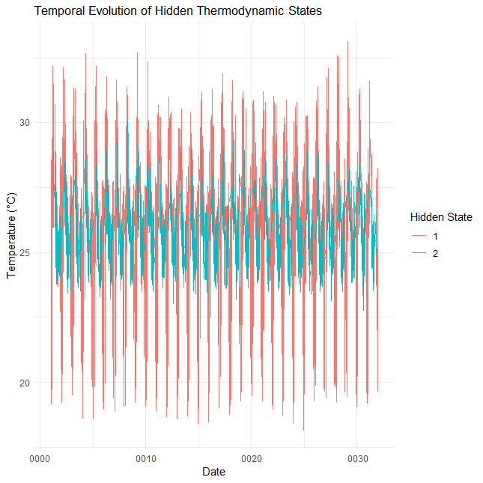
- Benue
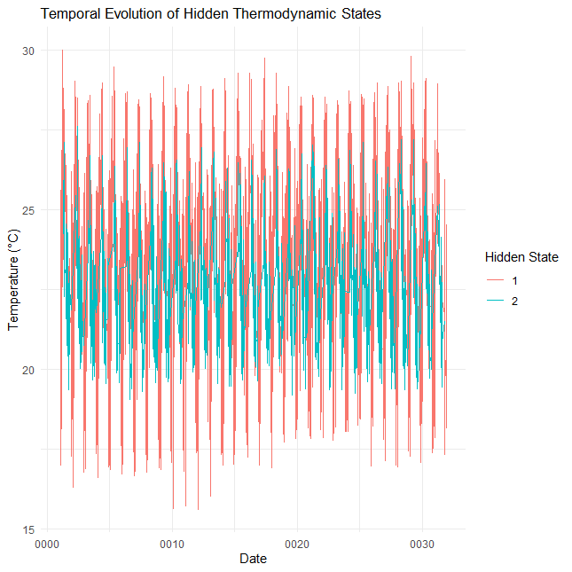
- Plateau
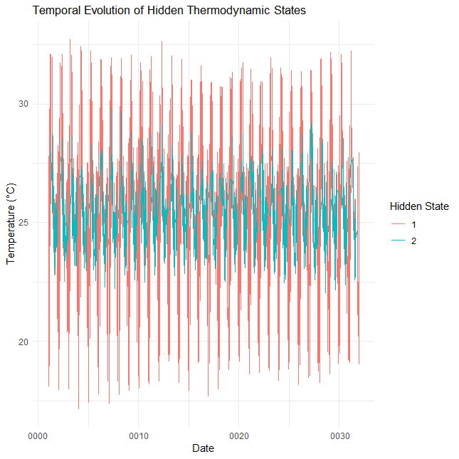
- Niger
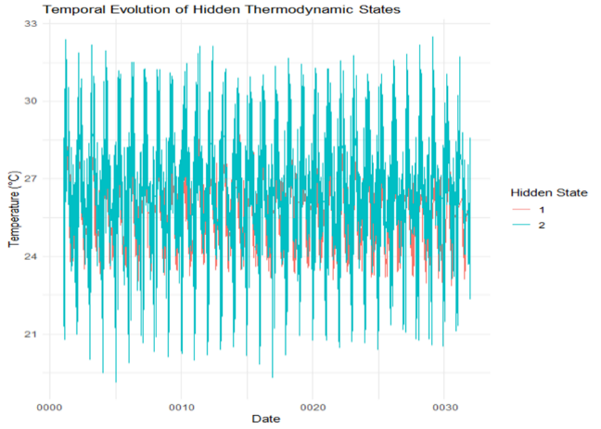
- Kogi
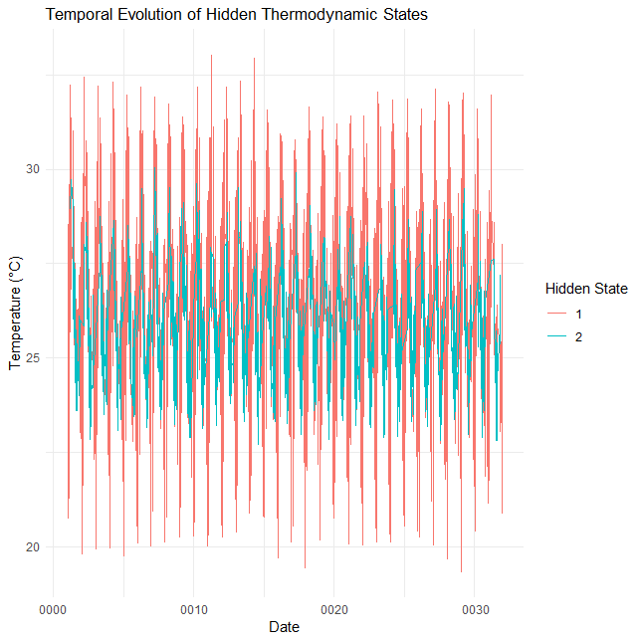
- Kwara
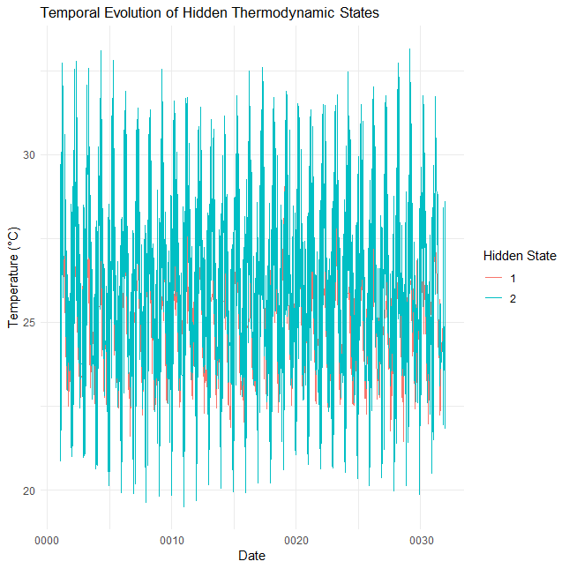
- Nasarawa
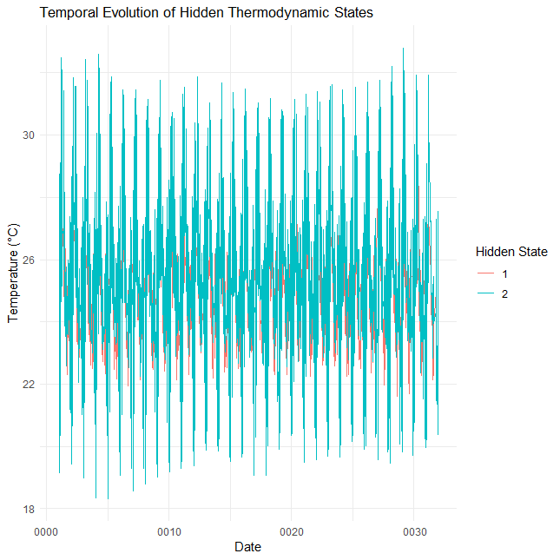
- FCT

Figure 2(a–g): Temporal evolution of Hidden thermodynamic states

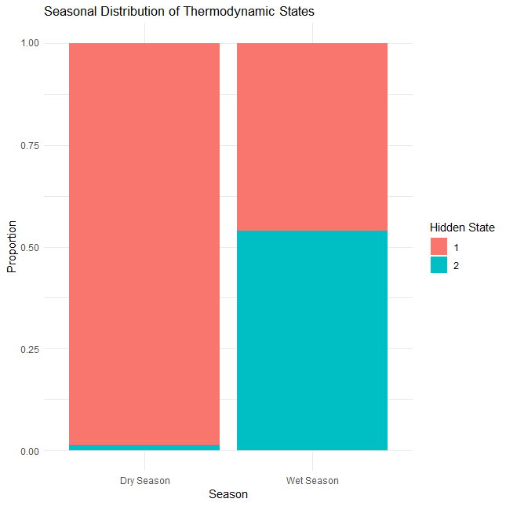
- Benue
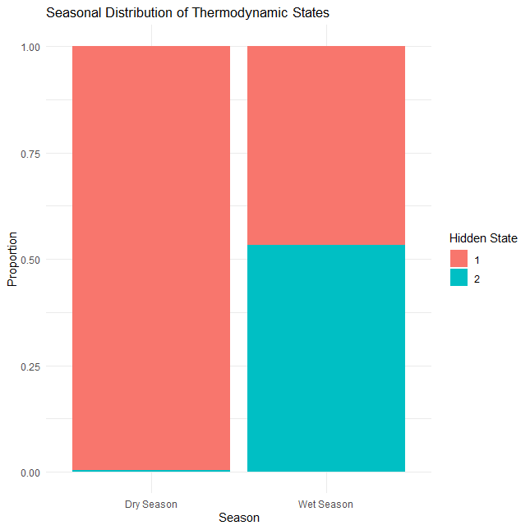
- Plateau

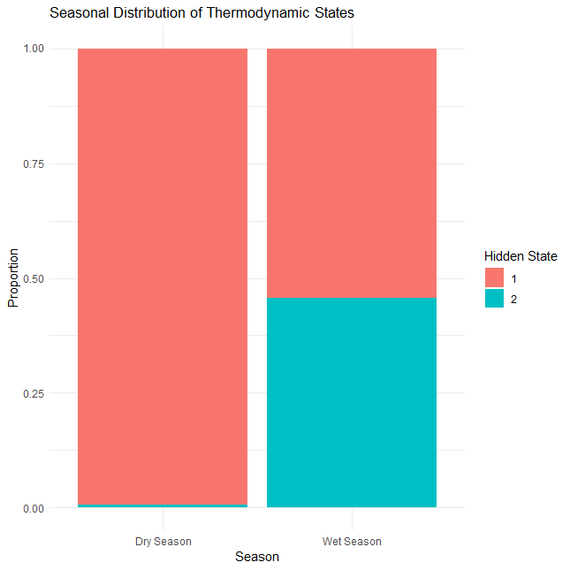
- Niger
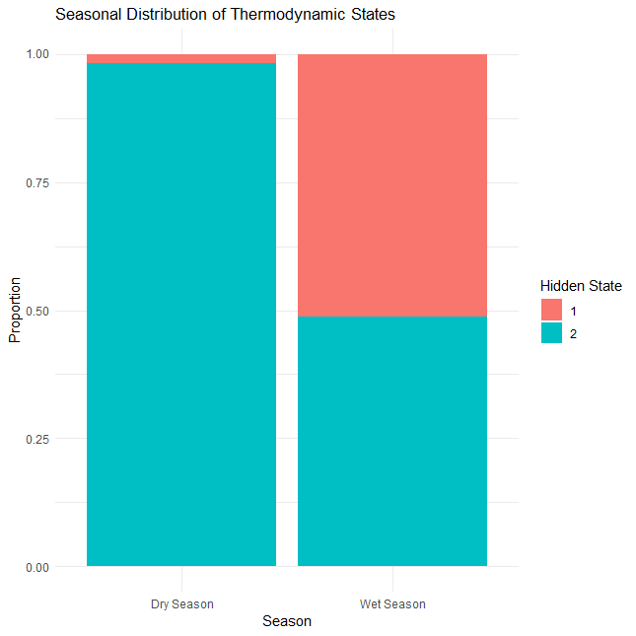
- Kogi
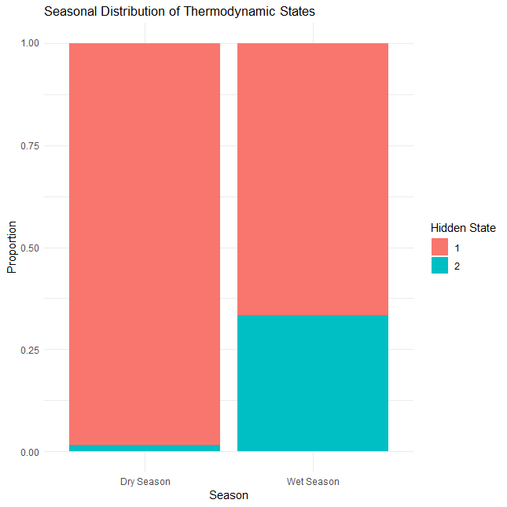
- Kwara
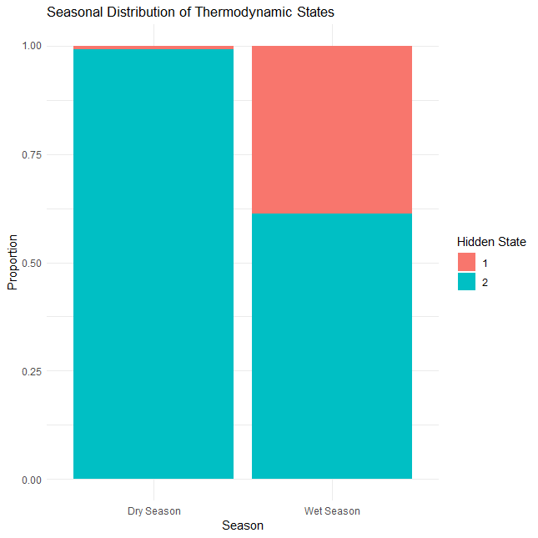
- Nasarawa
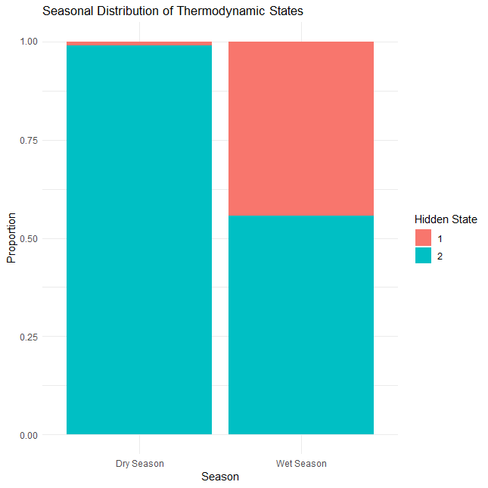
- FCT
Figure 3(a–g): Seasonal distribution of Hidden thermodynamic states 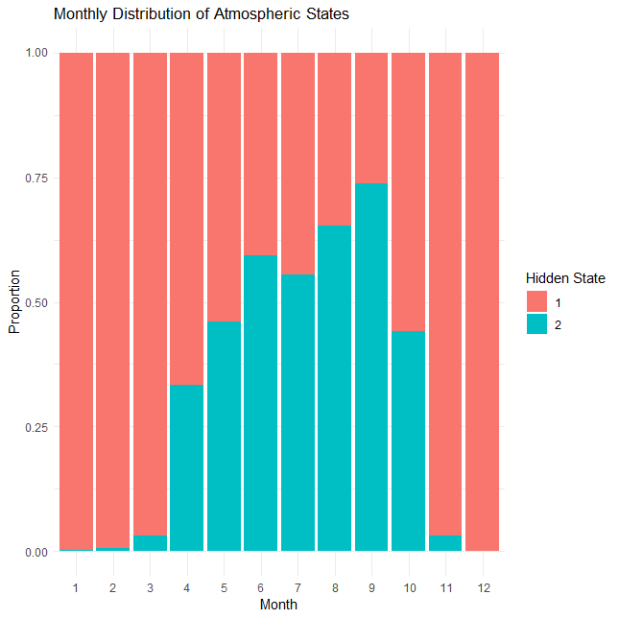
- Benue
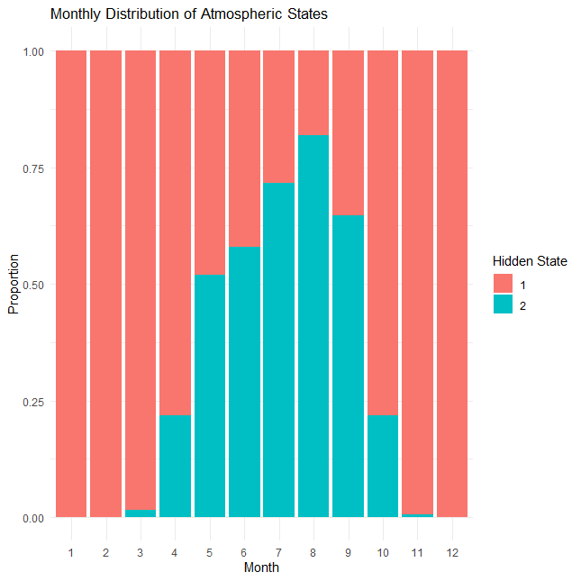
- Plateau
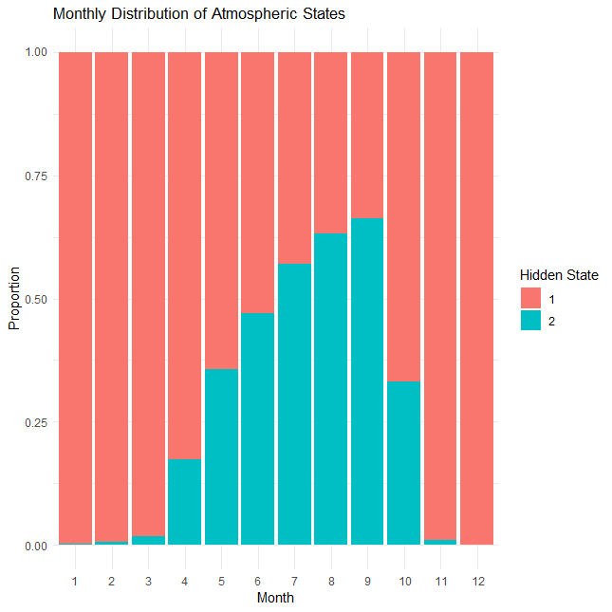
- Niger
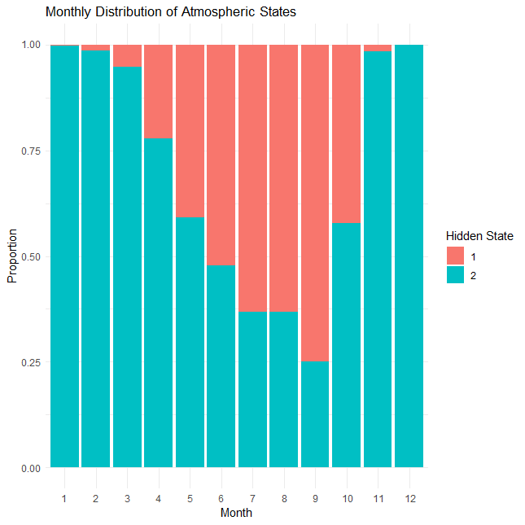
- Kogi
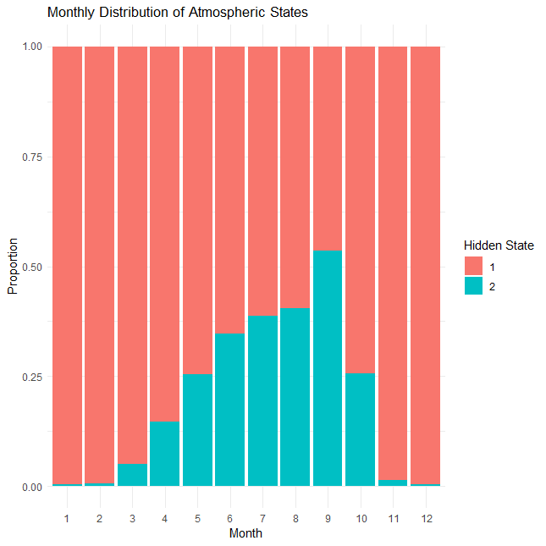
- Kwara
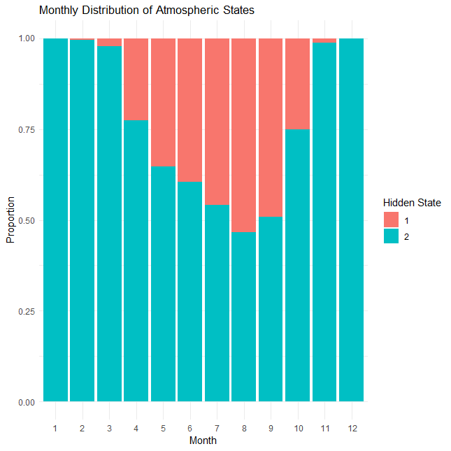
- Nasarawa
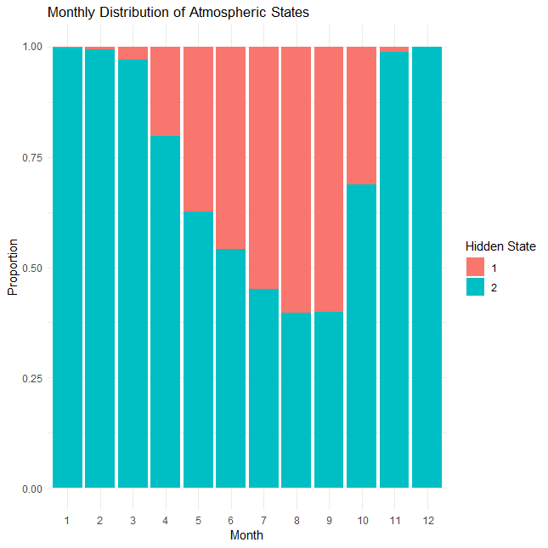
- FCT
Figure 4(a–g): The monthly distribution of Atmospheric states.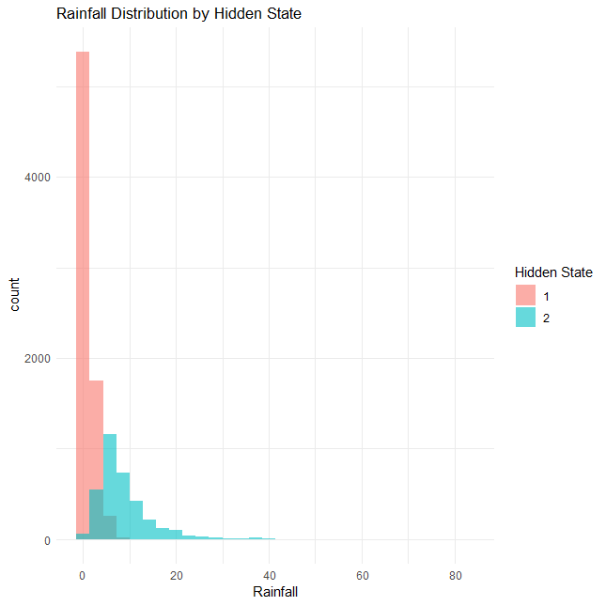
- Benue
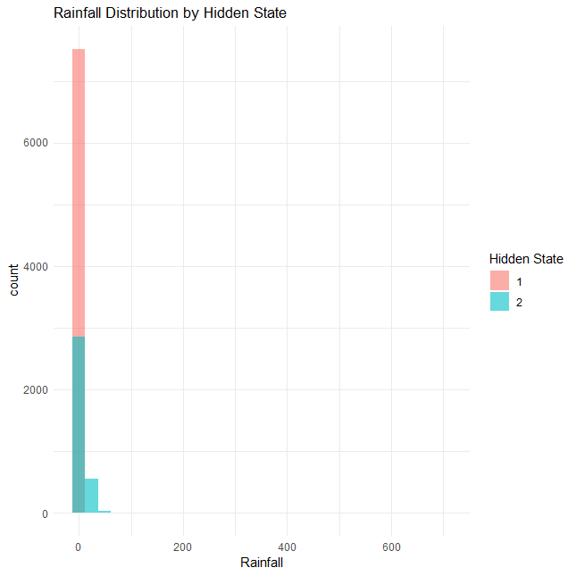
- Plateau
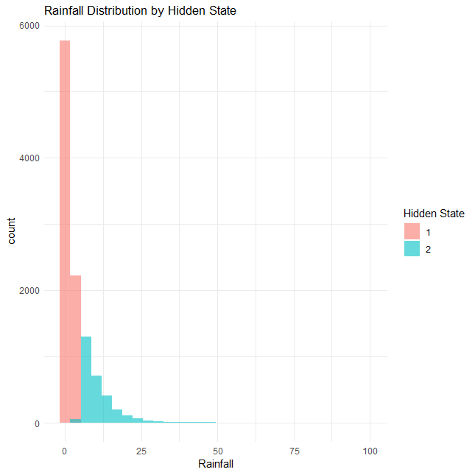
- Niger
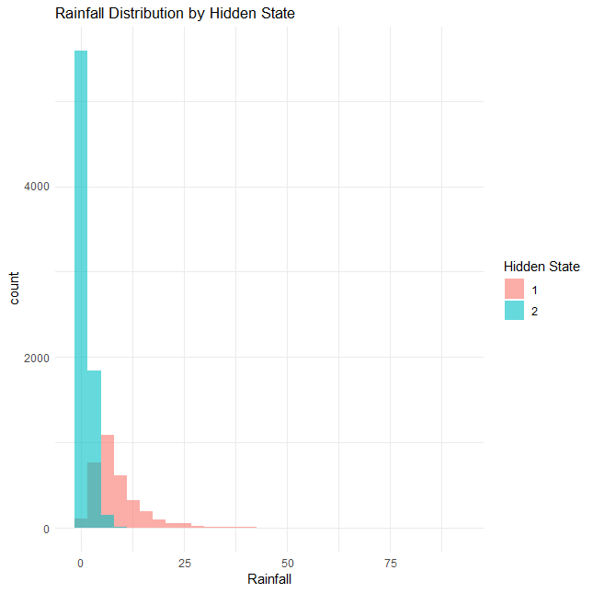
- Kogi
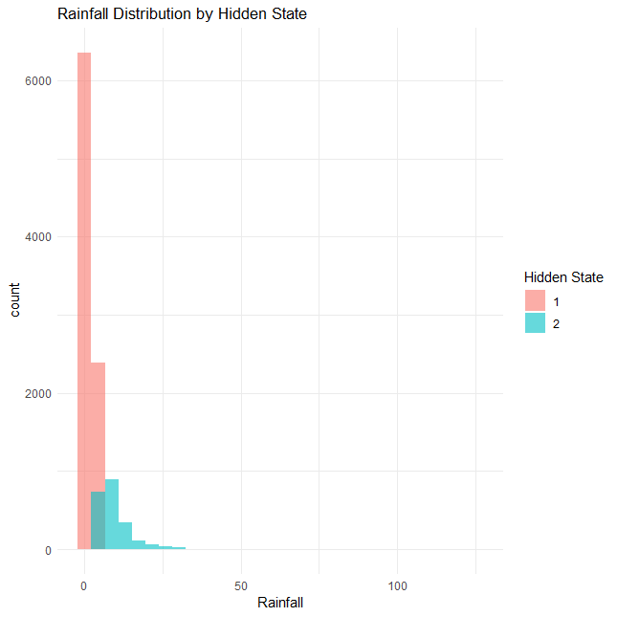
- Kwara
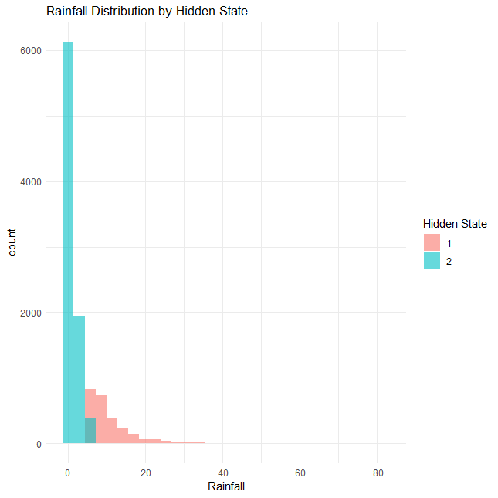
- Nasarawa

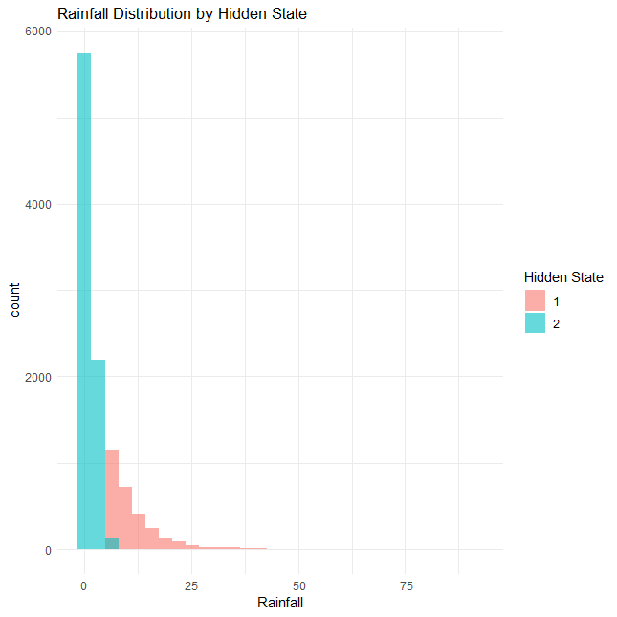
- FCT
Figure 5(a–g): Rainfall distribution by Hidden state.

