Isolation and identification of virulent Klebsiella spp from cattle in three districts of Chhattishgarh.

--------------------------------------------------------------------------------------------
Abstract
The study investigates the isolation and identification of virulent Klebsiella species from cattle in three districts of Chhattisgarh, India. A total of 50 biological samples, including milk, wound swabs, and uterine swabs, were collected from cattle exhibiting clinical symptoms of infections like mastitis, pyometra, and wounds. Isolation and identification of Klebsiella spp. were carried out using cultural, biochemical, and molecular techniques, including growth on selective media, biochemical testing, and PCR amplification targeting the gyrA gene. Results revealed an overall prevalence of 26% across the districts, with the highest incidence in Durg (40%) and a notable prevalence in mastitic milk samples (62.5%). The findings highlight the growing significance of Klebsiella in cattle infections, contributing to mastitis, uterine, and wound infections, which can result in considerable economic losses in the dairy industry. The study emphasizes the need for further research on the zoonotic potential of Klebsiella spp. and its impact on both animal health and dairy production.
Introduction
Members of the genus Klebsiella, belonging to the Enterobacteriaceae family, are non-motile, Gram-negative, and typically capsulated facultatively anaerobic bacteria found in various environmental sources such as water and soil. Presently, the genus comprises eight species: K. pneumoniae, which includes three subspecies (pneumoniae, ozaenae, and rhinoscleromatis); K. oxytoca; K. planticola; K. ornithinolytica; K. granulomatis; K. mobilis, K. terrigena, and K. variicola (Santajit and Indrawattana, 2016). Particularly, Klebsiella pneumoniae stands out as the primary pathogen responsible for a majority of human infections and represents one of the most critical multi-drug resistant (MDR) microorganisms globally. This pathogen can be isolated from the human digestive, urinary, and respiratory tracts, leading to potentially severe septic infections. In addition to human reservoirs, Klebsiella pneumoniae is frequently found in environmental sources such as soil, water, and vegetation. Furthermore, the pathogen is globally distributed among domestic and wild mammals, as well as insects, and has been detected in various food samples. In animals, it significantly contributes to pneumonia, epidemic metritis, and cervicitis in mares, as well as septicemia in foals (Dong et al., 2022). Notably, Klebsiella pneumoniae has been commonly associated with pneumonia and mastitis in cattle, resulting in substantial losses in milk production, decreased milk quality, and heightened mortality rates among affected cows (Okafor and Nwodo, 2023). Consequently, infection with this pathogen can lead to notable economic losses in the dairy industry, even in well-managed dairy farms. However, the prevalence of Klebsiella pneumoniae is on the rise within dairy herds and the food chain. At present, research related to Klebsiella pneumoniae in veterinary medicine remains limited, and the potential risk of human infection following contact with animals and consumption of contaminated food has received inadequate attention

Material and Methods
Collected samples:
Specimens were collected from 150 poultry birds suffering from diarrhea and sudden death. The birds were obtained from 35 farms in different localities of three districts (Balod, Durg and Rajnandgaon) in Chhattishgarh state from 2023 to 2024. Individual cases were subjected to clinical examination by registered veterinary practitioner. Samples underwent clinical, post-mortem, and bacteriological examinations. Under complete aseptic conditions, loopfuls from the anal swab inoculated nutrient broath were streaked on MacConkeyʼs agar and EMB agar. The inoculated plates were then incubated in a micro-aerobic environment (10% CO2) at 37°C for 48 hours. Suspected colonies were selected, purified, and identified morphologically and biochemically following the methods described by Kowalczyk et al., (2022). Molecular identification of the suspected Klebsiella spp colonies was carried out using PCR.
Bacterial isolation:
Each of appropriately processed samples were inoculated first in the Nutrient broth and then a loopful cultured broth showing turbidity were streaked in the MacConkey agar plates and incubated at 37⁰C for 24 hr. The Klebsiella growth was distinguished by its mucoid colony that appears as a pink colony on MacConkey medium due to lactose fermentation. Thus, the isolates identified as Klebsiella spp was subcultured on selective media agar plates, like MacConkey and/or Eosin methylene Blue (EMB) agar plates using the streak plate method. A single colony showing characteristic morphology was transferred to nutrient agar slant in duplicate and maintained as a pure culture throughout the study
Bacterial Identification:
1. Cultural and Biochemical characteristics:
Bacterial isolates obtained as pure culture were presumptively identified based on characteristic colony morphology as well as biochemical characteristics. Biochemical tests like the catalase test, oxidase test, IMViC tests (Indole, Methyl Red, Voges- Proskeur and Citrate test) and TSI (Triple Sugar Iron) agar test were performed as per standard procedure described by MacFaddin, (2000).
2. Growth on Klebsiella ChromoSelect Selective agar:
Analytical portions equivalent to 25 g of each sample was enriched in 225 ml of buffered peptone water (BPW) for 24 h at 37 ⁰C. For analytical portions lower than 25 gm, a volume of BPW was added to maintain a weight/volume ratio of 1:10. Thereafter, the enrichment a loopful of sample was inoculated onto Klebsiella ChromoSelect Selective agar base (Himedia) added with selective supplement (Carbenicillin) followed by incubation at 44 ⁰C for 48 hr. The inoculated plates were observed for development of, typical yellow mucoid colonies and purple colonies, respectively. The indivisual colony was picked up and subcultured onto nutrient agar slant incubated at 37 ⁰C for 24 h and maintained at 4⁰C till used. (Chiaverini et al., 2022)
3. Growth on Motility Indole Urease (MIU) medium
With the help of straight inoculation loop, the pure culture was stabbed on to MIU medium and incubated it for 24 hrs at 37⁰C. The absence of turbidity surrounding the stab-line indicated non-motile bacteria. A red color change from yellow indicated urease positivity, while the absences of a color ring formation after adding Kovac’s reagent, indicated Indole negativity. Interpretation had done as described by Kumala, (2006).
4. Polymerase Chain Reaction (PCR):
Each of isolates suspected for Klebsiella was confirmed by PCR amplification using Klebsiella gyrA genus- specific primers. Genomic DNA of phenotypically suspected isolates was extracted using the heating lysis method (Dashti et al., 2009) or boiling- snap chill method. The genomic DNA of each isolate was used as a template for PCR amplification of Klebsiella genus-specific primer and for further molecular analyses. PCR amplification reactions was optimized using positive controls.
List 1. PCR amplification
Gene | Primer sequence | Lenth  (bp) | Reference
Klebsiella gyrA | F- CGCGTACTATACGCCATGAACGTA- 3'  R- ACCGTTGATCACTTCGGTCAGG- 3' | 441 | (Okafor and Nwodo, 2023)

5. PCR protocol
The PCR assay used the BIO RAD T100 Thermal Cycler PCR system to confirm the presumptive isolates. The assay was performed under the following conditions: an initial denaturation of 94°C for 5 minutes; 35 cycles of 30 seconds at 94°C, 45 seconds at 55°C for annealing, extension at 72°C for 45 seconds, and a final extension cycle of 72°C for 10 minutes. The total reaction mixture of 25 μl consisted of 12.5 μl industrially synthesized master mix, 1 μl each of forward and reverse primers (Eurofins, Genomics India Pvt. Ltd., Bangluru), 6.5 μl PCR grade water, and 4 μl template DNA. Electrophoresis was carried out using a 1.5% agarose gel and 0.5x TBE buffer, set at 100 V for 45 minutes. The gel was stained with 4 μl ethidium bromide. A 100 bp DNA marker was used to estimate the DNA band, which was then examined with a UV transilluminator.

4. RESULTS &DISCUSSION
The details comprises a comprehensive collection of suspected isolates of Klebsiella spp, sourced from biological samples across three districts. These isolates were obtained from a range of sample types, including cattle pus swabs and milk. The data spans multiple districts, with a primary focus on Balod, Durg, and Rajnandgaon, and encompasses a variety of clinical symptoms observed in affected animals and humans.

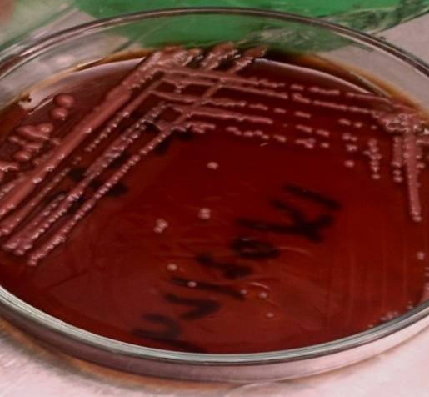
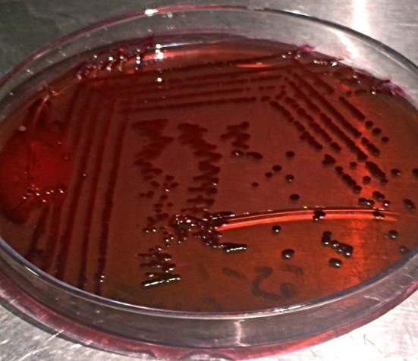
Figure 1: Klebsiella spp showed pink colour colony on MacConkey agar, and red color colony on EMB agar.
In cattle, Klebsiella isolates were found in all sample types of milk, wound, and pyometra. In the Balod district, 6 out of 23 cattle (26.09%) samples tested positive. In Durg, the prevalence was higher (40%) than that of Balod (26.09%) and Rajnandgaon, (8.33%). Overall, out of 50 cattle samples from all three districts, 13 samples (26%) were positive, with the highest prevalence in mastic milk samples from Durg (62.5%).
Table1: Isolates of Klebsiella spp isolates obtained from various samples
Serial No | Id of isolate of Klebsiella spp | Sample type | District | Clinical symptom
1 | KCB-6 | Cattle, Uterine swab | Balod | Pyometra
2 | KCB-27 | Cattle, wound swab | Balod | Wound
3 | KCB-34 | Cattle, Wound | Balod | Wound
4 | KCB-35 | Cattle, Uterine swab | Balod | Pyometra
5 | KCB- 39 | Cattle, Milk sample | Balod | Mastitis
6 | KCB- 44 | Cattle, Wound swab | Durg | Wound
7 | KCR-55 | Cattle, Wound sample | Rajnandgaon | Wound
8 | KCD-62 | Cattle, Milk sample | Durg | Mastitis
9 | KCD-63 | Cattle, Milk sample | Durg | Mastitis
10 | KCT-64 | Cattle, Milk sample | Durg | Mastitis
11 | KCD-65 | Cattle, Milk sample | Durg | Mastitis
12 | KCT-66 | Cattle, Milk sample | Durg | Mastitis
13 | KCD-67 | Cattle, Wound | Durg | Wound
.
Among cattle, milk samples from Durg district exhibit the highest (62.5%) prevalence while in Rajnandgaon none of the sample from mastitic cows showed presence of Klebsiella. Wound samples from cattle show varied positivity rates across districts, with highest in Balod (25%) followed by Durg (16.60%), and least in Rajnandgaon (14.28%).
Milk samples from cattle show highest prevalence rate (35.29%), while wound and pyometra samples it was 20% and 25%, respectively. The overall prevalence rate of 26% was recorded for cattle which is in accordance with report of Saddam et al. (2023), who found 25.1% prevalence in mastitic milk samples from dairy cows. Yadav et al. (2023) recorded prevalence of Klebsiella spp in 11.67% of the samples.
CONCLUSION
Klebsiella spp have been previously ignored in the case of cattle diseases, but their incidences have increased over the last few decades. Our research findings have observed its impact on cattle mastitis, uterine infections and wound infection indicating the need for extensive related studies.

8. REFERENCES
[1] Santajit, S. and Indrawattana, N. (2016). Mechanisms of antimicrobial resistance in ESKAPE pathogens. Biomed Res Inte. 2016: 2475067. doi: 10.1155/2016/2475067.
[2] Franklin-Alming F. V., Kaspersen, H., Hetland, M. A. K., Bakksjo, R. J., Nesse, L. L., Leangapichart, T., Löhr, I. H., Telke, A. A. and Sunde, M. (2021). Exploring Klebsiella pneumoniae in Healthy Poultry Reveals High Genetic Diversity, Good Biofilm-Forming Abilities and Higher Prevalence in Turkeys than Broilers. Front Microbiol. 12:725414. doi: 10.3389/fmicb.2021.725414.
[3] Dong, N., Yang, X., Chan, E. W. C., Zhang, R. and Chen, S. (2022). Klebsiella species: Taxonomy, hypervirulence and multidrug resistence. eBioMedicine. 79: 103998. doi: 10.1016/j.ebiom.2022.103998.
[4] Sarakby, T.M.B. (1979): Studies on the epidemiology of Klebsiella infection in poultry, M.V. Sc. Thesis Fac. Vet. Med. Cairo Unv.- (As cited by Tantawy et al., 2018).
[5] Karaman, R. (1980): Studies on some bacterial diseases of poultry casusing high mortality in balady hateries (in Monofia Province).M.V.Sc., thesis Fac. Vet Med .Cairo Univ. (As cited by Tantawy et al., 2018).
[6] Shivaprasad, H.L. (1998): An overview of anatomy, Physiology and Pathology of urinary system in birds, AV proceedings,PP. (As cited by Tantawy et al., 2018).
[7] MacFaddin, J.F., (2000). Biochemical tests for identification of medical bacteria. Lippincott Williams & Wilkins,Philadelphia, PA. 3: 173- 183
[8] Dashti, A. A., Jadaon, M. M., Abdulsamad, A. M. and Dashti, H. M. (2009). Heat treatment of bacteria: A simple method of DNA extraction for molecular techniques. Kuwait Med J. 41: 117- 122.
[9] Okafor, J. U. and Nwodo, U.U. (2023). Molecular characterization of antibiotic resistance determinants in Klebsiella pneumoniae isolates recovered from hosipital effluents in the eastern cape province, south africa. Antibiotics. 12. 1139. https://doi.org/10.3390/ antibiotics12071139
[10] Tantawy, M. A., Amer, H.A., El-Khyate, F. F. and Moshira, A. El-Abasy (2018). Klebsiella pneumoniae infection in Broiler chickens. Kafrelsheikh Vet Med J. 16. 17-42
[11] Kowalczyk, J., Czokajio, I., Ganko, M., Smialek, M. and Koncicki, A. (2022). Identification and antimicrobial resistance in Klebsiella spp. isolates from Turkeys in Poland between 2019 and 2022. Animals. 12:3157. https://doi.org/10.3390/ani12223157.

