Original Research Article
MODELLING AND FORECASTING OF ASYMMETRIC PRICE VOLATILITY OF ONION FOR LUCKNOW MARKET

Abstract: Onion prices in the Lucknow market exhibit very high instability, or in other words, volatility of UP. When price volatility affects differently with positive and negative shocks of the equivalent size, it is said to be asymmetric. Since GARCH is a symmetric model, it will be unable to account for asymmetric volatility in prices. EGARCH, GJR-GARCH and APARCH models are popularly used to capture asymmetric price volatility. The present study aimed to model and forecast the price volatility of the monthly modal prices of onion for the Lucknow market of UP. The study is based on the secondary time series data on the monthly price of onion from January 2007 to December 2021. Augmented Dicky-Fuller (ADF), Philips Peron (PP), and Kwiatkowski-Phillips-Schmidt-Shin (KPSS) tests have been used for testing the stationarity of the series. The best ARMA model has been selected for the individual series after conforming the stationarity of the series. Residuals have been examined for the presence of autocorrelation, heteroscedasticity, and nonlinear dependence in them, and it has been found that residuals have all those properties verification has been done using Ljung-Box test, ARCH-LM test and BDS test, respectively. Upon analysis of data, the ARMA (1,0)-APARCH (1,1) model outperformed the other forecasting model, and it is deemed to be the best fit model for the data under consideration. The R software version 4.2.3 has been used for data analysis.
Key words: ARMA model, GARCH type models, Onion prices, Time series, Volatility

1. Introduction
One of the most important vegetable crops in India is the onion (Allium cepa), which is a mainstay of Indian cooking and makes a substantial contribution to agricultural economy. Onion prices are notoriously volatile and frequently see significant swings as a result of a number of reasons, including weather, supply chain interruptions, seasonal variations, and governmental regulations. These fluctuations have a direct impact on both consumers and farmers, making onion pricing a critical issue in agricultural markets.
Uttar Pradesh's capital city Lucknow is a major hub for onion trading in North India. The Lucknow wholesale market plays a pivotal role in determining regional onion prices, influencing retail markets across the state. Given the socioeconomic significance of onions, policymakers, merchants, and farmers must comprehend pricing trends, seasonal patterns, and affecting elements in the Lucknow market in order to guarantee food security and price stability.
A time series is a compilation of data points documented at consecutive intervals over a specific duration. Based on historical patterns, time series analysis permits to make informed decisions. Successive realizations separated through time are correlated is the unique feature of a time series. This crucial feature helps to capture the underlying phenomenon of a time series. In a broad perspective, a time series can be decomposed into linear and nonlinear components. Since 1970s, time series modelling has become more popular and was invented by Box and Jenkins (Box et al., 2015) through the introduction of the autoregressive integrated moving average (ARIMA) model under the assumption of linearity and stationarity of the data set and the homoscedasticity of the error variance. Only capturing the linear component of a time series is the main lacuna of the ARIMA model. To address the nonlinear component of a time series like volatility, several complex models are introduced over time. An important aspect of time series modelling is volatility, which represents the phenomenon of unforeseen variation in the realizations of a time series. Thorough knowledge of the behaviour of volatility of a financial time series can be beneficial to all the stakeholders dealing with it.
To capture the volatility, Engle (1982) proposed the autoregressive conditional heteroscedastic (ARCH) model by relaxing the assumption of linearity and homoscedasticity of error variance. Later, Bollerslev (1986) and Taylor (1986) proposed the generalized ARCH (GARCH) model independently of each other. The GARCH architecture exhibits the same effect on volatility due to the positive and negative shocks of the same magnitude. For many practical situations, this type of symmetric characterization may not be viable. The reverse situation is regarded as asymmetric volatility when positive and negative shocks of the equal length affect volatility dissimilarly.
In order to overcome this difficulty, scientists have created a number of asymmetric GARCH model extensions that are capable of capturing the disparate impacts of positive and negative shocks. Exponential GARCH (EGARCH) model is one example of such a model which was proposed by Nelson in the year of 1991. EGARCH can better manage both asymmetric and non-negativity constraints than the conventional GARCH model because it takes into account the logarithm of the conditional variance. With this method, EGARCH can simulate situations in which volatility is more affected by negative shocks compared to positive ones.
Ding et al. in 1993 proposed Asymmetric Power ARCH (APARCH) model is another noteworthy extension. By adding a power parameter that controls the correlation between shock magnitude and volatility and an asymmetry parameter to take into consideration the varying impacts of positive and negative shocks, the APARCH model expands upon the GARCH framework. Because of its adaptability, APARCH can be used for a variety of time series applications.
The GJR-GARCH model, created by Glosten, Jagannathan, and Runkle in 1993, is another significant development in asymmetric volatility modelling. This model includes a leverage effect factor, explicitly accounting for the tendency of negative shocks to enhance volatility more crucially than positive shocks of the identical magnitude. This approach enables the GJR-GARCH model to provide a more accurate and reasonable representation of volatility patterns.
Ghosh et. al., 2010 studied applications of GARCH and EGARCH models have also been found in agricultural time series data. Rakshit et al. (2021) studied the Asymmetric price volatility of onion in India. Rakshit and Paul (2024) model time series with asymmetric volatility and long memory.
The Asymmetric volatility model was evaluated using MAPE, RMSE, and MAE, proved with superior forecasting performance compared within rest asymmetric model. In the present investigation, the goal of the present study is to modelling and forecasting the asymmetric volatility in onion prices in Lucknow market in Uttar Pradesh.

2. Materials and Methods
2.1 Description of the Data
To carry out the study, monthly model price data (Rs. /quintal) for the Lucknow market in the state of Uttar Pradesh will be compiled from the reliable online sources i.e., “Directorate of Marketing and Inspection (DMI), Ministry of Agriculture and Farmers Welfare, GOI”. Missing values in collected data were imputed by Kalman Smoothing (Moritz and Bratz-Beielstein, 2017) and daily data was subsequently converted to monthly data by calculating the average for each month. Subtracting the seasonal component from the original series yields a seasonally adjusted series, emphasizing the trend and irregular variations. 168 data points have been used to develop the model for the January 2007–December 2021 timeframe, while the remaining 12 data points are retained for model validation. All the analysis have been done based on percentage log return series. For seasonally adjusted time series, the percentage log-returns are calculated using formula:
$Log Return=(\left(ln\left(y_{t}\right)\right.$-$\left.ln\left(y_{t-1}\right)\right)*100$
These log-returns are crucial for modelling because they stabilize the variance of the time series data.
2.2 Test for Normality
In time series analysis, for validating developed models, assessing normality is essential. Examining normality also helps diagnose model fit, as non-normality may signal issues like model misspecification or outliers. In nonlinear model such as ARCH/GARCH, the residuals, known as innovations, are assumed to be independently and identically distributed (IID) with a mean of zero and unit variances. These innovations are generally expected to follow a normal distribution; however, in case of excess kurtosis, alternative distributions like t-distribution can be applied. To test for normality, the Shapiro-Wilks test (Shapiro & Wilk, 1965) and the Jarque-Bera test (Jarque & Bera, 1980) are often used.
2.2.1 Jarque-Bera Test
A goodness-of-fit test is the Jarque-Bera (JB) test, which tests that whether the underlying series’ skewness and kurtosis are matching with a normal distribution or not. The test statistic is always non-negative. A larger value of the test statistic leads to rejecting the null hypothesis. Jarque-Bera test statistics is given by,
$JB=\frac{n}{6}$ $\left[s_{k}^{2}+\frac{1}{4}\left({k-3}^{2}\right)\right],$
where, n denotes sample size,$s_{k}$ denotes sample skewness and k denotes sample kurtosis. The JB statistic asymptotically follows the chi-squared distribution with two degrees of freedom.
2.2.2 Shapiro-Wilk Test
The statistic of the Shapiro-Wilk test is,
$W=$ $\frac{{\left(\sum_{i=1}^{n}{a_{i}}y_{i}\right)}^{2}}{\sum_{i=1}^{n}{{\left(y_{i}-\overline{y}\right)}^{2}}}$ ,
where, $y_{i}$ is the i-th order statistics, and $a_{i}s$ are constants created from the covariances, variances and means of the sample (size n) from a normally distributed sample. Small values of W indicate the rejection of the null hypothesis. The larger the sample, there is more likely that the test would be statistically significant.
2.3 Stationarity test
For time series data, at first linear model like ARIMA can be applied. ARIMA methodology can only be applied to stationary data. If its underlying generating process is based on a mean and constant variance with its ACF essentially constant through time then a time series is said to be stationary. Let {$y_{t}$} be a time series with E (${y_{t}}^{2}$) < ∞. Then {$y_{t}$} is said to be weak stationary if
- E ($y_{t}$) is independent of t.
- cov$\left(y_{t},y_{t+h}\right)$ is independent of t for each integer h.
And {$y_{t}$} is said to be strong stationary if $\left\{\left.y_{t},y_{2},…,y_{n}\right\}\right.$ and $\left\{\left.y_{1+h},y_{2+h},…,y_{n+h}\right\}\right.$ have the same joint distribution for all integers h and n > 0.
Whether a time series process is stationary or not (presence of unit root) can be tested by Augmented Dicky-Fuller (ADF) test (Dicky and Fuller, 1979), Kwaiatkowski-Phillips-Schmidt-Shin (KPSS) test (Kwaitkowski et al., 1992), and Phillips-Perron (PP) test (Phillips and Perron, 1988). For ADF and PP tests, the null hypothesis is that the unit root is present in the time series or in other words, the time series is not stationary. For the KPSS test, the null hypothesis is that the unit root is not present in the time series or the time series is stationary.
2.4 Test for Seasonality: Kruskal-Wallis Test
The Kruskal-Walli’s test, introduced by Kruskal and Wallis in 1952, is a non-parametric statistical method used to determine if there are significant differences among multiple independent groups. This test is particularly effective for identifying seasonal trends in time series data, where seasonality reflects recurring patterns at specific intervals, such as daily, monthly, or annually. In areas like agricultural commodity pricing, these seasonal cycles often appear as predictable fluctuations over time. The Kruskal-Wllis test is frequently applied to uncover such seasonal trends in time series analysis.
The null hypothesis states that the median ranks are equal across all seasons, indicating no significant seasonal differences. Given a time, series divided into k seasons with$n_{i}$ observations per season, the test statistic H for Kruskal-Wallis test is calculated as:
$H=\frac{12}{N\left(N+1\right)}\sum_{i=1}^{k}{\frac{{R_{i}}^{2}}{n_{i}}}-3\left(N+1\right),$
where N is the total number of observations across all seasons, $R_{i}$ is the sum of ranks for the observations in seasons i, n_{i} is the number of observations across all seasons. Ranks are assigned across the entire data set, ignoring season distinctions, and then summed by season.
The H statistic follows approximately a chi-square distribution with (k-1) degrees of freedom, where k is number of seasons. The null hypothesis H₀ is rejected if H > ${{}_{,k-1}}^{2}$, where ${{}_{,k-1}}^{2}$ is critical value from the chi-square distribution table at significance level α. A rejection of H₀ indicates significant seasonality in data which is time aeries in nature.
2.5 Residual diagnostics
Residual diagnostics play a decisive role in evaluating the adequacy and credibility of models such as ARIMA in time series analysis. By analyzing the residuals, underlying patterns that the model may not have captured can be identified. Conducting through residuals diagnostics helps in detecting issues like serial autocorrelation and heteroscedasticity, which can then inform necessary model adjustments to improve forecasting accuracy.
For residuals diagnostics, the Ljung-Box test, a statistical method proposed by Ljung and Box (1978), is used to assess serial autocorrelation, while the ARCH Lagrange Multiplier (LM) test, introduced by Engle (1982), is applied to detect conditional heteroscedasticity. Moreover, the Broock-Dechert-Scheinman (BDS) test (Broock et al., 1996) is employed to detect nonlinearity in residuals, providing insights into whether the model has properly captured nonlinear structures in the data.
2.5.1 Ljung-Box Test
The Ljung-Box test is used to assess autocorrelation across multiple lags within a time series. It is frequently applied to the residuals of a time series model to evaluate whether the model has effectively accounted for any time-based patterns in the data. As a portmanteau test, it examines the cumulative effect of autocorrelation over a series of lags, rather than focusing on a single lag. The null hypothesis for the Ljung-Box test posits that the residuals are independently distributed, signifying an absence of autocorrelation.
The test statistic is calculated as:
$Q=n\left(n+2\right)\sum_{k=1}^{h}{\frac{\hat{ρ_{k}^{2}}}{n-k}}.$
In this context, n serve as sample size, h denotes the number of lags being evaluated, and ${\hat{ρ}}_{k}$ refers to the autocorrelation at lag k. The test statistic Q is distributed according to a chi-square (${}^{2}$) distribution with h digress of freedom under the null hypothesis.
2.5.2 ARCH-LM Test
After applying the linear ARIMA model, the residuals are collected and then they are examined for presence of conditional heteroscedasticity in the squared residual series {${}_{t}^{2}$}. For this purpose, the Lagrange multiplier test (Engle, 1982) is employed.
Suppose the linear regression of squared residuals defined as
${}_{t}^{2}=a_{0}+a_{1}{}_{t-1}^{2}+…+a_{q}{}_{t-q}^{2}+{}_{t}$,
where ${}_{t}$ is the error term and q denote a pre-specified positive integer.
The test statistics is as follows:
$LM={TR}^{2}$,
Where $R^{2}=\frac{\sum_{i=1}^{T}{{\left({\hat{x}}_{i}-\overline{x}\right)}^{2}}}{\sum_{i=1}^{T}{{\left(x_{i}-\overline{x}\right)}^{2}}}$,
and T is the total number of observations, $x_{i}={}_{t_{i}}^{2}.R^{2}$ is the R-squared obtained from the above-mentioned regression of ${}_{t}^{2}$.
Hypothesis of the ARCH LM test are
$$H_{0}=a_{0}=a_{1}=…=a_{q}=0$$
$H_{1}=$at least one coefficient is not equal to zero
2.5.3 BDS Test
The BDS test is used to recognize nonlinear patterns in time series data. When applied to residuals from time series model, it checks if any nonlinear dependencies remain, thereby assessing if the model adequately captures the data’s underlying dynamics. The null hypothesis in the BDS test assumes that residuals are independently and identically distributed (i.i.d).
The BDS test involves examining spatial correlations by embedding the series into a higher dimensional space. The test statistic is calculated as follows:
$V_{m,}=√T\left(c_{m,}\right.-\left.{\left(c_{1,}\right)}^{m}\right)$,
where, T is the sample size, m is the embedding dimension, ε is a proximity threshold, $C_{m, }$is the correlation integral for dimension m, $σ_{m,e}$ represents the standard deviation of the difference term$√T\left(c_{m,}\right.-\left.{\left(c_{1,}\right)}^{m}\right).$
If the test statistic $V_{m,}$ follows a standard normal distribution and is not significant, then that will indicate no nonlinear dependence. A significant result will indicate nonlinearity, meaning the current model may not be able to fully capture the time series dynamics.
2.6 Time series models
2.6.1 ARMA Model
The ARMA model is a widely used method for forecasting time series data, particularly when successive observations are correlated. It posits that the forthcoming value obtained from variable is decided by a weighted sum of its historical values and random errors. The ARMA model equation is represented as follows:
$$ϕ_{p}\left(B\right)y_{t}=µ+θ_{q}\left(B\right){}_{t}$$
where,
$$ϕ_{p}\left(B\right)=1-ϕ_{1}B-ϕ_{2}B^{2}-…ϕ_{p}B^{p}$$
$$θ_{q}\left(B\right)=1-θ_{1}B-θ_{2}B^{2}-…θ_{q}B^{q}$$
$y_{t}$ is the current value of the time series; $µ$ is the model intercept; B denotes backward shift operator; ${}_{t}$ represents the error term; $ϕ_{1},ϕ_{2},…,ϕ_{p}$ denote auto regressive (AR) coefficients; $θ_{1},θ_{2},…, θ_{q}$ represent Moving Average (MA) coefficients. The ARMA model is effective for capturing linear dependencies under the assumptions of stationarity, linearity, and independence of errors.
2.7 Asymmetric GARCH-type of Models
The GARCH models do not take into account the sign of shocks that affects the degree of volatility; instead, they merely take into account the dependence of volatility on the magnitude of external shocks. The GARCH model becomes a symmetric model as a result of these features. Several asymmetric GARCH-types of models have evolved to capture the asymmetric volatility of any time series, naming as EGARCH, GJR-GARCH and APARCH models. In applications, the GARCH (1,1) model has been the most widely used GARCH model.
2.7.1 Exponential GARCH (EGARCH) Models
By describing the conditional variance in terms of the logarithm function, Nelson (1991) presented the EGARCH model. In addition to addressing the asymmetric volatility, this model's primary advantage over the GARCH model is that it does not put any restrictions on the model's parameters because the conditional variance is always positive. The EGARCH model's conditional variance is described as
$$ln\left(h_{t}\right)=ω+\sum_{j=1}^{p}{{}_{j}*ln\left(h_{t-j}\right)+}\sum_{i=1}^{q}{\left(α_{i}\left|\frac{{}_{t-i}}{\sqrt{h_{t-1}}}\right|+{}_{i}\frac{{}_{t-1}}{\sqrt{h_{t-i}}}\right)}.$$
The parameter ${}_{i}$ represents the asymmetric factor, capturing external shocks.
For EGARCH (1,1) model the conditional variances$h_{t}$ reduces to
$$ln{(h}_{t})=ω+{}_{1}ln⁡(h_{t-1})+\left(α_{1}\left|\frac{{}_{t-1}}{\sqrt{h_{t-1}}}\right|+\frac{{}_{t-1}}{\sqrt{h_{t-1}}}\right)$$
2.7.2 GJR-GARCH Model
The GJR-GARCH model incorporates the effect of the previous periods squared error ${}_{t-1}^{2}$ on the $h_{t}$, adjusting for the sign of ${}_{t-1}$. This is achieved through an indicator variable $I_{t-1}$, which equals to 1 when ${}_{t-1}$<0 otherwise 0. The GJR-GARCH model is expressed as:
$h_{t}=ω+\sum_{j=1}^{p}{{}_{j}}h_{t-j}+\sum_{i-1}^{q}{α_{i}}{}_{t-i}^{2}+{}_{t-1}^{2}I_{t-1}$,
where γ (-1<γ<1) represents the asymmetric parameter. For GJR-GARCH (1,1) model, the $h_{t}$ simplifies to:
$$h_{t}=ω+α_{1}{}_{t-1}^{2}+{}_{1}h_{t-1}+{}_{t-1}^{2}I_{t-1}$$
2.7.3 APARCH Model
The APARCH model introduces asymmetric power into the $h_{t}$, defined as:
$$h_{t}^{\frac{}{2}}=ω+\sum_{j=1}^{p}{{}_{j}}h_{t-j}^{\frac{}{2}}+\sum_{i=1}^{q}{α_{i}}{\left(\left|{}_{t-i}\right|-{}_{t-i}\right)}^{}$$
Here, γ denotes the asymmetric factor, and δ (>0) represents the power term’s parameter. For various GARCH-type models, APARCH model provides a flexible framework. Different orders of GARCH models can be represented within the APARCH structure through assigning particular parameter values. Specifically, δ=2 and γ=0, makes the APARCH model equivalent to the standard GARCH model. The conditional variance for an APARCH (1,1) model can be reduced to:
$$h_{t}^{\frac{}{2}}=ω+{}_{1}h_{t-1}^{\frac{}{2}}+α_{1}{\left(\left|{}_{t-1}\right|-{}_{t-1}\right)}^{}$$
2.8 ARMA-GARCH type models
ARMA-GARCH type models integrate ARMA for capturing linear dynamics and various GARCH models (e.g., GARCH, EGARCH, GJR-GARCH, and APARCH) to address volatility clustering. The ARMA component accounts for linear behaviour in the first stage, thereby leaving nonlinear components in the residuals. If serial correlation, heteroscedasticity and non-linear dependence are recognised in the residuals based upon the results of the Ljung-Box test, ARCH-LM test and BDS test, respectively, the residuals are then subjugated to a GARCH model. GARCH is employed to model these residual patterns predominantly, thereby capturing both mean and volatility dynamics effectively. This approach make sure a thorough analysis of both linear and nonlinear components in the data, enhancing the overall modelling accuracy and robustness.

The schematic representation of ARMA-GARCH type model is illustrated in Fig-1

Fig. 1: ARMA-GARCH type model
2.9 Forecast evaluation and model evaluation criteria
Time series data can be analyzed by fitting various models, with the most suitable model selected based on forecast evaluation criteria. The forecasting accuracy of the chosen model is then assessed using a test dataset.
2.9.1 Error metrices
- Root mean square error (RMSE)
Consider $y_{t}$ as the observed value for time series at time t and ${\hat{y}}_{t}$ as the fitted value of a time series t=1, 2, 3, …, n, where, n is the forecast horizon. The RMSE defined in the role of positive square root of the mean squared error, calculated as
$$RMSE=\sqrt{\frac{1}{n}\sum_{t=1}^{n}{{\left(y_{t}-\hat{y_{t}}\right)}^{2}}}$$
- Mean absolute error (MAE)
The MAE is derived by converting each error to a positive value using absolute values, then calculating the average of these absolute values. The MAE is computed as:
$$MAE=\frac{1}{n}\sum_{t=1}^{n}{\left|y_{t}-\hat{y_{t}}\right|}$$
- Mean absolute percentage error (MAPE)
The MAPE is represented as a percentage and is calculated by averaging the relative absolute errors. MAPE is determined as:
$$MAPE=\frac{1}{n}\sum_{t=1}^{n}{\left|\frac{y_{t}-\hat{y_{t}}}{y_{t}}\right|*100}$$
The model that achieves the lowest values for RMSE, MAE and MAPE is regarded as the best fit.
2.9.2 Minimum information criteria
Akaike’s Information Criteria (AIC), Bayesian Information Criteria (BIC) and Hannan-Quinn Criterion are useful criteria in model selection,
Where, AIC is estimated by:
$$AIC=-2ln\left(L\right)+2m$$
Similarly,
BIC can be estimated by
BIC = $-2ln\left(L\right)+mln(n)$
HQC can be estimated by
$HQC=-2ln\left(L\right)+2mln\left(ln\left(n\right)\right)$,
where, m = number of parameters to be estimated in the model and L is the likelihood function derived from the model and n is the total number of observations.

3. Results and Discussion
Table 1 provides descriptive statistics of the price series. In this case, the total number of data points is 180 months. In Lucknow market, for monthly onion prices showed variability and instability in the data described in Table 1. The prices ranged from a minimum of Rs. 457.58 per quintal to Rs. 4680.62 per quintal, with a mean value of Rs. 1471.00 per quintal. There is significant variation around the mean, as indicated by the standard deviation of Rs. 853.00 per quintal. With a coefficient of variation (CV) of 57.98 %, the data exhibits a significant level of relative variability. A positively skewed distribution, as indicated by a skewness of 1.73 and leptokurtic distribution is suggested by a kurtosis of 2.92, which suggests heavier tails and sharp peak, implying irregular extreme price fluctuations.
Table 1: Descriptive statistics of monthly price of onion in Lucknow Market
Commodity | Minimum (Rs/q) | Maximum (Rs/q) | Mean (Rs/q) | S.D. (Rs/q) | C.V (Rs/q) | Skewness | Kurtosis
Onion | 457.58 | 4680.62 | 1471.00 | 853.00 | 57.98 | 1.73 | 2.92

3.1 Time plot
The time plot of price series for Lucknow market are depicted in Figure 2. The price spikes have been seen at some period of time from the time plot of the price series. These price spikes occurred during September 2013 to November 2013, August 2015 to October 2015, November 2017 to January 2018, September 2019 to November 2019, January 2020 and October2020 to November 2020. In the month of September 2015, the highest price spike has been seen.
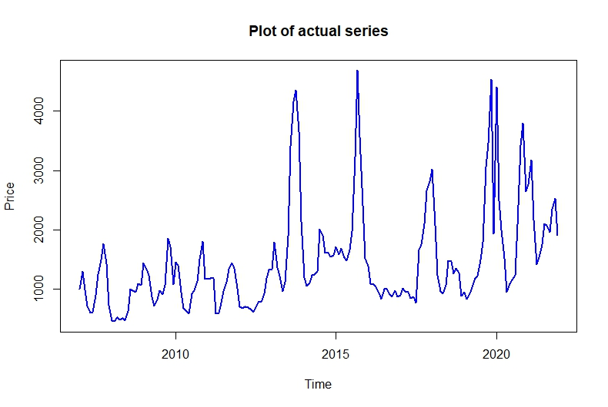
Fig. 2: Time series plot of price series for onion market
3.2 Seasonality test: The Kruskal-Wallis test (Kruskal and Wallis, 1952) is employed to detect seasonality within time series data. According to the outcomes displayed in Table 2, there is a confirmed presence of seasonality in the price data for onion crop in Lucknow market, with a significance level of 1%.
Table 2: Seasonality test results
Commodity | Kruskal-Wallis tset
Onion | Statistic | p-value
Onion | 56.87 | <0.001

3.3 Decomposition of Time Series: To remove seasonal influences, Seasonal-Trend decomposition (STL) based on LOESS (locally estimated scatterplot smoothing) is applied. Introduced by Cleveland et al. (1990), STL is a robust and versatile method that uses LOESS, a nonparametric technique that fits a smooth curve through data points by applying local weighted regression. STL decomposes the time series into three components: trend, seasonal and remainder. By iteratively applying LOESS smoothing, STL captures both short-term seasonal patterns and long-term trends, making it suitable for complex, evolving patterns. Figure 3 illustrates the seasonal decomposition of price series for selected onion market.
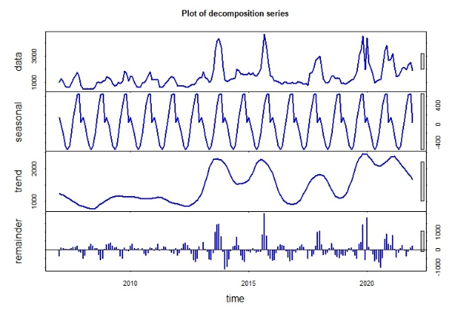
Fig. 3: Seasonally decomposition price series for Lucknow market

Subtracting the seasonal component from the original data sets produced a seasonally adjusted series, which highlights the trend and irregular variations. The Lucknow market's seasonally adjusted pricing series is displayed in Figure 4. This adjustment allows for a clearer view of underlying changes in onion prices, free from predictable seasonal trends, thereby enabling more accurate analysis of long-term trends. Following this adjustment, percentage log-returns are calculated from the seasonally adjusted series to stabilize the variance, which is crucial for effective modelling. Figure 5 presents the percentage log-returns for onion market. The relative change in prices in comparison to the prior realization is shown by the plot of the percentage log return series.

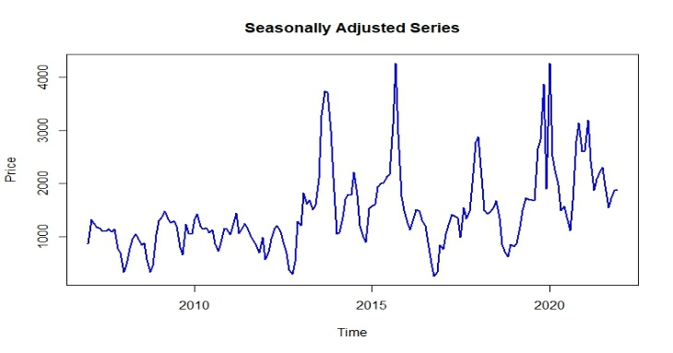
Fig. 4: Seasonally adjusted price series for Lucknow market

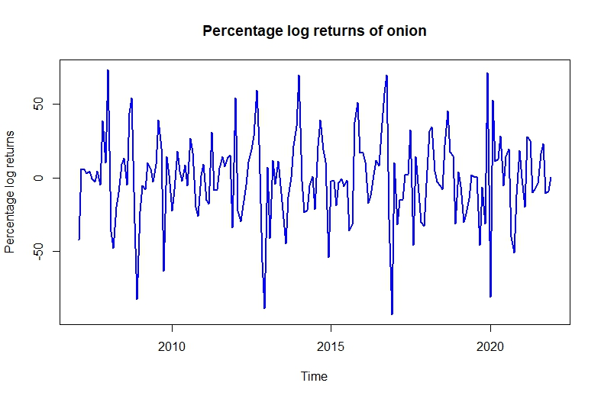
Fig. 5: Percentage log-return series for Lucknow market
3.4 Normality Test: To assess the normality in the distribution of percentage log-returns, two prevalent normality tests have been utilized: the Jarque-Bera test and the Shapiro-Wilk test. The outcomes of these tests, summarized in Table 3, the percentage log returns for onion in the Lucknow market show significant deviation at 1% level of significance based on both the tests. Thus, the series of percentage log-returns for Lucknow market is found to be non-normal. Because of the high kurtosis, the data series are assumed to follow the t-distribution. As a result, the distribution of innovation is regarded as the t-distribution.
Table 3: Normality test results for percentage log returns series
Commodity | Jarque-Bera rest |  | Shapiro-Wilk test
Onion | Statistic | p-value | Statistic | p-value
Onion | 10.34 | <0.01 | 0.97 | <0.01

3.5 Examination of Stationarity: Three essential tests, namely ADF (Augmented Dicky-Fuller) test, the PP (Phillips-Peron) test, and the KPSS (Kwaiatkowski-Phillips-Schmidt-Shin) test, have been employed to assess the stationarity of the dataset. The test results on stationarity for the series of percentage log returns for the Lucknow market have been summarized in Table 4. The findings show that the series is stationary, supported by the corresponding p-values.

Table 4: Stationary test on percentage log returns series
Commodity | ADF test |  | PP test |  | KPSS test
Onion | Statistic | p-value | Statistic | p-value | Statistic | p-value
Onion | -8.09 | <0.01 | -137.06 | <0.01 | 0.01 | 0.10

3.6 Residual Analysis: Residuals are obtained by fitting various order of ARMA as a mean model to the percentage log return series. The Ljung-Box test, ARCH-LM test, and BDS test are used to assess the residuals for serial autocorrelation, heteroscedasticity, and nonlinearity, respectively. The null hypothesis that there is no autocorrelation is rejected by the Ljung-Box test results, which are displayed in Table 5 and reveal strong serial autocorrelation. Table 5 provides a summary of the ARCH-LM test., reveals heteroscedasticity and suggests that the residual variance changes over time. Additionally, the BDS test results given in Table 6, present clear indications of nonlinearity pattern in the residuals for Lucknow market. This is denoted by ‘***’ for p-values less than 0.01, indicating a strong nonlinearity in the residuals.
Table 5: Ljung-Box Test and ARCH-LM Results
Commodity | Ljung-Box test statistic | ARCH-LM test statistic
Onion | 24.06 | 28.30
Note: The test statistics provided in the table lead to p-values of less than 0.01
Table 6: BDS Test results
Commodity | Dimension (m) | eps(1) | eps(2) | eps(3) | eps(4)
onion | 2 | 5.13*** | 4.85*** | 4.40*** | 3.94***
onion | 3 | 5.88*** | 5.40*** | 5.19*** | 4.61***
Note: “***” indicates significant at 1% level
After confirming the presence of serial autocorrelation, heteroscedasticity activity and nonlinearity in the residual part, Standard GARCH along with asymmetric GARCH-type models are fitted to the residual series as variance model. Together with the symmetric and asymmetric variance models, the superior-performing ARMA order is selected (Table 7) on the basis of minimum AIC, BIC and HQC.

Table 7: Selected Asymmetric GARCH-type models and GARCH model for Lucknow market
Model | Lucknow | AIC | BIC | HQC
GARCH | ARMA (1,0)-GARCH (1,1) | 9.48 | 9.57 | 9.51
EGARCH | ARMA (1,0)-EGARCH (1,1) | 9.47 | 9.58 | 9.51
GJR-GARCH | ARMA (1,0)-GJR-GARCH (1,1) | 9.54 | 9.65 | 9.59
APARCH | ARMA (1,0)-APARCH (1,1) | 9.49 | 9.62 | 9.54

On the basis of extent of fitting with the actual series in terms of MAE, MAPE and RMSE for the model building set, the ultimate decision is made reported in Table 8. For Lucknow market APARCH model with specific ARMA order outperforms as compared to the other applied variance models.
Table 8: Fitting performance of the selected GARCH and asymmetric GARCH-type of models in the model building set of Lucknow markets
Commodity | Model | RMSE | MAE | MAPE
Onion | ARMA (1,0)-GARCH (1,1) | 127.126 | 78.373 | 5.305
Onion | ARMA (1,0)-EGARCH (1,1) | 97.367 | 60.132 | 4.098
Onion | ARMA (1,0)-GJRGARCH (1,1) | 97.357 | 59.144 | 4.096
Onion | ARMA (1,0)-APARCH (1,1) | 77.539 | 47.448 | 3.205

The estimated parameters of the best-fitted APARCH model along with standard errors (in parentheses) are given in Table 9. From the parameter estimation, several inferences can be drawn about price volatility. For Lucknow market (α₁ =0.38) current volatility depends on the previous shock more than (β₁ =0.24) current volatility depends on previous volatility. The asymmetric parameter (γ= -0.36) is negative and significant that means negative shock will increase the volatility more than positive shock. Presence of shape parameter also justify the selection of the student-t distribution of errors. If error distribution is normal then there will be no shape.

Table 9: Estimate of parameters of the best-fitted models for onion price of Lucknow Market
Model  Variable | ARMA (1,0)-APARCH (1,1)
Mean model
mu | 0.17 (2.18)
AR (1) | 0.15 (0.10) **
Variance model
Alpha1 | 0.38 (0.14) ***
Beta1 | 0.24 (0.13) **
Gamma | -0.36 (0.08) **
Delta | 1.99 (0.57) ***
shape | 10.11 (7.83) *
***p<0.01, **p<0.05, *p<0.10
The extent of goodness of fit for the whole data with the actual series is visualized in Figure 6 where, black continuous line is representing the original values and red continuous line denotes the fitted values. The fit appears to be very good for Lucknow market.
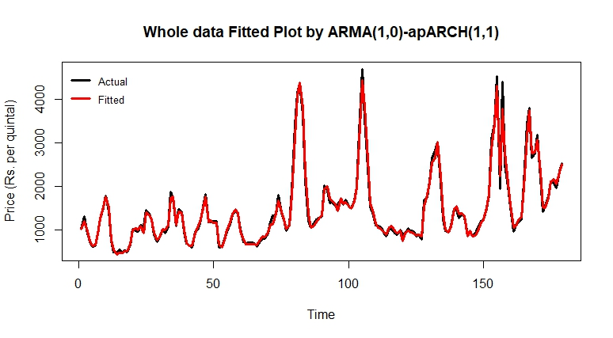
Figure. 6: Whole data fitted plot by ARMA (1,0)-APARCH (1,1) model
The performance comparison between GARCH and asymmetric GARCH-type models for onion price of Lucknow market is presented in Table 10. Performance of different models in the model validation set is evaluated in terms of RMSE, MAE and MAPE, as reported in Table 10, which suggests that at least two criteria indicate the out-performance of the APARCH model as compared to the other competing asymmetric volatility models in the model validation set. These forecasts represent percentage log returns. To convert these back to original scale, a reverse transformation is applied. The seasonal components are then reintegrated, resulting in the final forecast values for the original series.
Table 10: Forecasting performance of the selected GARCH and asymmetric GARCH-type of models in the model validation set of Lucknow markets
Commodity | Model | RMSE | MAE | MAPE
Onion | ARMA (1,0)-GARCH (1,1) | 245.911 | 126.383 | 9.727
Onion | ARMA (1,0)-EGARCH (1,1) | 246.969 | 126.873 | 9.725
Onion | ARMA (1,0)-GJRGARCH (1,1) | 245.773 | 126.068 | 9.658
Onion | ARMA (1,0)-APARCH (1,1) | 245.920 | 125.944 | 9.553

Each model has been tested under student’s t-distribution assumptions specifically applied to the residual of the GARCH model. The Pearson’s Goodness of fit test (with p-value in parentheses) has been performed to evaluate the adequacy of the assumed Student’s t-distribution for the residuals. Result shows that Lucknow market for onion met the assumptions related to student’s t-distribution.
Table 11: Optimal ARMA-GARCH type best model for percentage log returns series with Residual Diagnostics
Commodity | Optimal-ARMA-GARCH TYPE Model | Residual Distribution Assumed | Pearson Goodness of fit test | Residual Ljung-Box Test | Residual ARCH-LM Test
Onion | ARMA (1,0)-APARCH (1,1) | Student-t | 17.55 (0.55) | 0.27 (0.99) | 0.96 (0.32)

Residual diagnostics, including Ljung-Box and ARCH-LM tests, have been performed on the standardized residuals of optimal ARMA-GARCH model. For Lucknow market, the Ljung-Box test (with p-value in parentheses) confirmed the absence of significant autocorrelation, and the ARCH-LM test revealed no ARCH effect, indicating that residuals are free from serial autocorrelation and conditional heteroscedasticity. This suggests that the optimal ARMA-GARCH model has effectively captured the dependencies within this price series.
4. Conclusion
This study aimed to model and forecast the asymmetric volatility present in the monthly price data of onion for Lucknow market, which is major consumers market in Uttar Pradesh. In this study, asymmetric price volatility of onion for Lucknow market have been examined and its presence has been confirmed. ARMA (1,0)-APARCH (1,1) model exhibits more impact on volatility due to negative shocks than the impact of positive shocks. Moreover, the size of the asymmetric volatility is -0.36. The proposed model can be used by the stakeholders of onion production, consumption, and marketing for their planning and budgetary allocations. This asymmetric volatility model will also help the governments to anticipate the future prices and make policies in favour of farmers’ involved in the onion production and marketing.

COMPETING INTERESTS DISCLAIMER:
Authors have declared that they have no known competing financial interests OR non-financial interests OR personal relationships that could have appeared to influence the work reported in this paper.

References
Bollerslev, T. (1986). Generalized autoregressive conditional heteroskedasticity. J. Economet., 31(3), 307-327.
Box, G.E.P., G.M. Jenkins, G.C. Reinsel and G.M. Ljung (2015), Time-Series Analysis: Forecasting and Control, 5th Edition. John Wiley & Sons, Inc., New Jersey, U.S.A.
Broock, W.A., J.A. Scheinkman, W.D. Dechert and B. LeBaron (1996). A test for independence based on the correlation dimension. Econometric Reviews., 15(3), 197-235.
Cleveland, R.B., W.S. Cleveland, J.E. McRae and I. Terpenning (1990). STL: A seasonal-trend decomposition procedure based on Loess. J. off. stats., 6(1), 3-73.
Dickey, D. A., and W.A. Fuller (1979). Distribution of the estimators for autoregressive time series with a unit root. J. Amer. Stat. Assoc., 74(366a), 427-431.
Ding, Z., C.W. Granger and R.F. Engle (1993). A long memory property of stock market returns and a new model. J. Emp. Finan., 1(1), 83-106.
Engle, R.F. (1982). Autoregressive conditional heteroscedasticity with estimates of the variance of United Kingdom inflation. Econometrica: J. Econ. Soc., 50(4), 987-1007.
Ghosh, H., R.K. Paul and Prajneshu (2010). The GARCH and EGARCH Non-Linear Time Series Models for Volatile Data: An Application. J. Stat. Appl., 5(2), 177-193.
Glosten, L.R., R. Jagannathan and D.E. Runkle (1993). On the Relation between the Expected Value and the Volatility of the Nominal Excess Return on Stocks. J. Fin., 48(5), 1779-1801.
Jarque, C.M., and A.K. Bera (1987). A test for normality of observations and regression residuals. Int. Stat. Rev., 55(2), 163-172.
Kruskal, W. H., and W. A. Wallis (1952). Use of ranks in one-criterion variance analysis. J. Amer. Stat. Assoc., 47(260), 583-621.
Kwiatkowski, D., P. C. Phillips, P. Schmidt and Y. Shin (1992). Testing the null hypothesis of stationary against the alternative of a unit root: How sure are we that economic time series have a unit root? J. Econ., 54(1-3), 159-178.
Moritz, S., and T. Bartz-Beielstein (2017). Impute TS: Time series missing value imputation in R. R Journal., 9(1), 207-218.
Nelson, D.B. (1991). Conditional heteroskedasticity in asset returns: A new approach. Econometrica., 59(2), 347-370.
Phillips, P. C., and P. Perron (1988). Testing for a unit root in time series regression. Biometrika., 75(2), 335-346.
Rakshit, D., and R.K. Paul (2024). Modelling time series with asymmetric volatility and long memory. Ind. J. Agricult. Econ., 79(2), 231-244.
Rakshit, D., R. K. Paul and S. Panwar (2024). Asymmetric Price Volatility of Onion in India. Ind. J. Agricult. Econ., 76(2), 245-260.
Shapiro, S.S., and M.B. Wilk (1965). An analysis of variance test for normality (complete samples). Biometrika., 52(3), 591-611.

