Original Research Article

Assessment of long-term spatial and temporal soil moisture variability in the Sher River watershed, Madhya Pradesh

ABSTRACT
Soil moisture significantly impacts crop yield, irrigation scheduling, and farm-level water management decisions, Precision farming and watershed management. Therefore, enhancing agricultural resilience and guaranteeing sustainable water resource management. During the years 2015–2025, this study Shows long-term Geospatial and temporal variability of soil moisture in the Sher River Basin. The study examined seasonal trends, interannual variations, and geographical disparities throughout the watershed using a high-resolution monthly soil moisture dataset produced by a previously proven machine learning technique. The results show that 2024 was the wettest year for soil moisture levels. On the other hand, 2017 was quite dry with low moisture levels across the basin. Soil moisture was also higher in 2016, 2023 and 2025. These changes in soil moisture closely followed rainfall patterns, indicating that rainfall is a factor in determining soil moisture in the Sher River Basin. The Sher River Watershed experiences significant changes in soil moisture throughout the year. You can see a difference in soil moisture during July, August, and September. This is because it rains a lot during these months. The SMAP data also show that the soil moisture is higher during this time. In areas where people grow crops, the soil is really wet when they plant. This is because farmers use water to prepare the soil for seeds and help them grow. So, soil moisture changes in the Sher River Watershed are mostly due to how farmers irrigate their crops and to rainfall during the monsoon months. The soil moisture in the Sher River Watershed is influenced by both irrigation practices and monsoon rainfall.
Keywords: Soil Moisture, SMAP, Spatial-temporal, Sher River watershed.
- Introduction
Climate change makes it more crucial than ever to plan ahead and manage hydrological variables effectively. To support impact assessment and mitigation efforts, there is increased demand for trustworthy monitoring of critical hydrological indicators amid climate variability and extreme weather events. Among these factors, soil moisture is essential for controlling ecological, hydrological, and meteorological processes. It controls the flow of water and energy between the atmosphere and the land surface, influences the production of runoff, and directly affects vegetation development and agricultural output. The main source of moisture accessible to plants between rainstorm events is soil water storage. As a result, changes in soil moisture significantly affect crop yields, irrigation schedules, and farm-level water management decisions, such as planting timing and input use. Therefore, enhancing agricultural resilience and guaranteeing sustainable water resource management depend on accurate soil moisture data. Even though precision agriculture has seen tremendous technological advances, there are still issues with efficiently monitoring soil moisture at broader geographical and temporal scales. Precision agriculture is about keeping a close eye on soil moisture at all times.
Satellite-based soil moisture products, including those derived from SMAP, are widely used for large-scale monitoring; however, they have several limitations. First, their spatial resolution is relatively coarse (often exceeding 25 km), making it difficult to capture local variability, especially in heterogeneous landscapes. Second, most satellite algorithms estimate moisture only in the near-surface layer (approximately 0–5 cm), providing limited information about deeper soil layers that are important for crop growth and hydrological processes. Third, these datasets may contain spatial and temporal gaps. Optical sensors are affected by cloud cover, while microwave sensors can be influenced by vegetation density and surface roughness, leading to reduced accuracy under certain conditions. Although land surface models such as ERA5-Land provide continuous global coverage, they rely on simplified physical assumptions that can introduce uncertainties in regions with complex terrain or rapidly changing vegetation conditions.
Soil moisture variability is controlled by the combined influence of several interacting factors. Meteorological conditions such as rainfall and solar radiation play a major role, while soil characteristics, including texture and hydraulic properties, influence water retention and movement. Vegetation activity, often measured by indicators such as leaf area index (LAI), affects evapotranspiration and root water uptake. In addition, topographic features such as elevation and slope modify drainage and runoff patterns. Surface soil moisture typically responds quickly to rainfall events and changes in radiation, whereas deeper soil layers change more gradually due to slower subsurface processes. Conventional remote sensing approaches often struggle to separate the effects of multiple controlling factors, particularly in areas with limited ground observations. Though labour-intensive and unsuitable for continuous, large-area monitoring, conventional in-situ measurement techniques, such as gravimetric and volumetric methods, provide reliable point-based observations. Similarly, soil moisture sensors provide real-time observations but are often constrained by maintenance requirements, installation costs, and spatial representativeness.
To provide global observations of near-surface soil moisture and freeze-thaw conditions, NASA launched the Soil Moisture Active Passive (SMAP) mission in 2015. To detect soil moisture with high sensitivity to soil dielectric characteristics, the mission is equipped with an L-band microwave radiometer (Entekhabi et al., 2010). Hydrological modelling, drought monitoring, and agricultural research have all extensively used the SMAP Level-3 soil moisture product, which provides worldwide coverage with frequent revisits (Chan et al., 2018). The quasi-global rainfall product, the Climate Hazards Group InfraRed Precipitation with Station data (CHIRPS) dataset, was created to support climate research and drought monitoring. To provide gridded rainfall data from 1981 to the present, it integrates observations from ground-based stations with satellite-based infrared precipitation estimations (Funk et al., 2015). CHIRPS has been widely utilised in hydrological and agricultural evaluations due to its long-term temporal coverage and improved performance in areas with limited data.
Recent studies have increasingly explored machine learning and remote sensing techniques to address these limitations. These methods are especially suitable for watershed-scale evaluations, as they allow for long-term monitoring and continuous spatial coverage. In this context, the current work aims to assess long-term soil moisture variability in the Sher River Basin by generating reliable, high-resolution monthly soil moisture analyses.
- Materials and methods
  - Study Area
The study was conducted in the Sher River Watershed in Narsinghpur district, Madhya Pradesh, India. This watershed includes parts of Narsinghpur, Gadarwara, and Kareli blocks. The Sher River is very important because it is a tributary of the Narmada River. The Narmada River is one of the rivers that flows west in central India (CGWB, 2013). It forms part of the Narmada River system and supports farming and communities in the area. The region around the Sher River is mainly composed of farms, with some villages and small patches of vegetation. The Sher River Watershed is highly valuable to local farmers and residents. The Narmada River system is vital for this region. The Sher River Watershed includes farms and some natural areas. People in this area rely on the Sher River for their livelihood. The location and extent of the Sher River watershed are shown in Figure 1.
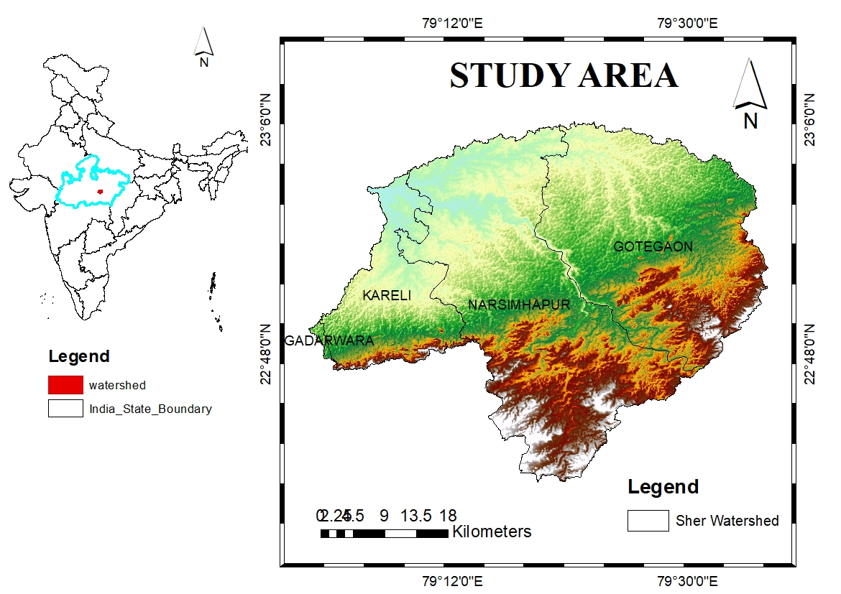
Figure 1: Map showing the location of the Sher River watershed in Narsinghpur district, Madhya Pradesh.
Three distinct seasons pre-monsoon (March–June), monsoon (July–September), and post-monsoon/winter (October–February), define the region's tropical monsoon climate. Usually occurring from June to September, the southwest monsoon season receives the majority of the year's rainfall. The rainy season usually runs from July to September. This is when we get most of the year's rain. It gets really hot during the summer months of May and June, when temperatures can exceed 40 degrees (IMD, 2025). The winter months are nice and dry. The timing of rainfall significantly affects the amount of water in the soil and the number of crops we can grow in the area (Mall et al., 2006). Originating from basaltic parent material connected to the Deccan volcanic formations, black cotton soils (Vertisols) make up the majority of the watershed (NBSS & LUP, 2010). These soils are very good at holding water because they contain a lot of clay. The clay makes them swell when wet and shrink when dry. Various types of soil are found in low-lying areas and near rivers. Clay-rich soil helps retain water during heavy rains, but during prolonged dry spells, the surface can crack. The soil's formation, texture, and structure affect water infiltration, drainage, and moisture retention throughout the year (Brady & Weil, 2016). The primary land use in the Sher River Watershed is agriculture, with most land covered by crops, followed by villages, fallow fields, scrubland, and scattered forests. Rainfed agriculture dominates upland areas, while irrigated farming, supported by groundwater extraction and canal irrigation, is more common in other parts. Land-use changes strongly influence evapotranspiration rates and the distribution of soil moisture (FAO, 2015). The farming pattern aligns with monsoon rainfall, with farmers primarily growing paddy and soybeans during the kharif season in irrigated zones. During the rabi season, wheat is mainly grown due to irrigation and adequate soil moisture. Some farmers also cultivate pulses like gram. Some areas support only one crop annually, but in irrigated zones, two crops are common. The amount of irrigation water and seasonal rainfall significantly affects crop yields and soil moisture levels (Government of Madhya Pradesh, 2022). Geologically, the watershed belongs to the Deccan Traps formation, mainly composed of late Cretaceous basaltic lava flows (CGWB, 2013). Basalt weathering has created fertile black soils in the region. The movement and presence of groundwater are influenced by the fractured basalt rocks, while localised differences in soil and moisture retention are caused by alluvial deposits along river channels.
  - Data used
Long-term soil moisture dynamics in the Sher River Watershed were reconstructed using auxiliary and multi-source satellite data. Using the Google Earth Engine platform, Sentinel-1 Ground Range Detected (GRD) C-band SAR data were retrieved from the European Space Agency mission archive. With a return frequency of 6–12 days, the collection provides VV and VH polarisation backscatter at a spatial resolution of approximately 10 m. The Climate Hazards Center's Climate Hazards Group InfraRed Precipitation with Station data (CHIRPS) dataset, which offers quasi-global precipitation estimates at about 5 km spatial resolution with daily to monthly temporal coverage, supplied the rainfall data.
Additionally, NASA's Soil Moisture Active Passive (SMAP) Level-3 product was used to provide soil moisture reference data. SMAP offers global near-surface soil moisture monitoring with continuous temporal coverage and coarse spatial resolution. Google Earth Engine's optical satellite imagery was used to compute vegetation indices, such as the NDVI. Digital Elevation Model (DEM) data were used to extract topographic variables, including elevation and slope, while publicly accessible national and international databases provided land-use and land-cover data. To ensure consistency in long-term soil moisture reconstruction, all records were harmonised both geographically and temporally before analysis.
  - Methodology
In this study, the Random Forest soil moisture model that was developed and validated earlier was used to analyse how soil moisture in the Sher River Watershed changed over time. The same modelling framework and optimized parameters were retained to ensure methodological consistency and comparability. The predictor variables and hyperparameters used in the previously validated Random Forest model were kept unchanged. Different satellite datasets were collected for the 2015–2025 period using Google Earth Engine. As illustrated in Figure 2, the overall workflow includes data acquisition, preprocessing, model application, and temporal analysis.
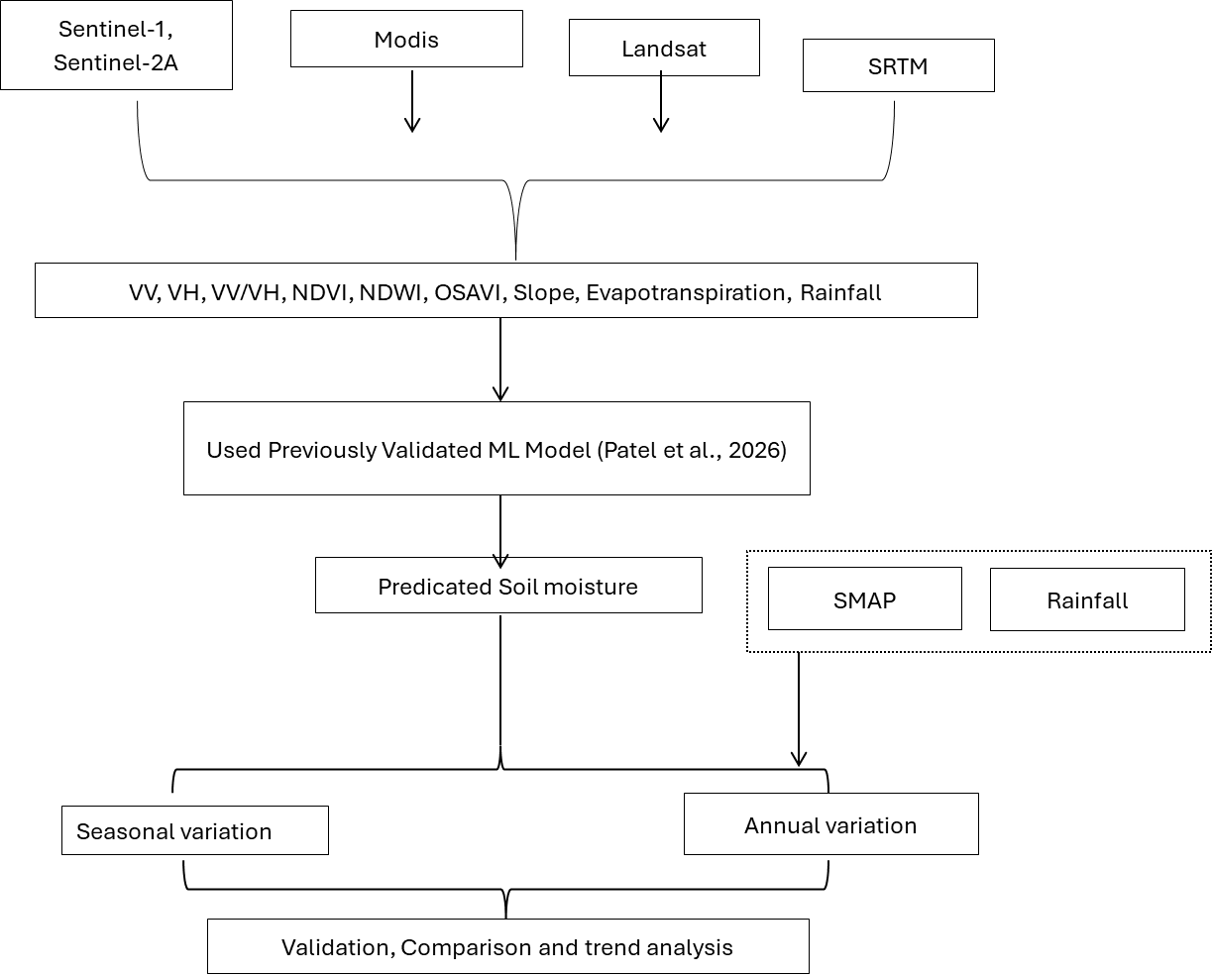
Figure: 2 Integrated flow chart of methodology
These datasets included Sentinel-1 SAR backscatter, vegetation indices from Sentinel-2A, rainfall data from CHIRPS, and topographic parameters such as Slope, Aspect, Elevation, and Evapotranspiration. Standard pre-processing steps like cloud masking, radiometric correction, speckle filtering, compositing, and spatial harmonisation were applied to ensure consistency across the time series. The trained RF model was applied directly to the prepared predictor variables to generate monthly soil moisture estimates for the entire 10-year period. No re-training was performed in this phase, as the goal was to assess temporal transferability and reconstruct historical soil moisture dynamics. The resulting monthly maps were aggregated into seasonal composites (pre-monsoon, monsoon, and post-monsoon) to evaluate seasonal variability. Long-term changes in soil moisture across different land use classes, especially agricultural areas affected by rainfall and irrigation practices, were analysed through temporal trends and spatial distribution patterns.
    - Pre-processing of satellite data
Long-term soil moisture dynamics in the Sher River Watershed were reconstructed in this study using a Random Forest (RF)-based soil moisture prediction model previously developed and verified in a separate study (Patel et al., 2026). Multiple decision trees are used in the RF algorithm, a non-parametric ensemble learning approach, to increase prediction accuracy and decrease overfitting (Breiman, 2001). RF has been widely employed in soil moisture retrieval investigations due to its resilience in handling nonlinear relationships and multicollinearity among predictor variables (Belgiu & Drăguň, 2016; Zhang et al., 2019). The Google Earth Engine (GEE) cloud computing platform was used to collect and evaluate multi-source satellite and meteorological datasets from 2015 to 2025 (Gorelick et al., 2017). VV and VH polarisation backscatter coefficients were extracted from European Space Agency Sentinel-1 Ground Range Detected (GRD) C-band Synthetic Aperture Radar (SAR) data. Because C-band SAR backscatter is sensitive to soil dielectric characteristics and surface roughness, it may be used to estimate soil moisture (Wagner et al., 2007). The Google Earth Engine cloud computing platform was used to retrieve and analyse large amounts of satellite and weather data from 2015 to 2025. This was done using the Google Earth Engine platform. We got the VV and VH polarisation backscatter coefficients from the European Space Agency Sentinel-1 Ground Range Detected data. This data comes from the C-band Synthetic Aperture Radar. The Google Earth Engine platform and the European Space Agency Sentinel-1 Ground Range Detected data were really helpful. C-band Synthetic Aperture Radar data is useful for estimating soil moisture because it provides information about the soil and its surface. The soil dielectric characteristics and surface roughness affect the C-band Synthetic Aperture Radar backscatter. The Normalised Difference Vegetation Index (NDVI) was used to assess how vegetation affects conditions. This NDVI information came from pictures taken by the Sentinel-2A satellite, which the European Space Agency made available. The Climate Hazards Group InfraRed Precipitation with Station data (CHIRPS) was used to obtain rainfall information (Funk et al., 2015). This dataset helps us understand how much rain falls over time by combining satellite and ground weather station data. The Normalised Difference Vegetation Index and rainfall data from the CHIRPS dataset were used to examine the connections between the energy balance of Earth’s surface and the amount of water the air needs. To do this, evapotranspiration data were also used, which is the Normalised Difference Vegetation Index and evapotranspiration data that show how plants and the earth’s surface release water into the air. Since topographic features affect runoff production, infiltration, and spatial soil moisture redistribution, topographic variables such as elevation, slope, and aspect were extracted from a Digital Elevation Model (DEM) (Western et al., 2002). Every dataset was trimmed to the watershed border and harmonised to a single spatial resolution. To preserve temporal consistency across the 10-year dataset, standard preprocessing procedures were applied. Cloud-masking techniques were used for optical imaging to eliminate atmospheric contamination. To reduce the impact of noise, SAR data were filtered for speckle and radiometrically calibrated. To reduce short-term swings and data gaps, monthly composites were created. After that, the harmonised predictor layers were ready to serve as input variables for the RF model.
    - Long-Term Soil Moisture Reconstruction
For the duration of the study (2015–2025), monthly soil moisture estimates were produced by directly applying the validated RF model to the provided predictor variables. The model maintained the established correlations between variables, including satellite-derived soil moisture estimates and ground-observed soil moisture, using the calibrated parameters from the original study. A seasonal composite encompassing the pre-monsoon (March–June), monsoon (July–September), and post-monsoon (October–February) periods was created by combining the monthly soil moisture maps. Examining intra-annual variability related to agricultural cycles and rainfall distribution was made possible by seasonal aggregation. Seasonal averages from several years were compared to evaluate interannual variability. The rebuilt time series was subjected to statistical trend analysis to assess long-term soil moisture patterns. Because nonparametric techniques such as the Mann-Kendall test are robust to nonnormal distributions, they are frequently used to detect monotonic trends in hydroclimatic data (Kendall, 1975). With an emphasis on agricultural areas affected by irrigation and rainfall variability, a spatial analysis was conducted to examine soil moisture variability across various land-use/land-cover classifications. The spatiotemporal evaluation shed light on long-term variability, seasonal soil moisture dynamics, and possible ramifications for the watershed's agricultural water management

- Result and discussion
  - Monthly Soil Moisture Variability (January–December 2025)
There is noticeable seasonal fluctuation throughout the Sher River Watershed in the monthly soil moisture maps predicted for 2025 using the verified Random Forest (RF) model (Figure 3). Very Dry, Dry, Moderate, and Wet were the four groups into which the findings were divided based on the highest anticipated soil moisture levels from January to December 2025. Understanding intra-annual soil moisture dynamics in relation to land use and rainfall distribution was facilitated by this categorisation. Soil moisture was highest during the monsoon season from June to September. During these months, much of the watershed was very wet. We saw the soil moisture in July and August. This is when we get the rain during the southwest monsoon season. Soil moisture increases significantly during the monsoon season in India, where rainfall is relatively low for most of the year (Mall et al., 2006). When it rains heavily during this time, the water seeps into the soil, helping it retain water and allowing crops to grow well during the kharif season. The monsoon season is very important for soil moisture. It helps the crops to grow. Soil moisture levels are very high during the monsoon season, from June to September.
Interestingly, the soil was also quite moist in farmlands during March and April. These months are usually dry. The moisture was likely due to farmers watering their crops during the zaid cropping period. When farmers water their crops at planting time, it helps the seeds sprout. The plants get started. Having soil moisture at this stage is really important for crops to grow evenly and produce a good harvest (FAO, 2012). Because of this, the fields that people were farming had soil moisture levels. This was when the nearby forests and scrublands were very dry. In contrast to non-irrigated land cover classes, agricultural areas had comparatively greater soil moisture throughout the early kharif (June–July) and rabi sowing periods (October–November). Pre-sowing or first irrigation activities trigger these increases, temporarily raising surface soil moisture levels above those caused by rainfall. According to earlier research, irrigation dramatically alters natural soil moisture regimes, especially in areas with intensive cultivation (Ozdogan et al., 2010).
In areas with trees and bushes, soil moisture changes were mainly influenced by rainfall and evaporation. These regions saw a decline in moisture during the monsoon season, followed by a sharp decrease before it began. This suggests that both water management policies and climate significantly impact soil moisture levels. In wooded and scrubland areas, soil moisture is primarily driven by rainfall and evapotranspiration, leading to a gradual decrease during the monsoon and a rapid drop during the rainy months. The dynamics of soil moisture within watersheds are shaped by the interplay between human water management and climate factors. This contrast emphasises the important roles of climate variability and human practices in controlling soil moisture fluctuations across the watershed, as shown in Figure 3, which depicts the spatial and temporal variations of soil moisture classes throughout 2025.
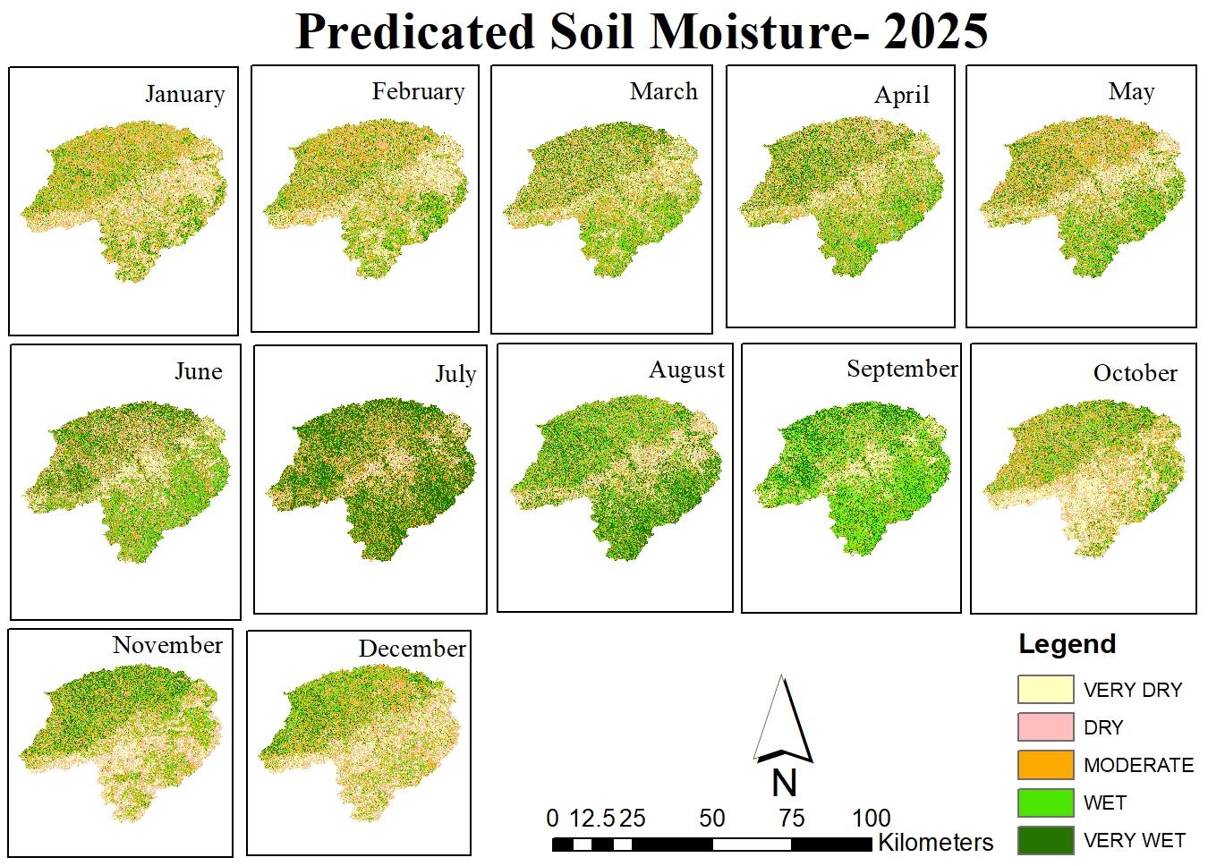
Figure 3: Monthly RF model soil moisture distribution (m³/m³) for 2025.
  - Validation of Monthly Soil Moisture with SMAP and Rainfall (January–December 2025)
A comparison was performed using NASA's Soil Moisture Active Passive (SMAP) program to evaluate the accuracy of RF-predicted soil moisture (Entekhabi et al., 2010). RF outputs and monthly SMAP soil moisture maps for 2025 were compared geographically. The monthly RF-predicted rainfall distribution for 2025 and the corresponding SMAP soil moisture maps used for comparison are shown in Figs. 4 and 5, respectively.
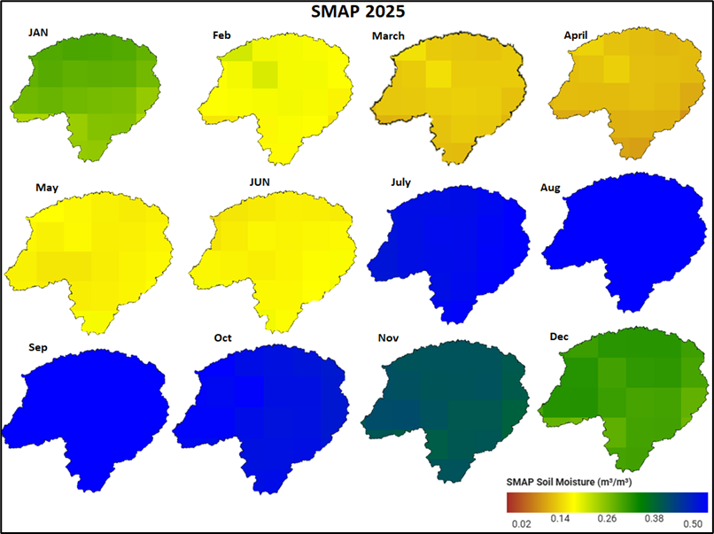
Figure 4. Monthly SMAP soil moisture distribution (m³/m³) for 2025.
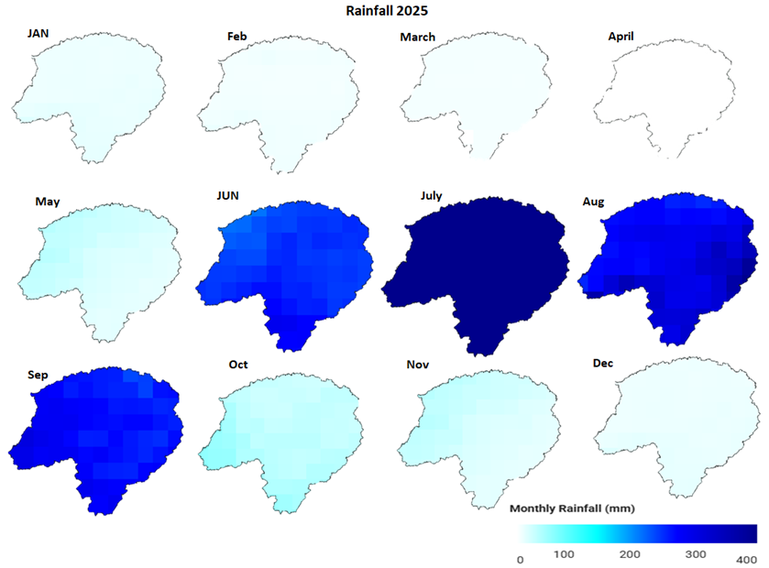
Figure 5. Monthly rainfall distribution (mm) for 2025.
Both datasets showed regular seasonal patterns, with April and May showing the lowest soil moisture and July and August showing the highest. Strong agreement between RF forecasts and SMAP measurements was observed in the overall temporal pattern, despite slight discrepancies due to differences in spatial resolution. To investigate the impact of climate control on soil moisture variability, rainfall data from the CHIRPS dataset (Funk et al., 2015) were further examined. The distribution of monthly rainfall and increases in soil moisture during the monsoon months were strongly correlated. Rainfall was the primary driver of seasonal soil moisture recharge in the watershed, as evidenced by the rapid increase in soil moisture from June to September and the corresponding increase in precipitation.
The rainfall pattern in 2025 clearly follows a seasonal trend associated with the southwest monsoon. From January to April, rainfall levels are almost zero, reflecting dry pre-monsoon conditions in the study area. A notable increase starts in June, with a sharp escalation in July when the maximum rainfall, around 650 mm, occurs. Although rainfall decreases slightly in August and September, it remains high during the monsoon phase. After October, rainfall rapidly diminishes, signalling the shift to post-monsoon and dry periods. Figure 6 shows the month-by-month CHIRPS rainfall variation, highlighting the peak monsoon rainfall in July.
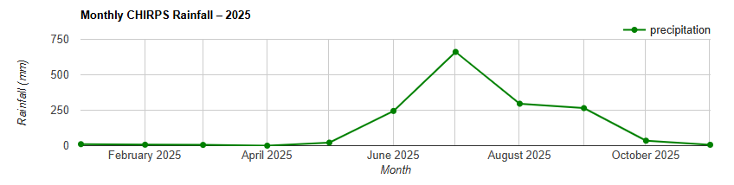Figure 6. Monthly Rainfall Trend in 2025
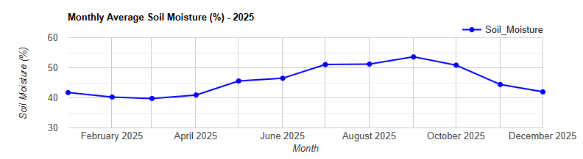
Figure 7. Monthly Soil Moisture Trend in 2025
The monthly average soil moisture (%) closely follows rainfall patterns. From January to April, moisture remains relatively low at about 39–41%, reflecting dry conditions. Starting in May, soil moisture gradually increases as the monsoon approaches. The highest levels, approximately 51–54%, occur between July and September, coinciding with the peak rainfall. After September, moisture declines gradually due to reduced rainfall and higher evapotranspiration. Figure 7 shows the seasonal changes in monthly average soil moisture, highlighting the peak during the monsoon season.
The SMAP-derived surface soil moisture (m³/m³) exhibits a distinct seasonal pattern throughout 2025. Moisture levels are lowest from February to April (approximately 0.15–0.20 m³/m³), indicating dry conditions before the monsoon. A rapid rise occurs from June, reaching peak levels in August (around 0.48–0.50 m³/m³). Following the monsoon, surface soil moisture gradually declines into October and December. This pattern clearly illustrates how surface soil moisture responds to rainfall. Figure 8 shows the monthly fluctuations in SMAP surface soil moisture, with maximum values recorded during August.
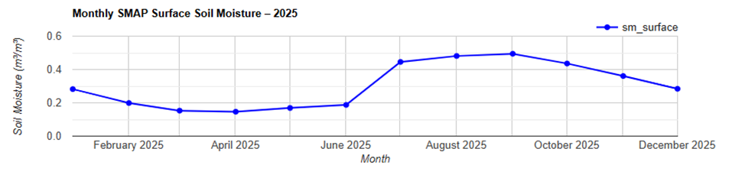Figure 8. Monthly SMAP Surface Soil Moisture Trend in 2025
  - Correlation analysis
Correlation analysis was used to evaluate model performance and quantify the climate effect. Good agreement and temporal consistency were indicated by the high positive correlation between SMAP soil moisture and RF-predicted soil moisture, as shown in Figure 9. Furthermore, there was a noteworthy positive connection between RF-predicted soil moisture and monthly rainfall, confirming the model's sensitivity to hydro-climatic variability. The correlation graph shows that soil moisture increases proportionally with rainfall during monsoon months, whereas deviations during pre-monsoon months are attributed to irrigation practices in agricultural lands. These findings confirm that the RF model successfully captures both rainfall-driven and irrigation-induced soil moisture dynamics within the Sher River Watershed.

Figure 9. Linear correlation between SMAP-derived soil moisture and RF model–predicted soil moisture in the Sher River Watershed.

Validation of the 10 m-resolution Random Forest model against coarse-resolution SMAP satellite data (9 km) yielded a correlation of 0.51. The moderate strength of this relationship reflects the expected loss of fine-scale information when comparing across different spatial scales. The 9 km SMAP pixels average the high-frequency variability at the 10 m level, thereby inherently suppressing the correlation coefficient. Despite this scale-induced attenuation, the R-value of 0.51 confirms a consistent temporal agreement between the model and satellite observations.
  - Long-Term Soil Moisture Trends and Temporal Dynamics (2015–2025)
The RF model–derived annual soil moisture trend markedly reflects these variations in rainfall. In 2015, soil moisture was approximately 0.33, which increased to about 0.42 in 2016, corresponding with higher rainfall levels. A pronounced decline to nearly 0.21 in 2017 mirrors the reduction in precipitation during that year. Soil moisture subsequently increased to roughly 0.41 in 2019, aligning with peak rainfall conditions. In 2021, when rainfall decreased, soil moisture similarly declined to approximately 0.31. From 2022 onward, soil moisture values show a gradual increase, reaching approximately 0.40 in 2022, 0.39 in 2023, peaking around 0.46 in 2024, and remaining comparatively high at 0.45 in 2025. The trend illustrated in Figure 10 confirms the RF model's ability to capture rainfall-driven variability and indicates strong sensitivity to interannual precipitation changes.

Figure 10. Interannual variation of RF model–derived soil moisture in the study area (2015–2025).
The annual soil moisture values from SMAP exhibit similar patterns, although within a narrower range. In 2015, soil moisture was approximately 0.238 m³/m³, increasing to about 0.255 m³/m³ in 2016. A decrease to nearly 0.23 m³/m³ in 2017 suggests drier conditions. The value then rose again to roughly 0.247 m³/m³ in 2019 and remained fairly steady around 0.24 m³/m³ from 2020 to 2022. In 2023, there was a notable increase to about 0.249 m³/m³, peaking in 2024 at around 0.255 m³/m³, before slightly declining to approximately 0.249 m³/m³ in 2025. As shown in Figure 11, although the fluctuation range is smaller than that of the RF model, the overall temporal pattern closely follows rainfall trends.
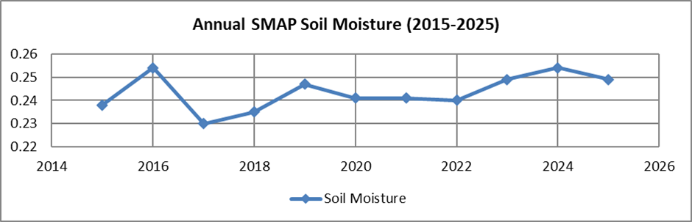Figure 11. Annual variation of SMAP-derived surface soil moisture (m³/m³) from 2015 to 2025.

Figure 12. Annual rainfall variability in the study area from 2015 to 2025.
The analysis of annual precipitation from 2015 to 2025 reveals notable interannual variability that directly impacts soil moisture conditions within the study area. Rainfall in 2015 was approximately 980 mm, which increased markedly to around 1600 mm in 2016, rendering it one of the wettest years of the decade. Conversely, in 2017, rainfall decreased to nearly 1100 mm, indicating comparatively drier conditions. A significant resurgence occurred in 2019, when rainfall reached approximately 1700 mm, representing the highest value recorded during the study period. This was followed by a reduction in 2021 to nearly 1120 mm. Rainfall increased once again in 2022 (approximately 1580–1600 mm) and remained elevated in 2024 (~1600 mm), before decreasing slightly to approximately 1550 mm in 2025. These fluctuations, as depicted in Figure 12, clearly illustrate alternating wet and dry phases across the region decade.
- Summery and conclusion
This investigation into the Sher River Basin over the decade from 2015 to 2025 offers crucial insights into the long-term patterns and spatial distribution of soil moisture, highlighting its essential function in both agricultural planning and hydrological management. Utilizing an advanced, high-precision soil moisture dataset generated through established machine learning methodologies, the analysis successfully pinpointed significant hydrological extremes, identifying 2024 as the period with the highest moisture content and 2017 as the most arid year within the study timeframe. The strong alignment between moisture fluctuations and precipitation records reinforces the understanding that rainfall serves as the principal natural determinant of water availability in this region. Nevertheless, the findings indicate that climatic factors alone do not dictate the region's hydrological behavior. The marked seasonal variations observed, especially the spike in moisture levels throughout the southwest monsoon period (July to September), are a direct consequence of intense seasonal downpours. Furthermore, the research brings to light the substantial role of human activity in shaping the landscape's hydrology. The notably elevated moisture readings recorded during crop establishment phases are clearly linked to anthropogenic intervention, where farmers deliberately inundate fields to create optimal conditions for germination and initial plant development.
In essence, the hydrological state of the Sher River Watershed represents an intricate interplay between natural processes and human intervention. It is fundamentally governed by two interconnected forces: the monsoonal climate, which drives broad annual and seasonal cycles, and agricultural water management, which deliberately alters local moisture conditions to satisfy cultivation requirements. This dual understanding is indispensable for promoting agricultural robustness and ensuring the long-term viability of water resources in the area. Future management approaches must consequently combine reliable weather predictions with site-specific, efficient irrigation methods to reconcile the competing demands of food production and watershed conservation.

References
Belgiu, M., & Drăguţ, L. (2016). Random forest in remote sensing: A review of applications and future directions. ISPRS Journal of Photogrammetry and Remote Sensing, 114, 24–31.
Brady, N. C., & Weil, R. R. (2016). The Nature and Properties of Soils. Pearson Education.
Breiman, L. (2001). Random forests. Machine Learning, 45(1), 5–32.
Chan, S. K., Bindlish, R., O’Neill, P. E., Jackson, T. J., Njoku, E. G., Dunbar, R. S., … Yueh, S. (2018). Development and assessment of the SMAP enhanced passive soil moisture product. Remote Sensing of Environment, 204, 931–941.
CGWB (2013). Ground Water Information Booklet: Narsinghpur District, Madhya Pradesh. Central Ground Water Board, Government of India.
Entekhabi, D., Njoku, E. G., O’Neill, P. E., Kellogg, K. H., Crow, W. T., Edelstein, W. N., … Van Zyl, J. (2010). The Soil Moisture Active Passive (SMAP) mission. Proceedings of the IEEE, 98(5), 704–716.
FAO (2012). Crop yield response to water. Food and Agriculture Organization of the United Nations.
FAO (2015). Status of the World’s Soil Resources. Food and Agriculture Organization of the United Nations.
Funk, C., Peterson, P., Landsfeld, M., et al. (2015). The climate hazards infrared precipitation with stations (CHIRPS) dataset. Scientific Data, 2, 150066.
Gorelick, N., et al. (2017). Google Earth Engine: Planetary-scale geospatial analysis for everyone. Remote Sensing of Environment, 202, 18–27.
Government of Madhya Pradesh (2022). District Statistical Handbook: Narsinghpur.
IMD (2020). Climatological Tables of Observatories in India. India Meteorological Department.
Kendall, M. G. (1975). Rank Correlation Methods. Charles Griffin.
Mall, R. K., Gupta, A., Singh, R., Singh, R. S., & Rathore, L. S. (2006). Water resources and climate change: An Indian perspective. Climatic Change, 78, 445–478.
Mall, R. K., et al. (2006). Impact of climate change on Indian agriculture. Climatic Change, 78, 445–478.
NBSS & LUP (2010). Soils of Madhya Pradesh for Optimizing Land Use. National Bureau of Soil Survey and Land Use Planning.
Ozdogan, M., Rodell, M., Beaudoing, H. K., & Toll, D. L. (2010). Simulating the effects of irrigation over the United States in a land surface model. Journal of Hydrometeorology, 11(1), 171–184.
Wagner, W., et al. (2007). Operational readiness of microwave remote sensing of soil moisture for hydrologic applications. Nordic Hydrology, 38(1).
Western, A. W., et al. (2002). Observed spatial organization of soil moisture and its relation to terrain indices. Water Resources Research, 38(12).

