Synthesis and Characterization of Fe-doped Manganese Oxide Nanoparticle for Photocatalytic Degradation of Indigo Blue Dye

…………………………………………………………………………………………………………………………………………………………………………………………
ABSTRACT
The chemical precipitation approach was effectively used to create Fe-doped Manganese Oxide nanoparticles. XRD, SEM, EDAX, FTIR, and UV were used to characterize the produced nanoparticles. The XRD method was used to examine the sample's average crystallite size. SEM pictures were used to determine the morphology and grain size. EDAX verified the elemental composition. The different functional groups found in the produced sample were validated by the FTIR analyses. The optical band gap was computed from the UV spectra. The average particle size of Fe doped MnO₂ nanoparticles was observed 11.56 nm by XRD analysis. The synthesized nanoparticles were used to photocatalytic drgradation of Indigo blue dye.
Keywords: Chemical precipitation, Manganese Oxide nanoparticles. XRD, SEM, EDAX,
FTIR, and UV, and Photocatalytic activity, Indigo blue dye.
………………………………………………………………………………………………… Introduction
Due to its amazing and intriguing applications in the fields of chemistry, pharmacology, agriculture, textiles, optoelectronics, physics, and more, the use of nanostructured materials has expanded during the past several decades (Indumathi, 2022). When compared to their majority counterparts, nanostructures disclose innovative and greatly better physicochemical characteristics and processes, which can lead to amazing understanding of materials and technology. Because of their special capabilities, nanomaterials will be widely used in a variety of applications and have vastly different qualities beyond what they demonstrate at the macro or micro levels. Nanotechnology is a field of science, engineering, and technology that works with atomic or molecular-scale dimensions and tolerances of less than 100 nm (Kuchekar, 2014). Because of their special size-dependent characteristics, nanoparticles are widely used. Because of its many uses, including immobilization of proteins and enzymes, bio-separation, immunological tests, drug delivery, and biosensors, magnetic nanoparticles have drawn a lot of attention. Because of their small size, nanoparticles have a high surface-to-volume ratio, which makes them particularly unique (AlZubaidi, 2025). Nanoparticles' distinct chemical and physical characteristics make them ideal for creating novel and enhanced sensing devices, particularly biosensors and electrochemical sensors. Biomolecules can be immobilized, electrochemical reactions can be catalyzed, electron transport between electrode surfaces and proteins can be improved, biomolecules can be labeled, and nanoparticles can even act as reactants (Sonawane, 2026). Metal oxide nanoparticles are typically inorganic (Krishnaraj, 2021). Fe, Ni, Co, Mn, and Zn nanoparticles are widely used magnetic materials for a variety of applications, including microwave absorbers, magnetic sensors, recording devices, telecommunications, and magnetic fluids. Manganese dioxide is a significant transition metal oxide of P-type emiconducting materials among other metal oxide nanoparticles. Physical vapor deposition, chemical vapor deposition, aerosol processing, sol-gel, reverse micelle, and mechanical milling have all been used to create nanoparticles. Due to their affordability, wet chemical techniques such hydrothermal sol-gel, emulsion, and the traditional co-precipitation process are employed extensively in commerce. Manganese oxides are recognized to be potent metal ion adsorbents and are found naturally in soils, aquifers, and sediments (Deshpande, 2026). They are significant materials having a wide range of uses in several industries, including microelectronics, rechargeable batteries, ion sieves, chemical sensing devices, magnetic devices, environmental pollution absorbent, catalysis, and hydrogen storage media. (Mahamude, 2022).Nanoparticles can be created using a variety of techniques, including vapor deposition, electrochemical synthesis, combustion, colloid thermal synthesis, microwave irradiation, thermal oxidation, pulsed wire explosion, precipitation, and solgel (Sindhushree, 2022). One of the most significant and well-known methods for creating nanoparticles is the electrochemical method. Manganese oxides are recognized to be potent metal ion adsorbents and are found naturally in soils, aquifers, and sediments (Deshpande, 2025).

2. Materials and Methods
2.1 Chemicals and Reagents
For this experiment, analytical reagent grade manganese chloride, ferric chloride, and NaOH were utilized. The experiment was conducted using double-distilled water as a solvent.
2.2 Synthesis of MnO₂ nanoparticles
A magnetic stirrer was used to dissolve 4 g of manganese chloride in 50 ml of distilled water for 30 minutes. To keep the pH at 8, the 3 g of NaOH pellets that had been dissolved in 20 ml of distilled water were then added to the mixture. The brown precipitate was obtained and filtered via filter paper after five hours of stirring (Subbiah, 2024). For ten minutes, the collected precipitate was heated to 75 W in a microwave oven. After that, it was dried for four hours at 400^{O}C in a muffle furnace. The dry nanoparticles were ground into a powder using a mortar (Otunla, 2019). The prepared powdered is of MnO₂ nanoparticles was used for further process.
2.3 Synthesis of Fe-doped MnO₂ nanoparticles
Dissolved 4 gm of The aforementioned powder in 20 ml of distilled water and add 1 g of ferric chloride diluted in it. Then after five hours of stirring the dark brown precipitate was obtained. Filter the precipitate with filter paper. The precipitate was collected and stored for ten minutes at 75 W in a microwave oven. After that, it was dried for four hours at 400⁰C in a muffle furnace. The dried Fe-doped MnO₂nanoparticles were ground into a powder using a mortar and use the powder for further characterization (Mingru, 2008).
3. Results and Discussion
3.1 XRD Analysis
Figure 1 showed the XRD pattern of the Fe-doped MnO2 nanoparticles. While the peaks corresponding to 2θ = 36.2°, 56.1°, 58.2°, and 62.4° represented the hexagonal shape and the miller indices (101), (110), (220), and (103), respectively, the narrow peaks of the XRD pattern showed the crystalline structure of the nanoparticles. The crystallite size of the Fe-doped MnO2 nanoparticles was found to be 11.56 nm, as indicated in Table 1 (Aleksandra, 2020). The crystallite size of the particles was calculated using the Debye-Scherrer formula, D=k λ ̸ β cos θ.
Where D stands for crystallite size,
λ for X-ray source wavelength (1.5406 Å),
β for whole width at half-maximum of the diffraction peak,
k for Scherrer's constant (0.9 to 1), and
θ for Bragg̕ s angle (Muhammad, 2025).

Table 1. XRD result of Fe-doped MnO₂ nanoparticles
Sample | 2 θ | FWHM | Crystalline Size | Average Size
Fe-doped MnO Nanoparticles | 36.1 | 0.790 | 10.50 | 11.56 nm
Fe-doped MnO Nanoparticles | 56.2 | 0.521 | 16.85 | 11.56 nm
Fe-doped MnO Nanoparticles | 58.1 | 0.780 | 11.50 | 11.56 nm
Fe-doped MnO Nanoparticles | 64.5 | 1.20 | 7.40 | 11.56 nm

Figure 1. Fe-doped MnO₂ nanoparticle XRD pattern.

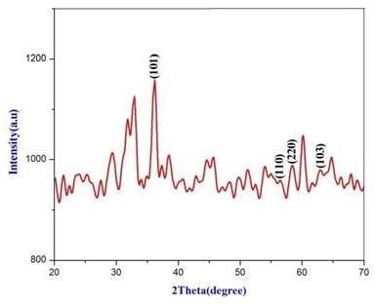

.
3.2 FT-IR Analysis
By generating an infrared absorption spectrum, Fourier Transform Infrared Spectroscopy (FTIR) was utilized to determine the chemical bonds within a molecule. As seen in Figure 2, it was used to examine the functional groups and other contaminants found in the Fe-doped Manganese Oxide nanoparticles. Fe-doped manganese oxide's FT-IR spectra were obtained in the 400-4000 cm-1 region. The different stretching of functional groups is revealed by the absorption spectra in the bond excitation shown in Table 2 (Ballal, 2022).
Table 2. FTIR peaks of Fe-doped MnO₂ nanoparticles.
Band Range (cm⁻¹) | Stretching Frequency | Intensity
1635 | C=O | Strong
2331 | CO₂ | Strong
2359 | NH⁺ | Strong
3260 | O-H | Strong
515 | MnO | Strong

Figure 2. FTIR spectrum of Fe-doped MnO₂ nanoparticles.
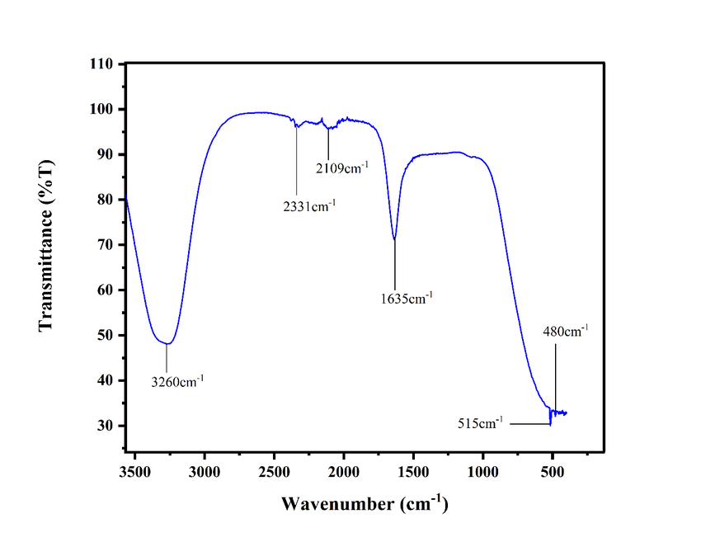
3.3 UV Visible Spectroscopy Analysis
UV absorbance was used to calculate the samples' optical characteristics and band gap energy. Figure 3, displayed the Fe-doped MnO₂ nanoparticles' UV visible spectra. The spectra were captured between 200 and 900 nm (Soaad, 2025) . At 225 nm, the absorbance peak reached its maximum. The Fe-doped MnO₂ nanoparticle has a bandgap energy (Eg) of 1.5 to 5.0 eV. The bandgap energy was determined using the formula Eg = hʋ= hc / λ, (Kumar, 2022). .
Where h = Planck's constant (6.626 × 10-34 m kg/s),
λ = wavelength (nm),
ʋ = frequency, and
c = the speed of light (3 × 108 m/s)

Figure 3. Absorption spectra of Fe-doped MnO₂ nanoparticles.
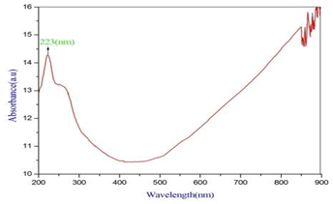

3.4 SEM Analysis
The size and shape of the produced Fe-doped manganese oxide nanoparticles were determined using a scanning electron microscope (SEM), (Sharma, 2022). The particles had shapes that were almost spherical, as shown in Figure 4. They vividly display smaller-sized granules that are dispersed at random. The produced Fedoped manganese oxide nanoparticles were found to be between 10 and 40 nm in size.

Figure 4. SEM images of Fe-doped MnO₂ nanoparticles.

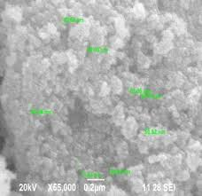

3.5 EDAX Analysis
The elemental composition of the sample is determined via EDAX analysis. Fe-doped MnO nanoparticles were detected by the manganese (Mn), oxide (O), and iron (Fe) peaks in Figure 5, (Kashif, 2023).

Figure 5. EDAX analysis for Fe-doped MnO₂ nanoparticles.
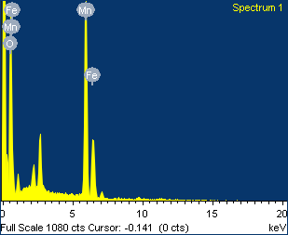

4. PHOTOCATALYTIC DEGRADATION OF INDIGO BLUE (MB) DYE
As shown in Figure 6, we have investigated the photocatalytic degradation of Indigo blue dye using synthesized manganese oxide nanoparticles (MnO₂ NPs) under ultraviolet (UV) light irradiation. A UV lamp served as the radiation source in the experimental setting. When the self-degradation behavior of Indigo blue dye was first evaluated without the synthetic photocatalyst (MnO₂ NPs) (Abdulrahman, 2026). The photocatalytic activity of synthesised MnO NPs was then assessed, showing effective degradation of Indigo dye under UV light irradiation for 120 minutes (Alaa, 2026). It was observed that the observed photocatalytic activity matched the average efficiency within the UV lamp irradiation spectrum. Additionally, Figure 7 shows the proportion of Indigo blue degradation over time. The experiment used a single sample at a concentration of 45 parts per million (ppm) (Chaudhari, 2023). The Figure 7, show a definite direct relationship between time and the percentage of Indigo blue dye degradation. About 93% breakdown after being exposed to produced MnO₂ nanoparticles for a maximum of 120 minutes. This demonstrates how effectively and potentially the produced nanoparticles can break down Indigo blue (Rathia, 2024).

Figure 6. MnO₂ nanoparticles' investigation of Indigo blue breakdown under UV light

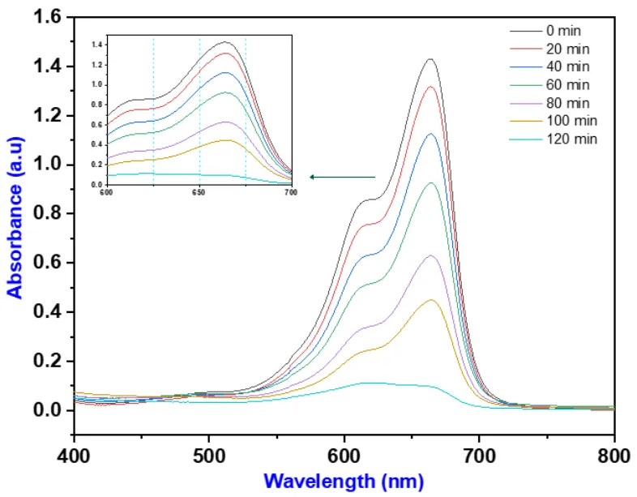

Figure 7. Shows the percentage of Indigo blue dye degradation by produced MnO₂ NPs.

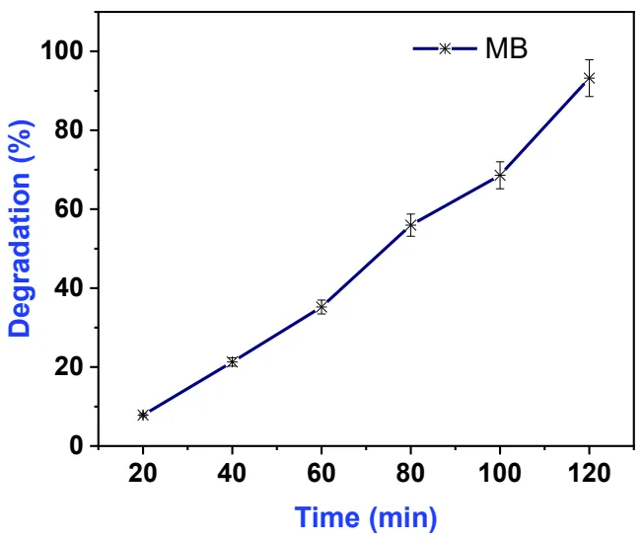

5. CONCLUSION
The chemical precipitation method was used in this study to create the pure and Fe-doped MnO₂ nanoparticles, which were subsequently analyzed by XRD, SEM, EDAX, FTIR, UV. Fe-doped MnO₂ nanoparticles made by chemical precipitation had a hexagonal shape and a crystallite size of 11.56 nm. The SEM pictures revealed a morphological structure that was almost spherical in shape. EDAX verified the existence of elemental composition. The different functional groups found in the produced sample were validated by the FTIR analyses (Sathasivam, 2025). The band gap energy of the Fe-doped MnO nanoparticle was found to be in the range of 5.60 nm in UV analysis. The Synthesized Fe-doped MnO₂ (manganese oxide) nanoparticles usually show a narrower, adjustable optical bandgap, frequently reported in the range of 1.5 eV to 5.0 eV. In order to improve visible light absorption, Fe-doping usually lowers the bandgap of manganese oxide from higher UV ranges (such as 3.0 eV or 5.5 eV) to lower values. (Sani, 2024).

References
Indumathi, T., Krishnamoorthy, N. , Valarmathy, R., Saraswathi, K., Dilwyn, S., Prabhu, S., (2022). Green synthesis of α-fe2o3 nanoparticles mediated musa acuminata: a study of their applications as photocatalytic degradation and antibacterial agent, Nano Biomed. Eng., 14(3), 254-262. DOI: 10.5101/nbe.v14i3.

Kuchekar, S. R., Gaikwad, V. B., and Sonawane, D. V. (2014). Removal of hexavalent chromium from industrial effluents by natural ion exchanger. Indian Journal of Chemical Technology, 21A, 338-344.

AlZubaidi, Asaad., Pandit, Vikram ., Jawale, Vivekanand Gupta, Madhu., and Late, Dattatray., (2025). Ag-Fe2O3 nanohybrids for photocatalytic degradation and antibacterial activity, Frontiers in Catalysis, 1-12. doi: 10.3389/fctls.2025.1655324

Sonawane, Digvijay. V., (2026). Biosynthesis and characterization of copper oxide nano- particle using orange fruit peel extract and evaluation of their effective antibacterial activity. Journal of Advance and Future Research, 3(12), 1-8.

Krishnaraj, S., Anitha, R., (2021). Photocatalytic degradation analysis of methylene blue by aluminium dope d cadmium oxide nanoparticles, Journal of Advanced Scientific Research, 12(1), 75-80. https://doi.org/10.55218/JASR.202112110

Deshpande Milind S., Sonawane, Digvijay V., Deshmukh, Shailesh S., and Athare, Anil E. (2026). Rhodamine b dye photocatalytic degradation using cu-doped zno nanoparticles. CurrentScience, CS6(1), 5846-5852. https://doi.org/10.52845/CS/2026-5-1-15

Sindhushree, H.S., Chaithra, K.M., Venkatesha, B.M., (2022). Electrochemical synthesis and characterization of cdo/cuo nanocomposite: photocatalytic degradation kinetics of indigo carmine dye and its antimicrobial-anticancer activities, Journal of Nanoscience and Technology, 8(4), 967-971. https://doi.org/10.30799/jnst.337.22080401

Deshpande, Milind S., Sonawane, Digvijay V., Deshmukh, Shailesh S., and Athare, Anil E. (2025). Synthesis and characterization of ag doped Fe₂O3 nanoparticles for photocatalytic dye degradation. International Journal of Scientific Research in Science, Engineering and Technology, 12(6), 225-230. doi : https://doi.org/10.32628/IJSRSET2513872

Mahamude, Abu Shadate Faisal., Wan, Sharuzi Wan Harun., Kumaran, Kadirgama., Devarajan, Ramasamy., Kaniz, Farhana., Khalid, Saleh., and Talal, Yusaf. (2022). Experimental study on the efficiency improvement of flat plate solar collectors using hybrid nanofluids graphene/waste cotton Energies, 15, 1-27. https://doi.org/10.3390/en15072309

Subbiah, Muthuraman., Natarajan, Saravanan., Murugan, Sivaraj., and Ayyappan, Kumar, (2024). Implementation of a solar-thermal hybrid air conditioning system in muscat for energy conservation. Thermal Science and Engineering, 7(4), 1-11. 10996. https://doi.org/10.24294/tse10996

Otunla, T. A,. (2019). Estimates of clear-sky solar irradiances over Nigeria. Renewable Energy, 131, 778-787. https://doi.org/10.1016/jrenene.2018.07.053

Mingru, Zhou., Zhiqiang, Wei., Hongxia, Qiao., Lin, Zhu., Hua. Yang., and Tiandong, Xia., (2008).
Particle size and pore structure characterization of silvernanoparticles prepared by conﬁned arc plasma. Journal of Nanomaterials, 2009, 1-5. doi:10.1155/2009/968058

Aleksandra, Zieli ´nska., Filipa, Carreiró., Ana, M. Oliveira., Andreia, Neves., Bárbara, Pires., Nagasamy, D. Venkatesh., Alessandra, Durazzo., Massimo, Lucarini., Piotr, Eder., Amélia, M. Silva., Antonello, Santini., and Eliana, B. Souto., (2020). Polymeric nanoparticles: production, characterization, toxicology and ecotoxicology. Molecules, 25, 2-20. 3731; doi:10.3390/molecules25163731

Muhammad, Sharf U. Din Awan., Muhammad, Tuoqeer Anwar., Hasan, Izhar Khan.,
Muhammad, Rehman Asghar., Muhammad, Rafi Raza., Naveed, Husnain., Muzamil, Hussain., Tahir, Rasheed., (2025). Nanoparticles’ classification, synthesis, characterization and applications-
A review. Characterization and Application of Nanomaterials. 8(1), 1-23. https://doi.org/10.24294/can8899

Ballal J. Sushma,, Yashwanth, C., Chethana, B. R., Dr. Anuroopa., (2022). Nanoparticles, their synthesis, effects and their applications in nanotechnology International. Journal for Research in Applied Science & Engineering Technology (IJRASET), 10(X), 278-283. Available at www.ijraset.com

Soaad, Mohamed Elashry., Fatma, S. Hassen., A. I. L. Abd, El Fatah., (2025). Sequential separation of u(vi) and th(iv) by a cyanex-921- based amberlite xad-4 chelating resin, NANOPARTICLE, 6(1), 1-18. DOI: https://doi.org/10.35702/nano.10020

Kumar, Anil., (2022). Role of nanoparticles in dye degradation, International Journal of Trend in Scientific Research and Development (IJTSRD), 6(4), 737-742. @ www.ijtsrd.com eISSN: 2456-6470

Sharma, Sandeep., Kumar Yadav, Deepak., Chawla, Kanhaiya., Lal, Nathu., Alvi, P. A., and Lal, Chhagan., (2022). Degradation of dyes using biologically synthesized iron oxide nanoparticles by manilkara zapota leaves extract, Rasayan J. Chem, 15(3), 2165-2170. http://doi.org/10.31788/RJC.2022.1536988

Kashif, Ali Khan., Afzal, Shah., Jan, Nisar., Abdul, Haleem., and Iltaf, Shah., (2023). Photocatalytic degradation of food and juices dyes via photocatalytic nanomaterials synthesized through green synthetic route: a systematic review, Molecules, 28, 4600, 2-18. https://doi.org/10.3390/molecules28124600

Abdulrahman, Amal., Algarni, Zaina., Ghazouani, Nejib., Saad, S. H. Sammen., Abdelfattah., Amari., and Miklas, Scholz., (2026). Innovative fabrication of highly efficient cu2znsns4-tio2/tio2 nanotube array heterostructure for efficient organic degradation in basic dye wastewater: experimental and rsm approaches, Water, 18, 632, 1-23. https://doi.org/10.3390/w18050632

Alaa, Y. Mahmoud., and Walaa, Al-masri., (2026). Rhodamine B Dye–Coupled Hydrophobic Carbon Quantum Dots with Dual-Emission for White-Light Optoelectronic Applications, Preprints.org (www.preprints.org),2-14. doi: 10.20944/preprints202603.0548.v1

Chaudhari, Ronak Kumar Shah, A. Priyanka., Shrivastav, S. Pranav S., (2023). Green synthesis of silver nanoparticles using Adhatoda vasica leaf extract and its application in photocatalytic degradation of dyes, Discover Nano , 18(135), 1-15. https://doi.org/10.1186/s11671-023-03914-5

Rathia, B. Senthil., Ewe , Lay Sheng., Sanjay, S., Sujatha, S., Weng, Kean Yew. , Baskaran, R., and Sieh, Kiong Tionga., (2024). Recent trends and advancement in metal oxide nanoparticles for the degradation of dyes: synthesis, mechanism, types and its application, Nanotoxicology, 1-29. https://doi.org/10.1080/17435390.2024.2349304

Sathasivam, Kavica., pattulingam, Rajesh., Manickavasagam, Baskaran., Nagarajan, Vignesh., Parethe, Gurusamy Thangam., (2025). Photocatalytic degradation of methylene blue dye using MnO2 nanoparticles by Ziziphus Oenopolia(L.) Mill Leaf extract, J. Water Environ. Nanotechnol., 10(3), 310-319. http://creativecommons.org/licenses/by/4.0/.

Sani, Kundu., Toton, Sarkar., Ahmad, Aziz Al-Ahmadi., Enas, Alic., and Ashis, Bhattacharjee., (2024). Thermally synthesized hematite (a-Fe2O3) nanoparticles as efficient photocatalyst for visible light dye degradation, RSC Adv., 14, 28944–28955. DOI: 10.1039/d4ra04316b

.

