Solar PV Performance and Shading Analysis in a Roof top Agro-Voltaic System

Abstract
The integration of solar photovoltaic (PV) systems with agricultural activities, known as roof top agro-voltaic system (RTAVS), offers a promising approach to simultaneously meet energy and food production demands in urban and peri-urban areas. This study evaluates the energy performance and shading effect of a 76.8 kWp roof top PV system installed at the CAET, DBSKKV, Dapoli, MH, India. The system comprises 240 mono-crystalline modules arranged in 12 strings and was monitored over two experimental periods (October 2022–May 2023 and October 2023–May 2024), covering winter and summer seasons. Energy performance was analyzed and shadow trajectory analysis was conducted using a 3D SketchUp model to simulate seasonal and daily shading patterns, quantifying shadow coverage over the cultivable area. Results demonstrated a strong correlation between solar irradiance and energy generation (R² = 0.984), with an estimated annual energy yield of 81,896 kWh. Seasonal shadow coverage ranged from 42.9% in winter to 18.9% in summer, with an overall mean of 30.9%. Moderate shading under RTAVS provided favorable conditions for shade-tolerant crops without compromising PV performance, confirming the technical feasibility of dual land use in urban renewable energy applications.
Keywords: Roof top agro-voltaic system, Solar photovoltaic, PV performance, Energy yield, Dual land use, Shading analysis, Urban renewable energy
1. Introduction
The increasing global demand for energy, coupled with climate change and depletion of fossil fuel reserves, has intensified the transition toward renewable energy technologies. According to the International Energy Agency (IEA, 2021), global energy consumption is projected to increase by nearly 50% by 2050, necessitating large-scale deployment of sustainable energy systems. Among renewable sources, solar photovoltaic (PV) technology has emerged as a leading solution due to its scalability, declining cost trends and environmental benefits. The levelized cost of electricity (LCOE) from solar PV has decreased by more than 80% since 2010, significantly improving its economic viability (IRENA, 2021).
Urban areas account for nearly 75% of global energy demand and offer substantial potential for decentralized renewable energy generation through roof top solar installations (Patel et al., 2022). Roof top PV systems reduce transmission losses, enhance distributed power generation and contribute to urban energy resilience. In India, government initiatives such as the Grid-Connected Roof top Solar Programme have accelerated adoption, targeting 40 GW of roof top capacity under MNRE schemes (MNRE, 2022; PIB, 2019). Recent policy analyses suggest that distributed roof top systems could contribute significantly to India’s future solar capacity expansion (NITI Aayog, 2023; CEEW, 2023).
Parallel to the rapid growth of roof top solar, agro-voltaic systems have emerged as an innovative dual-use strategy integrating agricultural production with solar PV installations. The concept, first formalized by (Dupraz et al. 2011), demonstrates that crops can benefit from moderated microclimatic conditions under partial shading, while PV modules may experience improved efficiency due to cooling effects associated with vegetation. Subsequent studies have reported enhanced land-use efficiency and improved system productivity in ground-mounted agro-voltaic configurations (Dinesh and Pearce, 2016; Barron et al., 2019).
However, most agro-voltaic research has focused on ground-based systems, whereas roof top agro-voltaic applications remain relatively underexplored. Roof top systems differ significantly from open-field installations due to structural constraints, limited mounting height, fixed tilt angles and restricted spacing between panels. These factors directly influence both electrical performance and the spatial-temporal distribution of shadows cast beneath the modules.
Shadow trajectory and distribution are governed by solar geometry, including solar altitude and azimuth angles, which vary throughout the day and across seasons. The dynamic movement of panel shadows affects light availability beneath the PV array and plays a critical role in determining system suitability for integrated applications (Marrou et al., 2013; Schindele et al., 2020). While controlled shading can reduce heat stress and evaporation, excessive or poorly distributed shading may adversely affect underlying utilization of roof top space. Therefore, understanding shadow behaviour is essential for optimizing system configuration in roof top agro-voltaic environments.
Performance evaluation of roof top PV systems typically includes parameters such as energy yield, specific yield and performance ratio. Although numerous studies have evaluated PV efficiency in conventional roof top installations, limited research has simultaneously assessed electrical performance and shadow distribution characteristics within roof top agro-voltaic systems. This gap is particularly significant in tropical and subtropical regions, where high solar intensity and seasonal variation strongly influence both PV output and shading dynamics.
In this context, the present study aims to evaluate the electrical performance of a roof top solar PV system and analyzed its shading analysis characteristics under agro-voltaic conditions. The findings are expected to provide technical insights for optimizing roof top agro-voltaic system design and development, ensuring sustained energy generation while enabling efficient dual-use utilization of roof top space.

2. Literature Review
2.1 Solar Photovoltaic Performance in Roof top Agro-Voltaic Systems
Berwal et al. (2017) analyzed a 50 kW roof top grid-tied solar PV system using 280 Wp polycrystalline modules and 17 kW string inverters (98.2% efficiency). The system generated over 5200 kWh per month and offset 4070 kg of CO₂ emissions. Techno-economic results showed a payback of 5.7 years with subsidy and 10.3 years without, with IRRs of 16.97% and 8.22%. The study proposed a general framework for roof top SPV deployment and emphasized the role of subsidies in enhancing financial viability.
Vasudev et al. (2018) analyzed a 48 kWp grid-connected roof top PV system with 158 polycrystalline modules (305 Wp) and seasonal tilt adjustments of 10° (summer) and 45° (winter). Over one year, the actual energy yield was 59.58 MWh compared to a simulated 69.18 MWh, with a measured PR of 80% and CUF of 13.9% (simulated 16.14%). Efficiency decreased by 36.4% as temperature increased from 13°C to 32°C, highlighting temperature effects and simulation overestimation. The system avoided 138 tons of CO₂ emissions, emphasizing the importance of real-time monitoring for reliable roof top PV performance.
Ramya et al. (2020) conducted a five-year field performance study (2014–2018) of a 100 kWp grid-connected roof top PV plant at B.V. Raju Institute of Technology, Telangana. The system generated an average of 146,616 kWh/year, with a performance ratio of 76.22% and CUF of 16.74%. A gradual performance decline was observed due to module degradation, inverter losses, shading and maintenance issues. The study emphasized regular diagnostics and inverter-level monitoring to sustain long-term SPV efficiency.
Ates and Singh (2021) assessed the one-year performance of a 30 kWp roof top PV system with 116 polycrystalline modules (260 Wp), tilted at 12° and azimuth −20°, using a Huawei SUN2000-33KTL inverter. The system produced 45,592 kWh under 1,818 kWh/m² annual irradiation, achieving a specific yield of 1,519.7 kWh/kWp/year, PR of 83.61% and capacity factor of 17.35%. The simulation model showed strong agreement with measured data (R² = 0.985), with average system and capture losses of 0.09 h/day and 0.72 h/day, respectively. High irradiation and lower ambient temperatures were identified as key factors for improved efficiency and investor confidence.
Saxena et al. (2021) performed a 3E (Energy, Economic, Environmental) analysis of 100 kWp grid-tied roof top PV systems across seven Indian cities using PVsyst. The systems produced about 170 MWh annually, with 400–500 kWh/day generation, PR of 70–80% and CUF of 19–21%. Annual CO₂ reduction was 150–170 tons, with a payback of 5–6 years and energy cost of INR 6–7 per unit. The study confirmed techno-economic feasibility across diverse climates and proposed a general framework for roof top SPV design and evaluation.
Abdullah et al. (2022) compared monocrystalline, polycrystalline and HIT technologies for a 3.12 kW residential roof top PV system. Polycrystalline modules produced the highest annual energy (4046.9 kWh), while HIT modules achieved the best overall performance with an 81% PR, lowest temperature losses (7.76%) and highest normalized output (3.35 kWh/kWp/day). The study concluded that HIT modules are more suitable for roof top applications due to higher efficiency and lower losses under identical conditions.
Patel et al. (2023) analyzed a roof top solar plant comprising 417 panels and 8 inverters using data from January 2016 to December 2020. The study evaluated array yield, reference yield, final yield, performance ratio, module and inverter efficiency and capacity factor. A peak solar radiation of 192.7 W/m² and an average temperature of 31.6°C (May) were recorded, significantly influencing energy output. The authors highlighted inverter efficiency and performance ratio as key reliability indicators and emphasized the need for long-term monitoring and maintenance.
Rathor and Agrawal (2025) examined roof top PV systems in educational institutions, highlighting the influence of irradiance, module type, tilt, azimuth and temperature on performance. Key indicators such as array yield, final yield and performance ratio were used for evaluation, with PVsyst applied for design optimization. A typical 5 kWp system generates 4–6 kWh/kWp per day, producing about 6500–7500 kWh annually under suitable site conditions.
Pandey et al. (2025) reviewed 226 agro-voltaic studies to assess PV performance and crop productivity across climates. AVS maintained electricity output comparable to conventional systems while enabling dual land use, with bifacial modules yielding 6–13% more energy. Panel shading reduced temperatures by 1.5–6°C, improving module efficiency and water-use efficiency. The study highlighted optimal panel height, spacing and orientation as key to balancing energy and crop yield.
2.2 Shadow Trajectory Analysis in Roof top Agro-Voltaic Systems
Marrou et al. (2013) reported that seasonal shadow length variation in agro-voltaic systems can differ by 30–50% between winter and summer due to changes in solar elevation. The study emphasized that dynamic shadow movement throughout the day influences radiation distribution beneath PV panels and affects overall system performance.
Duffie and Beckman (2013) explained that solar geometry parameters, particularly solar altitude and azimuth angles, govern the formation, direction and seasonal movement of shadows in photovoltaic installations. Shadow length is inversely proportional to the solar altitude angle; thus, during winter months, lower solar altitude results in longer shadows, whereas higher solar altitude during summer produces shorter shadows.
DOE Market (2022) analyzed roof top agro-voltaic, highlighting economic feasibility, technical challenges and the importance of shadow trajectory analysis in optimizing land and energy use. The study emphasized strategic panel placement and dynamic tracking to balance shading and productivity in urban settings. It recommended government incentives to support agro-voltaics for energy transition and food security.
Vorast (2022) reviewed key challenges in agro-voltaic systems, particularly the impact of shading on crop productivity and energy output. The study reported that excessive shading can reduce crop yield by 30–50%, especially for sun-intensive crops. It proposed solutions such as dynamic panel adjustment, reflective ground materials and AI-based shadow prediction models, along with optimized panel elevation, spacing and tilt. The findings stressed the need for adaptive shading strategies in agro-voltaic policies to ensure balanced energy production and agricultural viability.
Chalgynbayeva et al. (2023) reviewed agro-voltaic systems in urban settings, highlighting the impact of shadow trajectories on crop growth. The study found that using shade-tolerant crops and strategically spaced PV panels can reduce shading by 20–35%, improving light for crops while maintaining high energy output. Dynamic tracking of PV panels further increased system efficiency by 5–10% compared to fixed panels. The research emphasized integrating intelligent control mechanisms to optimize agro-voltaic performance.
Loktionov et al. (2023) studied the effects of shade coverage in agro-voltaic systems, showing that 25–40% shading slightly reduced yields of sun-intensive crops but benefited shade-tolerant crops like lettuce, spinach and kale. Optimal shading improved water retention by up to 15%, reducing irrigation needs and enhancing soil moisture. The study also highlighted bifacial panels, which captured reflected sunlight to increase energy output by 8–12% while moderating microclimatic conditions.
Wydra et al. (2024) studied PV configurations in agro-voltaic systems, finding that 40–50% shading optimally balances energy generation and crop productivity. Bifacial panels increased energy efficiency by up to 12% through reflected sunlight capture, while seasonal variations necessitated adaptive panel tilting to maintain uniform light. The study emphasized that real-time tracking technologies can enhance both economic and ecological performance of agro-voltaic installations.
Yu et al. (2024) proposed a systematic shading analysis method for PV systems, using SketchUp for precise 3D modeling and shadow analysis and PVsyst for simulating system performance. The approach helps identify and mitigate shading issues that are hard to detect with traditional methods, optimizes module layout and enhances overall energy efficiency. This method provides a practical strategy to improve the accuracy and effectiveness of PV system design.
Singla et al. (2025) investigated shadow mitigation in agro-voltaic systems using semi-transparent PV panels, reducing shading by up to 25% while maintaining energy output. Dynamic mounting with solar tracking further cut excessive shading by 15–20%, enhancing both energy yield and crop productivity. The study also proposed AI-driven controls for optimized panel orientation, concluding that semi-transparent panels combined with tracking systems improve land-use efficiency and minimize shading losses.
Although studies provide quantitative evidence on agro-voltaic productivity, shading effects and roof top PV performance, limited research integrates electrical performance evaluation with detailed seasonal shadow trajectory analysis specifically in roof top agro-voltaic systems. Particularly in tropical climatic regions, comprehensive studies quantifying both performance ratio and dynamic shadow distribution remain scarce.
Material & Methods
3.1 Study Area and System Description
The present investigation was conducted at the roof top of the College of Agricultural Engineering and Technology (CAET), Dr. Balasaheb Sawant Konkan Krishi Vidyapeeth (DBSKKV), Dapoli, Maharashtra, India (17°45′ N latitude, 73°26′ E longitude; altitude 256 m above mean sea level). The region falls under a humid tropical climate characterized by high humidity, significant monsoonal rainfall and an average solar irradiance of approximately 5.2 kWh m⁻² day⁻¹.
A 76.8 kWp grid-connected roof top solar photovoltaic (PV) system was installed at the experimental site, as shown in Fig. 1. The plant consisted of 240 mono-crystalline modules (320 Wp each), arranged in 12 parallel strings with 20 modules per string. The system was equipped with two string inverters (50 kW and 30 kW capacity). The modules were mounted at a tilt angle of approximately 14.3° (equal to site latitude) and oriented south-facing to maximize solar energy capture.
3.2 Performance Assessment of Roof top Solar PV System
The performance evaluation of the 76.8 kWp roof top solar PV system was carried out over two experimental periods: October 2022–May 2023 and October 2023–May 2024. Each experimental year was categorized into winter (October–January) and summer (February–May) seasons to assess seasonal variations in system performance. The technical specification of roof top solar PV power plant is described in Table no. 1.
Electrical parameters including energy output (kWh), DC and AC power output, voltage and current were recorded. Simultaneously, climatological parameters such as solar irradiance (W m⁻²), ambient temperature (°C), relative humidity (%) and sunshine hours (h) were monitored. Data were collected daily at regular intervals to ensure accurate assessment of solar generation and corresponding environmental variations. The methodology followed the performance evaluation procedures recommended by the International Energy Agency (IEA) 2021.
Table no. 1 Technical specification of roof top solar PV module
 | Project location | College of Agricultural Engineering and Technology, Dr. BSKKV, Dapoli, MH.
 | Name of company | M/s Cleanmax Enviro Energy solution Pvt. Ltd., 1511, Mumbai
 | District name | Ratnagiri
 | State | Maharashtra
 | Plant capacity | 76.8 kWp
 | Location of place of on earth | Latitude: 17°45' N  Longitude: 73°26' E
 | Technical specification of PV module
 | - Type of cell | Mono crystalline
 | - Capacity of PV Modules | 320W
 | - Open-circuit voltage (Voc) | 46.00V
 | - Short circuit current (Isc) | 9.03A
 | - Rated voltage (Vmpp) | 37.70V
 | - Rated current (Impp) | 8.50A
 | - Fill factor | 77.04%
 | - Efficiency | 16.9%
 | - Maximum system voltage | 1000V
 | - Dimension | 1956x992x36 mm
 | Number of strings | 12
 | Number of modules in each string | 20
 | Total number of modules | 240
 | Inverter, 02 nos | String inverter of (50kW and 30kW)
 | Control panels | LT (Low Tension) Panel
 | Cables | PVC copper cables
 | Lightning | Lightening protection unit
 | Cleaning unit | Manual cleaning

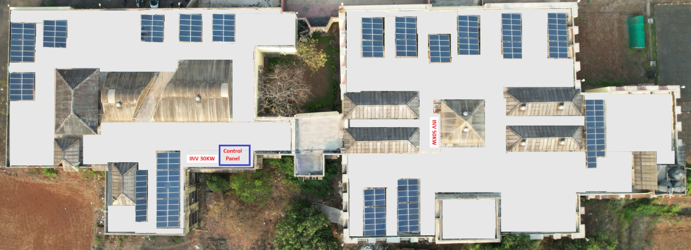
Fig 1: Arial view of roof top solar PV power plant
3.3 Shadow Distribution and Trajectory Assessment
Shadow trajectory analysis was conducted to evaluate spatial and temporal shading patterns between PV panel rows for roof top agro-voltaic integration. A 3D model of the roof top PV structure was developed using SketchUp to simulate solar path and shadow projections. Shadow simulations were conducted on the 15th day of each month during the period October 2022 to September 2023 at three representative day time intervals (9:00 h, 12:00h and 04:00h) to capture daily and seasonal variations in shading patterns. The layout and measurement of the shadow trajectory are presented in Fig. 2 and Fig. 3, respectively. The shadowed and sunlit areas were quantified using the measurement tools available in SketchUp and the shadow coverage percentage was calculated to assess the extent of shading over the cultivable area (Yu et al. 2024).
Shadow Coverage (%) = (Shadowed Area / Total Cultivable Area) × 100
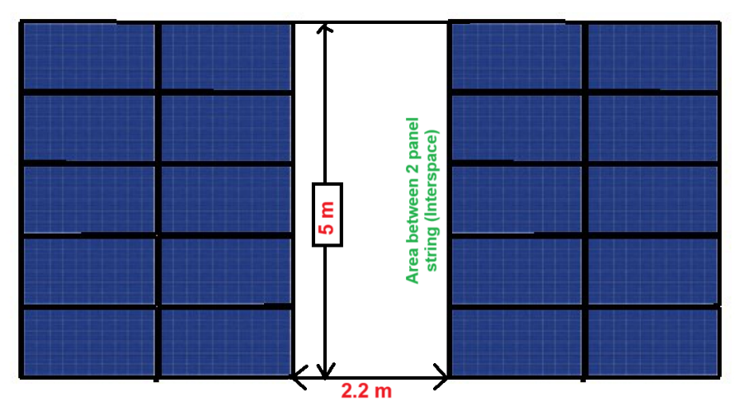
Fig. 2 Layout of shadow trajectory measurement
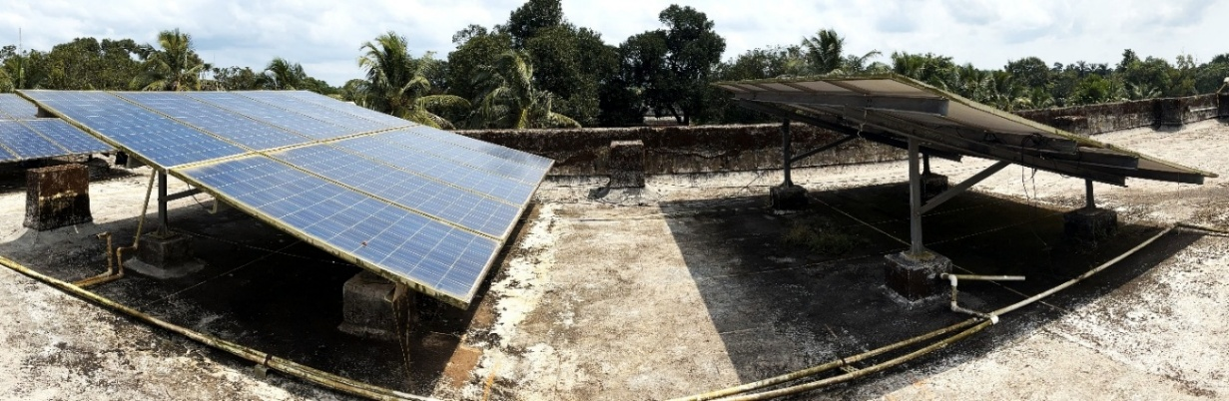
Fig 3. Measurement of shadow trajectory roof top solar PV power plant.
Results:
4.1 Performance Assessment of the Roof top Solar PV System
The 76.8 kWp roof top PV system was evaluated over two operational cycles (October 2022–May 2023 and October 2023–May 2024), excluding the monsoon season. The variation in ambient temperature, relative humidity, solar intensity and corresponding energy generation is presented in Fig. 4 and Fig. 5 During the study period, temperature ranged from 26.8–34.1°C and solar intensity from 336.1–518.2 W m⁻², with mean values of 29.9°C and 426.0 W m⁻², respectively. Monthly energy generation varied between 9,100 and 11,729 kWh, with maximum output observed in May and minimum in October. The average monthly generation was 10,237 kWh, corresponding to an estimated annual yield of 81,896 kWh. Summer energy production was approximately 19% higher than winter due to increased irradiance. Statistical analysis further confirmed a strong dependence of energy output on solar intensity (F = 370.96, p < 0.0001; R² = 0.9841), indicating stable and efficient system performance (Castellano, 2014; Yano et al., 2014; Bhuva, 2021).

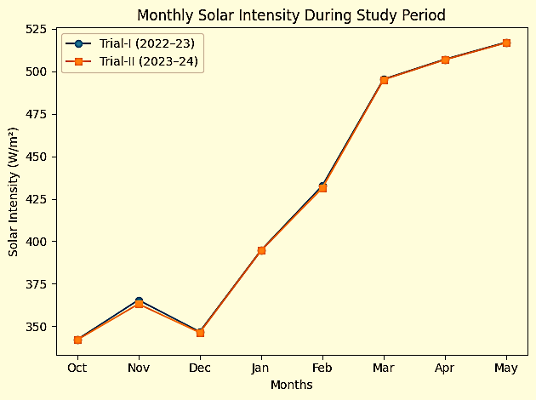
Fig. 4 Monthly Solar Intensity (Trial-I & Trial-II)
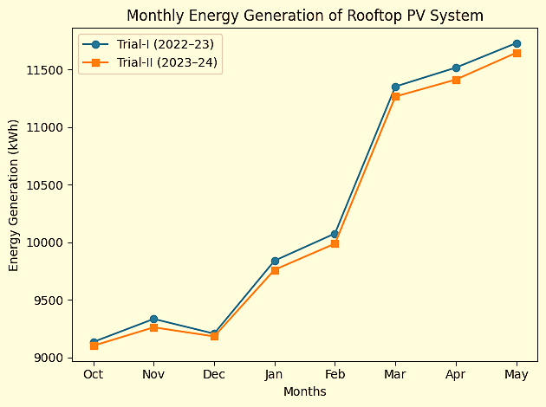
Fig. 5 Monthly Energy Generation (Trial-I & Trial-II)
4.2 Shadow Distribution Analysis in the Roof top Agro-Voltaic System
Shadow trajectory analysis presented in Fig. 6 showed clear seasonal variation in interspace shading. Winter months recorded higher shadow coverage (daily mean 42.9%; maximum 75.6%), whereas summer exhibited reduced shading (daily mean 18.9%) due to higher solar altitude. The overall cropping-period mean shadow coverage was 30.9% and photovoltaic performance remained unaffected (R² > 0.98), confirming effective agro-voltaic integration (Dupraz et al., 2011; Marrou et al., 2013).

Fig. 6: Shadow coverage (%) of roof top agro-voltaic system (RTAVS)
5. Conclusion
The roof top agro-voltaic system demonstrated stable PV performance with strong irradiance–generation correlation (R² = 0.9841) and consistent annual energy yield (81,896 kWh). Moderate average shading (30.9%), higher in winter and lower in summer, provided suitable conditions for shade-tolerant and partial-shade crops without compromising energy production. These findings confirm the technical feasibility of roof top agro-voltaic systems for simultaneous electricity generation and crop cultivation.

6. References
- Abdullah A. Z., Amlus M. H., Azizan N., Sali I. M. and Rahim M. H. (2022). Performance analysis of different type PV module for 3kW residential roof top PV system using PVSyst simulation tool. Journal of Physics: Conference Series, Vol 2312, 012042. https://doi.org/10.1088/1742-6596/2312/1/012042
- Ates A. M. and Singh H. (2021). Roof top solar Photovoltaic (PV) plant - One year measured performance and simulations. Journal of King Saud University - Science, Vol 33, 101361. https://doi.org/10.1016/j.jksus.2021.101
- Barron G. A., Minor R. L., Allen N. A., Cronin A. D., Brooks A. E. and Pavao Zuckerman M. A. (2019). The photovoltaic and biophysical performance of co-located agricultural and solar photovoltaic system. Nature Sustainability, 2(9), 848–855. https://doi.org/10.1038/s41893-019-0364-5
- Berwal A. K., Kumar S., Kumari N., Kumar V. and Haleem A. (2017). Design and analysis of roof top grid tied 50 kW capacity solar photovoltaic (SPV) power plant. Renewable and Sustainable Energy Reviews, Pages 1-12. https://doi.org/10.1016/j.rser.2017.03.017
- Bhuva D. M. (2021). Techno-economic performance of the agro-voltaic system for cultivation of cucumber, Unpublished B. Tech. Thesis, Department of Renewable Energy Engineering, College of Agricultural Engineering and Technology, Junagadh Agricultural University, Junagadh.
- Castellano S. (2014). Photovoltaic greenhouses: evaluation of shading effect and its influence on agricultural performances, Journal of Agricultural Engineering, XLV (433), 168–175.
- CEEW. (2023). Mapping India’s Residential Roof top Solar Potential. Council on Energy, Environment and Water. https://www.ceew.in/
- Chalgynbayeva A., Gabnai Z., Lengyel P. and Pestisha A. (2023). Worldwide research trends in agro-voltaic system a bibliometric review. Energies, Vol 16(2), 611. https://doi.org/10.3390/en16020611
- Dinesh H. and Pearce J. M. (2016). The potential of agrivoltaic system to increase the land-use efficiency of solar photovoltaic installations. Renewable and Sustainable Energy Reviews, 54, 299–308. https://doi.org/10.1016/j.rser.2015.10.024
- DOE Market. (2022). Agro-voltaics. U.S. Department of Energy Report. https://sc-drcds.osti.gov/-/media/sbir/pdf/Market-Research/SETO---Agro-voltaics-August-2022-Public.pdf
- Duffie J. A. and Beckman W. A. (2020) Solar Engineering of Thermal Processes, Photovoltaics and Wind, Wiley online library, pp. 3–42, doi: 10.1002/9781119540328
- Dupraz C., Marrou H., Talbot G., Dufour L., Nogier A. and Ferard Y. (2011). Combining solar photovoltaic panels and food crops for optimising land use: towards new agrivoltaic schemes, Renewable Energy, 36 (10), 2725–2732.
- International Energy Agency (IEA). (2021). Global Energy Review: Renewables in 2021. International Energy Agency. Retrieved from https://www.iea.org/reports/global-energy-review-2021
- International Renewable Energy Agency (IRENA). (2021). Renewable Power Generation Costs in 2020. International Renewable Energy Agency. Retrieved from https://www.irena.org/publications/2021/06/Renewable-Power-Costs-in-2020
- Loktionov E. Y., Klokov A. V., Loktionov Y. V. and Panchenko V. A. (2023). A mini-review of current activities and future trends in agro-voltaics. Energies, 16(7), 3009.
- Marrou H., Dufour L. and Wery J. (2013). How does a shelter of solar panels influence water flows in a soil–crop system? European Journal of Agronomy, 50, 38–51. https://doi.org/10.1016/j.eja.2013.05.004
- Marrou H., Dufour L. and Wery J. (2013). Microclimate under agrivoltaic systems: is crop growth rate affected in the partial shade of solar panels? Agricultural and Forest Meteorology, 177, 117–132.
- Ministry of New and Renewable Energy (MNRE-2022). Annual Report 2021–22. Government of India, New Delhi. Available at: https://mnre.gov.in/annual-report
- NITI Aayog. (2023). Harnessing Solar Potential in India: Roof top and Beyond. Government of India. https://www.niti.gov.in/
- Pandey G., Lyden S., Franklin E., Millar B. and Harrison M. T. (2025) A systematic review of agrivoltaics: productivity, profitability and environmental co-benefits, Sustainable Production and Consumption, 56, 13–36.
- Patel A. T., Dhimmar N. J. and Patel G. C. (2023). Performance analysis of a roof top solar power integration: A case study of an educational campus. Journal of Electrical Systems and Research, Vol 20(2), 3378-3387.
- Patel S., Desai N. and Shah R. (2022). Urban roof top solar PV system: A case study in optimizing urban energy use. Journal of Renewable Energy, 15(2), 112–126.
- PIB (2019). Cabinet approves Phase-II of Grid-Connected Roof top Solar Programme. Press Information Bureau, Government of India. https://pib.gov.in/PressReleasePage.aspx?PRID=1565893
- Ramya S., Reddy R. and Ramachander N. (2020). Long term field performance analysis of 100KWp grid-connected roof top solar PV power plant. Journal of Critical Reviews, Vol 7 (15), 2498-2510. https://www.jcreview.com/?mno=118701
- Rathor S. and Agrawal A. (2025) Performance evaluation of solar roof top plant of 5 kWp: A case study, J. Thermal Energy Syst., vol. 10 (1). Available: https://matjournals.net/engineering/index.php/JoTES/article/view/1413
- Saxena A. K., Saxena S. and Sudhakar K. (2021). Energy, economic and environmental performance assessment of a grid-tied roof top system in different cities of India based on 3E analysis. Clean Energy, Vol 5(2), 288-301. https://doi.org/10.1093/ce/zkab008
- Schindele S., Obergfell T. and Schlaak M. (2020). Agrivoltaics: Synergies and trade-offs between land, food and clean energy. Renewable and Sustainable Energy Reviews, 116, 109363. https://doi.org/10.1016/j.rser.2019.109363
- Singla M. K., Gupta J. and Gupta A. (2025). Empowering rural farming: Agro-voltaic applications for sustainable agriculture. Energy Science & Engineering. https://scijournals.onlinelibrary.wiley.com/doi/pdfdirect/10.1002/ese3.2017
- Vasudev K. P., Mathew M., Anand A. and Hossain J. (2018). Performance analysis of a 48 kWp grid connected roof top photovoltaic system. 4th International Conference for Convergence in Technology (I2CT), Pages 1-6. https://ieeexplore.ieee.org/document/8821954
- Vorast M. (2022). Challenges for agro-voltaics in the international context. M.Sc. Thesis, University of Graz Publication. https://unipub.uni-graz.at/obvugrhs/content/titleinfo/7648450/full.pdf
- Wydra K., Vollmer V. and Busch C. (2024). Agro-voltaic: Solar radiation for clean energy and sustainable agriculture. Springer. https://books.google.com/books?hl=en&id=UWQ0EQAAQBAJ
- Yano A., Onoe M. and Nakata J. (2014). Prototype semi-transparent photovoltaic modules for greenhouse roof applications, Biosystems Engineering, 122, 62–73. http://dx.doi.org/10.1016/j.biosystemseng.2014.04.003
- Yu Z., Wang C., Kong X., Yu L., Shao Y. and Jin H. (2024) Optimal layout design for photovoltaic shadow occlusion based on Sketchup and PVsyst, 2024 IEEE 25th China Conference on System Simulation Technology and its Application (CCSSTA), Tianjin, China, pp. 777–781.

