Seed Germination and Early Seedling Growth Enhancement in Hildegardia populifolia (DC.) Schott & Endl., a Threatened Medicinal Tree Species

Abstract
Aims: To evaluate seed germination and early seedling growth enhancement in Hildegardia populifolia (DC.) Schott & Endl., a threatened medicinal tree species, and to identify suitable techniques for large-scale propagation and conservation.
Study Design: Completely Randomized Design (CRD) with eight treatments and three replications.
Place and Duration of Study: Nursery Unit, Department of Forest Biology and Tree Improvement, Forest College and Research Institute, Mulugu, Telangana, India, between 2022 and 2025.
Methodology: Fresh mature seeds were collected from natural populations of Chekrayapeta forest, Andhra Pradesh, India. Seed viability was assessed using Tetrazolium (TTC) and water flotation tests. Seeds were subjected to eight pre-sowing treatments: water soaking (24 h), GA₃ (500, 1000 and 1500 ppm), H₂SO₄ (25%) scarification (2 min), cow dung slurry (24 h), cow urine (24 h), and untreated control. Fifteen seeds per treatment with three replications were sown in polybags containing red soil, black soil, and sand (2:1:1) supplemented with cocopeat. Germination parameters and seedling growth attributes were recorded at 45 and 90 days after sowing.
Results: Pre-sowing treatments significantly influenced germination and seedling growth. Water soaking for 24 hours recorded the highest germination (60.00%), germination energy (53.33%), and survival (46.66%) with a germination period of 9 days. Seedlings from this treatment showed superior growth at 90 days with maximum root length (19.16 cm), shoot length (39.43 cm), collar diameter (4.91 mm), and number of leaves (24.50). Cow dung slurry produced moderate results, whereas GA₃ (13.33–26.66%) and acid scarification (20.00%) were less effective. Control recorded the lowest germination (6.66%).
Conclusion: Seed dormancy in H. populifolia is mainly physical and can be effectively overcome through hydropriming. Water soaking for 24 hours is a simple, economical, and eco-friendly technique that significantly improves germination and seedling vigor, making it suitable for large-scale propagation and conservation programs.
Keywords: Hildegardia populifolia, seed germination, pre-sowing treatments, hydropriming, seedling growth, conservation.

1. INTRODUCTION
Medicinal plants have long served as fundamental components of traditional healthcare systems, providing therapeutic compounds that continue to contribute to modern pharmaceutical research. However, many medicinally important species are currently threatened due to overexploitation, habitat destruction, climate change, and poor natural regeneration. Hildegardia populifolia (DC.) Schott & Endl., a rare and endemic tree species of the Eastern Ghats of India, represents one such conservation concern. The species is categorized under threatened categories due to restricted distribution, anthropogenic pressure, and low reproductive success.
It is a medicinally important tree species of the family Malavaceace, narrowly endemic to South India and restricted to parts of Andhra Pradesh, Karnataka and Tamilnadu (Singh et al.,2014). According to IUCN Red list,2015 it is listed as Near threatened. It is a medium-sized deciduous tree adapted to xeric, dry deciduous forest habitats, typically occurring on rocky slopes and stony red or calcareous soils under semi-arid to semi-humid climatic conditions (Lavanya et al.,2014).
The species holds considerable ethnomedicinal value, with leaves and bark traditionally used to treat ailments such as dogbites, malaria and inflammatory disorders and contains bioactive compounds exhibiting antioxidant, antimicrobial, anticancer properties.
Natural regeneration of H. populifolia is severely constrained by poor seed viability, hard seed coat induced dormancy, fungal infections, and environmental disturbances such as forest fires (Raju et al.,2014). Previous studies reported extremely low germination rates under nursery conditions, emphasizing the urgent need for developing effective propagation techniques for conservation and restoration programs. Pre-sowing treatments are widely recognized for improving germination by overcoming physical dormancy and enhancing seedling vigor in forest tree species.
Therefore, the present study aimed to evaluate the effectiveness of different pre-sowing treatments on seed germination and early seedling growth of Hildegardia populifolia under nursery conditions to identify suitable techniques for large-scale propagation and conservation.

2. MATERIALS AND METHODS

Study Area
The experiment was conducted at the Nursery Unit, Department of Forest Biology and Tree Improvement, Forest College and Research Institute, Mulugu, Telangana, India, during 2022–2025. The region falls under the Central Agro-Climatic Zone of Telangana with an average annual rainfall of approximately 905 mm and temperature ranging from 18°C to 42°C.

Seed Collection
Fresh mature seeds were collected from natural populations located in Chekrayapeta forest, Andhra Pradesh, India (Lat: 14.1859930; Long: 78.5705030). Seeds were transported to the laboratory and processed for experimental use.

Seed Viability Assessment
Seed viability was tested using the Tetrazolium (TTC) test (1%) to determine embryo metabolic activity. Water flotation tests were also conducted to separate viable sinker seeds from non-viable floating seeds.

Experimental Treatments
Seeds were subjected to eight pre-sowing treatments represented in a Table 1.
Table 1. Treatment details for seeds
Treatment | Description
T₁ | Water soaking for 24 hours
T₂ | GA₃ 500 ppm
T₃ | GA₃ 1000 ppm
T₄ | GA₃ 1500 ppm
T₅ | H₂SO₄ (25%) for 2 minutes
T₆ | Cow dung slurry (24 hours)
T₇ | Cow urine (24 hours)
T₈ | Control (untreated)
Fifteen seeds were used per treatment with three replications in a Completely Randomized Design (CRD).

Sowing and Nursery Conditions
Seeds were sown in polythene bags filled with potting mixture (red soil: black soil: sand in 2:1:1 ratio) supplemented with cocopeat for moisture retention. Regular irrigation was provided.

Observations Recorded
The following parameters were recorded for seeds:
- Germination percentage
Germination (%) = $\frac{Number of seed germinated}{Total Number of seed sown }$ × 100

- Germination energy (%)
GE = $\frac{Total number of seeds germinated at the peak of daily germination }{Total number of seeds sown}$ × 100
- Germination period (days)
Germination Period =Final emergence −Initial emergence
- Survival percentage
Survival Percentage = $\frac{Total number of seedlings survived }{Total number of germinated seedlings}$ ×100

Seedling Growth Parameters
Rootlength(cm):
Root length was measured at the end of the germination period by uprooting selected seedlings and recording the distance from the collar region to the tip of the taproot. The mean value was expressed in centimetres.
Shootlength(cm):
Shoot length was measured from the collar region to the apical tip of randomly selected seedlings at the end of the observation period, and the mean value was recorded in centimetres.
Collardiameter(mm):
Collar diameter was measured at 2 cm above ground level using a digital Vernier caliper, and the average value was expressed in millimetres.
Numberofleaves:
The total number of leaves per seedling was counted from selected plants, and the mean number of leaves per plant was recorded.
Observations were recorded up to 90 days after sowing.

Statistical Analysis
Data were analyzed using Completely Randomized Design (CRD) procedures, and treatment means were compared using standard statistical methods.

3.RESULTS AND DISCUSSION
The present study demonstrated that pre-sowing treatments significantly influenced germination and seedling growth parameters represented in figure1. Among the treatments, water soaking for 24 hours (T₁) recorded the highest germination percentage (60%), germination energy (53%), and survival rate (46.6%) represented in Table 2 graphically represented in figure 2.
Pre-sowing treatments significantly influenced early seedling growth parameters. The data on growth parameters influenced due to different presowing treatments were recorded at 45 and 90 days interval and are described below as shoot length, root length, collar diameter and number of leaves per seedling.Seedlings raised from this treatment also showed superior growth performance with maximum root length (19.6 cm), shoot length (39.43 cm), collar diameter (4.91 mm), and number of leaves (24.50), Table 3 graphically represented in figure 3 indicating enhanced seedling vigor and establishment. The effectiveness of water soaking can be attributed to improved imbibition, softening of the hard seed coat, and activation of metabolic processes required for germination.
Organic treatments such as cow dung slurry also improved germination (46.6%) and seedling growth, possibly due to microbial activity and organic compounds that facilitate permeability of the seed coat. Cow urine treatment showed moderate germination (33.33%), whereas GA₃ treatments produced comparatively lower germination (13–26%), suggesting that dormancy in this species is primarily physical rather than physiological. Acid scarification resulted in poor germination (20%) and low survival percentage (6%), indicating possible embryo damage due to chemical exposure.
Kumar et al., (2016) reported that water soaking of the seed of Terminalia bellirica produced the highest germination. Vijayalakshmi and Rangnayaki (2017) in their study observed that soaking in water for 48 hours treatment recorded better germination% as compared to acid scarification in seeds of Redsanders. The results from study on Pterocarpus marsupium reported by Pooja (2020) stated that soaking in tap water for12hrs has given highest germination% (72.50%) followed by H₂SO₄ in same as in the present study. Ajay et al.,2022 revealed that the cow dung treated with 7 days has enhanced germination % (26%) in Malabar Neem. Anand et al., (2012) reported that cow dung slurry treatment for seven days had significantly enhanced germination and seedling growth. Pamai et al., (2017) reported that the germination % (33.3%) was observed in cow urine for 15 min in seeds of Tectona grandis under nursery condition. Eboeid et al., (2022) studied and reported that pre-sowing treatments on seed germination and seedling growth of Melia azaderach showed better with 1000ppm GA₃ on par with our results which showed better than 500 and 1500 ppm where increase in the concentration may also been responded for low germination.

Table 2. Effect of different pre-sowing treatments on seed germination of Hildegardia populifolia

Treatments | Germination % | Germination energy% | Germination period days | Survival %
T₁Water soaking 24 hrs | 60.00±20.00ª | 53.33±11.54ª | 9±0.23ª | 46.66±11.54ª
T₂500 ppm GA₃ 24 hrs | 26.6±11.54^{bcd} | 28.33±1.52^{c} | 6±0.23e | 13.33±11.54^{cde}
T₃1000 ppmGA₃ 24 hrs | 26.66±11.54^{bcd} | 35.00±1.00^{bc} | 7±0.23^{d} | 20.00±0.00^{bcd}
T₄1500 ppmGA₃ 24 hrs | 13.33±11.54^{cd} | 20.00±1.00^{d} | 5±0.23^{g} | 6.66±11.54de
T₅H₂SO₄-treated for 2 min | 20.00±0.00^{cd} | 20.00±1.00^{d} | 5±0.23^{f} | 13.33±11.54^{cde}
T₆Cow dung-treated 24 hrs | 46.66±11.54^{ab} | 40.00±1.00^{b} | 8±0.23^{b} | 33.33±11.54^{ab}
T₇Cow urine-treated 24 hrs | 33.33±11.54^{bc} | 38.33±1.52^{b} | 7±0.23^{c} | 26.66±11.54^{bc}
T₈Control (No treatment) | 6.66±11.54^{d} | 3.33±5.77e | 0.00±0.00^{h} | 0.00±0.00e
SE(m) ± | 7.07 | 2.70 | 0.10 | 5.78
CD (< 0.05) | 21.38 | 8.17 | 0.32 | 17.45

Treatment | Root length |  | Shoot length |  | Collar diameter |  | No.of leaves
 | 45D | 90D | 45D | 90D | 45D | 90D | 45D | 90D
T₁ | 17.48±8.10ª | 19.16±8.19ª | 19.37±1.94ª | 39.43±1.20ª | 3.95±2.26ª | 4.91±2.21ª | 22.50±2.17ª | 24.50±2.17ª
T₂ | 7.13b±6.38^{cd} | 8.11±7.15^{bcd} | 7.60±6.69^{bcd} | 23.00±3.26^{d} | 0.98±0.85^{bc} | 1.65±0.73^{cd} | 9.25±8.42^{cd} | 10.83±7.00^{bc}
T₃ | 8.13±7.12^{abcd} | 9.20±8.14^{abcd} | 13.56±3.50^{abc} | 26.43±1.05^{c} | 1.37±1.19^{bc} | 2.1±1.096^{bc} | 12.50±6.53^{c} | 15.40±4.61^{ab}
T₄ | 2.70±4.67^{cd} | 3.93±4.77^{cd} | 2.73±4.73de | 9.10±1.65^{f} | 0.50±0.87^{c} | 1.31±0.80^{cd} | 2.00±3.46de | 3.66±3.32^{cd}
T₅ | 7.20±6.36^{bcd} | 8.36±6.07^{bcd} | 6.50±5.63^{cde} | 19.96±1.88e | 0.85±0.75^{c} | 1.36±1.18^{cd} | 8.16±1.52^{cd} | 9.36±10.27^{bcd}
T₆ | 14.60±2.46^{ab} | 16.23±2.35^{ab} | 14.60±2.72^{ab} | 29.83±1.23^{b} | 2.96±0.89^{ab} | 3.85±0.83^{ab} | 20.50±0.86^{ab} | 22.33±0.577ª
T₇ | 10.68±1.55^{abc} | 11.98±1.43^{abc} | 13.71±2.86^{abc} | 28.23±0.87^{bc} | 1.67±0.33^{bc} | 2.50±0.40^{bc} | 13.00±4.35^{bc} | 17.33±7.522^{ab}
T₈ | 0.00±0.00^{d} | 0.00±0.00^{d} | 0.00±0.00e | 0.00±0.00^{g} | 0.00±0.00^{c} | 0.00±0.00^{d} | 0.00±0.00e | 0.00±0.00^{d}
SE(m)± | 3.08 | 3.24 | 3.29 | 0.95 | 0.63 | 0.63 | 2.52 | 3.21
CD (< 0.05) | 9.32 | 9.79 | 7.05 | 2.88 | 1.90 | 1.90 | 7.62 | 9.73
Table 3. Effect of different pre-sowing treatments on seedling growth parameters of Hildegardia populifolia

The superiority of hydropriming observed in the present study is consistent with earlier reports in several forest species such as Terminalia bellirica, Ziziphus mauritiana, and Pterocarpus marsupium, where water soaking significantly improved germination compared to chemical and hormonal treatments (Boora, 2016; Kumar et al., 2016; Pooja, 2020). Similar improvements in germination following organic treatments have also been reported in Manilkara hexandra and Prosopis flexuosa (Patel et al., 1996; Claudia et al., 1997).
Overall, treatment effectiveness followed the order: Water soaking > Cow dung slurry > Cow urine > GA₃ > Acid scarification > Control.

Figure 1. Response of seeds to different treatments.
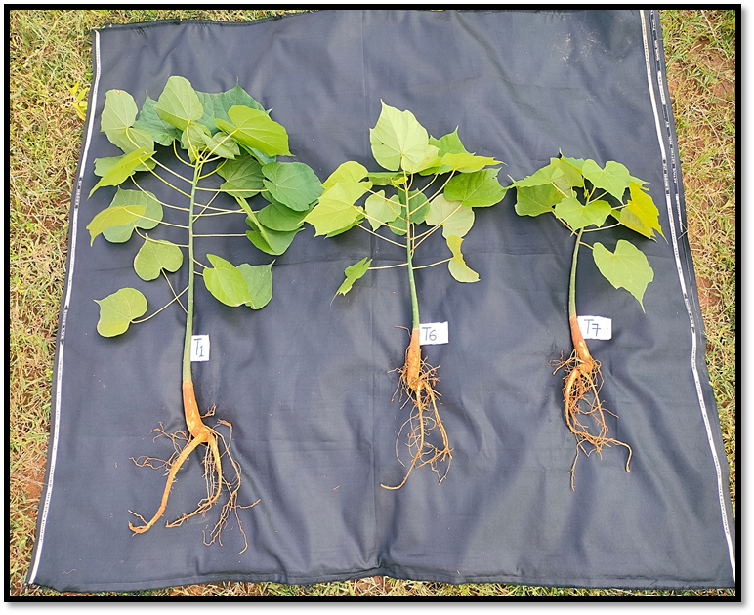

T₁Water soaking 24 hrs, T₂Cow dung treated 24 hrs, T₇Cow urine treated 24 hrs.

Figure 2. Growth parameter analysis for 45days

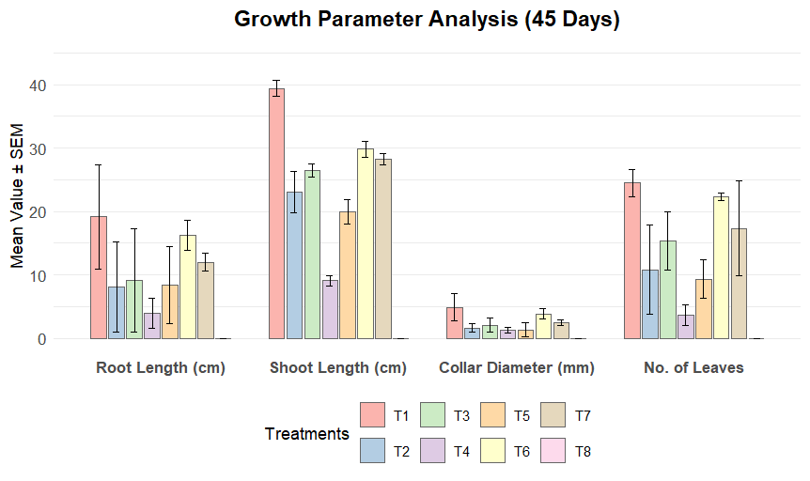

Figure 3. Growth parameter analysis for 90 days
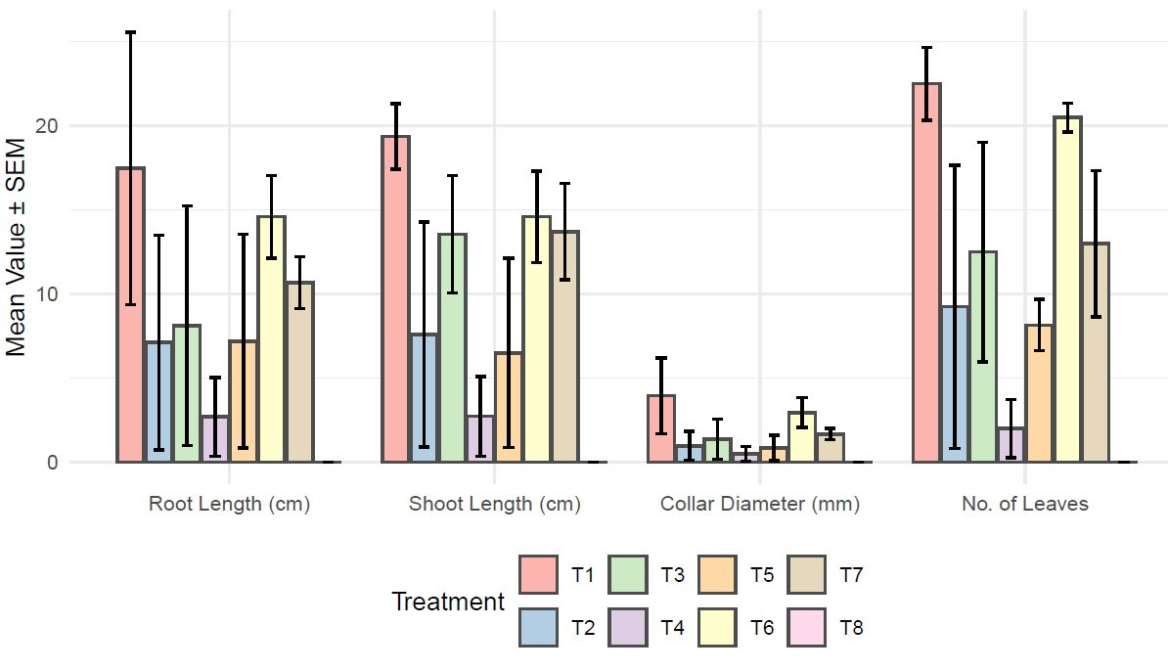

The results clearly indicate that water soaking for 24 hours is a simple, economical, and eco-friendly technique for improving germination and early seedling growth in Hildegardia populifolia. This method can be effectively adopted for large-scale nursery propagation and conservation programs aimed at restoring natural populations of this threatened medicinal tree species.

4. CONCLUSION
The present study confirms that pre-sowing treatments significantly enhance germination and early seedling growth in Hildegardia populifolia. Water soaking for 24 hours proved to be the most effective treatment, resulting in maximum germination, seedling vigor, and survival. This technique offers a practical approach for large-scale propagation and conservation of this threatened medicinal tree species. Adoption of such low-cost propagation methods can support restoration programs and reduce extinction risks.
REFERENCES
Ajay, S. Arya, K. Nanda, I. Redhu and Bhupender 2022. Effect of different pre-sowing treatments on viability, germination and seedling characters of Malabar neem (Melia dubia Cav.) fruits. The Pharma Innovation Journal, 11(7), 974-977.
Anand, B. Khaple, A.K. Devagiri, G.M. Vasudev, H.S. and Gaurav, M. 2012. Effects of pre-sowing seed treatments on germination and seedling growth performance of Melia dubia Cav.: an important multipurpose tree. International Journal of Life Science, 1(3), 59-63.
Boora, R.S. 2016. Effect of various treatments on seeds germination in Indian jujube (Ziziphus mauritiana Lamk). Agricultural Science Digest – A Research Journal, 36(3), 237-239.
Claudia, M. Campos and Ojeda, R.A. 1997. Dispersal and germination of Prosopis flexuosa (Fabaceae) seeds by desert mammals in Argentina. Journal of Arid Environments, 35, 707-714.
Eboeid, A.F.A. Mahmoud, M.M.A. and Mostafa, M.A.M. 2022. Effect of some pre-sowing treatments on seed germination and seedling growth of Melia azedarach L. and Tamarindus indica L. trees. Journal of Sohag Agriscience, 7(1), 100-107.
Kumar, V. 2016. Effect of pre-sowing seed treatment on germination and seedling growth of Terminalia bellirica (Gaertn.) Roxb. Indian Journal of Ecology, 43(1), 233-238.
Lavanya, A.R. Muthukrishnan, S. Muthukumar, M. Benjamin, J.F. Kumar, T.S. Kumaresan, V. and Rao, M.V. 2014. Indirect organogenesis from various explants of Hildegardia populifolia (Roxb.) Schott and Endl. — a threatened tree species from Eastern Ghats of Tamil Nadu, India. Journal of Genetic Engineering and Biotechnology, 12(2), 95-101.
Pamei, K. Larkin, A. and Kumar, H. 2017. Effect of different treatments on the germination parameters and seedling quality index of Tectona grandis (teak) under nursery condition. International Journal of Communication Systems, 5, 2418-2424.
Patel, B.N. Patel, C.B. and Patel, A.N. 1996. Seed germination technique for khirnee (Manilkara hexandra L.). Applied Horticulture, 2(1–2), 149-150.
Pooja, R.S. 2020. Germination and growth performance evaluation of pre-sowing treatment on bijasal (Pterocarpus marsupium Roxb.). (M.Sc. Thesis — unpublished) 43-44.
Raju, A.J.S. Chandra, P.H. and Krishna, J.R. 2014. Monoecy, anemophily, anemochory and regeneration ecology of Hildegardia populifolia (Roxb.) Schott and Endl. (Malvaceae), an economically important endemic and endangered dry deciduous tree species of southern Eastern Ghats, India. Journal of Threatened Taxa, 6(2), 5434-5446.
Singh, K. K. Choudhary, T. and Kumar, A. 2014. Effect of various concentrations of IBA and NAA on the rooting of stem cuttings of mulberry (Morus alba L.) under mist house condition in Garhwal hill region. Indian Journal of Hill Farming, 27(1), 74-77. Stem cuttings of Stercula urens, Roxb. Indian Forester. 120(2): 168-170.
Vijayalakshmi, K. P. and Renganayaki, P. R. 2017. Effect of pre-sowing treatment on germination of Red sanders. Int J Curr Microbiol App Sci, 4, 168-173.

