Original Research Article
Design of a smart IoT-based drip irrigation system for greenhouse cultivation

ABSTRACT
Increasing climate variability and water scarcity have created an urgent need for efficient irrigation strategies in greenhouse agriculture. This study focuses on the design and evaluation of a smart Internet of Things (IoT)-based drip irrigation system developed to enhance water use efficiency and crop productivity under protected cultivation. The experiment was conducted in a naturally ventilated polyhouse using cucumber as the test crop. The system integrates soil moisture, temperature, humidity, light, and flow sensors with an ESP32 microcontroller to enable real-time monitoring and automated irrigation scheduling. Sensor data were transmitted through a cloud platform to support remote monitoring and control. Soil physico-chemical properties were analyzed to characterize the experimental conditions, and soil moisture sensors were calibrated using the gravimetric method to ensure measurement reliability. The automated irrigation system operated through a feedback mechanism that supplied water based on predefined soil moisture thresholds, ensuring precise water application. Results showed high sensor accuracy and strong agreement with reference measurements. IoT-based irrigation treatments significantly improved water use efficiency compared to conventional practices, with the best treatment achieving the highest efficiency across seasons. The study demonstrates that IoT-enabled irrigation can optimize resource use, reduce water wastage, and support sustainable greenhouse crop production.
Key words: IoT-based irrigation, Drip irrigation, Greenhouse cultivation, Precision agriculture, Soil moisture sensors, Water use efficiency, Automated irrigation, Smart agriculture
- INTRODUCTION
The climate change is causing worldwide concern among scientists since unexpected variations on climatic variables are affecting the economic sector (Paramanik et al., 2022; Vaishali et al., 2017). Agriculture is one of the most affected sectors since the growth of crops depends mainly on variables such as temperature, relative humidity, soil humidity, solar radiation, and characteristics of wind and precipitation (Zwart and Bastiaanssen 2004). As a result, the three main areas of food security (access, stability, and nutrition) could be affected by the impact on food production, food prices, and food purchasing capacity of the most vulnerable population. Furthermore, in the long term, climate change could also affect economic investments and the location of crops and production activities, on which many people depend. India is also identified as one of the highly vulnerable countries to climate change (INCCA, 2010). For example, some of the most relevant problems observed are the variations in precipitation that modify production periods, and the variations in temperature and relative humidity that promote the spread of pests and diseases in crops. This situation has affected the food security of 52% of the rural population of the country. For example, some of the most relevant problems observed are the variations in precipitation that modify production periods, and the variations in temperature and relative humidity that promote the spread of pests and diseases in crops (Collado, 2021). This leads us to one of the biggest challenges we face in our generation today, which is “How do we provide more sustainably grown food while increasing our crop production? A greenhouse structure is one promising solution. It provides a controlled environment customized to the vegetation needs cultivated inside. However, traditionally, agroclimatic parameters have been recorded in a rather manual and inconsistent manner. Farming practices are executed on a pre-defined speculation-based schedule, thus wasting water, energy, and using too many pesticides. Thus, based on these concerns, the ability to monitor environmental conditions of greenhouses is crucial to research since it provides valuable information to the farmers to better understand how each factor affects growth and how to maximize crop productiveness (Collado, 2021).
The cucumber (Cucumis sativus L.) is one of the most favored vegetables grown in tropical and subtropical areas, where it is grown both in the field and under protected conditions. This crop belonging to the cucurbitaceae family is commonly referred to as cucurbits. A wide variety of vegetables used either for salad (cucumber) or cooking (all gourds), pickling (western Indian Serkin) or as desert fruits (musk melon, water melon) or candied or preserved (ash gourd). The Cucurbitaceace family found melons, gourds, tomato, squashes and cucumber to be a wide variety of vegetables. Cucumber is one of the oldest grown vegetable crops possibly originating in India. Cucumber is an incredibly low-calorie food, containing just 15 calories per 100 g. It contains high content of water which makes cucumber an ideal food for hydration and cooling. This is a very good source of potassium, vitamin K and other special antioxidants that are essential for the human body's brain, heart and urinary system (Sikarwar, 2016). The region under cultivation and cucumber production in India during 2016-2017, 2017-2018 was 78000, 72000 ha and 1142, 1260 M Tonnes, respectively (A glance horticultural statistics, 2018). Per ha kheera productivity In India as well as in all parts of Rajasthan is lower than developed countries and emerging countries.
The adoption of an IoT-based smart irrigation, fertigation, microclimate monitoring and control system has the potential to transform greenhouse farming practices significantly. By offering real-time data and accurate management of environmental conditions, farmers can establish optimal growth environments for their crops, leading to increased yields and enhanced sustainability. Utilizing a network of interconnected sensors, data analytics, and actuation mechanisms, this system equips greenhouse operators with critical insights and precise control over their growing conditions. The incorporation of IoT technology in greenhouse farming is in line with the larger movements toward precision agriculture and sustainable food production. Consequently, this innovative strategy presents substantial opportunities to boost crop yields, promote sustainability, and reshape the future of greenhouse agriculture.
- MATERIAL AND METHODS
2.1 Details of the study area and weather and climate
The field experiment was conducted in a naturally ventilated polyhouse of 292 m² area in the research plot of the Precision Framing Development Center, KCAET, Tavanur, Kerala. The average maximum temperature of the study area is 35ºC, and the average minimum temperature is 26ºC. Average RH and light intensity are 75% and 40,000 lx, respectively.
2.2 Characterization of soil
Soil samples were collected before sowing of the crop from greenhouse using core samplers, which were then used for characterization of physico-chemical properties of the soil. The physico-chemical properties of the soil and the methodologies adopted for the determination are illustrated in Table 1.
Table 1 Standard analytical methods for soil physical and chemical characteristics
Sl. No | Characteristic | Unit | Method used | Reference
1 | Soil texture  a) Sand, b) Silt, c) clay | Percent | Sieve analysis method
2 | Texture class | - | Triangular diagram of pursuit, Tylor and Marshall | Piper, (1956)
3 | Bulk density | g/cm³ | Core sampler method | Black, (1965)
4 | Field capacity | Percent | Pressure plate apparatus | Singh et. al., (2016)
5 | Permanent wilting point | percent | Pressure plate apparatus | Singh et. al (2016)
6 | PH | - | pH meter | Singh et. al (2016)
7 | EC | dS/m | EC meter | Singh et. al (2016)

2.3 Design of IoT based smart irrigation system
2.3.1 Software component
The essential software and tools used for developing, programming, and managing an IoT automation are explained below.
2.3.1.1 Arduino IDE (Integrated Development Environment)
Arduino IDE is a cross-platform application written in Java that serves as the primary editor and compiler for the platform. It provides a straightforward interface for writing code (often using a simplified version of C /C++), verifying it for errors, and uploading the compiled program (firmware) directly onto and compatible microcontrollers like Arduino, ESP32, ESP8266 via a USB cable. It is the crucial tool for transforming human-written logic into device-executable instructions.
2.3.1.2 Python.org
Python is a high-level, interpreted programming language widely used in for its simplicity, readability, and extensive libraries. In this context, it is typically used for two main purposes, one is Backend/Server-Side Logic means Running scripts on a more powerful device like a Raspberry Pi or a central server to process and analyze the data streamed from the sensors. Another one is data visualization/analytics for Creating graphs, dashboards, and machine learning models to make sense of the collected data before storing it in a database or sending commands back to the devices.
2.3.1.3 Blynk Cloud
Blynk is a popular, user-friendly IoT platform and cloud service. It offers a simple way to create mobile dashboards (digital interfaces) to control devices and visualize real-time data. The main role is, it acts as the bridge between the user's smartphone/web browser and the microcontroller. The microcontroller sends sensor data to blynk for data visualisation and analytics.
    - Hardware components
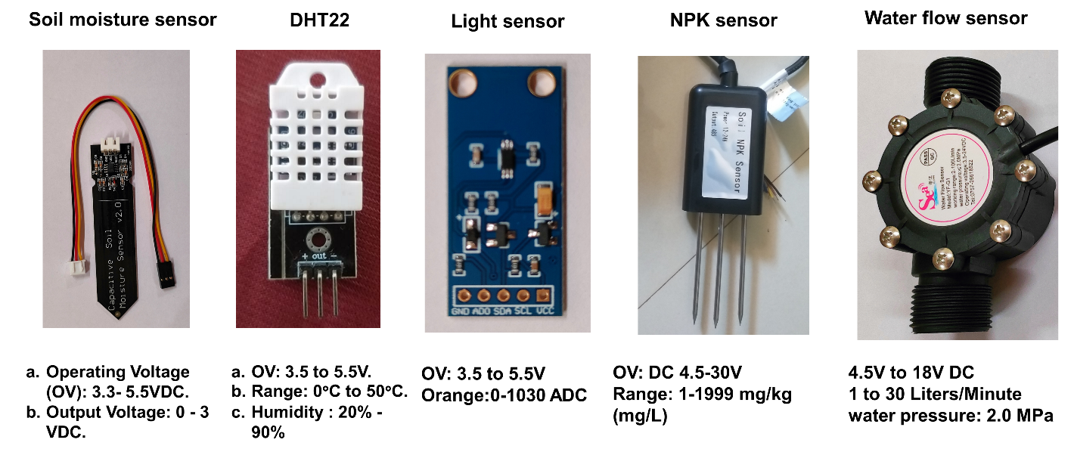
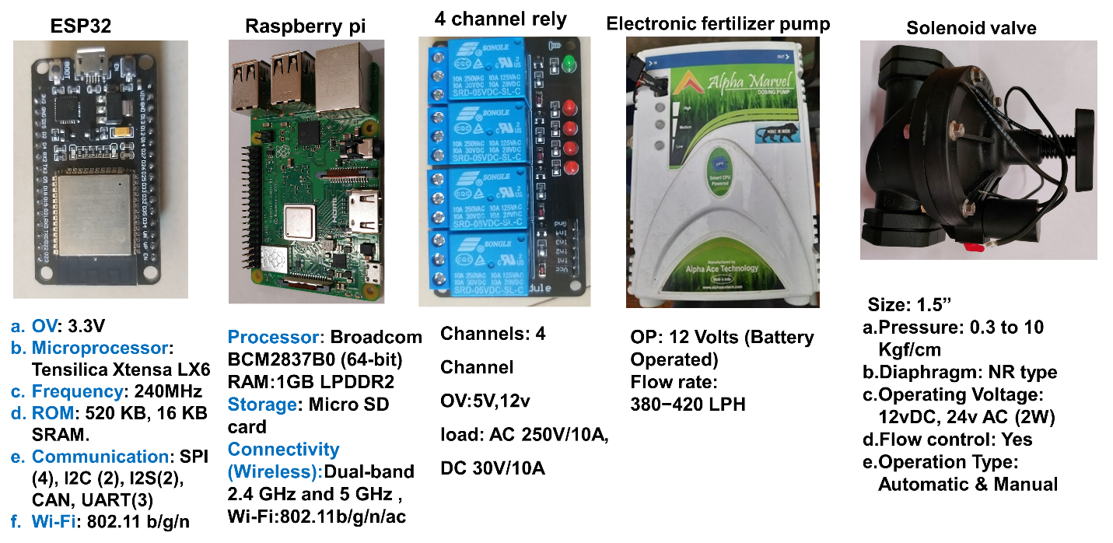
Fig. 1 Hardware components of IOT automation system
2.3.3 Calibration of soil moisture sensors
A total of four capacitive soil moisture sensors (V2.0) were calibrated and deployed at a depth of 15 cm in each treatment, and their calibration relationship with the gravimetric method is presented in Fig. 2. Care was taken to ensure good sensor-soil contact during installation. Soil moisture data were recorded at 5-minute intervals throughout the growing season using a Blynk IoT platform. For irrigation scheduling, readings from the three experimental replications were averaged to account for the natural variability of soil moisture within the different plots of the same treatment (Jones 2007).
Sensors were installed at depth of 10 cm to monitor the active root zone moisture of cucumber crop, the gravimetric moisture content of the soil was subsequently calculated as the ratio of the mass of water to the mass of the dry soil. Gravimetric moisture content was determined by oven-drying soil samples at 105∘C for 24 hours. Additionally, bulk density was estimated by dividing the mass of the dried soil by its volume. Volumetric water content was then calculated by multiplying the gravimetric moisture content by the soil bulk density. A linear regression model was developed based on the relationship between gravimetric moisture content and the soil moisture sensor readings. This developed model was implemented into the system's software, allowing for direct and continuous assessment of the soil's moisture level.
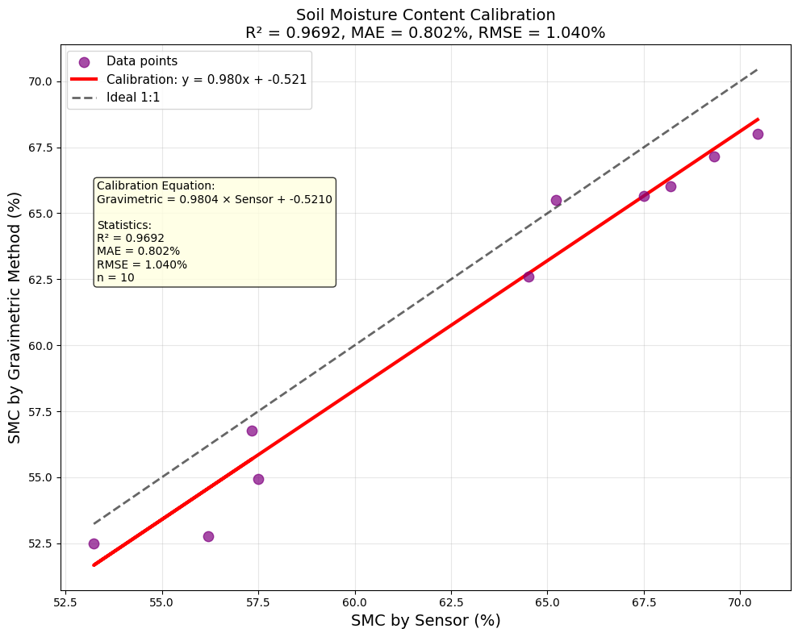
Fig. 2. Calibration graph for soil moisture sensor vs gravimetric method
2.4 System parameters
System parameters are the fundamental values, settings, and quantifiable characteristics that define the design, operating limits, and performance requirements of an engineered system, such as an IoT automation solution. They specify what the system does and how well it does it.
2.4.1 Range of Sensors
The range of a sensor defines the minimum and maximum values of the physical quantity it can reliably and accurately measure. Values outside this range generally lead to inaccurate readings or sensor damage. A typical capacitive soil moisture sensor might output an analogue value from 0 to 1023 (if connected to a 10-bit ADC) corresponding to a Volumetric Water Content (VWC) range of 0% (completely dry) to approximately 100% (saturated, depending on soil type). The sensor itself might physically withstand higher moisture, but its measurement range is within this defined band for reliable data. Calculation of range is usually specified by the manufacturer. To verify, test the sensor in conditions representing the extremes (e.g., air dry soil and fully saturated soil) and observe the output. This involves calibration.
2.4.2 Accuracy of sensors
Accuracy describes how close a sensor's measured value is to the true or actual value of the quantity being measured. It is the degree of correctness.
2.4.2.1 Capacitive Soil Moisture Sensor
If the true soil moisture is 40% VWC, and the sensor consistently reads 38% VWC, its accuracy for that point might be considered off by 2% VWC. Obtain a reliable reference measurement of soil moisture using a gravimetric method by weighing wet soil, drying it, and re-weighing, or a high-precision TDR/TDT sensor then take simultaneous readings from the capacitive sensor and the reference standard in various soil moisture conditions and calculate Error.
Absolute Error = |Measured Value - True Value|.
Percentage Error = (Absolute Error / True Value) * 100%.
Accuracy is often reported as a maximum deviation (e.g., ±5% VWC) or a Root Mean Square Error (RMSE) over a range of measurements.
2.4.3 Precision
Precision refers to the degree to which repeated measurements under unchanged conditions show the same results. It indicates the reproducibility or consistency of the measurements.
2.4.3.1 Capacitive Soil Moisture Sensor
For a constant soil moisture, the sensor repeatedly outputs 500, 501, 500, 499, this indicates high precision. To calculate this, maintain the measured quantity as constant as possible. Then take multiple consecutive reading from the sensor. Calculate the standard deviation of these readings. A smaller standard deviation indicates higher precision. The range (max value - min value) of the repeated readings can also indicate precision.
2.5 Irrigation control
2.5.1 Automated irrigation system design
The hardware architecture of the automated irrigation system, a crucial sub-system within the overall greenhouse automation. This system was designed for precise monitoring and controlling water delivery to different irrigation treatments within the cultivation area. ESP32-based control system designed for automated irrigation, as shown in Fig. 3. It integrates multiple flow sensors for measuring water delivery, capacitive soil moisture sensors for assessing soil hydration, and various solenoid valves along with a water pump for actuating water supply. Control signals from the ESP32 were interfaced with higher power components via multiple relay modules.
2.5.2 System working principle
The automated irrigation system operates through a feedback control loop: The four capacitive soil moisture sensors continuously measure the moisture content in their respective zones. These analog readings are fed into the ESP32 ADC pins. The four flow sensors provide real-time data on the volume of water flowing through specific lines by sending pulse signals to the ESP32's digital input pins. The ESP32 processes the incoming sensor data. Based on pre-defined irrigation thresholds (from soil moisture sensors) and desired water volumes (monitored by flow sensors), the ESP32's firmware determines whether irrigation is required for a particular zone and the duration. If irrigation is needed, the ESP32 sends a control signal to Relay Module 1 to activate the water pump. Simultaneously, it sends signals to the specific relay modules (2-5) corresponding to the solenoid valve to open the valves. This allows for precise water delivery to the target areas. The flow sensors then provide feedback to confirm the water delivery. This integrated design enables an automated, data-driven approach to irrigation, allowing for efficient water management and optimized water supply to different cultivation zones within the greenhouse.
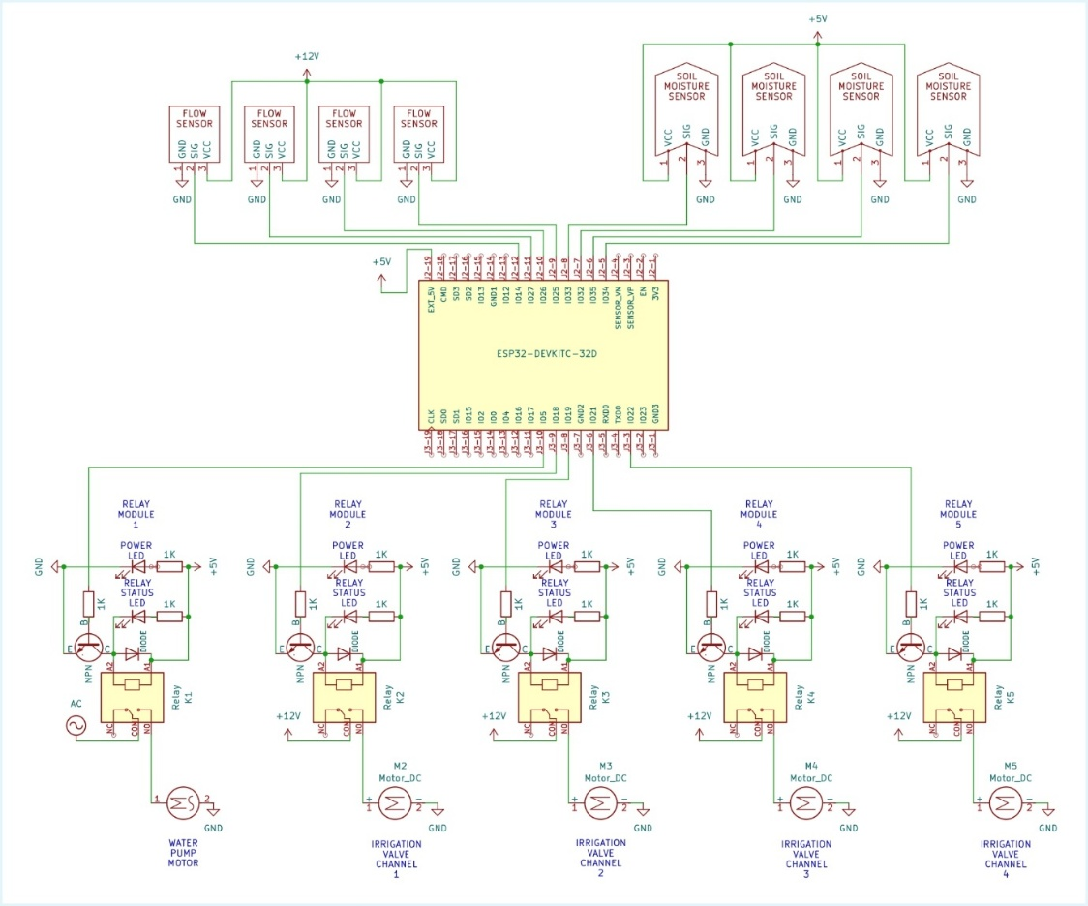
Fig. 3. Circuit diagram of IOT automation
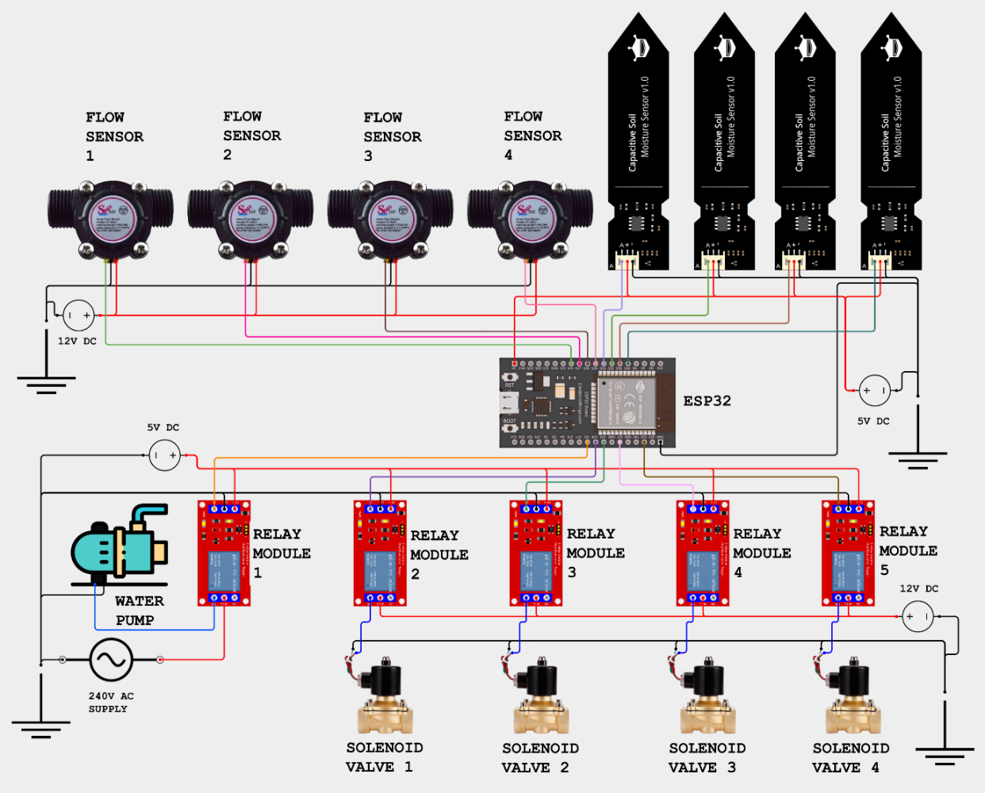
Fig. 4. Schematic diagram of IOT automation
- RESULTS AND DISCUSSION
The physical properties of the soil, such as texture, texture class, bulk density, field capacity, and permanent wilting point, as well as the chemical properties, such as pH and EC were determined using the standard procedure. The data generated is presented in Table 2.
Table 2 Soil physical characteristics of experimental site
Sl. No | Parameters | Unit | Value
1 | Soil texture
1 | Sand | Per cent | 58-61
1 | Silt | Per cent | 20-25
1 | Clay | Per cent | 10-16
2 | Texture class | -- | Sandy loam
3 | Bulk density | gcm⁻³ | 1.85
4 | Field capacity | Per cent | 13.42
5 | Wilting point | Per cent | 6.98
6 | pH | -- | 6.76
7 | EC | Dsm-1 | 0.28

Table 3. Performance metrics and statistical validation of low-cost IoT sensors integrated into the automated control system.
Parameter | DHT22 Temperature (°C) | DHT22 Relative humidity (%) | CSMS (Soil moisture) | LDR (Light Intensity)
Range | -40 - +80 °C | 0 - 100% | NA | ADC: 0-1025
Accuracy | 0.36°C | 2.38% | ±2.04 | ±3
Precision | ±0.17°C | 0.47 | 1.1 | 1.5
Sensitivity | 0.85 | 0.95 | 0.99 | 0.0063 ADC/Lux
RMSE(R²) | 0.977 | 0.985 | 0.969 | 0.965
Resolution | 0.1°C | 1 % | 1 | 0.2Lux
Response Time | 2s | 2s | 2s | 2s
The reliable operation of the automated IoT system hinges on the accuracy and precision of the integrated low-cost sensors, whose performance characteristics are summarized in Table 4.4. the Coefficient of Determination R² values for all sensors were exceptionally high, ranging from a minimum of 0.965 (LDR) to a maximum of 0.985 (DHT22 Humidity), indicating a near-perfect linear correlation between sensor output and standard reference measurements (Louki and Al-Omran, 2023; Kumar et al., 2014).
3.1 Monitoring and Controlling using IoT Cloud Remote Mobile Application
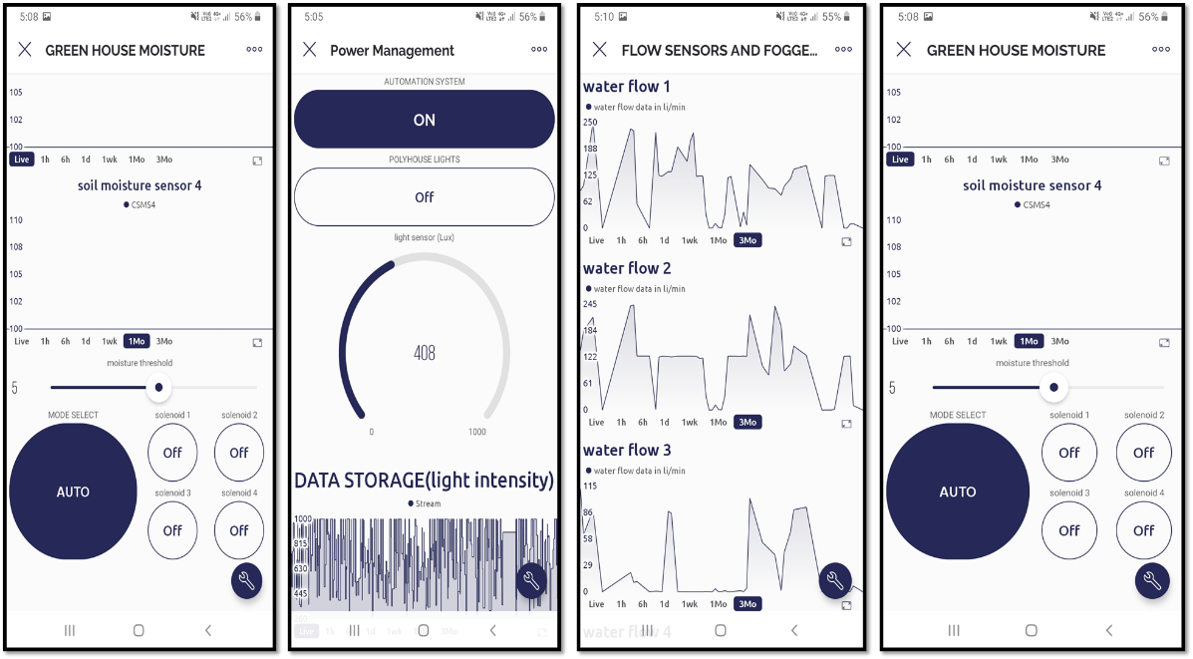
Fig.5. Live monitoring of IOT automation system in blynk mobile application
The developed IoT-based automation system utilizes the Blynk IoT platform to provide a centralized mobile interface for real-time monitoring and remote control of the greenhouse environment. The application integrates data from soil moisture sensors, and water flow sensors, visualizing the parameters through interactive widgets such as SuperCharts, gauges, and digital displays. Beyond data acquisition, the interface enables bi-directional communication, allowing for the manual or automated control of solenoid valves and lighting systems through integrated toggle switches and adjustable threshold sliders. By leveraging the Blynk Cloud, the system ensures seamless data logging and high-frequency synchronization between the field microcontrollers and the user's mobile device, facilitating precise irrigation scheduling and microclimate management essential for optimizing crop yield.
Table 4. Water use efficiency for first season
Treatment | Yield (tons/ha) | Water Applied (mm) | Yield (kg/ha) | WUE (kg/ha-mm)
I1 | 94.30 | 355.60 | 94300 | 265.19
I2 | 95.63 | 320.04 | 95633 | 298.82
I3 | 96.1 | 284.48 | 96100 | 337.81
I4 | 95.2 | 248.92 | 95200 | 382.45
I5 | 81.6 | 355.6 | 81600 | 229.47
Table 5. Water use efficiency for second season
Treatment | Yield (tons/ha) | Water Applied (mm) | Yield (kg/ha) | WUE (kg/ha-mm)
I1 | 91.25 | 506.00 | 91250 | 180.34
I2 | 91.70 | 455.40 | 91700 | 201.36
I3 | 92.55 | 404.80 | 92550 | 228.63
I4 | 90.75 | 390.20 | 90753 | 232.58
I5 | 78.47 | 506.00 | 78467 | 155.07

WUE across the two cultivation seasons and various irrigation treatments reveals key insights into the hydrological performance of the different control systems is shown in table 4.5. and table 4.6. The seasonal variation in efficiency, with WUE values for all treatments being substantially higher during Season 1 than in Season 2, suggesting better climatic conditions or stronger crop performance relative to water input in the initial season. Across both seasons, treatment I₄ consistently demonstrated the highest water utilization, achieving the peak WUE of 382.5 kg/ha.mm in season 1 and a peak of 232.6 kg/ha.mm in season 2, positioning it as the most effective regime for converting water into yield. Conversely, treatment I₅ maintained the lowest efficiency in both periods, plummeting to 155.1 kg/ha.mm in Season 2, highlighting the performance gap created by uncontrolled or sub-optimal irrigation/environmental management. The sustained superiority of the IoT systems is attributed to their ability to dynamically respond to instantaneous crop needs and environmental fluctuations, a critical capability that the fixed, non-automated system (I₅) fundamentally lacks. Treatments I₁ through I₄ leverage sensor feedback to maintain optimal soil moisture, ensuring that water delivery is precise and timely, minimizing waste from deep percolation or surface evaporation. This precision is reflected in the high cluster of WUE values across the IoT group, all of which represent highly efficient water-to-yield conversion, far surpassing the relatively fixed and inefficient resource utilization of I₅. (Sagheer et al., 2021; Kumar et al., 2022; Hakkim and Jisha 2014; Sahin et al., 2015; Jenal et al., 2021; Sai et al., 2019).

COMPETING INTERESTS
Authors have declared that no competing interests exist.
REFERENCES
Anonymous, 2018. Horticultural statistics at a glance 2018, GOI Ministry of Agriculture and farmers’ welfare, Department of Agriculture, Cooperation and Farmers’ welfare, Horticulture Statics Division. GOI 3738 Controller of Publication. 256, 500-2018.
Collado, E., Valdés, E., García, A. & Sáez, Y., 2021. Design and implementation of a low-cost IoT-based agroclimatic monitoring system for greenhouses, Sensors, 21(9), 2977.
Hakkim, V. M. A. & Chand, A. R. J. 2014. Effect of Drip Irrigation Levels on Yield of Salad Cucumber under Naturally Ventilated Polyhouse. IOSR Journal of Engineering, 4 (4), 18-21.
INCCA, 2010. 2010, Indian Network for Climate Change Assessment, India: Greenhouse Gas Emissions 2007. Ministry of Environment & Forests, India.
Jenal, D., Mahyuzie, J., & Ahmad, S. 2021. Automated irrigation and fertigation system using IoT. Journal of Electronic Voltage and Application, 2, 84-91.
Jones, H. G. 2007. Monitoring plant and soil water status: established and novel methods revisited and their relevance to studies of drought tolerance. Journal of experimental botany, 58(2), 119-130.
Kumar, D. S., Reddy, S. P., & Swamy, B. S. (2014). Greenhouse environment monitoring system using digital signal processor. International Journal of Scientific and Research Publications, 4(1), 1-7.
Kumar, V., Singh, R., & Singh, J. P. 2022. Evaluation of IoT based smart drip irrigation system over ET_{c} based system for sweet corn. Agricultural Water Management, 261, 107384.
Louki, K., & Al-Omran, A. M. 2023. Empirical correction equation for ECH2O-5TE sensor to improve soil moisture measurements under hot and saline conditions. Water, 15(3), 543.
Pramanik, M., Khanna, M., Singh, M., Singh, D. K., Sudhishri, S., Bhatia, A., & Ranjan, R. 2022 Automation of soil moisture sensor-based basin irrigation system, Smart Agricultural Technology 2, 100032,
Sahin. U., Kuslu, Y. & Kiziloglu, F. M. 2015. Response of cucumbers to different irrigation regimes applied through drip irrigation system. Journal Animal Plant Science, 25 (1), 198-205.
Sai, K. V., Kumar, S. S. S. A. and Raja Kumar K. N., 2019. Effect of Different Irrigation Levels through Drip System on Water Use Efficiency of Cluster Beans (Cyamopsis tetragonoloba). Research Journal of Agricultural Sciences, 10(4); 701-705.
Sagheer, I. E., Abdel-Raouf, S. E., El-Sayed, T., & Khalil, M. 2021. Multi-tier cloud based IoT platform for precise soilless greenhouse cultivation. Sensors, 21(23), 7793.
Shukla, A., Bhakar, S.R., Chippa, B.G. and Singh, M., 2020. Study the effect of different irrigation and fertigation levels on growth and yield parameters of cucumber crop under naturally ventilated polyhouse. International journal of Current Microbiology and Applied Sciences, 9(10), 3730-3738.
Vaishali, S., Suraj, S., Vignesh, G., Dhivya, S., & Udhayakumar, S. 2017. Mobile integrated smart irrigation management and monitoring system using IOT, in: 2017 international conference on communication and signal processing (ICCSP), IEEE, 2164–2167.
Zwart, S. J., & Bastiaanssen W. G. 2004 Review of measured crop water productivity values for irrigated wheat, rice, cotton and maize. Agriculture Water Management, 69 (2), 115–133.

