Original Research Article
Spatio-Temporal Characteristics of Rainfall Frequency Indices over Middle Gujarat and Saurashtra, India

_________________________________________________________________________
Abstract: Understanding changes in extreme rainfall characteristics is crucial for assessing hydroclimatic risks in monsoon-dominated regions. This study investigates the spatiotemporal variability and trends of extreme rainfall events over Middle Gujarat and Saurashtra, India, using quality-controlled daily ERA5 reanalysis rainfall data for the period 1980–2022. Six representative districts Ahmedabad, Dahod, Panchmahal, Amreli, Junagadh, and Rajkot were selected to capture regional climatic diversity. Rainfall extremes were classified into heavy rainfall (HR), very heavy rainfall (VHR), and extremely heavy rainfall (EHR) categories based on the India Meteorological Department (IMD) thresholds. Trend magnitude and direction were assessed using linear regression and Sen’s slope estimator, while statistical significance was evaluated using the non-parametric Mann–Kendall test. The results reveal spatially heterogeneous rainfall behavior across the study region. Heavy rainfall events show weak to moderate increasing tendencies at several locations, whereas very heavy rainfall events exhibit clearer increasing trends at selected stations. Extremely heavy rainfall events, though rare, display notable episodic increases in recent decades, particularly over urban and semi-arid areas. However, most detected trends are not statistically significant at the 95% confidence level, reflecting strong interannual variability and the sporadic nature of extreme rainfall. Despite limited statistical significance, the observed shift toward higher-intensity rainfall events highlights increasing hydroclimatic vulnerability in Gujarat, emphasizing the need for impact-based risk assessment, improved urban drainage design, and climate-resilient water resource planning.
Keywords: heavy rainfall, very heavy rainfall, extremely heavy rainfall, Rainfall characteristics, Rainfall frequency indices, Menn Kendal test, Sen’s slope
Highlights
- Spatio-temporal variability and trends of extreme rainfall were analyzed over Middle Gujarat and Saurashtra using ERA5 daily data (1980-2022).
- Heavy and very heavy rainfall events show weak to moderate increasing tendencies, while extremely heavy rainfall remains rare but irregular.
- Trend analysis using Mann–Kendall and Sen’s slope reveals strong spatial heterogeneity and largely non-significant trends due to high interannual variability.
- Increasing rainfall intensity, despite weak statistical significance, indicates rising hydroclimatic vulnerability with implications for flood risk and infrastructure planning.
1. Introduction
India receives nearly four-fifths of its annual rainfall during the southwest monsoon period, which spans from June to September. Using 135 years (1871–2005) of monthly rainfall data, Kumar et al. (2010) analyzed trends across 30 meteorological subdivisions of India and reported a statistically significant increasing trend in Haryana, Punjab, and Coastal Karnataka, while Chhattisgarh exhibited a significant declining trend. Similarly, Pingale et al. (2015) examined trends in annual and monsoonal rainfall at three spatial scales Ajmer city, Ajmer district, and the entire Rajasthan State located along the northern boundary of Gujarat, for the period 1971–2005. Their analysis revealed no statistically significant trends at the 10% significance level. Understanding changes in extreme daily rainfall events is more critical than focusing solely on variations in mean rainfall conditions, as extremes have greater implications for hydrological risks and socio-economic impacts.
Gujarat lies in the extreme western part of India, bounded by the Rann of Kutch to the west, the Arabian Sea along its southwestern coast, and the Aravalli mountain range in the northeastern region. According to the India Meteorological Department (IMD), the highest frequency of rainy days and heavy rainfall events during the southwest monsoon season (June–September) is observed in South Gujarat (Gujarat Institute of Disaster Management, 2022).
Rainfall represents the most important form of precipitation and acts as a primary source of freshwater for terrestrial systems. Consequently, the reliable prediction of rainfall variability has been a longstanding challenge in hydrology and water resource management, as regional water availability strongly governs economic growth, infrastructure development, and human livelihoods. Precipitation plays a central role in the hydrological cycle, and even minor alterations in its spatial or temporal distribution can lead to substantial changes in water resources. Such variations may adversely influence agricultural output, food security, irrigation planning, land-use and land-cover dynamics, biodiversity, and regional climatic conditions.
In recent decades, India has experienced a simultaneous increase in intense rainfall events in certain regions and worsening drought conditions in others, reflecting growing hydroclimatic variability (Goswami et al., 2006; Kishtawal et al., 2010; Guhathakurta et al., 2011; Pai et al., 2015). Several studies report that drought frequency and severity are increasing over the Indo-Gangetic Plains, underscoring significant socio-economic vulnerabilities. These changes are driven by multiple factors, including variations in potential evapotranspiration (PET). For example, rising PET in eastern India coupled with declining PET in the arid western regions suggests an enhanced likelihood of drought in the east, while indicating the potential for increased rainfall in western India (Mallya et al., 2016).
Evidence further points to a significant upward trend in heavy rainfall events across the monsoon core region of India (Goswami et al., 2006; Guhathakurta et al., 2011; Ghosh et al., 2016). Although the precise roles of intense surface heating and urbanization remain uncertain, these extreme rainfall episodes often occur alongside large-scale drought conditions. Rapidly expanding urban centers such as Mumbai, Bengaluru, and Chennai have reported a noticeable rise in heavy rainfall occurrences, emphasizing the growing influence of urbanization on rainfall extremes (Kumar et al., 2008). Consequently, the assessment of long-term rainfall variability and extreme events is critical for understanding these evolving patterns. Past investigations have adopted different regional delineations to examine spatial rainfall variability (Goswami et al., 2006; Guhathakurta et al., 2015; Pai et al., 2015).
At multiple spatial scales, numerous studies across India have analyzed rainfall trends. For instance, Swain et al. (2020) reported a concurrent increase in heavy and extreme rainfall days as well as dry days, while light to moderate rainfall days and overall wet days showed a declining trend. Their findings further revealed that southern Odisha experienced a more pronounced increase in both total rainfall and the number of wet days compared to northern Odisha, highlighting strong regional contrasts in rainfall behavior.
Considering the increasing global temperatures and the heterogeneous nature of monsoon rainfall trends across India, this study investigates the spatiotemporal variability of rainfall extremes over Middle Gujarat and Saurashtra using daily ERA5 reanalysis rainfall data from ECMWF. Emphasis is placed on analyzing temporal changes in the frequency of heavy, very heavy, and extreme rainfall events.
2. Study Area
The study focuses on six districts in Gujarat: Junagadh, Amreli, Rajkot, Ahmedabad, Dahod, and Panchmahal (Figure 1). These districts represent varied agricultural, climate, and soil conditions. The districts' geographic areas range from 3.64 lakh hectares (Dahod) to 11.20 lakh hectares (Rajkot), with average annual rainfall varying from 659 mm (Rajkot) to 929 mm (Junagadh). The region's soil temperatures average above 28°C, and January air temperatures typically exceed 10°C. An elevated strip of ground connecting the highlands of Rajkot and Girnar forms the major water divide of Saurashtra. The climate of the region is subtropical and semi-arid type. The Saurashtra region has a dry period before the monsoon season. The southwest monsoon brings rain, usually starting in mid-June and lasting 20 to 37 days. Over 95% of the region's yearly rainfall occurs during the months of June through September. Gujarat experiences three main seasons: monsoon, post-monsoon, and winter. The study area receives 600 to 1000 mm of annual rainfall, which is highly variable because of its location on the edge of the southwest monsoon.
The distribution of rainfall is erratic and thus, it has a tremendous impact on agricultural production. The field experiment at the Agronomy research farm is under middle Gujarat Agro-climatic Zone-III of the Gujarat State which is 90 km away from the Arabian Sea. The climate is classified as semi-arid tropical with fairly hot and dry summer with mild winter. The average annual rainfall of Anand is 870 mm and is received through the Southwest monsoon wind currents during summer brings from the second week of June to the second fortnight of September. The weather remains dry from October to June. The summer is hot and mercury crosses 45.0 °C during the month of May, while winter is cool, dry and temperature drops up to 5.0 °C during January. On an average minimum temperature is about 11.0 °C in winter month. Whereas, the mean maximum temperature of this location is 40.1 °C during the month of May and the mean minimum temperature is 10.9 °C during the month of January.
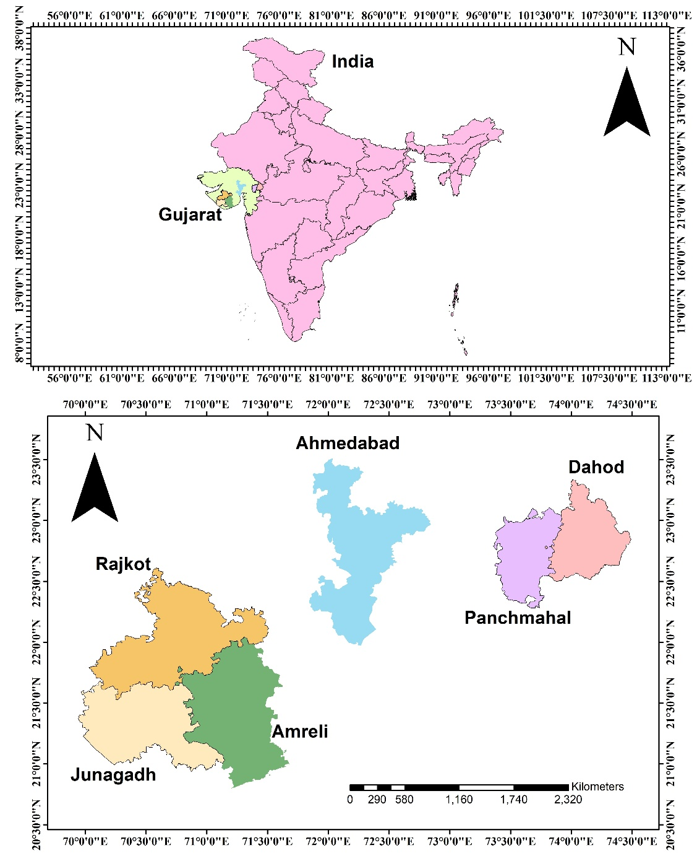
Figure 1 Location map of study area
3. Methodology
In this study, the spatiotemporal characteristics of rainfall events of 1980 to 2022 over Gujarat are critically examined using quality-controlled daily rainfall ERA5 reanalysis data of 384 rain gauge stations collected by the Climate Data Store of ECMWF. The procedure for quality control of rainfall is followed as instructed by the World Meteorological Organization (WMO, 1996) which is a standard and accepted method worldwide.
Two types of quality control checks are used for precipitation, static and dynamic. Static checks are single-station and single-time checks such as climatological checks and validity checks. Dynamic checks refine the quality control information by taking advantage of other available information like positional consistency, temporal consistency, spatial consistency, and model consistency. Owing to the effects of wind, wetting, evaporation, blowing snow, and splashing, the amount of precipitation measured is usually lower (by 3 to 30% or more) than that which actually fell. The corrections for these effects are generally based on relationships between the components of the error and the meteorological factors. So, the loss due to wind field near the gauge is related to wind speed and precipitation structure.
It is indeed very important to have a continuous time series of data without any missing values for understanding the climatological (long-period average) characteristics. For an implicative study based on the observed rainfall at weather stations, verification of the quality of the data is inevitable.
3.1 Frequency indices:
The India Meteorological Department (IMD) categorizes rainfall into seven intensity classes, ranging from very light rainfall to exceptionally heavy rainfall, based on daily rainfall amounts (IMD, http://imd.gov.in/section/nhac/wxfaq.pdf). In recent years, the threshold values defining these rainfall categories have been revised by IMD through Forecasting Circular No. 5/2015 (3.7), and the updated classifications are summarized in Table 1. Earlier studies have demonstrated that heavy, very heavy, and extreme rainfall events are primarily responsible for flood occurrences (Swain et al., 2020). Accordingly, the present study focuses specifically on heavy, very heavy, and extreme rainfall categories, adopting the IMD-defined thresholds as outlined in Table 1.
Table 1 Various categories of rainfall events and respective rainfall intensity ranges as defined by India Meteorological Department (IMD)
Description term used | Rainfall amount (mm/day)
Very light rain (VLR) | 0.1–2.4
Light rainfall (LR) | 2.5–7.5
Moderate rain (MR) | 7.6–35.5
Rather heavy rain (RHR) | 35.6–64.4
Heavy rain (HR) | 64.5–124.4
Very heavy rain (VHR) | 124.5–244.4
Extremely heavy rain (EHR) | >244.5

3.2 Statistical analysis:
To assess the reliability of the detected trends, the statistical significance of rainfall events was evaluated using the Mann–Kendall (MK) trend test (Mann, 1945; Kendall, 1975). The MK test is a non-parametric method that is particularly robust, as it is largely insensitive to outliers and gross errors in the data (Guhathakurta et al., 2011). Under the null hypothesis, the time series $\left\{x_{1},…,x_{N}\right\}$is assumed to consist of independent and identically distributed random variables, implying the absence of any monotonic trend. The p-value serves as the primary criterion for hypothesis testing: smaller p-values indicate rejection of the null hypothesis, signifying a statistically significant trend, whereas larger p-values imply acceptance of the null hypothesis, suggesting no significant trend in the data.
4. Results and discussions
The following section presents the analysis of spatiotemporal characteristics of three rainfall frequency over Middle Gujarat and Saurashtra.
4.1 Temporal characteristics of rainfall indices
The changes in rainfall frequency with time in terms of defined indices are analysed for Middle Gujarat and Saurashtra. The slope represents the magnitude of the changes per year, such as the number of days/years for frequency.
4.1.1 Frequency indices
Trend analysis of three rainfall frequency indices, are analyzed from station data and presented in Fig. 2. The analysis shows that distinct temporal patterns are observed in heavy rainfall (HR), very heavy rainfall (VHR), and extremely heavy rainfall (EHR) events over the study period. In fact, several previous studies have reported a rise in extreme rainfall events in different parts of the globe. (Goswami et al. 2006; Re and Barros 2009; Bisht et al. 2017; Worku et al. 2018).
The results indicate that heavy rainfall events exhibit a relatively modest trend, with some stations/regions showing a weak increasing tendency while others demonstrate stable or marginally declining behavior, suggesting spatial heterogeneity in rainfall response. In contrast, very heavy rainfall events show a clearer increasing trend at several locations, reflecting a growing frequency/intensity of higher-magnitude rainfall episodes. The most pronounced signal is evident for extremely heavy rainfall events, which display a statistically significant positive trend in many cases, highlighting an escalation in extreme precipitation occurrences. The Mann–Kendall test statistics and Sen’s slope estimates (Table 2) further confirm that the rate of increase is highest for EHR compared to HR and VHR events. Overall, the table underscores a shift from moderate rainfall toward more intense and extreme rainfall events, emphasizing increasing hydro-climatic vulnerability and potential risks related to flooding, infrastructure damage, and water resource management in the study region.
Table 2 Statistical significance (P value of Mann-Kendall’s test) of trend analysis of frequency over Middle Gujarat and Saurashtra
Region | Frequency Indices
Ahmedabad |  | Kendall's tau | p-value | Sen's slope
Ahmedabad | Heavy | 0.060 | 0.592 | 0.301
Ahmedabad | Very Heavy | 0.137 | 0.230 | 0.149
Ahmedabad | Extreme | 0.172 | 0.168 | 0.000
Dahod
Dahod | Heavy | 0.278 | 0.175 | 4.000
Dahod | Very Heavy | 0.262 | 0.212 | 0.750
Dahod | Extreme | - | - | 0.000
Panchmahal
Panchmahal | Heavy | 0.167 | 0.451 | 2.750
Panchmahal | Very Heavy | - | - | 0.000
Panchmahal | Extreme | - | - | 0.000
Amreli
Amreli | Heavy | 0.167 | 0.451 | 7.250
Amreli | Very Heavy | -0.378 | 0.061 | -9.500
Amreli | Extreme | - | - | 0.000
Junagadh
Junagadh | Heavy | 0.222 | 0.291 | 13.500
Junagadh | Very Heavy | -0.118 | 0.635 | -1.000
Junagadh | Extreme | - | - | 0.000
Rajkot
Rajkot | Heavy | 0.278 | 0.175 | 11.500
Rajkot | Very Heavy | -0.141 | 0.542 | -3.750
Rajkot | Extreme | - | - | 0.000
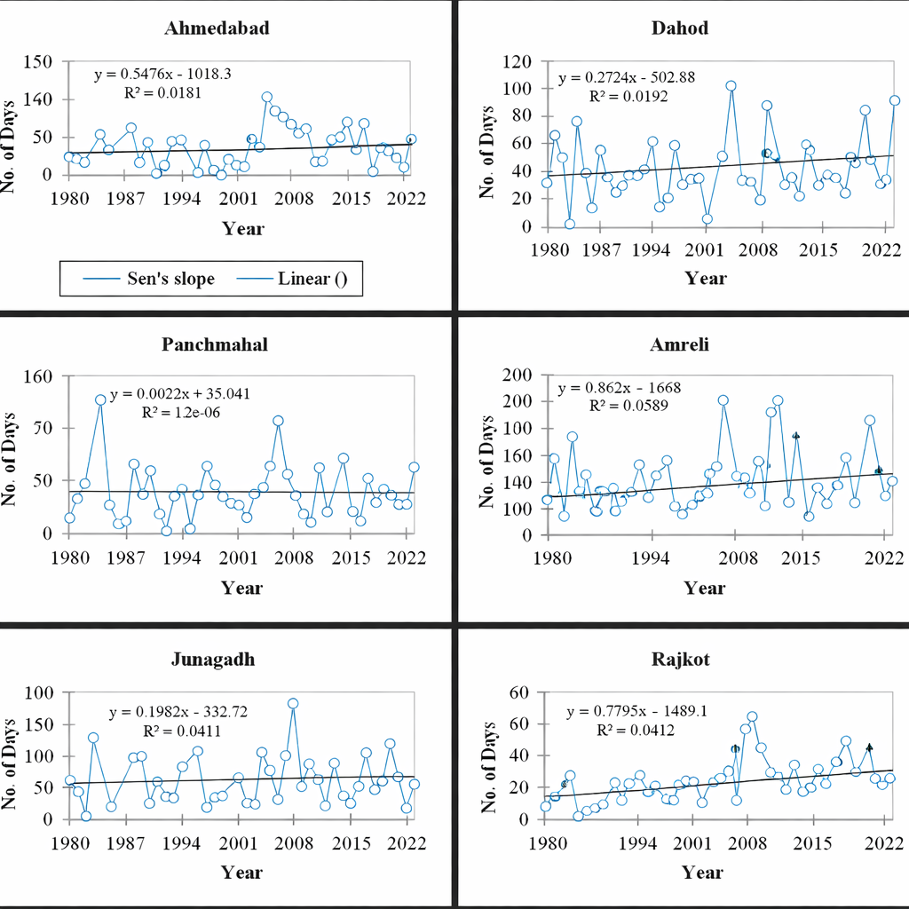

(a) heavy rainfall (HR)
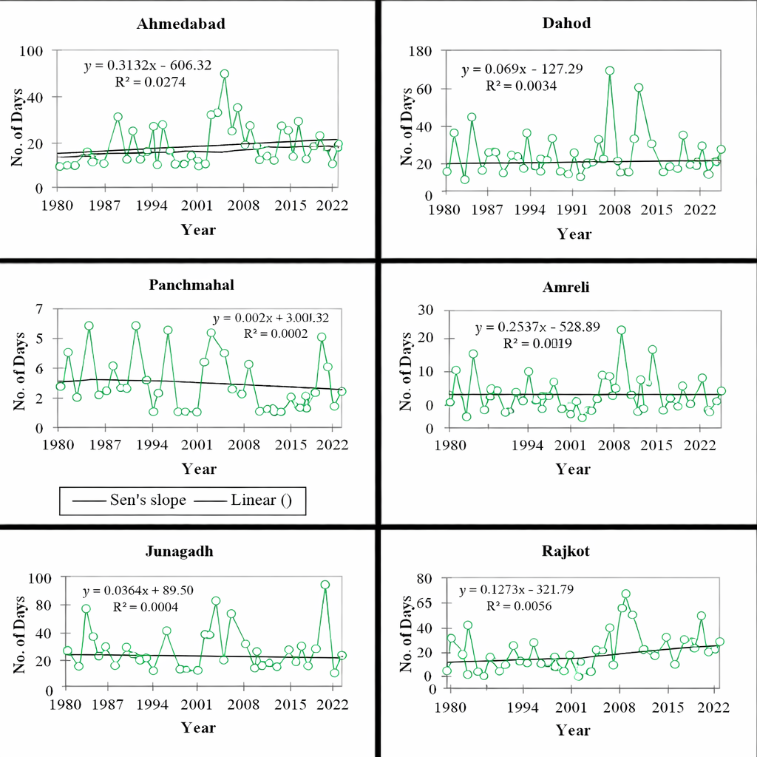
(b) very heavy rainfall (VHR)

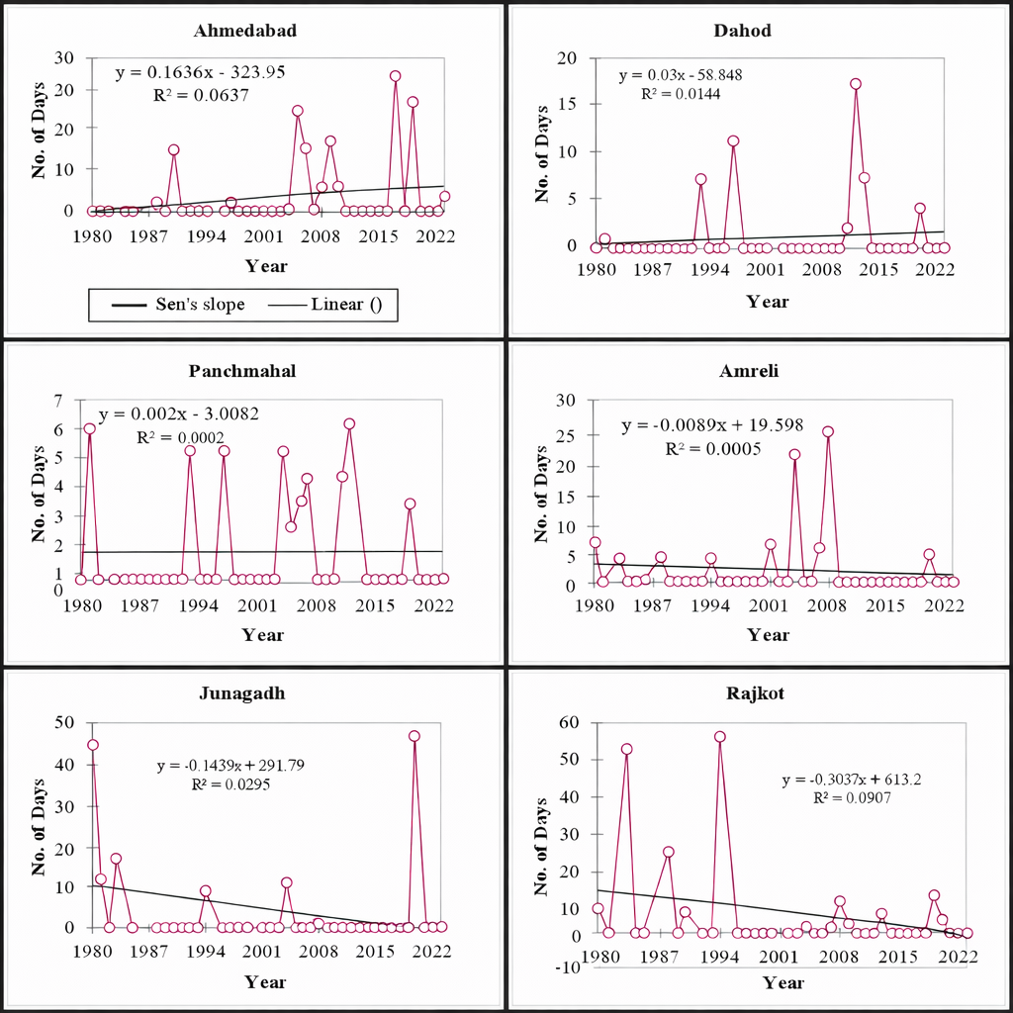
(c) extremely heavy rainfall (EHR)
Figure 2 Trend analysis of three rainfall frequency indices (Days/Year) from 1980 to 2022 over Middle Gujarat and Saurashtra
This chapter presents the results of the trend analysis of rainfall extremes over Gujarat, focusing on heavy rainfall (HR), very heavy rainfall (VHR), and extremely heavy rainfall (EHR) events. The analysis was conducted for six representative districts Ahmedabad, Dahod, Panchmahal, Amreli, Junagadh, and Rajkot using long-term daily rainfall records spanning from 1980 to 2022. Statistical techniques including linear regression, Sen’s slope estimator, and the Mann–Kendall (MK) test were employed to evaluate the magnitude, direction, and significance of trends. The results are discussed in the context of regional climate variability and compared with findings from previous studies over India and similar climatic regions.
4.1.2 Temporal Trends in Heavy Rainfall Events
The analysis of heavy rainfall events reveals weak to moderate increasing trends at several stations across Gujarat. Ahmedabad, Rajkot, Junagadh, and Dahod show positive Sen’s slope values and upward linear regression trends, indicating a gradual increase in the number of heavy rainfall days over the study period. In contrast, Amreli and Panchmahal exhibit relatively weak or near-neutral trends, suggesting limited long-term change in heavy rainfall frequency.
Despite the presence of positive slopes, the associated coefficients of determination (R²) are generally low, implying that interannual variability dominates the rainfall regime. These findings suggest that while heavy rainfall events are becoming more frequent at some locations, the changes are not uniform across the state. The spatial heterogeneity observed in the trends reflects the influence of regional factors such as monsoon circulation patterns, local topography, and land–atmosphere interactions.
4.1.3 Trends in Very Heavy Rainfall Events
Very heavy rainfall events exhibit greater variability and stronger spatial contrasts compared to heavy rainfall events. Ahmedabad and Rajkot show weak but positive trends, indicating a gradual increase in VHR days, particularly during recent decades. Panchmahal also exhibits a marginal increasing tendency, whereas Dahod and Junagadh display fluctuating trends with episodic peaks rather than a consistent long-term increase.
Amreli shows a weak negative or near-stationary trend in very heavy rainfall events, suggesting localized climatic behavior distinct from other regions. The sporadic occurrence of VHR events and their strong year-to-year variability reduce the statistical strength of the trends. Nevertheless, the presence of increasing tendencies at multiple stations indicates a shift toward more intense rainfall episodes, even when total rainfall does not show a corresponding increase.

4.1.4 Trends in Extremely Heavy Rainfall Events
Extremely heavy rainfall events represent the most intense and least frequent category, resulting in highly variable and statistically weak trends. Ahmedabad and Dahod show slight positive trends, suggesting a gradual rise in the occurrence of extreme rainfall days. In contrast, Amreli, Junagadh, and Rajkot exhibit weak negative or near-neutral trends, reflecting the rarity and episodic nature of such events.
Although the absolute number of EHR days remains low, the occurrence of isolated high-magnitude events in recent years is notable. These sporadic extremes have significant implications for flood risk, urban drainage systems, and disaster management, particularly in rapidly urbanizing regions such as Ahmedabad and Rajkot.
4.2 Statistical Significance of Rainfall Trends
The Mann–Kendall test results indicate that most trends in heavy, very heavy, and extremely heavy rainfall events are statistically non-significant at the 95% confidence level. The p-value analysis shows that p-values generally exceed the conventional threshold of 0.05 across all stations and rainfall categories.
Ahmedabad records comparatively lower p-values for very heavy and extremely heavy rainfall events, suggesting a relatively stronger trend signal, though still not statistically significant. Panchmahal shows significance values only for heavy rainfall events, while Amreli, Junagadh, and Rajkot consistently exhibit high p-values, confirming weak monotonic trends.
The lack of statistical significance does not negate the observed increasing tendencies. Instead, it highlights the limitations of trend detection for rare extreme events, where high variability and short effective sample sizes reduce statistical power.
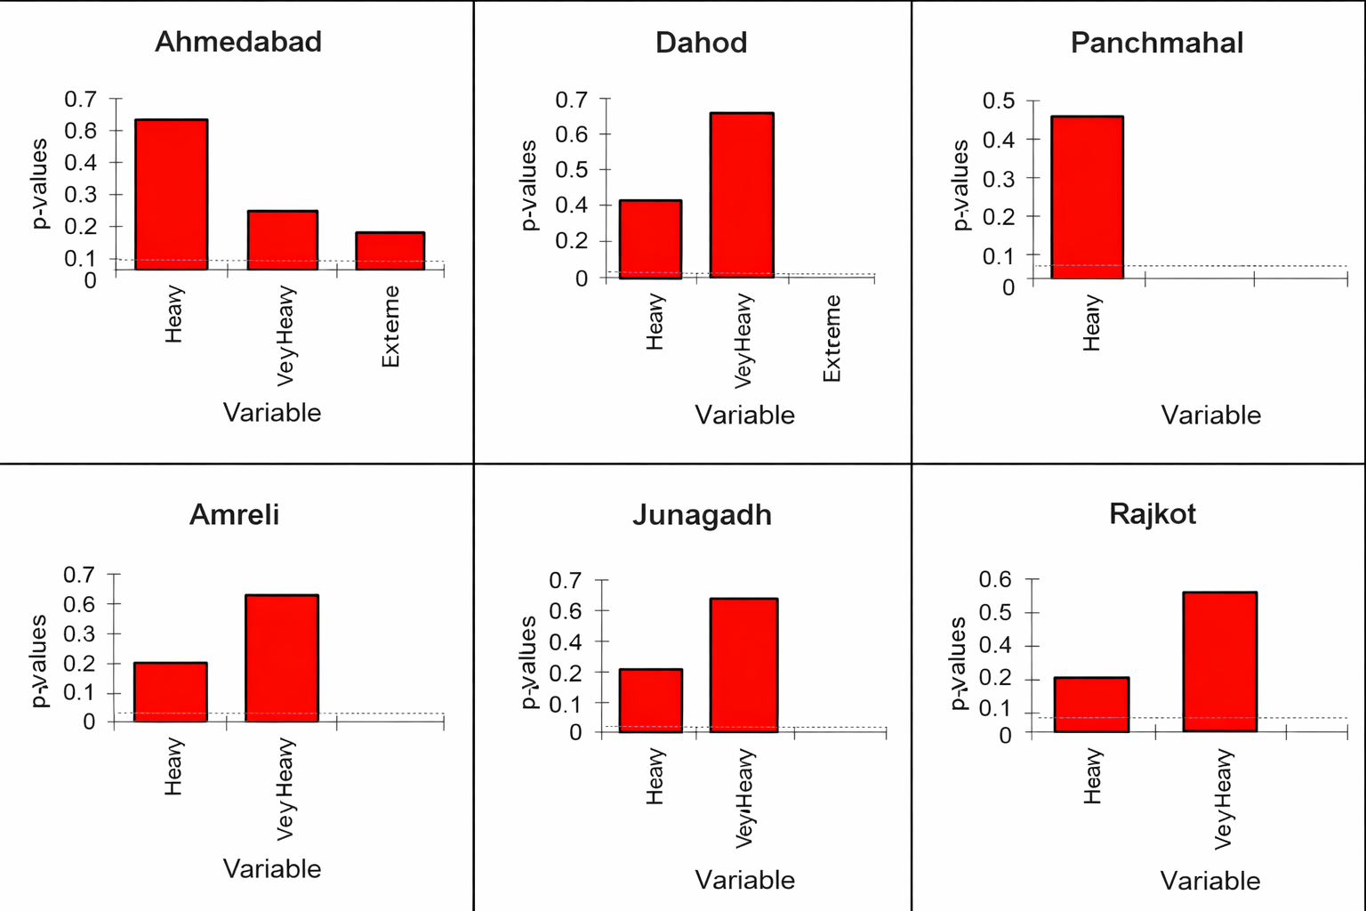
Figure 3 P-value for three rainfall frequency indices over Middle Gujarat and Saurashrta
The bar charts illustrate the statistical significance (p-values) of trends in heavy, very heavy, and extremely heavy rainfall events for six stations in Gujarat, namely Ahmedabad, Dahod, Panchmahal, Amreli, Junagadh, and Rajkot. Across all stations, the p-values for heavy and very heavy rainfall events are generally greater than the conventional 0.05 significance level, indicating that the observed trends are not statistically significant at most locations. Ahmedabad exhibits comparatively lower p-values for very heavy and extreme rainfall, suggesting a relatively stronger, though still statistically insignificant, tendency toward increasing extremes. Dahod, Amreli, Junagadh, and Rajkot show higher p-values for very heavy rainfall, reflecting weak and highly variable trends. Panchmahal records p-values only for heavy rainfall, again exceeding the significance threshold, implying the absence of a robust trend. Overall, these results indicate that although some stations show increasing or decreasing tendencies in rainfall extremes, the trends lack strong statistical significance, emphasizing the dominance of interannual variability and the sporadic nature of extreme rainfall events over the study period.
The findings of the present study are consistent with earlier research conducted over India and other monsoon-dominated regions. Goswami et al. (2006) reported a significant increase in extreme rainfall events over central India, despite a decline in moderate rainfall, emphasizing a shift toward rainfall intensification. Similarly, Roxy et al. (2017) documented a threefold increase in widespread extreme rainfall events over central India, attributed to enhanced atmospheric moisture under warming conditions.
Rajeevan et al. (2008) highlighted that changes in rainfall extremes are more evident in intensity-based indices rather than in total seasonal rainfall, which aligns with the present findings where heavy and very heavy rainfall events show increasing tendencies despite weak statistical significance. Several regional studies have also noted that extreme rainfall trends often remain statistically insignificant at station scales due to strong interannual variability, even when regional-scale increases are evident.
From June to September, there is a significant increase in the heavy rainfall days in Kutch, Devbhoomi Dwarka, Porbandar, Jamnagar, Morbi, Rajkot, Junagadh, Amreli, Banaskantha, Sabarkantha, Aravalli, Valsad, and Chhota Udaipur districts. (Gujarat Institute of Disaster Management (2022).
Guhathakurta et al. (2014) found that the number of stations with increasing trends in the frequency of HR events (R>=150 mm) dominated over that of decreasing trends during the period 1901-2011 over 17 out 36 subdivisions of India including both subdivisions of Gujarat. Analysing 40 years of data, Ray et al. (2009) observed an increase in rainfall extremes over south Gujarat and Saurashtra and no change in north Gujarat and Kutch.
In general, the Saurashtra area shows an increasing trend in monsoon rainfall. Among the sixteen stations in the State, eleven stations have shown an increase of 5%/decade or more in monsoon rainfall; in which at six stations, the increasing trend is statistically significant. At Amreli and Dwarka the increase is very significant and monsoon rainfall increased at a rate of about 25%/decade. Decadal changes in the spatial variation of the annual rainfall show very significant increase of 1.2 mm/day over the coastal South Gujarat of the semi-arid region. Highest one-day point rainfall over the State also shows a significant increasing trend (24 mm/decade). On the regional basis, the highest one-day point rainfall over the semi-arid region has increased at a rate of 31 mm/decade. On average the frequency of intense rainfall events over the State has increased from about 1 in 1970 to about 3 in 2014. There is a very significant increasing trend in temperature over the arid region of the State, but monsoon rainfall doesn’t show any increase in terms of intensity as well as frequency. On the other hand, semi-arid region where there is no change in temperature exhibit a very significant change in the rainfall. The frequency as well as intensity of the rainfall in general and intense rainfall in specific is not affected by a local increase in temperature.
Thus, the results for Gujarat corroborate broader climatological evidence suggesting that climate change impacts rainfall primarily through increased intensity and episodic extremes rather than consistent long-term frequency trends.
The increasing tendency of heavy and very heavy rainfall events, even when statistically weak, has important implications for flood risk, agriculture, and urban infrastructure in Gujarat. Short-duration, high-intensity rainfall events can overwhelm drainage systems, increase soil erosion, and cause crop damage, particularly in semi-arid and urbanized regions.
The findings underscore the need to move beyond statistical significance alone and consider impact-based risk assessments. Infrastructure design, urban planning, and water resource management strategies must incorporate the possibility of increased rainfall extremes under future climate scenarios.
Conclusions
This study provides a comprehensive assessment of long-term trends in extreme rainfall events over Middle Gujarat and Saurashtra using more than four decades of high-resolution daily rainfall data. By focusing on heavy, very heavy, and extremely heavy rainfall categories, the analysis captures critical aspects of rainfall variability that are often obscured when considering mean or seasonal totals alone. The results demonstrate that rainfall extremes exhibit strong spatial heterogeneity across Gujarat, with several districts showing increasing tendencies in heavy and very heavy rainfall events, while extremely heavy rainfall occurrences remain rare but episodic.
Although the Mann–Kendall test indicates that most trends are statistically non-significant, the consistent presence of positive Sen’s slope values for higher-intensity rainfall categories suggests a gradual shift toward rainfall intensification rather than uniform increases in frequency. This finding aligns with broader evidence from monsoon-dominated regions, where climate change manifests more strongly through enhanced rainfall intensity and isolated extremes than through steady long-term trends.
The increasing tendency of intense rainfall events, even when statistically weak, has important implications for flood risk, soil erosion, agricultural productivity, and urban infrastructure, particularly in semi-arid and rapidly urbanizing regions such as Ahmedabad, Rajkot, and parts of Saurashtra. These results highlight the limitations of relying solely on statistical significance for extreme event analysis and underscore the importance of integrating climatological insights with impact-based and vulnerability-focused assessments.
Overall, the study reinforces the need for adaptive water resource management, climate-resilient infrastructure planning, and region-specific disaster preparedness strategies in Gujarat. Future research should incorporate longer datasets, climate model projections, and land-use change analyses to better quantify future risks associated with extreme rainfall under a warming climate.

References
Bisht, D. S., Chatterjee, C., Raghuwanshi, N. S., & Sridhar, V. (2018). Spatio-temporal trends of rainfall across Indian river basins. Theoretical and applied climatology, 132(1), 419-436.
Das, D., McKee, T. B., & Morgan, J. (2016). Temporal analysis of rainfall and potential evapotranspiration (PET) for drought monitoring in India. MAUSAM, 70(4), 833–840.
Ghosh, S., Das, D., Kao, S. C., & Ganguly, A. R. (2016).
Lack of uniform trends but increasing spatial variability in observed Indian rainfall extremes. Nature Climate Change, 6, 533–539.https://doi.org/10.1038/nclimate2887
Goswami, B. N., Venugopal, V., Sengupta, D., Madhusoodanan, M. S., & Xavier, P. K. (2006). Increasing trend of extreme rain events over India in a warming environment. Science, 314(5804), 1442-1445.
Guhathakurta, P., Rajeevan, M., Sikka, D. R. & Ajit, Tyagi. (2014). Observed changes in southwest monsoon rainfall over India during 1901-2011. International Journal of Climatology. DOI: 10.1002/joc.4095
Gujarat Institute of Disaster Management. (2022). Rainfall variability over Gujarat in 2022 (Monsoon analysis report). Government of Gujarat.
Kishtawal, C. M., Niyogi, D., Tewari, M., Pielke Sr, R. A., & Shepherd, J. M. (2010). Urbanization signature in the observed heavy rainfall climatology over India. International journal of climatology, 30(13), 1908-1916.
Kumar, V., Jain, S.K., & Singh, Y. (2010). Analysis of long-term rainfall trends in India. Hydrological Sciences Journal, 55, 484–496. doi:10.1080/02626667.2010.481373
Mallya, G., Mishra, V., Niyogi, D., Tripathi, S., & Govindaraju, R. S. (2016). Trends and variability of droughts over the Indian monsoon region. Weather and Climate Extremes, 12, 43–68. https://doi.org/10.1016/j.wace.2016.01.002
Pai, D. S., Sridhar, L., Badwaik, M. R., & Rajeevan, M. (2015).
Analysis of the daily rainfall events over India using a new long-period gridded rainfall data set. Climate Dynamics, 45, 755–776. https://doi.org/10.1007/s00382-014-2307-1
Pingale, S. M., Khare, D., Jat, M. K., & Adamowski, J. (2014). Spatial and temporal trends of mean and extreme rainfall and temperature for the 33 urban centers of the arid and semi-arid state of Rajasthan, India. Atmospheric Research, 138, 73-90.
Rajeevan, M., Bhate, J., & Jaswal, A. K. (2008). Analysis of variability and trends of extreme rainfall events over India using 104 years of gridded daily rainfall data. Geophysical research letters, 35(18).
Ray Kamaljit, Mohanty M. & Chincholikar J. R. (2009). Climate variability over Gujarat, India”, ISPRS Archives XXXVIII-8/W3 Workshop Proceedings: Impact of Climate Change on Agriculture, 38-43.
Re, M., & Barros, V. R. (2009). Extreme rainfalls in se South America. Climatic Change, 96(1), 119-136.
Roxy, M. K., Ghosh, S., Pathak, A., Athulya, R., Mujumdar, M., Murtugudde, R., & Rajeevan, M. (2017). A threefold rise in widespread extreme rain events over central India. Nature communications, 8(1), 708.
Swain, M., Sinha, P., Pattanayak, S., Guhathakurta, P., & Mohanty, U. C. (2020). Characteristics of observed rainfall over Odisha: An extreme vulnerable zone in the east coast of India. Theoretical and Applied Climatology, 139(1-2), 517-531.
Worku, G., Teferi, E., Bantider, A., & Dile, Y. T. (2019). Observed changes in extremes of daily rainfall and temperature in Jemma Sub-Basin, Upper Blue Nile Basin, Ethiopia. Theoretical and Applied Climatology, 135(3), 839-854.

