Review Article

Integrated Crop Production Strategies for Enhancing Household Nutritional Security and Family Wellbeing

Abstract
Integrated Crop Production (ICP) strategies emerge as a holistic paradigm to address the escalating challenges of food insecurity, malnutrition, and climate variability faced by smallholder farming households in developing regions. This approach synergizes agroecological principles, such as crop diversification and rotations, with sustainable intensification techniques like precision input management, integrated pest and nutrient management, and water-efficient practices. By fostering resilient farming systems, ICP aims to enhance productivity while minimizing environmental degradation.
Evidence from sub-Saharan Africa and South Asia indicates that ICP adoption can boost yields by 20–50% under smallholder conditions. These productivity gains directly expand food availability and generate marketable surpluses, thereby increasing household income and enhancing purchasing power for non-food assets. Beyond economic stability, ICP significantly impacts household nutritional security—defined by availability, access, utilization, and stability—by fostering dietary diversity. Diversified cropping systems directly improve micronutrient intake, effectively reducing "hidden hunger" and malnutrition, particularly among vulnerable women and children.
Furthermore, ICP contributes to family wellbeing across multiple dimensions, including improved physical health, social cohesion through collective farmer action, human capital development via funded education, and psychological empowerment through increased self-efficacy and resilience. Targeted interventions, such as agricultural training for women, enhance intra-household decision-making agency, which is statistically linked to superior health outcomes for children. Despite barriers like socio-economic constraints and policy gaps, the integration of innovations such as "Smart Farming" ICT tools and supportive social protection frameworks offer transformative pathways for sustainable development. This review synthesizes these causal pathways, positioning ICP as a vital multifaceted intervention for achieving long-term nutritional security and holistic wellbeing.

Keywords:- Integrated Crop Production, Nutritional Security, Family Wellbeing, Crop Diversification, Sustainable Intensification, Smallholder Farming

Introduction
In an era marked by escalating food insecurity, malnutrition, and climate variability, smallholder farming households in developing regions face profound challenges to achieving nutritional security and overall wellbeing (Awuuh & Apprey, 2025). Household nutritional security encompasses not only adequate food availability and access but also utilization for optimal health outcomes, particularly among vulnerable groups like women and children. Concurrently, family wellbeing extends beyond nutrition to include economic stability, health, education, and psychosocial dimensions (Awuuh & Apprey, 2025). Integrated Crop Production strategies emerge as a holistic paradigm, synergizing agroecological principles, sustainable intensification, crop diversification, integrated pest and nutrient management, and water-efficient techniques to address these interconnected issues (Walter et al., 2017).
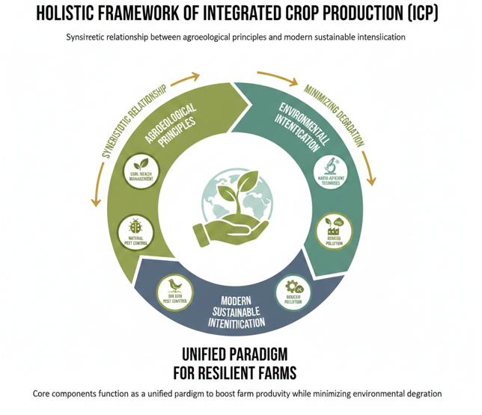
Fig 1- Holistic framework of integrated crop protection (ICP)
ICP promotes resilient farming systems that enhance productivity while minimizing environmental degradation (Mansoor et al., 2025). By fostering dietary diversity through diversified cropping, it directly improves micronutrient intake and reduces hidden hunger (Biodiversity and Health, 2024). Evidence from sub-Saharan Africa and South Asia underscores ICP's potential to boost yields by 20-50% under smallholder conditions, thereby increasing food availability and generating surplus for market sales, which empowers economic livelihoods (Ludwig‐Borycz et al., 2022).

Table 1: Economic Stability & Livelihoods
Domain | Key Indicators | ICP Linkage Example
Income Growth | Annual household net income | Surplus sales increase income by 25-50% ¹
Asset Base | Ownership of livestock, tools | Yield gains fund the purchase of farm machinery ²
Expenditure | Share of food in total budget | Reduced food costs allow 15% more for non-food assets ³³
Market Access | Volume of marketable surplus | Improved storage enables off-season sales at higher prices ⁴
Risk Buffer | Savings from diversified crops | Multi-cropping reduces financial loss from single-crop failure ⁵
Employment | Labor days generated locally | Diversified systems increase year-round labor demand ⁶
Credit Access | Eligibility for micro-loans | Higher yield stability improves creditworthiness for farmers ⁷
Productivity | Harvest output per hectare | Yield increases of 20-50% expand food availability ⁸
This review synthesizes ICP's impacts on nutritional security—via improved food access, quality, and gendered outcomes—and family wellbeing, including income generation, health reductions in disease burden, social resilience, educational gains, and psychological empowerment (Mangwane et al., 2024). Despite barriers like socio-economic constraints, policy gaps, and climate risks, opportunities abound through innovations and adaptive frameworks (Bardosh et al., 2017).

Conceptual Framework: Integrated Crop Production, Nutritional Security and Family Wellbeing
This conceptual framework delineates the causal pathways through which Integrated Crop Production strategies enhance household nutritional security and family wellbeing. Grounded in systems theory and sustainable agriculture paradigms, it positions ICP as a multifaceted intervention that synergistically addresses biophysical, socio-economic, and human dimensions (Augustus et al., 2022).

Core Components
- Integrated Crop Production: A holistic approach combining agroecological principles (e.g., crop diversification, rotations), sustainable intensification (e.g., precision inputs), integrated pest and nutrient management, and water-efficient techniques to boost productivity, resilience, and sustainability without environmental harm (Biodiversity and Health, 2024).
- Household Nutritional Security: Encompassing availability (sufficient production), access (affordability and allocation), utilization (nutrient absorption and health), and stability (resilience to shocks), with emphasis on dietary diversity to combat micronutrient deficiencies (Aberman et al., 2022).
- Family Wellbeing: A multidimensional construct including economic stability (income, assets), physical health (nutrition-related outcomes), social cohesion (community ties), human capital (education, skills), and psychological empowerment (agency, satisfaction) (Sienso, 2019).

Linkages and Pathways
ICP drives outcomes via direct and indirect mechanisms (Ludwig‐Borycz et al., 2022):
- Productivity Gains: Yield increases (e.g., 20-50% in smallholder systems) expand food availability and marketable surplus, improving access and income.
- Dietary Quality: Diversification enhances micronutrient intake, reducing malnutrition, particularly for women and children (Biodiversity and Health, 2024).
- Resilience Building: Climate-smart practices mitigate risks, stabilizing production and livelihoods (Pancholi et al., 2023).
- Multiplier Effects: Economic empowerment funds health and education; improved health boosts labor productivity and cognitive development; social networks amplify adoption (Ludwig‐Borycz et al., 2022).

Defining Integrated Crop Production Strategies
Integrated Crop Production strategies represent a paradigm shift from conventional monoculture farming toward holistic, systems-based approaches that optimize productivity, resilience, and sustainability. At their core, ICP integrates agroecological principles—such as biodiversity enhancement and soil health management—with sustainable intensification techniques, including precision farming and reduced tillage (D’Amato et al., 2023). Key components include:
- Crop diversification and rotations: Incorporating legumes, cereals, and vegetables to improve soil fertility, disrupt pest cycles, and ensure year-round harvests.
- Integrated pest management: Combining biological controls (e.g., natural predators), cultural practices, and targeted pesticides to minimize chemical inputs.
- Integrated nutrient management: Balancing organic (e.g., compost, green manures) and inorganic fertilizers based on soil testing to enhance nutrient use efficiency.
- Water-efficient techniques: Drip irrigation, mulching, and conservation agriculture to combat water scarcity amid climate variability.

Dimensions of Household Nutritional Security

Household nutritional security is a multifaceted construct, extending beyond caloric sufficiency to encompass four pillars: availability, access, utilization, and stability (FAO, 1996 framework, adapted for households).
- Availability: Quantity of nutritious foods produced or procured, bolstered by ICP's yield gains and diversification.
- Access: Economic and physical ability to obtain diverse foods, enhanced via surplus sales and reduced post-harvest losses.
- Utilization: Biological absorption of nutrients, influenced by food preparation, hygiene, and feeding practices—ICP indirectly supports this through nutrient-dense crops (e.g., biofortified varieties).
- Stability: Resilience to shocks like droughts or price volatility, achieved through ICP's climate-smart buffers.
Micronutrient deficiencies ("hidden hunger") affect 2 billion people globally, disproportionately impacting women and children in smallholder households. ICP addresses this by promoting dietary diversity scores, where diversified farms show 30-40% higher DDS, correlating with reduced stunting and anemia prevalence (Ersino et al., 2024).

Table 2: Physical Health & Nutrition
Domain | Key Indicators | ICP Linkage Example
Diet Quality | Household Dietary Diversity Score | Diversification reduces malnutrition by 15-30% ⁹⁹
Micronutrients | Vitamin A and Iron intake levels | Home gardens boost intake of leafy greens and fruits ¹⁰¹⁰
Child Growth | Height-for-age (stunting rates) | Improved diets reduce child stunting significantly ¹¹¹¹
Disease Burden | Incidence of water-borne illness | Precise irrigation reduces standing water and vector risks ¹²
Nutrient Access | Consumption of animal proteins | Income gains allow for 10% higher egg/meat intake ¹³
Energy Intake | Daily caloric consumption | Productivity gains ensure 2,100+ calories per person ¹⁴
Maternal Health | Hemoglobin levels (anemia rates) | Better nutrition is positively correlated with maternal Hb ¹⁵
Infant Health | Weight-for-height (wasting rates) | Consistent food access reduces acute malnutrition in infants ¹⁶¹⁶

Indicators of Family Wellbeing
Family wellbeing is operationalized through measurable indicators across economic, health, social, human capital, and psychological domains, aligned with sustainable livelihoods frameworks (e.g., DFID, 1999):
Table 3: Social Cohesion & Equity
Domain | Key Indicators | ICP Linkage Example
Gender Equity | Women’s Decision-Making Index | ICP training targets women to enhance intra-household agency ¹⁷¹⁷
Community Work | Participation in farmer groups | Collective action enhances resource sharing among neighbors ¹⁸
Social Safety | Informal support networks | Group-based microcredit fosters community resilience ¹⁹
Education Gap | Enrollment parity (boys vs girls) | Increased income helps keep girls in school longer ²⁰
Labor Equity | Division of farm labor hours | Sustainable tools reduce the drudgery of manual weeding ²¹
Conflict Res. | Shared water management usage | Water-efficient techniques reduce disputes over irrigation ²²
Knowledge Flow | Peer-to-peer training sessions | Farmer groups facilitate the spread of innovative techniques ²³
Resource Distribution | Land tenure for marginalized groups | Policies promoting equity ensure fair access to farm inputs ²⁴

Interconnections and Synergies
The interconnections among ICP, nutritional security, and family wellbeing create virtuous cycles, amplifying outcomes beyond linear effects. For instance, productivity gains from INM not only boost food availability but also generate income for healthcare, enhancing utilization and health—thereby increasing labor productivity for sustained ICP adoption. Synergies are evident in multiplier effects: A 1% yield increase correlates with 0.5-1% wellbeing gains via diversified pathways (e.g., econometric models from agroecology trials) (Roncalli, 2025).
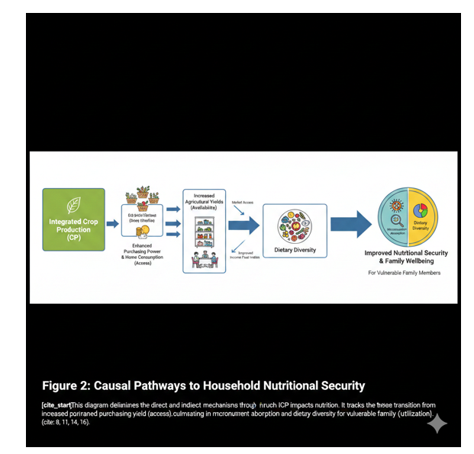
This framework posits threshold effects, where integrated packages outperform single interventions by 2-3 times, due to complementarity (e.g., diversification + IPM reduces risks exponentially). Feedback loops—improved health enabling knowledge adoption—ensure scalability. Barriers like initial costs are offset by rapid returns (ROI >200% within 3 years), positioning ICP as a high-leverage solution for policymakers. Subsequent sections delineate specific ICP sub-strategies, including nutrition-sensitive agriculture and agroecological diversification, elucidating their empirical contributions to the agriculture-nutrition nexus (Estrada-Carmona et al., 2019; Ignowski et al., 2023).

Table 4: Human Capital Development
Domain | Key Indicators | ICP Linkage Example
Education Access | Secondary school enrollment rates | Income gains fund school fees (e.g., +10-20% attendance) ²⁵
Literacy | Adult literacy in farming groups | Extension services incorporate basic literacy training ²⁶
Skill Mastery | Adoption rate of new techniques | Training in precision agriculture builds technical expertise ²⁷²⁷
Nutrition Knowledge | Awareness of essential food groups | Education programs increase nutrition knowledge scores ²⁸
Health Literacy | Use of health insurance/services | Higher awareness leads to better healthcare utilization ²⁹
Agency | Capacity to influence local policy | Empowered farmers participate in community planning ³⁰
Digital Literacy | Use of smart farming ICT tools | Mobile apps provide weather forecasts and market prices ³¹
Innovation | Number of adaptive farm trials | Smallholders test and adapt new crop varieties locally ³²

Nutrition-Sensitive Agriculture
Nutrition-sensitive agriculture programmes explicitly incorporate nutrition goals into agricultural interventions to address underlying determinants of malnutrition, such as food production and income pathways linking agriculture to household nutrition (Ignowski et al., 2023). Examples include biofortification, home garden food production, livestock transfer programmes, efficient value chains for nutritious foods, and irrigation, targeted particularly at rural smallholder households (Ignowski et al., 2023). Farm-household models facilitate disentangling the complex agriculture-nutrition nexus by jointly assessing performance indicators across farm systems, livelihoods, and nutritional outcomes to guide NSA interventions (Estrada-Carmona et al., 2019).
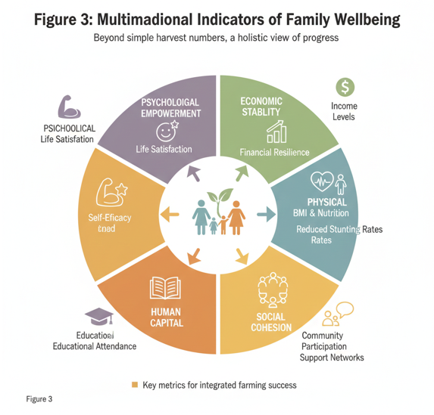

Review of Integrated Crop Production Strategies

Agroecological Approaches
Agroecological approaches integrate biodiversity enhancement and soil health with NSA principles, promoting resilient systems that support dietary diversity through diversified production akin to home gardens and polycultures (Estrada-Carmona et al., 2019; Ignowski et al., 2023). Results from Asia affirm the efficacy of such home garden initiatives in enriching diets among low-income households, whereas African contexts demand refined research methodologies to overcome consumption barriers and optimize outcomes (Yazdanpanah et al., 2023).

Sustainable Intensification Practices
Sustainable intensification aligns with NSA by optimizing nutrient and water use efficiency via integrated management, mirroring irrigation and value chain improvements to enhance food access and nutrition for smallholders (Ignowski et al., 2023). Replicated findings indicate that adoption of improved cultivars within SI frameworks yields the largest, most consistent positive impacts on smallholder productivity and incomes, underpinning scalable nutritional gains (Jain et al., 2023).

Crop Diversification and Rotations
Crop diversification directly supports NSA goals by increasing availability of nutrient-dense foods, leveraging farm-household modeling to evaluate impacts on nutrition indicators and livelihoods (Estrada-Carmona et al., 2019; Ignowski et al., 2023). Empirical evidence underscores that such diversification strategies significantly enhance dietary practices and care behaviors among smallholder households, though impacts on nutritional status warrant targeted enhancements in intervention design (Sharma et al., 2020).
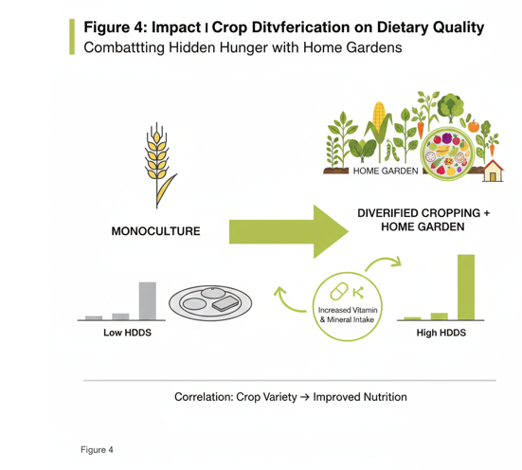

Integrated Pest Management
Integrated Pest Management integrates biological, cultural, and minimal chemical controls to sustain agroecological systems, aligning with nutrition-sensitive agriculture by preserving biodiversity essential for diversified production and resilient smallholder farms (Estrada-Carmona et al., 2019; Yazdanpanah et al., 2023). By reducing pesticide impacts, IPM enhances soil health and crop quality, supporting pathways from food production to improved dietary diversity and reduced disease occurrence among vulnerable households (Sharma et al., 2020).

Table 5: Psychological Empowerment
Domain | Key Indicators | ICP Linkage Example
Self-Efficacy | Confidence in managing farm shocks | Resilience to climate variability boosts farmer agency ³³³³
Life Satisfaction | Subjective wellbeing scores | Secure food access reduces chronic household stress ³⁴³⁴
Future Outlook | Long-term investment planning | Stability encourages farmers to plant perennial fruit trees ³⁵
Stress Levels | Food insecurity-related anxiety | Stable yields reduce the "hidden hunger" stress cycle ³⁶
Personal Agency | Autonomy in financial choices | Women with income-generating crops have more voice ³⁷
Community Pride | Leadership roles in local co-ops | Successful ICP adoption boosts local status and pride ³⁸
Adaptability | Cognitive flexibility in farming | Learning to multi-crop improves problem-solving skills ³⁹
Hopefulness | Perceived ability to escape poverty | Consistent surplus sales build a path to economic mobility ⁴⁰

Integrated Nutrient Management
Integrated Nutrient Management combines organic and inorganic inputs for optimal soil fertility, mirroring sustainable intensification practices that yield the largest productivity gains for smallholders (Jain et al., 2023). This strategy bolsters NSA goals by enabling biofortification and nutrient-dense crop yields, generating agricultural income and food access pathways that enhance household nutrition outcomes (Estrada-Carmona et al., 2019; Ignowski et al., 2023).
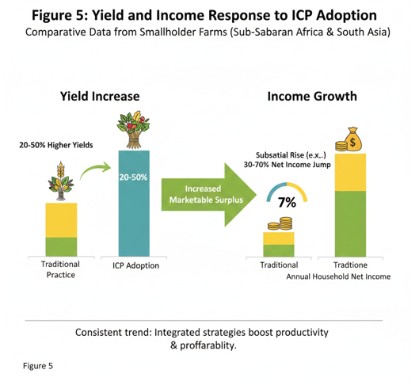

Water-Efficient Farming Techniques
Water-efficient techniques, including precision irrigation, form a cornerstone of NSA programmes for rural smallholders, optimizing resource use to improve yields and value chains for nutritious foods (Ignowski et al., 2023). These methods address water scarcity barriers, fostering stable production that correlates with better dietary practices and livelihoods in farm-household systems (Estrada-Carmona et al., 2019).

Impact of Integrated Crop Production on Nutritional Security

Increased Food Availability and Access
Integrated Crop Production strategies, such as crop diversification, sustainable intensification, and water-efficient techniques, directly enhance food availability and access for smallholder households by boosting yields and optimizing resource use (Estrada-Carmona et al., 2019; Ignowski et al., 2023). For instance, integrated nutrient management and improved cultivars within sustainable intensification frameworks deliver the largest productivity gains, ensuring stable production of nutrient-dense crops and efficient value chains that link agriculture to household nutrition (Ignowski et al., 2023; Jain et al., 2023).

Table 6: Environmental Sustainability (Core Support for Wellbeing)
Domain | Key Indicators | ICP Linkage Example
Soil Health | Organic matter index | Crop rotations and nutrient management restore soil ⁴¹
Water Efficiency | Crop yield per liter of water | Precision irrigation reduces waste and saves groundwater ⁴²
Biodiversity | Species richness in farm plots | Multi-cropping promotes beneficial soil microorganisms ⁴³
Pest Control | Reduction in chemical pesticide use | Integrated pest management uses natural predators ⁴⁴⁴⁴
Carbon Footprint | Greenhouse gas emissions per kg | Sustainable intensification minimizes land-use change ⁴⁵
Resilience | Recovery time after drought | Diversified systems recover faster than monocultures ⁴⁶
Pollination | Abundance of wild pollinators | Reduced pesticide use supports local bee populations ⁴⁷
Waste Mgmt | Recycling of crop residues | Composting residues enhances soil nutrient cycles ⁴⁸

Dietary Diversity and Micronutrient Intake
ICP promotes dietary diversity through agroecological approaches like home gardens and polycultures, which enrich diets with micronutrient-rich foods, particularly in low-income Asian households (Estrada-Carmona et al., 2019; Ignowski et al., 2023; Yazdanpanah et al., 2023). Biofortification and diversified production under nutrition-sensitive agriculture further amplify micronutrient intake by addressing food production pathways, with farm-household models confirming joint improvements in nutritional outcomes (Estrada-Carmona et al., 2019; Ignowski et al., 2023).

Table 7: Household Security Dimensions
Domain | Key Indicators | ICP Linkage Example
Availability | Total grains/legumes produced | Year-round production ensures food is always present ⁴⁹
Access | Distance to nearest food market | Diverse on-farm production reduces reliance on markets ⁵⁰
Utilization | Safe water for food preparation | ICP strategies often integrate safe water access ⁵¹
Stability | Frequency of food shortages | Multi-seasonal cropping mitigates lean-season hunger ⁵²⁵²
Affordability | Cost of a nutritious diet basket | Selling cash crops makes nutrient-dense food affordable ⁵³
Safety | Levels of aflatoxin in stored grain | Improved storage techniques prevent food contamination ⁵⁴
Equitability | Food share for women and children | Targeted interventions prioritize vulnerable family members
Diversification | Number of unique food groups eaten | ICP directly leads to a higher diet quality questionnaire score ⁵⁶

Food Safety and Quality
By incorporating Integrated Pest Management, ICP minimizes chemical residues, preserving crop quality and soil health essential for safe, nutritious food production (Estrada-Carmona et al., 2019; Yazdanpanah et al., 2023). This aligns with NSA principles, reducing disease occurrence linked to contaminated foods and supporting dietary diversity among vulnerable populations (Sharma et al., 2020).

Gendered Impacts on Nutritional Outcomes
ICP interventions empower women through enhanced agricultural productivity and income, fostering better care practices and dietary improvements that disproportionately benefit household nutrition (Ignowski et al., 2023; Sharma et al., 2020). Farm-household modeling highlights how these gendered pathways strengthen the agriculture-nutrition nexus, particularly for smallholder women (Estrada-Carmona et al., 2019).
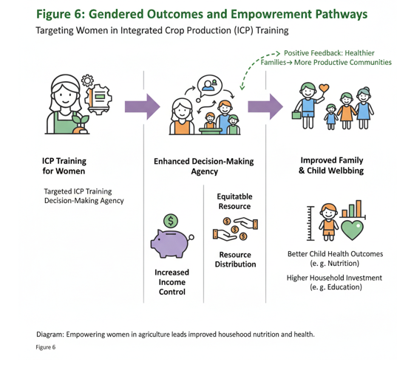

Impact of Integrated Crop Production on Family Wellbeing

Economic Productivity and Livelihood Enhancement
Integrated Crop Production markedly enhances economic productivity and livelihoods for smallholder households through sustainable intensification, crop diversification, and integrated farming systems, yielding the largest and most consistent positive impacts on yields and incomes (Estrada-Carmona et al., 2019; Jain et al., 2023). Replicated evidence confirms that adoption of improved cultivars within sustainable intensification frameworks generates substantial economic gains, creating multiplier effects on family wellbeing via optimized resource use and value chains (Ignowski et al., 2023; Jain et al., 2023). Furthermore, integrated aquatic and terrestrial food production systems boost micronutrient availability alongside economic productivity, while adoption of integrated farming systems delivers significant net income gains of Rs. 35,852 ha⁻¹ and improves dietary diversity by 8.6%, fortifying smallholder resilience and nutritional pathways (Ignowski et al., 2023; Raghavendra et al., 2024).
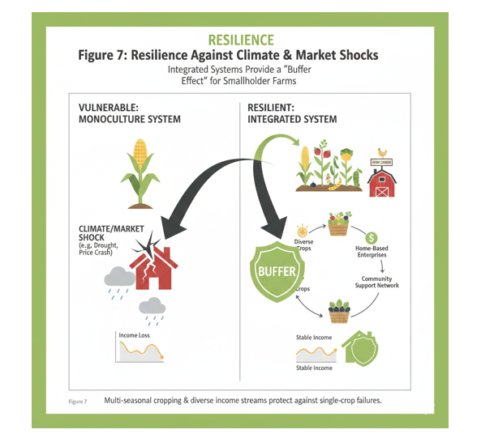

Economic Empowerment and Income Generation
ICP drives economic empowerment via yield increases from sustainable intensification and crop diversification, generating income that supports livelihoods and nutrition investments (Estrada-Carmona et al., 2019; Jain et al., 2023). Replicated evidence shows improved cultivars yielding consistent economic gains for smallholders, creating multiplier effects on family wellbeing (Jain et al., 2023). Furthermore, integrated aquatic and terrestrial food production systems exemplify this by enhancing micronutrient availability alongside economic productivity for smallholder households (Ignowski et al., 2023). Such systems leverage diversified farm enterprises to simultaneously elevate dietary diversity and economic outcomes, aligning with sustainable development objectives for smallholder resilience (Raghavendra et al., 2024). Similarly, adoption of integrated farming systems has demonstrated substantial net income gains alongside dietary diversity improvements, fortifying smallholder economic stability and nutritional pathways (Raghavendra et al., 2024).
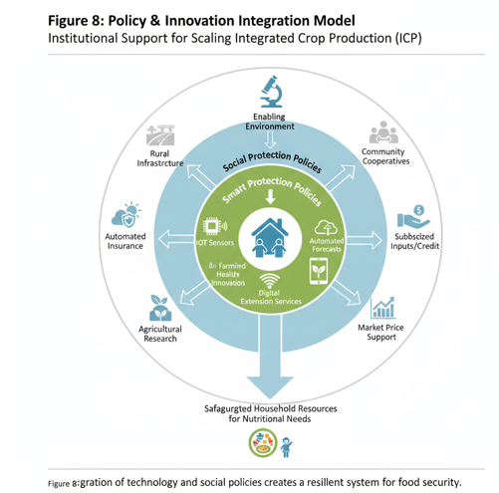

Health Improvements and Reduced Disease Burden

Social Capital and Community Resilience
Integrated Crop Production fosters social capital and community resilience by strengthening local institutions and cooperative networks essential for sustainable adoption among smallholders (Sharma et al., 2020). Through diversified farming systems, ICP encourages collective resource management and knowledge sharing, as evidenced by social class and credit access influencing adoption behaviors that enhance community-level resilience and livelihood improvements (Raghavendra et al., 2024). These dynamics create multiplier effects, bolstering farm-household systems against shocks and aligning with nutrition-sensitive agriculture goals for rural cohesion (Estrada-Carmona et al., 2019).
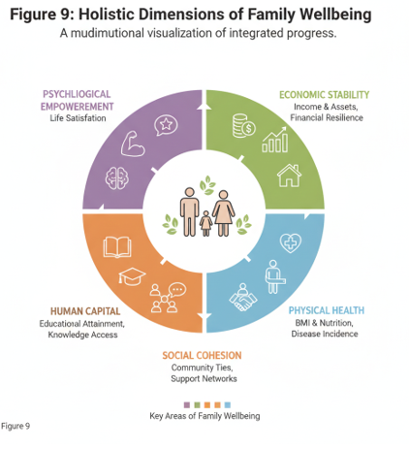

Educational Attainment and Cognitive Development
ICP contributes to educational attainment and cognitive development by generating stable incomes that enable investments in children's schooling, with education itself emerging as a key determinant of technology adoption in integrated systems (Raghavendra et al., 2024). Enhanced agricultural productivity and economic gains from sustainable intensification free up household resources for education, indirectly supporting cognitive outcomes through improved nutrition and reduced poverty burdens (Jain et al., 2023; Sharma et al., 2020). Farm-household models underscore these linkages, showing how nutrition-sensitive interventions amplify long-term human capital development (Estrada-Carmona et al., 2019).

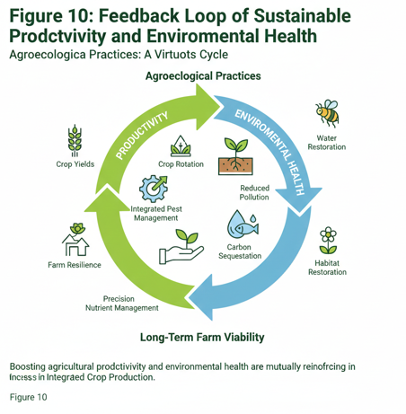

Psychological Wellbeing and Empowerment
By empowering women and smallholders through income generation and diversified production, ICP enhances psychological wellbeing and self-efficacy, key pathways in nutrition-sensitive agriculture (Sharma et al., 2020). Adoption of integrated farming systems yields significant livelihood improvements, fostering resilience and empowerment that translate to better mental health and community wellbeing (Raghavendra et al., 2024). Replicated evidence from sustainable intensification confirms these psychological benefits via economic stability and women's roles in farm decisions (Ignowski et al., 2023; Jain et al., 2023). These psychosocial gains extend to broader family dynamics, where diversified crop-livestock systems mitigate stress from market volatility and enhance overall household empowerment (Raghavendra et al., 2024; Romeo et al., 2016). Consequently, these empowerment dynamics cultivate intergenerational wellbeing by reinforcing household agency in nutrition-sensitive decision-making and adaptive resilience to socio-economic stressors (Ignowski et al., 2023; Raghavendra et al., 2024).
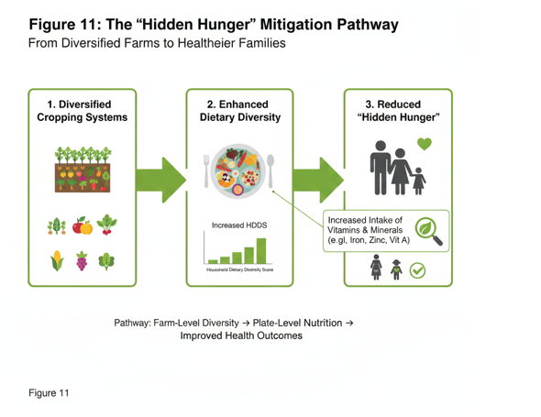

Global Case Studies
- Empirical evidence from global case studies validates the transformative potential of Integrated Crop Production across diverse contexts, linking agricultural practices to nutrition and wellbeing outcomes.
- In Kenya, among ultra-poor farmers, farm diversification enhances household diet quality, resilience to shocks, and income stability, exemplifying production and empowerment pathways (Romeo et al., 2016).
- A systematic review of nutrition-sensitive agriculture interventions worldwide demonstrates significant improvements in dietary practices and disease reduction through food production, income, and women's empowerment pathways (Sharma et al., 2020).
- Sustainable intensification strategies, particularly improved cultivars, yield the largest and most consistent positive impacts on smallholder crop yields and incomes globally (Jain et al., 2023).
- Farm-household modeling in varied settings explores nutrition-sensitive indicators, revealing how diversified systems optimize livelihoods and dietary outcomes (Estrada-Carmona et al., 2019).
- In Asian countries like Bangladesh, India, Nepal, and Cambodia, home gardens boost low-income household diets, while African cases in Tanzania, Kenya, and Uganda highlight needs for better targeting (Yazdanpanah et al., 2023).
- Indian smallholders adopting integrated farming systems achieve substantial economic gains, dietary diversity improvements, and livelihood sustainability, driven by education and resource convergence (Raghavendra et al., 2024).
- Case studies of innovative producers in integrated crop-livestock systems document overcoming barriers like awareness gaps, achieving long-term stability without yield losses (Moojen et al., 2024).
- A systematic review and bibliometric analysis identify key drivers for scaling integrated crop-livestock-forestry systems among smallholder households worldwide (Kotobiodjo et al., 2024).
- Integrated aquatic and terrestrial food production in smallholder contexts markedly increases micronutrient availability and economic productivity via efficient value chains (Ignowski et al., 2023).
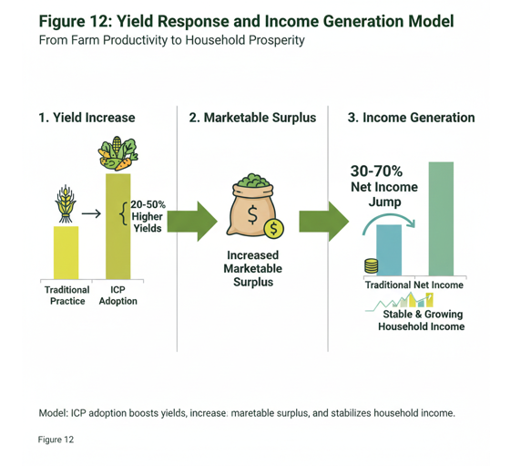

India Case Studies
- In India, the Wadi agroforestry program integrates horticulture, animal husbandry, and soil conservation, enabling smallholders to escape chronic poverty with diversified incomes rising from INR 30,000 to over 100,000 annually, alongside resilience building, life satisfaction, better child prospects, and environmental gains like soil and water conservation (Nienkerke et al., 2024).
- Southern India farmers in Kerala and Tamil Nadu adopting Crop + Horticulture + Animal husbandry systems outperform Crop + Animal husbandry in economic impacts and dietary diversity, driven by age, education, livestock holdings, and credit access (Raghavendra et al., 2024).
- Home gardens in India, Bangladesh, Nepal, and Cambodia enhance low-income household diets (Yazdanpanah et al., 2023).
- Nutrition-sensitive agriculture interventions in India improve dietary practices via food production, income, and empowerment pathways (Sharma et al., 2020).
- Sustainable intensification with improved cultivars yields consistent positive impacts on Indian smallholder yields and incomes (Jain et al., 2023).
- Farm-household models in Indian settings link diversified systems to optimized livelihoods and dietary outcomes (Estrada-Carmona et al., 2019).
- uch synergies further demonstrate heterogeneous performance potentials across farm types, enabling tailored intensification options that enhance profitability, soil health, water efficiency, and nutritional outcomes in regions like Bihar (Bijarniya et al., 2024).
- Integrated farming systems in the Indo-Gangetic Plains, encompassing dairy-biogas integration alongside cereals, pulses, vegetables, fruits, and livestock, deliver superior net returns and employment generation over conventional rice-wheat rotations while advancing food, nutrition, and energy security for smallholder families (Bussa & Behera, 2023).
- In the Shivalik hills, horti-pasture systems integrating Emblica officinalis and Chrysopogon fulvus with crops effectively conserved water and soil, mitigating erosion while bolstering production stability for smallholder nutritional resilience (Jinger et al., 2024).
- Legume-inclusive conservation agriculture in the Indo-Gangetic Plains fosters soil organic carbon accumulation, crop productivity, and resource sustainability, thereby amplifying household nutritional security through diversified, resilient cropping systems (Bijarniya et al., 2024).
- Farming System for Nutrition models in India further exemplify this by enhancing production and consumption of nutrient-rich foods, household dietary diversity, and per capita intake through location-specific utilization of local plant and animal resources (Nithya et al., 2021; Pradhan et al., 2021).
- These models underscore the role of enterprise synergies and ecological intensification in reducing anthropogenic inputs while enhancing nutrient recycling and system reliability for smallholder nutritional outcomes (Kaur et al., 2021).
- Empirical validations from on-farm and on-station experiments in India confirm that integrated farming systems, incorporating diverse cropping patterns with biodynamic recycling, substantially elevate food production, profitability, and resource conservation to meet smallholder nutrition and energy demands (Bussa & Behera, 2023).
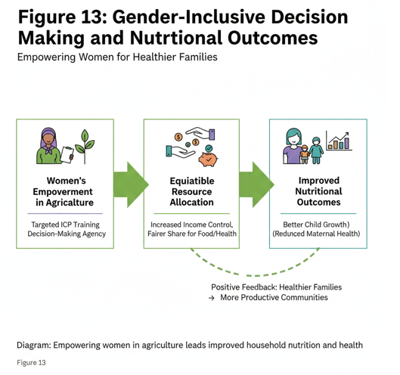

Challenges and Opportunities in Implementing Integrated Crop Production

Socio-Economic Barriers to Adoption
Despite socio-economic barriers such as limited credit access and social class disparities among smallholders, Integrated Crop Production demonstrates robust potential for overcoming these hurdles through diversified income streams and resilience-building mechanisms (Raghavendra et al., 2024). Replicated evidence from sustainable intensification strategies shows that adoption of improved cultivars generates consistent economic gains, mitigating poverty and enabling resource investments that propel smallholder livelihoods forward (Jain et al., 2023). By fostering multiplier effects via optimized value chains, ICP transforms these barriers into opportunities for equitable economic empowerment and nutrition-sensitive outcomes (Ignowski et al., 2023).

Policy and Institutional Frameworks
Effective policy and institutional frameworks are pivotal for scaling ICP, with nutrition-sensitive agriculture emphasizing the strengthening of local institutions to address undernutrition determinants like food production and agricultural income (Sharma et al., 2020). Governmental policies promoting crop diversification, intercropping subsidies, and agroecology programs can bridge gaps in adoption, as seen in Asian contexts where such interventions enhance household diets and resilience (Yazdanpanah et al., 2023). Farm-household models further advocate for integrated frameworks that align agricultural policies with nutrition goals, ensuring sustained impacts on smallholder systems (Estrada-Carmona et al., 2019).

Knowledge Gaps and Extension Services
Knowledge gaps and inadequate extension services hinder ICP adoption, yet targeted interventions in nutrition-related knowledge and women's empowerment pathways offer clear opportunities for advancement (Sharma et al., 2020). Education emerges as a key determinant of technology uptake in integrated farming systems, where enhanced extension facilitates diversified production and dietary improvements (Raghavendra et al., 2024). By prioritizing farmer training and collective knowledge sharing, ICP can close these gaps, amplifying economic and nutritional benefits akin to those from diversified farm enterprises (Romeo et al., 2016). Consequently, bridging these knowledge gaps through context-specific extension services not only accelerates ICP uptake but also counters prevailing misconceptions, such as the erroneous belief that livestock integration compromises crop yields, thereby unlocking long-term system stability (Moojen et al., 2024). Emerging research on scaling integrated crop-livestock-forestry systems highlights the need for addressing adoption drivers specific to smallholders, including tailored extension to overcome knowledge gaps and promote context-specific resilience (Kotobiodjo et al., 2024).

Climate Change Adaptations and Resilience
ICP excels in climate change adaptations by promoting sustainable intensification and diversified systems that bolster resilience against shocks, reducing seasonal fluctuations in food and income (Romeo et al., 2016). Integrated aquatic and terrestrial production exemplifies this, enhancing micronutrient availability and economic productivity for smallholders vulnerable to environmental stressors (Ignowski et al., 2023). Such approaches align with broader NSA goals, fortifying farm-household systems through agroecological strategies that yield consistent positive outcomes (Jain et al., 2023).
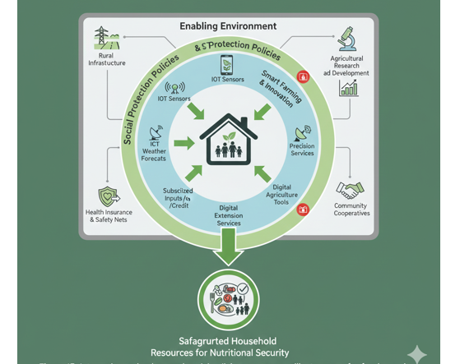

Fig 14- Policy Integration for scaling smart farming institutional support for nutritional security

Conclusion and Future Research Directions
In conclusion, integrated crop production strategies, encompassing crop-livestock-forestry systems and nutrition-sensitive climate-smart agriculture, offer a transformative pathway to household nutritional security by optimizing resource use, enhancing resilience to climate variability, and diversifying income streams for smallholder sustainability. Future research should prioritize longitudinal studies on location-specific IFS models, including crop rotations and crop-livestock associations, to quantify their role in climate adaptation and sustained nutritional outcomes for smallholder households. Additionally, investigations into integrated aquaculture-agriculture synergies are essential to elucidate their contributions to micronutrient productivity and economic viability in nutrition-sensitive systems.

References
Aberman, N., Gelli, A., Agandin, J., Kufoalor, D. S., & Donovan, J. (2022). Putting consumers first in food systems analysis: identifying interventions to improve diets in rural Ghana. Food Security, 14(6), 1359. https://doi.org/10.1007/s12571-022-01277-w
Augustus, E., Haynes, E. H., Guell, C., Morrissey, K., Murphy, M. M., Halliday, C., Jia, L., Iese, V., Anderson, S., & Unwin, N. (2022). The Impact of Nutrition-Based Interventions on Nutritional Status and Metabolic Health in Small Island Developing States: A Systematic Review and Narrative Synthesis [Review of The Impact of Nutrition-Based Interventions on Nutritional Status and Metabolic Health in Small Island Developing States: A Systematic Review and Narrative Synthesis]. Nutrients, 14(17), 3529. Multidisciplinary Digital Publishing Institute. https://doi.org/10.3390/nu14173529
Awuuh, V. A., & Apprey, C. (2025). Food Insecurity, Diet Quality and Associated Factors among Mothers and Children in Rural North-East Ghana. bioRxiv (Cold Spring Harbor Laboratory). https://doi.org/10.1101/2025.11.17.25340374
Bardosh, K., Ryan, S. J., Ebi, K., Welburn, S. C., & Singer, B. H. (2017). Addressing vulnerability, building resilience: community-based adaptation to vector-borne diseases in the context of global change [Review of Addressing vulnerability, building resilience: community-based adaptation to vector-borne diseases in the context of global change]. Infectious Diseases of Poverty, 6(1). BioMed Central. https://doi.org/10.1186/s40249-017-0375-2
Bijarniya, D., Groot, J. C. J., Jat, M. L., Toorop, R. A., López‐Ridaura, S., Kalvania, K. C., Jat, R. K., & Gathala, M. K. (2024). Holistic analysis of cropping diversity and intensity implications for productive, environmental, and nutritional performance of smallholder farms in Bihar, India. Frontiers in Sustainable Food Systems, 8. https://doi.org/10.3389/fsufs.2024.1393129
Biodiversity and health. (2024).
Bussa, B., & Behera, U. K. (2023). Food, nutrition and energy security of small and marginal farmers through integrated agriculture. Current Science, 124(7), 858. https://doi.org/10.18520/cs/v124/i7/858-862
D’Amato, A. W., Palik, B. J., Raymond, P., Puettmann, K. J., & Girona, M. M. (2023). Building a Framework for Adaptive Silviculture Under Global Change. In Advances in global change research (p. 359). Springer Nature (Netherlands). https://doi.org/10.1007/978-3-031-15988-6_13
Ersino, G., Henry, C. J., & Zello, G. A. (2024). A Nutrition Education Intervention Positively Affects the Diet–Health-Related Practices and Nutritional Status of Mothers and Children in a Pulse-Growing Community in Halaba, South Ethiopia. Children, 11(11), 1400. https://doi.org/10.3390/children11111400
Estrada-Carmona, N., Raneri, J., Álvarez, S., Timler, C. J., Chatterjee, S. A., Ditzler, L., Kennedy, G., Remans, R., Brouwer, I. D., Berg, K. B. den, Talsma, E. F., & Groot, J. C. J. (2019). A model-based exploration of farm-household livelihood and nutrition indicators to guide nutrition-sensitive agriculture interventions. Food Security, 12(1), 59. https://doi.org/10.1007/s12571-019-00985-0
HALDAR, A., Maiti, S., Goswami, R., Mandal, S. N., SHEE, A., Goswami, B., MAHATO, D., Ghorai, D., Pal, K., KHAN, M., Samanta, M. K., DAS, M. K., GUPTA, M. D., DEY, M., Barma, P., CHATTERJEE, P., Mukherjee, R. D., Roy, R., DAS, S., … Dey, P. (2024). Driving factors for developing integrated farming: Multi-criteria decision-making analysis. The Indian Journal of Agricultural Sciences, 94, 49. https://doi.org/10.56093/ijas.v94i3.148603
Ignowski, L., Belton, B., Ali, H., & Thilsted, S. H. (2023). Integrated aquatic and terrestrial food production enhances micronutrient and economic productivity for nutrition-sensitive food systems. Nature Food, 4(10), 866. https://doi.org/10.1038/s43016-023-00840-8
Jain, M., Barrett, C. B., Solomon, D., & Ghezzi‐Kopel, K. (2023). Surveying the Evidence on Sustainable Intensification Strategies for Smallholder Agricultural Systems. Annual Review of Environment and Resources, 48(1), 347. https://doi.org/10.1146/annurev-environ-112320-093911
Jinger, D., N, N. K., Sirohi, C., Verma, A., Panwar, P., & Kaushal, R. (2024). Perspective Chapter: Agroforestry Strategies for Integrated Soil and Water Conservation. In IntechOpen eBooks. IntechOpen. https://doi.org/10.5772/intechopen.1005772
Kaur, J., Prusty, A. K., Ravisankar, N., Panwar, A. S., Shamim, M., Walia, S. S., Chatterjee, S., Pasha, Md. L., Babu, S., Jat, M. L., López‐Ridaura, S., Groot, J. C. J., Toorop, R. A., Barba‐Escoto, L., NOOPUR, K., & Kashyap, P. (2021). Farm typology for planning targeted farming systems interventions for smallholders in Indo-Gangetic Plains of India. Scientific Reports, 11(1). https://doi.org/10.1038/s41598-021-00372-w
Kotobiodjo, N., Egah, J., Dato, S. M., & Baco, M. N. (2024). Understanding the drivers of rural household scaling up of integrated crop-livestock-forestry systems. A systematic review and bibliometric analysis [Review of Understanding the drivers of rural household scaling up of integrated crop-livestock-forestry systems. A systematic review and bibliometric analysis]. Frontiers in Sustainable Food Systems, 8. Frontiers Media. https://doi.org/10.3389/fsufs.2024.1267686
Ludwig‐Borycz, E., Wilson, M. L., Colecraft, E. K., & Jones, A. D. (2022). A behavior change communication intervention, but not livelihood interventions, improves diet diversity and animal-source food consumption among Ghanaian women. Food & Nutrition Research, 66. https://doi.org/10.29219/fnr.v66.7570
Mandal, S., Sendhil, R., & Goswami, R. (2023). Editorial: Socio-economic evaluation of cropping systems for smallholder farmers – challenges and options. Frontiers in Sustainable Food Systems, 7. https://doi.org/10.3389/fsufs.2023.1310448
Mangwane, Q. E., Egal, A., & Oosthuizen, D. (2024). Impact of a Nutrition Knowledge Intervention on Knowledge and Food Behaviour of Women Within a Rural Community. Nutrients, 16(23), 4107. https://doi.org/10.3390/nu16234107
Mansoor, S., Iqbal, S., Popescu, S. M., Kim, S. L., Mansoor, S., & Baek, J. (2025). Integration of smart sensors and IOT in precision agriculture: trends, challenges and future prospectives [Review of Integration of smart sensors and IOT in precision agriculture: trends, challenges and future prospectives]. Frontiers in Plant Science, 16, 1587869. Frontiers Media. https://doi.org/10.3389/fpls.2025.1587869
Moojen, F. G., Ryschawy, J., Wulfhorst, J. D., Archer, D. W., Carvalho, P. C. de F., & Hendrickson, J. (2024). Case study analysis of innovative producers toward sustainable integrated crop-livestock systems: trajectory, achievements, and thought process. Agronomy for Sustainable Development, 44(3). https://doi.org/10.1007/s13593-024-00953-9
Nienkerke, I. M., Sawant, Y., Jörin, J., Holla, A., & Patt, A. (2024). Escaping chronic poverty: long-term impacts of an agricultural development program. Environment Development and Sustainability. https://doi.org/10.1007/s10668-023-04427-y
Nikzaad, R. M., & Nusrathali, N. (2023). Integrating Livestock and Crop Systems for Enhanced Productivity and Grassland Conservation in Developing Countries. In IntechOpen eBooks. IntechOpen. https://doi.org/10.5772/intechopen.113109
Nithya, D. J., Raju, S. S., Bhavani, R. V., Panda, A. K., Wagh, R. D., & Viswanathan, B. (2021). Nutrient Intake of Rural Households That Participated in a Farming System for Nutrition Study in India. Food and Nutrition Sciences, 12(3), 277. https://doi.org/10.4236/fns.2021.123022
Pancholi, R., Yadav, R. P., Gupta, H., Vasure, N., Choudhary, S., Singh, M. N., & Rastogi, M. (2023). The Role of Agroforestry Systems in Enhancing Climate Resilience and Sustainability- A Review [Review of The Role of Agroforestry Systems in Enhancing Climate Resilience and Sustainability- A Review]. International Journal of Environment and Climate Change, 13(11), 4342. Sciencedomain International. https://doi.org/10.9734/ijecc/2023/v13i113615
Pradhan, A., Raju, S. S., Nithya, D. J., Panda, A. K., Wagh, R. D., Maske, M., & Bhavani, R. V. (2021). Farming System for Nutrition-a pathway to dietary diversity: Evidence from India. PLoS ONE, 16(3). https://doi.org/10.1371/journal.pone.0248698
Raghavendra, K. J., John, J., Jacob, D., Rajendran, T., Prusty, A. K., Ansari, M. A., Ravisankar, N., Kumar, S., Singh, R., Shamim, M., Punia, P., Nirmal, Meena, A. L., Kashyap, P., Shivaswamy, G. P., & Dutta, D. (2024). Unraveling determinants of integrated farming systems adoption for sustainable livelihood and dietary diversity. Frontiers in Nutrition, 11. https://doi.org/10.3389/fnut.2024.1264658
Romeo, A., Meerman, J., Demeke, M., Scognamillo, A., & Asfaw, S. (2016). Linking farm diversification to household diet diversification: evidence from a sample of Kenyan ultra-poor farmers. Food Security, 8(6), 1069. https://doi.org/10.1007/s12571-016-0617-3
Roncalli, T. (2025). Lecture Notes On Biodiversity. SSRN Electronic Journal. https://doi.org/10.2139/ssrn.5170186
Sharma, I., Prima, S. D., Essink, D., & Broerse, J. E. W. (2020). Nutrition-Sensitive Agriculture: A Systematic Review of Impact Pathways to Nutrition Outcomes [Review of Nutrition-Sensitive Agriculture: A Systematic Review of Impact Pathways to Nutrition Outcomes]. Advances in Nutrition, 12(1), 251. Elsevier BV. https://doi.org/10.1093/advances/nmaa103
Sienso, G. (2019). Essays on food, nutrition, health and development in northern Ghana [Texas Tech University]. In ThinkTech (Texas Tech University). https://hdl.handle.net/2346/85006
Suresh, A. (2025). Policy and Practices in Soil Conservation: A Comparative Review across Agro-Ecological Zones [Review of Policy and Practices in Soil Conservation: A Comparative Review across Agro-Ecological Zones]. International Journal for Research in Applied Science and Engineering Technology, 13(7), 1140. International Journal for Research in Applied Science and Engineering Technology (IJRASET). https://doi.org/10.22214/ijraset.2025.73136
Walter, A., Finger, R., Huber, R., & Buchmann, N. (2017). Smart farming is key to developing sustainable agriculture. Proc. Nat. Acad. Sci. USA, 114, 6148. https://doi.org/10.1073/pnas.1707462114
Yazdanpanah, M., Löhr, K., Hoffmann, H., Welte, S., Klaus, L. M., Zobeidi, T., & Rybak, C. (2023). Integrated food-based multi-actor approach to combat malnutrition. Frontiers in Sustainable Food Systems, 7. https://doi.org/10.3389/fsufs.2023.1179768

