In Vitro Evaluation of Thrombolytic Activity and Flavonoid Profiling of Borassus flabellifer L. Using Streptokinase as Standard on Chicken Blood Clots

Abstract
Heart attacks, strokes, and pulmonary embolism these clot-related problems take a huge toll on people everywhere. These days, there’s growing interest in plant-based answers, especially flavonoids, to fight blood clots naturally. Borassus flabellifer L., which people in Tamil Nadu call the Palmyra palm or 'Karpakatharu,' has a long history in traditional medicine for helping with heart issues. But honestly, hard scientific evidence for its clot-busting ability is pretty scarce. That’s why this study zeroed in on seed coat extract from Borassus flabellifer L. Researchers wanted to know does it actually break down clots in the lab? And, is its power linked to how much flavonoid it has? They ran tests comparing the extract to streptokinase, which is a go-to drug for breaking down clots, and used plain water as a control. Here’s what they did: they picked tender seeds from southern Tamil Nadu, dried and powdered them, then soaked them in ethanol for 72 hours. Once they screened for phytochemicals, they measured flavonoid content with UV spectrophotometry at 280 nm and put the extract up against chicken blood clots. Two dilutions 5 mL and 10 mL (both cut 1:10) were tested next to the controls, and the whole setup sat for 90 minutes. The extract turned out to be loaded with flavonoids; the absorbance at 280 nm shot up to 4.000. The smaller dose broke down about 27% of the clot, and the larger one got to 46%. Streptokinase, no surprise, was the powerhouse at 72%, while water barely made a dent, only 2.5%. Bigger doses meant more clots disappeared. In short, Borassus flabellifer L. seed coat extracts actually did the job it broke down clots in a dose-dependent way, most likely because of all those flavonoids. This matches up with the old folk wisdom about the plant’s heart benefits, and it could have a future as a natural source for clot-busting drugs. It’s definitely a lead worth pursuing.
Keywords: Borassus flabellifer L.; Palmyra palm; thrombolytic activity; flavonoids; streptokinase; clot lysis; in vitro; phytochemicals

- INTRODUCTION
Thrombotic diseases like heart attacks, strokes, deep vein thrombosis, and pulmonary embolism are a major cause of illness and death worldwide. At the root of these problems, you get blood clots packed with fibrin that build up inside blood vessels, blocking flow and leading to sudden damage in the tissues. To break up these clots, doctors rely on thrombolytic drugs. Basically, these medications kickstart the body’s natural system for dissolving clots.
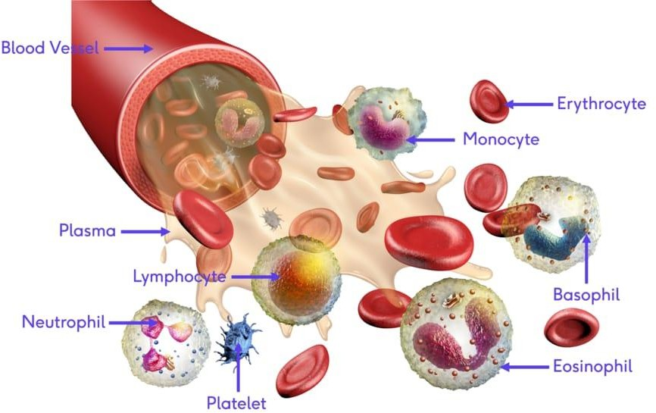
Right now, the main drugs such as streptokinase, urokinase, alteplase, reteplase, and Tenecteplase all work by switching plasminogen into plasmin (the enzyme that chops up fibrin and opens blocked vessels). While they're effective, each has its drawbacks. Streptokinase is affordable and used a lot in places with fewer resources, but it's not specific to fibrin, can trigger immune reactions, and often leads to bleeding. The newer, more targeted drugs are safer, but they’re expensive and out of reach for many people in developing countries. That leaves a real need for safer and cheaper alternatives ideally, something natural.
Fig 1. Blood and its components
Medicinal plants have always been key players in drug discovery. Around a third of all plant species have been used for health at some point. The compounds inside, especially polyphenols and flavonoids, have shown a lot of promise for heart health. They're antioxidant, anti-inflammatory, stop platelets from clumping, and even help break clots.
Borassus flabellifer L. the Palmyra palm, or ‘Tala palm’ is a tall tree native to South and Southeast Asia, plus parts of Africa, and stands out in India (mainly Tamil Nadu, which holds about 58% of India's Palmyra trees). Locally, people call it ‘Karpakatharu,’ the wish-granting tree, and use almost every part for traditional medicine treating inflammation, digestive problems, skin issues, and heart conditions. The plant is loaded with bioactive compounds: flavonoids, tannins, saponins, steroids, glycosides. Researchers have found quercetin derivatives, kaempferol glycosides, and catechin in different bits of the tree. These flavonoids are thought to help break down clots, stop platelets from sticking together, and improve blood vessel health.
But, so far, there hasn’t been a thorough lab study looking at how well the seed coat extract of Borassus flabellifer L. breaks up clots especially with a proper flavonoid analysis alongside. That’s what this study set out to do: first, by preparing an ethanolic extract from the seed coat; second, by running phytochemical screens and measuring flavonoid content with UV spectrophotometry; third, by testing its clot-busting power compared to streptokinase using a gravimetric method with chicken blood clots.

2.MATERIALS AND METHODS
  - Plant Material Collection and Authentication
We picked up fresh Borassus flabellifer L. seeds from a palm grove in southern Tamil Nadu during the summer of 2024–2025. The Siddha Medicinal Plants Garden (SMPG) at the Central Council for Research in Siddha checked and confirmed the identity of the plant (Authentication Certificate No. B1511250170F, dated 21.11.2025), and they're part of the Ministry of Ayush, Government of India, in Mettur Dam, Tamil Nadu. We kept a voucher specimen in the Department of Pharmacology at SSM College of Pharmacy, Jambai.
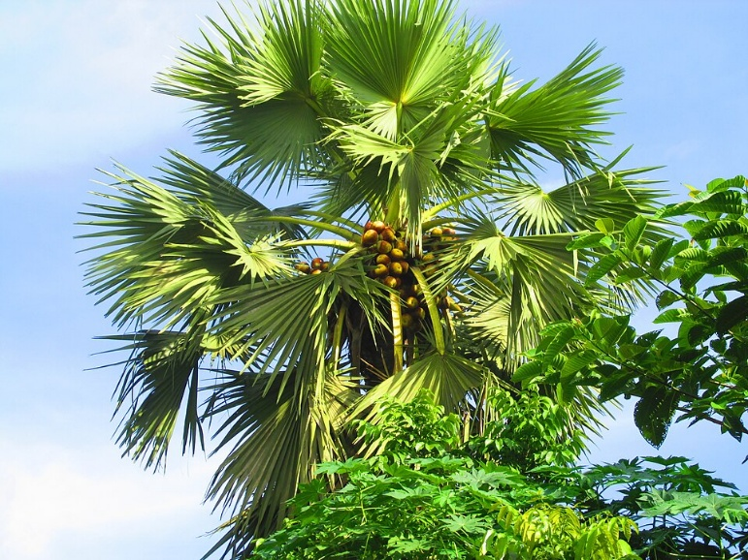

Fig 2. Borassus flabellifer L. or Palmyra palm
  - Preparation of Ethanolic Extract
Firstly, I rinsed the seeds with a steady stream of running tap water for about two minutes to remove anything on the surface. Next, I removed the seed coats by carefully peeling them off with a sterile stainless-steel knife. Finally, the seeds dried in the shade at room temperature for five days. Once dried, I crushed the seeds to a powder with a mechanical grinder. The powder was stored in a container at room temperature until I needed it. For the ethanolic extract, I used cold maceration. I took 10 grams of the dried and powdered seed coat and soaked it in 100 millilitres of analytical-grade ethanol. The mixture was stored in a sterile and airtight container at room temperature for 72 hours with occasional shaking to facilitate extraction. Finally, I filtered the mixture with Whatman No. 1 filter paper after 72 hours. The filtrate was stored at room temperature until the ethanol evaporated, leaving a thick semi-solid substance. The substance was stored at 4 degrees Celsius until I needed it.
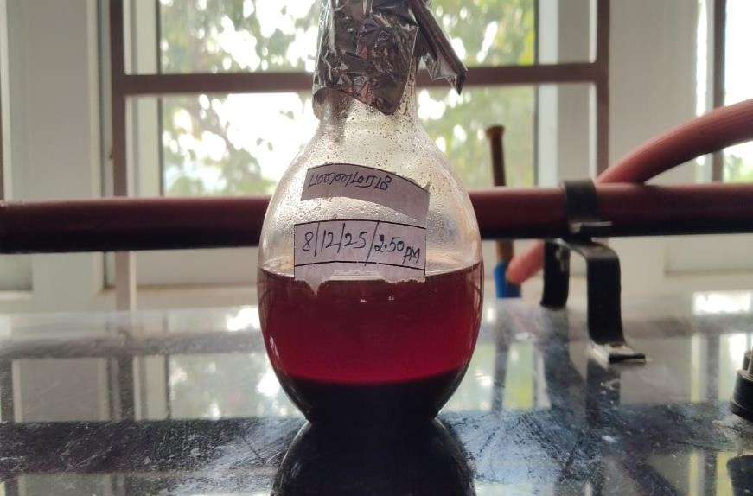
Qualitative Phytochemical Screening
Fig 3. Ethanolic Extraction of Borassus flabellifer L.
I dissolved 10 mg of the ethanolic extract in 10 mL of ethanol. Then, I ran a set of standard chemical tests to figure out which phytochemicals were in the extract. For tannins and phenolic compounds, I used ferric chloride. Frothing tested for saponins. To check for proteins, I relied on the Bradford assay. The Shinoda test helped me spot flavonoids. Dragendorff’s revealed alkaloids, Salkowski’s worked for steroids and terpenoids, Borntrager’s showed anthraquinones, and Keller-Killiani confirmed cardiac glycosides.
  - UV Spectrophotometric Analysis (Flavonoid Quantification)
I dissolved 10 mg of the ethanolic extract in 10 mL of ethanol, then ran a series of standard chemical tests to see which phytochemicals were present. For tannins and phenolic compounds, I used ferric chloride. To check for saponins, I tried the frothing test. I used the Bradford assay to look for proteins. Shinoda helped me spot flavonoids. For alkaloids, I went with Dragendorff’s reagent. Salkowski’s test showed me which steroids and terpenoids were there, and for anthraquinones, I used Borntrager’s. Finally, the Keller-Killiani test pointed out any cardiac glycosides.
  - Collection of Chicken Blood and Preparation of Blood Clots
We collected fresh chicken blood right after slaughter from a licensed local facility, using aseptic techniques to keep its natural ability to clot. We didn't add any anticoagulant. The blood went straight from the slaughterhouse to the lab. There, we put about 2 grams of blood into each pre-weighed test tube and let it sit at 37°C for 45 minutes to clot. Once the blood clotted, we gently poured off the serum, then weighed the tubes again to find out how much clot had formed. Since we only used blood from chickens after slaughter, not live animals, we didn’t need approval from the Institutional Animal Ethics Committee (IAEC).

  - Preparation of Standard Streptokinase Solution
Commercially available streptokinase (1,500,000 IU/vial) was reconstituted with sterile distilled water as per the manufacturer's instructions. The prepared solution was used as the positive control in the thrombolytic assay.
  - In Vitro Thrombolytic Assay
We used the gravimetric clot lysis method to test thrombolytic activity. First, we weighed each test tube with its blood clot, then subtracted the empty tube’s weight to get the real clot weight. We set up the experimental groups and incubated all tubes at 37°C for 90 minutes. After that, we poured out the fluid from the lysed clots and weighed the tubes again. To figure out the percentage of clot lysis, we used this formula:

Group | Treatment | Details
Control | Distilled water (negative) | 5 mL distilled water added to clot-containing tube
Standard | Streptokinase (positive) | 1,500,000 IU reconstituted streptokinase solution added to clot
S1 (Low dose) | Plant extract 5 mL (1:10 dilution) | 5 mL of 1:10 diluted ethanolic extract added to clot (initial clot weight 2 g)
S2 (High dose) | Plant extract 10 mL (1:10 dilution) | 10 mL of 1:10 diluted ethanolic extract added to clot (initial clot weight 2 g)

Table 1. Experimental groups for thrombolytic assay.

% Clot Lysis = [(Weight of clot before lysis − Weight of clot after lysis) / Weight of clot before lysis] × 100
3.RESULTS
3.1 Qualitative Phytochemical Screening
When researchers looked at the ethanolic seed coat extract from Borassus flabellifer L., they found flavonoids were the main bioactive compound. The Shinoda test nailed it, giving a red-pink color when they mixed the extract with magnesium chloride and concentrated HCl. As for the other big phytochemical groups—terpenoids, saponins, tannins, alkaloids, and cardiac glycosides—they came up negative in this extract. ou can see all the results in Table 2.
Fig 4. Shinoda test
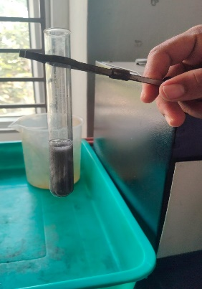
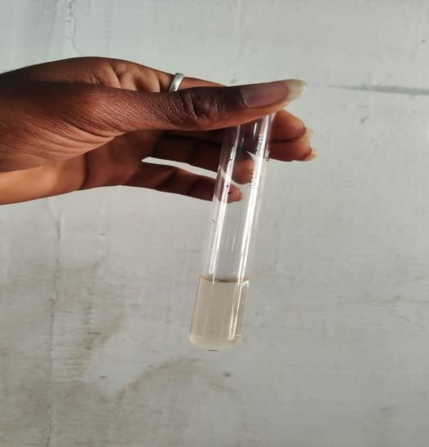
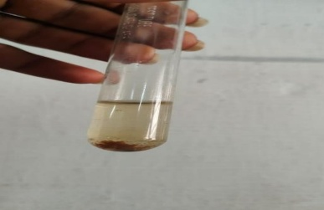
Dragendorff test
Ferric chloride test
Phytochemical Test | Result
Flavonoids | Present (+)
Terpenoids | Absent (−)
Saponins | Absent (−)
Tannins | Absent (−)
Alkaloids | Absent (−)
Cardiac Glycosides | Absent (−)
Phenols | Absent (−)
Steroids | Absent (−)
Table 2. Qualitative phytochemical screening results of ethanolic seed coat extract of Borassus flabellifer L.
3.2 UV Spectrophotometric Analysis
When we scanned the ethanolic extract with UV spectrophotometry between 200 and 400 nm, we saw a strong absorption peak at 280 nm, with an absorbance of 4.000 Abs. That’s usually a sign there’s a good number of flavonoids and polyphenolic compounds present, since these types of molecules tend to absorb light between 250 and 300 nm—thanks to their aromatic rings and the way electrons jump around in those structures. Such a high reading at this wavelength shows the extract contains a lot of flavonoids.
Fig 5. UV Spectrophotometric Reading
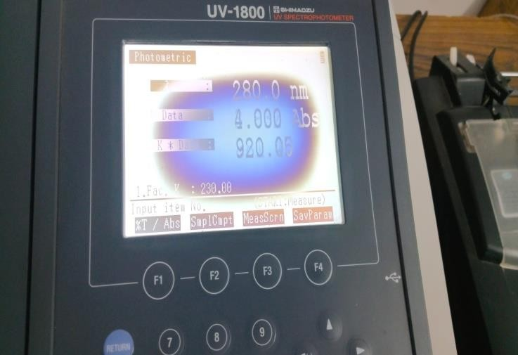

3.3 In Vitro Thrombolytic Activity
Table 3 sums up how the plant extract performed against blood clots, comparing two doses with a standard drug. The positive control, streptokinase, cleared away 72% of the clot, while distilled water (our negative control) only managed 2.5%. That reassures us the experiment’s working as it should. When we tested the extract, the smaller dose (S1, 5 mL) broke down 27% of the clot, and the larger dose (S2, 10 mL) got up to 46%. Basically, the more extract we used, the stronger the clot-busting effect became.

Group | Treatment | Clot Weight Lost (g) | % Clot Lysis
Control | Distilled water (negative) | 0.05 | 2.5
Standard | Streptokinase (positive) | 1.44 | 72.0
S1 | Extract 5 mL (1:10 dilution) | 0.54 | 27.0
S2 | Extract 10 mL (1:10 dilution) | 0.92 | 46.0
Table 3. In vitro thrombolytic activity of Borassus flabellifer L. ethanolic seed coat extract compared to streptokinase and distilled water control.

3.4 Dose-Dependent Absorbance Profile
Concentration (µg/mL) | % Clot Lysis (Mean ± SD)
1 | 10 ± 5.77
2.5 | 13 ± 5.77
5 | 27 ± 5.77
10 | 46 ± 5.77
Table 4. Concentration-dependent thrombolytic activity (% clot lysis) of ethanolic extract of Borassus flabellifer L.

4. DISCUSSION
This study is the first to look closely at how the ethanolic seed coat extract from Borassus flabellifer L. breaks down blood clots in vitro, while also mapping out what’s actually in the extract. Here’s the key takeaway: the extract shows real promise. At the highest volume tested (10 mL at a 1:10 dilution), it cleared away 46% of the clot, which is about 64% as effective as the standard drug, streptokinase (72%). That’s impressive, especially considering the extraction method was pretty basic.

Flavonoids came out on top as the main active compounds in this extract. That matters, especially since flavonoids are well-known for their role in breaking down clots. Prior studies using HPLC-MS/MS have already spotted flavonoids like quercetin, kaempferol, and rutin in Borassus flabellifer L. Molecular docking studies show that these compounds bind strongly to plasminogen activation sites, which help break up clots. Scientists have also found that flavonoids can ramp up tissue plasminogen activator (t-PA), boost plasmin’s ability to break down fibrin, and keep platelets from sticking together. The high UV absorbance seen at 280 nm in this study (4.000 absorbance) further supports that there’s a hefty number of flavonoids in the mix.

Looking closer, as the extract concentration went up from 1 µg/mL to 10 µg/mL clot lysis increased from 10% to 46%. This matches what others have found: higher flavonoid or polyphenol content usually means better clot-busting results. Several recent studies reported strong connections between total flavonoid content and ability to break down blood clots. The current data fits right into these trends, making it even more likely that flavonoids are pulling most of the weight in Borassus flabellifer L.’s effect.

For the experiments, the team used chicken blood clots. That's a smart and ethical switch from human samples, since chicken blood has similar coagulation factors, and this model is well-established for thrombolytic research. The gravimetric approach used to measure clot lysis is straightforward, reliable, and widely accepted even if it’s not as high-tech as some alternatives.

That said, some gaps still exist. Everything here was done in vitro, and the researchers didn’t break down which exact flavonoids are the most active. The extract wasn’t compared to a precise flavonoid standard for quantification, so it’s tough to compare concentrations directly. More importantly, we don’t know yet if this works in living animals there’s no data on safety, efficacy, or bioavailability from in vivo studies.

Next steps are pretty clear. Future work should zero in on exactly which flavonoids are driving the effect, using HPLC or LC-MS. Isolating the most active fractions, testing different doses, and trying this in animal models will all be important. Safety checks are also a must especially cytotoxicity and haemolytic activity to be sure the extract isn’t causing harm.

5. CONCLUSION
This study is the first to show that the ethanolic seed coat extract of Borassus flabellifer L. can break down blood clots in the lab, and it does so in a way that depends on how much you use. At the doses tested, it broke up to 46% of clots less than streptokinase, which managed 72%, but still impressive for a plant extract. Phytochemical screening and UV analysis revealed lots of flavonoids, which helps explain why the extract works. So, science is catching up with tradition: people have used this plant for heart health, and now there’s evidence to back it up. Borassus flabellifer L. stands out as a strong candidate for developing new plant-based drugs to dissolve clots, Of course, this is just the beginning—researchers need to purify the active compounds, figure out their structures, test them in animals, and make sure they're safe before thinking about actual treatments.

COMPETING INTERESTS DISCLAIMER:
Authors have declared that they have no known competing financial interests OR non-financial interests OR personal relationships that could have appeared to influence the work reported in this paper.

6.REFERENCES
1. Mozaffarian D, Benjamin EJ, Go AS, et al. Heart disease and stroke statistics—2016 update: A report from the American Heart Association. Circulation. 2016;133(4):e38–e360.
2. Mackman N. Triggers, targets and treatments for thrombosis. Nature. 2008;451(7181):914–918.
3. Collen D. The plasminogen (fibrinolytic) system. Thrombosis and Haemostasis. 1999;82(2):259–270.
4. Rang HP, Dale MM, Ritter JM, Flower RJ. Rang and Dale's Pharmacology. 8th ed. London: Elsevier; 2015.
5. Farnsworth NR. Screening plants for new medicines. In: Wilson EO, ed. Biodiversity. Washington DC: National Academy Press; 1990:83–97.
6.Middleton E, Kandaswami C, Theoharides TC. The effects of plant flavonoids on mammalian cells: implications for inflammation, heart disease and cancer. Pharmacological Reviews. 2000;52(4):673–751.
7. Sivamaruthi BS, Kesika P, Chaiyasut C, et al. Nutritional and therapeutic potential of palmyra palm (Borassus flabellifer L.): A comprehensive review. Food Research International. 2020;133:109172.
8. Patel S, Goyal A, Sharma K, et al. Borassus flabellifer L.: Comprehensive phytochemical and pharmacological evaluation. Journal of Ayurveda and Integrative Medicine. 2020;11(4):465–472.
9. Kumar R, Sharma V, Sinha AK, et al. Phytochemical profiling and cardiovascular protective potential of Borassus flabellifer L. Journal of Food Biochemistry. 2022;46(3):e14028.
10. Natarajan M, Elizabeth A. Borassus flabellifer seed coat: An in vitro exploration of its antibacterial and antifungal properties with preliminary phytochemical screening. Journal of Medicinal Plants. 2024.
11. Harborne JB, Williams CA. Advances in flavonoid research since 1992. Phytochemistry. 2000;55(6):481–504.
12. Harborne JB. Phytochemical Methods: A Guide to Modern Techniques of Plant Analysis. 3rd ed. London: Chapman and Hall; 1998.
13. Khandelwal KR. Practical Pharmacognosy: Techniques and Experiments. 25th ed. Pune: Nirali Prakashan; 2015.
14. Prasad S, Kashyap RS, Deopujari JY, et al. Development of an in vitro model to study clot lysis activity of thrombolytic drugs. Thrombosis Journal. 2006;4:14.
15. Babu BH, Shylesh BS, Padikkala J. Antioxidant and hepatoprotective effect of Acanthus ilicifolius. Fitoterapia. 2001;72(3):272–277.
16. Islam MS, Ahsan SM, Ahmed KT, et al. Evaluation of in vitro thrombolytic potential of medicinal plants. Asian Pacific Journal of Tropical Biomedicine. 2020;10(6):252–259.
17. Hossain MK, Rahman SM, Nayeem J, et al. Correlation between phytochemical constituents and thrombolytic activity of selected medicinal plants. Journal of Ethnopharmacology. 2023;312:116472.
18. Umesh MK, Sanjeevkumar CB, Nayaka HB, Londonkar RL. Evaluation of in vitro anti-thrombolytic activity and cytotoxicity potential of Typha angustifolia L. leaves extracts. International Journal of Pharmacy and Pharmaceutical Sciences. 2014;6(5):534–538.

