Case report
Novel Precision Tunnel Technique for Isolated Cairo’s Recession Type-1 Coverage in Lower Anterior Teeth - A Case Report

ABSTRACT
Gingival recession is a common mucogingival deformity associated with aesthetic concerns, dentinal hypersensitivity, root caries and plaque retention. Among the various root coverage procedures, the tunneling technique combined with connective tissue graft (CTG) has gained popularity due to its minimally invasive nature and superior aesthetic outcomes. This case report describes the management of an isolated Cairo’s Recession Type-1 (RT-1) in relation to a mandibular incisor using a microsurgical tunneling approach with CTG and root biomodification using 17% EDTA. Complete root coverage with excellent tissue integration and colour harmony was achieved. Preservation of interdental papillae, enhanced vascularity, and reduced surgical trauma contributed to predictable healing. This report highlights the clinical effectiveness of microsurgical tunneling with CTG as a reliable treatment modality for isolated gingival recession defects.
Key Words: Gingival recession, Tunneling technique, Connective tissue graft, EDTA, Microsurgery

INTRODUCTION
Gingival recession is defined as the apical displacement of the gingival margin resulting in exposure of the root surface [1]. It may result in dentinal hypersensitivity, root caries, plaque accumulation and compromised aesthetics, particularly in the anterior region. The aetiology of gingival recession is multifactorial, which includes traumatic tooth brushing, periodontal disease, thin gingival biotype and malpositioned teeth [2].
Several periodontal plastic surgical procedures have been described for root coverage, including coronally advanced flap, free gingival graft, laterally positioned flap and subepithelial connective tissue graft. Among these, connective tissue graft combined with coronally advanced flap is considered the gold standard due to its predictable outcomes and long-term stability [3].
The tunneling technique represents a refinement of traditional flap procedures, allowing placement of a connective tissue graft beneath an intact papillary complex. This approach enhances vascular supply to the graft, minimises post-operative morbidity and improves aesthetic outcomes. The present case report describes the successful management of an isolated Cairo Type I gingival recession using a microsurgical tunneling technique with connective tissue graft.

PRESENTATION OF CASE
A 33-year-old systemically healthy female patient reported to the Department of Periodontics with a chief complaint of unaesthetic appearance and sensitivity in the lower anterior region for the past 1 year. The patient did not report any deleterious oral habits.
Clinical Examination
Intraoral examination revealed an isolated gingival recession on the labial aspect of the mandibular left central incisor (tooth 31), classified as Cairo Recession Type I (Figure 1). The recession defect showed no loss of interdental clinical attachment. Probing depths were within normal limits and an adequate width of keratinised tissue was present. Based on clinical findings, a microsurgical tunneling technique with connective tissue graft was planned to achieve complete root coverage with optimal aesthetic outcome.
Surgical Procedure
Following phase I therapy; the surgical site was anaesthetised using 2% lignocaine as a local infiltration. A single vertical incision was placed distal to 31 and a full-thickness mucoperiosteal tunnel was carefully prepared extending beyond the mucogingival junction till mesial to 41 while preserving the interdental papilla (Figure 2).
Root biomodification was performed using 17% EDTA applied for 2 minutes to remove the smear layer (Figure 3). A CTG was harvested from the right palatal mucosa using loupes () extending from 13 to 16. Using a Hurler’s single-incision technique and the CTG was inserted into the prepared tunnel. The graft was stabilised using Vicryl 5-0 sling sutures (Figure 4). The flap was coronally advanced to completely cover the graft and secured with simple interrupted sutures. Primary closure was achieved at the donor site using Vicryl 5-0 simple interrupted sutures.
Immediate post-operative healing after 2 weeks was uneventful. At the one-week follow-up, satisfactory tissue adaptation with minimal inflammation was observed. At the one-month review, complete root coverage was achieved with excellent colour match, tissue contour and aesthetic harmony (Figure 5). The patient reported complete resolution of dentinal hypersensitivity and expressed satisfaction with the treatment outcome.
DISCUSSION
Achieving predictable root coverage remains a key objective in periodontal plastic surgery due to its functional and aesthetic implications. Among available techniques, subepithelial connective tissue graft has consistently demonstrated superior outcomes over other techniques due to its dual blood supply and color matching.
Zucchelli and De Sanctis (2000) reported that connective tissue graft combined with coronally advanced flap provides reliable root coverage with long-term stability and favourable aesthetic integration [5].
The tunneling technique offers a biologically sound modification by preserving the interdental papillae and maintaining an uninterrupted blood supply to the graft. Allen (1994) emphasised that preservation of papillary integrity enhances graft survival and minimises post-operative recession [4]. In the present case, intact papillary architecture contributed to uneventful healing and complete root coverage.
Minimally invasive principles further improve clinical outcomes. Burkhardt and Lang (2005) demonstrated that microsurgical approaches result in reduced tissue trauma, improved wound stability and superior aesthetic outcomes compared to conventional macrosurgical techniques [8].
Root biomodification with 17% EDTA was employed to enhance connective tissue attachment. Blomlof and Lindskog (1995) showed that EDTA effectively removes the smear layer without causing dentinal erosion, thereby promoting fibroblast adhesion [6]. This may have contributed to favourable soft tissue integration.
Tavelli et al. (2018) concluded that tunneling procedures provide excellent aesthetic outcomes with minimal patient morbidity, particularly in Cairo Type I recession defects [7]. The present case corroborates these findings and highlights the clinical effectiveness of minimally invasive tunneling with connective tissue graft.
Recent randomized clinical trials have continued to evaluate the effectiveness of connective tissue grafts (CTG) and alternative biomaterials in root coverage procedures. In 2019, Stahli et al. evaluated the addition of enamel matrix derivative (EMD) to the modified coronally advanced tunnel technique with subepithelial connective tissue graft (MCAT + SCTG) and reported significant reduction in recession depth and improvement in keratinized tissue width, although EMD did not significantly alter overall outcomes. [9]
In 2020, Gil et al. compared coronally advanced flap (CAF) with and without CTG for single gingival recession defects and reported stable root coverage with both procedures after a 4-year follow-up.[10]
In 2021, Tonetti et al. conducted a multicentre RCT comparing CAF + CTG with xenogeneic collagen matrix for multiple recessions, where CTG demonstrated slightly greater mean root coverage and long-term stability. [11]
In 2022, Dias et al. evaluated adjunctive EMD with CAF + SCTG in a split-mouth RCT and observed higher mean root coverage and improved healing markers. [12]
Long-term results reported in Stahli et.al, 2023 also confirmed the stability of the modified coronally advanced tunnel technique with CTG for RT1 and RT2 recession defects. [13]
In 2024, Balice et al. compared CAF + CTG with leukocyte-platelet rich fibrin (L-PRF) and found superior root coverage with CTG despite reduced morbidity with L-PRF. [14]
Other biomaterial studies 2025, Zucchelli evaluating enamel matrix protein-coated xenogeneic dermal matrices have also shown favourable root coverage and soft-tissue integration. [15]
Most recently, a 2026 Tavelli L et.al. randomized clinical trial comparing CAF + CTG with xenogeneic collagen matrix for maxillary recession defects reported significant improvements in both groups [16]; however, CTG demonstrated slightly higher predictability in mean root coverage, while collagen matrices reduced donor-site morbidity. Additionally, trials comparing modified coronally advanced tunnel technique with CTG versus collagen matrix reported comparable mean root coverage of approximately 96-97%, suggesting collagen matrices may be viable alternatives when minimizing patient morbidity is a priority.

CONCLUSION
Overall, the present case supports existing evidence that minimally invasive tunneling combined with connective tissue graft provides predictable root coverage, favourable aesthetic integration, and stable clinical outcomes, reaffirming CTG as the gold standard for the management of gingival recession defects.

REFERENCES
- Chambrone L, Tatakis DN. Periodontal soft tissue root coverage procedures: A systematic review. J Periodontol 2015; 86:507-21.
- Kassab MM, Cohen RE. The etiology and prevalence of gingival recession. J Am Dent Assoc 2003; 134:220-5.
- Miller PD Jr. A classification of marginal tissue recession. Int J Periodontics Restorative Dent 1985; 5:8-13.
- Allen EP. Subpapillary continuous sling suturing method for soft tissue grafting with the tunneling technique. Int J Periodontics Restorative Dent 1994; 14:206-15.
- Zucchelli G, De Sanctis M. Treatment of multiple recession-type defects in patients with esthetic demands. J Periodontol 2000; 71:1506-14.
- Blomlof J, Lindskog S. Root surface texture and early cell and tissue colonization after different etching modalities. Eur J Oral Sci 1995; 103:17-24.
- Tavelli L, Barootchi S, Ravidà A, Wang HL. Tunneling techniques for root coverage. Periodontol 2000 2018; 77:166-85.
- Burkhardt R, Lang NP. Coverage of localized gingival recessions: Comparison of micro- and macrosurgical techniques. J Clin Periodontol 2005; 32:287-93.
- Stahli A, Rasperini G, Sculean A, Salvi GE. Addition of enamel matrix derivative to the modified coronally advanced tunnel technique with subepithelial connective tissue graft for the treatment of multiple gingival recessions: A randomized clinical trial. J Clin Periodontol. 2019;46(5):637-645.
- Gil A, Bittencourt S, Sallum EA, Nociti FH Jr, Sallum AW, Casati MZ. Coronally advanced flap with or without connective tissue graft for the treatment of single gingival recession defects: 4-year follow-up of a randomized clinical trial. J Clin Periodontol. 2020;47(6):738-746.
- Tonetti MS, Jepsen S, Working Group 2 of the European Workshop on Periodontology. Coronally advanced flap with connective tissue graft versus xenogeneic collagen matrix for treatment of multiple gingival recessions: A multicentre randomized clinical trial. J Clin Periodontol. 2021;48(2):210-221.
- Dias SB, Benic GI, Buser D, Sculean A, Salvi GE. Adjunctive enamel matrix derivative in coronally advanced flap with connective tissue graft for root coverage: A split-mouth randomized controlled clinical trial. Clin Oral Investig. 2022;26(3):2453-2462.
- Stähli A, Salvi GE, Sculean A. Modified coronally advanced tunnel technique with connective tissue graft with or without enamel matrix derivative for multiple gingival recessions: 5-year results of a randomized clinical trial. J Clin Periodontol. 2023;50(4):520-529.
- Balice MP, Campanelli F, Santoro R. Coronally advanced flap with leukocyte-platelet rich fibrin versus connective tissue graft in the treatment of gingival recession: A randomized controlled clinical trial. Dent J (Basel). 2024;12(4):86.
- Zucchelli G, Tavelli L, McGuire MK. Xenogeneic dermal matrix versus connective tissue graft for treatment of multiple gingival recessions: A randomized clinical trial. J Periodontol. 2025;96(2):245-254.
- Tavelli L, Barootchi S, Rasperini G. Coronally advanced flap with connective tissue graft versus xenogeneic collagen matrix for maxillary gingival recession defects: A randomized clinical trial. J Clin Periodontol. 2026;53(1):65-74.

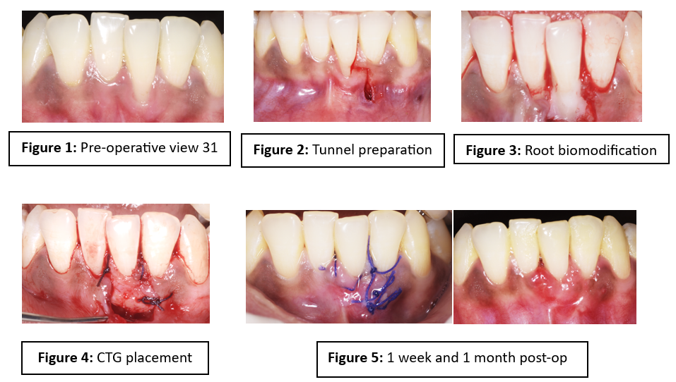
Figure 1: Pre-operative view showing isolated gingival recession in relation to tooth 31
Figure 2: Tunnel preparation preserving interdental papillae
Figure 3: Root biomodification using 17% EDTA
Figure 4: Placement and stabilisation of connective tissue graft
Figure 5: One-week and One-month post-operative view showing complete root coverage respectively.

