Case report

Global development delay with microcephaly and left side hydroureteronephrosis

ABSTRACT:
Global development delay generally affects children in multiple developmental domains, which require a multidisciplinary treatment approach for diagnosis and treatment. It is pivotal to understand the relationship between global development delay (GDD) and associated conditions such as autism. With early diagnosis, targeted intervention, and supportive strategies, children with GDD can achieve significant milestones. We report a child with typical clinical features of GDD alongside microcephaly and hydroureteronephrosis.

KEYWORDS:
Developmental delay, congenital microcephaly, intellectual disability, nephrotic syndrome

INTRODUCTION:
GDD is generally referring to the failure to achieve two or more developmental milestones within the expected age range, generally in children aged 5 years or younger. According to the American Association on Intellectual and Developmental Disabilities, intellectual disability is characterized by a significant limitation in intellectual functioning, such as learning, reasoning, and problem-solving, and adaptive behavior, such as conceptual, social, and practical skills.¹ Various community-based studies in various countries reported that GDD affects around 1% to 3% of children. And the studies also suggested that a family medical history could play a pivotal role in GDD.² Microcephaly (head circumference more than 2 SDs below the mean for age and gender)³ develops only among 0.1% of the general asymptomatic population, but its prevalence in GDD becomes 15 to 20%.⁴ Rare heterozygous de novo mutations in developmental genes were found to be a significant contributing factor in a recent whole exome sequencing (WES) study of children with unidentified developmental abnormalities.¹ Another rare instance in the development delay is the occurrence of hydroureteronephrosis, which occurs when an obstruction or blockage in the urinary tract causes swelling in the ureter and the kidneys. If left untreated, this can lead to serious infection and kidney damage.⁵ A recent study done at Columbia University found that about 10% of kids born with kidney defects have large alterations in their genome that can be linked with neurodevelopmental delay and mental illness.⁶ In this study, we report a case of a 2-year-old child who is admitted to the hospital with GDD with microcephaly and left-sided hydroureteronephrosis (HUN).

CASE REPORT:
A 2-year-old child was admitted to the pediatric department in SIMS hospital on 30 February 2025 with the complaint of fever for 2 days with generalized Tonic-Clonic seizure (GTCS)-type seizures in the morning along with delayed attainment of milestones noted for 4 months of age along with involuntary movements of the bilateral upper limbs along with up rolling of the eyes.

CLINICALS SIGNS:
On examination, the child's heart rate was 132 bpm, respiratory rate was 30 bpm, pulse was 89, SpO₂ was 98% on oxygen prongs, and temperature was 98°F (ca. 37 °C). The central nervous system (CNS) findings show bilateral exaggerated reflex in the biceps, triceps, knee, and ankle and bilateral extensor reflex in the plantar side. Microcephaly was present in the head along with nystagmus in the eyes. Furthermore, the patient was also suffering from congenital talipes equinovarus (CTEV) in the lower limb. The anthropometry measurement reveals weight: 7.5 kg, height: 70 cm, HC: 41.5 cm, CC: 45 cm, MAC: 14 cm, and BMI: 15.3 kg/m². The mother noticed that there was a lack of alertness and decreased movement along with decreased quality of sleep with irritableness overnight. Furthermore, the mother also noticed that the baby was not making eye contact or responding to the mother's voice and had no social smile at 4 months of age. Development assessment shows gross motor: no neck holding; fine motor: no unidextrous/bidextrous reach; language: alert to sound; social: no social smile; vision: does not follow light/object. Furthermore, the baby was also suffering from excessive nausea and vomiting with generalized weakness, which continued till 5 months of age. However, the baby did not have any history of fever with rashes, radiation exposure, or drug intake.

INVESTIGATIONS:
Relevant investigations were done on arrival of the patient. Hematology results show Hb%: 11.1 g/dl, RBC count: 4.97 million/cumm, hematocrit: 35.9%, platelet count: 4.94 lacks/cumm, total WBC count: 16640 cells/cumm, neutrophils: 64%, lymphocytes: 30%, monocytes: 06%, eosinophils: 0%, and basophils: 0%. Renal function test shows Urea: 56 mg/dl, serum creatinine: 0.5 mg/dl serum sodium: 146 mmol/L, serum potassium: 4.7 mmol/L, and serum chloride: 112 mmol/L. Urine culture and sensitivity tests show the presence of enterococcus species in the urine. USG of the abdomen and pelvis shows mild hydroureteronephrosis in the left kidney due to the blockage in the urinary tract.
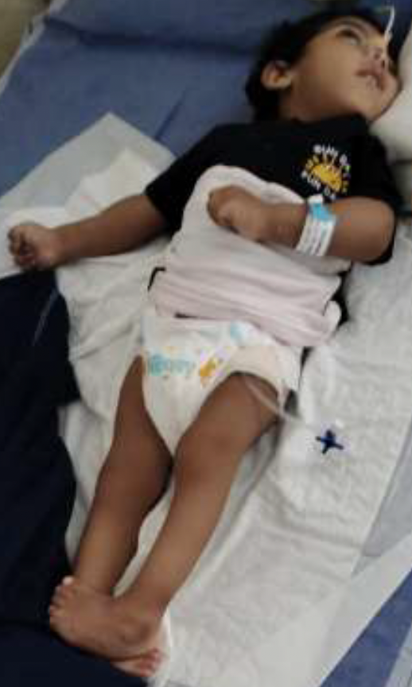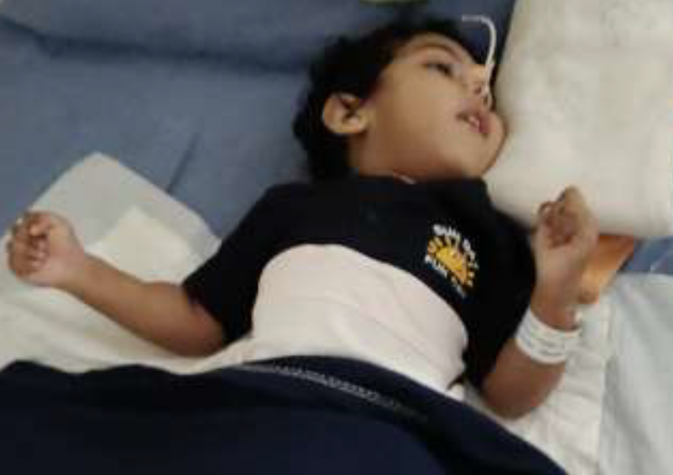
Figure 1: Cleft foot in the lower limb Figure 2: No fine motor skills with lack of
alertness.
THERAPEUTIC INTERVENTION:
After the confirmation of the diagnosis, the child was advised to get a plaster cast (above the knee) with weekly follow-up and the need for a weekly change of the cast, as the child was operated on for the same at 3 months of age. The parents were also told to continue using a Congenital Talipes Equino Varus (CTEV) shoe for clubfoot. Furthermore, the patient was prescribed inj. levipil (20 mg/kg/day). 90 mg IV 1-0-1 at 10 pm and 10 am and inj phenytoin (8 mg/kg/day) 35 mg IV 1-0-1 at 6am and 6pm, inj loraz (0.1 mg/kg) 0.9 mg IV stat, IVF DNS with 5 ml KCL at 15 ml/hr, inj PCT 12 ml in 6 hours, PCT suppository 170 mg (3/4) PR in 6 hours, inj ceftrixone (100 mg/kg/day) 400 mg IV 1-0-1, inj amikacin 120 mg IV OD, O₂ in nasal prongs at 1 liter per minute. Also, it was advised to monitor vitals, sensorium, and the signs of a seizure attack.
DISCUSSION:

GDD is a common condition that is seen in pediatrics and is most frequently caused by structural abnormalities and genetic predisposition. Due to which there will be a delay in two or more development domains such as cognition, social/personal, speech/language, gross/fine motor, and daily activities, which basically affects children under the age of 5. Despite genetic investigations, clinical assessment is very vital to guide making a diagnosis. However, with time, whole genome sequencing/exome sequencing could become the first line of treatment for unexplained GDD.⁷ It is also important to check for the comorbidities that are associated with GDD, such as motor disabilities, epilepsy, feeding disorders, constipation, drooling, vision impairment, malnutrition, and hearing impairment.⁸ In our case, similar development delays were found, such as no social smile with eye contact, lack of alertness, no neck holding, and no fine motor reach. Microcephaly is sometimes common in children, but GDD with microcephaly is a quite rare phenomenon. Microcephaly incidence ranges between 1.3 and 150 cases per 100,000 births. The exact cause of microcephaly is not known; therefore, new clinical characteristics, causes, and pathological mechanisms continue to be identified. However, there are some risk factors that contribute to the occurrence of microcephaly, such as infections, reduced oxygen supply to the fetus, lack of nutrients in the first third of pregnancy, and chemicals or drugs.⁹⁻¹⁰ As there is no cure or specific treatment to increase cerebral growth, it is important to have a proper diagnostic approach, such as proper history collection, cerebral MRI, postnatal clinical evaluation, neuropsychological evaluation, metabolic and genetic testing, toxoplasmosis and others, rubella, cytomegalovirus and herpes (TORCH), and comparative genomic microarray hybridization (CGH).^{8,10} Occupational therapy, speech therapy, and physiotherapy can help improve motor skills among microcephaly patients. A study found that congenital defects of the kidney and urinary tract are accountable for nearly 25% of all birth defects in the US. It is very important to find out about kidney malformation in a child in the early stage, as it could be a warning sign that the child has a genome disorder that needs to be looked at immediately due to the risk of neurodevelopmental delay or mental illness in later life.⁶ Several genetic disorders, including Angelman syndrome, Rett syndrome, Rubinstein-Taybi syndrome, and Christianson syndrome, can cause various neurodevelopmental problems. These disorders arise from mutations in genes crucial for regulating gene expression during the development of the forebrain and hindbrain. Consequently, they pose a significant risk of decelerated head growth resulting microcephaly.¹¹
Furthermore, hydroureteronephrosis can also be linked to developmental delay. Routine prenatal diagnostic checks could reveal the anomaly in the earlier stage, which can be detected by prenatal ultrasound. If confirmed, then during the postnatal period, renal ultrasound, voiding cystourethrogram (VCUG), and renal scan can be used to detect the severity and types of anomalies. If the child has mild to moderate hydroureteronephrosis, sometimes it will correct itself on its own. However, if the condition becomes severe, surgery such as pyeloplasty can be a better option.¹² In this case, surgical correction was done, and the child responded well during the postoperative stage. Furthermore, after the conservative treatment, the vitals were stable, and there was no sign of any infection.

CONCLUSION:
Global development delay is relatively common in pediatric neurologic conditions. Despite few clinical signs, it is important to have a robust medical examination for suspected patients with development delay or learning disability with a complete medical history with the birth details, family history with special emphasis on growth parameters, neurocutaneous stigmata, dysmorphism, and systemic and neurological examination.

ETHICAL APPROVAL: Ethical approval were taken as per international standards.

COMPETING INTERESTS DISCLAIMER:
Authors have declared that they have no known competing financial interests OR non-financial interests OR personal relationships that could have appeared to influence the work reported in this paper.

REFERENCE:
- Vasudevan P, Suri M. A clinical approach to developmental delay and intellectual disability. Clinical Medicine. 2017;17(6):558–61.
- Aldosari AN, Aldosari TS. Comprehensive evaluation of the child with global developmental delays or intellectual disability. Clinical and Experimental Pediatrics. 2024;67(9):435–46.
- Ashwal S, Michelson D, Plawner L, Dobyns WB. Practice Parameter: Evaluation of the child with microcephaly (an evidence-based review) [RETIRED]. Neurology. 2009;73(11):887–97.
- Aggarwal A, Mittal H, Patil R, Debnath S, Rai A. Clinical profile of children with developmental delay and microcephaly. Journal of Neurosciences in Rural Practice. 2013;04(03):288–91.
- The Kingsley Clinic. Hydroureteronephrosis: causes, symptoms, and treatment options - The Kingsley Clinic. The Kingsley Clinic. Accessed on 5 oct 2025. https://thekingsleyclinic.com/resources/hydroureteronephrosis-causes-symptoms-and-treatment-options/
- Surprising Link between Kidney Defects and Neurodevelopmental. Columbia University Irving Medical Center. Accessed on 5 oct 2025.https://www.cuimc.columbia.edu/news/surprising-link-between-kidney-defects-and-neurodevelopmental-disorders-kids
- Mithyantha R, Kneen R, McCann E, Gladstone M. Current evidence-based recommendations on investigating children with global developmental delay. Archives of Disease in Childhood. 2017;102(11):1071–6.
- Choudhary P, Chakrabarty B. Approach to Developmental delay: A Developing World perspective. Deleted Journal. 2024;1(1):16–20.
- Becerra-Solano LE, Mateos-Sánchez L, López-Muñoz E. Microcephaly, an etiopathogenic vision. Pediatrics & Neonatology. 2021;62(4):354–60.
- Moussa Z. Microcephaly: causes, symptoms, and therapy options - NAPA. Accessed on 5 oct 2025. https://napacentre.com.au/microcephaly/
- Seltzer LE, Paciorkowski AR. Genetic disorders associated with postnatal microcephaly. American Journal of Medical Genetics Part C Seminars in Medical Genetics. 2014;166(2):140–55.
- Hydronephrosis | Boston Children’s Hospital. Accessed on 5 oct 2025. https://www.childrenshospital.org/conditions/hydronephrosis

