Original Research Article

A Comparative Study Of The Engineering Properties Of Fired And Unfired Hollow Clay Bricks Stabilized With Lime And Pozzolana

Abstract -The transition to sustainable, energy-efficient masonry has renewed interest in stabilized earth-based bricks as alternatives to fired clay bricks. This study focused on comparative study of engineering properties of fired and unfired hollow clay bricks stabilized with lime and pozzolana. A representative clay was characterized by particle size distribution, Atterberg limits, and X-ray fluorescence (XRF). The soil classified as a highly plastic, slightly silty sand, and both clay and pozzolana contained high reactive silica and alumina contents, indicating strong pozzolanic potential. Hollow bricks incorporating 0% to 8% weight of lime and pozzolana were produced and tested in fired and unfired conditions. Bulk density, water absorption, and 28-day compressive strengths were determined. One hundred and fifty samples were prepared using manual moulding method. These samples were tested for 7 ,14, 21 and 28days. Testing was conducted with universal testing machine. Fired bricks was fired at a temperature of 900˚to 1100˚ in kilns and using an infrared pyrometer thermometer for determining the temperature. Stabilized bricks, increasing lime and pozzolana content led to higher density of 2071.98kg̷ m³ for stabilized 8%LP and 2089.30 kg̷ m³ for fired hollow brick, with reduced water absorption of 0.95% and 0.92% for stabilized 8% LP and fired hollow brick respectively. Additionally, there was improved abrasion resistance of 0.46% as against 0.21% for stabilized and fired respectively. Enhanced compressive strengths, reaching a maximum compressive strength of 2.145 MPa at 8% stabilization. Corresponding fired bricks achieved 15.035 MPa. Lime and pozzolana stabilization therefore substantially improve unfired hollow clay brick performance, offering a viable low-energy alternative to conventional firing for non-load-bearing and low-rise construction, and contributing to reduced environmental impact of masonry materials. Finally, the study of fire resistance of the stabilized brick can be looked at in future research.

Keywords: Lime, Pozzolana, Stabilization, X-ray fluorescence (XRF), Compressive Strength, Bulk density, and Water absorption.
- INTRODUCTION
Every country's ability to develop sustainably depends on its infrastructure, of which providing citizens with affordable housing is essential. Due to the high cost of building materials, the nation faces the problem of inadequate housing, which cannot be satisfied without the use of locally produced materials like burnt bricks (Danso & Akwaboah, 2021). With a quick view of a nearby suburb, one will come across a fast rate of residential houses springing up and in all these, the demand for building materials seen to be going higher and higher by the day. One of the key materials which is dominant in our construction space today is cement. According to Devi (2018), the demand for cement is closely linked to economic growth, and the rapid infrastructure development that many developing economies are aiming for highlights the enormous increase in cement production. However, there are additional environmental issues associated with the use of cement for infrastructure development.

Environmental imbalances, particularly those related to air quality, are largely caused by the cement industry. Grey dust, sulfur dioxide (SO2), and nitrogen oxides (NOx) are the main environmental emissions (Devi, 2018). Furthermore, according to Ba et al. (2022) Dust is the most significant pollution associated with cement production, a study that examined Dust Deposition and Associated Heavy Metal Contamination in the Neighborhood of a Cement Production Plant at Konongo, Ghana. Cement dust contains heavy metals that are dangerous to the biosphere, including chromium, nickel, cobalt, lead, and mercury (Cities, 2008). These are risky. In order to address the growing cost of cementitious materials in our building space, this research paper will examine the use of local or indigenous building materials to create sustainable and eco-friendly bricks. According to a recent study, the construction industry a significant economic sector and one of the biggest consumers of energy and natural resources is adjusting to the use of materials and techniques with less of an impact on the environment due to urgent environmental issues (Pavia, 2020).Due to the high availability of indigenous building materials including clay in our part of the world, hence the need for its utilization in addressing the housing deficit, which according to the 2020 Ghana Statistical Service census stands at over 1.8 million. However, several studies have investigated how the physicomechanical properties of burnt clay bricks can be enhanced by adding various industrial waste and by-products at the proper sintering temperatures (Tang, 2018).

Firing clay brick to the sintering temperature of integrated crystalline phases for mechanical strength resulted in higher carbon footprints, greenhouse gas emissions, and atmospheric particulate matter since low calorific value fossil fuel was employed. Because of this, the conventional brick-firing procedure is energy-intensive, environmentally dangerous, and poses several health hazards in addition to contributing to global warming. Nevertheless, the strength of burnt clay bricks is attributed to the sintering process, which fuses the crystalline mineralogical phases of clay into the pores to densify the microstructure of the brick (Javed et al., 2020). However, in order to avoid the brick firing process, previous research suggested utilizing a lime stabilization strategy to boost soil stiffness and its long-term mechanical strength (Javed et al. 2020). Therefore, this current research aims to examine properties of fired and unfired hollow clay bricks stabilized with lime and pozzolana. The process of adding materials to raw soil to enhance its strength and other performance characteristics for building homes is known as stabilization of soil. The goal of stabilizing a soil is to improve its qualities despite a number of flaws, including dimensional instability for building homes, low strength, cracking shrinkage, and lack of durability. Soil can be stabilized for housing purposes in a number of ways. There are four primary ways to stabilize soil: (1) stabilization through reinforcement; (2) stabilization through water proofing; (3) stabilization through cementing; and (4) stabilization through chemical treatment. One of the techniques, used for this purpose since ancient times, is the incorporation of fibers into the soil matrix (Medina-Martinez,2022).

- MATERIALS AND METHODS
The study made use of various materials, including clay, lime, pozzolana and water.

2.1 Clay
The clay was obtained from a clay deposit site located in Nkuntraw/Ankaful in the Central region of Ghana. The clay was extracted from about 150mm depth below ground level to avoid the inclusion of impurities.
2.2 Lime
Lime for this study was obtained from the Carmeuse in Takoradi in sacks and transported to the factory.
2.3 Pozzolana
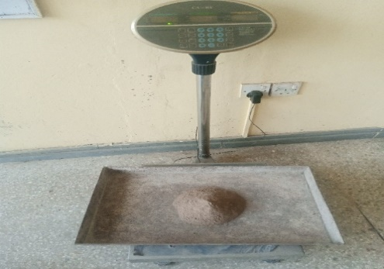
Pozzolana for stabilizing the soil was obtained from CSIR-Building and Road Research Institutes of Kumasi, Ghana.
a
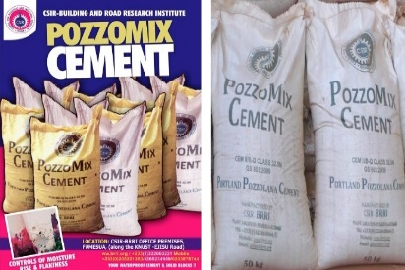
b
Fig 1. (Pozzolana cement) (Pozzolana cement in sacks)

2.3 Water
The water used for this study was clean portable water, was obtained from the brick factory where the mixing and moulding took place. (Ankaful) conforming to
(BS:EN:1008:2002, 2002).

2.4 Determination of Particle size distribution
A standard set of sieves was used for particle size distribution which conforms to BS EN 1377-1-1990. The cumulative passing percentage retained on each sieve was determined. The result obtained was plotted on a graph of the particle sizes showing the percentage passing through the sieve and the sieve size.

2.5 X-Ray refractive Analysis
The Rigaku NEX CG desktop XRF at the University of Ghana, Legon's Department of Earth Science was used for the XRF analysis. Standard ASTM E1621 was followed in the process. Rigaku NEX CG provides quick qualitative and semi-quantitative determination of major and minor atomic elements in a wide range of sample types. Rigaku NEX CG XRF performs non-destructive analysis from æ₁Na to Ψ₂U. Solids, liquids, powders, and thin films can all be used with the Rigaku NEX CG XRF. A sample cup with a lid was filled with four grams (4g) of the sample. A borosilicate bead was used in multi-channel analyzer calibration (MCA) to determine the correlation between the energy of fluorescent x-rays and the channels of spectrum data. Using the fundamental parameters method double determination approach analysis, the samples were exposed to X-ray fluorescence in order to extract major oxides and elemental constituents. Aluminum (Al), molybdenum (Mo), copper (cu), and rigak are the four measurement conditions or secondary targets.

2.6 Preparation of brick specimens
The number of specimens used for the study was determined using BS EN 772-1(2003) as a guide.

2.7 Mixing
The materials for the study were mixed manually. The measured clay was spread on the flat surface. The lime content was then added to the clay followed by pozzolana content respectively as shown in fig. 1, the materials were then mixed until a uniform mixture was attained. Measured water was finally added and mixed thoroughly until a uniform mixture was attained.
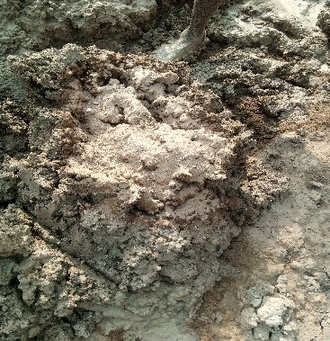
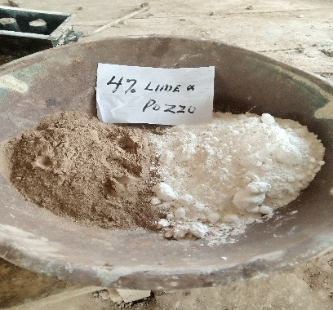
b
a
Fig 2. Clay with Lime and Pozzolana (Batched) Lime and pozzolana

2.8 Moulding
Moulding of the specimen was done manually by the hand and compressed in mould of size 216mm X 102.5mm X 68mm. To ensure easy removal and smooth finish of the brick, the mould was oiled. The mixture was placed in the mould in three layers and compressed using wooden rammer to fill the mould as shown in Fig 3. A metallic string was then used to level the surface of the mould to remove excess mixture and gently removed from mould.
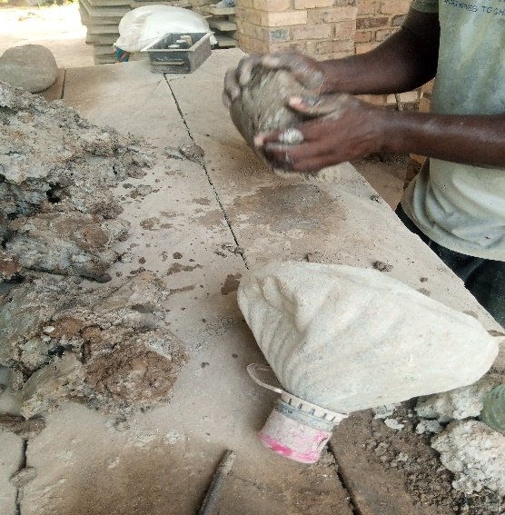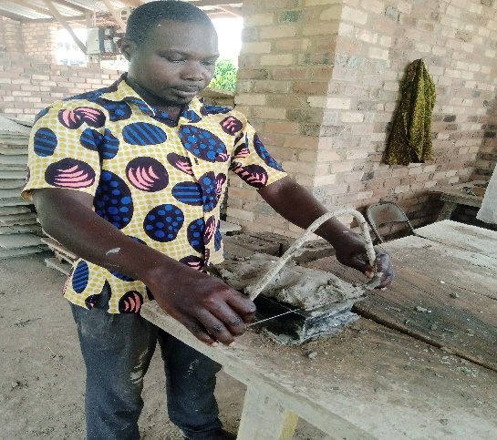
a
b
fig.3 Filling the mould with mixed clay Leveling using the string instrument

2.9 Curing
The specimens were cured using the air-drying for 7,14,21and 28. Some of the samples were fired in an oven. Curing of samples was done in two phases. Air dried under the shade and was also sun dried after three days as shown in figure 4a and 4b respectively.
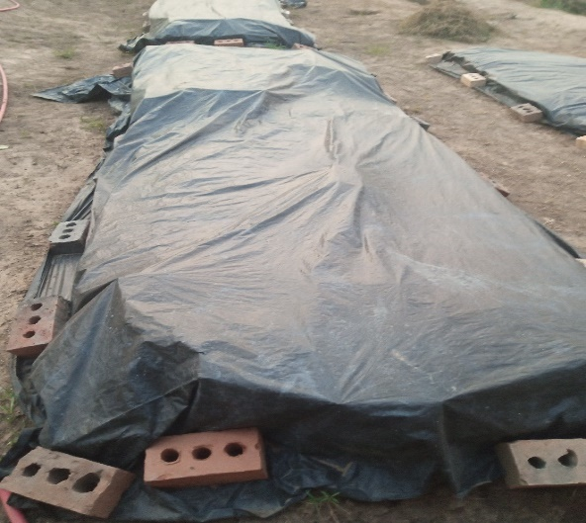
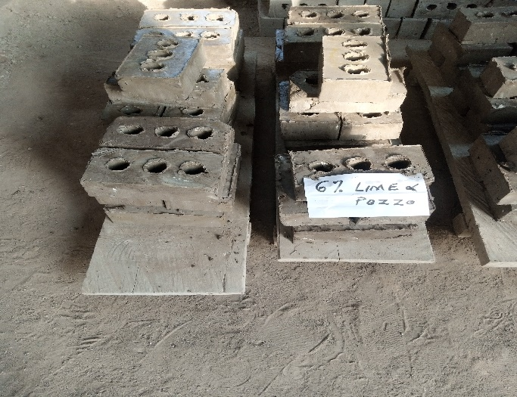
b
a
Fig. 4a (Sun drying) Fig. 4b (Air drying)

2.10 Firing
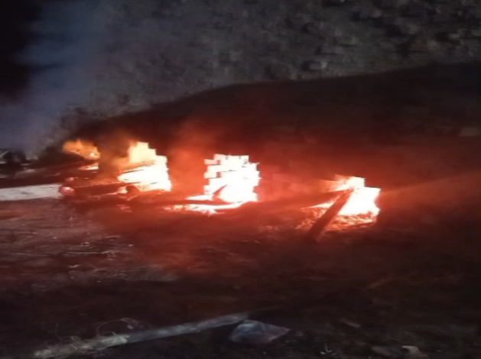
Brick specimens were burnt at a temperature ranging between 900˚to 1100˚ C.
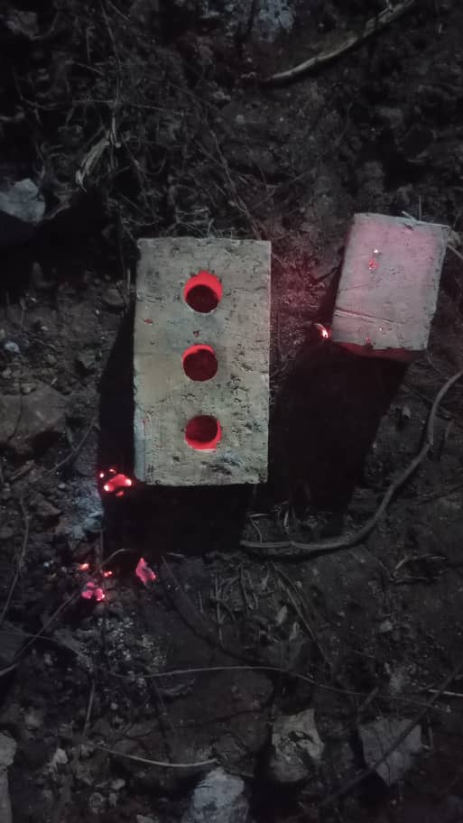Fig. 5a (Burning of bricks) Fig. 5b: (Burnt brick)
b
a

2.11 Testing procedure

2.11.1 Compressive strength
The specimens were tested for compressive strength, water absorption, and bulk density was determined respectively after 7,14,21, and 28 curing days respectively.
Following different curing days, the specimens were tested for compressive strength using BS EN 772-1 (2011) as a reference. The compressive strength test was performed using a universal testing equipment with a maximum capacity of 1000 KN, as shown in figure 6
The brick specimen was subjected to a load delivered by the testing machine at a steady rate of 0.05 N/mm2/s until the specimen broke; the applied load at which the brick failed was noted (N). Then the cross-sectional area of the brick was calculated and recorded (mm²). The maximum compressive strength was calculated using the formula;
F$=\frac{P }{A}$
Where
F=Compressive strength of the brick in (N/mm²)
P= Maximum Load applied to the brick in (N)
A= cross-sectional area of the specimen (mm²)
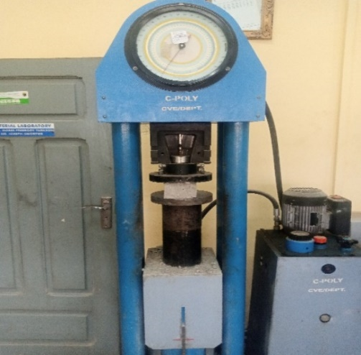
Fig. 6: Universal testing machine

2.11.2 Water absorption
The objective of this test was to determine the percentage of water absorbed by the specimen. The test was conducted using BS EN 772-11(2011) as a guide. Specimen was tested following the various curing days for water absorption in percentage. The bricks specimens were oven-dried at a temperature of 110⁰C for 24 hours. The specimen was then allowed to cool down at normal room temperature and the oven-dried weight of the specimen was recorded as (Md). The specimen was soaked in 5mm depth clean water for 10 minutes. After 10 min. and wiped off their surface water and their final mass was recorded as (Ms). This is shown in the fig.7a and 7b respectively. Water absorption in the percentage of the specimen was calculated using the formula;
$Ws =\frac{Ms- Md }{Md}x100\%$
Where,
Ws is the Water absorption of the specimen (%).
Md is the Mass of the specimen after oven drying (Kg).
Ms is the mass of the specimen after soaking (Kg).

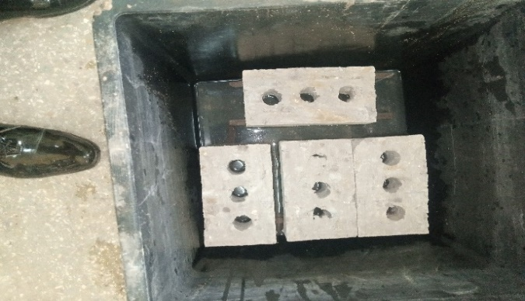
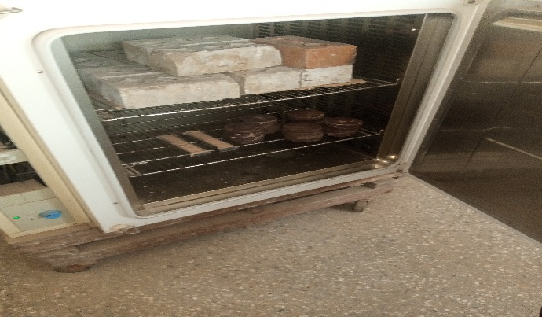

Fig.7a: Specimen placed on 5mm strip of in water Fig.7b : Specimen place in oven at 110°C

3.0 RESULTS AND DISCUSSIONS

3. 1 Results of the particle size distribution of earth
Table 1 shows the particle size distribution and figure 8 shows the particle size distribution curve of the earth used for the study. The results of the particle size distribution revealed that the earth used for the study contains 3.14% gravel, 87.76% sand, 7.67% silt and 1.38% clay respectively.

Table 1: Particle size distribution of earth.
IS SEIVE (mm) | WEIGHT OF SOIL RET/kg | CUMM. MASS RETAINED | % CUMM. RETAINED | % OF FINER OR PASSING
6.3 | 0.8 | 0.8 | 0.078 | 99.922
4.74 | 6.5 | 7.3 | 0.714 | 99.286
3.35 | 24.1 | 34.4 | 3.363 | 96.637
1.18 | 295.0 | 326.6 | 31.926 | 68.074
0.6 | 223.0 | 549.6 | 54.96 | 43.998
0.425 | 190.5 | 763.4 | 74.624 | 25.376
0.300 | 0.00 | 763.4 | 74.624 | 25.376
0.212 | 78.9 | 842.3 | 82.336 | 17.664
0.15 | 90.2 | 932.5 | 91.153 | 8.847
0.063 | 76.7 | 1009.2 | 98.651 | 1.349
0.000 | 13.8 | 1023.0 | 100.00 | 0.000

Figure 8: Particle size distribution of earth

Particle-size distribution tests were performed on the test sample and the results are presented in Table 1 (sieve sizes and % passing reproduced from the laboratory record). The results shows that the, sample is dominated by sand fraction 97.9%, with a negligible gravel content 0.7% and a very small fines fraction 0.063 mm of 1.35%. Characteristic diameters obtained by log-interpolation are D10 = 0.157 mm, D30 = 0.463 mm, D50 = 0.710 mm and D60 = 0.941 mm, giving Cu = 5.99 and Cc = 1.45. Because fines are 5% the material is classified as a clean sand. The very low fines content suggests the material will not be self-binding for unfired earth construction and therefore requires either blending with a clayey fraction or the use of stabilizers example, cement or lime to produce durable unfired bricks. Studies show that adding cement, lime, or other binders to sandy soils with low fines content significantly improves compressive strength, modulus of rupture, and durability, making them suitable for construction (Abed et al., 2020). According to Zhu et al. (2019) in his study of geotechnical properties and microstructure of lime-stabilized silt clay affirmed a similar particle distribution and hence the need to add stabilizers to attain high strength of the brick.

3.2 Result of X-ray Fluorescence (XRF) of Clay
Material composition of clay was determined by X-ray fluorescence and the result is shown in displayed in the table below.

Table 2: Result of material composition of clay
Chemical composition | Average Mass in Percentage
Al2 O3 | 29.4
SiO2 | 61
K2O | 1.32
Fe2O3 | 6.19

The results in (Table 2) indicate that the clay is predominantly composed of silica (SiO₂) and alumina (Al₂O₃), with average mass percentages of 61.0% and 29.4%, respectively, while minor oxides such as iron oxide (Fe₂O₃) and potassium oxide (K₂O) are present at 6.19% and 1.32%. The dominance of silica and alumina confirms that the clay is an alumino-silicate material, which is characteristic of raw clays employed in both fired and unfired brick production.Potassium oxide, though present in a relatively small quantity, further supports fluxing, lowering the melting point of the clay matrix and assisting sintering. In unfired stabilized systems, alkali oxides may enhance reactivity by increasing the dissolution of silica and alumina, thereby supporting pozzolanic reactions when lime or other stabilizers are used (Heath et al., 2012). A study by Mechati Boukoffa et al., (2021) which looked at Mineralogical, Physico-chemical and Geochemical Characterization of Three Kaolinitic Clays (Ne Algeria): Comparative Study also affirm that SiO₂ 59–68%, Al₂O₃ 18–39%, Fe₂O₃ 0.26–1.38%; are judged suitable for bricks and ceramic products.

3.2 Result of X-ray Fluorescence (XRF) of Calcined clay Pozzolana
Material composition of calcined clay pozzolana was determined by X-ray fluorescence and the result is shown in displayed in the table below.

Table 3: Result of material composition of calcined clay pozzolana
Chemical composition | Average Mass in Percentage
Al2 O3 | 26.3
SiO2 | 66
K2O | 1.32
Fe2O3 | 4.41

The result of the chemical composition of calcined clay pozzolana, presented in (Table 4), indicates that the material is rich in silica (SiO₂) and alumina (Al₂O₃), with average mass percentages of 66.0% and 26.3%, respectively. This high alumino-silicate content is a defining characteristic of effective pozzolanic materials and confirms the suitability of the calcined clay as a reactive supplementary binder in stabilized brick production. Many studies confirm that pozzolans with very high amorphous SiO₂ contents often greater than 70%–90% show strong pozzolanic activity, including silica fume, rice husk ash, bamboo leaf ash, nano‑silica and synthetic eco‑pozzolan (G. P. Lyra et al.,2024). Alumina, present at 26.3%, plays a complementary role by participating in pozzolanic reactions to form calcium aluminate hydrates (CAH) and calcium alumino-silicate hydrates (CASH). High alumina content in calcined clays has been widely reported to improve the mechanical and microstructural performance of unfired stabilized earth blocks (Heath et al., 2012; Scrivener et al., 2018).

The iron oxide (Fe₂O₃) content of 4.41% is moderate and beneficial. The reduced iron content compared to raw clay is also advantageous, as excessive iron can reduce pozzolanic reactivity by stabilizing less reactive crystalline phases during calcination (Dondi et al., 2014). Potassium oxide (K₂O), present at 1.32%, is a minor but influential constituent.

3.3 Result of X-ray Fluorescence (XRF) of Lime
Material composition of Lime was determined by X-ray fluorescence and the result is shown in displayed in the table below.

Table 4: Result of material composition of lime
Chemical composition | Average Mass in Percentage
MgO | 1.89
Al2 O3 | 0.543
CaO | 95.6

The chemical composition of the lime used in this study, as presented in (Table 5), shows a very high calcium oxide (CaO) content of 95.6%, with minor quantities of magnesium oxide (MgO) at 1.89% and alumina (Al₂O₃) at 0.543%. This composition is characteristic of high-calcium (air) lime and confirms its suitability as a primary stabilizing agent in unfired and fired clay brick systems. Additionally, previous studies have shown that lime with Shear strength increases with CaO through formation of Ca(OH)₂ and aggregation, but also increases pore volume; effect depends on content and microstructure (Lijie Chen et al.,2020). Magnesium oxide, present at 1.89%, occurs in relatively low concentration and is not expected to adversely affect performance. The very low alumina content (0.543%) indicates that the lime itself does not act as a pozzolanic material but rather functions as an activator.

3.4 Result of Density test of Bricks

Figure 9: Density test

The results in figure 9 exhibited a clear, progressive increase in brick density with increasing lime–pozzolana content at 28 days. The control sample (Control 1) recorded the lowest density of 2001.44 kg/m³, while stabilized bricks exhibited densities ranging from 2029.65 to 2071.98 kg/m³. The highest density among the stabilized mixes was achieved at 8% Lime & Pozzo (2071.98 kg/m³), representing an increase of approximately 3.5% relative to Control 1. This gradual increase in density can be attributed to improved particle packing and matrix densification resulting from pozzolanic reactions between lime and reactive silica/alumina in the calcined clay A similar trend was recorded in the study by Cabrera et al. (2022) which looked at the effect of local pozzolans and lime additions on the mineralogical, physical and mechanical properties of compressed earth blocks in Argentina. Control 2 (fired brick) recorded the highest overall density (2089.30 kg/m³), suggesting that the brick had and increased in strength as well. Previous research by H K Thejas & Nabil Hossiney (2022), had similar findings of density ranging in an increasing pattern from (2150-2200) kg/m³. Control 2 density was high, because of its high bonding during the sintering

3.5 Results of Water Absorption

Figure 10: Water Absorption Test results

Figure 10 shows the water absorption results of the specimens after curing days of 28 days. The results shows that the water absorption of the control specimens exhibited a marginal water absorption 2.40% however with the addition of 2% lime and pozzolana it further reduced to 2.33% less than 16.8% of the control absorption. The water for 4%,6% and 8% decreased. This could be explained to be the more you add the stabilizers the lower the rate of absorption. This phenomenon could be attributed to the the pozzolanic reaction between lime and silica/alumina forms C-S-H and C-A-H products, which fill pores and refine the microstructure, thereby lowering permeability and water absorption. (Quezon & Kebede, 2017). According to Laouidji et al., (2025) opined that the decrease in the water absorption was as a result of the pozzolanic reaction of the cementitious stabilizers used in the study and is consistent with acceptable studies.

3.6 Results of compressive strength

Table 5: 7-28-days Compressive strength test results
 | 7 days | 14 days | 21 days | 28 days
Control 1 | 1.074 | 1.076 | 1.325 | 1.479
2% LP | 1.262 | 1.273 | 1.382 | 1.769
4% LP | 1.732 | 1.750 | 1.768 | 2.056
6% LP | 1.821 | 1.911 | 1.921 | 2.137
8% LP | 1.890 | 1.962 | 2.011 | 2.145
Control 2 |  |  |  | 15.035

Table 5test result shows that at 28 days, compressive strength increased progressively from the control (1.479 MPa) to 2.145 at 8% stabilization of lime and pozzolan. The increase from 1.479 MPa (control) to 2.145 MPa at 8% LP represents an improvement of approximately 45%, indicating that stabilization significantly enhances load-bearing capacity. However, the rate of strength gain diminishes beyond 6% LP, suggesting that most reactive silica and alumina become consumed at higher lime contents. They explicitly note that “any further increase in the lime ratio after an optimum value will not be as advantageous for the strength enhancement (Fatima zohra El wardi et al., 2021). Laouidji et al (2025) show that for lime-stabilized fired clay bricks, compressive strength increases up to 6–8% lime and then does not keep increasing uniformly for higher lime, whereas cement continues to increase strength up to 10%. They study further disclose that lime addition is beneficial mainly in the 2–8% range, evidencing an optimum window rather than indefinite strength gains with dosage.

List 1-: Regression model of 28-day compressive strength

Regression analysis conducted on 28-day strength vs Lime and Pozzolana content.
This linear regression was performed using LP content (0–8%) as the independent variable and 28-day compressive strength as the dependent variable.
Coefficient of determination $R^{2}=0.87$
Outcome of the regression showed the following:
- The very high $R^{2}$value 0.87 indicates a strong positive linear relationship between LP content and 28-day compressive strength.
- Each 1% increase in LP contributes approximately 0.085 MPa to compressive strength at 28 days.
- This confirms that lime-based stabilization is the dominant factor controlling strength development at standard curing age.

4.0 CONCLUSIONS
      - It can be concluded that the earth material used was slightly silty sand and that it required the introduction of stabilizers for adequate bonding and strength.
      - From the XRF, conducted on the materials, all the materials had the chemical composition at a desirable percentage for brick moulding.
      - Unstabilized brick recorded a high percentage of water absorption and this reduced appreciably as the stabilizers were introduced. Hence, stabilized brick was less permeable.
      - However, fired brick recorded the least water absorption due to the glassy nature after sintering.
      - Density of unstabilized brick was less as compared to the stabilized and the fired brick. This can be concluded that, the stabilized brick with Lime and pozzolan had some improved effect on the density. Again, it can also be concluded that density was seen increasing with corresponding increase in compressive strength.
      - Compressive strength of 2.145Mpa fell within the acceptable compressive strength for non-load bearing walls.

REFERENCES
Access, O. (2016). American Journal of Engineering Research (AJER): Evaluation of the strength properties of soil bricks produced with processed African locust bean wastewater as stabiliser. American Journal of Engineering Research, 1, 34–41.
Adegoke, D. D., Afuwape, R., Olukanni, D. O., & Bamigboye, G. (2019). Utilization of palm fruit fibers as constituent materials for hand mould clay bricks. Journal of Physics: Conference Series, 1378(2), 022044. https://doi.org/10.1088/1742-6596/1378/2/022044
Adogla, F., Paa, P., Yalley, K., & Arkoh, M. (2016). Improving compressed laterite bricks using powdered eggshells. Proceedings, 71–75.
Amu, O. O. (2020). Effects of burnt clay on cement-stabilized lateritic soil samples in Osun and Oyo States, Nigeria. International Journal of Engineering Research and Technology, 6(6), 3339–3343.
Asamoah, R. B., Nyankson, E., Annan, E., & Efavi, J. K. (2018). Industrial applications of clay materials from Ghana (A review).
Ba, P., Adjaottor, A. A., Gikunoo, E., Arthur, E. K., Agyemang, F. O., & Baah, D. S. (2022). Dust deposition and associated heavy metal contamination in the neighborhood of a cement production plant at Konongo, Ghana. Environmental Challenges, 2022.
Bell, F. G. (1996). Lime stabilization of clay minerals and soils. Engineering Geology, 42(4), 223–237. https://doi.org/10.1016/0013-7952(96)00028-2
BS EN 1008:2002. (2002). Mixing water for concrete: Specification for sampling, testing and assessing the suitability of water, including water recovered from processes in the concrete industry, as mixing water for concrete. BSI Standards Publication.
Cabrera, S., Elert, K., Guilarducci, A., & Margasin, A. (2022). The effect of local pozzolans and lime additions on the mineralogical, physical and mechanical properties of compressed earth blocks in Argentina.
Chen, L., Chen, X., Wang, H., Huang, X., & Song, Y. (2020). Mechanical Properties and Microstructure of Lime-Treated Red Clay. KSCE Journal of Civil Engineering, 25, 70-77. https://doi.org/10.1007/s12205-020-0497-0.
Cities, M. T. (2008). Impact of dust emission on plant vegetation in the vicinity of cement plant. January.
Danso, H. (2017a). Experimental investigation on the properties of compressed earth blocks stabilised with a liquid chemical. American Journal of Materials Science, 6(6), 122–128. https://doi.org/10.11648/j.am.20170606.13
Danso, H. (2017b). Experimental investigation on the properties of compressed earth blocks stabilised with a liquid chemical. American Journal of Materials Science, 6(6), 122–128. https://doi.org/10.11648/j.am.20170606.13
Danso, H., & Akwaboah, M. (2021). Assessment of the quality of burnt bricks produced in Ghana: The case of Ashanti region. Case Studies in Construction Materials, 15, e00708. https://doi.org/10.1016/j.cscm.2021.e00708
Danso, H., Martinson, D. B., Ali, M., & Williams, J. B. (n.d.). Physical, mechanical and durability properties of soil building blocks reinforced with natural fibres.
Devi, K. S. (2018). Impacts of cement industry on environment – An overview. February.
Dondi, M., Raimondo, M., & Zanelli, C. (2014). Clays and bodies for ceramic tiles: Reappraisal and technological classification. Applied Clay Science, 96, 91–109.
Driss, A., Harichane, K., Ghrici, M., Sert, S., & Bol, E. (2023). Effect of natural pozzolana on the unconsolidated undrained shear strength of a lime-stabilized clay soil. International Journal of Civil Engineering, 21, 1007–1026. https://doi.org/10.1007/s40999-023-00817-5
Laouidji, Z., Boutlikht, M., Douadi, A., Hebbache, K., Atiki, E., Belebchouche, C., Moretti, L., & Czarnecki, S. (2025). Exploring the effect of lime and cement ratios on the mechanical properties of clay bricks made from different types of soils. Buildings, 15(4), 631. https://doi.org/10.3390/buildings15040631
Lyra, G., Duran, A., Tashima, M., Borrachero, M., Soriano, L., Payá, J., & Rossignolo, J. (2024). Eco-Pozzolans as Raw Material for Sustainable Construction Industry: Comparative Evaluation of Reactivity Through Direct and Indirect Methods. Sustainability. https://doi.org/10.3390/su162210087.
Medina-Martinez, C., Sandoval-Herazo, L., Zamora-Castro, S., Vivar-Ocampo, R., & Reyes-González, D. (2022). Natural Fibers: An Alternative for the Reinforcement of Expansive Soils. Sustainability. https://doi.org/10.3390/su14159275.
Pavia, S. (2020). Properties of unfired, illitic-clay bricks for sustainable construction. Construction and Building Materials, 121118. https://doi.org/10.10 16/j.conb uildmat.2020.121118
Wardi, F., Ladouy, S., Khabbazi, A., Ibaaz, K., & Khaldoun, A. (2021). Unfired Clay-Cork Granules Bricks Reinforced with Natural Stabilizers: Thermomechanical Characteristics Assessment. Civil Engineering Journal. https://doi.org/10.28991/cej-2021-03091778.

