Original research article

Performance assessment of laterite concrete modified with Nano-silica fines and Rice husk ash

.

ABSTRACT

Aims: This study investigates the effect of partial substitution of 10% cement with varying compositions of nano-silica fines (NS) and rice husk ash (RHA) on the mechanical performance of laterite concrete.
Methodology: Physical tests were performed on the constituent materials with reference to the British standards. Laterite was substituted for river sand by 30%, the batching was done by volume using a nominal mix ratio of 1:1.5:3 and a water/cement ratio of 0.6. Three ratios of NS/RHA were considered (3, 1, and 0.33) for the modification of the laterite mix, and were tested for workability, compressive strength and water absorption to determine the optimal mixture.
Results: The results show that, laterite concrete specimens modified with NS/RHA ratio of 3 produced the highest 28-day compressive strength (17.991N/mm²) with adequate workability and water absorption. Notably, excessive RHA content led to lower compressive strength due to its lower reactivity. A 30% substitution of river sand with laterite resulted in a 19.13% drop in 28-day compressive strength, however, the modification of the laterite concrete with NS/RHA ratios of 3, 1 and 0.33 led to strength changes of +24.18%, +6.433% and -7.124%, respectively, while maintaining sufficient workability (slump classes: S3 and S4) and water absorption (≤ 1.13%).
Conclusion: The work highlights the potential of combining NS and RHA as an environmental friendly solution for lower cement usage, improving the strength of laterite concrete, promoting waste utilization, reduction in reliance on river sand and sustainability in construction works. The optimal NS/RHA ratio for 10% cement replacement was obtained as 3, and resulted in improved strength performance in the laterite concrete specimens.

Keywords: Cementitious material; compressive strength; laterite concrete; nano-silica fines; pozzolanic material; rice husk ash; sustainable construction.

1. INTRODUCTION

The use of concrete in construction has contributed to a massive urbanization drive on the global stage. This is due to its ability to sufficiently withstand heavy loads and environmental stresses within its lifespan. Concrete is produced with materials (cement, sand, granite, water) that are locally available, however, concerns over environmental impact, cost and continuous availability of these materials has necessitated research into alternate materials which physical and chemical characteristics would enable a direct replacement or partial substitution for the constituent concrete materials. The production and utilization of cement in construction proposes a serious environmental concern, due to high amounts of greenhouse gases released into the environment whenever cement is manufactured and used. Researchers have sought after sustainable ways to reduce cement usage without significant compromise on the overall quality of construction works (Ukpata et al., 2024).

River sand continues to serve as the main fine aggregate in concrete production, due to its properties finely satisfying the requirements stipulated in available codes of practice in aspects of workability, gradation and cohesiveness. However, excessive use of this raw material solely as fine aggregate in concrete production could result in its exhaustion. Laterite soil types are abundantly found in Nigeria and over time the local construction industry has adopted its use in concrete production as a cheaper and more easily attainable alternative to river sand. Ukpata et al. (2024) characterized laterite as a soil rich in alumino silicate and exhibiting oxide properties favorably comparable to river sand in clinker requirements (see Table 1).

Agricultural by-products, when combusted at high temperatures into ashes have attracted significant interest due to their potential for improving the performance of concrete as a consequence of their pozzolanic nature. The introduction of agricultural ashes into concrete production has aided in its valorization, the cementitious characteristics of these ashes enables their usage as eco-friendly partial substitutes for cement, thereby not only contributing to an effective and value driven waste management process, but also aiding in the reduction of the energy footprint associated with cement usage in concrete works (Akeke et al., 2016).

Rice husks whose grains have been extracted by the milling process generally have no economic value and are often discarded as wastes, this creates environmental concerns and visible pollution. In addressing this concern, rice husks are altered into useful materials by combustion at high temperatures to alter their chemical composition to a more desirable state. In this state, they could serve as suitable partial substitutes for cement due to their high silica content. Olii et al. (2024) examined the combined effect of rice husk ash (RHA) and fly ash (FA) on the mechanical characterization of geopolymer concrete in relation to its compressive strength and workability. The geopolymer binding agent involved a combination of RHA and FA and an alkaline activation solution in controlled proportions. The alkaline solution was formulated from the mixture of NaOH and Na₂SiO₃ compounds, stirred until a homogenized mixture capable of supporting the formation of strong geopolymer gels and maintain good workability was achieved. The findings revealed that, high contents of RHA resulted in lower compressive strength and workability, due to its lower reactivity and high porosity. The optimal RHA:FA content was obtained as 60:40, this ratio was associated with maximum compressive strength and enhanced workability. Aboshio et al. (2009) experimented on the use of RHA as an admixture in concrete, it was reported that, the workability of concrete increased with increase in RHA content. RHA contents within 5% – 10% resulted in greater compressive strength relative to the control concrete, however, it was observed that beyond 5% RHA contents the compressive strength in the RHA modified specimens began to gradually decrease; with 15% RHA content exhibiting strength lower than the control concrete. It was concluded that 5% RHA content is more suitable for use as admixtures in concrete grades M20 and M30 within normal environment. Akeke et al. (2016) investigated the pozzolanic characteristics of rice husk ash (RHA) in relation to its chemical composition and its effect on the compressive strength of concrete when RHA was partially substituted for cement. A chemical analysis on the oxide composition of rice husk ashes extracted from different locations revealed that the silica content in the different ashes were between 68% – 85%, indicating high pozzolanic properties. The compressive strength of the RHA modified concrete specimens was found to gradually decrease with increase in RHA content. RHA replacement levels within 20% was reported to compare favorably with the control concrete. Khan et al. (2021) examined the performance of sandcrete blocks modified with RHA as partial substitute for cement in proportions up to 50%. The pozzolanic properties of RHA was demonstrated by use of an X-ray fluorescence analysis, RHA was discovered to contain high levels of silica (SiO₂) and alumina (Al₂O₃), obtained as 73% and 22.8% respectively. The sum of oxides SiO₂, Al₂O₃ and Fe₂O₃ (iron oxide) was obtained as 98.9%, far exceeding the minimum threshold of 50% as specified in ASTM C168 (2012). It was reported that, the workability of the concrete mixture decreased with increase in RHA content, this made the addition of a superplasticizer necessary to ensure continuous workability at RHA contents within 30% – 50% replacement levels. The compressive strength of the modified concrete specimens was reported to steadily decrease with increase in RHA content, however, specimens made up of RHA contents within 10% – 40% exhibited compressive strength higher than those commercially produced.

The use of nano-silica fines (NS) in concrete has led to desirable outcomes in aspects of early set, enhanced strength, decreased permeability and durability. Its pozzolanic value is associated with its relatively high silica content and finer particle size, which promotes its use as filler materials, while ensuring an accelerated hydration process and formation of more calcium-silicate-hydrate gel (Khan et al., 2022).
A bibliographic analysis and review of the mechanical properties of nano-silica modified concrete was performed by Khan et al. (2022), and was based on a scientometric analysis. The findings revealed that, the high pozzolanic reactivity and surface area of nano-silica enhanced the mechanical properties of concrete when applied in lower proportions, higher NS content posed a detrimental effect on the overall concrete performance due to increased porosity and micro-cracking, as the formation of larger clusters by NS particles progressed. Optimal outcomes were obtained when NS was introduced into concrete in proportions of 2% – 3%, enhancing strength gains as high as 20% – 25% relative to the control concrete. El-Ghany Abo El-Enein et al. (2018) examined the effect of nano-silica on the physic-mechanical properties and alkali silica reactivity of dolomite concrete. NS was used to partially substitute for cement in proportions up to 4%. It was reported that incorporating NS up to 4% resulted in higher compressive strength gain relative to the control concrete. The optimal replacement level was obtained at 2%. The enhanced strength gain was attributed to the pozzolanic properties of NS and its ability to nucleate sites for enhanced cement hydration. The findings also reported that, NaOH possess a marginal impact on the mechanical properties of dolomite concrete, this was attributed to dolomite aggregate exhibiting higher resistivity to alkali-silica reaction. Mukherjee et al. (2023) investigated the effect of nano-silica (NS) and nano-vanadium (NV) as partial cement substitutes on the strength and durability characteristics of concrete. The results revealed that, 1% NS and 0.1% NV replacement proportions enhanced the compressive strength (6.55%) and split tensile strength (15%) relative to the control concrete. The acidity and alkalinity test on the concrete specimens revealed that a loss in compressive strength was more significant in normal concrete than in the NS and NV modified concrete.

Table 1. Oxide composition of River sand, Laterite, Nano silica (NS) and Rice husk ash (RHA)
Oxides | Percentage Composition (%)
Oxides | River sand  (Ukpata et al., 2024) | Laterite  (Ukpata et al., 2024) | Nano-silica  (El-Ghany Abo El-Enein et al., 2018) | Rice husk ash  (Van et al., 2014)
SiO₂ | 76.77 | 54.02 | 95 | 87.4
Al₂O₃ | 8.91 | 22.34 | 1.08 | 0.4
Fe₂O₃ | 4.25 | 10.15 | 0.45 | 0.3
CaO | 3.79 | 2.78 | 0.20 | 0.9
MgO | 2.02 | 1.84 | 1.06 | 0.6
SO₃ | 0.07 | 0.00 | 0.31 | 0.4
K₂O | 1.34 | 0.08 | 0.12 | 3.39
Na₂O | 1.03 | 0.00 | 0.68 | 0.04
P₂O₅ | ---- | ---- | 0.12 | ----
M_{n}O | 0.18 | 0.12 | ---- | ----
T_{i}O₂ | 0.18 | 0.51 | 0.18 | ----
*LOI | 1.74 | 7.95 | 0.5 | 4.60
*LOI is the loss on ignition

This work investigates the performance characteristics of laterite concrete when nano-silica fines (NS) and rice husk ash (RHA) are introduced into the constituent materials as partial substitute for 10% cement content. An experimentation was conducted with concrete mixtures containing different proportions of NS and RHA as supplementary cementitious materials, with reference made to relevant code specifications. The different concrete mixes were examined in aspects of workability, compressive strength and water absorption.

2. material and methods

2.1. Materials

The experimental materials are laterite, river sand, fresh water, nano-silica fines, rice husk ash, granite and cement. All materials were obtained within the southern senatorial district of Cross River State, Nigeria.

Fine aggregate

The laterite and river sand were sieved through a 4.75mm sieve in accordance with BS 812-103:1 (1985). They are responsible for the cohesiveness of the mixture.
Coarse aggregate
The granite was sieved through a 28mm sieve in accordance with BS 812-103:1. It is responsible for creating a mechanical interlock within the cement paste.

Binder

The primary binding agent is a UNICEM portland limestone cement (PLC): grade CEM II/B-L 32.5R conforming to BS EN 197-1 (2011) and NIS 444-1 (2003) standards.

Water

The water used was in conformance with BS 17075 (2018). The hydration process is activated upon contact with the cement.

Rice husk Ash

The rice husk ash served has a cementitious additive due to its pozzolanic properties and was obtained from the calcination of rice husk obtained from rice milling operational sites within the study area. The rice husks were collected and adequately sun dried to rid them of moisture prior to combustion at 600⁰c for 2 hours. The ash was collected and sieved through a 600 microns sieve.

Nano-silica

The nano-silica fines (NS) served as a cementitious additive due to their high silica content, enabling the formation of additional calcium silicate hydrate through the consumption of excess calcium hydroxide, and aiding in filling the micro-pores in the cement paste due to their extremely fine particles. The quartz was extracted from sterling construction company in Akamkpa quarry site in Cross River State, Nigeria, and milled to a size of approximately 10 micron (0.01mm) by use of a jaw crusher and miller. The NS was sieved through a 750 microns sieve.

2.2. Method

The fresh concrete was batched by volume and combined in a nominal mix ratio of 1:1.5:3 (binder with or without cementitious additive: fine aggregate: coarse aggregate) with a water/cement (w/c) ratio of 0.6. The plain concrete was modified with a direct substitution of 30% river sand with laterite, together with a partial replacement of cement (PLC) with RHA and NS at a replacement level of 10% in ratios of 7.5%NS: 2.5%RHA, 5%NS: 5%RHA and 2.5%NA: 7.5%RHA. The mix proportions of material used are presented in Table 2. A slump test was performed to measure the workability and consistency of the freshly mixed concrete. The slump test was carried out in accordance with BS EN 12350-2 (2009). Three (3) replicates were prepared for each mix combination and curing age. The prepared concrete specimens were cured by full water immersion for 14 days, 21 days and 28 days.
A compressive strength test was performed on the hardened concrete specimens measuring 100mm x 100mm x 100mm in dimension. The test was done with reference to BS 1881 – 116 (1983) and determined by use of equation (1).

(1)

The durability of the hardened concrete specimens was examined through a water absorption test, this test determines how resistant the specimens are to water damage by measuring the amount of water absorbed by the specimens when immersed in water. The test was performed in accordance with BS 1881-122 (2011) and determined by use of equation (2)

(2)

A strength activity index (SAI) was performed to evaluate the contribution of the cementitious additives to the strength development of the modified laterite concrete. A high SAI value denotes a superior contribution to the compressive strength development of the concrete. The SAI is the ratio between the compressive strength of the laterite mixtures with cementitious additives (Mix C, D and E) and the laterite mix without cementitious additives (Mix B), see equation (3).

(3)

Table 2. Material mix proportion
Mix ID | Cement (m³) | River Sand (m³) | Granite (m³) | Laterite (m³) | Nano-silica (m³) | Rice husk ash (m³) | Water (m³) | W/C ratio | NS/RHA ratio
A | 0.000164 | 0.000246 | 0.000492 | ---- | ---- | ---- | 0.0000984 | 0.6 | ----
B | 0.000164 | 0.000172 | 0.000492 | 0.0000738 | ---- | ---- | 0.0000984 | 0.6 | ----
C | 0.000148 | 0.000172 | 0.000492 | 0.0000738 | 0.0000123 | 0.0000041 | 0.0000984 | 0.6 | 3
D | 0.000148 | 0.000172 | 0.000492 | 0.0000738 | 0.0000082 | 0.0000082 | 0.0000984 | 0.6 | 1
E | 0.000148 | 0.000172 | 0.000492 | 0.0000738 | 0.0000041 | 0.0000123 | 0.0000984 | 0.6 | 0.33

where
Mix A: is the plain concrete which serve as the experimental control mix (0% laterite; 0% nano-silica fines; 0% rice husk ash).

Mix B: is the laterite concrete with no cementitious additives and serve as the laterite reference mix (30% laterite; 0% nano-silica fines; 0% rice husk ash).

Mix C: is the laterite modified concrete containing cementitious additives (30% laterite; 7.5% nano-silica fines; 2.5% rice husk ash).

Mix D: is the laterite modified concrete containing cementitious additives (30% laterite; 5% nano-silica fines; 5% rice husk ash).

Mix E: is the laterite modified concrete containing cementitious additives (30% laterite; 2.5% nano-silica fines; 7.5% rice husk ash).

3. results and discussion

The physical properties of the aggregates are presented in Table 3, Figures 1, 2 and 3. The specific gravity and bulk density of river sand, laterite and granite were within acceptable limits of code specifications, BS 812 – 2 (1995), BS EN 1097-6 (2013) and BS EN 1097-3 (1998). The values of the uniformity coefficient (C_{u}) and coefficient of gradation (C_{c}) indicates that river sand and laterite are uniformly graded (2 < C_{u} < 6; 1< C_{c} < 3), while the fineness modulus show that both materials are coarse sand. Granite is classified coarse and uniformly graded (1< C_{c} < 3; C_{u} < 4) as well.

Table 3. Physical properties of aggregates
Properties | River sand | Laterite | Granite
Specific gravity | 2.55 | 2.82 | 2.56
Bulk density (kg/m³) | 1424 | 1254 | 1410
Water absorption (%) | 1.73 | 2.66 | 1.50
Fineness modulus | 2.940 | 2.942 | 4.51
Uniformity coefficient (C_{u}) | 2.86 | 3.183 | 1.66
Coefficient of gradation (C_{c}) | 1.03 | 1.187 | 1.05

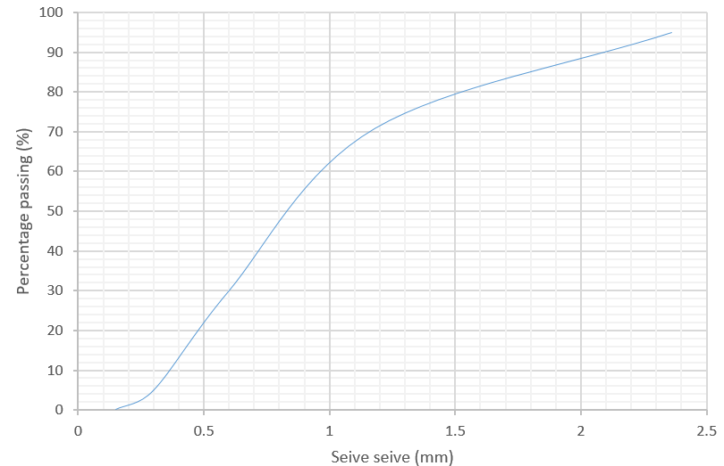
Fig. 1. Aggregate grading curve: river sand

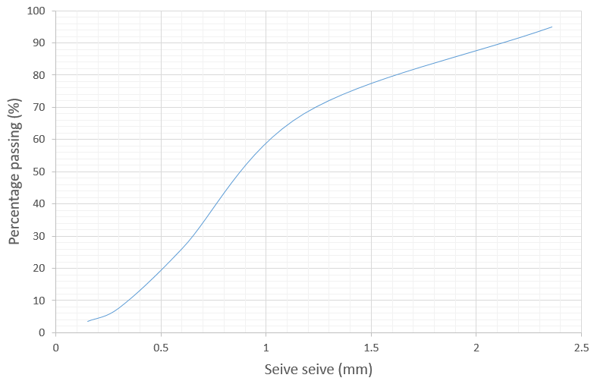
Fig. 2. Aggregate grading curve: laterite

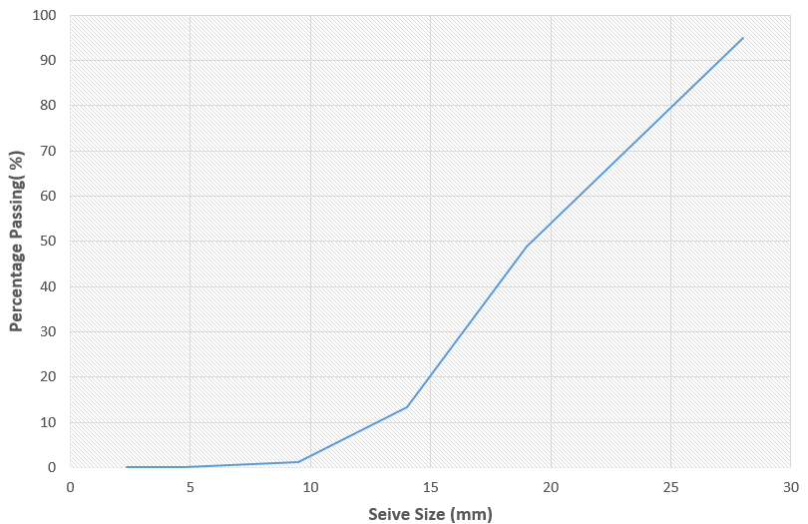
Fig. 3. Aggregate grading curve: granite

3.2. Slump test (workability)

The slump test was performed to assess the workability of the fresh concrete mixes, the results are presented in Table 4. It can be observed that, the replacement of 30% river sand with laterite led to a decrease in slump value (reduced workability), this is as a consequence of the higher water absorption capability of laterite relative to river sand. Among the laterite concrete mixes, it can be observed that, workability increases as the ratio of NS/RHA decreases, highlighting the ability of RHA to enhance the flowability of laterite concrete. Additionally all concrete mixes exhibited true slump with medium to high workability (slump class: S3 and S4) and are suitable for application in reinforced concrete.

Table 4. Slump values for the different concrete mixes
Mix ID | Slump value | Slump class  [BS 8500 (2023)] | NS/RHA ratio
A | 165mm | S4 (150 – 220mm) | ------
B | 160mm | S4 (150 – 220mm) | ------
C | 120mm | S3 (90 – 160mm) | 3
D | 135mm | S3 (90 – 160mm) | 1
E | 145mm | S3 (90 – 160mm) | 0.33

3.3. Compressive strength

Tables 5, 6 and 7 shows the compressive strength performance of the concrete specimens modified with different proportions of rice husk ash and nano-silica fines for curing ages 14, 21 and 28days. Across all mixes, the compressive strength of the specimens increased with age irrespective of the introduction of the cementitious additives. The replacement of 30% river sand with laterite in plain concrete led to an early strength gain (13.709%) at 14 days, however, a loss in strength was observed at 21 days (10%) and 28 days (19.13%). Laterite concrete mixes modified with varying compositions of nano-silica fines and rice husk ash at 10% cement replacement level, satisfied the requirement of ASTM C618 (SAI ≥ 75%), across all ages. Furthermore, it can be observed that, higher proportions of nano-silica relative to rice husk ash significantly improves the compressive strength of laterite concrete. As depicted in Table 7, the compressive strength of the laterite concrete is enhanced by 24.187% and 6.433% for NS/RHA ratio of 3 and 1 respectively, nevertheless, at NS/RHA ratio of 0.33, there is a drop in compressive strength (-7.124%) when compared with the laterite reference mix. Laterite concrete specimens with NS/RHA ratio of 3 exhibited compressive strength performances in close agreement with that of plain concrete at 28 days, the variation obtained was +0.43%. Notably, the compressive strength of the modified laterite concrete was observed to decrease as the ratio of NS/RHA decreased.

Table 5. 14-day compressive strength results
Mix ID | Compressive  strength  (N/mm²) | Strength activity index (SAI) ref. Mix B (%) | Strength change ref. Mix A (%) | Strength change ref. Mix B (%)
A | 11.102 | ---- | ---- | ----
B | 12.624 | ---- | +13.709 | ----
C | 11.281 | 89.361 | +1.612 | -10.638
D | 12.687 | 100.499 | +14.277 | +0.499
E | 10.906 | 86.391 | -1.765 | -13.609

Table 6. 21-day compressive strength results
Mix ID | Compressive  strength (N/mm²) | Strength activity index (SAI) ref. Mix B (%) | Strength change ref. Mix A (%) | Strength change ref. Mix B (%)
A | 15.000 | ---- | ---- | ----
B | 13.500 | ---- | -10.000 | ----
C | 15.000 | 111.111 | +0.000 | +11.111
D | 14.667 | 108.644 | -2.220 | +8.644
E | 11.500 | 85.185 | -23.330 | -14.815

Table 7. 28-day compressive strength results
Mix ID | Compressive strength (N/mm²) | Strength activity index (SAI) ref. Mix B (%) | Strength change ref. Mix A (%) | Strength change ref. Mix B (%)
A | 17.914 | ---- | ---- | ----
B | 14.487 | ---- | -19.130 | ----
C | 17.991 | 124.187 | +0.430 | +24.187
D | 15.419 | 106.433 | -13.928 | +6.433
E | 13.455 | 92.876 | -24.891 | -7.124

3.4. Statistical analysis

A one-way ANOVA was performed at a 95% confidence level to determine if there are statically significant differences among the means of the compressive strength for the different concrete mixes considered. The dataset is presented in Table 8, the analysis was carried out using Excel 2013 software and results are presented in Table 9. The results show that, there are no statistically differences between the mean compressive strength of the different concrete mixes examined. The P-value was obtained as .111352, which was greater than the alpha level of .05.

Table 8. Datasets for statistical evaluation
Compressive strength (N/mm²)
Mix A | Mix B | Mix C | Mix D | Mix E
8.600 | 14.592 | 13.232 | 12.246 | 10.95
13.020 | 11.022 | 9.980 | 13.205 | 11.321
11.680 | 12.257 | 10.633 | 12.610 | 10.448
14.000 | 15.000 | 17.000 | 16.000 | 13.500
16.000 | 11.500 | 13.000 | 13.000 | 10.000
15.000 | 14.000 | 15.000 | 15.000 | 11.000
15.063 | 14.265 | 16.585 | 15.726 | 14.073
17.789 | 14.563 | 17.742 | 15.486 | 13.256
20.891 | 14.633 | 19.646 | 15.045 | 13.036

Table 9. ANOVA for compressive strength response
SUMMARY
Groups | Count | Sum | Average |  | Variance
Mix A | 9 | 132.043 | 14.67144 |  | 12.4272
Mix B | 9 | 121.832 | 13.53689 |  | 2.295579
Mix C | 9 | 132.818 | 14.75756 |  | 10.8105
Mix D | 9 | 128.318 | 14.25756 |  | 2.165366
Mix E | 9 | 107.584 | 11.95378 |  | 2.268897
ANOVA
Source of Variation | SS | df | MS | F | P-value | F crit
Between Groups | 48.21451 | 4 | 12.05363 | 2.011113 | 0.111352 | 2.605975
Within Groups | 239.7404 | 40 | 5.993509
Total | 287.9549 | 44

3.5. Water absorption

Table 10 present the results of the water absorption test performed on the concrete at 28 days, the water absorption ranged between 0.7% and 1.13% (<5%), demonstrating proper durability and good quality concrete. Notably, specimens of the different concrete mixes exhibited excellent resistance to water ingress, indicating lower permeability and fewer pores. Consequently, the water absorption serve as an intimation of the specimen’s porosity.

Table 10. Water absorption results
Mix ID | W₁(Dry weight, kg) | W₂(Wet weight, kg) | W₂ – W₁ (kg) | Water absorption (%)
A | 2.648 | 2.678 | 0.030 | 1.130
B | 2.537 | 2.560 | 0.023 | 0.907
C | 2.607 | 2.628 | 0.021 | 0.806
D | 2.435 | 2.452 | 0.017 | 0.700
E | 2.386 | 2.404 | 0.018 | 0.750

4. Conclusion

The performance of laterite concrete modified with different proportions of nano-silica fines (NS) and rice husk ash (RHA) at 10% partial cement substitution was investigated. The laterite concrete was produced from the modification of plain concrete by the substitution of 30% river sand with laterite. The results show that, a 30% substitution of river sand with laterite led to a drop in 28-day compressive strength by 19.13%. However, the laterite concrete mix modified with NS/RHA ratio of 3 considerably increased the strength of laterite concrete, achieving the highest compressive strength of 17.991 N/mm², which was in agreement with the strength obtained by plain concrete (17.914 N/mm²). The workability of laterite concrete was observed to improve as NS/RHA ratio decreased. However, with higher RHA content, it was discovered that the compressive strength gradually diminished, this could be attributed to the lower reactivity of RHA relative to NS in promoting cement hydration. The findings suggest that using the right combination of NS and RHA in laterite concrete improves its performance considerably, highlighting the complementary role of NS and RHA in laterite concrete production, supporting agricultural waste recycling, lowering cement usage, and promoting a more sustainable construction environment.

Competing interests

Authors have declared that no competing interests exist.

COMPETING INTERESTS DISCLAIMER:
Authors have declared that they have no known competing financial interests OR non-financial interests OR personal relationships that could have appeared to influence the work reported in this paper.

References

Ukpata, J. O., Ewa, D. E., Success, N. G., Alaneme, G. U., Otu, O. N., Olaiya, B. C. (2024). Effects of aggregate sizes on the performance of laterized concrete. Scientific reports, 14(448), 1 – 20. https://doi.org/10.1038/s41598-023-50998-1

Olii, M. R., Saliko, M., Doda, N., Nento, S., Olii, R. S. (2024). Compressive strength performance of rice husk ash-based geopolymer concrete with fly ash as a secondary material. Jurnal Teknik Sipil Dan Lingkungan, 10(2), 259 – 266. DOI:10.29244/jsil.10.2.259-266

Aboshio, A., Ogork, E. N., Balami, D. A. (2009). Rice husk ash as admixture in concrete. Journal of Engineering and Technology, 4(2), 95 – 101.

Akeke, G. A., Ewa, D. E., Okafor, F. O. (2016). Effects of variability in the pozzolanic properties of rice husk ash on the compressive strength of concrete. Nigerian Journal of Technology, 35 (4), 694 – 698. http://dx.doi.org/10.4314/njt.v35i4.1

Khan W., Fahim, M., Zaman, S., Khan, S. W., Badrashi, Y. I., Khan, F. (2021). Use of rice husk ash as partial replacement of cement in sandcrete blocks. Advances in Science and Technology research Journal, 15(2), 101 – 107. https://doi.org/10.12913/22998624/133470

ASTM C618 (2012). Standard specification for coal fly ash and raw or calcined natural pozzolan for use in concrete. American Society for Testing and Materials.

Khan, K., Ahmad, W., Amin, M., Nazar, S. (2022). Nano-silica-modified concrete: A bibliographic analysis and comprehensive review of material properties. Nanomaterials, 12(1989), 1 – 29. https://doi.org/10.3390/nano12121989

El-Ghany Abo El-Enein, S. A., Refaey Zedan, S. R., Abu-Elwafa Mohamed, R. (2018). Effect of nano-SiO₂ (NS) on dolomite concrete towards alkali silica reaction. HBRC J., 14, 165 – 170. http://dx.doi.org/10.47832/2717-8234.12.26

Mukherjee, B., Das, P., Das, S., Maji, R., Pal, A., Ghosh, S. (2023). Strength and durability characteristics of concrete by using nanosilica – nanovanadium mixture as partial replacement of cement. International Journal of Engineering Research & Technology, 12(7), 75 – 79.

Van, V.-T.-A., Robler, C., Bui, D.-D., Ludwig, H.-M. (2014). Pozzolanic reactivity of mesoporous amprphous rice husk ash in portlandite solution. Construction and Building Materials, 59, 111 – 119.

BS 812-103.1 (1985). Methods for determination of particle size distribution. British Standard Institute, London UK.

BS EN 197-1 (2011). Cement - Composition, specifications and conformity criteria for common types of cement. British Standards Institute, London UK.

Nigerian Industrial Standard (NIS) 444-1 (2003). Composition, specifications and conformity criteria for common cements. Standard Organization of Nigeria.

BS 17075 (2018). Water quality – general requirements and performance test procedures for water monitoring equipment – measuring devices. British Standard Institute, London UK.

BS EN 12350-2 (2009). Testing fresh concrete – Part 2: Slump test. British Standards Institute, London UK.

BS 1881- 116 (1983). Methods for Determining Compressive Strength of Concrete Cubes. British Standard Institute, London UK.

BS EN 1881-122 (2011). Testing concrete – Part 122: Method for determination of water absorption. British Standards Institute, London UK.

BS 812-2 (1995). Testing aggregates – Part 2: Methods of determination of density. British Standard Institute, London UK.

BS EN 1097-6 (2013). Tests for mechanical and physical properties of aggregates – Determination of particle density and water absorption. British Standard Institute, London UK.

BS EN 1097-3 (1998). Tests for mechanical and physical properties of aggregates – Determination of loose bulk density and voids. British Standard Institute, London UK.

BS 8500 (2023). Method of specifying concrete. British Standard Institute, London UK.

