Distribution and Risk Assessment of Phthalates in Water and Sediment of Omambala River, Anambra State, Nigeria, in the Wet Season

Abstract: Phthalates categorized as an endocrine disruptor and persistent organic pollutants, are known for their environmental contamination and toxicological effects. In this study, the concentration of selected phthalates was determined across the sampling site to investigate their occurrence and the ecological and health risk assessment they pose to the environment. Water and sediment samples were collected following standard procedures. Solid phase and ultrasonic methods were used to extract seven different PAEs, which were analysed by Gas Chromatography with Mass Detector (GCMS). The analytical average recovery was found to be within the range of 83.4 ± 2.3%. The results showed that PAEs were detected in six out of seven samples with a high percentage of detection rate in water. Di-n-butyl phthalate (DPB) and disobutyl phthalates (DiBP) showed a greater detection rate compared to other PAE monomers. The concentration of Phthalates (PAEs) was found to be higher in sediment samples compared to water samples due to the fact that sediments serve as a sink for most persistent organic pollutants. The concentrations of PAEs in water samples and sediments ranged from 0.00 mg/kg to 0.23 mg/kg and 0.00 mg/l to 0.028 mg/l, respectively. Ecological risk assessment using the risk quotient method (RQ) reveals that the estimated environmental risk caused by phthalates lies within the moderate level as RQ ranges from 0.1 to 1.0, whereas the health risk assessment caused by phthalates on estimating the average daily dose reveals that the ingestion of phthalates was found to be approaching permissible limit which can cause serious carcinogenic occurrence in the human system with time due to excess accumulation.

Keywords—Phthalates, endocrine disruptor, risk assessment, ecological risk, health risk.
1. Introduction
PHTHALATES are a class of synthetic chemicals that are widely utilized in a wide range of consumer and industrial products, such as medicines, plastics, and personal hygiene items. Phthalates are environmental pollutants that are widely present in the environment and may be hazardous to both human health and the environment because of their widespread use and improper disposal. Two important environments where phthalates can build up and cause long-term persistence and bioaccumulation are water and sediment. Phthalates, often known as phthalate esters (PAEs), are synthetic chemical substances classified as 1,2-benzoldicarbonic acid [1]. PAEs are widely utilized as plasticizers. A plasticizer is an additive that is mixed into a plastic to give it softness, flexibility, and toughness to help in the manufacturing process [2]. PAEs are primarily utilized as plasticizers in the manufacture of plastics, rubber, polyvinyl chloride (PVC), and other polyethylene products to improve flexibility, workability, and durability [3]-[5]. PAEs are also used to improve the quality of a wide range of consumer and industrial products, including pharmaceutical coatings, gels, dispersants, lubricants, binders, medical devices, waxes, detergents, textile fabrics, and children's toys [6]. Humans are exposed to PAEs through nutritional consumption, bioaccumulation in aquatic food webs, ingestion and bathing in contaminated water, and broad usage or exposure to PAEs in a wide range of industrial items during manufacture, storage, transportation, and utilization [7]. Because PAEs provide multiple potential dangers when exposed, a thorough assessment of the environmental and human health concerns of PAEs is required. The prevalence and abundance of PAEs in the ocean have been extensively examined. Sources of phthalates esters in marine settings are numerous, as oceans are widely regarded as the final sink for all plastic in the environment, particularly during the rainy season, when there is an oversupply of plastic trash carried into rivers. In addition to river inputs, plastics enter the ocean directly through mismanaged marine or fishing trash, such as abandoned fishing gear, unintentional cargo loss, and unlawful dumping. Models have been built to explore the transport and fate of phthalates esters in the ocean, which may help us understand the processes that influence phthalates esters' transit in freshwater environments. Furthermore, contamination of water bodies and aquatic life by persistent organic pollutants has been a major worry worldwide, with the majority of the consequences being carcinogenic, according to numerous studies [8], [9]. As a result, preventive practices should be implemented to reduce the emergence of toxic health challenges by identifying the major source of pollution, conducting laboratory analyses of target samples to determine the extent of hazard caused by these pollutants, and providing appropriate solutions/ recommendations. The aim of this study is to determine the physicochemical properties of the water and sediment. In addition, the concentration of phthalates in the water and sediment using Gas Chromatography Mass Spectroscopy (GCMS) was determined. The ecological and health risks assessment of the phthalates in the water and sediment and fish via specific exposure routes was also evaluated to investigates the potential risks arising from such exposure in Omambala riverine area of Anambra State.

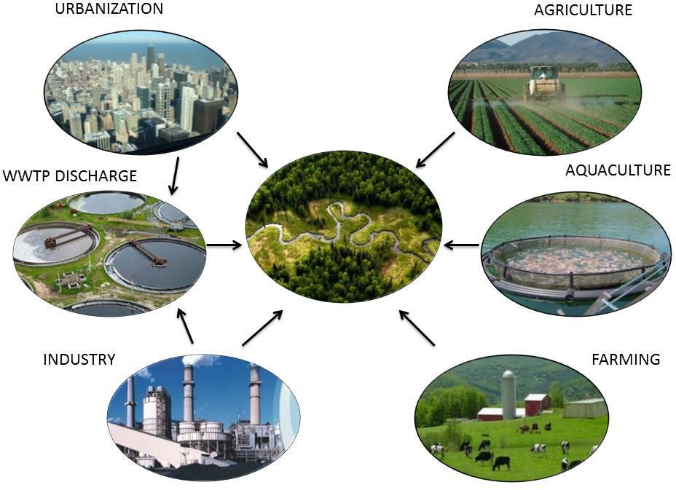
Fig. 1 Possible pathways PAEs can be released into the aquatic environment [19]

  - Review of Literature
In PET bottled non-carbonated water, Di(2-ethylhexyl) phthalate (DEHP) was the most prevalent PAE, followed by DBP and DIBP, according to [10]. PAE levels, especially DEHP, rose dramatically at 22 °C, 40 °C, 50 °C, and 60 °C during storage. Also, because of the larger surface/volume ratio in 0.5 L PET containers, the scientists found that the PAE concentration was highest in these containers. When [11] looked at a variety of commercial non-alcoholic beverages that were bought in China, such as fruit juices, tea drink samples, sport drinks, and coffees, they found that DEHP was the most common PAE. They also kept an eye on the PAE content of a variety of alcoholic and non-alcoholic beverages, such as tonic and mineral water. To identify important areas, [12] looked at the level of PAE contamination in olives prior to harvesting and the presence of phthalates following each stage of production. When comparing olives directly harvested from the olive grove to those collected at mills, the authors found greater levels of contamination (DIBP, DBP, and DEHP). These findings suggest that contamination can happen when the olives are being harvested and transported to the mill. Additionally, a rise in PAE levels was noted throughout the olive oil manufacturing chain, most likely as a result of the olives, paste, and oil coming into touch with pipes and other plastic materials. Nonetheless, contamination levels were generally within the recommended limits of the EEC Directive 2007/19/CE. The study of [13] looked into the phthalate concentration of edible oil that was marketed in Turkish markets. In virgin olive oil, the mean phthalate concentrations ranged from 102 µg L⁻¹ to 3863 µg L⁻¹; in olive oil, from 172 µg L⁻¹ to 6486 µg L⁻¹; in hazelnut oil, from 501 µg L⁻¹ to 3.651 µg L⁻¹; in canola oil, from 457 µg L⁻¹to 3415 µg L⁻¹; in sunflower oil, from 2227 µg L⁻¹ to 6673 µg L⁻¹; and in corn oil, from 1585 µg L⁻¹ to 6248 µg L⁻¹. Sunflower oil had the highest phthalate content, whereas virgin olive oil and hazelnut oil had the lowest phthalate content. Specifically, oil samples containing polyethylene terephthalate (PET) had the greatest levels of phthalates.
- Materials and Methods
  - Materials
The materials used in this research are water and sediments samples.
  - Equipment
The equipment used in this research includes: 5 mm sieve, beakers, filter paper, Volumetric flask, separatory funnel, trawls and neuston nets (for collecting water samples) HANNA pH 209, U.S.A, gas chromatography mass spectrometry (Agilent model 6890N GC–5973 MSD), electrical conductivity meter, model ADS-102.
  - Chemical Reagents
The reagents used in this research include: hydrogen peroxide, NaCl solution, potassium hydroxide, pH 4.0 buffer solutions, concentrated nitric acid (HNO₃), ferrous ammonium sulphate, ethanol, dichloromethane, acetone, and ultra-pure water.
  - Study Area
This research was carried out in Omambala River categorized under Anambra East Local Government. Its source is located in the Ankpa highlands in Nigeria's Kogi State, some 100 kilometres north of Nsukka [14]. The river lies between latitudes 6°10´ and 7° 40´ East of the Niger. It has a southward course crossing the Kogi/Enugu States boundary. It then crossed through Ogurugu to Otuocha from where it flows down to its confluence with the Niger at Onitsha. The main river channel has a total length of about 207.40 km. The river bank is covered by plants like Echinoclae spp., Salviniany mnellula, Ludiwigia decurrens, Imperita cylindirica, Andropogon spp., Jussiaea spp., Pennisetum spp. and Cynodon spp. There are two seasons: rainy season (April – September/October) and dry season (October/November - March). The mean annual rainfall is between 150 cm and 200 cm. The harmattan affects the basin from December to January or February, but its impact is not very noticeable. The water temperature and Secchi disc reading in the river ranges from 24 ºC to 31 ºC and 5 cm to 85 cm, respectively. The occupations of people living within the area are mostly farming and fishing.

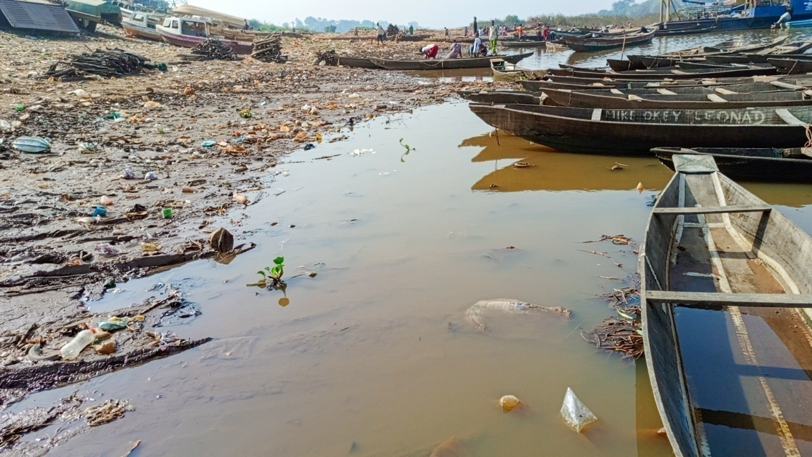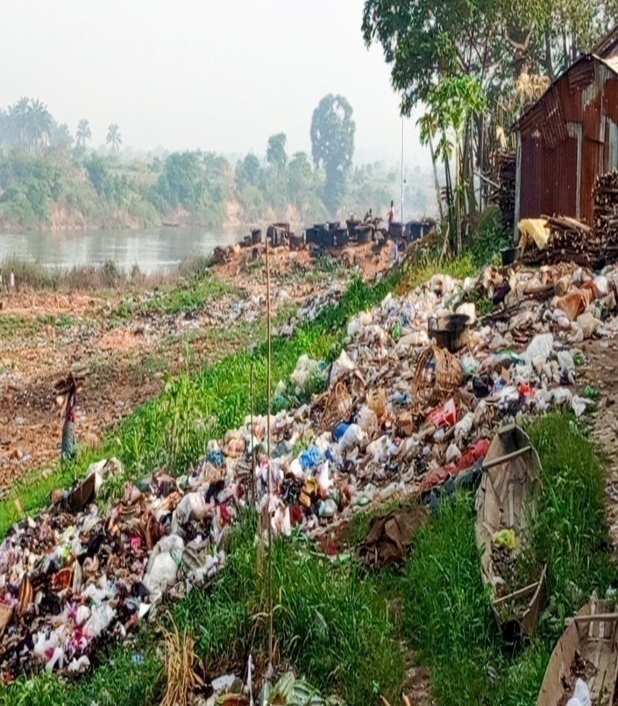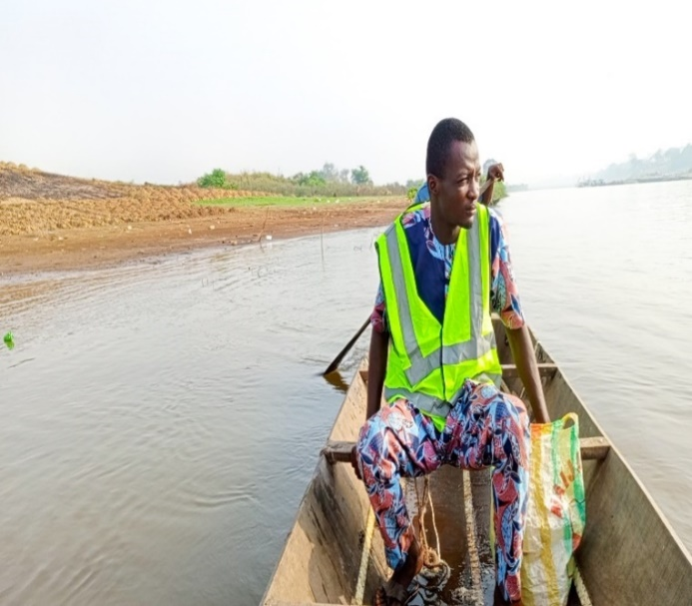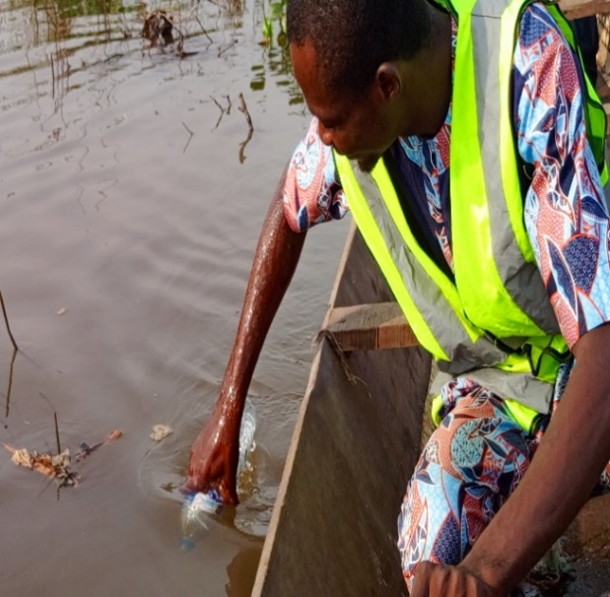
Fig. 2 Survey of sampling location

  - Experimental Design
1. Preparation of Sampling Equipment, Glass Wares and Reagents
Glass is used in every piece of sample equipment. After giving amber glass bottles a thorough detergent wash and two thorough cleanings with acetone, hexane, and dichloromethane of High Performance Liquid Chromatography (HPLC) grade, the bottles were heated in a muffler oven for a minimum of one hour at 400 °C. Following baking, the bottles were cleaned with fresh aluminium foil and rinsed three more times using acetone, methanol, hexane, and dichloromethane. Aluminium foils were also cleaned with acetone and hexane before being used, and they were heated for 10 hours at 45 °C in a hot oven. Before sampling, buckets, flat trays, and spoons made of stainless steel were wrapped in aluminium foil and cleaned. The sediment grab sampler and glass water samplers were washed with lab-grade detergent and then washed three times with HPLC grade of acetone, C-H, O-Hexane as well as dichloromethane, respectively.
2. Pre-Sample Collection
All sample equipment, containers, and tools were cleaned with ultrapure water before sampling. Throughout the sampling process, nitrile gloves and a cotton coat were always used.
3. Collection of Sediments and Water Samples
At the precise location where the silt was collected, seven surface waters were collected. In order to prevent pollution from being over-concentrated and erupting from the sediments, this was done prior to the sediments being collected. Using a stainless-steel shovel, sediments were scooped up to a mass of around 50 g at a depth of 5 cm, following the procedure outlined by [15]. Prior to additional examination, seven sediment samples were conserved and placed in tin foil pouches.

TABLE I-Code for Sample Collection
Sampling location | Water code | Sediment code
A | W_{A} | S_{A}
B | W_{B} | S_{B}
C | W_{C} | S_{C}
D | W_{D} | S_{D}
E | W_{E} | S_{E}
F | W_{F} | S_{F}
G | W_{G} | S_{G}

  - Physicochemical Analysis in Water Samples
1. Determination of pH
Using a portable pH meter (HANNA pH 209), which was calibrated and kept in a 4 M KCl solution, the pH values of the samples were determined using the method outlined by [16]. Each sample's pH was measured by dipping the probe into 50 mL of the sample in the beaker, reading and recording the result, and then rinsing the probe in deionized water. This process was repeated for each sample, and the results were recorded.
2. Determination of Dissolved Solid [16]
20 beakers were washed, oven dried, and cooled in the desiccators; their various weights were recorded. A 50 ml measure of each sample was filtered into each of the beakers and heated to dryness using a heating mantle. Afterward, the beakers were cooled in the desiccators and the final weights of the beakers were recorded.
3. Determination of Suspended Solid [16]
After a 50 ml measure of each water sample was filtered into a separate beaker, the seven filter papers were weighed in an electrical analytical weighing balance, oven dried, and allowed to cool in the desiccators. The weight of each filter paper was then recorded once the cooling process was complete.
  - Physicochemical Analysis in Sediment Samples
1. pH [16]
The soil sample's pH was measured using a 1:1 soil to distilled water ratio. A beaker containing 10 g of soil was filled with 10 mL of distilled water, shaken rapidly, and left to stand for half an hour. The pH of the sample was measured using a microprocessor pH 213 meter that had been calibrated before being submerged in the soil solution's supernatant. The pH meter was calibrated using a buffer solution with pH values of 4 and 7. The sample's pH levels were measured three times.
2. Determination of Electrical Conductivity
Following the guidelines provided by [16], the analysis was performed using an electrical conductivity meter (model ADS-102). The conductivity cell was rinsed with three portions of the water sample, and the temperature of the sample was adjusted to 20 ± 0.1 °C. The electrode-containing conductivity cell was then submerged in a sufficient volume of the sample, and the conductivity meter was turned on and the sample readings were recorded.
  - Determination of Phthalates
1. Digestion of Water Sample for Phthalates Analysis
After passing through a 0.45 μm Millipore membrane for filtering, the 250 mL water sample was pre-concentrated using solid-phase extraction (SPE). Each of the following four amounts —5 mL hexane, 1 mL acetone, 2 mL methanol, and 2 mL clean water— was used to activate the SPE cartridge containing florisil. The SPE cartridge was allowed to air dry for three minutes following the loading of water samples. The dried cartridge was used to filter the eluent at a rate of one millilitre per minute. By employing a slow flow of nitrogen gas during evaporation, the eluate was partially dried. Before the GC-MS analysis, the residue was again dissolved using an extraction solvent, 2 ml of n-hexane, and the isotope surrogate standard.
2. Digestion of Sediment Samples for Phthalates Analysis
Pretreatment of the sediment samples was done using a technique from [17]. Using a mortar and pestle, each sediment sample was crushed and homogenized. This was put in brown glass bottles at -20 °C while it was being extracted after being filtered via a 60-mesh stainless steel sieve. Samples of weighed riverine sediment (10 grams) were put into glass centrifuge tubes, combined with 10 millilitres of acetone/hexane (1:1 v/v), AND ALLOWED TO SIT OVERNIGHT BEFORE BEING EXTRACTED USING AN ultrasonic method for 30 minutes. Each extract was then filtered into a flask with a round bottom after the procedure was performed twice. The filtrates were then cleaned using SPE, solvent swapped with n-hexane and dichloromethane, and concentrated to 1-2 mL using a rotary evaporator. The SPE cartridge with florisil, was successively activated by 15 mL C-H, O-Hexane followed by 15 mL acetone/C-H, O-Hexane (1:1, v/v), and the eluents were properly disposed of. The PAEs extract was moved to the extraction cartridge and eluted with 10 mL acetone/n- hexane (1:4, v/v), the final eluent was collected into sample containers. The portion containing PAEs was concentrated to 2 mL and the portion was adjusted to a constant volume of 1 mL and filtered via a 0.25 μm membrane filter into brown vial bottles for sample injection prior to GC-MS.
2.8.3 Instrumental analysis of phthalates by GC-MS
A GC/MS gas chromatograph/mass spectrometer, functional electron influence, and an HP-5 MS in selective ion monitoring mode (30 mm × 0.25 mm × 0.25 mm) were used to analyze each sample. Using a fused-silica capillary column, chromatographic separation was accomplished. A steady flow rate of 1 milliliter per minute was maintained using pure helium gas (99.9999%) as the carrier gas. The oven's temperature program was set for one minute at 30°C, then for one minute at 70°C, and finally for four minutes at 90°C. At 100°C, the injector temperature was used to inject each 2.0 µl extract volume into the GC–MS instrument in splitless and non-pulse mode.
2.9 Pollution assessment
2.9.1 Ecological Risk Assessment of phthalates
The ecological risk of PAEs in water, sediment and fish phase was also considered by the application of the risk quotient (RQ) method. In accordance to the European technical guidance document (TGD) on risk assessment of chemical pollutants [18], RQ for PAE congeners was evaluated by dividing the measured environmental concentration (MEC) with the predicted no effect concentration (PNEC), RQ was used to evaluate the ecological risk. MEC was the concentration of Individual PAEs measured in water and sediment samples. Whereas, PNEC was obtained from no observed effect concentration (NOEC) or median effective concentrations (EC50), which were divided by an assessment factor (AF).The estimated environmental risk could be considered insignificant if RQ < 0.1, low when the RQ value ranges from 0.1–1, moderate if RQ values lies from 1 to 10, and high if RQ >10 [19].
The RQs of PAEs were estimated by using the formula:
𝑅𝑄 = $\frac{MEC}{PNEC}$
2.9.2 Health Risk Assessment of phthalates
For the calculation of health risk, the target population is children and adults. The exposure routes to human considered are the following: (i) ingestion through drinking of water and (ii) dermal absorption during bathing and washing. Approaches as described by [20] and United States Environmental Protection Agency [21] were implemented with slight modification for human health risk assessment. The average daily exposure concentration, in this regard is referred to as average daily dose (ADD) and were computed using Equation below:
ADD = $\frac{Cmean ×IR ×ED ×Fc}{BW ×AT}$
where, C_{mean} is the concentration of PAEs in the polluted tap water samples collected from four waterworks in the study area; IR represents the average daily consumption rate; ED is referred to the exposure period (in years); Fc simply means the fraction contaminated; BW simply means the average body weight; AT represents the average lifetime of exposure (mg/kg/day).
Carcinogenic risk assessment as a result of lifetime exposure was evaluated by using the following formula:
LADD_{ingestion} =$\frac{ ADDingestion ×ED}{Lft}$
where, LADD is referred to as the average daily dose of lifetime exposure; Lft means lifetime.
Dermal absorption dose (DAD) was evaluated by using the equation below:
DAD_{dermal} = $\frac{Cmean ×SA ×SL×ABS ×EF ×ED}{BW ×AT}$
where, SA simply represent the skin surface area; SL is skin adherence factor = 0.7 mg cm⁻² day⁻¹; ABS is referred to as the dermal absorption factor; EF is exposure frequency risk characterization.
Table 2: Exposure parameters used for noncarcinogenic risk and carcinogenic risk
Parameter |  | Value
Reference dose (RfD) | DBP | 0.2 mg/kg/day
 | DEHP | 0.02 mg/kg/day
 | DEP | 0.02 mg/kg/day
 | DPP, BB | 0.1 mg/kg/day
 | MBP | 0.115 ^{b} mg/kg/day
Concentration of PAEs (C) | Mean value of PAEs | from result
Intake rates (IR) | Adults/Children | 1.5
Exposure frequency (EF) | Adults | 365 years
Exposure duration (ED) | Children | 6 years
Body weight (BW) | Adults | 60 kg
 | Adolescent | 30 kg
 | Children | 15kg
Average time (AT) | Noncancer risk | 365 x ED
 | Cancer risk | 365x 70
Slope factor (SF) | PAEs | 0.014 mg/kg/day
Source: [21]
Table 3: Exposure parameters used to generate exposure estimate of PAEs

Exposure parameter | Unit
Drinking water | 365 events/year, 2L/event (adult), 1L/event (children); 100% portion of contaminated tap water
Dermal absorption | 365 events/year; 12 min/event, 6 min/event; 5700 cm² skin surface (adult), 2800 cm² skin surface (children); Skin adherence factor = 0.7 mg/cm²/day; ABS is dermal absorption factor = 0.1 for all  PAEs congeners
Source: [20]

Table 4: Established health limit of daily intake of PAEs, TDI and RfD

PAEs compound | TDI  µg/kg/day | RfD  mg/kg/day | References
DBP | 10 | 100 | [31]
DEHP | 50 | 20 | [31]
DPP | 150 | - | [32]
DEP | 150 | - | [32]
BB, MBP | 500 | 200 | [31]
Source : [22]

3.0 RESULTS AND DISCUSSION
Table 5: Physicochemical analysis of sediment
Sample code | pH | EC
S_{A} | 5.55±0.001 | 80±0.01
S_{B} | 5.90±0.002 | 65±0.02
S_{C} | 5.90±0.21 | 75±0.11
S_{D} | 6.60±0.01 | 100±0.10
S_{E} | 5.95±0.043 | 100±0.24
S_{F} | 6.35±0.11 | 110±0.11
S_{G}  Mean | 6.80±0.001  6.15 | 120±0.26  92.86

The pH of sediment ranges from 5.55 to 6.80 with mean value of 6.15, which indicates a slight level of acidity. Sample S_{A} has the highest level of acidity, while sample S_{G} has the lowest value of acidity as it tends to neutrality. Based on the pH level, the water sourced from such sediments is considered fit for consumption in the sampling location as it is within WHO [23] specification of pH level (5.5- 8.5). The EC of sediment range from 65 µS/cm (S_{B}) to 120 µS/cm (S_{L}). All these results fell within the WHO specification limit of 0-500 µS/cm for standard water.
Table 6: Physicochemical analysis of water
Sample code | pH | TDS mg/l | TSS (mg/l)
W_{A} | 5.90±0.01 | 76±0.014 | 1.48±0.01
W_{B} | 6.30±0.001 | 53±0.001 | 1.25±0.04
W_{C} | 6.82±0.02 | 48±0.01 | 1.07±0.01
W_{D} | 6.45±0.001 | 82±0.00 | 2.04±0.01
W_{E} | 6.70±0.1 | 59±0.032 | 1.34±0.01
W_{F} | 6.60±0.11 | 72±0.1 | 2.45±0.03
W_{G}  Mean | 6.50±0.12  6.47 | 38±0.011  61.14 | 1.05±0.033  1.53

The pH of water ranges from 5.90 to 6.82 with mean value of 6.47 indicating slight level of acidity. Sample W_{A} has the highest level of acidity while sample W_{C} has the lowest value of acidity as it approaches neutrality. Based on the pH results, the water is considered fit for consumption in the sampling location as it is within WHO [23] specification of pH level (5.5- 8.5). The pH values obtained in this study are similar to that reported for surface water by other research [22], [24]. Suspended solids affect the clarity of water and can have negative impacts on aquatic organisms according to [25]. In this research, the suspended solid levels and total dissolved solids were below the WHO permissible level.
Table 7: Concentration of phthalates in sediments
Sample code | Phthalates (mg/kg)
 | MBP | DEP | DPP | BBP | DBP | DEHP
S_{A} | 0.02 | 0.03 | 0.102 | 0.00 | 0.018 | 0.018
S_{B} | 0.00 | 0.01 | 0.003 | 0.00 | 0.001 | 0.13
S_{C} | 0.001 | 0.002 | 0.001 | 0.00 | 0.001 | 0.03
S_{D} | 0.00 | 0.01 | 0.00 | 0.00 | 0.00 | 0.00
S_{E} | 0.00 | 0.01 | 0.00 | 0.00 | 0.002 | 0.07
S_{F} | 0.001 | 0.00 | 0.001 | 0.00 | 0.001 | 0.023
S_{G}  Mean | 0.001  0.003 | 0.02  0.012 | 0.03  0.02 | 0.00  0.00 | 0.03  0.008 | 0.04  0.044
MBP: Monobutyl phthalate DEP: Diethyl phthalate
DPP: Dipentyl phthalate BBP: Butyl benzyl phthalate
DBP: Dibutyl phthalate DEHP: Di (2ethylhexyl) phthalate

Table 7 showed the levels of PAEs congeners (MBP, DEP, DPP, BB, DBP and DEHP) contents in sediments analyzed from seven sampling points of Omambala River. The result indicated that the analyzed sediments samples contained high proportion of DEHP in most of the sampling point. This observation was due to different contamination of different sites. The differences of PAEs concentrations in the sediments are mainly influenced by different pollution sources including industries, residential areas, agricultural fields and aquaculture ponds. Furthermore, this result suggested that the distribution of PAEs in this present study was also influenced by other factors such as transport, mixing, sedimentation/accumulation pattern, metabolic processes and pathways in sediments and characteristics of the investigated river systems, which is consistent with previous studies reported by [26].
All the selected PAEs was detected in all investigated sediment samples with the exception of BB indicating that PAEs is a ubiquitous organic pollutant in the riverine environment. Frequency of detection for individual PAEs congeners in this study, followed the order of DEHP > DPP > DEP > DBP > MBP> BB. However, the relative percentage contributions of the total level of PAE congeners detected in the sediments indicated that DEHP had the highest relative contribution percentage. These results are not consistent with the commonly documented findings published in literature, which indicated that DEHP and DBP are the predominant congeners with the highest concentration in sediments [27].
Table 8: Concentration of phthalates in water
Sample code | Phthalates (mg/l)
 | MBP | DEP | DPP | BBP | DBP | DEHP
W_{A} | 0.01 | 0.03 | 0.02 | 0.00 | 0.07 | 0.08
W_{B} | 0.00 | 0.021 | 0.007 | 0.00 | 0.00 | 0.01
W_{C} | 0.008 | 0.023 | 0.00 | 0.00 | 0.08 | 0.06
W_{D} | 0.00 | 0.00 | 0.00 | 0.00 | 0.00 | 0.00
W_{E} | 0.00 | 0.00 | 0.00 | 0.00 | 0.00 | 0.00
W_{F} | 0.001 | 0.00 | 0.00 | 0.00 | 0.00 | 0.00
W_{G}  Mean | 0.009  0.004 | 0.012  0.012 | 0.01  0.005 | 0.00  0.00 | 0.00  0.02 | 0.028  0.025
MBP: Monobutyl phthalate DEP: Diethyl phthalate
DPP: Dipentyl phthalate BBP: Butyl benzyl phthalate
DBP: Dibutyl phthalate DEHP: Di (2ethylhexyl) phthalate

The concentrations of the six targeted PAE congeners (MBP, DEP, DPP, BB, DBP and DEHP) in water samples shows that all PAEs congeners were detected in all the water samples analyzed in minute quantity except BB, suggesting that PAEs are priority pollutants in the river system. The concentration of PAEs in water ranged from non-detectable (ND) to 0.08 mg/L with mean value ranging from 0.00 mg/L to 0.025 mg/L The distribution patterns of PAEs in the water phases of the sampling point is suggested to be controlled by factors such as the properties of the suspended solid particles, the physicochemical properties of the PAEs themselves and the level of urbanization as reported by [19]. This finding is consistent with previous studies that reported that urbanization influences the pollution status of PAEs in aquatic environment [17]. Low concentration of PAEs was detected at sampling sites that are mainly located at rural region of the river. These sites are mainly dominated by agricultural and aquaculture activities, which may be the main contributor of PAEs pollution in these areas. In addition, most of these sites are located at the downstream of the river, thus higher river flow may have caused better dilution of local discharge as well as the fact that there may be fewer or no actual municipal and industrial discharge wastewater in these regions of the canal. The relative contribution presented that DEHP has the highest contribution and predominant in water samples analyzed in this work. This result opposes previous studies that reported that DEHP are dominant components of PAEs in water [5]. In addition, this observation reflects the usual pattern of plastic or rubber industry productions being dominated by DEHP and DEP documented in published literature [17].
3.1 Risk assessment of PAEs
Table 9: Health risk of PAEs in water media in the wet season in adult
PAEs | Mean (mg/L) | ADD | RfD | HQ | Slope factor | Cancer risk
MBP | 0.004 | 4.29E-07 | 0.115 | 3.73E-6 | 0.014 | 5.22E-08
DEP | 0.012 | 6.07E-07 | 0.02 | 3.04E-05 | 0.014 | 4.25E-07
DPP | 0.005 | 1.71E-06 | 0.1 | 1.71E-05 | 0.014 | 2.39E-07
BB | 0.00 | 0 | 0.1 | 0 | 0.014 | 0
DBP | 0.02 | 7.85E-07 | 0.2 | 3.93E-06 | 0.014 | 5.50E-08
DEHP | 0.025 | 8.57E-07 | 0.02 | 4.29E-05 | 0.014 | 6.0E-07
Total |  | 4.47E-06 |  | 9.89E-05 |  | 1.37E-06

Table 10: Health risk of PAEs in water media in the wet season in children
PAEs | Mean (mg/L) | ADD | RfD | HQ | Slope factor | Cancer risk
MBP | 0.004 | 1.71E-06 | 0.115 | 1.49E-05 | 0.014 | 2.08E-07
DEP | 0.012 | 2.43E-06 | 0.02 | 1.21E-04 | 0.014 | 1.70E-06
DPP | 0.005 | 6.86E-06 | 0.1 | 6.86E-05 | 0.014 | 9.60E-07
BB | 0.00 | 0 | 0.1 | 0 | 0.014 | 0
DBP | 0.02 | 3.14E-06 | 0.2 | 1.57E-05 | 0.014 | 2.20E-07
DEHP | 0.025 | 3.43E-06 | 0.02 | 1.72E-04 | 0.014 | 2.40E-06
Total |  | 1.79E-05 |  | 3.95E-04 |  | 5.49E-06
Table 11: Ecological risk of PAEs in water media in the wet season
PAEs | Mean (mg/L) | MEC | PNEC | RQ
MBP | 0.004 | 0.012 | 26 | 4.6E-04
DEP | 0.012 | 0.017 | 26 | 6.5E-04
DPP | 0.005 | 0.048 | 0.84 | 5.7E-02
BB | 0.00 | 0.002 | 0.34 | 5.9E-03
DBP | 0.02 | 0.022 | 26 | 8.5E-04
DEHP | 0.025 | 0.024 | 0.84 | 2.9E-02
Total |  |  |  | 0.0939

Table 12: Ecological risk of PAEs in sediment in the wet season
PAEs | Mean (mg/L) | MEC | PNEC | RQ
MBP | 0.004 | 0.007 | 2.88 | 2.4E-03
DEP | 0.012 | 0.015 | 2.88 | 5.2E-03
DPP | 0.005 | 0.009 | 13.6 | 6.6E-04
BB | 0.00 | 0.00 | 181.4 | 0.00
DBP | 0.02 | 0.01 | 2.88 | 3.5E-03
DEHP | 0.025 | 0.033 | 13.6 | 2.4E-03
Total |  |  |  | 0.0142

The results of health risk assessment of PAEs as shown in Table 9 and Table 10 reveals that in the wet season, the calculated cancer risk in both adults and children are closer to the permissible limit (1.37E-06 in adults and 5.49E-06 in children). This may be due to the excessive discharge of toxic substance into the water bodies by human forces. In addition, risk quotient (RQ) method was also used in evaluating the ERA (Ecological Risk Assessment) of PAEs as shown in Table 11 and Table 12. The total RQ value for PAEs in water media in the wet season is found to be 0.0939, which also signifies low level of risk, while in sediments, the total RQ value is found to be 0.0142, which tends to cause low risk. Concentration below the threshold effect level (TEL) value do not pose adverse ecological effects on aquatic biota, while those between TEL can pose occasional adverse ecological effects, and a DEHP level greater than TEL may cause severe ecological risk on aquatic biota.
Moreover, previous studies indicated that if the pollutants level exceeds the environmental risk levels (ERLs), it may generate several adverse effects on both environmental and human health [2], [28]. The study by [29] proposed the ERLs for DBP and DEHP are capable of causing adverse ecological effects in an ecosystem. There is need for routine monitoring and control of PAEs pollution of the sampling sites to prevent further PAEs pollution and protect the aquatic biota and human. However, DEHP poses higher health risk effects to humans when compared to DBP and other PAEs [30].
4.0 Conclusion
The study revealed that Omambala River was contaminated with DEHP, DPP, DEP, MBP, and DBP. The level of PAEs contamination posed a moderate ecological risk to the aquatic ecosystem. However, the levels of PAEs in the river posed acceptable health risk concerning carcinogens. Nonetheless, the moderate contamination of PAEs raised concerns over the adverse effects on the aquatic ecosystem since it is a major water resource for drinking water, balancing the aquatic ecosystem, industrial and agricultural utilizations, and transferring PAEs to lower water bodies, which act as sinks for the chemical to accumulate. The endocrine disruptive effects of PAEs have the potential to cause infertility to aquatic animals, especially fish, shrimp, and crabs, which are abundant there. To prevent negative impacts on local economy and food security, both point sources and nonpoint sources of PAEs should be strictly regulated and monitored continuously. It is therefore recommended that the development of new technology for wastewater treatment systems that can eliminate PAEs be encouraged, along with reuse and recycle of PAEs in consumer and industrial products.

Declarations
Ethics approval and consent to participate: Not applicable.
Consent to publication: Not applicable.
Competing interests: The authors declare that they have no relevant financial or nonfinancial interests to disclose.

Disclaimer: - This manuscript was presented in a Conference.
Conference name
Conference Title : ICOPPS 2024 : International Conference on Ocean Plastic Pollution Studies
Conference Location : London, United Kingdom
Conference Dates : August 22-23, 2024
Available link: - https://publications.waset.org/abstracts/182898/distribution-and-risk-assessment-of-phthalates-in-water-and-sediment-of-omambala-river-anambra-state-nigeria-in-wet-season

REFERENCES
[1] Selvaraj, K. K., Sundaramoorthy, G., Ravichandran, P. K., Girijan, G. K., Sampath, S., & Ramaswamy, B. R. (2014). Phthalate esters in water and sediments of the Kaveri River, India: environmental levels and ecotoxicological evaluations. Environmental Geochemistry and Health, 37(1), 83–96. https://doi.org/10.1007/s10653-014-9632-5.
[2] Net , S., Delmont, A., Sempéré, R., Paluselli, A., & Ouddane, B. (2015). Reliable quantification of phthalates in environmental matrices (air, water, sludge, sediment and soil): A review. Science of the Total Environment, 515–516, 162–180. https://doi.org/10.1016/j.scitotenv.2015.02.013.
[3]Wormuth, M., Scheringer, M., Vollenweider, M., & Hungerbühler, K. (2006). What are the sources of exposure to eight frequently used phthalic acid esters in Europeans? Risk Analysis, 26(3), 803–824. https://doi.org/10.1111/j.1539-6924.2006.00770.x.
[4] Wang, J., Bo, L., Li, L., Wang, D., Chen, G., Christie, P., & Teng, Y. (2014a). Occurrence of phthalate esters in river sediments in areas with different land use patterns. Science of the Total Environment, 500–501, 113–119. https://doi.org/10.1016/j.scitotenv.2014.08.092.
[5] Zhang, Z. M., Zhang, H. H., Zou, Y. W., & Yang, G. P. (2018). Distribution and ecotoxicological state of phthalate esters in the sea-surface microlayer, seawater and sediment of the Bohai Sea and the Yellow Sea. Environmental Pollution. https://doi.org/10.1016/j.envpol.2018.04.056.
[6] Adeniyi, A. A., Okedeyi, O. O., and Yusuf, K. A. (2011). Flame ionization gas chromatographic determination of phthalate esters in water, surface sediments and fish species in the Ogun river catchments, Ketu, Lagos, Nigeria. Environmental Monitoring and Assessment, 172(1–4), 561–569. https://doi.org/10.1007/s10661-010-1354-2.
[7] Cheng, L., Zhao, Y., Li, L., Chen, B., & Zhang, Y. (2013). Exposure assessment of phthalates in non-occupational populations in China. Science of the Total Environment, 427–428, 60–69. https://doi.org/10.1016/j.scitotenv.2012.03.090.
[8] Ogbuagu, J.O., Obi, E.N., Okeke, A.P., Ukpai, U.E. (2021). Pollution status and health risk assessment of polycyclic aromatic hydrocarbons in surface water, sediment and fish from Ezu-River, Anaku, Anambra State, Nigeria. Asian Journal of Applied Chemistry Research. 2021;10(1):26-39.
[9] Ogbuagu, J.O., Ukpai, U.E., Okeke A.P and Nweke, E.N. (2021). Occurrence and fate of Polychlorinated Biphenyls in water and sediments: A case study of Bodo River in Ogoni, River State Nigeria. Asian Journal of Applied Chemistry Research. 10(3-4): 12-20.
[10] Keresztes, S.; Tatar, E.; Czegény, Z.; Zaray, G.; Mihucz, V.G. (2013). Study on the leaching of phthalates from polyethylene terephthalate bottles into mineral water. Sci. Total Envt. 458, 451–458.
[11] Wu, C.F., Chang-Chien, G.P., Su, S.W., Chen, B.H.,Wu, M.T. (2014). Findings of 2731 suspected phthalate-tainted foodstufs during the 2011 phthalates incident in Taiwan. J. Formos. Med. Assoc. 113, 600–605.
[12] Marega, M., Grob, K., Moret, S., Purcaro, G., Conte, L.S. (2009). Phtalate contamination in olive oil production chain. In Proceedings of the Workshop Contaminants of Edible Fats and Oils: Analytical, normative issues and prevention, Udine, Italy, 12–13 November 2009.
[13] Sungur, S., Okur, R., Turgut, F., Ustun, I., Gokce, C. (2015). Migrated phthalate levels into edible oils. Food Addit. Contam. Part B Surveill. 2015, 8, 190–194.
[14] Azugo, W. I. (1978). Ecological Studies of the Helminth Parasites of the Fish of Anambra River System. M. Phil Thesis, University of Nigeria Nsukka, 178 pp.
[15] Deng H., Wei R., Luo W.Y., Hu L.L., Li B.W., Shi H.H. (2020). Microplastic pollution in water and sediment in a textile industrial area. Environ. Pollut. 258, 113658. https://doi.org/10.1016/j.envpol.2019.113658.
[16] APHA. (2017). Standard methods for the examination of water and sediments for physicochemical parameters, 23rd Edition, Washington, DC, pp 148- 176.
[17] Wang, J., Bo, L., Li, L., Wang, D., Chen, G., Christie, P., & Teng, Y. (2014a). Occurrence of phthalate esters in river sediments in areas with different land use patterns. Science of the Total Environment, 500–501, 113–119. https://doi.org/10.1016/j.scitotenv.2014.08.092.
[18] European commission. (2003). Technical Guidance Document on risk assessment in support of Commission Directive 93/67/EEC, Commission Directive 98/8/EC, Commission Regulation (EC) No 1488/94, Commission Directive 93/67/EEC. . EUR 20418 EN/2.
[19] Li, R., Liang, J., Gong, Z., Zhang, N., & Duan, H. (2017a). Occurrence, spatial distribution, historical trend and ecological risk of phthalate esters in the Jiulong River, Southeast China. Science of the Total Environment, 580, 388–397. https://doi.org/10.1016/j.scitotenv.2016.11.190.
[20] Okechukwu, O. J., Princewill, O. A., Ernest, U. U., & Nweke, O. E. (2023). Ecological and health risk assessment of polychlorinated biphenyls in water and sediments in Bodo Riverine area, River State, Nigeria. Journal of Material Sciences and Engineering Technology, 1(3), 1-7.
[21] USEPA (U.S. Environmental Protection Agency). (2012). Edition of the tap waterstandards and health advisories. Washington, DC: U.S. EPA; 2012 (Available: http://water.epa.gov/action/advisories/drinking/upload/dwstandards2012.pdfLast accessed October 2017).
[22] Olujimi, O. O., Aroyeun, O. A., Akinhanmi, T. F., & Arowolo, T. A. (2017). Occurrence, removal and health risk assessment of phthalate esters in the process streams of two different wastewater treatment plants in Lagos and Ogun States, Nigeria. Environmental Monitoring and Assessment, 189(7). https://doi.org/10.1007/s10661- 017-6028-x.
[23] World Health Organisation, (WHO), (2017); Guidelines for Drinking Water Quality, 4th Edition; Incorporating the first addendum, A publication of World Health Organisation, Geneva Switzerland.; 1-631.
[24] Ogata, Y., Takada, H., Mizukawa, K., Hirai, H., Iwasa, S., Endo, S., Mato, Y., Saha, M., Okuda, K., Nakashima, A., Murakami, M., Zurcher, N., Booyatumanondo, R., Zakaria, M. P., Dung, L. Q., Gordon, M., Miguez, C., Suzuki, S., Moore, C., Karapanagioti, H. K., Weerts, S., McClurg, T., Burres, E., Smith, W., Velkenburg, M. V., Lang, J. S., Lang, R. C., Laursen, D., Danner, B., Stewardson, N. and Thompson, R. C. (2009). International Pellet Watch: Global monitoring of persistent organic pollutants (POPs) in coastal waters. 1. Initial phase data on PCBs, DDTs, and HCHs. Marine Pollution Bulletin, 58 (10). pp 1437-1446.
[25] Reddy, M. S., Shaik, B., Adimurthy, S. and Ramachandraiah, G. (2006). Description of the small plastics fragments in marine sediments along the Alang-Sosiya ship-breaking yard, India’. Estuarine, Coastal and Shelf Science, 68 (3-4). pp 656-660.
[26] Okechukwu, O. J., Princewill, O. A., Ernest, U. U., & Nweke, O. E. (2023). Ecological and health risk assessment of polychlorinated biphenyls in water and sediments in Bodo Riverine area, River State, Nigeria. Journal of Material Sciences and Engineering Technology, 1(3), 1-7.
[27] Hahladakis J.N., Velis C.A., Weber R., Iacovidou E. and Purnell P. (2018). An Overview of Chemical Additives Present in Plastics: Migration, Release, Fate and Environmental Impact During Their Use, Disposal and Recycling. Journal of Hazadous Materials, Vol. 344, , pp. 1799-199.
[28] Sun, J., Huang, J., Zhang, A., Liu, W., & Cheng, W. (2013a). Occurrence of phthalate esters in sediments in Qiantang River, China and inference with urbanization and river flowregime. Journal of Hazardous Materials,248–249(1),142–149. https://doi.org/10.1 016/j.jhazmat.2012.12 .057.
[29] Princewill, O. A., Okechukwu, O. J., Uche, A. R., & Stellamaris, O. A. (2024). Phthalate esters in water and surface sediments of Anambra River in dry season: Distribution and human health risks assessment. Journal of Global Ecology and Environment, 20(4), 52-65.
[30] Chen, N., Shuai,W., Hao, X., Zhang, H., Zhou, D., Gao, J. (2017). Contamination of Phthalate Esters in Vegetable Agriculture and Human Cumulative Risk Assessment. Pedosphere. 27, 439–451.
[31] U.S. EPA (U.S. Environmental Protection Agency). (2012). Edition of the tap water standards and health advisories. Washington, DC: U.S. EPA; 2012 (Available: http://water.epa.gov/action/advisories/drinking/upload/dwstandards2012.pdfLast accessed October 2017).
[32] EFSA (European Food Safety Authority). (2005). Opinion of the scientific panel on food additives, flavouing, processing aids and materials in contact with food (AFC) on a request from commission related to phthalate for use in food contact materials: question.

