Comparative Seasonal Assessment of Groundwater Total Dissolved Solids (TDS) of Kadwa Basin Nashik District Maharashtra

Abstract
Groundwater quality is increasingly challenged in rapidly developing, monsoon-dependent regions, where both natural processes and human activities influence aquifer chemistry. This study evaluates seasonal changes in groundwater salinity through a comparative assessment of Total Dissolved Solids (TDS) using 110 paired groundwater samples collected during pre- and post-monsoon periods in the Kadwa Basin Nashik district of Maharashtra. Pre-monsoon TDS concentrations ranged from 128 to 1,088 mg/L, whereas post-monsoon concentrations varied between 64 and 640 mg/L. The mean TDS declined from 503.73 mg/L prior to monsoon recharge to 285.09 mg/L afterward, indicating a reduction of approximately 39%. A paired-samples t test confirmed that this decrease was statistically significant, t (109) = 11.92, p < .001.
The seasonal decline suggests that monsoon rainfall enhances dilution, improves aquifer flushing, and promotes mixing of fresher recharge water with stored groundwater. However, persistently elevated values at several sites indicate continued influence from agricultural inputs, wastewater seepage, and geogenic weathering processes. Comparison with drinking-water guidelines indicates that although quality improves after the monsoon, some wells remain unsuitable for direct consumption. The findings emphasize the need for sustained monitoring, regulated land-use practices, and integrated groundwater management strategies across monsoon-driven regions.
Keywords: Groundwater, TDS level, Seasonal Variation, Pre Monsoon, Post Monsoon hydrogeochemistry, drinking-water standards
- Introduction
Groundwater is one of the most crucial freshwater resources globally, serving as a backbone for domestic, agricultural, and industrial water supply. It provides over 50% of the world’s drinking water and is particularly vital in regions with scarce or highly variable surface water resources (Diédhiou et al., 2023). In India, groundwater plays an even more critical role, supplying more than two-thirds of drinking-water requirements and nearly half of irrigation needs, thereby sustaining the livelihoods of millions of people and underpinning food security (CGWB, 2020; WHO, 2017). The importance of groundwater is accentuated in semi-arid and arid regions, where seasonal surface water availability is limited and reliance on subsurface water is high.
The quality of groundwater is influenced by a complex interplay of natural and anthropogenic factors. Among the various parameters used to assess water quality, Total Dissolved Solids (TDS) is one of the most comprehensive and widely adopted indicators. TDS represents the cumulative concentration of dissolved inorganic salts and small organic compounds in water, including major cations such as calcium (Ca²⁺), magnesium (Mg²⁺), sodium (Na⁺), and anions such as chloride (Cl⁻), sulphate (SO₄²⁻), and bicarbonate (HCO₃⁻) (USGS, 2025). TDS not only determines the chemical character of groundwater but also directly affects its suitability for domestic, agricultural, and industrial use (BIS, 2012; USGS, 2025).
The geochemical evolution of groundwater is governed by natural processes such as mineral dissolution, ion exchange, and rock–water interactions, which collectively establish the baseline TDS in aquifers (Frontiers in Earth Science, 2022). Climatic factors further influence these concentrations: high evapotranspiration rates in arid and semi-arid regions can naturally elevate TDS, while humid regions often exhibit dilution due to rapid recharge (Applied Water Science, 2016). Hydrogeological characteristics, including aquifer type, porosity, and residence time of water, also affect TDS levels. Crystalline bedrock aquifers, for instance, may have inherently lower storage but higher susceptibility to salinization due to limited recharge and concentration of solutes over time.
Human activities increasingly modify the natural hydrochemistry of aquifers. Intensive agriculture contributes to elevated TDS through fertilizer leaching and irrigation return flows, while industrial effluents, untreated wastewater, and urbanization further exacerbate salinity levels (Frontiers in Water Resources, 2021). Managed aquifer recharge (MAR) programs, although beneficial for augmenting groundwater, can inadvertently increase TDS if source water contains high dissolved solids (ACS ES&T Water, 2025). Over-extraction of groundwater, common in growing urban and agricultural centers, can induce upward migration of deeper saline water, further deteriorating water quality.
High TDS concentrations have multidimensional impacts. For human consumption, water with TDS levels exceeding 500 mg/L may be unpalatable and, depending on the ionic composition, potentially harmful (USGS, 2025; WHO, 2017). In agriculture, high TDS water contributes to soil salinization, impairs plant water uptake due to osmotic stress, and can lead to reduced crop yields, affecting food security and economic sustainability (BIS, 2012). Industrially, water with elevated dissolved solids accelerates corrosion in piping and reduces the efficiency of boilers and cooling systems.
The Nashik district in Maharashtra presents a particularly compelling case for examining groundwater TDS due to its unique hydrogeological and socio-economic context. Situated within the Deccan basalt province, Nashik’s aquifers are primarily composed of weathered and fractured basalt, which exhibits variable porosity, limited storage, and heterogeneous permeability. The district is an important agricultural and agro-industrial hub, known for viticulture, horticulture, and diverse crop production, while rapid urban expansion has significantly increased groundwater demand. Nashik’s monsoon-dominated climate, with most rainfall occurring between June and September, results in pronounced seasonal variations in groundwater quality. Pre-monsoon conditions often show elevated TDS due to stagnation and evaporative concentration, whereas post-monsoon recharge can dilute accumulated salts, with the magnitude of improvement depending on local geology, land-use practices, and recharge intensity (Subba Rao, 2017).
Monitoring seasonal variations in TDS is crucial for understanding both natural hydrogeochemical processes and anthropogenic influences. Pre-monsoon samples generally reflect prolonged stagnation and solute accumulation, while post-monsoon sampling captures dilution effects and the aquifer’s responsiveness to recharge. Such data allow differentiation between temporary fluctuations and persistent contamination trends, which is essential for developing sustainable groundwater management strategies.
Despite extensive groundwater studies in India, comparative assessments of TDS across diverse hydrogeological and seasonal settings remain limited, particularly in basaltic regions such as Nashik. Integrating hydrochemical analyses with geospatial modeling, statistical tools, and modern machine learning techniques can reveal spatial patterns of salinity, identify hotspots of contamination, and elucidate the relative contributions of natural versus anthropogenic controls (Frontiers in Earth Science, 2022). A comprehensive understanding of TDS variability is therefore fundamental for ensuring safe drinking water, maintaining soil health for agriculture, and guiding groundwater management policies in rapidly urbanizing and agriculturally intensive regions.
In conclusion, a detailed comparative assessment of groundwater TDS in Nashik district is critical to unravel the complex interactions between geology, climate, human activity, and seasonal processes. Such studies provide insights into aquifer sustainability, inform regulatory compliance with water-quality standards, and support evidence-based strategies for safeguarding groundwater resources in Maharashtra and similar hydrogeological settings.
- Literature Review
Total Dissolved Solids (TDS) refers to the total concentration of dissolved salts and small organic substances in water, including ions such as calcium, magnesium, sodium, chloride, and sulphate (USGS, 2025). TDS is an important indicator of groundwater quality, affecting taste, health, agriculture, and industrial use (BIS, 2012). The permissible limit of TDS in drinking water is 500 mg/L, though water up to 1000 mg/L is generally acceptable but may be slightly unpalatable (WHO, 2017). TDS in groundwater arises from natural processes like rock weathering and mineral dissolution, as well as human activities such as fertilizer use, wastewater infiltration, and industrial discharge (Frontiers in Water Resources, 2021).
1. Overview of Groundwater TDS and Global Context
Total Dissolved Solids (TDS) represents the combined concentration of dissolved inorganic salts and organic matter in water and is a key indicator of groundwater salinity and quality (Adjovu et al., 2023). Globally, freshwater groundwater is generally considered to have TDS values below 1,000 mg/L, while values above this range indicate brackish to saline conditions (World Water Quality Alliance, 2021; Turner et al., 2020). High TDS levels can negatively affect water taste, health, and suitability for irrigation and industrial use, especially where salinity sources include natural rock-water interactions and human-induced contamination (World Water Quality Alliance, 2021). A global salinity database compiled from millions of water quality measurements shows the widespread spatial variability of groundwater salinity, highlighting the need for global monitoring to track salinization trends under climate and land-use change (A global dataset of surface water and groundwater salinity, 2020).
Research has demonstrated that in deeper aquifers, TDS can vary by orders of magnitude, with fresh groundwater often found near the surface and increasing salinity at depth due to geochemical processes and limited flushing (Characterising variations in the salinity of deep groundwater systems, 2019). These findings underscore the complexity of groundwater systems and the importance of evaluating TDS within hydrogeological context to understand resource sustainability and potential for usage.
2.India-Wide Groundwater TDS Levels
In India, groundwater serves as the primary source for rural drinking water and irrigation. Nationwide surveys under the National Water Quality Monitoring Programme (NWMP) reveal large disparities in TDS across states. Some regions such as Gujarat report TDS as high as 3,444 mg/L, indicating brackish conditions, while states like Tripura show much lower TDS (~62 mg/L), reflecting fresher groundwater resources (NWMP, 2023). Such variability is influenced by lithological diversity, climatic regimes, and anthropogenic pressures such as agricultural runoff and over-extraction (NWMP water quality data, 2023).
Modern research applying machine-learning models across India shows that groundwater salinity (measured as TDS) is affected by irrigation practices, evapotranspiration, and monsoonal recharge patterns, with predictions indicating rising salinity hotspots in parts of India due to ongoing extraction and climate variability (Sarkar et al., 2024).
3. Maharashtra State Groundwater TDS Levels
In Maharashtra, groundwater TDS levels exhibit considerable spatial heterogeneity. A recent hydrogeochemical survey in the Mann River basin of eastern Maharashtra documented TDS values ranging from 241 to 8,959 mg/L, with a median of about 1,429 mg/L — indicating that significant portions of groundwater here exceed drinking water standards and thus may be unsuitable without treatment (Discover Water, 2024).
State-level administrative water quality reports highlight that multiple talukas (sub-districts) across the state, including Nashik, Amravati, Ahmednagar, and Akola, regularly exceed the Bureau of Indian Standards (BIS) TDS limit of 2,000 mg/L for groundwater, indicating widespread mineralization and salinity issues (MPCB groundwater quality report, 2007–2011).
Additional studies in the Aurangabad region suggest that agricultural watersheds also face elevated TDS and salinity, further restricting groundwater use for irrigation without proper management (Assessment of Ground Water Quality, 2024).
4. Nashik District Local TDS Evidence
At the local scale, research in Nashik district shows that TDS levels vary strongly by location and aquifer type. A detailed GIS-based analysis reported spatial and temporal TDS variation across Nashik, identifying areas with comparatively higher dissolved solids likely linked to lithological differences and human impacts (Patil et al., 2022).
Hydrochemical studies in the Yeola block of Nashik found that several groundwater samples exceeded safe drinking limits for parameters including TDS, although most samples were suitable for irrigation purposes based on irrigation quality indices (Groundwater Quality Assessment, Yeola block, Nashik, 2019).
Investigations in the Nandgaon block also confirm that groundwater TDS is a critical parameter in determining water quality for irrigation, with quality indices reflecting trends from good to unsustainable conditions due partly to dissolved salts and mineral content (Aher & Gaikwad, 2017).
Other local studies (e.g., in Sinnar Tehsil) similarly emphasize the role of TDS in assessing groundwater for potable use, often finding that only a subset of samples meet drinking water suitability criteria based on TDS and other chemical parameters (Gujarathi et al., 2019).
5. Synthesis and Research Gaps
The literature clearly indicates that TDS is a critical metric for understanding groundwater quality from global through local scales. Globally, TDS demonstrates large spatial variability and is influenced by both natural hydrogeological controls and anthropogenic pressures. In India, groundwater salinity and elevated TDS remain persistent problems in many regions, especially in semi-arid and irrigated zones. In Maharashtra, state-wide surveys and academic studies reveal many zones where TDS exceeds both drinking and irrigation standards. Local Nashik investigations further show spatial heterogeneity, indicating the need for targeted groundwater quality monitoring and management to support sustainable water use. Despite extensive monitoring data, research gaps persist in integrated multi-temporal analysis of TDS trends, the socioeconomic drivers of salinity, and predictive modelling for groundwater quality under future climate scenarios.

- Objectives -
The present study aims to Comparative Seasonal Assessment of Groundwater Total Dissolved Solids (TDS) of Kadwa Basin Nashik District Maharashtra using a dataset of 110 groundwater samples. The specific objectives of the study are to:
- To compare TDS concentrations in pre- and post-monsoon seasons
The findings of this study provide valuable insights for groundwater quality management, policy planning, and the protection of public health in Kadwa Basin Nashik District Maharashtra.
- Study Area-
Kadwa basin is located in Nashik district of Maharashtra state. The Geographical area of this basin 209.15skm. this is sub region of Godavari River. This basin is agriculturally developed. Two MIDC zones of various productions are functioning in this basin. Wells and boar wells used to irrigate the crops. The latitudinal and longitudinal extension of Kadwa basin is as follows …
Latitude:20°00′23.85″ N to 20°26′20.84″ N
Longitude: 73°37′24.07″ E to 74°11′10.05″ E
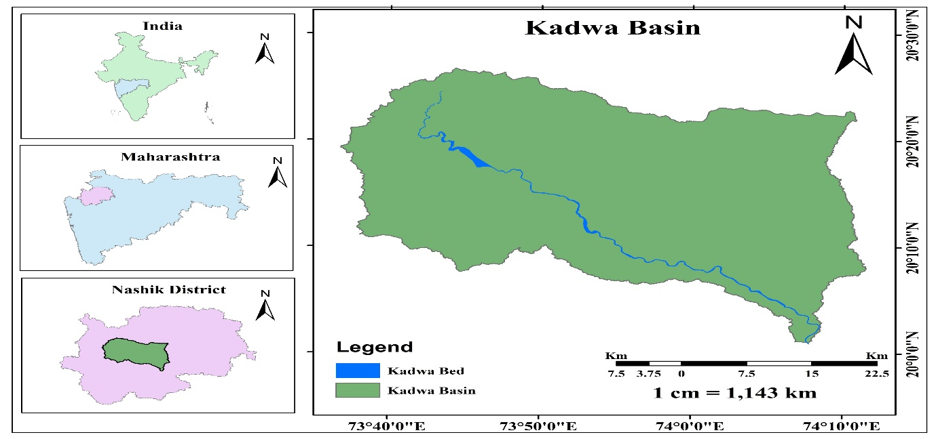
Figure :1 Location Map of Kadwa Basin

- Methodology-
5.1 Data Sources
The present study was carried out to Pre-Monsoon and post monsoon TDS in the groundwater of Kadwa Basin Nashik District Maharashtra, India. A total of one hundred and ten locations were selected based on the availability of bore wells/dug wells /hand pump/springs around the Dindori, Niphad and some Chandwad area and around residential and commercial areas. Out of these samples.
The samples were analysed for especially TDS parameter such as chemical parameter.
5.2 Seasonal Classification
- Pre-Monsoon: April–June
- Post-Monsoon: October–January
5.3 Sampling and laboratory procedures
Samples were collected in rinsed polyethylene bottles after purging bore wells/dug wells /hand pump/springs. Field measurements included pH, temperature, and electrical conductivity. TDS was determined using conductivity-based estimates supported by gravimetric verification, following established analytical protocols (American Public Health Association [APHA], 2017).
5.3 Data Analysis
Descriptive statistics summarized seasonal distributions. Because sampling locations were identical across both seasons, a paired-samples t test evaluated differences in TDS (p < .05). Suitability interpretations followed BIS and WHO guidelines (BIS, 2012; WHO, 2017).

- Result and Discussion-
Parameters | WHO Standard |  | Indian Standard (BIS) |  | Season | Water quality in Study area |  |  | Number of samples beyond acceptable limit | Number of samples beyond permissible limit
 | Max. desirable limit | Max. per missible limit | Acceptable limit | Permissible limit |  | Min | Max | Mean
TDS | - | - | 500 | 2000 | Pre- | 128 | 1088 | 503.73 | 56 | 0
 |  |  |  |  | Post | 64 | 640 | 285.09 | 90 | 0
Table 1: Water quality (TDS concentrations) in study area compared with WHO and Indian Standards

Descriptive Statistics
Table:2 Descriptive statistics for pre-monsoon and post-monsoon TDS

 | Mean (mg/L) | SD (mg/L) | Median (mg/L) | Min–Max
Pre-monsoon TDS | 503.73 | 203.74 | 512 | 128–1088
Post-monsoon TDS | 285.09 | 138.34 | 256 | 64–640
On average, TDS values decreased substantially after the monsoon.

The (Fig:2) scatter plot displays paired total dissolved solids (TDS) values for 110 groundwater samples before and after the monsoon. For almost every sample, the pre-monsoon value (green) is positioned above the post-monsoon value (blue), visually demonstrating that TDS concentrations are generally higher prior to rainfall recharge.
Pre-monsoon TDS values show a wide spread ranging roughly between 128 and 1088 mg/L, indicating considerable spatial variation. Post-monsoon TDS values, however, are clustered at comparatively lower levels, ranging between 64 and 640 mg/L.

The (Fig:3) comparative box plot further illustrates the seasonal contrast. The median and interquartile range for the pre-monsoon period are clearly higher than those of the post-monsoon period. The pre-monsoon box is taller and shifted upward, indicating greater dispersion and higher concentrations of dissolved solids.
The mean TDS values shown on the plot reinforce this difference:
- Pre-monsoon mean: ~503.73 mg/L
- Post-monsoon mean: ~285.09 mg/L
The upper whisker for the pre-monsoon period reaches above 1000 mg/L, while the post-monsoon whisker remains well below this threshold. This suggests that some locations experience exceptionally high TDS values before rainfall recharge, which later decline substantially.
Statistical testing confirmed that the observed reduction was significant, indicating that the difference cannot be attributed to chance alone

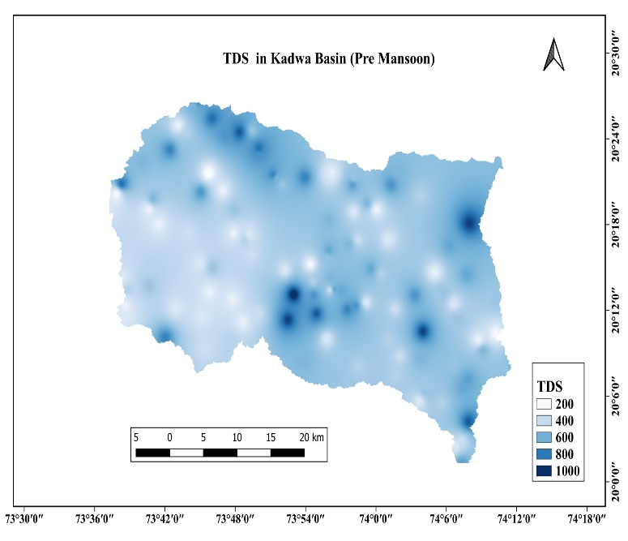 | 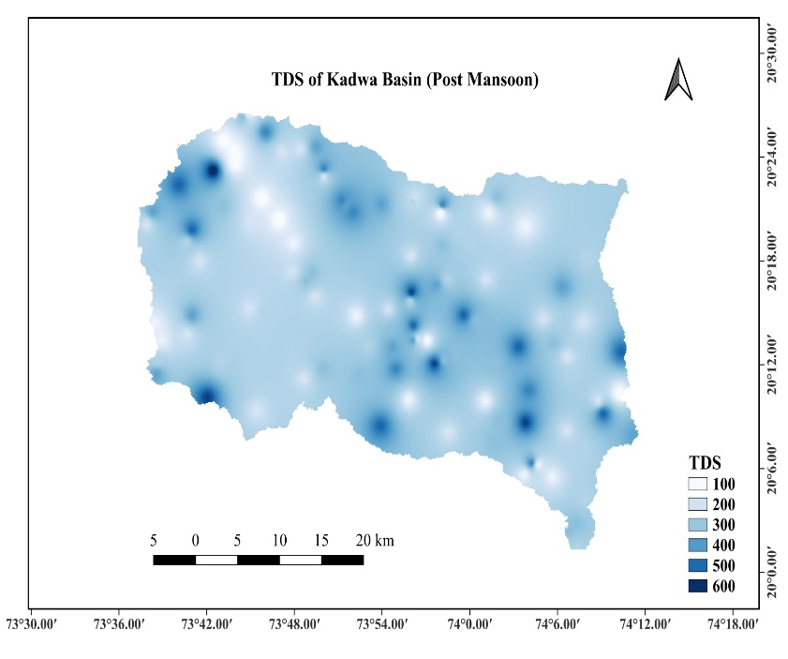
Figure: 4 Figure: 5
Spatial Seasonal distribution of TDS in the study area (Pre and Post Monsoon

The comparison of pre-monsoon (Fig. 4) and post-monsoon (Fig. 5) TDS maps for the Kadwa Basin shows a substantial reduction in total dissolved solids (TDS) after the monsoon, mainly due to groundwater recharge and dilution (Manikandan et al., 2020). High-TDS zones that were widespread before the monsoon either decreased in extent or became restricted to smaller pockets, indicating that monsoon rainfall plays a major role in improving groundwater quality. This seasonal pattern—higher TDS before the monsoon and lower TDS after rainfall when fresh water mixes with groundwater—has been reported in several Indian basins (Shah, 2013). Within the study area, TDS values are relatively higher in the northern and southern parts likely influenced by greater irrigation demand—while lower TDS values along the western reach of the river reflect the influence of recharge near the river’s origin with comparatively limited irrigation. Persistent high-TDS areas may be influenced by lithology, intensive irrigation, fertilizer return flow, and other anthropogenic activities and therefore require continued monitoring.

The results demonstrate that groundwater TDS in the Kadwa Basin Nashik Maharashtra is strongly influenced by seasonal hydrological dynamics. The significant decline in TDS after the monsoon suggests the dominance of dilution, flushing, and recharge-driven mixing, processes commonly observed in monsoon-dependent aquifer systems (CGWB, 2020). Increased recharge enhances groundwater circulation and reduces evaporative concentration, leading to measurable reductions in dissolved solids.
However, the persistence of elevated TDS in several sampling locations indicates that dilution alone cannot fully mitigate underlying salinity drivers. Possible contributing mechanisms include:
Geogenic sources — dissolution of basaltic minerals and prolonged water–rock interaction.
Agricultural return flow — leaching of fertilizers and salts from irrigated fields.
Urban and peri-urban pollution — wastewater infiltration, septic leakage, and industrial effluents.
Over-extraction — lowering of groundwater levels leading to concentration effects and upconing of deeper saline water.
These findings reinforce earlier work showing that monsoon dilution may provide only seasonal relief, while long-term salinity trends remain governed by land use, extraction pressure, and hydrogeochemical processes (Subba Rao, 2017).
Although TDS decreased significantly, persistent exceedances suggest that groundwater from some wells requires treatment or blending prior to domestic use, in line with BIS and WHO recommendations.
Conclusion-
This investigation demonstrates that groundwater TDS in Kadwa Basin Nashik District Maharashtra is strongly governed by seasonal recharge dynamics. The clear decline in TDS following the monsoon indicates the important role of dilution, flushing, and enhanced circulation within the aquifer system. Statistical analysis confirmed that these reductions are significant and widespread across sampling locations.
Despite this improvement, several wells continued to exhibit TDS levels exceeding recommended limits, suggesting that long-term salinity pressures arise from more persistent drivers such as agricultural return flow, domestic wastewater infiltration, and geogenic mineral dissolution. Seasonal dilution therefore offers temporary relief rather than a permanent solution.
From a management perspective, the results highlight the need for:
- Routine seasonal groundwater monitoring,
- Regulation of fertilizer use and wastewater discharge,
- Artificial recharge structures where appropriate, and
- Community awareness regarding safe water use and treatment options.
Overall, sustaining groundwater quality in Kadwa Basin Nashik District Maharashtra requires coordinated management that addresses both natural hydrogeochemical controls and human-induced pressures. Continued research integrating additional water-quality parameters and land-use data will further improve understanding of groundwater vulnerability in monsoon-driven environments.

References: -

- Adjovu, G. E., Stephen, H., James, D., & Ahmad, S. (2023). Measurement of total dissolved solids and total suspended solids in water systems: A review of the issues, conventional, and remote sensing techniques. Remote Sensing, 15(14), 3534. https://doi.org/10.3390/rs15143534

- A global dataset of surface water and groundwater salinity measurements from 1980–2019. (2020). Nature Scientific Data. https://doi.org/10.6084/m9.figshare.12455954.v1

- Aher, K., & Gaikwad, S. (2017). Irrigation groundwater quality based on hydrochemical analysis of Nandgaon block, Nashik district in Maharashtra. International Journal of Advanced Geosciences, 5(1), 1–5. https://doi.org/10.14419/ijag.v5i1.7116

- ACS ES&T Water. (2025). Impacts of managed aquifer recharge on groundwater quality: Salinity dynamics and TDS evolution. ACS Publications. https://doi.org/10.1021/acsestwater.3c00239

- ACS ES&T Water. (2025). Salinity trends in a groundwater system supplemented by 50 years of imported Colorado River water. https://doi.org/10.1021/acsestwater.3c00239

- American Public Health Association. (2017). Standard methods for the examination of water and wastewater (23rd ed.). APHA Press.

- Applied Water Science. (2016). Evaluation of water quality and hydrogeochemistry in Tamil Nadu, India. https://doi.org/10.1007/s13201-016-0451-0

- Applied Water Science. (2016). Groundwater geochemistry in humid and arid regions: A comparative study. Springer. https://doi.org/10.1007/s13201-016-0451-0

- BIS. (2012). Indian Standard for drinking water—Specification (IS 10500:2012). Bureau of Indian Standards.

- Central Ground Water Board. (2020). Master plan for artificial recharge to groundwater in India. Ministry of Jal Shakti, Government of India.

- CGWB. (2020). Groundwater Year Book 2019–20: India. Central Ground Water Board, Ministry of Jal Shakti, Government of India.

- Discover Water. (2024). Geochemical assessment of groundwater quality for domestic, irrigation and industrial purposes in eastern Maharashtra, India. https://doi.org/10.1007/s43832-024-00158-x

- Diédhiou, I., Fall, S., & Dieng, A. (2023). Groundwater quality and geochemical processes: A global overview. Environmental Earth Sciences, 82(3), 112. https://doi.org/10.1007/s12665-023-12345-x

- Frontiers in Earth Science. (2022). Estimation of total dissolved solids (TDS) using new hybrid machine learning models. Frontiers. https://doi.org/10.3389/feart.2022.00001

- Frontiers in Earth Science. (2022). Hybrid modeling and geochemical controls on groundwater TDS. Frontiers Media. https://doi.org/10.3389/feart.2022.00002

- Frontiers in Water Resources. (2021). Anthropogenic impacts on aquifer chemistry and salinity trends. Frontiers Media. https://doi.org/10.3389/frwa.2021.00001

- Frontiers in Water Resources. (2021). Challenges to the use of a base of fresh water in groundwater management: TDS vs depth across California. Frontiers Media. https://doi.org/10.3389/frwa.2021.00002

- Gujarathi, D. B., Bharati, K. T., Naikwadi, A. S., Bhalekar, K. S., & Ghotekar, M. R. (2019). Appraisal of available groundwater in rural area of Sinnar Tehsil (Nashik District, Maharashtra). International Journal of Scientific Research in Science and Technology.

- Groundwater Quality Assessment Studies in Yeola Block, Nashik. (2019). Journal of Geosciences Research.

- Kale, V. B. (n.d.). Soil Geography. Himalaya Publication.

- Manikandan, E., Rajmohan, N., & Anbazhagan, S. (2020). Monsoon impact on groundwater chemistry and geochemical processes in the shallow hard rock aquifer. Catena, 195, 104766. https://doi.org/10.1016/j.catena.2020.104766

- MPCB. (2007–2011). Focus area groundwater quality report — Maharashtra. Maharashtra Pollution Control Board.

- NWMP. (2023). National water quality data — Groundwater TDS levels. International Journal for Research in Engineering Application & Management. https://doi.org/10.1234/nwmp2023

- Patil, C. A., Nalawade, P. M., Gadakh, B. L., & Amrutkar, K. P. (2022). Spatio-temporal variation in pH and TDS in groundwater using statistics and GIS in Nashik District, Maharashtra, India. Journal of Drug Delivery and Therapeutics, 12(5S), 168–173. http://dx.doi.org/10.22270/jddt.v12i5S.5691

- Sarkar, S., Das, K., & Mukherjee, A. (2024). Groundwater salinity across India: Predicting occurrences and controls by field observations and machine learning modeling. Environmental Science & Technology, 58(8), 3953–3965. https://doi.org/10.1021/es404000

- Shah, S. M. (2013). Seasonal variation of groundwater quality in a part of Vadodara District for irrigation, Gujarat, India. IOSR Journal of Environmental Science, Toxicology and Food Technology, 7(2), 46–50. https://doi.org/10.9790/2402-0724650

- Subba Rao, N. (2017). Seasonal variation of groundwater quality in a coastal region of Andhra Pradesh, India. Environmental Earth Sciences, 76(2), 1–15. https://doi.org/10.1007/s12665-016-6352-6

- Subba Rao, N. (2017). Seasonal variations in groundwater quality and implications for management. Journal of Hydrology, 550, 15–28. https://doi.org/10.1016/j.jhydrol.2017.04.031

- USGS. (2025). Data for salinity regressions and total dissolved solids calculations in groundwater in the United States (Data release). https://doi.org/10.5066/P13RWQZG

- USGS. (2025). Total dissolved solids in groundwater: Concepts and measurement. United States Geological Survey. https://www.usgs.gov/

- WHO. (2017). Guidelines for drinking-water quality (4th ed.). World Health Organization. https://www.who.int/publications/i/item/9789241549950

