Assessing the Effect of Aerosol Optical Depth on Solar Radiation Components over Iraq from 2010 to 2022

Abstract
Aerosols play an important role in modifying the components of solar radiation at the Earth's surface, especially in dry environments with high dust activity such as Iraq. This study evaluates the impact of aerosol optical depth (AOD at 550 nm) on solar radiation components (DNI, DHI, and GHI) over the period 2010–2022, using MERRA-2 reanalysis data for aerosols and ERA5 data for solar radiation. The analysis includes daily, monthly, and spatial assessments, in addition to a comparison between clear-sky conditions and actual atmospheric conditions. Temporal analysis revealed a statistically significant downward trend in AOD according to the Mann–Kendall test (p = 0.002), while global horizontal irradiance (GHI) did not exhibit a comparable temporal trend, suggesting a compensatory mechanism between direct and diffuse radiation components. At the national daily scale, a statistically significant inverse relationship was identified between AOD and direct normal irradiance (DNI), with a slope of −326.99 W m⁻² per unit AOD (R² = 0.28, p < 0.001) and a relative sensitivity of −157% compared to its overall mean value (207.77 W m⁻²). In contrast, diffuse horizontal irradiance (DHI) showed a statistically significant positive relationship with AOD, with a slope of +123.68 W m⁻² per unit AOD (R² = 0.38, p < 0.001) and a relative sensitivity of +149% relative to its mean (82.74 W m⁻²). For GHI, although the regression slope was positive (≈ +22.51 W m⁻² per unit AOD), the explanatory power was extremely weak (R² ≈ 0.002), indicating that the relationship is statistically detectable but physically limited, primarily reflecting energy redistribution rather than a net radiative gain or loss. The aerosol impact was found to be more pronounced under clear-sky conditions compared to all-sky conditions, confirming the masking role of clouds in modulating aerosol–radiation interactions.
The maps of spatial radiative sensitivity revealed clear geographic variability, with stronger negative sensitivities concentrated over central and southern Iraq. Seasonal analysis showed that the highest radiative sensitivity occurred during winter (DJF: −2.99 kWh m⁻² per unit AOD, p = 0.00019) and autumn (SON: −2.24 kWh m⁻², p < 0.001), whereas spring exhibited weaker and statistically insignificant responses. These findings demonstrate that aerosols substantially redistribute solar energy over Iraq and directly influence the estimation of solar energy resources, particularly for photovoltaic resource assessment, highlighting the necessity of incorporating aerosol effects into regional solar energy modeling frameworks.

Keywords: Aerosols Optical Depth, Solar Radiation, DNI, DHI, Radiative Sensitivity, Iraq
1. Introduction
Solar radiation at the Earth’s surface constitutes the primary energy source driving atmospheric circulation, land–atmosphere interactions, and renewable energy systems(Spiridonov, Ćurić, & Novkovski, 2025). Accurate quantification of surface solar radiation is particularly critical in arid and semi-arid regions(Liu et al., 2026), where solar energy potential is among the highest globally and where energy planning increasingly depends on reliable radiation assessment(Creutzig et al., 2017; Emmanuel, Doubleday, Cakir, Marković, & Hodge, 2020). However, the transmission of solar radiation through the atmosphere is strongly modulated by aerosols(Akinyoola, Oluleye, & Gbode, 2024). By altering atmospheric optical depth, aerosols modify both the magnitude and partitioning of solar radiation reaching the surface(Dangayach & Pandey, 2024). These radiative interactions influence not only regional climate processes but also the performance and planning of solar energy systems(Dangayach & Pandey, 2024).
Aerosol–radiation interactions operate through extinction processes that include scattering and absorption(Li et al., 2022). An increase in aerosol optical depth (AOD) reduces direct normal irradiance (DNI) by attenuating the direct solar beam(Papachristopoulou et al., 2022), while simultaneously enhancing diffuse horizontal irradiance (DHI) through multiple scattering within the atmospheric column(Gao et al., 2024). The resulting response of global horizontal irradiance (GHI) is often non-linear and may reflect a compensatory redistribution between direct and diffuse components rather than a simple net decrease(Yusuf, Tahrin, & San, 2026). The magnitude of this redistribution depends on aerosol optical properties, particle size distribution, solar zenith angle, atmospheric stability, and cloud conditions. Consequently, aerosol impacts on surface radiation are expected to vary temporally, seasonally, and spatially, particularly in dust-dominated environments(Fountoulakis et al., 2022).
Iraq lies within one of the most active dust corridors globally and experiences frequent dust storms originating from regional desert sources(Salman, Al-Jumaily, & AL-Salihi, 2022). Mineral dust constitutes a dominant fraction of atmospheric aerosols in the region, leading to pronounced seasonal variability in aerosol loading(Kok et al., 2023). Elevated AOD values are commonly observed during spring and summer, associated with enhanced wind activity and regional dust transport(Yu et al., 2023). Despite the recognized prevalence of dust events, quantitative assessments of how aerosol variability modifies individual solar radiation components over Iraq remain limited(Noori, 2024). Previous regional studies have often focused on total irradiance trends, short-term dust events, or descriptive spatial patterns(Al-Ramadan, Aldosary, Kafy, Altuwaijri, & Rahaman, 2025; Mytilinaios, 2022; Noori, 2024), while fewer studies have systematically quantified radiative sensitivity using long-term, spatially resolved datasets(Al-Bayati & Rajab).
Two major gaps can therefore be identified in the current literature. First, an empirical gap exists in long-term, component-specific quantification of aerosol–radiation relationships over Iraq. Although aerosol variability has been documented in the broader Middle East, limited research has estimated the magnitude of radiative sensitivity (expressed in W·m⁻² per unit AOD) for DNI, DHI, and GHI within a consistent analytical framework. Second, a methodological gap persists in integrating national-scale temporal analysis with spatially explicit regression-based sensitivity mapping. Many previous studies rely either on aggregated averages that obscure spatial heterogeneity or on spatial maps without systematic statistical quantification of explanatory power. Furthermore, few analyses explicitly test the redistribution hypothesis by simultaneously examining direct, diffuse, and global components under both clear-sky and all-sky conditions(Hassan et al., 2025).
Addressing these gaps is essential for improving solar resource assessment, atmospheric radiative modeling, and climate impact evaluation in dust-affected regions. Therefore, this study quantifies the influence of aerosol optical depth (AOD at 550 nm) on surface solar radiation components over Iraq during the period 2010–2022.Data on aerosols that were obtained from MERRA-2 reanalysis were incorporated into ERA5 radiation components. These components included direct normal irradiance (DNI), diffuse horizontal irradiance (DHI), and global horizontal irradiance (GHI). At both the national and grid scales, radiative sensitivity was estimated using linear regression models. These models quantified the change in radiation (W·m⁻²) per unit increase in AOD. It also contrasts clear-sky and all-sky situations, examines seasonal variation, and quantifies geographical heterogeneity using sensitivity and R² coefficients.
A detailed assessment of aerosol-induced radiative redistribution across Iraq is presented here. Component-specific sensitivity assessment, geographical mapping, and long-term reanalysis datasets enable this evaluation. The results quantify dust-radiation interactions in dry conditions and provide key insights for atmospheric radiative modeling and regional solar energy planning.
2. Data and Methodology
2.1 Study Area
The study area encompasses the entire territory of the Republic of Iraq, located between the latitudes 29°–37.5° North and the longitudes 38°–49° East. Iraq is located within the arid and semi-arid zone of West Asia and is characterized by a continental climate with hot, dry summers and relatively mild winters. The country is frequently subjected to dust storms caused by local and regional sources, especially during the spring and summer seasons, making it a suitable area for studying the interaction of aerosols with components of solar radiation.
2.2 Data Sources
The study relied on reanalyzed data for the period from 2010 to 2022, in order to ensure the homogeneity of time series and the completeness of spatial coverage.

2.2.1 Aerosol Data
Aerosol optical depth data at a wavelength of 550 nanometers (AOD₅₅₀) were obtained from the Modern-Era Retrospective Analysis for Research and Applications, Version 2 (MERRA-2) reanalysis product. Issued by the Goddard Space Flight Center of the American Space Agency (NASA Global Modeling and Assimilation Office–GMAO).MERRA-2 provides a globally consistent representation of aerosols based on a data assimilation system that combines numerical models and satellite observations. The approximate spatial resolution of the data is 0.5° × 0.625°, and daily values of aerosol optical depth were used for statistical and spatial analysis.
2.2.2 Solar Radiation Data
The components of solar radiation were obtained from the reanalysis product. ERA5 Affiliated with the European Center for Medium-Range Weather Forecasts (ECMWF).
ERA5 provides global data with a spatial resolution of approximately 0.25° × 0.25° and a temporal resolution of one hour. The variables related to solar radiation have been extracted, and they include: Global Horizontal Irradiance (GHI), Diffuse solar radiation (DHI) and Direct Normal Irradiance (DNI). The time values were converted to daily averages to ensure compatibility with AOD data and to standardize the temporal basis for analysis.
2.3 Software Data Processing
All data loading, processing, and analysis operations were performed using the Python programming language. I used a suite of specialized scientific libraries, including: x-array for processing multidimensional NetCDF files, numpy for numerical operations, pandas for time series management, scipy and statsmodels for conducting statistical analysis and matplotlib, cartopy for producing graphs and spatial maps. The data was uploaded in NetCDF format, and then the spatial coordinates between MERRA-2 and ERA5 were unified to ensure grid consistency. After that, a spatial mask was applied to extract the grid cells located within the geographical boundaries of Iraq, based on a digital administrative boundary file (Shapefile). The daily spatial average for each variable was calculated to represent the national level, while individual grid values were retained for spatial analysis and the production of radiation sensitivity maps.
2.4 Statistical Analysis
To study the relationship between the optical depth of the atmosphere and the components of solar radiation, a simple linear regression model was used according to the formula:
𝑌 = 𝑎 𝑋 + 𝑏 Y=aX+b ………….. (1)
where X represents aerosol optical depth (AOD), Y denotes one of the solar radiation components, a is the regression slope representing the change in radiation per unit change in AOD (radiative sensitivity), and b is the intercept.
The coefficient of determination (R²) was calculated to estimate the explanatory power of the model, and a statistical significance test was used to determine the significance of the relationship at a 95% confidence level (p < 0.05).
The relative sensitivity was also calculated by dividing the slope of the regression by the overall mean of the radiation, to express the percentage change per unit change in AOD.
2.5 Analysis of Temporal Trends
The non-parametric Mann–Kendall test was used to detect long-term temporal trends in both AOD and GHI during the study period. This test is suitable for climatic time series as it does not assume a normal distribution of the data.
2.6 Seasonal and Spatial Analysis
The data was divided into four climatic seasons: Winter (DJF), Spring (MAM), Summer (JJA) and Autumn (SON). The slope of the relationship between AOD and radiation components was calculated for each season separately to determine the seasonal variation in radiative sensitivity.
As for the spatial analysis, it was conducted by calculating the slope of the regression for each grid cell within Iraq independently, showing only statistically significant values (p < 0.05) in the spatial sensitivity maps, which allowed for the identification of areas with the highest and lowest radiological response within the country.
3. Results
This section presents the main results related to the temporal changes in aerosol optical depth and components of solar radiation over Iraq during the period 2010–2022, in addition to analyzing the statistical relationships between AOD and direct (DNI), diffuse (DHI), and global (GHI) radiation. The section also addresses the seasonal variation of radiative sensitivity, and finally the spatial distribution of response intensity within the country. This sequence aims to provide a comprehensive picture starting with general temporal trends, then moving on to the analysis of quantitative sensitivity, and finally to the spatial and seasonal variations in the radiative impact of atmospheric aerosols.
3.1 Temporal Trends
3.1.1 Temporal Trend of Aerosol Optical Depth (AOD)
Figure (1) shows the monthly variation in the average optical depth at the national level. The time series shows a clear seasonal fluctuation characterized by an increase in values during dust activity periods and a decrease during periods less affected by dust. The data also show variation between years in terms of the intensity of maximum and average values. AOD values often range within approximately 0.2–0.5, with higher peaks recorded in some months, reflecting the impact of severe dust events. It is noted that the periodic fluctuation associated with seasonal factors is the most prominent feature in the time series compared to any long-term change.
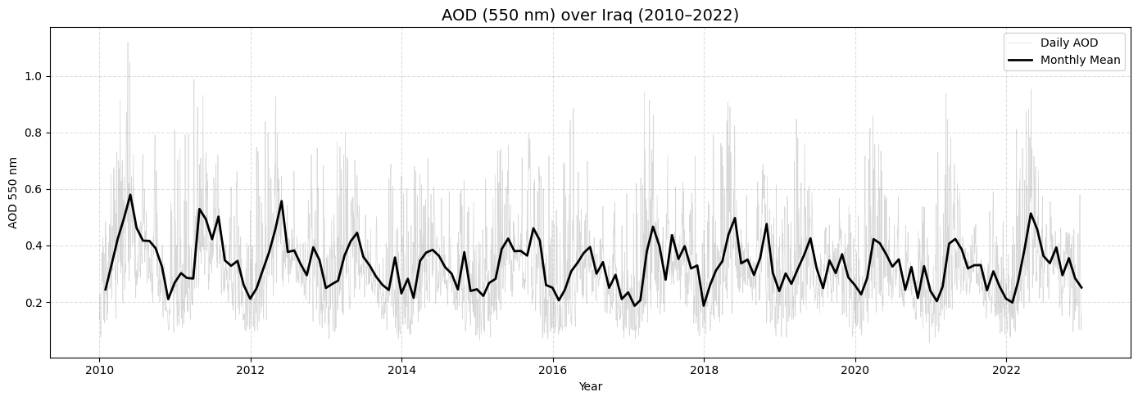
Figure (1): The time series of the average aerosol optical depth (AOD) over Iraq during the study period.
3.2 Relationship Between AOD and Solar Radiation Components
Figure (2) shows the daily relationship between the optical depth of the atmosphere and the three components of solar radiation. The results show a clear variation in the response of each component to the increase in dust load in the atmosphere. The relationship between AOD and DNI shows a clear negative slope, with a slope of −326.99 Wm⁻² per unit of AOD (R² = 0.28), indicating a significant decrease in direct radiation with an increase in the concentration of suspended particles. In contrast, the diffuse radiation (DHI) shows a relatively strong direct relationship, with a slope of +123.68 Wm⁻² per unit AOD (R² = 0.38), reflecting an increased contribution of radiative scattering under high dust conditions. As for the global horizontal irradiance (GHI), it showed a very weak relationship with AOD, with a slope of +22.51 Wm⁻² and a coefficient of determination close to zero (R² ≈ 0.002), indicating that the change in dust load does not directly reflect a change in the total irradiance value, but rather manifests mainly in the redistribution of energy between the direct and diffuse components. These results confirm that the primary impact of aerosols over Iraq is in modifying the radiative structure of the atmosphere rather than a change in the total radiation falling on the surface.
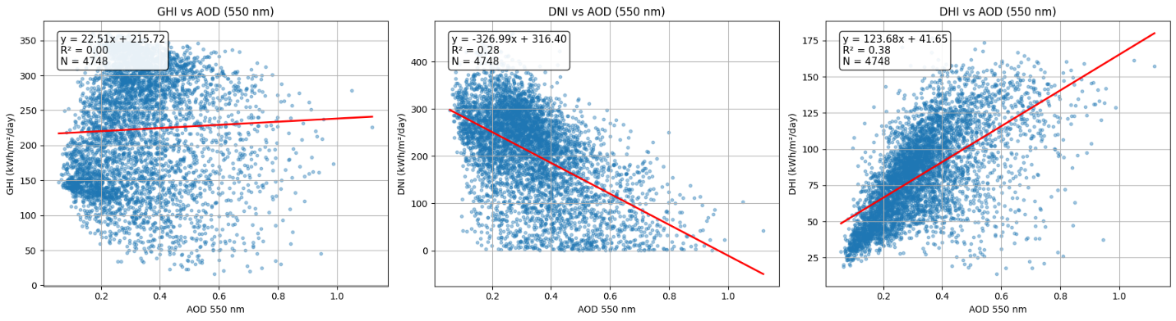
Figure (2): Relationship between AOD and solar radiation components (GHI, DNI, and DHI) over Iraq during 2010–2022.
Figure (3) delineates the discrepancies between the values computed under clear sky conditions and the actual values (All-Sky) for the three components of solar energy. The results indicate a significant level of conformity for GHI, with a coefficient of determination R² = 0.91 and a slope of less than one (0.84), signifying a relative reduction in actual values compared to clear sky conditions, attributed primarily to atmospheric influences, particularly aerosols.
The coefficient of determination R² for direct radiation (DNI) was 0.80, with a slope of 0.67, indicating a more significant influence of real conditions relative to clear sky conditions, hence affirming the heightened sensitivity of direct radiation to suspended particles.
The diffuse irradiance (DHI) exhibited a slope exceeding one (1.10) with R² = 0.84, signifying an elevation in actual values relative to the clear-sky condition, which aligns with the impact of radiative scattering induced by aerosols.
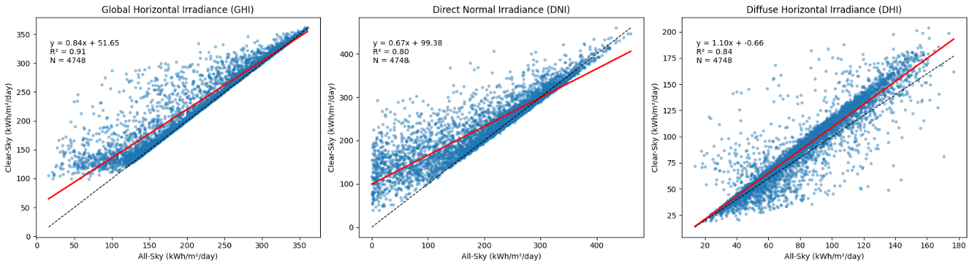
Figure (3): Comparison between clear-sky and all-sky conditions for GHI, DNI, and DHI over Iraq (2010–2022).
The results indicate that the disparities between clear sky conditions and actual conditions are chiefly associated with the redistribution of solar radiation, characterized by a decrease in the direct component and an increase in the diffuse component, while the variation in total radiation is comparatively minor.
Figure (4) depicts the seasonal fluctuation in the response of direct normal irradiance (DNI) to alterations in air mass optical depth. The data reveal a distinct variation in sensitivity levels across the four seasons. Winter (DJF) exhibits the highest sensitivity, characterized by a significant negative slope, signifying that an increase in AOD correlates with a more substantial decline in DNI values during this season. The autumn season demonstrates a notably robust reaction, characterized by a superior explanatory coefficient compared to the other seasons.
Conversely, the correlation diminishes in the spring season (MAM), as the model's explanatory power declines, signifying increased unpredictability in the influencing factors during this period. The summer season (JJA) exhibits a significant negative correlation, albeit to a smaller degree than winter and autumn. The results indicate that the radiative impact of dust varies periodically, influenced by seasonal atmospheric conditions, including the angle of solar radiation incidence and the features of scattering and absorption.
Figure (5) shows how well radiative forcing works at the Earth's surface for three different levels of dust: low, medium, and high. The results show that the radiative effect changes clearly depending on how strong the AOD is. If there isn't much dust in the air, the radiative forcing numbers are very low, which means they don't have much of an effect on the radiation components. When something moves up to the medium category, the amount of radiation goes up by a lot. High amounts of dust are linked to high levels of radiative forcing, which means that solar radiation at the Earth's surface has changed in a big way. This result shows that the aerosol effect is not completely linear; it gets stronger as AOD levels rise, which supports what the sensitivity and linear regression studies found: high dust levels have a big effect on direct radiation.
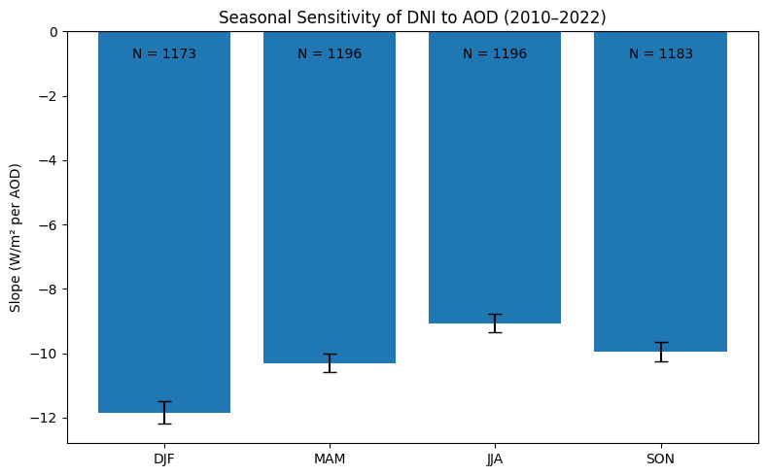
Figure (4): Seasonal sensitivity of Direct Normal Irradiance (DNI) to AOD over Iraq (2010–2022).
Figure 6 illustrates the seasonal averages of aerosol optical depth over Iraq, demonstrating a discernible variation in dust burden throughout the year. The values are at their lowest point prior to winter, and they then increase during the spring and summer. It represents a transitional phase that is moderately valued in relation to autumn. The characteristics of dust activity in the region are reflected in seasonal changes in AOD. In the spring and summer, AOD is higher due to the increased frequency of dust storms and surface wind activity, while in the winter, AOD is lower due to the improved atmospheric stability and the presence of fewer sources of dust resuspension.

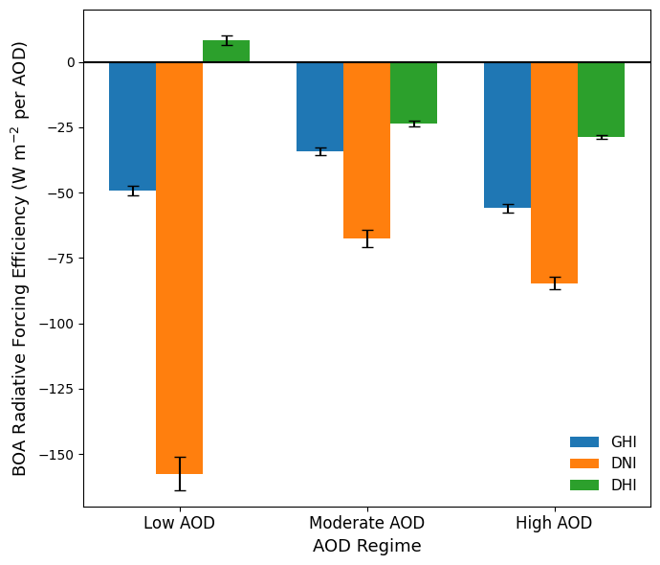
Figure (5): Bottom-of-Atmosphere (BOA) Radiative Forcing Efficiency under different AOD regimes (Low, Moderate, High).
These results are consistent with the seasonal sensitivity study's findings, as they indicate a correlation between the intensity of dust and the extent to which it influences solar radiation components. This is due to the fact that a more robust radiative response is observed during seasons with a higher dust burden.
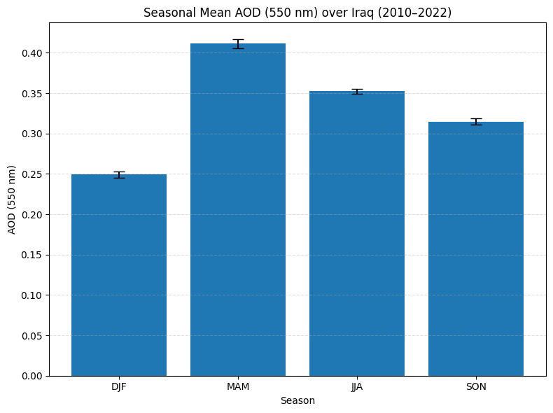
Figure (6): Seasonal mean distribution of AOD (550 nm) over Iraq (2010–2022).
3.3 Spatial Distribution of Radiative Sensitivity
Figure 7 shows the spatial variation of the regression slope between AOD and direct normal irradiance (DNI) across Iraq. Most grid cells display negative values, which means that higher aerosol optical depth is generally linked to lower direct radiation. The strongest negative slopes appear mainly in the central and southern parts of the country. In the north, the response is weaker in comparison. This difference from one region to another indicates that the effect of aerosols is not the same everywhere. It may be related to differences in dust sources, background aerosol levels, or local weather conditions. In general, the spatial pattern supports the national results, showing that direct radiation is sensitive to changes in AOD.
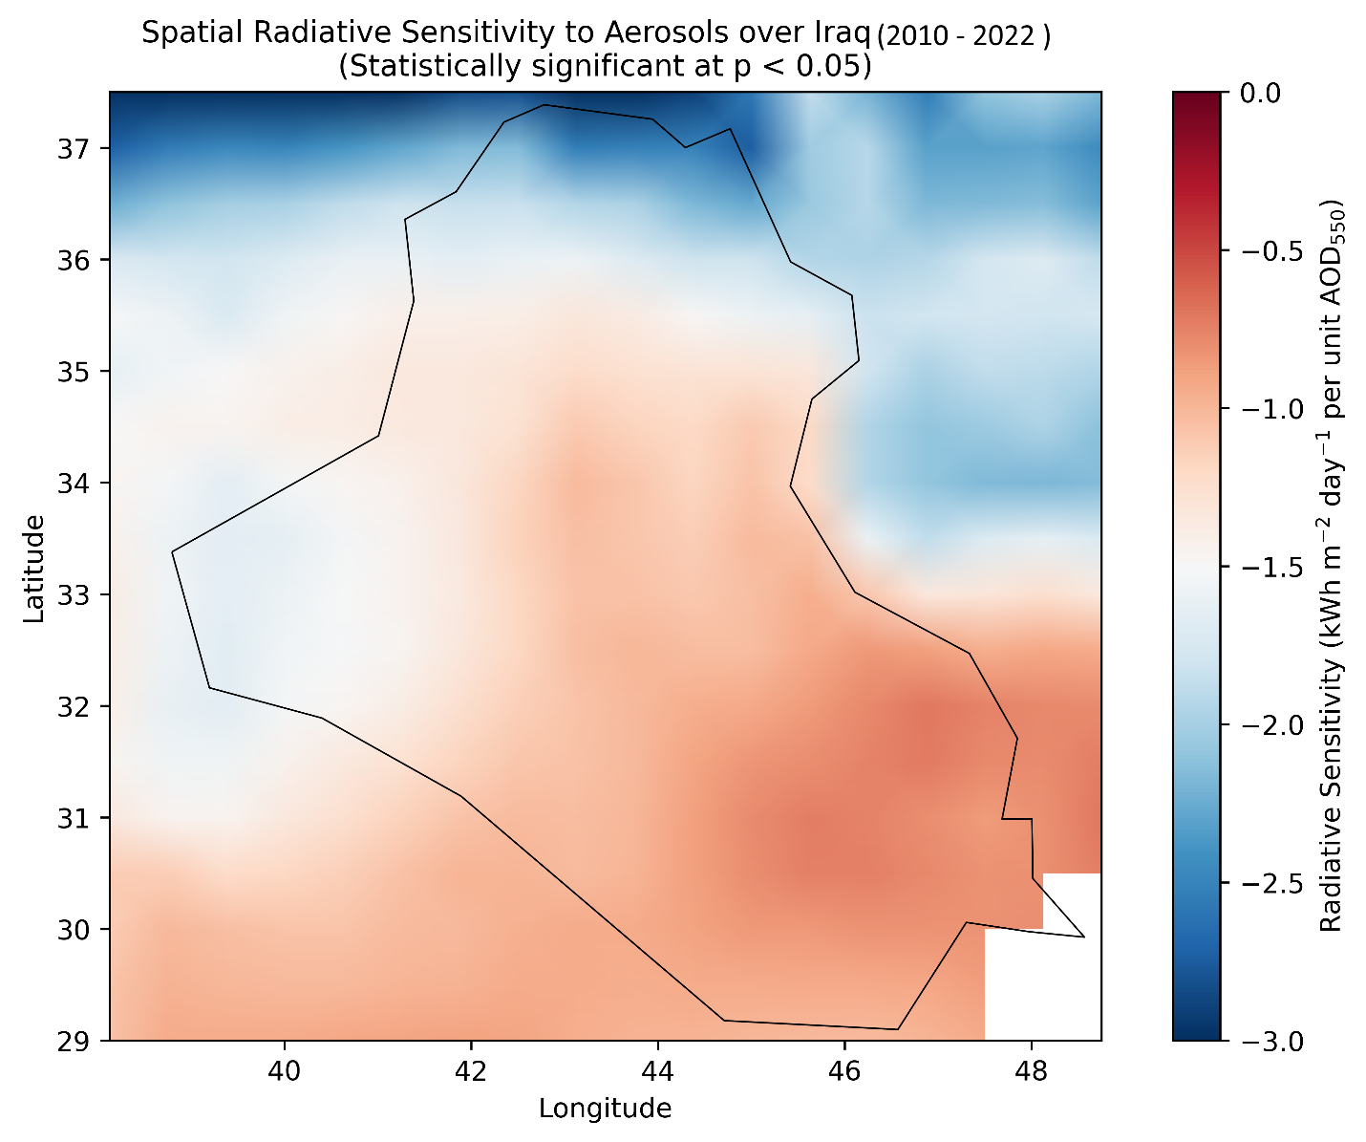Figure (7): Spatial distribution of radiative sensitivity (slope of DNI–AOD relationship) over Iraq.
Figure 8 shows how the coefficient of determination (R²) is spread out throughout different regions. This is about the relationship between the angle of incidence (AOD) and the direct normal irradiance (DNI). This map shows how well the linear model works to explain things that happen in each grid cell. The percentage of the change in AOD that explains the change in DNI. A lot of places in the middle and southern parts of the country have high R2 values, which means that changes in AOD explain a larger part of the differences in direct radiation at those places. The results show that the strength of the link is different in different regions. However, the numbers decrease in other areas, which suggests that other factors may be affecting the changes in radiation in some areas. The sensitivity map (Figure 7) and the determination coefficient map (Figure 8) together give a full picture of how the aerosol affects space. This idea is based on how strong the statistical correlation is and how big the effect is. This information supports the national results that showed a clear change in how direct radiation reacts to changes in AOD.
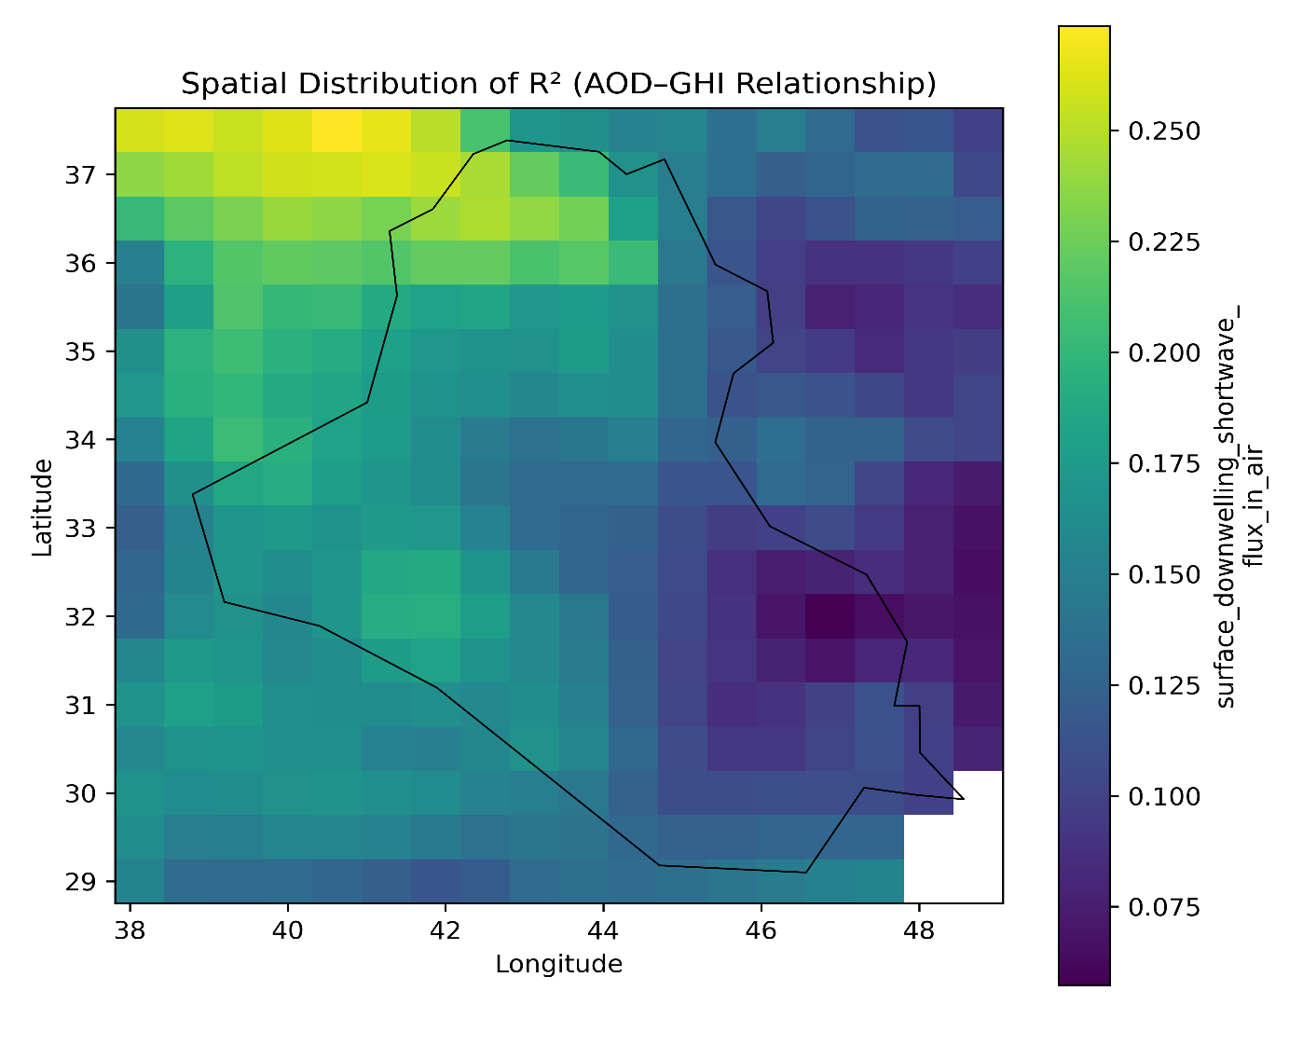
Figure (8): Spatial distribution of the coefficient of determination (R²) for the DNI–AOD relationship over Iraq.

Figure 9 illustrates the radiative sensitivity distribution throughout the four seasons. This illustrates that the AOD effect's sensitivity to different regions varies over the course of the year. The direct radiation sensitivity to variations in AOD is at its highest during the winter (DJF) and autumn (SON) seasons, as indicated by the maps. This is illustrated by the more pronounced and widespread manifestations of negative values. An additional observation is that the negative results are more comparable across regions than they were in previous seasons. In contrast, the spring map (MAM) exhibits a lower overall sensitivity, a higher spatial variability, and a lower statistical consistency in specific regions. Summer (JJA) generally demonstrates a less apparent adverse reaction when contrasted with winter and autumn. The southern and central regions continue to exhibit the highest values. The results substantiate the notion that the relationship between AOD and DNI fluctuates annually. This is because the intensity of the reaction is regulated by seasonal atmospheric factors, and the radiative impact of aerosols varies both geographically and temporally.
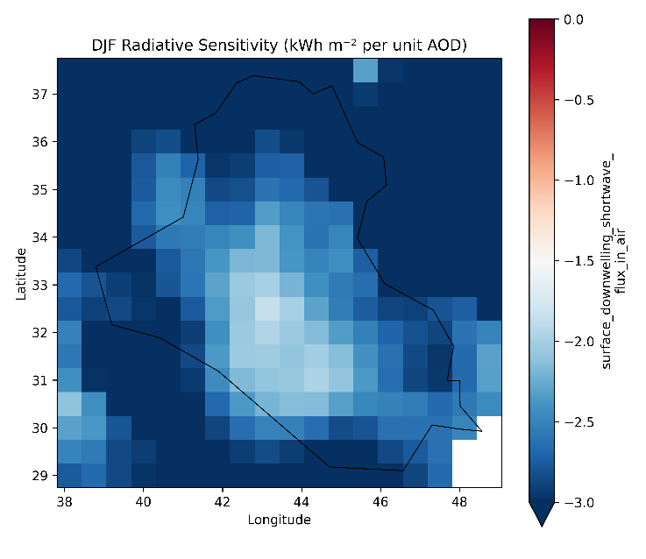 | 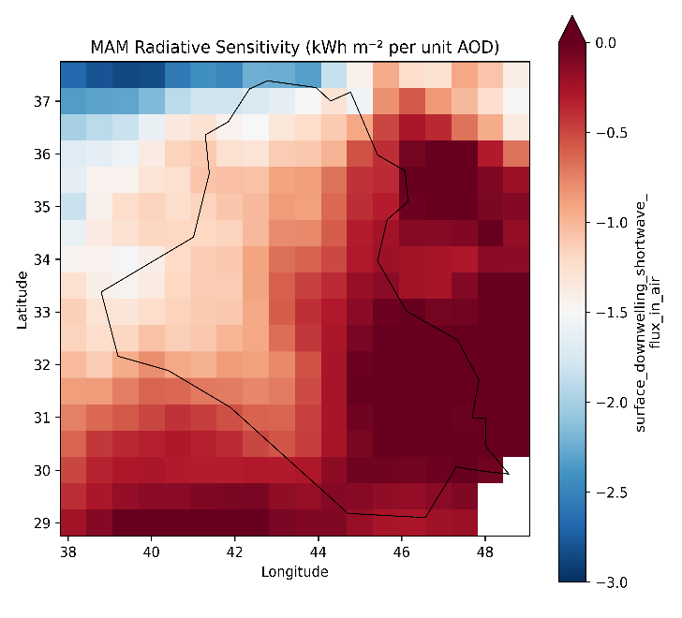
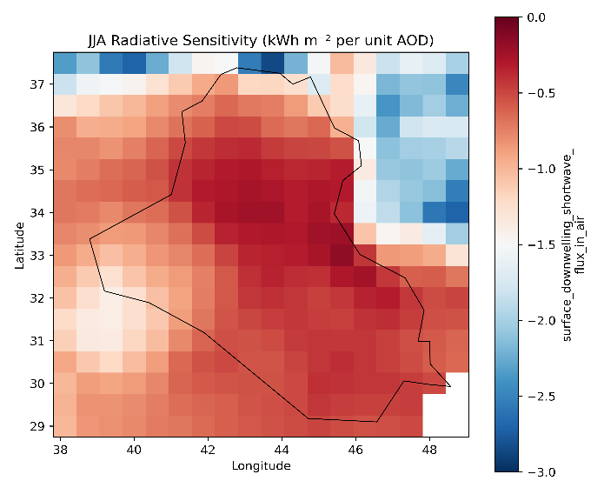 | 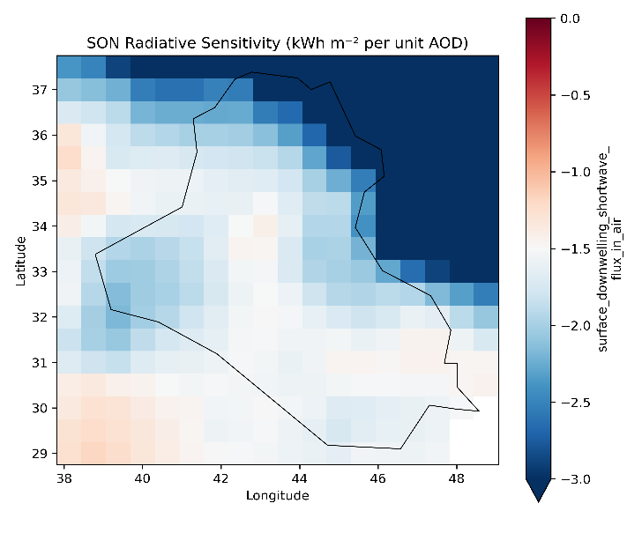
Figure (9): Seasonal spatial distribution of the DNI–AOD radiative sensitivity over Iraq.
4-Discussion
On the basis of the most recent study, it has been determined that aerosols in Iraq mostly affect the dispersion of solar radiation rather than the intensity of the radiation as a whole. An increase of one unit in Aerosol Optical Depth (AOD) leads to a decrease in direct normal irradiance (DNI) by -326.99 W·m⁻² per unit AOD (R2 = 0.28), while the rise in diffuse horizontal irradiance (DHI) is +123.68 W·m⁻² per unit AOD (R2 = 0.38). This phenomenon occurs on a daily basis over the entire nation. It is worth noting that the correlation between aerosol optical depth (AOD) and global horizontal irradiance (GHI) is quite weak (slope = +22.51 W·m⁻²; R² ≈ 0.002), indicating that aerosols mostly transfer radiative energy between direct and diffuse components, rather than considerably lowering overall irradiance.
The reduction in Direct Normal Irradiance (DNI) that was seen in this is consistent with the range that has been described for arid and semi-arid regions that are influenced by mineral dust. In these regions, reductions typically range from -327 to 400 W·m⁻² per AOD when there is a large amount of dust loading situation. Comparable sensitivity has been seen in arid environments and regions of the Middle East(Mostamandi et al., 2023; Mousavi, Panahi, & Kalantari, 2024; Seifert et al., 2022). The extent of DNI reduction documented in this study (−326.99 W·m⁻² per unit AOD) aligns with values reported in dust-dominated settings, where reductions generally range from about −250 to −400 W·m⁻² per unit AOD under high aerosol loading conditions. This agreement indicates that the radiative response in Iraq aligns with previously recorded aerosol–radiation interaction mechanisms in arid and semi-arid areas(Mousavi et al., 2024).
The observed increase in DHI, which totals 123.68 W·m⁻² per unit AOD, is in agreement with the findings of earlier studies that have demonstrated an increase in diffuse radiation due to the increased scattering caused by mineral aerosols. A significant portion of the direct-beam attenuation that occurs under dusty conditions is redirected into the diffuse component rather than being completely absorbed, according to a number of radiative transfer evaluations(Chen, Zhao, & Fan, 2022; Williams, Stier, Dagan, & Watson-Parris, 2022). A compensatory relationship between DNI reduction and DHI augmentation has been extensively established, and the virtually neutral reaction of GHI provides further evidence that this interaction exists. When total surface irradiance remains essentially constant despite considerable changes in its components, similar behavior has been observed in observational and modeling investigations. For example, aerosol forcing evaluations in arid locations have been observed to exhibit this behavior.
It is because of the increased extinction (scattering plus absorption) of the direct sun beam by coarse mineral dust particles that the DNI has a high negative sensitivity. In dry environments, dust particles often exhibit a higher scattering efficiency at 550 nm, which results in a decrease in beam transmittance while simultaneously boosting diffuse radiation. When the DHI response is positive, it shows that there are several scattering processes taking place inside the air column environment. Significant increases in DHI are brought about as a consequence of the fact that, as AOD grows, a greater proportion of the incoming radiation is redirected away from the direct beam and toward diffuse directions. As a result of the little effect on GHI, it can be inferred that, under the majority of conditions during the duration of the investigation, scattering is more prevalent than absorption in the optical features of the regional aerosol. Under the assumption of a predominate absorption, a more significant net reduction in GHI would be predicted.
Interactions between clouds and aerosols have the potential to alter the variability of conditions across the entire sky. The comparison between clear-sky and all-sky settings revealed that clear-sky conditions were more consistent than all-sky situations. This suggests that the presence of clouds may partially mask the radiative effects that may be attributed only to aerosols, as was established in earlier studies on atmospheric radiation.
According to the results of the seasonal analysis, there was an increase in the radiative sensitivity during the winter (DJF) and autumn (SON) seasons. The seasonal sensitivity in winter was observed to be approximately -2.99 kWh·m⁻² per unit AOD. There is a possibility that this seasonal improvement is connected to: Variations in the angle of the sun's zenith and the length of the optical chain. There are seasonal differences in the dispersion of dust particles of different sizes. Changes in the stability of the air and the vertical dispersion may occur.
The fluctuations in cloud percentage have an effect on the interactions between aerosols and radiation. It is possible that a mixture of aerosol species during transitional seasons is the cause of reduced sensitivity in spring (MAM). This could be an indication of increased variability in atmospheric conditions. Seasonal fluctuations in the efficacy of aerosol radiative forcing have been extensively observed in regional climate evaluations and radiative transfer models, particularly in places that are dominated by dust.
When looking at spatial maps of radiative sensitivity, it is clear that the central and southern regions of Iraq have more significant negative slopes. This suggests that these regions experience a greater decrease in the amount of direct sun energy for every unit increase in AOD. Perhaps the following is what this geographical configuration indicates: location in close proximity to big dust-producing areas, an increased aerosol concentration at the baseline level, there are regional meteorological elements that influence the duration of aerosol persistence.
Furthermore, the regional distribution of R2 provides further evidence that AOD is responsible for a bigger fraction of the variability in DNI in these regions than it is in northern locales, where additional atmospheric elements may have a more substantial influence.
These concentrated solar power (CSP) systems, which are mostly dependent on direct irradiance, are immediately impacted by the considerable sensitivity of DNI to aerosol loading. In situations when there is a large concentration of dust, a decrease of around 327 Wm⁻² per unit AOD indicates a considerable influence. Photovoltaic (PV) systems, which are able to harness both direct and diffuse radiation, may demonstrate a reduced sensitivity to the decline in total irradiance as a result of partial compensation from increased diffuse horizontal irradiance (DHI). Notwithstanding this, it is possible that the redistribution effect will continue to have an effect on performance modeling and long-term energy yield estimates. As a consequence of this, conducting solar resource evaluations in Iraq without taking into account the variability of aerosols may lead to a significant overestimation of the direct solar potential.

4.6 Limitations
This study relies on reanalysis aerosol and radiation datasets, which may possess intrinsic uncertainties relative to ground-based radiometric observations. Although reanalysis products provide spatially consistent coverage, possible biases in aerosol optical properties and radiation parameterization could affect the magnitude of the estimated sensitivities. The linear regression method assumes a linear relationship between AOD and radiation components. While this assumption is appropriate for large-scale statistical analysis, nonlinear responses may occur during extreme dust events. Despite these limitations, the consistency of the results across temporal, seasonal, and spatial analyses strengthens confidence in the overall robustness of the findings.
5. Conclusion
This study examined how aerosol optical depth (AOD) affected solar radiation components in Iraq from 2010 to 2022 using long-term reanalysis datasets. The results showed that direct normal irradiance (DNI) was sensitive to higher AOD levels, but diffuse horizontal irradiance (DHI) increased to make up for it. The influence on global horizontal irradiance (GHI) was not as strong. These results corroborate that aerosols mostly disperse solar energy instead of significantly modifying total surface irradiance. Spatial and seasonal investigations indicated that the radiative effects of aerosols are not consistent nationwide, exhibiting heightened sensitivities in central and southern regions, particularly during the winter and autumn seasons. The contrast between clear-sky and all-sky settings underscored the obscuring function of clouds in influencing aerosol–radiation interactions. The results underscore the imperative of integrating aerosol variability into solar resource evaluation and atmospheric radiative modeling in Iraq. Subsequent study could enhance the quantification of dust–radiation interactions by amalgamating ground-based observations with nonlinear modeling techniques.

Conflict of Interest
The authors declare that they have no conflict of interest.
Ethics approval
Not applicable.
Consent to participate
Not applicable.
Consent for publication
Not applicable.
Availability of data and material / Data availability
The data used in this study are publicly available from the ERA5 reanalysis dataset provided by the Copernicus Climate Change Service (C3S). The data can be accessed through the Copernicus Climate Data Store (https://cds.climate.copernicus.eu).
Code availability
The data analysis and visualization were performed using Python-based scripts developed by the author. The code is available from the corresponding author upon reasonable request.

References
Akinyoola, J. A., Oluleye, A., & Gbode, I. E. (2024). A review of atmospheric aerosol impacts on regional extreme weather and climate events. Aerosol science and engineering, 8(3), 249-274.
Al-Bayati, M. H., & Rajab, J. M. Long-Term Time Series Variability of Outgoing Longwave Radiation and Interrelationship with Air Temperature over Iraq. Tuijin Jishu/Journal of Propulsion Technology, 45(2), 2024.
Al-Ramadan, B., Aldosary, A. S., Kafy, A. A., Altuwaijri, H. A., & Rahaman, Z. A. (2025). Unraveling solar irradiance dynamics in arid atmospheres: A multi-decadal wavelet coherence and probability density functions analysis with implications for air quality, climate, and renewable energy. Air Quality, Atmosphere & Health, 18(5), 1463-1487.
Chen, A., Zhao, C., & Fan, T. (2022). Spatio-temporal distribution of aerosol direct radiative forcing over mid-latitude regions in north hemisphere estimated from satellite observations. Atmospheric Research, 266, 105938.
Creutzig, F., Agoston, P., Goldschmidt, J. C., Luderer, G., Nemet, G., & Pietzcker, R. C. (2017). The underestimated potential of solar energy to mitigate climate change. Nature Energy, 2(9), 1-9.
Dangayach, R., & Pandey, A. K. (2024). Unraveling the complex relationships between aerosol optical depth and temperature: a review. Aerosol optical depth and precipitation: measuring particle concentration, health risks and environmental impacts, 1-18.
Emmanuel, M., Doubleday, K., Cakir, B., Marković, M., & Hodge, B.-M. (2020). A review of power system planning and operational models for flexibility assessment in high solar energy penetration scenarios. Solar Energy, 210, 169-180.
Fountoulakis, I., Papachristopoulou, K., Proestakis, E., Amiridis, V., Kontoes, C., & Kazadzis, S. (2022). Effect of aerosol vertical distribution on the modeling of solar radiation. Remote Sensing, 14(5), 1143.
Gao, X.-Y., Huang, C.-L., Zhang, Z.-H., Chen, Q.-X., Zheng, Y., Fu, D.-S., & Yuan, Y. (2024). Global horizontal irradiance prediction model for multi-site fusion under different aerosol types. Renewable Energy, 227, 120565.
Hassan, B. M., Samman, A. E., Morsy, M., Abdaldym, A., Alsubhi, Y., Almazroui, M., . . . Aboelkhair, H. (2025). Advanced Regression Approaches for High-Fidelity Solar Radiation Prediction: Analysis of a 12-Year Meteorological Dataset from Egypt. Earth Systems and Environment, 1-21.
Kok, J. F., Storelvmo, T., Karydis, V. A., Adebiyi, A. A., Mahowald, N. M., Evan, A. T., . . . Leung, D. M. (2023). Mineral dust aerosol impacts on global climate and climate change. Nature Reviews Earth & Environment, 4(2), 71-86.
Li, J., Carlson, B. E., Yung, Y. L., Lv, D., Hansen, J., Penner, J. E., . . . Zhang, P. (2022). Scattering and absorbing aerosols in the climate system. Nature Reviews Earth & Environment, 3(6), 363-379.
Liu, Q., Zhou, G., Zhang, S., Zeng, Z., Fu, C., He, B., . . . Jing, D. (2026). Optical and thermodynamic study of a novel photovoltaic and concentrated thermoelectric generator (PV-CTEG) hybrid system based on spectral beam splitting technology. Applied Thermal Engineering, 129878.
Mostamandi, S., Ukhov, A., Engelbrecht, J., Shevchenko, I., Osipov, S., & Stenchikov, G. (2023). Fine and coarse dust effects on radiative forcing, mass deposition, and solar devices over the Middle East. Journal of Geophysical Research: Atmospheres, 128(22), e2023JD039479.
Mousavi, H., Panahi, D. M., & Kalantari, Z. (2024). Dust and climate interactions in the Middle East: Spatio-temporal analysis of aerosol optical depth and climatic variables. Science of the Total Environment, 927, 172176.
Mytilinaios, M. (2022). Study of atmospheric desert dust and dust model evaluation through synergy and integration of different measurement techniques.
Noori, F. J. (2024). Dust Storms Monitoring in Iraq using The Low Resolution Satellite Images. University of Baghdad.
Papachristopoulou, K., Fountoulakis, I., Gkikas, A., Kosmopoulos, P. G., Nastos, P. T., Hatzaki, M., & Kazadzis, S. (2022). 15-year analysis of direct effects of total and dust aerosols in solar radiation/energy over the mediterranean basin. Remote Sensing, 14(7), 1535.
Salman, A. D., Al-Jumaily, K. J., & AL-Salihi, A. M. (2022). Patterns of aerosols-clouds interactions over Iraq using MODIS satellite data during (2008-2017). Paper presented at the AIP Conference Proceedings.
Seifert, A., Bachmann, V., Filipitsch, F., Förstner, J., Grams, C., Hoshyaripour, G. A., . . . Wagner, A. (2022). Aerosol-cloud-radiation interaction during Saharan dust episodes: the dusty cirrus puzzle. Atmospheric Chemistry and Physics Discussions, 2022, 1-35.
Spiridonov, V., Ćurić, M., & Novkovski, N. (2025). Solar Radiation: Driving Atmospheric Change. In Atmospheric Perspectives: Unveiling Earth's Environmental Challenges (pp. 137-170): Springer.
Williams, A. I., Stier, P., Dagan, G., & Watson-Parris, D. (2022). Strong control of effective radiative forcing by the spatial pattern of absorbing aerosol. Nature Climate Change, 12(8), 735-742.
Yu, T., Xiaole, P., Yujie, J., Yuting, Z., Weijie, Y., Hang, L., . . . Zifa, W. (2023). East Asia dust storms in spring 2021: Transport mechanisms and impacts on China. Atmospheric Research, 290, 106773.
Yusuf, H., Tahrin, N. M., & San, L. H. (2026). Quantifying the Impact of Atmospheric Aerosols on Clear-Sky and All-Sky Solar Irradiance Components in a Tropical Coastal Urban Environment: A Case Study of Penang, Malaysia (2014–2018).

