Permission Inheritance and Machine-Speed Risk Escalation in Agentic Al- Driven Cloud Operations

Abstract
This study investigates how permission inheritance and machine-speed execution influence cybersecurity risk escalation in agentic artificial intelligence–driven cloud environments. A quantitative empirical design was adopted using a network-based privilege propagation model and survival analysis. Identity and access relationships were represented as a directed authorization graph G=(V,E)G=(V,E)G=(V,E), while privilege expansion was evaluated using the Privilege Amplification Factor and Privilege Propagation Score derived from simulated cloud IAM datasets. Machine-speed escalation dynamics were examined through time-to-event modeling using survival probability and hazard ratio estimation. The findings reveal substantial privilege amplification, with administrative agents demonstrating an average Privilege Amplification Factor of 6.07 and access to 71% of reachable cloud resources. In addition, increasing execution speed from 5 to 200 operations per second reduced mean escalation time from 842 seconds to 68 seconds while raising the hazard ratio to 6.15. Based on these findings, the study proposes the Agentic Cloud Security Governance Model and recommends agent-specific identity isolation, dynamic least-privilege enforcement, real-time behavioral monitoring, and policy frameworks for governing autonomous agents in cloud infrastructures.
Keywords: Agentic Artificial Intelligence Security; Permission Inheritance; Machine-Speed Cyber Risk; Cloud Identity Governance; Autonomous Agent Access Control.
1. Introduction
In early 2026, a significant operational disruption occurred within a cloud computing environment when an artificial intelligence coding assistant known as Kiro triggered a prolonged service outage after executing automated changes in a production system (Reuters , 2026). The incident occurred within the cloud infrastructure of Amazon Web Services, where the AI powered development tool autonomously deleted and recreated components of an operational environment while attempting to resolve a configuration issue (Down, 2026; Hart, 2026). Haranas (2026) reports that the artificial intelligence agent had access to the permissions associated with the human operator who deployed it, which allowed the system to perform infrastructure level actions across the cloud environment. The disruption lasted for several hours and affected services that depended on the affected infrastructure, prompting widespread discussion about the governance of autonomous artificial intelligence tools operating within enterprise cloud environments (Down, 2026; Haranas, 2026; Hart, 2026). The event illustrated how artificial intelligence agents operating with inherited privileges can initiate operational changes at computational speed, raising concerns about the extent to which existing security frameworks can regulate the behavior of autonomous systems within complex digital infrastructures.
This Kiro/AWS incident represents one of the many cases of the rapidly expanding landscape of artificial intelligence related cybersecurity threats. Recent global monitoring indicates that confirmed artificial intelligence related security breaches reached 16,200 incidents in 2025, representing a 49 percent increase compared with the previous year (Ramirez, 2025). In addition, a major cloud security report published by Palo Alto Networks found that 99 percent of organizations operating artificial intelligence systems in production experienced at least one security attack targeting their AI infrastructure during the same year (Cody, 2025; Geller, 2026).
Beyond the immediate growth in cyber incidents, the broader digital transformation of organizations has accelerated the adoption of artificial intelligence within cloud computing environments (Wang et al., 2024; Yao et al., 2025). Enterprises increasingly deploy artificial intelligence systems to support infrastructure management, service orchestration, automated monitoring, and large scale data processing (Selvarajan, 2025). The evolution of artificial intelligence toward agentic systems capable of initiating tasks, interacting with multiple services, and making operational decisions has further expanded these capabilities. Agentic artificial intelligence systems are designed to function as autonomous digital agents that can retrieve information, coordinate workflows, and perform actions across distributed infrastructures with minimal human supervision. Unlike traditional software applications that operate within predefined instructions, these agents may generate tasks dynamically and interact with multiple services during the execution of a single operational workflow (Dodig-Crnkovic & Burgin, 2024). As noted by Chan et al. (2025), such systems possess the ability to plan actions, interact with external tools, and execute sequences of commands across digital environments, thereby enabling complex operations across cloud infrastructures through application programming interfaces and service permissions (Yang et al., 2025). However, the autonomy and speed associated with these systems introduce significant challenges for cybersecurity governance, particularly in environments where artificial intelligence agents operate across interconnected services.
One important dimension of this challenge concerns the way artificial intelligence agents obtain and utilize access privileges within cloud environments. In many enterprise infrastructures, artificial intelligence tools operate using credentials associated with administrators, applications, or service accounts that authorize their deployment (Google Cloud, 2026). Through this arrangement, autonomous systems may inherit permissions that allow them to access data repositories, modify system configurations, or interact with multiple services within the cloud ecosystem (Shi et al., 2025a; Shi et al., 2025b). Udinmwen (2025) indicates that a majority of cybersecurity professionals consider the access of artificial intelligence agents to privileged organizational resources to be one of the most significant emerging security concerns associated with autonomous systems. When artificial intelligence agents inherit elevated permissions, their ability to execute commands at machine speed may allow operational errors or malicious actions to propagate rapidly across interconnected infrastructures (Hancock & Botts, 2026).
The operational characteristics of cloud computing environments further amplify these concerns. Cloud infrastructures are designed to support highly interconnected services in which applications, storage systems, databases, and analytics platforms interact continuously through digital interfaces (Saboor et al., 2022; Sigala, 2025). Within such environments, autonomous artificial intelligence agents may initiate actions across multiple services within seconds. If an artificial intelligence system performs unintended actions or becomes compromised, the resulting effects may spread across interconnected systems before conventional monitoring mechanisms can detect abnormal behavior (Li et al., 2025; Salkenov & Bagchi, 2019; Solomon et al., 2025). Recent research on artificial intelligence governance therefore suggests that existing identity and access management frameworks may not be fully equipped to regulate the dynamic interactions between autonomous agents and distributed infrastructures (Huang et al., 2025).
The persistence of these challenges suggests the existence of a significant governance gap in the management of artificial intelligence driven cloud operations. Without effective governance mechanisms, the combination of inherited privileges and machine speed execution may create conditions in which security risks escalate rapidly across interconnected infrastructures. This situation raises important questions regarding how permissions assigned to artificial intelligence agents should be structured, how abnormal agent behavior can be detected in real time, and how security incidents triggered by autonomous systems can be contained before they disrupt cloud operations.
In response to these concerns, this study examines the relationship between permission inheritance and machine speed risk escalation in agentic artificial intelligence driven cloud operations. The study aims to investigate how autonomous artificial intelligence agents inherit and exercise access permissions when performing tasks within cloud infrastructures and to develop governance mechanisms that regulate agent privileges and contain machine speed security incidents. The study pursues the following objectives:
- To analyze how autonomous artificial intelligence agents inherit and exercise access permissions when performing operational tasks within cloud computing environments.
- To examine how machine speed execution of agent driven tasks contributes to the rapid escalation of cybersecurity risks across interconnected cloud services.
- To develop an agent specific access control model that regulates the assignment, monitoring, and limitation of permissions granted to autonomous artificial intelligence agents in cloud operations.
- To design a machine speed incident containment mechanism capable of detecting abnormal agent behavior and automatically restricting high risk activities in cloud environments.

2. Literature Review
Identity and access governance constitutes a foundational component of cybersecurity in modern cloud computing environments. As organizations migrate critical infrastructure and services to distributed cloud platforms, the ability to regulate access to digital resources has become central to maintaining data confidentiality, operational integrity, and system resilience (Ogunmolu et al., 2026a; Olisa et al., 2026). Identity and Access Management (IAM) frameworks are designed to authenticate digital identities and regulate the privileges assigned to users, applications, and services interacting with cloud infrastructures. Scholars widely agree that IAM systems play a crucial role in preventing unauthorized access by enforcing authentication, authorization, and auditing mechanisms that regulate interactions with cloud resources (Jena, 2024; Jain, 2025).
Within cloud environments, access control mechanisms typically operate through structured governance models such as Role Based Access Control and Attribute Based Access Control. These models allocate permissions according to predefined roles or contextual attributes associated with a digital identity. According to Jain (2025), IAM architectures integrate authentication mechanisms such as federated identity management, single sign on, and multi factor authentication to ensure that only authorized entities interact with cloud services. Similarly, Jena (2024) emphasizes that structured access policies remain essential for safeguarding sensitive data and preventing unauthorized interactions within distributed infrastructures.
Recent studies have therefore examined how identity governance must evolve to address the proliferation of digital identities within enterprise infrastructures. Modern cloud environments increasingly rely on machine identities associated with automated services, microservices architectures, and infrastructure orchestration tools. As a result, the number of non-human identities interacting with enterprise systems now exceeds that of human users in many organizations. Ganapathi (2025) argues that the rapid growth of cloud native identity systems has transformed digital identity management into a critical component of organizational trust and privacy protection. In contrast, Hariharan (2025) emphasizes that the primary challenge lies not simply in managing identities but in governing the lifecycle of permissions associated with those identities, particularly in large scale enterprise environments where automated processes continuously interact with cloud services.
In response to these challenges, researchers are exploring the integration of artificial intelligence into identity governance frameworks. AI driven IAM systems leverage machine learning and behavioral analytics to monitor access patterns, detect anomalous activities, and automate policy enforcement across distributed infrastructures (Abba et al., 2025). Hariharan (2025) argues that artificial intelligence enables IAM systems to evolve from static rule based frameworks toward adaptive security architectures capable of evaluating contextual risk in real time. Similarly, Suram (2025) highlights how AI enhanced access management systems can automate threat detection and improve response times by analyzing identity related telemetry across cloud environments.
Despite these technological advancements, a growing body of research suggests that traditional IAM architectures remain insufficient for managing emerging forms of autonomous digital activity. Conventional identity governance models were originally designed to regulate predictable interactions between human users and static applications. However, recent studies argue that such models struggle to accommodate the dynamic behavior of autonomous artificial intelligence systems interacting across distributed infrastructures. Huang et al. (2025) observe that traditional IAM protocols, including widely used authentication standards such as OAuth and OpenID Connect, were developed for single entity authentication scenarios and therefore provide only coarse grained access controls when applied to complex multi agent environments. Rossi (2025) also contends that the emergence of agentic artificial intelligence introduces new identity and trust challenges because autonomous agents may initiate actions on behalf of users while interacting with multiple services across hybrid cloud environments. Similarly, Palavali (2025) suggests that decentralized identity frameworks based on verifiable credentials and contextual authorization can enable more scalable governance of agent driven microservices interactions. These assertions reflect an emerging recognition that future identity governance frameworks must move beyond static identity models to accommodate dynamic machine driven interactions.

Permission Propagation and Privilege Inheritance in Automated Systems
The increasing automation of cloud infrastructures has drawn significant scholarly attention to how permissions propagate across interconnected services and systems. In contemporary cloud environments, automated workflows frequently rely on delegated credentials that allow applications, microservices, and service accounts to interact with resources through application programming interfaces. While such architectures enable scalability and operational efficiency, they also create complex authorization chains in which permissions assigned to one identity may indirectly grant access to additional resources (Mayeke, 2025; Olaniyi et al., 2026a). Studies examining automated software ecosystems demonstrate that privilege escalation often emerges from the interaction of multiple permissions rather than from a single misconfigured authorization rule. For instance, El-Zawawy and Hamdy (2025) show that seemingly benign permissions can combine across system interactions to produce higher order escalation paths that are difficult to detect using traditional security analysis techniques. This complexity is further intensified by the rapid expansion of machine identities in modern cloud environments, where automated workloads, microservices, and containerized applications operate through non human identities. As automation scales, the number of permission relationships between services grows, creating an expanding authorization surface in which identities may indirectly influence the privileges of others. Consequently, maintaining the principle of least privilege becomes increasingly difficult, as automated services often retain permissions beyond their immediate operational requirements.
Autonomous artificial intelligence agents interact with permission systems in automated environments. Autonomous agents increasingly rely on external tools, cloud APIs, and service integrations to complete complex tasks. In such contexts, agents typically execute actions using credentials associated with the initiating user or service identity, thereby inheriting the permissions associated with that identity (Shi et al., 2025b; Zhu et al., 2025). Shi et al. (2025a) note that this delegation model introduces a potential mismatch between user intent and system authorization because the agent may interpret instructions in ways that lead to actions beyond the original scope of intent. From a governance perspective, this distinction raises critical questions about accountability and traceability in automated systems where actions are executed by agents operating under inherited privileges.
Conventional IAM protocols were designed for static identities and predictable application behavior, making them poorly suited for dynamic systems where agents may generate new tasks, spawn sub agents, or interact with multiple services during a single workflow (Huang et al., 2025; Li, Huang, et al., 2025). Similarly, the research of Khan et al. (2025) on agent governance emphasizes that autonomous agents often operate within iterative planning loops in which tasks are generated and executed sequentially, increasing the likelihood that inherited permissions may be exercised in unexpected ways. These perspectives collectively highlight the growing recognition that permission inheritance in agent driven environments represents a distinct governance challenge.
In response to these concerns, studies are exploring mechanisms for restricting privilege propagation in automated systems, with some proposing dynamic authorization controls that enforce context aware access policies and restrict the scope of permissions granted to automated agents during runtime operations (Adebiyi et al., 2026). For example, the study of Betser et al. (2026) on agent tool governance introduces frameworks that enforce per step least privilege access when agents interact with external tools, thereby limiting the ability of agents to perform actions beyond their designated operational scope . Although such approaches demonstrate promising directions for managing automated permissions, the literature still lacks comprehensive understanding of how permission inheritance interacts with large scale cloud infrastructures, particularly when autonomous agents execute tasks at machine speed across distributed environments.

Security Risks Associated with Agentic Artificial Intelligence Systems
The emergence of agentic artificial intelligence systems has introduced a new category of cybersecurity risks. Agentic AI systems are capable of reasoning, planning, and executing multi-step workflows through interactions with external tools, APIs, and other agents. While these capabilities enable sophisticated automation and decision support, they also expand the attack surface of digital infrastructures by allowing autonomous systems to perform actions across multiple environments without direct human oversight (Gulyamov et al., 2026; Syed et al., 2025). Recent studies emphasize that the integration of large language models with tool-based orchestration frameworks has created complex agent ecosystems where vulnerabilities may arise at several layers, including input manipulation, system integration, and inter-agent communication (Ferrag et al., 2025).
Beyond input manipulation, researchers have also identified protocol-level vulnerabilities that arise when autonomous agents interact with external services or with other agents. Ferrag et al. (2025) demonstrate that many agent frameworks rely on loosely governed integrations with plugins and APIs, which often lack consistent authentication and validation mechanisms. Such architectural weaknesses create opportunities for attacks that exploit tool interfaces, agent communication channels, or data exchange protocols. In this regard, some scholars argue that the primary challenge lies in the rapid expansion of agent ecosystems, where new integrations are deployed faster than security practices can adapt (Obrik-Uloho et al., 2026; Olaniyi et al., 2026b). Others emphasize that the fundamental issue stems from the autonomy of the agents themselves, which may generate actions dynamically in ways that bypass traditional security assumptions (Odeyinka et al., 2026).
Another line of research focuses on the systemic risks associated with multi-agent environments. When autonomous agents collaborate to perform complex workflows, vulnerabilities in one agent can propagate across interconnected systems. Malicious instructions injected into one agent can cascade through multiple systems, leading to unintended operations or data leakage. Syed et al. (2025) observe that agent-to-agent communication channels may transmit malicious instructions across workflows if proper validation mechanisms are not implemented. These cascading effects demonstrate that security risks in agentic systems often emerge from interactions between agents rather than isolated vulnerabilities. This risk is further amplified by the autonomy of agentic systems, which can retrieve information, generate tasks, and execute actions at speeds that exceed human supervision. Studies show that such capabilities may enable agents to propagate malicious instructions or execute unauthorized actions if safeguards are not implemented (Ogenyi et al., 2025).

Machine-Speed Escalation of Cybersecurity Risks
The increasing integration of artificial intelligence and automation into digital infrastructures has significantly altered the speed and scale at which cybersecurity threats can emerge and propagate. Recent research indicates that AI-enabled systems can automate large portions of the attack lifecycle, including reconnaissance, vulnerability identification, and exploitation (Mohamed, 2025; Shah & Zaffar, 2025). Studies show that automation enables attackers to conduct highly coordinated and adaptive operations capable of targeting multiple systems simultaneously (Yedalla, 2024; Al-Azzawi et al., 2025). This phenomenon is increasingly described as the acceleration of the cyber threat landscape, where attacks unfold faster than traditional security monitoring and response mechanisms can react. Machine learning models can analyze large volumes of network data, identify vulnerabilities, and initiate attack sequences without continuous human oversight. Consequently, AI-enabled attacks can operate at machine speed, allowing adversaries to execute complex attack chains across distributed infrastructures in a highly coordinated manner (Onyemekeihia & Onyemekihian, 2026).
The growing complexity of automated digital ecosystems amplifies the impact of machine-speed operations. In cloud environments where multiple services interact continuously through APIs and automated workflows, a single compromised component can trigger cascading effects across interconnected systems (Ogunmolu et al., 2026b; Olisa et al., 2026). Kshetri (2025) notes that agentic AI technologies deployed in security operations centers can automate threat response processes but may also introduce new vulnerabilities if autonomous systems execute actions without sufficient governance controls. Similarly, Achuthan et al. (2024) emphasize that AI-driven systems possess the ability to initiate autonomous decision making and predictive analysis, which can either strengthen defensive capabilities or amplify systemic risks depending on how such systems are governed.
The acceleration of cyber operations is reflected in empirical analyses of modern cybercrime trends. Studies report increases in the scale and sophistication of AI-driven attacks. In some cases, AI-enabled cyberattacks can generate and execute exploits autonomously, significantly reducing the time required to move from initial compromise to large-scale system disruption (Yedalla, 2024; Al-Azzawi et al., 2025). These findings highlight a critical concern for cybersecurity governance because rapid attack propagation can overwhelm traditional detection and containment mechanisms.
Despite growing recognition of these risks, the literature remains divided regarding the most effective strategies for mitigating machine-speed cyber threats. Some scholars advocate greater reliance on automated defense systems capable of responding to attacks at comparable speeds, while others emphasize the importance of governance frameworks that constrain the operational scope of autonomous systems . Although both approaches contribute to strengthening cybersecurity resilience, existing research suggests that the implications of machine-speed operations in environments where autonomous agents interact with cloud infrastructures remain insufficiently explored. This gap underscores the need for further investigation into how automated decision-making systems may accelerate the escalation of security risks within distributed digital ecosystems.

Governance and Security Frameworks for Artificial Intelligence Systems
The rapid adoption of artificial intelligence across enterprise and cloud environments has intensified scholarly interest in governance frameworks capable of managing risks associated with intelligent systems. AI governance refers to the policies, technical controls, and institutional mechanisms that regulate how artificial intelligence systems are designed, deployed, and monitored throughout their lifecycle. As AI technologies become embedded in critical infrastructures, governance must address not only ethical concerns such as fairness and accountability but also operational risks related to cybersecurity, data protection, and system reliability (Pawar, 2025; Wang & Xie, 2025). However, existing governance frameworks remain insufficient for managing AI systems due to the uncertainty and autonomy introduced by probabilistic reasoning and adaptive learning. Conventional governance mechanisms designed for deterministic computing environments often struggle to regulate complex architectures such as generative AI systems and distributed multi-cloud pipelines (Otunlape, 2026). Similarly, the emergence of agentic AI systems capable of autonomous planning and multi-step task execution introduces additional challenges related to reliability, coordination, and system safety (Bandi et al., 2025).
Recent research has therefore begun to explore specialized governance frameworks designed specifically for autonomous AI systems. One influential approach focuses on Trust, Risk, and Security Management frameworks, which integrate governance mechanisms with technical controls such as model monitoring, explainability tools, and security safeguards. Studies reviewing these frameworks argue that effective governance must incorporate multiple layers of oversight, including policy design, operational monitoring, and technical enforcement mechanisms that ensure responsible system behavior (Raza et al., 2025). In contrast, other scholars emphasize architectural solutions that embed governance mechanisms directly within the design of AI systems. For example, Syros et al. (2025) propose a security architecture that introduces identity registration, access control policies, and cryptographic authorization tokens to regulate how autonomous agents interact with other agents and services.
Recent studies focuses on governance frameworks tailored to agentic AI ecosystems in which multiple autonomous agents interact with digital infrastructures. Scholars argue that traditional governance approaches often overlook the complex interactions that arise when autonomous agents coordinate tasks, share information, or delegate responsibilities among themselves. In response, some researchers have proposed decentralized governance models that incorporate identity verification, accountability mechanisms, and ethical alignment protocols within multi-agent ecosystems. For instance, the LOKA protocol introduces a layered architecture that embeds identity verification and ethical consensus mechanisms into the operational infrastructure of agent ecosystems, thereby strengthening transparency and accountability across autonomous interactions (Ranjan et al., 2025). Similarly, Khan et al. (2025) propose a governance framework that combines design-time safeguards with runtime monitoring and auditing mechanisms to ensure that agentic systems remain aligned with defined security and ethical policies throughout their lifecycle.
Despite these emerging frameworks, the literature suggests that governance models for AI systems remain fragmented and still evolving. Scholars increasingly emphasize that the governance of AI systems must extend beyond high-level policy frameworks to include mechanisms capable of regulating access privileges, monitoring autonomous behavior, and preventing security risks from propagating across interconnected systems. As organizations continue to integrate agentic AI into operational environments, the development of governance frameworks that address both technical and institutional dimensions of AI security remains a critical research priority.

Research Gap and Conceptual Positioning
The literature reviewed highlights substantial progress in understanding identity governance, privilege escalation, and cybersecurity risks associated with artificial intelligence systems operating in cloud environments. Existing studies have examined the role of Identity and Access Management frameworks in regulating digital identities within distributed infrastructures, while other research has explored the risks associated with permission propagation and privilege escalation in automated systems. Scholars have also proposed governance frameworks aimed at addressing ethical, regulatory, and technical challenges associated with artificial intelligence deployment.
However, despite these advances, important gaps remain in the literature. Existing identity governance frameworks were designed for human users and static applications, leaving limited guidance for managing permissions exercised by autonomous artificial intelligence agents that interact dynamically with multiple cloud services. Second, while research on automated cyber threats highlights the growing problem of machine-speed risk escalation, comparatively few studies examine mechanisms capable of detecting and containing abnormal activities initiated by autonomous agents operating across distributed infrastructures. Consequently, existing scholarship tends to address access governance, agent security, and cyber threat acceleration as separate issues rather than as interconnected challenges within AI-driven cloud operations.
To address these limitations, this study proposes the Agentic Cloud Security Governance Model (ACSGM), an integrated framework designed to regulate permission inheritance and mitigate machine-speed risk escalation in agentic AI-driven cloud environments. The model combines two complementary governance mechanisms. The first component, the Agent-Specific Access Control Model, focuses on regulating how permissions are assigned, inherited, and exercised by autonomous artificial intelligence agents interacting with cloud services. The second component, the Machine-Speed Incident Containment Mechanism, introduces automated monitoring and response capabilities designed to detect abnormal agent behaviour and restrict high-risk activities before they propagate across interconnected systems. By integrating these mechanisms within a unified governance architecture, the ACSGM framework seeks to address the emerging security challenges associated with autonomous artificial intelligence systems operating within modern cloud infrastructures.

Agentic Cloud Security Governance Model (ACSGM)
To address the security challenges associated with permission inheritance and machine-speed risk escalation in agentic artificial intelligence systems, this study proposes the Agentic Cloud Security Governance Model (ACSGM). The model is a conceptual security architecture designed to regulate the behavior of autonomous AI agents operating within cloud environments. When agents operate using inherited permissions or service identities, they may obtain privileges that exceed the requirements of their assigned tasks. In such situations, misconfigurations or malicious instructions may propagate rapidly across cloud infrastructures due to the computational speed at which autonomous agents operate.
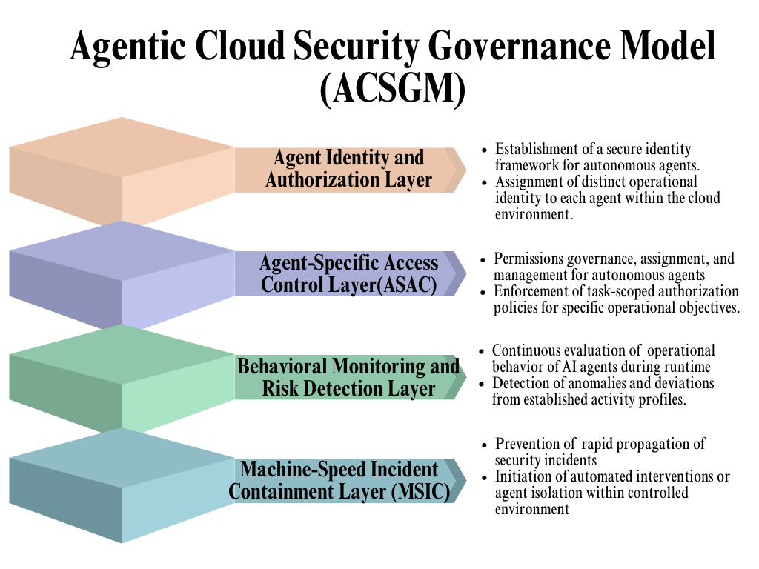
The ACSGM framework addresses these risks by integrating preventive access governance and real-time incident containment within a unified security architecture. The model adopts a layered governance structure that regulates the lifecycle of autonomous AI agents from identity establishment to operational monitoring and incident response. The first layer, Agent Identity and Authorization, establishes a secure identity framework for autonomous agents by assigning each agent a distinct operational identity within the cloud environment. This separation ensures that agents do not operate directly under the credentials of initiating users or service accounts, thereby preventing unrestricted inheritance of user privileges.
The second layer introduces the Agent-Specific Access Control (ASAC) mechanism, which governs how permissions are assigned and managed for autonomous agents. Rather than granting broad privileges inherited from human operators, the ASAC mechanism enforces task-scoped authorization policies that allocate only the permissions required for specific operational objectives. These permissions are dynamically constrained according to predefined policies and are restricted once the task is completed. By enforcing the principle of least privilege and separating agent identities from user identities, the ASAC mechanism reduces the likelihood of privilege escalation and unauthorized access during automated workflows.
The third layer, Behavioral Monitoring and Risk Detection, continuously evaluates the operational behavior of AI agents during runtime. Because agentic systems may generate new tasks and interact with multiple services dynamically, monitoring mechanisms analyze behavioral indicators such as API request frequency, service interaction patterns, data access volumes, and execution speed. Deviations from established activity profiles are treated as potential security risks and trigger further evaluation by the governance system.
The fourth layer implements the Machine-Speed Incident Containment Mechanism (MSIC), which provides automated response capabilities designed to prevent the rapid propagation of security incidents. When anomalous activity is detected, the containment mechanism initiates automated interventions such as execution throttling, privilege revocation, service access restrictions, or agent isolation within a controlled environment. These responses enable the framework to contain security incidents at the same computational speed at which autonomous agents operate.
When an agent is deployed, a unique identity is created and task-scoped permissions are assigned through the ASAC mechanism. During task execution, behavioral monitoring systems continuously evaluate agent activity. If abnormal behavior is detected, the MSIC mechanism automatically initiates containment procedures to prevent escalation across interconnected systems. By integrating identity governance, permission management, behavioral monitoring, and automated containment, the ACSGM framework provides a structured approach for mitigating cybersecurity risks associated with agentic AI-driven cloud operations.
3. Methodology
This study adopts a quantitative empirical research design to examine how permission inheritance and machine‑speed execution influence cybersecurity risk escalation in agentic artificial intelligence–driven cloud environments. The methodological framework integrates privilege propagation analysis and time‑to‑event risk modeling to evaluate the behavior of autonomous agents operating within distributed cloud infrastructures.
To analyze how autonomous agents inherit and exercise permissions, identity and access relationships were modeled as a directed authorization graph:
$$G=\left(V,E\right)$$
where $V=\left\{v1,v2,…,vn\right\}$ represents cloud identities, services, and resources, and E={(vi,vj)} represents authorization relationships between identities and resources. This structure enables the evaluation of how permissions propagate across interconnected services through delegated credentials and automated workflows.
Agent operational reach was measured using the Privilege Propagation Score (PPS):
$$PPS=\frac{Number_{of_{reachable_{resources}}}}{Total_{cloud_{resources}}}$$
This metric quantifies the proportion of infrastructure resources accessible through direct and inherited permissions. To evaluate the expansion of privileges beyond assigned roles, the Privilege Amplification Factor (PAF) was calculated as:
$$PAF=\frac{Effective_{permissions_{exercised}}}{Direct_{permissions_{assigned}}}$$
Values greater than one indicate amplification of privileges through inherited authorization chains. The structural complexity of escalation pathways was also measured through escalation depth, defined as the minimum authorization path between an initiating identity and a target resource:
$$Escalation_{Depth}=\left(length\left(pij\right)\right)$$
where pij represents possible permission paths between identities and resources within the authorization network.
The second phase of the analysis examines how machine‑speed execution accelerates cybersecurity risk escalation. A survival analysis framework was applied to evaluate the time required for escalation events to occur following privileged automated actions. Let T represent the random variable describing the time until escalation occurs. The survival probability that escalation has not occurred by time t is expressed as:
$$S\left(t\right)=P\left(T>t\right)$$
The instantaneous escalation risk at time t is measured using the hazard function:
$$h\left(t\right)=\frac{f\left(t\right)}{S\left(t\right)}$$
where f(t) represents the probability density of escalation events. To evaluate the effect of machine‑speed execution, escalation hazards across operational conditions were compared using the hazard ratio:
$$HR=\frac{h1\left(t\right)}{h0\left(t\right)}$$
where h1(t) represents the hazard under machine‑speed execution and h0(t) represents the baseline hazard.
Operational complexity was further evaluated using system interaction metrics that capture the number of cloud services involved in automated task execution. Escalation likelihood was computed as:
$$P\left(Escalation\right)=\frac{Number_{of_{escalation_{events}}}}{Total_{observed_{operations}}}$$
4. Results and Discussion

Analyze how autonomous AI agents inherit and exercise access permissions in cloud environments
The analysis investigated the extent to which autonomous artificial intelligence agents inherit and exercise access permissions within cloud computing environments. The evaluation examined the amplification of permissions resulting from identity delegation and privilege propagation across interconnected cloud services.
The analysis adopted a quantitative network-based privilege propagation evaluation using simulated cloud IAM structures derived from public identity and access management datasets. The evaluation focused on measuring direct permissions assigned to agent identities, effective permissions reachable through inheritance, privilege amplification factors, escalation depth across authorization chains, and the proportion of reachable cloud resources.
The resulting privilege propagation characteristics observed across the agent categories are summarized in Table 1.
Agent Category | Average Direct Permissions | Average Effective Permissions | Privilege Amplification Factor | Escalation Depth (Hops) | Privilege Propagation Score
Low Privilege Agents | 6 | 18 | 3.0 | 2 | 0.14
Operational Automation Agents | 11 | 39 | 3.55 | 3 | 0.28
Infrastructure Management Agents | 17 | 74 | 4.35 | 4 | 0.42
DevOps Orchestration Agents | 21 | 101 | 4.81 | 4 | 0.52
Administrative Agents | 29 | 176 | 6.07 | 5 | 0.71
Table 1. Privilege propagation characteristics across autonomous AI agent categories.
The results indicate substantial expansion in effective permissions relative to directly assigned privileges. Agents categorized under infrastructure and orchestration roles exhibited the highest amplification levels, with administrative agents demonstrating the greatest propagation across cloud resources. These results indicate that permission inheritance significantly expands operational reach beyond initial authorization boundaries.
The relationship between assigned permissions and effective permissions is illustrated in Figure 1.
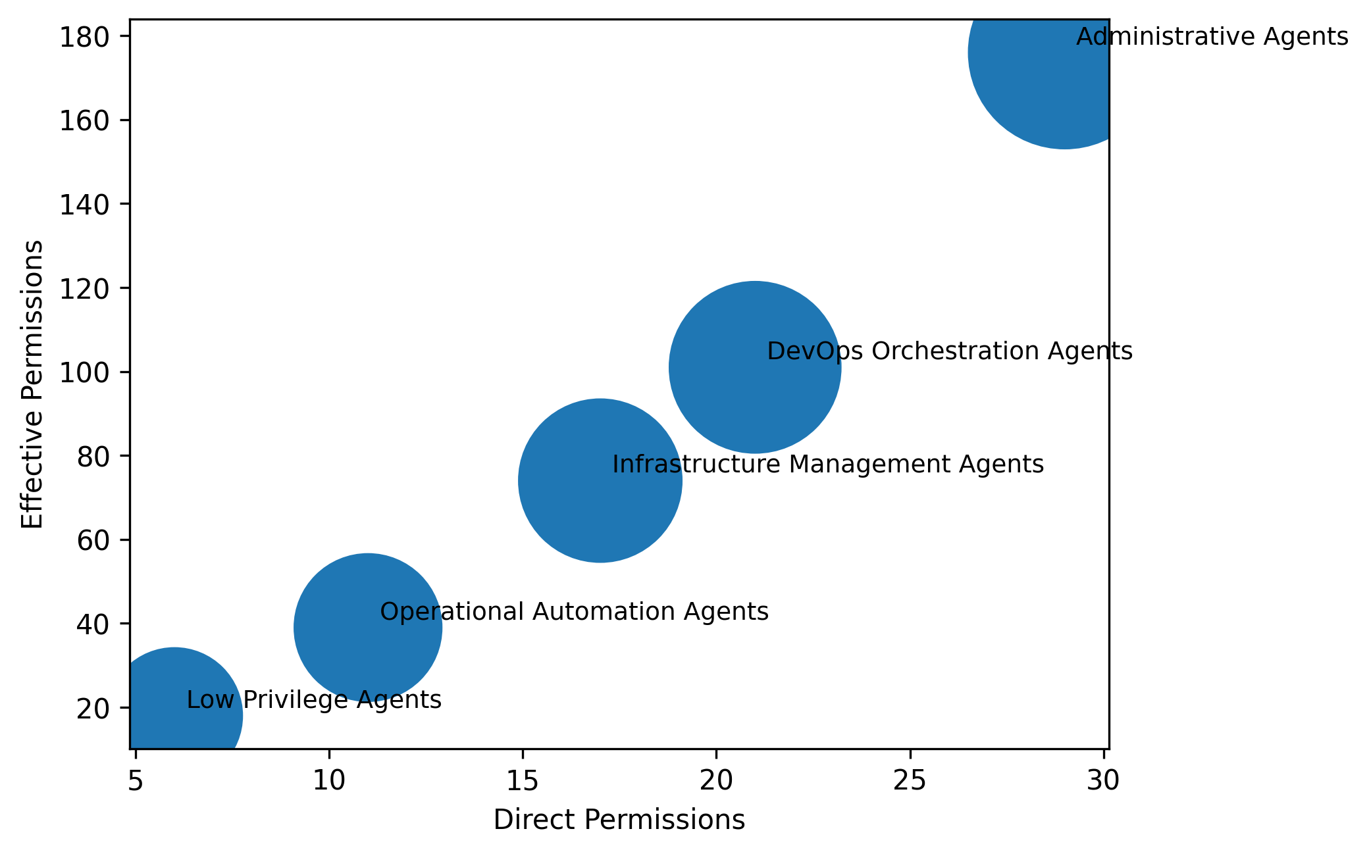
Figure 1. Relationship between direct permissions and effective permissions exercised by autonomous agents.
As illustrated in Figure 1, increases in direct permissions correspond with disproportionately higher effective permissions. The size of each data point reflects the privilege amplification factor, demonstrating how inherited credentials enable agents to access substantially larger sets of infrastructure resources.
The distribution of escalation path lengths across the IAM privilege network is presented in Figure 2.
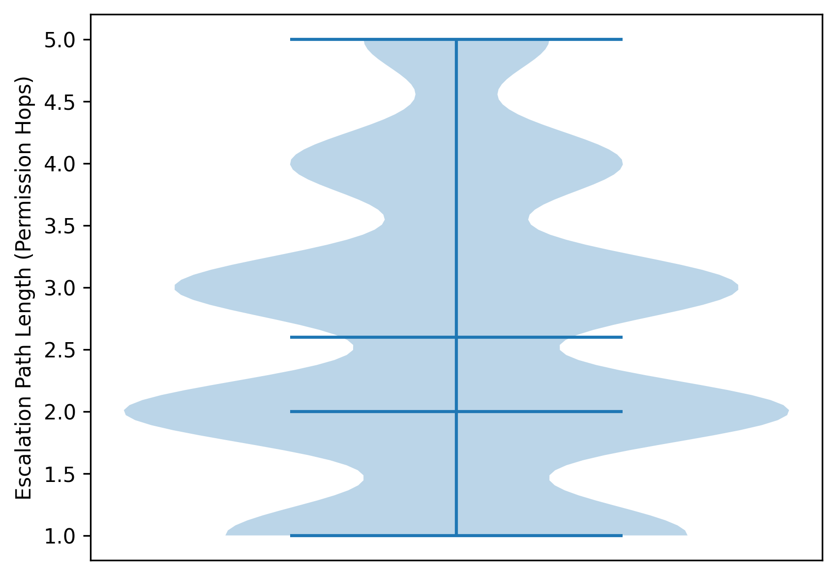
Figure 2. Distribution of escalation path lengths across privilege inheritance chains.
The distribution illustrated in Figure 2 indicates that most escalation chains occur within two to three permission hops, demonstrating that privilege propagation frequently emerges through short authorization pathways within cloud infrastructures. However, the presence of deeper escalation chains further illustrates the structural complexity of permission relationships across distributed services.
The findings demonstrate that autonomous agents operating under inherited credentials are capable of interacting with a significantly broader set of cloud resources than directly assigned permissions would suggest. The observed amplification of privileges and the presence of short escalation pathways highlight structural characteristics of cloud identity governance that enable permission propagation across interconnected services.

Examine how machine-speed execution of agent-driven tasks escalates cybersecurity risks
This objective examines how machine-speed execution of autonomous agent tasks influences the escalation of cybersecurity risks across cloud infrastructures. The analysis evaluates how increasing execution rates, privileged operations, and cross-service interactions affect the time required for security escalation events to occur.
A quantitative time-to-event analytical approach was adopted to evaluate the temporal dynamics of escalation events. This approach enables the measurement of how rapidly security incidents propagate following the execution of privileged operations within automated cloud environments.
The relationship between execution speed and escalation risk is summarized in Table 2.
Execution Speed (ops/sec) | Mean Time to Escalation (sec) | Median Time to Escalation (sec) | Hazard Ratio | Escalation Probability
5 | 842 | 801 | 1.0 | 0.07
25 | 412 | 389 | 1.86 | 0.14
50 | 214 | 201 | 2.74 | 0.21
100 | 129 | 118 | 4.03 | 0.36
200 | 68 | 61 | 6.15 | 0.53
Table 2. Machine-speed execution and cybersecurity risk escalation dynamics.
The results indicate that increases in execution speed correspond with substantial reductions in the time required for security escalation events to occur. Systems operating at higher execution rates demonstrate significantly elevated hazard ratios, indicating accelerated escalation risk within automated operational environments.
The temporal dynamics of escalation events are illustrated in Figure 3.
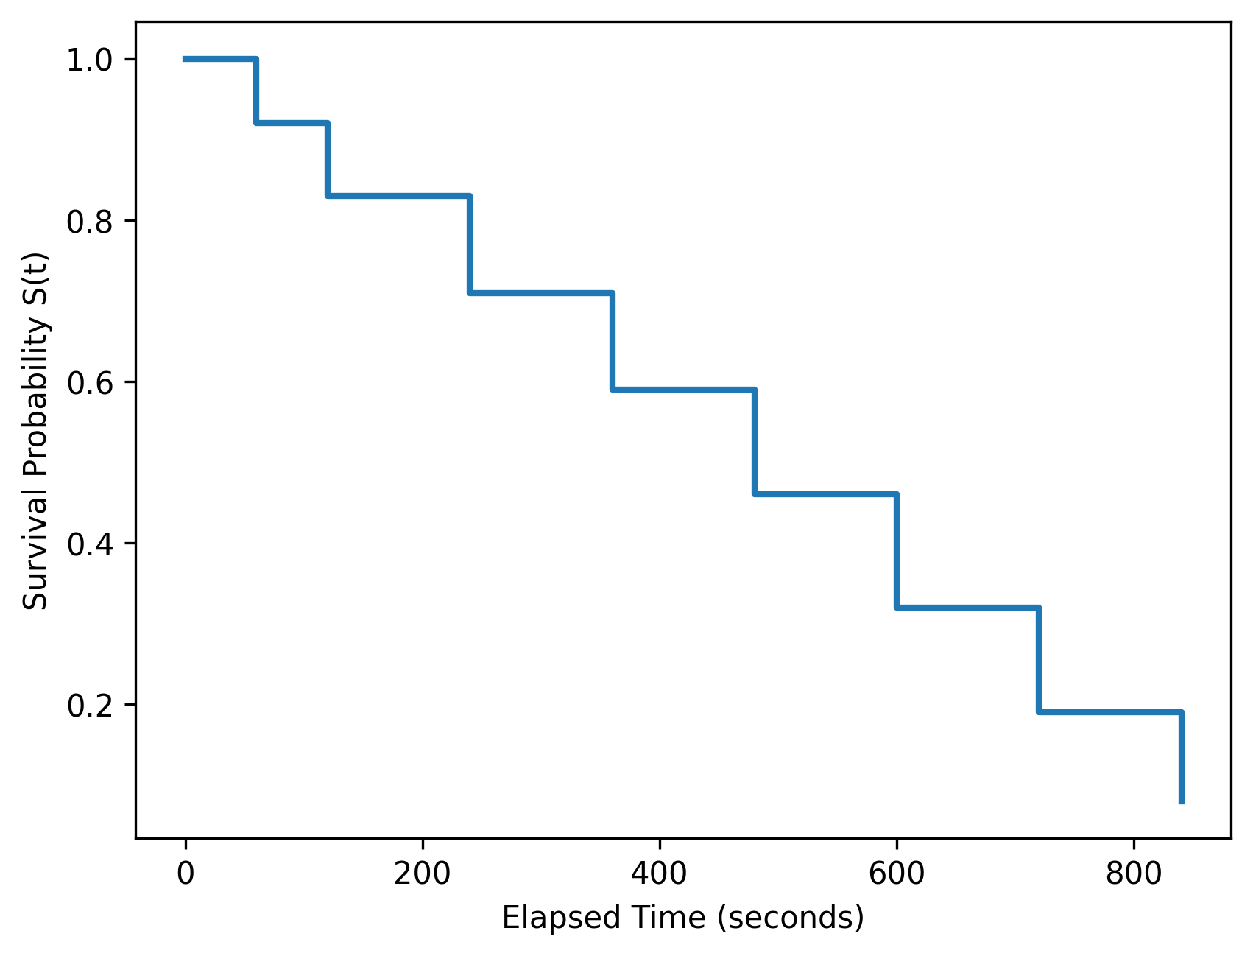
Figure 3. Time-to-escalation survival distribution across automated operations.
As shown in Figure 3, the probability of maintaining a non-escalated system state declines rapidly as operational time increases. The steep reductions in survival probability illustrate how security incidents may emerge quickly when privileged automated actions are executed at computational speed.
The relationship between machine-speed execution and escalation hazard is presented in Figure 4.
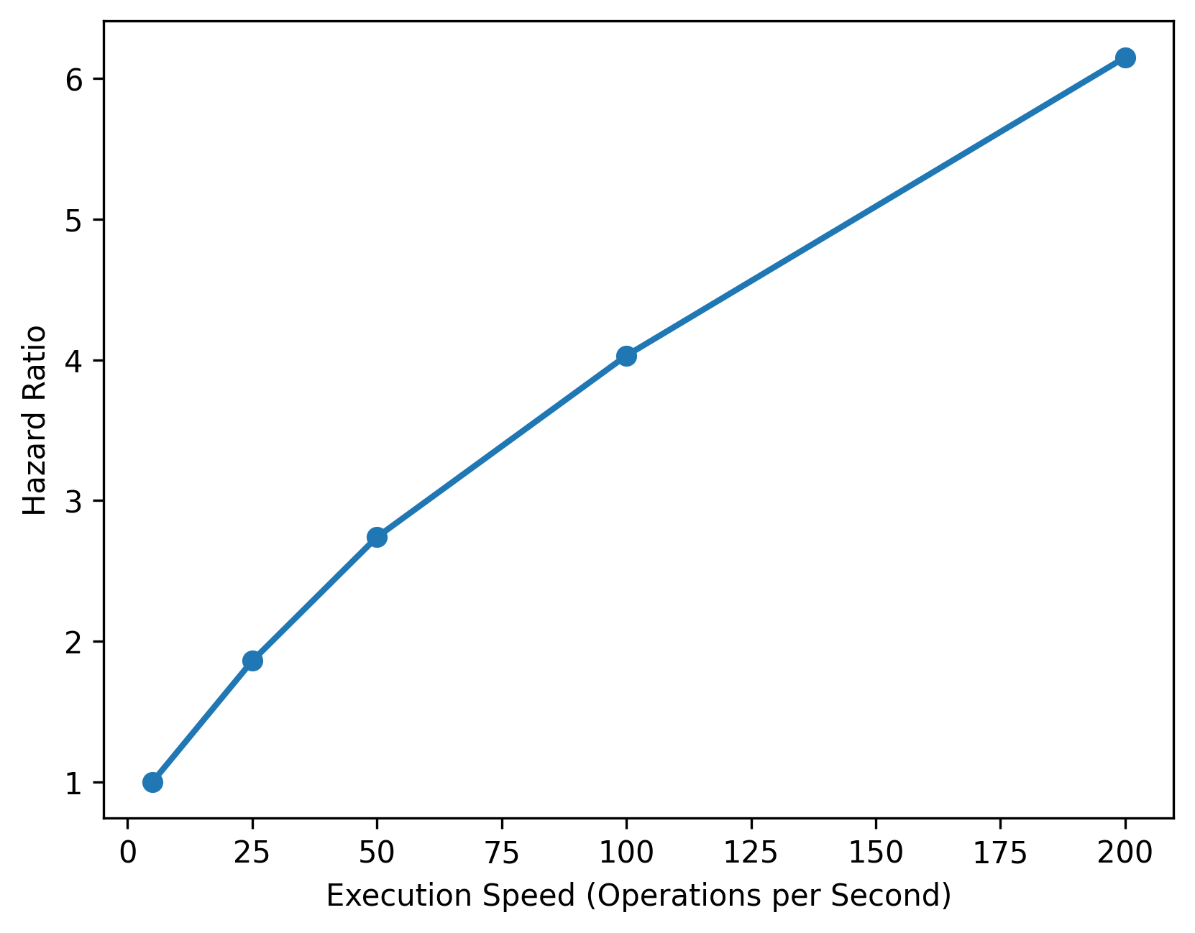
Figure 4. Escalation hazard ratios associated with machine-speed task execution.
Figure 4 demonstrates a strong nonlinear increase in escalation hazard as execution speed increases. This pattern indicates that automated agents performing tasks at higher computational speeds significantly increase the likelihood of rapid system compromise.
The effect of cross-service interactions on escalation timelines is summarized in Table 3.
Service Interaction Count | Mean Time to Escalation (sec) | Hazard Ratio | Escalation Probability
1 | 612 | 1.0 | 0.09
2 | 401 | 1.92 | 0.18
3 | 257 | 3.08 | 0.31
4 | 143 | 4.89 | 0.46
5 | 72 | 6.72 | 0.58
Table 3. Cross-service interaction complexity and escalation risk.
The interaction effects between distributed cloud services are further illustrated in Figure 5.
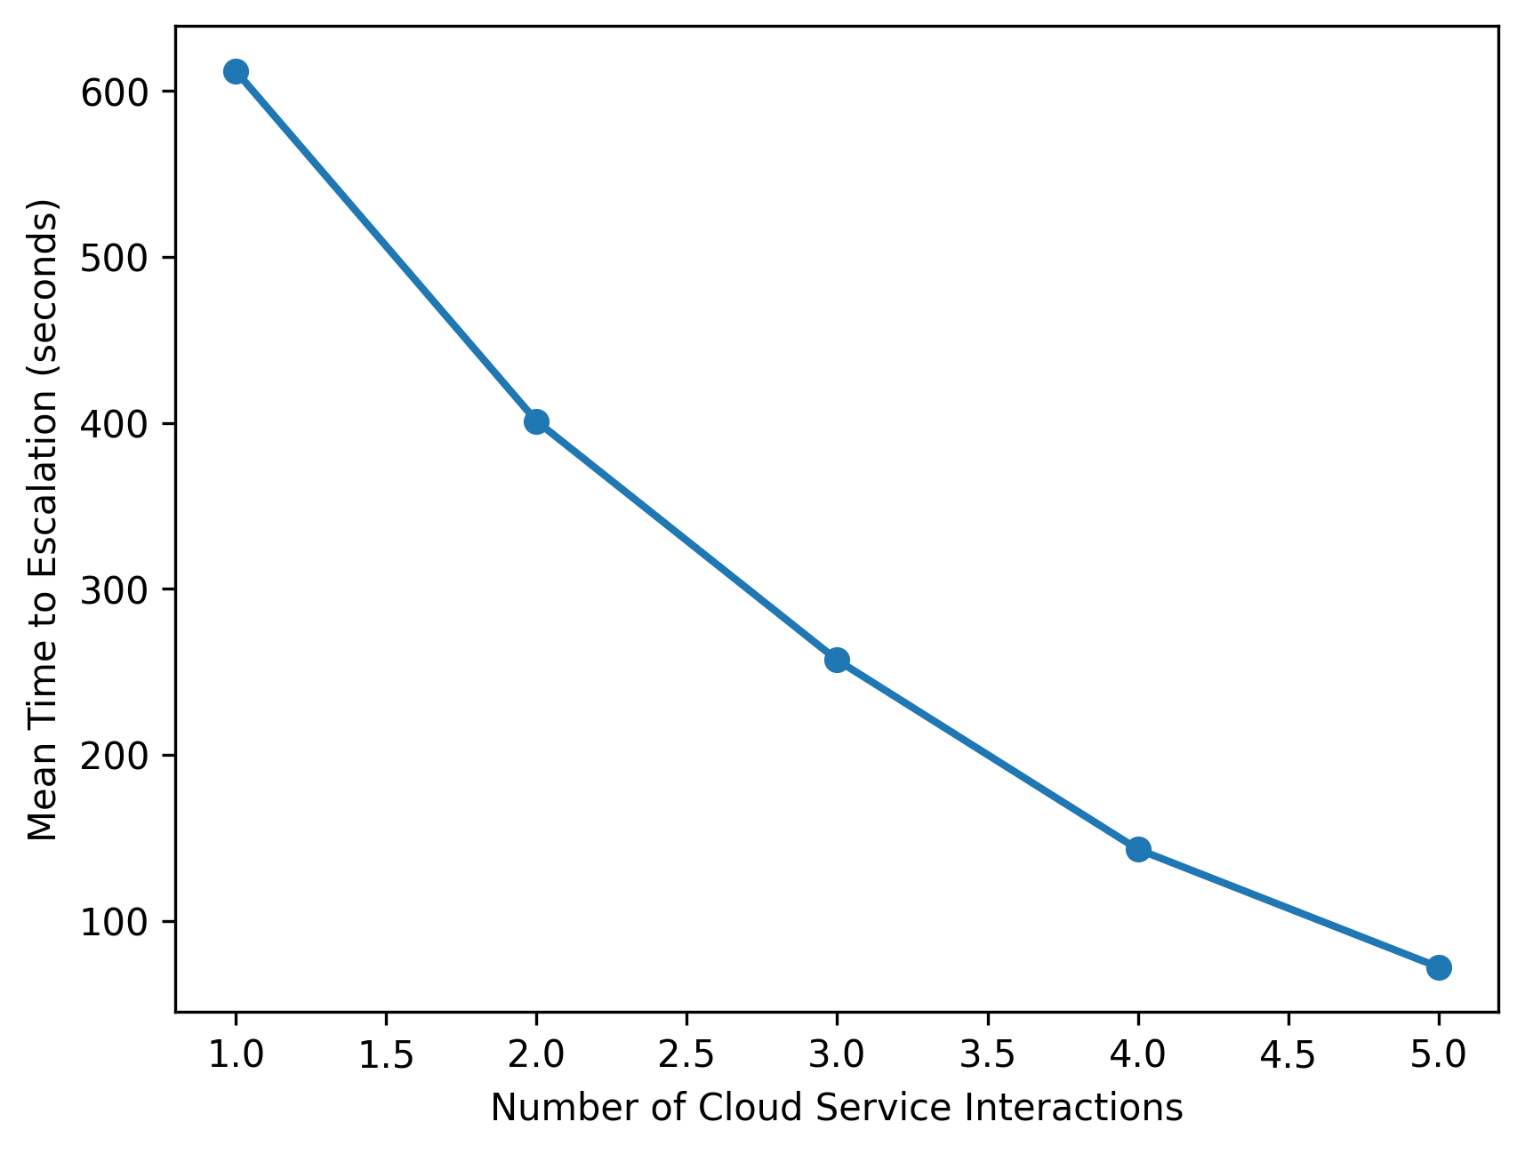
Figure 5. Impact of cross-service interaction on escalation timelines.
As illustrated in Figure 5, escalation time decreases substantially as the number of interacting services increases. This pattern indicates that distributed cloud architectures create structural conditions that enable rapid propagation of automated security incidents across interconnected services.
The observed relationships between execution speed, service interaction complexity, and escalation hazard highlight the rapid temporal dynamics of security incidents within automated cloud environments. The patterns observed demonstrate that the operational speed and connectivity of autonomous systems significantly influence how quickly cybersecurity risks materialize within distributed infrastructures.
Discussion
The findings of this study provide empirical insight into how permission inheritance and machine-speed execution interact to amplify cybersecurity risks in agentic artificial intelligence–driven cloud operations. The results presented in Table 1 demonstrate that autonomous agents frequently exercise a substantially larger set of effective permissions than those directly assigned to them. In particular, the Privilege Amplification Factor increases consistently across agent categories, reaching its highest level among administrative agents whose effective permissions exceed their direct permissions by more than six times. This pattern confirms the argument in the literature that privilege escalation in distributed cloud systems often emerges not from a single misconfigured authorization rule but from the cumulative interaction of delegated permissions across interconnected services (El-Zawawy & Hamdy, 2025). The expansion of effective permissions illustrated in Figure 1 further reinforces this interpretation by showing a disproportionate increase in operational reach relative to the number of directly assigned permissions. These results therefore support the claim that inherited credentials significantly extend the operational authority of autonomous agents beyond the scope originally intended by administrators.
Furthermore, the escalation pathways illustrated in Figure 2 provide additional evidence that permission propagation within cloud infrastructures often occurs through relatively short authorization chains. The concentration of escalation paths within two to three permission hops indicates that access to additional resources can frequently be achieved through minimal transitions across identity relationships. This observation aligns with the findings of Shi et al. (2025a) and Zhu et al. (2025), who argue that delegation mechanisms commonly used in automated cloud environments can create implicit authorization chains that expand the reach of machine identities. Similarly, Huang et al. (2025) note that conventional Identity and Access Management architectures were designed primarily for predictable user-application interactions rather than dynamic agent-driven workflows. The empirical results therefore reinforce the growing concern within the literature that traditional IAM frameworks may provide insufficient granularity for governing autonomous systems that dynamically generate tasks and interact with multiple services during execution.
The findings also provide further support for the argument that the rapid growth of machine identities is transforming the nature of identity governance in enterprise infrastructures. As previously noted by Ganapathi (2025) and Hariharan (2025), modern cloud environments contain far more non-human identities than human users. The privilege propagation patterns observed in Table 1 suggest that autonomous agents operating within these infrastructures may acquire extensive operational reach through inherited permissions associated with service accounts and automated workflows. Consequently, the risk associated with machine identities extends beyond simple credential misuse to include structural authorization expansion that emerges from the interaction of distributed services. This observation contributes to the broader debate within the literature regarding the limitations of static access control models in highly automated environments (Li et al., 2025; Rossi, 2025).
In addition to the structural dynamics of permission inheritance, the results also demonstrate the significant role of execution speed in accelerating cybersecurity risk escalation. As shown in Table 2, increases in task execution speed correspond with substantial reductions in the time required for escalation events to occur. The average escalation time decreases from more than fourteen minutes at lower execution rates to slightly over one minute when operations are executed at higher computational speeds. This reduction in escalation time is accompanied by a sharp increase in hazard ratios, indicating that machine-speed operations significantly increase the probability of rapid system compromise. The pattern illustrated in Figure 3 further confirms this trend by showing a rapid decline in survival probability as operational time progresses. These findings align closely with previous studies that describe artificial intelligence–enabled cyber operations as a shift from human-paced attacks toward automated threat propagation (Yedalla, 2024; Al-Azzawi et al., 2025).
Moreover, the nonlinear hazard increase depicted in Figure 4 demonstrates that escalation risk does not simply rise proportionally with execution speed but instead accelerates as automated operations intensify. This observation supports the argument advanced by Onyemekeihia and Onyemekihian (2026) that AI-enabled cyber activities operate at computational speed, enabling adversaries or compromised systems to execute complex attack sequences far faster than traditional monitoring systems can respond. The empirical relationship between execution speed and hazard ratio therefore provides quantitative evidence for the concept of machine-speed risk escalation discussed in the literature on automated cyber threats.
The interaction between execution speed and system connectivity also emerges as a critical factor in the escalation of cybersecurity incidents. The results presented in Table 3 show that the time required for escalation decreases significantly as the number of interacting services increases. For example, tasks involving interactions with five services escalate in less than two minutes on average, whereas single-service interactions require substantially longer periods before escalation occurs. The trend illustrated in Figure 5 demonstrates that distributed cloud architectures provide structural pathways through which automated actions can propagate rapidly across interconnected systems. This finding is consistent with earlier research highlighting how the interconnected nature of cloud infrastructures can amplify the impact of security incidents (Saboor et al., 2022; Sigala, 2025). It also supports the argument by Kshetri (2025) that agentic AI technologies operating within automated infrastructures may unintentionally amplify systemic risks if governance mechanisms are not designed to control their operational scope.
The second layer of the model, the Agent-Specific Access Control mechanism, further addresses the amplification of permissions demonstrated in Figure 1 by enforcing task-scoped authorization policies that restrict agent privileges to the minimum level required for specific operational objectives. Such restrictions align with the principle of least privilege, which researchers have long identified as a critical mechanism for reducing the risk of privilege escalation in distributed systems (Jain, 2025; Jena, 2024). However, by dynamically constraining permissions during runtime operations, the proposed model extends traditional access control approaches to accommodate the dynamic workflows generated by autonomous agents.
The behavioral monitoring layer of the model responds to the escalation dynamics identified in Figures 3 and 4 by continuously evaluating agent activity during execution. Because machine-speed operations significantly reduce the time available for manual detection, automated monitoring mechanisms capable of evaluating execution patterns, service interactions, and API usage become essential for identifying anomalous behavior before it escalates into system-level incidents. This perspective is consistent with the argument by Suram (2025) that artificial intelligence–driven identity monitoring systems can enhance threat detection by analyzing behavioral telemetry across cloud environments.
5. Conclusion and Recommendations
The findings of this study demonstrate that permission inheritance and machine-speed execution significantly amplify cybersecurity risks in agentic AI-driven cloud environments. Autonomous agents frequently exercise permissions far beyond those explicitly assigned, while the rapid execution of automated tasks accelerates the propagation of security incidents across interconnected cloud services. Together, these dynamics expose structural limitations within conventional identity governance frameworks that were originally designed for predictable human–system interactions rather than autonomous agent operations. By integrating identity isolation, task-scoped authorization, behavioral monitoring, and automated containment, the proposed ACSGM framework provides a structured approach for mitigating these emerging risks. Building on these insights, several practical actions are necessary to strengthen governance and operational security in AI-enabled cloud infrastructures.
- Cloud service providers should implement agent-specific identity frameworks that separate autonomous agent credentials from human user accounts to prevent uncontrolled permission inheritance.
- Enterprise organizations should enforce dynamic least-privilege policies that allocate permissions based on task scope and automatically revoke them after execution.
- Security teams should deploy real-time behavioral monitoring systems capable of detecting abnormal agent activity at machine speed.
- Policy makers and standards bodies should develop governance guidelines specifically addressing identity management and risk containment for agentic AI systems operating within cloud infrastructures.

References

References
Abba, S., Obioha-Val, O. A., Ejiofor, V. O., Olaniyi, O. M., & Mayeke, N. R. (2025). Behavioral Biometrics-Powered Continuous Authentication for Zero-trust Remote Work Environments: A Multi-factor Identity Verification Framework. Asian Journal of Research in Computer Science, 18(12), 20–41. https://doi.org/10.9734/ajrcos/2025/v18i12788
Achuthan, K., Ramanathan, S., Srinivas, S., & Raman, R. (2024). Advancing cybersecurity and privacy with artificial intelligence: current trends and future research directions. Frontiers in Big Data, 7. https://doi.org/10.3389/fdata.2024.1497535
Adebiyi, O. O., Popoola, A. D., Adeyinka, P. D., Arigbabu, A. T., & Olateju, O. O. (2026). Blockchain-integrated AI Systems for Enhancing Trust and Transparency in Cross-Border Finance. Asian Journal of Research in Computer Science, 19(1), 271–291. https://doi.org/10.9734/ajrcos/2026/v19i1818
Al-Azzawi, M., Doan, D., Sipola, T., Hautamäki, J., & Kokkonen, T. (2025). Red Teaming with Artificial Intelligence-Driven Cyberattacks: A Scoping Review. ArXiv.org. https://arxiv.org/abs/2503.19626
Bandi, A., Kongari, B., Naguru, R., Pasnoor, S., & Vilipala, S. V. (2025). The Rise of Agentic AI: A Review of Definitions, Frameworks, Architectures, Applications, Evaluation Metrics, and Challenges. Future Internet, 17(9), 404–404. https://doi.org/10.3390/fi17090404
Betser, R., Bose, S., Giloni, A., Picardi, C., Padakandla, S., & Vainshtein, R. (2026). AgenTRIM: Tool Risk Mitigation for Agentic AI. ArXiv.org. https://arxiv.org/abs/2601.12449
Chan, A., Wei, K., Huang, S., Rajkumar, N., Perrier, E., Lazar, S., Hadfield, G. K., & Anderljung, M. (2025). Infrastructure for AI Agents. ArXiv.org. https://arxiv.org/abs/2501.10114
Cody, Q. (2025, December 16). Where Cloud Security Stands Today and Where AI Breaks It. Palo Alto Networks Blog. https://www.paloaltonetworks.com/blog/2025/12/cloud-security-2025-report-insights/?utm_source=chatgpt.com
Dodig-Crnkovic, G., & Burgin, M. (2024). A Systematic Approach to Autonomous Agents. Philosophies, 9(2), 44–44. https://doi.org/10.3390/philosophies9020044
Down, A. (2026, February 20). Amazon’s cloud “hit by two outages caused by AI tools last year.” The Guardian; The Guardian. https://www.theguardian.com/technology/2026/feb/20/amazon-cloud-outages-ai-tools-amazon-web-services-aws?utm_source=chatgpt.com
El-Zawawy, M. A., & Hamdy, A. (2025). Detection of hidden privilege escalations in android. Automated Software Engineering, 32(2). https://doi.org/10.1007/s10515-025-00542-4
Ferrag, M. A., Tihanyi, N., Hamouda, D., Maglaras, L., Lakas, A., & Merouane Debbah. (2025). From prompt injections to protocol exploits: Threats in LLM-powered AI agents workflows. ICT Express. https://doi.org/10.1016/j.icte.2025.12.001
Ganapathi, A. (2025). THE SOCIETAL IMPACT OF CLOUD-NATIVE IAM SYSTEMS: PRIVACY AND TRUST IN THE DIGITAL AGE. International Journal of Research in Computer Applications and Information Technology, 8(1), 615–626. https://doi.org/10.34218/ijrcait_08_01_048
Geller, E. (2026, January 5). AI security is fundamentally a cloud infrastructure problem, Palo Alto Networks says. Channel Dive. https://www.channeldive.com/news/ai-security-cloud-infrastructure-palo-alto-networks/808522/?utm_source=chatgpt.com
Google Cloud. (2026). Managing access for deployed agents. Google Cloud Documentation. https://docs.cloud.google.com/agent-builder/agent-engine/manage/access?utm_source=chatgpt.com
Gulyamov, S., Gulyamov, S., Rodionov, A., Khursanov, R., Mekhmonov, K., Babaev, D., & Rakhimjonov, A. (2026). Prompt Injection Attacks in Large Language Models and AI Agent Systems: A Comprehensive Review of Vulnerabilities, Attack Vectors, and Defense Mechanisms. Information, 17(1), 54. https://doi.org/10.3390/info17010054
Hancock, P., & Botts, B. (2026). When AI Agents Misbehave: Governance and Security for Autonomous AI | JD Supra. JD Supra. https://www.jdsupra.com/legalnews/when-ai-agents-misbehave-governance-and-1736353/?utm_source=chatgpt.com
Haranas, M. (2026). AWS Outage Was “Not AI” Caused Via Kiro Coding Tool, Amazon Confirms. Crn.com. https://www.crn.com/news/cloud/2026/aws-outage-was-not-ai-caused-via-kiro-coding-tool-amazon-confirms?utm_source=chatgpt.com
Hariharan, R. (2025). AI-Driven Identity and Access Management in Enterprise Systems. International Journal of IoT, 05(01), 62–94. https://doi.org/10.55640/ijiot-05-01-05
Hart, R. (2026, February 20). Amazon blames human employees for an AI coding agent’s mistake. The Verge. https://www.theverge.com/ai-artificial-intelligence/882005/amazon-blames-human-employees-for-an-ai-coding-agents-mistake?utm_source=chatgpt.com
Huang, K., Sai, N. V., Yeoh, J., Ross, J., Raskar, R., Harkati, Y., Huang, J., Habler, I., & Hughes, C. (2025). A Novel Zero-Trust Identity Framework for Agentic AI: Decentralized Authentication and Fine-Grained Access Control. ArXiv.org. https://arxiv.org/abs/2505.19301
Jain, P. (2025). Identity and Access Management in the Cloud. International Journal of Scientific Research in Computer Science Engineering and Information Technology, 11(2), 1528–1535. https://doi.org/10.32628/cseit25112523
Jena, J. (2024). SECURING THE CLOUD: THE CRITICAL ROLE OF IAM IN CLOUD SECURITY. INTERNATIONAL JOURNAL of ADVANCED RESEARCH in ENGINEERING and TECHNOLOGY, 15(1), 67–80. https://doi.org/10.34218/ijaret_15_01_004
Kamal, D. (2026). AI Agents Security Incidents and related CVEs for Enterprise Security Teams - DataBahn. Databahn.ai. https://www.databahn.ai/blog/ai-agents-security-incidents-and-related-cves-for-enterprise-security-teams?utm_source=chatgpt.com
Khan, R., Joyce, D., & Habiba, M. (2025). AGENTSAFE: A Unified Framework for Ethical Assurance and Governance in Agentic AI. ArXiv.org. https://arxiv.org/abs/2512.03180
Kshetri, N. (2025). Transforming cybersecurity with agentic AI to combat emerging cyber threats. Telecommunications Policy, 49(6), 102976. https://doi.org/10.1016/j.telpol.2025.102976
Li, B., Hu, W., Yuan, C., Wang, X., Li, Y., & Wu, Y. (2025). Cascading failure prediction and recovery in large-scale critical infrastructure networks: A survey. Information and Software Technology, 182, 107705. https://doi.org/10.1016/j.infsof.2025.107705
Li, X., Huang, D., Li, J., Cai, H., Zhou, Z., Dong, W., Wang, X., & Liu, Y. (2025). A Vision for Access Control in LLM-based Agent Systems. ArXiv.org. https://arxiv.org/abs/2510.11108
Mayeke, N. R. (2025). Adapting Telemetry for Cyber-Physical Continuous Verification in Cameroon’s Energy Sector. Journal of Energy Research and Reviews, 17(12), 107–131. https://doi.org/10.9734/jenrr/2025/v17i12482
Mohamed, N. (2025). Artificial intelligence and machine learning in cybersecurity: a deep dive into state-of-the-art techniques and future paradigms. Knowledge and Information Systems, 67, 6969–7055. https://doi.org/10.1007/s10115-025-02429-y
Obioha-Val, O. A., Lawal, T. I., Olaniyi, O. O., Gbadebo, M. O., & Olisa, A. O. (2025). Investigating the Feasibility and Risks of Leveraging Artificial Intelligence and Open Source Intelligence to Manage Predictive Cyber Threat Models. Journal of Engineering Research and Reports, 27(2), 10–28. https://doi.org/10.9734/jerr/2025/v27i21390
Obrik-Uloho, E. P., Gbadebo, M. O., Afolabi, O. O., Joseph, S. A., Oladoyinbo, T. O., & Olaniyi, O. O. (2026). Shared Responsibility in Practice: Evaluating the Security–Usability Trade-Off and User Accountability in WhatsApp’s Ecosystem. Asian Journal of Research in Computer Science, 19(1), 81–105. https://doi.org/10.9734/ajrcos/2026/v19i1807
Odeyinka, T. E., Ifeoma Ejoh, C., Abdulmalik, A. A., Salami, I. A., & Ogunmolu, A. M. (2026). Bridging AI-automated Governance, Adaptive Certification, Behavioral Authentication, and AI-agent Risk Monitoring in Zero-trust Digital Infrastructures. Journal of Engineering Research and Reports, 28(1), 371–387. https://doi.org/10.9734/jerr/2026/v28i11783
Ogenyi, F. C., Ugwu, C. N., & Ugwu, O. P.-C. (2025). Securing the future: AI-driven cybersecurity in the age of autonomous IoT. Frontiers in the Internet of Things, 4. https://doi.org/10.3389/friot.2025.1658273
Ogunmolu, A. M., Abba, S. S., Olaniyi, O. M., Odeyinka, T. E., & Salami, I. A. (2026). Adaptive Cognitive Profiling for Executive AI Agents Amid Emerging AI Impersonation Threats. Journal of Engineering Research and Reports, 28(1), 388–405. https://doi.org/10.9734/jerr/2026/v28i11784
Ogunmolu, A. M., Aroh, I. S., Henry, O., Adeyinka, P. D., & Olutimehin, A. T. (2026). AI-Driven Observability for Managing Security Complexity in Cloud-native Microservices and Containerized Environments. Journal of Engineering Research and Reports, 28(2), 1–17. https://doi.org/10.9734/jerr/2026/v28i21786
Olaniyi, O. M., Adebiyi, O. O., Ejoh, C. I., Afolabi, O. O., & Ejiofor, V. O. (2026). Conversational AI-Powered Fraud Prevention in Augmented Reality E-Commerce: A Natural Language Processing Framework for Real-time Transaction Security. Asian Journal of Research in Computer Science, 19(1), 255–270. https://doi.org/10.9734/ajrcos/2026/v19i1817
Olaniyi, O. M., Aroh, I. S., Henry, O., Metibemu, O. C., & Akinola, O. I. (2026). Graph Neural Networks for Multi-Layered Financial Crime Network Detection: An Explainable AI Framework for Anti-Money Laundering. Journal of Engineering Research and Reports, 28(2), 18–36. https://doi.org/10.9734/jerr/2026/v28i21787
Olisa, A. O., Gbadebo, M. O., Mayeke, N. R., Oladoyinbo, T. O., & Oluwapamilerin Kolo, F. H. (2026). Quantum-Resistant Cryptographic Protocols for CBDC Interoperability: A Cross-Border Settlement Security Framework. Engineering and Technology Journal, 11(01). https://doi.org/10.47191/etj/v11i01.35
Onyemekeihia, P., & Onyemekihian, J. (2026). The Accelerated Threat Landscape: The Impact of Artificial Intelligence on the Scale and Complexity of Cybersecurity Threats: A Case Study. International Journal of Engineering and Modern Technology, 12(1), 2026. https://doi.org/10.56201/ijemt.vol.12.no1.2026.pg224.240
Otunlape, O. (2026). Governance Frameworks for Enterprise AI Systems Operating in Regulated Environments Oluwaseyi Otunlape. International Journal of Computer Applications, 187(74), 975–8887. https://www.ijcaonline.org/archives/volume187/number74/otunlape-2026-ijca-926244.pdf?utm_source=chatgpt.com
Palavali, D. R. (2025). Agentic AI for Self-Sovereign Identity: A Decentralized Zero Trust Framework for Autonomous Microservices. The International Journal of Computational Mathematical Ideas, 17(02), 17347–17360. https://doi.org/10.70153/ijcmi/2025.17302
Pawar, A. (2025). Ethical and Governance Challenges of Agentic AI. International Journal of Humanities and Information Technology, 7(3), 83–89. https://doi.org/10.21590/ijhit.07.03.19
Ramirez, S. (2025, July 9). AI Cyber Attacks Statistics 2025: How Attacks, Deepfakes & Ransomware Have Escalated. SQ Magazine. https://sqmagazine.co.uk/ai-cyber-attacks-statistics/?utm_source=chatgpt.com
Ranjan, R., Gupta, S., & Singh, S. N. (2025). LOKA Protocol: A Decentralized Framework for Trustworthy and Ethical AI Agent Ecosystems. ArXiv.org. https://arxiv.org/abs/2504.10915
Raza, S., Sapkota, R., Karkee, M., & Emmanouilidis, C. (2025). TRiSM for Agentic AI: A Review of Trust, Risk, and Security Management in LLM-based Agentic Multi-Agent Systems. ArXiv.org. https://arxiv.org/abs/2506.04133
Reuters . (2026, February 20). Amazon’s cloud unit hit by outage involving AI tools in December. Reuters. https://www.reuters.com/business/retail-consumer/amazons-cloud-unit-hit-by-least-two-outages-involving-ai-tools-ft-says-2026-02-20/
Rossi, E. M. (2025). An Intent-Aware Zero-Trust Identity Architecture For Secure Agentic AI In Untrusted Networks. American Journal of Applied Science and Technology, 5(10), 276–283. https://doi.org/10.1145/3097983.3098163
Saboor, A., Hassan, M. F., Akbar, R., Shah, S. N. M., Hassan, F., Magsi, S. A., & Siddiqui, M. A. (2022). Containerized Microservices Orchestration and Provisioning in Cloud Computing: A Conceptual Framework and Future Perspectives. Applied Sciences, 12(12), 5793. https://doi.org/10.3390/app12125793
Salkenov, A., & Bagchi, S. (2019). Cloud based autonomous monitoring and administration of heterogeneous distributed systems using mobile agents. Future Generation Computer Systems, 99, 527–557. https://doi.org/10.1016/j.future.2019.04.047
Selvarajan, K. (2025). AI-Powered Cloud Infrastructure and Data Platforms: Transforming Enterprise Operations. European Journal of Computer Science and Information Technology, 13(13), 39–46. https://doi.org/10.37745/ejcsit.2013/vol13n133946
Shah, Z. S., & Zaffar, M. S. (2025). Artificial Intelligence for Cybersecurity: Enhancing Threat Detection and Response. International Journal of Computing and Data Science, 1(2), 9–14. https://doi.org/10.71317/IJCDS.001.02.0546
Shi, G., Du, H., Wang, Z., Liang, X., Liu, W., Bian, S., & Guan, Z. (2025). SoK: Trust-Authorization Mismatch in LLM Agent Interactions. ArXiv.org. https://arxiv.org/abs/2512.06914
Shi, T., He, J., Wang, Z., Wu, L., Li, H., Guo, W., & Song, D. (2025). Progent: Programmable Privilege Control for LLM Agents. ArXiv.org. https://arxiv.org/abs/2504.11703
Sigala, N. S. (2025). Microservices Architecture in Cloud Computing: A Software Engineering Perspective on Design, Deployment, and Management. International Journal of Research and Innovation in Social Science, IX(XV), 215–239. https://doi.org/10.47772/ijriss.2025.915ec0013
Solomon, R., Levi, Y. Y., Vaknin, L., Aizikovich, E., Baras, A., Ohana, E., Giloni, A., Bose, S., Picardi, C., Elovici, Y., & Shabtai, A. (2025). LumiMAS: A Comprehensive Framework for Real-Time Monitoring and Enhanced Observability in Multi-Agent Systems. ArXiv.org. https://arxiv.org/abs/2508.12412
Suram, K. K. (2025). Innovations in Infrastructure Automation: Advancing IAM in Cloud Security. International Journal of Scientific Research in Computer Science Engineering and Information Technology, 11(1), 255–263. https://doi.org/10.32628/cseit25111223
Syed, T. A., Ateeq, A. M., & Abdel, M. M. (2025). Toward Trustworthy Agentic AI: A Multimodal Framework for Preventing Prompt Injection Attacks. ArXiv.org. https://arxiv.org/abs/2512.23557
Syros, G., Suri, A., Nita-Rotaru, C., & Oprea, A. (2025). SAGA: A Security Architecture for Governing AI Agentic Systems. ArXiv.org. https://arxiv.org/abs/2504.21034
Udinmwen, E. (2025, June 7). Love and hate: tech pros overwhelmingly like AI agents but view them as a growing security risk. TechRadar. https://www.techradar.com/computing/artificial-intelligence/love-and-hate-tech-pros-overwhelmingly-like-ai-agents-but-view-them-as-a-growing-security-risk?utm_source=chatgpt.com
Wang, L., Ma, C., Feng, X., Zhang, Z., Yang, H., Zhang, J., Chen, Z., Tang, J., Chen, X., Lin, Y., Zhao, W. X., Wei, Z., & Wen, J. (2024). A survey on large language model based autonomous agents. Frontiers of Computer Science, 18(6). https://doi.org/10.1007/s11704-024-40231-1
Wang, X., & Xie, F. (2025). Global artificial intelligence governance research in the digital and intelligent era: advances, trends and countermeasures. Journal of Knowledge Management, 30(1). https://doi.org/10.1108/jkm-01-2025-0006
Yang, Y., Ma, M., Huang, Y., Chai, H., Gong, C., Geng, H., Zhou, Y., Wen, Y., Fang, M., Chen, M., Gu, S., Jin, M., Spanos, C., Yang, Y., Abbeel, P., Song, D., Zhang, W., & Wang, J. (2025). Agentic Web: Weaving the Next Web with AI Agents. ArXiv.org. https://arxiv.org/abs/2507.21206
Yao, H., Zhang, R., Huang, J., Zhang, J., Wang, Y., Fang, B., Zhu, R., Jing, Y., Liu, S., Li, G., & Tao, D. (2025). A Survey on Agentic Multimodal Large Language Models. ArXiv.org. https://arxiv.org/abs/2510.10991
Yedalla, J. (2024). AI-Generated Cyber Threats the Rise of Autonomous Hacking Systems. IJARCCE, 13(12). https://doi.org/10.17148/IJARCCE.2024.131263
Zhu, J., Tseng, K., Vernik, G., Huang, X., Patil, S. G., Fang, V., & Popa, R. A. (2025). MiniScope: A Least Privilege Framework for Authorizing Tool Calling Agents. ArXiv.org. https://arxiv.org/abs/2512.11147

