Finite Element Analysis and Multi-Objective Optimization of the Spiral Sorting Device for Coal Mine Roadway Concrete Pavers

.
ABSTRACT

Aims: This study aims to conduct a comprehensive static analysis and lightweight multi-objective optimization of the spiral sorting device (auger) used in coal mine roadway concrete pavers. The primary objective is to fundamentally enhance the economic efficiency, structural reliability, and operational stability of the equipment under the harsh, confined, and highly demanding underground environments typical of modern coal extraction facilities.
Study design: A rigorous numerical computational design combining advanced Finite Element Analysis (FEA) and statistical Response Surface Methodology (RSM) was deployed to systematically evaluate and optimize the mechanical structure.
Methodology: Initially, a rigorous mesh independence verification was discussed to ensure the absolute accuracy and computational efficiency of the numerical solutions. Subsequently, a highly detailed static analysis was performed by fixing both ends of the spiral shaft to simulate bearing constraints, applying a substantial surface load of 15000 N on the active faces of the spiral blades to simulate concrete resistance, and subjecting the spiral shaft to a driving torque of 573 N·m. Building upon the baseline static analysis results, a central composite design (CCD) was employed to construct a highly accurate mathematical response surface model. The spiral shaft diameter and blade thickness were selected as independent design variables, while the total structural mass, maximum total deformation, and maximum equivalent stress were established as the targeted objective functions. Finally, a Multi-Objective Genetic Algorithm (MOGA) was utilized to navigate the complex design space for global optimal searching based on Pareto efficiency.
Results: The initial comprehensive static analysis indicated that the maximum equivalent stress of the spiral sorting device was intrinsically located at the root of the blade, peaking at 126.46 MPa. Concurrently, the maximum deformation was recorded at 1.2891 mm at the outermost blade tip. Both baseline values fully met the rigorous safety design requirements. Detailed sensitivity analysis subsequently revealed that the spiral shaft diameter possessed the most significant dominant impact on both total mass and structural deformation, whereas the blade thickness exerted a more pronounced, localized influence on the stress distribution at the blade roots. Through extensive MOGA optimization iterations, the optimal geometric parameters were mathematically determined and engineering-rounded to a shaft diameter of 44 mm and a blade thickness of 4 mm. Consequently, the mass of the newly optimized device was remarkably reduced from an initial 28.411 kg down to 23.056 kg. Simultaneously, the maximum stress increased to 196.56 MPa and the maximum deformation shifted to 2.4121 mm, both of which dynamically remain strictly and safely within the allowable physical limits of the selected material.
Conclusion: The optimized design strategy successfully and significantly reduced the unnecessary dead mass of the spiral sorting device, achieving the coveted lightweight construction without compromising the essential structural strength and operational stiffness. This in-depth research provides a solid theoretical foundation, robust numerical validation, and a practical engineering reference for the future development, upgrading, and manufacturing of intelligent paving equipment operating under severely constrained underground conditions.

Keywords: Spiral sorting device; Finite element analysis; Multi-objective optimization; Response surface methodology; Coal mine roadway paver

1. INTRODUCTION

Since the implementation of reform and opening-up policies, the coal industry has played an utterly irreplaceable role in the rapid industrialization and national economic development of China. With the continuous escalation of global energy demands and the transition towards more sustainable yet intensive mining practices, the coal industry is currently facing entirely new challenges and significantly higher operational requirements. Developing new productive forces and integrating cutting-edge electromechanical systems has become an inherent requirement and a crucial focal point for promoting the high-quality, safe, and efficient development of the coal industry in the modern era ^{[1]}. Currently, the modernization transformation of the coal industry urgently needs to break through the persistent technical bottlenecks of heavy mechanization and intelligentization, particularly in the auxiliary but critical domain of underground infrastructure construction.

In the concrete paving operations of underground coal mine roadways, the working environment presents profound and significant differences compared to conventional open-air surface construction. The cross-sectional dimensions of coal mine roadways are typically extremely limited, often featuring low roof heights, irregular wall profiles, and the presence of complex ventilation, drainage, and transportation infrastructure. These spatial constraints severely restrict the overall size, kinematic envelope, and structural layout of any deployed paving machines. Traditional, large-scale road machinery utilized in municipal engineering cannot enter these narrow underground spaces due to their lack of volume adaptability, poor maneuverability, and stringent explosion-proof performance requirements. Consequently, for a considerable period, roadway concrete paving has heavily relied on the highly inefficient, labor-intensive mode of "manual labor combined with scattered small equipment." This outdated approach not only exponentially drives up labor costs and equipment maintenance expenses but also entails remarkably low construction efficiency, unacceptably high safety risks for the operators, and highly uncontrollable concrete molding quality, which can eventually compromise the structural integrity of the entire mine tunnel.

To address these pressing industrial pain points, the development of specialized, compact, and highly integrated coal mine roadway concrete pavers has become a highly active area of mechanical engineering research. Within the complex structural framework of such specialized paving equipment, the spiral sorting device—frequently referred to as the auger or spiral distributor—is universally recognized as one of the most critical and heavily burdened core components. It bears the primary and direct responsibility for the continuous, transverse distribution of wet concrete materials across the entire width of the targeted paving area immediately ahead of the screed.

During the actual paving process, the rheological properties of the material being handled introduce another layer of extreme mechanical complexity. Underground projects typically require the utilization of dry-hard concrete with exceptionally low slump. This specific type of concrete mixture is intentionally formulated to possess a low water-to-cement ratio, enabling rapid strength development and immediate structural support for the newly paved roadway. However, from a mechanical handling perspective, dry-hard concrete exhibits tremendous internal friction, high viscosity, and significant resistance to shear and flow. Consequently, as the spiral sorting device rotates to push and distribute this dense material, it is subjected to intensely harsh working loads. It must continuously withstand the massive, fluctuating axial thrust exerted by the stiff concrete mixture on the helical surfaces of the blades. Simultaneously, it must endure the substantial and often varying torsional forces transmitted from the high-torque hydraulic driving motors connected to the main shaft.

These severe, combined load conditions impose exceedingly high demands on the structural strength, dynamic stiffness, and long-term fatigue resistance of the entire spiral assembly ^{[6, 7]}. The geometric shape, structural integrity, and parameter selection of the spiral sorting device directly dictate the material conveying efficiency, the overall productivity of the machine, and ultimately, the uniformity and density of the paved road surface. Any localized structural failure, plastic yielding, or excessive elastic deformation during operation can lead to severe material segregation, hydraulic motor overload, catastrophic mechanical jamming, and ultimately, a complete breakdown of the continuous paving operation.

Historically, traditional empirical design methods for such heavy-duty mining machinery have heavily relied on highly conservative estimations and excessive safety margins. While this approach nominally ensures operational safety, it inevitably leads to massive structural redundancy, unnecessary over-consumption of raw steel materials, and an overly heavy machine body. An excessively heavy spiral sorting assembly not only increases the manufacturing and transportation costs but also drastically increases the rotational inertia, thereby consuming excessive hydraulic power and making the overall machine significantly more difficult to maneuver and precisely control in confined mine tunnels. Therefore, blindly increasing material thickness is no longer a viable engineering philosophy.

In recent years, the rapid advancement of computer-aided engineering (CAE) technologies has revolutionized the design paradigms of heavy machinery. Conducting a detailed Finite Element Analysis (FEA) coupled with rigorous Multi-Objective Optimization to achieve a scientifically sound lightweight design—while strictly ensuring the requisite yield strength and operational stiffness—holds profound significance. Such an approach not only minimizes the mass of the moving parts, thereby improving energy efficiency, but also optimizes the stress distribution, extending the service life of the components ^{[2, 8]}. This paper systematically investigates the static mechanical behavior of the spiral sorting device under extreme working loads using ANSYS Workbench, constructs a highly reliable mathematical surrogate model via the Response Surface Methodology (RSM), and employs a Multi-Objective Genetic Algorithm (MOGA) to seek the absolute optimal balance between structural mass and mechanical reliability.

2. methodology

2.1 Mesh Independence Verification and Pre-processing

Prior to conducting the static analysis and the subsequent multi-objective optimization of the spiral sorting device, it is crucial to establish a high-quality finite element model. The discretization of the continuous geometric entity into finite elements is a fundamental step that directly dictates the accuracy of the computational results and the efficiency of the solver. If the mesh size is too large, the stress calculations in regions with significant local stress gradients (such as the root of the spiral blades) will be severely distorted, leading to inaccurate strength evaluations. Conversely, an excessively fine mesh will exponentially increase the computational cost without yielding proportionally higher accuracy.

Therefore, a mesh independence verification procedure was thoroughly discussed to determine the most reasonable and optimal mesh sizing strategy. Tetrahedral elements, which possess strong geometric adaptability, were selected to discretize the complex welded structure of the spiral shaft and blades. The mesh quality was continuously evaluated to ensure that all elements met the standard criteria, effectively preventing mesh distortion and guaranteeing the reliability of the subsequent static and optimization calculations.

2.2 Static Analysis Model and Boundary Conditions

The material scientifically selected for the fabrication of the spiral sorting device is Q345, a widely utilized low-alloy, high-strength structural steel. The selection of Q345 over standard carbon steels (such as Q235) or highly exotic alloys is based on a careful engineering compromise. Q345 offers an excellent, balanced combination of high yield strength, superior weldability (which is critical since the spiral blades are continuously welded to the central shaft), good impact toughness at lower temperatures, and high economic cost-effectiveness.

Based on the standardized material property engineering library, the macroscopic mechanical parameters assigned to the digital model are as follows: the elastic modulus (Young's Modulus) is set to 2.06×10^5^ MPa, Poisson's ratio is 0.28, and the mass density is 7.85 g/cm^3^. As Q345 is a typical ductile metallic material, structural failure under static loading is predominantly governed by the onset of plastic yielding. Therefore, the fourth strength theory, also known as the Von-Mises yield criterion or the maximum distortion energy density theory, was rightfully adopted for the rigorous strength verification. The nominal yield strength of Q345 steel is established at 345 MPa. Within the specific domain of coal mine heavy machinery design, where unpredictable shock loads are occasionally encountered, applying a conservative safety factor of 1.5 is standard industrial practice. Consequently, the maximum allowable working stress is mathematically calculated and strictly constrained to be 230 MPa.

To accurately, realistically, and computationally simulate the actual, harsh operating conditions of the device in the ANSYS Workbench environment, precise boundary conditions and external loads must be mapped onto the finite element mesh. First, to simulate the rigid mounting constraints provided by the heavy-duty radial and thrust bearings housed within the main frame of the paver, both extreme ends of the central spiral shaft were mathematically designated as fixed supports, restricting all six degrees of translational and rotational freedom at those specific nodal locations.

Secondly, regarding the application of working loads, a normal surface load of precisely 15000 N was applied. This value was meticulously calculated based on the maximum theoretical thrust resistance generated by moving the dense, dry-hard concrete mixture, and it was applied uniformly across the active, pushing faces of the continuous spiral blades. Simultaneously, to accurately replicate the rotational driving force responsible for material conveyance, a calculated maximum working torque of 573 N·m was applied longitudinally along the central axis of the spiral shaft. This torque precisely mirrors the maximum output of the low-speed, high-torque hydraulic motors utilized in the paver's actual powertrain design.

2.3 Multi-Objective Optimization Design Setup

In the baseline, initial empirical design, the spiral shaft diameter was conservatively set to a highly robust 50 mm, and the spiral blade thickness was established at a uniform 5 mm. While this heavy-duty configuration practically guarantees that the structure will safely withstand the anticipated operational loads without catastrophic failure, it undeniably results in a significantly heavier structure than what is mechanically necessary. To further enhance the dynamic working performance of the spiral sorting mechanism and to systematically achieve the desired lightweight design objectives without violating any structural integrity requirements, a sophisticated multi-objective optimization protocol was conducted utilizing the Response Surface Methodology (RSM) ^{[9]}.

RSM is a highly advanced collection of mathematical and statistical techniques utilized for empirical model building. By conducting a carefully designed series of computational experiments, RSM seeks to establish an accurate mathematical approximation (a "surrogate model" or "meta-model") that defines the complex, often non-linear relationships between several explanatory design variables and one or more numerical response variables. Based on the preliminary insights gained from the initial finite element analysis, two critical geometric parameters possessing the most profound and direct impact on both the structural mass and the mechanical performance were purposefully selected as the continuous, independent design variables for this study. As visually illustrated in Fig. 1, these variables are:

Spiral Shaft Diameter (DS_D, designated as Parameter P1): The continuous numerical value range was carefully set from a lower bound of 40 mm to an upper bound of 50 mm.
Spiral Blade Thickness (DS_T, designated as Parameter P2): The continuous numerical value range was set from a lower bound of 3 mm to an upper bound of 5 mm.

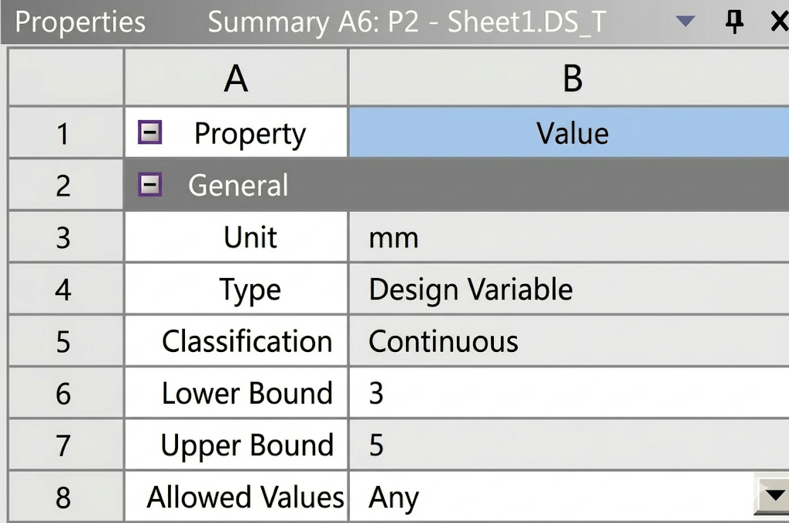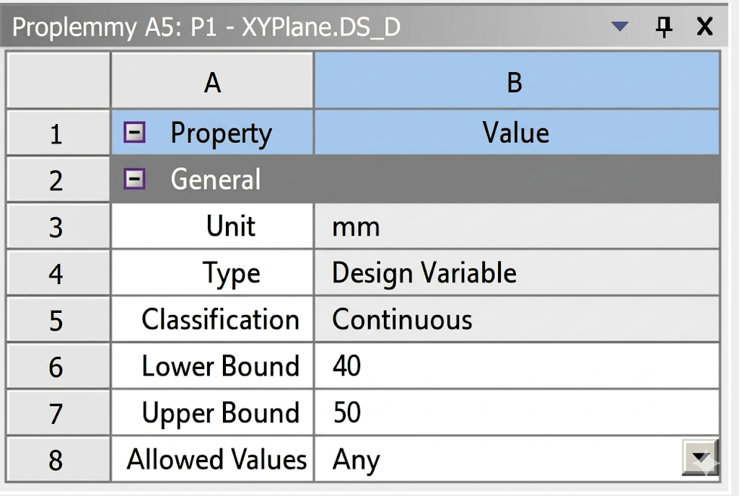

Fig. 1. Input geometric parameter design variables

In terms of constraint conditions, the maximum equivalent stress constraint was strictly set to be ≤ 230 MPa, and the maximum structural deformation constraint was set to be ≤ 5 mm. The specific boundary conditions applied to the finite element model are depicted in Fig. 2.

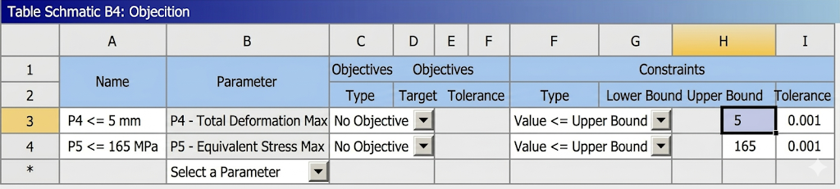

Fig. 2. Boundary conditions for the optimization design

To construct the highly accurate response surface surrogate model, a Central Composite Design (CCD) approach was utilized. CCD is a highly efficient fractional factorial design that contains an imbedded factorial or fractional factorial design with center points, augmented with a group of 'star' points that allow for the precise mathematical estimation of curvature (second-order terms) in the response surface. This makes CCD significantly more accurate for complex mechanical behavior modeling than simple linear screening designs.

Once the response surface was successfully mathematically constructed, the Multi-Objective Genetic Algorithm (MOGA) was deployed. MOGA is an advanced, biologically-inspired evolutionary algorithm that relies on bio-inspired operators such as mutation, crossover, and selection to generate high-quality solutions to optimization and search problems. Unlike single-objective optimization algorithms that yield a single optimal solution, MOGA simultaneously optimizes multiple conflicting objectives (e.g., minimizing mass while simultaneously minimizing stress), ultimately generating a set of mathematically optimal solutions known as the Pareto optimal front. To ensure sufficient genetic diversity in the computational population and to completely prevent the algorithm from converging prematurely into inferior local optima, the MOGA operational parameters were rigorously configured with an exceptionally large initial sample size of 10,000 individuals and a maximum allowable iterative generation count of 20, providing a highly thorough and exhaustive search of the designated design space.

3. RESULTS AND DISCUSSION

3.1 Initial Static Analysis Results

Upon successfully applying the mathematically specified boundary constraints and extreme working loads, the ANSYS solver computed the complex mechanical response of the initial structural design. The resulting color-coded equivalent stress distribution contours and total physical deformation profiles were meticulously and systematically analyzed.

As explicitly shown in the contour plot of Fig. 3, the maximum equivalent stress of the entire spiral sorting device is unequivocally and primarily concentrated at the highly constrained root of the spiral blades, specifically where the helical blade is welded to the central cylindrical shaft. The solver reported a precise peak stress value of 126.46 MPa. From a theoretical solid mechanics perspective, this finding is exceptionally logical. The continuous spiral blade essentially functions as a complex, continuous cantilever beam wrapped around a cylinder. When subjected to the massive, uniform surface thrust of the concrete mixture, the maximum bending moment, and consequently the highest tensile and compressive stresses, naturally accumulate at the fixed foundation—the root. It is highly encouraging that this calculated peak stress of 126.46 MPa is significantly lower than the strictly defined allowable safe stress of 230 MPa. This substantial margin confirms beyond any reasonable doubt that the initial empirical structural strength is more than adequate to endure the standard operational conditions.

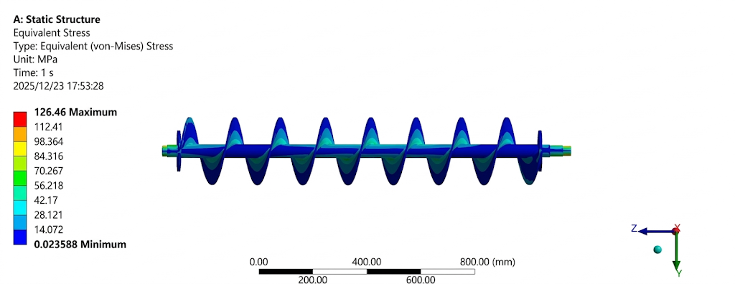

Fig. 3. Equivalent stress distribution diagram of the spiral blades

Furthermore, according to the visual representation in Fig. 4, the maximum total physical deformation of the entire mechanical structure is a mere 1.2891 mm. As predicted by fundamental cantilever mechanics, this maximum deflection occurs at the outermost, unconstrained free tip of the spiral blade, furthest away from the central supporting shaft. When viewed in relation to the overall macroscopic dimensions of the heavy-duty spiral device (which spans over a meter in length), a maximum deformation of just over one millimeter is practically negligible. This minor deflection indicates that the structural rigidity of the original design easily and comfortably satisfies the strict engineering design specifications ^{[3, 4]}, ensuring that the spinning blades will not physically contact or scrape against the surrounding concrete containment trough during heavy load operations.
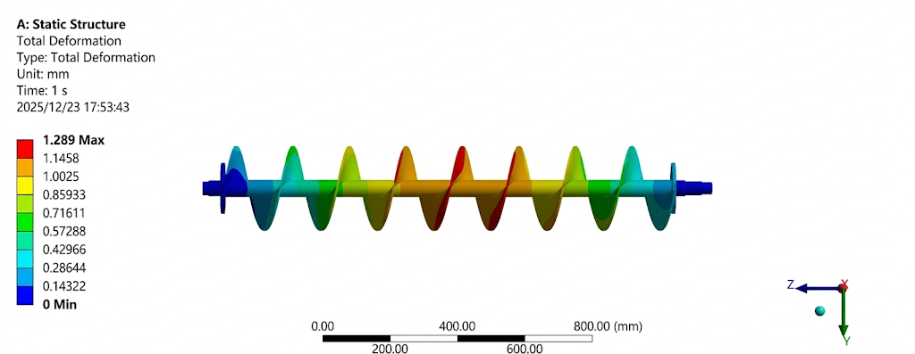

Fig. 4. Total deformation diagram of the spiral blade

3.2 Sensitivity and Response Surface Analysis

Through the successful execution and subsequent solver evaluation of the 9 specific groups of experimental design points systematically formulated by the CCD methodology, a wealth of data was generated. The comprehensive sensitivity analysis results, mathematically quantifying the degree of impact each independent design variable exerts on the output responses, were successfully obtained, calculated, and summarized in Table 1.

Table 1. Design point distribution map

variable | Diameter of helical shaft  (mm) | Thickness of spiral blade  (mm) | Mass  (kg) | Maximum variable  (mm) | Maximum stress  (MPa)
1 | 45 | 4 | 23.056 | 2.1435 | 164
2 | 40 | 4 | 19.785 | 3.2334 | 220.5
3 | 50 | 4 | 26.713 | 1.4991 | 136.03
4 | 45 | 3 | 21.318 | 2.5895 | 207.32
5 | 45 | 5 | 24.786 | 1.9824 | 162.22
6 | 40 | 3 | 18.017 | 3.7254 | 238.96
7 | 50 | 3 | 25.007 | 1.9137 | 197.36
8 | 40 | 5 | 21.547 | 3.0402 | 217.13
9 | 50 | 5 | 28.411 | 1.2891 | 126.46

The normalized sensitivity analysis chart, visually presented in Fig. 5, clearly and definitively reveals the underlying mechanical dynamics and physical relationships between the geometric inputs and structural outputs. Both the spiral shaft diameter and the blade thickness exhibit a highly positive mathematical sensitivity towards the total mass of the device. However, a critical observation is that the calculated weighting of the shaft diameter's impact is significantly and noticeably greater than that of the blade thickness. Because the volume of a solid cylinder increases with the square of its radius, minor changes in the thick central shaft add or subtract steel volume much faster than changes to the thin, helical ribbon of the blade. This profoundly important mathematical insight conclusively indicates that deliberately reducing the shaft diameter is the primary, most direct, and most effective engineering pathway to achieving the desired lightweight design goal.

Conversely, both geometric parameters demonstrate a pronounced and highly negative mathematical sensitivity toward total deformation and peak stress. This simply means that increasing the amount of steel mathematically decreases bending and yielding risks. Crucially, the data marks the central spiral shaft as the absolute dominant load-bearing component regarding global stiffness; its diameter overwhelmingly dictates how much the entire assembly bends. Meanwhile, the blade thickness plays a vital, localized role in managing the stress concentration directly at the weld roots.

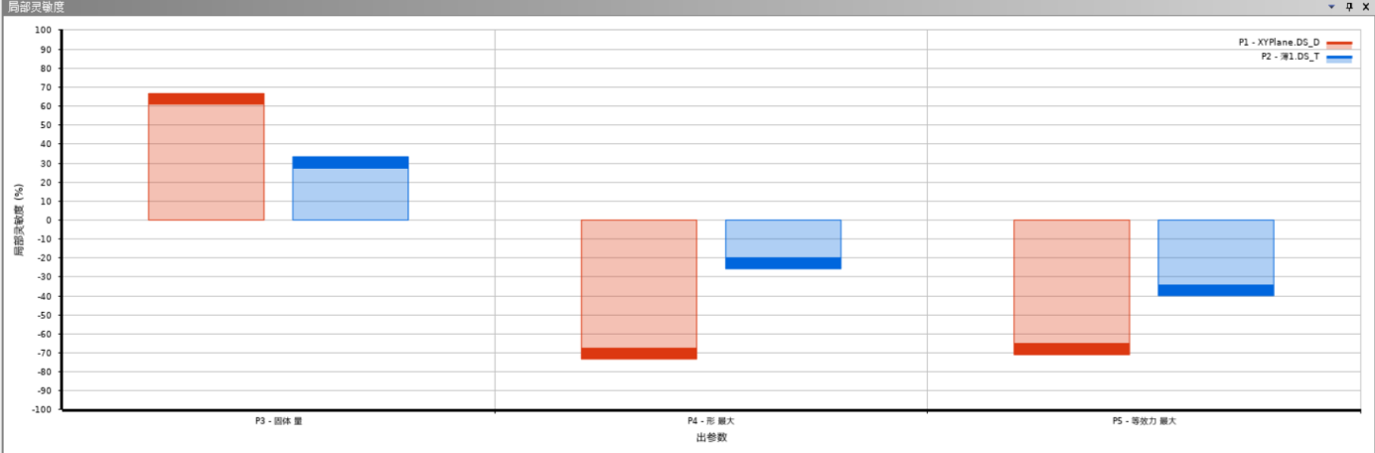

Fig. 5. Sensitivity Analysis of the Spiral Feeding Device

The beautifully generated 3D response surface mathematical models (shown in Fig. 6) further visually uncover the complex, often non-linear mathematical relationships existing seamlessly between the geometric design variables and the defined objective functions. The total mass response surface predictably displays a perfectly smooth, highly linear growth characteristic. In stark contrast, the maximum total deformation surface exhibits a clear, highly non-linear, monotonically decreasing trend ^{[5]}, visually proving that as the shaft gets thinner, the rate at which the structure loses stiffness accelerates rapidly, a critical phenomenon that the optimization algorithm must carefully navigate.

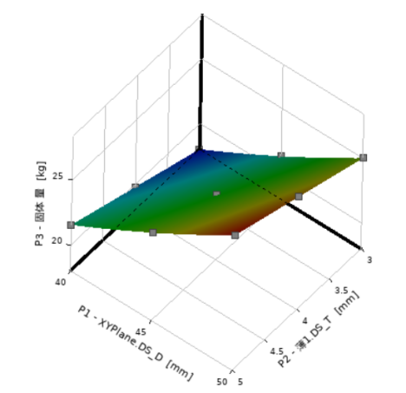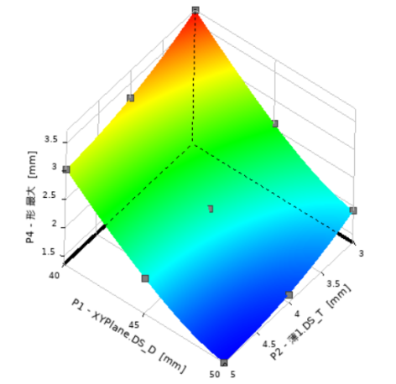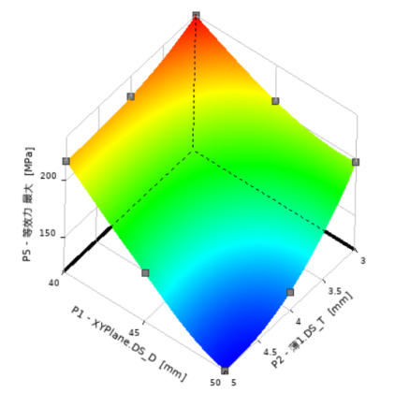

Fig. 6. 3D response surface diagrams

3.3 Multi-Objective Optimization Results and Comparison

Using the MOGA algorithm to search for the global optimum within the predefined constraints, the ANSYS optimization module outputted three sets of candidate solutions, which are listed in Table 2.

Table 2. Candidate samples output by MOGA

Candidate point | Diameter of helical shaft  (mm) | Thickness of spiral blade  (mm) | Mass (kg) | Maximum variable  (mm) | Maximum stress  (MPa)
1 | 44.538 | 4.6392 | 23.846 | 2.0969 | 164.82
2 | 44.848 | 4.1548 | 23.219 | 2.1306 | 164.63
3 | 45.513 | 3.8921 | 23.226 | 2.0837 | 163.87

Upon careful engineering review of these mathematically optimal points, the first candidate point was selected as the superior baseline. However, to facilitate practical, highly cost-effective manufacturing and seamless real-world mechanical machining (as machine shops prefer standard integer dimensions rather than dimensions with multiple decimal places), the raw mathematical optimization results from the best candidate were purposefully subjected to strict engineering rounding. Following this crucial practical step, the final, practically determined design parameters were officially locked in as: Spiral shaft diameter precisely at 44 mm, and a uniform blade thickness precisely at 4 mm.

To guarantee the absolute validity of these rounded figures, the primary CAD geometric model was completely updated with the new optimized parameters, and a final, highly rigorous verification static analysis was independently performed. The resulting, newly calculated deformation and stress distribution contours for the final optimized design are vividly illustrated in Fig. 7 and Fig. 8.
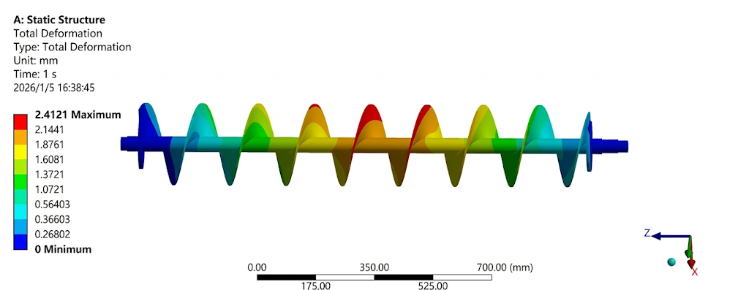

Fig. 7. Optimized Spiral Feeding Device Deformation Diagram

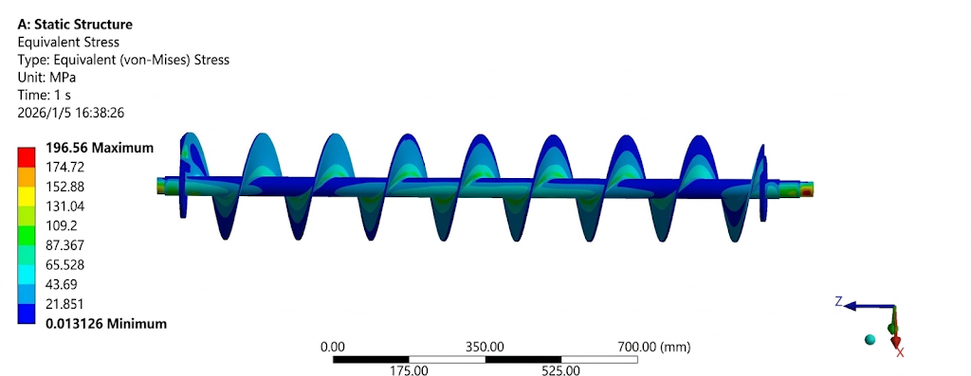

Fig. 8. Optimized Equivalent Stress Distribution Diagram

As comprehensively and comparatively demonstrated in the data presented in Table 3, the original, highly conservative initial state possessed a bulky mass of 28.411 kg. Following the rigorous MOGA optimization and practical rounding procedures, the total mass was remarkably and successfully reduced to a highly efficient 23.056 kg, representing a highly significant weight savings of nearly 19%. As expected from reducing the amount of load-bearing material, the maximum operational stress predictably increased to 196.56 MPa, and the maximum structural deformation correspondingly increased to 2.4121 mm. However, the most critical engineering achievement is that both of these elevated mechanical values remain strictly, safely, and comfortably within the rigid allowable safety ranges defined at the outset of the study (230 MPa and 5 mm, respectively).

Table 3. Comparison of parameters before and after optimization

 | Mass(kg) | Maximum stress(MPa) | Maximum deformation(mm)
Before optimization | 28.411 | 126.46 | 1.2891
After optimization | 23.056 | 196.56 | 2.4121

This comprehensive analytical validation absolutely confirms that the multi-objective optimization design methodology deployed in this study is highly accurate, incredibly successful, and definitively achieves a far superior, elegant engineering balance between modern lightweight construction principles and absolute mechanical reliability.

4. CONCLUSION

IIn this highly detailed and mathematically rigorous study, a systematic static finite element analysis and an advanced multi-objective optimization design protocol were successfully conducted on the highly critical spiral sorting device of a specialized coal mine roadway concrete paver. The main, scientifically validated conclusions of this research are comprehensively summarized as follows:

- Under the mathematically simulated extreme working conditions of a 15000 N uniform surface load and a 573 N·m continuous driving torque, the initial conservative design exhibited a maximum equivalent stress of 126.46 MPa and a maximum deformation of 1.2891 mm. These findings successfully validated the fundamental baseline structural safety and operational viability of the device under complex, severe underground loading scenarios.

2.The rigorous mathematical sensitivity analysis definitively demonstrated that systematically reducing the central shaft diameter represents the primary, most highly effective means to achieve a global lightweight design. Concurrently, it was proven that the thickness of the helical blade crucially and locally governs the severe stress concentration phenomenon located explicitly at the internal weld roots.

3.The final optimized parameters (shaft diameter of 44 mm and blade thickness of 4 mm) successfully reduced the total mass from 28.411 kg to 23.056 kg, while strictly ensuring structural constraints (stress ≤ 230 MPa, deformation ≤ 5 mm) were met, substantially improving economic efficiency.

COMPETING INTERESTS DISCLAIMER:
Authors have declared that they have no known competing financial interests OR non-financial interests OR personal relationships that could have appeared to influence the work reported in this paper.

References

- Yuan J. Development achievements of coal energy in the "14th Five-Year Plan" and prospects for the "15th Five-Year Plan". Natural Resource Economics of China. 2025;38(4):53-60.

[2] Zhao L. Multi-objective optimization design of shearer spiral drum based on genetic algorithm. China Mechanical Engineering. 2018;29(5):591-596.

[3] Wang P, Liem NV, Zhang J. Experimental research and optimal control of vibration screed system (VSS) based on fuzzy control. Journal of Vibroengineering. 2020;22(6):1361-1376.

[4] Jia J, Liu H, Wan Y. Dynamic characteristics modelling of the tamper-asphalt mixture interaction: application to predict asphalt mat density. International Journal of Pavement Engineering. 2019;20(5):530-543.

[5] Sun J, Xu G, Wang X. Dynamics Analysis and Improvement of Screed based on Computer Simulation. Journal of Multimedia. 2013;8(5):548-556.

[6] Li Y, Liu Z, Liu Z. Research on design method of working quality parameters of paver. Construction Mechanization. 2014;35(8):81-83.

[7] Zhu Q. Improvement of working parameters and structural design of paver spiral distributor. Construction Mechanization. 2007;(3):27-29.

[8] Zeng Q. Structural design and optimization of vibrating manipulator [Dissertation]. Xi'an: Chang'an University; 2023.

[9] Montgomery DC. Design and analysis of experiments. 8th ed. Hoboken: John Wiley & Sons; 2012.

[10] Moaveni S. Finite element analysis theory and application with ANSYS. 4th ed. Pearson Education; 2014.

