Review Article
Research on the Application of Epoxy Resin in the Field of Foundation, Curing and Corrosion

.
ABSTRACT

Epoxy resin, a globally prevalent organic material, accounts for 81% of total sales in coatings, composite materials, and construction sectors. Its exceptional corrosion resistance makes it the preferred choice for buildings, ships, and automobiles. This paper systematically analyzes the performance characteristics and influencing factors of various epoxy resins, while documenting current modification techniques. It details how different modifiers enhance resin properties, summarizes curing types and mechanisms, and provides a comprehensive review of curing structures. The study concludes with research on epoxy resin applications in construction, shipbuilding, and automotive industries. A review was conducted.

Keywords: Epoxy resin; coating applications

- INTRODUCTION

Epoxy resin, a globally ubiquitous organic material, holds a leading position in thermosetting materials due to its multifunctional properties. It exhibits outstanding mechanical strength, chemical resistance, high-temperature stability, and corrosion resistance [1], enabling extensive applications in coatings, composite materials, construction, electronics, adhesives, and power systems [2–4]. The epoxy ring structure, formed by two carbon atoms and one oxygen atom, constitutes the epoxy group. Compounds containing this three-membered ring are collectively termed epoxy-based materials. Depending on the synthetic substances used, epoxy resins can be classified into various types. Epoxy resins are synthesized through various methods, including bisphenol-based, phenolic, cycloaliphatic, aliphatic, glycidylamine, and glycidyl ester types. Each epoxy resin type exhibits distinct properties, influenced by factors such as molecular weight, epoxy group quantity, and main chain structure. However, due to their poor toughness, fatigue resistance, and impact resistance [5], these resins require post-treatment before application [6]. Depending on the modifiers used, they are categorized into organic [7], nanomaterials [8,9], fiber materials [10], elastomer toughening [11], and halogenated [1] 2] halogen-free composites [13], thermoplastic polymer composites [14], and bio-based materials [15]. To meet current demands for composite applications, research focuses on epoxy resin materials with high thermal conductivity [16], waterproofing [17], flame retardancy [18], and corrosion resistance [19]. As a non-solid material, epoxy resin requires curing treatment in practical applications. The cross-linking between curing agents and resin forms a stable structure with excellent mechanical properties [20].
Epoxy resins account for 81% of the total epoxy resin usage in coatings, composite materials, and construction applications [21] (Figure 1). This paper provides a comprehensive overview of epoxy resin types, analyzes how various factors influence their properties, and details their synthesis and modification methods. The study examines how different chemical structures affect application mechanisms and curing processes. It also introduces practical applications of epoxy resins in coatings, composite materials, and construction, offering a thorough analysis of their operational mechanisms.
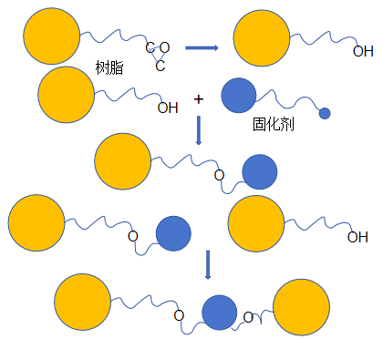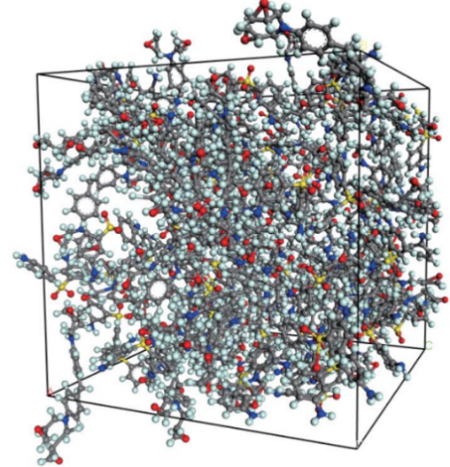
Fig.1 & Fig.2 Initial structure before curing reaction .in this system ，the matrix resins and curing agcnts arc randomly packcd in a 3D pcriodic ccll.[20]

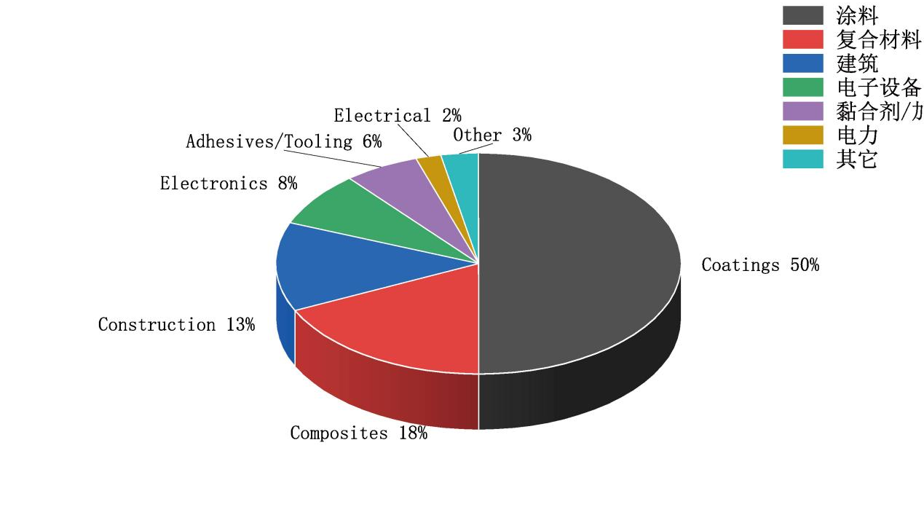
Fig.3 Statistical Analysis of Epoxy Resin Consumption Demand in Various Fields

Epoxy resin base
  - ​Properties of Epoxy Resin

Epoxy resins are classified into several types based on their synthetic materials, including bisphenol epoxy resins, hydrogenated bisphenol A epoxy resins, phenolic epoxy resins, cycloaliphatic epoxy resins, aliphatic epoxy resins, glycidylamine epoxy resins, and glycidyl ester epoxy resins. Among these, bisphenol A epoxy resins and phenolic epoxy resins are the most commonly used. As shown in Table 1, phenolic epoxy resins are high-molecular-weight organic compounds with multiple benzene rings and epoxy groups. Through process modifications, composite functional epoxy resins and halogenated epoxy resins have also been developed [22]. The unique properties of these epoxy resins are determined by their specific compositions. Bisphenol epoxy resins are synthesized from bisphenol compounds and epichlorohydrin. Propane-reacted bisphenol A exhibits excellent mechanical properties, while bisphenol F demonstrates superior chemical resistance. Phenolic epoxy resins containing formaldehyde and phenol products are more heat-resistant but more brittle [23,24]. Table 2 lists application-oriented composite resins, including nanomaterial composites [25], organo-inorganic composite modified multifunctional epoxy resins [26], halogen flame-retardant modified epoxy resins, halogen-free flame-retardant epoxy resins [27,28], aromatic epoxy resins, and aliphatic epoxy resins [29].

Table 1 : Types of Phenolic Epoxy Resins and their structural Formula
Epoxy resin type name | abbreviation | molecular structural formula
Bisphenol A-type epoxy resin | DGEBA | 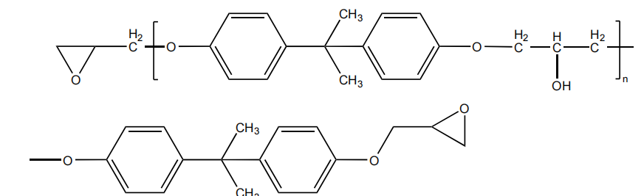
Bisphenol F-type epoxy resin | DGEBF | 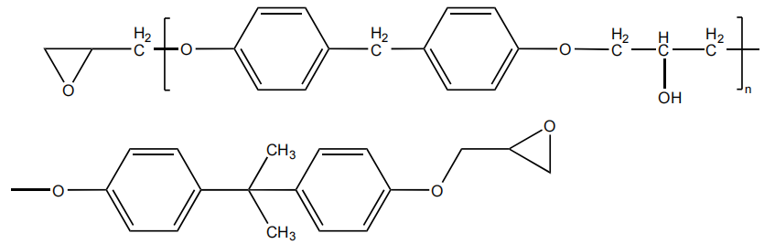
Hydrogenated Bisphenol A Epoxy Resin | HBPAE | 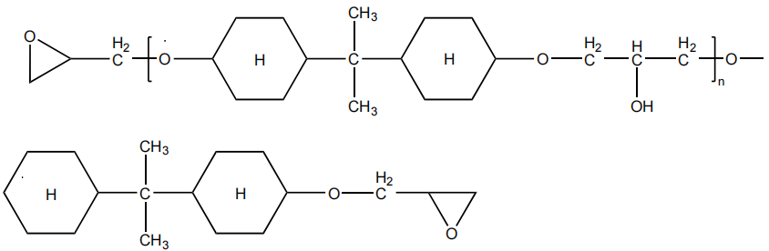
novolac epoxy | PER | 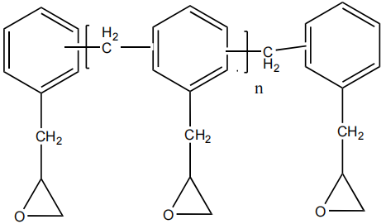
cycloaliphatic epoxy | CER | 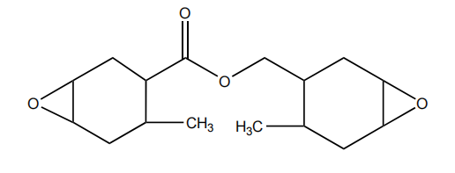
aliphatic epoxy resin | AER | 
Glycidyl amine epoxy resin | GAER | 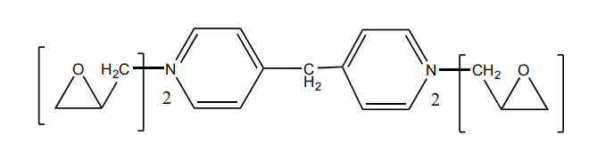
Glycidyl ester epoxy resin | GEER | 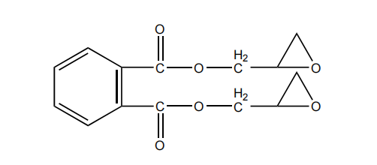
type of epoxy resin | attribute | 参考文献
bisphenol epoxy resin | It contains two hydroxyl groups (-OH) and two benzene rings connected by a methylene bridge, appearing as a white crystalline powder or granules with chemical resistance, heat resistance, reactivity, and electrical insulation properties. | ^{[23,24]}
cycloaliphatic epoxy resin | It contains one or more cyclic structures and is a transparent or pale yellow liquid or low-melting-point solid with low viscosity, easy processability, chemical resistance, weather resistance, heat resistance, electrical insulation, and mechanical properties. | ^{[30}
novolac epoxy resin | It contains structural units of phenolic resin and epoxy groups, presenting as a transparent or pale yellow liquid or solid with high viscosity, chemical resistance, heat resistance, weather resistance, electrical insulation properties, and mechanical performance. | ^{[23,24]}
multifunctional composite epoxy resin | The overall heat resistance, chemical resistance, mechanical properties, flexibility, conductivity, thermal conductivity and electrical insulation of ER were improved by combining silicone, rubber, nanomaterials, heterocyclic compounds and multifunctional monomers. | ^{[26]}
halogen epoxy resin | The introduction of halogen groups (F, Cl, Br) adjacent to or on the epoxy backbone of the resin yields transparent or pale yellow liquids/solids, significantly enhancing flame retardancy, chemical resistance, heat resistance, electrical insulation, and mechanical properties. | ^{[22]}
Table 2. Types of Phenolic Epoxy Resins and their attributes

2.2 Factors Affecting the Properties of Epoxy Resin
The performance of epoxy resins is influenced by multiple factors, including resin type, molecular weight, epoxy group quantity, preparation method, and curing agent [30]. Notably, the resin preparation method and curing agent selection directly determine the main chain structure. Table 3 details these effects. Elham's study employed N,N' -bis(4-(4-aminophenoxyl)phenyl)phthalic diamine (DIDA) to cure bisphenol A diethylene glycol ester (BDEGE) and polyethylene glycol (PEGDGE). Experimental results demonstrated that as PEGDGE was progressively added to the resin mixture, the hydroxyl branching and molecular weight of the composite resin increased. The flexibility of the resulting product is significantly enhanced. [31] Garima et al. investigated epoxy resins with varying concentrations of carboxyterminal butadiene-acrylonitrile (CTBN). As the epoxy group concentration decreased, the tensile strength of the cured material declined. Their team attributed this to insufficient chemical bonding between the epoxy groups and rubber fillers during curing due to reduced epoxy group quantity, leading to a decrease in overall tensile strength. [32] Liuzhongguo et al. developed a trifluoromethyl side-chain epoxy resin using polypropylene glycol diether (D230), methylene diamine (DDM), and phthalic anhydride (P A) The team conducted experimental data analysis on four curing agents, including A and 2-methylimidazole (2MI), and concluded that all cured resins exhibited high thermal stability, excellent low hygroscopicity, and certain hydrophobicity. Notably, DDM curing demonstrated a higher glass transition temperature (Tg), while PA curing achieved the highest contact angle of 105.5°. [33]
Sun et al.[11] effectively improved the dispersibility and compatibility of gas-phase silica in organic systems through advanced technologies such as organofluorine modification.
The modified material retained its original reinforcing and thickening properties while acquiring new characteristics such as hydrophobicity, oleophobicity, stain resistance, and self-cleaning, thereby broadening its application range in high-end manufacturing.
Polymer grafting modification involves grafting polymer chains (e.g., polyethylene glycol, polystyrene) onto surfaces to form core-shell structures, enhancing interfacial bonding with organic matrices.
Cabot prepared gas separation membranes with a 153% increase in gas flux and a separation coefficient of 30.77 through polyether block amide grafting modification.
Functional groups can be customized to meet specific application needs.

Factors Affecting the Properties of Epoxy Resin | influence mechanism | specific impact performance | References
LMN | Short molecular chains result in weak intermolecular forces; the presence of high-density epoxy groups enhances reactivity. | low viscosity, high reactivity, low mechanical properties, good flexibility and impact resistance, poor heat resistance, average chemical resistance | ^{[31]}
high molecular | The long molecular chain and strong intermolecular forces, coupled with the low density of epoxy groups, reduce the number of reactive sites and consequently lower the reactivity. | high viscosity, low reactivity, high mechanical properties, good rigidity and durability, excellent heat resistance, and superior chemical resistance | ^{[31]}
Number of epoxy groups | Epoxy resins contain more epoxy groups and reaction sites, which enhances their reactivity. However, the limited number of epoxy groups and reaction sites in epoxy resins weakens their reactivity. | Reactivity, mechanical properties, heat resistance | ^{[32]}
main chain structure | Different main chain structures, such as benzene rings, cyclic structures, and long-chain alkanes, confer their respective properties. | The benzene ring exhibits high rigidity and heat resistance, but may be brittle. The cyclic structure demonstrates excellent flexibility and weather resistance, though its heat resistance is slightly inferior to that of long-chain alkanes. It possesses good flexibility and weather resistance, but exhibits lower heat resistance and mechanical properties. | ^{[29,33]}
main chain structure | The modifier is combined with epoxy resin through physical blending and chemical copolymerization, thereby imparting corresponding properties to the epoxy resin. | The silicone groups improve the heat resistance, weather resistance and flexibility of the epoxy resin, the rubber particles improve the impact toughness and crack resistance of the epoxy resin, the nanoparticles improve the mechanical properties, electrical conductivity and thermal conductivity of the epoxy resin, and the heterocyclic compounds improve the heat resistance and chemical resistance of the epoxy resin. | ^{[31–35]}
table 3: Factors influencing the properties of Epoxy Resin

2.3 Modification of Epoxy Resin

Epoxy resin modification is required in applications due to its properties such as toughness, flammability, chemical resistance, mechanical properties, and electrical conductivity. The materials involved include organic materials, nanomaterials, fiber materials, elastomer toughening, halogens, and thermoplastic polymer composites. Table 4

Most organic modifications can enhance the flexibility and mechanical properties of epoxy resins. Phitsanulok synthesized a cycloepoxy polycyanopropylmethylsiloxane (PCPMS)-copolydimethylsiloxane (PDMS) and tested the data of different ratios of silane and phenolic resin through nuclear magnetic resonance (NMR), Fourier transform infrared (FTIR), and differential scanning calorimetry (DSC). The glass transition temperature (Tg) of the polysiloxane ranged from 118 to 68°C. By adjusting the ratio of organic silicon in the epoxy resin, PCPMS, and PDMS, its maximum toughness strength was achieved at 1.11 MPa·m⁻⁰.⁵. 35] Yuan Wang et al. designed and synthesized a vinyl bifunctional epoxy resin, which showed a 391% increase in tensile strength, a 78% increase in elongation at break, and a 292% increase in shear strength according to mechanical test data. [34]

Nanomaterial modification can effectively enhance the mechanical and thermal conductivity properties of epoxy resins. Yinke Kang et al. prepared coatings by dispersing hydrophilic silica nanoparticles coated with epoxy in epoxy resin. The friction coefficient of the coatings with different epoxy-to-nano-SiO2 ratios was measured using a surface profile analyzer. When the ratio reached 8:1, the friction coefficient was minimized to 0.05, whereas the friction coefficient of the resin alone ranged from 0.35 to 0.47. Tianjin300072 developed hybrid epoxy resins with nanoparticles and tested the microalumina (AO) using a TC3010 hot pan thermal analyzer. The thermal conductivity of the composite coatings (AN, AO/AN/GE, AO (micron alumina), AN (aluminum urate), CNT (graphene)) was 0.46,0.54,0.57, and 0.55 W/(m·K) respectively. When AO was added to the epoxy resin alone, its thermal conductivity increased by 130% compared to pure resin. [36]

Fiber materials can enhance the thermal and mechanical properties of epoxy resins. T. Niranjana et al. prepared polypropylene fiber epoxy resin composites and investigated the optimal first-stage decomposition temperature of 3758°C and complete decomposition temperature of 6008°C through thermogravimetric analysis when polypropylene fibers were incorporated at 10wt%. At this temperature, the activation energy (E) reached 101.84 Kj/mol, with a first-stage Rmax (maximum weight loss rate) of 5.12wt%/min. The second-stage E was 127.83 Kj/mol, and the Rmax was 4.96wt%/mol. [37] Nagara Jan et al. investigated the mechanical properties and epoxy composite interface strength of alkali-treated Cocos Nucifera Var Aurantiaca Peduncle (CNVAP) fibers. When the CNVAP content was 30wt%, the composite material exhibited optimal overall performance, with a tensile strength of 57 MPa and a tensile modulus of up to 480 MPa. The flexural strength was 130 MPa, and the flexural modulus was 5.3 GPa. [38]

There are multiple methods for toughness enhancement and modification. Elastoplastic materials such as organic hyperbranched or rubber can significantly improve the toughness of epoxy resin. A bio-based hyperbranched toughening agent, carboxylic acid-functionalized tannic acid (CATA), was prepared by Hangzhou 311300 in Zhejiang. When the resin contains 1 wt% CATA, its comprehensive performance reaches the optimal level, with tensile strength of 48 MPa, modulus of 1050 MPa, and impact strength of 16 kJ/m². DSC (differential scanning calorimetry) and TGA (thermogravimetric analysis) measurements revealed a Tp (thermal peak) of 153.7°C and T(50%) (50% thermal weight loss) of 456.6°C. [39]

In the field of epoxy resin flame retardant modification, two main approaches exist: environmentally friendly halogen-free formulations and high-efficiency halogen-based modifications. Zhang et al. developed DOPO (9,10-dihydro-9-oxo-10-phenanthro-10-oxide) loaded flame-retardant epoxy resin (Eps). The combustion parameters of DOPO-loaded Eps were as follows: TTI (ignition time) 54 seconds, p-HRR (peak heat release rate) 686 kW/m², THR (total heat release rate) 96 MJ/m², TSR (total smoke release rate) 4675 m², and SEA (specific extinguishing area) 1111 m²/kg. All these values showed significant improvement compared to pure resin. [40] Jin et al. prepared fluorinated epoxy resin (FEP) blended with tetrafunctional epoxy resin (TGDDM). The increase in fluorine content reduced the total surface energy. When the fluorine content reached 80 wt%, the composite exhibited optimal overall performance, with an initial decomposition temperature (IDT) of 303°C, a maximum degradation rate temperature (Tmax) of 418°C, and a decomposition activation energy (Ed) of 140 kJ/mol. [41]

Thermoplastic modification of epoxy resin not only enhances its temperature resistance but also improves mechanical properties and electrical insulation. Ma et al. developed a novel damping composite using polyester-based polyurethane/epoxy resin and functional particles. TGA and DMA (Dynamic Mechanical Analysis) tests revealed that the effective damping temperature increased from 43.9°C to 132.6°C after PU addition, with the damping peak value rising from 0.75 to 1.44. [42] Abeer et al. investigated the mechanical properties and dielectric constant of epoxy resin composites with varying PVC (polyvinyl chloride) content. Experimental data showed that adding 6g PVC to 20g epoxy resin... The邵氏硬度 reaches 75D, compressive strength is 68MPa, Young's modulus is 0.15MPa, total elongation reaches 300%, dielectric constant is 1.0, and dielectric loss is 0.05-0.12. [43]

Modification method | material | function | References
organic modification | Silicone, phosphides (e.g. PDMS), aminosilanes, vinyltrimethoxysilanes, DHPDOPO, phosphotriamides | Flexibility, mechanical properties, electrical insulation, weather resistance, heat resistance | ^{[7,31]} ^{[32]} ^{[34,35]}
nanomaterial modification | nano-ZnO，nano-TiO2，nano-SiO2，CNTs，Graphene | strong mechanical properties, excellent thermal conductivity, corrosion resistance, electrical insulation | ^{[8,36]}
fiber modification | glass fiber, carbon fiber, aramid fiber, nanofiber, composite fiber | strong mechanical properties, heat resistance, weather resistance | ^{[10,37]} ^{[38]}
toughening modification | rubber particles, core-shell particles, liquid crystal polymers, block copolymers, hyperbranched polymers | high toughness, impact resistance, wear resistance | ^{[11,39]}
Halogenated, halogen-free modified | Fluorides, bromides, nitrates, phosphates | high flame retardancy, chemical resistance, mechanical properties, adhesion, electrical insulation, heat resistance | ^{[12]} ^{[13,40]} ^{[41]}
Thermoplastic Polymer Composite Modification | PE,PP,PVC,PS,PA,PC,PET,PMMA,PU,POM,PEEK | high toughness, impact resistance, heat resistance, chemical resistance, electrical insulation | ^{[14,42]} ^{[43]}
table 4. Epoxy Resin Modification Method
3. Curing of Epoxy Resin

3.1 Plasma Treatment

Epoxy resins, owing to their inherently stable chemical structure, typically require curing agents and accelerators during the curing process to ensure proper curing [44]. Different curing agents necessitate distinct conditions and reactions, resulting in epoxy resins with varying performance advantages. Commonly used curing agents include amine-based, anhydride-based, phenolic resin-based, and aliphatic amine-based types. The chemical bonding between epoxy resins and curing agents through amine groups, anhydride groups, and aromatic groups synthesizes organic structures with diverse properties [45]. five

Zhou et al. investigated the thermal analysis of degradation-curing for epoxy resin cured with methyl anhydride (MNA) and 2-ethyl-4-methylimidazole accelerator. Through DMTA and DSC-TGA tests, the epoxy resin cured with anhydride groups under accelerator synergistic effects exhibited a glass transition temperature (Tg) of 224°C, with decomposition heat release peaks at 191°C and 360°C, and a degradation onset temperature of 324°C, demonstrating thermal stability of the epoxy resin system. [46] Fatemeh et al. utilized diaminodiphenylmethane (DDM, an aromatic amine) and diethylenetriamine (DETA, a fatty amine) to cure epoxy resin, with the number of activated hydrogen in the amine group calculated. The cured resin was bonded with epoxy resin groups, and the Tg of the cured resin was 179°C obtained by DSC and TGA experiments. Analysis showed that the aromatic components in the curing agent exhibited excellent thermal stability. [47]

3.2 cured resin structure

Epoxy resin curing is broadly categorized into anhydride curing and amine curing [48]. Anhydride curing involves the reaction of anhydride with epoxy groups, which cleaves the epoxy ring to generate hydroxyl and carboxyl groups. These carboxyl groups then react with newly formed epoxy groups to form ether bonds, repeating this process to create a three-dimensional cross-linked structure. Amine curing, on the other hand, involves the opening of the epoxy ring by amino groups, producing hydroxyl and secondary amines. These secondary amines subsequently react with another epoxy group to form cross-linked structures, with the process repeating to build a three-dimensional cross-linked structure. Table 5 presents the structural formula flow of common epoxy resin curing agents.
type of curing agent

Amine curing agents: These are among the most commonly used curing agents, including aliphatic amines, aromatic amines, and modified amines. Amine curing agents can undergo ring-opening addition reactions with epoxy groups to form a three-dimensional network structure, thereby curing the resin. The characteristics of amine curing agents include rapid curing speed, but they may cause skin irritation.

Anhydride curing agents: Curing is achieved through the formation of ester bonds via reaction with epoxy groups. These curing agents exhibit higher curing temperatures and typically require heating to complete the reaction. However, the cured materials possess excellent chemical resistance and mechanical properties.

Phenolic resin: When used as a curing agent, it provides excellent heat resistance and mechanical properties, but the curing rate is relatively slow, typically requiring heating.

Isocyanate: Although not the most commonly used curing agent for epoxy resins, isocyanate can serve as a curing agent in certain specialized applications, such as two-component polyurethane-epoxy systems, providing excellent mechanical properties and chemical resistance.

condition of cure

Temperature: Most epoxy resin curing reactions are exothermic. An increase in temperature can accelerate the reaction rate and shorten the curing time. However, excessively high temperatures may lead to degradation of material properties or the formation of bubbles.

Humidity: Certain amine curing agents are sensitive to humidity. Excessive humidity may impair curing efficiency and even degrade material performance.

Catalyst: In certain cases, a catalyst may be added to accelerate the curing process. The selection of the catalyst depends on the type of curing agent used and the required curing conditions.
curing process
Pre-mixing stage: Mix epoxy resin and curing agent uniformly in a specified ratio. Inadequate mixing may lead to localized poor curing.
Gel phase: The mixture begins to thicken, gradually losing its fluidity and forming a gel-like substance.
Hardening stage: The gel undergoes further cross-linking to form a solid polymer material. This stage requires a certain duration, with the specific time depending on factors such as the type of curing agent, temperature, and catalyst.
Post-curing: To further enhance the material's properties, post-curing treatment is sometimes required, which involves heating at higher temperatures for a period to ensure more complete cross-linking.
apply
The cured epoxy resin exhibits outstanding mechanical properties, chemical resistance, heat resistance, and electrical insulation performance, making it widely applicable across various fields, including but not limited to:
Composite materials: As matrix resin, combined with fiber reinforced materials, high-performance composite materials are prepared.
Electronic packaging: Used to encapsulate electronic components, providing protection and insulation.
Adhesive: Exhibits excellent bonding performance and is suitable for bonding various substrates.

Types of curing agents | Schematic diagram of curing mechanism | References
acid anhydride | 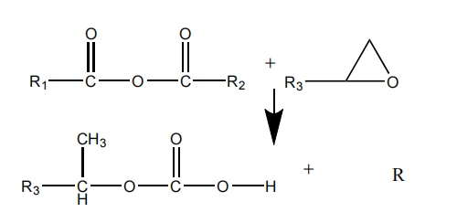 | ^{[48,49]}
amine | 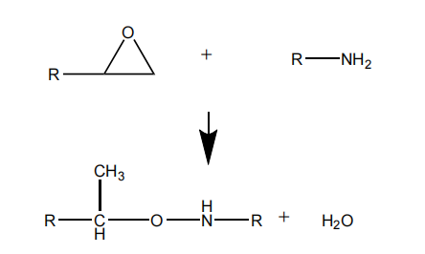 | ^{[50,51]}
aliphatic amine | 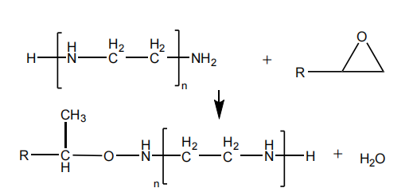 | ^{[47,52]}
aromatic amine | 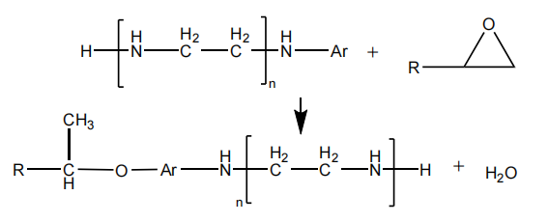 | ^{[47,52,53]}
anhydride amine | 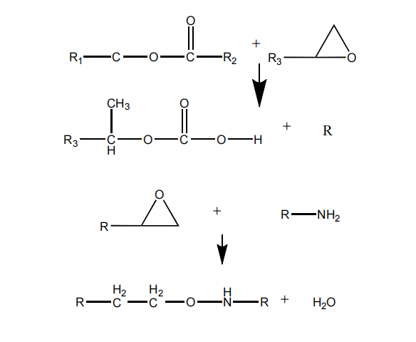 | ^{[46,54]} ^{[33]}

Table 5. Types of Curing agents and their mechanism diagram

4 Application of Epoxy Resin

The global application and consumption of epoxy resin have been continuously growing. According to surveys, the Asia-Pacific region accounted for 44.9% of the global market value in 2014. Until 2020, the consumption of waterborne epoxy resin in the Asia-Pacific region remained dominant, with China being the primary market in the region. From 2016 to 2022, the annual growth rate of the epoxy resin market, based on global market information statistics, was 6%, and the epoxy resin market reached $9 billion in 2021. China's epoxy resin production capacity accounted for approximately 45% of the global total, while its consumption accounted for about 50% of the global total. The market consumption of epoxy resin is mainly in coatings, electronic equipment, power, and construction. Composite materials and adhesives are widely used across various applications. As shown in Table 6, epoxy resin accounts for approximately 50% of the anticorrosive applications in the coatings industry.

Epoxy resins demonstrate exceptional corrosion resistance, particularly on metal surfaces. S. et al. evaluated their anti-corrosion performance on galvanized steel plates using EIS (electrochemical impedance spectroscopy). Through breakpoint frequency analysis, experimental impedance measurements, coating capacitance data, and pore resistance analysis, they concluded that epoxy resin coatings exhibit outstanding anti-corrosion effects on galvanized steel. The pore resistance reaches its minimum at a coating thickness of 100μm, with the breakpoint frequency increasing over time to 4Hz after 2000 hours of exposure. The experimental impedance measurements showed the most significant fluctuations at 0Hz (4Ω) within the first 2 hours of testing. At 31 hours and 0 Hz, the impedance of thicker epoxy resin (200 μm and 500 μm) remained stable with minimal fluctuation over the corrosion duration, while that of thinner epoxy resin showed significant variations. [55]

3.1 Architecture

The construction industry faces widespread corrosion challenges, particularly in bridge steel frames, maritime infrastructure, and high-rise metal components. Epoxy resin is extensively utilized in structural repair and reinforcement, waterproofing materials, adhesives, and thermal insulation applications. [56] Typical applications include interior walls, flooring, kitchens, bathrooms, basements, roofs, and reinforced concrete structures.

Li et al. conducted a comprehensive study on the application of epoxy resin in architectural floor coatings. Among these, waterborne epoxy wear-resistant coatings, solvent-free epoxy self-leveling coatings, and epoxy anti-static floor fillers are the most widely used. As application scenarios become increasingly complex and diverse, selecting appropriate raw materials and optimizing formulation design are key to addressing challenges. [57]

L. et al. developed an epoxy resin that effectively repairs surface defects in Portland cement concrete pavements, bonding the hardened concrete surfaces together. [58]

3.2 Ships

The same epoxy resin is applied in the field of ship research, coating the surface of the bottom and deck, and manufacturing the hull and deck, propeller, rudder, etc., so as to provide high mechanical properties and seawater corrosion resistance for the ship application.

Joseph et al. investigated a modified tantalum carbide (TaC) composite graphene oxide (GO) epoxy resin coating. EIS analysis revealed that this composite material exhibits a strong adhesion of 15.8 MPa and a high hydrophobic angle of 168°. Resistivity measurements showed that after 960 hours of seawater immersion (800 KΩcm², 640 KΩcm⁴), the resistivity fluctuation was minimal compared to the initial value (800 KΩcm², 800 KΩcm⁴) [59,60][59].

3.3 Automobiles

Epoxy resin is widely used in the automotive industry due to its excellent corrosion resistance, chemical resistance, and high adhesion. Applications include surface painting and repainting of vehicles, as well as manufacturing body components such as engine covers, doors, and bumpers, and interior parts like instrument panels and seat frames.

Sushmit et al. investigated a cathodic electrodeposition (CED) epoxy resin coating and conducted a performance summary study, which found that CED coatings can significantly reduce the emission of organic compounds while enhancing the anticorrosive performance of the coating. [60]

4. Conclusions and Perspectives

The global market share of epoxy resin materials continues to grow annually, with their exceptional corrosion resistance accounting for over 90% of applications in construction, coatings, electronics, and adhesives. This article provides a comprehensive overview of epoxy resin's global demand, covering its fundamental properties, curing processes, and practical applications. As a high-performance composite material, epoxy resin achieves outstanding performance across diverse fields through specialized composites. Further research could focus on modifying and curing processes for epoxy resin, particularly in corrosion-resistant and high-temperature applications. The ongoing study of epoxy resin materials remains a promising area for technological advancement. It is still a hot topic.

COMPETING INTERESTS

Author has declared that no competing interests exist.

COMPETING INTERESTS DISCLAIMER:
Authors have declared that they have no known competing financial interests OR non-financial interests OR personal relationships that could have appeared to influence the work reported in this paper.

REFERENCES

1 CAPRICHO J C, FOX B, HAMEED N. Multifunctionality in Epoxy Resins[J/OL]. Polymer Reviews, 2020, 60(1): 1-41.
2 DALLAEV R, PISARENKO T, PAPEŽ N, 等. A Brief Overview on Epoxies in Electronics: Properties, Applications, and Modifications[J/OL]. Polymers, 2023, 15(19): 3964.
3 RAHMAN Md M, AKHTARUL ISLAM M. Application of epoxy resins in building materials: progress and prospects[J/OL]. Polymer Bulletin, 2022, 79(3): 1949-1975.
4 JOJIBABU P, ZHANG Y X, PRUSTY B G. A review of research advances in epoxy-based nanocomposites as adhesive materials[J/OL]. International Journal of Adhesion and Adhesives, 2020, 96: 102454.
5 ZHOU H R, LI H X, YU W M. Preparation and Properties of Polysiloxane Modified Epoxy Encapsulating Material[J/OL]. Advanced Materials Research, 2014, 1021: 3-6. DOI:10.4028/www.scientific.net/AMR.1021.3.
6 PALUVAI N R, MOHANTY S, NAYAK S K. Synthesis and Modifications of Epoxy Resins and Their Composites: A Review[J].
7 HUANG W, ZHANG Y, YU Y, 等. Studies on UV‐stable silicone–epoxy resins[J/OL]. Journal of Applied Polymer Science, 2007, 104(6): 3954-3959.
8 S S K, M M V, K M B, 等. Review on Recent Advancements in the Field of Reinforced Epoxy Nano Composits[J/OL]. International Journal of Trend in Scientific Research and Development, 2018, Volume-2(Issue-6): 570-574.
9 ZAGHLOUL M M Y, ZAGHLOUL M M Y, FUSEINI M. Recent progress in Epoxy Nanocomposites: Corrosion, structural, flame retardancy and applications — A comprehensive review[J/OL]. Polymers for Advanced Technologies, 2023, 34(11): 3438-3472. 10 MATYKIEWICZ D, BARCZEWSKI M, KNAPSKI D, 等. Hybrid effects of basalt fibers and basalt powder on thermomechanical properties of epoxy composites[J/OL]. Composites Part B: Engineering, 2017, 125: 157-164.
11 doi:10.1016/j.polymertesting.2004.09.010[J].
12 ZHI M, YANG X, FAN R, 等. A comprehensive review of reactive flame-retardant epoxy resin: fundamentals, recent developments, and perspectives[J/OL]. Polymer Degradation and Stability, 2022, 201: 109976.
13 MAUERER O. New reactive, halogen-free flame retardant system for epoxy resins[J/OL]. Polymer Degradation and Stability, 2005, 88(1): 70-73. 14 GUO L Y, WANG L Y, SU X. Research Progress of New Methods for Toughening Epoxy Resin[J/OL]. Advanced Materials Research, 2012, 490-495: 3598-3602.
15 RAMON E, SGUAZZO C, MOREIRA P M G P. A Review of Recent Research on Bio-Based Epoxy Systems for Engineering Applications and Potentialities in the Aviation Sector[J/OL]. Aerospace, 2018, 5(4): 110.
16 RUAN K, ZHONG X, SHI X, 等. Liquid crystal epoxy resins with high intrinsic thermal conductivities and their composites: A mini-review[J/OL]. Materials Today Physics, 2021, 20: 100456.
17 LIU B T, ZHU G Y, DING P J. The Research Progress of Epoxy Resin Coating in Building Waterproof[J/OL]. Advanced Materials Research, 2013, 671-674: 1779-1782. DOI:10.4028/www.scientific.net/AMR.671-674.1779.
18 LEVCHIK S, PIOTROWSKI A, WEIL E, 等. New developments in flame retardancy of epoxy resins[J/OL]. Polymer Degradation and Stability, 2005, 88(1): 57-62.
19 KAUSAR A. Performance of corrosion protective epoxy blend-based nanocomposite coatings: a review[J/OL]. Polymer-Plastics Technology and Materials, 2020, 59(6): 658-673.
20 OKABE T, OYA Y, TANABE K, 等. Molecular dynamics simulation of crosslinked epoxy resins: Curing and mechanical properties[J/OL]. European Polymer Journal, 2016, 80: 78-88.
21 MI X, LIANG N, XU H, 等. Toughness and its mechanisms in epoxy resins[J/OL]. Progress in Materials Science, 2022, 130: 100977.
22 ANWAR S, LI X. A review of high-quality epoxy resins for corrosion-resistant applications[J/OL]. Journal of Coatings Technology and Research, 2024[2024-09-30]. https://link.springer.com/10.1007/s11998-023-00865-5.
23 BAIG M M A, SAMAD M A. Epoxy\Epoxy Composite\Epoxy Hybrid Composite Coatings for Tribological Applications—A Review[J/OL]. Polymers, 2021, 13(2): 179.
24 BOBBY S, SAMAD M A. Enhancement of tribological performance of epoxy bulk composites and composite coatings using micro/nano fillers: a review: Epoxy Bulk Composites and Composite Coatings Tribology: A Review[J/OL]. Polymers for Advanced Technologies, 2017, 28(6): 633-644.
25 SINGH N P, GUPTA V K, SINGH A P. Graphene and carbon nanotube reinforced epoxy nanocomposites: A review[J/OL]. Polymer, 2019, 180: 121724.
26 PALUVAI N R, MOHANTY S, NAYAK S K. Synthesis and Modifications of Epoxy Resins and Their Composites: A Review[J/OL]. Polymer-Plastics Technology and Engineering, 2014, 53(16): 1723-1758.
27 ZHI M, YANG X, FAN R, 等. A comprehensive review of reactive flame-retardant epoxy resin: fundamentals, recent developments, and perspectives[J/OL]. Polymer Degradation and Stability, 2022, 201: 109976.
28 LIU Q, WANG D, LI Z, 等. Recent Developments in the Flame-Retardant System of Epoxy Resin[J/OL]. Materials, 2020, 13(9): 2145.
29 SANKAR LAL S, SEKAR K. Recent Advances in Bio-Based Sustainable Aliphatic and Aromatic Epoxy Resins for Composite Applications[J/OL]. Key Engineering Materials, 2021, 882: 121-131.
30 李泽宇. Research Progress on Synthesis, Modification and Application of Epoxy Resin[J/OL]. Material Sciences, 2024, 14(08): 1159-1168.
31 ELHAM NAEEMIKHAH, HOSSEIN BEHNIAFAR. Silica Loaded Binary Epoxy Resins Cured by an Imide–Amine Hardener Suitable for Preparing Transparent and Flexible Coatings[J/OL]. Polymer Science, Series B, 2023, 65(2): 151-159.
32 TRIPATHI G, SRIVASTAVA D. Effect of carboxyl-terminated poly(butadiene-co-acrylonitrile) (CTBN) concentration on thermal and mechanical properties of binary blends of diglycidyl ether of bisphenol-A (DGEBA) epoxy resin[J/OL]. Materials Science and Engineering: A, 2007, 443(1-2): 262-269.
33 LIU Z. Synthesis and properties of an epoxy resin containing trifluoromethyl side chains and its cross-linking networks with different curing agents[J].
34 WANG Y, WU H, CHEN Z, 等. Silicone-epoxy block hybrid network to achieve high-performance and transparent polydimethylsiloxane materials[J/OL]. Reactive and Functional Polymers, 2020, 150: 104537.
35 RUTNAKORNPITUK M. Modification of epoxy–novolac resins with polysiloxane containing nitrile functional groups: synthesis and characterization[J/OL]. European Polymer Journal, 2005, 41(5): 1043-1052.
36 GAO Z, ZHAO L. Effect of nano-fillers on the thermal conductivity of epoxy composites with micro-Al2O3 particles[J/OL]. Materials & Design (1980-2015), 2015, 66: 176-182.
37 PRABHU T N, HEMALATHA Y J, HARISH V, 等. Thermal degradation of epoxy resin reinforced with polypropylene fibers[J/OL]. Journal of Applied Polymer Science, 2007, 104(1): 500-503.
38 NAGARAJAN K J, BALAJI A N, RAMANUJAM N R, 等. Preparation and characterization of alkali treated cocos nucifera var aurantiaca peduncle fibers reinforced epoxy composites[J/OL]. Materials Research Express, 2019, 6(12): 125310.
39 XU J, YANG J, WANG H, 等. Bio-Based Hyperbranched Toughener From Tannic Acid and Its Enhanced Solvent-Free Epoxy Resin with High Performance[J/OL]. Journal of Renewable Materials, 2019, 7(12): 1333-1346.
40 ZHANG W, LI X, FAN H, 等. Study on mechanism of phosphorus–silicon synergistic flame retardancy on epoxy resins[J/OL]. Polymer Degradation and Stability, 2012, 97(11): 2241-2248.
41 JIN F L, KIM H Y, PARK S J. Effect of fluorine functional groups on surface and mechanical interfacial properties of epoxy resins[J/OL]. Journal of Fluorine Chemistry, 2007, 128(3): 184-189.42 MA C, CHEN E F, SUN T, 等. Properties and Morphology of Damping Composite Consisting of Polyester-Type Polyurethane/Epoxy Resin[J/OL]. Advanced Materials Research, 2011, 295-297: 747-750.
43 ABD A. Studying the mechanical and electrical properties of epoxy with PVC and calcium carbonate filler[J/OL]. International Journal of Engineering & Technology, 2014, 3(4): 545.
44 WANG H M, ZHANG Y C, ZHU L R, 等. Curing behavior and kinetics of epoxy resins cured with liquid crystalline curing agent[J/OL]. Journal of Thermal Analysis and Calorimetry, 2012, 107(3): 1205-1211.
45 LIU T, SHAO L, ZHAO B, 等. Progress in Chemical Recycling of Carbon Fiber Reinforced Epoxy Composites[J/OL]. Macromolecular Rapid Communications, 2022, 43(23): 2200538.
46 ZHOU Z W, YU M M, BAI R C, 等. Thermal Analysis of a Novel Tetrafunctional Epoxy Resin Cured with Anhydride[J/OL]. Polymers and Polymer Composites, 2014, 22(1): 45-50.
47 FERDOSIAN F, YUAN Z, ANDERSON M, 等. Sustainable lignin-based epoxy resins cured with aromatic and aliphatic amine curing agents: Curing kinetics and thermal properties[J/OL]. Thermochimica Acta, 2015, 618: 48-55.
48 LIU J, LIU X, CHEN B, 等. High-performance naphthalene epoxy resins cured by catalyst for packaging materials[J/OL]. Materials Today Communications, 2022, 33: 104483.
49 ROCKS J, GEORGE G A, VOHWINKEL F. Curing kinetics and thermomechanical behaviour of co‐anhydride cured aminoglycidyl epoxy resins[J/OL]. Polymer International, 2003, 52(11): 1758-1766.
50 AMANOKURA N, KANEKO M, SAHARA T, 等. Curing Behavior of Epoxy Resin Initiated by Amine-Containing Inclusion Complexes[J/OL]. Polymer Journal, 2007, 39(8): 845-852.
51 BLANCO M, LÓPEZ M, FERNÁNDEZ R, 等. Thermoplastic-modified epoxy resins cured with different functionalities amine mixtures. Kinetics and miscibility study[J/OL]. Journal of Thermal Analysis and Calorimetry, 2009, 97(3): 969-978.
52 WAN J, LI C, BU Z Y, 等. A comparative study of epoxy resin cured with a linear diamine and a branched polyamine[J/OL]. Chemical Engineering Journal, 2012, 188: 160-172.
53 MENG F, ZHENG S, LIU T. Epoxy resin containing poly(ethylene oxide)-block-poly(ɛ-caprolactone) diblock copolymer: Effect of curing agents on nanostructures[J/OL]. Polymer, 2006, 47(21): 7590-7600.
54 JAIN R, KUKREJA P, NARULA A K, 等. Studies of the curing kinetics and thermal stability of epoxy resins using a mixture of amines and anhydrides[J/OL]. Journal of Applied Polymer Science, 2006, 100(5): 3919-3925.
55 GONZÁLEZ S, GIL M A, HERNÁNDEZ J O, 等. Resistance to corrosion of galvanized steel covered with an epoxy-polyamide primer coating[J/OL]. Progress in Organic Coatings, 2001, 41(1-3): 167-170.
56 SPEE T, VAN DUIVENBOODEN C, TERWOERT J. Epoxy Resins in the Construction Industry[J/OL]. Annals of the New York Academy of Sciences, 2006, 1076(1): 429-438.
57黎新初. 环氧树脂及其在建筑地坪涂料中的应用[J/OL]. 建筑设计与研究, 2023, 4(8): 52-54.
58 DAVIS W L, ASCE A, PINKSTAFF E, 等. Epoxy Resin for Structural Repair of Concrete Pavement[J].
59 RAJ XAVIER J, RAMESH B. A study on the effect of multifunctional tantalum carbide nanofillers incorporated graphene oxide structure in the epoxy resin for the applications in the shipbuilding industry[J/OL]. Materials Science and Engineering: B, 2023, 289: 116234.
60 SEN S, CHATTERJEE A, RAMAKANTH D, 等. Recent advances in cathodic electrodeposition coatings with special reference to resin materials: A comprehensive review[J/OL]. Progress in Organic Coatings, 2024, 190: 108387.

