Trend Analysis and Change Point Detection of Temperature and Relative Humidity Patterns in Owerri, Imo State, South-Eastern Nigeria (1992-2022)

ABSTRACT
The aim of this study is to analyse the trend and detection point of change for annual temperature and relative humidity in Owerri, Nigeria. 31-year (1992-2022) meteorological data of daily temperature and relative humidity were obtained from the Nigerian Meteorological Agency. Mann-Kendall trend tests, Sen's slope estimator, CUSUM and Sequential Mann-Kendall change point detection methods were applied to annual maximum and minimum temperatures and annual relative humidity. Results showed weak positive trends in maximum temperature (Kendall's tau = 0.118, p = 0.386) and relative humidity (Kendall's tau = 0.172, p = 0.184), with weak negative trends in minimum temperature (Kendall's tau = -0.095, p = 0.489), all non-significant. Change point analysis identified a significant shift in maximum temperature around 2020-2022 (CUSUM value = 7, exceeding critical threshold of 6.79), while minimum temperature and relative humidity showed no significant change points. Owerri exhibited the most stable temperature regime among South-Eastern Nigerian cities studied, with lower variability reflecting coastal maritime influence. These findings suggest relative climate stability but with potential recent acceleration in maximum temperature requiring continued monitoring.
Keywords: Temperature, trends, Change point detection, Mann-Kendall test, CUSUM analysis, Climate stability, Owerri, Imo State

1 INTRODUCTION
Climate change affects different regions with varying intensities and patterns of manifestation. While global temperature increases are well-documented (IPCC, 2021; Morice et al., 2021), regional responses exhibit substantial spatial heterogeneity (Olali et al., 2025). Different cities across Nigeria may experience different climate change trajectories due to variations in atmospheric moisture and different land-ocean interaction patterns. Understanding location-specific temperature trends is essential for developing appropriate adaptation strategies tailored to local conditions.
Owerri as the capital of Imo State in South-Eastern Nigeria, represents a coastal-influenced urban centre experiencing rapid development. The city's proximity to the Atlantic Ocean (approximately 80 km) provides maritime climate moderation that may buffer against temperature extremes (Onyenechere et al., 2018). However, urbanization processes including vegetation removal, impervious surface expansion, and anthropogenic heat generation counteract this moderating influence. The interplay between maritime moderation and urban development creates unique temperature dynamics requiring detailed analysis. Oguntunde et al. (2012) documented spatial and temporal temperature trends across Nigeria, finding varying patterns with some regions showing significant warming while others remained stable.
Climate systems may undergo both gradual trends and abrupt change points, representing relatively sudden transitions from one climatic state to another (Pacalal et al., 2004). These change points represent critical moments when temperature regimes fundamentally alter, potentially reflecting threshold responses or tipping point crossings. Detecting such change points is essential for understanding temporal evolution of climate patterns and for attribution to specific mechanisms (Patakamuri, 2022).
This study aims to comprehensively analyse temperature trends and change points in Owerri using robust statistical methods. Specific objectives include detecting monotonic trends using Mann-Kendall tests (Nwaogazie, 2021), quantifying trend magnitudes with Sen's slope estimator, identifying change points through CUSUM and Sequential Mann-Kendall methods, and comparing Owerri's temperature evolution with other South-Eastern Nigerian cities. The findings will inform climate adaptation planning and provide baseline information for this important coastal urban centre.
Two objectives observed in this study are as follow:
- Analyse the variations and trends in temperature and relative humidity data distribution for Owerri from 1992 to 2022 using statistical techniques; and
- Detection of change point(s) in temperature and relative humidity data distribution in Owerri for the study period.

2 MATERIALS AND METHODS

2.1 Study Area
The map of Owerri showing the meteorological stations is presented in Figure 1. Owerri is located at approximately 5.48°N latitude and 7.03°E longitude in South-Eastern Nigeria. The city occupies low-lying terrain with elevations generally below 100 meters above sea level. This coastal-proximal position (approximately 80 km from the Atlantic Ocean) provides strong maritime climate influence, resulting in consistently high relative humidity and moderated temperature regimes.
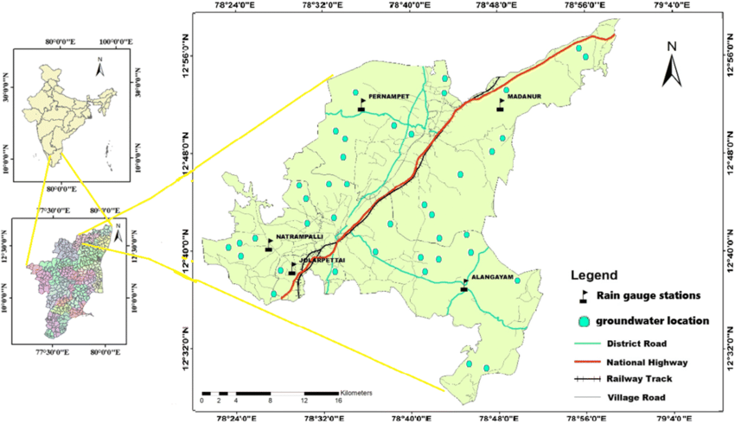
Figure 1: Location Rain Gauge Stations in Owerri
Source: Govindaraji et al., 2021
The city experiences humid tropical climate with exceptionally high relative humidity year-round, typically exceeding 80% during wet seasons. Annual rainfall exceeds 2,500 mm, among the highest in the region, with precipitation occurring throughout the year though concentrated between March and November. Population growth has accelerated in recent decades, with current estimates exceeding 500,000 residents, driving substantial urban expansion and land use changes.

2.2 Data Collection
Temperature and Relative humidity data were obtained from the Nigerian Meteorological Agency (NIMET) meteorological station in Owerri from January 1, 1992 to December 31, 2022 (31 years). Daily maximum, minimum temperatures and relative humidity were recorded using standard instruments housed in Stevenson screens at 1.2 meters height. From daily observations, annual maximum, minimum temperatures and relative humidity parameters were extracted. Comprehensive quality control procedures ensured data reliability, with completeness exceeding 98% across the years.

2.3 Data Analysis
Descriptive statistical analysis methods were employed in analysing the temperature and relative humidity data distributions. The Mann-Kendall test, Sen’s slope and Cumulative Sum (CUSUM) statistical methods were employed in this study. Autocorrelation functions assessed temporal dependencies. The Mann-Kendall test detects a trend while the Sen’s slope estimator quantifies the magnitude of the trend. The CUSUM and Sequential Mann-Kendall methods identify change point(s) in the data distribution.

3 RESULTS AND DISCUSSION
3.1 RESULTS
3.1.1 Annual Temperature and Relative Humidity Distribution in Owerri
Table 1 presents the descriptive statistics of climatic variables being considered in this study for Owerri.
Table 1: Descriptive Statistics of Climate Variables
Parameter | Mean | Std Dev | Min | Max | CV (%) | Skewness | Remark
Annual Maximum Temperature (°C) | 37.60 | 1.09 | 36.00 | 40.00 | 2.89 | 0.44 | Approximately Normal
Annual Minimum Temperature (°C) | 26.35 | 1.02 | 24.10 | 28.30 | 3.86 | -0.41 | Approximately Normal
Relative Humidity (%) | 96.10 | 1.89 | 91.50 | 99.00 | 1.96 | -0.53 | Approximately Normal
Note: CV = Coefficient of Variance.

A mean of 37.60°C, 26.35°C and 96.10% were observed for annual maximum and minimum temperatures and annual relative humidity respectively. Also, a standard deviation of 1.09°C, 1.02°C and 1.89% were observed for annual maximum and minimum temperatures and annual relative humidity respectively.
3.1.2 Trend Analysis in Data Distribution
Autocorrelation analysis was carried out before the detection of trend using Mann-Kendall, and the results are illustrated in Figures 2 and 3. The autocorrelation analysis demonstrated the temporal dependencies of the annual temperature (maximum and minimum) and annual relative humidity time series for Owerri.

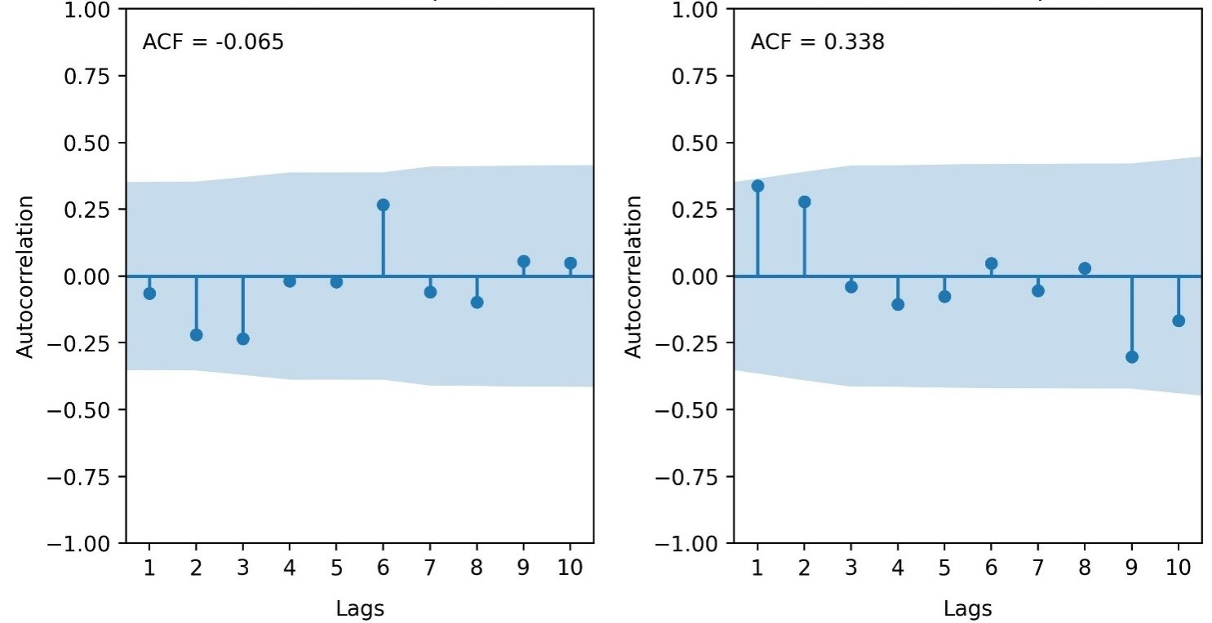
Figure 2: ACF for Annual Maximum and Minimum Temperature for Owerri

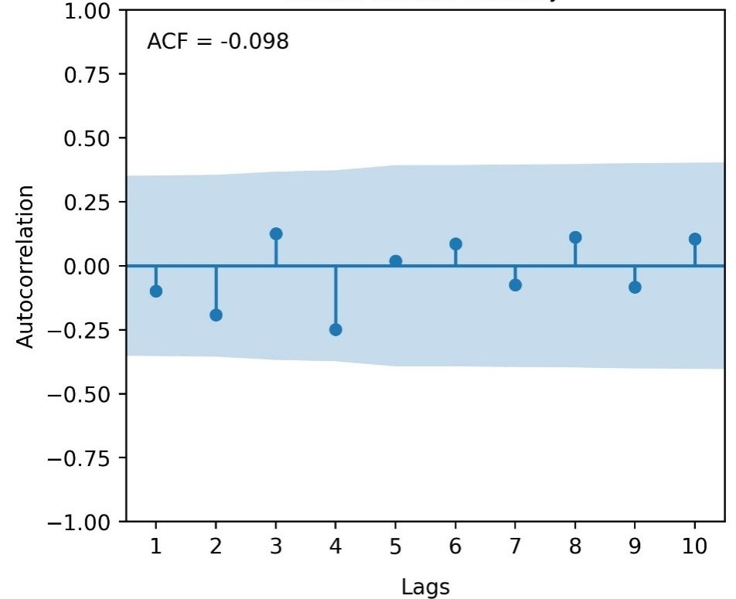
Figure 3: ACF for Annual Relative Humidity for Owerri
The Mann-Kendall trend test results for Owerri are illustrated in Table 2.
The results presented Kendall’s Tau values of 0.118, -0.095 and 0.172 for annual maximum, minimum and annual relative humidity respectively. Also, p-values of 0.386, 0.489 and 0.184 were obtained for annual maximum, minimum and annual relative humidity respectively. Finally, Sen’s slope of +0.015, -0.011 and +0.026 unit/year were obtained for annual maximum, minimum and annual relative humidity respectively.
Table 2: Mann-Kendall Trend Test Results for Owerri
Parameter | Kendall's Tau | p-value | Sen's Slope (unit/year)
Annual Maximum Temp | 0.118 | 0.386 | +0.015
Annual Minimum Temp | -0.095 | 0.489 | -0.011
Relative Humidity | 0.172 | 0.184 | +0.026
Note: Significant at α = 0.05
3.1.3 Change Point Detection
CUSUM analysis of change point detection for annual maximum, minimum and relative humidity for Owerri is presented in Table 3.
Table 3: CUSUM Statistic for Trend Change Detection for Owerri
Climate Variable | Maximum CUSUM Value | CL @ 90% | CL @ 95% | CL @ 99% | Change Point Year | Remark
Annual Maximum Temperature | 7 | 6.7927 | 7.5722 | 9.0755 | 2022 | Significant change point
Annual Minimum Temperature | 6 | 6.7927 | 7.5722 | 9.0755 | 2010 | No significant change point
Annual Relative Humidity | 6 | 6.7927 | 7.5722 | 9.0755 | 2004, 2005 | No significant change point
Note. CV = Critical Value. Sample size (n) = 31. Critical values calculated using: CV = k × √n, where k = 1.22 (90%), 1.36 (95%), 1.63 (99%). Decision rule: If Maximum |DF-CUSUM| > Critical Value, there is a significant change point at that confidence level.

A maximum CUSUM value of 7, 6 and 6 were derived for annual maximum, minimum temperatures and annual relative humidity respectively.
The CUSUM and Sequential Mann-Kendall plots for annual maximum temperature are illustrated in Figures 4 and 5.
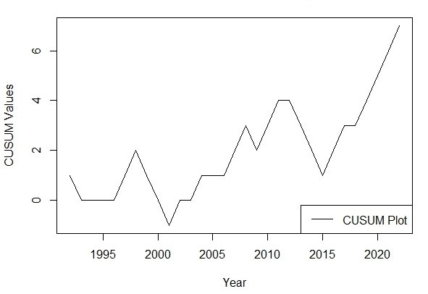
Figure 4: CUSUM change point plot for Annual Maximum temperature for Owerri

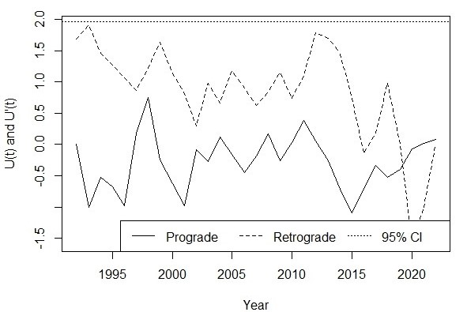
Figure 5: Sequential Mann Kendall change point plot for Annual Maximum temperature for Owerri

The CUSUM and Sequential Mann-Kendall plots for annual minimum temperature are illustrated in Figures 6 and 7.
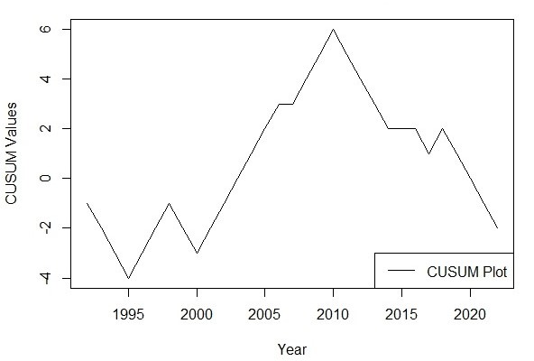
Figure 6: CUSUM change point plot for Annual Minimum Temperature for Owerri
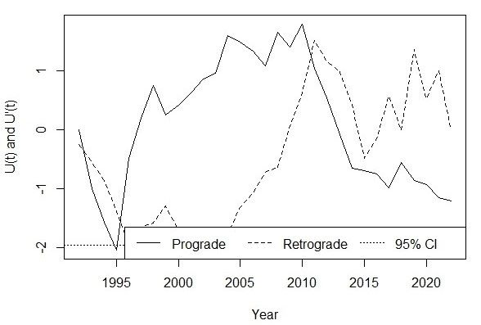
Figure 7: Sequential Mann Kendall change point plot for Annual Minimum Temperature for Owerri

The CUSUM and Sequential Mann-Kendall plots for annual relative humidity are illustrated in Figures 8 and 9.

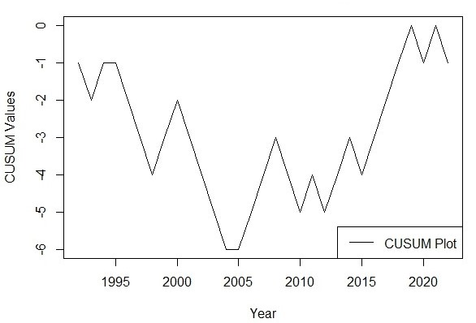
Figure 8: CUSUM change point plot for Annual Relative Humidity for Owerri
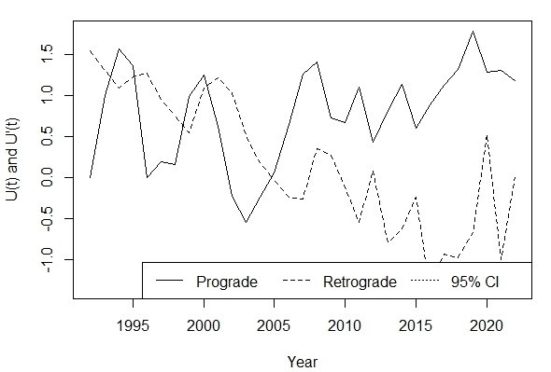
Figure 9: Sequential Mann Kendall change point plot for Annual Relative Humidity for Owerri.

3.2 DISCUSSION
3.2.1 Annual Temperature and Relative Humidity Distribution in Owerri
Descriptive analysis revealed Owerri's temperature and relative humidity characteristics from 1992 to 2022 as presented on Table 1. Annual maximum temperature ranged from 36.00 to 40.00°C with mean value of 37.60°C, standard deviation of 1.09°C (CV = 2.89%) skewness of +0.44. This means that the distribution is skewed to the right. Annual minimum temperature ranged from 24.1 to 28.3°C with mean value of 26.35°C, standard deviation of 1.02°C (CV = 3.86%) skewness of -0.41. In effect, the distribution is skewed to the left. Annual relative humidity ranged from 91.50 to 99.00% as the minimum and maximum values respectively with mean value of 96.10% and standard deviation of 1.89% (CV = 1.96%).
3.2.2 Trend Analysis in Data Distribution
The Autocorrelation analysis in Figures 2 and 3, demonstrated no significant serial correlation for any temperature parameter. Lag-1 ACF values were 0.098 (maximum temperature), -0.134 (minimum temperature), and 0.067 (relative humidity), all well within 95% confidence level (±0.352). The absence of autocorrelation permitted direct Mann-Kendall testing without pre-whitening correction.
No temperature trends reached statistical significance. Weak positive trends in maximum temperature and relative humidity suggest possible gradual increase, while weak negative minimum temperature trends indicate slight cooling tendency. However, all p-values substantially exceeded 0.05, indicating non-significant trends.
Mann-Kendall trend test results are presented in Table 2. For annual maximum temperature, the test yielded no significant trend (Kendall's tau = 0.118, p-value = 0.386). For annual minimum temperature, the Mann-Kendall test produced a negative trend that was not significant (Kendall's tau = -0.095, p-value = 0.489). Annual relative humidity exhibited no significant trend (Kendall's tau = 0.172, p-value = 0.184). No parameter (annual maximum, minimum and relative humidity) under this study was significant.
The Sen's slope indicated that maximum temperature increases by 0.015°C per year, minimum temperature decreases by 0.011°C per year, and relative humidity increases by 0.026% per year. Since no parameter under this study was significant, the Sen’s slope for all parameters are not taking in account.
Owerri's climate is relatively stable. This is evident in the non-significant trends across all temperature and relative humidity parameters, in contrasts with significant warming observed in other South-Eastern Nigerian cities. Oguntunde et al. (2012) documented varying temperature trends across Nigeria from 1901-2000, finding that coastal and near-coastal areas often exhibited different patterns compared to inland regions. This stability likely reflects strong maritime moderation from Atlantic Ocean proximity (Numbere, 2018). High atmospheric moisture content year-round buffers against temperature extremes through enhanced evaporative cooling and increased atmospheric heat capacity. Coastal airflows provide continuous ventilation that disperses anthropogenic heat and moderates urban heat island development (Numbere, 2018).
3.2.3 Change Point Detection
In Table 3, CUSUM analysis for annual maximum temperature revealed maximum value of 7 near 2022, exceeding the 90% confidence threshold (6.79), indicating a significant change point. In Figure 5, Sequential Mann-Kendall identified 2020 as a probable change point for maximum temperature. For the annual minimum temperature (Table 3), the CUSUM value reached only 6 (below threshold), indicating no significant change point. For annual relative humidity (Table 3), CUSUM values remained well below significance thresholds. The identification of a maximum temperature change point around 2020-2022 suggests potential recent acceleration deserving continued monitoring. Amadi et al. (2020) emphasized that recent change points in climate time series may indicate emerging responses to intensifying climate change that could signal the beginning of more rapid transitions. This timing coincides with intensified urban development, suggesting possible threshold crossing where urbanization effects begin overwhelming maritime moderation (Amadi et al., 2020). The divergent behaviours of maximum (weak positive trend) and minimum temperatures (weak negative trend), though neither significant, hint at possible increasing diurnal temperature range. Gbode et al. (2019) observed that such patterns can affect thermal comfort and energy demand even without mean temperature changes.
Owerri's climate stability has important implications. Agricultural systems may face fewer climate-related disruptions compared to rapidly warming locations. Infrastructure design can rely on relatively stable temperature parameters. Public health risks from heat stress remain lower than inland urban areas. However, complacency should be avoided, as the recent change point signals potential transition toward less stable conditions. Onyenechere et al. (2018) documented the importance of understanding local climate characteristics for water resource management and urban planning in Owerri metropolis.
Comparison with other Nigerian cities provides important context. While Enugu showed significant warming in minimum temperatures (Nnaji et al., 2016), Owerri's coastal influence appears to provide effective buffering. Eludoyin et al. (2014) emphasized that climate regionalization in Nigeria must account for these spatial variations, as coastal, inland, and elevated locations exhibit distinct thermal regimes. The findings of this study underscore the importance of location-specific climate analysis rather than applying regional averages that may obscure important local variations.

4 CONCLUSION
In line with the data analysis carried out in this study, the following conclusions are drawn:
- This study revealed relative climate stability in Owerri over 1992-2022, with no statistically significant temperature trends detected.
- A significant change point in maximum temperature around 2020-2022 (CUSUM value = 7) suggests potential recent transition toward less stable conditions. The absence of significant trends reflects strong maritime climate moderation from Atlantic Ocean proximity.
- Owerri exhibited the most stable temperature regime among South-Eastern Nigerian cities studied, with lower variability (CV = 2.7% for maximum temperature) compared to inland locations. Continued monitoring and periodic re-analysis are essential for detecting emerging changes as longer records accumulate.

REFERENCES
Amadi, S. O., Udo, S. O., & Ewona, I. O. (2020). Trends and variations of monthly mean minimum and maximum temperature data over Nigeria for the period 1950-2012. International Journal of Pure and Applied Physics, 8(1), 1-18.
Eludoyin, O. M., Adelekan, I. O., Webster, R., & Eludoyin, A. O. (2014). Air temperature, relative humidity, climate regionalization and thermal comfort of Nigeria. International Journal of Climatology, 34(6), 2000-2018.
Gbode, I. E., Adeyeri, O. E., Menang, K. P., Intsiful, J. D. K., Ajayi, V. O., Omotosho, J. A., & Akinsanola, A. A. (2019). Observed changes in climate extremes in Nigeria. Meteorological Applications, 26(4), 642-654.
Govindaraji, V., Subramani, T., Duraisamy, K., Sathya, U., & Peiyue, L. (2021). Impact of precipitation disparity on groundwater fluctuation in a semi-arid region (Vellore district) of southern India using geospatial techniques. Environmental Science and Pollution Research Journal. 28(10). DOI: 10.1007/s11356-020-10790-4.
IPCC. (2021). Climate Change 2021: The Physical Science Basis. Contribution of Working Group I to the Sixth Assessment Report of the Intergovernmental Panel on Climate Change [Masson-Delmotte, V., Zhai, P., Pirani, A., Connors, S. L., et al. (Eds.)]. Cambridge University Press.
Olali, K., Nwaogazie, I. L., & Ikebude, C. F. (2025). Establishing Climate Change on Temperature Trend, Variation and Change Point Pattern in Warri, Nigeria. Hydrology, 13(2), 90-101.
Morice, C. et al. (2021). An updated assessment of near-surface temperature change from 1850: the HadCRUT5 data set. Journal of Geophysical Research, 126, e2019JD032361.
Nnaji, C. C., Mama, C. N., & Ekwueme, B. N. (2016). Analysis of temperature variability in Southeastern Nigeria. Atmospheric and Climate Sciences, 6(2), 322-335.
Numbere, A. O. (2018). Mangrove species distribution and composition, adaptive strategies and ecosystem services in the Niger River Delta, Nigeria. In Mangrove Ecosystem Ecology and Function. IntechOpen.
Nwaogazie, I. L. (2021). Statistical method for environmental pollution analysis. Spring Publishers Limited, Nigeria.
Oguntunde, P. G., Abiodun, B. J., & Lischeid, G. (2012). Spatial and temporal temperature trends in Nigeria, 1901–2000. Meteorology and Atmospheric Physics, 118, 95-105.
Onyenechere, E., Azuwike, D. O., & Enwereuzor, A. I. (2018). Effect of rainfall variability on water supply in Owerri metropolis, Nigeria. International Journal of Geography and Regional Planning Research, 3(1), 9-22.
Pacalal, S., Cole, J. E., Kim, S. J., & Smerdon, J. E. (2004). Empirical evidence for North Pacific regime shifts in 1977 and 1989. Progress in Oceanography, 60(2), 241-263.
Patakamuri, S. K. (2022). trendchange: Change Point and Trend Analysis in R. R Package Version 1.1.1.9000. Available at: https://github.com/patakamuri/trendchang.

