Research Status on Formation Mechanism, Prevention and Repair Technology of Cracks in Marine Engineering Concrete

Abstract
With the increase of corrosion products and expansion force, microcracks and damage appear inside the concrete and continue to intensify, inducing the expansion and penetration of cracks and pores. The deterioration of the microstructure reduces the macroscopic properties of concrete. This study elaborates on the formation mechanisms of cracks in marine engineering concrete, analyzes the current status of major technical methods for crack prevention and repair, and discusses future research directions, aiming to provide valuable references for relevant research and engineering practice. Marine concrete structures suffer from cracks due to construction, service, erosion, and other factors. Such defects not only affect the normal use of structures but also endanger people’s lives and property in severe cases. Researchers have developed microcapsule repair technology. By incorporating microcapsules containing special repairing agents into concrete, the active components inside the microcapsules are activated upon cracking, thereby achieving automatic crack repair. More theoretical, simulation, and experimental studies are needed in future research to balance the improvement of crack repair performance and the retention of concrete mechanical properties. Furthermore, construction in complex natural environments such as extreme cold, oxygen deficiency, high pressure, and high temperature has become a trend of social development.

Keywords: Microcracks, corrosion products, social development, Marine concrete

Introduction
With the continuous exploitation of global marine resources and the rapid development of marine engineering, marine engineering concrete structures have been increasingly widely applied in various marine engineering projects [1]. However, due to the complexity and particularity of the marine environment, marine engineering concrete is frequently subjected to the challenges of environmental factors such as chloride ion erosion, sulfate attack, freeze-thaw cycles, and carbonation damage. These factors lead to a reduction in the durability of concrete structures and the formation of cracks [2]. The occurrence of cracks not only affects the appearance of marine engineering concrete structures but also impairs their load-bearing capacity and structural safety. Therefore, researching the formation mechanisms, prevention, and repair technologies of cracks in marine engineering concrete is of great significance for improving the quality and safety of marine engineering projects. This paper elaborates on the formation mechanisms of cracks in marine engineering concrete, analyzes the current status of major technical methods for crack prevention and repair, and discusses future research directions, aiming to provide valuable references for relevant research and engineering practice.
1 Formation Mechanism of Cracks in Marine Engineering Concrete
1.1 Salt erosion damage
Seawater contains a large number of ions that corrode marine engineering concrete, such as SO₄²⁻, Mg²⁺ and Cl⁻. A large number of research findings indicate that chloride ions (Cl⁻) are the primary corrosive medium in chloride salt environments. Due to its small ionic radius, Cl⁻ can easily penetrate the capillary pores in concrete to reach the surface of steel bars, resulting in the destruction of the passive film on the steel bar surface and further corrosion of the steel bars. With the volume expansion of rust, structural cracking occurs; subsequently, water, Cl⁻ and other harmful substances in the environment can more easily invade the concrete structure, leading to the damage of the concrete structure [3]. Figure 1(a) shows a schematic diagram of concrete damage caused by steel bar corrosion and expansion. It can be seen from the figure that with the passage of time, the surface of the steel bar is gradually surrounded by rust, and the accumulated corrosion products gradually expand, which changes the structural stress of marine engineering concrete and eventually leads to the formation of cracks [4]. The convective depth of chloride ion transport in cracked concrete is significantly greater than that in uncracked concrete; the cracked concrete provides more channels for chloride ions, thereby exacerbating steel bar corrosion [5].
Figures 1(b) and 1(c) show the corrosion morphologies of steel bars with and without a passive film, respectively. When there is no passive film on the steel bar, its surface will suffer severe corrosion, while only scattered corrosion pits appear when a passive film is present. Zhan et al. [6] found that the initial corrosion location of steel bars is related to top casting defects, and pitting corrosion mainly occurs at the rib feet at the bottom of deformed steel bars with top casting defects. Zhu Weibin et al. [7] found that under normal circumstances, the cement used for mixing ordinary concrete is basically ordinary Portland cement (OPC), and the content of tricalcium aluminate (C₃A) in its clinker minerals is about 7% ~ 15%. The sulfate content in seawater is relatively high, usually around 1%. The reaction between sulfate and components in concrete generates ettringite (3CaO∙Al₂O₃∙3CaSO₄∙31H₂O) crystals, which contain a large amount of crystal water and have a volume more than 1.5 times larger than the original volume. This generates large expansion internal stress in the hardened cement paste, leading to the cracking and damage of concrete. Wu et al. [8] found that sulfate attack can change the internal microstructure of concrete; sulfate ions react with hydration products in concrete to form expansive crystalline ettringite and gypsum. With the increase of corrosion products and expansion force, microcracks and damage appear inside the concrete and continue to intensify, inducing the expansion and penetration of cracks and pores. The deterioration of the microstructure reduces the macroscopic properties of concrete. The experimental results of Wei et al. [9] show that sulfate attack has the most significant impact on the dynamic properties of coral concrete, while the influence of chloride ion penetration is negligible. The loss modulus and storage modulus of coral concrete decreased by 38.5% and 51.8%, respectively, but the loss factor of coral concrete in a corrosive environment increased by 59.5% compared with that of ordinary concrete. This is mainly due to the low sulfate attack resistance of coral concrete, which leads to more cracks and pores in the matrix.
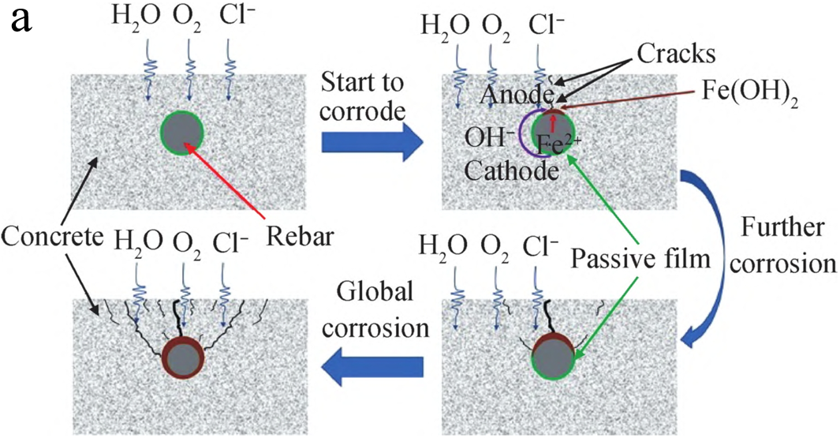
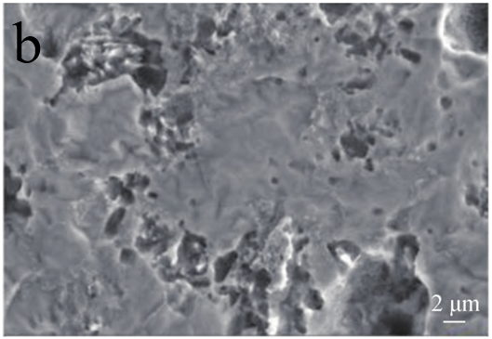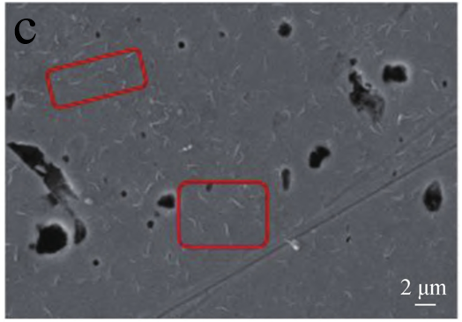
Figure 1: (a) Concrete damage caused by steel bar corrosion and expansion; (b) Surface of steel bar without passive film; (c) Surface of steel bar with passive film [4].
1.2 Freeze-thaw damage
Marine engineering concrete in high-latitude and severe winter regions is frequently damaged by freeze-thaw cycles, and the degree of damage is much more rapid and severe than expected. Periodic freeze-thaw cycles cause irreversible damage to the mesostructure of concrete materials in frozen regions, thereby degrading their bearing capacity and durability. Yang Xiaolin et al. [10] showed that hydration products of concrete hydrolyze and dissolve during freeze-thaw cycles, the structure of the original cementitious matrix is damaged, the development of internal pores and microcracks in concrete is accelerated, and eventually the macroscopic mechanical properties are degraded. Zhao et al. [11] observed the surface of concrete subjected to different numbers of freeze-thaw cycles using SEM. The results showed that with the increase of freeze-thaw cycles, the number and size of pores/cracks observed in the scanning field increased significantly. Figure 2(a) shows the SEM image of the original concrete, in which only a few pores can be observed. Figure 2(b) shows the SEM image after 225 freeze-thaw cycles. Compared with the original image, obvious microcracks appear in the sample after freeze-thaw cycles. Peng et al. [12] assumed that freeze-thaw damage mainly occurs during the freezing process while neglecting the damage during thawing, thus simplifying freeze-thaw cycle damage into a slow non-cyclic loading process, as shown in Figure 2(c). By defining the distribution of expansion force within each pore, all pore walls undergo centrifugal displacement along the radial direction, so as to simulate the ice expansion effect of water in pores during freezing, and analyze the influence of non-uniform pore distribution on the cracking failure mode of concrete. Wang Yao et al. [13] found that in regions with continuously distributed pores, continuous cracks are formed locally in internal pores. Affected by aggregates, internal cracks propagate in the same direction under the constraint of aggregates. Isolated pores merge into local cracks, which further form a crack network along the interfacial transition zone. Hu Shaowei et al. [14] indicated that different freezing-thawing modes have similar effects on concrete. Both water freeze-thaw and salt freeze-thaw cause loss of elastic modulus and decrease fracture mechanical properties of concrete, but improve the toughness of concrete.
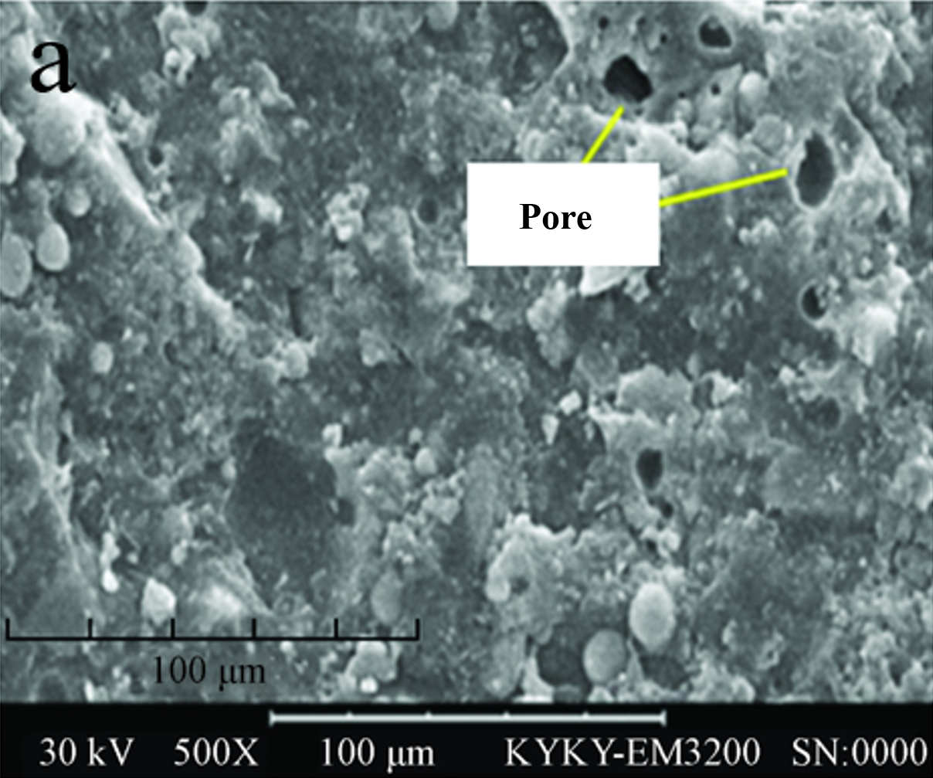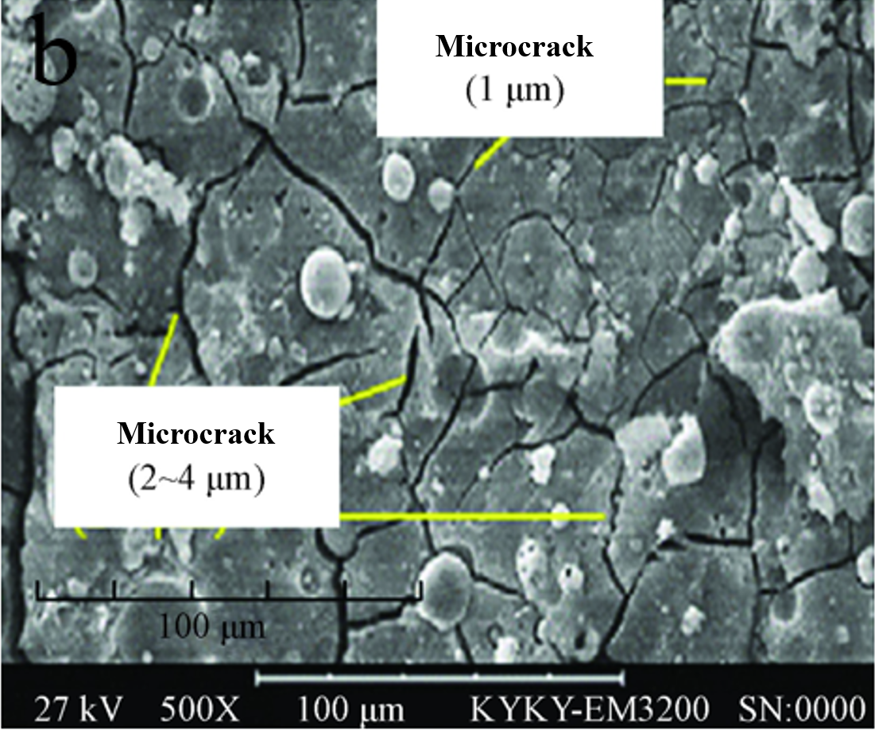
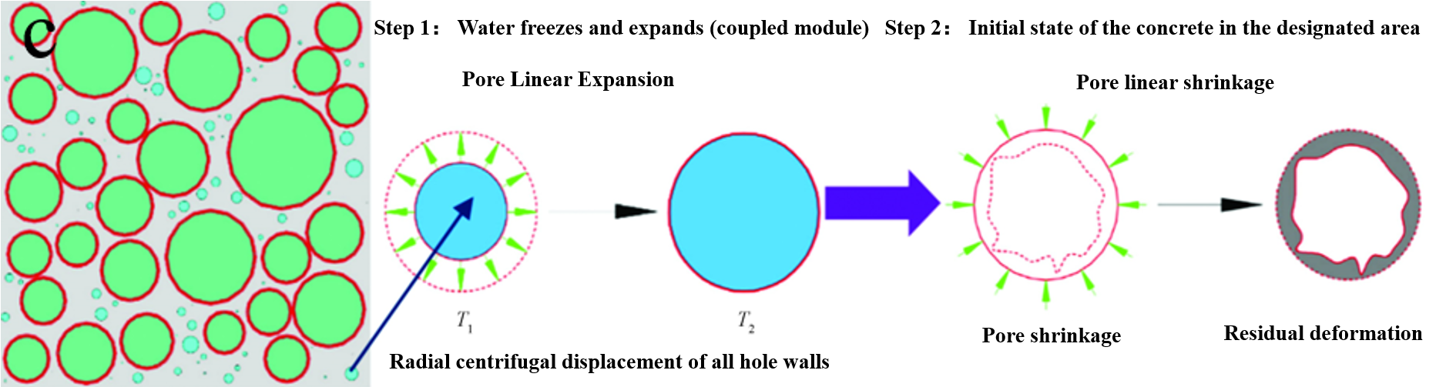
Figure 2: (a) Mesostructure of the original sample; (b) Mesostructure after 225 freeze-thaw cycles [11]; (c) Schematic diagram of expansion force evolution during freeze-thaw cycling [12].
1.3 Carbonation damage
Under the actions of natural environment and chemical corrosive media, carbonation occurs in concrete, leading to performance degradation and even structural damage in severe cases. During concrete carbonation, its internal structure changes, resulting in a reduction in strength. This is mainly because carbon dioxide in the air reacts with Ca(OH)₂ in concrete to form CaCO₃ and water. This chemical reaction increases the porosity of concrete and reduces the content of the hydration product C-S-H, leading to a decrease in concrete strength, which gradually declines with an increase in carbonation depth. In addition, ambient temperature also has a significant effect on concrete carbonation. As temperature rises, the diffusion rate of carbon dioxide in concrete accelerates, thereby speeding up the carbonation process [15]. Concrete carbonation also greatly affects the performance of steel bars. When concrete carbonates, its alkalinity decreases, destroying the passive film on the steel surface and making the steel prone to corrosion. Furthermore, carbonation increases concrete shrinkage and induces cracking, which further accelerates steel corrosion [16].
Figure 3 (a) schematically illustrates the adsorption of water and carbon dioxide by concrete. The adsorbed water and carbon dioxide react chemically to form calcium carbonate, which damages the passive layer formed by concrete and causes cracking or spalling of the concrete cover. Figure 3(b) shows the cracking process of reinforced concrete. When corrosion initiates, fine internal inclined cracks appear around the steel bars. Once surface cracks form, severe damage occurs as the steel is directly exposed to oxygen. It can be seen from Figure 3(c) that carbon dioxide diffusion and carbonation reactions only take place in the mortar composed of water, cement and sand, which means that using less mortar or coarser aggregate can reduce the carbonation depth. Using smaller coarse aggregate further reduces carbonation depth, because the larger specific surface area of coarse aggregate provides a longer and more difficult path for carbon dioxide diffusion [17].
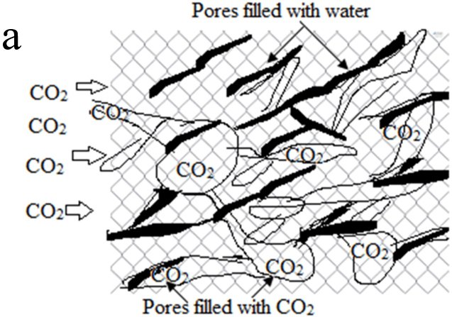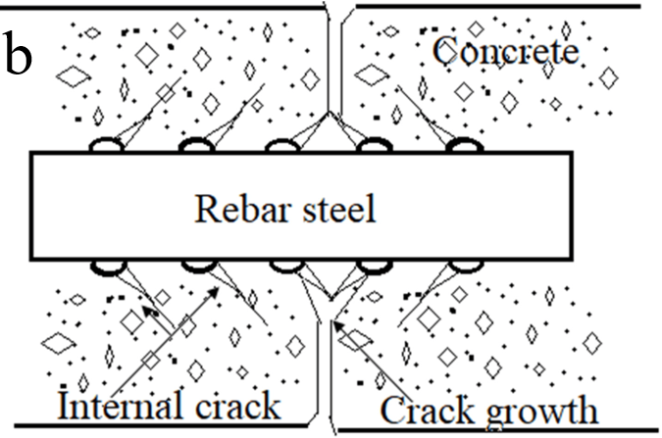
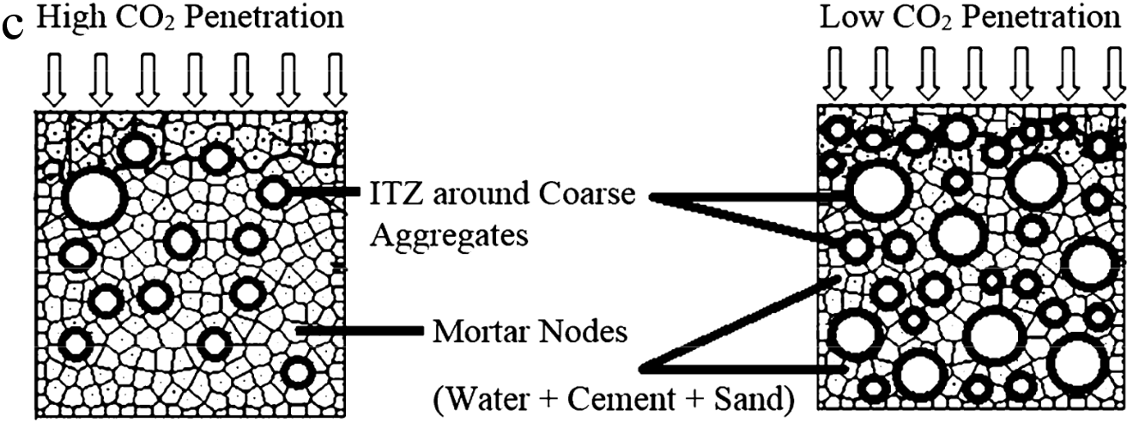
Figure 3: (a) Carbonation assisted by water and CO₂ adsorption; (b) Initiation and propagation of cracks in reinforced concrete; (c) Effect of mortar and coarse aggregate content on carbonation resistance of concrete mixtures [17].
1.4 Temperature cracking of mass marine concrete
In practical marine engineering concrete structures, temperature cracks frequently occur in mass concrete. After formation, such temperature cracks gradually develop into through cracks or deep cracks, which greatly affect construction progress and structural quality [18]. The schematic diagram of the cracking process of mass concrete is shown in Figure 4. The temperature of mass concrete may rise significantly due to the heat generated by cement hydration combined with thermal boundary conditions, resulting in thermal deformation of the concrete structure. When the internal temperature of mass concrete rises and then falls, thermal strain is produced (expansion during heating and shrinkage during cooling). Owing to the temperature gradient across the cross-section of the concrete member, the core zone (at a higher temperature) initially expands more than the outer layer (at a lower temperature). Consequently, tensile stress develops on the concrete surface, which may lead to surface cracking [19].
Li Jinkui et al. [20] found that when the total content of fly ash and slag powder in mass marine engineering concrete exceeds 45%, the complementary advantages of fly ash and slag powder are fully exerted. The overall performance of concrete is significantly better than that of single-admixture concrete, and the temperature rise of concrete can be greatly reduced. The alternate bay construction method has a remarkable effect on temperature rise and crack control in mass concrete, allowing the release of early-age stress in concrete and enabling the concrete to resist cracking by its own tensile capacity at a later stage. Combined with other internal cooling and surface thermal insulation and moisture retention measures, the formation of thermal stress cracks can be reduced from the perspective of construction. Xie Biao et al. [21] showed that mineral admixtures can reduce the total heat release of cementitious materials and improve the chloride ion permeability coefficient. However, the autogenous shrinkage of concrete increases with the rise of slag powder content. Considering comprehensively, the optimal comprehensive performance is achieved when the fly ash content is 30% and the slag powder content is 25% in the mix proportion.

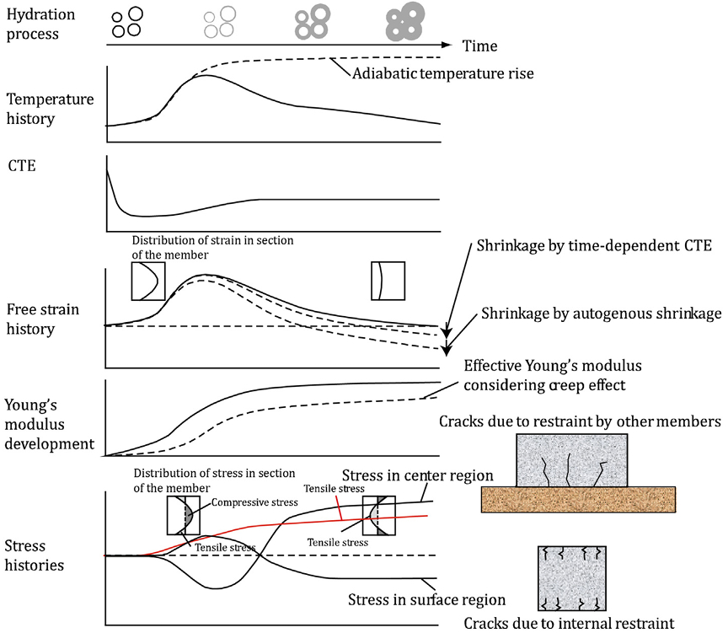
Figure 4: Schematic diagram of cracking in mass concrete [19].
2 Crack Prevention for Marine Concrete
2.1 Ultra-High Performance Concrete
Ultra-High Performance Concrete (UHPC) is a new type of cement-based composite material with excellent properties such as ultra-high strength, high toughness, high durability, and microcrack self-healing ability. It can effectively improve the service life of concrete structures and reduce maintenance frequency and cost [22]. The matrix of UHPC is extremely dense with very low porosity. The cement hydration product Ca(OH)₂ reacts with silica fume through a pozzolanic reaction and transforms into calcium silicate hydrate, thereby preventing the corrosion of Ca(OH)₂. This ultimately endows UHPC with ultra-high durability. Under uncracked conditions, all durability indicators of UHPC are significantly better than those of high-strength concrete and high-performance concrete [23]. As shown in Figure 5(a), these excellent properties of UHPC allow for lighter structural weight, enabling the construction of slenderer structures. In addition, UHPC performs far better than ordinary concrete under blast, impact, and seismic loads. As shown in Figures 5(b) and (c), compared with ordinary concrete, UHPC has an extremely dense interfacial transition zone (ITZ) with low porosity and high compactness [24]. Li et al. [25] found that little carbonation occurs in UHPC after 1 to 3 years of exposure, regardless of standard curing or high-temperature curing. Due to its low permeability, UHPC does not require consideration of steel corrosion or alkali-silica reaction under any curing regime. Moreover, no obvious degradation in mass, strength, or relative dynamic elastic modulus of UHPC is observed after hundreds of freeze-thaw cycles. Limited by the sensitivity of the UHPC matrix to component changes, only a few studies have attempted to explore the self-healing behavior of UHPC cracks using autonomous healing methods such as microcapsule encapsulation [26]. Zheng Qiaomu et al. [27] found that due to its unique material composition and structural characteristics, UHPC contains a large amount of unhydrated cementitious materials and usually exhibits excellent strain-hardening performance, strong secondary hydration and pozzolanic reactivity, as well as multiple microcracking patterns, which provide a reliable basis for its good crack self-healing potential. The lower the damage degree of UHPC and the smaller the crack width, the better the crack self-healing effect. Meanwhile, a curing environment with sufficient moisture is most effective for the self-healing of UHPC cracks.
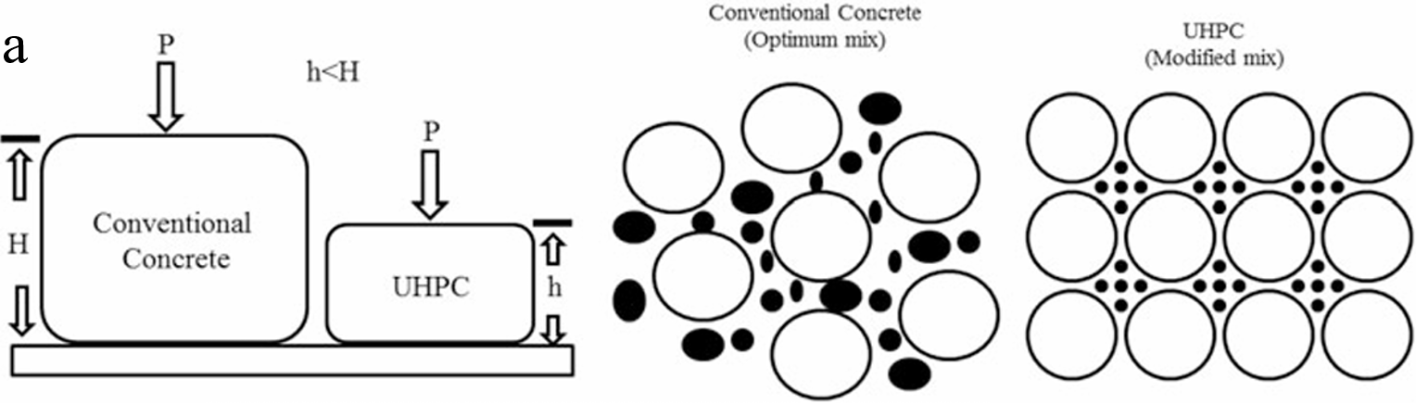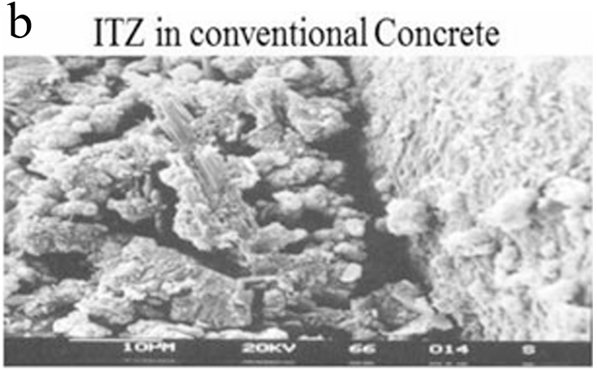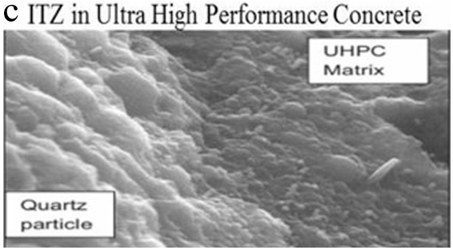
Figure 5: (a) Ordinary concrete and ultra-high performance concrete; (b) ITZ in ordinary concrete; (c) ITZ in ultra-high performance concrete [22].
2.2 Hydrophobic Concrete
Concrete failure caused by insufficient corrosion resistance and freeze-thaw resistance severely impairs engineering operation and incurs huge economic losses. Therefore, it is of great significance to address the stability of concrete engineering performance in corrosive and freeze-thaw environments. Scholars worldwide have found that superhydrophobic coatings can effectively reduce the water absorption rate of concrete, thereby improving its frost resistance and corrosion resistance. Han Zhengjin et al. developed a fluorosilane-based superhydrophobic concrete that retains excellent superhydrophobicity even after scratching. Song et al. fabricated superhydrophobic concrete (S-type concrete) via metal mesh covering and fluoroalkylsilane modification. As shown in Figure 6(a), multiple methods were employed to test the surface robustness of S-type concrete, including sandpaper abrasion, knife scratching, and hammering. Meanwhile, linear abrasion tests (Figure 6(b)) revealed that S-type concrete does not lose its superhydrophobicity even after 6 m of abrasion under 600 Pa pressure using standard 1500# sandpaper. In the knife-scratching test (Figure 6(c)), when the scratching direction is perpendicular to the blade edge, S-type concrete still exhibits excellent superhydrophobicity due to its high hardness and the protection of sand grains on the microscale structure. To demonstrate its practical application prospects, researchers conducted further tests on S-type concrete, including artificial cold rain, freeze-thaw cycles, and applied-voltage corrosion in corrosive solutions. As shown in Figure 6(d), the results indicate that S-type concrete possesses remarkable anti-icing, freeze-thaw resistance, corrosion resistance, and mechanical robustness. Ding Caihong et al. prepared DC-30 modified superhydrophobic concrete and found that it exhibits outstanding superhydrophobicity, with a water absorption rate of only 11%–40% that of ordinary concrete. The study also showed that moist curing significantly enhances the strength of superhydrophobic concrete. After 28 days of moist curing, the compressive strength reduction rate is 7.7% and the flexural strength reduction rate is 8.1%. This is mainly because moist curing provides sufficient water for the hydration reaction, and the rapid increase in hydration products leads to a prompt strength improvement. Tian Lei et al. discovered that both surface (super)hydrophobic modification and bulk (super)hydrophobic modification of cement-based materials can significantly improve their impermeability, frost resistance, and chloride ion penetration resistance, thereby greatly enhancing the durability of cement-based materials.
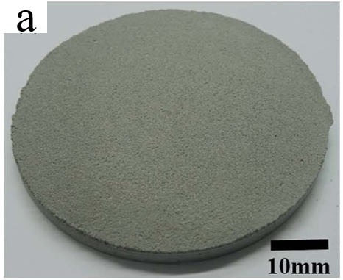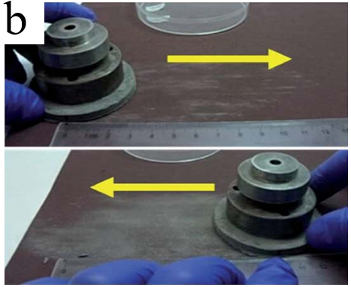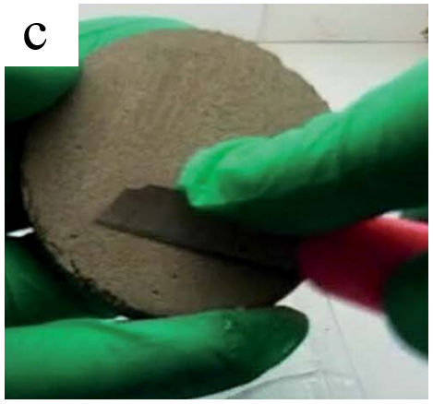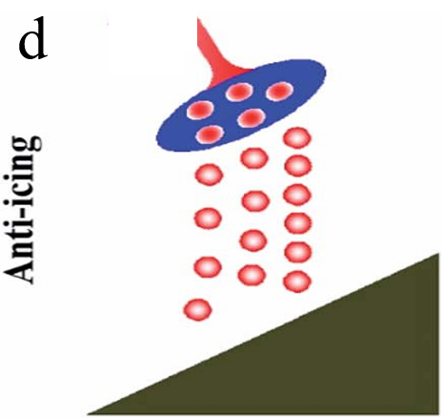
Figure 6: (a) Macro digital photo of S-type concrete; (b) Sample placed face-down in contact with sandpaper during sandpaper abrasion test; (c) Knife scratch test; (d) Schematic diagram of cold rain under freeze-thaw environment [30].
2.3 Low-heat cement
Low-heat cement concrete is characterized by low hydration heat and excellent comprehensive crack resistance, which can effectively reduce the difficulty of temperature control and crack prevention in mass marine engineering concrete. Zeng et al. [33] evaluated the physical and chemical properties and cracking behavior of low-heat cement (LHC), medium-heat cement (MHC), and ordinary Portland cement (OPC) under 1200 thermal cycles (TC) in the temperature range of 5–45 °C, as shown in Figure 7(a). The results show a negative linear relationship among porosity, crack density, and compressive strength, highlighting the competitive mechanism that determines the damage degree under thermal cycles. Jianda et al. [34] found that under the same constraint degree, the temperature difference for concrete cracking increases with a decreasing slope as the concrete curing age increases, as shown in Figure 7(b). Under loading at the same curing age, the temperature difference for concrete cracking increases as the constraint degree of concrete decreases, as shown in Figure 7(c). Lv et al. [35] showed that adding fly ash (FA) or phosphorus slag (PS) to low-heat Portland cement (LHPC) reduces the cumulative heat to a certain extent, and the simultaneous addition of FA and PS in LHPC mixtures further reduces the cumulative heat. As shown in Figure 7(d), PS exhibits a lower cumulative heat at an early age compared with FA. Figure 7(e) indicates that FA has a more significant effect on reducing the peak heat release rate than PS. Jing et al. [36] found that the heat flow rate and cumulative heat of low-heat Portland cement (LHC) pastes are generally lower than those of medium-heat cement (MHC) and ordinary Portland cement (OPC) pastes. LHC-based materials show a slow development of early compressive strength (reduced by 18.2%–28.3% at 3 d) but can achieve comparable mechanical properties at a later age (increased by 3.4%–8.4% at 180 d), with better crack resistance, a prolonged initial cracking time by 11.9%–32.4%, and stronger corrosion resistance.
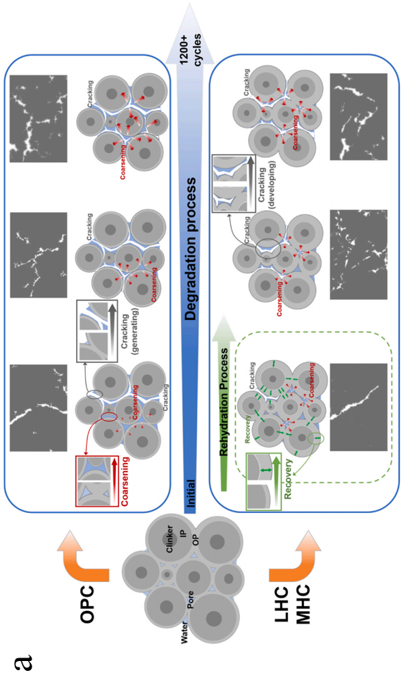

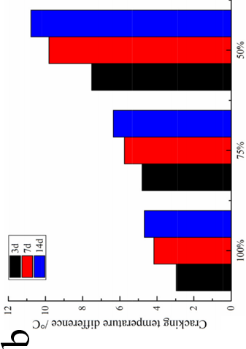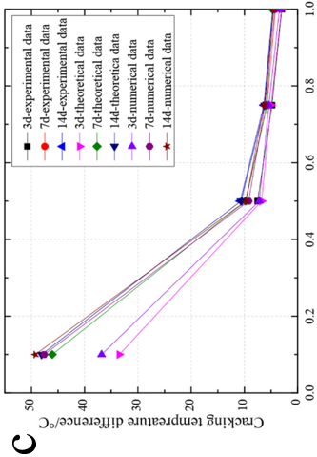
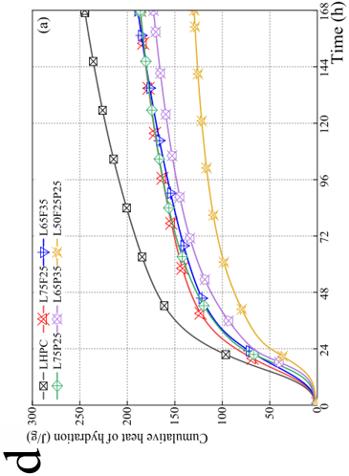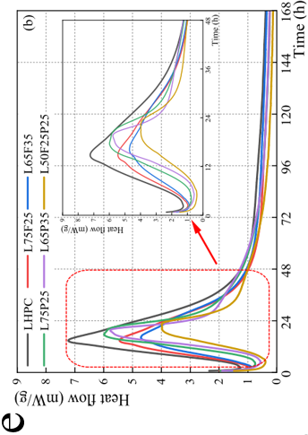
Figure 7: (a) Schematic diagram of performance evolution and algorithm-identified images of crack development for OPC, LHC and MHC pastes under thermal cycles [33]; (b) Relationship between cracking temperature difference and constraint degree; (c) Relationship between constraint degree and cracking temperature difference based on numerical simulation, theoretical analysis and experiment [34]; (d) Cumulative heat of different specimens; (e) Thermal evolution rate of different specimens [35].
3 Crack Repair for Marine Concrete
3.1 Chemical grouting repair
Cracks are common defects in marine engineering concrete. Cracks can cause water seepage accompanied by calcium leaching, which further leads to steel corrosion inside concrete and affects the durability and safety of marine concrete structures [37]. Chemical grouting is suitable for various special environments such as water seepage at crack surfaces. Grouting materials have the advantages of good wettability to concrete, high bonding strength at crack surfaces, and no damage to the integrity of the concrete surface [38]. Zhang et al. [39] showed that vertical drilling grouting technology has many defects when applied to walls: it can only repair shallow cracks in concrete, and this grouting technique cannot ensure that the grout fills the entire crack. This is because it is difficult to form an effective pressure (Pe zone) during grouting, resulting in irregular diffusion of grout in concrete cracks, as shown in Figure 8(a). To solve the problems of vertical drilling grouting, researchers proposed an inclined drilling grouting technology. This technology can form an effective pressure (Pe zone) at the outlet of the grouting pipe, and under the action of gravity and grouting pressure, the grout forms a regular elliptical diffusion zone, as shown in Figure 8(b). The construction of large arch bridges is difficult, and cracks are common quality defects in large arch bridges, which greatly affect the appearance, service life and safety of bridges. Hole layout and drilling are the main steps in grouting repair with modified epoxy chemical grout. The drilling depth must be strictly controlled according to the crack depth, and each crack must be provided with at least one air inlet hole and one air outlet hole to improve the smoothness of grouting construction with modified epoxy chemical grout. The schematic diagram of grouting hole positions is shown in Figure 8(c). The modified epoxy chemical grout is gradually injected into the cracks by low-pressure grouting. After initial setting of the grout surface, the grouting nozzles can be removed and sealed smoothly with quick-setting sealing compound in time to complete the grouting construction of modified epoxy chemical grout. Then the sealing compound is polished with steel sandpaper and cleaned with acetone, and epoxy mortar is applied at the crack positions to finally complete all crack repair work. The schematic diagram of grouting and sealing construction is shown in Figure 8(d). The final inspection results showed that the cracks were almost completely sealed, indicating that grouting repair with modified epoxy chemical grout has a good effect on cracks [40]. Zhang Yong et al. [41] proposed a grouting technology for micro-cracks in hydraulic structures featuring “nondestructive + high-pressure + simultaneous multi-hole grouting”. This technology can significantly improve the effect of chemical grouting for micro-cracks in hydraulic structures and avoid problems such as damage to the concrete surface caused by grouting hole drilling and grooving. It is an organic component and important supplement to the chemical grouting technology for cracks in hydraulic concrete structures.
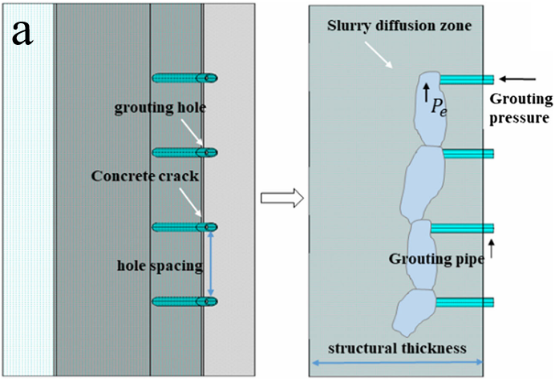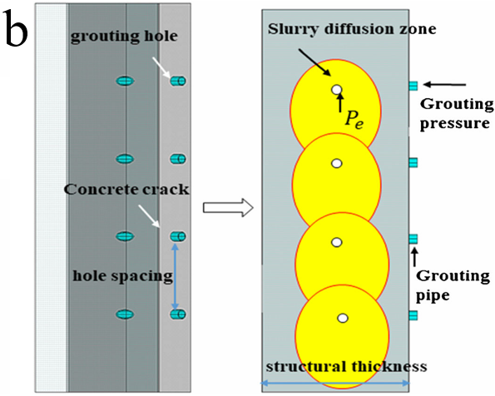
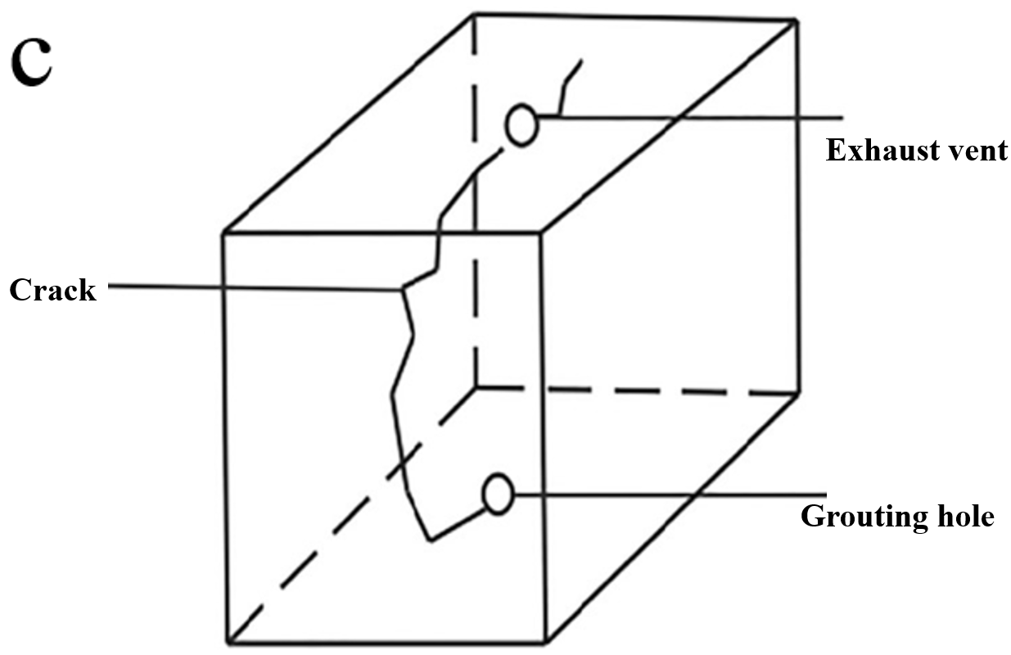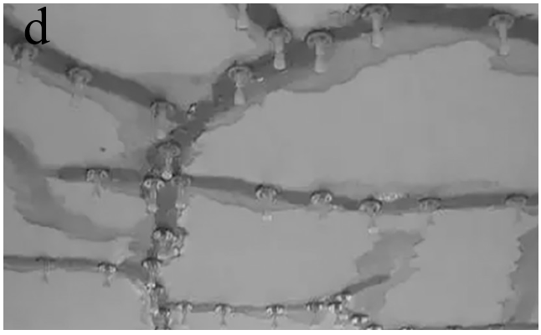
Figure 8 (a) Crack diffusion mechanism of vertical drilling grouting in the secondary lining; (b) Crack diffusion mechanism of inclined shaft drilling grouting in the secondary lining [39]; (c) Schematic diagram of grouting hole locations; (d) Schematic diagram of grouting sealing construction [40].
3.2 Mineralizing microbial repair technology
Marine engineering concrete materials are characterized by high brittleness and low tensile strength, making it inevitable that microcracks occur inside or on the surface. Crack self-healing technology based on microbial mineralization and deposition can effectively realize the self-diagnosis and self-healing of concrete cracks [42]. Zhang Jiaguang et al. [43] added mineralizing microorganisms into concrete using expanded perlite, which improved the survival rate of microorganisms. After 28 days of healing curing, the crack repair ratios of concrete specimens mixed with aerobic mixed bacteria, facultative anaerobic mixed bacteria and pure bacteria reached 83.3%, 63.3% and 73.3% respectively. The repair ratio of specimens mixed with anaerobic mixed bacteria was relatively low, but still reached 41.5%. Jogi et al. [44] showed that “microbial concrete” can replace high-quality concrete. This type of concrete can heal cracks, provides good economic benefits, is environmentally friendly, and ultimately improves the durability of building materials. Their results also indicated that Bacillus pasteurii and Bacillus subtilis are the most effective beneficial bacteria for repairing concrete cracks (Figure 9(a)). Zhang et al. [45] studied the effects of two self-healing techniques—direct bacteria introduction and bacteria immobilization in expanded clay (EC)—on crack healing efficiency. As shown in Figure 9(b), specimens incorporated with expanded perlite (EP)-immobilized bacteria exhibited the most effective crack healing after each healing cycle. Li Zhu et al. [46] used Bacillus cohnii to undergo chemical or biological metabolic reactions with nutrients in the concrete matrix, forming calcium carbonate precipitates to fill cracks. The repair mechanism is illustrated in Figure 9(c). The results showed that mineralization deposition of Bacillus cohnii effectively improved the crack self-healing ability of concrete. After 28 days of repair curing, the maximum repair width of concrete using expanded perlite as the repair agent carrier reached 0.56 mm, which was 2.2 times that of ordinary concrete. The expanded perlite carrier provided good protection for aerobic microorganisms, improved the survival rate of Bacillus cohnii, and significantly enhanced the crack self-healing effect of concrete. Jonkers et al. [47] used inorganic porous materials such as expanded clay particles, ceramsite and ceramic sand as carriers, which could prolong the service life of bacteria in concrete. When bacterial spores and essential substances for microbial mineralization were immobilized in ceramsite, the effective repair function of bacteria could be extended to more than 6 months. Khaliq et al. [48] conducted experimental studies on crack self-healing using Bacillus subtilis immobilized in different carriers. The results showed that the repair effect of concrete was relatively stable when lightweight aggregate was used as the carrier. Cao Hui et al. [49] found that Bacillus pasteurii could effectively repair surface cracks of concrete. Oxygen supply is an important environmental condition for microbial mineralization inside cracks. The repair effect of Bacillus pasteurii gradually weakened with increasing crack depth. Similarly, the mineralization effect inside cracks decreased with increasing crack width. Yuan Jie et al. [50] found that microbial mineralization had a certain compensatory effect on the frost resistance and sulfate attack resistance of cracked concrete. The performance of repaired concrete was between that of cracked and uncracked concrete. In the early stage of accelerated testing, the deposited calcium carbonate acted as a barrier to protect the concrete matrix inside the cracks. After a certain number of cycles, the calcium carbonate gradually peeled off, releasing internal pressure and delaying crack propagation.
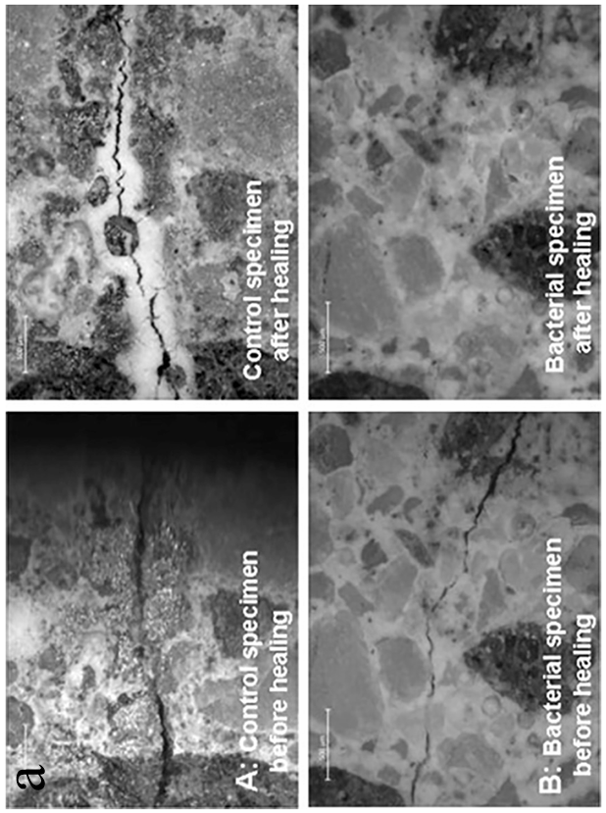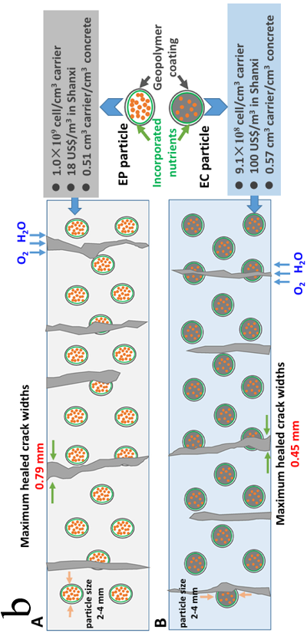
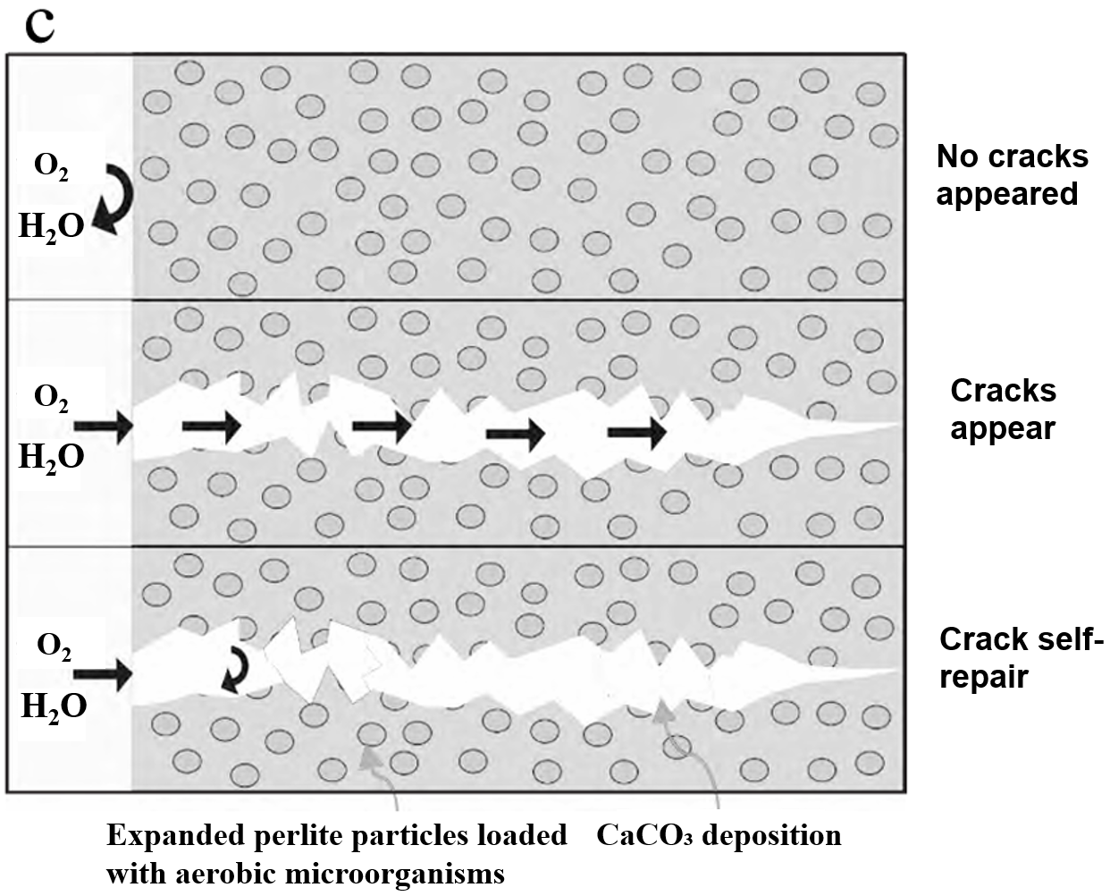
Figure 9: (a) Radiation microscopy image [44]; (b) Schematic diagrams of two healing processes (EP-B (A) and EC-B (B)) [45]; (c) Self-healing mechanism of concrete cracks based on mineralization deposition of Bacillus cohnii [46].
3.3 Microcapsule Repair Technology
Marine concrete structures suffer from cracks due to construction, service, erosion, and other factors. Such defects not only affect the normal use of structures but also endanger people’s lives and property in severe cases. Researchers have developed microcapsule repair technology. By incorporating microcapsules containing special repairing agents into concrete, the active components inside the microcapsules are activated upon cracking, thereby achieving automatic crack repair. The fundamental principle of self-healing by microcapsules is as follows: when a crack initiates in the cement matrix, the propagating crack causes the dispersed microcapsules to rupture mechanically, releasing their core materials into the crack, as shown in Figure 10(a). Similar to encapsulation, the self-healing mechanism depends on the nature of the loaded material, which may react with an activator (supplied as a two-component system, e.g., two-component epoxy), cement hydration and carbonation products (such as lime), or the surrounding environment (e.g., air, moisture) [51]. Kanellopoulos et al. [52] produced microcapsules with sodium silicate solution as the core via a complex coacervation method in an oil-in-water double emulsion system, as illustrated in Figure 10(b) and (c). The microcapsules can survive and function successfully when exposed to a cementitious environment, and rupture upon crack formation to release the encapsulated water-glass solution. An example of the cracked region is shown in Figure 10(d), from which it is clear that the crack can gradually heal over time. The crack area healing ratio of mortar specimens with non-encapsulated bacterial spores was 72.7%, lower than that of specimens with microencapsulated bacterial spores (95.4%). Therefore, sodium alginate freeze-dried encapsulated bacterial spores can improve crack healing efficiency through biochemical activity and can be applied in concrete technology as a microencapsulation technique for MICP spores [53]. Mao Qian et al. [54] reported that calcium alginate/epoxy microcapsules exhibit four repair behaviors in cement matrices: (1) Mechanically triggered rupture of microcapsules, releasing epoxy resin that cures with a hardener in the matrix to bond cracks rapidly; (2) Water-triggered swelling of microcapsules to block cracks; (3) Water absorption by microcapsules promoting further hydration of cement particles and enhancing autogenous healing; (4) Alkaline environment triggering decomposition of the calcium alginate shell and release of core materials. Dai Min et al. [55] synthesized microcapsules via a two-step in-situ composite method using urea-formaldehyde resin as the shell and epoxy resin E-44 as the core. Self-healing mortars with different microcapsule contents were prepared by blending a curing agent and microcapsules. Results showed that the repair efficiency of self-healing mortar was maximized when the microcapsule content was 6% and the preloading stress was 50%. Liu Bo et al. [56] prepared polypropylene-coated toluene diisocyanate (TDI) microcapsules using the melt-dispersion-condensation method. The microcapsules exhibited good mechanical properties and resisted breakage during concrete mixing. When the microcapsule content was 2.5%, concrete showed excellent self-healing ability for cracks and effectively extended service life.
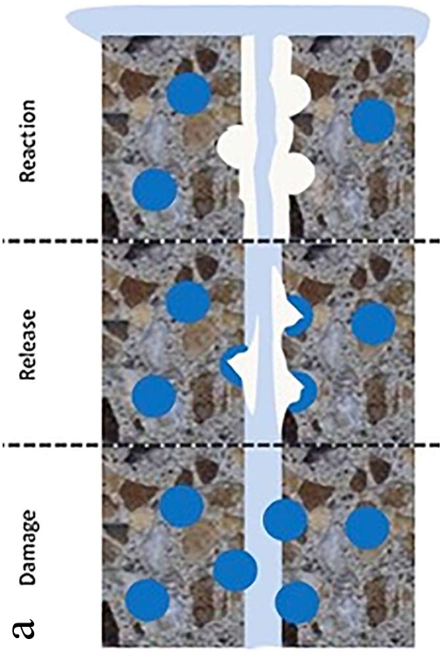
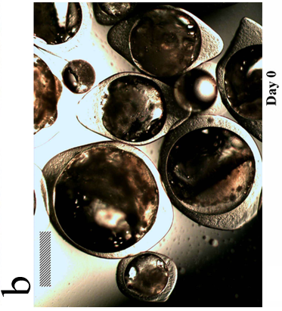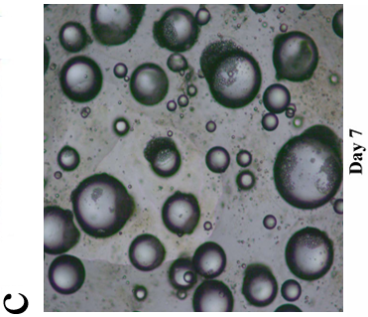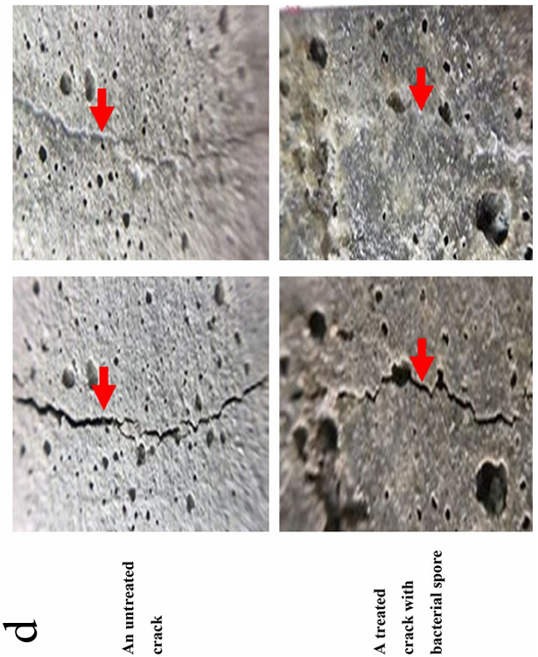
Figure 10: (a) Schematic diagram of microcapsule-mediated concrete self-healing [51]; (b) Larger microcapsules with characteristic “rugby ball” shape; (c) Smaller and more spherical microcapsules (scale bar corresponds to 500 μm) [52]; (d) Repair effect of sodium alginate microencapsulated bacterial spores after freeze-drying on mortar cracks [53].
4 Outlook and Challenges
With the development of science and technology and the increasing attention paid to infrastructure construction, marine concrete crack repair technologies will be continuously advanced and improved. The treatment of cracks in the future will become more effective, enabling better solutions to the cracking issues of marine concrete. Meanwhile, more scholars will focus on this field and work together to enhance the quality and level of infrastructure construction in China.
For concrete crack repair, the industrial production and large-scale application of microbial concrete or microbial healing agents still require in-depth exploration and overcoming many challenges. Current research needs further improvement; for example, the long-term activity of microorganisms in concrete remains unresolved. In addition, the addition of microorganisms, selection of carrier materials, types of nutrients, and proportioning of various raw materials are all challenges faced in the application of MICP technology to concrete crack repair. Unbelievably, research methods are still limited to short-term experiments, lacking long-term and large-sample mechanical tests. The long-term mechanical properties of concrete specimens repaired using MICP technology are still uncertain, which greatly restricts its practical engineering application. Moreover, more theoretical, simulation, and experimental studies are needed in future research to balance the improvement of crack repair performance and the retention of concrete mechanical properties. Furthermore, construction in complex natural environments such as extreme cold, oxygen deficiency, high pressure, and high temperature has become a trend of social development.
References
[1] Li Huajun, Liu Fushun, Du Junfeng, et al. Development trends and technical challenges of ocean engineering[J]. Coastal Engineering, 2022, 41(04): 283-300.
[2] Wang Mengran. Study on chloride ion erosion process of concrete under freeze-thaw cycles [D]. Southeast University, 2018.
[3] Xie Fang, Ma Zhideng, Huang Kanghua, et al. Practical study on marine cement for improving erosion resistance of concrete engineering [J]. Journal of Yangtze River Scientific Research Institute, 2013, 30(09): 114-118.
[4] Liu Yumei, Yang Lang, Rao Feng, et al. Research progress on steel corrosion in marine concrete induced by chloride ions [J]. Bulletin of the Chinese Ceramic Society, 2023, 42(09): 3059-3074.
[5] LIU J, JIANG Z L, ZHAO Y L, et al. Chloride distribution and steel corrosion in a concrete bridge after long-term exposure to natural marine environment[J]. Materials, 2020, 13(17): 3900.
[6] ZHANG W L, FRANÇOIS R, CAI Y X, et al. Influence of artificial cracks and interfacial defects on the corrosion behavior of steel in concrete during corrosion initiation under a chloride environment[J]. Construction and Building Materials, 2020, 253: 119165.
[7] Zhu Weibin, Chi Heng, Liu Kun, Li Cuizhen. Research on application technology of high-performance marine engineering concrete[J]. China Civil Engineering, 2023, 12(6): 840-845.
[8] Wu Q, Ma Q, Huang X. Mechanical properties and damage evolution of concrete materials considering sulfate attack[J]. Materials, 2021, 14(9): 2343.
[9] Wei J, Cheng B, Li L, et al. Prediction of dynamic mechanical behaviors of coral concrete under different corrosive environments and its enhancement mechanism[J]. Journal of Building Engineering, 2023, 63: 105507.
[10] Yang Xiaolin，Wang Genhui． Ｒesearch on the constitutive rela tionship and pore structure characteristics of freeze-thawed concrete[J]. Journal of Lanzhou Jiaotong University, 2020, 39(3): 13-18.
[11] Zhao R D, Yuan Y, Cheng Z Q, et al. Freeze-thaw resistance of class F fly ash-based geopolymer concrete[J]. Construction and Building Materials, 2019, 222: 474-483.
[12] Peng R X, Qiu W L, Teng F. Three-dimensional meso-numerical simulation of heterogeneous concrete under freeze-thaw [J]. Construction and Building Materials，2020, 250: 118573.
[13] Wang Yao, Li Shengjun, Ye Min, et al. Research progress on mesostructure evolution and mechanical damage characteristics of concrete under freeze-thaw cycles [J]. Science Technology and Engineering, 2023, 23(14): 5853–5874.
[14] Hu Shaowei, Wang Yang. Comparative test on double-K fracture toughness of concrete under different freeze-thaw modes [J]. Hydro-Science and Engineering, 2018(2): 90–96.
[15] Jia Xingliang. Research status of influencing factors on concrete carbonation [J]. Science and Technology Innovation, 2020(05): 108–109.
[16] Zhang Xiaoli. Influencing factors of concrete carbonation and its control measures [J]. Heilongjiang Communications Science and Technology, 2020, 43(10): 33+35.
[17] Fuhaid A F A, Niaz A. Carbonation and corrosion problems in reinforced concrete structures[J]. Buildings, 2022, 12(5): 586.
[18] Xu Chuanke. Research on temperature control of mass hydraulic concrete [J]. Building Materials & Decoration, 2019(11): 286–287.
[19] Maruyama I, Lura P. Properties of early-age concrete relevant to cracking in massive concrete[J]. Cement and Concrete Research, 2019, 123: 105770.
[20] Li Jinkui, Zhang Qiang. Temperature rise and crack control of mass marine engineering concrete [J]. Concrete, 2019(10): 155–160.
[21] Xie Biao, Xu Wen, Zhang Jian, et al. Research and application of crack resistance of C50 low heat rise and low shrinkage mass marine concrete [J]. Concrete, 2021(09): 98–101+105.
[22] Yang Bowen, Dai Lei, Jin Luyun, et al. Review on research of ultra-high performance concrete (UHPC) [J]. Building Technology, 2020, 51(12): 4.
[23] Zhao Yun, Lian Huizhen, Jin Jianchang. A new model of steel-concrete composite—ultra-high performance concrete (UHPC/UHPFRC) (Part 3): Shrinkage and cracking, high temperature resistance, permeability and durability, design guide [J]. Concrete World, 2013(12): 60–71.
[24] Mishra O, Singh S P. An overview of microstructural and material properties of ultra-high-performance concrete[J]. Journal of Sustainable Cement-Based Materials, 2019, 8(2): 97-143.
[25] Li J, Wu Z, Shi C, et al. Durability of ultra-high performance concrete–A review[J]. Construction and Building Materials, 2020, 255: 119296.
[26] GARCÍA CALVO J L, PÉREZ G, CARBALLOSA P, et al. Development of ultra-high performance concretes with self-healing micro/nano-additions[J]. Construction and Building Materials, 2017, 138: 306-315.
[27] Zheng Qiaomu, He Bei, Li Chen, et al. Research progress on self-healing of cracks in ultra-high performance concrete [J]. Journal of the Chinese Ceramic Society, 2021, 49(11): 2450–2461.
[28] Zhao J, Gao X, Chen S, et al. Hydrophobic or superhydrophobic modification of cement-based materials: A systematic review[J]. Composites Part B: Engineering, 2022: 110104.
[29] Han Zhengjin. Preparation and Performance Study of High-Strength Superhydrophobic Concrete [D]. Dalian: Dalian University of Technology, 2017.
[30] Song J, Zhao D, Han Z, et al. Super-robust superhydrophobic concrete[J]. Journal of Materials Chemistry A, 2017, 5(28): 14542-14550.
[31] Ding Caihong. Study on engineering properties and micro-mechanism of modified superhydrophobic concrete[J]. Synthetic Materials Aging and Application, 2022, 51(06): 99–101+161.
[32] Tian Lei, Qiu Liuchao. Research progress of (super)hydrophobic cement-based materials[J]. Materials Review, 2021, 35(19): 11.
[33] Zeng H, Jin M, Li W, et al. Performance evolution of low heat cement under thermal cycling fatigue: A comparative study with moderate heat cement and ordinary Portland cement[J]. Construction and Building Materials, 2024, 412: 134863.
[34] Jianda X, Guoxin Z, Xiaoming J, et al. Exploring the effect of low-heat cement on early-age thermal cracking resistance of roller-compacted concrete[J]. Journal of Materials Research and Technology, 2022, 214439-4451.
[35] Xingdong L, Yan S, Yuanyi W, et al. Utilization of phosphorus slag as fly ash replacement in low-heat Portland cement blends: Comparative study of hydration behaviors, physical properties, and life-cycle assessment[J]. Construction and Building Materials, 2023, 396.
[36] Jing X, Zemei W, Xuanhan Z, et al. Trends and developments in low-heat portland cement and concrete: A review[J]. Construction and Building Materials, 2023, 392.
[37] Xu Qingyuan, Huang Zhuo. Application of a new grouting material in crack reinforcement of overflow surface of Xixiayuan Reservoir spillway[C]//Chinese Dam Engineering Association. Intelligent Construction and High-Quality Development of Reservoirs and Dams. China Architecture & Building Press, 2023: 5.
[38] Wu Jianhua, Deng Shaozhen, Li Yan. Simulation of concrete crack chemical grouting pressure and discussion on appropriate pressure[J]. Yangtze River, 2015, 46(1): 5.
[39] Zhang B, Gao F, Zhang X, et al. Modified cement-sodium silicate material and grouting technology for repairing underground concrete structure cracks[J]. Arabian Journal of Geosciences, 2019, 12: 1-10.
[40] Cui Jinglong. Construction technology of modified epoxy chemical grouting for crack repair in large arch bridges[J]. Journal of Changzhou Institute of Technology, 2021, 34(02): 6–9+35.
[41] Zhang Yong. Chemical grouting technology for fine cracks in hydraulic structures[J]. Journal of Yangtze River Scientific Research Institute, 2017, 34(7): 121.
[42] Li Zhu, Feng Tao, Zhou Mengjun, et al. Experimental study on self-healing performance of concrete cracks based on mineralization deposition of Bacillus cohnii[J]. Concrete, 2017(06): 5–8.
[43] Zhang Jiaguang, Xu Shunshun, Feng Tao, Zhao Lin, Li Zhu. Effects of different mineralizing microorganisms on self-healing efficiency of concrete cracks[J]. Journal of Tsinghua University (Science and Technology), 2019, 59(8): 607–613.
[44] Jogi P K, Lakshmi T V S V. Self healing concrete based on different bacteria: a review[J]. Materials Today: Proceedings, 2021, 43: 1246-1252.
[45] Zhang J, Liu Y, Feng T, et al. Immobilizing bacteria in expanded perlite for the crack self-healing in concrete[J]. Construction and Building Materials, 2017, 148: 610-617.
[46] Li Zhu, Feng Tao, Zhou Mengjun, et al. Experimental study on self-healing performance of concrete cracks based on mineralization deposition of Bacillus cohnii [J]. Concrete, 2017, (06): 5–8.
[47] Jonkers H M.Bacterial-based self-healing concrete[J]. Heron, 2011, 56(1-2): 1-12.
[48] Khaliq W, Ehsan M B. Crack healing in concrete using various bio influenced self-healing techniques[J]. Construction and Building Materials, 2016(102): 349-357.
[49] Cao Hui, Zang Yang, Feng Qiong, et al. Experimental study on concrete crack repair effect under microbial action [J]. Journal of Lanzhou University of Technology, 2022, 48(4): 126.
[50] Yuan Jie, Chen Xin, He Honglin, et al. Concrete crack repair and performance compensation based on microbial mineralization [J]. Journal of Jilin University (Engineering and Technology Edition), 2020, 50(2): 641–647.
[51] Al-Tabbaa A, Litina C, Giannaros P, et al. First UK field application and performance of microcapsule-based self-healing concrete[J]. Construction and Building Materials, 2019, 208: 669-685.
[52] Kanellopoulos A, Giannaros P, Palmer D, et al. Polymeric microcapsules with switchable mechanical properties for self-healing concrete: synthesis, characterisation and proof of concept[J]. Smart Materials and Structures, 2017, 26(4): 045025.
[53] Pungrasmi W, Intarasoontron J, Jongvivatsakul P, et al. Evaluation of microencapsulation techniques for MICP bacterial spores applied in self-healing concrete[J]. Scientific reports, 2019, 9(1): 12484.
[54] Mao Qianjin, Wu Wenwen, Liang Peng, et al. Self-healing effect of calcium alginate/epoxy microcapsules in cement-based materials [J]. Materials Review, 2018, 32(22): 4016–4021.
[55] Dai Min, Wang Yang, Zhang Jingjuan. Experimental study on microcapsule self-healing mortar [J]. Bulletin of the Chinese Ceramic Society, 2018, 37(4): 1282–1287.
[56] Liu Bo, Jiang Lu, Wang Luoxin, et al. Preparation of polypropylene-coated toluene diisocyanate self-healing microcapsules for concrete cracks [C]//Chinese Materials Research Society. Proceedings of China Materials Conference 2022–2023. 2023: 7.

