A Review on Wind Effects and Wind Resistance Performance Improvement of Flexible Photovoltaic Supports

Abstract: Flexible photovoltaic (PV) support systems, featuring long spans and lightweight configurations, are widely used in complex terrains. However, their high flexibility and low damping make them vulnerable to wind-induced vibration and stability problems.This paper reviews research on wind load characteristics, wind-induced dynamic responses, wind-resistance enhancement strategies, and construction and monitoring technologies for flexible PV support systems. The effects of tilt angle, pre-tension, and array configuration on wind load distribution and dynamic behavior are summarized, and key control parameters are identified. Aerodynamic optimization, structural system improvement, and supplemental damping measures are compared in terms of effectiveness and limitations.Although existing studies support structural design, further research is needed on large-scale array fluid–structure interaction, integrated optimization strategies, and construction–operation coordination. This review provides a reference for improving the safety and performance of flexible PV support systems.

Keywords: Flexible photovoltaic support system; wind-induced response; wind-resistance enhancement; vibration control; structural monitoring

Introduction
With the global energy transition and carbon reduction targets, photovoltaic (PV) capacity continues to expand, increasing the demand for adaptable support systems in complex terrains and multifunctional land-use scenarios. Compared with conventional fixed supports, flexible photovoltaic support systems, based on prestressed cable structures, provide long spans, high clearance, low self-weight, and strong terrain adaptability. They have been widely applied in agricultural–PV, fishery–PV, and desert PV projects.
However, the low stiffness and damping of flexible systems, combined with natural frequencies close to dominant wind frequencies, make them susceptible to significant wind-induced vibration and potential aeroelastic instability under strong winds. Recent wind-induced failures indicate that wind effects are a critical constraint on large-scale application. Current design codes, developed primarily for rigid structures, provide limited guidance on aeroelastic behavior, fluid–structure interaction, and nonlinear dynamic responses of flexible systems.
Extensive studies have addressed wind load characteristics, wind-induced dynamic responses, wind-resistance enhancement measures, and construction and monitoring technologies. Nevertheless, a systematic synthesis remains limited. This paper reviews existing research, identifies key technical issues and limitations, and provides a reference for the safe design and performance improvement of flexible photovoltaic support systems.

1 Research Progress on Wind-Induced Response of Flexible Photovoltaic Support Systems
Compared with conventional rigid supports, flexible photovoltaic (PV) support systems use cables (steel wires or strands) instead of purlins as the primary load-bearing components, resulting in significantly increased structural flexibility. Multi-row arrangements generate pronounced three-dimensional flow effects. Aerodynamic interference alters surface pressure distribution, cable force redistribution, and overall stability. Understanding wind load characteristics is therefore fundamental to structural safety design and wind-resistance optimization^{[1]}.

1.1 Wind Load Characteristics of Flexible PV Support Systems
Wind load characteristics of single-row flexible PV supports have been investigated mainly through rigid model wind tunnel tests and CFD simulations. Ma et al.^{[2–4]} analyzed the influence of wind loads on cable axial forces and examined the effects of tilt angle and installation position on pressure distribution. They proposed a method to estimate cable forces based on axial load ratios and suggested load distribution coefficients for upper and lower support cables. Zhang et al.^{[5]} used CFD to study pressure coefficient distributions under varying tilt angles, wind directions, and spacing ratios. The wind load shape coefficient increased approximately linearly with tilt angle and ground clearance, with peak values near 30° and 150° wind directions. Wind loads were more sensitive to tilt angle and cable pre-tension than to other parameters. These results indicate that geometric configuration and pre-stress level govern wind load behavior.
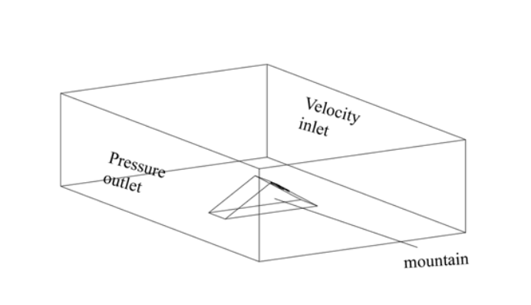
Figure 1 the model in mountainous conditions^{[5]}
In practice, flexible PV systems are often arranged in multi-row arrays, where aerodynamic interference becomes significant. Jubayer et al.^{[6]} and Zhang et al.^{[7]} showed that the first row experiences substantially higher wind loads than subsequent rows, and row spacing controls interference intensity. Wind tunnel tests by Ma et al.^{[8]} confirmed shielding effects from upstream rows, with pronounced variation in the first three rows and stabilization beyond the fourth. Similar trends were observed in marine applications^{[9]}. Zhang et al.^{[5]} further demonstrated the influence of terrain and ground clearance on array wind loads.
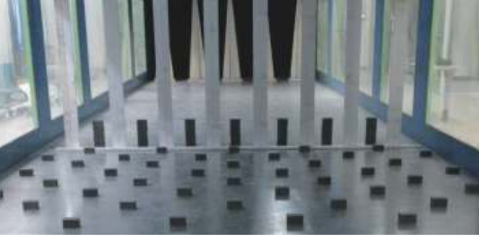 | 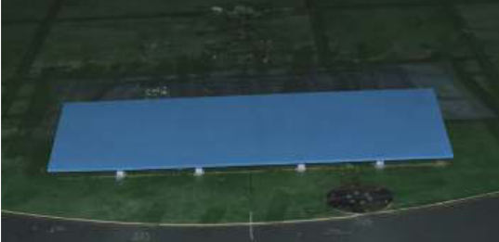
（a）Wind farm layout | （b）Photovoltaic installation diagram
Figure 2 Wind tunnel test photo^{[8]}
For large-scale arrays, Li et al.^{[10]} found that central panels in the first row exhibit higher shape coefficients than edge panels, and central regions generally experience higher loads. Array length and width had limited influence on unfavorable load distribution. Lou et al.^{[11]} reported that shielding effects increase with upstream row number and stabilize beyond 12 rows. Yemenici et al.^{[12]} proposed estimation formulas for wind load coefficients based on vortex shedding characteristics.

1.2 Wind-Induced Dynamic Response of Flexible PV Support Systems
Due to high flexibility and low damping, flexible PV supports are prone to significant dynamic responses and possible aeroelastic instability under wind excitation. Accurate characterization of wind-induced vibration is essential for safety assessment and design.
Wind tunnel aeroelastic tests have been widely conducted. Tamura et al.^{[13]} reported sudden increases in fluctuating displacement at specific wind directions and highlighted the influence of sag and span on aeroelastic stability. Kim et al.^{[14,15]} showed that vibration response is sensitive to panel shape, inflow condition, and wind direction, with instability occurring under high wind speeds and certain angles. Xu et al.^{[16]} found that aerodynamic damping decreases with wind speed and may become negative at high speeds; increasing cable tension enhances stiffness but may reduce damping. Xu et al.^{[17]} observed that small-tilt systems are dominated by vertical vibration, which increases with tilt angle and decreases with pre-tension. Ayodeji et al.^{[18]} noted potential fatigue under sustained high winds.
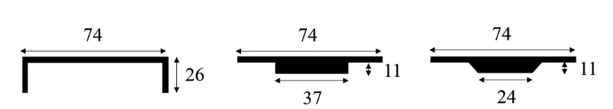
Figure 3 Panel shapes^{[14]}
For array systems, Cai et al.^{[19]} identified buffeting as the dominant response, with torsional effects increasing along the span and modal energy shifting toward higher modes as row numbers increase. Wang et al.^{[20]} showed that edge and leading-row panels experience larger displacements, and that pre-tension, tilt angle, and longitudinal and transverse connections significantly influence stability.
Numerical simulations further clarified parameter effects. He et al.^{[21]} indicated that cable pre-tension and diameter control the ultimate capacity of double-layer systems. Zhao et al.^{[22]} and Wang et al.^{[23]} emphasized the importance of spatial correlation in fluctuating wind loads, noting that neglecting it may underestimate responses. Zhu et al.^{[24,25]} employed two-way fluid–structure interaction analysis and found that tilt angle strongly affects internal force vibration coefficients. Increasing pre-tension reduces natural period and reaction vibration coefficients but may increase displacement response. Du et al.^{[26]} showed that displacement is more sensitive to wind speed than cable force. Zhou et al.^{[27]} demonstrated that higher pre-tension improves reliability and reduces deflection.
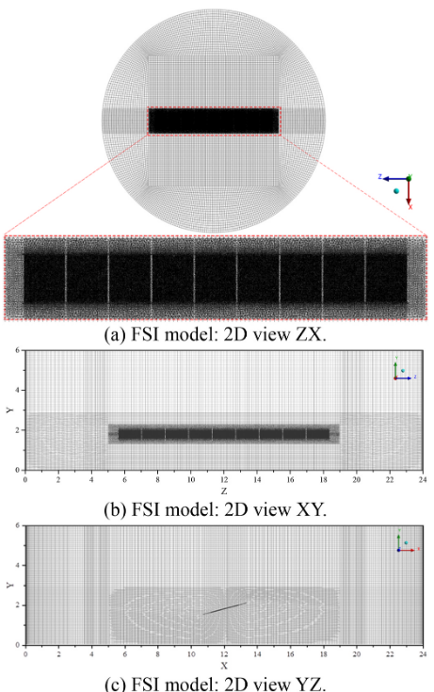
Figure 4 Fluid domain mesh at a panel tilt angle of 15◦^{[25]}

1.3 Summary
Existing studies have clarified wind load distributions and dynamic response characteristics under different configurations, identifying tilt angle, pre-tension, row spacing, and array scale as key parameters. Combined wind tunnel and numerical approaches provide a basis for design. However, understanding of aerodynamic interference in large arrays, nonlinear fluid–structure interaction, and responses under complex environments remains limited. Further multi-scale analysis and field validation are required to support safe design and performance optimization.
- Research Progress on Wind-Resistance Enhancement of Flexible Photovoltaic Support Systems
With the increasing application of flexible photovoltaic (PV) supports in long-span and multi-row array projects, vibration amplification and instability under strong winds have become prominent. Compared with rigid systems, flexible supports exhibit high flexibility, low damping, and pronounced geometric nonlinearity. Wind-resistant design therefore requires integrated optimization of aerodynamic behavior, structural configuration, and supplemental energy dissipation rather than simple strength enhancement. Current studies focus on aerodynamic optimization, structural improvement, and damping control.

2.1 Aerodynamic Optimization
Aerodynamic optimization aims to improve flow patterns and aeroelastic stability by adjusting tilt angles and adding flow-guiding devices. Studies indicate that tilt angle and pre-tension strongly influence aerodynamic response. Xu et al^{.[17]} reported that small-tilt systems are dominated by vertical vibration, which increases with tilt angle and decreases with pre-tension. Chen et al.^{[28]} analyzed flutter stability margins and found significant variation with tilt angle, with the lowest margin at 10°, indicating strong aerodynamic sensitivity.
Li et al.^{[29]} improved flow conditions by installing a central stabilizing plate, increasing the critical flutter wind speed. For double-layer cable systems and additional stabilizing components, Zou et al.^{[30]} showed that tilt angle significantly affects along-wind vibration. Gao et al.^{[31]} demonstrated that stabilizing cables enhance system integrity and suppress wake-induced vibration and flutter. However, Wu et al.^{[32]} found that increasing initial cable tension has limited effect on critical wind speed, suggesting that pre-tension alone cannot substantially improve aeroelastic stability. Wang et al.^{[33]} noted that insufficient vertical and torsional stiffness in some new systems may lead to amplified responses under strong winds.
Overall, aerodynamic measures can improve stability within specific parameter ranges, but their effectiveness depends on tilt angle, inflow condition, and configuration. Unified design guidelines remain limited.
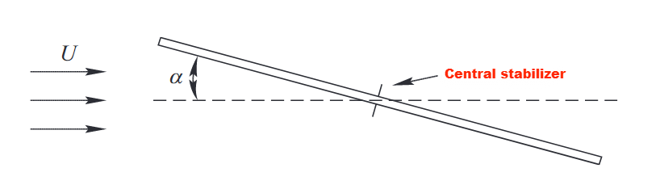
Figure 5 Central stabilizer^{[29]}

2.2 Structural Optimization
Structural optimization enhances global stiffness and vibration coordination through system reconfiguration and component strengthening. Flexible PV supports have evolved from single-layer cable systems to double-layer and multi-layer systems with stabilizing cables, improving span capacity and stability.
For single-layer systems, Wang et al.^{[23]} showed that vertical rigid members effectively coordinate cable vibration and reduce displacements. Song et al.^{[34]} found that adding wind-resistant cables significantly reduces vibration. Zhu et al.^{[24]} demonstrated through fluid–structure interaction analysis that appropriate ground anchorage reduces displacement response, with anchor stiffness ratio as a key parameter. He et al.^{[17]} proposed a three-cable system with an inverted triangular frame, which increases stiffness under large displacement and enhances torsional resistance under strong winds.
Regarding cable arrangements, Liu^{[35]} proposed two anti-wind cable layouts, with the reverse-curvature stabilizing cable providing better performance. Ding et al.^{[36]} showed that upstream shielding in double-layer systems reduces downstream vibration by about 50%. Liu et al.^{[37]} confirmed through experimental models that transverse and cross-bracing connections effectively suppress torsional motion^{[38–40]}. Modifications to cable truss configurations also improve natural frequency and torsional stiffness, though optimal parameters remain unclear.
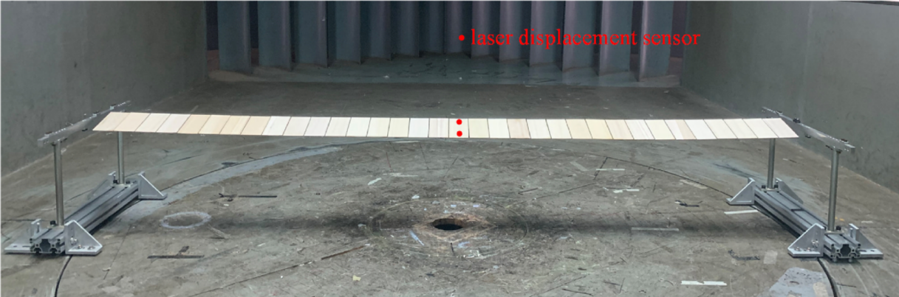
Figure 6 Aerodynamic model wind tunnel test^{[37]}
Engineering practice indicates that adjusting pre-stress and system stiffness can reduce vibration-induced panel cracking^{[41]}. Wang et al.^{[20]} showed that increasing pre-tension and optimizing longitudinal and transverse connections reduce displacement and flutter risk. Structural optimization effectively enhances stiffness and coordination, but unified evaluation methods and systematic parameter design are still lacking.

2.3 Supplemental Damping Control
Compared with aerodynamic and structural approaches, damping control remains limited in application. Constraints from lightweight requirements and cost restrict the use of damping devices.
Watwe et al.^{[42]} showed that hydraulic dampers reduce galloping in single-axis PV systems. Du^{[43]} investigated single and multiple tuned mass dampers (STMD and MTMD) for single-row flexible supports, reporting vibration reduction rates exceeding 20%, with optimal placement at mid-span. These results demonstrate the effectiveness of mass dampers for vibration mitigation.
Although damping control shows theoretical potential, research on multi-row, large-span arrays remains limited, particularly regarding device layout, mass ratio selection, and long-term reliability. Development of lightweight and adaptable damping systems is needed for practical application.
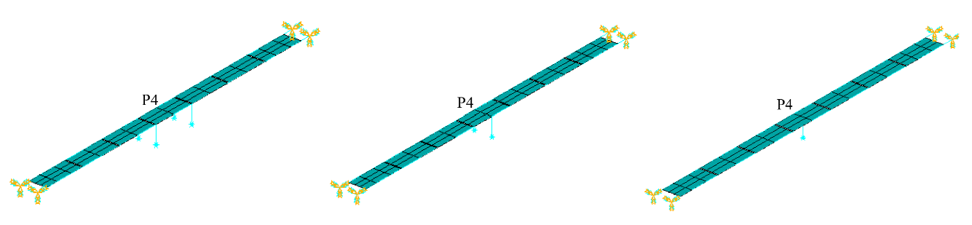
Figure 7 TMD installation location diagram^{[43]}

2.4 Summary
Wind-resistance enhancement studies have explored aerodynamic optimization, structural improvement, and supplemental damping control. Aerodynamic measures improve local flow stability, structural optimization increases global stiffness and coordination, and damping control offers vibration reduction potential. However, most studies focus on single strategies, and integrated optimization frameworks and unified design criteria for large-scale arrays are still lacking.
- Research Progress on Engineering Implementation and Structural Monitoring
Flexible photovoltaic (PV) support systems are widely applied in tidal flats, mountainous areas, mining backfill zones, and water surfaces. These projects involve long spans, complex prestressing systems, and high construction precision. Beyond design, construction control and operational monitoring directly affect structural safety and durability. Recent studies have extended from construction practice to digital construction and intelligent operation, though development remains experience-based.

3.1 Key Construction Technologies
Most studies summarize construction challenges based on specific projects.
For water surfaces and wastewater facilities, Wang^{[44]} detailed construction organization and tension control for cross-pool cable systems. Bai^{[45]} proposed a suspension-type support system for fishery–PV projects and specified fabrication and installation requirements. Zhao^{[46]} summarized construction procedures for agro–PV projects, emphasizing the importance of prestressing sequence and geometric control.
In tidal flats and complex terrain, construction organization becomes more critical. Liu et al.^{[47]} reported low automation levels in tidal PV projects and proposed an integrated construction system covering foundation, columns, supports, and modules. Lu^{[48]} and Tian et al.^{[49]} suggested flexible rod techniques and zoned precision control for mountainous and steep sites. Zhang et al.^{[50]} highlighted the need for multidisciplinary coordination to meet precision demands. Yang et al.^{[51]} and Gou^{[52]} addressed double-column installation accuracy and cable anchorage in mining areas.
In digital construction, Dong et al.^{[53]} developed a BIM library for building-integrated PV systems to support forward design. Koo et al.^{[54]} proposed an integrated multi-objective optimization (iMOO) model for rooftop PV planning, demonstrating the role of digital tools in design and construction management.
For risk management, Dong and Hou^{[55]} established a Bayesian network based on the Leaky Noisy-or Gate model and identified material and equipment quality as key risk factors. However, systematic research on prestress system failure, cumulative tension errors, and construction-stage structural safety remains limited.
Overall, construction studies indicate that prestress control and geometric accuracy significantly affect performance, complex terrain increases organizational demands, and automation and precision require further improvement.
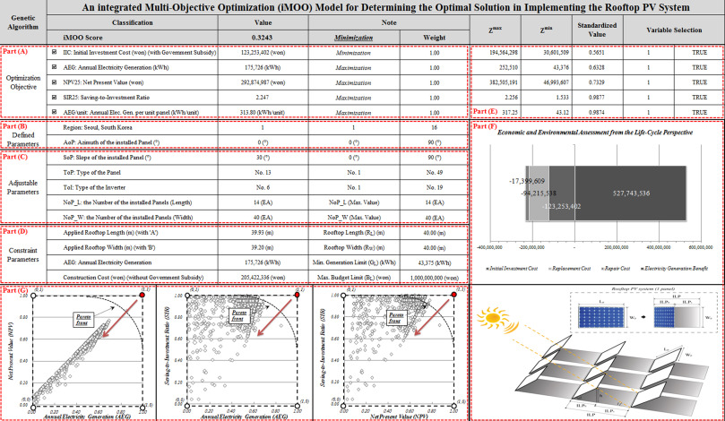
Figure. 8 Graphical user interface of the iMOO model^{[54]}

3.2 Structural Monitoring and Early Warning
Due to hinngh flexibility and low damping, flexible PV systems are sensitive to wind-induced vibration. Operational monitoring is therefore essential for long-term safety. Current research focuses on module condition detection and monitoring platform development.
For module diagnostics, Wang et al.^{[56]} used infrared imaging to assess surface temperature distribution. Yang^{[57]} applied K-means and SVM for hotspot detection. Segovia et al.^{[58]} employed convolutional neural networks for automated thermal image analysis. Jia et al.^{[59]} developed a multi-sensor fault localization system using an improved BP neural network. These approaches show effectiveness but rely mainly on conventional machine learning methods with limited adaptability.
For monitoring platforms, Hai et al.^{[60]} developed a cloud-based system using a GA-Elman neural network for prediction. Han et al.^{[61]} built a low-power long-range monitoring system based on LoRa technology. While IoT and cloud computing enhance operation management, most platforms use single-architecture frameworks with limited integration and scalability.
Research on long-term monitoring of structural vibration, cable force variation, and key node stresses remains insufficient. Systematic studies on vibration data filtering, lightweight predictive models, and multi-source data fusion are still needed.
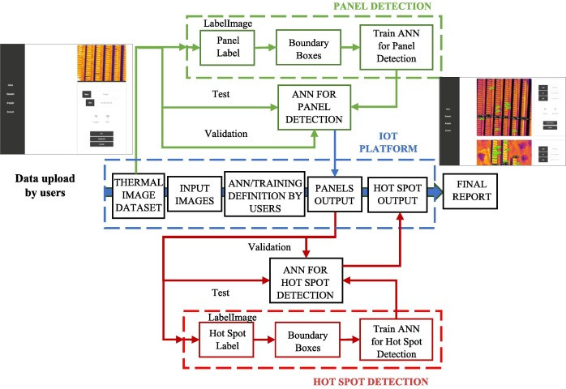
Figure. 9 Graphical user interface of the iMOO model^{[58]}

3.3 Summary
Research on engineering implementation and monitoring has advanced in construction practice, digital methods, and intelligent operation. Prestress control and terrain adaptability are recognized as critical in construction, and image-based and IoT monitoring systems have been introduced. However, systematic construction control, long-term structural health monitoring, and integrated multi-source early-warning models remain underdeveloped. Integrated management of construction and operational monitoring is a key direction for future research.
- Conclusions
(1) In terms of wind-induced response, existing studies have clarified wind load distribution and dynamic behavior under varying tilt angles, pre-tension levels, and array configurations, identifying tilt angle, cable force, and row spacing as key parameters. However, the overall response mechanisms of large-scale arrays, particularly aerodynamic interference and nonlinear fluid–structure interaction, require further investigation.
(2) Regarding wind-resistance enhancement, aerodynamic optimization and structural system improvement have been shown to increase stiffness and stability margins, and supplemental damping demonstrates vibration reduction potential. Nevertheless, integrated multi-strategy optimization and unified design criteria remain undeveloped, limiting practical application.
(3) For engineering implementation and monitoring, construction practices are advancing toward higher precision and digitalization, and monitoring technologies support intelligent operation. However, systematic construction control and long-term structural health monitoring are not yet fully established, and an integrated construction–operation safety framework is still needed.

References
[1] CHEN F, ZHU Y, WANG W, et al. A review on aerodynamic characteristics and wind-induced response of flexible support photovoltaic system[J]. Atmosphere, 2023, 14(4): 731.
[2] MA W Y, CHAI X B, ZHAO H Y, et al. Study on distribution coefficient of flexible support cable based on eccentric wind load distribution model[J]. Journal of Vibration and Shock, 2021, 40(12): 305-310.
[3] MA W Y, CHAI X B, MA C C. Experimental study on influencing factors of wind load on flexible supported photovoltaic modules[J]. Acta Energiae Solaris Sinica, 2021, 42(11): 10-18.
[4] MA W Y, CHAI X B, GAO F, et al. Axial force analysis of flexible photovoltaic support cables under wind load[J]. Journal of Vibration, Measurement & Diagnosis, 2023, 43(2): 271-276, 408.
[5] ZHANG Y, LOU Y. Study of wind load influencing factors of flexibly supported photovoltaic panels[J]. Buildings, 2024, 14(6): 1677.
[6] JUBAYER C M, HANGAN H. A numerical approach to the investigation of wind loading on an array of ground mounted solar photovoltaic (PV) panels[J]. Journal of Wind Engineering and Industrial Aerodynamics, 2016, 153: 60-70.
[7] ZHANG C, HUANG X D, TAO T, et al. Study on wind-induced vibration characteristics of photovoltaic support system based on fluid-structure interaction simulation[J]. Acta Energiae Solaris Sinica, 2017, 38(9): 2418-2425.
[8] MA W Y, MA C C, WANG C Y, et al. Wind tunnel experimental study on the wind load interference effect of solar panel arrays[J]. Journal of Experiments in Fluid Mechanics, 2021, 35(4): 19-25.
[9] MA J Y, CHEN Z G, FENG Y K. Numerical simulation of wind load on marine solar photovoltaic flexible support[J]. Ship Engineering, 2024, 46(7): 66-73.
[10] LI J, HONG G, XU H. Wind load effects and gust loading factor for cable-suspended photovoltaic structures[J]. Energies, 2023, 17(1): 38.
[11] LOU W J, SHAN H Y, YANG Z, et al. Study on shielding effect of shape coefficients of ultra-large array photovoltaic panels[J]. Journal of Building Structures, 2021, 42(5): 47-54.
[12] YEMENICI O, AKSOY M. An experimental and numerical study of wind effects on a ground-mounted solar panel at different panel tilt angles and wind directions[J]. Journal of Wind Engineering and Industrial Aerodynamics, 2021, 213: 104630.
[13] TAMURA Y, KIM Y C, YOSHIDA A, et al. Wind-induced vibration experiment on solar wing[J]. MATEC Web of Conferences, 2015, 24: 04006.
[14] KIM Y C, SHAN W, YANG Q S, et al. Effect of panel shapes on wind-induced vibrations of solar wing system under various wind environments[J]. Journal of Structural Engineering, 2020, 146(6): 04020104.
[15] KIM Y, TAMURA Y, YOSHIDA A, et al. Experimental investigation of aerodynamic vibrations of solar wing system[J]. Advances in Structural Engineering, 2018, 21(15): 2217-2226.
[16] XU H W, LI J L, HE X F, et al. Experimental study on aerodynamic damping of large-span single-layer flexible photovoltaic support structures[J]. Journal of Vibration and Shock, 2024, 43(10): 21-29.
[17] XU H, DING K, SHEN G, et al. Experimental investigation on wind-induced vibration of photovoltaic modules supported by suspension cables[J]. Engineering Structures, 2024, 299: 117125.
[18] ABIOLA-OGEDENGBE A, HANGAN H, SIDDIQUI K. Experimental investigation of wind effects on a standalone photovoltaic (PV) module[J]. Renewable Energy, 2015, 78: 657-665.
[19] CAI Q, KE S, WANG L, et al. Evolution of wind-induced vibration form of large-span flexible PV aeroelastic arrays[J]. Solar Energy, 2024, 277: 112684.
[20] WANG W, CAO J X, CAO S Y. Study on wind-induced vibration characteristics of array flexible photovoltaic systems[J/OL]. Engineering Mechanics: 1-9 (2024-04-08).https://link.cnki.net/urlid/11.2595.O3.20240407.1148.002.
[21] HE X H, DING H, JING H Q, et al. Mechanical characteristics of a new type of cable-supported photovoltaic module system[J]. Solar Energy, 2021, 226: 408-420.
[22] ZHAO Z X, WANG P, WANG Y H, et al. Dynamic response analysis of prestressed double-layer cable flexible photovoltaic supports under fluctuating wind loads[J]. Steel Construction, 2024: 1-12.
[23] WANG Z G, ZHAO F F, JI C M, et al. Wind-induced vibration analysis of multi-row and multi-span flexible photovoltaic supports[J]. Engineering Journal of Wuhan University, 2021, 54(S2): 75-79.
[24] ZHU Y F, HUANG Y, XU C, et al. Effect of tilt angle on wind-induced vibration in pre-stressed flexible cable-supported photovoltaic systems[J]. Solar Energy, 2024, 277: 112729.
[25] ZHU Y F, HUANG Y, GUO Y, et al. Numerical assessment of the initial pre-tension impact on wind-induced vibration in flexible cable-supported photovoltaic systems[J]. Journal of Wind Engineering and Industrial Aerodynamics, 2024, 251: 105788.
[26] DU H, XU H W, ZHANG Y L, et al. Wind pressure characteristics and wind-induced vibration response of large-span flexible photovoltaic support structures[J]. Journal of Harbin Institute of Technology, 2022, 54(10): 67-74.
[27] ZHOU R, WANG H, XU Z D, et al. Wind resistance reliability assessment of flexible photovoltaic supports in wind-prone areas[J]. Journal of Southeast University (Natural Science Edition), 2024, 54(4): 845-851.
[28] CHEN Q, NIU H W, LI H X, et al. Study on aerodynamic stability and interference effects of flexible photovoltaic supports based on aeroelastic model wind tunnel tests[J]. Journal of Building Structures, 2023, 44(11): 153-161.
[29] LI S Y, MA J, LIU J Q, et al. Sectional model experimental study on flutter performance of flexible photovoltaic systems[J]. China Civil Engineering Journal, 2024, 57(2): 25-34.
[30] ZOU L H, WANG J, SONG J, et al. Analysis of wind-induced vibration response characteristics of multi-span double-layer cable-supported photovoltaic support structures[J]. Journal of Southeast University (English Edition), 2025, 41(1): 37-43.
[31] GAO Y F, LI S Y, LIU J Q, et al. Research on wind-induced response and vibration suppression measures of flexible photovoltaic support arrays based on aeroelastic model wind tunnel tests[J]. Acta Energiae Solaris Sinica, 2025, 46(3): 394-403.
[32] WU Y, WU Y, SUN Y, et al. Wind-induced vibration response and suppression of the cable-truss flexible support photovoltaic module array[J]. Solar Energy, 2024, 284: 113096.
[33] WANG J, LI S Y, XUE J Z, et al. Mechanical performance analysis and design of offshore large-span flexible photovoltaic structure system[J]. Building Structure, 2025, 55(20): 7-13.
[34] SONG Y M, YUAN H X, DU X X, et al. Study on static and dynamic responses of single-layer cable flexible photovoltaic supports[J]. Building Structure, 2025, 55(11): 24-30.
[35] LIU Z C. Mechanical performance of flexible photovoltaic supports with elastic wind-resistant cables[D]. Nanjing: Southeast University, 2022.
[36] DING H, HE X, JING H, et al. Shielding and wind direction effects on wind-induced response of cable-supported photovoltaic array[J]. Engineering Structures, 2024, 309: 118064.
[37] LIU J, LI S, CHEN Z. Experimental study on effect factors of wind-induced response of flexible photovoltaic support structure[J]. Ocean Engineering, 2024, 307: 118199.
[38] YANG C X, ZHANG Z J, CUI H Z, et al. Analysis of natural vibration characteristics and seismic time-history response of cable-truss flexible photovoltaic support structures[J]. Building Structure, 2023, 53(S1): 722-729.
[39] LEI Z H. Experimental study on wind-induced vibration characteristics and control of large-span cable-supported photovoltaic support structures[D]. Changsha: Central South University, 2023.
[40] LOU Y, ZHANG J, PAN Y. Static and dynamic response analysis of flexible photovoltaic mounts[J]. Buildings, 2024, 14(7): 2037.
[41] CUI H B. Research on structural design of fish-belly cable flexible support system[J]. Innovation and Application of Science and Technology, 2024, 14(11): 23-27.
[42] WATWE N H, KARTIK V. Damping of wind-induced galloping oscillations of solar trackers[C]// SEN D, MOHAN S, ANANTHASURESH G K. Mechanism and Machine Science. Singapore: Springer, 2021: 511-523.
[43] DU H. Wind-induced effects and control of large-span flexible photovoltaic support structures[D]. Hangzhou: Zhejiang University, 2024.
[44] WANG J P. Discussion on construction technology of flexible photovoltaic support and photovoltaic modules in Cangzhou Sewage Treatment Plant[J]. Green Environmental Protection Building Materials, 2019(10): 123-124.
[45] BAI R L. Application research of new suspension cable support system in fishery-photovoltaic complementary project[J]. Solar Energy, 2022(10): 74-78.
[46] ZHAO Y. Analysis of construction methods for flexible photovoltaic supports[J]. Solar Energy, 2023(10): 75-80.
[47] LIU L Z, LI H F, YAN J Y, et al. Research on technology status and development trend of foundation-support system of photovoltaic power station in tidal flat area[J]. Water Resources and Hydropower Engineering, 2023, 54(S2): 431-438.
[48] LU Q. Discussion on construction difficulties and countermeasures in mountainous photovoltaic areas[J]. Yellow River, 2023, 45(S1): 175, 177.
[49] TIAN C, LI W, LIN J C. Research on construction method of flexible photovoltaic supports in complex terrain with large slope[J]. Hongshui River, 2024, 43(4): 110-114.
[50] ZHANG D D, FAN X L, ZHANG B, et al. Design scheme and construction technology of flexible photovoltaic supports in mountainous areas[J]. China Construction Metal Structure, 2023, 22(10): 22-24.
[51] YANG Y M, LI P H, WU Z W. Research and application of key construction technologies for photovoltaic support systems in coal mine backfill areas[J]. Installation, 2024(S1): 184-185.
[52] GOU H. Advantages and construction technology of flexible steel cable supports for solar photovoltaic power stations[J]. China High-Tech, 2024(16): 88-90.
[53] DONG Y K, LIU L J, FAN X Y, et al. Application research of CIGS photovoltaic BIM family library in building integrated photovoltaic design[J]. Architectural Journal, 2019(S2): 48-51.
[54] KOO C, HONG T, LEE M, et al. An integrated multi-objective optimization model for determining the optimal solution in implementing the rooftop photovoltaic system[J]. Renewable and Sustainable Energy Reviews, 2016, 57: 822-837.
[55] DONG H S, HOU X L. Construction risk assessment method for photovoltaic power generation projects based on Leaky Noisy-or Gate and Bayesian network[J]. Science Technology and Industry, 2023, 23(2): 218-223.
[56] WANG P Z, ZHENG S C. Fault analysis of solar photovoltaic array based on infrared image[J]. Acta Energiae Solaris Sinica, 2010, 31(2): 197-202.
[57] YANG Y N. Research and implementation of solar photovoltaic array identification and hot spot detection technology[D]. Nanjing: Nanjing University of Posts and Telecommunications, 2019.
[58] SEGOVIA RAMÍREZ I, GARCÍA MÁRQUEZ F P, PARRA CHAPARRO J. Convolutional neural networks and Internet of Things for fault detection by aerial monitoring of photovoltaic solar plants[J]. Measurement, 2024, 234: 114861.
[59] JIA R, LI Y Q, ZHANG H Z, et al. Multi-sensor fault detection and location method for photovoltaic array based on improved BP neural network[J]. Acta Energiae Solaris Sinica, 2018, 39(1): 110-116.
[60] HAI T, XIAO J L, WEI W, et al. Monitoring and power prediction system of photovoltaic power station based on cloud platform[J]. Journal of Guilin University of Technology, 2022, 42(1): 249-255.
[61] HAN W Z, YAO X D, HUANG X H. Photovoltaic power station monitoring system based on LoRa[J]. Instrument Technique and Sensor, 2020(6): 59-62.

