NUMERICAL SIMULATION OF WAX PIGGING OPERATIONS IN CRUDE OIL PIPELINES OF X FIELD IN THE NIGER DELTA FIELD

Abstract
Wax buildup in Niger Delta crude oil pipelines is a major challenge that often leads to expensive blockages. This study looked at a 19.4 km pipeline in the region to demonstrate how simulation tools can take the guesswork out of planning pigging schedules. Analysis in Multiflash showed that the crude has a Wax Appearance Temperature (WAT) of 48 °C and a wax content of 1.2%. Steady state simulations with PIPESIM revealed a critical detail: while pressure remains stable, the oil cools below the WAT just 0.5 km from the inlet. This means wax settles along nearly the entire length of the pipe. By using OLGA software for dynamic simulations, it became clear that about 75 kg of wax accumulates every month, making a 30-day pigging cycle the most effective choice for this pipeline. The study also demonstrated that a pig speed of 0.12 m/s is ideal, resulting in a 40-hour travel time. Ultimately, combining these simulation tools provides a reliable way to predict wax behavior and keep pipeline operations running safely and efficiently.
Keywords: wax treatment; waxy crude; pigging operation; wax models; flow assurance.

1.0 INTRODUCTION
The main components found in crude oil are paraffins, naphthenes and polycyclic aromatic hydrocarbons (Ahmad et al., 2020). Other ways to classify these components include saturated hydrocarbons, aromatic hydrocarbons, asphaltenes and colloids (Yu et al., 2020). Generally, petroleum waxes fall into two groups - paraffin wax and microcrystalline wax. Paraffin waxes are made of straight chain saturated hydrocarbons ranging from C₁₈ to C₃₆, while microcrystalline waxes consist of branched and cyclic hydrocarbons from C₃₀ to C₆₀ (Ismail et al., 2015). Many crude oils around the world contain a significant amount of wax, anywhere from 3% to 44%, which starts to crystallize during production, transport and storage (Rehan et al., 2016). These waxy oils cause real problems in the field by restricting flow, increasing the thickness or viscosity of the oil, and causing wax to settle during shutdowns (Tordal, 2006).
Under normal reservoir conditions, high temperatures and pressures keep wax molecules dissolved in the oil. However, once the temperature of the mixture drops below the solubility limit, also called the Cloud Point, solid particles begin to form (Sousa, 2016); this makes temperature variation the primary factor in wax formation (Rehan et al., 2016). As crude oil moves through a pipeline, the temperature drops, and the heat loss lessens the kinetic energy thereby reducing molecular motion. Thus, making it easier for wax molecules to cluster together. When this condition is not managed properly, it can lead to a total blockage of both wells and pipelines (Thota and Onyeanuna, 2016; Chinwuba et al., 2015). We see wax start to settle as a solid phase whenever the bulk temperature of the oil falls below the Wax Appearance Temperature (Joshi, 2017; Mohammad et al., 2022). Wax deposition is a major hazard in the daily work of producing and moving crude oil. It is a tough challenge for the petroleum industry because millions of dollars are spent every year just to deal with wax buildup. This makes removing those deposits essential, not just to keep the oil flowing, but also to keep production costs down (Jiang et al., 2020). Wax deposition is a serious threat to production (Li et al., 2020; Aiyejina et al., 2011). When wax clogs a pipe, it reduces the diameter and changes how the fluid behaves, which forces pumps to work harder and uses more energy. This ultimately cuts into profits and can even lead to a permanent facility shutdown (Onwumelu et al., 2022). Since the petroleum industry took off in the 19th century, engineers have had to find ways to balance costs while keeping production high. Pipelines are the safest and cheapest way to move hydrocarbons over long distances, but they naturally gather deposits like rust and wax over time (Giro et al., 2022). While there are other ways to prevent wax like using chemicals or thermal insulation, pigging remains the most important method (Jalalnezhad and Kamali, 2016). Pigging operation is mostly used to clear out dirt and paraffin wax from the inside of oil pipes without having to stop the flow of oil (Mushiri et al., 2016). Most pigs feature small bypass holes that allow liquid to flush through and help disperse the removed wax (Li et al., 2020). The frequency of this operation depends on the oil's wax content; waxy oil pipelines require much more frequent cleaning than gas lines (Gupta and Sircar, 2016). The speed of a pig is very important in pigging operation; If it moves too slowly, the operation becomes inefficient (Esmaeilzadeh et al., 2006). If it moves too fast, it can damage the pig or the pipe itself, and we might miss important inspection data. Thus, it is necessary to analyze and predict how a pig moves before the operation begins. Being able to accurately estimate speed and position helps operators stay in control and lowers the risks involved in pipeline work (Zhang et al., 2020). Modeling this process is complicated because it touches on several different fields like chemistry, thermodynamics and fluid mechanics.
To model wax deposition accurately, we have to understand how wax moves from the main flow of the fluid to the pipe wall. This is modeled by Equation 2.1.
$\frac{{dm}_{m}}{dt}= ρ_{d}D_{m}A\frac{dC}{dr}$ (2.1)
where 𝑚𝑚 is the mass of deposited wax, $ρ_{d}$ is the density, and $D_{m}$ is the diffusion coefficient (Aiyejina et al., 2011).
Several theories explain this transport, such as: molecular diffusion (see, (Aiyejina et al., 2011), shear dispersion, Brownian diffusion, and gravity settling (see, Sousa, 2016; Yao et al., 2021).
For modeling the pig process: since a pig is moved by the pressure difference between its front and back, the motion of a pig is determined by a balance of forces:
$m_{dt}^{{dV}_{pig}}=\left(P_{1}- P_{2}\right)A- m_{pig} g\sin{β}- F_{c}$ (2.2)
where, ${dV}_{pig}$, is the velocity and $F_{c}$ represents the axial contact force with the pipe wall (Esmaeilzadeh et al., 2009). The contact force can be further broken down using the shrink fit correlation:
$F_{c}= μ_{f}N=2πr_{pig}L_{pig}μ_{f}P_{f}$ (2.3)
$P_{f}= \frac{E_{i}δ}{r_{pig}(1- v_{i})}$ (2.4)
Simulations of pigging operations are cost effective. However, their success depends on accurate fluid data and realistic modeling of the wax under actual operating conditions (Dahwal et al., 2025). This research therefore focuses on conducting a dynamic simulation model for wax deposits and pigging routines using the OLGA simulator. By using these simulations, we can predict exactly how wax will build up and develop a proper schedule for removing it. This work uses numerical methods to simulate these processes with the goal of making pigging operations in X oil pipeline in the Niger Delta as efficient as possible.

2.0 DATA AND METHODOLOGY
There is no public literature on the pigging operations carried out at X oil pipeline. However, information on the pipeline geometry and crude oil properties have been reported by Chinwuba et al. (2015). The pipeline is 19.4 km long with an internal diameter of 10 inches. The crude oil is a waxy type; the detailed molecular composition and physical properties are presented in Table 1.
Table 1: Crude oil composition and physical properties (Chinwuba et al., 2015)
Sample A Component | Separator Oil Composition Mole %
N₂ | 0.15
CO₂ | 0.32
H₂S | 0.00
C₁ | 3.99
C₂ | 0.70
C₃ | 0.13
i-C₄ | 0.12
n-C₄ | 0.14
i-C₅ | 0.24
n-C₅ | 0.24
C₆ | 1.08
C₇ | 1.93
C₈ | 8.06
C₉ | 7.14
C₁₀ | 12.28
C₁₁ | 13.06
C₁₂ | 13.60
C₁₃ | 12.79
C₁₄ | 8.96
C₁₅ | 7.71
C₁₆ | 3.09
C₁₇ | 1.69
C₁₈ | 1.48
C₁₉ | 0.54
C₂₀ | 0.25
C₂₁ | 0.13
C₂₂ | 0.07
C₂₃ | 0.03
C24 | 0.01
C₂₅ | 0.01
C₂₆ | 0.01
C₂₇ | 0.01
C₂₈ | 0.01
C₂₉ | 0.01
C₃₀+ | 0.02
Total | 100.00
M.wt (g/gmol) | 152.11
Density (g/cm³) | 0.806
M.wt C₇+ [g/gmol] | 161.09
Mol% of C₇+ | 92.88

Table 2: Other physical properties (Chinwuba et al., 2015)
Parameter | Method | Value
Base sediment and water (%) | ASTM D97 | <0.01
Copper corrosion | ASTM D130 | Slightly tarnished 1A
Wax content (%) @ 0⁰C | ASTM D5452 | 3.73

The Wax Appearance Temperature (WAT) was determined using Multiflash advanced thermodynamic software, which generated a wax precipitation curve based on the PVT data. Other essential parameters, such as density and molecular weight, were obtained directly from industry standard PVT reports.
OLGA dynamic multiphase flow simulator was used to model the wax deposition and removal processes. For this study, Matzain model in the OLGA software modeled the wax deposition. Tunning the model parameters to align with experimental data from previous studies to ensure accuracy was performed.
The pigging configuration used in the study has an outer diameter (OD) of 249 mm, with 259 mm cups and a total length of 635 mm. It is configured with polyurethane cups and stainless-steel brushes for mechanical scraping.
2.1 Simulation Procedure and Scenarios
The simulation was carried out in several distinct steps to ensure the results were robust:
- Model Construction: We built the 19.4 km pipeline profile in OLGA and defined the boundary conditions (inlet temperature and pressure).
- Scenario Testing: We ran multiple scenarios to see how different operating conditions—specifically varying inlet temperatures and flow rates—affected the rate of wax buildup.
- Pigging Execution: Once a significant wax layer was established, we triggered the pigging model to evaluate how effectively it cleared the line.
- Data Analysis: We calculated the wax deposition rates and determined the "optimal pigging frequency" by looking at when the wax buildup began to significantly restrict flow or increase pressure drop.

3.0 RESULTS AND DISCUSSION
Results of the fluid behavior, pressure and temperature profiles of the pipeline, and pigging performances are presented.
3.1 Phase Envelope Analysis
The first step in any flow assurance study is understanding how the produced fluid behaves under different conditions. The phase envelope describes the regions where the fluid exists as a liquid, gas, or a mixture of both. Figure.1 represents the phase envelope for our sample fluid, showing it to be a multiphase system of oil and gas.
Under reservoir conditions, high pressure keeps the fluid in the liquid phase. however, as it travels through the pipeline and experiences cooling and pressure drops, it crosses into the two-phase region. This transition is critical because it directly influences wax precipitation and gas breakout. By using Multiflash to generate this envelope, we identified the Wax Appearance Temperature (WAT) as approximately 48 °C. Practically, this means that if the pipeline temperature falls below this threshold, the risk of wax deposition increases significantly, making timely pigging essential.
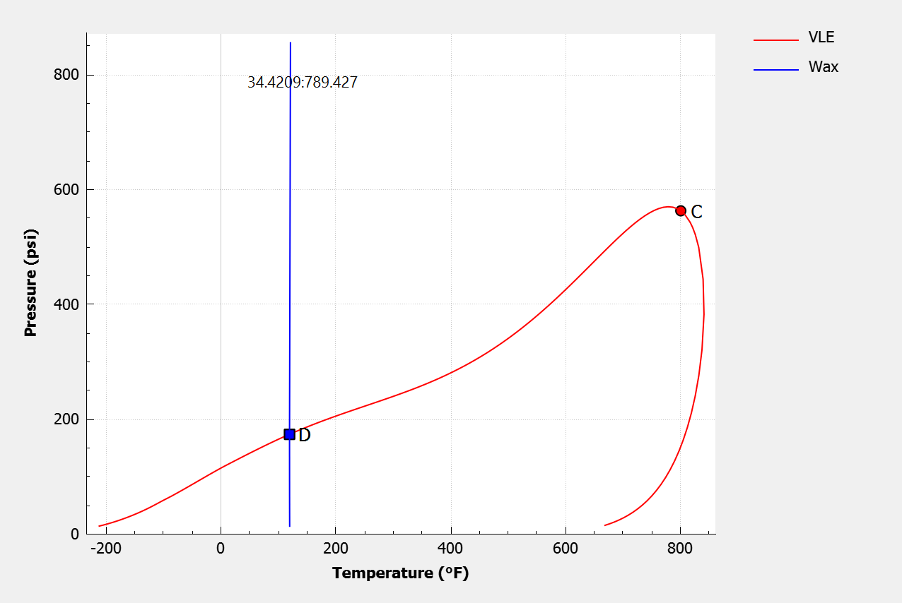
Figure 1: Phase Envelop

3.2 Pressure and Temperature Profiles
We performed a steady state simulation using PIPESIM to map the pipeline's environmental conditions. At an inlet pressure of 80 psi, a temperature of 60 °C, and a flow rate of 400 bbl/day, the pressure drop across the 19.4 km line was remarkably small, falling only to 79.94 psi (Figure 2). This suggests that for shorter pipelines in this field, pressure loss during steady state flow is almost negligible.
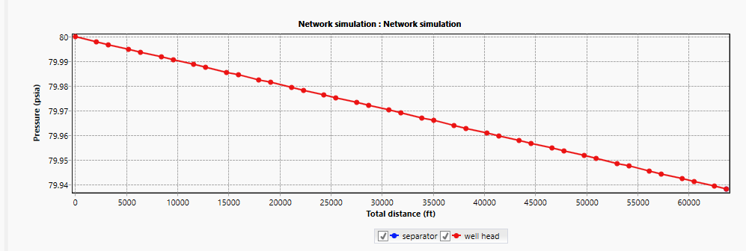
Figure 2: Pressure Profile
In contrast, the temperature profile (Figure 3) shows a steady decline from 60 °C at the inlet to about 15 °C at the outlet. This cooling is expected due to heat loss to the surrounding environment. By comparing this to our phase envelope, we can see that the fluid crosses the 48 °C WAT just 0.5 km into the line. This implies that wax deposition begins almost immediately and occurs along nearly the entire length of the pipeline, confirming findings by Noumo et al. (2021).
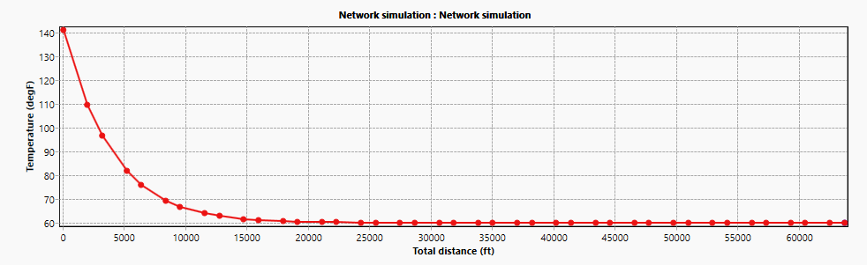
Figure 3: Temperature Profile
3.3 Wax Precipitation and Comparison
The wax precipitation curve (Figure 4) further clarifies the deposition risk. We observed that the maximum possible wax precipitation is about 1.2% by mass at the lowest temperature.
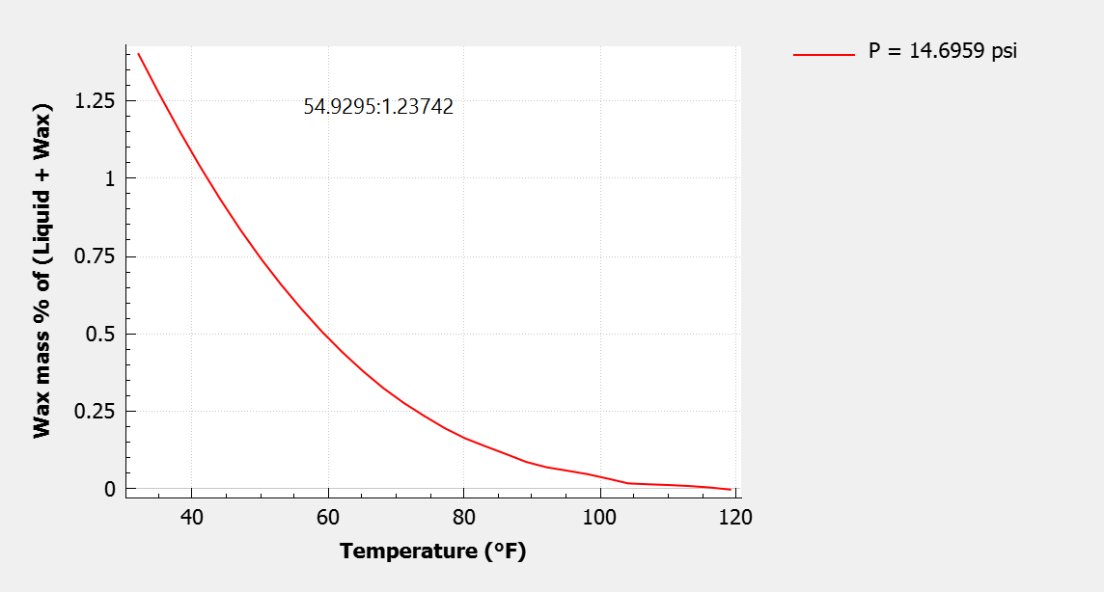
Figure 4: Wax Precipitation Curve
Interestingly, our WAT of 48 °C is lower than the 58–62 °C reported for Sudanese crudes (Mohammed et al., 2022) but aligns well with the 32 °C found in other Niger Delta studies (Joseph et al., 2018). While our calculated wax content of 1.2% is lower than the 3.71% reported by Chinwuba et al. (2015), this variance is likely due to the higher precision of modern simulation software. Despite the lower percentage, the fact that the pipeline operates below the WAT for 97% of its length confirms a high tendency for deposition (Montero, 2020).
3.4 Dynamic Simulation and Pigging Performance
While steady state analysis shows where wax forms, dynamic simulation in OLGA shows how fast it builds up. Figure 5 tracks this growth over time. For instance, following the 30-day pigging cycle recommended by Parameshwar et al. (2015), approximately 75 kg of wax would accumulate in the line.
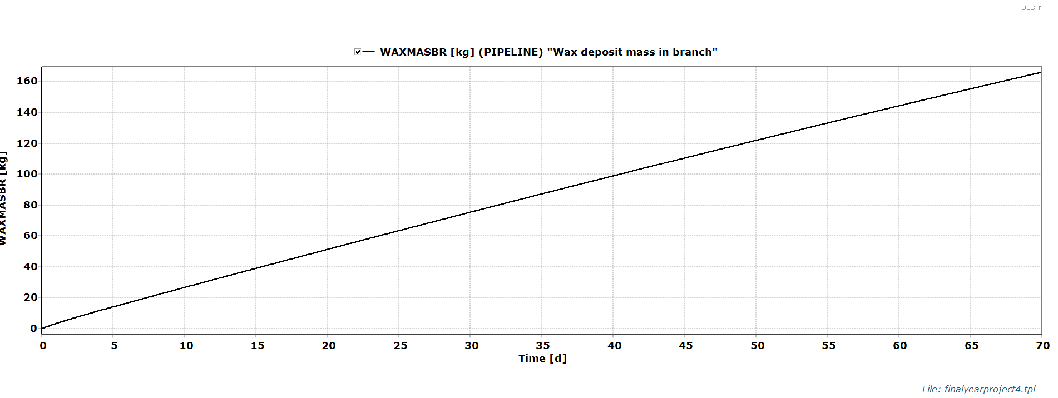
Figure 5: Wax deposition volume
To evaluate remediation, we modeled the pigging performance (Figure 6). The pig was launched 5 hours into the flow at a speed of 3 kg/s and reached the receiver in roughly 40 hours. This results in an average speed of 0.12 m/s, which matches the findings of Gupta and Sircar (2016). This speed is ideal; it is fast enough to avoid getting stuck but slow enough to prevent "hydroplaning" over the wax deposits (Esmaeilzadeh et al., 2006). This 40-hour travel time gives operators a clear window for planning launch and reception activities, ensuring both cleaning efficiency and operational safety.
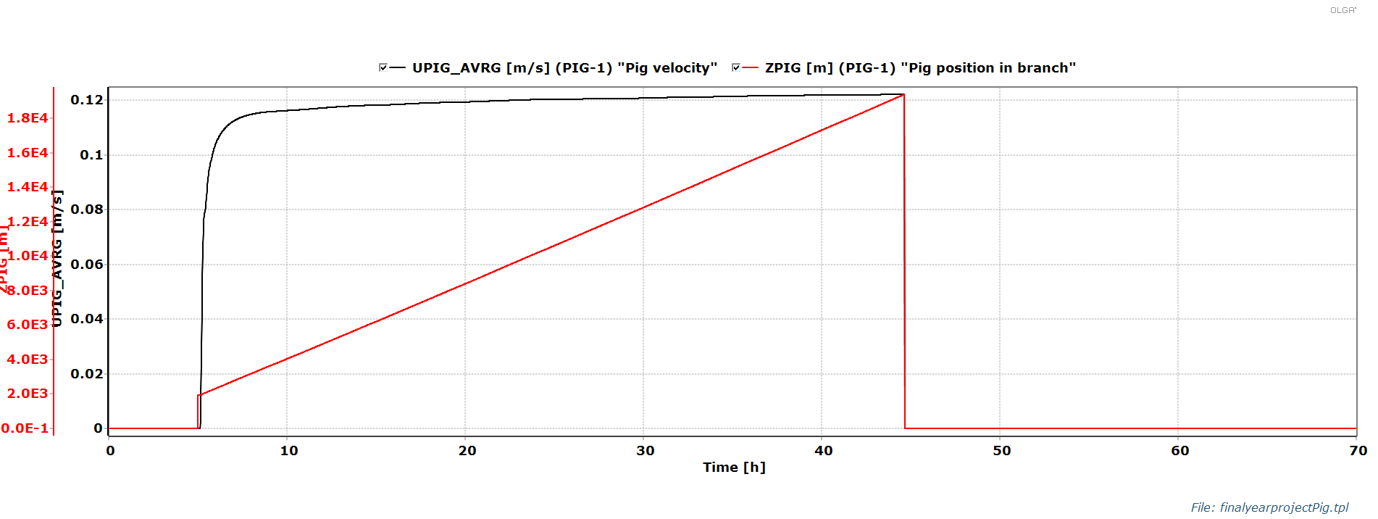
Figure.6: Pigging performance
4.0 CONCLUSION
This research, with a cased study from a Niger Delta crude oil pipeline, demonstrates that integrated numerical simulation is a robust method for managing wax deposition. By coupling thermodynamic characterization with dynamic flow modeling, we successfully identified the operational risks for a waxy crude oil pipeline in X Field.
The study confirms that the crude oil in this field is highly paraffinic, with a Wax Appearance Temperature (WAT) of 48 °C and a wax content of 1.2%. As the 19.4 km pipeline operates below the WAT for nearly its entire length, deposition is inevitable. Our dynamic simulation indicates that a 30-day pigging frequency is required to manage a predicted accumulation of 75 kg of wax. Furthermore, the simulation established that a pigging velocity of 0.12 m/s (taking approximately 40 hours for transit) provides the most effective mechanical cleaning without risking tool stall or bypass.
These findings contribute a field-specific workflow for the Niger Delta that bridges the gap between theoretical modeling and actual field operations. For practical application, it is recommended that operators utilize this integrated simulation approach to optimize pigging schedules. While 0.12 m/s is efficient for cleaning, maintaining a field speed closer to 1.0 m/s may offer a higher safety margin against stalling. Future operations could further enhance flow assurance by combining this mechanical pigging schedule with chemical inhibitors to potentially extend maintenance intervals.

COMPETING INTERESTS DISCLAIMER:
Authors have declared that they have no known competing financial interests OR non-financial interests OR personal relationships that could have appeared to influence the work reported in this paper.

REFERENCES
Ahmad, A. A., Muhammad, I., Shah, T., Kalwar, Q., Zhang, J., Liang, Z., Mei, D., Juanshan, Z., Yan, P., Zhi, D. X. and Rui-Jun, L. (2020). Remediation Methods of Crude Oil Contaminated Soil. World Journal of Agriculture and Soil Science. 4 (3)
Aiyejina, A., Chakrabarti, D. P. and Sastry, A. (2011). Wax formation in oil pipelines: A critical review. International Journal of Multiphase Flow, Vol. 37, No. 3, pp. 671–694.
Alshaikh, A. A., Adam, A. D. A., Saeed, H. A. H. and Mohammed, S. A. (2018). Mitigation of wax crude oil problems in wellbore: Case study: AL- RAWAT Oil Field (R-C10 well). Sudan University of Science and Technology, College of Petroleum Engineering and Technology, Vol. 35, No. 5, pp. 103,134.
Chinwuba, I. K., Vivian, O. C. and Princewill, O. N. (2015). Evaluation of Flow Assurance in Onshore Production Facilities in the Niger Delta. Advances in Research. Vol. 6, No. 2, pp. 1 - 14
Dahwal, S. H., Patel, Z. and Nagar, A. (2025). Modelling of wax deposition for waxycrude oil by ANSYS Fluent. Journal of Petroleum Exploration and Production Technology, Vol. 22, No. 2, pp. 201 - 230.
Esmaeilzadeh, F., Mowla, D. and Asemani, M. (2006). Modeling of pig operations in natural gas and liquid pipeline. SPE Annual Technical Conference and Exhibition, Texas, USA, Vol. 301, No. 2, pp. 301 - 320.
Esmaeilzadeh, F., Mowla, D., and Asemani, M. (2009). Mathematical modeling and simulation of pigging operation in gas and liquid pipelines. Journal of Petroleum Science and Engineering, 69, 100 – 106.
Giro, R., Bernasconi, G., Giunta, G., and Cesari, S. (2022). Online monitoring of inner deposits in crude oil pipelines. SPE Production and Operations, Vol. 11, No. 1, pp. 100 – 123.
Gupta, A. and Sircar, A. (2016). Introduction to pigging and a case study on pigging of an onshore crude oil trunkline. International Journal of Latest Technology in Engineering, Management and Applied Science, Vol. 5, No. 2, pp. 18.
Ismail, A. S. I., Ismail, I., Zoveidavianpoor, M., Mohsin, R., Piroozian, A., Misnan, M. S., Sariman, M. Z. (2015). Experimental Investigation of Oil-Water two-phase flow in horizontal pipes: Pressure losses, liquid holdup and flow patterns. Journal of Petroleum Science and Engineering 127: 409 - 420
Jalalnezhad, M. J. and Kamali, V. (2016). Development of an intelligent model for wax deposition in oil pipeline. Journal of Petroleum Exploration and Production Technology, Vol. 6, No. 1, pp. 129–133.
Jiang, H., Liu, X., Zhao, H., Liu, Y., Ma, C. and Li, X. (2020). Numerical study for removing wax deposition by thermal washing for the waxy crude oil gathering pipeline. Science Progress, Vol. 103, No. 3, pp. 120 – 130.
Joseph, A., Ajienka, J. A. and Essien, E. E. (2018). Waxy Crude Oil Surveillance. European Journal of Engineering and Technology. Vol. 6, No. 2, pp. 10 - 23
Joshi, R. R. (2017). Modeling and simulation of wax deposition in crude oil pipeline. International Journal of Engineering Research and Technology, Vol. 10, No. 1, pp. 0974-3154.
Li, W., Huang, Q., Wang, W., and Gao, X. (2020). Advances and future challenges of wax removal in pipeline pigging operations on crude oil transportation systems. Energy Technology: Generation, Conversion, Storage, Distribution, Vol. 8, No. 6, pp. 23-48.
Mohammed, F. A. M., Elhassan, A. A. and Hajo, A. A. (2022). Flow Assurance, Simulation of Wax Deposition for Rawat Field Using Pipesim Software. World Journal of Advanced Engineering Technology and Sciences. Vol. 7, No. 1, pp. 9 - 22
Montero, F. (2020). Wax Deposition Analysis for Oil and Gas Multiphase Flow in Pipelines. MSc Thesis, Aalborg University Esbjerg, Oil and Gas Technology, Vol. 20, No. 2, pp. 20-39.
Mushiri, T., Ndlovu, S. and Mbohwa, C. (2016). Design of a mechanical cleaning device P.I.G (pipeline intervention gadget) connecting two transfer lines in Zimbabwe. Proceedings of the 2016 International Conference on Industrial Engineering and Operations Management, Vol. 57, No. 2, pp. 34-78.
Nasir, N. A. (2012). Simulation of wax deposition model for many fields. University Technology, Petronas, Tronoh, Perak, Vol. 39, No. 2, pp. 20-
39.
Noumo, P. G., Njomo, D., Nana, K. Z. and Nguewo, L. R. (2021). Numerical Simulation of the Minimum Insulation Thickness to Thermally Design a Subsea Pipeline Carrying an Oil and Gas Flow. International Journal of Heat and Technology. Vol. 39, No. 3, pp. 763 - 774
Onwumelu, D. C., Onwuka, M. K., Nnebeana, S. E., Okoro, T. C., Ekeocha, A. F., Offurum, C. C. and Ndubuisi, V. N. (2022). Crude oil and the problem of wax deposition on pipeline systems during transportation: A review. World Journal of Advanced Research and Reviews, Vol. 15, No. 1, pp. 781–798.
Parameshwar, S., Joshi, R. R. and Babu, M. (2015). Prediction of wax deposition in pipelines using MATLAB simulator: Case study of ABC Field Pipeline. International Journal of Interdisciplinary Research and Innovations, Vol. 3, No. 2, pp. 98 – 107.

Yu, Y., Zhang, Y., Zhao, N., Guo, J., Xu, W., Ma, M. & Li, X. (2020). Remediation of Crude Oil Polluted Soil by the Bacterial Rhizosphere Community of Suaeda Salsa Revealed by 16S rRNA Genes. International Journal of Environmental Research and Public Health. 17, 147.
Rehan, M., Nizami, A. S., Taylan, O., Al-Sasi, B. O. and Demirbas, A. (2016). Determination of wax content in crude oil. Petroleum Science and Technology, Vol. 34, No. 7, pp. 600–605.
Sousa, A. (2016). Numerical simulation of wax deposition in pipelines and wells. Annual Meeting Master of Petroleum Engineering. Vol. 23, No. 1,
pp. 302-320.
Thota, S. T. and Onyeanuna, C. C. (2016). Mitigation of wax in oil pipelines. International Journal of Engineering Research and Reviews, Vol. 4, No. 4, pp. 39–47.
Tordal, A. (2006). Pigging of pipelines with high wax content. Pigging Products and Services Association, Vol. 2, No. 1, pp. 37 – 40.
U.S. Environmental Protection Agency (EPA). (2019). Pipeline pig launching and receiving. Natural Gas STAR Program, Vol. 302, No. 2, pp. 102-120.
Yao, B., Zhao, D., Zhang, Z., and Huang, C. (2021). Safety study on wax deposition in crude oil pipeline. Processes, Vol. 90, No. 2, pp. 29-41.
Zhang, H., Li, H., Li, W., Wang, J., Wang, W., Zhang, Y., Teng, L., Yin, P. and Huang, X. (2022). Application of superparamagnetic nanoparticle (SPM- NP) heating in wax removal during crude oil pipeline pigging, Vol. 203, No. 2, pp. 304-406.
Zhang, Z., Yang, Y., Hou, J. and Gong, Y. (2020). Modeling and simulation on speed prediction of bypass pipeline inspection gauge in medium of water and crude oil. Measurement and Control, Vol. 53, No. 9–10, pp. 1851– 1860.

