Fatigue analysis of Jute/GFRP/Go reinforced polymer matrix composites for marine applications

ABSTRACT
The GFRP Composites used in Parts of Marine Application such as Duck, Hull, Structural Grid, Cockpit Sole, Central Console and integral Parts etc. GFRP laminates have good Mechanical Properties, Corrosion Resistance, Resistance to water absorption and fatigue properties, even though GFRP Laminates have good Mechanical Properties but GFRP composites will be costlier, non-biodegradable, and derived from nonrenewable sources, has significant environmental footprint, raises disposal and sustainability concerns. This research aims to develop material, which will be lighter, cheaper and Sustainable. The Natural fiber composites such as Jute composites will be prone to water absorption, so in this research the hybridization of GFRP and Jute fibers is studied for Fatigue performance and effect of Water Absorption on fatigue life of Jute Composites. The Hand lay up process used to fabricate composites of Jute/Epoxy, Jute/GFRP/Epoxy, Jute/GFRP/Go/Epoxy composites The Hybridization of composites is as follows firstly Jute/GFRP/Epoxy and secondly Jute/GFRP/epoxy/Go. The fatigue performance is tested as per ASTM E466 before and after water absorption to find the effect of water absorption. The weights of each specimen measured before and after water immersion to find percentage of water absorption the second hybridization method shows good resistance to water absorption and adding of nanofiller reduces the permeability of materials thus reduces the water absorption. The Jute/GFRP/Go/Epoxy Composites will be having good fatigue performance even after and before water absorption without much more reduction in percentage of fatigue cycle reducing 3% in fatigue cycle after water absorption. Hence it will be suitable for Marine Applications.

Key Words— Jute/GFRP/epoxy/Go, Fatigue performance, water absorption, ASTM E466, Mechanical properties, Hybridization.

INTRODUCTION
The benefits like low cost, biodegradability, and less environmental impact, natural fiber composites (NFCs) are becoming more and more acknowledged as viable substitutes for synthetic fiber reinforced composites. These materials, which are typically made of plant-derived fibers (like flax, hemp, and jute) embedded in polymeric matrices, are becoming more popular in a variety of engineering fields, such as packaging, construction, and automotive. The increasing need for sustainable materials that support the objectives of the circular economy and lessen reliance on fossil fuels is what makes them appealing. Natural Fiber Composites (NFC) have become viable substitutes for synthetic fiber reinforced composites in numerous applications since the 1990s. For low load bearing applications, technologies have been developed to partially replace expensive synthetic fiber by combining jute fiber with synthetic polymers or resins. Natural fibers have many advantages over costly synthetic fibers, such as carbon, aramid, glass, etc., including acceptable specific strength properties, low cost, low density, high toughness and good thermal properties, and low specific weight, which leads to a higher specific strength and stiffness [1]. Additionally, they are less abrasive when it comes to processing tools, and most importantly, they pose no threat to society or humanity. The primary disadvantage of these fibers is that they have poor thermal stability and their mechanical properties are dependent on a number of variables, including moisture content, cultivation area, and processing techniques [2].

However, when these fibers are combined with biodegradable matrices, environmentally friendly "green" products are produced that meet current societal demands. Biodegradable polymers are typically used as the matrix phase and natural fibers as the enhancement phase when creating composites. Among lignocellulosic fibers (jute, hemp, sisal, abaca, and so forth), jute fiber has almost the highest specific strength and modulus, which is particularly significant to improve composites [3].
According to certain research, the treated jute fiber performed better in certain industries (such as packing, car parts, roof tiles, footwear additives, and home accessories) [4]. In a similar vein, other research revealed that the radio-activated treated fiber also enhanced performance in a variety of applications, including electrical wire, celling for roofing, and structural materials like beams and panels [5]. Additionally, different surface treatments have improved the bonding between the polymeric matrix material and jute fiber. To extend their lifespan, they should be resistant to bacteria, flames, and moisture [6].
Because the fiber and the epoxy matrix stick to one another so well and create a strong bond, jute fibers are highly compatible with the matrix. the potential to take the place of synthetic fibers in the world of composite manufacturing since they exhibit comparable or superior mechanical and physical qualities in a wide range of applications, including window panels, decorative items, cushioning pads, fishing rods, internal aircraft parts, lampshades, food trays, and interior paneling. [7] With an epoxy coating, the maximum tensile strength of a starch-jute fiber hybrid composite with a 15% fiber by weight composition was determined to be 10.43 MPa [8]. The density, extensibility, and dimensional stability of pure coir composites can all be enhanced by hybridizing them with jute fibers [9]. Applications for small wind turbine blades have been discussed, along with the mechanical characteristics of a novel hybrid bamboo/jute/polyester composite with five different combinations. Jute fibers have a wide range of uses in polymer- based composites, including the production of carpet and twine ropes, packaging bags, sanitary products, wall decorations, kitchen sinks and roof tiles, various automotive parts, roofing for homes and businesses, and more [10].
Composite materials have been used in a wide range of industrial applications over the past 50 years, including defense, aerospace, automotive, renewable energy, power generation, and naval structure [11]. The field of marine engineering has seen a sharp rise in the use of fiber- reinforced polymers (FRPs) in recent years for products like offshore wind turbines and underwater vehicles [12,13,14]. The high stiffness-to-weight ratio of FRPs in comparison to metallic components is one of their many advantages [15,16,17,18,19,20,21]. FRPs are non- homogeneous composite materials with anisotropic mechanical properties made of fibers embedded in a polymer matrix. These materials frequently include glass fiber-reinforced plastics (GFRP) and carbon fiber-reinforced plastics (CFRP), which have been shown to have remarkable stiffness and strength characteristics when compared to other composite reinforcement [22,23,24,25]. Crucially, by changing the arrangement or architecture of the components—matrix, reinforcements, adhesives, or cores in the case of a sandwich structure— the mechanical behaviors can be customized for particular uses [26]. When stiffness is a key factor, for example, complex fibrous reinforcements like woven, braided, and fabric ones are frequently used. This arrangement could be further improved by laying a fabric in the through- thickness direction, creating a three-dimensional textile structure [27, 28]. In a similar vein, it has been shown that the mechanical properties of heterogeneous materials can be improved by varying the methods used to fabricate individual constituents or the entire material [29]. Composite materials (with natural or synthetic reinforcements) are known to undergo significant water uptake [30, 31, 32] and swelling because of the differences in the water-absorption properties of the fibers and matrix [33, 34]. The type of polymeric matrix, reinforcements, fabrication method, interface configuration, and environmental factors (temperature, humidity, pressure, and exposure duration) all affect the rate of sorption [35].
Broadly speaking, these factors also influence the composite materials' desorption (re-drying stage) and, consequently, their mechanical characteristics, which should be considered for material optimization in marine applications. For example, it was found that the absorption mechanism of polyester resins submerged in deionized water exhibited both Fickian behavior at room temperature and non-Fickian behavior at higher temperatures. were found to be [36, 37]. Composite structures' resistive response to hygro-thermal exposure causes swelling, which ultimately results in modifications to residual stresses. In composites, the moisture that has

been absorbed can either exist in a bound state, which entails integration with a matrix, fiber, and core and may cause the constituents to degrade chemically, or it can exist in a free state without interacting with their constituents. The polymer matrix, fiber reinforcement, and the fiber/matrix interface for laminates all undergo irreversible property changes as a result of this degradation. As is well known, a polymer matrix is more vulnerable to this kind of damage than a fiber reinforcement because, aside from natural fibers, the latter hardly ever absorbs moisture [38]. As a result, when the matrix is exposed to moisture, it undergoes a variety of degradation effects. Chain scission, residual cross-linking, hydrolysis, oxidation, and plasticization are some of the main consequences of moisture concentration in the polymer [39].
Moisture penetration through the composites may attack the glass/carbon fibers in the form of stress corrosion, resulting in an overall deterioration of mechanical properties, even though there is theoretically no absorption of moisture into the reinforcements. It is clear that the water intrusion has a detrimental impact on mechanical properties in all cases, either by causing or accelerating the development of different types of internal deterioration or harm. Changes in the structure may be reversible or irreversible, depending on the loading conditions.
Cheap, breaking down naturally, plus doing less harm to nature - natural fiber composites gain attention as real alternatives to man-made fiber mixes. Plant-based threads - flax, hemp, jute - locked into plastic-like bases form these blends now seen in cars, buildings, packages. Push for greener stuff drives their rise; cutting oil dependence matches goals where waste loops back into use.
Fiber amount inside the mix shapes how well natural fiber materials perform, along with what those fibers are made of - like cellulose, hemicellulose, or lignin - and whether they’ve had any surface adjustments. For different jobs and needed traits, natural fibers usually take up between 30% and 60% of the total weight. Take flax and hemp - they often sit at 40–50% fiber by mass, whereas jute-based mixes run a bit lighter, around 30–40%. Boosting fiber levels tends to make things stiffer and stronger, though it might open the door to more moisture absorption; meanwhile, chemical tweaks such as soaking in alkali or applying silane help fibers bond better with their surroundings and resist water. Surprisingly small additions, like nanocrystalline cellulose, if evenly spread and properly linked into the structure, can lift both toughness and resistance against gases or liquids.
The Tensile characteristics, environmental effects, ageing, and surface treatments are just a few of the aspects of NFC behaviour that have been the subject of an increasing amount of research over the last ten years. Nevertheless, the majority of research has concentrated on single failure modes or isolated variables. Because of this, a thorough understanding of how moisture absorption affects mechanical and fatigue performance under different conditions—such as temperature, fibre orientation, treatment type, and fibre volume fraction—is lacking.

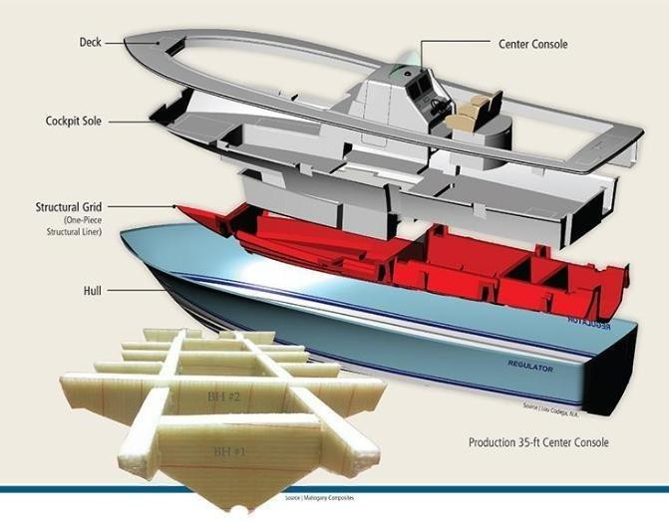

Fig 1: Parts of Marine applications

OBJECTIVES

- To Fabricate jute/Epoxy, Jute/Glass/Epoxy, Jute/Glass/Go Composites by Hand layup process and Cut the composites by water jet cutting for specimen size 300*30*t in mm (L*w*t) as Per ASTM Standard ASTME466.
- Test for the Fatigue Performance, before and water absorption behavior of Jute/Glass/Go Composites for Marine applications.
- To evaluate the fatigue life of the composites under High cycle loading.

- METHODOLOGY
Chart 1. Flow chart

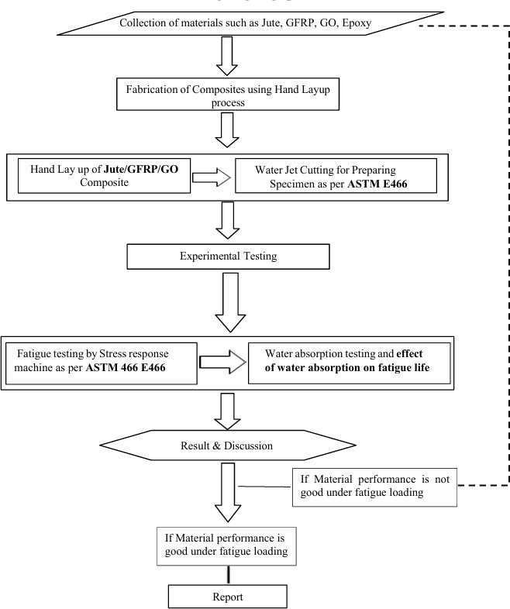

- FABRICATION
- Material Selection:
This research looks at a mix made from epoxy, a type that hardens when heated, layered with thin sheets of graphene and rough strands from jute plants. Strong sticking power, little change in size while setting, and toughness make epoxy the base choice here. Though glass threads often show up in such mixes thanks to solid pull resistance and low price, they aren’t the focus now. Instead, tiny flakes of carbon boost stiffness and spread force better across the structure. Their wide surface helps bind things more tightly. Past tests showed these pieces work well together - easy to get, stick without trouble, hold up under stress. Readiness to bond plus real- world results guided picking each part.
  - Jute fibre
One of the top green choices for reinforcing polymers is jute fibre. From the inner stem bark of Corchorus plants, it emerges as a lignocellulosic material found in nature. Around 58 to 63 percent cellulose makes up its core structure; between 20 and 24 percent is hemicellulose; while lignin occupies 12 to 15 percent - alongside traces of pectin, wax, and mineral residue. Strength under pull comes largely thanks to that rich cellulose mix, yet how much water it soaks up depends more on hemicellulose and lignin, which also shape how well it binds with surrounding matrix material.
Not heavy at all - jute fibers usually weigh in around 1.3 to 1.5 grams per cubic centimeter. Because of that lightness, they resist bending well. Their ability to stretch without breaking? Often measured anywhere from 400 up to 800 megapascals. How stiff they are depends on several things: how pure the fiber is, how it was pulled out from the plant, even how tests were run - values seen range between 10 and 30 gigapascals. When weight matters, these traits help jute stand out among materials used to add support without dragging down heft.
Not long after repeated stress begins, jute fibres start showing wear - tiny cracks form first, then small internal slips pile up inside the strands. Still, because these fibres naturally soak up water, dampness sneaks in over time, weakening how well they stick to surrounding materials when wet. This softening effect hits hardest where air stays thick with moisture, or near seawater, quietly wearing down resilience through continuous strain.
Fibres made from jute soak up plenty of energy when layered into composites, holding cracks together or stopping them outright - slowing their spread. Even so, differences in thickness and texture across individual strands tend to gather stress in spots. That is why natural jute gets mixed with man-made fibres quite often, boosting how well it withstands repeated loads while making durability over time less uncertain.

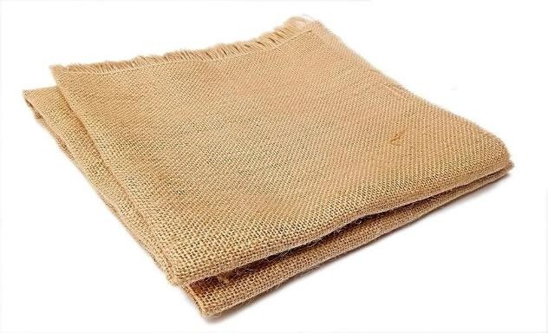

Fig 2: Jute fibre

  - Glass Fiber
Used a lot in man-made building materials, glass fibres offer solid strength, stay stable when chemicals hit them, also do not cost much. That would be E-glass - holds up well under stress while lasting long. Silica makes up the core part of these strands; mixed in are alumina, calcium oxide, plus boron oxide. Together, those ingredients create something tough to pull apart and hard to break down with acids or moisture.
Glass fibres usually have a stiffness around 70 to 76 GPa, handle pulling forces from 2000 up to 3500 MPa, while weighing about 2.5–2.6 grams per cubic centimetre. Unlike plant-based fibres, they resist bending more and support heavier stresses, which suits tasks where repeated stress happens often. With ongoing back-and-forth strain, materials made with these fibres maintain performance, showing almost no weakening even after many rounds of pressure.
Starting off smooth, glass fibres bond well with epoxies thanks to their even texture, helping spread stress evenly while slowing down cracks. Because they resist water absorption and chemicals so effectively, these fibres work particularly well near oceans or salty conditions. When layered together with natural ones like jute in mixed composites, glass tends to sit on the outside, shielding weaker inner layers from sea exposure - this setup boosts how long the material lasts under repeated strain.

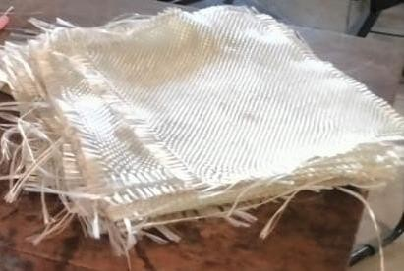

Fig 3: Glass Fiber

  - Graphene Oxide (Industrial Grade)
One and a half centuries back, someone first suggested a thin form of graphite oxide. This substance, now called graphene oxide, caught attention only lately. Not long ago, scientists began seeing it as a possible base for making lots of graphene. Its chemical behavior has already been studied in detail. Depending on how much oxygen sits within its structure, it might act like a semiconductor or block electricity entirely. Changes in oxidation open wide shifts in how it handles light and electrons. Graphene oxide finds uses across several areas because its light and electrical traits can be adjusted. Its chemistry, how it conducts electricity, ways it reacts when reduced, along with how molecules attach to it, draw most attention. Scientists still struggle to pin down its exact makeup since it lacks a fixed ratio of elements. Oxygen shows up in various forms bonded to carbon sheets - like bridges (epoxy), OH tags (hydroxyl), double- bonded O spots (carbonyl), and acid tips (carboxylic).
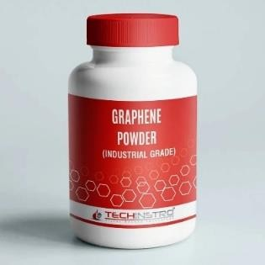
Fig 4: Graphene oxide

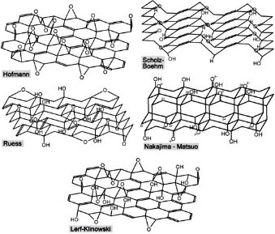

Fig 5: Carboxylic groups

Table 1: Graphene Specifications

Type | Graphene Nanoparticles
Bulk Density | 0.30 g/cc
Diameter | 10-15 microns
Purity | 98%
Surface Area | 112 𝑚²/g

- Fabrication of Composites:

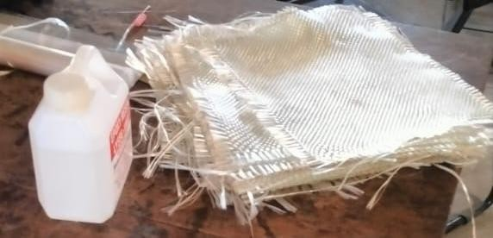
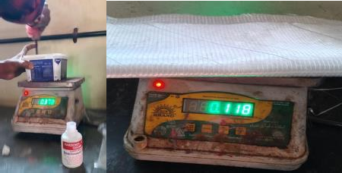
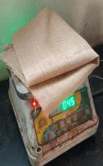

Fig 6: Resin, GFRP and Jute Fig 7: Weighing of resin and fibers

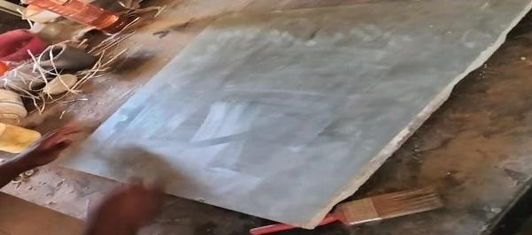
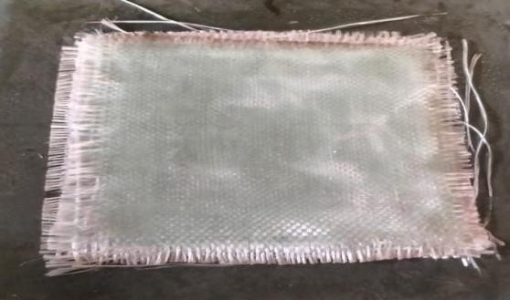

Fig 8: Cleaning Surface and applying the release agent
Fig 9: Stacking up of Fibers

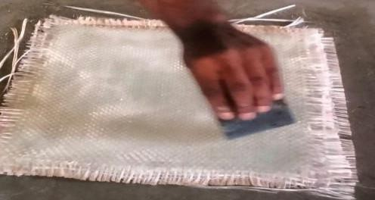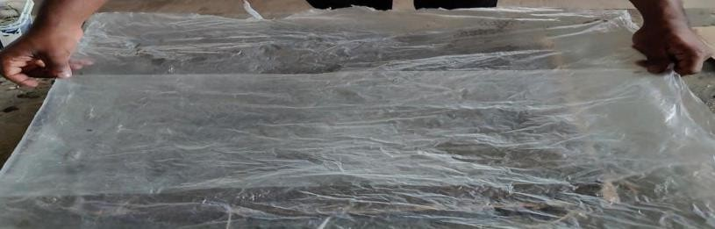

Fig 10: Spreading the resin uniformly
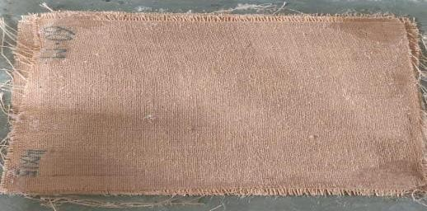

Fig 12: Cured Laminate
Fig 11: Covering the laminate with

Chart 2. Flowchart of Preparation of Specimen
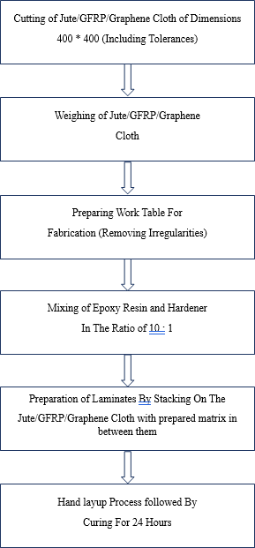

  - Dispersion of Graphene Nanoplatelets into Epoxy Resin by Mechanical Stirring:

Tiny flakes of graphene went into the epoxy by stirring them slowly to spread evenly. With mixing spinning not too fast plus sound waves breaking clumps apart, particles stayed separated while sticking well to the liquid. Once blended, workers poured in the hardener, swirled it completely through, then left the mix to thicken naturally in room air. Spinning helps - sure - but getting every tight cluster fully split open? That part stays tough when power fed in hits a wall. Still, tiny particles might stick together now and then, especially when stacked in thin layers. For smoother removal and fewer flaws on the surface, a release substance went on before making the material.
A set amount of nanoparticles stayed constant to keep each sample alike. Using a standard layering method, workers built up the composite sheets by hand. Prior to assembly, the mold got coated with a substance that stopped sticking. Fibers went into place next, then soaked in epoxy mixed with tiny particles. Rolling by hand made sure fibers absorbed enough liquid while squeezing out trapped bubbles. This helped spread the resin evenly from top to bottom.
After sitting untouched for a long while, the layered material finished hardening naturally. From that hardened sheet, samples were sliced - aligned with the main fiber path - using tools made for composites. Those pieces later went through strength tests.

  - Hand Layup Technique
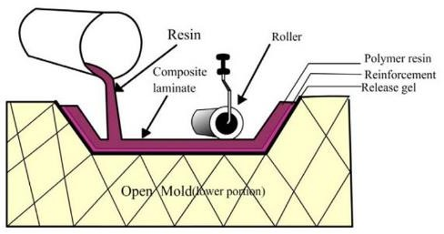

Fig 13: Hand layup process

    - Fabrication Procedure followed for Pure Jute:

      - Firstly, the Jute fiber mat is collected and fiber is cut as per requirement.
      - The ply is weighed on the weighing machine. And the weight of the ply is noted. The weight of the ply varies from 40-45 grams.
      - The surface where the preparation is to be made, should be cleaned and apply the releasing agent (wax).
      - The resin mixture (Epoxy and Hardener) has to be prepared, as per weight proportion of 10:1.
      - The laminate is prepared for Jute Epoxy.
      - The mixture is poured on the surface and resin is equally distributed on base plate.
      - Now place the ply on the surface where the mixture poured and avoid the wrinkles in the ply by using rollers and impregnate another layer of mixture by distributing equally without any pores or voids.
      - Repeat the same procedure until the desired thickness is achieved (about 8 layers).
      - Now cover the laminate with releasing filament and let it cure at atmospheric pressure for the duration about 24 hours.
      - After 24 hours, expose the laminate under sunlight about 2 to 3 hours to eliminate the moisture and for better curing.

    - Fabrication Procedure followed for Jute/Glass:

      - Firstly, the glass fiber mat is collected and fiber is cut as per requirement.
      - The ply is weighed on the weighing machine. And the weight of the ply is noted. The weight of each Jute ply varies from 40-45 grams. The weight of each glass ply varies from 117-118 grams.

      - The surface where the preparation is to be made, should be cleaned and apply the releasing agent (wax).
      - The resin mixture (Epoxy and Hardener) has to be prepared, as per weight proportion of 10:1.
      - The mixture is poured on the surface and resin is equally distributed on base plate.
      - Now place the ply on the surface where the mixture poured and avoid the wrinkles in the ply by using rollers and impregnate another layer of mixture by distributing equally without any pores or voids.
      - Repeat the same procedure until the desired thickness is achieved (about 3 layers Jute and Glass layers).
      - Now cover the laminate with releasing filament and let it cure at atmospheric pressure for the duration about 24 hours.
      - After 24 hours, expose the laminate under sunlight about 2 to 3 hours to eliminate the moisture and for better curing.
      - For Graphene Hybrid composite add 0.52% weight of resin.

- Water Jet cutting

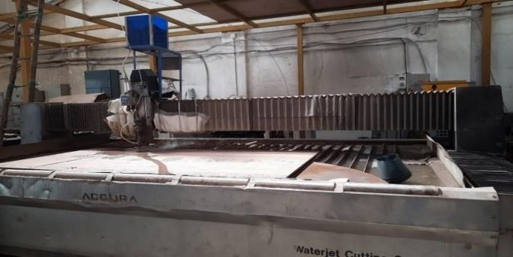

Fig 14: Water jet cutting
A powerful burst of water slices through many kinds of materials, making water jet cutting useful across different industries. From inside a narrow opening, the liquid shoots out fast when pushed hard by strong pumps. Supersonic speed happens once pressure builds up enough during operation. The force shapes whatever it meets, guided precisely without melting or warping surfaces. This method relies on intensity rather than heat to remove matter bit by bit.
Only water powers pure jet cutting, great for gentle slicing of things like foam, paper, plastic, rubber, or wood. Yet when dealing with tougher stuff, tiny gritty bits mix into the spray to boost performance. That grit transforms the stream, letting it slice metal, tile, glass, rock, and even thick slabs of concrete. Most factories choose this rougher method because it scrapes away matter instead of burning through it. Efficiency climbs since erosion replaces heat-based removal in daily operations. Flying streams of water slice through materials in various ways, shaped by what’s being cut and how exact the job needs to be. Because it bends easily to new tasks, intricate forms emerge cleanly, holding close to strict size rules. Not every method works everywhere, yet fine edges often come from this blend of pressure and flow.
Heat isn’t much of an issue with water jet cutting, unlike lasers or plasma tools. Because of this lack of warmth, the area around the cut stays untouched. The internal structure of the material holds its shape, strength, and hardness without shifting. Materials that react badly to high temperatures handle this process well. Precision matters - water jets deliver it without altering what they’re slicing.
Eight parts measuring 300*30 mm come from three composite panels, shaped by water jet. A narrow stream escapes through a 1 mm opening, slicing material cleanly. High-pressure water drives the process, replacing blades with force. Precision forms each section without heat damage. The method splits layers fast, using only speed and flow. Cuts emerge exact, guided by focused liquid power.

STANDARDS USED
  - ASTM E466:
ASTM E466 fatigue test fixtures are specialized, high-alignment grips used in servo- hydraulic or electromechanical machines to conduct force-controlled, constant-amplitude axial fatigue tests on metallic materials. They securely hold uniform gauge, cylindrical or flat specimens to apply precise, direct tension-compression, or tension-tension loading, while minimizing bending stresses. There are four recommended specimen geometries for 0⁰ unidirectional, 90⁰ unidirectional, balanced, and symmetric and random-discontinuous material types. ASTM D3039 can be used for the lay-up of the laminate specimen must be balanced and symmetric with respect to the test direction.
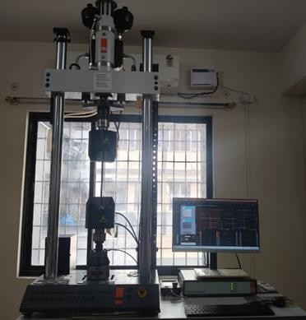

Fig 15: ASTM E466 Fixture

RESULT AND DISCUSSION
  - Experimental Testing:
A machine commonly applied in testing how composite materials handle repeated stress - both intense and mild cycles - performed the fatigue trials. By means of a self-correcting fluid-driven mechanism, it delivers repeating force patterns to the sample, ensuring precise handling of wave shape, rhythm, and intensity. This setup includes a fluid-powered mover, support structure for bearing weight, sensor for measuring force, supply unit providing pressure, along with digital controls that manage operation and record results.
Operating Principle
Hydraulic pressure moves the actuator piston inside a servo-hydraulic fatigue tester, powered by the HPU. Instead of just running steadily, the system adjusts fluid delivery through a servo valve when it receives signals from the control unit. This adjustment allows exact back-and- forth force on the sample being tested. Midway through each cycle, the setup checks actual performance against target values using live measurements. When mismatches appear, instant tweaks happen so loads stay consistent over thousands of cycles. Over time, these small fixes keep everything balanced without drifting off track during long tests.

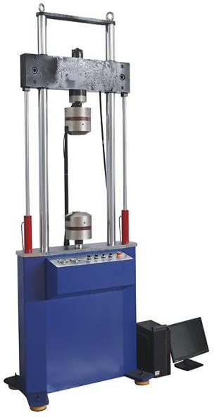

Fig 16: Fatigue testing Machine

Table 2: Composition of composites for Jute/Epoxy, Jute/Glass/Epoxy, Jute/Glass/Graphene/Epoxy

Composite | Jute | Glass | Epoxy | Graphene
Jute/Epoxy | 8 Layers (40-45 grams of weight each layer) | 0% | 800 gram + 80 Gram (Hardener) | 0%
Jute/Glass/Epoxy | 3 layers (40-45 grams of weight each layer) | 3 layers (115-120 grams of weight each layer) | 500 gram + 50 Gram (Hardener) | 0%
Jute/Glass/Epoxy/G raphene | 3 layers (40-45 grams of weight each layer) | 3 layers (115-120 grams of weight each layer) | 550 gram + 55 Gram (Hardener) | 0.5% of Resin

Table 3: Specimen specification for water absorption and fatigue testing as per ASTME466

Composite | Length in mm | Width in mm | Thickness in mm
Jute | 300 | 30 | 7
Jute/Glass | 300 | 30 | 6
Jute/Glass/Graphene | 300 | 30 | 5

  - Water absorption test and effect of water absorption test:

The specimens are initially weighed the dry specimens and the weight as been tabulated. To determine the impact of water absorption on Fatigue life the Jute/epoxy, Jute/Glass/Epoxy, Jute/Glass/Graphene/Epoxy are immersed in water for 24hrs as shown in fig 17. Then the materials are taken out and weighed on weighing machine and weight as been tabulated to determine the percentage water absorption of specimen. The measured weight was used to determine the percent water content %Δwt:
%Δwt=^{(𝑤𝑡−𝑤𝐹𝐷)} × 100% (1)
𝑤𝐹𝐷
where wt is the weight at the monitoring time t, and
wFD is the weight of the fully dry specimen (%Δwt = 0).
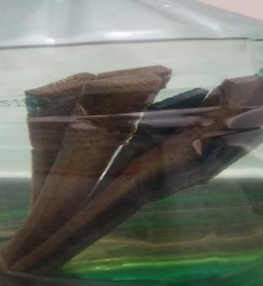

Fig 17: Specimens immersed in water

Table 4: Weight of specimen Before and After water absorption

Specimens |  | Weight of specimens before water absorption in grams | Weight of specimens after water absorption in grams | Average % of water absorption for 24 hrs
Jute Epoxy | Specimen 1 | 60 | 68 | 12.5%
Jute Epoxy | Specimen 2 | 65 | 71 | 12.5%
Jute Epoxy | Specimen 3 | 70 | 74 | 12.5%
Jute Epoxy | Specimen 4 | 60 | 70 | 12.5%
Jute/Glass Epoxy | Specimen 1 | 55 | 60 | 9%
Jute/Glass Epoxy | Specimen 2 | 50 | 56 | 9%
Jute/Glass Epoxy | Specimen 3 | 55 | 60 | 9%
Jute/Glass Epoxy | Specimen 4 | 60 | 66 | 9%
Jute/Glass  /Graphene Epoxy | Specimen 1 | 60 | 63 | 6%
Jute/Glass  /Graphene Epoxy | Specimen 2 | 60 | 64 | 6%
Jute/Glass  /Graphene Epoxy | Specimen 3 | 60 | 64 | 6%
Jute/Glass  /Graphene Epoxy | Specimen 4 | 60 | 65 | 6%

The specimens are prepared as per ASTM E466 for Jute/Epoxy, Jute/Glass/Epoxy, Jute/Glass/Graphene/Epoxy, conducted Fatigue testing for 2 samples each (Jute/Epoxy, Jute/Glass/Epoxy, Jute/Glass/Graphene/Epoxy), before water absorption & after water absorption. Water absorption test is conducted for 4 samples for 24 hours at room temperature, it is absorbed that the water absorption in Jute/Epoxy, Jute/Glass/Epoxy, and Jute/Glass/Go/Epoxy is 12.5%, 9% and 6% respectively as given in table 4. The water absorption reduces to 6% for jute/Glass/Go/Epoxy from 12.5% for Jute/Epoxy. Hence the addition of Nano filler into epoxy improves the permeability and the viscosity of epoxy reduces thus the defect (Voids) contains reduces also addition of nanofillers will reduces the water absorption as observed for Jute/Glass/Graphene/Epoxy.

Figures
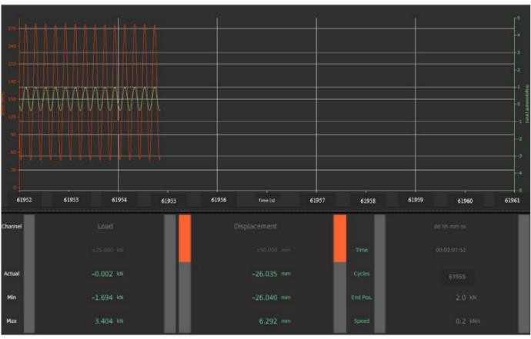
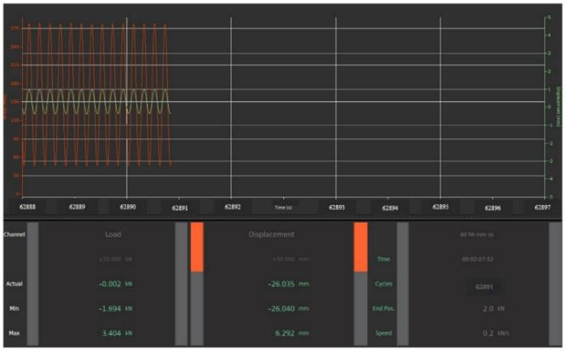

Fig 18: shows the stable cyclic stress–time response of Jute Specimen 1 during fatigue testing before water absorption, indicating uniform load amplitude and no premature failure.
Fig 19: shows the stable cyclic stress–time response of Jute Specimen 2 during fatigue testing before water absorption, indicating uniform load amplitude and no premature failure.

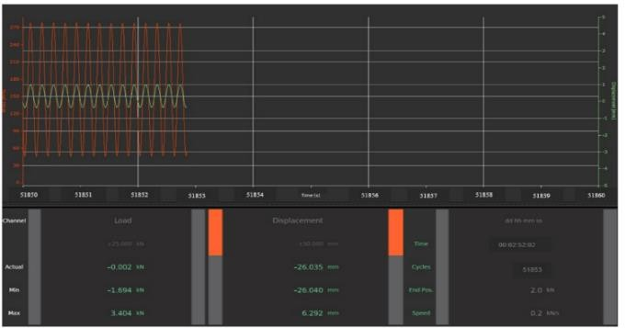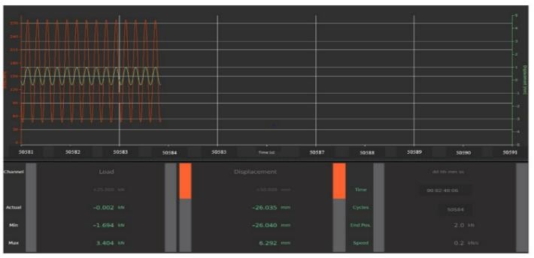

Fig 20: shows the stable cyclic stress–time response of Jute Specimen 1 during fatigue testing after water absorption, indicating uniform load amplitude and no premature failure.
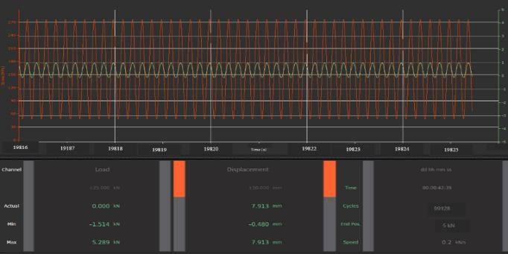

Fig 22: shows the stable cyclic stress–time response of Jute Specimen 2 during fatigue testing after water absorption, indicating uniform load amplitude and no premature failure.

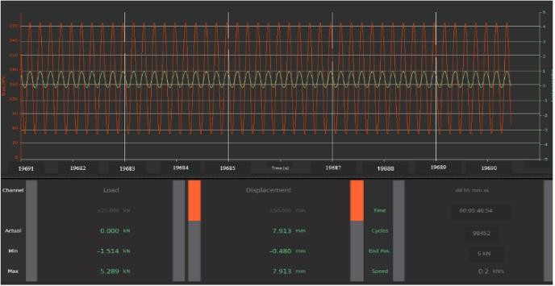
Fig 24: shows the stable cyclic stress–time response of Jute/GFRP specimen 1 during fatigue testing before water absorption, indicating uniform load amplitude and no premature failure.

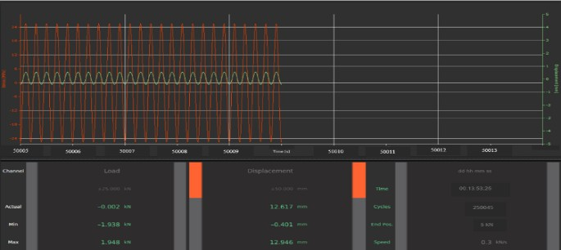

Fig 26: shows the stable cyclic stress–time response of Jute/GFRP specimen 2 during fatigue testing before water absorption, indicating uniform load amplitude and no premature failure.
Fig 21: shows the stable cyclic stress–time response of Jute/GFRP specimen 1 during fatigue testing after water absorption, indicating uniform load amplitude and no premature failure.
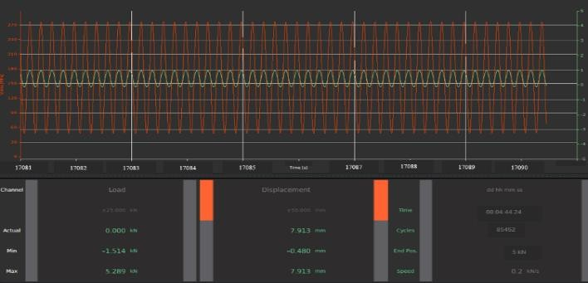
Fig 23: shows the stable cyclic stress–time response of Jute/GFRP specimen 2 during fatigue testing after water absorption, indicating uniform load amplitude and no premature failure.
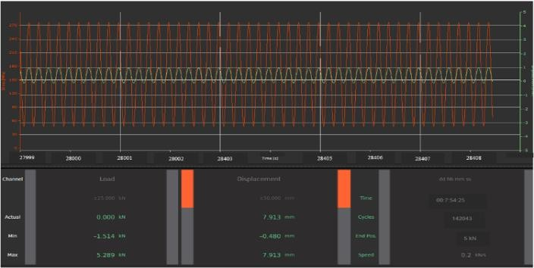
Fig 25: shows the stable cyclic stress–time response of Jute/GFRP/GO specimen 1 during fatigue testing before water absorption, indicating uniform load amplitude and no premature failure.
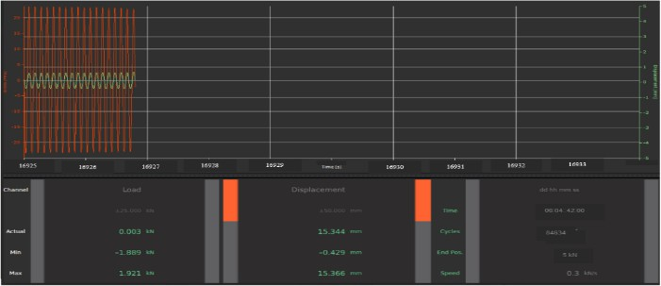

Fig 27: shows the stable cyclic stress–time response of Jute/GFRP/GO specimen 1 during fatigue testing after water absorption, indicating uniform load amplitude and no premature failure.

Table 5: No of cycles sustained by pure Jute, Jute/GFRP, Jute/GFRP/Go composite materials for fatigue loading before water absorption and after water absorption

Sl No | Materials | No of Cycles Before water absorption |  | No of Cycles After water absorption
1 | Jute/Epoxy | 61955 | 62891 | 51853 | 50584
2 | Jute/GFRP/Epoxy | 98452 | 99128 | 85452 | 84634
3 | Jute/GFRP/Go/Epoxy | 250045 |  | 242043

The fatigue test is conducted as per ASTM E466(Stress Response) [300*30*T] at constant stress of 25Mpa since it is for marine applications such as Duck, Hull, Grid, Sole etc. For Jute/Epoxy. Jute/GFRP/Epoxy, and Jute/GFRP/GO/Epoxy Composites Before water absorption and after water absorption. Fatigue testing revealed that the Jute/Epoxy composites sustain 62000 fatigue cycles before water absorption and sustains 51000 of fatigue cycles as given in Table 5, losing 80% of its fatigue life after water absorption, hence it is unfavorable to marine applications and Jute/Glass/Epoxy sustains 98500 fatigue cycles before water absorption and sustains 85000 fatigue cycles after water absorption, as given in Table.5. losing its fatigue life by 2% after water absorption, But still there is concerns over the water absorption it has 9-10% of water absorption for 24 hours at room temperature But the Jute/GFRP/GO/Epoxy has good response to fatigue loading sustaining the 250045 cycles before water absorption for 25Mpa and still doesn’t shows any behavior to break or Delaminate also material sustained the 242043 cycles after water absorption and still there is no breakage and delamination, even the water absorption rate is 5-6% for 24 hours at room temperature and it is behaving like CFRP composites for tensile properties.
The study reveals that the addition of Graphene Oxide reduces the Defects by reducing the viscosity of epoxy. And Nano filler improves permeability and The Jute/Glass/Go/Epoxy. Jute/Glass/Epoxy are the best suitable for marine applications. From Table 4 It is observed that wight of GO reinforced composites is 60 Grams for all specimens, but for Jute/GFRP/Epoxy composites weight is varying, the variation of weight indicates the contains of voids in laminates. The GO reinforced composites will be suitable for marine applications and GO Reinforced composites are lighter in weight when compared with other Specimens such as Jute/Epoxy, Jute/GFRP/Epoxy composites. Whereas the delamination problem is observed in Jute/GFRP/Epoxy Composites due to improper bonding between jute and GFRP lamina.

CONCLUSION

- The Jute/Glass/GO/Epoxy composites sustain high fatigue cycles (50% more fatigue cycles than jute/glass/epoxy) compared to jute/epoxy, Jute/Glass/epoxy.
- The water absorption percentage of Jute/Glass/Graphene/Epoxy with increase in weight of specimen by 5-6% after 24 Hours of water absorption at room temperature, which is less compared to other specimens i.e Jute/Epoxy, Jute/GFRP/Epoxy.
- Water absorption is a problem even in GFRP composites used in marine applications due to the water absorption of polymer, hence this much water absorption for 24 Hours for jute/glass/graphene/epoxy is acceptable.

- The addition of nanofiller reduces the water absorption and improves the quality of laminates by reducing the defects such as voids and delamination.
- The Jute/GFRP/GO/Epoxy composites retain its fatigue life with reduction of 3% in fatigue life after water absorption for 24 hours at room temperature. And lighter in weight as shown in Table 4.
- The Jute/GFRP/Epoxy composites have failed due to delamination between laminates in fatigue loading cycles. Whereas Jute/Glass/GO/Epoxy doesn’t fail due to delamination because adding nanofiller reduces the viscosity and makes good bond between each lamina.

COMPETING INTERESTS DISCLAIMER:
Authors have declared that they have no known competing financial interests OR non-financial interests OR personal relationships that could have appeared to influence the work reported in this paper.

REFERENCES

- Suriya Ferdous, Md Sarwar Hossain, Natural Fibre Composite (NFC) New Gateway for Jute, Kenaf a d Allied Fibres in Automobiles and Infrastructure Sector, World Journal of Research and Review (WJRR). 2017; 535-42
- Dipa Ray, Suparna Sengupta, Siba P. Sengupta, Amar K. Mohanty, Manjusri Misra. A Study of the Mechanical and Fracture Behavior of Jute-Fabric-Reinforced Clay-Modified Thermoplastic Starch-
Matrix Composites, Macromolecular Materials and Engineering. 2007; 2921075–1084
- Lifang Liu, Jianyong Yu, Longdi Cheng, Xiaojie Yang. Biodegradability of poly (butylene succinate) (PBS) composite reinforced with jute fiber, Polymer Degradation and Stability. 2008; 90-94.
- Nam Gibeop, DW Lee, C Venkata Prasad, F Toru, Byung Sun Kim, Jung Il Song. Effect of plasma treatment on mechanical properties of jute fiber/poly (lactic acid) biodegradable composites,
Advanced Composite Materials. 2013; 22389–399
- Haydar U, Zaman AH, Khan, MA Hossain, Mubarak A Khan & Ruhul A Khan. Physico-Mechanical, Interfacial, Degradation and Dielectric Properties of Jute/PP Composites Effect of Dye and Gamma Radiation, International Journal of Polymeric Materials. 2012; 61596–610
- Sweety Shahinur, Mahbub Hasan, Qumrul Ahsan, Nayer Sultana, Zakaria Ahmed and Julfikar Haider. Effect of Rot- , Fire-, and Water-Retardant Treatments on Jute Fiber and Their Associated Thermoplastic Composites A Study by FTIR, Polymers. 2021; 13.
- Shahana Parbin, Nitin Kumar Waghmare, Suraj Kumar Singh, Sabah Khan. Mechanical properties of natural fiber reinforced epoxy composites A review, Procedia Computer Science. 2019; 152375– 379.
- Akarsh Verma, Kamal Joshi, Amit Gaur and V. K. Singh, 2018, Starch-jute fiber hybrid bio composite modified with an epoxy resin coating fabrication and experimental characterization, Journal of the Mechanical Behavior of Materials. 2019; 89-98.
- Sudhir Kumar Saw, Khurshid Akhter, Narendra Yadav & Ashwini Kumar Singh. Hybrid Composites Made from Jute/Coir Fibers Water Absorption, Thickness Swelling, Density, Morphology, and Mechanical Properties, Journal of Natural Fibers. 2014; 1139–53.
- BY Mekonnen, YJ Mamo. Tensile and Flexural Analysis of a Hybrid Bamboo/Jute Fiber-reinforced Composite with Polyester Matrix as a Sustainable Green Material for Wind Turbine Blades, International Journal of Engineering. 2019; 33314-319.
- Underhill, R.: Determining the influence of immersion on polymeric composites-theory and testing standards. Defence Research and Development Canada Report (DRDC) (2016). https://doi.org/10. 13140/RG.2.2.23046.98888
- Zhou, J., Wang, J., Su, M., Zhou, W.: Acoustic emission monitoring and damage failure behavior of seawater-aged composites under the bending load. Appl. Compos. Mater. (2023). https://doi.org/10. 1007/s10443-023-10126-8
- Doğan, N.F., Oğuz, Z.A., Erkliğ, A.: An experimental study on the hydrothermal aging effect on the free vibration properties of hybrid aramid/glass/epoxy composites: Comparison of sea water and distilled water. Polym. Compos. (2023). https://doi.org/10.1002/pc.27606
- Adeniran, O., Osa-uwagboe, N., Cong, W., Ramoni, M.: Fabrication temperature-related porosity effects on the mechanical properties of additively manufactured CFRP composites. J. Comp. Sci. (2023). https://doi.org/10.3390/jcs7010012
- Altin Karataş, M., Gökkaya, H.: A review on machinability of carbon fiber reinforced polymer (CFRP) and glass fiber reinforced polymer (GFRP) composite materials. Defence Technology. 14, 318–326 (2018). https://doi.org/10.1016/j.dt.2018.02.001
- Mouritz, A.P., Gellert, E., Burchill, P., Challis, K.: Review of advanced composite structures for naval ships and submarines. Compos. Struct. (2001). https://doi.org/10.1016/S0263-8223(00)00175-6

- Manalo, A.C., Aravinthan, T., Karunasena, W., Islam, M.M.: Flexural behaviour of structural fibre composite sandwich beams in flatwise and edgewise positions. Compos. Struct. 92, 984–995 (2010). https://doi.org/10.1016/j.compstruct.2009.09.046
- Langdon, G.S., von Klemperer, C.J., Rowland, B.K., Nurick, G.N.: The response of sandwich structures with composite face sheets and polymer foam cores to air-blast loading: Preliminary experiments. Eng. Struct. 36, 104–112 (2012). https://doi.org/10.1016/j.engstruct.2011.11.023
- Siriruk, A., Penumadu, D.: Degradation in fatigue behavior of carbon fiber-vinyl ester based composites due to sea environment. Compos. B Eng. 61, 94–98 (2014). https://doi.org/10.1016/j.compositesb.2014.01.030
- Osa-uwagboe, N., Silberschimdt, V.V., Aremi, A., Demirci, E.: Mechanical behaviour of fabric- reinforced plastic sandwich structures: A state-of-the-art review. J. Sandw. Struct. Mater. (2023). https://doi.org/10. 1177/10996362231170405
- Osa-uwagboe, N., Udu, A.G., Silberschmidt, V.V., Baxevanakis, K.P., Demirci, E.: Damage assessment of glass-fibre-reinforced plastic structures under quasi-static indentation with acoustic emission. Materials 16, 5036 (2023). https://doi.org/10.3390/ma16145036
- Sakoshev, Z.G., Blaznov, A.N., Bychin, N.V., Medvedev, P.A., Zadvornykh, G.S., Sakoshev, E.G., Firsov, V.V., Cheremukhina, I.V.: Morphological and physicomechanical characterization of synthetic and natural fibers. J. Polym. Res. (2024). https://doi.org/10.1007/s10965-024-03938-0
- Peças, P., Carvalho, H., Salman, H., Leite, M.: Natural fibre composites and their applications: A review. J. Compos. Sci. (2018). https://doi.org/10.3390/jcs2040066
- Huner, U.: Effect of water absorption on the mechanical properties of flax fibre reinforced epoxy composites. Adv. Sci. Technol. Res. J. 9, 1–6 (2015). https://doi.org/10.12913/22998624/2357
- Osa-uwagboe, N., Udu, A.G., Ghalati, M.K., Silberschmidt, V.V., Aremu, A., Dong, H., Demirci, E.: A machine learning-enabled prediction of damage properties for fiber-reinforced polymer composites under out-of-plane loading. Eng. Struct. 308, 117970 (2024). https://doi.org/10.1016/j.engstruct.2024.117970
- Kamble, Z.: Advanced structural and multi-functional sandwich composites with prismatic and foam cores: A review. Polym. Compos. (2023). https://doi.org/10.1002/pc.27849
- Uzal, A., Sonmez, F.O., Oz, F.E., Cinar, K., Ersoy, N.: A composite sandwich plate with a novel core design. Compos. Struct. 193, 198–211 (2018). https://doi.org/10.1016/j.compstruct.2018.03.047
- Tong, L., Mouritz, P.A., Bannister, K.M.: 3D Fibre reinforced polymer composites. Elsevier (2002)
- Saito, T., Nakai, A., Ohtani, A.: Effects of fabrication method of composite yarn intermediate material and resin melt viscosity on the impregnation properties and mechanical properties of PA66 fiber and glass fiber composites. J. Thermoplast. Compos. Mater. 35, 2409–2434 (2022). https://doi.org/10. 1177/0892705720964559
- Calabrese, L., Fiore, V., Scalici, T., Valenza, A.: Experimental assessment of the improved properties during aging of flax/glass hybrid composite laminates for marine applications. J. Appl. Polym. Sci. 136, 1–12 (2019). https://doi.org/10.1002/app.47203 2014 Applied Composite Materials
(2024) 31:1991–2018 1 3
- Park, Y. Bin., Kweon, J.H., Choi, J.H.: Failure characteristics of carbon/BMI-Nomex sandwich joints in various hygrothermal conditions. Compos. B Eng. 60, 213–221 (2014). https://doi.org/10.1016/j. compositesb.2013.12.035
- Osa-Uwagboe, N., Silberschimdt, V.V., Demirci, E.: Seawater effect on energy-absorption properties of polymerbased composite sandwich structures. In: Procedia Structural Integrity, pp. 44–
51. Elsevier B.V. (2024)
- Le Duigou, A., Davies, P., Baley, C.: Seawater ageing of flax/poly(lactic acid) biocomposites. Polym.
Degrad. Stab. 94, 1151–1162 (2009). https://doi.org/10.1016/j.polymdegradstab.2009.03.025
- Dezulier, Q., Clement, A., Davies, P., Arhant, M., Flageul, B., Jacquemin, F.: Water ageing effects on the elastic and viscoelastic behaviour of epoxy-based materials used in marine environment.
Compos. B Eng. 242, 110090 (2022). https://doi.org/10.1016/j.compositesb.2022.110090
- Weitsman, Y.J.: Fluid Sorption Data and Modeling. In: Fluid effects in polymer and polymeric composites, pp. 31–68. (2012)
- Dhakal, H.N., Zhang, Z.Y., Richardson, M.O.W.: Effect of water absorption on the mechanical properties of hemp fibre reinforced unsaturated polyester composites. Compos. Sci. Technol. 67, 1674–1683 (2007). https://doi.org/10.1016/j.compscitech.2006.06.019
- Colin, X., Verdu, J.: Humid ageing of organic matrix composites. In: Durability of composites in a marine enviroment, pp. 47–114. (2014)
- Pochiraju, K., Tandon, G., Schoeppner, G.: Long-term durability of polymeric matrix composites. Springer International Publishing (2012)
- Norman Osa-uwagbo, Vadim V. Silberschmidt, Emrah Demirci: Review on Mechanical Performance of Fibre-Reinforced Plastics in Marine Environments, Applied Composite Materials (2024) 31:1991– 2018 https://doi.org/10.1007/s10443-024-10247-8
- High cycle fatigue life analysis of unidirectional flax/PLA composites through infrared thermography Samuel Charca a,b, Liu Jiao-Wang a, J.A. Loya, Miguel A. Martínez c, Carlos Santiuste a, https://doi.org/10.1016/j.compstruct.2024.118370

- The low-cycle fatigue performance aluminum matrix composites reinforced with particles AlFeCrMnTi and SiC that are extruded by equal-channel angular pressingYiqiang He, Hang Gu b, Tong Wang b, Kai Tao b, Sicheng Qian, Xiao He, Ying Cao, Hanwen Lu https://doi.org/10.1016/j.mtcomm.2025.111782
- Experimental and micromechanical investigation of precipitate size effectson the creep behaviour of a high chromium martensitic steelJun-Dong Yin a, Lei Wang a, Bao-Yin Zhu, Xiao Jin, Chen-Feng Li, Esteban P. Busso a,Dong-Feng Li a, https://doi.org/10.1016/j.euromechsol.2025.105591
- Fatigue performance of HFRP-reinforced track composite slabs: Experiments and numerical simulationZhongzhi Guan, Hongguang Wang, Yuhang Ren, Guangzhu Zhang, Yongli Xu https://doi.org/10.1016/j.engstruct.2025.121471
- Fatigue behavior and nonlinear life prediction of open-hole thermoplastic composite laminates with drilling-induced delamination˙Ça˘ Ilhan , Ulvi Sekergrı ¸ https://doi.org/10.1016/j.engfracmech.2025.111076
- Low-cycle fatigue life prediction of modified 9Cr-1Mo ferritic-martensitic steel in liquid lead–bismuth eutectic environments using a physically-based modelShouwen Shi, Weibin Li, Dan Wu, Wei Huang
, Gang Chen, Qiang Lin, Xu Chen https://doi.org/10.1016/j.engfracmech.2025.111434
- Improving fatigue testing of AISI 304L stainless steel in high temperature water regarding their complex hardening and softening material behaviourGeorg Veile, Jürgen Rudolph b, Nina Gr¨ ozinger a, Martin Herzig, Michael Grimm, Stefan Weihe https://doi.org/10.1016/j.ijpvp.2025.105612
- Fatigue life prediction of aluminum-steel magnetic pulse crimped joints based on point cloud measurement and gradient boosting regression treesYujia Zhao a, Ming Lai, Yuqi Wu, Guangyao Li,
Hao Jiang a, Junjia Cui https://doi.org/10.1016/j.ijfatigue.2025.109020
- Fatigue crack initiation mechanism and life prediction of laser-arc hybrid welded TC4 titanium alloy jointsZheng Lei, Long He a, Ruilin Liu a, Xu Zhao https://doi.org/10.1016/j.ijfatigue.2025.109308
- Fatigue performance and fatigue life prediction model of hybrid fiber reinforced geopolymer with steel and polypropylene fibersCai Wu a, Peiyuan Zhou b, Zhijiang Li, Nanhui Huang c, Daopei Zhu https://doi.org/10.1016/j.conbuildmat.2025.142185

