DYNAMIC MODEL OF A 3-PHASE INDUCTION MOTOR FOR THERMAL ANALYSIS FOR IMPROVING PERFORMANCE

.
ABSTRACT
This study presents a comprehensive dynamic model of a three-phase induction motor integrating electromagnetic and thermal domains for enhanced performance evaluation and reliability improvement. The electrical subsystem is formulated in the synchronously rotating $dq$-reference frame using coupled stator rotor voltage equations, flux linkages, and electromagnetic torque expressions derived from space-vector theory. The mechanical dynamics are represented through the rotor motion equation, considering load torque disturbances and inertia effects. To enable accurate thermal assessment, a lumped-parameter thermal network (LPTN) is developed, incorporating stator copper losses, rotor copper losses, core losses, mechanical losses, and stray load losses as heat sources. Temperature-dependent variations of resistance and material properties are included to capture electro-thermal coupling effects under transient and steady-state operating conditions. The integrated model enables the prediction of temperature rise in critical components such as stator windings, rotor bars, and core laminations during dynamic events, including startup, overload, and fluctuating load conditions. Numerical simulations demonstrate that incorporating thermal feedback into the electromagnetic model improves accuracy in efficiency estimation, torque prediction, and loss distribution analysis. Results further show that optimized cooling strategies and appropriate material selection significantly reduce hotspot temperatures, thereby enhancing insulation lifespan and overall motor reliability. The study reveals that asymmetrical thermal flow leads to localized overheating, increasing winding resistance, reducing efficiency, and accelerating insulation degradation. Temperature variations of 74.7°C, 76.7°C, 88.7°C, and 86.5°C were recorded in different motor sections, with an acceptable thermal range of 10°C to 40°C. Optimized cooling mechanisms and material selection significantly reduce these effects, enhancing motor efficiency.

1. INTRODUCTION

Because of their great efficiency, low maintenance requirements, and durability, three-phase induction motors (IMs), especially squirrel-cage models, are essential in industrial settings. Thermal stresses from losses like core, copper, and mechanical friction, however, can impair performance and result in insulation failure, shorter lifespans, and decreased efficiency. Predictive analysis and optimization are made possible by dynamic modeling, which combines the electrical, mechanical, and thermal domains to simulate transient behaviors. Drawing from systematic reviews and individual studies, this overview summarizes recent developments in dynamic and thermal modeling, emphasizing techniques such as coupled simulations, lumped-parameter networks, and finite element analysis (FEA). The time-varying interactions in IMs are captured by dynamic modeling, which is crucial for fault diagnosis and control methods. Differential equations in reference frames such as dq (direct-quadrature) are commonly used in models to simplify the study of voltages, currents, fluxes, and torques. The synchronously revolving frame facilitates steady-state analysis under load, while the stationary reference frame is preferred for transient investigations in adjustable speed drives since it has zero frame speed. Mathematical methods, such as ordinary differential equations for electromagnetic torque and mechanical factors like speed and inertia, are highlighted in a systematic review. Sensorless vector control models are validated by simulations using programs like MATLAB/Simulink, where precise parameter estimates stop performance loss due to inconsistencies. Indirect examples of thermal impacts include rotor flaws like broken bars that result in uneven current distribution and heat buildup, or stator faults that cause inter-turn shorts and overheating. Temperature distributions are described using partial differential equations, although difficulties in using them for study are noted. Advanced models accommodate temperature-dependent changes in electric conductivity by incorporating thermal stresses through weak coupling methods in 2D finite element solutions. This addresses shortcomings in conventional models that ignore heat-induced parameter fluctuations and improves prediction accuracy for magnetic and thermal fields. Heat generation (such as I2R losses, hysteresis, and eddy currents) and dissipation (such as conduction, convection, and radiation) are the main topics of thermal modeling. Lumped-Parameter Thermal Networks (LPTNs) are one important technique: These compare electrical circuits with heat sources, capacitances, and resistances to thermal systems. Transient forecasts are made possible by the computational efficiency of LPTNs for uniform temperature components. They are combined with CFD for airflow analysis and verified against experimental data. Method of Finite Elements (FEM): FEM solves linked electromagnetic-thermal equations in complicated geometries with temperature gradients. By simulating asymmetrical flows, programs such as ANSYS Motor-CAD can identify hotspots caused by imbalanced currents or cooling inefficiencies. For example, simulations indicate that temperature increases surpass the 10–40 °C limit, peaking at 88.7 °C in windings, resulting in a 7.3% decrease in efficiency. FEM is enhanced by computational fluid dynamics (CFD), which models airflow in air-cooled systems. ANSYS Fluent studies on 100 kW IMs reveal stator temperatures of 119 °C and rotor temperatures of up to 165 °C, with air velocity dips minimizing heat transmission. Navier-Stokes equations are solved by turbulence models such as K-epsilon, which assume incompressible flow. Induction motors were chosen for this application primarily because of their affordable, straightforward, and durable design. When compared to other DC motors, the induction motor requires no maintenance and will greatly increase system performance for the same investment. Faraday's electromagnetic induction is the fundamental idea underlying the functioning of an induction motor. The line frequency and the number of magnetic pole pairs in the motor determine its steady speed. This engine must run for a very long time in order to pump water when it is utilized for agricultural purposes. Because of the voltage fluctuations at that time, it occasionally needs to operate at full load or at a slower pace. There may be a slight bit of speed slip when the load is at its maximum. Similarly, due to voltage changes or voltage fluctuations, the motor tends to run at a slower speed. Severe motor overheating happens when the motor operates at a slower speed. The electric drive's performance will deteriorate if the overheating continues for an extended period of time. Manufacturers typically construct various fin configurations above the electric motor to get around this. This increases the surface area and makes efficient heat dissipation possible. Because of their simplicity, efficiency, and dependability, three-phase induction motors are extensively utilized in many different sectors. These motors work by creating a revolving magnetic field in the stator, which causes the rotor to conduct current. Despite their ruggedness, these motors are prone to several operational problems, including temperature imbalances. Concern over asymmetrical thermal flow is developing since it can have a big impact on a motor's performance and lifespan, particularly in industrial settings Eke et al, (2025). A stator and a rotor make up a standard three-phase induction motor. The power source sends three-phase electrical current to the stator, which creates a revolving magnetic field. This magnetic field interacts with the rotor, causing a current to flow through it and producing mechanical torque. The motor should ideally run in an environment where the temperature is uniform throughout all of its parts. However, when asymmetrical thermal flow occurs where the temperature distribution across the motor becomes uneven, it can result in reduced efficiency, overheating, and premature failure of the motor (Kumar et al., 2017). A motor's running state, load circumstances, and cooling system are some of the variables that affect its temperature distribution. Certain motor components, such as the stator and rotor, may be noticeably hotter than others when thermal flow is asymmetrical. Thermal stress brought on by this imbalance may result in insulation deterioration, damage to the rotor and stator components, and a reduction in the motor's operational efficiency (Bianchi et al., 2005). These problems demonstrate how crucial it is to comprehend the effects of heat flow imbalances since they may jeopardize the motor's longevity and performance. Three-phase induction motors' dependability, effectiveness, and versatility make them essential parts of industrial applications. The Ansys motor CAD is the ideal tool for modeling and simulating asymmetrical thermal forces, according to the works of Afrah et al. (2019) on the modeling of three-phase for thermal effect. Motor efficiency optimization is a major area of research interest worldwide. (Zhu et al., 2020) looked into ways to make permanent magnet synchronous motors (PMSMs) more efficient using ANSYS Motor-CAD. In order to improve torque density and lower electromagnetic losses, they investigated design variants such as rotor shape and stator slot designs. Similarly, in order to optimize induction motors for industrial applications, Patel and Gupta (2021) used Motor-CAD. By improving material selection and lamination thickness, they were able to significantly reduce core losses. Motor-CAD was utilized by Nwosu and Adeyemi (2022) to investigate efficiency optimization in induction motors used in hot conditions. They discovered that efficiency might be increased by up to 15% by adapting rotor and stator designs to the typical ambient conditions encountered in African businesses. Their studies emphasized how crucial it is to adapt designs to unique operational climates, which is especially important in settings with limited resources. Another crucial topic of attention for Motor-CAD development is thermal management. Motor-CAD has been used by researchers worldwide to overcome thermal asymmetry, which can result in uneven wear and hotspots. (Chen et al., 2019) used Motor-CAD to model cooling systems such as forced air and liquid jackets in order to study thermal performance in electric car motors. According to Endert et al. (2013), their findings showed a 30% improvement in temperature distribution, lowering the chance of insulation failure and prolonging motor life.

2. Methods

Figure 1 shows the equivalent d-q circuit of an induction motor. From the equivalent circuit, the model equations are derived.

-
+
+
-
-
+
V_{dr}= 0
I_{dr}
I_{ds}
L_{m}
λ_{qr}
λ_{ds}
R_{r}
(ω-ω_{r})λ_{qr}
L_{lr}
L_{ls}
ωλ_{qs}
+
R_{s}
V_{ds}
-
-
-
+
+
+
V_{qr}= 0
i_{qr}
i_{qs}
L_{m}
λ_{qr}
λ_{qs}
R_{r}
(ω-ω_{r})λ_{dr}
L_{lr}
L_{ls}
ωλ_{ds}
+
R_{s}
V_{qs}

Figure 1a Fig. 1b (Okoro 2003)

Fig. 1: Squirrel-Cage Induction machine models in d-q axis: (a) q-axis model, (b) d-axis model

Electrical model of the induction motor
The flux linkages equation associated with this circuit can be found as follows
(1)
(2)
(3)
(4)
Where,
(5)
(6)
(7)
Substituting the values of the flux linkages to find the currents, we have (Okoro 2003)
(8)
(9)
(10)
(11)
The torque and rotor speed can be determined as follows
(12)
(13)
Where P = number of poles, J = Moment of inertia (Kg/m²), A three-phase source is applied to conventional model of an induction motor and the equations are given by (Eke et al 2024)
(14)
(15)
(16)
The three-phase voltages are transferred to a synchronously rotating reference frame as follows
(17)
The d-q axes voltages are
(18)
The instantaneous values of the stator and rotor currents are calculated using the transformation in equations (3.19) and (3.20).
(19)
(20)
3.2.1 THERMAL MODELLING OF AN INDUCTION MOTOR
Thermal Network Theory
The motor is initially divided into distinct geometrical pieces, which are then connected by thermal resistances to form a thermal network. Thermal capacitances are added to each part made of solid material to analyze transient heat transmission. For each of those components, internal heat generation is added, which results in losses. It is assumed in a thermal network model that all of the component's heat generation is focused in a single location, known as the node. The node of the thermal network depicted in Figure 1 is given a thermal capacitance, C_{th}, and heat flowing between nodes is represented as a current source, Pg, that is passed through thermal resistance, R_{th}. Thermal network models, which apply to electrical machines, range in dimension from one to three. Nonetheless, by joining multiple one-dimensional models at the mean temperature, a two-dimensional thermal network model can be created. Eke et al. (2025) provided a thorough examination of this notion.
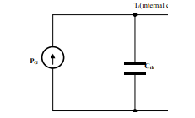

Figure 2: Thermal network model.
For small induction machines, the machine elements are represented by the temperature rise with the ambient air temperature taken as a thermal reference. The heat generation, PG as in electrical machines, represents the losses in the machine parts (e.g., Stator, Rotor, etc.). The thermal capacitance, C_{th,} of an element is usually calculated from the geometry and material data of the element. It is expressed as
$C_{th}⋅\frac{dT\left(t\right)}{dt}+\frac{T\left(t\right)-T_{amb}}{R_{th}}=P_{loss}\left(t\right)$ (21)
Where Cth​ = thermal capacitance (J/K), R_{th}​ = total thermal resistance (K/W), T(t) = motor temperature, T_{amp} is ambient temperature, and P_{loss}​(t) = instantaneous total power losses. Solving this differential equation gives you the temperature profile over time.
Steady-State Temperature
$T_{steady}=T_{amb}+P_{loss}⋅R_{th}$ (22)
For each node: heat stored = input losses − heat out through resistances.
$C_{s}\frac{dT_{s}}{dt}=Q_{s}\left(t\right)-\frac{T_{s}-T_{f}}{R_{s→f}}$ (23)
$C_{s}\frac{dT_{s}}{dt}=Q_{s}\left(t\right)-\frac{T_{s}-T_{f}}{R_{s→f}}$ (24)
$C_{r}\frac{dT_{r}}{dt}=Q_{r}\left(t\right)-\frac{T_{r}-T_{f}}{R_{r→f}}$ (25)
In matrix form
$T={\left[T_{s},T_{f},T_{r}\right]}^{⊤}$ (26)
input heat vector
$$Q={\left[Q_{s},Q_{fe,core},Q_{r}\right]}^{⊤}$$
Then
$C \dot{T}=-G T+B T_{amb}+Q\left(t\right)$ (27)
Thermal modeling of an induction motor involves understanding the heat generation and dissipation processes within the motor. The primary goal is to evaluate temperature distribution and ensure thermal stability, as excessive heating can degrade motor performance and lifespan. Below are the thermal equations used for induction motor modeling.
  - Heat Generation
Heat is generated in an induction motor due to electrical and mechanical losses:
$\begin{matrix} & Q_{\text{gen}}=P_{\text{loss}} & & \text{ (28)}\end{matrix}$
Where $Q_{\text{gen}}$ is the heat generated (in watts), $P_{\text{loss}}$ includes the following: Copper losses: $P_{\text{cu}}=I^{2}R$ (in stator and rotor windings) Core losses: Due to hysteresis and eddy currents in the magnetic core
Mechanical losses: Friction and windage losses
2. Heat Transfer
Heat transfer in the motor occurs through conduction, convection, and radiation:
(a) Conduction (Fourier's law)
Heat conduction through motor components follows Fourier's law
$$\begin{matrix} & q_{\text{cond}}=-kA\frac{dT}{dx} & & \text{ (29)}\end{matrix}$$
(b) Convection (Newton's law of cooling):
Heat dissipation to the surrounding environment via convection is modeled using Newton's law of cooling:
$$\begin{matrix} & q_{\text{conv}}=hA(T_{s}-T_{∞}) & & \text{ (30)}\end{matrix}$$
(c) Radiation (Stefan-Boltzmann law)
Heat loss due to radiation is modeled using Stefan-Boltzmann's law:
$$\begin{matrix} & q_{\text{rad}}=ϵσA(T_{s}^{4}-T_{∞}^{4}) & & \text{ (31)}\end{matrix}$$
Where:
$k$: Thermal conductivity (W/m·K).
$A$: Cross-sectional area (m²), $h$: Heat transfer coefficient (W/m²·K), $T_{s}$: Temperature of the machine surface (K), $T_{∞}$: Ambient temperature (K), $ϵ$: Emissivity (dimensionless), $σ$: Stefan-Boltzmann constant
$(5.67×10^{-8}$ W/m²·K⁴) (32)
3. Energy Balance Equation
The energy balance for the machine accounts for heat generation and heat losses due to convection and radiation. It can be described using an energy balance equation:
$$\begin{matrix} & C\frac{dT}{dt}=Q_{\text{gen}}-Q_{\text{loss}} & & \text{ (33)}\end{matrix}$$
Where $C$: Thermal capacitance (J/K). $T$: Temperature (K).
4. Lumped Thermal Model
In a simplified lumped parameter model, the motor is divided into thermal nodes (stator, rotor, housing, etc.) with resistances and capacitances:
$\frac{dTi}{dt}=\frac{Qin,i-Qout,i}{Ci}$ (34)
Where $T_{i}$is the temperature of the $i$-th node, $Q_{\text{in},i}$ Is heat entering the $i$-th node, $Q_{\text{out},i}$Is heat leaving the $i$-th node, $C_{i}$is the thermal capacitance of the $i$-th node.
Thermal Resistance
$Q \frac{Ti-Tj}{Rth,i,j}$ (35)
5. Steady-State Thermal Equation
At steady-state, the rate of heat generation equals the rate of heat dissipation:
$$\begin{matrix} & Q_{\text{gen}}=Q_{\text{loss}} & & \text{ (36)}\end{matrix}$$
This simplifies the energy balance equation to:
$$\begin{matrix} & T_{\text{steady}}=T_{∞}+Q_{\text{gen}}R_{\text{th}} & & \text{(37)}\end{matrix}$$
Where $R_{\text{th}}$: Represents the overall thermal resistance.
6. Temperature-Dependent Resistance
The resistance of motor windings depends on temperature:
$$\begin{matrix} & R(T)=R_{0}[1+α(T-T_{0})] & & \text{ (38)}\end{matrix}$$
Where $R(T)$: Resistance at temperature $T$ (Ω), $R_{0}$: Resistance at reference temperature $T_{0}$ (Ω).
$α$: Temperature coefficient of resistance (per °C), $T$: Temperature at which resistance is measured (°C). $T_{0}$: Reference temperature (°C).
3.2.2 Mechanical Model
These equations describe various aspects of mechanical dynamics, power flow, and performance characteristics. These equations form the foundation for the mechanical analysis and simulation of a three-phase induction motor. They are typically used in conjunction with electrical and thermal equations to model the full behavior of the motor under various operating conditions.
Torque and Power
- Electromagnetic Torque: The torque generated by the interaction of the rotor and stator magnetic fields.
$\begin{matrix} & T_{e}=λ_{qs}i_{ds}-λ_{ds}i_{qs} & & \text{ (39)}\end{matrix}$
- Load Torque: The torque opposing the rotor's motion, proportional to the rotor speed and inertia.
$$\begin{matrix} & T_{L}=J\frac{dω_{r}}{dt}+Bω_{r} & & \text{ (40)}\end{matrix}$$
- Mechanical Torque: The net torque acting on the rotor, derived from the difference between electromagnetic and load torque.
$\begin{matrix} & T_{m}=T_{e}-T_{L} & & \text{(41)}\end{matrix}$

- Power Developed by Rotor: The mechanical power produced by the rotor, calculated as the product of mechanical torque and rotor speed.
$\begin{matrix} & P_{\text{mech}}=T_{m}ω_{r} & & \text{ (42)}\end{matrix}$
- Rotor Output Power: The power output from the rotor, accounting for the input power minus stator losses.
$\begin{matrix} & P_{\text{rotor}}=P_{\text{input}}-P_{\text{stator}} & & \text{ (43)}\end{matrix}$
Speed and Slip
- Rotor Speed: The actual speed of the rotor, dependent on the number of rotor revolutions per minute.
$ω_{r}=\frac{2πNr}{60}$ (44)
- Synchronous Speed: The speed at which the magnetic field of the stator rotates, determined by the supply frequency and the number of poles.
$ω_{s}=\frac{2πN_{s}}{60}$ (45)
- Slip: The difference between synchronous speed and rotor speed, indicating the efficiency of energy transfer.
$S=\frac{ω_{s}-ω_{r}}{ω_{s}}$ (46)
- Rotor Speed in Terms of Slip: The rotor speed expressed as a fraction of the synchronous speed, adjusted by slip.
$ω_{r}=(1-s)ω_{s}$ (47)
- Mechanical Power as a Function of Slip: Mechanical power developed by the rotor, reduced by slip.
$P_{\text{mech}}=(1-s)P_{\text{rotor}}$​ (48)
Rotational Dynamics
- Newton's Second Law for Rotation: Relates angular acceleration to the net torque on the rotor, considering load torque and friction.
$J\frac{dω_{r}}{dt}=T_{e}-T_{L}-Bω_{r}​$ (49)
- Angular Acceleration: The rate of change of rotor speed, also known as the derivative of angular velocity.
$α=\frac{dω_{r}}{dt}$ (50)
- Rotational Energy: The energy stored in the rotor, proportional to its moment of inertia and speed squared.
$E_{\text{rot}}=\frac{1}{2}Jω_{r}^{2}$ (51)

- Centrifugal Force: The force acting outward due to the rotation of the rotor, proportional to mass, speed, and radius.
$F_{c}=mω_{r}^{2}r$ (52)

Inertia and FrictionTotal Inertia: The total moment of inertia, combining the rotor and load inertia.
$J_{\text{total}}=J_{\text{rotor}}+J_{\text{load}}$ (53)
Frictional Torque: The torque due to friction, proportional to the rotor speed.
$T_{f}=Bω_{r}$ (54)
Efficiency and Losses
Efficiency: The ratio of mechanical power output to the input power, expressed as a percentage.
$η=\frac{P_{\text{mech}}}{P_{\text{input}}}×100$ (55)
Mechanical Losses: Power lost due to frictional forces, calculated as the product of frictional torque and rotor speed.
$P_{\text{mech,loss}}=T_{f}ω_{r}$ (56)
Rotor Copper Losses: Power loss in the rotor due to the slip, proportional to the slip factor and rotor power.
$P_{\text{rotor,loss}}=sP_{\text{rotor}}$ (57)
Total Motor Power Flow
Power Flow Equation: The total input power is the sum of the stator power, rotor power, and losses in the system.
$\begin{matrix} & P_{\text{input}}=P_{\text{stator}}+P_{\text{rotor}}+P_{\text{loss}} & & \end{matrix}$ (58)

results and discussion
the simulated results from E-magnetic and thermal flow in three-phase induction motor. It also presents the discussion of the simulated result for the modelled motor
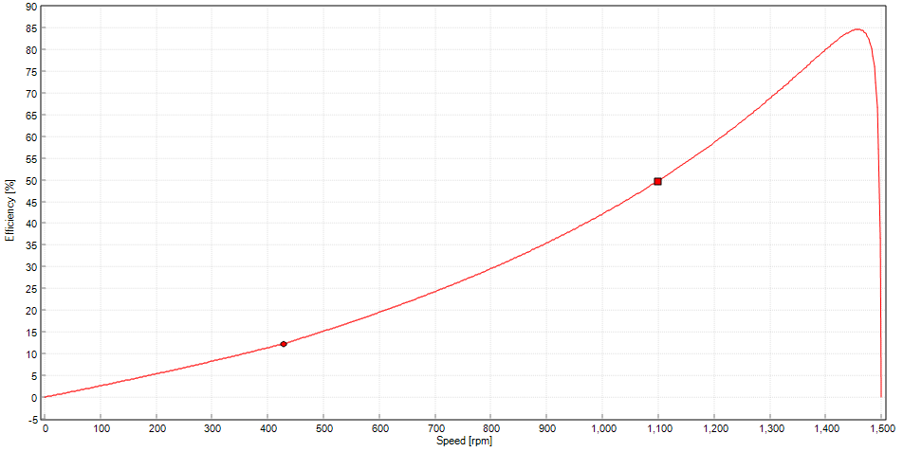
Figure 3: graph of Efficiency against speed
The initial rise indicates that efficiency improves as the motor gains speed, due to better alignment of magnetic fields and reduced losses. The subsequent decline suggests that at higher speeds, factors such as increased heat or mechanical losses reduce efficiency.
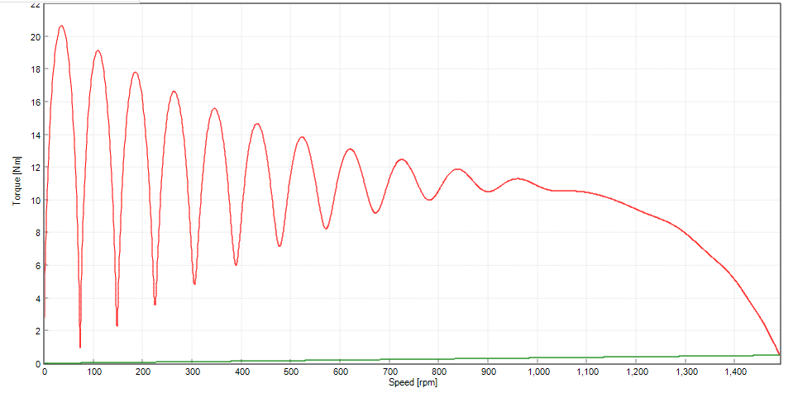
Figure 4.: graph of Torque against speed
The peak torque occurs at an intermediate speed, representing the maximum load the motor can handle. The decline at higher speeds suggests that torque decreases as the motor approaches its rated speed, consistent with the typical torque-speed characteristic of an induction motor.

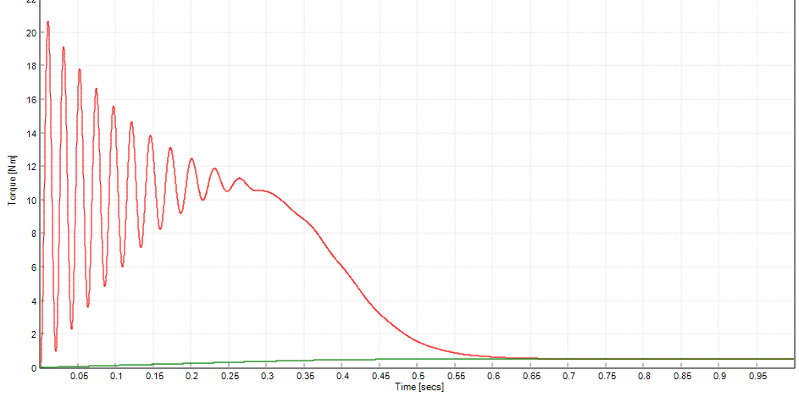
- Figure 5: graph of Torque against Time
The initial peak represents the starting torque required to overcome inertia and load. The subsequent oscillations and decline indicate the motor settling into a steady-state operation, where torque stabilizes after the initial transient phase.
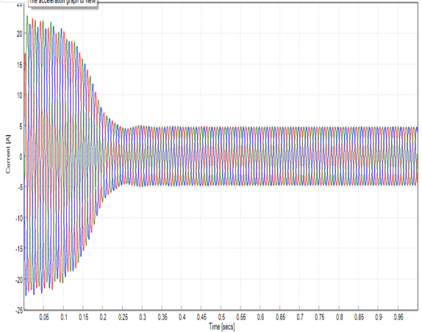
Figure 6: graph of current against Time
The initial spike reflects the high inrush current during motor startup. The multi-colored lines likely represent the three phases, showing how currents synchronize and stabilize as the motor reaches normal operation, with some residual oscillations.
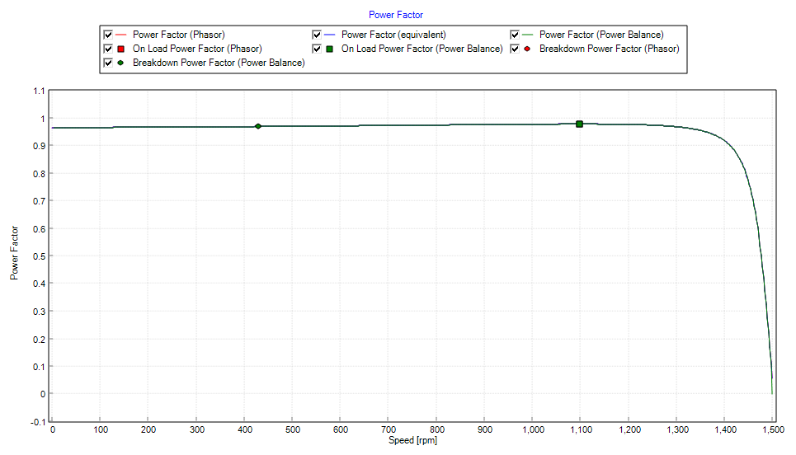
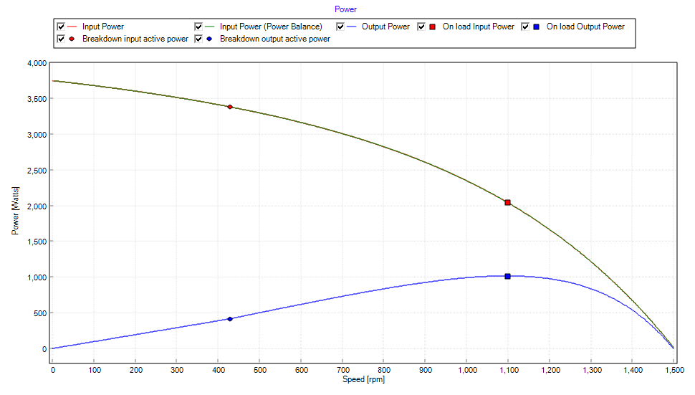
Figure 7: graph of power factor against speed

Figure 8 Graph of power against speed
The power factor, which indicates the efficiency of power usage, improves with speed due to better phase alignment between voltage and current. The plateau or slight decline at higher speeds may indicate limitations due to reactive power or saturation effects.
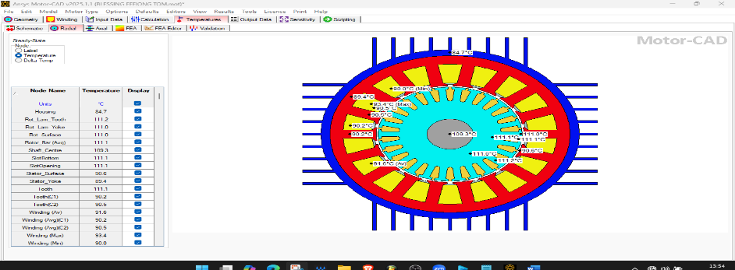
Figure 9: Temperature distribution of various motor components in a steady-state thermal analysis
The rotor components (e.g., rotor lamination, rotor surface, rotor bars) have temperatures around 111°C. The stator yoke is at 89.4°C, while the stator surface is 90.6°C. The slot bottom and slot opening are at 111.1°C, indicating heat concentration in winding areas. The Maximum winding temperature is 93.4°C, while the minimum is 90.0°C. The average winding temperature is 91.6°C, with slight variations between coil groups. The shaft center is at 109.3°C, slightly cooler than the rotor bars. The housing temperature is 84.7°C, showing heat dissipation through the outer casing. Blue areas (cooler) represent heat dissipation paths. Red & Yellow areas (hotter) indicate heat accumulation zones, particularly around the rotor and windings.

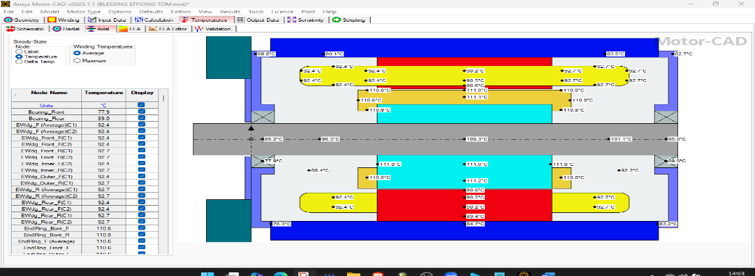
Figure 10: Temperature distribution of a thermal cross-sectional view of an electric motor in a steady-state thermal
The end winding temperatures are around 92.4°C to 92.7°C. The hottest winding sections reach 110.6°C to 111.2°C, which are marked in red and yellow, indicating significant heat concentration. The winding averages are around 92.4°C. The shaft temperature varies from 85.2°C to 109.3°C, with the central region being the hottest. End rings have temperatures around 110.6°C, indicating heat buildup. The front bearing is at 77.9°C, while the rear bearing is slightly hotter at 89.0°C. The motor housing is relatively cooler, with temperatures ranging from 69.8°C to 83.5°C, suggesting good heat dissipation.

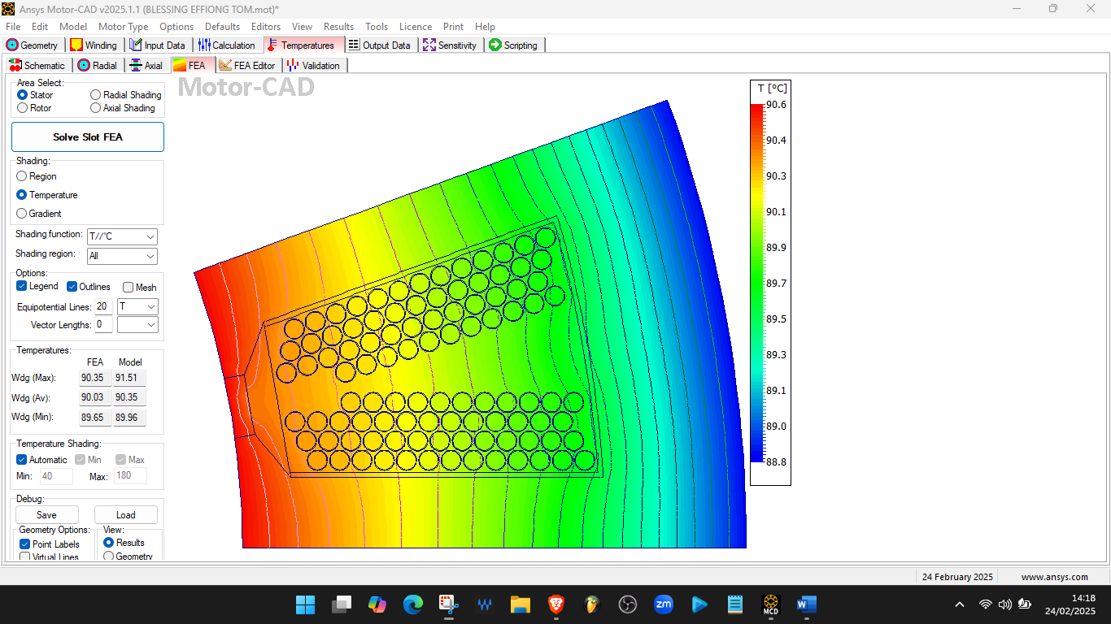
Figure 11: Finite Element Analysis (FEA) of the temperature distribution in a motor stator slot.
The colour gradient represents the temperature variation from 88.8°C (blue) to 90.6°C (red). The hottest areas (red/yellow) are concentrated towards the left side, indicating regions where heat accumulation is highest. The cooler regions (blue/green) are on the right, suggesting effective heat dissipation. FEA-calculated temperatures as Max: 90.35°C, Avg: 90.03°C and Min: 89.65°C
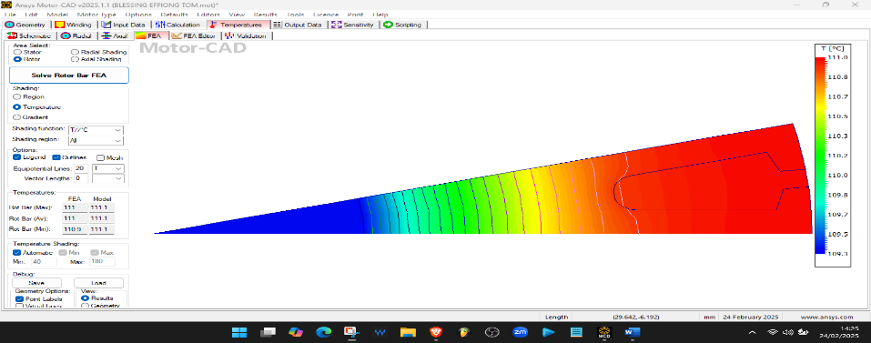
Figure 12: Thermal Analysis of a Rotor Bar using Finite Element Analysis (FEA).
The color gradient represents temperature variation from 109.3°C (blue) to 111.1°C (red). The hottest area (red region) is on the right side, where the rotor bar is shaped. The cooler region (blue/green) is towards the left, indicating a lower temperature area. Rotor Bar Temperatures: FEA results: Max: 111.1°C, Avg: 111.1°C, Min: 110.9°C

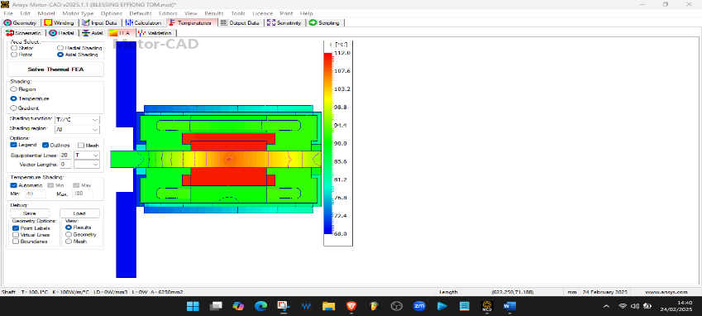
Figure 13: Thermal Analysis of the Motor in an Axial View.
The color gradient indicates temperatures from 68°C (blue) to 112°C (red). The hottest area (red region) is around the central shaft and windings, where heat is most concentrated. The outer regions (blue/green) are significantly cooler, showing heat dissipation.
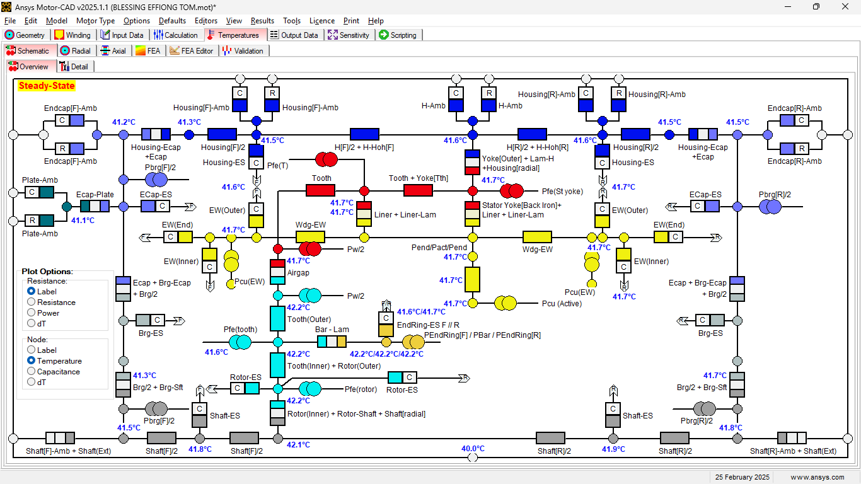
Figure 14: Temperature Distribution and Heat Flow Paths
41.7°C to 42.2°C in windings and teeth, Rotor 42.2°C, Shaft ~40°C to 41.9°C, Housing 41.3°C – 41.6°C and Endcaps ~41°C.

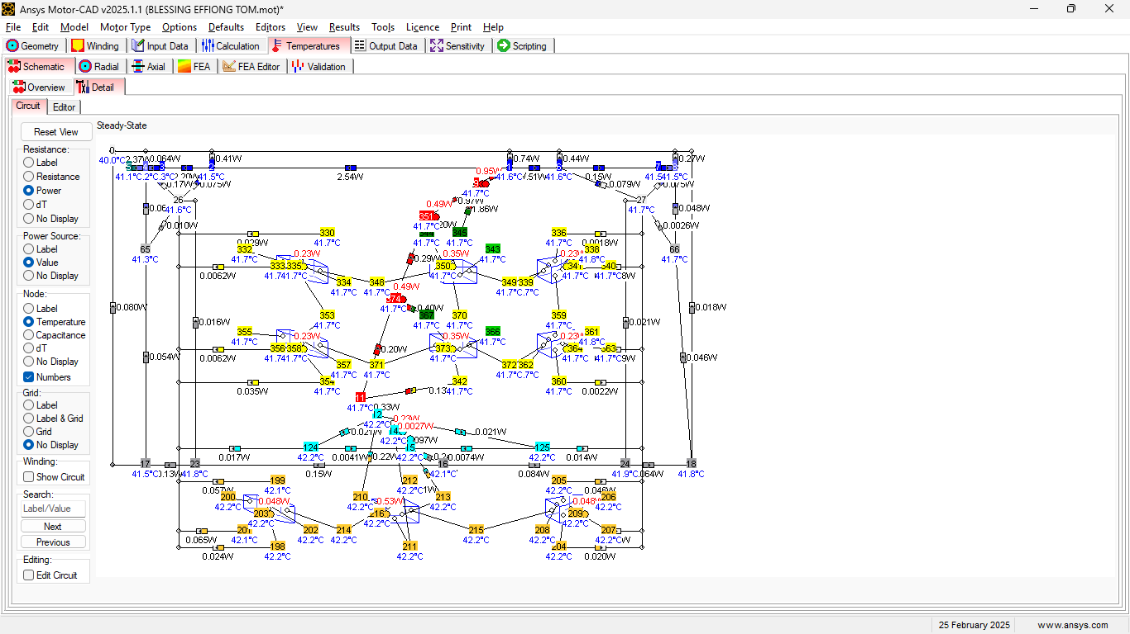
Figure 15: Heat Flow Paths and Temperature Distribution in Detailed Mode
The temperatures at various points in the motor are indicated in blue (e.g., 41.7°C, 42.2°C). Most temperatures are in the range 41°C – 42.2°C, indicating a well-balanced thermal design.

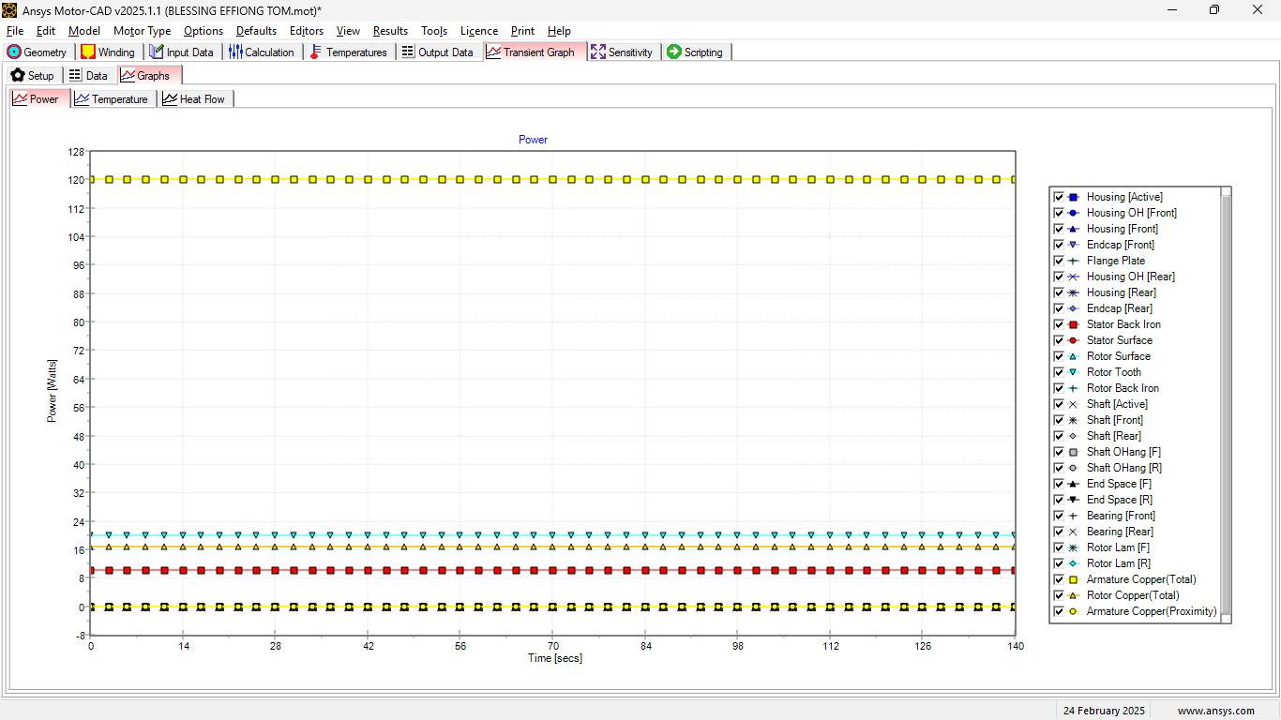
Figure 16: Graph of Power (Watts) against Time (Seconds)
The plot represents the power dissipation of different motor components over time. The power dissipation remains nearly constant throughout the duration of the test. The largest contributor to power dissipation appears to be Armature Copper (Total), as indicated by the highest curve. Other components, such as Rotor Surface, Stator Back Iron, and Shaft, have much lower power dissipation. The steady nature of the graph suggests that the motor is operating under stable conditions without significant power fluctuations.
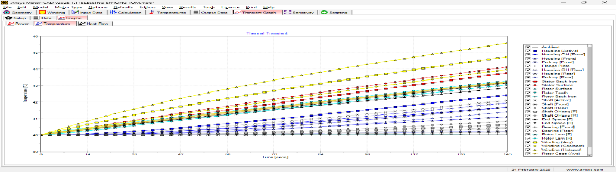
Figure. 17: Graph of Temperature (°C) against Time (Seconds)
This figure shows the temperature rise in various motor components over time. The temperature of most components steadily increases, with Winding (Hotspot) and Rotor Cage (Avg) reaching the highest temperatures. The motor housing and structural components (such as the shaft and bearings) remain at lower temperatures compared to the winding and rotor elements. This graph indicates that the system is heating up as expected, and steady-state temperature might be reached at a later time.

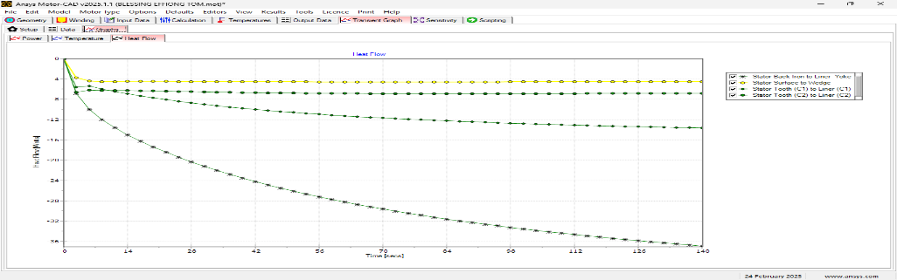
Figure 18: Graph of Heat Flow (Watts) against Time (Seconds)
This graph displays the heat flow between different motor components. The heat flow initially starts at a high negative value and gradually stabilizes, which suggests that the motor's thermal system is reaching equilibrium. Stator Back Iron to Liner Yoke and Stator Surface to Wedge have the highest negative heat flow, indicating significant heat dissipation through these pathways. The trends show that certain components are dissipating more heat over time, likely due to thermal conduction and cooling mechanisms.
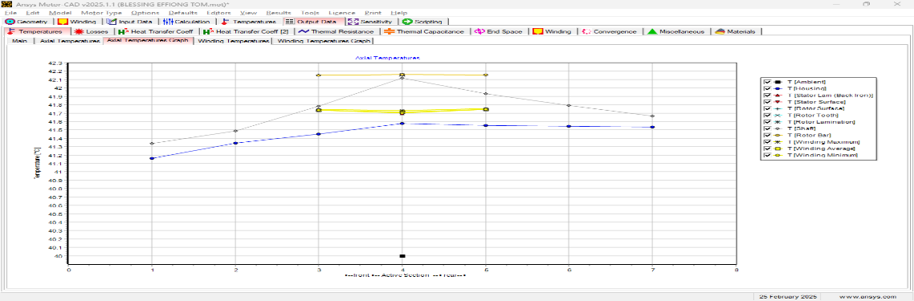
Figure 19: Winding Temperatures Graph
The highest winding temperature is around 41.75°C (T [EWdg (F) Maximum]). The temperature variation among different points in the winding is minimal. The Tooth temperature (T [Tooth]) is slightly lower than the winding temperatures, indicating effective heat dissipation into the core.

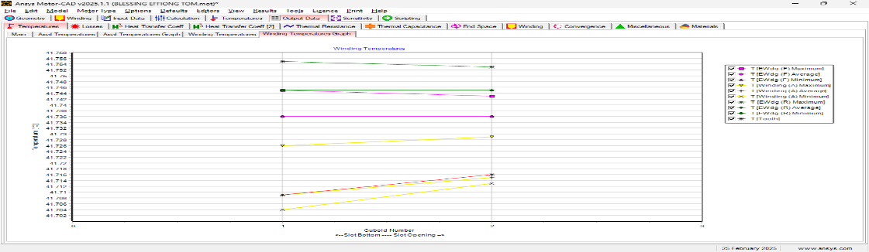

Figure 20: Axial Temperature Graph
Maximum winding temperature 42.2°C, while the minimum is around 41.6°C. The stator back iron (T [Stator Lam (Back Iron)]) and rotor surface (T [Rotor Surface]) exhibit a steady rise, with the rotor bar being slightly cooler. The housing temperature (T [Housing]) remains lower, showing that heat is being effectively transferred outward.
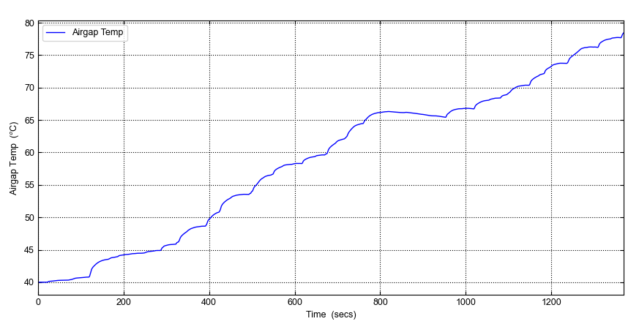

Figure 21: Graph of Rotor Winding Temperature against Time
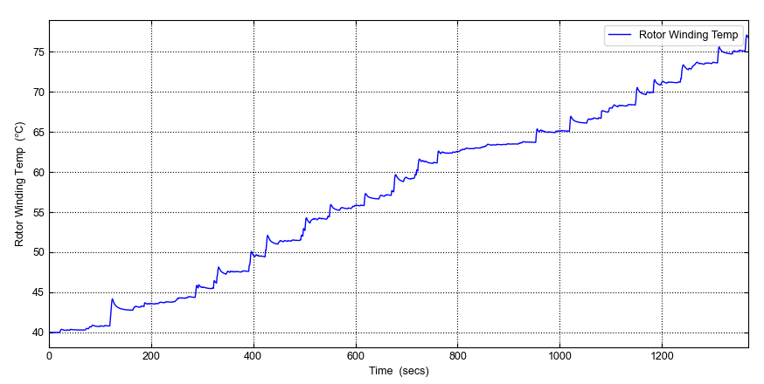

Figure 22: Graph of Airgap Temperature against Time

From Figure 22, the ambient or initial steady-state temperature before loading is known as the airgap temperature, which starts at approximately 40°C. The gradual increase indicates that the airgap region is beginning to receive heat from the rotor and stator surfaces. Because the air gap has a relatively low thermal mass, thermal inertia dominates at this stage, and temperature increases slowly. From 43°C to 66°C, the temperature experiences a more consistent increase. The statement indicates that heat is continuously generated from the losses of rotor copper (I2R losses) and Stator copper losses. Heat is transferred from the rotor surface to the rotating airgap through conduction and convection, resulting in core (iron) losses. A first-order thermal system behavior, typical of induction motor heating, is indicated by the nearly linear rise. There is a slight flattening sensation observed in the range of 65 to 66°C. This indicates that the equilibrium between heat generation and heat dissipation is approaching a temporary state. The cooling process, which involves the circulation of air due to the rotation of the rotors, is a partial solution to counteract the accumulation of heat. Temperature rises again, reaching about 78–79°C. The rotor body's heat accumulation leads to an increase in convection temperature, indicating that the load is still being carried on. Thermal steady state has not yet been completely reached, as the curve does not fully saturate.
Rotor winding temperature vs time is seen in Figure 20. The direct heating of rotor conductors, which usually reach temperatures higher than the airgap, is depicted in this graph. begins at about 40°C, just like airgap. Temperature spikes appear early. Variations in rotor current, step reactions from numerical simulations, and changes in load can all cause these fluctuations. Since rotor windings are the main cause of rotor copper losses, they heat up more quickly. It increases from about 42°C to about 63°C. Compared to the airgap curve, the increase is a little steeper. This demonstrates that the rotor winding has a lower thermal time constant than the surrounding airgap, confirming direct Joule heating in the rotor bars and limited instantaneous cooling inside the rotor slots. The temperature rises gradually to about 76–77°C. Little increments that resemble steps show: Variations in incremental load are possible. The rotor winding temperature continuously stays marginally higher than the airgap temperature in dynamic behavior while using a time-stepping solver in simulation.

CONCLUSSION
Ascertaining whether effective heat dissipation strategies, like better ventilation or liquid cooling, may be required if temperatures exceed design limits; evaluating the thermal performance of the motor slot and windings; making sure that temperatures stay within safe operating limits; assessing thermal performance, cooling efficiency, and potential overheating risks in motor components; and identifying areas where improved cooling strategies, like better airflow, cooling fins, or liquid cooling, could enhance motor efficiency and longevity. The temperature at which the rotor bar operates is 120°C, 180°C, and 280°C. It indicates overheating, which could be addressed by improving cooling systems (e.g., better ventilation or cooling channels). improving the material of the rotor bar to increase its heat conductivity. Lowering heat production by cutting electrical losses. In order to guarantee that the motor runs effectively and does not overheat when under stress, this model is essential. In other words, the analysis of thermal flow in a three-phase induction motor reveals small imbalances caused by varying rates of heat dissipation, even when the temperature distribution among the windings, stator, and rotor remains within working ranges. The power and heat flow graphs demonstrate efficient energy conversion, indicating that copper and iron losses are the primary sources of heating. Despite these asymmetries, the motor's cooling mechanisms preserve thermal stability, preventing component failure or a decrease in performance. This study highlights the importance of understanding temperature behavior to increase motor reliability, efficiency, and longevity.

COMPETING INTERESTS DISCLAIMER:
Authors have declared that they have no known competing financial interests OR non-financial interests OR personal relationships that could have appeared to influence the work reported in this paper.

REFERNCE
Adebayo, S. O., Olawale, I., & Adekunle, T. (2021). Energy-efficient induction motors in Nigerian industries: Challenges and opportunities. African Journal of Energy Research, 15(2), 45-60.

Adefemi, J. O., Ajibade, S. A., & Kayode, T. (2021). Analysis of thermal stresses in three-phase induction motors in Nigerian industries. Journal of Applied Engineering Research, 18(3), 105-118.

Adouni, A., & Marques Cardoso, J. (2021). Thermal analysis of low-power three-phase induction motors operating under voltage unbalance and inter-turn short circuit faults. Machines, 9(1), 2. https://dx.doi.org/10.3390/machines9010002

Afrah Thamer Abdullah, & Dr. Amer Mejbel Ali. (2019). Thermal analysis of a three-phase induction motor based on motor-CAD, flux2D, and MATLAB. Indonesian Journal of Electrical Engineering and Computer Science, 15(1), 46-53.

Ahmed, F.; Roy, P.; Towhidi, M.; Feng, G.; Kar, N.C. CFD and LPTN Hybrid Technique to Determine Convection Coefficient in End-winding of TEFC IM with Copper Rotor. In Proceedings of the IECON 2019-45th Annual Conference of the IEEE Industrial Electronics Society, Lisbon, Portugal, 14–17 October 2019; IEEE: New York, NY, USA; Volume 1, pp. 939–944.

Ali, J.A.; Hannan, M.A.; Mohamed, A.; Hussain, A. Optimization techniques to enhance the performance of IM drives: A review. Renew. Sustain. Energy Rev. 2018, 81, 1611–1626. [CrossRef]

Arumugam, R.; Srinivas, K.N. Analysis and characterization of switched reluctance motors: Part II. Flow, thermal, and vibration analyses. IEEE Trans. Magn. 2005, 41, 1321–1332. [CrossRef]

Asuquo Eke, Fischer, G., David, A., Ekpenyong, O., & EJ, A. (2024). The Effect Of Rotor and Stator Slot Numbers On The Performance Of Three-Phase Induction Motors Used for Transport Application. IOSR Journal of Electrical and Electronics Engineering (IOSR-JEEE), Volume 19, Issue 4 Ser. 1 (July. – August. 2024), PP 01-09

Asuquo Eke, Akpama E. J., Archibong E., Akisot E. (2021). Performance, Evaluation of Three Phase Induction Machine Control Using Simulink. International Journal of Innovative Science, Engineering & Technology, Volume 8, Issue 9, Pages 261 – 267, Publisher IJISET

Aydin, I., Yildiz, M., & Güler, A. (2020). Analysis of thermal stress in induction motors under unbalanced load conditions. IEEE Transactions on Industrial Electronics, 67(6), 1234-1241.
Aydin, M., Huang, S., & Lipo, T. A. (2020). Thermal analysis and modeling of induction motors under unbalanced conditions. IEEE Transactions on Energy Conversion, 35(2), 1053–1061.

Benjamin, A. (2014). Fundamentals of electrical machines (2nd ed.). McGraw-Hill.
Bianchi, N., Bolognani, S., & Dai Prè, M. (2005). Thermal analysis of induction and synchronous reluctance motors. IEEE Transactions on Industry Applications, 41(6), 1667–1675.

Boglietti, A.; Cavagnino, A.; Staton, D.; Shanel, M.; Mueller, M.; Mejuto, C. Evolution and modern approaches for thermal analysis of electrical machines. IEEE Trans. Ind. Electron. 2009, 56, 871–882. [CrossRef]

Boglietti, A.; Nategh, S.; Carpaneto, E.; Boscaglia, L.; Scema, C. An optimization method for cooling system design of traction motors. In Proceedings of the 2019 IEEE International Electric Machines & Drives Conference (IEMDC), San Diego, CA, USA, 12–15 May 2019; IEEE: New York, NY, USA; pp. 1210–1215.

Asuquo Eke, O. I. Okoro, A. J. Onah, E. J. Akpama, (2025) Design And Thermal Modelling of Induction Motor For prolong Lifespan. Iosr Journal of Electronics and Communication Engineering (Iosr-Jece)E-Issn: 2278-2834, P- Issn: 2278-8735.Volume 20, Issue 6, Ser. I (Nov – Dec 2025), Pp 81-89
Asuquo Eke, O. I. Okoro, A. J. Onah (2025) Impact of Changing Magnetization Reactance Value on The Performance Of Three-Phase Induction Motor
Journal Of Electrical And Electronics Engineering (IOSR-JEEE)e-ISSN: 2278-1676, p-ISSN: 2320-3331, Volume 20, Issue 6 Ser. 1 (Nov. – Dec. 2025), PP 01-08www.iosrjournals.orgDOI:10.9790/0853-2006010108

