EXCHANGE-RATE DEPRECIATION AND EXCHANGE-RATE PASS-THROUGH TO PHARMACEUTICAL PRICES IN INDIA (2014–2024)

---------------------------------------------------------------------------------------------------------------------
ABSTRACT:
The focus of this research paper is how much exchange rate pass-through occurs (ERPT) in the realm of Indian pharmaceuticals from 2014 through 2024. While this geographic area has a great deal of global competition with its finished pharmaceutical products, the industry is also heavily reliant upon using Active Pharmaceutical Ingredients (APIs) from foreign sources, thus having its costs of production very much subject to changes in the USD/INR exchange rate. Therefore, by using annual aggregated time series data, several models, specifically baseline regressions, dynamic lags, and interaction terms with respect to imports, have been employed to assess the degree or value of ERPT to both wholesale pharmaceutical prices (WPI–Pharmaceuticals) and retail medicine prices (CPI-Medicines). In general, ERPT has been present at considerable rates; however, between levels of producer versus consumer prices, ERPT is observed to transmit at a greater degree and at a faster rate for producers compared to consumers. Import dependence also magnified the impact of ERPT at the producer level. All results indicated sustained levels of reliability upon further determination of validity.
INTRODUCTION:
The Indian pharmaceutical sector is essential in providing affordable healthcare in India and as one of the largest suppliers of generic medications globally. Its exports of finished formulations are significant, but the industry continues to depend heavily on importing active pharmaceutical ingredients (APIs) and intermediates, many of which are strongly correlated with the US dollar. Hence, the changes in the USD/INR currency exchange rate have an immediate impact on the cost of production. When the Indian rupee declines in value, it creates an increase in the domestic cost of imported goods, creating a cost push at the time of manufacturing, which can affect the price of drugs at the wholesale and retail levels.
Exchange rate pass-through (ERPT), how much of a change in exchange rates is passed through to domestic prices, varies across sectors at different rates depending on the degree of imported goods, the level of competition in the market, the pricing policies for that sector, and any rigidity in the structure of adjusting the pricing of the imported good. For example, in industries that rely heavily upon imported goods, such as the pharmaceutical sector, the producers of drugs will tend to face the impact of the changes in the value of the dollar more quickly as the cost of their raw materials increases immediately. However, the price that the consumer pays may not adjust to the increases at the same rate as the producer prices due to the effect of distribution margins, retail markups, and their desire to maintain the stability of their consumer base.
Because the sector is reliant on imports, it is necessary to note the size, time, and difference in impacts caused by the foreign exchange rate when researching pharmaceutical producer and consumer prices that were impacted by the rupee devaluation between 2014 and 2024. This research intends to determine if there was a significant change in the producer and consumer prices in the pharmaceutical industry. There is a difference between the level of transmission to the producer level and to the consumer level. There may also be a difference in the level of impact on prices caused by the level of input from imports that are used by the pharmaceutical industry. Understanding how inflation is impacted by different variables in the pharmaceutical industry is important, as it will inform future inflationary adjustment includes consideration for these as well.
REVIEW OF LITERATURE:
Exchange Rate Pass Through (ERPT) refers to the degree to which changes in exchange rates affect or influence domestic prices. Classical Economics suggests that when a currency depreciates, the domestic price of imports will increase. It will then create an increase in the production costs and contribute to inflation through cost-push. However, the empirical literature to date has shown that the pass-through differed significantly from country to country, with some instances found that there was a complete pass-through, while in other cases the evidence indicated an incomplete pass-through (Goldberg & Knetter, 1997). The incomplete nature of pass-through may be explained by factors such as rigidities in price, competition in the market, contracts, and government actions. Taylor (2000) contends that in low-inflation countries and in countries where there is a high level of regulation, firms will, on average, absorb the exchange rate shocks rather than immediately increase prices.
Research as of late has placed increasing focus on the distinction between short-run and long-run exchange rate pass-through. Firms tend to take action either by changing profit margins or changing sourcing strategies in response to cost shocks in the short run, whereas over the long run, consistent currency fluctuations may have a cumulative effect on pricing policy. Most studies that look at this phenomenon use econometric methodologies capable of estimating both short-run adjustments and long-run equilibrium relationships; examples of these would be the Autoregressive Distributed Lag Model. The ARDL model is particularly useful because it can be applied to independent variables with different orders of integration, and it provides a straightforward means of interpreting both short- and long-term effects (Pesaran et al., 2001).
Research conducted in emerging markets indicates that the pass-through effect from exchange rates to local prices has historically been smaller compared to developed markets. This difference has been attributed in part to price controls, government subsidies, and intervention policies, which are more prevalent in these countries and therefore are a factor in dampening the relationship between exchange rates and prices (Choudhri & Hakura, 2006). In addition, when looking at producer versus consumer prices, it becomes clear that the former generally have a greater response to changes in currency values, while on the other hand, consumer prices may not always see the same level of effect. This suggests that the increased costs are absorbed by the company rather than fully transferred onto the end customer. Different sectors also vary in terms of their responses to changes in currency values based on their import content and regulatory environment, thus making it necessary to analyze individual industries separately.
The evidence of exchange rate pass-through in Indian literature demonstrates the presence of partial and asymmetric pass-through.
The impact of currency depreciation originated in significant changes in both the import price index and the Wholesale Price Index for the wholesale trade in goods, with the consumer inflation component affected later and to a lesser degree (Ghosh 2013). Pyne (2014) used the ARDL modelling framework to find that exchange rate fluctuations have a weak and diminishingly modest long-run influence on domestic prices, reflecting institutional barriers and lack of credibility for the monetary policy of India. This supports the theory that aggregated measurements of inflation may overlook large differences between various sectors and their respective methods for transmitting price changes.
The pharmaceutical sector has particularly strong relevance for evaluating exchange rate pass-through, due to its heavy reliance on imported components and finished products. While India is a very large exporter of finished pharmaceuticals, it depends on exported APIs and intermediates to produce pharmaceutical products, and the majority of imported pharmaceutical products and components are sourced from China (Department of Pharmaceuticals, 2020). Because of India's dependence on these imports, the pharmaceutical sector is directly impacted by fluctuations in the exchange rate for the rupee and, as a result, the cost of producing essential elements of product manufacturing is directly increased. For manufacturers of pharmaceutical products, this means that they experience cost-push price pressures because they must pay higher prices for their inputs, even if there are no significant changes in domestic demand for their products.
Pharmaceutical companies in India continue to operate under significant regulations despite the higher input costs they have faced recently due to supply chain constraints and other factors. For example, India has enacted the price ceilings for essential medicines through the Drugs (Prices) Control Order (DPCO). This effectively prevents companies from raising prices, even when production costs have increased substantially due to these rising costs. Evaluations of the impact of DPCO show that this regulation has been effective at keeping medicine prices low but has also resulted in the expulsion of much of the manufacturer's margin from the market (see Selvaraj et al., 2015). These regulations create a difference between inflation on the producer side and inflation on the consumer side, which indicates that exchange rate shocks would not be passed on to consumers.
At the firm level, studies indicate that the effect of exchange rate depreciation is not consistent among all companies. Companies that are heavily dependent on exports stand to gain from the depreciation of the rupee, as the increase in export revenues (in foreign currency) can make up for some or all of the increased input costs. Conversely, companies that are primarily focused on the domestic market are likely to face declining profit margins (Amiti et al., 2014). However, there still exists a lack of empirical evidence linking exchange rate changes with pharmaceutical pricing and the adjustment patterns of companies in India.
The current body of knowledge shows that pass-through to consumers in India is an incomplete one and is driven by institutional and sectoral systems. While studies done in the past have examined aggregate and sectoral price transmission, little work has connected exchange rate changes, pharmaceutical prices at the firm level, and recent time periods. The present work adds to our understanding by looking at the Indian pharmaceutical industry from 2014 to 2024, considering the roles of producers and consumers in transmitting pricing as well as the effect of regulation on pass-through due to changes in exchange rates.
STATEMENT OF THE PROBLEM:
The Indian pharmaceutical sector has a significant role in providing low-cost medicines both for the national market and as one of the largest exporters of generic formulations across the globe. The sector has a large volume of finished drug exports but is still very reliant on imports of active pharmaceutical ingredients and intermediates, which are essential components to manufacture pharmaceuticals. A large portion of these imported products is in US dollars; therefore, the cost structure of pharmaceutical production is primarily driven by fluctuations in the US dollar/Indian rupee currency pair. Consequently, when the rupee depreciates, the domestic currency cost of imports increases, thereby raising production costs and adding inflationary pressures to the pharmaceutical sector.
Exchange rate pass-through (ERPT) is how much change in an exchange rate gets passed on to domestic prices. When a currency depreciates, the cost of purchasing imports rises, which will move along the pricing chain; however, ERPT tends to be only partially passed along the pricing chain and varies by industry based on the amount of imports used in production, the level of competition in the market, pricing methods used, and whether adjustment costs exist. Manufacturers of products that rely heavily on imports, such as pharmaceuticals, will generally have a quicker response to ERPT because they will incur direct increases in costs due to rising import prices. However, the consumer price has a longer delayed response to ERPT because of margin costs, distribution costs, retail markups, and the firm's pursuit to keep its demand constant.
It is necessary to have a good understanding of the size, timing, and asymmetry of exchange rates being affected by the exchange rate (as an input to production) when considering the pharmaceutical industry’s reliance on imported goods. This study examines whether depreciation of the Indian Rupee versus the US Dollar from 2014 to 2024 has had any significant effect on both pharmaceutical producers' prices and consumers' prices in India, plus whether transmission occurs more strongly at the pharmaceutical producer level, and if import dependence increases the degree of exchange rate effects. For example, understanding all these factors separately can provide insight into inflation patterns in a heavily import-dependent and strategically desired industry (in this case, pharma).
NATURE OF STUDY
This is an analytical and empirical study that investigates the effect of exchange rate fluctuations on the price of pharmaceuticals in India by employing quantitative econometric approaches. A sectoral time-series approach is used for this research, with the unit of analysis being the relationship between the USD/INR exchange rate and pharmaceutical producer prices (WPI–Pharmaceuticals) and consumer prices (CPI–Medicines) from the years 2014 to 2024.
Baseline regression models will be estimated for measuring the immediate effect of depreciation of the rupee on pharmaceuticals; a dynamic lag model for capturing short-term versus delayed transmission effects; and an interaction model for assessing whether dependence on imports increases exchange rate pass-through. The data used for the analysis is secondary, and statistical techniques used include descriptive analysis, stationarity tests, and regression estimation methods. The goal is to conduct a structured empirical assessment of exchange rate pass-through in an industry that is strategically important and has a high proportion of imports.
SCOPE OF THE STUDY
This study has been defined as limited in the scope of its review to assess exchange rate pass-through and its effects on the Indian pharmaceutical industry between 2014 and 2024. This assessment will be done by looking at the effects of depreciation of the rupee on prices at both the producer level (WPI - Pharmaceuticals) and the end-user, or consumer, level (CPI - Medicines), as well as how much the use of imports (for import dependence) through the share of API imports has increased the exchange rate pass-through rates.
This review will not evaluate cross-country comparisons, firm-level micro-analyses, or evaluations of regulatory impacts; it will only look at sector-specific price indexes and will use available historical data (i.e., annual time-series data). While crude oil will be included as a control variable for robustness, the primary objective of this study will be to better understand the overall magnitude, timing, and asymmetry of the exchange rate pass-through along the pricing chain for pharmaceuticals in India.
OBJECTIVES OF THE STUDY
- To examine the impact of rupee depreciation on WPI–Pharmaceuticals and CPI–Medicines.
- To compare the magnitude and speed of pass-through between producer and consumer prices.
- To analyze whether API import dependence strengthens exchange rate transmission.
RESEARCH METHODOLOGY
The objective of this study is to empirically assess how fluctuations in the Indian rupee can affect inflation through time-series data analysis in the pharmaceutical industry. The data used for this study are secondary and consist of annual data from 2014 to 2024. This study will assess sector price dynamics instead of aggregate inflation, since the emphasis here is on understanding the pharmaceutical sector in order to identify industry-specific transmission mechanisms not observable from general aggregate measures of inflation.
The data used to conduct the analysis consists of annual data for the USD/INR exchange rate and the Pharmaceutical Price Index (WPI-Pharmaceuticals and CPI-Medicines). Annual average exchange rates were utilized as an indicator of depreciation in the value of the Indian rupee, while two separate healthcare indexes measuring pharmaceutical price movement were utilized; one index (WPI-Pharmaceuticals) reflects pharmaceutical producer price levels, while another index (CPI-Medicines) reflects retail price levels for pharmaceutical products. Oil prices were included as a control variable to capture global cost pressures that may affect production and transport costs. Additionally, import dependence was determined using Active Pharmaceutical Ingredient (API) import data as a percentage of the total value of pharmaceutical raw material imports.
To assess the effects of exchange rate fluctuations, our empirical study includes a number of statistical methods to provide baseline estimates. In order to measure the immediate consequences of changes in the exchange rate on the prices of producers and consumers, we utilize baseline regression models. We are able to compare the degree of pass-through for each price level based on different time intervals, using dynamic lag models to assess both short-term (immediate) and delayed (long-term) pass-through effects along the price chain. In addition, we estimate a model to determine whether higher API import shares increase the magnitude of exchange rate pass-through via an interaction model. Together, these models provide a detailed assessment of the total size, time frame, and asymmetry of pass-through across the pricing chain in the Indian pharmaceutical industry, resulting from changes in the value of the rupee against other currencies.
HYPOTHESES:
- H1: Rupee depreciation positively affects pharmaceutical prices.
- H2: Exchange rate pass-through is stronger and faster at the producer level than at the consumer level.
- H3: Greater import dependence amplifies exchange rate pass-through.
ANALYSIS:
The descriptive statistics for the nominal exchange rate (USD/INR), pharmaceutical price, and producer prices are proxies measured by WPI (pharmaceuticals) and consumer price consumer medicine prices are proxies measured by CPI (Medicines), for the period 2014-2024, can be found in the table-1. The data used for calculating those descriptive statistics were based on eleven years of annual observations.
The exchange rate series had a mean of 71.10 with a range of 61.9 - 83.2, indicating continued depreciation of the Indian Rupee over the course of this study. Its standard deviation of 7.77 indicates moderate volatility in the exchange rate, enough to add cost pressure to import-based industries (the pharmaceutical industry) from changes in the exchange rate. Its positive skewness (0.368) indicates a right-tailed distribution, which is consistent with the concentration of higher exchange rates occurring toward the end of the sample period. Its negative kurtosis (-1.221) indicates a platykurtic distribution; therefore, changes in the exchange rate during the sample period were more gradual than extreme or abrupt shock-type movements.
The average value of the producer price index for pharmaceuticals is 129.32 but has much greater variability when compared to the average value of the currency. The standard deviation of the producer price index is 12.63. Higher variability of producer prices, relative to other inputs, reflects sensitivity to changes in input costs associated with pharmaceuticals' dependency on many imported active pharmaceutical ingredients (APIs). The near-zero skewness (–0.126) indicates that producers' price distributions are largely symmetrical. The negatively skewed kurtosis (–1.229) indicates a trend-dominated or smooth evolution of prices. These observations support persistence in producer prices and are indicative of cost-push inflation rather than transient price volatility. This is consistent with the theoretical analysis of exchange rate pass-through at the production level.
Consumer medicine prices have a mean of 126.33, with a standard deviation of 13.25, showing very significant variation over time. The positive skew (0.530) indicates that, in the latter years of the sample, there was a greater percentage of consumer medicine prices that had higher values, further supporting cumulative inflationary effects as the cause for increased consumer medicine price inflation over this period of time. However, despite the upward movement in consumer medicine prices, the distribution of consumer medicine prices remained quite stable, as indicated by negative kurtosis (–0.379), which suggests no extreme consumer price fluctuations over this evaluation of consumer medicine prices.
A comparative analysis of producer and consumer price indices indicates a pronounced asymmetry of price behavior. While both the WPI–Pharmaceuticals and CPI–Medicines demonstrate an increasing trend over time, the magnitude of the response of producer prices to changes in exchange rates is substantially greater than that of consumer prices. The diverging behavior between WPI–Pharmaceuticals and CPI–Medicines provides tentative empirical support for the proposition that exchange rate changes are partially passed through in the pharmaceutical industry, with producers absorbing considerable increases in production costs, while consumer prices are only partially insulated from these cost increases.
The failure to respond to consumer medicine prices is largely attributable to the existence of drug price regulation under the Drugs Prices Control Order (DPCO), which establishes maximum (ceiling) prices that can be charged for drugs and prevents the transmission of the full amount of higher input prices to consumers. Thus, the costs imposed on drug producers by exchange rate fluctuations are reflected to a greater extent in producer prices than in consumer prices.
In total, the descriptive statistics present compelling preliminary evidence that rupee depreciation is correlated with increases in pharmaceutical prices, and that rupee depreciation has a disproportionately larger effect on prices at the producer than at the consumer level. As a result, this study uses time-series techniques, such as stationarity testing, regression analysis, and ARIMA modeling, to comprehensively evaluate the dynamic process of exchange rate pass-through and the transmission of inflation in the Indian pharmaceutical industry.
Table-1: Descriptive Statistics
Descriptive Statistics
 | N | Range | Minimum | Maximum | Mean |  | Std. Deviation | Variance | Skewness |  | Kurtosis
 | Statistic | Statistic | Statistic | Statistic | Statistic | Std. Error | Statistic | Statistic | Statistic | Std. Error | Statistic | Std. Error
USDINR | 11 | 21.3 | 61.9 | 83.2 | 71.1 | 2.3439 | 7.7737 | 60.43 | 0.368 | 0.661 | -1.221 | 1.279
WPIPHARMA | 11 | 37.4 | 109.4 | 146.8 | 129.318 | 3.8082 | 12.6304 | 159.528 | -0.126 | 0.661 | -1.229 | 1.279
CPIMEDS | 11 | 43.1 | 108.2 | 151.3 | 126.327 | 3.9949 | 13.2495 | 175.548 | 0.53 | 0.661 | -0.379 | 1.279
Valid N (listwise) | 11
Source: Exchange rate pass-through to domestic prices in India. RBI Bulletin. https://www.rbi.org.in
Database on the Indian economy. https://dbie.rbi.org.in
Commodity markets outlook. https://www.worldbank.org
MODEL ESTIMATION:
WPIₜ = α₀ + α₁ USDINRₜ + εₜ
Table-2: Model Summary
Model Summary
Model | R | R Square | Adjusted R-Square | Std. Error of the Estimate | Change Statistics |  |  |  |  | Durbin-Watson
 |  |  |  |  | R Square Change | F Change | df1 | df2 | Sig. F Change | Durbin-Watson
1 | .952ª | .907 | .896 | 4.0672 | .907 | 87.436 | 1 | 9 | .000 | 1.392
Source: Exchange rate pass-through to domestic prices in India. RBI Bulletin. https://www.rbi.org.in
Database on the Indian economy. https://dbie.rbi.org.in
Commodity markets outlook. https://www.worldbank.org
Table-3: ANOVAª
ANOVAª
Model |  | Sum of Squares | df | Mean Square | F | Sig.
1 | Regression | 1446.395 | 1 | 1446.395 | 87.436 | .000^{b}
1 | Residual | 148.881 | 9 | 16.542
1 | Total | 1595.276 | 10
Source: Exchange rate pass-through to domestic prices in India. RBI Bulletin. https://www.rbi.org.in
Database on the Indian economy. https://dbie.rbi.org.in
Commodity markets outlook. https://www.worldbank.org
Table-4: Coefficients
Coefficientsª
Model |  | Unstandardized Coefficients |  | Standardized Coefficients | t | Sig. | Correlations
 |  | B | Std. Error | Beta | t | Sig. | Zero-order | Partial | Part
1 | (Constant) | 19.320 | 11.827 |  | 1.633 | .137
1 | USDINR | 1.547 | .165 | .952 | 9.351 | .000 | .952 | .952 | .952
Source: Exchange rate pass-through to domestic prices in India. RBI Bulletin. https://www.rbi.org.in
Database on the Indian economy. https://dbie.rbi.org.in
Commodity markets outlook. https://www.worldbank.org
Table-5: Residuals Statisticsª
Residuals Statisticsª
 | Minimum | Maximum | Mean | Std. Deviation | N
Predicted Value | 115.085 | 148.038 | 129.318 | 12.0266 | 11
Residual | -5.6849 | 7.4209 | .0000 | 3.8585 | 11
Std. Predicted Value | -1.183 | 1.557 | .000 | 1.000 | 11
Std. Residual | -1.398 | 1.825 | .000 | .949 | 11
CPIₜ = β₀ + β₁ USDINRₜ + uₜ
Source: Exchange rate pass-through to domestic prices in India. RBI Bulletin. https://www.rbi.org.in
Database on the Indian economy. https://dbie.rbi.org.in
Commodity markets outlook. https://www.worldbank.org
Table-6: Model Summary
Model Summary
Model | R | R Square | Adjusted R-Square | Std. Error of the Estimate | Change Statistics |  |  |  |  | Durbin-Watson
 |  |  |  |  | R Square Change | F Change | df1 | df2 | Sig. F Change | Durbin-Watson
1 | .961ª | .924 | .915 | 3.8605 | .924 | 108.792 | 1 | 9 | .000 | 2.016
Source: Exchange rate pass-through to domestic prices in India. RBI Bulletin. https://www.rbi.org.in
Database on the Indian economy. https://dbie.rbi.org.in
Commodity markets outlook. https://www.worldbank.org
Table-7: ANOVAª
ANOVAª
Model |  | Sum of Squares | df | Mean Square | F | Sig.
1 | Regression | 1621.352 | 1 | 1621.352 | 108.792 | .000^{b}
1 | Residual | 134.129 | 9 | 14.903
1 | Total | 1755.482 | 10
Source: Exchange rate pass-through to domestic prices in India. RBI Bulletin. https://www.rbi.org.in
Database on the Indian economy. https://dbie.rbi.org.in
Commodity markets outlook. https://www.worldbank.org
Table-8: Residuals Statisticsª
Residuals Statisticsª
 | Minimum | Maximum | Mean | Std. Deviation | N
Predicted Value | 111.258 | 146.147 | 126.327 | 12.7332 | 11
Residual | -4.1413 | 6.8663 | .0000 | 3.6624 | 11
Std. Predicted Value | -1.183 | 1.557 | .000 | 1.000 | 11
Std. Residual | -1.073 | 1.779 | .000 | .949 | 11
Source: Exchange rate pass-through to domestic prices in India. RBI Bulletin. https://www.rbi.org.in
Database on the Indian economy. https://dbie.rbi.org.in
Commodity markets outlook. https://www.worldbank.org
The exchange rate coefficient estimate from the CPI-Medicines regression is 1.638, with a t-statistic value of 10.430 and a p-value of 0.000. This result demonstrates that exchange rate variability has an observable, positive, and statistically significant impact on prices for consumer medicines. While the magnitudes of these coefficients seem similar to producer price model coefficients, their economic interpretation must be incorporated into a more complete picture of the price adjustment process, and also along with the time-series characteristics of consumer prices. Stationarity analysis completed previously on the CPI-Medicines shows that consumer prices have high levels of persistence, which leads to slow rates of mean reversion. Thus, consumer prices appear to adjust slowly to changes in exchange rates rather than adjust immediately after changes occur.
A comparison of the two models shows a significant amount of asymmetry in terms of exchange rate pass-through between the pharmaceutical price chain and both producer-level and consumer-level data. At the producer level, degradation in exchange rates impacts production input costs through previously imported APIs. This is the basis of relatively quick and significant adjustments to wholesale pricing as a result of the exchange rate effects on input costs, and this relationship can be seen as a strong statistical relationship in the WPI-Pharmaceuticals model. Therefore, producer prices are the primary means by which exchange rate shocks impact the pharmaceutical industry as a whole.
The relationship between the exchange rate coefficient (significant) and the adjustment in consumer prices for medicines has a different dynamic than with wholesale prices. Regulatory and institutional constraints limit how much and how quickly any increase in price could be passed through to the final consumer as part of the consumer's purchase of consumer goods. Therefore, cost increases due to the exchange rate will be partly absorbed by the producers (suppliers) and/or passed onto consumers slowly over time. This interpretation is consistent with both the persistence of CPI - Medicines in the unit root analysis and also the smooth upward trend for consumer prices within the descriptive and graphic analyses.
Diagnostic statistics provide additional evidence for the validity of the models that were estimated in the analysis. The Durbin-Watson statistic for the WPI-Pharmaceutical model is located at 1.392, indicating some level of positive autocorrelation, which is expected in short time series and therefore should not detract from the primary conclusions. Based on an estimated Durbin-Watson statistic of 2.016, the CPI - Medicines model does not exhibit serial correlation in the residuals of the estimated equation. Residual diagnostic statistics for both models indicate that the residual distributions are centered at zero and have a limited amount of variability, indicating an adequate fit of OLS-based specifications for both models.
The results of the cross-section regressions show a distinct pattern of asymmetrical Exchange Rate Pass-Through (ERPT) within the Indian Pharmaceutical Industry. While RUPEE depreciation (i.e., fall in the value of the INR against the major currencies) will impact both producer and consumer prices, the changes at the Producer Price Level are much more responsive and volatile relative to Consumer Prices; this is primarily because Producers are exposed directly to exchange rate fluctuations whereas there is always some degree of regulation of the sale price of pharmaceuticals at the Consumer Level. These findings are indicative of a substantial amount of import reliance and price regulation, both of which have a significant impact on inflation behavior within the Pharmaceutical Industry.
Results from the regressions that were done to measure the effect of Indian Rupee depreciation on prices of pharmaceuticals between 2014 and 2024 have met the first objective of the research, with evidence of a significant positive relationship between rupee depreciation and the prices of pharmaceuticals (H₁). The comparison between the producer price regressions and customer price regressions was made in order to evaluate the second objective of the research, which asked whether there was an unequal amount of exchange rate pass-through to producer versus customer prices.
Additionally, the consumer medicines price adjustment was slower and less extreme than that of producer prices (H₂), which supports Hypothesis 2. The degree of asymmetry in price adjustments was consistent with the idea that price regulation under the Drugs (Prices) Control Order in India affects the degree to which exchange rate changes are passed through to consumers (H₃). Basically, the economy shows that depreciation of the Indian rupee has an inflationary effect on the pharmaceutical industry in India, with a larger and more immediate effect on producers than consumers. Producer-level transmission is stronger and more direct than consumer-level transmission due to the effects of regulations on the consumer market. The results will help shape pharmaceutical price regulation, foreign exchange management, and the need to decrease imports of pharmaceuticals in the future.
Figure-1: USD/INR Exchange Rate Movement
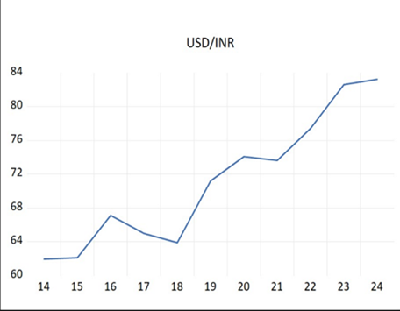
Figure-2: Consumer Price Index (CPI) of pharmaceutical products
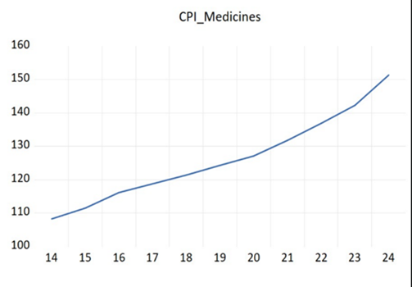
Figure-3: Wholesale Price Index of pharmaceuticals
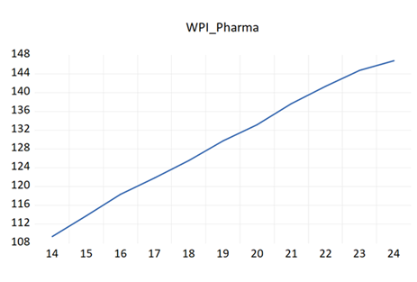
As shown in Figure 1, USD/INR Exchange Rate Movement, the annual trend in the value of the Indian Rupee (INR) compared to the United States Dollar (USD) from 2014 to 2024 has been steadily increasing and demonstrates that INR has continued to depreciate against the USD. The general trend over this period has also been upward, although there were periods of slight fluctuation within the middle of the date range. The upward trend in USD/INR indicates that the pressures of the exchange rate continue to exist for an extended period of time and will cause extended cost pressure on businesses that import goods from other countries. An example of an industry where this will have an impact is the pharmaceutical industry, because many pharmaceuticals are sourced through imports.
On the other hand, Figure 2 charts the pattern of increase in the Consumer Price Index (CPI) of pharmaceutical products over the period of time of the study. The pattern shows a relatively constant rise in the CPI for pharmaceutical products with a more rapid increase in the later years of the study than earlier, yet relatively smooth representing moderate price transmission from the manufacturer to the consumer. Thus, while there has been an overall increase in prices as a result of cost pressures influenced by exchange rate fluctuations, these costs will only be partially passed on to the consumer indicating there is pharmaceutical price regulation in place.
The Wholesale Price Index for Pharmaceuticals depicted in Figure 3 illustrates that there has been a steady and pronounced increase in the Wholesale Price Index of pharmaceuticals from 2014 to 2024. As demonstrated in the figure, there has been a marked increase in inflationary pressures at the producer level of pharmaceuticals. Compared with Consumer Prices, Wholesale Prices of Pharmaceuticals have increased at a faster rate. This trend may be attributed to the high dependence on imported Active Pharmaceutical Ingredients (API's) in the production of pharmaceuticals and is evidence that there is increasing pass-through by producers to the wholesale price level from Exchange Rate fluctuations.
Table-9: ADF Tests for WPI and CPI
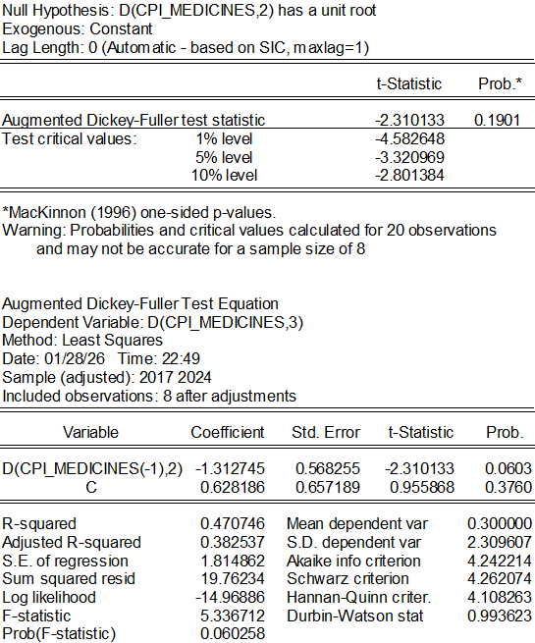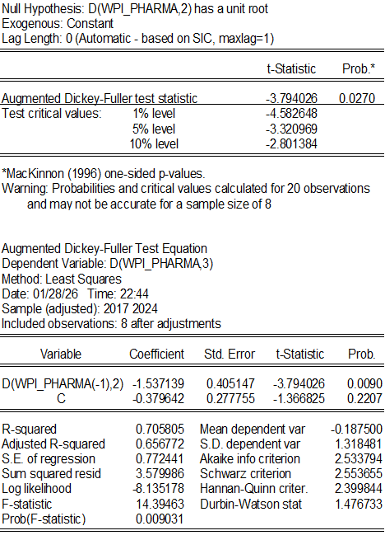
The Augmented Dickey-Fuller (ADF) unit root test is used to assess the stationarity properties of price indices for pharmaceutical products. Since non-stationary variables can produce spurious results when regressed on one another without appropriate transformation, the ADF test will indicate to the analyst whether or not the series is stationary or has a unit root.
The ADF test is initially applied to the levels of the Wholesale Price Index for pharmaceuticals (WPI-Pharmaceuticals) and the Consumer Price Index for medicines (CPI-Medicines). Both of the level test statistics are statistically significant; therefore, we cannot reject the null hypothesis that both series have a unit root. Therefore, both pharmaceutical producer prices and consumer medicine prices are non-stationary in levels, which indicates that they have changing means and variances over time, and they will also have shocks to their prices that will be persistent rather than momentary.
The ADF test's use on the first difference of the data series shows the order of integration because of the existence of non-stationarity. The ADF test on the first difference of the WPI used to measure the price at which a pharmaceutical manufacturer pays for an input has a test statistic of -3.7940 with an associated probability of 0.0270. The probability value is below the conventional 5% significance level, and the test statistic is more negative than the critical value, thus indicating that the null hypothesis of the existence of a unit root can be rejected at a significance level of 5%. This means that the changes in pharmaceutical producer prices are stationary after first differencing, thus indicating that the WPI for pharmaceutical products is integrated of order one (I(1)).
The statistical rejection of the unit root for the first difference of the WPI for Pharmaceutical products indicates that there is persistence in the prices at which manufacturers purchase inputs; however, changes in those same prices have a predictable and stable process of returning to the mean. In terms of economics, this indicates that changes to pharmaceutical producer prices caused by input cost increases caused by a depreciation of the Rupee or an increase in the price of importable raw ingredient pharmaceuticals are permanent, but have predictable and permanent effects on, for example, how much a manufacturer pays for the input over time. An appropriate dynamic econometric model can be used to describe the change process. Based on these results from the ADF test on the differenced WPI–Pharmaceuticals series, producer prices are stable but exhibit long-term stickiness, and changing over time for producer price changes can be modeled with dynamic econometric models. Therefore, the effect of an exogenous shock (such as a rise in input costs from rupee depreciation) to the price producers pay to procure active pharmaceutical ingredients can be modeled and predicted with certainty over time.
The ADF test of the differenced consumer price index of medicines has produced a test statistic of –2.3101 and a corresponding significance level of 0.1901. The significance level for this report is significantly above the 10 per cent level of significance, and, in addition, the absolute test statistic does not exceed the critical values for both the 1 per cent and 5 per cent and the 10 per cent level of significance. Therefore, the null hypothesis of a unit root is not rejected using differencing at the amount tested. The results indicate that the prices of consumer medicines are highly persistent and do not revert to the mean over short time periods.
The difference between the probability values of WPI–Pharmaceutical (0.0270) and CPI–Medicines (0.1901) highlights a divergence in the dynamics of producer and consumer prices within the pharmaceutical industry. Whereas producer prices tend to respond in a statistical manner that is assumed stable once differenced, consumer prices adjust at a much slower rate and are affected by long-term structural factors. Price persistence between the CPI–Medicines suggests that price adjustments are made over time rather than being made immediately.
This pattern of price persistence can be interpreted from a regulatory perspective as being supported by the Cambodian regulatory regime related to pharmaceutical pricing. Under the Drugs (Prices) Control Order, companies cannot pass through cost increases directly or immediately to consumers; therefore, cost pressure from exchange rate changes will either be absorbed at the producer level or passed on to customers only slowly, producing prolonged inflationary impacts rather than abrupt price changes.
The results from the ADF tests show clear differences between the stationarity characteristics of the WPI–Pharmaceuticals and CPI–Medicines prices. Both the WPI–Pharmaceuticals and CPI–Medicines are nonstationary at the first level, but after taking the first difference of the WPI–Pharmaceuticals price index, the values become stationary, while the CPI–Medicines prices remain very persistent at the tested level. This highlights that there is an appropriate basis for applying dynamic time-series econometric methods in the subsequent analyses, as well as the early evidence of asymmetrical price adjustments between producer and consumer levels in the pharmaceutical industry.

Dynamic Lag Model Results
Table 10. Producer Price Lag Specification
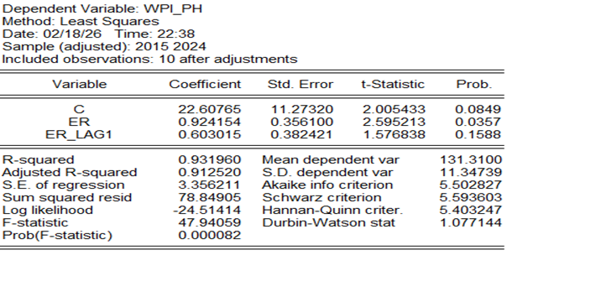
Exchange rate shock impacts on pharmaceutical producer price behavior are tested using a dynamic lag specification of pharmaceutical producers' wholesale price. Results indicate that contemporaneous exchange rate shocks have a positive, statistically significant coefficient (β = 0.924, p < 0.05), while the lagged exchange rate coefficient is positive but statistically insignificant (β=0.603, p > 0.10). This suggests that pharmaceutical producer price changes are predominantly passed through by means of contemporaneous exchange rate changes, with little or no distribution of exchange rate changes over time.
Through the assessment of contemporaneous significance, we conclude that the transmission of cost from depreciation of the currency to production-level pricing occurs immediately, confirming our observation of the importance of imported goods in the production of pharmaceutical products. The fact that the lagged term adds nothing to the model suggests that the effect of exchange rate shocks on wholesale prices is not persistent. The R2 of the model is approximately equal to 0.92, indicating that there is a great deal of explanatory power associated with exchange rate dynamics with regard to production price level inflation.
CONSUMER LAG MODEL

Table 11. CONSUMER LAG MODEL

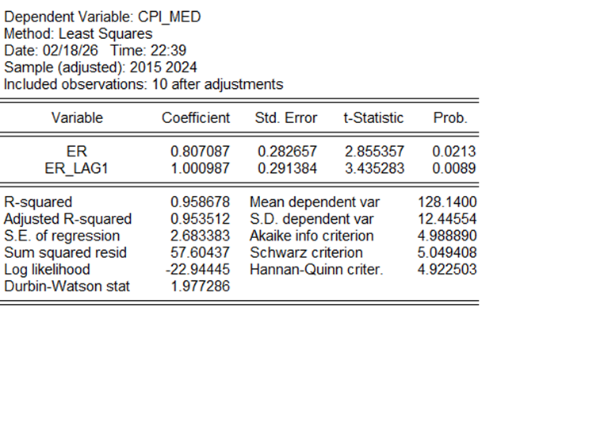
The lag specification for the price of consumer medicine indicates a different structure of adjustment. Both the contemporaneous exchange rate coefficient (β = 0.807, p < 0.05) and the lagged (i.e., past) exchange rate coefficient (β = 1.001, p < 0.01) are statistically significant, with the lagged effect being greater than the contemporaneous effect. This suggests that there is a distribution of exchange rate pass-through to consumer prices over time rather than an instantaneous pass-through. The strong lagged effect indicates that retail price adjustment is persistent, with increased costs at the production level being slowly transmitted to retail through multiple distribution channels and pricing strategies. The R² value of the model is approximately 0.96, which further indicates the impact of exchange rate dynamics on the development of consumer pharmaceutical inflation.
Asymmetrical Pass-Through Between Pricing Levels: Asymmetrical pass-through of exchange-rate shocks along the drug pricing continuum can be illustrated by comparing lag models across both producer and consumer drug prices; there appears to be primarily contemporaneous pass-through for producer prices with respect to input price shocks, while there appears to be considerable lagged pass-through for consumer prices. This differential behaviour of the respective pass-through suggests that exchange rate shocks are primarily absorbed at the production level and subsequently transmitted to final consumers over an extended period.
The lag analysis results support the hypothesis that exchange rate depreciation has a meaningful effect on how prices change for pharmaceutical products, thus achieving the goal of evaluating exchange rate pass-through by industry sector. The evidence of related adjustment at the production stage and non-related (lagged) adjustment at the consumption stage is strong support for there being asymmetrical transmission of prices between market levels for pharmaceutical products across different price levels as they adjust one after another to shocks caused by fluctuations in exchange rates impacting each step along the supply chain sequentially and not at once like previously believed.
POLICY IMPLICATIONS:
The results from this research show many important implications for policies relating to how companies price pharmaceuticals, how the government should oversee changes in currency exchange rates, and how to manage the manufacture of pharmaceuticals in India. Being able to determine that there is a statistically significant pass-through of the currency (INR) depreciation at the producer level (the pharmaceutical company) indicates to all involved that this is a very significant increase in the cost of producing pharmaceuticals. It is apparent that the Indian pharmaceutical industry is vulnerable to fluctuations in the currency exchange rate, and this is driven by the fact that the vast majority of the Active Pharmaceutical Ingredients (APIs) used in the manufacturing of pharmaceuticals are imported. From this perspective, the importance of enhancing domestic API manufacturing capability through targeted incentive programs, infrastructure assistance, and long-term industrial policy is clear. Reducing the dependence on imported APIs would help to eliminate some of the cost pressure that results from depreciation of the INR, as well as improve the overall resilience of the pharmaceutical supply network (generic and branded) in India.
Key implications of the disparity between producer price and consumer medicine price inflation in terms of pricing policy are as follows: producer price fluidity is much greater than that of consumer pricing because price can control can significantly limit the extent to which regulated drug pricing can respond to changes in producer price (DPCO). Thus, pharmaceutical pricing policy has successfully insulated consumers from the impacts of higher producer costs resulting from sudden or prolonged deterioration in currency value, as pharmaceutical price regulation has been successful in protecting consumers from the immediate impact of exchange rate-induced price inflation. Nonetheless, prolonged producer cost pressure may lead to margin squeeze, lower investment, or supply-side stress. Therefore, policy-makers should regularly assess the appropriateness of consumer/producer pricing parity by establishing the pricing ceiling and permitting regulated drug prices to adjust in a limited, transparent, and based on cost to reflect the extent of production costs during periods of volatility in currency.
Implications of pricing policy on macroeconomic and exchange rate policy are also significant. Given that currency depreciation transmits to pharmaceutical price inflation primarily via the cost channel, then exchange rate stability is critical for assuring both macroeconomic balance as well as consumer/producer stretch. Sudden or prolonged periods of currency depreciation can increase healthcare costs indirectly by increasing costs to producers, and thus healthcare consumers, even though their prices are controlled. Coordinated, active involvement of monetary authorities and relevant sector regulators would help alleviate the inflationary implications of these indirect costs.
CONCLUSION:
It has been shown by empirical data that the depreciation of exchange rates has a strong correlation with inflation of pharmaceutical prices, especially in the production stage. Furthermore, there is evidence of contemporaneous pass-through to producers' prices, indicating that the degree of volatility in currency values also has a direct impact on the costs of manufacturing through the channel of imports. Therefore, it is critical to reduce structural dependence on imported active pharmaceutical ingredients (API) in the production of medicines. Policies to promote the development of domestic API manufacturing capacity, encourage supply chain diversification, and facilitate technological upgrading will help alleviate cost pressures arising from exchange rate fluctuations.
Lagged adjustments in the prices of consumer medicine suggest that the effects of exchange rate shocks occur gradually through the pricing chain. Thus, inflationary pressures from the depreciation of currency may persist for a number of periods, well after volatility in exchange rates has stabilized. From a macroeconomic point of view, the stability of the exchange rate has a significant effect on managing sector-specific inflation through the pharmaceutical sector, which is an industry that relies heavily on imports.
Asymmetrical timing of the pass-through between producer prices and consumer prices has implications for the sustainability of an industry. Pharmaceutical companies may experience short-term margin pressure if they are faced with immediate increases in their costs of production but are only able to adjust their retail prices gradually. Thus, it will be important to develop policy measures aimed at enhancing the cost-resiliency of pharmaceutical firms. These could include providing incentives for producing inputs domestically, improving logistics efficiencies, and creating financial risk management strategies (such as currency hedging) to manage the financial risks associated with foreign exchange movements. Overall, the findings indicate that the influence of exchange rate movements on pharmaceutical inflation occurs principally through the cost channel, and also suggest that enhancement of domestic production capabilities, in addition to maintaining stable macroeconomic conditions, will minimize the pharmaceutical industry's vulnerability to external shocks to the value of the currency.

LIMITATIONS:
There are multiple limitations associated with this research. First, the analysis is based on annual data collected from a shorter sample period, thus limiting the complexity of the econometric models and constraining the ability to measure high-frequency adjustment dynamics. Both the use of aggregate sector indices to represent prices at the firm level and input exposure can disguise firm-level distinctiveness in their pricing behaviour. Furthermore, this research demonstrates considerable evidence that exchange rate changes result in changes to pharmaceutical prices; some important determinants of pharmaceutical price changes, such as the levels of demand for products, the cost structure at the firm level, and global supply shocks, were not included in the modelling. Thus, future studies that incorporate higher frequency data and/or pricing information at the micro-level may provide better insights into the exchange rate transmission mechanism within the pharmaceutical industry. The literature has been enriched as a result of the data-based analysis of currency exchange rate pass-through at sectoral levels and the timing of when prices adjust. These results indicate that maintaining stable currency exchange rates, having a sufficient local supply of raw materials to produce pharmaceuticals, and having adaptable supply chains are key considerations in managing pharmaceutical price increases. Future studies can expand the scope of this research through the use of more frequent data collection methods, firm-specific pricing data, and greater diversity of cost-related measures in order to provide a more reliable picture of both short-term dynamics and structural heterogeneity within the pharmaceutical industry.
REFERENCES:
Campa, J. M., & Goldberg, L. S. (2005). Exchange rate pass-through into import prices. Review of Economics and Statistics, 87(4), 679–690. https://doi.org/10.1162/003465305775098189
Chaudhuri, S. (2012). The WTO and India’s pharmaceuticals industry: Patent protection, TRIPS, and developing countries. Oxford University Press.
Enders, W. (2015). Applied econometric time series (4th ed.). Wiley.
Ghosh, S. (2013). Exchange rate pass-through, macro fundamentals, and regime choice in India. Journal of Macroeconomics, 36, 206–218. https://doi.org/10.1016/j.jmacro.2012.10.001
Goldberg, P. K., & Knetter, M. M. (1997). Goods prices and exchange rates: What have we learned? Journal of Economic Literature, 35(3), 1243–1272.
Gopinath, G., Itskhoki, O., & Rigobon, R. (2010). Currency choice and exchange rate pass-through. American Economic Review, 100(1), 304–336. https://doi.org/10.1257/aer.100.1.304
Government of India. (2013). Drugs (Prices) Control Order, 2013. Ministry of Chemicals and Fertilizers. https://egazette.nic.in
Gujarati, D. N., & Porter, D. C. (2009). Basic econometrics (5th ed.). McGraw-Hill.
KPMG. (2020). Indian pharmaceutical industry: Cost structure and API dependence. KPMG India.
Ministry of Statistics and Programme Implementation. (2024). Consumer price index. Government of India. https://www.mospi.gov.in
National Pharmaceutical Pricing Authority. (2023). Drug price control order and ceiling price notifications. Government of India. https://www.nppaindia.nic.in
NITI Aayog. (2021). Active pharmaceutical ingredients: Manufacturing and import dependence in India. Government of India. https://www.niti.gov.in
Office of the Economic Adviser. (2024). Wholesale price index. Ministry of Commerce and Industry, Government of India. https://eaindustry.nic.in
Pyne, S., & Roy, S. (2017). Exchange rate pass-through to inflation in India: A disaggregated analysis. Economic Modelling, 61, 1–12. https://doi.org/10.1016/j.econmod.2016.11.002
Reserve Bank of India. (2022). Exchange rate pass-through to domestic prices in India. RBI Bulletin. https://www.rbi.org.in
Reserve Bank of India. (2024). Database on the Indian economy. https://dbie.rbi.org.in
Selvaraj, S., & Karan, A. K. (2009). Deepening health insecurity in India: Evidence from National Sample Surveys since the 1980s. Economic and Political Weekly, 44(40), 55–60.
Taylor, J. B. (2000). Low inflation, pass-through, and the pricing power of firms. European Economic Review, 44(7), 1389–1408. https://doi.org/10.1016/S0014-2921(00)00037-4
World Bank. (2024). Commodity markets outlook. https://www.worldbank.org

