GROWTH, INSTABILITY AND STRUCTURAL DYNAMICS IN CHILLI
EXPORT FROM INDIA

Abstract
India's export market is extensive and vibrant, significantly enhancing its global economic influence. As one of the world's major producers and exporters of red chilli, India has a significant influence on the global spice trade. Thus, the study analysed India's chilli export trend from 2010-11 to 2023-24, focusing on major markets like China, the USA, the UAE, Thailand and Sri Lanka. The research focused on growth, instability, the association between growth and instability and factors affecting the export of chilli from India and revealed India's comparative advantage in chilli export. The results indicated that the export quantity grew non-significantly, while value growth was significantly positive. All markets exhibited instability, with China being the most volatile and Sri Lanka the most stable. China, the USA, the UAE and Thailand were found to be the preferred destinations for the export of Indian chilli. Indian production and exchange rates influenced exports. India had a comparative advantage over China, Sri Lanka, Thailand and the UAE. The most loyal markets for Indian chilli were China and Thailand, whereas Sri Lanka and the UAE were unstable markets. The USA and other countries exhibited moderate loyalty. Chilli exports from China, the United States and Thailand are expected to increase. However, Sri Lanka, the UAE and other countries indicate a decreasing tendency. The Spices Board of India guarantees that Indian chilli satisfies international quality standards through certification schemes like Agmark, which helps to maintain Indian chilli's reputation in worldwide markets.
Key Words: Comparative Advantage, Direction of Trade, Markov and Stability

Introduction
Spices are the common thread connecting all Indian cuisines and Indian cuisine is incomplete without spices. Since time immemorial, India had been a notable destination for originating and cultivating a diverse range of spices that transcend history, nation and culture (Sharangi and Acharya 2018). The trade-in spices are one of the oldest and most important types of commerce. The spice trade, like the trade in silver and gold, connected many different civilisations and contributed to the spread of global communication. India produces over 75 distinct spices and exports 54 of them (Joshi et al. 2015) and is the world's largest producer, consumer and exporter of spices, accounting for 48% of total volume and 43% of global value.
Specifically, Indian chilli is well-known for two significant commercial qualities: its colour and pungency. Some types are known for their red hue due to the pigment capsanthin and capsorubin, while other quality factors in chilli include length, width and skin thickness. To highlight the health benefits, Indian chillies, particularly green chillies, provide numerous health benefits. They are high in vitamins and have antioxidant effects. They increase metabolism and the capsaicin in green chillies can relieve pain and inflammation. Moderate consumption can improve blood pressure and cholesterol levels by improving digestion (Chakrabarty et al. 2017; Dudwal 2021). The global production of chilli crops is approximately 7 million tons (Geetha and Selvarani 2017), grown on 1.93 million hectares (Penella and Calatayud 2018) of land. India is the global leader in chilli production, followed by China and Pakistan (Balaji 2021). Chilli is in high demand in various countries, including India, China, Mexico, Thailand, the United States, the United Kingdom, Germany and Sweden. The Indian portion of world output ranges from 50 to 60 per cent. However, India is the only source of hot chilli. Considering the potential, this study will be beneficial in better understanding the chilli international market.

Methodology
The importance of chilli in terms of export performance and instability analysis was analysed using secondary data concerning production, export quantity, export value & export performance and competitiveness. The study period is 13 years (2010-11 to 2023-24). The study is concentrated on some of the leading importers of Indian chillies, namely, China, the USA, the UAE, Sri Lanka and Thailand. The data were collected from various publications viz, Directorate General of Commercial Intelligence and Statistics (DGCI&S), Government of India, Food and Agricultural Organization (FAO), Spices Board, Agricultural and Processed Food Products Export Development Authority (APEDA), Indian Institute of Spices Research (IISR), National Bank for Agriculture and Rural Development (NABARD), Annual Research Report of the Department of Agricultural Economics, Junagadh Agricultural University etc. Various software such as Microsoft Excel, SPSS, Python 3 (ipykernel), etc. have been used for the study.
Analytical tools and techniques:
- Growth and instability: Compound Annual Growth Rate (CAGR) (Audichy et al. 2017), Co-efficient of variation (CV) (Nidhishree and Deka 2024) and Cuddy-Della Valle Index (CDV) (Anantha and Sidana 2019).
- Matrix of association between growth and instability: Growth and instability association matrix: The market under study was divided into four categories based on the analysis of growth rates and the instability index (Jeyanthi and Nikita 2012).
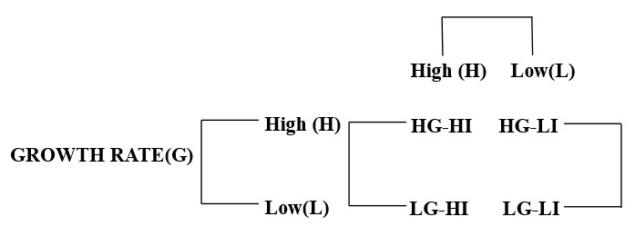
  - High Growth / High Instability (HG-HI): The growth rate and instability of the particular market are greater than the average.
  - High Growth / Low Instability (HG-LI): The growth rate of the market is higher than the average, but the instability of the market is lower.
  - Low Growth / High Instability (LG-HI): The market, where the growth rate is below average and instability is above average; and
  - Low Growth / Low Instability (LG-LI): The growth rate and instability of the particular market are below average.
- Multiple Linear Regression Analysis: To identify the factors affecting the export of chilli from India, multiple regression analysis was carried out, using the Ordinary Least Squares (OLS) estimation procedure (Kanan 2013).
Y= a+ b₁x₁ +b₂x₂+b₃x₃+b₄x₄+ b₅x₅+u
Were,
Y = India’s export of chilli (MT); x₁ = Chilli Production in India (MT); x₂ = Total world export of chilli (MT); x₃ = Indian export price of chilli (USD/ton); x₄= World export value (USD/ton); x₅= Exchange rate (Rs/USD); a = Intercept; u = error term; b₁, b₂……b₅ = Regression Coefficients
- Revealed Comparative Advantage: It is an index used in international economics for calculating the relative advantage or disadvantage of a certain country in a certain class of goods or services, as evidenced by trade flows, which is based on the Ricardian Comparative Advantage concept. A comparative advantage is "revealed" if RCA is greater than 1. If RCA is less than 1, the country is said to have a comparative disadvantage in the commodity or industry (Jambor et al. 2018).
RCAij = (Xij / Xit) / (Xwj/ Xwt)
X_{ij} = values of country i’s exports of product j; X_{wj} = world exports of product j; X_{it} = country i’s total exports; X_{wt} = world’s total exports.
- Direction of Trade of Exports: The first-order Markov chain approach was used to analyse the trade directions of Indian chilli exports. Markov chain analysis involves estimating the transitional probability matrix 'P', with P_{ij} indicating the probability of exports switching from country 'i' to country 'j' over time (Nidhishree 2022). The diagonal element P_{ij}, where i=j, measures the probability of a country retaining its market share or the loyalty of an importing country to a country (Kusuma and Kumara 2014).
- Prediction of future chilli exports: The Transitional Probability Matrix was used to predict chilli export quantities. Chilli exports were forecasted for the following years. (Kusuma and Basavaraja 2014).

Results and Discussion
India holds a significant position in the international chilli trade. Over the years, India has witnessed substantial growth in chilli exports, driven by rising international market demand. Figure 1 illustrates India's chilli export trends to China, the USA, the UAE, Sri Lanka, Thailand and other countries from 2010-11 to 2023-24. The graph reveals India's consistent exports to countries such as Sri Lanka, the USA, the UAE and Thailand. In contrast, the quantity of chillies shipped to China had steadily increased, reaching around 2022-23 and then declining slightly. The export quantity to Thailand was relatively steady, with only minor changes. Exports to the USA had gradually increased throughout the years. The export volume to the UAE had been relatively low and consistent throughout the time. Similar to the UAE, exports to Sri Lanka remained low and consistent. The quantity exported to the Other countries group showed significant fluctuations, with notable peaks around 2013-14 and 2016-17.

Figure 1. Quantity Export of Chilli from India (In MT) between 2010-11 and 2023-24
Compound Annual Growth Rate (CAGR) provides a clear picture of long-term trends by smoothing out short-term deviations, thus aiding in analysing the general growth trajectory of chilli exports across several years, revealing whether exports are increasing, declining, or staying stable. Table 1 shows the CAGR in export quantity and value of chilli, with standard error. During the study period, chilli was primarily exported to China, the USA, the UAE, Thailand and Sri Lanka. Export growth rates, both in number and value, were positive and quite substantial. The quantity of chilli exported was increasing at a rate of 3.88 per cent each year, while the value gained from chilli exports was significantly increasing at 15.66 per cent per year. This trend explains that chilli exports yield higher returns (Shende and Ghumare 2019). China had the highest growth rate in export quantity (18.24%), followed by the UAE (12.99%), Thailand (12.18%), the USA (8.49%) and Sri Lanka (2.25%). Other countries saw a decrease in the quantity exported from India (-2.37%). In terms of export value, China again led with a growth rate of 57.95%, followed by the USA (17.73%), Thailand (13.76%), the UAE (13.52%), other countries (10.97%) and Sri Lanka (9.08%). China, the UAE and Thailand experienced a notable increase in both export quantity and value (>10%). The overall positive and significant growth rate in export value spurred an increase in chilli exports from India, even when the growth rate for export quantity remained non-significant. Consequently, the substantial growth in chilli exports contributed to their increased export share (Suresh and Mathur 2016).
The Cuddy-Della Valle Index (CDV) with the CV of chilli export quantity and value is also represented in Table 1. The findings revealed that other countries had the highest level of instability in quantity (119.49 %) but had the lowest instability in the case of export value (14.10%). Variability in output due to factors such as weather, pests and diseases can cause considerable swings in export volumes (Singh 2024). However, if demand for the commodity remains relatively consistent, the export value may not vary as much (Kaur and Kapoor 2018). Meantime, China also had the highest volatility in export value (66.28 %). Throughout the study period, all countries experienced fluctuations in chilli exports. Even when the growth of quantity exported was less, Sri Lanka seemed to be the most stable market both in terms of quantity (9.81%) and value (17.38%). Sri Lanka was followed by the USA, Thailand, the UAE and China during the study period. Sri Lanka has undergone severe political and economic advancements in recent years, which have influenced its import patterns and demand for agricultural products (Ashoka et al. 2013; Akhil 2021). Thailand, the USA and the UAE also stood as one of the more stable destinations for Indian chilli exports in terms of quantity and value across the study period. Favourable trade agreements and practices between the two countries would make simpler and more stable trade relations (Akhil 2021).

Table 1. Market-wise growth and stability analysis of chilli export from India
Export Market | Export Quantity |  |  |  | Export value
Export Market | CAGR  (%) | CV  (%) | CDV  (%) | SE | CAGR  (%) | CV  (%) | CDV  (%) | SE
China | 18.24*  (0.000) | 67.18 | 40.61 | 0.55 | 57.95*  (0.000) | 117.07 | 66.28 | 1.20
The USA | 8.49*  (0.002) | 37.68 | 25.05 | 0.32 | 17.73*  (0.000) | 51.62 | 24.91 | 0.35
The UAE | 12.99**  (0.011) | 42.63 | 32.20 | 0.61 | 13.52*  (0.000) | 53.19 | 21.12 | 0.21
Thailand | 12.18*  (0.001) | 42.46 | 27.40 | 0.42 | 13.76*  (0.000) | 53.99 | 23.88 | 0.25
Sri Lanka | 2.25**  (0.011) | 12.98 | 9.81 | 0.11 | 9.08*  (0.000) | 35.07 | 17.38 | 0.19
Other countries | -2.37  (0.582) | 121.07 | 119.49 | 0.64 | 10.97*  (0.000) | 38.68 | 14.10 | 0.16
Overall | 3.88  (0.196) | 54.45 | 50.64 | 0.42 | 15.66  (0.000) | 56.27 | 8.57 | 8.20

CAGR = Compound Annual Growth Rate, CV=Coefficient of variance; CDV=Cuddy-Della Valle; SE = Standard Error
***, **, * indicate significance at 10 per cent level, 5 per cent and 1 per cent probability levels, respectively. Note: Figures in the parentheses indicate respective p-values

Based on an analysis of the growth rate and instability index (Table 1), the market under review was divided into four categories (Table 2 in Appendix). The average growth rate of the export quantity was 3.88 per cent (Table 1). Growth rates above the average indicate substantial growth, while those below the average indicate low growth (Table 2 in Appendix). The average instability index value for the export quantity and the value were 50.64 (Table 1). If the instability exceeds the average value, it indicates high instability, while less than the average value indicates moderate instability (Table 2 in Appendix). Figure 2 depicts the growth versus instability of Indian chilli export quantity.

- High growth and low instability (Highly Preferable): Chilli exports from China, the USA, The UAE and Thailand showed high growth and minimal instability, making them highly preferable in this area. These countries were regarded as the most desired. The USA and Thailand were faithful to Indian chilli exports. Both countries have a high demand for Indian chilli, particularly for its distinct aroma and pungency (Anonymous 2021a). Indian chilli farmers can export the goods to China with ease (Anonymous 2021b) which makes the country to stay in this category. The UAE has a significant demand for Indian chillies because of their outstanding quality and multiple varieties (Balaji and Paltasingh 2014).
- High growth and high instability (This category is preferable based on the greatness of growth over the instability index): Global demand and supply fluctuations can lead to substantial growth in some years while causing sharp declines in others. These variations can be driven by a multitude of factors, such as evolving customer preferences, changing economic conditions and modifications in trade policies. None of the countries selected for this study fell into this category.
- Low growth and low instability (Less Preferable): This classification includes Sri Lanka based on its export amount and value. Thus, Sri Lanka is the least preferred country for Indian chilli exports. Changes in domestic prices may be the reason that impact the competitiveness of Indian chilli on the international market (Balaji and Paltasingh 2014).
- Low growth rate and high instability (Not Preferable): This category includes both the amount and value of exports from the “other countries”. Instability is caused by the growth of high-yielding varieties in the country, which are in higher demand in international markets (Ashoka et al. 2013). To address this unique circumstance, we can use targeted market trade promotions by entering the new trade agreements.
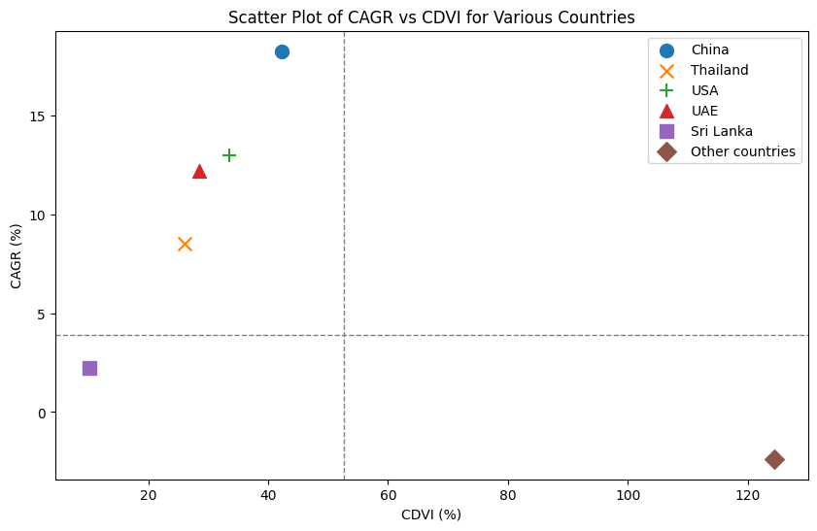
Figure. 2 Growth Vs Instability of Indian chill export quantity
Regression analysis was conducted on time series data from 2010-11 to 2023-24 to find factors influencing chilli exports. Table 3 displays the coefficients and Probability values (p-values) for various parameters influencing chilli export, comprising Indian export price, domestic output, global export, value and exchange rate. Only the world export value follows a normal distribution. All other elements were adjusted to a normal distribution using the natural log.
India's chilli exports were influenced by factors such as production, global exports, value and exchange rates at the time of export. The coefficient of multiple determinations (R²) was 0.92, meaning that the independent factors had explained 92 per cent of the variation in the dependent variable. The adjusted R² value of 0.84 indicates that the dependent variable explains 84 per cent of the variation after accounting for degrees of freedom.
The coefficient of Indian production and the exchange rate were statistically significant, influencing the chilli exports. However, world export, world export price and Indian export value were not statistically significant. Every 1 per cent increase in Indian chilli production results in 1.54 per cent increase in exports. This association suggests that increasing production levels would result in higher export quantities, most likely due to the ability to meet increased demand in overseas markets. This result is at par with the results of Akhil 2021. Meanwhile, every 1 per cent change in the currency rate affects 3.74 per cent of Indian chilli exports. Cheung and Sengupta 2013, explored the impacts of exchange rate fluctuations on Indian enterprises' export shares and discovered that currency volatility has a considerable impact on export volumes. The world export of chilli and the Indian export value had a theoretically negative sign, although it is not substantial.

Table 3. Factors influencing the export of chilli from India
Sr. No. | Factors | Coefficients | P-value
1 | Intercept(a) | -7.57 | 0.2363
2 | Production(x_{l}) | 1.54* | 0.0242
3 | World export(x₂) | -0.70 | 0.9387
4 | Indian export value(x₃) | -1.50 | 0.1889
5 | World export value(x₄) | 0.06 | 0.2160
6 | Exchange rate(x₅) | 3.74* | 0.0272
7 | R² | 0.92
8 | Adjusted R² | 0.84
9 | Observations | 10
*Indicate the level of significance at 5 per cent and **Indicate the level of significance at 1 per cent.
Balassa 1978 pioneered the concept of examining export flows to identify a country's strong sectors. It is commonly referred to as the Balassa Index. Alternatively, Revealed Comparative Advantage refers to the fact that actual export flows show the country's strong industry. The measure of relative export growth by country and commodity was calculated by dividing a country's portion of global commodity exports by its total global export share.
The RCA index is relatively straightforward to interpret. If the value exceeds unity, the country has a clear comparative advantage in that commodity. This approach evaluates the intrinsic advantage of a certain export commodity and aligns with changes in an economy's relative factor endowment and productivity.
Table 4 shows that China had the highest comparative advantage among major chilli exporters, indicating a high potential for competitiveness. This suggests that China had greater production efficiency and export potential in the chilli market than other big exporters (Yeats 2010). Other countries and the USA had comparative disadvantages in chilli exports. Thailand and Sri Lanka were the two countries showing better RCA values in recent years which indicates a recent development of comparative advantage in this market. Variability in the quality and consistency of chilli output can have an impact on export competitiveness (Akhil 2021).

Table 4. Revealed Comparative Advantage (RCA) in the export of chilli from India
YEAR | CHINA | The USA | The UAE | THAILAND | SRILANKA | OTHER  COUNTRIES
2010-2011 | 2.15 | 0.37 | 0.73 | 0.08 | 0.30 | 0.26
2011-2012 | 2.40 | 1.32 | 3.83 | 0.64 | 2.12 | 0.64
2012-2013 | 2.62 | 0.68 | 1.75 | 0.34 | 1.33 | 0.84
2013-2014 | 3.33 | 0.72 | 1.15 | 0.45 | 2.25 | 0.86
2014-2015 | 4.16 | 0.55 | 0.34 | 0.22 | 1.87 | 0.56
2015-2016 | 2.66 | 0.53 | 0.88 | 0.32 | 0.37 | 0.44
2016-2017 | 1.18 | 0.79 | 0.95 | 0.28 | 1.23 | 0.34
2017-2018 | 2.26 | 0.61 | 0.79 | 0.24 | 0.46 | 0.51
2018-2019 | 3.48 | 0.95 | 1.87 | 0.44 | 1.23 | 0.87
2019-2020 | 4.81 | 0.78 | 0.65 | 0. 46 | 0.67 | 0.65
2020-2021 | 4.67 | 0.61 | 1.34 | 3.59 | 3.66 | 0.66
2021-2022 | 5.05 | 0.58 | 0.91 | 2.46 | 5.58 | 0.67
2022-2023 | 7.03 | 0.62 | 0.90 | 2.94 | 5.82 | 0.68
2023-2024 | 8.66 | 0.63 | 1.12 | 3.87 | 6.37 | 0.69
RCA < 1: comparative disadvantage; RCA =1: comparative neutral; RCA >1: comparative advantage
Figure 3 presents a Transitional Probability Matrix(TPM) that shows variations in the direction of chilli exports from India from 2010-11 to 2023-24. The transitional probability matrix's row elements indicate the magnitude of trade losses due to competing countries. The columns represent the likelihood of increased trade volume from competing countries, while the diagonal represents the likelihood of the country maintaining its prior year's trade volume (Devi et al. 2016). The transition probability matrix for chilli exports revealed that China was the most reliable market for India’s chilli followed by Thailand, other countries groups, The USA, the UAE and Sri Lanka.
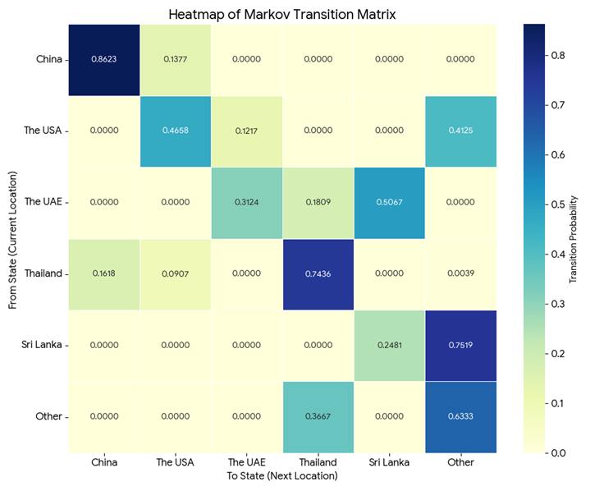
Figure 3. Transition Probability Matrix of Chilli Export from India
Table 5 (In the Appendix) shows the actual and expected export quantities of Indian chilli to key importers. It was clear that the actual value deviated from the predicted value when forecasted for more years. These deviations were due to the changes in trade policies or tariffs that could impact export volumes (Akhil 2021). Figure. 4 depicts the graphical representation of the trend in the actual and predicted quantity of chilli exported from India. Major fluctuations in the actual and predicted value of an export quantity of chilli from India were observed for China and the Other countries' categories. Rigid quality control measures, variable climate conditions and pressure from other producing countries were some of the causes of India's fluctuating export quantity of chilli (Anonymous 2024).
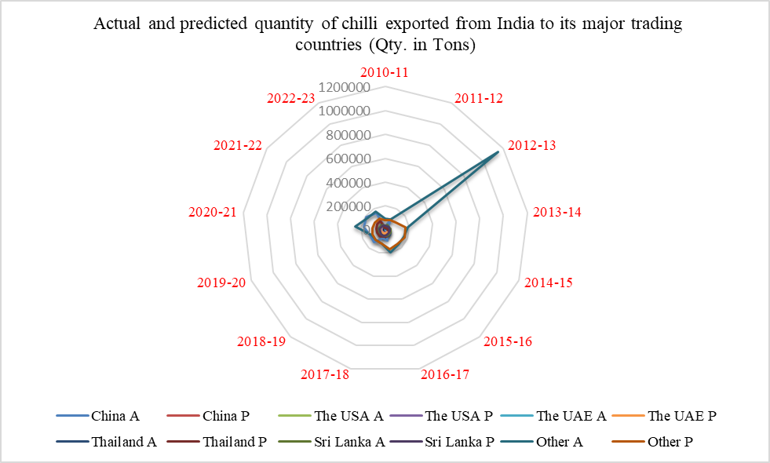
Figure 4. Actual and predicted quantity of chilli exported from India to its major trading countries

Conclusion
The results of this study showed that the export of chilli from India was mainly focused on China, the USA, the UAE, Thailand and Sri Lanka. The growth of the export quantity of chilli was positive but non-significant. While the growth of the export value of chilli was positive and significant. The value of chilli exported was growing at 15.66 per cent per annum. All countries showed more than 10 per cent instability in chilli export during the study period. Sri Lanka remains a more stable market in terms of export quantity and value of Indian chilli throughout the study period. China, The USA, The UAE and Thailand were the most preferable markets for the export of chilli, as they showed high growth in quantity exported with less instability. Indian production and exchange rate were the major factors influencing the export of chilli from India. India has a comparative advantage in chilli export with China, Sri Lanka and Thailand. Moreover, China was one of the most loyal markets. Predictions of future chilli exports showed that China, the USA and Thailand group had an increasing trend. However, Sri Lanka, the UAE and other countries group had a decreasing trend.

References
Akhil R M. 2021. Export performance and value chain analysis of chilli in India. Doctoral dissertation, Department of Agricultural Economics, College of Agriculture, Vellanikkara.
Anantha V P B and Sidana B K. 2019. Growth performance of Indian spice trade. Journal of Agricultural Development and Policy 29(1): 88-95.
Anonymous. 2021a. Socio-economic report on chilli. International Federation of Essential Oils and Aroma Trades Report. Retrieved from socio-economic_chilli.pdf
Anonymous. 2021b. China’s love for Indian hot chillies spices up exports. India Shipping News. Retrieved from China’s love for Indian hot chillies spices up exports - India Shipping News
Anonymous. 2024. India's Chili Export Market: A Spicy Tale of Trends, Challenges and
Opportunities. Happily Trade Exim. Retrieved from Chili Export from India: Trends, Challenges and Opportunities
Ashoka N, Kuldeep C, Ramachandra V A and Yeledhalli R A. 2013. A study on growth, instability and direction of chilli trade in India. Journal of Spices and Aromatic Crops 22(1): 76-80.
Audichy R, Thakar K P, Burark S S and Arha A. 2017. Production and export performance of Indian groundnut. International Journal of Agriculture Sciences 9(4): 3724-3727.
Balaji and Paltasingh K R. 2014. WTO and Indian Chilli export: Issues of growth, instability and competitiveness. Indian Journal of Agricultural Marketing 28(2): 35-50.
Balaji S J. 2021. Product-clusters, export promotion and agricultural growth: A partial assessment of India's relative competitiveness in light of the agricultural export policy 2018. Indian Journal of Agricultural Marketing 35(1): 106-114.
Balassa B. 1978. New Protectionism and the International Economy. Journal of World Trade 12: 409.
Chakrabarty S, Islam A M and Islam A A. 2017. Nutritional benefits and pharmaceutical potentialities of chili: A review. Fundamental and Applied Agriculture 2(2): 227-232.
Cheung Y W and Sengupta R. 2013. Impact of exchange rate movements on exports: An analysis of Indian non-financial sector firms. Journal of International Money and Finance 39: 231-245.
Devi I B, Srikala M, Ananda T and Subramanyam V. 2016. Direction of trade and export competitiveness of chillies in India. Agricultural Economics Research Review 29(2): 262-272.
Dudwal M. 2021. A Review Study on Medicinal Uses and Health Advantage of Chili Pepper. International Journal of Innovative Research in Computer Science & Technology 9(5): 83-86.
Geetha R and Selvarani K. 2017. A study of chilli production and export from India. International Journal of Advance Research and Innovative Ideas in Education 3(2): 205-210.
Jeyanthi P and Nikita G. 2012. Growth and instability in Indian frozen scampi export. Central Institute of Fisheries Technology 49(2012): 187-192.
Joshi D, Singh H P and Gurung B. 2015. Stability analysis of Indian spices export–a Markov chain approach. Economic Affairs 60(2): 257-262.
Kusuma D K and Basavaraja H. 2014. Export of fresh Indian grapes. International Journal of Commerce and Business Management 7(1): 6-10.
Kusuma D K and Kumara B R. 2014. Changing direction of Indian onion exports. International Journal of Agricultural Sciences 10(1): 198-201.
Nidhishree R. 2022. Dynamics in growth and development of horticulture sector in Assam: An economic analysis. Master’s thesis submitted to Assam Agricultural University, Jorhat, Assam.
Nidhishree R and Deka N. 2024. Agricultural Performance Across Assam: Examining the Interplay of Cropping Intensity, Irrigation and Productivity. Indian Journal of Economics and Development 20(4): 243-252.
Penella C and Calatayud A. 2018. Pepper crop under climate change: grafting as an environmental friendly strategy. Climate resilient agriculture: strategies and perspectives, pp 129-155. IntechOpen, London.
Sharangi A B and Acharya S K. 2018. Spices in India and beyond: the origin, history, tradition and culture. Indian Spices: The Legacy, Production and Processing of India’s Treasured Export, Springer: 1-11.
Shende N V and Ghumare V B. 2019. Export Performance of Indian Chilli: An Econometric Approach. Emerging Global Economic Situation: Impact on Trade and Agribusiness in India, pp 223-232. Allied Publishers, New Delhi.
Suresh A and Mathur V C. 2016. Export of agricultural commodities from India: Performance and prospects. Indian Journal of Agricultural Sciences 86(7): 876-83.
Yeats A J. 2010. China's foreign trade and comparative advantage: prospects, problems and policy implications (English). World Bank discussion papers; no. WDP 141 Washington, D.C.: World Bank Group. Retrieved from http://documents.worldbank.org/curated/en/393671468769255793/Chinas-foreign

APPENDIX

Table 2. Matrix of association between growth and instability in the export quantity of chilli from India
Risk Assessment | High Instability | Low Instability
High Growth | - | China, The USA, The UAE, Thailand
Low Growth | Other countries | Sri Lanka

Year | China |  | The USA |  | The UAE |  | Thailand |  | Sri Lanka |  | Other
 | A | P | A | P | A | P | A | P | A | P | A | P
2010-11 | 23636 | 20567 | 17332 | 17180 | 21040 | 24928 | 10582 | 11865 | 32413 | 34313 | 95678 | 82345
2011-12 | 95381 | 25734 | 13528 | 17562 | 19545 | 25175 | 11974 | 13542 | 44666 | 35281 | 101573 | 91536
2012-13 | 35315 | 30876 | 25405 | 18808 | 2508 | 24227 | 33591 | 30989 | 38635 | 37045 | 1150345 | 110252
2013-14 | 23784 | 28756 | 7709 | 19045 | 18049 | 24243 | 21844 | 20948 | 44360 | 38938 | 190456 | 171080
2014-15 | 20293 | 24788 | 23109 | 19123 | 33786 | 24613 | 47708 | 41317 | 49900 | 40186 | 167598 | 178909
2015-16 | 23990 | 30908 | 23907 | 19542 | 36416 | 25430 | 59916 | 53893 | 46508 | 43236 | 166148 | 157897
2016-17 | 93734 | 36458 | 20795 | 19862 | 36800 | 32677 | 60008 | 57456 | 51392 | 48985 | 197924 | 164563
2017-18 | 74903 | 43456 | 30164 | 22365 | 29741 | 30516 | 60725 | 60809 | 51291 | 49670 | 118618 | 118767
2018-19 | 139966 | 47678 | 27793 | 25783 | 40779 | 32345 | 66197 | 67711 | 53185 | 46784 | 115786 | 115789
2019-20 | 131339 | 55984 | 30688 | 26984 | 36784 | 36864 | 59363 | 73232 | 50835 | 45834 | 118934 | 112971
2020-21 | 180221 | 70135 | 35172 | 28790 | 52423 | 38960 | 59426 | 76364 | 52035 | 44678 | 249862 | 109045
2021-22 | 191391 | 79456 | 45336 | 30984 | 44742 | 36514 | 43838 | 78780 | 50457 | 43103 | 174209 | 106732
2022-23 | 157935 | 85367 | 29173 | 32245 | 46715 | 35719 | 54512 | 80907 | 43004 | 42387 | 169537 | 104781
Table 5. Actual and predicted quantity of chilli exported from India to its major trading countries (Qty. in Tons)

Note: A- Actual export; P- Export prediction by using TPM approach

