Impact of Rice-Based Integrated Farming System (IFS) on Sustainable Livelihood Security: A Study Among Small and Marginal Farmers in Kuttanad, Kerala

.
ABSTRACT

Aims: To assess the Sustainable Livelihood Security Index (SLSI) of rice-based Integrated Farming System (IFS) farmers in the Kuttanad region of Kerala and to identify socioeconomic determinants of livelihood security across seven sub-dimensions.
Study design: Cross-sectional survey.
Place and Duration of Study: Kumarakom, Vechoor, Thalayazham, and Vaikom villages, Kuttanad region, Kerala, India; January – March 2024.
Methodology: Ninety small and marginal rice-based IFS farmers were selected by criterion based purposive sampling. The Sustainable Livelihood Security Index (SLSI) was computed across seven dimensions - food, occupational, habitat, education, social, health, and environmental security. Pearson's correlation analysis was performed between 12 socio economic variables and all seven sub-indices and overall SLSI.
Results: Mean SLSI = 0.763. Habitat (0.931), social (0.915), and education (0.894) security were highest; environmental (0.511) and food (0.605) security the lowest. Six significant sub-index correlations were identified: credit acquisition negatively correlated with food security (r = −.251, P = .017) and positively with education security (r = +.287, P = .006); social participation positively correlated with occupational security (r = +.230, P = .029); source of credit negatively correlated with occupational security (r = −.225, P = .033); family type positively correlated with social security (r = +.226, P = .032) and environmental security (r = +.216, P = .041.
Conclusion: Rice-based IFS provides broadly equitable medium-to-high livelihood security across socioeconomic strata in Kuttanad. Environmental security is critically low and demands urgent intervention. Social capital and responsible credit management are the key modifiable predictors of specific livelihood dimensions.

1. INTRODUCTION
Kuttanad, popularly known as the "Rice Bowl of Kerala," is one of the most ecologically distinctive agro-ecosystems in India. Spanning approximately 1,100 square kilometres between latitudes 9°17' to 9°40' N and longitudes 76°19' to 76°33' E, it is the only major rice-cultivating region in the country situated below mean sea level (Thampatti, 1999; Jayan and Sathyanathan, 2010). Recognised as Globally Important Agriculture Heritage System by FAO, the region's low-lying terrain lying between 0.6 and 2.2 metres below mean sea level, is maintained through an intricate system of canals, rivers and backwaters with interwoven strectches of vast paddy lands. Historically, Kuttanad's economy has been anchored in a rice system that has shaped the social fabric, land use, and livelihoods of its farming communities for generations.

However, the agrarian system of Kerala is currently witnessing a significant transition characterized by a declining trend in area and production. Agriculture, once the backbone of the state's rural livelihood, is no longer considered an assured source of income capable of providing a sustainable life for farmers. This shift is driven by a complex interplay of factors, including the deterioration of soil quality, increasing outbreak of pests and diseases, and heightened climate variability. Furthermore, fluctuating market prices, lack of labor availability, high input costs, and ever increasing production risks have created a precarious environment for the farming community. Together, these pressures have triggered significant migration of the farming community away from agriculture toward non-farm occupations, threatening not only the region's food production capacity but also its cultural and ecological heritage.

The Integrated Farming System (IFS) has emerged as a viable and increasingly adopted alternative to conventional farming systems, especially in Kuttanad. IFS involves the purposive integration of multiple enterprises-including crops, livestock, poultry, fisheries, and allied activities-on the same land, and is based on the principle that the waste or by-product of one component becomes the input for another (Edwards et al., 1986). This systemic integration aims to maximise resource utilisation throughout the year, minimise environmental degradation, and ensure higher and more stable economic returns for small and marginal farmers. The unique ecology of Kuttanad region has supported a multiplicity of enterprises based on inland fisheries, paddy, coconut, and several cultures while evolving different economic activities (Swaminathan,2007). While several studies across India have examined the productivity and income effects of various Integrated Farming Systems, relatively fewer have assessed their broader implications for livelihood security using a multidimensional framework. Given the ecological sensitivity of Kuttanad and the ongoing transition in its agrarian structure, there is a need for context-specific empirical evidence on how Rice-based Integrated Farming Systems influence different aspects of farmers’ livelihood security. It is in this context that the present study was undertaken to provide insights into the role of integrated farming as a livelihood strategy in the below-sea-level rice ecosystem of Kuttanad.

2. material and methodS
2.1 Study area and sampling
The study was conducted in Kumarakom, Vechoor, Thalayazham, and Vaikom villages of the Kuttanad region, Kerala. Ninety small and marginal rice-based IFS farmers were selected by criterion based purposive sampling across all four villages. Primary data were collected during January – March 2024 using a pre-tested semi structured interview schedule.
2.2 Computation of Sustainable Livelihood Security Index (SLSI)
The Sustainable Livelihood Security Index (SLSI) was computed by integrating the theoretical framework of Swaminathan (1991) with the multidimensional dimensions identified by Pradhan et al. (2022). Following the indexing logic of Sri Chandana et al. (2023), each dimension was calculated as a composite of its respective indicators. The seven dimensions assessed were food, occupational, habitat, education, social, health, and environmental security. The indicators of sub-indexes are listed in Table 1.Each sub-index score was calculated as follows:
I_{i} = Obtained Score / Maximum Obtainable score
where i = food security, occupational security, habitat security, education security, social security, health security, and environmental security. All sub-index scores were thus expressed on a 0–1 scale. The overall SLSI was computed as the mean of the seven sub-index scores:
SLSI = I₁+ I₂+I₃+I₄+I₅+I₆+I₇ / 7
SLSI scores were interpreted as low security (0.00–0.50), medium security (0.51–0.75), and high security (0.76–1.00)

Table 1. SLSI sub-index dimensions and key indicators

Dimension | Key Indicators | Max Score
Food Security | Per capita food production; food purchases; food availability score; perception of food sufficiency; food quality; dietary balance; grain stock | 9
Occupational Security | Regular vs. seasonal employment; migration for work; year-round employment; occupational satisfaction | 4
Habitat Security | Own house; type of construction; access to toilet, electricity and water; transportation facilities | 4
Education Security | Quality of school education; affordability of higher education; access to educational information; no dropout due to cost | 4
Social Security | Community willingness to help; organisational membership; social status aiding livelihood | 3
Health Security | Incidence of chronic, specific, and epidemic diseases; healthcare affordability; IFS diet-health benefit | 5
Environmental Security | Pollution levels; flood/drought risk; groundwater shortage; clean water access; irrigation; organic manure use; soil conservation; climate change impact | 13
Source: Source: Adapted from Sri Chandana et al. (2023); dimensions following Sivamohan and Scott (1994) and Narayanamoorthy (2013).
2.3 Statistical analysis
Descriptive statistics (frequency and percentage) were used to analyse the farmer characteristics. Pearson's correlation coefficient (r) was computed between each of 12 independent socioeconomic variables and all seven sub-indices and overall SLSI.
3. results and discussion
3.1 Socioeconomic profile of IFS farmers
The socioeconomic characteristics of respondents are presented in Table 2.
Table 2. Socioeconomic profile of rice-based IFS farmers in Kuttanad (N = 90)
Characteristic | Frequency | %
I. Age
Young (<35 yrs) | 4 | 4.44
Middle age (35–55 yrs) | 22 | 24.45
Old age (>55 yrs) | 64 | 71.11
II. Gender
Male | 79 | 87.78
Female | 11 | 12.22
III. Education
Primary | 11 | 12.22
High school | 20 | 22.22
Higher secondary | 49 | 54.44
Undergraduate | 10 | 11.11
IV. Family Type
Nuclear (<5 members) | 67 | 74.44
Joint (≥5 members) | 23 | 25.56
V. Farming Occupation
Major occupation | 65 | 72.22
Subsidiary occupation | 25 | 27.78
VI. Area under IFS
< 1 acre | 41 | 45.56
1–2 acres | 34 | 37.78
> 2 acres | 15 | 16.67
VII. Annual Family Income
< ₹1 lakh | 11 | 12.22
₹1–2 lakh | 49 | 54.44
₹2–4 lakh | 21 | 23.33
> ₹4 lakh | 9 | 10.00
VIII. Income from IFS
< ₹1 lakh | 29 | 32.22
₹1–2 lakh | 46 | 51.11
₹2–4 lakh | 13 | 14.44
> ₹4 lakh | 2 | 2.22
IX. No. of Enterprises in IFS
2–4 enterprises | 56 | 62.22
5–7 enterprises | 30 | 33.33
> 7 enterprises | 4 | 4.44
X. Social Participation
Member of one organization | 38 | 42.22
Member of >1 organisation | 43 | 47.78
Leadership role | 9 | 10.00
XI. Credit Acquisition
Nil | 10 | 11.11
Short-term (<12 months) | 55 | 61.11
Medium-term (12–36 months) | 18 | 20.00
Long-term (>36 months) | 7 | 7.78
XII. Source of Credit
Nil | 10 | 11.11
Nationalised bank | 35 | 38.89
Co-operative society | 32 | 35.56
Friends/Relatives | 7 | 7.78
Money lenders | 6 | 6.67
Source: Primary survey data (2023–24).
The community was markedly ageing: 71.11% of respondents were in the old age group (>55 years) and only 4.44% were young (<35 years), reflecting rural youth outmigration to urban centres and Gulf countries. Gender disparity was pronounced, with 87.78% male respondents. No illiteracy was observed; 54.44% had higher secondary education, consistent with Kerala's literacy record. Nuclear families predominated (74.44%), reducing available farm labour. Landholdings were small: 45.56% farmed less than one acre. Incomes were predominantly in the ₹1–2 lakh band. Most respondents (62.22%) operated only 2-4 IFS enterprises, indicating limited enterprise diversification. Short-term credit dominated (61.11%), primarily from nationalised banks (38.89%) and co-operative societies (35.56%).
Extension contact was highest with Krishi Bhavan (56.67% regular contact; Table 2), while Agricultural Service Centres had the highest 'never' contact rate (23.33%), indicating a significant institutional extension gap.
Table 3. Frequency of extension contact among IFS farmers (N = 90)

Extension Source | Regular (%) | Occasional (%) | Never (%)
Krishi Bhavan (KB) | 56.67 | 37.78 | 5.56
RARS / KVK | 35.56 | 51.11 | 13.33
Agrl. Service Centre (ASC) | 18.89 | 57.78 | 23.33
Progressive Farmer | 43.33 | 50.00 | 6.67
Source: Primary survey data (2022–23).
3.2 Sustainable Livelihood Security Index (SLSI)
SLSI sub-index scores and the overall index are presented in Table 4 and Figs. 2-3.
Table 4. Sustainable Livelihood Security Index of rice-based IFS farmers in Kuttanad (N = 90)
Livelihood Security Dimension | Index Score | Security Level
Food Security | 0.605 | Medium
Occupational Security | 0.664 | Medium
Habitat Security | 0.931 | High
Education Security | 0.894 | High
Social Security | 0.915 | High
Health Security | 0.820 | High
Environmental Security | 0.511 | Medium (low boundary)
Overall SLSI | 0.763 | Medium–High boundary
Low = 0.00–0.50; Medium = 0.51–0.75; High = 0.76–1.00.
Source: Computed from primary data.

Fig 1. Radar chart of SLSI sub-index scores for rice-based IFS farmers in Kuttanad (N = 90).
Habitat security (0.931) was highest, reflecting Kerala's near-universal rural access to pucca housing, electricity, safe water, and sanitation through decades of state investment. High social security (0.915) indicates strong community solidarity, widespread organisational membership, and the perception that social status positively supports livelihood - findings consistent with Sabyasachi et al. (2021), who reported significant positive associations between social participation and livelihood security among small farmers. Education security (0.894) was consistent with Kerala's literacy legacy. Health security (0.820) reflected adequate healthcare access and the documented nutritional benefit of IFS dietary diversity (Singh et al., 2020). The finding is in agreement with Kowsalya (2017), who reported that IFS demonstration programmes improved nutritional security among beneficiary farmers
Occupational security (0.664) remained at medium level, with several respondents reporting seasonal employment patterns and income supplementation through non-farm activities which is a reflection of the agrarian stress in Kuttanad documented by Jayan and Sathyanathan (2010). Food security (0.605) was the second most vulnerable dimension. Per capita food production and grain stock adequacy were the weaker indicators, while food availability and quality perception scores were comparatively better. The integration of crop and livestock components in IFS has been shown to improve food availability and reduce market dependency (Begum et al., 2016), though the present study indicates that this benefit has not yet translated into uniformly high food security across the sample. This is consistent with Sri Chandana et al. (2023), who reported medium food and nutritional security (53.97%) among IFS farmers in Andhra Pradesh, attributing the moderate scores to gaps in dietary knowledge and income inadequacy.
Environmental security (0.511) was the most vulnerable dimension, barely above the low security threshold. This finding is not surprising given Kuttanad's well-documented environmental challenges, including flood-prone below sea-level conditions, soil and water pollution, groundwater stress, and the increasing impact of climate change on farming operations (Jayan and Sathyanathan, 2010). The present finding reinforces the urgent need for targeted environmental security interventions specific to below sea-level farming ecosystems.
3.3 Correlation between Socioeconomic Variables and SLSI Sub-indices
Pearson's correlation between 12 independent variables and all seven SLSI sub-indices and overall SLSI is presented in Table 5. Six statistically significant correlations were identified.
Table 5. Pearson's correlation matrix - socioeconomic variables and SLSI sub-indices (N = 90)
Variable | Food | Occ. | Hab. | Edu. | Soc. | Hlt. | Env. | SLSI
No. of enterprises | +.036 | -.042 | -.015 | +.099 | +.076 | +.081 | +.035 | +.071
IFS income | -.042 | -.114 | +.018 | +.056 | +.171 | +.123 | +.046 | +.033
Annual income | -.027 | -.106 | +.019 | -.107 | +.036 | +.040 | +.050 | -.074
Farming occupation | -.059 | +.011 | +.042 | -.171 | -.149 | -.147 | -.014 | -.149
Credit acquisition | -.251* | -.181 | +.029 | +.287** | +.055 | -.121 | -.095 | -.128
Social participation | +.043 | +.230* | +.091 | +.104 | -.134 | +.043 | -.021 | +.189
Education | +.020 | -.010 | +.194 | -.059 | -.128 | -.119 | -.170 | -.085
Area under IFS | -.141 | -.090 | -.006 | +.020 | +.012 | +.052 | -.153 | -.120
Age | +.030 | +.129 | -.083 | -.118 | -.122 | -.052 | +.003 | -.021
Gender | +.031 | -.056 | +.003 | +.157 | +.063 | +.040 | -.180 | +.013
Family type | -.092 | -.001 | +.018 | -.074 | +.226* | -.077 | +.216* | +.044
Source of credit | -.097 | -.225* | -.099 | +.137 | +.020 | +.067 | -.097 | -.149
**P < .01; *P < .05. Occ. = Occupational; Hab. = Habitat; Edu. = Education; Soc. = Social; Hlt. = Health; Env. = Environmental. Source: Computed from primary data.

Credit acquisition showed a significant negative correlation with food security (r = −0.251, P = .017) and a highly significant positive correlation with education security (r = +0.287, P = .006), with a marginal negative association with occupational security (r = −0.181, P = .088). The negative association between credit acquisition and food security suggests that short-term debt obligations divert household resources away from food expenditure and production investment, reducing dietary security - a pattern consistent with Puste et al. (2013), who noted that financial stress among smallholder IFS farmers constrains optimal resource allocation across livelihood dimensions. The positive association with education security, however, indicates that credit also enables investment in children's education, which the general public including farmers in Kerala prioritise even under financial constraint. Shivaji et al. (2018), in their study of IFS smallholders in Maharashtra, similarly found that access to institutional credit was associated with better human capital outcomes despite its adverse effects on immediate consumption security.
Social participation showed a significant positive correlation with occupational security (r = +0.230, P = .029) and a marginal positive association with overall SLSI (r = +0.189, P = .075). Farmers with higher organisational membership and community engagement reported more stable year-round employment and greater occupational satisfaction. This finding supports the established role of social capital in stabilising livelihood outcomes through collective access to markets, technology, and institutional support.Sabyasachi et al. (2021) similarly identified social participation as a significant correlate of livelihood security among small farmers, emphasising the role of training and group membership in improving farmers' access to development programmes.
Source of credit showed a significant negative correlation with occupational security (r = −0.225, P = .033). Farmers dependent on formal institutional credit - nationalised banks and co-operative societies - reported lower occupational security scores, possibly reflecting the burden of structured repayment obligations that constrain flexible investment in IFS enterprises and seasonal labour management.
Family type positively correlated with both social security (r = +0.226, P = .032) and environmental security (r = +0.216, P = .041). Joint families reported higher scores on both dimensions, likely due to greater labour availability for community engagement and for environmentally sustainable farming practices such as organic manure application and soil conservation - activities that are more labour-intensive and therefore less accessible to nuclear families with smaller household labour pools. Vani and Ritu (2022), in their study of IFS adoption in Kerala, noted that household composition and labour availability were significant determinants of the extent of enterprise integration and sustainable practice adoption. The absence of any statistically significant correlation between the 12 socioeconomic variables and overall SLSI indicates that background characteristics such as age, income, landholding size, educational qualification, and credit behaviour do not determine the overall livelihood security level achieved by IFS farmers in Kuttanad.
Figure 2 represents the correlation heatmap of socioeconomic variables against SLSI sub-indices and figure 3 is the summary diagram clearly showing the six statistically significant correlations (P < .05)
Fig 2. Correlation heatmap of socioeconomic variables against SLSI sub-indices (N=90)

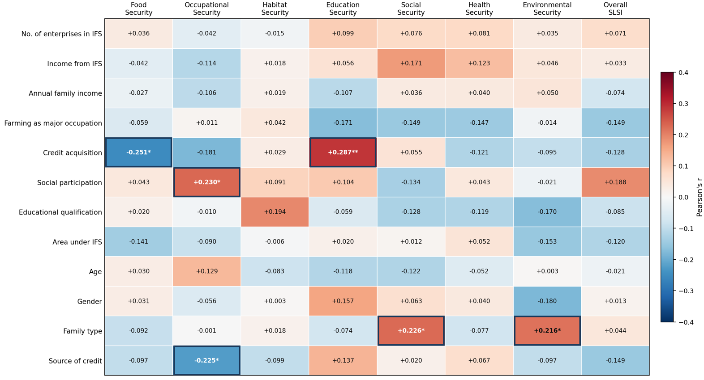

Fig 3. Significant correlation between Socio economic variables and SLSI sub indices (N=90)
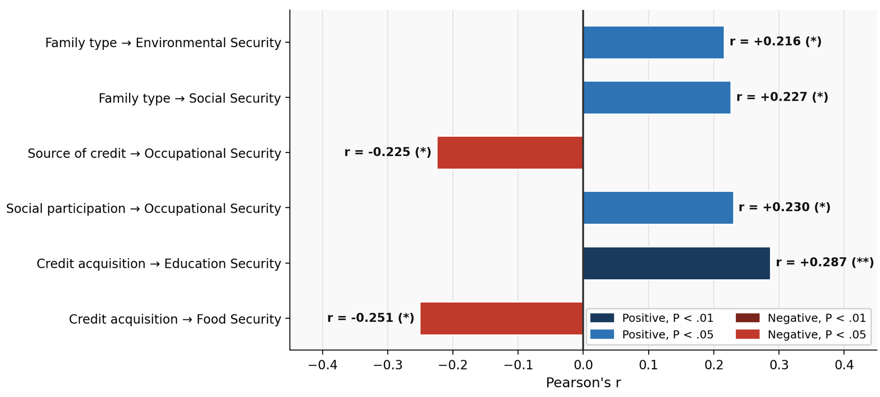

4. CONCLUSION
This study provides the first comprehensive sub-index level SLSI analysis for rice-based IFS farmers in Kuttanad's below sea-level farming ecosystem. The overall SLSI of 0.763 indicates medium-to-high livelihood security. Habitat, social, and education security were strongest, indicating the regions strong public service infrastructure. Environmental security (0.511) and food security (0.605) were the most vulnerable dimensions, requiring urgent targeted intervention. Six significant sub-index level correlations were identified: credit acquisition with food security and education security; social participation with occupational security; source of credit with occupational security; and family type with social and environmental security. None of the socioeconomic variables significantly predicted overall SLSI, indicating broadly equitable livelihood outcomes across socioeconomic subgroups in this community.

References

- Thampatti, K. M., & Padmakumar, K. G. (1999). Nature watch: Rice bowl in turmoil - the Kuttanad wetland ecosystem. Resonance, 4(3), 62–70.
- Jayan, P. R., & Sathyanathan, N. (2010). Overview of farming practices in the water-logged areas of Kerala, India. International Journal of Agricultural and Biological Engineering, 3(4), 28–43.
- Edwards, P., Kaewpaitoon, K., McCoy, E. W., & Chantachaeng, C. (1986). Pilot small scale crop/livestock/fish integrated farm. AIT Research Report 184. Asian Institute of Technology, Bangkok, Thailand. p. 131.
- Swaminathan, M. S. (2007). Measures to mitigate agrarian distress in Alappuzha and Kuttanad wetland ecosystem. Retrieved from http://59.160.153.188/library/node/667
- Swaminathan, M S. 1991. “From Stockholm to Rio de Janeiro: The Road to Sustainable Agriculture (Monograph No. 4).” Madras: MS Swaminathan Research Foundation
- Pradhan, S., Kamal, A., & Das, S. (2022). Empowering communities through dialogue and critical consciousness on food security in Odisha, India. Asian Journal of Agricultural Extension, Economics & Sociology, 40(10), 312-321.
- Sri Chandana, T., Praveena, P. L. R. J., Lakshmi, T., Subramanyam, D., & Ravindra Reddy, B. (2023). Sustainable livelihood security of integrated farming systems practicing farmers through different enterprise combinations in Andhra Pradesh. Indian Journal of Extension Education, 59(1), 101–106.
- Sabyasachi, P., Seema, N., Harikrishna, Y. V., & Venkteshwar, J. (2021). Socio-economic correlates of livelihood security of small farmers in Jabalpur district of Madhya Pradesh. Indian Journal of Extension Education, 57(3), 57–59.
- Singh, V.K., Rathore, S.S., Singh, R.K., Upadhyay, P.K., Shekhawat, K., 2020. Integrated farming system approach for enhanced farm productivity, climate resilience and doubling farmers' income. Indian Journal of Agriculture Science. 90 (8), 1378–1388.
- Begum, R. A., Miah, M. A. M., Rahman, M. Z., & Sarker, M. A. (2016). Effect of integrated farming system in changing household food security of farmers in a Haor area. Bangladesh Journal of Extension Education, 28(1&2), 83–90.
- Puste, A. M., Tanuj, K. M., Dasgupta, M., & Maity, T. K. (2013). Productivity, profitability and livelihood improvement through integrated farming system for new alluvial zone of West Bengal. Indian Journal of Agronomy, 58(4), 451–458.
- Shivaji, A., Gopal, S., Senthilkumar, R., Meena, B. S., & Sagar, W. (2018). Assessing livelihood variation among smallholders practising integrated farming systems in tribal areas of Maharashtra. Asian Journal of Extension Education, 36, 151–164.
- Vani, C., & Ritu, C. (2022). Extent of adoption of available components in the IFS units of Kerala. Indian Journal of Extension Education, 58(4), 130–133.

