AGROECOLOGICAL EDUCATION AND COMMUNITY EXTENSION IN THE BRAZILIAN SEMI-ARID REGION: SUCCESSFUL TERRITORIAL ACTIONS DEVELOPED AT IFNMG – ARAÇUAÍ CAMPUS

ABSTRACT

This study aimed to analyze successful agroecological education and community extension actions developed at the Federal Institute of Northern Minas Gerais (IFNMG) – Araçuaí Campus, located in the Brazilian semi-arid region, highlighting their contributions to student training, the strengthening of family farming, and sustainable territorial development. The research is characterized as applied, qualitative, and descriptive, based on the systematization of pedagogical and extension experiences conducted between 2025 and 2026. The analyzed actions included discussion circles, technical lectures, a Field Day on agroecological cultivation, the implementation of portable sustainable gardens as a didactic modeling strategy, and the production and distribution of 300 fruit and forest seedlings. Data were collected through institutional records, participant observation, questionnaires, interviews, and focus groups, and analyzed using descriptive statistics and thematic categorization. The results demonstrated significant formative, technical, and socio-environmental impacts. Active methodologies strengthened systemic thinking and student protagonism, while extension activities enhanced dialogue between scientific knowledge and local wisdom. The high level of community participation evidenced the mobilizing potential of agroecological practices grounded in experiential learning and knowledge exchange. The production and distribution of seedlings reinforced environmental education and territorial sustainability. It is concluded that agroecology, when integrated into professional education and rural extension, constitutes a transformative strategy that consolidates the inseparability of teaching, research, and extension in semi-arid contexts.

Keywords: Agroecology; Rural Extension; Professional Education; Family Farming; Sustainable Territorial Development; Semi-Arid Region.

- INTRODUCTION

Agroecology has consolidated itself in recent decades as a scientific, political, and pedagogical field that articulates ecological, social, and cultural knowledge in the construction of more resilient and sustainable agricultural systems. More than a set of techniques, agroecology constitutes a systemic approach that integrates ecological principles into the management of agroecosystems and territorial dynamics (ALTIERI; NICHOLLS, 2020). In this context, its educational dimension becomes central, especially in territories marked by socio-environmental vulnerabilities, such as the Brazilian semi-arid region.
Rural education emerges as a strategic space for the dissemination and collective construction of agroecological knowledge, valuing traditional knowledge, participatory processes, and the formation of critical subjects. As argued by Caldart et al. (2012), rural education is not limited to schooling in rural areas, but represents a political-pedagogical project aimed at social emancipation and qualified permanence in the territory. From this perspective, the articulation between teaching, research, and extension assumes a structuring role in consolidating contextualized and transformative educational practices.
The Federal Institutes of Education, Science, and Technology, especially those located in semi-arid regions, play a strategic role in promoting integrated actions in teaching, applied research, and rural extension. These institutions contribute to strengthening sustainable production chains, family farming, and food security, acting as hubs of social and technological innovation (PEREIRA; SILVA, 2021). In the semi-arid region of Minas Gerais, characterized by irregular rainfall patterns and socioeconomic constraints, agroecological initiatives associated with education and extension become essential to enhance productive resilience and the autonomy of rural communities.
Recent literature highlights that territorial experiences based on agroecology promote not only productive gains, but also significant social impacts, such as strengthening community organization, income generation, and expanding food sovereignty (WEZEL et al., 2020). Furthermore, participatory extension actions grounded in the dialogue of knowledge foster horizontal learning processes and the collective construction of knowledge (CAPORAL; COSTABEBER, 2004).
In the educational sphere, strategies such as field days, the establishment of demonstration units, production of fruit and forest seedlings, pedagogical gardens, and the training of multipliers have been recognized as effective teaching-learning tools, as they articulate theory and practice, bringing students and farmers closer to the local productive reality (GLIESSMAN, 2015). Such initiatives contribute to consolidating agroecology as a structuring axis of technical and technological education, especially when linked to family farming.
Given this scenario, it becomes relevant to systematize and analyze successful experiences in agroecological education and extension developed within the institutional context of the Federal Institute of Northern Minas Gerais – Araçuaí Campus, considering its territorial insertion and its role in student training and support for family farming. The systematization of these actions allows for understanding their formative, social, and productive impacts, in addition to contributing to the advancement of academic discussions on agroecological education in the Brazilian semi-arid region.

- MATERIALS AND METHODS

This study is characterized as applied research with a qualitative and descriptive approach, based on the systematization of pedagogical and extension experiences developed at the Federal Institute of Northern Minas Gerais (IFNMG) – Araçuaí Campus, located in the Médio Jequitinhonha territory, Minas Gerais, Brazil. The actions were carried out from 2025 to 2026, involving students from the Technical Course in Agroecology, the Agricultural and Environmental Engineering program, and the local community, especially family farmers from the municipality of Araçuaí, MG. The methodology adopted was grounded in the systematization of experiences as a strategy for critical analysis of educational and extension practices, aiming to identify formative, productive, and socio-environmental impacts resulting from the implemented actions.
The first analyzed action corresponded to the project “Didactic Modeling of Agroecological Systems: Implementation of Portable Sustainable Gardens in Agroecology Education.” The project was developed based on an active, participatory, and experiential pedagogical approach, aiming to integrate theory and practice in the training process. Activities were conducted predominantly in the classroom, using portable sustainable gardens as a didactic resource for modeling agroecological systems on a reduced scale. Initially, an expository-dialogical lecture was delivered addressing the foundations of agroecology, its structuring principles, and the importance of sustainability in food production systems. Subsequently, students were organized in pairs, responsible for planning and constructing a portable box made from reused or low-cost materials. Each pair prepared a simple sketch of the garden, defining dimensions, internal layout, short-cycle vegetable species to be cultivated, and drainage strategies. The gardens were then assembled, including organization of drainage layers, substrate preparation, and planting of selected species. During the monitoring period, students performed basic management practices, irrigation, and systematic observations of plant development, recording information in monitoring sheets. At the end, a socialization session was held to share experiences, with formative assessment based on the coherence of the implemented system with agroecological principles and the students’ ability to articulate theory and practice.
The second experience corresponded to the project “Environmental Education and Extension Practices: Training Multipliers for Family Farming in Araçuaí/MG.” The methodology was structured in an integrated manner, combining theoretical training, practical workshops, production of educational materials, and field actions. Initially, a planning stage was conducted, including definition of a schedule, articulation with specialists in agroecology, rural extension, and environmental education, and dissemination among the academic community and local family farmers. The in-person training phase included thematic lectures, discussion circles, and practical workshops focused on the application of sustainable technologies and extension methodologies in family farming. In parallel, students and faculty prepared technical bulletins and institutional videos in accessible language, addressing sustainable practices adapted to the regional reality.
As an outcome of this action, the 1st Field Day – Agroecological Cultivation at IFNMG Araçuaí Campus was held on August 1, organized within the Rural Teaching and Extension Curricular Unit (UCE). The event was structured into three technical stations: Station 1 – Common Bean (Phaseolus vulgaris L.) and Soybean (Glycine max (L.) Merrill); Station 2 – Maize (Zea mays L.) and Sorghum (Sorghum bicolor L.); Station 3 – Sunflower (Helianthus annuus L.) and Cotton (Gossypium hirsutum L.). The agroecological field area was prepared by students from the Technical Course in Agroecology and the Agricultural and Environmental Engineering program. At each station, aspects related to agroecological crop management, soil conservation practices, productive diversity, and sustainable cultivation strategies were presented, promoting dialogue between technical-scientific knowledge and the local knowledge of participating farmers.
The third systematized action refers to the project “Planting for the Future: Fruit and Forest Seedlings and Environmental Education for the Population of Araçuaí.” Implementation occurred in an integrated manner, combining technical training, seedling production, and community extension. Initially, UCE students participated in theoretical-practical training covering selection of seeds and cuttings, substrate preparation, nursery organization, irrigation, fertilization, pest control, and seedling acclimatization. Subsequently, a nursery was established at IFNMG – Araçuaí Campus for the production of fruit and forest seedlings. Throughout the process, students conducted periodic monitoring of seedlings, recording growth, development, and management needs. Simultaneously, environmental education technical bulletins were prepared addressing environmental conservation, the importance of native species, urban afforestation, and ecological restoration. Seedlings were preferentially distributed at the Municipal Market of Araçuaí, accompanied by technical guidance on planting and initial management, thereby expanding the reach of extension actions.
Data collection was conducted through institutional records, attendance lists, technical reports, photographic records, participant observation, structured questionnaires, semi-structured interviews, and focus groups with participating students and farmers. Quantitative data were organized using descriptive statistics, employing absolute and percentage frequencies. Qualitative data were analyzed through thematic categorization, aiming to identify formative impacts, strengthening of family farming, integration of teaching and extension, and socio-environmental contributions of the developed actions.

3. results and discussion

The actions developed within the teaching–research–extension integration at IFNMG – Araçuaí Campus demonstrated significant formative, technical, and socio-environmental impacts, both for students and for the participating external community.
The discussion circle entitled “Rural Extension: Dialogues and Practices,” held on May 29, 2025, involved 18 students, two professors, and one member of the external community, and was conducted by a SENAR extension agent. The activity promoted critical debate on the role of rural extension in family farming, emphasizing the participatory construction of knowledge. This dialogical format reinforces the concept of extension as an emancipatory educational practice, as advocated by Freire (1996), by valuing horizontal dialogue between technicians and farmers. The adopted perspective also aligns with the systemic agroecological approach described by Altieri (2012), which recognizes local knowledge as a structuring element of rural sustainability.
From a formative standpoint, students reported greater understanding of the social role of the agricultural engineer and agroecology technician in rural territories, particularly regarding mediation processes, communication strategies, and respect for farmers’ empirical knowledge. The interaction between academic knowledge and lived experience contributed to strengthening students’ critical-reflective capacity, which is essential for professional practice in semi-arid regions marked by social and climatic vulnerabilities.
Furthermore, the activity contributed to reinforcing the institutional role of IFNMG – Araçuaí Campus as a territorial reference in agroecological education and rural extension. By promoting spaces for dialogue between academia and society, the institution advances toward a more contextualized and socially engaged educational model, strengthening family farming and sustainable territorial development in the Médio Jequitinhonha region.
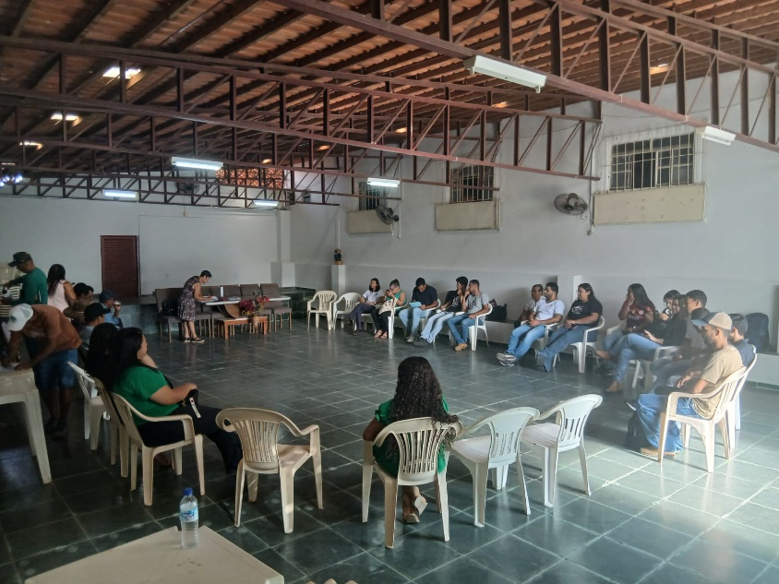
Figure 1 – Meeting and dialogue held during a session of the Municipal Council for Sustainable Rural Development (CMDRS) of Araçuaí, MG, Brazil.

The lecture “Technologies for Reducing Water Consumption in Pineapple Cultivation,” held on July 17, 2025, brought together 21 students, one professor, and two representatives from the external community. The topic proved to be strategic for the semi-arid region of Minas Gerais, characterized by water scarcity and irregular rainfall. The discussion on rational water management aligns with agroecological principles of efficient natural resource use and productive resilience (GLIESSMAN, 2015). Localized irrigation technologies and soil management practices aimed at increasing water retention are widely recognized as essential for sustainable production systems in water-deficit regions, contributing to climate adaptation and production security.
The lecture “Seed Quality: From Production to Storage,” held on August 14, 2025, involved 16 students, one professor, and one external community member. The discussion addressed physiological and technological aspects related to seed production and conservation, emphasizing the importance of moisture and temperature control for maintaining seed vigor. According to Marcos-Filho (2015), physiological deterioration initially compromises vigor before affecting final germination, making post-harvest management decisive for seed quality. When addressed within an agroecological context, the activity reinforced the importance of productive autonomy and seed sovereignty in family farming systems.
The lecture “Ornamental Peppers: An Alternative for Family Farming” gathered 23 students, one professor, and one external participant, highlighting growing interest in productive diversification strategies. Diversification is a central principle of agroecology, contributing to the economic and ecological stability of farming systems (ALTIERI; NICHOLLS, 2017). The introduction of value-added crops, such as ornamental peppers, expands income-generation opportunities, particularly in local markets and agroecological fairs.
The 1st Field Day – Agroecological Cultivation, held on August 1, 2025, stood out as the most far-reaching action, with 136 participants. Structured into three technical stations (Bean and Soybean; Maize and Sorghum; Sunflower and Cotton), the event was organized by students of the Rural Teaching and Extension Curricular Unit (UCE). The high level of participation highlights the potential of demonstrative methodologies in strengthening rural extension. Field days foster experiential learning and knowledge exchange, bridging theory and practice—an essential element in agroecological education (CAPORAL; COSTABEBER, 2004). Field-based experience contributed to consolidating systemic reasoning among students and strengthening the institutional bond with family farmers in the territory.

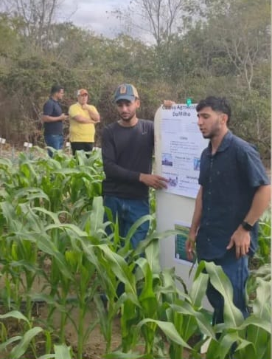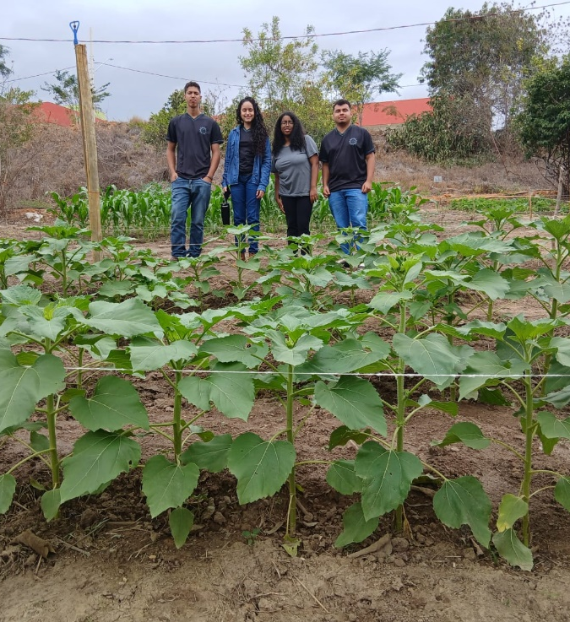
Figure 2 – Agroecological Cultivation Field Day at IFNMG – Araçuaí Campus, MG, Brazil.

In the pedagogical sphere, the project “Didactic Modeling of Agroecological Systems: Implementation of Portable Sustainable Gardens” involved 33 students, demonstrating strong student engagement. The construction and management of small-scale gardens enabled a concrete experience of agroecological principles, such as diversity, nutrient cycling, and rational use of inputs. Active methodologies and practice-based learning promote greater knowledge retention and the development of socio-environmental competencies (BACICH; MORAN, 2018). The didactic modeling approach proved to be an effective instrument for internalizing agroecological concepts within the context of professional education.
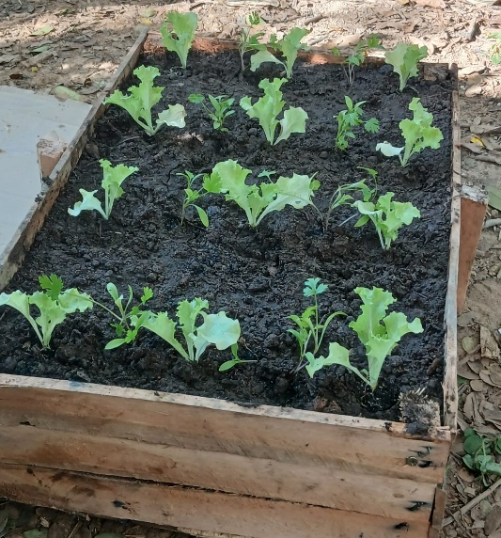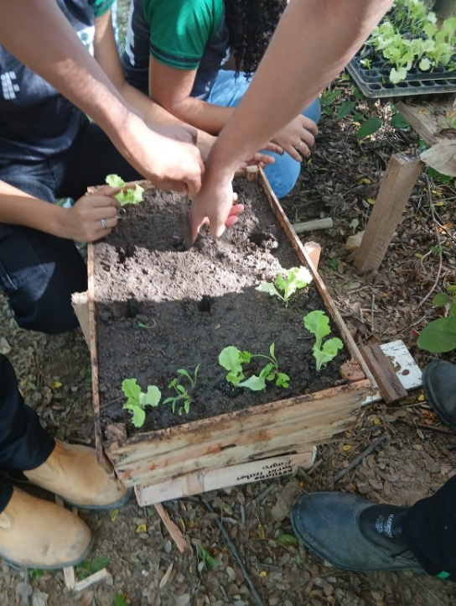
Figure 3 – Construction and implementation of portable sustainable gardens in Agroecology education.
The action “Planting for the Future,” culminating in the delivery of 300 seedlings of passion fruit (Passiflora edulis Sims), papaya (Carica papaya L.), and pink trumpet tree (Handroanthus heptaphyllus (Vell.) Mattos) on January 31, 2026, at the Municipal Market of Araçuaí, reinforced the socio-environmental commitment of the campus. The distribution of seedlings combined with technical guidance expands positive environmental impacts and strengthens the relationship between the institution and the community.
The inclusion of fruit and forest species contributes both to income generation and to environmental restoration and urban afforestation, aligning with the principles of territorial sustainability (GLIESSMAN, 2015).
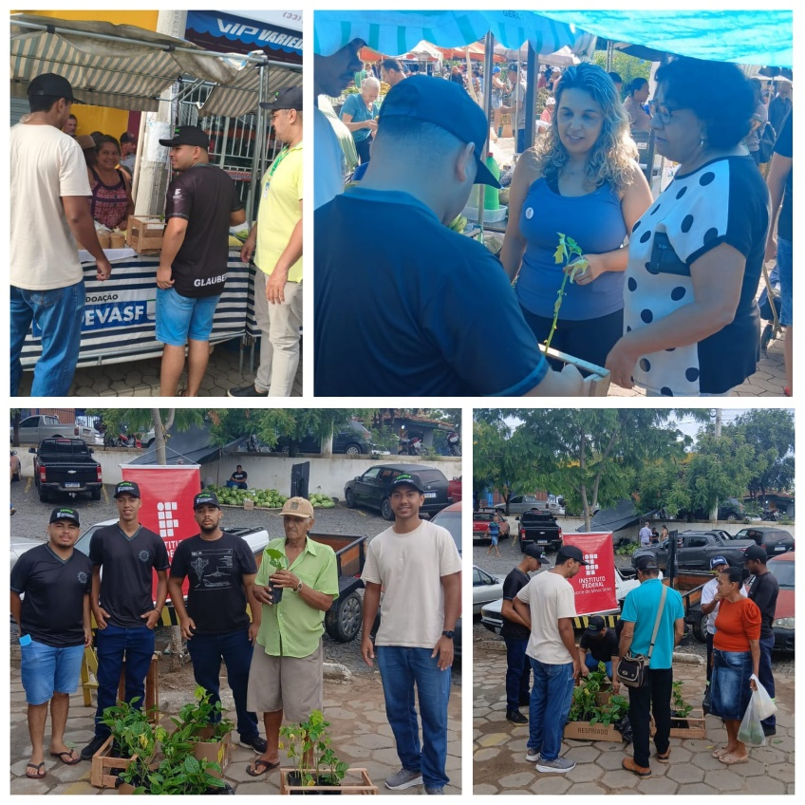
Figure 4 – Distribution of fruit and forest seedlings at the Municipal Market of Araçuaí, MG, to small rural producers, as an environmental education and agroecological extension action.

Overall, the results demonstrate that the successful actions went beyond the technical dimension, promoting critical education, strengthening family farming, and expanding dialogue between scientific knowledge and local wisdom. The articulation between teaching, research, and extension proved to be strategic for consolidating agroecology as a transformative educational practice, especially within the context of professional education in the semi-arid region of Minas Gerais.

4. Conclusions

The actions developed within the integration of teaching, research, and extension at IFNMG – Araçuaí Campus demonstrated that agroecology, when articulated with professional education and rural extension, constitutes an effective strategy for technical, civic, and socio-environmental training.
The implementation of discussion circles, technical lectures, and the Field Day expanded dialogue between scientific knowledge and local wisdom, strengthening local family farming and promoting meaningful learning. The high level of community participation in the activities, especially during the Field Day, highlights the mobilizing potential of extension practices grounded in experience exchange and practical demonstration.
Didactic modeling through the implementation of portable sustainable gardens proved to be an effective active methodology for consolidating agroecological principles within the educational process, fostering systemic thinking, interdisciplinarity, and student protagonism.
The production and distribution of 300 fruit and forest seedlings reinforced the institutional commitment to sustainable territorial development, combining technical training, environmental education, and tangible socio-environmental impact.
It is concluded that extension actions structured under an agroecological perspective simultaneously contribute to students’ professional qualification, the strengthening of family farming, and the promotion of sustainable practices in the territory, consolidating the inseparability of teaching, research, and extension as a structuring axis of rural education.

References

- ALTIERI, Miguel A. Agroecology: the science of sustainable agriculture. 2. ed. Boulder: Westview Press, 2012.
- ALTIERI, Miguel A.; NICHOLLS, Clara I. Agroecology: a brief account of its origins and currents of thought in Latin America. Agroecology and Sustainable Food Systems, v. 41, n. 3–4, p. 231–237, 2017. DOI: https://doi.org/10.1080/21683565.2017.1287147
- BACICH, Lilian; MORAN, José. Metodologias ativas para uma educação inovadora: uma abordagem teórico-prática. Porto Alegre: Penso, 2018.
- CALDART, Roseli Salete et al. Dicionário da educação do campo. Rio de Janeiro: EPSJV; São Paulo: Expressão Popular, 2012.
- CAPORAL, Francisco Roberto; COSTABEBER, José Antônio. Agroecologia: alguns conceitos e princípios. Brasília: MDA/SAF/DATER-IICA, 2004.
- FREIRE, Paulo. Pedagogia da autonomia: saberes necessários à prática educativa. São Paulo: Paz e Terra, 1996.
- GLIESSMAN, Stephen R. Agroecology: the ecology of sustainable food systems. 3. ed. Boca Raton: CRC Press, 2015. DOI: https://doi.org/10.1201/b17881
- MARCOS-FILHO, Júlio. Fisiologia de sementes de plantas cultivadas. 2. ed. Londrina: ABRATES, 2015.
- RANAL, Marli Aparecida; SANTANA, Dirce Maria G. How and why to measure the germination process. Revista Brasileira de Botânica, v. 29, n. 1, p. 1–11, 2006. DOI: https://doi.org/10.1590/S0100-84042006000100002
- WEZEL, Alexander et al. Agroecology as a science, a movement and a practice: a review. Agronomy for Sustainable Development, v. 29, p. 503–515, 2009. DOI: https://doi.org/10.1051/agro/2009004

