HYPERSPECTRAL RADIOMETRY FOR ANALYSING THRIPS DAMAGE IN MULBERRY

ABSTRACT

Thrips (Pseudodentrothrips mori) infestation is an emerging constraint in mulberry cultivation, causing subtle yet significant deterioration in leaf quality that adversely affects silkworm growth and cocoon productivity. Early detection of thrips damage using conventional field scouting is difficult due to the inconspicuous nature of initial symptoms. The present study evaluated the potential of hyperspectral radiometry for non-destructive detection and quantification of thrips-induced stress in mulberry (Morus spp.). The present study evaluated the potential of hyperspectral radiometry for detection, discrimination, and quantification of thrips-induced stress in mulberry through band sensitivity analysis, vegetation index sensitivity analysis, regression analysis and linear correlation intensity analysis. Field experiments were conducted in a V1 mulberry garden using naturally infested and protected control plots in Tamil Nadu Agricultural University, Coimbatore during 2018. Spectral reflectance data were collected using a field-portable hyperspectral spectroradiometer (350–1050 nm) at different crop stages, and vegetation indices including NDVI, Simple Ratio (SR), and GRVI were derived. Thrips infestation resulted in increased reflectance in the visible region and reduced reflectance in the near-infrared region, indicating chlorophyll degradation and internal tissue disruption. Vegetation indices were consistently lower in damaged plants compared to healthy plants, with SR and NDVI showing higher sensitivity to thrips-induced stress. Linear regression analysis revealed strong negative relationships between percent leaf damage and NDVI (R² = 0.886) and SR (R² = 0.791), whereas GRVI exhibited poor predictive capability. Linear correlation intensity analysis identified diagnostically important wavelengths, with the highest positive correlation observed at 689.45 nm (r = 0.94) in the red region and the strongest negative correlation at 763.26 nm (r = −0.10) in the NIR region. The wavelength-specific responses observed were consistent with earlier hyperspectral studies on thrips in cotton and other sucking pests such as pink mealy bug and spiralling whitefly in mulberry. Overall, the study demonstrates that hyperspectral radiometry combined with correlation intensity analysis and vegetation indices provides a robust, non-invasive approach for early detection and assessment of thrips damage in mulberry, supporting precision pest management in sericulture systems.
Key words: mulberry, thrips, spectral reflectance, vegetation index sensitivity, sensitive wavelengths.
INTRODUCTION:
Mulberry (Morus spp.) is the sole food plant of the silkworm (Bombyx mori L.), and the quality and availability of mulberry leaves directly govern cocoon yield and silk quality (Krishnaswami, 1978; Dandin et al., 2003). In sericulture-based farming systems, even minor deterioration in leaf health can lead to substantial economic losses due to reduced larval growth and cocoon productivity (Benchamin and Jolly, 1986; Reddy et al., 2010). Therefore, timely and accurate assessment of mulberry crop health forms the foundation of precision sericulture, which aims to optimize mulberry production through site-specific and need-based management practices (Choudhury et al., 2016). Among the biotic stresses affecting mulberry, sucking insect pests are particularly damaging due to their ability to impair leaf physiological quality without causing conspicuous early symptoms and thrips have emerged as an important pest in mulberry plantations, especially under warm and dry climatic conditions (Anusha, and Bhaskar, 2015). Their rasping–sucking feeding habit causes epidermal injury, chlorophyll depletion, leaf discoloration, curling, and surface roughness, ultimately reducing leaf palatability and nutritive value for silkworm feeding (Jayashree et al., 2025) Early-stage thrips infestation often remains unnoticed under conventional visual field scouting, thereby limiting the effectiveness of timely pest management interventions (Prabhakar et al., 2011; Yang et al., 2005).
Thrips-induced damage results in significant alterations in leaf biochemical composition and internal structure, which in turn influence the optical properties of mulberry leaves. A reduction in chlorophyll content modifies reflectance in the visible region, particularly in the blue and red bands, while disruption of mesophyll tissues affects light scattering and reflectance in the near-infrared (NIR) region (Gitelson et al., 2001; Carter and Knapp, 2001). These physiological and structural modifications generate distinct spectral signatures that can be effectively captured using hyperspectral remote sensing techniques. Hyperspectral radiometry, owing to its ability to acquire reflectance data across numerous narrow and contiguous wavelength bands, provides a sensitive and non-destructive approach for detecting subtle pest-induced stress before the appearance of severe visual symptoms (Prabhakar et al., 2011; Yang et al., 2005).
In recent years, remote sensing–based approaches have gained considerable importance in precision agriculture, and their application in sericulture is increasingly recognized as precision sericulture (Roshni., and Bharat M. 2022). Hyperspectral analysis facilitates continuous monitoring of mulberry crop health, identification of stress-specific spectral indicators, and quantification of damage severity, thereby supporting timely and informed decision-making for pest management. Earlier studies have demonstrated the effectiveness of hyperspectral reflectance data and vegetation indices in detecting damage caused by major sucking pests of mulberry, such as pink mealy bug and spiralling whitefly (Kalpana et al., 2024; Kalpana et al., 2026). However, information on the spectral response of mulberry plants specifically affected by thrips infestation remains limited.
Given the unique rasping–sucking feeding behaviour and characteristic injury pattern of thrips, it is hypothesized that thrips infestation induces distinct spectral responses and associated variations in vegetation indices in mulberry leaves. Accordingly, the present study was undertaken to characterize the hyperspectral reflectance behaviour of thrips-infested mulberry plants, identify diagnostically sensitive wavelength regions and vegetation indices, and evaluate their effectiveness for non-destructive detection and quantitative estimation of infestation severity. The findings of this investigation are expected to contribute to the development of remote sensing–based diagnostic and decision-support tools for pest monitoring under precision sericulture, thereby enhancing mulberry productivity and ensuring the sustainability of silk production systems.
MATERIALS AND METHODS
2.1 Experimental site and crop details
Field experiments were conducted to characterize the spectral response of mulberry plants infested by thrips (Pseudodentrothrips mori) using hyperspectral radiometry. The study was carried out in an established mulberry garden planted with variety V1 during 2018. Two experimental plots, each measuring 5 × 10 m, were selected based on the natural occurrence of thrips infestation. One plot was maintained as thrips-infested (damaged), while the other served as a thrips-free control (undamaged). Ten mulberry plants were randomly selected and tagged in each plot to represent damaged and undamaged conditions, and these plants were considered as replications for further analysis. In the control plot, plants were protected from insect damage through periodic application of recommended insecticides, whereas no insecticidal protection was provided in the damaged plot to allow natural buildup of thrips populations. Both plots were regularly monitored, and appropriate fungicidal or bactericidal treatments were applied uniformly, wherever necessary, to prevent confounding effects of plant diseases. (Kalpana et al., 2024)
2.2 Assessment of thrips damage
Thrips infestation in mulberry was identified based on characteristic symptoms such as silvery streaks during early stages, followed by blotching, yellowing due to chlorosis, leaf curling, and boat-shaped leaf deformation under severe infestation. The extent of damage was quantified on a plant basis by calculating the percentage of affected leaves using the formula:
$$\text{Per cent damage}=\frac{\text{Number of affected leaves}}{\text{Total number of leaves}}×100$$
Based on the percentage damage, pest incidence was categorized using a standardized damage rating scale: 0% (immune), 0.1–5% (highly resistant), 5.1–20% (moderately resistant), 20.1–50% (moderately susceptible), and 50.1–100% (highly susceptible), as described by Vasudha Prabhakar et al. (2015).
2.3. Hyperspectral reflectance measurements
Spectral reflectance data were collected using a field-portable hyperspectral spectroradiometer (GER 1500), available at the Department of Remote Sensing and Geographic Information System, Tamil Nadu Agricultural University, Coimbatore. Observations were carried out on clear, sunny days between 10:00 and 13:00 h local time to minimize illumination variability. The sensor was positioned approximately 30 cm above the mulberry leaf surface during data acquisition. The instrument was optimized and calibrated prior to the commencement of observations and recalibrated at five-minute intervals to account for changes in ambient light conditions. A barium sulphate reference panel was used to record incoming radiation before each set of measurements. Percentage spectral reflectance was computed as the ratio of reflected radiation from the plant canopy to that from the reference panel using the formula:
$$\text{Per cent reflectance}=\frac{\text{Reflectance from target}}{\text{Reflectance from reference}}×100$$
Spectral data were recorded across 512 contiguous bands spanning 276.86–1093.50 nm, with a bandwidth of approximately 1.5 nm. Reflectance values within the 350–1050 nm range were considered for further analysis due to higher signal stability. The data were exported as ASCII files and processed using spreadsheet software for subsequent analysis. Luther and Carroll (1999) and Abdel – Rahman et al. (2010)
2.4. Spectral band selection and vegetation indices
Reflectance values corresponding to green (520–590 nm), red (620–680 nm), and near-infrared (770–860 nm) spectral regions were obtained by averaging reflectance within the respective wavelength ranges for each plant. Using these band reflectance values, the following vegetation indices were computed: (Sellers, 1985; Sims and Gamon, 2002; Mirik et.al., 2006; yang et.al., 2009)
2.4.1. Normalized Difference Vegetation Index (NDVI):
$$\text{NDVI}=\frac{R_{NIR}-R_{RED}}{R_{NIR}+R_{RED}}$$
2.4.2. Simple Ratio (SR):
$$\text{SR}=\frac{R_{NIR}}{R_{RED}}$$
2.4.3. Green–Red Vegetation Index (GRVI):
$$\text{GRVI}=\frac{R_{GREEN}-R_{RED}}{R_{GREEN}+R_{RED}}$$where $R_{GREEN}$, $R_{RED}$, and $R_{NIR}$represent reflectance values in the green, red, and NIR bands, respectively. Motohka et.al. (2010)
2.5 Band and vegetation index sensitivity analysis
Sensitivity of individual spectral bands to thrips damage was calculated using the following expression:
$$\text{Band sensitivity}=\frac{R_{inf}-R_{ctrl}}{R_{ctrl}}×100$$
where $R_{inf}$and $R_{ctrl}$denote reflectance values of thrips-infested and control plants, respectively. Similarly, vegetation index sensitivity was computed as:
$$\text{VI sensitivity}=\frac{VI_{inf}-VI_{ctrl}}{VI_{ctrl}}×100$$
where $VI_{inf}$and $VI_{ctrl}$represent vegetation index values of infested and control plants. (Carter, 1993).
.2.6 Corrected sensitivity computation
To account for variations in illumination during spectral measurements, corrected sensitivity values were derived. Preliminary observations indicated that reflectance within the 350–370 nm wavelength region was unaffected by thrips infestation. Therefore, the mean sensitivity within this region was assumed to be zero and used as a correction factor. This factor was applied uniformly across all wavelengths to normalize the sensitivity curves, and the resulting corrected sensitivity values were used for interpretation.
  - Statistical analysis
Mean and standard deviation values were calculated for thrips-induced damage. Vegetation indices (SR, NDVI, and GRVI) were analyzed using a randomized block design, and treatment means were compared using the Least Significant Difference (LSD) test. Correlation analysis was performed to examine relationships between thrips damage, spectral reflectance in different bands, and vegetation indices. Linear regression models were developed to estimate thrips damage based on vegetation indices, and significance of correlation coefficients was tested following standard statistical procedures. Rangasamy (1985).
2.8. Randomized Block Design
Randomized Block Design was calculated for the vegetative indices namely RVI, NDVI and GRVI and means were compared by Least Significant difference.
2.9. Correlation and regression studies
The correlation between vegetation indices (RVI, NDVI and GRVI) and the per cent leaf damage caused by pests was worked out. Ten plants which have varying levels of pest infestation were selected. The per cent damage and the corresponding vegetative indices were worked out for each plant, which was used in working out the correlation coefficient (r) and the coefficient of determination (R2). The test of significance of the correlation coefficient was done as suggested by Rangaswamy (1995). A linear Regression of the per cent damage on each of the vegetation indices were fit based on varying levels of pest infestation in the ten tagged plants and corresponding vegetation indices.
2.9 Linear correlation intensity analysis
Linear correlation intensity analysis was carried out to identify wavelength regions most responsive to thrips damage. Pearson correlation coefficients between thrips damage and reflectance values across all 512 spectral bands (350–1050 nm) were computed and plotted against wavelength to generate correlation intensity curves. This analysis enabled identification of spectral regions exhibiting maximum positive and negative correlation with thrips infestation.
3. RESULTS AND DISCUSSION:
3.1. Per cent leaf damage by Thrips
Thrips infestation in mulberry showed a gradual increase in damage during the initial growth period, followed by a decline at later stages (Table 1). The percentage of leaf damage increased from 21.58 ± 3.84% at 15 DAP to a maximum of 27.27 ± 7.28% at 30 DAP, indicating active population buildup and feeding during the early crop stage. Subsequently, a marginal reduction in damage was observed at 45 DAP (25.54 ± 5.18%), followed by a further decline at 60 DAP (22.01 ± 20.61%). The higher variability recorded at 60 DAP suggests non-uniform infestation levels among plants, possibly due to natural regulation of thrips populations, leaf maturation, or changes in microclimatic conditions. Overall, thrips damage remained within the moderately susceptible category throughout the observation period, with peak infestation occurring around 30 DAP. The observed increase in thrips damage during the early crop stage followed by a decline at later stages is consistent with earlier findings that thrips population dynamics are closely linked to crop phenology, with thrips abundance peaking at early vegetative stages before declining as crops mature (Table 1.) (Sapkota et al., 2024].
Table 1. Per cent damage of thrips

Duration (DAP) | Percent damage*
15 | 21.58±3.84
30 | 27.27±7.28
45 | 25.54±5.18
60 | 22.01±20.61
* Mean and standard deviation of 10 tagged plants DAP- Days after pruning
In undamaged plants nil damage was recorded.

3.2 Spectral reflectance and vegetative indices of thrips damaged mulberry plants
The per cent spectral reflectance curve of thrips-damaged mulberry plants differed markedly from that of healthy plants, showing increased reflectance in the green and red regions and reduced reflectance in the near-infrared (NIR) region (Fig. 1). Such spectral behaviour has been widely reported in crops affected by sucking insect pests and is mainly attributed to chlorophyll degradation and internal leaf tissue damage (Reisig and Godfrey, 2007; Huang et al., 2010; Ranjitha et al., 2014). Sustained thrips feeding causes damage to chloroplasts and disrupts internal leaf architecture, resulting in higher reflectance in the visible region due to pigment loss and lower NIR reflectance due to the breakdown of spongy mesophyll air–cell interfaces (Carter and Knapp, 2001; Huang et al., 2010).The increase in red reflectance in pest-damaged plants may be attributed to the loss of chlorophyll pigments caused by scraping and feeding activity of insects (Carter, 1993; Shibayama et al., 1993; Riedell and Blackmer, 1999). Reisig and Godfrey (2007) similarly reported that feeding by sucking arthropods altered canopy reflectance patterns, particularly by reducing NIR reflectance as a result of mesophyll tissue damage. Mirik et al. (2007) observed that Russian wheat aphid-infested wheat canopies exhibited significantly higher reflectance in the visible region and lower reflectance in the NIR region compared with non-infested canopies.Yang et al. (2009) reported increased visible reflectance accompanied by reduced NIR reflectance in wheat canopies subjected to greenbug infestation. In rice, Maheswaran (2012) found that leaf folder-infested canopies consistently exhibited higher reflectance in the green and red spectral regions along with reduced NIR reflectance across all observation dates. Similar spectral responses were documented by Prasannakumar et al. (2013), who reported that brown planthopper-damaged rice crops under both field and glasshouse conditions showed distinct alterations in spectral signatures.
Qiu et al. (2008) demonstrated that hyperspectral reflectance in the red and near-infrared (NIR) regions was highly sensitive to brown planthopper infestation levels in rice.More recently, Prabhakar et al. (2025) confirmed that leaf folder infestation in rice resulted in increased reflectance in the visible bands and reduced reflectance in the NIR region using ground-based hyperspectral radiometry. Hyperspectral reflectance changes associated with pest damage have also been successfully applied for non-invasive monitoring in bell pepper, where spectral signatures enabled discrimination between healthy and infested plants (Krüger et al., 2024). Likewise, Zhu et al. (2025) reported that hyperspectral data and newly developed spectral indices were effective in monitoring planthopper infestation levels in rice. Huang et al. (2018) developed a visible and near-infrared hyperspectral imaging system that successfully distinguished Diaphania pyloalis larvae and their associated leaf damage from healthy mulberry leaf tissues. Overall, these consistent spectral responses across crops reinforce the potential of hyperspectral radiometry as a reliable tool for detecting and discriminating thrips-induced stress in mulberry under precision sericulture systems.

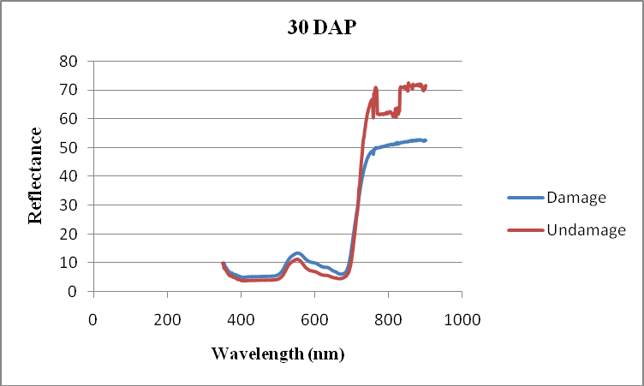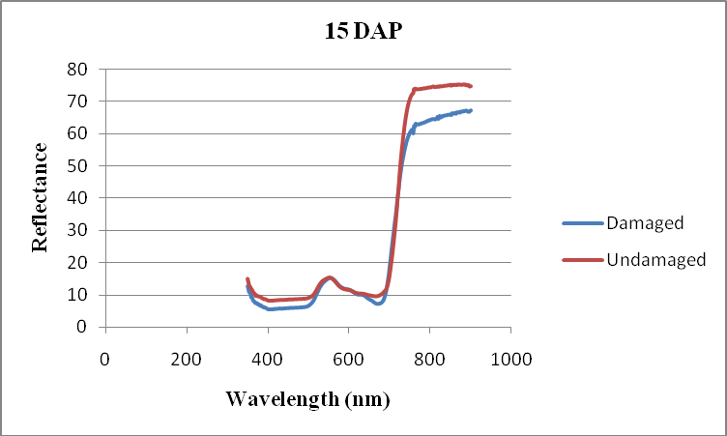
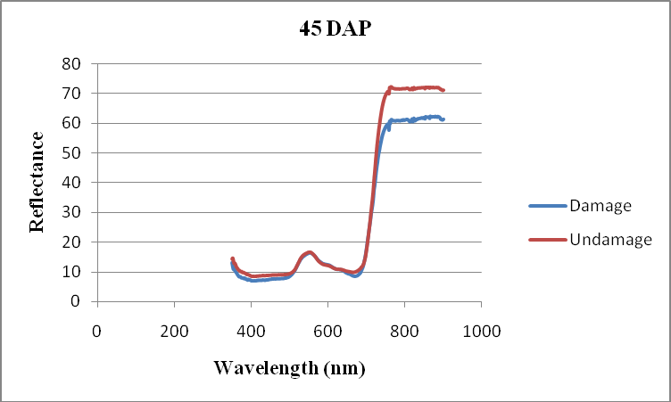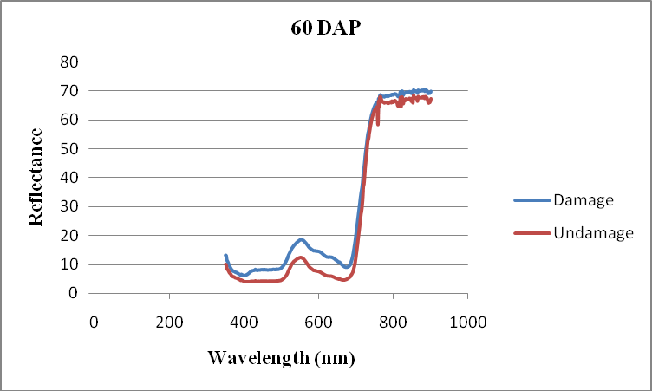
Fig 1. Spectral reflectance curve of thrips damaged mulberry plants
3.3 Vegetation indices of thrips damaged mulberry plants

Vegetation indices (VIs) are mathematical combinations of reflectance values measured in specific spectral bands and are widely used to assess plant vigor, chlorophyll content, and stress conditions. These indices enhance subtle spectral differences between healthy and stressed vegetation by minimizing the effects of illumination, background soil, and atmospheric variability. In hyperspectral remote sensing, vegetation indices derived from visible and near-infrared (NIR) wavelengths are particularly effective in detecting biotic stress caused by insect pests (Vidican et al., 2023). The Vegetation indices namely ratio vegetation index (RVI), normalized difference vegetation index (NDVI) and green red vegetation index (GRVI) were found to be lesser in thrips damaged plants compared to normal healthy plants. Jitendra kumar et al. (2010) reported that spectral indices of aphid infested mustard crop with different level of infestation showed lower level of vegetation indices values in the higher level of infestation while more value with lower level of infestation. In cotton infested by Solenopsis mealybugs, reflectance in the near-infrared (NIR) band drops significantly (from ~48 % in healthy plants down to ~33 % in infested ones), while reflectance in the visible (red) range increases (~9 % to ~14 %), indicating lower RVI/NDVI values correlate with infestation (Sharma et al., 2013).
Elliott et al., (2015) demonstrated that NDVI values decreased significantly with increasing plant injury caused by sugarcane aphids in grain sorghum, indicating that stressed plants show lower vegetation indices than healthy ones. According to Tan et al. (2019), RVI and NDVI derived from hyperspectral data decreased significantly with increasing brown planthopper (Nilaparvata lugens) stress in rice, underscoring the sensitivity of these indices to insect-induced canopy damage. Rouse et al. (1973) originally developed NDVI as a measure of vegetation vigor; later studies confirm that stress conditions (reduced chlorophyll, biomass loss) are associated with lower NDVI values. Vegetation index theory holds that stressed vegetation typically exhibits lower near-infrared reflectance and altered visible reflectance, leading to reduced index values relative to healthy vegetation. Kalpana et al., (2024) reported significantly lower NDVI, GRVI, and RVI values in pink mealybug-infested mulberry plants compared with healthy plants, indicating reduced canopy vigour and photosynthetic activity under pest-induced stress. Similarly, Kalpana et al., (2026) observed significantly lower NDVI and GRVI values in spiralling whitefly-damaged mulberry, demonstrating that hyperspectral vegetation indices are sensitive indicators of pest-induced stress in mulberry canopies.
TABLE 2. Vegetative indices of thrips damaged mulberry plants

DAP | NDVI |  | SR |  | GRVI
DAP | Undamaged* | Damaged* | Undamaged* | Damaged* | Undamaged | Damaged
15 | 0.756±0.04 | 0.755±0.04 | 9.32±2.64 | 7.51±1.65 | 0.21±0.06 | 0.21±0.06
30 | 0.870±0.050 | 0.746±0.032 | 16.63±9.81 | 7.07±0.98 | 0.32±0.08 | 0.23±0.05
45 | 0.795±0.05 | 0.736±0.03 | 8.37±3.40 | 6.67±1.00 | 0.21±0.07 | 0.20±0.04
60 | 0.852±0.02 | 0.726±0.14 | 12.61±1.96 | 8.17±4.03 | 0.31±0.09 | 0.22±0.07
Mean | 0.818±0.04 | 0.741±0.06 | 11.73±4.45 | 7.36±1.92 | 1.05±0.08 | 0.22±0.06
SEd | 0.0390 |  |  | 0.0296 |  | 0.7935
CD(.05) | 0.0849 |  |  | 0.0644 |  | 1.7288
CD(.01) | 0.1190 |  |  | 0.0903 |  | 2.4238
*Mean and standard deviation of 10 plants DAP – Days

3.4 Sensitivity of different spectral bands:
Band sensitivity analysis was carried out to identify the spectral regions most responsive to thrips infestation in mulberry. The red band exhibited higher sensitivity, particularly at later growth stages, indicating chlorophyll degradation caused by thrips feeding. The green band showed moderate sensitivity, suggesting minor changes in leaf pigment composition. In contrast, the NIR band showed reduced sensitivity at later stages, reflecting structural damage to leaf tissues and canopy architecture due to prolonged infestation. Overall, the results indicate that thrips-induced stress alters key spectral bands associated with plant health, enabling detection through hyperspectral radiometry. These findings are consistent with earlier hyperspectral studies on thrips-infested cotton reported by Ranjitha et al. (2014), in which the red band exhibited the highest sensitivity (20.7%) to thrips damage at 70 days after sowing, followed by the blue band, indicating the strong responsiveness of visible wavelengths to chlorophyll loss induced by thrips feeding. Similarly, Ranjitha and Srinivasan (2012) reported that, among the spectral bands, the red band exhibited the highest sensitivity to thrips and leafhopper damage, whereas the near-infrared (NIR) band was more sensitive to aphid damage during the active infestation stage in cotton fields affected by sucking pests.
TABLE 3. Band sensitivity of thrips damaged mulberry plants
DAP | Green | Red | NIR
15 | 17.69 | 6.52 | 6.02
30 | 32.84 | 13.63 | -32.84
45 | 16.98 | 10.44 | 3.42
60 | 72.17 | 28.06 | -28.38

3.5. The most sensitive wavelength to damage caused by thrips
.
Sensitivity of reflectance values in green and red wavelengths had positive values while that of NIR bands showed negative values to damage. When a graph was plotted with sensitivity against wavelength, there was an increase in green (520-580 nm) and red (620-680 nm) and finally decreased in NIR region. Based on sensitivity analysis of spectral bands, recorded on different days of pest incidence, the wavelength having highest sensitivity (positive value) to damage caused by thrips was found to lie in red and NIR band. The per cent sensitivity of thrips damaged plants on 15 DAP observed was 35.81 at a wavelength of 703.7 nm. On the other days of observation from 30 DAP to 60 DAP, the per cent sensitivity was observed as 36.01, 20.69 and 85.26 at a wavelength of 638.43 nm, 700.54 nm and 652.83 nm, respectively (Table 4). Overall, the results indicate that thrips-induced stress alters key spectral bands associated with plant health, enabling detection through hyperspectral radiometry. Likewise, Shukla et al. (2024) identified key sensitive wavelengths at 648, 682, 692, 720, 757, and 767 nm for assessing Alternaria blight severity in mustard using hyperspectral reflectance. These wavelengths predominantly fall within the red, red-edge, and near-infrared (NIR) regions, highlighting their strong responsiveness to stress-induced changes in pigment concentration and internal leaf structure.
Table 4. The most sensitive wavelength to damage caused by thrips affected mulberry plants.
DAP | Wavelength | Per cent sensitivity
15 | 703.7 | 35.81
30 | 638.43 | 36.01
45 | 700.54 | 20.69
60 | 652.83 | 85.26
DAP-Days After Pruning
3.6 Sensitivity of vegetation indices for thrips damage in mulberry.
Sensitivity analysis revealed marked differences among the indices in their response to thrips damage. The mean sensitivity values of SR, NDVI, and GRVI across all observation periods were −109.25, −35.75, and −30.64, respectively, indicating that SR was the most responsive index to thrips-induced stress. This enhanced sensitivity of SR can be attributed to its ability to capture subtle changes in canopy reflectance associated with epidermal cell disruption and chlorophyll loss caused by thrips feeding. Comparable findings were reported by Maheswaran (2012), who observed RVI to be more sensitive than NDVI and GRVI in detecting rice leaf folder damage. The strong sensitivity of NDVI and SR to pest-induced stress observed in the present study is consistent with earlier findings of Prabhakar et al. (2025), who demonstrated that these indices effectively captured leaf folder damage in rice using hyperspectral radiometry. The heightened responsiveness of NDVI and SR can be attributed to their dependence on red and near-infrared reflectance, which are significantly altered by chlorophyll degradation and internal tissue disruption resulting from sustained insect feeding. Tan et al. (2019) investigated the sensitivity of the Ratio Vegetation Index (RVI) to rice plants damaged by brown planthopper (Nilaparvata lugens) and found that RVI values decreased with increased pest damage, demonstrating that RVI is sensitive to biotic stress effects on canopy reflectance. Similar index-specific response has been reported by Mageshwaran et al. (2012) in rice, where GRVI showed greater sensitivity than SR and NDVI for detecting damage caused by yellow stem borer (Scirpophaga incertulas). These findings suggest that the sensitivity of vegetation indices varies with pest feeding behaviour and the nature of crop canopy alteration, highlighting the importance of selecting appropriate indices for pest-specific stress detection using hyperspectral data. Similarly, NDVI showed the highest vegetation index sensitivity in pink mealy bug–damaged mulberry plants, outperforming SR and GRVI, which highlights its effectiveness in capturing changes in red and near-infrared reflectance associated with chlorophyll degradation and internal tissue damage (Kalpana et al., 2023). In contrast, GRVI exhibited greater sensitivity than SR and NDVI in spiralling whitefly–affected mulberry plants, reflecting its stronger response to visible spectral changes induced by chlorosis and surface injury caused by whitefly feeding (Kalpana et al., 2026).
Table 5. Vegetation sensitivity of thrips damage
DAP | SR | GRVI | NDVI
15 | -15.65 | 11.09 | 0.13
30 | -42.71 | -25.70 | -13.98
45 | -14.26 | 4.79 | -7.07
60 | -36.63 | -20.82 | -14.83
Mean | -109.25 | -30.64 | -35.75
Calculated from mean of 10 plants in each in damaged and undamaged.

3.7Regression analysis of thrips damage based on vegetation indices.

Table 6. Vegetative indices and their relationship with per cent leaf damage caused by thrips
Plant no. | Per cent damage | RVI | NDVI | GRVI
1 | 17.49 | 9.37 | 0.786 | 0.17
2 | 18.16 | 9.02 | 0.784 | 0.24
3 | 33.00 | 6.19 | 0.671 | 0.24
4 | 29.68 | 6.36 | 0.714 | 0.22
5 | 29.03 | 6.27 | 0.738 | 0.22
6 | 21.44 | 8.22 | 0.758 | 0.27
7 | 21.29 | 7.22 | 0.754 | 0.23
8 | 30.46 | 6.10 | 0.691 | 0.17
9 | 19.17 | 7.57 | 0.756 | 0.20
10 | 21.30 | 7.24 | 0.756 | 0.18
r |  | -0.889* | -0.941* | 0.070
R2 |  | 0.791 | 0.886 | 0.005

*

The coefficients of determination (R²) between thrips damage and the vegetation indices RVI, NDVI, and GRVI were 0.791, 0.886, and 0.005, respectively (Table 6), indicating that RVI and NDVI were effective in estimating thrips damage, whereas GRVI exhibited poor predictive capability. Accordingly, linear regression equations were developed using RVI and NDVI, while GRVI was excluded due to its negligible R² value. Similar findings were reported by Yang et al. (2007), who observed that among several spectral indices derived from red and near-infrared bands, the NIR/RED ratio showed the highest determination coefficient (R² = 0.922; P < 0.001). In cotton, Ranjitha and Srinivasan (2012) reported significant linear regression relationships between aphid damage and NDVI and RVI, whereas GRVI consistently showed weak or non-significant associations. Likewise, Tan et al. (2019) established regression models between RVI and brown planthopper damage in rice, demonstrating a consistent decline in index values with increasing infestation levels. Prabhakar et al. (2023) further reported significant linear regressions between NDVI, SR, and leaf folder damage in rice, emphasizing the applicability of vegetation index–based regression models for insect stress detection.Supporting these observations, Vinothkumar et al. (2023) reported significant negative correlations between vegetation indices (NDVI, SR, GRVI, and SAVI) and damage caused by sucking pests such as aphids, red spider mites, and mealybugs, indicating a consistent reduction in index values with increasing pest infestation. Additionally, Ranjitha et al. (2014) observed significant negative correlations between aphid damage and all vegetation indices except GRVI across all observation periods in cotton, with R² values of 0.907, 0.920, 0.065, and 0.943 for RVI, NDVI, GRVI, and DSVI, respectively.Consistent with these earlier studies, the present investigation confirms that SR followed by NDVI was more sensitive for estimating thrips damage in mulberry, while GRVI showed limited applicability for regression-based damage assessment.

Fig.2. Relationship between different vegetative indices and per cent damage caused by in thrips damaged mulberry plants.

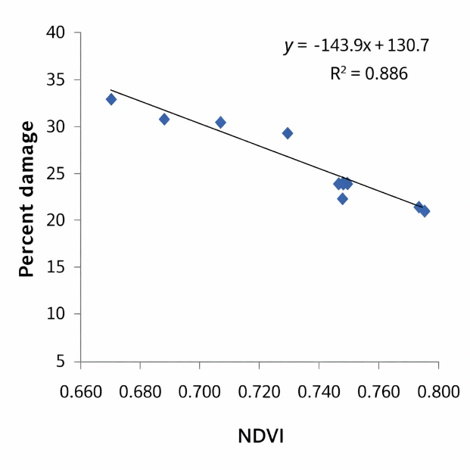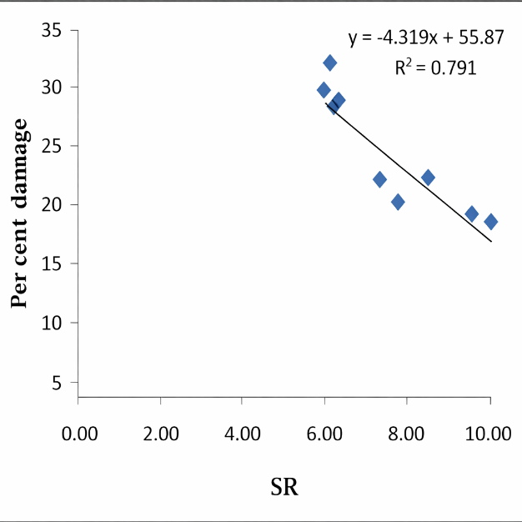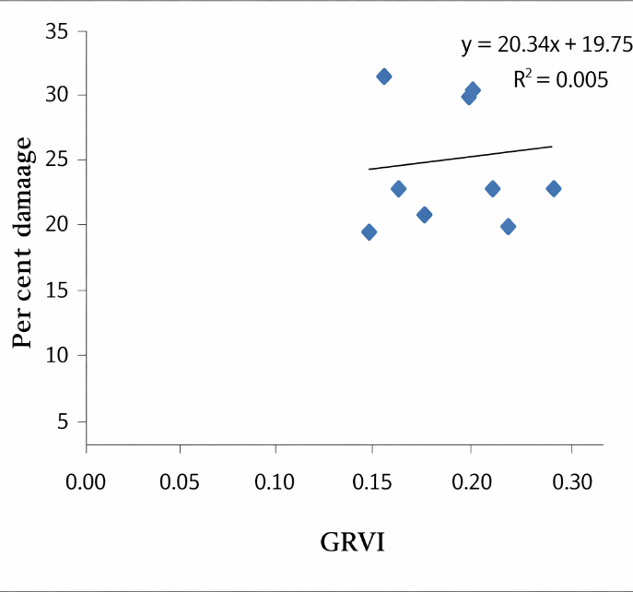

Linear correlation intensity analysis
Linear correlation intensity analysis was carried out to identify wavelength regions most strongly associated with thrips-induced damage in mulberry. The correlation coefficient (r) between percent leaf damage and spectral reflectance was computed for each wavelength across the hyperspectral range and plotted against wavelength to generate the correlation intensity curve. The resulting spectrum exhibited clear wavelength-specific responses, with positive correlations in the visible region—particularly in the red band—and negative correlations in the near-infrared (NIR) region. Thrips-infested mulberry plants recorded the highest positive correlation (r = 0.94) at 689.45 nm in the red band and the strongest negative correlation (r = −0.10) at 763.26 nm in the NIR band, indicating the sensitivity of these wavelengths to thrips-induced stress.
These findings are consistent with Mageshwaran (2012), who reported maximum positive correlations between brown planthopper (BPH) damage in rice and reflectance in the red region (651–680 nm), moderate positive correlations in the blue region (420–490 nm), and strong negative correlations in the NIR region (760–769 nm), highlighting the diagnostic importance of these wavebands for pest detection. Similarly, Yang et al. (2005) demonstrated that reflectance bands centered at 694 and 800 nm, along with vegetation indices derived from these bands, were highly senitive to greenbug infestation in wheat.Comparable correlation intensity patterns have also been reported in cotton, where Ranjitha and Srinivasan (2012) identified 376, 496, 691, 761, 1124, and 1457 nm as sensitive wavelengths for detecting leafhopper damage, confirming the reliability of both visible and NIR regions for sucking pest stress detection. Further supporting this, Prasannakumar et al. (2013) reported that correlation coefficients computed at 1-nm intervals across the 350–2500 nm range enabled the identification of sensitive bands at 500, 665, 1792, and 1986 nm for BPH damage in rice, with the correlation–wavelength curve exhibiting multiple peaks and troughs, reflecting waveband-dependent spectral responses. Likewise, Ranjitha et al. (2014) identified 508, 551, 691, and 710 nm as highly sensitive wavelengths for detecting thrips damage in cotton using linear correlation intensity curve analysis. Kalpana et al. (2024) observed that pink mealy bug–damaged mulberry plants showed the maximum positive correlation (r = 0.77) in the NIR region at 702.12 nm, indicating pronounced sensitivity of internal tissue alterations to infestation. Similarly, in spiralling whitefly–infested mulberry, Kalpana et al. (2026) reported a positive correlation in the blue region at 522.23 nm and the most negative correlation in the green region at 515.73 nm, demonstrating waveband-dependent reflectance responses to pest damage. The consistency of these wavelength-specific correlation patterns across thrips, pink mealy bug, and spiralling whitefly infestations confirms that linear correlation intensity analysis is an effective approach for identifying diagnostic spectral bands and quantifying sucking pest–induced stress in mulberry.

Fig 3. Correlation of reflectance in different wavelengths to per cent shoot damage by thrips in mulberry plants.
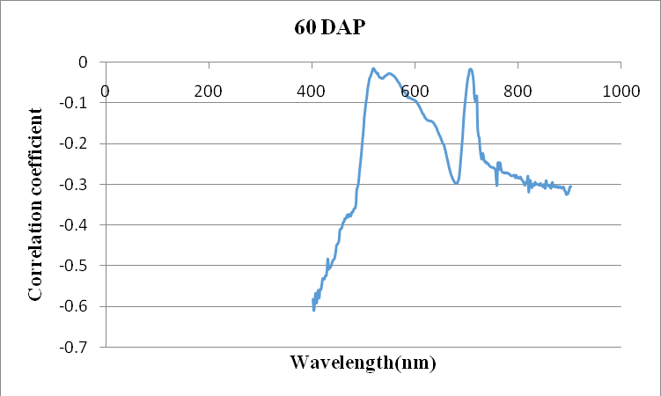
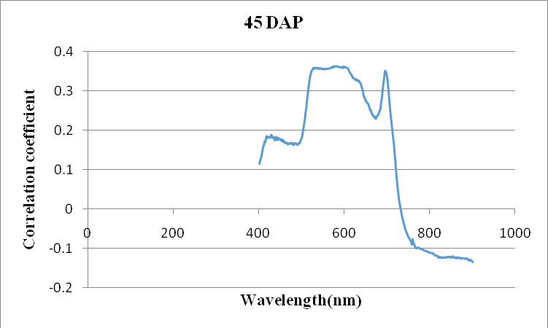
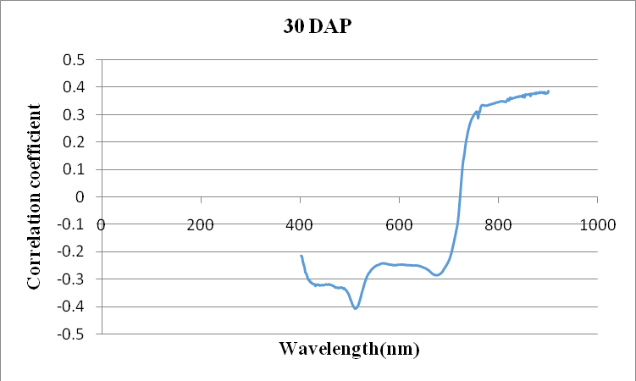
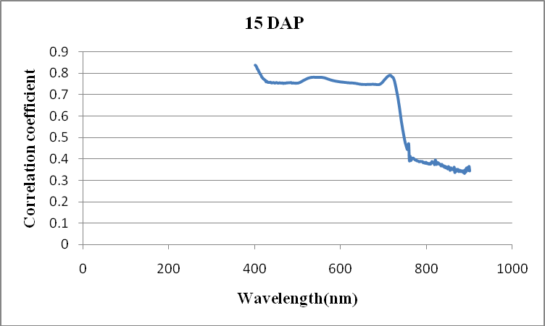

CONCLUSION:
The present investigation clearly demonstrates the potential of hyperspectral radiometry as a robust, non-destructive tool for detecting and quantifying thrips ( Pseudodentrothrips mori ) damage in mulberry under field conditions. Thrips infestation resulted in distinct and consistent alterations in the spectral reflectance behaviour of mulberry leaves, characterized by increased reflectance in the visible region (green and red bands) and reduced reflectance in the near-infrared (NIR) region. These spectral changes were directly associated with chlorophyll degradation and disruption of internal leaf structure caused by thrips feeding activity.Among the vegetation indices evaluated, the Simple Ratio (SR) followed by the Normalized Difference Vegetation Index (NDVI) exhibited the highest sensitivity and strongest negative correlation with thrips-induced leaf damage, making them reliable indicators for estimating infestation severity. Regression analysis further confirmed the effectiveness of SR and NDVI for predicting thrips damage, whereas GRVI showed limited applicability for regression-based damage assessment. Sensitivity analysis identified the red and red-edge regions as the most responsive spectral zones, with key wavelengths around 638–703 nm showing maximum sensitivity across observation periods.Linear correlation intensity analysis revealed strong wavelength-specific relationships between thrips damage and spectral reflectance, with the highest positive correlation observed in the red region (689.45 nm) and the strongest negative correlation in the NIR region (763.26 nm). The consistency of these correlation patterns with those reported for other sucking pests of mulberry, such as pink mealy bug and spiralling whitefly, underscores the reliability of hyperspectral techniques for pest-specific stress detection in mulberry.Overall, the study establishes that hyperspectral radiometry, combined with vegetation indices and correlation intensity analysis, can effectively detect early-stage thrips infestation and quantify damage severity in mulberry. The identified sensitive spectral bands and indices provide a scientific basis for developing remote sensing–based diagnostic and decision-support tools for precision sericulture, enabling timely pest management interventions and contributing to improved mulberry productivity and sustainability of silk production systems.
REFERENES:
- Krishnaswami S. (1978). New technology of silkworm rearing. Bulletin No. 2. Mysore, India: Central Sericultural Research and Training Institute.
- Dandin, S.B., Jayaswal, J., Giridhar, K. (2003). Handbook of sericulture technologies. Bangalore, India: Central Silk Board.
- Benchamin, K.V., Jolly, M.S. (1986). Principles of sericulture. Bangalore, India: SBR Publications.
- Reddy, R.M., Reddy, G.S., Rao, D. M. (2010). Impact of mulberry leaf quality on silkworm growth and cocoon yield. Indian Journal of Sericulture,49(2),123–128.
- Choudhury, B.N., Das, P.K., Rahman, A. (2016). Remote sensing applications in detecting crop stress and pest infestation: A review. International Journal of Agricultural and Environmental Research,2(3),145–156.
- Ranjitha, G., Srinivasan, M.R, Rajesh, A. (2014). Detection and estimation of damage caused by Thrips tabaci (Lind) of cotton using hyperspectral radiometer. Agrotechnology,3(1),123. doi:10.4172/2168-9881.1000123.
- Anusha, H.G., Bhaskar, R.N. (2015). Sucking pests of mulberry: A review paper. Journal of Agriculture and Veterinary Science,8(8),01-03.
- Jayashree, K.C., Narayanaswamy, manjunath gowda , Chinnamade, C., K. S. Jagadish. (2025). Varietal Response and Spatial Distribution of Thrips and Yellow Mite, Polyphagotarsonemus latus (Banks) on Mulberry. Mysore J. Agric. Sci, 59 (1): 87-96.
- Prabhakar, M., Prasad, Y.G., Thirupathi, M., Sreedevi, G., Dharajothi, B., & Venkateswarlu, B. (2011). Use of ground based hyperspectral remote sensing for detection of stress in cotton caused by leafhopper (Hemiptera: Cicadellidae). Computers and Electronics in Agriculture, 79(2), 189-198.
- Yang, Z., Rao, M.N., Elliott, N.C., Kindler, S.D., and Popham, T.W. (2005). Using ground based multispectral radiometry to detect stress in wheat caused by greenbug (Homoptera: Aphididae) infestation. Compur. Electron. Agric, 47(2), 121-135.
- Gitelson, A. A., Merzlyak, M. N., & Lichtenthaler, H. K. (2001). Detection of red edge position and chlorophyll content by reflectance measurements Near 700 nm: Journal of Plant Physiology,148(3-4), (pp. 151–157).
- Carter, G. A., & Knapp, A. K. (2001). Leaf optical properties in higher plants: Linking spectral characteristics to stress and chlorophyll concentration. American Journal of Botany, 88(4), 677–684.
- Roshni., and Bharat M.(2022).A Review: Applications of Remote Sensing in the Agriculture. International Journal of Research and Analytical Reviews,9(2348-1269),2349-5138.

- Kalpana, R., Murugesh, K. A., Perumal, R. K., Mithila Sri, M., and Kannan, B.(2024). Spectral analysis of pink mealy bug damaged mulberry plants using hyperspectral radiometry. Journal of Advances in Biology & Biotechnology, 27(5), 81–91.
- Kalpana, R., Menaka, S., Sabarish, M., Mavilashaw, V., Bharathi, B.S.A., Bhuvaneshwari, T., Devi D.M., Murugesh, K. A and Perumal R.(2026). Spectral Analysis of Spiralling Whitefly-Damaged Mulberry Plants Using Hyperspectral Radiometry. Journal of Scientific Research and Reports. 32(1),244-259
- Vasudha prabhakar, K., Reddy R.N., Babu, S.H., Sharma C.M.,and kumar, C. (2015). Screening of mulberry gremplasm for relation to sucking pests. I.J.Dev, 5(1):2976-2979.
- Luther, J. E and A.L.Carroll. 1999. Development of an index of balsam fir vigor by foliar spectral reflectance. Remote Sens. Environ., 69:241-252.
- Abdel-Rahman, E.M., Ahmed, F.B., Van den Berg M., and Way, M.J. (2010). Potential of spectroscopic data sets for sugarcane thrips (Fulmekiola serrta Kobus) damage detection. Int. J.Remote Sens, 31: 4199-4216.
- Sellers, P.J. 1985. Canopy Reflectance, Photosynthesis and Transpiration. Int. J. Remote Sens., 6:1335-1372.
- Sims, D.A and J.A. Gamon. 2002. Relationship between leaf pigment content and spectral reflectance across a wide range of spices, leaf structure and developmental stages. Remote Sens. Environ., 81: 337-354.
- Mirak, M., J.R. Michels, G.J. Kassymzhanova, S.Mirik, N.C. Elliott, V.Catana, D.B. Jones and R. Bowling. 2006a. Using digital image analysis and spectral reflectance data to quantify green bug (Homoptera:Aphididae) damage in winter wheat. Comput. Electron.Agric., 51:86-98.
- Yang, Z., Rao, M.N., Ellicott, N.C., Kindler S.D., and Popham T.W. (2009). Differentiating stress induced by greenbugs and Russian wheat aphids in wheat using remote sensing. Comput. Electron. Agric., 67(1-2):64-70.
- Motokha, T., Nasahara K.N., Oguma, H., and Tsuchida S. (2010). Applicability of Green- Red Vegetation Index for Remote Sensing of Vegetation Phenology. Remote Sensing, 2:2369-2387.
- Carter, G.A. 1993. Responses of leaf spectral reflectance to plant stress. Am. J. Bot., 80 (3):239-243.
- Reisig, D and L. Godfey. 2007. Spectral response of cotton aphid- (Hompotera: Aphididae) and Spidermite- Acari: Tetraanychidae) infested cotton: controlled studies. Environ Entolol., 36(6):1466-1474
- Huang, J., Sun, Q., and Liu X., (2010). Spectral characteristics of rice leaves damaged by rice leaf roller. Scientia Agricultura Sinica, 43(13): 2679-2687.
- Ranjitha G., Srinivasan M.R., Rajesh A., (2014). Detection and estimation of damage caused by thrips Thrips tabaci (Lind) of cotton using hyperspectral radiometer. Agrotechnology, 3(1):79-81
- Sapkota, R., Parajulee, M. N., & Craddock, K. R. (2024). Interactive effect of cover crop, irrigation regime, and crop phenology on thrips population dynamics in upland cotton. Agriculture, 14(7), 1128. doi:10.3390/agriculture14071128.
- Shibayama, M., Takahashi, W., Morinaga, S., and Akiyama, T., (1993). Canopy water deficit detection in paddy rice using a high-resolution field spectroradiometer. Remote Sens. Environ., 45: 117-126.
- Riedell, W.E and Blackmer, T.M. (1999). Leaf reflectance spectra of cereal aphid-damaged wheat. Crop Sci., 39(6): 1835-1840.
- Mirak, M., Michels, G.J. Jr. Kassymzhanova, G.J., Mirak, S., and Elliott, N.C. (2007). Reflectance characteristics of Russian wheat aphid (Hemipetera: Alphididae) stress and abundance in winter wheat. Comput. Electron. Agric., 57:123-134.
- M. Mageshwaran, Srinivasan, M.R., and Sivasamy, R. (2014). Detection and estimation of damage caused by rice yellow stem borer Scirpophaga incertulas (Walker) by hyperspectral radiometry. "National Symposium on ETEIPM" January, 2014.
- Prasannakumar, N.R., Subash Chander, R.N. Sahoo. (2013). Spectral signatures of rice crop damaged by brown planthopper under field and glass house conditions. Current Biotica., 7(3):124-133.
- Qiu, Z., He, Y., and Chen, C. (2008). Assessment of rice plant damage caused by brown planthopper (Nilaparvata lugens Stål) using hyperspectral reflectance measurements. International Journal of Remote Sensing, 29(21), 6315–6327. https://doi.org/10.1080/01431160802175493.
- Prabhakar, M., Prasad, Y. G., Thirupathi, M., Sreedevi, G., Dharajothi, B., & Venkateswarlu, B. (2011). Use of ground based hyperspectral remote sensing for detection of stress in cotton caused by leafhopper (Hemiptera: Cicadellidae). Computers and Electronics in Agriculture, 79(2), 189-198.
- Prabhakar, M., Sreedevi, K., and Sreekanth,P. (2013). Hyperspectral radiometry for detection and estimation of infestation caused by major sucking pests in brinjal. Madras Agricultural Journal, 100(7–9), 242–249.
- Prabhakar, M, Padmavathi, C., Thirupathi, M., Golla, S.K, Sravan, U.S., Rao, G.R., Kalpana, M., Sailaja, V., Chandana, P., Prasad, Y.G., Srinivasa Rao, M., Singh, V.K, Singh, R. Remote sensing of rice leaf folder damage using ground-based hyperspectral radiometry. Smart Agricultural Technology. 2025; 10:100757. doi: 10.1016/j.atech.2024.100757.
- Krüger, M., Zemanek, T., Wuttke, D., Dinkel, M., Serfling, A., and Böckmann, E. (2024). Hyperspectral imaging for pest symptom detection in bell pepper. Plant Methods, 20(1), Article 156. https://doi.org/10.1186/s13007-024-01273-5/
- Zhu, B.J, Liu, Q.N., Dai, L.S., Wang, L., Sun, Y., Lin, K.Z., Wei, G.Q., Liu, C.L. (2025) Developing spectral indices and models for monitoring rice planthoppers (Hemiptera: Delphacidae) with hyperspectral data and machine learning. Journal of Economic Entomology.118(5):2290–2300. doi:10.1093/jee/toaf214.
- Huang, L., Yang, L., Meng, L., Wang, J., Li, S., Fu, X., Du, X., Wu, D. (2018). Potential of visible and near-infrared hyperspectral imaging for detection of Diaphania pyloalis larvae and damage on mulberry leaves. Sensors. 18(7):2077. doi:10.3390/s18072077.
- Vidican, R., Mălinaș, A., Ranta, O., Moldovan, C., Marian, O., Ghețe, A., Ghișe, C.R., Popovici, F. and Cătuțescu, G.M. (2023). Using remote sensing vegetation indices for the discrimination and monitoring of agricultural crops: A critical review. Agronomy, 13(12), 3040. DOI: https://doi.org/10.3390/agronomy13123040
- Elliott, N.C., Backoulou, G.F., Brewer, M.J, Giles, K.L. (2015).NDVI to detect sugarcane aphid (Melanaphis sacchari) injury to grain sorghum. Journal of Economic Entomology,108(3),1452–1455. doi:10.1093/jee/tov080.
- Tan Y, Sun J-Y, Zhang B, Chen M, Liu Y, Liu X-D. (2019).Sensitivity of a ratio vegetation index derived from hyperspectral remote sensing to brown planthopper (Nilaparvata lugens) stress on rice plants. Sensors,19(2):375. doi:10.3390/s19020375
- Rouse, J.W, Haas, R.H, Scheel, J.A., Deering, D.W. Monitoring vegetation systems in the Great Plains with ERTS. In: Third Earth Resources Technology Satellite-1 Symposium. NASA SP-351. Washington, DC: NASA; 1974. p. 309–317.
- Ranjitha G, and Srinivasan, M.R. (2012). Hyperspectral radiometry for detection of sucking pests in cotton. Journal of Biopesticides,5(2),141-149.
- Shukla, K.S., Birah, A., Nigam, R., Kanojia, A.K., Khokhar, M.M., Bhattacharya, B.K., Chander, S., Selection of sensitive bands for assessing Alternaria blight diseased severity grades in mustard crops using hyperspectral reflectance. Journal of Agrometeorology. 2023;25(2):274–279. doi:10.54386/jam.v25i2.2057.
- Vinothkumar,B., Kannan, B., Jagadeeswaran, R., Hyperspectral radiometry for detection and estimation of infestation caused by major sucking pests in brinjal. Madras Agricultural Journal. 2023;103(7–9):242–249. doi:10.29321/MAJ.10.001028

