Original Research Article

Maintenance Therapy with capecitabine vs Observation after standard treatment for Patients with Triple-Negative Breast Cancer, Mansoura experience.

.
ABSTRACT
Background:
Triple-negative breast cancer (TNBC) is a great challenge in modern oncology due aggressive biological behavior. Chemotherapy is the only treatment option for those patients. This rises the idea of using capecitabine as maintenance therapies to reduce the risk of relapse after adjuvant treatment.
Patients and methods: this is a retrospective study done on 2 groups of patients with TNBC after completion of standard treatment. group 1 received capecitabine twice daily for 14 days and one-week rest for 6 months and group 2 was under observation.
Aim: To compare the 3 years DFS and OAS between both groups and to assess the toxicity in group 1.
Results: 112 cases were included in group 1 and 115 cases in group 2. The median follow-up period was 42 months. Patients characteristics were comparable between both groups. The results were better in group 1 regarding incidence of events (44 vs 51), OS (49.4 vs 46.2 months) and DFS (44.1 vs 40.9 months) but it did not reach significant level. The significant effect was observed in subgroup of cases with early nodal disease where OS was 54.3 vs 44.5 months (P- value 0.03) and DFS was 48.3 vs 39.9 months (P-value 0.04). Also, in cases who achieved PCR where OS was 54.7 vs 44.2 months (P-value 0.02) and DFS was 48.8 vs 39.2 months (P-value 0.03). the maintenance therapy was well tolerated with no need to stop the treatment or reduce the dose.
Conclusion: Low dose capecitabine therapy improves OS and DFS in cases with TNBC. The improvement is significant in early nodal disease cases and cases who achieved PCR. The therapy is well tolerated with no remarkable toxicity.

Keywords: TNBC, maintenance therapy, capecitabine

1. INTRODUCTION
Triple-negative breast cancer (TNBC) is still a difficult issue in practical modern oncology. This may be due to aggressive biological behavior and limited treatment options [1]. Unlike other subtypes of breast cancer, there is no available Maintenance therapy like hormonal or targeted therapy that could reduce the risk of relapse after the end of adjuvant therapy. In cases with TNBC, chemotherapy is the only treatment option. This fact rises the idea of using chemotherapeutic agents as maintenance therapy [2]. The rationale for this is that using chemotherapy in lower dosage and higher frequency could exert an anticancer effect by inhibition of angiogenesis and suppressing immune escape that could happened for circulating malignant cells [3]. Capecitabine which is a usual drug used in treatment of metastatic breast cancer, could be a potential agent for maintenance therapy in TNBC cases [4]. several trials tried to investigate adding capecitabine to adjuvant treatment of breast cancer, but the results were confusing [5]. Our study is a retrospective one done at clinical oncology and nuclear medicine department, Mansoura university hospital to compare 2 groups of cases diagnosed with TNBC and ended standard treatment, group 1 received capecitabine as a maintenance therapy and group 2 was only under observation.

Aim of work:
The 1ST end point is to compare the 3 years DFS and OAS between both groups. The 2nd end point is to assess the toxicity in group 1 who was under maintenance treatment.

2. material and methods

Patient and methods:
This study is a retrospective one done at clinical oncology and nuclear medicine department, Mansoura university hospital to compare 2 groups of cases diagnosed with TNBC and ended standard treatment, group 1 received capecitabine 650 mg/m2 twice daily for 14 days and one week rest as a maintenance therapy for 6 months and group 2 was only under observation. The study includes cases presented to our department from Jan 2021 to Dec 2022. Cases were under follow up till June 2025.

Eligibility criteria: cases that histologically diagnosed with TNBC and underwent surgery, adjuvant chemotherapy and radiotherapy if needed.
The exclusion criteria: recurrent or metastatic disease, medically unfit to continue maintenance chemotherapy.
Statistical analysis:
Data were analyzed using the Statistical Package of Social Science (SPSS) program for Windows (Standard version 24). The normality of data was first tested with one-sample Kolmogorov-Smirnov test.
We used independent t tests for continuous variables. A survival curve was illustrated with the Kaplan–Meier method. To compare the univariate survival distribution between neck dissections, a log-rank test was used. The independent predictors of mortality were identified by Cox proportional hazards models in a multivariate analysis for the significant risk factors observed in the univariate analysis
Level of significance:
For all above mentioned statistical tests done, the threshold of significance is fixed at 5% level (p-value).
The results were considered:
- Non-significant when the probability of error is more than 5% (p > 0.05).
- Significant when the probability of error is less than 5% (p ≤ 0.05).
- The smaller the p-value obtained, the more significant are the results

3. results and discussion

Results
At the end of the study, we had 112 cases in group 1 and 115 cases in group 2. The study started at Jan 2021 and ended at June 2025 with follow up period ranged between 30 and 54 months (median 42 months). Table 1 shows patients characteristics in both groups. 55 cases (49.1%) in group 1 were pre-menopausal compared to 59 cases (51.3%) in group 2. The size of the tumor was more than 5 cm in 41 cases (36.6%) in group 1 compared to 43 cases (37.4%) in group 2. Regarding LN status, 40 cases (35.7%) in group 1 presented with early disease (N 0-1) compared to 41 cases (35.7%) in group 2. Most of cases in both groups received NACT, 101 cases (90.2%) in group 1 compared to 104 cases (90.4%) in group 2. Out of them 50 cases (49.5%) achieved pathological complete response in group 1 compared to 52 cases (50%) in group 2. 83 cases (74.1%) in group 1 were underwent conservative breast surgery compared to 85 cases (73.9%) in group 2. Regarding adjuvant radiotherapy, 103 cases (92%) in group 1 received radiotherapy compared to 105 cases (91.3%) in group 2. For all previous data both groups were matching with no statistically significant difference.
Regarding toxicity profile in group 1 which was assessed according to CTCAE version 5, We reported only grade II hematological toxicity in 20 cases (17.8%) and only 9 cases (8%) developed grade II hand foot syndrome which was resolved with symptomatic treatment. There was no need to stop treatment or reduce the dose.
During the period of the study, we reported the number of events in both groups which included local recurrence, visceral metastasis or death because of the disease. regarding group 1, the events were reported in 44 cases (39.3%). It included 10 cases with local recurrence only, 19 cases with visceral metastasis only, 15 cases with both local and distant metastasis and 12 cases died because of disease progression. Regarding group 2, the events were reported in 51 cases (44.3%) which included 12 cases with local recurrence only, 22 cases with visceral metastasis only, 17 cases with both local and distant metastasis and 16 cases died due to disease progression. Although number of events were obviously better in group 1 compared to group 2 but it did not reach the significant value even it was so close (P-value 0.074). The same was noticed when we compare the mean time of events development between both groups where it was better (35.04±10.58 months) in group 1 compared to (31.49±8.88 months) in group 2. But again, the difference did not reach a significant value (P value 0.13).
Table (1): patients characteristics
 | Group (1) (no=112) | Group (2) (no=115) | Test of significance | p value
Pre-menopausal  Yes  No | 55 (49.1%)  57 (50.9%) | 59 (51.3%)  56 (48.7%) | χ²=0.110 | 0.741
Size  >5 cm  ≤5 cm | 41 (36.6%)  71 (63.4%) | 43 (37.4%)  72 (62.6%) | χ²=0.015 | 0.903
Lymph node  0-1  2-3 | 40 (35.7%)  72 (64.3%) | 41 (35.7%)  74 (64.3%) | χ²= 0.001 | 0.992
Neoadjuvant chemotherapy  Yes  No | 101 (90.2%)  11 (9.8%) | 104 (90.4%)  11 (9.6%) | χ²= 0.004 | 0.948
Pathological complete response Yes  No | 50 (49.5%)  51 (50.5%) | 52 (50%)  52 (50%) | χ²= 0.008 | 0.931
Conservative breast surgery  Yes  No | 83 (74.1%)  29 (25.9%) | 85 (73.9%)  30 (26.1%) | χ²= 0.001 | 0.973
Radiotherapy  Yes  No | 103 (92.0%)  9 (8.0%) | 105 (91.3%)  10 (8.7%) | χ²= 0.032 | 0.858
Events (Recurrence/ met/death)  Yes  No | 44 (39.3%)  68 (60.7%) | 51 (44.3%)  64 (55.7%) | χ²= 1.597 | 0.074
Time of event  Mean ± SD | 35.04±10.58 | 31.49±8.88 | t= 1.19 | 0.13
t: Independent t-test, χ^{2 :} Chi square test
Table 2 represents the data comparing overall survival between both groups and comparing the survival for every individual prognostic factor. From the table we noticed that the mean overall survival time was 49.4 months in group 1 compared to 46.2 months in group 2. The survival is better in group 1 but it did not reach significant value (P-value 0.10). from the table we can also noticed that the survival was markedly better in cases with early nodal disease compared to advanced nodal disease (49.4 vs 46.5 months) and also in cases who achieved pathological complete response compared to cases who did not (49.2 vs 44.7 months). But also, it did not reach a significant level.
Table (2): Kaplan-Meier overall survival
 | Overall survival |  |  |  | Log rank test | P value
 | Mean survival time | Std. Error | 95% Confidence Interval |  | Log rank test | P value
 | Mean survival time | Std. Error | Lower Bound | Upper Bound | Log rank test | P value
Groups  Group 1  Group 2 | 49.368  46.175 | .921  .780 | 43.563  42.646 | 55.173  49.704 | 0.719 | 0.10
Pre-menopausal  Yes  No | 47.399  48.173 | .883  .842 | 45.669  46.523 | 49.129  49.823 | 1.557 | 0.412
Size  >5 cm  ≤5 cm | 47.250  47.670 | .975  .735 | 45.339  46.229 | 49.161  49.111 | 0.001 | 0.970
Lymph node  0-1  2-3 | 49.447  46.545 | .968  .740 | 43.550  43.095 | 55.345  49.995 | 0.112 | 0.14
Neoadjuvant chemotherapy  Yes  No | 48.060  47.873 | .652  1.652 | 46.782  46.634 | 49.339  49.111 | 0.475 | 0.27
Pathological complete response  Yes  No | 49.179  46.717 | .877  .807 | 43.460  43.135 | 55.898  50.299 | 0.108 | 0.15
Conservative breast surgery  Yes  No | 47.522  47.141 | .731  1.021 | 46.088  45.140 | 48.955  49.143 | 0.542 | 0.761
Radiotherapy  Yes  No | 47.314  46.828 | .648  1.742 | 46.044  43.414 | 48.585  50.242 | 0.398 | 0.528

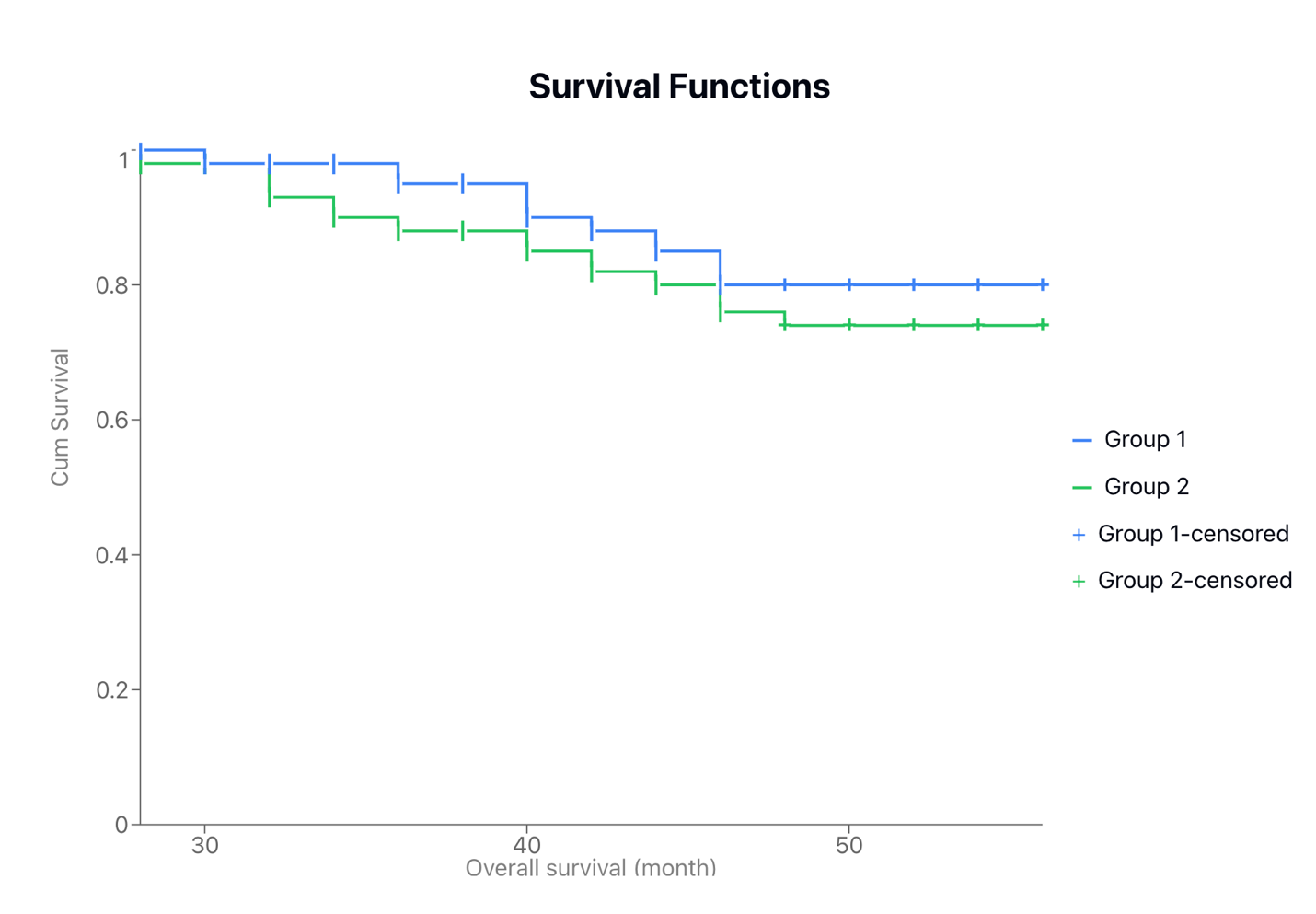

Figure 1 represents the Kaplan-Meier curve for overall survival between both groups. The curve shows better values for group 1. The 36 months overall survival is about 98% in group 1 compared to about 90% in group 2.

Table 3 represents the data about disease free survival between both groups. It was 44.1 months in group 1 compared to 40.8 months in group 2. The results were better in group 1 and was so close to be significant (P-value 0.092). Regarding the prognostic factors in both groups and their effect on the disease-free survival, the best results were noticed again in early nodal disease cases (44.1 vs 41.6 months) and pathological complete response (44 vs 40.8 months). But the P-value was not significant.

Table (3): Disease free survival
 | Disease free survival |  |  |  | Log rank test | P value
 | Mean survival time | Std. Error | 95% Confidence Interval |  | Log rank test | P value
 | Mean survival time | Std. Error | Lower Bound | Upper Bound | Log rank test | P value
Groups  Group 1  Group 2 | 44.079  40.830 | 1.426  1.383 | 34.284  33.119 | 53.875  48.541 | 0.847 | 0.092
Pre-menopausal  Yes  No | 43.179  41.766 | 1.412  1.392 | 40.412  39.037 | 45.946  44.495 | 0.575 | 0.448
Size  >5 cm  ≤5 cm | 41.316  43.635 | 1.593  1.218 | 38.195  41.247 | 44.437  46.022 | 0.645 | 0.231
Lymph node  0-1  2-3 | 44.081  41.676 | 1.587  1.222 | 34.959  34.782 | 53.203  48.571 | 0.944 | 0.19
Neoadjuvant chemotherapy  Yes  No | 42.497  41.091 | 1.040  3.105 | 40.460  35.005 | 44.535  47.176 | 0.006 | 0.938
Pathological complete response  Yes  No | 43.988  40.793 | 1.444  1.308 | 34.653  34.229 | 53.323  47.357 | 0.656 | 0.12
Conservative breast surgery  Yes  No | 41.900  41.853 | 1.175  1.753 | 39.597  38.417 | 44.204  45.290 | 0.384 | 0.745
Radiotherapy  Yes  No | 41.622  41.510 | 1.046  2.889 | 39.572  35.847 | 43.672  47.173 | 0.122 | 0.738

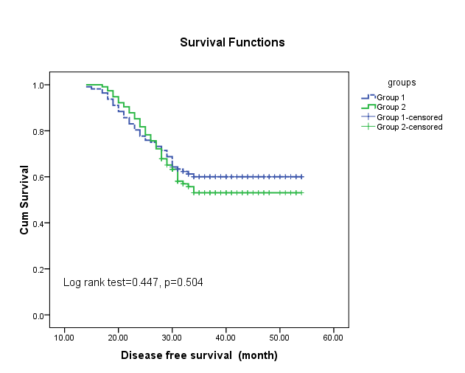
Figure 2 shows the Kaplan-Meier curve for disease-free survival between both groups. The curves show better survival for group 1 specially after 30 months. 36 months disease-free survival was about 60% in group 1 compared to 50% in group 2.

Table 4 shows the incidence of events between both group and between various prognostic factors. From the table we noticed that in general, the incidence of events was better in group 1 except in cases with heavy nodal disease and in cases who did not achieved PCR. the least incidence of events with significant effect was observed in cases with early nodal disease in group 1 (5/40 cases 12.5%) compared to 14/41 cases (34.1%) in group 2 with P-value 0.01 and also in cases who achieved PCR in group 1 (7/50 cases 14%) compared to 17/52 cases (32.6%) with P-value 0.021 in group 2. These data led us to investigate if this could be reflected on overall survival and disease-free survival for these sub-groups.

Table (4): incidence of events

 | Group 1 | Group 2 | P- value
Total | 44/112 (39.2%) | 51/115 (44.3%) | 0.074
Premenopausal | 21/55 (38.2%) | 26/59 (44%) | 0.06
Postmenopausal | 23/57 (40.3%) | 25/56 (44.6%) | 0.08
Size more than 5 cm | 17/41 (41.4%) | 19/43 (44.1%) | 0.12
Size less than 5 cm | 27/71 (38%) | 32/72 (44.4%) | 0.058
LN 0-1 | 5/40 (12.5%) | 14/41 (34.1%) | 0.01
L.N 2-3 | 39/72 (54.1%) | 37/74(50%) | 0.76
PCR | 7/50 (14%) | 17/52 (32.6%) | 0.021
No PCR | 37/62 (59.6%) | 34/63 (53.9%) | 0.34
CBS | 32/83 (38.5%) | 37/85 (43.5%) | 0.07
MRM | 12/29 (41.3%) | 14/30 (46.6%) | 0.065

Table 5 represents the data for overall survival comparing 40 cases of early nodal disease in group 1 compared to 41 cases of same sub-group in group 2. The table shows that the mean survival time in cases of sub-group 1 is 54.3 months compared to 44.5 months in sub-group 2 with significant P-value (0.03). The table also compare the overall survival between cases who achieved PCR in group 1 (50 cases) where it was 54.8 months compared to same cases in group 2 (52 cases) where it was 44.2 months. The P-value was significant too (0.02).

Table (5): Kaplan-Meier overall survival for early nodal and PCR cases
 | Overall survival |  |  |  | Log rank test | P value
 | Mean survival time | Std. Error | 95% Confidence Interval |  | Log rank test | P value
 | Mean survival time | Std. Error | Lower Bound | Upper Bound | Log rank test | P value
LN 0-1  Group 1  Group 2 | 54.342  44.538 | 1.462  1.184 | 53.486  43.244 | 55.216  45.883 | 2.07 | 0.03
Pathological complete response  Group 1  Group 2 | 54.787  44.154 | 1.329  1.080 | 53.682  43.037 | 55.892  45.271 | 2.10 | 0.02

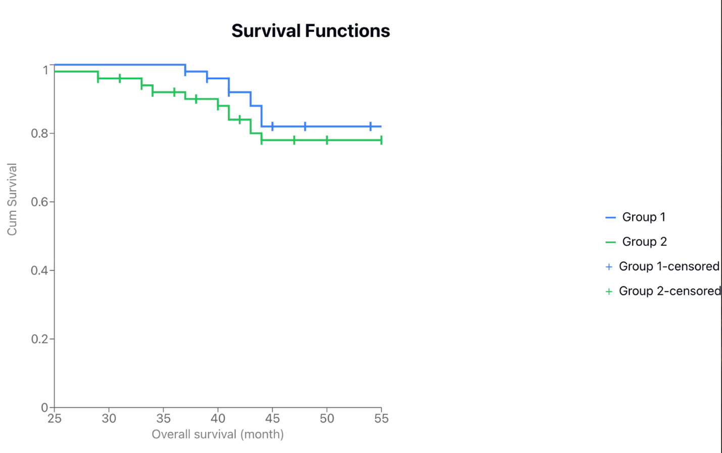

Figure 3 represents the Kaplan-Meier curve for overall survival (L.N 0-1 cases) between both groups. The 36 months overall survival was about 100% in group 1 compared to 90% in group 2.

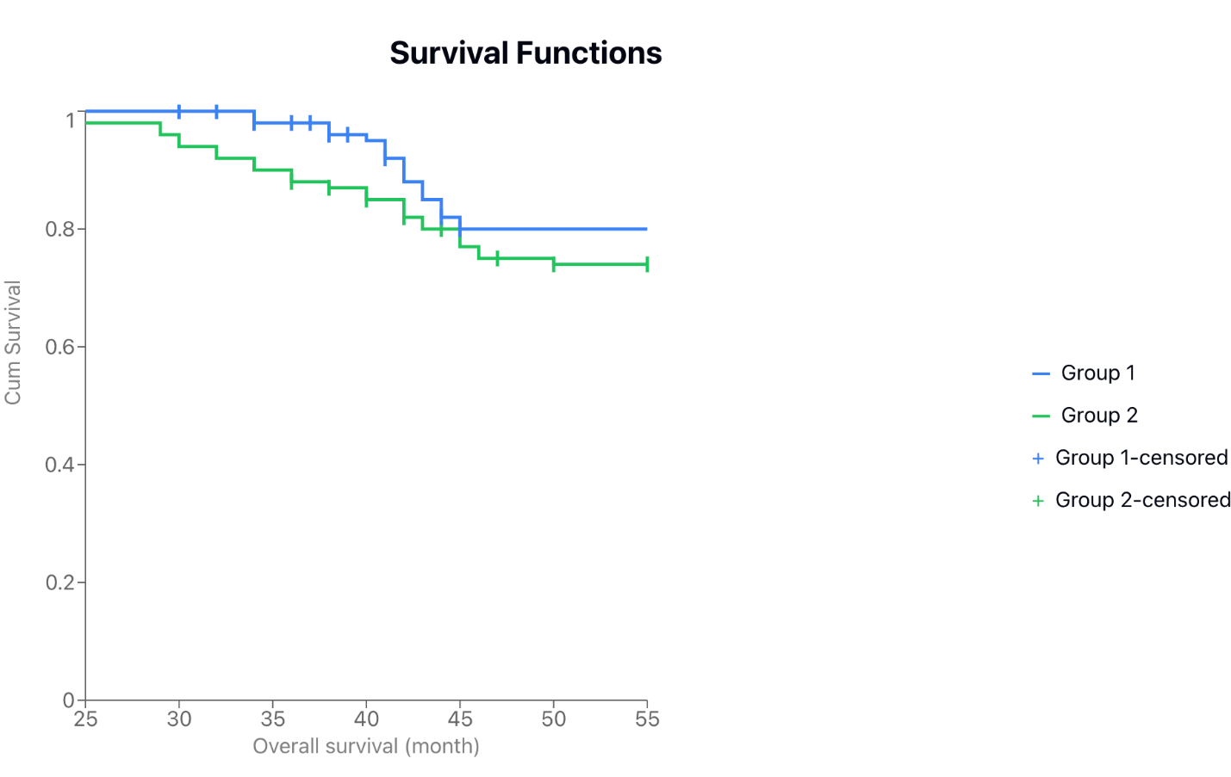

Figure 4 represents Kaplan-Meier curve for overall survival (PCR cases) between both groups. The 36 months overall survival is about 98% in group 1 compared to 88% in group 2.

Table 6 represented the data for comparison between both sub-groups regarding disease-free survival. It was 48.3 months in L.N 0-1 cases in group 1 compared to 39.9 months in group 2 with significant P-value (0.04). the same was observed regarding cases with PCR in both groups where it was 48.8 months in sub-group 1 compared to 39.2 months in sub-group 2 with significant P-value (0.03).

Table (6): Kaplan-Meier disease free survival
 | Disease free survival |  |  |  | Log rank test | P value
 | Mean survival time | Std. Error | 95% Confidence Interval |  | Log rank test | P value
 | Mean survival time | Std. Error | Lower Bound | Upper Bound | Log rank test | P value
LN 0-1  Group 1  Group 2 | 48.259  39.879 | 2.243  2.200 | 44.862  33.566 | 53.656  46.191 | 2.055 | 0.04
Pathological complete response  Group 1  Group 2 | 48.803  39.174 | 2.067  1.971 | 40.752  34.310 | 53.854  44.038 | 2.7 | 0.03

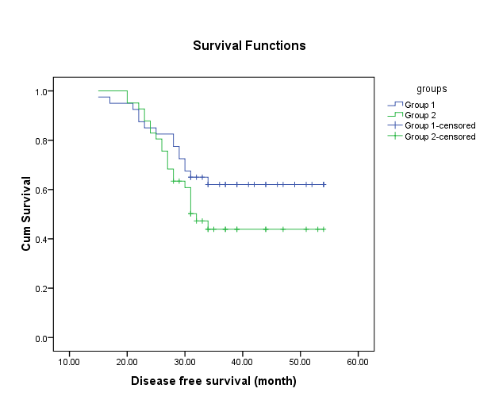

Figure (5) represents Kaplan-Meier curve for disease free survival (LN 0-1 cases). The 36 months disease-free survival is 62% in sub-group 1 compared to 48% in sub-group 2.
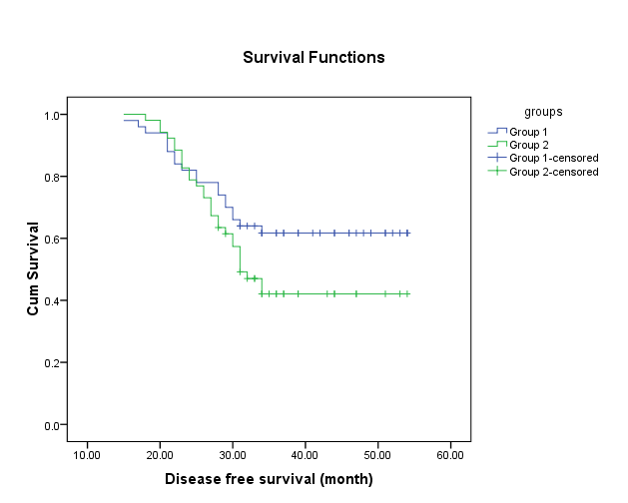

Figure (6) represents Kaplan-Meier curve for disease free survival (PCR cases). 36 months disease-free survival is 62% in sub-group 1 compared to 47% in sub-group 2.

Discussion:
This is a retrospective study done at Mansoura university hospitals using data of women diagnosed with TNBC, aimed to evaluate the effect of the addition of low dose capecitabine as maintenance therapy for 6 months following standard treatment versus observation. Our results showed numerical improving in both overall survival and disease-free survival in the study group compared to the control group. The improvement is significant in patients with early nodal disease and patients who achieved PCR. The current study demonstrated that 6 months of capecitabine was tolerable with no need to treatment interruption.
Capecitabine was not a usual drug used for adjuvant treatment of breast cancer. Miguel et al studied adding capecitabine to adjuvant therapy for cases of breast cancer. The study included 1,384 patients randomly assigned to receive 4 cycles of cyclophosphamide + epirubicin, followed by 4 cycles of docetaxel or 4 cycles of docetaxel + epirubicin, followed by 4 cycles of capecitabine (1,250 mg/m (2) twice a day on days 1 to 14. all regimens were given every 3 weeks. After 6.6 years median follow-up, the 5 years DFS was 86% in group 1 compared to 82% in group 2. The OS was not statistically different between the 2 arms. Toxicity profile were comparable between both groups with more incidence of neutropenia in group 1 and hand foot syndrome in group 2. The study failed to show significant effect for adding capecitabine to adjuvant treatment of breast cancer [6]
Another large trial (The Finland Capecitabine Trial (FinXX) 2004–2007) was done also to assess adding capecitabine to adjuvant chemotherapy of breast cancer. It included 1,500 cases divided into 2 groups, group 1 received cyclophosphamide plus epirubicin followed by docetaxel and group 2 received cyclophosphamide plus epirubicin plus capecitabine followed by docetaxel plus capecitabine. the results showed that the long-term 15-year follow up indicates better overall survival, particularly for triple-negative cases (HR, 0.53; 95% CI, 0.31-0.92; P = .02) [7].
Another study done by van Mackelenberg et al. (2022) on the effect of capecitabin as a part of neo/adjuvant therapy in early breast cancer. They concluded that there is no significant effect for adding Capecitabine upon the disease-free survival. But again, Subgroup analyses revealed that triple-negative breast cancer cases had improved DFS and OS [8].

All previous studies were done on the whole population of breast cancer not TNBC patients only. But with the positive results regarding that subgroup of cases, this make the rationale to investigate the effect of adding capecitabine after standard treatment of TNBC cases.

Ana et al studied 876 patients with early TNBC. Cases were randomly assigned to receive capecitabine after neo/adjuvant chemotherapy (n = 448) or to be just under observation (n = 428). After median follow up period of 7.3 years, DFS was better in capecitabine group although it did not reach significant level (P-value = 0.136) but toxicity was so high is the study group where about 25% of cases need to stop capecitabine. In this study, cases received capecitabine with high dose (2,000 mg/m²) and this could explain the high incidence of morbidity [9].
CBCSG010 trial was a randomized, open-label, phase III trial conducted in China. The study was done on cases with early TNBC after definitive surgery. They randomly assigned to receive 3 cycles of capecitabine, and docetaxel followed by 3 cycles of capecitabine, epirubicin, and cyclophosphamide (297 cases) or 3 cycles of docetaxel followed by 3 cycles of fluorouracil, epirubicin, and cyclophosphamide (288 cases). After 67 months of follow up, the 5-year DFS was higher for capecitabine than for control treatment (86.3% v 80.4%). Five-year overall survival was also higher but not significant in capecitabine group. (93.3% vs 90.7%). Considering the assessment of toxicity, it was higher in capecitabine group with 39.1% of patients had dose reduction, and 8.4% reported grade ≥ 3 hand-foot syndrome. The study concluded that adding Capecitabine improved DFS and OS in TNBC. These results are matching with our results except when considering the toxicity profile which was well tolerated in our study. This could be explained as we give capecitabine as a single agent after the end of treatment and not combined with other agents [10].
Aiming to solve the conflict about addition of capecitabine after treatment for TNBC cases, Feng Ye et al performed a meta-analysis of 7 randomized controlled trials to evaluate the effect of adding capecitabine in early TNBC patients after standard treatment. The study included 3329 early TNBC patients, with 1640 receiving standard chemotherapy alone, and the other 1689 receiving an additional capecitabine. Both DFS and OS were significantly improved with the addition of capecitabine. Subgroup analysis further proved that this improvement in DFS was significant in both nodal negative and positive patients. Similar benefits are also found across menopausal status (both pre- and post-menopause). Regarding toxicity, the hand-foot syndrome and neutropenia are the most common capecitabine related adverse events and are mostly tolerable. Our result agrees with that regarding improvement in OS and DFS and in acceptable tolerability. Considering subgroup analysis, we proved that the significant results were in cases with early nodal disease and in cases with PCR [11].
Our result is also consistent with findings from the CREATE-X trial, which compared adjuvant capecitabine vs no adjuvant treatment in patients with HER2 -negative breast cancer who had completed neoadjuvant chemotherapy. This study included 910 patients with HER2-negative breast cancer after neoadjuvant chemotherapy to receive maintenance treatment with capecitabine or not (control). The final analysis showed that disease-free survival was longer in the capecitabine group (74.1% vs. 67.6%). Overall survival was also longer in the capecitabine group (89.2% vs. 83.6%). Among patients with triple-negative disease, the rate of disease-free survival was 69.8% in the capecitabine group versus 56.1% in the control group, and the overall survival rate was 78.8% versus 70.3%. The hand–foot syndrome was the most common adverse reaction to capecitabine, occurred in 73.4%. This high incidence of toxicity could be due to the high dose of capecitabine given in the study (1250 mg/m2 twice daily) [12].

Another study done by Wang et al. (2021) To evaluate maintenance therapy with capecitabine in early-stage triple-negative breast cancer. It was conducted at 13 academic centers from 2010 to 2016. 443 cases had early-stage triple-negative breast cancer and had completed standard adjuvant chemotherapy. 222 cases received capecitabine at a dose of 650 mg/m² twice a day by mouth for 1 year without interruption. The other group was just under observation (n = 221). After a median follow-up of 61 months, the estimated 5-year disease-free survival was 82.8% in the capecitabine group and 73.0% in the observation group P = .03) and the estimated 5-year overall survival was 85.5% vs 81.3% P = 0.22) The most common capecitabine-related adverse event was hand-foot syndrome (45.2%), with 7.7% of patients experiencing a grade 3 event. This results cope with our results except regarding high toxicity associated with capecitabine in this study which could be explained with long duration of treatment (one year without interruption) [13].

4. Conclusion
Conclusion: maintenance therapy with low dose capecitabine improves overall survival and disease-free survival in cases with TNBC. The improvement is significant in early nodal disease cases and cases who developed PCR. The therapy is well tolerated with no remarkable toxicity. Further larger prospective studies are needed to confirm the results.

References

1.Fatemeh Derakhshan , Jorge S Reis-Filho. Pathogenesis of Triple-Negative Breast Cancer. Annu Rev Pathol 2022 Jan 24:17:181-204. doi: 10.1146/annurev-pathol-042420-093238.
2.Yun Li # , Huajun Zhang # , Yulia Merkher , et al. Recent advances in therapeutic strategies for triple-negative breast cancer. J Hematol Oncol2022 Aug 29;15(1):121. doi: 10.1186/s13045-022-01341-0.

3.Fan Yang , Yi Xiao , Jia-Han Ding ET AL. Ferroptosis heterogeneity in triple-negative breast cancer reveals an innovative immunotherapy combination strategy. Cell Metab 2023 Jan 3;35(1):84-100.e8. doi: 10.1016/j.cmet.2022.09.021. Epub 2022 Oct 17.

4. Giampaolo Bianchini, Carmine De Angelis ,Luca Licata et al. Treatment landscape of triple-negative breast cancer - expanded options, evolving needs.Nat Rev Clin Oncol 2022 Feb;19(2):91-113.doi: 10.1038/s41571-021-00565-2.

5. Li J, Yu K, Pang D, et al; CBCSG010 Study Group. Adjuvant capecitabine with docetaxel and cyclophosphamide plus epirubicin for triple-negative breast cancer (CBCSG010): an open-label, randomized, multicenter, phase III trial. J Clin Oncol. 2020;38(16):1774-1784. doi:10.1200/ JCO.19.02474.
6. Miguel Martín ¹, Amparo Ruiz Simón ², Manuel Ruiz Borrego et al. Epirubicin Plus Cyclophosphamide Followed by Docetaxel Versus Epirubicin Plus Docetaxel Followed by Capecitabine As Adjuvant Therapy for Node-Positive Early Breast Cancer: Results From the GEICAM/2003-10 StudyPMID: 26416999.DOI: 10.1200/JCO.2015.61.9510.
7. Heikki Joensuu ¹, Pirkko-Liisa Kellokumpu-Lehtinen ², Riikka Huovinen Adjuvant Capecitabine in Combination With Docetaxel, Epirubicin, and Cyclophosphamide for Early Breast Cancer: The Randomized Clinical FinXX Trial. PMCID: PMC5824321DOI: 10.1001/jamaoncol.2016.6120.
8. van Mackelenbergh MT, Seither F, Möbus V, et al. Effects of capecitabine as part of neo-/adjuvant chemotherapy – A meta-analysis of individual breast cancer patient data from 13 randomized trials including 15,993 patients. Eur J Cancer. 2022 May; 166:185-201.

9.Ana Lluch ¹ ² ³, Carlos H Barrios ⁴ ⁵, Laura Torrecillas et al. Phase III Trial of Adjuvant Capecitabine After Standard Neo-/Adjuvant Chemotherapy in Patients With Early Triple-Negative Breast Cancer (GEICAM/2003-11_CIBOMA/2004-01). PMC6968797DOI: 10.1200/JCO.19.00904

- 10. Junjie Li ¹ ², Keda Yu ¹ ², Da Pang ³ Adjuvant Capecitabine With Docetaxel and Cyclophosphamide Plus Epirubicin for Triple-Negative Breast Cancer (CBCSG010): An Open-Label, Randomized, Multicenter, Phase III Trial. PMC7255982DOI: 10.1200/JCO.19.02474.

11. Feng Ye ^{1,#}, Lei Bian ^{1,#}, Jiahuai Wen et al.Additional capecitabine use in early-stage triple negative breast cancer patients receiving standard chemotherapy: a new era? A meta-analysis of randomized controlled trials. PMCID: PMC8917675 PMID: 35279130.

12. Norikazu Masuda, M.D., Ph.D., Soo-Jung Lee, M.D., Ph.D., Shoichiro Ohtani, M.D., Ph.D et al Adjuvant Capecitabine for Breast Cancer after Preoperative Chemotherapy. Published June 1, 2017N Engl J Med 2017;376:2147-2159DOI: 10.1056/NEJMoa1612645VOL. 376 NO. 22.

13. Xi Wang, MD¹; Shu-Sen Wang, MD²; Heng Huang, MD³ et al. Effect of Capecitabine Maintenance Therapy Using Lower Dosage and Higher Frequency vs Observation on Disease-Free Survival Among Patients With Early-Stage Triple-Negative Breast Cancer Who Had Received Standard TreatmentThe SYSUCC-001 Randomized Clinical Trial. Published Online: December 10, 2020 2021;325;(1):50-58. doi:10.1001/jama.2020.23370

.

