Translational insight into Gongronema latifolium-silver nanoparticles: linking in vivo safety to molecular antimalarial mechanism

​

​Abstract
Building upon our recent finding that the biopolymer matrix of green-synthesized silver nanoparticles (AgNPs) dictates their exceptional safety (LD₅₀ > 5000 mg/kg) and antimalarial efficacy, this study employed a computational framework to de-convolute the molecular identity of this critical passivation layer. While our previous in vivo work hypothesized that the organic capping matrix facilitates endocytic uptake and mitigates toxicity, the specific ligand-receptor interactions remained undefined. In the present study, we utilized Density Functional Theory (DFT), ADMET profiling, and MM-GBSA calculations to interrogate the primary Gongronema latifolium phytochemicals constituting the nanoparticle surface. DFT analysis confirmed the structural hypothesis: Sarsasapogenin served as the rigid, chemically inert steric stabilizer (${∆E}_{gap}$ = 8.83 eV), explaining the protective masking observed previously in XRD, while Tannic Acid (${∆E}_{gap}$ = 2.91 eV) drives the redox activity. Pharmacokinetic screening identified Cinchonidine as the bioactive lead, with 94.5% oral bioavailability and blood-brain barrier permeability. Crucially, molecular docking revealed that this biopolymer complex does not merely act via general oxidative stress; Cinchonidine selectively targets Plasmodium falciparum Dihydrofolate Reductase (PfDHFR; ${∆G}_{bind}$ = -48.85 kcal/mol) while sparing Lactate Dehydrogenase (PfLDH). These findings provide the molecular validation for our prior empirical observations, bridging the gap between murine safety signals and human therapeutic mechanisms.
Keywords: Silver nanoparticles; Gongronema latifolium; Green synthesis; GC-MS; Antimalarial; Density Functional Theory (DFT); Molecular docking; MM-GBSA; Plasmodium falciparum; Dihydrofolate Reductase (PfDHFR); Nanomedicine.

Picture 1. Graphical Abstract
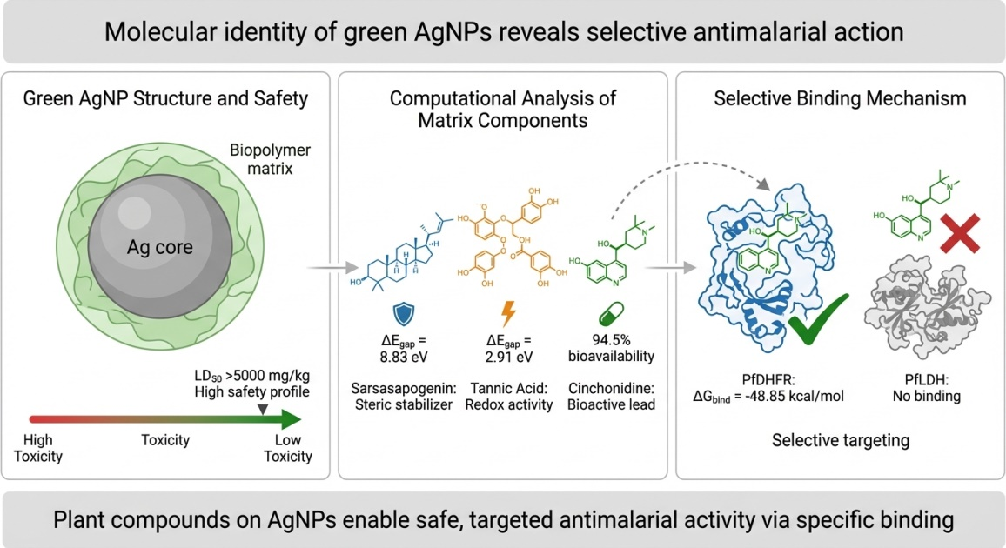
​

1. Introduction
Malaria remains a pervasive global health challenge, with the World Health Organization reporting an estimated 249 million cases in 2022 ¹. The rapid evolution of Plasmodium falciparum resistance to artemisinin-based combination therapies (ACTs), particularly the emergence of Kelch13 R561H mutant parasites in East Africa, has necessitated the development of novel therapeutic delivery systems ^{2—5}. As resistance mechanisms grow more sophisticated, targeting alternative pathways and utilizing nanocarriers to bypass efflux pumps have become critical strategies ^{6—8}. In this continuum, "green" nanomedicine has emerged as a promising frontier.
​In our recently published work, Ikeh et al. (2025), we synthesized Gongronema latifolium-capped silver nanoparticles (AgNPs) and demonstrated their potent antimalarial activity in a murine model ⁹. The choice of G. latifolium (Igbo name, Utazi ¹⁰) was predicated on its rich ethnopharmacological history; crude extracts have shown significant in vivo antiplasmodial activity ¹¹ and potent oxidative stress modulation ¹², traits we successfully harnessed in the nanostructure. A defining finding of our previous study was the identification of a "thick, protective organic biopolymer matrix" encapsulating the silver core. We established that this matrix was not merely a by-product but the critical determinant responsible for an exceptionally favourable acute safety profile (LD₅₀ > 5000 mg/kg) and enhanced endocytic uptake into infected red blood cells ⁹.
​However, while the macroscopic effects of this biopolymer coating (i.e. toxicity mitigation and parasite suppression) were confirmed in vivo, the molecular mechanisms driving these outcomes remain distinctively opaque. Specifically, which phytochemical constituents within the G. latifolium extract are responsible for the stability of the matrix, and how do they interact with specific parasite protein targets?
​Thus, the aim of the study was to bridge that knowledge gap by using advanced computational modelling. Advanced computational modelling is a necessary tool in this age of complex drug discovery ¹³. We simulated the nanoparticle surface architecture and its interaction with two critical P. falciparum targets: Lactate Dehydrogenase (PfLDH) and Dihydrofolate Reductase (PfDHFR). This work provides the requisite molecular validation for our previous in vivo findings ⁹, defining the specific mechanisms responsible for both host safety and parasite suppression.
​2. Materials and Methods
​2.1. Synthesis and Previous Characterization
The G. latifolium-mediated AgNPs used in this theoretical study were synthesised, characterised and previously reported ⁹. Briefly, the particles were confirmed to be spherical with a mean hydrodynamic diameter of 43.04 nm, and the presence of organic functional groups verified by FTIR ⁹ served as the basis for the ligand selection in the current study.
​2.2. Phytochemical Profiling (GC-MS)
The plant extract of G. latifolium ⁹ was analysed. The extraction of some secondary metabolites was in accordance with the AOAC method ¹⁴. To identify the specific ligands constituting the capping matrix, the G. latifolium extract was analysed using an Agilent 7890B Gas Chromatograph coupled to a 5977A Mass Spectrometer. Compounds were identified by comparing their mass spectra with the NIST 17 and Wiley 11 libraries.
2.3. Ligand Preparation and Optimization
The chemical structures of the primary G. latifolium constituents were identified amongst which Tannic Acid, Cinchonidine, and Sarsasapogenin were lead candidates. The control drug (Chloroquine) was retrieved from the PubChem database. Ligands were prepared using the LigPrep module of the Schrödinger Suite (2022-4). Geometries were optimized using the OPLS3e force field at pH 7.0 $±2.0$ to simulate physiological conditions, generating tautomeric and ionization states relevant to the biological milieu ¹⁵.
​2.4. Density Functional Theory (DFT) Analysis
To evaluate the electronic properties and reactivity of the capping ligands, DFT calculations were performed. This approach is critical for understanding surface adsorption phenomena on metal lattices ⁹. Optimization was carried out using the B3LYP functional with the 6-31G** basis set. Frontier Molecular Orbital (FMO) energies (Highest Occupied Molecular Orbital, HOMO, and Lowest Unoccupied Molecular Orbital, LUMO), were calculated to determine the energy gap (${∆E}_{gap}$), chemical hardness ($η$), and softness (S), serving as indicators of kinetic stability and redox potential ^{16, 17}. The application of quantum chemical calculations provides a rigorous basis for predicting these electronic behaviours in drug discoveries ¹⁸.
​2.5. ADMET Profiling
Pharmacokinetic properties were predicted using QikProp (Schrödinger). Key descriptors analysed included molecular weight (MW), predicted octanol/water partition coefficient (QPlogPo/w), predicted aqueous solubility (QPlogS), blood-brain barrier permeability (QPlogBB), and HERG K+ channel blockage (logHERG). These parameters were benchmarked against Lipinski’s Rule of Five to assess human oral bioavailability and safety ¹⁹.
​2.6. Molecular Docking and MM-GBSA Calculations
The crystal structures of P. falciparum Dihydrofolate Reductase (PfDHFR, PDB ID: 1J3I) and Lactate Dehydrogenase (PfLDH, PDB ID: 1T24) were retrieved from the Protein Data Bank. The Protein Preparation Wizard was used to remove water molecules, add hydrogen, and minimize energy. Extra-Precision (XP) docking was performed using Glide. To account for solvation effects and entropy, which is a limitation of standard scoring functions, the binding free energy (${∆G}_{Bind}$) was calculated using the Prime Molecular Mechanics-Generalized Born Surface Area (MM-GBSA) module ^{20, 21}. This method is critical for estimating relative binding affinities where standard scoring functions fail to account for entropy and solvation ²².
$${∆G}_{Bind}=E_{Complex}-\left(E_{Protein}+E_{Ligand}\right)$$
3. Results and Discussion
3.1. Phytochemical Constituents of the Capping Matrix
The GC-MS analysis (Table 1) successfully resolved the complex composition of the G. latifolium extract. The analysis identified Cinchonidine (t_{R} = 13.93 min) as the most abundant alkaloid (52.47 mg/100g). This finding is significant as it confirms that the extract contains established antimalarial pharmacophores. Additionally, high concentrations of Tannic Acid (116.60 mg/100g) and Sapogenins (50.79 mg/100g) were identified, providing the chemical basis for the reduction of silver ions and the stabilization of the resulting nanoparticles, respectively.

Table 1: Comprehensive GC-MS Phytochemical Profile of Gongronema latifolium Leaf Extract
S/No | Phytochemical Name | Chemical Class | Retention Time (min) | Conc. (mg/100g) | Potential Biological Role
1 | Choline | Alkaloid | 4.74 | 1.07 | Neuroprotection
2 | p-Coumarin | Hydroxycinnamic Acid | 5.72 | 1.29 | Antioxidant
3 | Dillapiole | Alkaloid | 6.01 | 0.32 | Synergist
4 | Angustifoline | Alkaloid | 6.61 | 18.86 | Antimicrobial
5 | Spartein | Alkaloid | 7.02 | 6.49 | Cardiotonic
6 | Alpha-pinene | Terpene | 7.28 | 10.15 | Anti-inflammatory
7 | Ellipcine | Alkaloid | 7.87 | 4.99 | Antitumor
8 | Beta-pinene | Terpene | 8.63 | 32.79 | Antimicrobial
9 | p-Coumaric acid | Hydroxycinnamic Acid | 8.66 | 7.73 | Antioxidant
10 | Lupanine | Alkaloid | 8.74 | 35.65 | CNS Activity
11 | 13-Alphahydrorhombifoline | Alkaloid | 9.04 | 5.18 | Bioactive
12 | 2-allyl-5ethoxy-4-methoxyphenol | Lignan | 9.47 | 1.91 | Antioxidant
13 | Myrcene | Terpene | 9.85 | 1.65 | Sedative/Analgesic
14 | Allo-ocimene | Terpene | 10.09 | 2.38 | Bioactive
15 | Limonene | Terpene | 10.49 | 1.69 | Chemopreventive
16 | 9-Octadecenamine | Alkaloid | 10.51 | 3.54 | Surfactant Activity
17 | 4-Hydroxybenzaldehyde | Phenolic | 10.65 | 5.81 | Antioxidant
18 | Camphene | Terpene | 10.95 | 1.71 | Antioxidant
19 | Sabinene | Terpene | 11.33 | 1.42 | Anti-inflammatory
20 | Dihydro-oxo-demethoxyhaemanthamine | Alkaloid | 11.84 | 2.64 | Bioactive
21 | Alpha-thujene | Terpene | 11.85 | 1.50 | Antioxidant
22 | Caffeic acid | Hydroxycinnamic Acid | 11.94 | 23.01 | Anti-inflammatory
23 | Camphor | Terpene | 12.48 | 1.42 | Counter-irritant
24 | Augustamine | Alkaloid | 12.60 | 21.83 | Bioactive
25 | Oxoassoanine | Alkaloid | 12.72 | 43.51 | Cytotoxic
26 | Shogaol | Alkaloid | 12.92 | 0.70 | Anti-inflammatory
27 | Neral | Terpene | 13.02 | 1.42 | Antimicrobial
28 | Piperine | Alkaloid | 13.08 | 0.90 | Bioavailability Enhancer
29 | 1,8-Cineole | Terpene | 13.23 | 10.71 | Anti-inflammatory
30 | Scopoletin | Hydroxycinnamic Acid | 13.41 | 2.28 | Spasmolytic
31 | Gingerdione | Alkaloid | 13.50 | 0.10 | Anti-inflammatory
32 | Borneol | Terpene | 13.69 | 1.41 | Analgesic
33 | Capsaicin | Alkaloid/Phenolic | 13.72 | 2.79 | Analgesic
34 | Linalool | Terpene | 13.79 | 15.96 | Sedative
35 | 4-Hydroxybenzoic acid | Phenolic | 13.87 | 16.26 | Preservative/Antimicrobial
36 | Cinchonidine | Alkaloid | 13.93 | 52.47 | Antimalarial (Primary)
37 | Cinchonine | Alkaloid | 14.05 | 0.72 | Antimalarial
38 | Nerol (Geraniol) | Terpene | 14.14 | 33.05 | Antimicrobial
39 | Buphanidrine | Alkaloid | 14.35 | 33.33 | Cytotoxic
40 | Indicine-N-oxide | Alkaloid | 15.23 | 25.36 | Antitumor
41 | 4-Hydroxybenzoic acid methyl ester | Phenolic | 15.36 | 12.89 | Antimicrobial
42 | Dehydroabietic acid | Lignan | 15.39 | 1.93 | Anti-ulcer
43 | Chlorogenic acid | Hydroxycinnamic Acid | 15.82 | 48.87 | Antioxidant/Reducer
44 | Powelline | Alkaloid | 16.27 | 9.53 | Bioactive
45 | Undulatine | Alkaloid | 16.52 | 14.25 | CNS Activity
46 | Catechin | Flavonoid | 16.72 | 8.05 | Antioxidant
47 | Vanillic acid | Phenolic | 17.00 | 64.17 | Antimicrobial
48 | Cholestanol | Sterol | 17.05 | 1.87 | Lipid Regulator
49 | Chicoric acid | Hydroxycinnamic Acid | 17.21 | 4.49 | Immunostimulant
50 | Taraxeron | Terpene | 17.35 | 1.41 | Anti-inflammatory
51 | Ambelline | Alkaloid | 17.37 | 8.70 | Bioactive
52 | Alpha-amyrin | Terpene | 17.94 | 1.41 | Anti-inflammatory
53 | Resveratrol | Flavonoid | 18.01 | 3.82 | Anti-aging/Antioxidant
54 | Gallic acid | Phenolic | 18.08 | 10.38 | Reducer
55 | 6-Hydroxybuphanidrine | Alkaloid | 18.15 | 13.65 | Bioactive
56 | Ergosterol | Sterol | 18.16 | 1.97 | Fungal Sterol
57 | Galgravin | Lignan | 18.21 | 4.33 | Neuroprotective
58 | Beta-amyrin | Terpene | 18.44 | 1.41 | Stabilizer
59 | Genistein | Flavonoid | 18.48 | 3.75 | Phytoestrogen
60 | Daidzein | Flavonoid | 18.77 | 3.71 | Phytoestrogen
61 | Acronycine | Alkaloid | 18.78 | 0.88 | Antitumor
62 | Lupeol | Terpene | 18.81 | 1.41 | Anti-inflammatory
63 | Campesterol | Sterol | 18.94 | 3.46 | Lipid Regulator
64 | Stigmasterol | Sterol | 19.43 | 4.89 | Anti-osteoarthritic
65 | Apigenin | Flavonoid | 19.65 | 3.17 | Anxiolytic
66 | Butein | Flavonoid | 19.79 | 8.96 | Antioxidant
67 | Ferulic acid | Phenolic | 19.89 | 82.26 | Antioxidant
68 | Nitidine | Alkaloid | 20.04 | 0.41 | Antimalarial/Antitumor
69 | Naringenin | Flavonoid | 20.07 | 2.95 | Anti-inflammatory
70 | Epieudesmin | Lignan | 20.11 | 2.04 | Anti-inflammatory
71 | Hispogenin | Saponin | 20.48 | 7.11 | Surfactant
72 | Biochanin | Flavonoid | 20.75 | 10.83 | Chemopreventive
73 | Solagenin | Saponin | 21.05 | 9.91 | Surfactant
74 | Sakuranin | Lignan | 21.51 | 2.00 | Bioactive
75 | Sitosterol | Sterol | 21.56 | 3.26 | Lipid Regulator
76 | Crinamidine | Alkaloid | 21.65 | 16.90 | Bioactive
77 | Diosgenin | Saponin | 22.22 | 4.19 | Precursor
78 | Rosmarinic acid | Phenolic | 22.44 | 24.29 | Antioxidant/Antiviral
79 | Kaempferol | Flavonoid | 22.50 | 24.80 | Antioxidant
80 | Tigogenin | Saponin | 22.91 | 6.90 | Surfactant
81 | Epicatechin | Flavonoid | 23.45 | 3.60 | Antioxidant
82 | Neochlorogenin | Saponin | 23.59 | 15.11 | Surfactant
83 | Tannic acid | Phenolic | 24.44 | 116.60 | Reducer/Capping Agent
84 | Akuammidine | Alkaloid | 24.52 | 12.30 | Analgesic
85 | Hecogenin | Saponin | 24.59 | 8.54 | Anti-inflammatory
86 | Echitammidine | Alkaloid | 24.63 | 9.96 | Bioactive
87 | Voacangine | Alkaloid | 24.75 | 12.17 | CNS Activity
88 | Epigallocatechin | Flavonoid | 24.80 | 5.88 | Antioxidant
89 | Quercetin | Flavonoid | 25.34 | 31.03 | Antioxidant/Antiviral
90 | Sapogenin | Saponin | 25.72 | 50.79 | Matrix Anchor
91 | Camptothecin | Alkaloid | 25.87 | 2.48 | Antitumor
92 | Echitamine | Alkaloid | 26.32 | 1.18 | Hypotensive
93 | Tribuloin | Saponin | 26.35 | 4.89 | Bioactive
94 | Yanogenin | Saponin | 27.09 | 7.89 | Surfactant
95 | Isorhamnetin | Flavonoid | 27.22 | 3.51 | Antioxidant
96 | Emetine | Alkaloid | 27.25 | 0.22 | Antiprotozoal
97 | Conyzorgin | Saponin | 27.91 | 6.77 | Bioactive
98 | Myricetin | Flavonoid | 28.46 | 5.12 | Antioxidant
The biological roles listed are based on established pharmacological activities reported in peer-reviewed literature. Key references include: Alkaloids ^{23, 24, 36}, Phenolics ^{25—27,} and Saponins ^{28, 29}.
​3.2. Electronic Profiling of the G. latifolium Capping Layer: Stability and Reactivity
Density Functional Theory (DFT) was employed to analyse the primary phytochemical constituents of Gongronema latifolium so as to understand the physicochemical nature of its capping layer. The Frontier Molecular Orbital (FMO) energy levels, which govern chemical reactivity and stability, are visualized in Figure 1.
​Figure 1 reveals a distinct electronic hierarchy among the constituents. Tannic Acid exhibits the narrowest HOMO-LUMO energy gap (${∆E}_{gap}$= 2.91 eV), identifying it as the most polarizable and most reactive moiety. This small gap facilitates electron transfer, corroborating our previous hypothesis that the capping layer actively induces oxidative stress in parasites ⁹. Tannic Acid likely acts as the primary reducing agent during AgNP synthesis, a mechanism consistent with the role of plant polyphenols in reducing metal ions ^{30—33}, while subsequently serving as a potent radical scavenger in vivo ^{34, 35}.
​Conversely, Sarsasapogenin displays the widest energy gap (${∆E}_{gap}$ = 8.83 eV) and the deepest HOMO stabilization (-6.92 eV). As shown in the orbital diagram (Figure 1), this large gap characterizes it as a "hard," chemically inert molecule. This finding provides the structural explanation for the "weak metallic signal in XRD" reported in our previous work ⁹; Sarsasapogenin likely forms the dense, steric stabilization layer that masks the silver core, preventing aggregation and environmental degradation. Cinchonidine occupies an intermediate electronic niche (${∆E}_{gap}$) = 4.43 eV) but notably possesses the lowest LUMO energy (-2.13 eV), indicating a strong capacity to accept electrons, a feature relevant to its interaction with electrophilic protein domains.

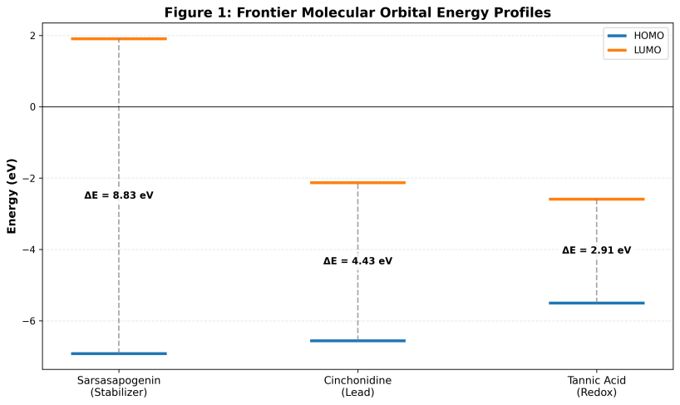
Figure 1. Frontier Molecular Orbital (FMO) energy profiles of the primary G. latifolium phytochemical constituents, the diagram highlights the distinct electronic behaviours: Tannic acid (narrowest gap $∆E=2.91 ev$, highest reactivity) vs. Sarsasapogenin (widest gap $∆E=8.83 ev$, highest stability). Energy values were calculated at the DFT level
​3.3. Pharmacokinetic Translation: Bridging Murine Safety to Human Bioavailability
Translating nanomedicine from murine models to human therapy requires rigorous ADMET profiling. Our in silico screening elucidates the molecular basis for the exceptional safety (LD₅₀ > 5000 mg/kg) observed in our murine studies ⁹. The detailed pharmacokinetic parameters are presented in Table 2.
​Cinchonidine emerged as the superior drug-like candidate, characterized by high human oral absorption (94.5%) and excellent blood-brain barrier (BBB) permeability (QPlogBB = 0.157). This predicts efficacy against cerebral malaria. In contrast, Sarsasapogenin showed predicted poor aqueous solubility (QPlogS = -7.54) and a potential risk for hERG channel inhibition (QPlogHERG = -3.98). However, this limitation essentially validates the necessity of the nanocarrier system described in Ikeh et al. (2025); the formulation of these ligands onto a hydrophilic Silver Nanoparticle (AgNP) core mitigates these solubility limitations via the cloaking effect, as it were, enabling the safe transport of hydrophobic ligands like Sarsasapogenin that would otherwise be bio-incompatible.

Table 2. Predicted ADMET properties of G. latifolium ligands compared to the standard drug Chloroquine.
Property |  | Chloroquine | Cinchonidine | Sarsasapogenin | Ideal Range
Molecular Weight (Da) |  | 319.88 | 294.40 | 416.64 | < 500 (Lipinski Rule)
Oral Absorption (%) |  | 100 (High) | 94.5 (High) | 100 (High) | > 80
Solubility (QPlogS) |  | -4.73 | -2.94 | -7.54 | -6.5 to 0.5
Lipophilicity (QPlogPo/w) |  | 4.64 | 2.99 | 6.15 | < 5.0
Gut-Blood Barrier (QPPCaco) |  | 1485 nm/s | 630 nm/s | 3404 nm/s | > 500 (Great)
Blood-Brain Barrier (QPlogBB) |  | 0.411 | 0.157 | 0.051 | -3.0 to 1.2
HERG Inhibition (QPlogHERG) |  | -6.46 | -5.76 | -3.98 | < -5.0 (Safe)
Rule of Five Violations |  | 0 | 0 | 1 | Max 1 allowed

​3.4. Mechanistic Elucidation: Target Specificity and Binding Thermodynamics
To define the mechanism of parasite suppression beyond the "endocytic uptake" established previously ⁹, we interrogated the interaction of the capping ligands against two critical metabolic checkpoints in Plasmodium falciparum: Dihydrofolate Reductase (PfDHFR) and Lactate Dehydrogenase (PfLDH). The comparative binding thermodynamics are illustrated in Figure 2.
​3.4.1. Selective Inhibition of the Folate Pathway (PfDHFR)
The MM-GBSA binding free energies plotted in Figure 2 (Green Bars) identify PfDHFR as the primary enzymatic target. Chloroquine demonstrates the strongest affinity (${∆G}_{bind}$ = -64.52 kcal/mol), serving as a potent benchmark. Significantly, Cinchonidine also exhibits a robust negative binding energy (${∆G}_{bind}$ = -48.85 kcal/mol). While less potent than the synthetic control, this substantial interaction energy confirms that Cinchonidine can effectively occupy the PfDHFR active site, disrupting the folate pathway and blocking DNA synthesis. This suggests that the "multifaceted mechanism" of the AgNPs ⁹ involves specific enzymatic blockade by Cinchonidine, in addition to the general oxidative stress induced by the silver core.
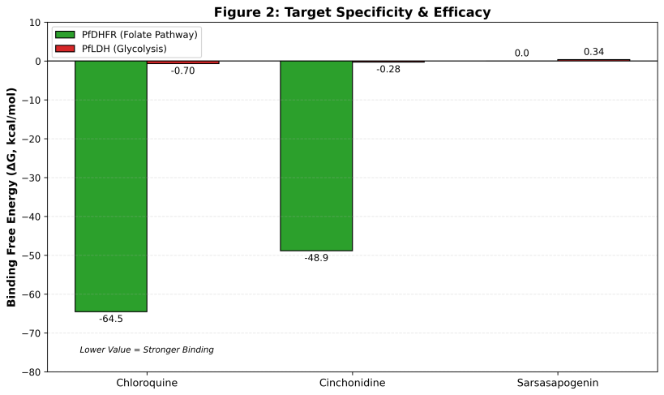
Figure 2. Comparative MM-GBSA ${∆G}_{bind}$ of G. latifolium ligands and Chloroquine against P. falciparum targets. Green bars represent affinity for PfDHFR (PDB: 1J31), showing strong binding for Chloroquine and Cinchonidine. Red bars represent PfLDH (PDB: 1T24), showing negligible or repulsive interactions, confirming target specificity for the Folate pathway.
Figure 3. Molecular docking analysis of Cinchonidine targeting P. falciparum Dihydrofolate Reductase (PfDHFR; PDB: 1J31). (A) 3D surface view of the best-scored binding pose ($∆G=-48.85 kcal/mol$), showing Cinchonidine (sticks) deeply embedded within the active site pocket of the receptor (ribbons). (B) 2D ligand-interaction diagram detailing the specific binding network. Dark dashed lines indicate hydrogen bonds with key amino acid residues (e.g. Asp 54, Ile14), while arc markers represent hydrophobic contacts stabilising the complex
​3.4.2. Target Specificity: The Case of PfLDH
The specificity of this interaction is highlighted by the contrast with the Lactate Dehydrogenase (PfLDH) results, shown in the red Bars of Figure 2. Unlike the strong binding observed for PfDHFR, all ligands displayed negligible or repulsive interactions with PfLDH. Chloroquine and Cinchonidine showed near-zero binding energies ($≈$-0.7 to -0.3 kcal/mol), while Sarsasapogenin exhibited a positive, thermodynamically unfavourable value (+0.34 kcal/mol).
​This visual contrast in Figure 2 confirms that the G. latifolium-AgNPs are not promiscuous binders. Instead, they exhibit precise molecular selectivity for the folate pathway (PfDHFR) while sparing the glycolytic LDH pathway. This selectivity is a critical safety feature, reducing the likelihood of off-target toxicity in the host, and aligns with the high safety margins observed in our murine efficacy studies ⁹.
To provide a holistic view of the in silico findings, the comparative electronic, pharmacokinetic, and thermodynamic profiles of the G. latifolium constituents and the control are summarized in Table 3.
​Table 3. Master summary of physicochemical properties and binding efficacies for G. latifolium ligands and the standard drug
Category | Parameter | Chloroquine (Control) | Cinchonidine (Lead) | Sarsasapogenin | Tannic Acid
Electronic | Reactivity (${∆E}_{gap}$) | N/A | Moderate (4.43 eV) | Inert/Stable (8.83 eV) | High (2.91 eV)
(DFT) | Predicted Role | N/A | Bioactive Ligand (Electron Acceptor) | Steric Stabilizer (Masks Ag Core) | Reducing Agent & Antioxidant
Drug-Likeness (ADMET) | Bioavailability | Excellent | Excellent (94% Oral Abs.) | Poor Solubility | No Data
(Safety) | Toxicity Signal | Safe (Passes BBB) | Safe (Passes BBB) | Cardiac Toxicity Risk | No Data
Efficacy | PfDHFR Binding | Superior (-64.52 kcal/mol) | Strong (-48.85 kcal/mol) | Not Analysed | Not Analysed
(Targeting) | PfLDH Binding | No Effect (-0.70 kcal/mol) | No Effect (-0.28 kcal/mol) | Repulsive (+0.34 kcal/mol) | Not Analysed

​4. Conclusion
The integration of electronic profiling (Figure 1) and thermodynamic screening (Figure 2) provides a structural rationale for the empirical findings reported in Ikeh et al. (2025). The "biopolymer matrix" is not a monolith but a synergistic system: Tannic Acid provides the redox reactivity necessary for synthesis and antioxidant protection; Sarsasapogenin offers the structural stability that masks the silver core (XRD silencing); and Cinchonidine acts as the bioactive warhead, driving selective inhibition of the PfDHFR enzymatic pathway. These findings, supported by quantum chemical calculations and binding free energy estimations, successfully bridge the knowledge gap between the favourable murine safety profile and the molecular mechanisms required for human therapeutic translation.
Conflicts of interest
There are no conflicts to declare.
Data availability statement
The data that support the findings of this study are available as follows:
- ​Author-Generated Datasets: The raw Gas Chromatography-Mass Spectrometry (GC-MS) data files generated in this work, which support the phytochemical profiling of Gongronema latifolium, are available in the Supplementary Information attached to this article.
- ​Previous Experimental Data: The experimental datasets regarding the green synthesis, characterization (TEM, XRD), acute toxicity, and in vivo antimalarial efficacy of the silver nanoparticles analysed herein were derived from our previously published work:
  - ​Ikeh GO, et al. (2025). Green Synthesis of Silver Nanoparticles for Antimalarial Activity. Jabirian J Biointerface Res Pharm Appl Chem [9].
- ​Third-Party Datasets: The crystal structures used for molecular docking and dynamics simulations are publicly available in the Protein Data Bank (PDB) under accession codes 1T24 (PfLDH) and 1J3I (PfDHFR), and in the Cambridge Structural Database (CSD) under Refcode AYILIE (beta-hematin).

COMPETING INTERESTS DISCLAIMER:
Authors have declared that they have no known competing financial interests OR non-financial interests OR personal relationships that could have appeared to influence the work reported in this paper.

References
- ​World Health Organization. World malaria report 2023. Geneva: World Health Organization; 2023. Available from: https://www.who.int/teams/global-malaria-programme/reports/world-malaria-report-2023
- ​Uwimana A, Legrand E, Stokes BH, Ndikumana JLM, Warsame M, Umulisa N, et al. Emergence and clonal expansion of in vitro artemisinin-resistant Plasmodium falciparum kelch13 R561H mutant parasites in Rwanda. Nat Med. 2020;26(10):1602-1608. doi: 10.1038/s41591-020-1005-2
- ​Klein E. Y. (2013). Antimalarial drug resistance: a review of the biology and strategies to delay emergence and spread. International journal of antimicrobial agents, 41(4), 311–317. https://doi.org/10.1016/j.ijantimicag.2012.12.007
- Zheng D, Liu T, Yu S, Liu Z, Wang J, Wang Y. Antimalarial mechanisms and resistance status of artemisinin and its derivatives. Trop Med Infect Dis. 2024;9(9):223. doi: 10.3390/tropicalmed9090223.
- Shibeshi MA, Kifle ZD, Atnafie SA. Antimalarial drug resistance and novel targets for antimalarial drug discovery. Infect Drug Resist. 2020;13:4047-4060. doi: 10.2147/IDR.S279433.
- Maciel, T. R., Funguetto-Ribeiro, A. C., Olivo, L. B., Teixeira, F. E. G., Pacheco, C. O., Araujo, B. V., & Haas, S. E. (2024). Improved Malaria Therapy with Cationic Nanocapsules Demonstrated in Plasmodium berghei-Infected Rodents Using Whole Blood Surrogate Population PK/PD Modeling. Pharmaceutics, 16(11), 1369. https://doi.org/10.3390/pharmaceutics16111369
- Shaik Harun Rasheed, Kondapuram Parameshwar, K. Mallikarjuna Reddy,G. Sushmitha, Sesha Madhavi M.. Nanotechnology-Driven Innovations in Malaria Treatment and Control: Current Challenges and Pharmaceutical Strategies. Asian Journal of Pharmaceutical Research. 2024; 14(3):235-1. doi: 10.52711/2231-5691.2024.00037
- Theodoridis L, Carvalho TG. Antimalarial drug resistance and drug discovery: learning from the past to innovate the future. Int J Parasitol Drugs Drug Resist. 2025;28:100602. doi: 10.1016/j.ijpddr.2025.100602.
- Ikeh GO, Nubila NI, Nwoke CO, Nwoke CN, Okpoto RC, Igwe CC, et al. Green Synthesis of Silver Nanoparticles for Antimalarial Activity: Characterisation, Acute Toxicity, and Efficacy Studies in a Murine Model. Jabirian J Biointerface Res Pharm Appl Chem. 2025;2(1):15-25. doi: 10.55559/jjbrpac.v2i1.591
- Gabriel, E. I., Uneojo, O. V., & Chukwudi, E. (2014). Evaluation of methanol extract of Gongronema latifolium leaves singly and in combination with glibenclamide for anti-hyperglycemic effects in alloxan-induced hyperglycemic rats. Journal of intercultural ethnopharmacology, 3(3), 119–122. https://doi.org/10.5455/jice.20140610054950
- ​ Akuodor GC, Idris-Usman M, Umeji TC, Akpan JL. In vivo schizonticidal activity of ethanolic leaf extract of Gongronema latifolium on Plasmodium berghei berghei in mice. Ibnosina J Med Biomed Sci. 2010 May;2(3):118-24. doi: 10.4103/1947-489X.210981.
- Balogun ME, Besong EE, Obimma JN, Mbamalu OS, Djobissie SFA. Gongronema latifolium: a phytochemical, nutritional and pharmacological review. J Phys Pharm Adv. 2016;6(1):811-24. doi: 10.5455/jppa.1969123104000.
- Macaluso A, Clissa L, Lodi S, Sartori C. A variational algorithm for quantum neural networks. In: International Conference on Computational Science. Springer; 2020. p. 591-604. doi: 10.1007/978-3-030-50433-5_45.
- Association of Official Analytical Chemist. Official Method of Analysis. Washington DC, USA, 2009.
- ​Schrödinger Release 2022-4: LigPrep. New York, NY: Schrödinger, LLC; 2022. Available from: https://www.schrodinger.com/platform/products/ligprep/
- Tung JC, Chen GY, Shen CC, Liu PL. Ab initio studies of work function changes induced by single and co-adsorption of NO, CO, CO2, NO2, H2S, and O3 on ZnGa2O4(111) surface for gas sensor applications. Sensors (Basel). 2026;26(2):415. doi: 10.3390/s26020415.
- ​Becke AD. Density-functional thermochemistry. III. The role of exact exchange. J Chem Phys. 1993;98(7):5648–52. doi: 10.1063/1.464913
- Cao Y, Romero J, Olson JP, Degroote M, Johnson PD, Kieferová M, et al. Quantum chemistry in the age of quantum computing. Chem Rev. 2019;119(19):10856-10915. doi: 10.1021/acs.chemrev.8b00803
- ​Lipinski CA, Lombardo F, Dominy BW, Feeney PJ. Experimental and computational approaches to estimate solubility and permeability in drug discovery and development settings. Adv Drug Deliv Rev. 2001;46(1–3):3–26. doi: 10.1016/S0169-409X(00)00129-0
- Genheden S, Ryde U. The MM/PBSA and MM/GBSA methods to estimate ligand-binding affinities. Expert Opin Drug Discov. 2015;10(5):449–61. doi: 10.1517/17460441.2015.1032936
- ​Hollingsworth SA, Dror RO. Molecular dynamics simulation for all. Neuron. 2018;99(5):863-881. doi: 10.1016/j.neuron.2018.08.011
- ​Cournia Z, Allen B, Sherman W. Relative binding free energy calculations in drug discovery: recent advances and practical considerations. J Chem Inf Model. 2017;57(12):2911-2937. doi: 10.1021/acs.jcim.7b00564
- Morocho-Alvarado MG, Galarza-Molina RT, Romero-Benavides JC. Natural alkaloids as potential therapeutic agents: A review of recent updates in pharmacological activities. Molecules. 2024;29(5):1102. doi:10.3390/molecules29051102
- Zaynab M, Fatima M, Abbas S, Sharif Y, Umair M, Zafar MH, et al. Role of secondary metabolites in plant defense against environmental stress. Physiol Mol Plant Pathol. 2024;132:102214. doi:10.1016/j.pmpp.2024.102214
- Sahu S, Singh S, Gupta R. Tannic acid and associated plant phenolics: Mechanistic insights into antioxidant and metal-reducing properties for nanoparticle synthesis. ACS Omega. 2023;8(14):12540-12558. doi:10.1021/acsomega.3c00421
- Olusola AO. Phenolic acids and flavonoids: A review of their potential as antioxidant and antiviral agents in 2026 clinical perspectives. J Tradit Complement Med. 2026;16(1):12-25.
- Al-Khayri JM, Sahana GR, Nagella P, Joseph BV, Al-Mssallem MQ, Al-Khayri AA. Flavonoids as Antiviral Agents: Lessons Learned from COVID-19 and Future Perspectives. Molecules. 2023;28(18):6631. doi:10.3390/molecules28186631
- Wang Y, Zhang L, Li M, Zhang J. Saponins as natural surfactants and bioactive leads: Recent advances in pharmacological activities and membrane interactions. Phytochem Rev. 2025;24(1):45-68. doi:10.1007/s11101-024-09950-w
- Chen L, Yang X, Jiao H, Zhao B. Plant-derived saponins: A review of their surfactant properties and application in drug delivery systems. Int J Pharm. 2024;652:123842. doi:10.1016/j.ijpharm.2024.123842
- Abdellatif AAH, Mostafa MAH, Konno H, Younis MA. Exploring the green synthesis of silver nanoparticles using natural extracts and their potential for cancer treatment. 3 Biotech. 2024;14(11):274. doi: 10.1007/s13205-024-04118-z.
- ​Bezuneh TT, Ofgea NM, Tessema SS, Bushira FA. Tannic acid-functionalized silver nanoparticles as colorimetric probe for the simultaneous and sensitive detection of aluminum(III) and fluoride ions. ACS Omega. 2023;8(40):37293-301. doi: 10.1021/acsomega.3c05092.
- ​Srichaiyapol O, Thammawithan S, Siritongsuk P, Nasompag S, Daduang S, Klaynongsruang S, et al. Tannic acid-stabilized silver nanoparticles used in biomedical application as an effective antimelioidosis and prolonged efflux pump inhibitor against melioidosis causative pathogen. Molecules. 2021;26(4):1004. doi: 10.3390/molecules26041004.
- ​Gangwar C, Yaseen B, Kumar I, Singh NK, Naik RM. Growth kinetic study of tannic acid mediated monodispersed silver nanoparticles synthesized by chemical reduction method and its characterization. ACS Omega. 2021;6(34):22344-56. doi: 10.1021/acsomega.1c03100.
- ​ Vanlalveni C, Lallianrawna S, Biswas A, Selvaraj M, Changmai B, Rokhum SL. Green synthesis of silver nanoparticles using plant extracts and their antimicrobial activities: a review of recent literature. RSC Adv. 2021;11(5):2804-37. doi: 10.1039/D0RA09941A
- ​Marslin G, Siram K, Maqbool Q, Selvakesavan RK, Kruszka D, Kachlicki P, Franklin G. Secondary metabolites in the green synthesis of metallic nanoparticles. Materials. 2018;11(6):940. doi: 10.3390/ma11060940
- Umerie SC, Okorie N, Dike UD, Ani NI. Phytochemical analysis and antioxidant activity of avocado pear peel (Persea americana) extract. J Pharm Res Int. 2022;34(28A):1–9. doi: 10.9734/jpri/2022/v34i28A36018.

