CASE REPORT

TOOTH GERM OSTEOMYELITIS IN A CHILD THAT INVOLVES MANDIBULAR LEFT PREMOLAR REGION- A RARE CASE REPORT

ABSTRACT
Tooth germ osteomyelitis is a rare inflammatory condition involving the developing tooth follicle and surrounding alveolar bone in paediatric patients. The condition is uncommon and often presents with nonspecific symptoms, which may delay diagnosis and treatment. If not found early, the infection can compromise the developing permanent dentition and may lead to disturbances in mandibular growth.
Case Presentation: A 7-year-old child presented with swelling and discomfort in the left mandibular posterior region. Clinical examination revealed localised intraoral swelling and tenderness in the mandibular left premolar region with mild facial asymmetry. Radiographic evaluation proved an ill-defined radiolucent lesion associated with the developing premolar tooth germ, suggestive of inflammatory bone destruction. Based on the clinical and radiographic findings, a provisional diagnosis of tooth germ osteomyelitis was made.
Management and Intervention: The patient underwent surgical exploration and debridement of the infected bone, along with removal of necrotic tissue under proper antibiotic coverage. Care was taken to preserve surrounding anatomical structures and minimise damage to the developing dentition. Postoperative management included systemic antibiotics, analgesics, and regular clinical and radiographic follow-up.
Outcome: The postoperative course was uneventful, with gradual resolution of swelling and pain. Follow-up radiographs proved progressive bone healing without evidence of recurrence or further infection. Mandibular growth and development of adjacent teeth were preserved.
Conclusion: Tooth germ osteomyelitis is a rare but potentially serious paediatric condition. Early diagnosis, proper radiographic evaluation, and prompt surgical intervention are essential to prevent damage to the developing tooth germs and keep normal mandibular growth. Awareness of this rare entity is important for clinicians managing paediatric odontogenic infections.

Keywords: Tooth germ osteomyelitis; Paediatric mandibular osteomyelitis; Developing tooth germ infection; Paediatric jaw infection; Mandibular premolar region; Odontogenic infection; Paediatric oral pathology; Surgical debridement; Case report; Paediatric maxillofacial infection.
INTRODUCTION
Osteomyelitis of the jaws is an inflammatory condition of bone characterised by infection and progressive destruction of the cortical and cancellous bone structures. Although osteomyelitis can affect individuals of all age groups, its occurrence in children is uncommon due to the rich vascular supply of the maxilla and mandible, which helps rapid immune response and healing of infected tissues [1]. The vascularity of paediatric jaw bones and the presence of active bone remodelling often limit the spread of infection; however, when infection occurs, it may progress rapidly and affect adjacent developing structures [2].
Osteomyelitis of the jaws may be classified as acute, subacute, or chronic depending on the duration and severity of the infection. The condition commonly arises from odontogenic infections, trauma, postoperative complications, or hematogenous spread of microorganisms [3]. In paediatric patients, odontogenic sources remain the most common etiological factor, particularly infections originating from untreated dental caries, pulpal necrosis, or periodontal infections associated with deciduous teeth [4]. These infections may spread to the surrounding bone through the periodontal ligament space or medullary spaces, resulting in inflammatory bone destruction and sequestration.
Tooth germ osteomyelitis stands for a rare and distinctive form of jaw osteomyelitis that involves the developing tooth follicle and surrounding alveolar bone. The infection typically affects children during the mixed dentition period when permanent tooth germs are actively developing within the alveolar process [5]. In most cases, the infection originates from an infected deciduous tooth or from odontogenic sources in proximity to the developing permanent tooth germ. Trauma, poor oral hygiene, and delayed treatment of dental infections may further contribute to the development of this condition [6].
The clinical presentation of tooth germ osteomyelitis can vary and is often nonspecific, which makes early diagnosis challenging. Patients commonly present with symptoms such as localised pain, swelling, tenderness, and sometimes purulent discharge from the affected region. In some cases, systemic manifestations including fever, malaise, and regional lymphadenopathy may also be present [7]. Extra-oral swelling and facial asymmetry may occur when the infection extends into adjacent soft tissues. Intraoral examination may reveal gingival swelling, mucosal erythema, or fluctuant swelling in the affected region [8].
Radiographic examination plays a crucial role in the diagnosis of osteomyelitis of the jaws. Early radiographic changes may include ill-defined radiolucent areas around the developing tooth germ, widening of the follicular space, and destruction of surrounding trabecular bone. As the disease progresses, more pronounced radiographic features such as cortical bone destruction, sequestration, and periosteal reaction may become clear [9]. However, these radiographic findings may mimic other odontogenic and non-odontogenic lesions such as odontogenic cysts, tumours, or chronic inflammatory conditions, further complicating the diagnostic process [10].
The developing permanent tooth germ is particularly vulnerable to infection because of its proximity to infected deciduous teeth and the thin cortical bone in children. Infection involving the tooth germ may interfere with normal odontogenesis and result in several long-term complications. These complications may include arrested tooth development, hypoplasia of the permanent tooth, delayed or failed eruption, displacement of the tooth germ, and disturbances in mandibular growth [11]. In severe cases, untreated infection may lead to facial asymmetry, pathologic fractures, or chronic osteomyelitis with persistent bone destruction [12].
Management of tooth germ osteomyelitis requires early diagnosis and prompt treatment to prevent these complications. Treatment strategies typically involve a combination of systemic antimicrobial therapy and surgical intervention. Antibiotic therapy is used to control the bacterial infection, while surgical procedures such as incision and drainage, removal of the infected tooth germ, and debridement of necrotic bone are performed to eliminate the source of infection and promote healing [13]. Adequate removal of infected tissue combined with proper postoperative care and follow-up is essential to prevent recurrence and ensure favourable outcomes [14].
Despite advances in diagnostic imaging and antimicrobial therapy, tooth germ osteomyelitis remains a rarely reported condition in paediatric oral and maxillofacial practice. The rarity of this condition and its resemblance to other odontogenic pathologies often result in delayed diagnosis and treatment. Therefore, increased awareness among clinicians is essential to ensure early recognition and proper management of this condition [15].
The present report describes a rare case of tooth germ osteomyelitis involving the left mandibular premolar region in a 7-year-old child. The case highlights the clinical presentation, radiographic findings, surgical management, and follow-up outcome, emphasising the importance of early diagnosis and prompt intervention in preventing complications affecting mandibular growth and permanent tooth development.
Case Report
A 7-year-old male child presented to the Department of Oral and Maxillofacial Surgery with the chief complaint of pain and swelling over the left lower jaw region for the past 15 days. The swelling was associated with mild fever and difficulty in mastication on the affected side.
The patient’s dental history revealed the extraction of grossly carious left mandibular deciduous canine and first molar approximately two weeks before presentation at a local dental clinic. The postoperative period was reportedly uneventful initially; however, progressive swelling and intermittent purulent discharge developed thereafter. There was no history of facial trauma, systemic illness, or previous hospitalization. The patient’s medical history was otherwise non-contributory.
Clinical Examination
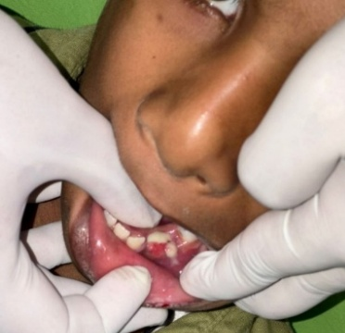
Fig A--Showing an extra oral fistula

Extraoral examination revealed a diffuse swelling over the left body of the mandible extending from the para-symphysis to the mandibular angle region. The swelling measured approximately 3 × 2 cm, was ill-defined, tender on palpation, and associated with mild local warmth.
Palpation revealed mild left submandibular lymphadenopathy, suggestive of an ongoing inflammatory process. An extraoral sinus tract was present in the left mandibular body region with intermittent purulent discharge (Fig. A).
The overlying skin appeared erythematous and slightly indurated.
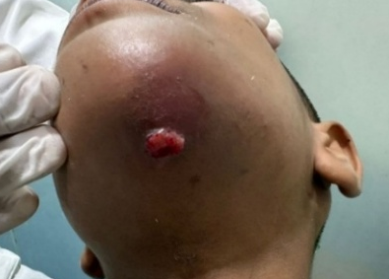
Fig B- push discharge from previously extracted deciduous teeth under digital pressure.
Intraoral examination demonstrated obliteration of the buccal vestibule in the left mandibular premolar region. Digital pressure over the extraction socket region elicited purulent discharge, indicating persistent infection (Fig. B). The surrounding mucosa appeared erythematous, inflamed, and tender on palpation.
No significant mobility of adjacent teeth was observed. The remaining deciduous dentition was within normal limits for the patient’s age.

Radiographic investigation included orthopantomogram (OPG) and cone beam computed tomography (CBCT) to evaluate the extent of the lesion.
The OPG revealed an ill-defined radiolucent area involving the left mandibular canine and first premolar region, surrounding the developing tooth germs of teeth 33 and 34. The lesion exhibited irregular borders with evidence of surrounding bone rarefaction and disruption of normal trabecular architecture, suggestive of inflammatory osteolytic changes (Fig. C).
Fig C-OPG showing radiolucency around developing 33 34
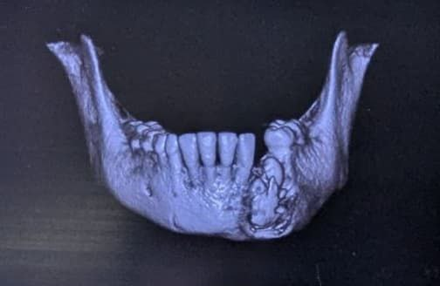
Fig D- Showing CBCT
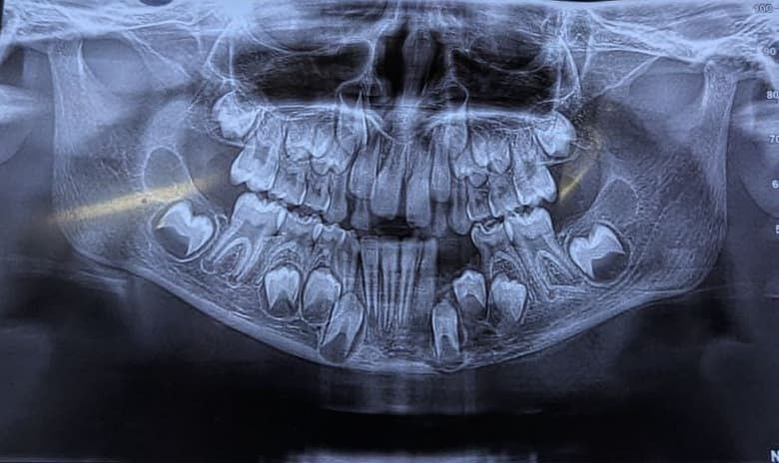

CBCT imaging provided further confirmation of the lesion, demonstrating irregular bone destruction with poorly defined margins and areas of sequestration in the affected mandibular segment. The imaging also revealed radiographic evidence of periapical infection associated with the previously extracted deciduous mandibular canine (73) and first molar (74), indicating possible spread of infection from the deciduous teeth to the underlying permanent tooth germs (Fig. D).
These radiographic findings were highly suggestive of osteomyelitis involvement of the developing tooth germs.
Diagnosis
Based on the clinical presentation, persistent purulent discharge, extraoral sinus formation, and radiographic evidence of osteolytic bone destruction surrounding the developing tooth germs, a provisional diagnosis of tooth germ osteomyelitis involving the developing mandibular canine (33) and first premolar (34) was established.
The condition was considered secondary to infection originating from the previously extracted deciduous teeth (73 and 74).
Following further clinical evaluation and persistence of infection despite conservative therapy, the final diagnosis of secondary chronic suppurative osteomyelitis involving the developing tooth germs of the left mandibular canine and first premolar was confirmed.
Initial Medical Management
The patient initially underwent incision and drainage of the affected region to reduce local infection and relieve pressure. Empirical broad-spectrum antibiotic therapy was initiated, consisting of:
- Amoxicillin–clavulanate
- Metronidazole
This regimen was prescribed to cover both aerobic and anaerobic bacterial flora commonly associated with odontogenic infections.
Additionally, the patient was prescribed:
- Analgesics and anti-inflammatory medications for pain management
- 0.12% chlorhexidine mouthwash twice daily to maintain oral hygiene and reduce microbial load
Despite adequate antibiotic therapy and drainage, the patient continued to exhibit persistent purulent discharge from the sinus tract, along with radiographic evidence of ongoing infection during the three-week follow-up period.
To improve tissue oxygenation and enhance the host immune response, hyperbaric oxygen therapy (HBO) was initiated. The patient underwent four treatment dives over one week. However, no significant clinical improvement or radiographic resolution was observed following HBO therapy.
Due to persistent infection and lack of response to conservative measures, surgical intervention was planned.
Surgical Management
Definitive surgical management was performed under general anaesthesia with nasotracheal intubation to provide optimal surgical access and airway protection.
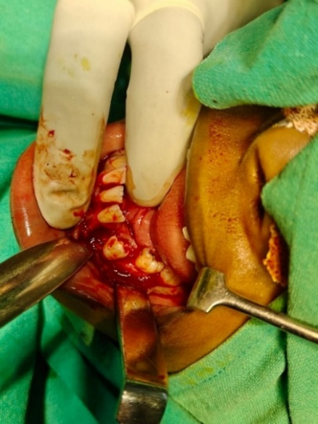
FIG E- Showing surgical exploration of the infected site

A surgical incision was made in the left mandibular premolar region, followed by careful reflection of the mucoperiosteal flap to expose the infected bone.
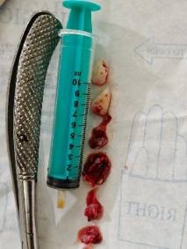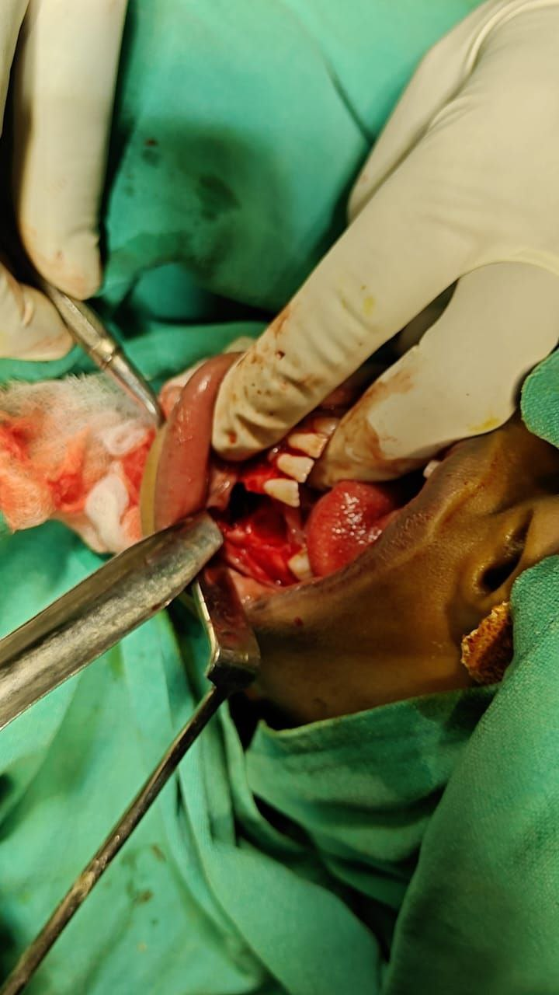
Fig F-extraction of 33 and 34
Intraoperative findings revealed the presence of necrotic bone (sequestrum) and non-viable developing tooth germs corresponding to teeth 33 and 34. These structures were removed completely to eliminate the source of infection (Fig. E, F).
Thorough curettage of the surrounding granulation tissue was performed to remove all infected and necrotic tissue. The extraoral sinus tract was completely excised, followed by extensive debridement of the affected bone to ensure complete removal of the infected focus.
The surgical site was irrigated copiously using povidone–iodine solution and sterile normal saline to achieve adequate decontamination. After confirming complete removal of necrotic tissue and achieving satisfactory haemostasis, primary closure of the surgical wound was performed.
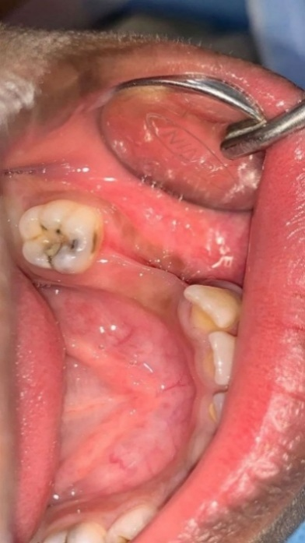
Fig G- Showing the intra-oral picture post-operative after 3 months
The extraoral sinus tract incision was closed using Prolene sutures to ensure proper soft tissue healing.
Histopathological Findings
The excised tissue specimens were submitted for histopathological examination.
Microscopic examination of the soft tissue sections revealed keratinized stratified squamous epithelium overlying a connective tissue stroma. The underlying connective tissue showed dense chronic inflammatory cell infiltrate, predominantly composed of lymphocytes, neutrophils, and occasional plasma cells.
Numerous endothelial-lined blood vessels with extravasated red blood cells were observed, indicating active inflammatory changes and vascular response.
The decalcified haematoxylin and eosin (H&E) stained bone sections demonstrated areas of necrotic bone characterized by empty osteolytic lacunae, confirming sequestrum formation. Peripheral bone exhibited acute inflammatory infiltrate dominated by neutrophils, consistent with chronic suppurative osteomyelitis.
These findings confirmed the clinical and radiographic diagnosis.
Outcome and Follow-Up
Postoperative healing was uneventful. The patient was followed up on periodically over
three months.
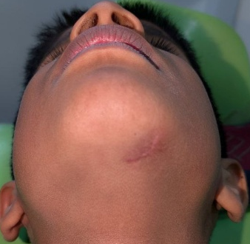
Fig H-Showing Extra-oral picture post-operative after 3 months

Clinical evaluation demonstrated complete resolution of pain, swelling, and purulent discharge. Both intraoral and extraoral surgical sites exhibited satisfactory healing with no evidence of recurrent sinus tract formation or infection (Fig. G, H).
Radiographic evaluation at the three-month follow-up using OPG and CBCT demonstrated progressive new bone formation in the affected mandibular region, indicating favourable healing of the surgical site (Fig. I, J).
No complications or recurrence were observed during the follow-up period. The patient was advised to undergo periodic monitoring to evaluate mandibular growth and development of adjacent permanent teeth, considering the removal of the developing tooth germs.

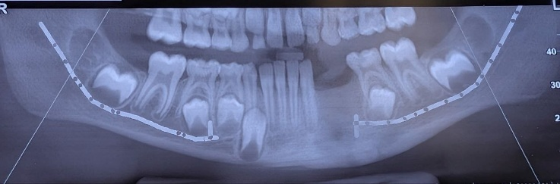

FIG I -shows OPG after 3 months follow up

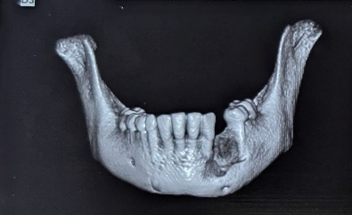

FIG J- Shows CBCT after 3 months which revealed new bone formation.

Discussion
Tooth germ osteomyelitis is a rare but potentially serious condition affecting the paediatric population. The most common etiological factors include untreated dental caries of deciduous teeth, trauma to primary teeth, and, less often, hematogenous spread of infection [3,4]. The mandibular premolar region is particularly vulnerable due to its close anatomical relationship to the roots of deciduous molars, which may act as a source of infection spreading to the developing permanent tooth germ [5]. Osteomyelitis of the mandible in children is uncommon compared with adults because of the rich vascularity and enhanced immune response present in growing bone [1]. Nevertheless, when infection involves the developing tooth germ, the condition becomes clinically significant because of its potential to interfere with normal odontogenesis and mandibular growth.
Tooth germ osteomyelitis is considered an extremely rare entity, with only isolated case reports available in the literature [2,6]. The developing tooth follicle may act as a reservoir for infection, particularly when associated with untreated dental caries or periapical infection of the overlying deciduous teeth [5]. Infection may spread through the cancellous bone of the mandible and involve the developing tooth germ, leading to inflammatory bone destruction and disruption of normal tooth development.
Radiographically, early lesions of tooth germ osteomyelitis may mimic other odontogenic and inflammatory conditions, making diagnosis challenging. Differential diagnoses may include dentigerous cyst, periapical abscess associated with deciduous teeth, odontogenic cysts, and neoplastic conditions such as unicystic ameloblastoma [10]. Conventional radiographs in early stages may demonstrate subtle findings such as ill-defined radiolucency surrounding the developing tooth germ or widening of the follicular space.
Advanced imaging modalities such as cone beam computed tomography (CBCT) have significantly improved the diagnostic accuracy in such cases. CBCT provides three-dimensional visualisation of the lesion and allows precise evaluation of the extent of bone involvement, cortical perforation, and relationship of the infection to the developing tooth germ [7]. This information is essential for correct diagnosis and planning surgical intervention.
Clinically, paediatric osteomyelitis often presents with localised pain, swelling, tenderness, and occasionally purulent discharge from the affected region [4]. Systemic symptoms such as fever or malaise may be mild or absent, which can delay recognition of the condition. Extra-oral swelling and facial asymmetry may occur when infection spreads into adjacent soft tissues.
Management of tooth germ osteomyelitis depends on the stage of infection, the viability of the developing tooth germ, and the extent of bone involvement. Early lesions may occasionally be managed conservatively with antibiotic therapy and drainage. However, when the infection directly involves the tooth germ or when necrotic bone is present, definitive surgical intervention becomes necessary [6]. Surgical treatment typically involves removal of the infected tooth germ along with thorough curettage and debridement of necrotic bone to eliminate the source of infection.
Failure of conservative treatment, such as incision and drainage alone, may result in persistent infection and complications including sinus tract formation or orocutaneous fistula, as seen in the present case [8]. Persistent infection can further compromise mandibular development and lead to chronic osteomyelitis.
Definitive management therefore requires elimination of the infectious focus through removal of the infected tooth germ combined with adequate debridement of necrotic bone [6]. Early and aggressive surgical intervention supported by appropriate antibiotic therapy has been shown to produce favourable outcomes with minimal long-term complications in children [9,15]. Timely treatment is particularly important to prevent disturbances in mandibular growth, facial asymmetry, and developmental abnormalities of permanent teeth.

Comparative Analysis with Previously Reported Cases
Several paediatric cases of mandibular osteomyelitis involving developing tooth germs have been reported in the literature, although the condition stays extremely rare. Most reported cases involve children between 7 and 14 years of age, corresponding to the mixed dentition period when permanent tooth germs are actively developing within the alveolar bone [11,13,20]. Like the present case, odontogenic infection arising from untreated deciduous molars has been identified as the most common etiological factor leading to infection of the underlying permanent tooth germ [5,9].
In terms of anatomical location, the mandibular molar and premolar regions are most often affected due to their proximity to infected deciduous teeth [12,14]. Radiographically, many reported cases have proved ill-defined radiolucent lesions surrounding the developing tooth germ, often resembling odontogenic cysts or inflammatory lesions [10]. This similarity often contributes to delayed diagnosis and highlights the importance of advanced imaging modalities such as CBCT for correct evaluation [7].
Management strategies reported in the literature vary depending on the stage of infection and the viability of the developing tooth germ. Early lesions may occasionally be treated conservatively; however, several studies have emphasised that definitive surgical removal of the infected tooth germ and debridement of necrotic bone provides the most reliable treatment outcome [6,15,20]. Similar findings were seen in the present case, where persistent infection following conservative management required surgical removal of the involved tooth germ. Most published reports describe favourable postoperative outcomes following surgical intervention, with complete resolution of infection and satisfactory bone healing during follow-up [9,20,23]. Early intervention is still crucial in preventing long-term complications such as delayed tooth eruption, mandibular growth disturbances, and facial asymmetry.

Limitations and Future Directions
As this report describes a single clinical case, the findings cannot be generalized to all paediatric osteomyelitis cases involving tooth germs. Additionally, long-term follow-up is necessary to evaluate the effects of surgical removal of the tooth germ on mandibular growth and eruption of adjacent teeth. Future studies involving larger case series and long-term observational data would help improve understanding of the pathogenesis, optimal treatment strategies, and long-term outcomes of tooth germ osteomyelitis in paediatric patients.

Table 1-Literature Review of Paediatric Mandibular Osteomyelitis Cases (2020–2026)

Author | Year | Age | Site | Aetiology | Management | Outcome
Lee KH [6] | 2020 | 10 yrs | Mandible | Non-bacterial osteomyelitis | Antibiotics | Healing
Lo DS et al. [7] | 2020 | 13 yrs | Mandible | Odontogenic infection | Curettage | Recovery
Ibrahim N et al. [8] | 2020 | 11 yrs | Mandible | Chronic osteomyelitis | Surgery | Good outcome
Chacko R et al. [9] | 2021 | 9 yrs | Mandible | MRSA infection | Debridement | Resolution
Philip LMN et al. [10] | 2021 | 12 yrs | Mandible | Garré’s osteomyelitis | Surgery | Favourable
Patel V et al. [11] | 2021 | 8 yrs | Mandible | Dental infection | Extraction | Healing
Singh R et al. [12] | 2021 | 7 yrs | Mandible | Odontogenic | Curettage | Healing
Mandrekar PN et al. [13] | 2022 | 11 yrs | Mandible | Odontogenic infection | Debridement | Recovery
Blanco GO et al. [14] | 2022 | 10 yrs | Mandible | Chronic infection | Surgery | Bone regeneration
Prashant D et al. [15] | 2022 | 9 yrs | Mandible | Dental infection | Extraction | Healing
Arslan SY et al. [16] | 2023 | 11 yrs | Mandible | Garré’s osteomyelitis | Conservative | Good outcome
Karadayi B et al. [17] | 2023 | 8 yrs | Mandible | Chronic osteomyelitis | Surgery | Favorable
Makino S et al. [18] | 2023 | 3 yrs | Mandible | Non-bacterial osteomyelitis | Antibiotics | Stable
Kim H et al. [19] | 2024 | 9 yrs | Mandible | Garré’s osteomyelitis | Conservative | Resolution
Wicaksono SD et al. [20] | 2024 | 7 yrs | Mandible | Odontogenic infection | Debridement | Healing
Khan MA et al. [21] | 2024 | 12 yrs | Mandible | Tubercular infection | Anti-TB therapy | Recovery
Choi S et al. [22] | 2024 | 10 yrs | Mandible | Chronic osteomyelitis | Antibiotics | No recurrence
Feki W et al. [23] | 2025 | 14 yrs | Mandible | Garré’s osteomyelitis | Surgery | Healing
Yamamoto-Silva FP et al. [24] | 2025 | 12 yrs | Mandible | Chronic osteomyelitis | Curettage | Favorable
Arslan SY et al. [25] | 2026 | 13 yrs | Mandible | Actinomycotic infection | Surgery + antibiotics | Resolution

Conclusion
Tooth germ osteomyelitis of the mandible is an extremely rare but clinically significant entity in the paediatric population. Because of its nonspecific clinical and radiographic presentation, early diagnosis may be difficult, and the condition may be misinterpreted as other odontogenic or inflammatory lesions. Clinicians should therefore maintain a high index of suspicion when evaluating children presenting with persistent mandibular swelling or recurrent odontogenic infections.
Prompt surgical removal of the infected tooth germ, along with thorough debridement of necrotic bone, combined with proper antibiotic therapy, is essential to achieve complete resolution of infection and prevent recurrence. Early recognition and definitive management are crucial to avoid long-term complications such as mandibular growth disturbances, facial asymmetry, and developmental abnormalities of the permanent dentition. Timely intervention therefore, plays a key role in ensuring favourable outcomes and preservation of normal craniofacial development in paediatric patients.

COMPETING INTERESTS DISCLAIMER:
Authors have declared that they have no known competing financial interests OR non-financial interests OR personal relationships that could have appeared to influence the work reported in this paper.

REFERENCES
- Topazian RG, Goldberg MH, Hupp JR. Oral and Maxillofacial Infections. 4th ed. Philadelphia: WB Saunders; 2002. p.158-175.
- Lew DP, Waldvogel FA. Osteomyelitis. Lancet. 2004;364(9431):369-379.
DOI: https://doi.org/10.1016/S0140-6736(04)16727-5
- Koorbusch GF, Fotos P, Goll KT. Retrospective assessment of osteomyelitis of the jaws. Oral Surg Oral Med Oral Pathol. 1992;74(2):149-154.
DOI: https://doi.org/10.1016/0030-4220(92)90318-6
- Brook I. Microbiology and management of osteomyelitis in children. Pediatr Int. 2003;45(2):127-131.
DOI: https://doi.org/10.1046/j.1442-200X.2003.01669.x
- Marx RE. Chronic osteomyelitis of the jaws. Oral Maxillofac Surg Clin North Am. 1991;3:367-381.
- Lee KH. Pediatric non-infectious osteomyelitis of the mandible: a case report. J Oral Med Pain. 2020;45(2):39-43.
DOI: https://doi.org/10.14476/jomp.2020.45.2.39
- Lo DS, Oliveira LR. A rare case of mandibular osteomyelitis of odontogenic origin in a healthy adolescent. Pediatrics. 2020;146(3):e20200395.
DOI: https://doi.org/10.1542/peds.2020-0395
- Ibrahim N, Janjua OS, Qureshi S. Chronic diffuse sclerosing osteomyelitis of the mandible in a pediatric patient: a case report. Oral Radiol. 2020;36:376-381.
DOI: https://doi.org/10.1007/s11282-019-00402-5
- Chacko R, Kumar S. Juvenile mandibular osteomyelitis associated with MRSA infection: a rare variant. J Oral Maxillofac Pathol. 2021;25(3):547-551.
DOI: https://doi.org/10.4103/jomfp.JOMFP_101_21
- Philip LMN, Mathew AL. Surgical management of Garré’s osteomyelitis in a child: case report. Ann Maxillofac Surg. 2021;11(2):345-349.
DOI: https://doi.org/10.4103/ams.ams_138_21
- Patel V, Shah P. Pediatric mandibular osteomyelitis secondary to odontogenic infection: a case report. Int J Paediatr Dent. 2021;31(5):567-571.
DOI: https://doi.org/10.1111/ipd.12735
- Mandrekar PN, Patil S, Joshi R. Pediatric mandibular osteomyelitis: diagnostic dilemma and management. J Korean Assoc Oral Maxillofac Surg. 2022;48(2):117-121.
DOI: https://doi.org/10.5125/jkaoms.2022.48.2.117
- Blanco GO, Pelissaro GS, Oliveira JGP. Chronic osteomyelitis with mandibular fracture in a pediatric patient: case report. Res Soc Dev. 2022;11:e27004.
DOI: https://doi.org/10.33448/rsd-v11i3.27004
- Arslan SY, Bal ZS, Ozenen GG, et al. Garré’s osteomyelitis of the jaw in a child: report of a case treated with colchicine. J Pediatr Res. 2023;10(2):151-155.
DOI: https://doi.org/10.4274/jpr.galenos.2023.80148
- Karadayi B, Kocak-Berberoglu H. Garré’s osteomyelitis of the jaw in a child. J Pediatr Res. 2023;10:299-303.
- Makino S, Suzuki K, Tanaka H. Chronic nonbacterial osteomyelitis of the jaw in a 3-year-old child: a case report. Dent J (Basel). 2023;15(1):16.
DOI: https://doi.org/10.3390/dj15010016
- Kim H, Park JH. Nonsurgical management of Garré’s osteomyelitis of the mandible in a pediatric patient. Restor Dent Endod. 2024;49:e13.
DOI: https://doi.org/10.5395/rde.2024.49.e13
- Wicaksono SD, Arumsari A, Putri FA, Hak MS. Mandibular osteomyelitis in pediatric patient: case report. Int J Med Biomed Stud. 2024;8:18-23.
- Khan MA, Gupta A, Sharma S. Tubercular osteomyelitis of the mandible in a pediatric patient: a rare case report. Int J Clin Pediatr Dent. 2024;17(2):234-238.
DOI: https://doi.org/10.5005/jp-journals-10005-35707
- Choi S, Lee JH. Pediatric mandibular chronic nonbacterial osteomyelitis with long-term follow-up: a case report. Case Rep Dent. 2024;2024:8892143.
DOI: https://doi.org/10.1155/2024/8892143
- Feki W, Kamoun K, Ben Ali N. Garré’s osteomyelitis of the mandible in an adolescent: case report. J Med Case Rep. 2025;19:92.
DOI: https://doi.org/10.1186/s13256-025-05692-3
- Yamamoto-Silva FP, Gomes CC. Juvenile chronic mandibular osteomyelitis: a case report. J Stomatol Oral Maxillofac Surg. 2025.
DOI: https://doi.org/10.1016/j.jormas.2025.105214
- Singh R, Gupta P, Sharma A. Odontogenic mandibular osteomyelitis in a pediatric patient: case report and literature review. J Clin Pediatr Dent. 2021;45(3):120-124.
DOI: https://doi.org/10.17796/1053-4625-45.3.6
- Al-Saeed M, Al-Rashed F. Acute mandibular osteomyelitis in a child following dental infection: case report. J Pediatr Surg Case Rep. 2022;78:102210.
DOI: https://doi.org/10.1016/j.epsc.2022.102210
- Arslan SY, Kurugol Z. Pediatric mandibular actinomycotic osteomyelitis: diagnostic and therapeutic challenge. Turk J Pediatr. 2026.
DOI: https://doi.org/10.24953/turkjped.2026.6451

