Case Report

Marsupialisation for Odontogenic Keratocyst: A Conservative Approach to Preserve Mandibular Integrity in a Young Adult

Abstract
Background: Odontogenic keratocyst (OKC) is a developmental odontogenic cyst characterized by aggressive biological behavior and a high recurrence rate. Management of large lesions in young patients is challenging, as radical surgery may compromise function and aesthetics. Conservative approaches such as marsupialization have gained attention for their ability to reduce intracystic pressure, promote gradual shrinkage, and facilitate bone regeneration while preserving surrounding structures.
Case Presentation: A 19-year-old female presented with bony hard swelling in the left mandibular region, persisting for one year. Cone beam computed tomography (CBCT) revealed a well-defined radiolucent lesion measuring 51.7 × 22.2 mm involving teeth 34, 35, and 36. Treatment included the extraction of the involved teeth, creation of a bony window from the alveolar crest, and the marsupialization of the cyst cavity. Straw-colored fluid was aspirated intraoperatively, and a custom obturator was placed after 15 days to maintain patency. Weekly follow-up involved the replacement of chlorhexidine medicated packing. At one year, CBCT demonstrated a reduction in lesion size to 38.5 × 13.6 mm with radiographic evidence of progressive bone formation. Histopathological examination confirmed classical OKC features, including parakeratinized epithelial lining and palisaded basal cells.
Conclusion: Marsupialization proved to be an effective conservative approach, preserving mandibular integrity while facilitating bone regeneration. Continued marsupialization followed by secondary enucleation with topical 5-fluorouracil (5-FU) and implant rehabilitation is planned. This case highlights the value of conservative management in preparing large OKCs for definitive surgical treatment while minimizing morbidity.

Keywords
Odontogenic keratocyst; Marsupialization; Mandibular cyst; CBCT; Conservative management; Implant rehabilitation; Oral surgery.

Introduction
Odontogenic keratocyst (OKC) is a developmental odontogenic cyst arising from remnants of the dental lamina and represents approximately 5–15% of odontogenic cysts. The lesion is known for its aggressive growth pattern and a higher recurrence rate compared with other odontogenic cystic lesions of the jaws [1–3].
OKCs most frequently occur in the posterior mandible and ramus region, and are commonly diagnosed during the second and third decades of life. Many lesions remain asymptomatic for long periods because they tend to grow along the cancellous bone with minimal cortical expansion. As a result, the lesion may reach a considerable size before becoming clinically evident [4–6].
Radiographically, odontogenic keratocysts typically appear as well-defined unilocular or multilocular radiolucencies with corticated margins. Larger lesions may cause displacement of adjacent teeth, thinning of cortical plates, and inferior displacement of the mandibular canal. Advanced imaging modalities such as cone beam computed tomography (CBCT) have significantly improved diagnostic accuracy by providing detailed three-dimensional assessment of lesion dimensions and their relationship with surrounding anatomical structures [7–9].
Histopathologically, OKCs demonstrate a thin parakeratinized stratified squamous epithelial lining with a corrugated keratin surface and palisaded basal cell layer. Satellite cysts and epithelial islands within the fibrous cyst wall are frequently observed and are believed to contribute to the high recurrence potential of the lesion [10–12].
Various treatment strategies have been proposed for the management of odontogenic keratocysts, including simple enucleation, enucleation with peripheral ostectomy, marsupialization, decompression, and resection. Although aggressive surgical approaches may reduce recurrence rates, they are associated with increased morbidity, including nerve injury, jaw fracture, and loss of mandibular continuity [13–15].
Marsupialization is a conservative surgical technique that involves creating a surgical window in the cyst wall and establishing communication between the cyst cavity and oral cavity. This procedure reduces intracystic pressure, allowing gradual shrinkage of the lesion and promoting new bone formation along the cyst walls [16–18].
The present case report describes the management of a large mandibular odontogenic keratocyst in a 19-year-old female patient, highlighting clinical features, radiographic findings, surgical management, histopathological characteristics, and long-term treatment planning from both oral surgeon and oral pathologist perspectives.
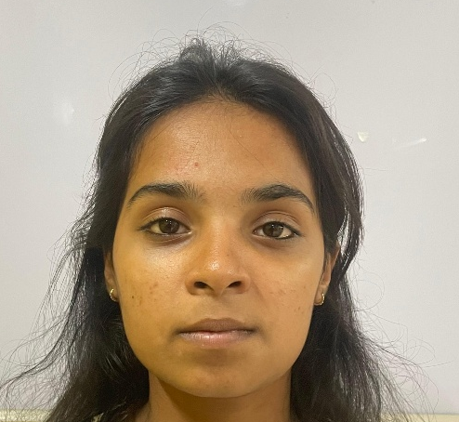
Case Report
A 19-year-old female patient presented with the chief complaint of swelling in the left lower jaw region for one year.
Fig 1-Front Profile view of the patient showing facial asymmetry
The patient first noticed a small swelling in the left mandibular premolar region approximately one year earlier. The swelling gradually increased in size over time.
Initially, the swelling was painless and asymptomatic. During the last two months, the patient experienced mild discomfort while chewing food.There was no history of trauma, pus discharge, paraesthesia, or fever. The progressive but painless nature of the swelling suggested a benign cystic lesion.
The patient reported no systemic illness, was not on any medications, and had no known allergies. Personal history revealed that she was a non-smoker, did not consume alcohol, and had no tobacco-chewing habits. Extraoral examination demonstrated mild facial asymmetry in the left mandibular body region. The overlying skin appeared normal, with no evidence of erythema or ulceration, and no regional lymphadenopathy was detected. Intraoral inspection revealed a diffuse swelling measuring approximately 3 × 3 cm on the lower left side of the face, extending anteroposteriorly from 1 cm away from the corner of the mouth to 1 cm anterior to the tragus of the ear, and superoinferiorly from 1 cm below the tragus line to 1 cm above the lower border of the mandible.
Clinical findings included buccal cortical expansion, normal mucosal coloration, absence of ulceration, and no sinus tract formation. On palpation, the swelling was bony hard in consistency, non-tender, and exhibited buccal cortical expansion. An egg-shell cracking sensation was elicited on pressure, indicating thinning of the cortical bone. Vestibular tenderness was noted in relation to teeth 34, 35, 36, and 37.
Collectively, these findings were suggestive of a large intraosseous cystic lesion involving the left mandibular region.

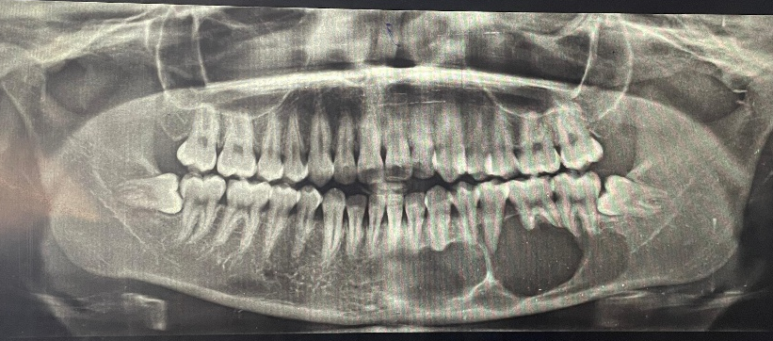

Fig 2-OPG of the patient
Radiographic Evaluation
Orthopantomogram revealed a multilocular radiolucency extending anteroposteriorly from tooth 41 to 37, and superoinferiorly from the interradicular bone of the same teeth to approximately 1 cm superior to the lower border of the mandible. The lower border of the mandible appeared intact. The inferior alveolar nerve canal was not traceable on the left side. Internal septa were noted, dividing the radiolucent areas between teeth 34 and 35. Knife-edge root resorption was evident in relation to teeth 33, 34, 35, 36, and 37. Additionally, horizontal impaction was observed in relation to teeth 38 and 48. These findings were consistent with a large intraosseous lesion exhibiting aggressive radiographic features.
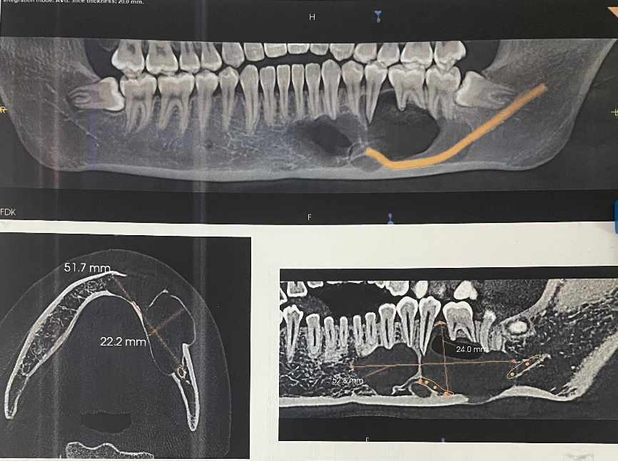
Cone Beam Computed Tomography
Cone beam computed tomography (CBCT) revealed a multilocular radiolucent lesion involving the left body of the mandible, extending mesiodistally from tooth 41 to the distal aspect of 37, and superoinferiorly from the alveolar crest to the lower border of the mandible. The lesion measured approximately 52.8 mm anteroposteriorly, 24 mm superoinferiorly, and 22.2 mm buccolingually.
A distinct septum was noted between teeth 34 and 35, imparting a multilocular appearance. The inferior alveolar nerve canal was displaced inferiorly. Knife-edge root resorption was evident in relation to teeth 32, 33, 34, 36, and 37.
Fig 3-CBCT slices showing the dimensions of the radiolucency

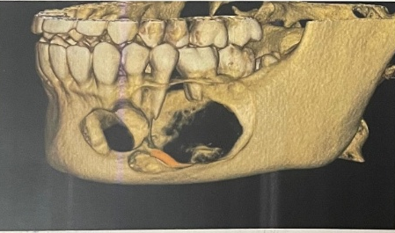

Fig 4-Bony view of cbct showing the defect

Buccolingual expansion was present, with thinning and areas of perforation of both buccal and lingual cortical plates. The lower border of the mandible remained intact, with no evidence of pathological fracture. Horizontal impaction of teeth 38 and 48 was also observed. The internal content of the lesion demonstrated cystic characteristics with low-density fluid.
Initial CBCT analysis (dimensions: 51.7 × 22.2 mm) confirmed buccolingual expansion, cortical thinning without perforation, inferior displacement of the inferior alveolar nerve canal, and multilocular radiolucency with cystic changes. Collectively, these findings were consistent with an aggressive intraosseous cystic lesion exhibiting classical radiographic features of odontogenic keratocyst.
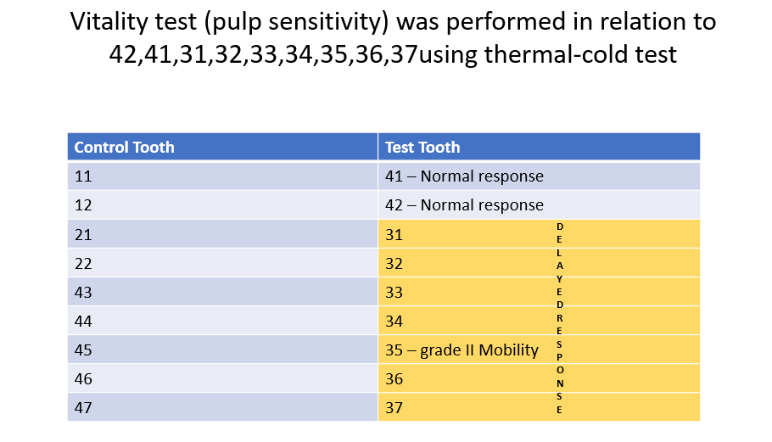

List 1-- The pulp vitality test

Management and Surgical Procedure

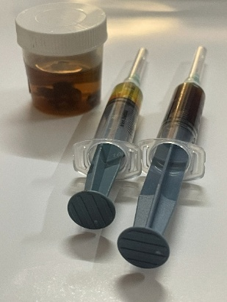

Fig 5-Aspiration done and specimen sent for biopsy

Given the large dimensions of the lesion, its multilocular nature, and the young age of the patient, a conservative approach was prioritized to preserve mandibular continuity and encourage gradual bone regeneration. Marsupialization was selected as the initial treatment modality to achieve decompression and facilitate shrinkage of the cystic cavity.
The procedure commenced with aspiration under local anaesthesia and aseptic precautions. A fine needle introduced into the cystic cavity yielded straw-coloured fluid, characteristic of odontogenic cysts, thereby confirming the diagnosis and providing initial decompression.
Teeth 34, 35, and 36, which demonstrated root resorption and loss of supporting bone, were extracted to eliminate potential foci of infection and facilitate surgical access. Haemostasis was achieved, and the surgical field prepared for entry.
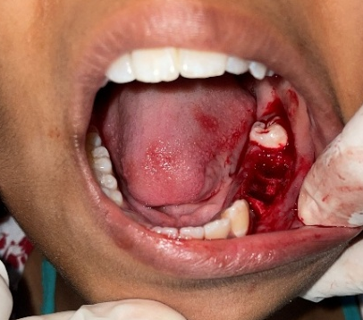

Fig 6-Post extraction of 34,35,36
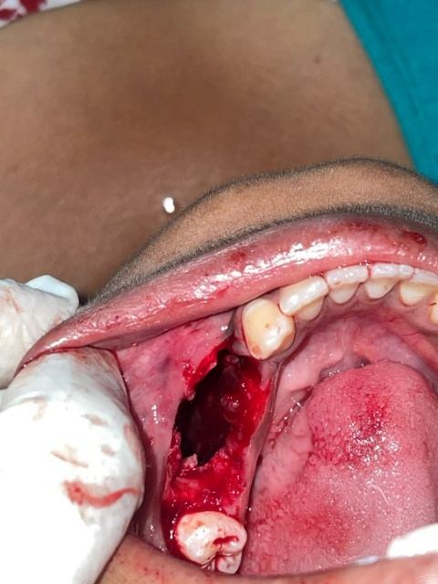

Fig 7-Creation of a bony window for marsupialization

A crestal incision was placed, followed by elevation of a full-thickness mucoperiosteal flap. Using a surgical bur under copious irrigation, a bony window was created at the alveolar crest, providing direct access to the cystic cavity. Tissue fragments and cystic lining removed during entry were collected and submitted for histopathological examination. The cystic lining was sutured to the oral mucosa, establishing a marsupialization window that allowed continuous drainage, reduced intracystic pressure, and promoted gradual shrinkage of the lesion.

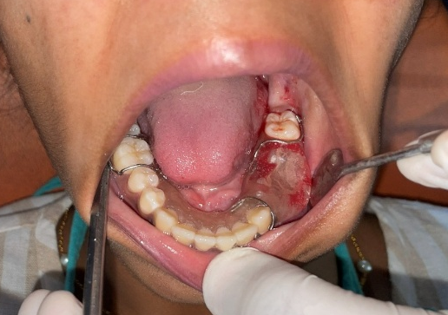

Fig 8-Obturator placement in the patient's mouth
The cavity was packed with chlorhexidine-impregnated gauze to maintain hygiene and prevent secondary infection.
After 15 days, once initial healing was observed, a custom acrylic obturator was fabricated and placed to maintain patency of the marsupialization window, ensure patient comfort, and facilitate irrigation during follow-up. Postoperative care included meticulous oral hygiene, regular irrigation, and weekly review to monitor lesion reduction, bone regeneration, and obturator function. From the surgeon’s perspective, the sequence of aspiration, extraction, window creation with biopsy, marsupialization, medicated packing, and obturator placement was carefully planned to balance decompression with preservation of mandibular integrity.
This conservative approach minimized morbidity, maintained continuity, and provided a predictable pathway for progressive bone regeneration, offering favourable functional and aesthetic outcomes in a young patient.
Follow-Up Protocol
The patient was recalled on a weekly basis for clinical monitoring and maintenance of the marsupialization window. At each visit, the cystic cavity was irrigated with saline, the chlorhexidine-impregnated pack was replaced, and the size of the cavity was clinically evaluated. This regimen ensured continuous decompression, hygiene, and progressive reduction of the lesion.
Radiographic Follow-Up
After one year, CBCT imaging demonstrated a significant reduction in lesion dimensions, from an initial size of 51.7 × 22.2 mm to 38.5 × 13.6 mm. Radiographic evaluation revealed new bone formation along the cystic walls, confirming the effectiveness of marsupialization in promoting gradual osseous regeneration. The findings highlighted the progressive shrinkage of the lesion and preservation of mandibular integrity, validating the conservative treatment approach.
Histopathological Examination
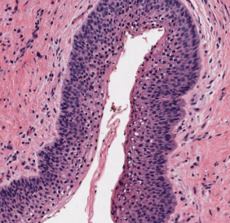

Fig 9-Histopathological image showing OKC

Microscopic evaluation of the submitted specimen revealed features characteristic of an odontogenic keratocyst (OKC). The cyst wall was lined by a thin parakeratinized stratified squamous epithelium, measuring approximately 6–8 cell layers in thickness. The epithelial surface demonstrated a corrugated parakeratin pattern, a hallmark feature of OKC, imparting a wavy appearance under low magnification.
At the basal layer, the cells were arranged in a palisaded configuration, with nuclei that appeared hyperchromatic and polarized, further supporting the diagnosis. This basal cell arrangement provided a distinct demarcation between the epithelial lining and the underlying connective tissue.
The fibrous connective tissue capsule was relatively thin and showed areas of mild chronic inflammatory infiltrate, predominantly lymphocytes. Importantly, within the cyst wall, daughter cysts and satellite cystic structures were identified. These microscopic foci are clinically significant, as they contribute to the well-recognized tendency of OKCs to recur following treatment.
Microscopic examination revealed a thin parakeratinized epithelial lining with a corrugated surface and a palisaded basal cell layer exhibiting hyperchromatic nuclei. The underlying fibrous capsule showed mild inflammatory infiltrate, and daughter cysts were present within the connective tissue wall. This constellation of features is pathognomonic for odontogenic keratocyst (OKC). These findings confirmed the diagnosis and explained the lesion’s aggressive clinical behavior, including its potential for progressive expansion, cortical perforation, and recurrence.
Future Treatment Plan
In view of the lesion’s aggressive nature and the progressive but incomplete reduction achieved with marsupialization, a staged treatment strategy has been formulated. The patient will continue marsupialization until further reduction in lesion dimensions is achieved, thereby minimizing surgical morbidity. Secondary enucleation of the residual cystic cavity will then be performed to ensure complete removal of the lesion. Topical application of 5-fluorouracil (5-FU) will be incorporated intraoperatively to reduce the risk of recurrence. Following enucleation, the site will be allowed to undergo natural bone healing, with radiographic monitoring to confirm adequate regeneration. Once sufficient bone volume and quality are established, dental implants will be placed in relation to teeth 34, 35, and 36 to restore function and aesthetics. This phased approach balances conservative management with definitive surgical intervention, ensuring long-term stability and rehabilitation.

Discussion
Odontogenic keratocyst is recognized for its aggressive growth pattern and high recurrence potential, which makes its management challenging. Several treatment approaches have been proposed, ranging from conservative methods to radical surgical procedures [19–21].
Conservative approaches such as marsupialization are particularly advantageous in young patients because they preserve important anatomical structures and minimize surgical morbidity. Marsupialization works by reducing intracystic pressure, which promotes gradual shrinkage of the cyst and stimulates bone formation within the cavity [16,20].
Numerous studies have reported successful outcomes with decompression and marsupialization techniques. These methods allow reduction in lesion size, making subsequent surgical removal easier and safer while reducing the risk of damage to adjacent anatomical structures such as the inferior alveolar nerve [22,23].
Another important benefit of marsupialization is the histological alteration of the cyst lining. Studies have demonstrated that decompression may lead to epithelial thickening and decreased keratinization, thereby reducing the aggressive behavior of the lesion [12,17].
Recent research has also highlighted the potential role of topical 5-fluorouracil after enucleation in reducing recurrence rates. This chemotherapeutic agent selectively targets proliferating epithelial cells and may eliminate residual epithelial remnants that contribute to recurrence [24,25].
In the present case, significant reduction in lesion size was observed after one year of marsupialization therapy, with CBCT demonstrating reduction from 51.7 × 22.2 mm to 38.5 × 13.6 mm. These findings are consistent with previously reported studies demonstrating favorable outcomes with conservative decompression techniques.

Treatment | Advantages | Disadvantages
Enucleation | Complete removal of cyst | Higher recurrence if remnants remain
Marsupialization | Conservative, preserves bone | Requires long follow-up
Decompression | Gradual reduction of lesion | Patient compliance required
Resection | Lowest recurrence rate | High morbidity
Table 1-Comparison of Treatment Modalities for OKC
Conclusion
Marsupialization represents an effective conservative approach for the management of large odontogenic keratocysts, particularly in young patients. The technique allows gradual reduction of cyst size, preservation of mandibular structure, and stimulation of bone regeneration.
A staged treatment approach involving marsupialization followed by secondary enucleation with 5-fluorouracil application and implant rehabilitation offers favorable long-term outcomes with minimal morbidity.Long-term follow-up remains essential due to the recurrence potential of odontogenic keratocysts.
Ethical Approval
This case was managed in accordance with institutional ethical standards and the principles outlined in the Declaration of Helsinki. All procedures performed were part of routine clinical care, and ethical guidelines were strictly adhered to throughout the management and reporting process.
Patient Consent
Written informed consent was obtained from the patient for both the surgical procedure and the publication of clinical details, radiographic images, and histopathological findings. The patient was assured that anonymity would be maintained and that no identifying information would be disclosed.

COMPETING INTERESTS DISCLAIMER:
Authors have declared that they have no known competing financial interests OR non-financial interests OR personal relationships that could have appeared to influence the work reported in this paper.

References
- Johnson NR, Batstone MD, Savage NW. Management and recurrence of odontogenic keratocysts. J Oral Maxillofac Surg. 2022. DOI: https://doi.org/10.1016/j.joms.2022.03.015
- Dioguardi M, et al. Odontogenic keratocyst: clinical and molecular aspects. Diagnostics. 2024. DOI: https://doi.org/10.3390/diagnostics14020234
- Boffano P, et al. Clinical behavior of odontogenic keratocysts. J Craniomaxillofac Surg. 2022. DOI: https://doi.org/10.1016/j.jcms.2022.02.011
- Pogrel MA. Decompression and marsupialization. Oral Maxillofac Surg Clin. 2023. DOI: https://doi.org/10.1016/j.coms.2023.02.006
- He J, et al. Clinical characteristics of OKC. J Oral Sci. 2023. DOI: https://doi.org/10.2334/josnusd.22-0450
- MacDonald-Jankowski DS. Imaging of OKC. Dentomaxillofac Radiol. 2022. DOI: https://doi.org/10.1259/dmfr.20220105
- Scarfe WC, Farman AG. CBCT in oral pathology. Dentomaxillofac Radiol. 2022. DOI: https://doi.org/10.1259/dmfr.20220114
- Kambalimath DH, et al. CBCT evaluation of jaw cysts. Imaging Sci Dent. 2023. DOI: https://doi.org/10.5624/isd.2023.53.1.45
- Kumar GS, et al. Radiographic diagnosis of cysts. J Clin Diagn Res. 2022. DOI: https://doi.org/10.7860/JCDR/2022/56780.16123
- Wright JM, Vered M. Update on odontogenic cysts. Head Neck Pathol. 2022. DOI: https://doi.org/10.1007/s12105-022-01460-5
- Neville BW, et al. Oral pathology update. Oral Surg Oral Med Oral Pathol Oral Radiol. 2023. DOI: https://doi.org/10.1016/j.oooo.2023.01.004
- Consolo U, et al. Histological changes after marsupialization. Oral Dis. 2022. DOI: https://doi.org/10.1111/odi.13600
- Al-Moraissi EA, et al. Treatment modalities for OKC. J Oral Maxillofac Surg. 2023. DOI: https://doi.org/10.1016/j.joms.2023.01.012
- Kolokythas A. Conservative management of OKC. Oral Maxillofac Surg Clin. 2022. DOI: https://doi.org/10.1016/j.coms.2022.06.003
- Mendes RA, et al. Recurrence of OKC. Int J Oral Maxillofac Surg. 2022. DOI: https://doi.org/10.1016/j.ijom.2022.03.012
- Pogrel MA. Marsupialization technique. J Oral Maxillofac Surg. 2023. DOI: https://doi.org/10.1016/j.joms.2023.04.009
- Yu L, et al. Decompression outcomes. J Stomatol Oral Maxillofac Surg. 2023. DOI: https://doi.org/10.1016/j.jormas.2023.01.003
- Liu H, et al. Conservative treatment outcomes. Medicine. 2024. DOI: https://doi.org/10.1097/MD.0000000000036472
- Mondal S, et al. Pathogenesis of OKC. J Oral Maxillofac Pathol. 2024. DOI: https://doi.org/10.4103/jomfp.jomfp_2024
- Abdelfadil E, et al. Marsupialization outcomes. J Craniomaxillofac Surg. 2025. DOI: https://doi.org/10.1016/j.jcms.2025.02.011
- Manojlović L, et al. Histopathology of OKC. Clin Oral Investig. 2025. DOI: https://doi.org/10.1007/s00784-025-0467
- Khalil A, et al. Surgical management of OKC. J Surg Case Rep. 2023. DOI: https://doi.org/10.1093/jscr/rjad119
- Caminiti MF, et al. Conservative surgical strategies. J Oral Maxillofac Surg. 2023. DOI: https://doi.org/10.1016/j.joms.2023.02.014
- Al-Sukhun J, et al. Conservative outcomes. Cureus. 2024. DOI: https://doi.org/10.7759/cureus.52761
- Caminiti MF, et al. Topical 5-FU for OKC. J Oral Maxillofac Surg. 2023. DOI: https://doi.org/10.1016/j.joms.2023.02.014

