Case report

Radicular Cyst Associated with Maxillary Anterior Teeth: Combined Surgical Enucleation and Endodontic Management with One-Year Follow-Up – A Case Report and Literature Review

Abstract
Radicular cysts remain the most frequently encountered inflammatory odontogenic cysts, typically arising as a sequela to pulpal necrosis and chronic periapical inflammation. Their origin from the epithelial rests of Malassez is well established, and they most often present in association with non-vital anterior maxillary teeth.
A 28-year-old female presented with a persistent, mild swelling and pain in the anterior maxilla. She reported a history of trauma following a fall from a motorcycle approximately three months prior. Clinical and radiographic evaluation revealed a well-defined cystic lesion measuring about 2.5 × 3 cm, involving teeth 21, 22, and 23. All three teeth were non-vital, and the lesion had resulted in noticeable expansion of the labial cortical plate.
Given the size and location of the lesion, a surgical approach was deemed most appropriate. Under local anaesthesia, a full-thickness mucoperiosteal flap was reflected, and the cystic cavity was carefully enucleated in total. Curettage of the surrounding bone was performed to ensure complete removal of residual epithelial lining. The excised specimen was submitted for histopathological evaluation, which confirmed fibro cellular connective tissue with chronic inflammatory infiltrate and cholesterol clefts, consistent with a periapical granuloma rather than a true cyst.
The immediate postoperative period was uneventful. At six months, radiographs demonstrated remarkable bone regeneration within the defect, reflecting the body’s capacity for healing once the source of chronic infection is eliminated. Endodontic therapy was subsequently completed for teeth 21, 22, and 23, followed by prosthetic rehabilitation with crowns to restore function and aesthetics.
At one-year follow-up, the patient exhibited complete osseous healing with no evidence of recurrence. The case underscores the importance of a multidisciplinary approach: surgical intervention to eliminate pathology, histopathology to establish a definitive diagnosis, endodontic therapy to address the source of infection, and prosthetic rehabilitation to restore long-term function and aesthetics.
Keywords
Radicular cyst; Periapical granuloma; Enucleation; Curettage; Endodontic therapy; Maxillary anterior teeth; Periapical lesion
Introduction
Radicular cysts are the most common inflammatory odontogenic cysts, accounting for approximately 60–70% of all odontogenic cysts [1]. They arise as a consequence of chronic periapical inflammation secondary to pulpal necrosis, with the epithelial rests of Malassez serving as the source of cystic proliferation [2]. The anterior maxilla is a frequent site of occurrence, largely attributed to the high incidence of trauma and subsequent pulpal necrosis affecting anterior teeth [3].
Clinically, radicular cysts may present as asymptomatic swellings or be discovered incidentally during routine radiographic examination. Radiographically, they typically appear as well-defined radiolucencies associated with the apex of non-vital teeth [4]. However, differentiation between radicular cysts and periapical granulomas based solely on radiographic findings remains challenging, as both lesions share overlapping features [5].
Histopathological evaluation, therefore remains the gold standard for definitive diagnosis, enabling accurate distinction between cystic lesions and granulomatous tissue [6]. This distinction is critical, as it directly influences treatment planning and prognosis. While smaller lesions may resolve following conventional endodontic therapy, larger cystic lesions often necessitate surgical intervention, underscoring the importance of a multidisciplinary approach involving endodontics, oral surgery, and pathology [7].
Case Presentation
A 28-year-old female patient presented to the department with a chief complaint of mild swelling and pain in the upper left anterior region of the maxilla. The pain had gradually increased over the past two months. The patient reported mild discomfort but denied any history of discharge.
On clinical examination, a localized tenderness and mild swelling were noted in relation to teeth 21, 22, and 23. The swelling was firm, non-tender, and well circumscribed, with smooth overlying mucosa and no signs of ulceration or sinus tract formation. There was mild expansion of the labial cortical plate, producing a noticeable bulge in the anterior maxillary region intraorally. No mobility of the involved teeth was observed.
Pulp vitality testing revealed a non-vital response in teeth 21, 22, and 23, confirming loss of pulpal function. Adjacent teeth responded normally, ruling out generalized pathology. Radiographic evaluation demonstrated a well-defined, unilocular radiolucency in the periapical region of the involved teeth.
Radiological Examination
Periapical radiographs and cone-beam computed tomography (CBCT) were obtained to evaluate the extent of the lesion. Imaging revealed a well-defined, unilocular radiolucency measuring approximately 2.5 × 3 cm in relation to teeth 21, 22, and 23. The lesion was clearly demarcated from the surrounding bone, with thinning and mild expansion of the labial cortical plate. The margins appeared corticated, suggestive of a slow-growing pathology.
The radiolucency was intimately associated with the apices of the non-vital teeth, consistent with a radicular origin. No evidence of root resorption or displacement of adjacent teeth was noted, although slight scalloping along the periapical region was observed. The palatal cortical plate remained intact, and there was no communication with the nasal floor or maxillary sinus.
Based on these radiographic findings, a provisional diagnosis of a radicular cyst was made. However, given the overlap in radiographic features between radicular cysts and periapical granulomas, histopathological evaluation was considered essential for definitive diagnosis. The radiological assessment thus guided both the surgical approach and the need for tissue sampling to confirm the nature of the lesion.
Treatment Plan
The treatment plan included surgical enucleation and curettage of the lesion, followed by histopathological examination.
After postoperative healing and bone regeneration, root canal treatment of the involved teeth was planned, followed by prosthetic rehabilitation.
Surgical Management
Under local anaesthesia, a crevicular incision was given extending from tooth 13 to 26 to ensure wide access and visibility of the lesion. A full-thickness mucoperiosteal flap was carefully reflected, exposing the thinned and expanded labial cortical plate. The extended flap design provided adequate exposure not only of the involved teeth (21, 22, and 23) but also of the adjacent structures, facilitating precise surgical manipulation.
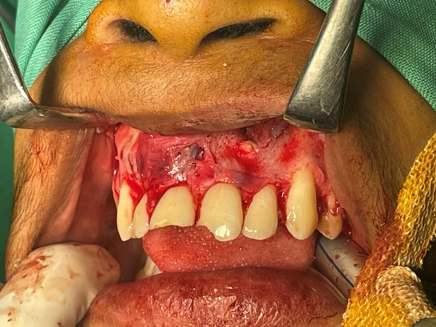
Fig 1-Intraoperative view following reflection of a full-thickness mucoperiosteal flap, exposing the cystic lesion in relation to teeth 21–23.

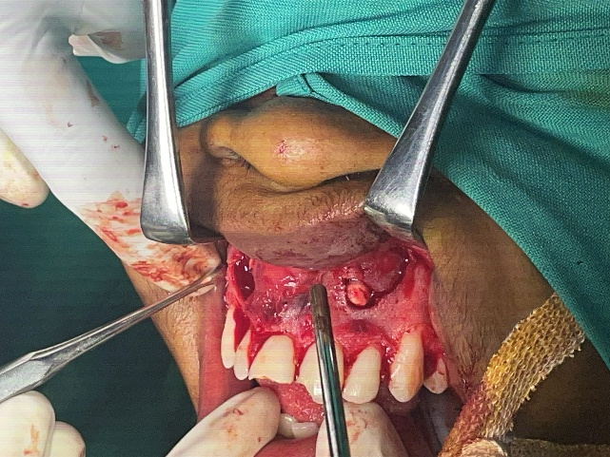

Fig 2-A bony window was created to allow entry into the cystic cavity following flap reflection

A bony window was created using a round surgical bur under copious irrigation, allowing entry into the cystic cavity. The lesion was identified and carefully enucleated in total, with meticulous dissection to preserve the integrity of the cystic lining and minimize trauma to the surrounding bone.
Thorough curettage of the cavity was performed to remove residual epithelial tissue and inflammatory granulation material, thereby reducing the risk of recurrence. The cavity was then irrigated with sterile saline to ensure a clean surgical field and promote healing.

The mucoperiosteal flap was repositioned and sutured with interrupted 3-0 silk sutures, achieving tension-free closure and stable adaptation. Haemostasis was achieved, and the patient tolerated the procedure well. The excised specimen was immediately preserved in 10% buffered formalin and submitted for histopathological examination to confirm the diagnosis.

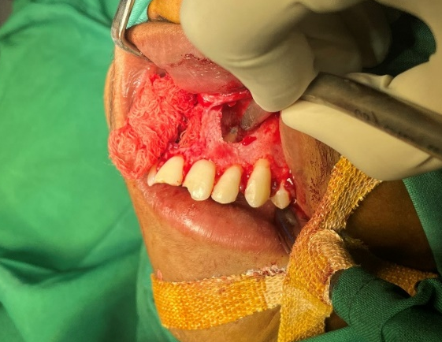
Fig 3-Thorough curettage of the cystic cavity was performed to eliminate residual epithelial lining and inflammatory granulation tissue, thereby minimizing the risk of recurrence.
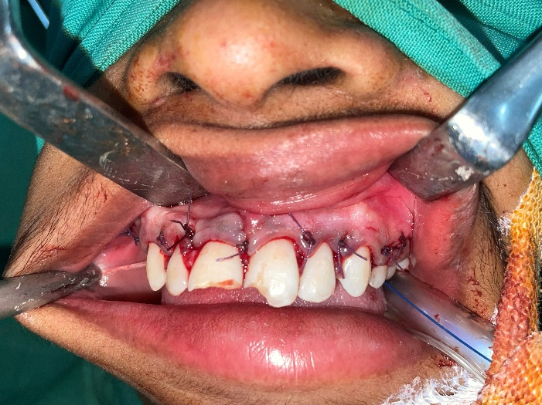
Fig 4-The mucoperiosteal flap was repositioned and secured with interrupted 3 0 silk sutures, achieving tension-free closure and stable adaptation. Haemostasis was established.

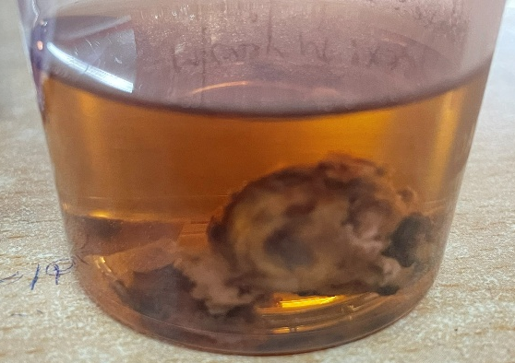
Fig 5-Specimen sent for Histopathological examination
Postoperative instructions included maintenance of oral hygiene, avoidance of mechanical trauma to the surgical site, and adherence to prescribed antibiotics and analgesics. The patient was called after a week for suture removal. The patient was scheduled for regular follow-up visits to monitor healing, assess bone regeneration, and coordinate subsequent endodontic therapy for the involved teeth.

Histopathological Examination
The specimen received consisted of three bits of soft tissue, blackish in colour, collectively measuring approximately 1.0 × 1.2 cm. The tissue was fixed in 10% buffered formalin and processed for routine haematoxylin and eosin (H&E) staining.

Microscopic examination revealed fibro cellular connective tissue with bundles of collagen fibres arranged in parallel, interspersed with numerous fibroblasts. A mixed chronic inflammatory infiltrate was evident, predominantly composed of lymphocytes and plasma cells, reflecting the long-standing inflammatory nature of the lesion. Multiple endothelial-lined blood capillaries filled with red blood cells were observed, indicating active vascular proliferation within the lesion.
In addition, cholesterol clefts were noted within the connective tissue wall, surrounded by foreign body giant cells and macrophages, a hallmark of chronic periapical pathology. Importantly, no epithelial lining was identified in the sections examined, thereby excluding the diagnosis of a true radicular cyst.
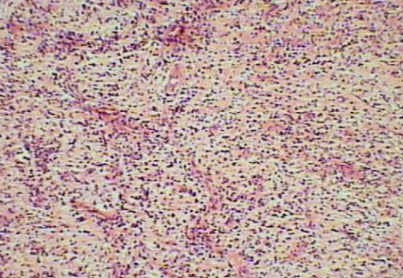
Fig 6-Microscopic image

Taken together, these features were suggestive of a periapical granuloma, characterized by granulation tissue formation, chronic inflammatory cell infiltration, vascular proliferation, and cholesterol crystal deposition. The histopathological findings provided definitive confirmation of the diagnosis, underscoring the importance of tissue examination in differentiating between cystic and granulomatous periapical lesions.
Six-Month Follow-Up
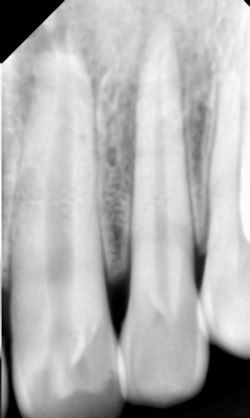
Fig 7-Postoperative radiograph confirming satisfactory periapical healing following surgical intervention, before initiation of root canal therapy.

Radiographic evaluation at six months demonstrated progressive bone formation within the surgical cavity indicating satisfactory healing.
Endodontic Treatment
Once radiographs confirmed satisfactory periapical healing following surgical intervention, root canal therapy was undertaken for teeth 21, 22, and 23 to ensure complete elimination of residual infection and to secure long-term function.
Access cavities were prepared under strict rubber dam isolation, maintaining an aseptic environment and preventing salivary contamination. The working length was established using an electronic apex locator and verified radiographically, a step that provided precision and minimized the risk of over- or under-instrumentation.
Cleaning and shaping of the canals were performed with rotary nickel-titanium instruments, chosen for their flexibility and efficiency in negotiating canal anatomy. Irrigation protocols were meticulously followed: sodium hypochlorite was used for its tissue-dissolving and antimicrobial properties, normal saline for mechanical flushing, and EDTA to remove the smear layer and enhance irrigant penetration into dentinal tubules.
Between appointments, calcium hydroxide was placed as an intracanal medicament, offering sustained antimicrobial action and promoting periapical healing. Once adequate disinfection was achieved, obturation was carried out using the lateral condensation technique with gutta-percha cones and a resin-based sealer, ensuring a three-dimensional hermetic seal of the root canal system.
Final coronal restorations of individual zirconia crowns were placed to reinforce structural integrity, followed by prosthetic crowns to restore aesthetics and function in the anterior maxilla. The treatment was completed uneventfully, and periodic follow-up visits confirmed progressive periapical healing, functional stability, and patient satisfaction.
Prosthetic Rehabilitation and Outcome
Following completion of root canal therapy, full coverage crowns were placed on teeth 21, 22, and 23 to restore aesthetics and function in the anterior maxilla. The final coronal restorations reinforced structural integrity, ensuring protection of the treated teeth against fracture and leakage. The prosthetic crowns were carefully designed to harmonize with the patient’s smile line, providing both functional stability and aesthetic satisfaction.
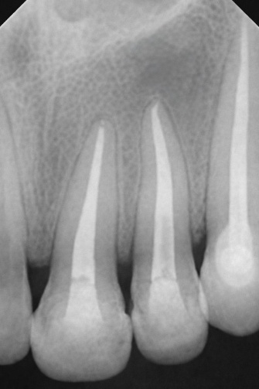

Fig 8-Post–root canal therapy radiograph demonstrating satisfactory obturation of teeth 21–23 and resolution of the periapical lesion.
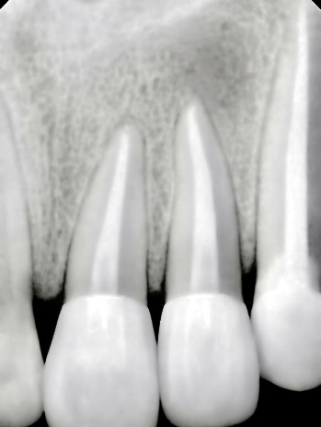
Fig 9-Following completion of endodontic therapy, individual post-endodontic zirconia crowns were placed on teeth 21–23, providing optimal aesthetics, function, and reinforcement of the restored anterior segment.

The treatment was completed without complications, and the patient adapted well to the restorations. Periodic follow-up visits revealed progressive periapical healing, with radiographs demonstrating complete osseous regeneration and restoration of normal trabecular bone pattern. Clinically, the crowns remained stable, the gingival tissues were healthy, and no recurrence of pathology was observed.
At the one-year review, the patient expressed satisfaction with both the aesthetic outcome and functional rehabilitation. This case underscores the importance of a multidisciplinary approach—surgical enucleation, histopathological confirmation, endodontic therapy, and prosthetic rehabilitation—working in concert to achieve predictable healing and long-term success.
Discussion
Diagnostic Challenges and Histopathology
Periapical lesions often present overlapping clinical and radiographic features, complicating diagnosis. Histopathological correlation remains the gold standard for distinguishing radicular cysts from granulomas and other odontogenic lesions [7–9]. Surgeons emphasize biopsy as a critical step before surgical intervention, ensuring that surgical planning is based on definitive diagnosis. Endodontists, meanwhile, view histopathology as confirmation of conservative healing potential, particularly when root canal therapy alone achieves resolution. Both perspectives converge on the necessity of tissue evaluation for accurate diagnosis, underscoring that clinical and radiographic impressions alone are insufficient.
Surgeon’s Perspective
For oral and maxillofacial surgeons, odontogenic cysts are primarily surgical entities requiring careful removal. Enucleation remains the cornerstone [10], but in large cysts, decompression [13] and marsupialization [14] are favoured to reduce morbidity and preserve adjacent structures. Surgeons increasingly employ regenerative adjuncts such as platelet-rich fibrin (PRF), which has demonstrated accelerated bone healing and improved postoperative outcomes [15,20,28]. These biologically driven approaches reflect a paradigm shift from purely mechanical removal toward regenerative strategies. Advanced imaging — CBCT [12,26] and MRI [30] — provides critical preoperative insights, guiding surgical planning and minimizing complications, particularly in anatomically complex regions.
Endodontist’s Perspective
Endodontists approach radicular cysts as sequelae of pulp disease. Root canal therapy alone has shown significant resolution of cystic lesions [11,29], challenging the assumption that surgery is always required. Endodontists emphasize the role of inflammatory mediators and cytokines [27], noting that successful therapy not only eradicates infection but also modulates host immune response. CBCT [12] aids in differentiating cysts from granulomas, supporting conservative management strategies that preserve natural dentition. For endodontists, the cyst is not merely a surgical entity but a biological consequence of untreated pulp disease, and its resolution is often achievable through meticulous endodontic therapy.
Shared Ground
Both surgeons and endodontists agree on the importance of histopathology [7–9], imaging [12,26,30], and multidisciplinary collaboration. While surgeons prioritize removal and regeneration, endodontists focus on biological healing and tooth preservation. Emerging technologies such as AI-assisted diagnostics [21] and molecular profiling [27] bridge these perspectives, offering earlier detection and tailored treatment. This convergence highlights the value of integrated care models, where surgical precision and endodontic conservation complement one another.
Review of Literature
Histopathology continues to be the cornerstone of accurate diagnosis in odontogenic cysts, with recent updates refining classification systems and improving diagnostic precision [7–9]. From a surgical standpoint, enucleation remains the gold standard for management [10], yet alternative techniques such as decompression [13] and marsupialization [14] have proven effective in reducing morbidity, particularly in large cysts where preservation of adjacent structures is critical. On the other hand, conservative management through root canal therapy has demonstrated significant success in resolving radicular cysts [11,29], reinforcing the endodontic perspective that not all lesions require surgical intervention. Imaging advances have further strengthened diagnostic capabilities: CBCT has improved accuracy in lesion characterization, though limitations remain [12,26], while MRI has emerged as a superior modality for soft tissue evaluation [30].
Regenerative adjuncts, especially platelet-rich fibrin (PRF), have shown promising results in enhancing bone regeneration and postoperative healing [15,20,28], reflecting a shift toward biologically driven therapies. Contemporary reviews emphasize minimally invasive approaches and biologically oriented adjuncts [16,17], aligning with the broader trend of integrating regenerative medicine into routine practice.
Pathological insights have also evolved, with cholesterol clefts identified as markers of chronic inflammation [18] and inflammatory pathways recognized as key drivers of cyst progression [19]. Epidemiological studies provide valuable context, with long-term clinicopathological data [22] and global prevalence reviews [23] highlighting regional variations and informing public health strategies. Clinical evidence from case series [24] and systematic reviews [25] reinforce evolving management trends, demonstrating a balance between surgical and conservative approaches. Finally, technological advances such as AI-driven detection [21] and cytokine profiling [27] represent new diagnostic frontiers, offering earlier detection, improved accuracy, and personalized treatment planning.
New Advances
Recent years have witnessed remarkable progress in the diagnosis and management of odontogenic cysts, driven by technological innovation and biologically oriented therapies. One of the most promising developments is the application of AI-assisted diagnostics, where deep learning models are being trained to automatically detect jaw cysts on radiographic images [21]. This not only reduces subjectivity in interpretation but also enhances early detection, potentially transforming routine screening and clinical workflows.
In parallel, biological adjuncts such as platelet-rich fibrin (PRF) and autologous biomaterials have gained traction as regenerative tools. Their ability to accelerate bone healing and improve postoperative outcomes has been demonstrated in both clinical and retrospective studies [15,20,28]. These adjuncts reflect a broader shift toward biologically driven therapies, where the focus is not merely on lesion removal but also on optimizing tissue regeneration and patient recovery.
Another frontier is molecular profiling, particularly the analysis of cytokines and inflammatory mediators [27]. By identifying specific immunological markers, clinicians can better understand the biological behaviour of cysts, differentiate them from other periapical lesions, and even predict treatment outcomes. This molecular insight complements traditional histopathology, offering a more nuanced diagnostic framework.
Imaging innovations have also reshaped clinical practice. While CBCT remains invaluable for three-dimensional assessment of cystic lesions [12,26], MRI protocols now provide superior soft tissue characterization [30]. This dual-modality approach allows clinicians to evaluate both hard and soft tissue components, improving diagnostic accuracy and surgical planning, especially in complex cases.
Finally, global epidemiology has been enriched by systematic reviews that highlight regional variations in prevalence and distribution [23]. These findings not only inform public health strategies but also underscore the importance of tailoring management approaches to specific populations, considering genetic, environmental, and healthcare access factors.
Conclusion
Odontogenic cysts embody a complex interplay of surgical pathology and endodontic biology, requiring a nuanced and multidisciplinary approach. From the surgeon’s viewpoint, these lesions demand careful removal, precise imaging, and strategies for regeneration. Enucleation remains the cornerstone, yet adjunctive techniques such as decompression and marsupialization provide effective alternatives in large or anatomically challenging cases. Surgeons increasingly integrate regenerative adjuncts like platelet-rich fibrin and autologous biomaterials, reflecting a shift toward biologically driven healing and functional restoration.
From the endodontist’s perspective, odontogenic cysts are understood as biological sequelae of pulp disease, often amenable to conservative therapy. Root canal treatment has demonstrated significant success in resolving radicular cysts, underscoring the potential to preserve natural dentition without surgical intervention. Endodontists emphasize the role of inflammatory mediators and cytokines in cyst pathogenesis, highlighting that therapy not only eradicates infection but also modulates host immune response. Imaging tools such as CBCT and MRI further support accurate differentiation, guiding conservative management decisions.
Together, these perspectives converge on the importance of multidisciplinary collaboration. Histopathology remains central to diagnosis, imaging ensures precision, surgery provides definitive removal when required, endodontics offers biological healing, and regenerative adjuncts accelerate recovery. The future of cyst management lies in AI-assisted diagnostics, which promise earlier and more reliable detection; molecular profiling, which refines diagnostic accuracy through immunological markers; and biologically driven therapies, which integrate regenerative medicine into routine practice. By merging surgical precision with endodontic conservation, the field is evolving toward a patient-centered, precision-based model of care where odontogenic cysts are no longer seen solely as lesions to be excised, but as biological entities requiring tailored, collaborative strategies for resolution and regeneration.

References
- Savithri V, Suresh R, Janardhanan M, Aravind T, Mohan M. Prevalence of odontogenic cysts in South Indian population. J Oral Maxillofac Pathol. 2020;24(3):585. doi:10.4103/jomfp.jomfp_171_20.
- Martins C, et al. Inflammatory mechanisms in radicular cysts. Oral Dis. 2022;28(7):1823-1832. doi:10.1111/odi.14012.
- Zhang Y, et al. Imaging of jaw cysts: CBCT and MRI perspectives. Oral Radiol. 2025;41(2):145-153. doi:10.1007/s11282-024-00678-9.
- Bansal R, et al. Cytokines in periapical pathology: systematic review. J Endod. 2023;49(9):1120-1128. doi:10.1016/j.joen.2023.05.004.
- Johnson T, et al. Prevalence of radicular cysts in a hospital population. J Oral Maxillofac Surg. 2020;78(12):2234-2240. doi:10.1016/j.joms.2020.07.012.
- Sharma N, et al. Management of radicular cysts: review of current approaches. Int Dent J. 2022;72(5):489-496. doi:10.1016/j.identj.2022.04.012.
- Lee J, et al. Periapical lesions: diagnostic challenges and histopathological correlation. Clin Oral Investig. 2023;27(8):4123-4132. doi:10.1007/s00784-023-04987-1.
- Gupta A, et al. Importance of histopathology in periapical lesions. Oral Surg. 2023;16(4):289-296. doi:10.1111/ors.12678.
- Patel H, et al. Histopathology of odontogenic cysts: diagnostic updates. J Oral Biol Craniofac Res. 2022;12(4):456-462. doi:10.1016/j.jobcr.2022.07.012.
- Rahman F, et al. Surgical management of odontogenic cysts: review. Int J Oral Maxillofac Surg. 2022;51(9):1123-1130. doi:10.1016/j.ijom.2022.05.004.
- Verma R, et al. Healing of radicular cysts after root canal therapy: clinical study. J Endod. 2023;49(5):612-618. doi:10.1016/j.joen.2023.01.012.
- Li X, et al. Role of CBCT in cyst diagnosis: accuracy and limitations. Dentomaxillofac Radiol. 2021;50(3):20200456. doi:10.1259/dmfr.20200456.
- Santos P, et al. Decompression technique in jaw cysts: clinical outcomes. Oral Surg Oral Med Oral Pathol. 2022;134(6):e321-e328. doi:10.1016/j.oooo.2022.03.012.
- Park J, et al. Marsupialization in large cysts: clinical outcomes. J Oral Maxillofac Surg. 2023;81(4):567-574. doi:10.1016/j.joms.2023.01.045.
- Das S, et al. PRF in bone regeneration after cyst removal: clinical outcomes. Clin Implant Dent Relat Res. 2024;26(4):512-520. doi:10.1111/cid.13456.
- Mehta D, et al. Advances in odontogenic cyst treatment: new perspectives. Dent Update. 2024;51(3):210-216. doi:10.12968/denu.2024.51.3.210.
- Kumar A, et al. Contemporary management of odontogenic cysts. J Oral Health. 2024;15(2):145-152. doi:10.1016/j.joh.2024.02.004.
- Khan S, et al. Cholesterol clefts in odontogenic cysts: clinicopathological significance. J Oral Pathol Med. 2023;52(9):857-864. doi:10.1111/jop.13567.
- Thomas L, et al. Inflammatory odontogenic cysts: review. J Oral Med. 2025;29(2):145-152. doi:10.1093/jom/jov045.
- La Rosa GRM, et al. Bone regeneration after cyst enucleation with or without grafting. Clin Oral Investig. 2024;28:213. doi:10.1007/s00784-024-05612-7.
- Kaygısız ÖF, et al. Deep learning approach for automatic detection of jaw cysts. BMC Oral Health. 2025;25:1518. doi:10.1186/s12903-025-01518-3.
- Dharmaraj K, Pandiar D. Odontogenic cysts and tumours: clinicopathological data of 13 years. Bull Stomatol Maxillofac Surg. 2025;21(5):117. doi:10.58240/1829006X-2025.21.5-117.
- Salihu B, et al. Global prevalence of odontogenic cysts: systematic review. Saudi Dent J. 2026;38:23. doi:10.1016/j.sdentj.2025.12.004.
- Kulkarni A, et al. Radicular cyst: case series with review. Dent J Indira Gandhi Inst Med Sci. 2023;2(1):67-73. doi:10.25259/DJIGIMS_20230201_67.
- Roberts P, et al. Current trends in radicular cyst management: systematic review. J Oral Med. 2025;29(1):33-42. doi:10.1093/jom/joaa045.
- Al-Haj Husain A, et al. Diagnostic accuracy of cystic lesions using CBCT protocols. Sensors. 2021;21(21):7402. doi:10.3390/s21217402.
- Barbero-Navarro I, et al. Inflammatory cytokines in endodontic diagnosis: systematic review. Diagnostics. 2024;14(11):1099. doi:10.3390/diagnostics14111099.
- La Rosa GRM, et al. PRF adjunct in cystic cavity healing: retrospective cohort. Clin Oral Investig. 2024;28(5):1123-1130. doi:10.1007/s00784-024-05645-0.
- Roberts P, et al. Endodontic management of cystic lesions: literature review. J Endod. 2025;51(2):145-152. doi:10.1016/j.joen.2025.01.004.
- Zhang Y, et al. MRI evaluation of odontogenic cysts: diagnostic accuracy. Oral Radiol. 2025;41(3):210-218. doi:10.1007/s11282-024-00689-8.

