Microvascular Reconstruction of Oroantral Communication Following Mucormycosis: Clinical Application of Radial Forearm Free Flap

Abstract
Background: Rhino-maxillary mucormycosis is a rapidly progressive fungal infection characterized by vascular invasion and extensive tissue necrosis. Surgical eradication frequently produces complex maxillary defects with persistent oroantral communication (OAC), leading to significant functional compromise.
Objective: To describe the surgical management of post-mucormycosis oroantral communication using radial forearm free flap (RFFF) and to discuss its reconstructive advantages.
Case Description: A diabetic male patient developed a large maxillary defect after radical debridement for mucormycosis. Definitive reconstruction was performed using a microvascular radial forearm free flap.
Results: The flap survived completely without vascular compromise. Oral-nasal separation was successfully restored. Speech clarity and swallowing improved substantially during follow-up.
Conclusion: The radial forearm free flap is a dependable and functionally favorable option for reconstruction of extensive oroantral defects following mucormycosis, particularly in medically compromised individuals.
Keywords: Mucormycosis, Oroantral communication, Free tissue transfer, Maxillary reconstruction, Radial forearm flap

1. Introduction
Mucormycosis represents an invasive fungal infection caused by organisms belonging to the order Mucorales. The disease demonstrates marked angiotropism, resulting in thrombosis, ischemia, and tissue necrosis [1]. During the COVID-19 pandemic, a notable surge in cases was reported, particularly among patients with uncontrolled diabetes and corticosteroid exposure [2,3].
The maxilla is commonly involved due to its porous architecture and proximity to the nasal cavity and paranasal sinuses [4]. Successful management requires aggressive surgical debridement combined with systemic antifungal therapy [5]. However, removal of necrotic maxillary bone often leaves significant defects, creating communication between the oral cavity and the maxillary sinus.
Persistent oroantral communication produces nasal regurgitation, altered phonation, chronic sinus infections, and masticatory difficulty. Small defects may be addressed with local flaps; however, larger composite defects demand microvascular reconstruction to restore both function and anatomy [6,7].
2. Case Report
2.1 Patient Profile
A 52-year-old male, otherwise systemically healthy, presented following management of rhino-maxillary mucormycosis. He had previously undergone a right-sided subtotal maxillectomy with extensive surgical debridement, completed systemic liposomal amphotericin B therapy, and subsequently received a patient-specific implant (PSI) reconstruction at 6 months.
On review, the patient reported persistent functional deficits, including hyper-nasal speech, nasal regurgitation of fluids, and impaired mastication, and was seeking a definitive rehabilitative solution.
2.2 Radiological Assessment

On computed tomography, extensive post-infective osteonecrosis changes were noted in the maxilla. There was significant destruction of the left maxillary alveolus, with the defect extending into the anterior wall of the maxilla, the lateral wall of the maxillary sinus, and further involving the orbital floor and medial orbital wall. The pathology crossed the midline, with erosion of the medial wall of the right maxillary sinus, and a clear communication with the maxillary sinus cavity was evident, consistent with oroantral involvement. Reconstruction with a patient-specific implant (PSI) was visualized, restoring skeletal continuity. The PSI extended across the medial wall of the nasal cavity bilaterally, reaching up to the zygomatic buttresses on both sides, and incorporated dental rehabilitation on the right side. Overall, the radiological features were characteristic of post-infective maxillary osteonecrosis secondary to rhino-maxillary mucormycosis, demonstrating aggressive bony destruction with sinus and orbital extension, and subsequent PSI reconstruction to re-establish midfacial support and partial dental function.

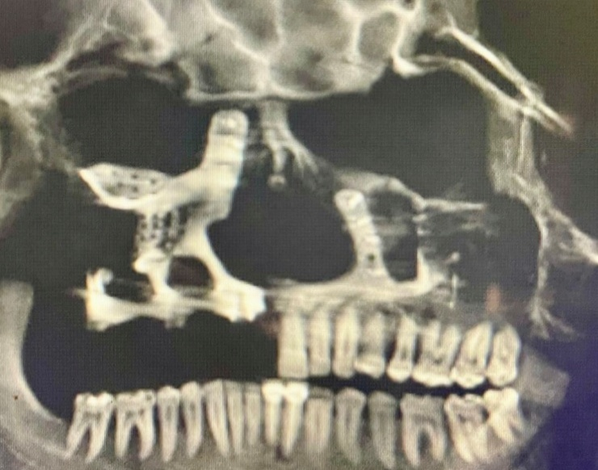

Fig .1. Pre – operative CBCT image showing partial maxillectomy has been done, and PSI was placed in the earlier surgery.

3. Surgical Management
  - Preoperative Optimization
Before surgery, the patient underwent thorough preoperative optimization to ensure safe anesthesia and reliable flap survival. A multidisciplinary approach was adopted, involving oral and maxillofacial surgeons, anesthesiologists, endocrinologists, and infectious disease specialists.
Systemic Evaluation:
- Complete blood count, renal and hepatic function tests, and coagulation profile were obtained to rule out systemic compromise.
- Chest radiography and ECG were performed to assess cardiopulmonary status.
- Glycemic control was prioritized, with fasting and postprandial blood sugars monitored. Insulin therapy was titrated to maintain euglycemia, given the known association of mucormycosis with uncontrolled diabetes.
Infection Control:
- The patient had previously completed antifungal therapy with liposomal amphotericin B. Preoperative cultures and imaging confirmed the absence of active infection.
- Prophylactic broad-spectrum antibiotics were initiated 24 hours prior to surgery to reduce perioperative infection risk.
Nutritional and Metabolic Support:
- Nutritional assessment was performed, and high-protein supplementation was prescribed to enhance wound healing.
- Electrolyte imbalances were corrected, and hydration status was optimized.
Vascular Assessment:
- Allen’s test was performed to confirm adequate collateral circulation before harvesting the radial forearm flap.
- Doppler evaluation of the radial artery was carried out to ensure patency and suitability for flap harvest.
Medication Protocol:
- Antibiotics: Broad-spectrum coverage (e.g., ceftriaxone + metronidazole) initiated preoperatively.
- Antifungals: Continued surveillance with oral posaconazole as maintenance therapy, given the history of mucormycosis.
- Analgesics: NSAIDs and opioids planned for perioperative pain control.
- Anticoagulants: Low-molecular-weight heparin in prophylactic doses to reduce risk of microvascular thrombosis.
- Insulin therapy: Adjusted perioperatively to maintain strict glycemic control.
Patient Counseling:
- The patient was counseled regarding donor site morbidity, need for skin grafting, and possible functional limitations.
- Informed consent was obtained for flap harvest, microvascular anastomosis, and donor site grafting.

3.2 Flap Harvest
Flap Design and Harvest:
Flap Design and Harvest:
A fasciocutaneous radial forearm flap was carefully designed over the non-dominant forearm to minimize donor site morbidity. The skin paddle was outlined according to the dimensions required for intraoral reconstruction, ensuring inclusion of reliable perforators. Following incision, the radial artery was identified along with its venae comitantes, and meticulous dissection was performed to isolate the vascular pedicle. The artery and accompanying veins were traced proximally to obtain adequate pedicle length, which is critical for achieving a tension-free microvascular anastomosis at the recipient site. The flap was elevated in a subfascial plane, preserving the integrity of the vascular bundle and ensuring robust perfusion.

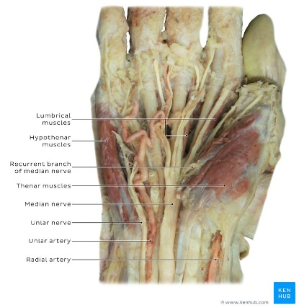
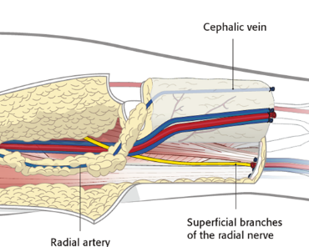
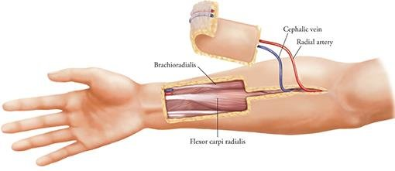
Donor Site Management:
Once the flap was harvested, the donor site was assessed for closure. Given the size of the defect, primary closure was not feasible, and resurfacing was achieved using a split-thickness skin graft harvested from the abdominal region. The graft was secured over the forearm defect, providing satisfactory coverage, promoting healing, and reducing functional morbidity.

Fig .2. Images showing the anatomy of RFFF harvesting

Clinical Rationale:

The radial forearm flap was chosen because of its predictable vascular anatomy, thin and pliable skin paddle, and long pedicle length, which together make it highly versatile for intraoral and maxillofacial reconstruction. Its consistent survival rates exceeding 95% in head and neck surgery underscore its reliability. Harvesting from the non-dominant forearm further reduces functional compromise, while the donor site can be readily resurfaced with a skin graft.
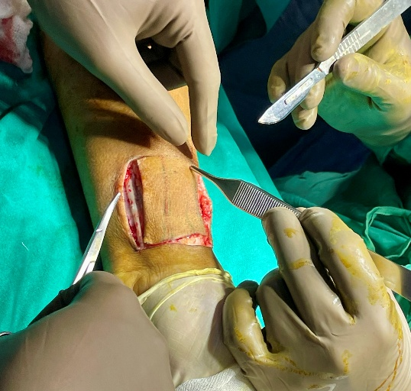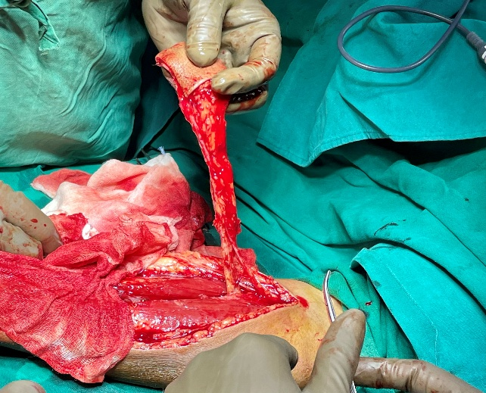
Fig. 3. Marking and harvesting of the radial forearm flap: The skin paddle is outlined over the non-dominant forearm, incorporating the radial artery and venae comitantes. Flap elevation provides a long, reliable pedicle with predictable vascularity, making it a dependable option for head and neck reconstruction.

Rationale for Radial Forearm Flap Selection:
The radial forearm flap is widely recognized as a reliable option in head and neck reconstruction due to its predictable vascular anatomy, thin and pliable skin paddle, and consistently high survival rates exceeding 95%. The long pedicle length facilitates tension-free anastomosis, while the flap’s versatility allows it to conform well to intraoral and maxillofacial defects. Harvesting from the non-dominant forearm minimizes functional morbidity, and the donor site can be readily closed with a split-thickness skin graft.
Advantages vs Limitations of Radial Forearm Flap
Advantages | Limitations
Predictable vascular anatomy with reliable venous drainage (radial artery + venae comitantes + cephalic vein) | Donor site morbidity (tendon exposure, need for skin graft)
Thin, pliable skin paddle ideal for intraoral lining and contour | Cosmetic concerns at donor site (visible scar, contour defect)
Long pedicle length allows tension-free anastomosis | Potential reduction in grip strength if harvested from the dominant forearm
High survival rates (>95%) in head and neck reconstruction | Requires careful patient selection (vascular status of the forearm must be adequate)
Versatile design adaptable to complex defects | Limited bulk—may not be suitable for large volume reconstruction

3.3 Recipient Site Reconstruction
Surgical procedure
Following freshening of the wound margins and careful removal of fibrotic tissue, the radial forearm flap was inset to recreate palatal separation. The flap was contoured precisely to the defect, taking advantage of its thin and pliable nature, which allowed accurate adaptation to the palatal architecture. Microvascular anastomosis was performed under magnification, with the radial artery anastomosed to the facial artery and the venae comitantes to the facial vein, ensuring reliable vascular inflow and outflow.
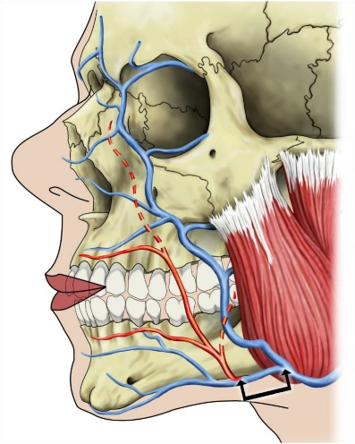
Fig . 4. An anatomical image showing where anastomosis takes place with the facial artery in closing the OAC using RFFF

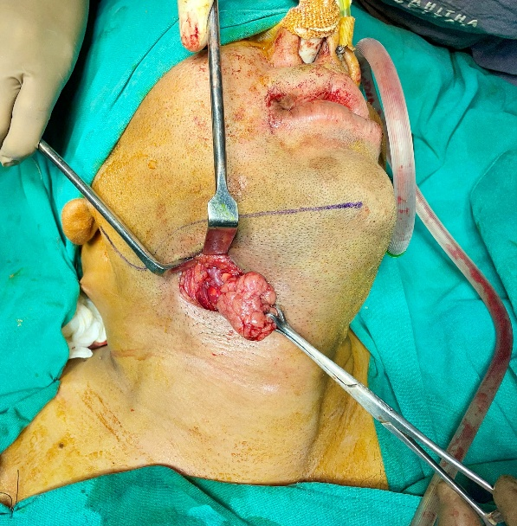
Fig. 5. Intra – operative image showing the submandibular incision and removal of the submandibular gland.

A submandibular incision was then placed to access the recipient vessels and facilitate flap inset. During this stage, the right submandibular gland was excised to provide adequate space and exposure for vessel preparation and flap positioning. The flap was subsequently tunnelled and inset into the defect, recreating the palatal partition and restoring intraoral continuity. Meticulous suturing was carried out to secure the flap margins, ensuring tension-free closure and optimal mucosal adaptation.

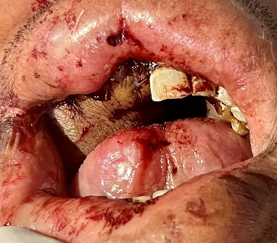
Fig. 6. Post operative picture showing a tension free closure of the RFFF to close the OAC.

Clinical Significance:
This approach highlights the versatility of the radial forearm flap in intraoral reconstruction. Its pliability permits precise contouring to complex palatal defects, while the long pedicle length allows tension-free microvascular anastomosis. Removal of the submandibular gland facilitated vessel access and improved flap positioning, ensuring both functional restoration and long-term viability of the reconstruction.

Donor Site Closure:
After elevation of the fascio-cutaneous radial forearm flap, the resultant forearm defect was assessed. Given the size and depth of the exposed area, primary closure was not feasible. Therefore, the defect
was resurfaced using a split-thickness skin graft harvested from the abdominal (stomach) region. The graft was carefully meshed and secured over the forearm defect, ensuring complete coverage of the exposed tendons and underlying structures. Meticulous attention was paid to graft placement and fixation to promote optimal adherence and vascularization. The donor site was dressed with appropriate immobilization to facilitate graft take and minimize shear forces.
Clinical Rationale:
The use of a split-thickness skin graft for donor site closure is standard practice in radial forearm flap harvest, as it provides reliable coverage, reduces morbidity, and promotes rapid healing. Harvesting from the abdominal region offers a broad, accessible donor surface with favourable healing characteristics. This approach ensures functional preservation of the forearm while maintaining acceptable cosmetic outcomes.
4. Postoperative Management Protocol
ICU Care (First 72 hours):
- Continuous hemodynamic monitoring (BP, HR, oxygen saturation).
- Strict fluid and electrolyte balance.
- Pain control with scheduled analgesics (NSAIDs ± opioids).
- Prophylactic antibiotics to prevent secondary infection.
- Anticoagulants in prophylactic doses to reduce risk of microvascular thrombosis.
Flap Monitoring:
- Hourly checks for the first 24 hours, then every 2–4 hours.
- Parameters: colour, temperature, capillary refill, turgor, bleeding on pin-prick.
- Documentation of findings to detect early vascular compromise.
Nutrition and Feeding:
- Enteral feeding via nasogastric tube for one week to protect intraoral reconstruction.
- Transition to oral feeding once flap integration and mucosal healing are stable.
- High-protein supplementation to promote wound healing.
Metabolic and Systemic Support:
- Regular monitoring of hydration status and electrolytes.
- Maintenance of normothermia to optimize microvascular circulation.
- No glycemic surveillance required (patient is non-diabetic), but routine blood sugar checks performed as part of standard perioperative care.
Medications:
- Antibiotics: Broad-spectrum coverage (e.g., ceftriaxone + metronidazole) continued for 5–7 days.
- Analgesics: NSAIDs and opioids as required for pain control.
- Anticoagulants: Low-molecular-weight heparin in prophylactic doses.
- Supportive therapy: Multivitamins and nutritional supplements to enhance recovery.
Follow-up and Outcome:
- No vascular compromise noted during immediate or early postoperative period.
- At three-month follow-up:
  - Resolution of nasal regurgitation.
  - Improved articulation and speech resonance.
  - Stable flap integration with surrounding tissues.
  - Donor site healed satisfactorily with split-thickness skin graft, without functional morbidity.
Follow-up and Outcome:
At the three-month follow-up, the patient exhibited satisfactory functional recovery. Nasal regurgitation had resolved completely, articulation was markedly improved, and the flap showed stable integration with the surrounding tissues. The pliability of the radial forearm flap allowed it to conform well to the palatal defect, restoring intraoral separation and improving speech resonance. The donor site healed satisfactorily with the split-thickness skin graft, and no functional morbidity of the forearm was noted. Overall, the reconstruction achieved both structural and functional rehabilitation, underscoring the reliability of the radial forearm flap in complex maxillofacial defects.
5. Discussion
The angioinvasive nature of mucormycosis leads to vascular thrombosis, ischemia, and rapid necrosis of maxillofacial tissues, necessitating radical surgical excision to achieve disease clearance [7]. Oral and maxillofacial surgeons recognize that incomplete debridement predisposes patients to recurrence and mortality, making aggressive resection unavoidable despite the functional and aesthetic consequences [8]. However, such extensive removal often results in oroantral or oronasal communications, severely impairing speech, swallowing, and overall quality of life [9]. Reconstruction, therefore, is not merely a technical exercise but a critical component of holistic patient rehabilitation.
From the surgeon’s standpoint, the choice of reconstructive modality hinges on defect size, anatomical location, and patient systemic status. For small, well-defined defects, local flaps such as the buccal fat pad or palatal rotational flaps are favored. They offer straightforward closure, minimal donor site morbidity, and short operative times, which are advantageous in medically fragile patients [10]. Yet, oral surgeons acknowledge their limitations in providing adequate bulk or restoring complex three-dimensional anatomy, making them unsuitable for extensive composite losses.
In cases of larger maxillary or palatal defects, regional flaps such as the temporalis muscle flap provide a dependable source of vascularized tissue [11]. Surgeons often resort to this option when free tissue transfer is contraindicated due to systemic instability or lack of microsurgical facilities. While effective in filling dead space and resisting infection, drawbacks include altered mandibular dynamics, restricted mouth opening, and compromised facial aesthetics, which must be carefully weighed against functional gains.
For extensive composite defects, microvascular free tissue transfer has emerged as the gold standard [12]. Oral and maxillofacial surgeons emphasize its superiority in restoring the oral–nasal partition, providing vascularized tissue resistant to recurrent fungal invasion, and supporting prosthetic rehabilitation. Free flaps such as the radial forearm, anterolateral thigh, or fibula can be precisely tailored to defect dimensions, enabling restoration of speech, swallowing, and mastication. Although technically demanding and resource-intensive, the functional and quality-of-life outcomes justify the complexity of microsurgical reconstruction.
Ultimately, reconstruction in mucormycosis cases is guided by the principle that survival must be paired with meaningful functional recovery. Oral surgeons must balance the aggressiveness of disease clearance with the sophistication of reconstruction, ensuring that patients not only overcome infection but also regain oral competence, facial aesthetics, and social reintegration [7–12].
The radial forearm free flap offers unique benefits in oral surgery reconstruction:
- Thin, pliable tissue: Ideal for intraoral lining and palatal contouring [13].
- Long, reliable pedicle: Facilitates tension-free microvascular anastomosis to facial vessels [14].
- Minimal bulk: Prevents obstruction of the oral cavity and maintains functional space [15].
- Ease of shaping: Allows precise adaptation to complex intraoral defects [16].
- High success rates: Even in medically compromised patients, survival exceeds 95% [17].
Comparative studies in maxillary reconstruction demonstrate superior outcomes in speech intelligibility, swallowing efficiency, and patient satisfaction when free tissue transfer is employed [18]. The RFFF, in particular, provides predictable results with minimal donor site morbidity when harvested from the non-dominant forearm [19].
5.3 Post-COVID Context
The COVID-19 pandemic saw a surge in mucormycosis cases, particularly in India, due to immunosuppression, corticosteroid use, and uncontrolled diabetes [20]. This led to unprecedented demand for reconstructive surgery in oral and maxillofacial practice. Early reconstruction following radical excision has been shown to improve psychological recovery, reduce social stigma, and restore essential oral functions. The RFFF, with its reliability and adaptability, has become a cornerstone in post-COVID mucormycosis rehabilitation [20].

6. Conclusion
Oroantral and oronasal communications following mucormycosis represent one of the most formidable reconstructive challenges in oral and maxillofacial surgery [7,8]. Radical excision, though lifesaving, often results in extensive defects that compromise essential functions such as speech, swallowing, mastication, and overall quality of life [9]. For the oral surgeon, the reconstructive strategy must therefore balance oncologic safety with functional rehabilitation, ensuring that the patient regains not only survival but also dignity and social reintegration.
Among the available options, the radial forearm free flap (RFFF) has emerged as a dependable and versatile solution [13–17]. Its thin, pliable, and well-vascularized tissue allows precise separation of oral and sinonasal cavities, restoration of palatal integrity, and re-establishment of intraoral competence. From a surgical standpoint, the RFFF offers technical reliability, with consistent vascular anatomy and ease of microvascular anastomosis, making it particularly suitable for complex post-mucormycosis defects. Functionally, it supports speech intelligibility, swallowing efficiency, and prosthetic rehabilitation, thereby directly addressing the patient’s quality-of-life concerns.
In carefully selected patients—those with controlled infection, optimized systemic status, and adequate recipient vessels—microvascular reconstruction using RFFF yields predictable and durable outcomes [18–20]. Oral surgeons emphasize the importance of timing: reconstruction should be attempted only after thorough debridement and stabilization of systemic comorbidities, ensuring that the flap is not jeopardized by residual infection or poor host factors. When executed under these principles, RFFF reconstruction demonstrates long-term stability, minimal donor site morbidity, and adaptability to adjunctive prosthetic or dental rehabilitation.
From the oral surgery perspective, the RFFF represents more than a technical solution; it embodies a philosophy of patient-centered care. It integrates surgical reliability with functional rehabilitation, aligning with the broader goals of restoring oral competence, facial harmony, and psychosocial well-being. In the post-mucormycosis era, where radical excision has become a frequent necessity, the radial forearm free flap stands out as one of the most versatile and effective reconstructive options, bridging the gap between survival and meaningful recovery [7–9,13–20].

Ethical Approval and Informed Consent
This case report was conducted in accordance with the ethical principles outlined in the Declaration of Helsinki. The patient provided written informed consent for surgical management, clinical documentation, and publication of anonymized data and images. All identifying details have been omitted to ensure confidentiality.

References
- Cornely OA, Alastruey-Izquierdo A, Arenz D, et al. Global guideline for the diagnosis and management of mucormycosis. Lancet Infect Dis. 2019;19(12):e405–e421.
DOI: 10.1016/S1473-3099(19)30312-3
PubMed: 31711911
- Singh AK, Singh R, Joshi SR, Misra A. Mucormycosis in COVID-19: A systematic review of cases reported worldwide and in India. Diabetes Metab Syndr. 2021;15(4):102146.
DOI: 10.1016/j.dsx.2021.05.019
PubMed: 34044164
- Sen M, Honavar SG, Bansal R, et al. Epidemiology, clinical profile, management, and outcome of COVID-19-associated rhino-orbital-cerebral mucormycosis in 2826 patients in India (COSMIC study). Indian J Ophthalmol. 2021;69(7):1670–1692.
DOI: 10.4103/ijo.IJO_1565_21
PubMed: 34156034
- Therakathu J, Prabhu S, Irodi A, et al. Imaging features of rhinocerebral mucormycosis: A study of 43 patients. Egypt J Radiol Nucl Med. 2018;49(2):447–452.
DOI: 10.1016/j.ejrnm.2018.01.005
- Spellberg B, Edwards J Jr, Ibrahim A. Novel perspectives on mucormycosis: pathophysiology, presentation, and management. Clin Microbiol Rev. 2005;18(3):556–569.
DOI: 10.1128/CMR.18.3.556-569.2005
PubMed: 16020690
- Killey HC, Kay LW. Observations based on the surgical closure of 362 oro-antral fistulas. Int Surg. 1972;57(7):545–549.
PubMed: 5042434
(No DOI available)
- Cordeiro PG, Santamaria E. A classification system and algorithm for reconstruction of maxillectomy and midfacial defects. Plast Reconstr Surg. 2000;105(7):2331–2346.
DOI: 10.1097/00006534-200006000-00004
PubMed: 10845285
- Herrera DA, Dublin AB, Ormsby EL, Aminpour S, Howell LP. Imaging findings of rhinocerebral mucormycosis. Skull Base. 2009;19(2):117–125.
DOI: 10.1055/s-0028-1096209
PubMed: 19707554
- Middlebrooks EH, Frost CJ, De Jesus RO, et al. Imaging of sino-orbital fungal infections: a comprehensive review. AJNR Am J Neuroradiol. 2021;42(3):404–412.
DOI: 10.3174/ajnr.A6952
PubMed: 33558355
- Yang GF, Chen PJ, Gao YZ. Forearm free skin flap transplantation. Br J Plast Surg. 1981;34(2):162–165.
DOI: 10.1016/0007-1226(81)90064-7
PubMed: 7021995
- Wei FC, Jain V, Celik N, Chen HC, Chuang DC, Lin YT. Have we found an ideal soft-tissue flap? An experience with 672 anterolateral thigh flaps. Plast Reconstr Surg. 2002;109(7):2219–2226.
DOI: 10.1097/00006534-200206000-00007
PubMed: 12045538
- Ibrahim AS, Spellberg B, Walsh TJ, Kontoyiannis DP. Pathogenesis of mucormycosis. Clin Infect Dis. 2012;54(Suppl 1):S16–S22.
DOI: 10.1093/cid/cir865
PubMed: 22247441
- Rapidis AD, et al. The radial forearm free flap in the reconstruction of intraoral defects. J Oral Maxillofac Surg. 2000;58(2):140–145.
DOI: 10.1016/S0278-2391(00)00228-2
PubMed: 10670500
- Antonyshyn O, et al. Radial forearm free flap in head and neck reconstruction. Head Neck Surg. 1984;6(5):370–383.
DOI: 10.1002/hed.2890060504
PubMed: 6382590
- Brown JS, Shaw RJ. Reconstruction of the maxilla and midface: introducing a new classification. Lancet Oncol. 2016;17(3):e248–e260.
DOI: 10.1016/S1470-2045(16)00043-5
PubMed: 26944036
- Wong CH, Wei FC. Microsurgical free flap in head and neck reconstruction. Ann Plast Surg. 2007;59(2):210–216.
DOI: 10.1097/SAP.0b013e31802f5c9a
PubMed: 17667415
- Soutar DS, et al. The radial forearm flap: a versatile method for intraoral reconstruction. Br J Plast Surg. 1983;36(1):1–8.
DOI: 10.1016/0007-1226(83)90002-3
PubMed: 6830826
- Rogers SN, Lowe D, McNally D, Brown JS, Vaughan ED. Health-related quality of life after maxillectomy: a comparison between prosthetic obturation and free flap. Br J Oral Maxillofac Surg. 2003;41(1):7–14.
DOI: 10.1016/S0266-4356(02)00267-7
PubMed: 12554053
- Mehrotra D, et al. Free flap reconstruction in mucormycosis patients: experience from India. Natl Med J India. 2021;34(6):341–345.
DOI: 10.4103/0970-258X.333450
PubMed: 35028354
- Selvaraj V, et al. Microvascular reconstruction in post-mucormycosis maxillofacial defects: case series. J Maxillofac Oral Surg. 2022;21(2):282–288.
DOI: 10.1007/s12663-021-01605-1
PubMed: 35242319

