Phenotypic Assessment of Bacterial and Fungal Colonization on Mobile Phone Earpieces of University Students in Port Harcourt, Nigeria

ABSTRACT
Background: Mobile phones are personal devices handled frequently and may serve as reservoirs for pathogenic microorganisms, posing potential public health risks, particularly in communal settings such as universities.
Aim: This study investigated bacterial and fungal colonization of mobile phone earpieces used by university students and evaluated the antimicrobial susceptibility patterns of bacterial isolates.
Methods: A cross-sectional descriptive study was conducted on twenty (20) mobile phone earpiece samples collected from students at Rivers State University, Port Harcourt, Nigeria. Swab samples were cultured on selective bacteriological and mycological media. Bacterial isolates were identified based on colonial morphology, Gram staining, and biochemical tests, while fungi were identified using macroscopic and microscopic characteristics. Antimicrobial susceptibility testing of bacterial isolates was performed using the Kirby–Bauer disk diffusion method in accordance with CLSI guidelines (CLSI, 2023).
Results: All earpieces (100%) showed microbial growth. Bacterial isolates included Staphylococcus aureus (75%), Staphylococcus epidermidis (60%), Escherichia coli (25%), and Pseudomonas aeruginosa (20%). Fungal isolates included Candida spp. (40%) and Aspergillus spp. (25%). Antimicrobial susceptibility testing revealed higher sensitivity to Ciprofloxacin (75–87%) and Gentamicin (75–80%), while some isolates exhibited reduced susceptibility to commonly used antibiotics.
Conclusion: Mobile phone earpieces used by university students are contaminated with potentially pathogenic bacteria and fungi, emphasizing their role as vectors for microbial transmission. Regular disinfection of mobile devices and reinforcement of personal hygiene practices are recommended to reduce infection risks.
Keywords: Mobile phones; Earpieces; Microbial colonization; Antibiotic susceptibility; University students; Nigeria
INTRODUCTION
Mobile phones have become ubiquitous, serving not only as tools for communication but also as essential instruments for academic, social, and professional purposes. Their frequent handling and constant exposure to diverse environments make these devices potential reservoirs for microorganisms, including bacteria and fungi (Zenbaba et al., 2023; Kayed et al., 2023). The risk of contamination is not restricted to healthcare settings; community and academic environments are equally vulnerable, where mobile devices can facilitate the indirect transfer of pathogenic microorganisms between users or from contaminated surfaces to mucous membranes and skin.
Studies conducted across various student populations have documented the presence of pathogenic bacteria on mobile phones, including Staphylococcus aureus, Escherichia coli, and Pseudomonas aeruginosa (Adomi, 2022; Shilpa et al., 2025). These organisms can act as opportunistic pathogens, causing infections particularly in immunocompromised individuals or those with minor injuries. Frequent handling of mobile devices without prior hand hygiene enhances the potential for microbial transfer, making personal devices important but often overlooked vectors of infection (Mbanga et al., 2021).
In addition to bacterial contamination, fungal colonization has also been reported on mobile phones. Species such as Candida albicans, Candida tropicalis, and Aspergillus niger have been isolated from both handsets and accessories like earpieces, reflecting the ability of warm, moist environments to support fungal survival and growth (Dubljanin et al., 2022; Ahmed et al., 2023). Fungal contamination poses additional health risks, particularly for individuals with respiratory vulnerabilities or compromised immune systems.
A growing concern in the study of mobile phone contamination is the emergence of antimicrobial-resistant microorganisms. Recent investigations have reported the presence of multidrug-resistant bacteria, including methicillin-resistant Staphylococcus aureus (MRSA) and multidrug-resistant Pseudomonas aeruginosa, on mobile phones in both healthcare and community settings (Kayed et al., 2023; Shilpa et al., 2025). These findings highlight mobile phones as potential reservoirs for resistant strains, raising concerns about the role of personal electronic devices in the dissemination of antimicrobial resistance in the broader community (Al-Azzam et al., 2022; Zubair et al., 2021).
Despite the growing body of literature on mobile phone contamination, few studies have specifically targeted mobile phone earpieces. Earpieces differ from handsets in that they maintain prolonged contact with the ear canal, a region rich in sebum and moisture, potentially creating an ideal environment for microbial colonization (Olayemi et al., 2020). The close proximity to skin and mucous membranes may facilitate more direct microbial transfer, yet earpieces are often neglected in hygiene practices and are rarely cleaned or disinfected.
This study seeks to address this knowledge gap by evaluating bacterial and fungal contamination of mobile phone earpieces among university students in Port Harcourt, Nigeria. Additionally, the study aims to determine the antibiotic susceptibility patterns of bacterial isolates recovered from these devices. The findings are expected to contribute to awareness regarding mobile device hygiene, provide baseline data on microbial contamination in academic settings, and inform practical strategies for minimizing the risk of microbial transmission through personal electronic devices.

MATERIALS AND METHODS
Study Design and Area
This cross-sectional descriptive study was conducted among students at Rivers State University, Port Harcourt, Nigeria. The investigation focused on bacterial and fungal contamination of mobile phone earpieces and the antimicrobial susceptibility patterns of bacterial isolates.
Sample Collection
Twenty (20) mobile phone earpieces were randomly collected from consenting students. Sterile cotton swabs moistened with sterile normal saline were used to swab the surfaces of the earpieces. Swabs were immediately transported to the microbiology laboratory for culture and analysis.
Isolation and Identification of Microorganisms
Swabs were cultured on Nutrient Agar, MacConkey Agar, Mannitol Salt Agar, and Sabouraud Dextrose Agar using standard microbiological techniques. Bacterial cultures were incubated aerobically at 37 °C for 24–48 hours, while fungal cultures were incubated at 25–28 °C for up to 5 days.
Bacterial isolates were identified based on colony morphology, Gram staining, and standard biochemical tests, including catalase, coagulase, oxidase, indole, citrate utilization, and sugar fermentation tests (Cheesbrough, 2019). Fungal isolates were identified using macroscopic colony characteristics and lactophenol cotton blue staining (Dubljanin et al., 2022).
Antimicrobial Susceptibility Testing
Bacterial isolates were subjected to antimicrobial susceptibility testing using the Kirby–Bauer disk diffusion method on Mueller–Hinton Agar. The antibiotics tested were ciprofloxacin (10 µg), gentamicin (10 µg), erythromycin (15 µg), amoxicillin (25 µg), ceftriaxone (30 µg), and tetracycline (30 µg), chosen based on common clinical usage in the study region. Zones of inhibition were measured, and susceptibility interpreted according to CLSI guidelines (CLSI, 2023).
Ethical Consideration
Ethical approval was obtained from the appropriate institutional review board. Participation was voluntary, and informed consent was obtained from all students before sample collection. Confidentiality was strictly maintained.
RESULTS
Microbial Contamination of Mobile Phone Earpieces
All twenty earpieces (100%) exhibited microbial growth. Both bacterial and fungal species were isolated, with bacteria being more prevalent.

Bacterial Isolates
Staphylococcus aureus was the most frequently recovered bacterial species, present in 15 of 20 earpieces (75%), followed by Staphylococcus epidermidis in 12 earpieces (60%). Enteric bacteria such as Escherichia coli were detected in 25% of samples, and Pseudomonas aeruginosa in 20% (Table 1, Figure 1).

Table 1. Frequency and Percentage of Bacterial Isolates (n=20 earpieces)
Bacterial Species | Number of Earpieces Contaminated | Percentage (%)
Staphylococcus aureus | 15 | 75
Staphylococcus epidermidis | 12 | 60
Escherichia coli | 5 | 25
Pseudomonas aeruginosa | 4 | 20

Key: S = Sensitive; NA = Not applicable
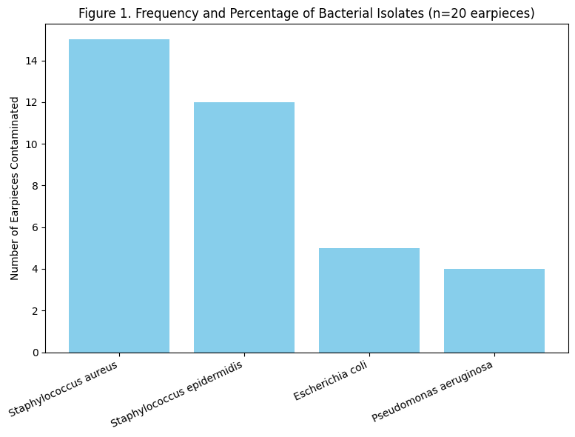

Fungal Isolates
Fungal contamination was observed in a smaller proportion of samples. Candida spp. were present in 8 earpieces (40%), while Aspergillus spp. was isolated from 5 earpieces (25%) (Table 2, Figure 2).
Table 2. Frequency and Percentage of Fungal Isolates
Fungal Species | Number of Earpieces Contaminated | Percentage (%)
Candida spp. | 8 | 40
Aspergillus spp | 5 | 25

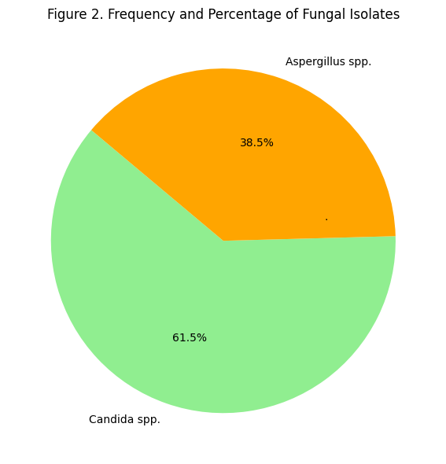
Antimicrobial Susceptibility Patterns
Bacterial isolates exhibited varying susceptibility patterns. Ciprofloxacin and Gentamicin demonstrated the highest efficacy, while resistance to Erythromycin, Amoxicillin, and Tetracycline was observed in some isolates. Multidrug resistance was noted in S. aureus and P. aeruginosa (Table 3, Figure 3).

Table 3. Antibiotic Susceptibility of Bacterial Isolates (n=36 isolates)
Antibiotic | S. aureus (n=15) | S. epidermidis (n=12) | E. coli (n=5) | P. aeruginosa (n=4)
Ciprofloxacin | 13 (87%) S | 10 (83%) S | 4 (80%) S | 3 (75%) S
Gentamicin | 12 (80%) S | 9 (75%) S | 4 (80%) S
Erythromycin | 9 (60%) S | 7 (58%) S | NA | NA
Amoxicillin | 7 (47%) S | 5 (42%) S | 3 (60%) S | 2 (50%) S
Ceftriaxone | 10 (67%) S | 8 (67%) S | 4 (80%) S | 3 (75%) S
Tetracycline | 8 (53%) S | 7 (58%) S | 3 (60%) S | 2 (50%) S
Key: S = Sensitive; NA = Not applicable
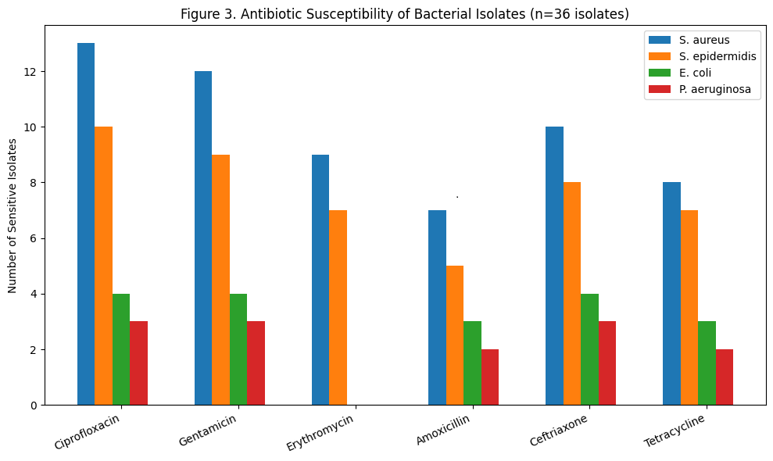
DISCUSSION
This study revealed that all mobile phone earpieces (100%) sampled from university students were contaminated with bacterial and fungal organisms, indicating a high prevalence of microbial colonization. This finding aligns with prior research showing extensive microbial contamination on personal electronic devices in both healthcare and community settings (Zenbaba et al., 2023; Kayed et al., 2023). The high level of contamination can be attributed to frequent handling, exposure to varied environments, and limited routine cleaning of devices, particularly earpieces, which are in direct contact with the skin and ear canal.
Staphylococcus aureus was the predominant bacterial isolate (75%), followed by Staphylococcus epidermidis (60%). This is consistent with studies by Adomi (2022) and Shilpa et al. (2025), who reported high prevalence of S. aureus and coagulase-negative staphylococci on mobile phones of students and healthcare workers. The predominance of staphylococcal species is expected, as they are part of the normal skin flora and are readily transferred to devices during handling. Their presence on earpieces is concerning because S. aureus can cause skin and soft tissue infections, otitis externa, and in immunocompromised individuals, more severe infections such as bacteremia (Kumar et al., 2021).
The isolation of Escherichia coli (25%) suggests possible fecal contamination, likely arising from inadequate hand hygiene after using the toilet. This finding is in agreement with studies conducted by Al-Ghamdi et al. (2021), which reported enteric bacteria on mobile phones in non-clinical student populations. The detection of Pseudomonas aeruginosa (20%) is particularly significant given its role as an opportunistic pathogen, capable of causing respiratory, urinary, and wound infections (Murray et al., 2022). The presence of P. aeruginosa may be attributed to environmental exposure, as this organism can survive in damp surfaces, and possibly from waterborne contamination during earpiece cleaning with insufficiently sanitized water.
Fungal isolates included Candida spp. (40%) and Aspergillus spp. (25%). The presence of Candida is consistent with findings by Dubljanin et al. (2022), who reported Candida contamination on student mobile devices. Earpieces create warm and humid microenvironments that favor fungal survival and growth. Aspergillus spp. contamination indicates environmental deposition of spores from air or dust, a finding corroborated by previous studies in community and healthcare settings (Sandle, 2018). Fungal contamination is particularly relevant for immunocompromised individuals, as exposure to Candida and Aspergillus can lead to opportunistic infections.
Antimicrobial susceptibility testing revealed high sensitivity to Ciprofloxacin (75–87%) and Gentamicin (75–80%), while moderate resistance was observed against Amoxicillin, Erythromycin, and Tetracycline. Multidrug resistance was noted in S. aureus and P. aeruginosa. These results are in line with studies by Kayed et al. (2023) and Shilpa et al. (2025), which reported mobile phones as potential reservoirs of multidrug-resistant bacteria. The observed resistance may be due to widespread and often inappropriate use of antibiotics among students, self-medication practices, or horizontal gene transfer among bacteria on device surfaces.
The higher susceptibility to Ciprofloxacin and Gentamicin may be due to their less frequent use in the student population compared to commonly available antibiotics like Amoxicillin and Tetracycline, reducing selective pressure. Conversely, the moderate resistance observed is a public health concern, highlighting mobile phone earpieces as vectors for the dissemination of antimicrobial-resistant organisms.
The 100% contamination rate reported in this study is slightly higher than previous reports. For example, Adomi (2022) reported 92% contamination of mobile phones among students, and Zenbaba et al. (2023) reported contamination rates of 85–90% among healthcare workers’ phones in Africa. The slightly higher prevalence in this study may reflect the exclusive focus on earpieces, which are in closer contact with skin and ear secretions compared to handsets.
The predominance of staphylococcal species is consistent with both community- and hospital-based studies (Shilpa et al., 2025; Al-Ghamdi et al., 2021). Similarly, the presence of enteric bacteria like E. coli on devices has been widely reported in studies assessing hygiene practices among students and healthcare workers (Zenbaba et al., 2023). The presence of fungal isolates, particularly Candida spp., is corroborated by Dubljanin et al. (2022) and supports the notion that humid microenvironments on device accessories promote fungal growth.
CONCLUSION
This study demonstrates a high prevalence of bacterial and fungal contamination on mobile phone earpieces among university students in Port Harcourt, Nigeria. Staphylococcus aureus and Staphylococcus epidermidis were the predominant bacterial isolates, while Candida spp. was the most frequently isolated fungus. The presence of multidrug-resistant strains highlights the public health implications of mobile phone use in communal settings. These findings emphasize the importance of regular disinfection of mobile devices, particularly earpieces, using alcohol-based wipes or other approved disinfectants. Reinforcing proper hand hygiene practices before and after handling electronic devices is essential to reduce microbial transmission. The results also indicate a need for awareness campaigns and institutional policies that recommend routine cleaning of electronic devices. Future studies with larger sample sizes, inclusion of other device types, and molecular characterization of isolates would provide a more comprehensive understanding of microbial contamination and antimicrobial resistance patterns. Overall, mobile phone earpieces serve as reservoirs for potentially pathogenic microorganisms, including multidrug-resistant bacteria and opportunistic fungi, highlighting the necessity for targeted hygiene interventions to reduce the risk of microbial transmission in university and community settings.
RECOMMENDATIONS
University students and other users of mobile devices should adopt regular cleaning practices for their earpieces and handsets. Alcohol-based wipes or suitable disinfectants should be used to reduce microbial load effectively. Reinforcement of proper hand hygiene before and after handling devices is crucial to minimize the transfer of microorganisms. Educational programs and awareness campaigns should be implemented in universities and other communal settings to highlight the risks associated with contaminated mobile devices and to promote hygiene-conscious behavior. Additionally, institutions should consider developing guidelines or policies recommending routine cleaning of electronic devices, particularly in high-contact environments such as laboratories, libraries, and healthcare-related settings. Future research should expand on this study by including larger sample sizes, examining different types of mobile devices, and conducting molecular analyses to better understand antimicrobial resistance mechanisms and the diversity of microorganisms present. These combined measures would contribute to mitigating the public health risks posed by contaminated mobile phone earpieces.

COMPETING INTERESTS DISCLAIMER:
Authors have declared that they have no known competing financial interests OR non-financial interests OR personal relationships that could have appeared to influence the work reported in this paper.

REFERENCES
Ahmed, S., Khan, M., & Al-Farhan, H. (2023). Fungal colonization on mobile devices: A study among university students. Journal of Infection and Public Health, 16(2), 210–218. https://doi.org/10.1016/j.jiph.2022.12.004
Adomi, P. O. (2022). Microbial colonization and multidrug resistance patterns of phones of healthcare workers in Delta State, Nigeria. International Journal of Microbiology and Biotechnology, 7(2), 58–63. https://doi.org/10.11648/j.ijmb.20220702.12
Al-Azzam, S., Alzoubi, K., & Saadeh, R. (2022). Antimicrobial resistance on personal devices: A systematic review. International Journal of Environmental Research and Public Health, 19(18), 11543. https://doi.org/10.3390/ijerph191811543
Al-Ghamdi, S., Khan, A., & Asif, M. (2021). Microbial contamination of mobile phones used by university students: Public health implications. Journal of Infection and Public Health, 14(5), 617–624. https://doi.org/10.1016/j.jiph.2021.02.012
Cheesbrough, M. (2019). District laboratory practice in tropical countries (Part 2, 2nd ed.). Cambridge University Press.
Clinical and Laboratory Standards Institute. (2023). Performance standards for antimicrobial susceptibility testing (33rd ed., CLSI supplement M100). Wayne, PA: CLSI.
Dubljanin, E., Crvenkov, T., Vujčić, I., Šipetić Grujičić, S., Dubljanin, J., & Džamić, A. (2022). Fungal contamination of medical students’ mobile phones: A cross-sectional study. Scientific Reports, 12, 16852. https://doi.org/10.1038/s41598-022-21118-2
Kayed, K., Khoder, G., Farhat, J., & Ghemrawi, R. (2023). Mobile phones as reservoirs of resistant bacteria during the COVID-19 pandemic. Microorganisms, 11(2), 523. https://doi.org/10.3390/microorganisms11020523
Kumar, S., Rani, M., & Singh, D. (2021). Pathogenicity and antimicrobial resistance of Staphylococcus aureus isolated from mobile devices. Journal of Infection in Developing Countries, 15(11), 1635–1642. https://doi.org/10.3855/jidc.14935
Mbanga, J., Moyo, P., & Chigona, W. (2021). Bacterial contamination of smartphones and associated hygiene practices among university students. BMC Infectious Diseases, 21, 115. https://doi.org/10.1186/s12879-021-05820-3
Murray, P. R., Rosenthal, K. S., & Pfaller, M. A. (2022). Medical microbiology (9th ed.). Elsevier.
Olayemi, E., Akinlabi, O., & Eze, U. (2020). Microbial contamination of earphones and implications for public health. Journal of Environmental Health Science, 56(4), 310–318. https://doi.org/10.1007/s12199-020-00897-4
Sandle, T. (2018). Fungal contamination of healthcare environments: Implications for clinical microbiology. Current Fungal Infection Reports, 12(3), 145–154. https://doi.org/10.1007/s12281-018-0312-9
Shilpa, K., Niranjan, D., Rafiq, S. H., Nargees, A., & Bernaitis, L. (2025). Mobile phones as reservoirs of microorganisms among medical students. World Journal of Applied Medical Sciences.
Zenbaba, D., Sahiledengle, B., Beressa, G., Desta, F., Teferu, Z., Nugusu, F., & Chattu, V. K. (2023). Bacterial contamination of healthcare workers’ mobile phones in Africa: A systematic review and meta-analysis. Tropical Medicine and Health, 51(1), 55. https://doi.org/10.1186/s41182-023-00547-3
Zubair, M., Alnasser, S., & Alqahtani, F. (2021). Mobile devices as vectors of antimicrobial-resistant pathogens: An overview. Saudi Journal of Biological Sciences, 28(10), 5773–5781. https://doi.org/10.1016/j.sjbs.2021.06.065

