Integrating Artificial Intelligence in Anesthesia Practice: Innovative Applications, Ethical Considerations, and Future Prospects in Saudi Arabia

.
ABSTRACT

Artificial intelligence (AI) is now a crucial part of modern anesthesia and healthcare, changing clinical practice with precision, safety, and efficiency. AI in Saudi Arabia helps predict how patients will react, provides live monitoring assistance, and aids clinical judgments. Even though these technologies boost perioperative outcomes, worries about data privacy, algorithmic openness, and legal liability linger. Doctors also voice concerns about preparedness and training, highlighting the need for a step-by-step, ethical introduction. Vision 2030 and Saudi Data and Artificial Intelligence Authority (SDAIA) are examples of national projects that seek to strengthen digital infrastructure, governance, and innovation. Human-centered AI systems are expected to be key to the future of anesthesia, improving patient safety, care customization, and clinical accuracy.

Keywords: Artificial intelligence, Anesthesia, Saudi Arabia, Patient safety, Future integration

1. INTRODUCTION
Artificial intelligence (AI) is showing promise in healthcare, particularly in anesthesia, where it can deliver innovative enhancements to patient care. According to recent studies, it has potential for patient monitoring and the analysis of ECGs, blood pressure, oxygen saturation, and respiratory parameters. It can also identify early adverse complications, like hypotension, breathing problems, and irregular heartbeats. Ongoing observation enables anesthesiologists to act swiftly and effectively, and these tools can improve patient outcomes, reduce complications, and enhance the overall effectiveness of perioperative care [1].
AI systems utilize deep learning to predict the start and advancement of chronic pain, such as low back pain or osteoarthritis, with greater precision than conventional clinical methods; pain management is one application of this technology. Anesthesiologists can personalize pain management through these predictive models, which permit them to adjust analgesic regimens, predict future outcomes, and refine medication dosages [1].
AI’s ability to gather electronic health record (EHR) data may help with surgery decisions by suggesting anesthesia, drugs, and aftercare plans. Anesthesiologists can use these decision support tools to figure out the best anesthesia strategy and lower the chances of mistakes, notably in intricate or dangerous operations. Studies have proven that AI can predict events during surgery and assist in postoperative care planning [1].
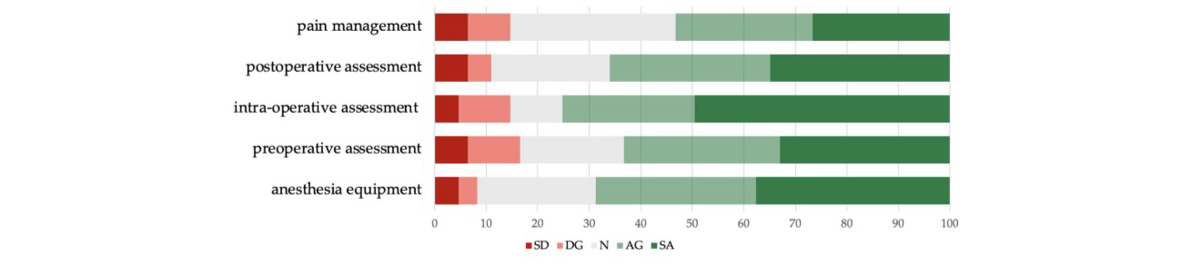
Saudi Arabian healthcare workers show excitement and reservations regarding the applications. In a national survey, the majority (73.39%) of anesthesiologists thought that AI could be included in various settings around surgery, for example, monitoring depth of anesthesia, controlling medication administration, predicting issues with the airway, and taking care of pain after the operation. Moreover, anesthesiologists recognized substantial patient gains like increased access to healthcare and improved patient learning and direction during their care [2].
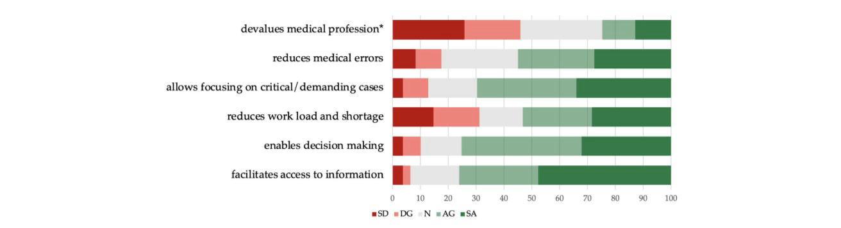
Fig1. Participants' perceptions on Artificial Intelligence (AI) uses in anesthesia practice [2].

Fig2. Participants' perceptions on the benefits of Artificial Intelligence (AI) for healthcare personnel [2].


Fig3. Participants’ perceptions of the benefits of Artificial Intelligence (AI) for patients [2].
Even with these promising uses, research often points out the challenges for safe and effective incorporation. These challenges encompass the demand for datasets that are both high-quality and representative, worries regarding algorithmic bias, the proprietary aspect of certain AI systems, and ethical aspects pertaining to transparency and patient authorization. Despite Saudi Arabia's development of institutional structures such as the Saudi Data and Artificial Intelligence Authority (SDAIA) for national AI healthcare support, some hospital surveys reveal a need for structured plans and expert adoption teams [2].

Fig4. Respondents' opinion on current use of Artificial Intelligence (AI) in their workplace [2].
Healthcare's digital transformation is the main reason for AI in modern medicine. Patient privacy is a legal requirement in Saudi Arabia, as per Article 21 of the Health Professions Practice Law. Yet, since AI systems need lots of sensitive data, the risk of misuse grows with medical errors. From denial-of-service attacks to clinical data manipulation, every digital layer of AI systems faces threats that compromise patient safety and national health security [3]. Doctor surveys also indicate a lack of legal knowledge, with most not trained in Al law and unsure about adhering to national data regulations such as the Personal Data Protection Law [4].
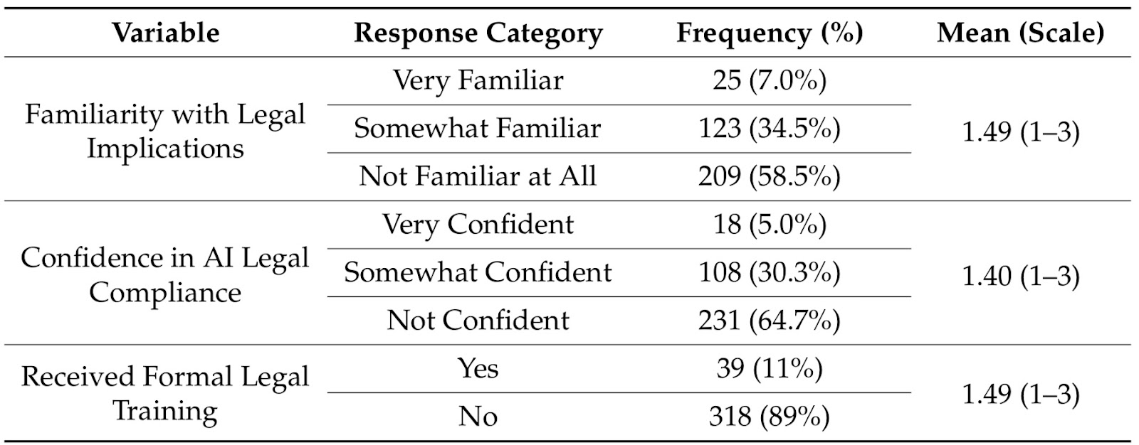
Table 1. Clinicians' familiarity, confidence, and legal training regarding AI legal aspects [4].
Through the Saudi Data and Artificial Intelligence Authority (SDAIA), the Saudi Food and Drug Authority (SFDA), and the National Data and AI Strategy, Saudi Arabia's regulatory approach stresses transparency and human-centered values. However, recent analyses show many hospitals still lack the specialized systems and teams for AI adoption, hurting both regulatory compliance and clinical trust [5]. "Soft regulation" brings up enforceability issues, which means Saudi standards should be consistent with international models, like the EU's Al Act, while still being culturally and ethically sensitive [6].
Saudi Arabia's Vision 2030, focusing on diversification, digital transformation, and health improvements, is connected to AI in healthcare. Studies show healthcare professionals need digital skills for AI. Colleges are vital by including AI in medical studies, creating skilled staff for innovation [7]. Simultaneously Joint efforts among healthcare, academia, and tech seek to speed up innovation [8].
Saudi Arabia's privatization and healthcare innovation interest suggest Al's positive future. Nevertheless, achieving this goal requires robust governance, increased funding, and a nurturing culture in healthcare. These strategies are anticipated to change anesthesia and perioperative care through AI, improving accuracy, safety, and efficiency [7,8].

2. INNOVATIVE APPLICATION

AI is a region within scientific computation that has a goal in conceiving a system that can accomplish the intellectual ability of humans to handle tasks individually, As a result of that, it has a distinct function in anesthesia [9, 10].
Furthermore, Anesthesiology is an area of practice in which AI could be implemented the most effectively; therefore, it’s essential to grasp its characteristics.

Moreover, Anesthesiology is a specialty that focuses on preventing and easing the pain usually during the surgery period whether it is before, during, or after. It also doesn’t only imply the perioperative period but it has a further extent more than that, therefore the need for AI has been noticed somehow not only in this department but also in the medical field [11,12].

The fundamental concept of the necessity of AI is that it has a framework based on Instant assessment of detailed physiological data, ultrasound-guided regional anesthesia, and monitoring to determine the degree of anesthesia, as well as to predict upcoming risks and prognosis [13].
Regarding the recent years of 2015 up to 2018, AI has developed noticeably by extending its function via providing key strategies to advance and support the clinical debilitation, technical exactness, and safety of care in the medical field especially in serving the anesthesia department [9,10].

Therefore, positive impacts of AI have reached an optimal level after the algorithms being enhanced by aiding in prioritization of assessments requested for a particular therapeutic intervention in such departments, as radiology in CTs and X-rays, pathology, pharmacology, and others thus in the treatment of cardiac and neuro conditions [14].

In particular, within anesthesia, the positive aspects are divided into multiple areas, consisting of (Advantages for medical professionals {In some research the majority were convinced that AI improves data, reducing healthcare malpractice, promotes more accurate decision-making, and addresses the scarcity of medical personnel.}, Advantage to the patients { helps grant more effective treatment, provides Knowledge to get through the therapeutic process while being protective of their confidentiality. Regarding this sector of advantages, studies have shown the equivalent of results despite the acceptance and Opposition.} [15].

Preceding the discussion of AI’s positive effects, prior studies highlighted the various perspectives of anesthesiologists on the actual application of AI in their field by evaluating their perception which held both positive and negative opinions. But some demonstrated a future of it in anesthesiology, suggesting that it indicates a probability to grow even more and increasingly dependable and advantageous as it was mentioned before, but on the other hand, a subset of the participants showed concern about the likelihood of AI to take over their position and other limitations.
However, these studies of their attitude were not conducted worldwide [9,15,1].

Overall, from what has been the main discussion in the prior notes, it is indeed that AI carries both positive and negative aspects. The effect largely depends on how the algorithms are formed, developed, and directed, whether they are biased or not, in how it’s used and where they are applied, especially in anesthesia as we are focusing on.

3. ETHICAL CONSIDERATION
The ethics of utilizing AI in anesthesia and associated healthcare areas are important, and investigations have been conducted to evaluate its importance and problems. From Nov. 11, 2022, to Feb. 20, 2023, a qualitative study followed 11 researchers in AI clinical trials to understand AI’s significance, particularly for the first pediatric AI trial [16]. The research showed that AI clinical trials have many unique ethical challenges, like the measurement of social value, scientific validity, fair recruitment, and risk-benefit analyses across subgroups, along with data use in informed consent [16][17].
Artificial intelligence is used to supply the necessary prescriptions and to keep an eye on patients' vital signs. Additionally, a new stage of clinical development is beginning, combining artificial intelligence with anesthesia to help physicians perform surgery. Following the procedure, we verify and identify observations, using artificial intelligence to assess and discover issues and combine them with the required quick natural remedies to treat them quickly and for a longer amount of time [17]. However, because competence and a good human touch demand a very delicate stage in view of the future, we may encounter ethical problems between patients and clinicians over this evolution. For training and education in the field of anesthesia, they must be included in standard clinical practice, and this development, and physicians must work together [17][18].
Because any mistake due to this development will cause challenges, difficulties, and moral consequences for the doctor who is dependent on this development. The biggest challenge here is that the challenges must be addressed and this development requires a commitment to ethical principles because they are related to reliable issues and strict security standards and relying on technical specialists who have skilled skills to monitor to ensure the safety of the patient, the doctor and everyone in health care and not to infringe on regulations and controls for security and safety conditions such as the European Union law on artificial intelligence and have basic principles for use [18].

These laws are crucial for ethics and standards and benefiting from artificial intelligence without risks or moral or even legal damage. Ethics needs specialists like all specialists in any field called an artificial intelligence ethics specialist [18]. There are some famous applications such as Chat GPT in various fields such as the educational, health, medical, and therapeutic fields, which are made identical to actual humans. For example, we can use it as a human voice alarm instead of alarms with annoying sounds [19].
For example, if there is a rise in pressure or a sudden cardiac arrest occurs in the patient. This sound that matches the human voice can warn us that there is a problem and needs quick intervention, whether from anesthesiologists or any doctor who can save the patient instead of the usual sounds in the devices [20]. It is currently one of the largest artificial intelligence models used in the world. It also helps everyone, not only doctors, but also students, so it can constitute moral consequences for violating copyrights. You must be careful not to violate these rights, such as research [20].

4. PROSPECTS
AI’s future in anesthesia is a complex but potentially great path in Saudi Arabia. Studies show that future progress in anesthesia will be centered on safety, precision, and ethical integration within healthcare systems as current applications change practices [21]. An important focus for advancement is closed-loop systems that immediately tailor anesthetic drug delivery to each patient’s reaction. Anesthesiologists will be supported by these systems, which are expected to improve the safety and accuracy of perioperative care [21, 22].
Data privacy is a continuing concern for healthcare professionals [23], yet ethical guidance, proper training, and tech used to assist, rather than lead, are key to building trust [24]. In Saudi Arabia, healthcare AI demands innovation, not just passive use. Researchers stress the importance of contributing to artificial intelligence development and designing solutions appropriate for the Kingdom’s cultural and clinical needs while supporting national plans for Saudi leadership in digital health. Emerging technologies such as blockchain are being integrated, securing patient data, and building trust, along with advanced anesthesia monitoring and predictive modeling [7].
Saudi Arabia’s AI anesthesia future has potential but also difficulties. Anesthesia will be revolutionized by intelligent systems improving patient safety and accuracy. But, we must handle healthcare professionals’ ethical, legal, and practical worries with governance, training, and transparent execution. With a focus on innovation and ethical governance, Saudi Arabia can develop an AI-powered anesthesia healthcare system that improves efficiency and quality, while prioritizing patient trust, safety, care, and close monitoring. [7,24].

5. CONCLUSION
New AI solutions are changing anesthesia in Saudi Arabia, resulting in better safety, monitoring, and decision support. Nonetheless, switching to AI systems needs careful ethical consideration, legal governance, and proper professional preparation. A sustainable AI framework for anesthesia in Saudi Arabia can be created through innovation, transparency, and collaboration between clinicians, technologists, and policymakers. This balanced approach guarantees technological progress while preserving patient trust, good care, and clinical integrity.

CONSENT
It’s not applicable.

Competing interests
Authors have declared that no competing interests exist

Ethical approval
It’s not applicable.

References
- Kambale M, Jadhav S. Applications of artificial intelligence in anesthesia: A systematic review. Saudi J Anaesth. 2024 Apr-Jun;18(2):249-256. doi:10.4103/sja.sja_955_23. Epub 2024 Mar 14. PMID:38654854; PMCID: PMC11033896.
- Al Harbi M, Alotaibi A, Alanazi A, Alsughayir F, Alharbi D, Bin Qassim A, Alkhwaiter T, Olayan L, Al Zaid M, Alsabani M. Perspectives toward the application of Artificial Intelligence in anesthesiology-related practices in Saudi Arabia: A cross-sectional study of physicians views. Health Sci Rep. 2024 Oct 14;7(10):e70099. doi:10.1002/hsr2.70099. PMID:39410950; PMCID: PMC11473377.
- Al-Suwaidan FA. The security risks of artificial intelligence applications on the healthcare system. Saudi J Health Syst Res. 2025;5(1):52-54. doi:10.1159/000542288.
- Alanazi A. Assessing clinicians’ legal concerns and the need for a regulatory framework for AI in healthcare: A mixed-methods study. Healthcare (Basel). 2025;13(13):1487. doi:10.3390/healthcare13131487.
- Gorian E, Osman N. Digital ethics of artificial intelligence (AI) in Saudi Arabia and United Arab Emirates. Malays J Syariah Law. 2024;12(3):583-597. doi:10.33102/mjsl.vol12no3.798.
- Albous MR, Al-Jayyousi OR, Stephens M. AI governance in the GCC states: A comparative analysis of national AI strategies. arXiv. 2025; abs/2505.02174. Available from: https://api.semanticscholar.org/CorpusID:278140778
- Aljehani NM, Al Nawees FE. The current state, challenges, and future directions of artificial intelligence in healthcare in Saudi Arabia: Systematic review. Front Artif Intell. 2025 Apr 7;8:1518440. doi:10.3389/frai.2025.1518440. PMID:40276492; PMCID: PMC12019849.
- Chikhaoui E, Alajmi A, Larabi-Marie-Sainte S. Artificial intelligence applications in healthcare sector: Ethical and legal challenges. Emerg Sci J. 2022;6(4):717-738. doi:10.28991/ESJ-2022-06-04-05.
- Erel S, Kılıç AG. The use of artificial intelligence in anesthesiology: Attitudes and ethical concerns of anesthesiologists. Saudi J Anaesth. 2025 Oct–Dec;19(4):498–504. doi: 10.4103/sja.sja_164_25.
- Tulgar YK, Ozdemir H, Yılmaz S, et al. Anesthesiologists’ perspective on the use of artificial intelligence in regional anesthesia. J Clin Anesth. 2023;91:110312. Doi: 10.1016/j.jclinane.2023.110312.
- Tulgar YK, Ozdemir H, Yılmaz S, et al. Anesthesiologists’ perspective on the use of artificial intelligence in regional anesthesia. J Clin Anesth. 2023;91:110312. Doi: 10.1016/j.jclinane.2023.110312.
- National Institute of General Medical Sciences. Anesthesia [Internet]. Bethesda (MD): National Institute of General Medical Sciences; [cited 2025 Sep 28]. Available from: https://www.nigms.nih.gov/education/fact-sheets/Pages/anesthesia.
- Alghamdi A, Alzahrani T, Alharthi M, et al. Perspectives toward the application of artificial intelligence in anesthesiology-related practices in Saudi Arabia: A cross-sectional study of physicians’ views. Saudi J Anaesth. 2025;19(3):275–281. doi: 10.4103/sja.sja_123_25.
- Bellini V, Fabbri A, Bassi S, et al. Artificial intelligence and anesthesia: a narrative review. Ann Transl Med. 2022;10(11):711. doi: 10.21037/atm-21-7031.
- Ministry of Health, Saudi Arabia. Seha Virtual Hospital. Available from: https://www.moh.gov.sa/en/Ministry/Projects/Documents/Seha-Virtual-Hospital.pdf.
- Yossef A, Nichol AA, Martinez-Martin N, Larson DB, Abramoff M, Wolf RM, Char D. Ethical Considerations in the Design and Conduct of Clinical Trials of Artificial Intelligence. JAMA Netw Open. 2024 Sep 3;7(9):e2432482. Doi: 10.1001/jamanetworkopen 2024.32482. PMID:39240560; PMCID: PMC11380101.
- Singam A. Revolutionizing Patient Care: A Comprehensive Review of Artificial Intelligence Applications in Anesthesia. Cureus. 2023 Dec 4;15(12):e49887. Doi: 10.7759/cureus 49887. PMID: 38174199; PMCID: PMC10762564.
- Cascella M, Shariff MN, Viswanath O, Leoni MLG, Varrassi G. Ethical Considerations in the Use of Artificial Intelligence in Pain Medicine. Curr Pain Headache Rep. 2025 Jan 6;29(1):10. doi:10.1007/s11916-024-01330-7. PMID: 39760779.
- Dave T, Athaluri SA, Singh S. ChatGPT in medicine: an overview of its applications, advantages, limitations, future prospects, and ethical considerations. Front Artif Intell. 2023 May 4;6:1169595. Doi: 10.3389/frai.2023.1169595. PMID: 37215063; PMCID: PMC10192861.
- Mennella C, Maniscalco U, De Pietro G, Esposito M. Ethical and regulatory challenges of AI technologies in healthcare: A narrative review. Heliyon. 2024 Feb 15;10(4):e26297. doi:10.1016/j.heliyon.2024.e26297. PMID: 38384518; PMCID: PMC10879008.
- Alahmari HM, Al Qahtani SA, Alshehri OA, Alzahrani OH. The use of artificial intelligence in anesthesia: Current applications and future prospects. J Med Sci Clin Res. 2023 Dec;11(12):70-74. doi:10.18535/jmscr/v11i12.14.
- Alsaedi AR, Haddad ME, Khinkar RM, Alsharif SM, Elbashir AA, Alghamdi AA. Ethical and practical considerations of physicians and nurses on integrating artificial intelligence in clinical practices in Saudi Arabia: A cross-sectional study. Nurs Rep. 2025;15(9):309. doi:10.3390/nursrep15090309.
- Alsaedi AR, Alneami N, Almajnoni F, Alamri O, Aljohni K, Alrwaily MK, Eid M, Budayr A, Alrehaili MA, Alghamdi MM, et al. Perceived worries in the adoption of artificial intelligence among healthcare professionals in Saudi Arabia: A cross-sectional survey study. Nurs Rep. 2024;14(4):3706-3721. doi:10.3390/nursrep14040271.
- Bayer M, Eisawi A. Exploring the landscape of artificial intelligence in Saudi Arabia’s healthcare sector: Current trends and challenges. Cureus. 2025 May 15;17(5):e84163. doi:10.7759/cureus.84163

